 | F/A  Platform : Fast Agreements Application
Digital e - Rent Agreement Details
Date |  | : | 18-07-2026
First Party Name (Owner) |  | : | Abdullah Arshad Fazal
First Party Mobile Number |  | : | 8780805047
Second Party Name (Tenant) |  | : | ABDULLAH ARSHAD FAZAL
Second Party Mobile Number |  | : | 9825143601
Description |  | : | Digital E- Rent Agreement
Location |  | : | 43, Vesu, Surat, Gujarat, India, 395007
Monthly Rent Amount |  | : | 2,548
Deposit Amount |  | : | 54,884
Duration of Time |  | : | 3 Months 7 Days
Starting Date |  | : | 18-07-2026
Ending Date |  | : | 24-10-2026

-:: rent AGREEMENT::-

Today the said Rent agreement implemented on 18-07-2026 in English Day.

this Rent Agreement is executed in favour of the party of the first PART (Owner):-
Name: Abdullah Arshad Fazal
Aged about: 29 yrs, Occupation: Graphic Designer,
Residing at: Burj Khalifa, Rammurthy nagar, Bangalore-560016

(Hereinafter referred to called as a "First Party" i.e. "Owner" in this agreement. Which expression includes the party of the second part himself and his heirs, guardians, successors, assignees, executors from time to time)

And
this Rent Agreement is executed by the party of the second part (tenant) :-
Name: ABDULLAH ARSHAD FAZAL
Aged about: 26 yrs, Occupation: Application Designer,
Residing at: Avuvaiagajcajcajcs Gaiga

(Hereinafter referred to called as a "Second Party" in this agreement. Which expression includes the party of the second part himself and his heirs, guardians, successors, assignees, executors from time to time)
WHEREAS, we the both parties hereby executed by this Rent Agreement to binding each other that

Description of Property

All that piece or parcel of the Immovable property bearing Society Name Bsb along with construction made thereon All Floors / બધા ફ્લોર of Society / House No / Plot no hzg known as situated at Bsb area, Bag City, Its Municipal Tenament No. is Gag and Light bill/ Power Service No. is Haga. The party of the first part became owner and possessor of the said property. The party of the second part has retained the said property for the monthly rent of Rs. 2,548/- In Words Two Thousand Five Hundred Forty Eight only for the residential purpose for 3 Months 7 Days from 18-07-2026. Today we the both parties executed this Rent Agreement subject to the following conditions.

-:: Conditions ::-

(1) The deposit amount of the said is Rs. 54,884/- In Words Fifty Four Thousand Eight Hundred Eighty Four only and its monthly rent is Rs. 2,548/- In Words Two Thousand Five Hundred Forty Eight only of the said property. The deposit/security amount will have to be returned to the party of the second part after the vacating of this property or after the completion of the agreement.
(2) This property is kept by the party of the second part from the party of the first part for use only for a period of 3 Months 7 Days from 18-07-2026. The rent will have to be paid from 1 to 10 of every month.
(3) This rent agreement will have to be implemented from 18-07-2026 to 24-10-2026 and after the expiry of this rent agreement, this rent agreement will have to be renewed again after the consent of the owner.
(4) The monthly rent of the rented property is to be paid regularly every month. The month will not be missed in it. There will be no dispute in this regard in the future. If we do not deposit the rent for three consecutive months, the party of the first part (owner) can take possession of this property.
(5) The rent of the rented property is to be considered to start on the 1st of every English month and to be completed on the last date of the same month.
(6) The quiet, vacant, direct possession of this property has been handed over by the party of the first part to the party of the second part today. Which the party of the second part has seen, checked and received the possession.
(7) This property is rented by the party of the second part for residential purposes. It is not to be used for any other purpose. Also, it is not to be given to anyone on rent, sub-rent or by leave and license or by good leave. Also, our rights as tenants are not to be transferred or assigned to anyone.
(8) If the rented property is sold by the party of the second part for any reason, you will have to vacate it within one month.
(9) The flammable materials or materials prohibited by the Government of India will not be stored in the said property. However, if any accident or incident occurs in the future, the entire responsibility will be with the party of the second part (tenant).
(10) We will not cause any damage or destruction to the property kept for residential purposes and will have to return the property in the same good condition as it was given for use. Also, we will not do any act that will cause a nuisance to the surrounding people.
(11) If we both parties want to vacate the property kept for residential purposes, we will have to inform each other one month in advance.
(12) This property is rented by the party of the second part for residential purposes. The total number of family members in this property will be 5. If it is found that there are more members than this family member, then you are entitled to take back the possession of the property kept for this use without notice and without dispute from the party of the first part.
(13) The party of the second part shall not carry out any amendment, painting, repairing etc. in this property without the written consent/permission of the party of the first part.
(14) In case, the said property is found to be used in suspicious or unsafe conditions, the party of the first part (Owner) or your people will be allowed to come and inspect it and no action or obstruction will be made and if they do, it will be null and void.
(15) After the party of the second part takes direct possession of the said property, the owner of the property shall be fully responsible for any financial loss caused by any natural calamity such as natural calamity, earthquake, flood, fire, storm etc. and man-made calamities such as riots, war etc., due to any damage to the property or the entire building, the party of the second part shall not be directly or indirectly liable for any financial, technical or legal liability in the said regard. Whose guarantee given by the party of the first part.
(16) The light bill of the said property shall be paid by the party of the second part i.e. the tenant and the property tax i.e. tax bill shall be paid by the Owner, if there is a gas line bill, it shall be paid by the party of the second part i.e. the tenant, the maintenance of the Society shall be paid by the party of the second part i.e. the tenant. The bills mentioned in condition no. 16 shall be paid separately by the tenant i.e. the party of the second part.
(17) The tampering with the light/gas meter shall not be allowed. If so done and any penalty incurred due to it, it shall be borne by the tenant.
(18) All the information and details to be provided for police verification as well as information and details as per other applicable laws will be completed by all the legal procedures and the party of the second part will have to provide the party of the first part with a copy of the evidence of all the information and details being submitted.
(19) The party of the second part shall not obtain a loan or credit from any bank, private company or finance company at the address of this property or shall not cause any private or government, semi-government charge to be created and even if any such loan or duty, charges arises, the party of the second part shall be fully responsible for repaying it and obtained the NOC.
(20) The party of the second part shall not become the owner of the property as per the amendment bill by adding new section-1(A) under section-4(1) of the Mumbai Rent Hotel and Residential Rate Control Act, 1947. The owner of this property is the party of the first part.
(21) If, during the term of the lease agreement, any natural or man-made disaster results in a lockdown or curfew causing business activities to remain closed, the Second Party shall still be obligated to pay the fixed rent amount to the First Party for that period. No waiver or reduction in the agreed rent shall be requested or granted.
(22) The Second Party shall mandatorily hand over vacant possession of the property to the First Party on 24-10-2026 upon completion of the agreement period. If the Second Party fails to deliver vacant possession, the First Party shall have the right to place their own lock on the property and remove any belongings of the Second Party to regain possession. Once the First Party takes possession in this manner, the Second Party shall have no right to raise any dispute. Any such dispute, if raised, shall be considered null and void. In short, after 24-10-2026, the Second Party shall have no possession, usage, or rights whatsoever over the property. The Second Party hereby gives full assurance, trust, guarantee, and undertaking to the First Party in this regard.
(23) If any of the above conditions are violated, the First Party shall have the right to take back possession of the property used for this purpose without notice and without any dispute.

We, the party of the second part, have written this Rent Agreement to the party of the first part with our utmost intelligence, having read, understood, considered and in a healthy state, keeping our lives intact, without any kind of pressure or coercion from anyone, willingly, happily, with pure intelligence and with free consent. Which is binding on us and our heirs, guardians and successors. In witness whereof, the party of the second part has signed our signature in the presence of the following witnesses.
The party of the first part i.e. Owner

Document Front Side Photo
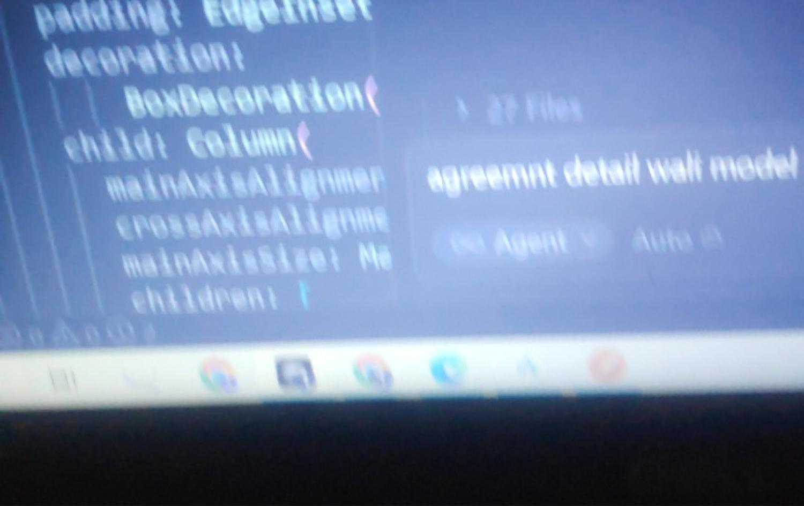
Document Back Side Photo
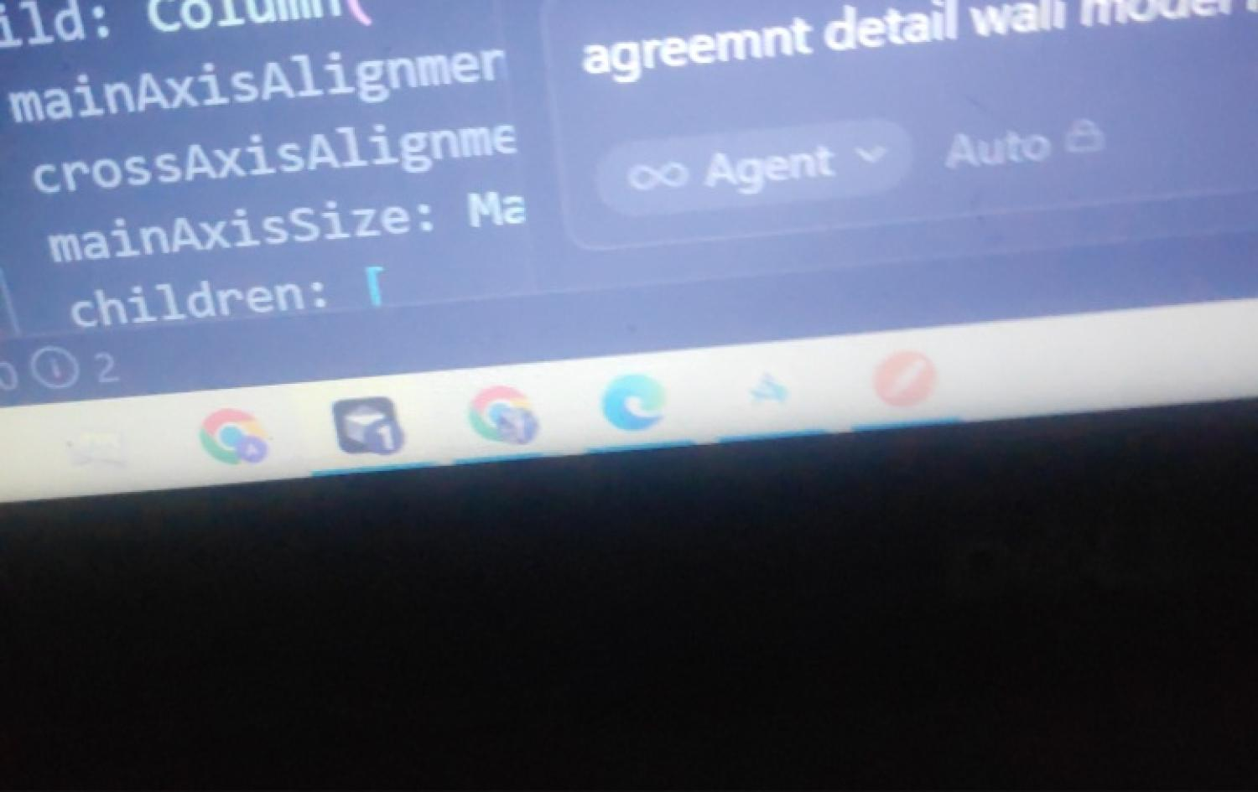

The party of the Second part i.e. Owner
Document Front Side Photo

Document Back Side Photo


name and Signature photo left hand
thumb impression

Signature 

Name Abdullah Arshad Fazal

party of the second part i.e. Tenant

Signature 

Name ABDULLAH ARSHAD FAZAL

WITNESSES:-

1. Name: Affa | Mobile Number: 4545654353
2. Name: | Mobile Number:

Precedient/BROKER/medium (if any):-

1. Name: 8bsgdgd | Mobile Number: 7868468649
2. Name: | Mobile Number:

