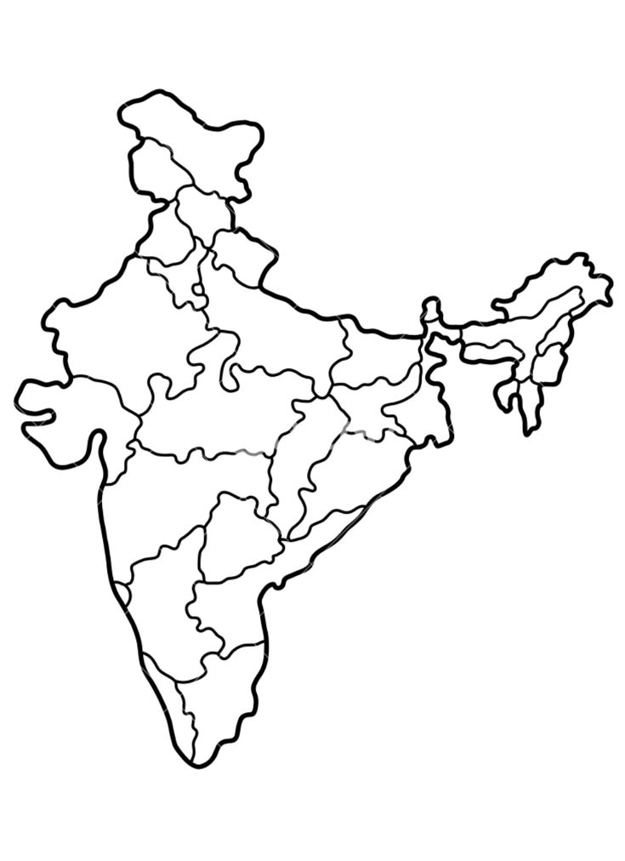 | F/A  Platform: Fast Agreements Application
Digital E - Leave and License Agreement Details
Date |  | : | 24-07-2026
First Party Name |  | : | MISTRI Miteshkumar DINESHBHAI
First Party Mobile Number |  | : | 9913855496
Second Party Name |  | : | Surati Dipakempire Bharatbhai
Second Party Mobile Number |  | : | 9913771173
Description |  | : | Digital E- Leave and License Agreement
Location |  | : | 4/7/129, Vishal Nagar, Narayan Nagar, Katargam, Surat, Gujarat 395004, India
Monthly License fees |  | : | 70,000
Deposit Amount |  | : | 1,50,000
Duration of Time |  | : | 11 Months
Starting Date |  | : | 05-07-2026
Ending Date |  | : | 04-06-2027

:: leave and license agreement ::-
Today the said Leave and License Agreement implemented on 24-07-2026 in English Day.
this leave and license agreement is executed in favour of the party of the first PART (Owner):-
Name MISTRI Miteshkumar DINESHBHAI
Aged about : 41 yrs, Occupation : Gov.job,
Residing at : 18 MADHUKUNJ SOCIETY BEHIND KASANAGAR KATARGAM SURAT
(Hereinafter referred to called as a "First Part" i.e. "Owner" in this agreement. Which expression includes the party of the second part himself and his heirs, guardians, successors, assignees, executors from time to time)
And
this leave and license agreement is executed by the party of the second part :-
Name Surati Dipakempire Bharatbhai
Aged about : 41 yrs, Occupation : Gov.job,
Residing at : 113, Mahavir Dham Vibhag 2, Near Madhav Baug School, Satadhar Chokadi Amroli
(Hereinafter referred to called as a "Second Part" in this agreement. Which expression includes the party of the second part himself and his heirs, guardians, successors, assignees, executors from time to time)
WHEREAS, we the both parties hereby executed by this Leave and License Agreement to binding each other that

Description of Property
All that piece or parcel of the Immovable property bearing Godown/ shop No. 06 along with construction made thereon All Floors / બધા ફ્લોર of the building /Society/ Complex known as CAMPUS situated at KATARGAM area, SURAT City, Its Municipal Tenament No. is 98472626485 and Light bill/ Power Service No. is 9384757197. The party of the first part became owner and possessor of the said property. The party of the second part has retained the said property for the monthly license fee of Rs. 70,000/- In Words Seventy Thousand only for the purpose of trade/business for 11 Months from 05-07-2026. Today We the both parties executed this Leave and License agreement subject to the following conditions.
-:: Conditions ::-
(1) The said property has been kept by the party of the second part for the purpose of legally business/trade/professional for a period of 11 Months from date: 05-07-2026 to 04-06-2027 for the exclusive use of the license fee. The monthly license fee has been fixed at Rs. 70,000/- In Words Seventy Thousand only for the use of the said property. The amount of which license fee shall be paid by the party of the second part to the party of the first part regularly from the first to the tenth date of every English month. The period/month for this license fee shall be deemed to commence from the first date of every English month and to end on the last date.
(2) The quiet, vacant, direct possession of this property has been handed over by the party of the first part to the party of the second part today. Which the party of the second part has seen, checked and received the possession.
(3) The party of the second part shall pay all bills including any bills of the electricity company for the use and occupancy of the said property on a regular monthly basis. However, if the electricity connection is lost or damaged due to the fault of the party of the second part and if that connection is restored or reconnected, the party of the second part shall be responsible for the all costs and the party of the second part shall have to pay for increasing the load in this electricity meter, whatever action is required regarding the electricity meter and all costs and fines, deposits etc. shall also be paid by the party of the second part and the property tax bill of Surat Municipal Corporation and water bill shall also be paid by the party of the second part.
(4) This property can be used only for the purpose of business/trade/professional. There was no work prohibited by law shall be done in the said property. The party of the second part shall not do any demolition, alteration, painting, etc. in the said property without the written consent of the party of the first part and no change shall be made in the construction of this property or its fixed electric fittings, etc. and if the party of the second part fails to maintain as the owner has done, then the vacant direct possession of the party of the first part shall automatically be considered as the same condition as it is at present in the party of the first part or the owners of this property. Further, this property is given to be used only for the purpose of business/trade/professional. So any other persons, workers etc. shall not be stay in night in the said property.
(5) The said property is to be used for purpose of business/trade/professional and if we have to appoint workers as per the requirement for our business/trade/professional for that purpose, the party of the second part shall furnish the all details, information to the police etc., of the workers employed/retained in this property as well as the information, details etc. as per other applicable laws and you shall have to complete all legal procedures and have the party of the second part provide the party of the first part with a copy of the evidence of all the information, details etc. have been submitted.
(6) If any incident or accident occurs on the property given to the party of the second part for use by this agreement and any person is injured or dies in the accident, the party of the second part will be fully responsible for the same, the party of the second part will also be responsible for providing information about the workers employed in the said property to the police and other government and semi-government offices. The party of the second part will be responsible for all proceedings in case of any illegal activity in the said property and any police action, any civil or criminal or any other court case arising and the party of the second part will have to bear all the costs of all such proceedings and responsibilities. If the party of the first part suffers any expense or loss due to this activity, the party of the second part will be able to recover all the costs and losses from the party of the first part.
(7) The use of this property shall not cause any activity or action to be done which may cause obstruction, annoyance or nuisance to the neighbours. The use of this property shall not cause any vibration to the property or weaken the structure of the property, moreover for the safety of the property kept for use, we the party of the second part shall take other safety measures at our own expense, if necessary and the party of the first part shall not be liable in this regard and shall not incur any expenses in this regard. In addition if any damage is caused to this property in any unforeseen circumstances, we the party of the second part shall make it up at our own expense. In short, we shall make it up as per the instructions of the party of the first part.
(8) The property mentioned in the schedule to this agreement has been acquired by the party of the second part for the purpose of business/trade/professional through a license or permit, the party of the second part has not transferred and assigned the license of the said property to any way or create any right of any other person.
(9) The party of the second part shall not obtain a loan or credit from any bank, private company or finance company at the address of this property or shall not cause any private or government, semi-government charge to be created and even if any such loan or duty, charges arises, the party of the second part shall be fully responsible for repaying it and obtained the NOC.
(10) The party of the second part shall not cause the said property to be used in a way that causes inconvenience or annoyance to others. The illegal activities shall not be carried out in the said property, nor shall any works or acts which may cause dirt, nuisance to other property holders in the vicinity nor shall any things prohibited by law be kept. However, if any such works or acts are carried out, the party of the first part shall be entitled to take possession of this property without notice and all such illegal works or acts shall be completed by the party of the second part at our own cost and risk and the property shall be handed over to the party of the first part without any notice.
(11) The party of the second part shall not carry out any amendment, painting, repairing etc. in this property without the written consent/permission of the party of the first part.
(12) If either of we the party of the second part, wishes to vacate the property before the expiry of this agreement, that party shall give notice thereof two months in advance and at the time of vacating the property, the property shall be handed over in the same condition in which it was handed over to the party of the first part by the party of the second part.
(13) The party of the second part shall bear all the liabilities and expenses of the Surat Municipal Corporation licenses, labor laws, Sales Tax, Income Tax, VAT, GST laws and all government and semi-government legal offices for any business, trade/profession carried out by the party of the second part in the property given to us and after the expiry of the term of this agreement, all such licenses/permits etc. shall be cancelled or revoked by us and cost of the party of the second part. The license fee shall be payable by the party of the second part to the party of the first part until the evidence of the cancellation is provided by the party of the second part to the party of the first part.
(14) The license fee fixed for this property does not include any direct or indirect tax. The Government, Semi-Government employees or the Central Government, State Government are responsible for paying direct or indirect taxes such as GST, VAT, Service Tax, Professional Tax or any other type of taxes. The amounts of such taxes shall also be paid separately by the party of the second part apart from the license fee or shall be paid to the party through an alternative and after the expiry of this agreement, all such taxes shall be reimbursed and all such parties shall also be responsible for getting the address details of this property given by the party of the second part in all government, semi-government offices, etc., reduced/cancelled.
(15) The party of the second part shall install and maintain all types of fire safety equipment required for commercial purposes in accordance with the existing laws, policies and rules of the Government of India at its own cost and risk in the said property and the responsibility of obtaining the necessary NOC, permits/licenses etc. from the Surat Municipal Corporation or applicable offices, including the cost thereof, shall be the responsibility of the party of the second part. Further, the responsibility of maintenance, services, renewal etc. of these fire safety equipment and all the costs incurred therein shall also be the responsibility of the party of the second part. The party of the first part shall not be liable in this regard.
(16) After the party of the second part takes direct possession of the said property, the owner of the property shall be fully responsible for any financial loss caused by any natural calamity such as natural calamity, earthquake, flood, fire, storm etc. and man-made calamities such as riots, war etc., due to any damage to the property or the entire building, the party of the second part shall not be directly or indirectly liable for any financial, technical or legal liability in the said regard. Whose guarantee given by the party of the first part.
(17) This is a Leave and License Agreement, therefore, the party of the second part is not or does not become the tenant of the said property, the party of the second part has understood the said fact. Therefore, the party of the second part shall not have any right-claim as a tenant of this property and shall not initiate any proceedings under the Bombay Rent Act against the party of the first part in respect of this agreement nor the party of the second part shall be able to initiate any court proceedings against the party of the first part in respect thereof.
(18) The party of the second part shall use this property for the purpose of business/trade/professional only for the period specified in this agreement i.e. for a period of 11 Months (Eleven) months.
(19) The party of the second part shall not become the owner of the property as per the amendment bill by adding new section-1(A) under section-4(1) of the Mumbai Rent Hotel and Residential Rate Control Act, 1947. The owner of this property is the party of the first part.
(20) In case, the said property is found to be used in suspicious or unsafe conditions, the party of the first part (Owner) or your people will be allowed to come and inspect it and no action or obstruction will be made and if they do, it will be null and void.
(21) All the information and details to be provided for police verification as well as information and details as per other applicable laws will be completed by all the legal procedures and the party of the second part will have to provide the party of the first part with a copy of the evidence of all the information and details being submitted.
(22) We have decided the monthly license fee of this property after considering both the parties. Therefore, there is no need to decide the standard rent and the monthly fee that has been decided is acceptable to both parties. Therefore, there is no dispute regarding the monthly license fee and along with this, the party of the second part has paid Rs. 1,50,000/- In Words One Lakh Fifty Thousand only as deposit/reserve amount to the party of the first part (owner). The amount which is to be returned to the party of the first part after calculating all the outstanding amounts on handing over the possession of the said property.
(23) If the Party of the second part has keep the employs, workers below 18 years of age in this property used for business purposes, and if any legal action is taken or any offense occurs, then the responsibility shall be of the Party of the second part. The Party of the first part shall have no responsibility in such matters.
(24) During the term of the rent agreement, if due to any natural or man-made disaster, lockdown, or curfew, the business operations remain closed, then during such period the Party of the second part shall be obligated to pay the fixed rent amount to the Party of the first part. That no exemption or reduction in the decided rent amount shall be requested.
(25) After the completion of the agreement period, on dated 04-06-2027, the Party of the second part shall mandatorily hand over vacant possession of the property to the Party of the first part. If the Party of the second part fails to hand over vacant possession, then the Party of the first part shall have the right to put their own lock on the property, remove all belongings of the Party of the second part, and take back possession. If the Party of the first part takes possession in this manner, the Party of the second part shall not raise any objection, and any such objection, if made, shall be considered null and void. In short, after 04-06-2027, the Party of the second part shall have no possession, usage, or any rights over the property. The Party of the second part hereby gives full assurance, trust, guarantee, and undertaking to the Party of the first part.
(26) If any of the above conditions are violated, the Party of the first part shall be entitled to take back possession of the property kept for use without notice and without any dispute.

THE PARTY OF THE FIRST PART I.E. LICENSOR

Document Front Side Photo
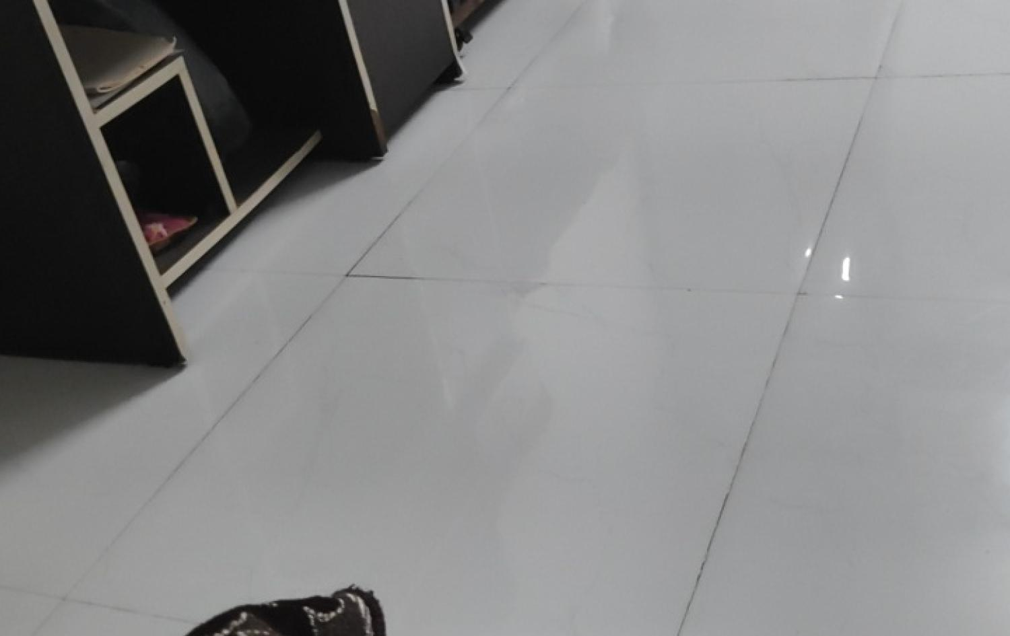
Document Back Side Photo
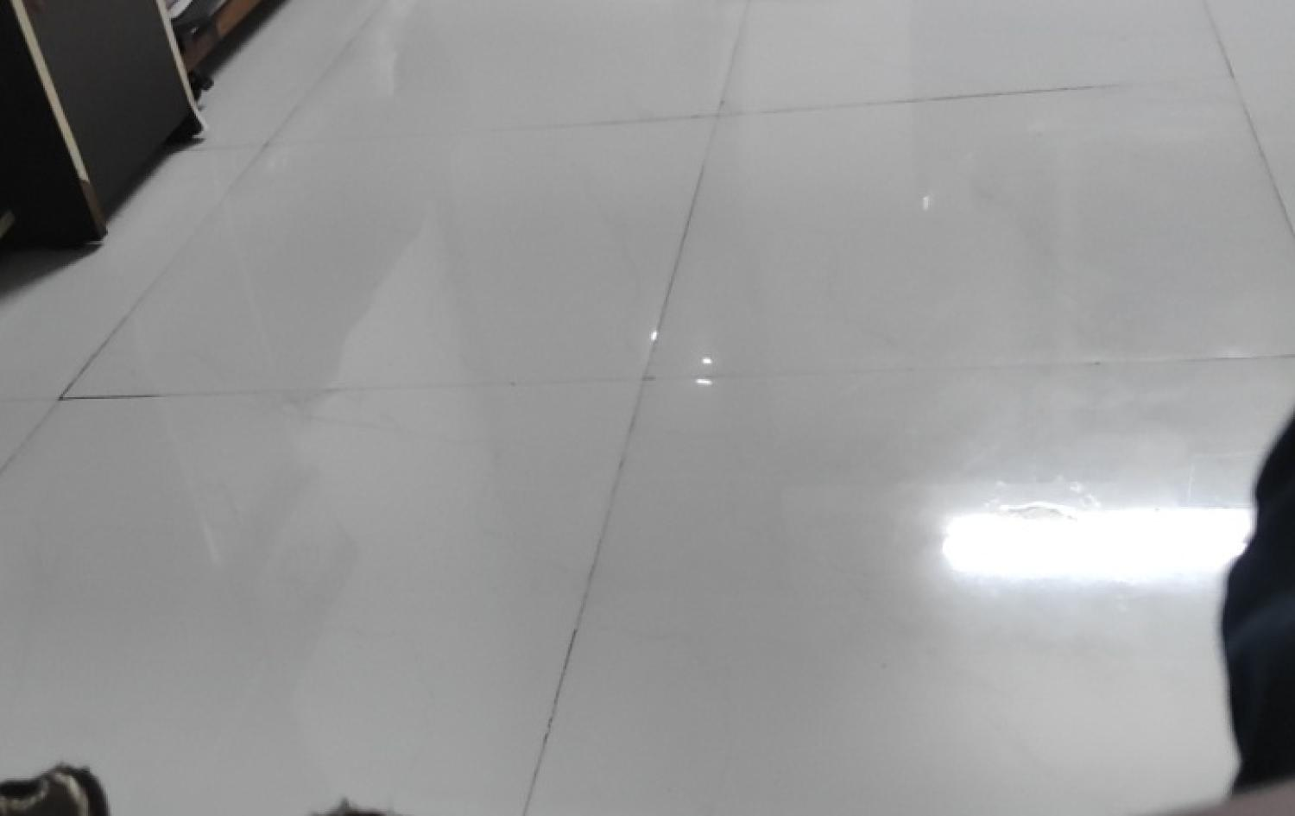

party of the second part i.e. licensee

Document Front Side Photo
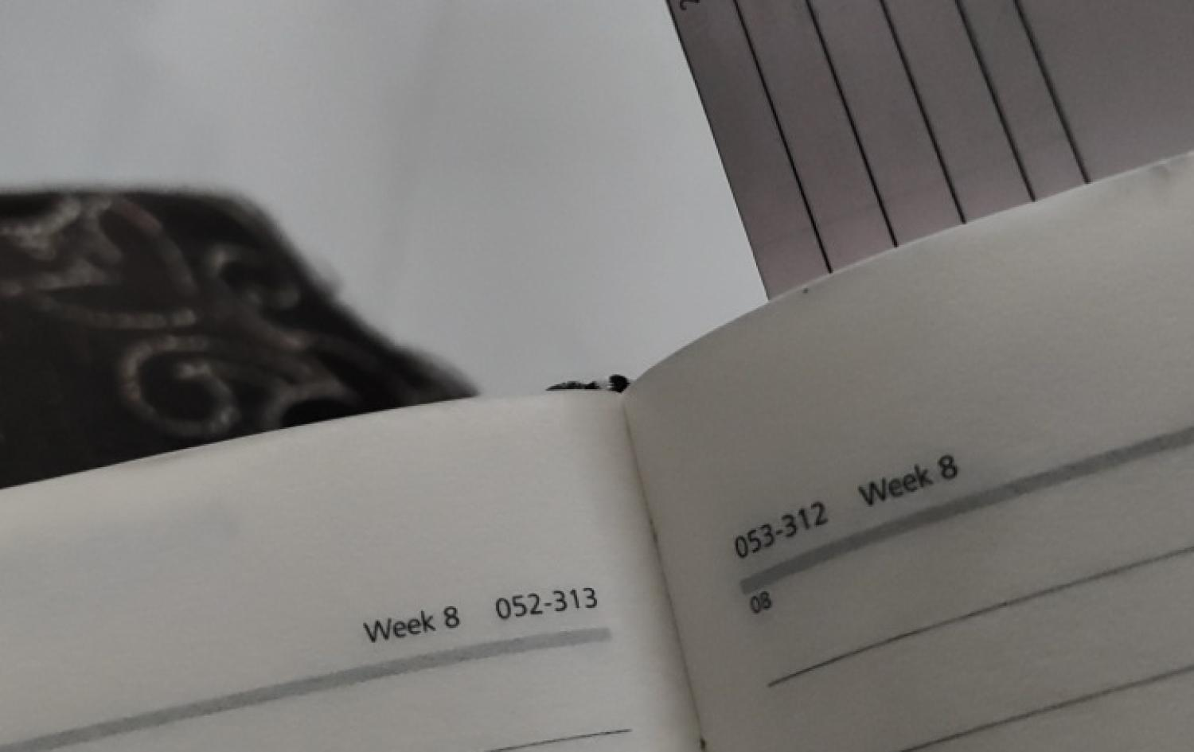
Document Back Side Photo
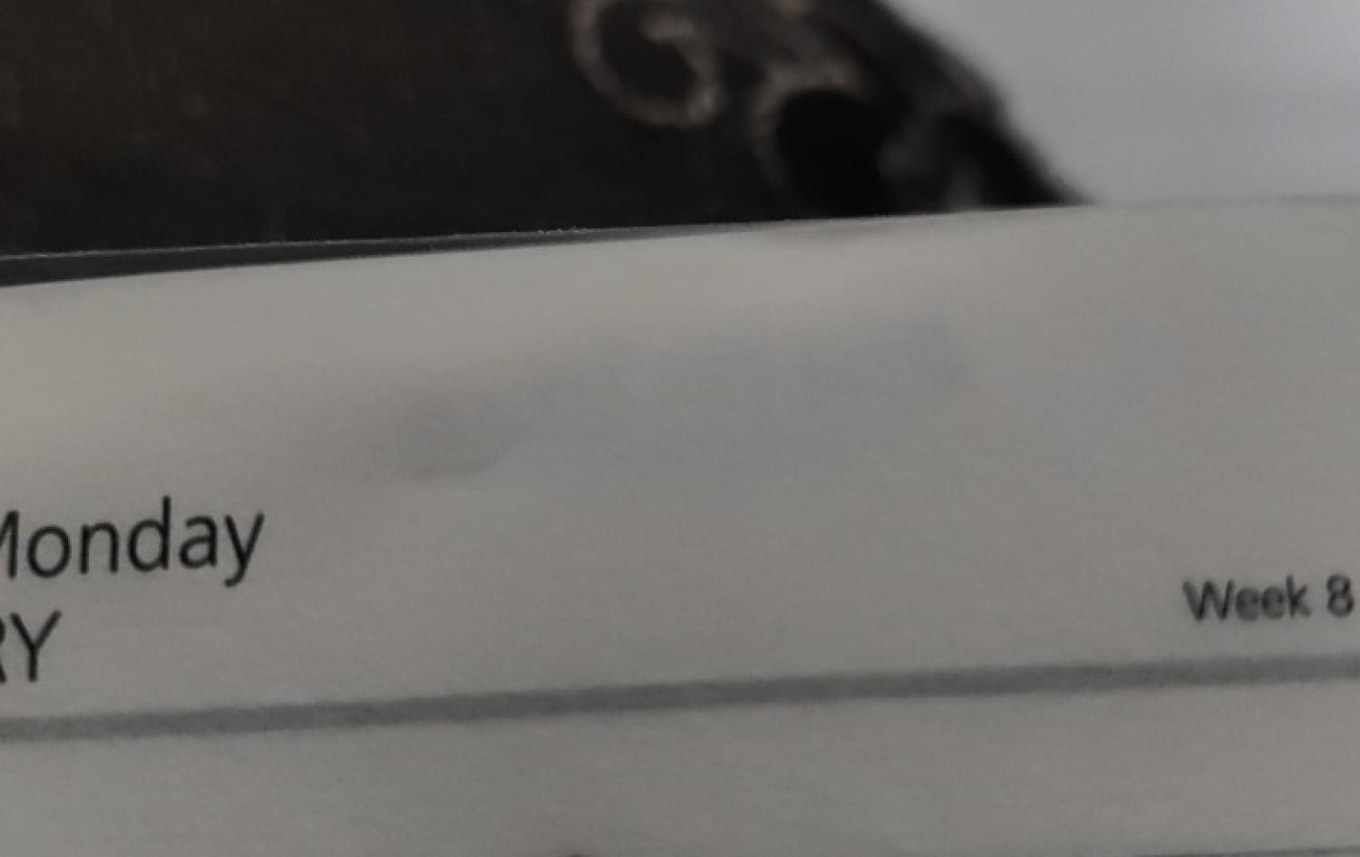

We, the party of the second part, have written this Leave and License Agreement to the party of the first part with our utmost intelligence, having read, understood, considered and in a healthy state, keeping our lives intact, without any kind of pressure or coercion from anyone, willingly, happily, with pure intelligence and with free consent. Which is binding on us and our heirs, guardians and successors. In witness whereof, the party of the second part has signed our signature in the presence of the following witnesses.

- The party of the first part i.e. Licensor

name and Signature photo left hand
thumb impression

SIGNATURE 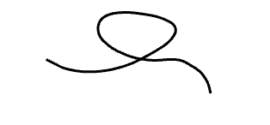

Name: MISTRI Miteshkumar DINESHBHAI

- party of the second part i.e. licensee

SIGNATURE 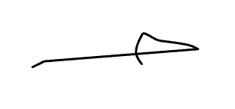

Name: Surati Dipakempire Bharatbhai

WITNESSES: -

1. Name: HEMALBHAI | Mobile Number: 6532984758
2. Name: NILBHAI | Mobile Number: 6452356897

Name of the President/Broker/ Mediator

1. Name: VISHALBHAI | Mobile Number: 6532146528

