 | F/A  Platform : Fast Agreements Application
Digital e – Rent Agreements Details
Date |  | : | 30-07-2026
First Party Name sDSFG DFl,Sf |  | : | Surati Pushpaben Bharatbhai
First Party Mobile Number |  | : | 7567403252
Second Party Name sEF0]VFTf |  | : | Thakar Yogeshbhai Balvantbhai
Second Party Mobile Number |  | : | 7878778858
Description |  | : | Digital E- Rent Agreement
Location |  | : | 27, Lake Garden Rd, near Kasanagar, Madhukunj Society, Katargam, Surat, Gujarat 395004, India
Monthly Rent sDFl;S EF0]f |  | : | 6,000
Deposit Amount s0L5MhL8qVGFDT ZSDf |  | : | 10,000
Duration of Time sS[8,F ;DI DF8[f |  | : | 11 Months
Starting Date sSZFZ X~GL TFZLBf |  | : | 15-05-2026
Ending Date sSZFZ 5}6" YIFGL TFZLBf |  | : | 14-04-2027

voo EF0F SZFZoov
VF EF0F SZFZ VFH ZMH TFZLB 30-07-2026 GF V\U|[HL lNG[ YL VD, U6JFGM ZC[X[P
voo VF EF0F SZFZ ,BFJL ,[GFZ IFG[ EF0[ VF5GFZ T[ 5C[,F 51FGF sDSFG DFl,Sf oov
GFDo Surati Pushpaben Bharatbhai
pPVFPJP o 69 JØ", W\WMo Housewife4
ZC[P o 113,mahavirdham Vibhag-2, Opp. Madhavbag School, Amroli, Surat
H[VMG[ CJ[ 5KL VF SZFZDF\ 5C[,F 51FGF VUZ DSFG DFl,S TZLS[ ;\AMWJFDF\ VFJ[, K[P H[VMGF ;\5}6" VY"DF\ 5C[,F 51FGF 5MT[ TYF T[VMGF J\XvJF,L4 JFZ;M4 V[;F.GM4 V[ShLSI]8;" .tIFNLGM ;DFJ[X Y. HFI K[P
HMU ,LP
voo VF EF0F SZFZ ,BL VF5GFZ IFG[ EF0[ ZFBGFZ T[ ALHF 51FGF sEF0]VFTf oov
GFDo Thakar Yogeshbhai Balvantbhai
pPVFPJP o 37 JØ", W\WM o Private4
ZC[P o Building C-1/102, Shrushti Residncy V-1, Kosad, Surat
H[VMG[ CJ[ 5KL VF SZFZDF\ ALHF 51FGF VUZ EF0]VFT TZLS[ ;\AMWJFDF\ VFJ[, K[P H[VMGF ;\5}6" VY"DF\ ALHF 51FGF 5MT[ TYF T[VMGF J\XvJF,L4 JFZ;M4 V[;F.GM4 V[ShLSI]8;" .tIFNLGM ;DFJ[X Y. HFI K[P
HT VF EF0F SZFZYL VF56[ 51FSFZM V[SALHFG[ ,BL VF5L H6FJLV[ KLV[ S[PPPPPPPP4
HT VFHZMH CDM A\G[ 51FSFZM VF EF0F SZFZGF ,[B YSL A\WF.V[ KLV[ S[ PPPPPPP

voo EF0[ JF5ZJF VF5[, lD,STGL lJUT oov
0L:8=LS84 Surat4 UFDo Katargam. Kasanagar lJ:TFZDF\ VFJ[, HDLGDF\ VFIMHLT V[5F8"D[g8G\] GFD Madhukunj Appartment DF\ VFJ[, O,[8 G\P 104 GL First Floor (પહેલો ફ્લોર) O,MZ JF/L lD,ST H[GM DCFGUZ 5Fl,SF NOTZ[ sJ[ZFAL,f 8[GFPq U|FD 5\RFIT 3ZJ[ZMq 5|M58=L 8[1F G\P 019-E-17-1655-0-001 TYF ,F.8AL,q5FJZ ;lJ"; G\P 500317946 K[P H[ lD,ST TDM 5C[,F 51FGFGL DFl,SL VG[ SAHF EMUJ8FGL RF,L VFJ[, K[P ;NZC]\ lD,ST CDM ALHF 51FGFV[ DFl;S ~FP6,000qv V\S[ ~l5IF Six Thousand 5]ZFGF EF0[YL TFP 15-05-2026 GF ZMHYL 11 Months DF8[ OST ZC[9F6GF C[T] DF8[ ZFB[, K[P H[ EF0F SZFZ VF56[ VFHZMH GLR[ D]HAGL XZTMG[ VFlWG SZL VF5LV[ KLV[P
voo XZTM oov
s!f ;NZC]\ lD,STGL 0L5MhL8 5[8 ~FP 10,000qv V\S[ ~l5IF Ten Thousand 5]ZF TYF T[G]\ DFl;S EF0] ~FP6,000qv V\S[ ~l5IF Six Thousand 5]ZF GSSL SZ[, K[P ;NZC\] lD,ST BF,L SZ[ VYJF SZFZ 5}6" YIF AFN 0L5MhL8qVGFDT ZSD ALHF 51FG[ 5ZT VF5JFGL ZC[X[P
sZf ;NZC]\ lD,ST CDM ALHF 51FGFV[ TDM 5C[,F 51FGF 5F;[YL TFP 15-05-2026 GF ZMHYL 11 Months GL D]N'T[ OST J5ZFX DF8[ ZFB[, K[P NZ DF;GL ! YL !_ TFZLB ;]WLDF\ EF0] R]SJL VF5JFG]\ ZC[X[P
s#f VF EF0F SZFZGM TFP 15-05-2026 YL TFP 14-04-2027 ;]WL VD, SZJFGM ZC[X[P TYF VF EF0F SZFZGL D]N'T 5}6" YIF AFN ;NZ EF0F SZFZ DSFG DFl,SGL ;\DlT 5KL OZL ZLgI] SZJFGM ZC[X[P
s$f ;NZC]\ EF0[ lD,STG]\ DFl;S EF0] NZ DF;MDF; R-FR-L ZLT[ lGIlDT VF5JFG]\ K[P T[DF\ SM. DF; R]SL HJFGM GYLP VF AFAT[ ElJQIDF\ SM. TZvTSZFZ SZJFGL ZC[X[ GCLP ;TT +6 DF; EF0FGL ZSD HDF G SZFJLV[ TM TDM 5C[,F 51FGF sDFl,Sf VF ;NZC\] lD,STGM SAHM D[/JL XSMP ;lCP
s5f ;NZC]\ EF0[ VF5[,L lD,STGM EF0FGM DF; NZ V\U|[HL DF;GL !,L TFZLB[ X~ YTM U6LG[ T[ H DlCGFGL VFBZL TFZLB[ 5]ZM YTM U6JFGM K[P
s&f ;NZC\] lD,STGM XF\T4 5|tI1F SAHM TDM 5C[,F 51FGFV[ VFH ZMH VDM ALHF 51FGFG[ ;]5|T SZ[, K[ H[ ALHF 51FGFV[ HM.4 T5F;L4 ;F\E/L :JLSFZL ,LW[, K[P
s*f ;NZC]\ lD,ST CDM ALHF 51FGFV[ ZC[9F6GF C[T] DF8[ EF0[YL ZFB[, K[P T[ l;JFI ALHM SM. p5IMU SZJFGM GYLP T[DH SM.G[ EF0[4 5[8F EF0[ S[ ,LJ V[g0 ,FI;g;YL IFG[ U]0,LJYL VF5JFGL GYLP T[DH VDFZF EF0]T TZLS[GF CSSM SM.G[ 8=Fg;OZ S[ V[;F.G SZJF vSZFJJFGF GYLP
s(f ;NZC\] EF0[ VF5[, lD,ST CDM ALHF 51FGF SM. SFZ6M;Z J[RF6 SZLV[ TM V[S DF;YL ALHF DF;DF\ TDFZ[ CDMG[ BF,L SZL VF5JFG\] ZC[X[P
s)f ;NZC]\ lD,STDF\ TZT ;/UL p9[ T[JF 5|NFYM" T[DH EFZT ;ZSFZ[ DGF. OZDFJ[, 5|NFYM"GM ;\U|C SZJFGM GYL KTF\ HM ElJQIDF\ SM. VS:DFT S[ V[S;L0g8 YFI TM T[GL TDFD HJFANFZL CDM ALHF 51F sEF0]VFTfGL ZC[X[P ;CLPPP
s!_f ;NZC]\ ZC[9F6GF C[T] DF8[ ZFB[,L lD,STDF\ VDMV[ SM. EF\UOM0 S[ G]SXFG SZJFG]\ GYL VG[ lD,ST H[JL ;FZL l:YlTDF\ JF5ZJF VF5[, K[ T[JL H ;FZL l:YlTDF\ 5ZT SZJFGL ZC[X[P T[DH VFH]AFH]JF/FVMG[ gI];g; YFI T[JF SM. S'tI SZFJFv SZFJJFGF GYLP
s!!f ;NZC]\ ZC[9F6GM C[T] DF8[ ZFB[, lD,STGF VF56[ A\G[ 51FSFZM VZ;v5Z; BF,L SZJFv SZFJJF DF\UTF CM.V[ TM V[S DF; VUFpYL HF6 SZJFGL ZC[X[P
s!Zf ;NZC]\ lD,ST CDM ALHF 51FGFV[ ZC[9F6GF C[T] DF8[ EF0[YL ZFB[, K[ VFJ[, lD<STDF\ S], S\]8\]A ;eI ;\bIF 3 ZC[X[P HM VF S\]8\]A ;eI ;\bIF SZTF\ JW] ;eIM DF,]D 50X[ TM 5C[,F 51FGF lJGF GM8L;[ VG[ lJGF TSZFZ ;NZC]\ J5ZFX DF8[ ZFB[,L lD,STGM SAHM 5ZT ,[JF CSNFZ KMP ;CLP
s!#f ;NZC] lD,STDF\ VDM ALHF 51FGFV[ SM. ;]WFZM4 JWFZM4 Z\UvZMUFG4 ZL5[ZL\U lJU[Z[ TDM 5C[,F 51FGFGL ,[lBTDF\ ;\DlTq 5ZJFGUL lJGF SZJF SZFJJFGL ZC[X[ GCL ;CLP
s!$f ;NZC\] lD,ST X\SFDF S[ VF5lTHGS 5lZl:YlTDF\ J5ZFX SZTF\ DF,}D 50[ T[JL l:YlTDF\ TDM 5C[,F 51FsDSFG DFl,SfGF S[ TDFZF DF6;M HMJF T5F;JF VFJ[ tIFZ[ T[VMG[ VFJJF N[JFGF K[ ;lC VG[ T[DF\ SM. CZST S[ ~SFJ8 SZJF SZFJJFGL GYL VG[ SZ[ TM T[ ZN AFT, YFI ;lCP
s!5f ;NZC\] lD,STGM VDM ALHF 51FGFV[ 5|tI1F SAHM ;\EF?IF AFN SM. 56 HFTGL S]NZTL VF5TLVM H[JL S[4 S]NZTL CMGFZT4 WZTLS\54 JZ;FNL 5]Z4 VFU4 JFJFhM0] lJU[Z[ TYF DFGJ;HLT VF5TL H[JL S[ ZDBF6M4 TMOFGM4 I]wW lJU[Z[ VF5TLVM ;NZC\] lD,ST S[ S], .DFZTGF AF\WSFDDF\ TM0vOM0 YJFYL H[ VFlY"S G]SXFG YFI T[GL TDFD HJFANFZL H[ T[ lD,STNFZGL ZC[X[ T[ V\U[GL CDM ALHF 51FGFGL 5|tI1F S[ 5ZM1F SM. 56 ZLT[ SM. 56 5|SFZGL VFlY"S4 8[SGLS, S[ SFINFSLI HJFANFZL ZC[X[ GCL\P H[GL VFYL TDM 5C[,F 51FGF BF+L VF5[ K[P ;lCP
s!&f ;NZC]\ lD,STG]\ ,F.8AL, CDM ALHF 51FGF IFG[ EF0]VFT[ EZJFGF ZC[X[ TYF 5|M58L" 8[1F vJ[ZFAL, Owner EZJFGF ZC[X[ 4 U[;,F.G AL, CMI TM ALHF 51FGF IFG[ EF0]VFT[ EZJFGF ZC[X[4 V[5F8"D[g8G\] D[.G8[Gg; ALHF 51FGF IFG[ EF0]VFT[ EZJFGF ZC[X[P XZT G\P !& DF\ p<,[B SZ[, lA,M EF0[ ZFBGFZ IFG[ ALHF 51FGFV[ EF0FGL ZSDYL V,U EZJFG\] ZC[X[P ;lCP
s!*f ,F.8qU[;GF DL8Z ;FY[ SM. 56 5|SFZGL K[0KF0 SZJFGL GYLP HM T[D SZJFDF\ VFJ[ VG[ T[GF ,LW[ HM SM. N\0 YFI TM T[ EF0[ ZFBGFZ[ EMUJJFGM ZC[X[P ;Lcp
s!(f 5M,L; J[ZLOLS[XGG[ VF5JFGL YTL TDFD DFlCTL lJUTM lJU[Z[ T[DH ,FU] VgI SFINF D]HAGL DFlCTL lJUTM lJU[Z[ TDFD[ TDFD SFIN[;ZGL SFI""JFCLVM 5ZL5}6"" SZL VDM ALHF 51FGFV[ TDM 5C[,F 51FGFG[ T[ TDFD[ TDFD DFlCTL lJUTM lJU[Z[ HDF SZFjIF V\U[GF 5]ZFJFVMGL GS, VF5JF V5FJJFGL ZC[X[P ;lCP
s!)f ;NZC\] lD,STGF ;ZGFD[ VDM ALHF 51FGFV[ SM. 56 A[\S4 BFGUL S\5GL S[ OFIGFg; S\5GLDF\YL ,MG S[ SZH D[/JJFG]\ GYL S[ SM.56 BFGUL S[ ;ZSFZL4 VW""v;ZSFZL AMHM pEM SZJF SZFJJFGM GYLP VG[ T[D KTF\ T[JL SM. ,MG S[ OZH4 AMHM GLS/L VFJ[ TM T[ EZ5F. SZJFGL T[DH V[GPVMP;LP D[/JJF ;lCTGL ;\5}6"" HJFANFZL VDM ALHF 51FGFGL ZC[X[ ;CLP
sZ_f D\]A. EF0F CM8[, VG[ lGJF;U'C NZ lGI\+6 VlWlGID !) s!f GLR[ GJL S,Dv! sV[f pD[ZL SZ[,F ;]WFZF ;FY[GF\ JLW[IS D]HA ALHF 51FGF DHS]Z lD,STGF DFl,S AGL XSX[ GlCP DHS]Z lD,STGF DFl,S 5C[,F 51FGF K[ VG[ ZC[X[P
sZ!f ;NZC\] EF0[ VF5[, lD,ST SZFZGL ;DIDIF"NFDF\ HM SM. S]NZTL S[ DFGJ;HL"T VF5lTGF SFZ6[ ,MS 0FpG S[ SO"I]GF SFZ6[ J[5FZ W\WF A\W ZC[ TM T[ ;DIUF/F NZdIFG GSSL SZ[, EF0[ ZSD CDM ALHF 51FGFV[ TDM 5C[,F 51FGFG[ OZHLIFT R}SJJFG\] ZC[X[P GSSL SZ[, EF0FGL ZSDDF\ DFOL DF\UJFGL ZC[X[ GlCP ;lCP
sZZf CDM ALHF 51FGF SZFZGL D]NT 5]ZL YIF AFN TFP14-04-2027 GF ZMH ;NZC] lD,STGM SAHM OZHLIFT TDM 5C[,F 51FGFG[ ;]5ZT SZJFGM ZC[X[ VG[ HM CDM ALHF 51FGF ;NZ lD,STGM BF,L SAHM ;]5ZT G SZ[ TM TDM 5C[,F 51FGF ;NZ lD,ST p5Z 5MTFG]\ TF/] DFZL CDM ALHF 51FGFGM H[ SF.\ DF,;FDFG CMI T[ ACFZ SF-L S-FJL SAHM 5ZT D[/JL XSXM ;CL G[ TDM 5C[,F 51FGF ;NZC] lD,ST p5Z 5MTFG]\ TF/] DFZL SAHM D[/JM TM T[ V\U[ VDM ALHF 51FGFGL SM.56 5|SFZGL TZTSZFZ RF,L XSX[ GCL VG[ HM SZLV[ SZFJLV[ TM T[ VFYL ZNAFT, YFI ;CLP 8}\SDF\ TFP14-04-2027 GF ZMH AFN CDM ALHF 51FGFGM ;NZ lD,ST p5Z SM.56 5|SFZGM SAHM EMUJ8M S[ SM.56 5|SFZGF CSSM ZCIF GYLPV[JM CDM ALHF 51FGF TDM 5C[,F 51FGFG[ ;\5}6" lJ`JF;4 EZM;M4BF+L VG[ AFC[\WZL VF5[, K[ ;CLP
sZ#f p5ZGL SM.56 XZTM E\U YFI TM TDM 5C[,F 51FGF lJGF GM8L;[ VG[ lJGF TSZFZ ;NZC]\ J5ZFX DF8[ ZFB[,L lD,STGM SAHM 5ZT ,[JF CSNFZ KMP ;CL P
V+[PPPPPPPPPPPPPPPPPPPPPPPPPPPPPPPPPPPPPDT] T+[PPPPPPPPPPPPPPPPPPPPPPPPPPPPPPPPPPPPXFB

VF EF0F SZFZ ,BFJL ,[GFZ T[ 5C[,F 51FGF sDSFG DFl,Sf
5]ZFJFGL VFU/GL AFH]JFZM OM8M
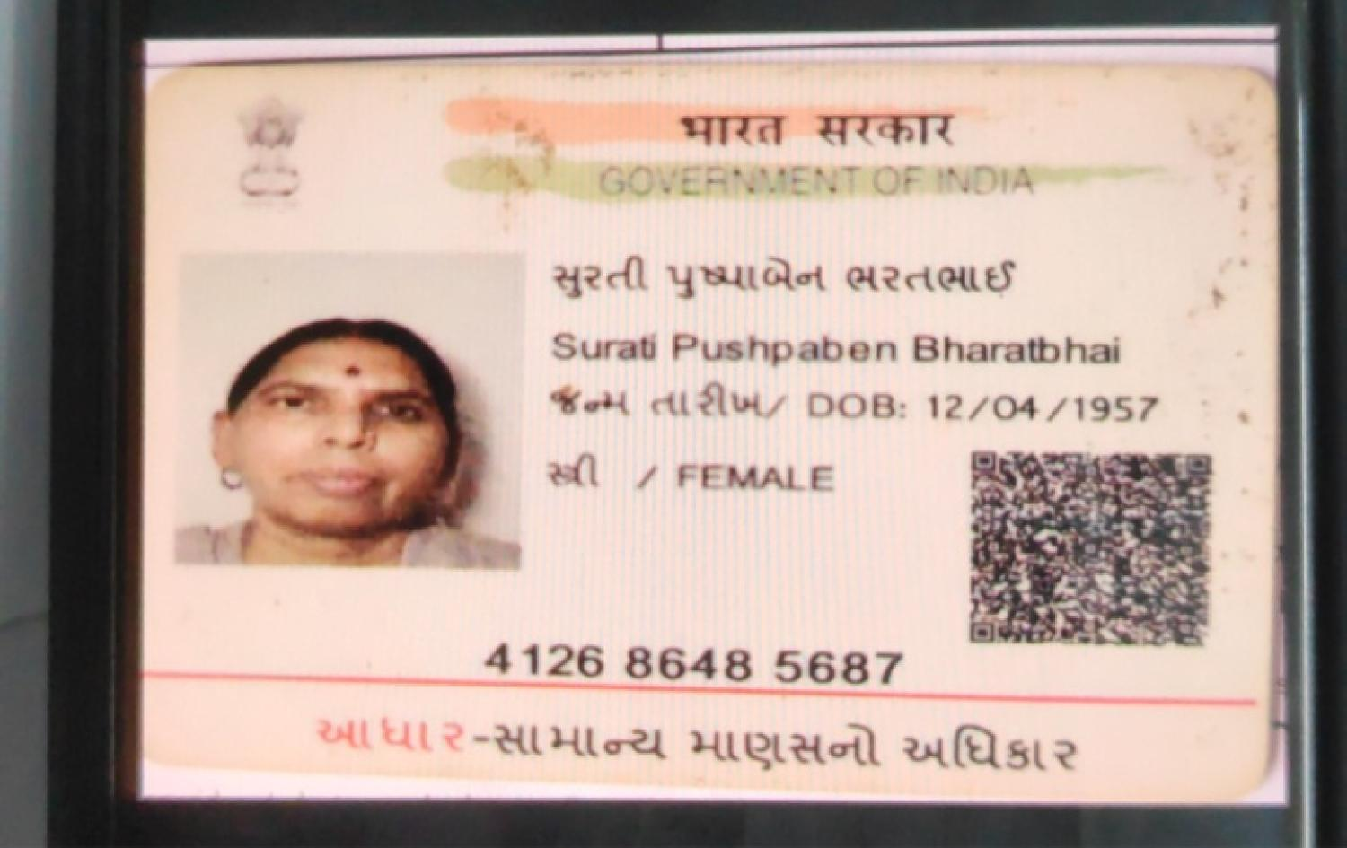
5]ZFJFGL 5FK/GL AFH]JFZM OM8M
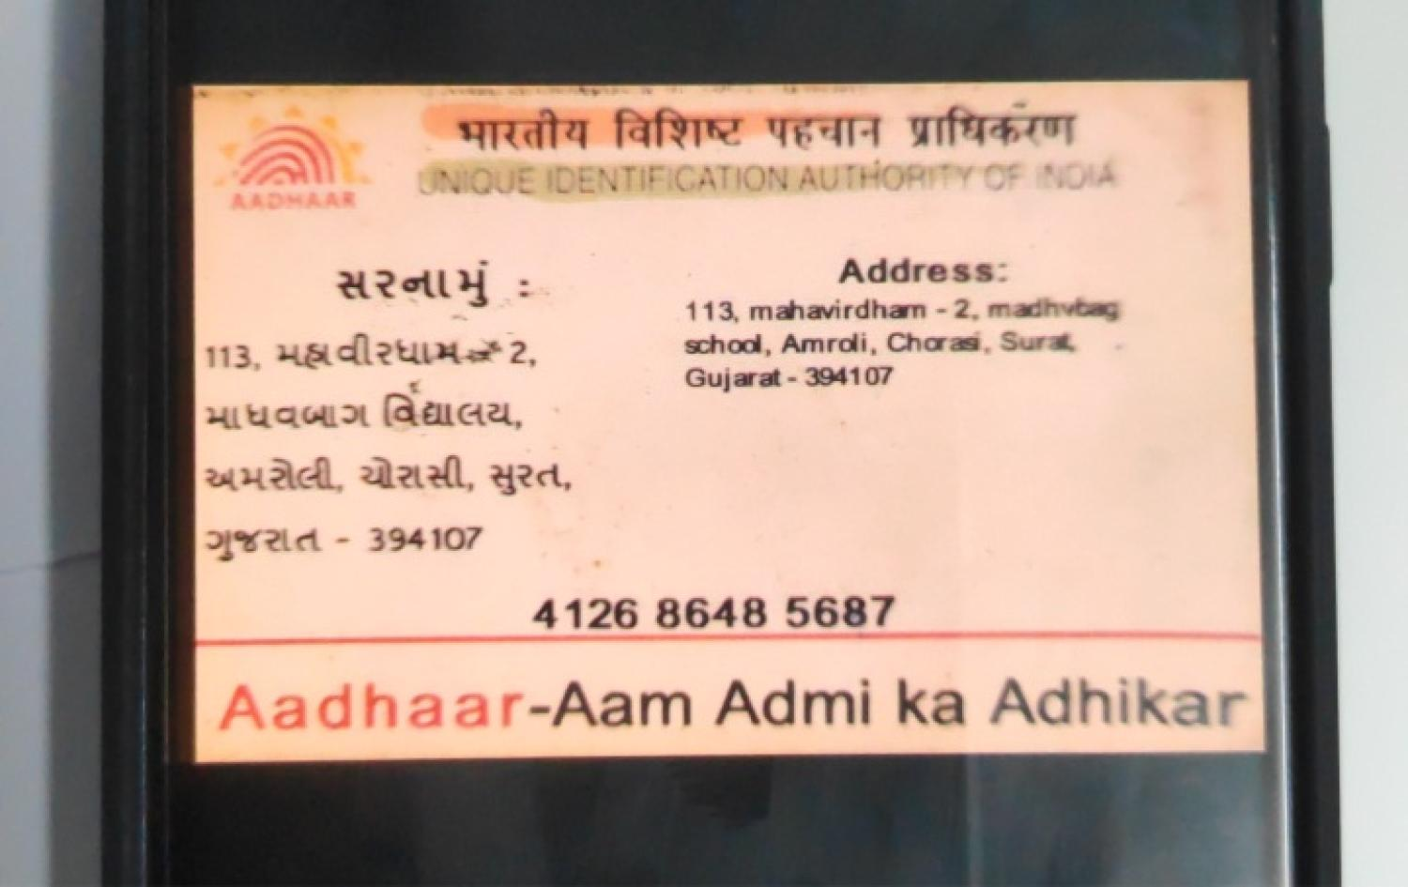

VF EF0F SZFZ ,BL VF5GFZ T[ ALHF 51FGF sEF0]VFTf
5]ZFJFGL VFU/GL AFH]JFZM OM8M
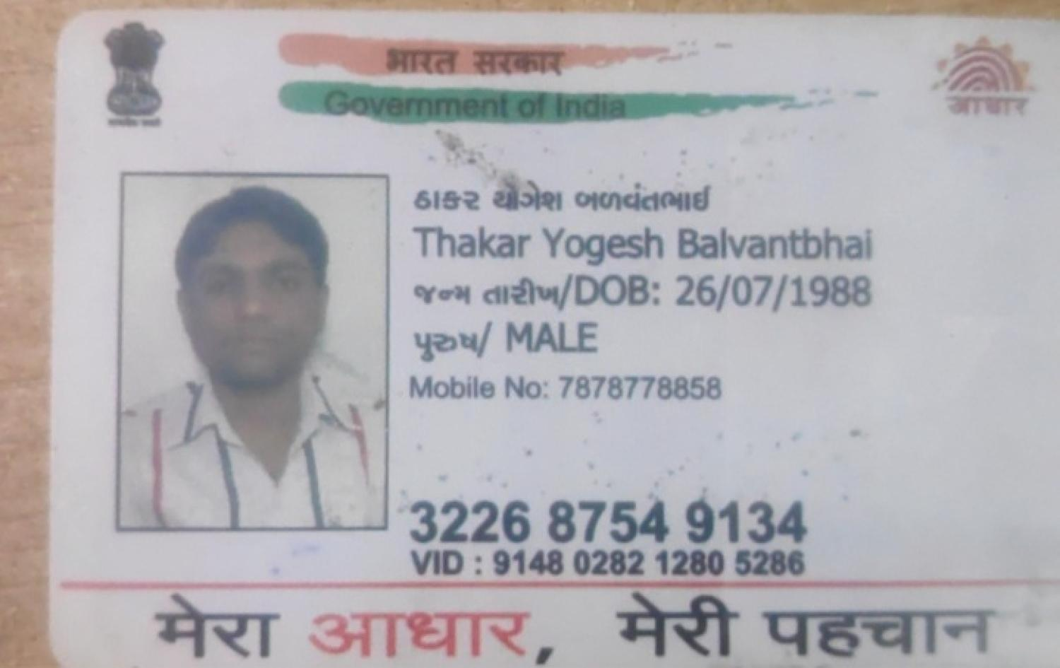
5]ZFJFGL 5FK/GL AFH]JFZM OM8M
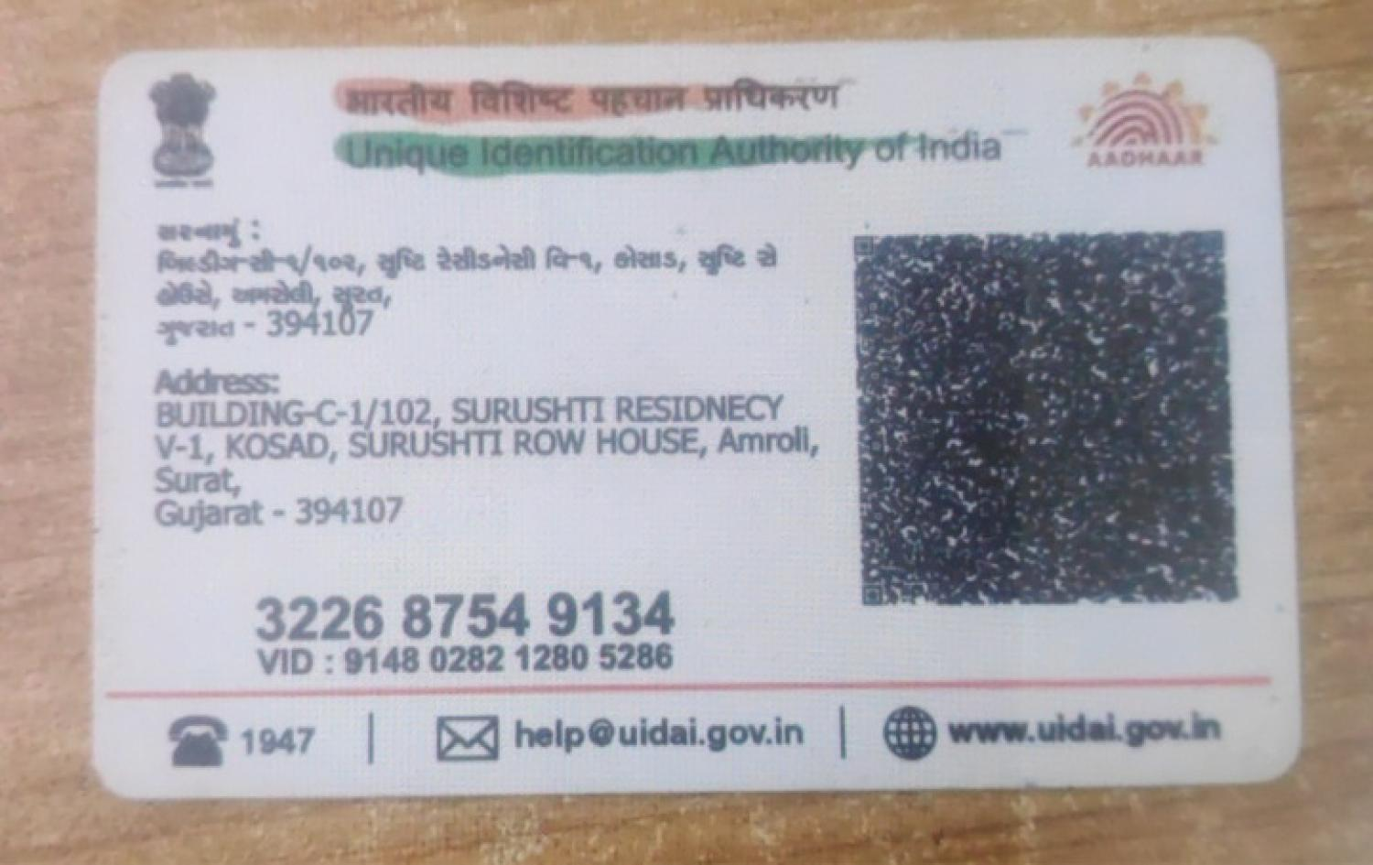

VDM ALHF 51FGFV[ VF EF0F SZFZ VDFZL VSS, CM\lXIFZLYL4 JF\RL4 ;DHL4 lJRFZL4 lAGO[S[ VG[ :J:Y CF,TDF\4 HLJ SFID ZFBL SM.GF SM.56 HFTGF NFAvNFAF6 JUZ ZFHLB]XLYL4 X]wW A]lwW5]J"SYL VG[ D]ST ;\DlTYL 5C[,F51FG[ ,BL VF5[, K[4 H[ VDMG[ TYF VDFZF J\X4 JF,L JFZ;MG[ TDFDG[ SA],4 D\H]Z A\WGSTF" K[ VG[ ZC[X[4 H[GL BF+L AN, VDM ALHF 51FGFV[ GLR[GF ;F1FLVMGL ~A~DF\ VDFZL ;CL SZ[, K[P
s!f VF EF0F SZFZ ,BFJL ,[GFZ T[ 5C[,F 51FGF sDSFG DFl,Sf o

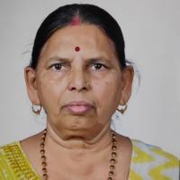

;CL 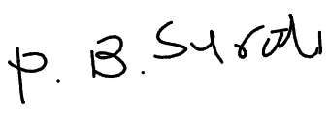
GFD o Surati Pushpaben Bharatbhai

sZf VF EF0F SZFZ ,BL VF5GFZ T[ ALHF 51FGF sEF0]VFTf o

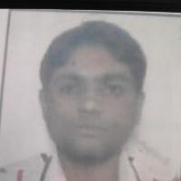

;CL 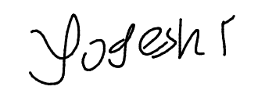
GFD o Thakar Yogeshbhai Balvantbhai
;F1FL oov
s!f GFD o Surati Dipak | DMAF., G\AZ o 9913771173
sZf GFD o Kehul Prajapati | DMAF., G\AZ o 9998539188

5|D]BqN,F,q A|MSZq DwIYLG\] GFD sHM CMI TMf
s!f GFD o | DMAF., G\AZ o
sZf GFD o | DMAF., G\AZ o

