 | F/A  Platform : Fast Agreements Application
Digital E -Satakhat Agreement Details
Date |  | : | 10-07-2026
First Party Name sBZLNGFZf |  | : | PRAJAPATI KEHUL PRAHLADBHAI
First Party Mobile Number |  | : | 9998539188
Second Party Name sJ[RGFZf |  | : | Prajapati Chirag Prahaladbhai
Second Party Mobile Number |  | : | 7069593391
Description |  | : | Digital E- Satakhat Agreement
Location |  | :
Total Amount |  | : | 10,00,000
Property Address |  | : | 32 bhakti heights

oo ;F8FBFT oo
VF SAHF JUZGM ;F8FBT SZFZ VFH ZMH TFZLB 10-07-2026 GF V\U|[HL lNG[ YL VD, U6JFGM ZC[X[P
VF ;F8FBFT ,BFJL ,[GFZ IFG[ 5C[,F 51FGF sBZLNGFZf ov
"PRAJAPATI KEHUL PRAHLADBHAI4
pPVFPJP o 234 W\WM ov Job
ZC[P 123,jalaramnagar, G.h.bord, Ganeshpura, Sayan Road,Amroli,Surat
sH[DG[ CJ[ 5KL VF ;F8FBFTDF\ TDM VUZ 5C[,F 51FGF VUZ BZLNGFZ VG[ J[RF6 ZFBGFZ T[ ZLT[ ;\AMWJFDF\ VFjIF K[4 H[GF ;\5}6" VY"DF\ lJZMWFEF; G CMI tIF\ 5C[,F 51FGF TYF T[DGF JBTMJBTGF J\X4 JF,L4 JFZ;M4 8=Fg;OZLVM4 GMDLGLh4 V[;F.GLh4 V[ShLSI]8;"4 V[0DLGL:8=[8;"4 ;S[;[;;" .tIFlN TDFDGM ;DFJ[X U6JFGM K[Pf
HMU l,P
VF ;F8FBFT ,BL VF5GFZ IFG[ ALHF 51FGF sJ[RGFZfov
"Prajapati Chirag Prahaladbhai
pPVFPJP o 194 W\WM ov Others
ZC[P 123,Jalaramnagar G.h Board Amroli,Surat
sH[DG[ CJ[ 5KL VF ;F8FBFTDF\ CDM VUZ ALHF 51FGF VUZ J[RGFZ VG[ J[RF6 VF5GFZ T[ ZLT[ ;\AMWJFDF\ VFjIF K[4 H[GF ;\5}6" VY"DF\ lJZMWFEF; G CMI tIF\ ALHF 51FGF TYF T[DGF JBTMJBTGF J\X4 JF,L4 JFZ;M4 8=Fg;OZLVM4 GMDLGLh4 V[;F.GLh4 V[ShLSI]8;"4 V[0DLGL:8=[8;"4 ;S[;[;;" .tIFlN TDFDGM ;DFJ[X U6JFGM K[Pf
HT CDM ALHF 51FGF TDM 5C[,F 51FGFG[ VF ;F8FBTGM ,[B ,BL VF5L A\WF.V[ KLV[ S[ov
surat 0L:8=LS84 Surat city4 ;Av0L:8=LS8 TF,]SM vesu GF DMH[ UFD o GFP Z[P;J[" G\P 6251771 8LP5LP :SLD G\P 727 VMP5LPG\P 72626 OFP%,M8 G\P 32 5{SL lA<0L\U G\P 32 YL GM\WFI[, HDLG p5Z bhakti heights GFDGL VM/BFTL lA<0L\U 5{SL lA<0L\U G\P 32 GF DF/[ VFJ[, O,[8 G\P 32 JF/L lD,ST H[GM VFXZ[ lA<8V5 V[ZLIF ;]DFZ[ 6577 RMPDLP TYF T/GL HDLGDF\ VgI ;EF;NM ;FY[ J6 JC[\RFI[, 6577 ;PRMPDLP CL:;F ;lCTGL lD,STGF VDM TYF T[G[ ,FU] V\NZGF TYF ACFZGF TDFD CSSM ;lCTGL lD,STGF VDM ALHF 51FGF 5|tI1F DFl,S4 SAH[NFZ T[DH EMUJ8[NFZ CMI4 ;NZC] lD,ST TDM 5C[,F 51FGFG[ J[RF6 VF5JFG]\ GSSL SZ[, K[4 H[GL XZTM GLR[ D]HA K[P
oo XZTM oo
- ;NZC] lD,STGL S]<,[ J[RF6 lS\DT VF5[ 51FSFZM JrR[ ~FP 10,00,000 V\S[ ~l5IF Ten Lakh 5]ZF GSSL SZ[, K[4 H[ J[RF6 lS\DT ;NZC] lD,STGL :Y/4 l:YlT4 AF\WSFD JQF" TYF V[ZLIF HMTF IMuI VG[ jIFHAL CMI A\G[ 51FGFV[ SA],4 D\H]Z ZFB[, T[YL lS\DT AFAT[ SM.56 51FSFZ[ TZ TSZFZ SZJFGL GYLP
- ;NZC] J[RF6 VF5JF GSSL SZ[, lD,STGL S], lS\DTGF AFGF 5[8[ VFHZMH ;]WLDF\ 2,00,000qv V\S[ ~l5IF Two Lakh R]ST[ R]SJL VF5[, K[P p5ZMST D]HAGL ZSD TDM 5C[,F 51FGF TZOYL VDM ALHF 51FGFG[ R]ST[ D/L UI[,K[ ;CL4 H[ ZSD AN, VF ,[B YSL 5FSL 5CM\R ,BL VF5LV[ KLV[4 H[YL CJ[ 5KL aIFGFGL ZSD G D?IFGL S[ VMKL D?IFGL CDM ALHF 51FGFV[ SM. TZ TSZFZ SZJF SZFJJFGL GYL VG[ T[JL SM. TZ TSZFZ CDM ALHF 51FGF S[ CDFZF J\X4 JF,L4 JFZ;M SZ[ TM T[ VFYL ZN AFT, YFI ;CLP
- ;NZC] lD,STGF AFSL J[RF6 VJ[H 5[8[GL AFSLGL ZSD ~FP 8,00,000 V\S[ ~l5IF Eight Lakh 5]ZF TDM 5C[,F 51FGFV[ VFHZMH YL 2 Months DF; Two GL D]NTDF\ R]ST[ R]SJL VF5JFGF ZC[X[ ;CLP ;NZC] J[RF6 VJ[HGF 5]Z[5]ZF GF6F\ D?I[YL CDM ALHF 51FGFV[ TDM 5C[,F 51FGFG[ ;NZC] lD,STGM SAHM ;]5|T SZL ZHL:8Z J[RF6 N:TFJ[ SZL VF5JFGM ZC[X[ ;CLP DHS]Z D]NTDF\ SM.56 HFTGM O[ZOFZ VF5[ 51FSFZMV[ VF\TlZS ;DH]TLYL GSSL SZJFGM ZC[X[ ;CLP
- ;NZC] J[RF6 VF5JF GSSL SZ[, lD,ST VDM ALHF 51FGFV[ TDM 5C[,F 51FGFG[ ;NZC] lD,STMGF CDFZF H[JF ;\5}6" VG[ :JT\+ DFl,S4 SAH[NFZ AGFJL SFIDGF DF8[ J[RF6 VF5JFG] GSSL SZ[, K[ H[YL TDM 5C[,F 51FGF 5F;[YL J[RF6 VJ[HGL 5]Z[5]ZL R]ST[ ZSD VDM ALHF 51FGFG[ D?I[YL VDM ;NZC] lD,STGM SAHM ;]5ZT SZL VF5LV[ tIFZ[ TDM 5C[,F 51FGF TDF~ lN, RFC[ T[ ZLT[ p5IMU4 p5EMU4 JCLJ84 jIJ:YF SZM vSZFJM4 EF0[ VF5M4 ULZMD]SM4 A1FL;DF\ VFM5 S[ CZSM. ZLT[ p5IMU SZM T[DF CDM ALHF 51FGFV[ SM. 56 HFTGL TZ TSZFZ SZJFGL GYLP ;NZC] lD,STM VDM ALHF 51FGFV[ VF VUFp VgI SM.G[ J[RF6 S[ D{FlBS SZFZYL VgI SM.G[ J[RF6 YL VF5[, GYL VG[ ElJQIDF\ VFJ] SM.5 HFTG]\ S'tI GLS/L VFJ[ TM VF ;F8FBTGL ~V[ ZN AFT, U6JFG]\ ZC[X[ TYF V[J] SM. GLS/L VFJ[, TM T[G[ VDM ALHF 51FGFV[ VDFZF BR[" N]Z SZL SZFJL VF5JFG]\ ;CLP
- ;NZC] lD,STGF ;ZSFZL4 VW";ZSFZL J[ZF4 DC[;], J[ZF4 dI]lGP SM5M"Z[XGGF J[ZF4 ,F.8AL,4 D[.g8[Gg; RFH" lJU[Z[ SF\.56 VtIFZ ;]WLGF AFSL CMI TM T[ CDM 5C[,F 51FGFV[ EZ5F. SZJFGF K[ VG[ SAHM ;]5ZT SZL VF5LV[ 5KL VFJL TDFD HJFANFZL TDM 5C[,F 51FGFGL ZC[X[P
- ;NZC] lD,ST CF, ;ZSFZL4 VW";ZSFZL NOTZ[4 ;M;FI8L NOTZ[4 Z[S0" VMO ZF.8;GF NOTZ[4 DCFGUZ5Fl,SF SR[ZL4 .,[S8=LS S\5GL lJU[Z[ H[ T[ SR[ZLVMDF\ CDM ALHF 51FGFG] GFD DFl,SL CSS[ RF,[ K[ H[ TDM 5C[,F 51FGF TZOYL J[RF6 VJ[HGL ZSD R]ST[ YI[YL J[RF6 N:TFJ[H SZL VF%IF AFN CDM ALHF 51FGFG] GFD SDL SZFJL TDF~ GFD DFl,SL WMZ6[ NFB, SZL SZFJL XSMP
- ;NZC] lD,STGM 5FS[ ZHL:80" J[RF6 N:TFJ[H 5C[,F 51FGF VUZ TM 5C[,F 51FGFV[ SZL VF5JFGM ZC[X[ ;CL4 VG[ T[ AFAT ALHF 51FGFV[ 5FK/YL SM.56 TZ TSZFZ SZJF SZFJJFGL GYL S[ JF\WM ,[JFGM GYL VG[ T[JL SM. TZ TSZFZ SZLV[ TM T[ VFYL ZNAFT, YFI ;CLP
- ;NZC] lD,ST SM.56 ;\:YFVM S[ A[\S lJU[Z[ 5F;[YL CDM ALHF 51FGFV[ ;NZC] lD,STM V\U[ SM. ,MG S[ HFDLGULZL T[DH EZ65MQF6GF VlWSFZDF\ GYLP VFD ;NZC]\ lD,STM DHS]Z GSZHL4 GAMHL4 GHMBDL RMbBF VG[ DFS["8[A, 8F.8,JF/L CMJFGM ;\5}6" lJ`JF; VG[ EZM;M VF5L 5C[,F 51FGFG[ J[RF6 N:TFJ[H SZL VF5JFGM ZC[X[ VG[ ElJQIDF\ ;NZC] lD,ST AFAT[ SM. CSS lC:;M SZT] GLS/L VFJ[ TM T[ TDFD CDM ALHF 51FGFV[ CDFZF BR[" N]Z SZL VF5JFG]\ ZC[X[P
- ;NZ ;F8FBTGF VF56[ 51FSFZMGL HM ElJQIFDF\ CIFTL G CMI TM 56 ;NZ ;F8FBTGF ,[B VF56[ 51FSFZMG[ TYF VF56F J\X4 JF,L4 JFZ;MG[ SA], D\H]Z TYF A\WGSTF" YFI ;CL VG[ ZC[X[ ;CLP
voo J[RF6 VF5JF GSSL SZ[, lD,STGL lJUT oov
surat 0L:8=LS84 Surat city4 ;Av0L:8=LS8 TF,]SM V0FH6GF DMH[ UFD o althan GFP Z[P;J[" G\P 6251771 8LP5LP :SLD G\P 727 VMP5LPG\P 72626 OFP%,M8 G\P 32 5{SL lA<0L\U G\P 32 YL GM\WFI[, HDLG p5Z bhakti heights GFDGL VM/BFTL lA<0L\U 5{SL lA<0L\U G\P 32 GF DF/[ VFJ[, O,[8 G\P 32 JF/L lD,ST H[GM VFXZ[ lA<8V5 V[ZLIF ;]DFZ[ 6577 RMPDLP TYF T/GL HDLGDF\ VgI ;EF;NM ;FY[ J6 JC[\RFI[, PPP ;PRMPDLP CL:;F ;lCTGL lD,STGF VDM TYF T[G[ ,FU] V\NZGF TYF ACFZGF TDFD CSSM ;lCTGL S]<,[ NZMA:TP
V[6L lJUTGM VF ;F8FBTGM ,[B CDM ALHF 51FGFV[ CDFZL VSS, CM\XLIFZLDF\ 4 JF\RL4 J\RFJL4 ;DHL4 lJRFZL4 TG DGGL ;\5}6" :J:Y VG[ ;FJW VJ:YFDF\ SM.GF SM.56 HFTGF NFA NAF6 S[ WFSvWDSLDF\ VFjIF JUZ lAGO[O CF,TDF\ SZL VF5[, K[4 H[ CDM ALHF 51FGFG[ TYF CDFZF J\X4 JF,L4 JFZ;M .tIFNL TDFDG[ SA], D\H]Z VG[ A\WGSTF" K[ ;CL VG[ ZC[X[ ;CLP
H[GL RT'NL"XF GLR[ D]HA K[P
5}J" o76
5l`RD[ o865
ptTZ[ obbvm
Nl1F6[ ojbv
V+[PPPPPPPPPPPPPPPPPPPPPPPPPPPPPPPPPPPPPDT] T+[PPPPPPPPPPPPPPPPPPPPPPPPPPPPPPPPPPPPXFB

VF SAHF JUZGM ;F8FBFT SZFZ ,BFJL ,[GFZ T[ 5C[,F 51FGF sBZLNGFZf
5]ZFJFGL VFU/GL AFH]JFZM OM8M
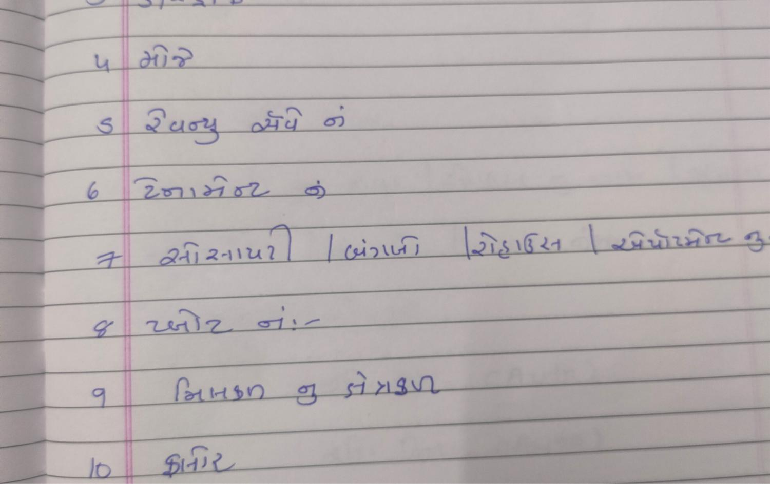

5]ZFJFGL 5FK/GL AFH]JFZM OM8M
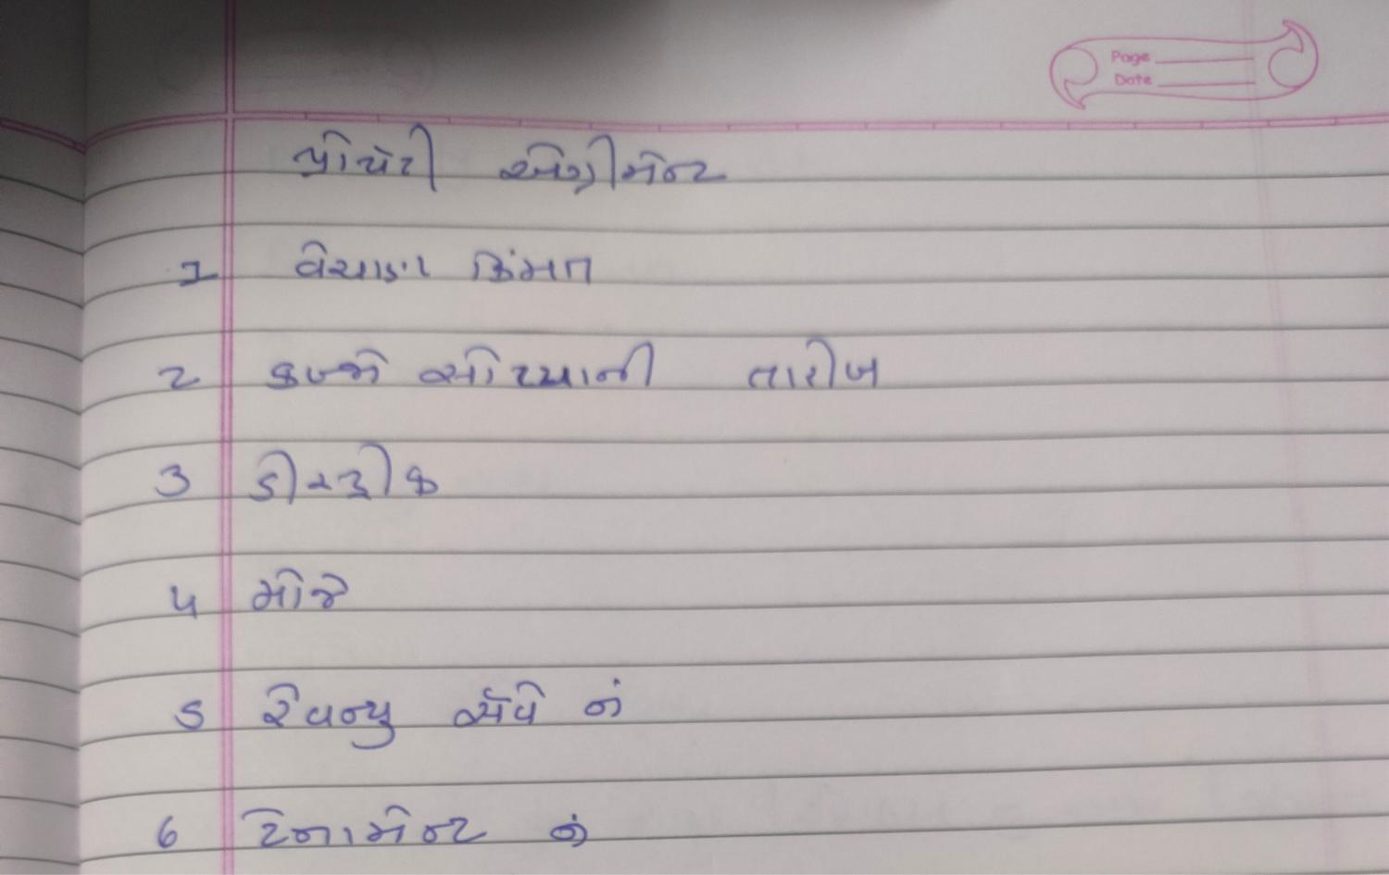

VF SAHF JUZGM ;F8FBFT SZFZ ,BL VF5GFZ T[ ALHF 51FGF sJ[RGFZf

5]ZFJFGL VFU/GL AFH]JFZM OM8M


5]ZFJFGL 5FK/GL AFH]JFZM OM8M
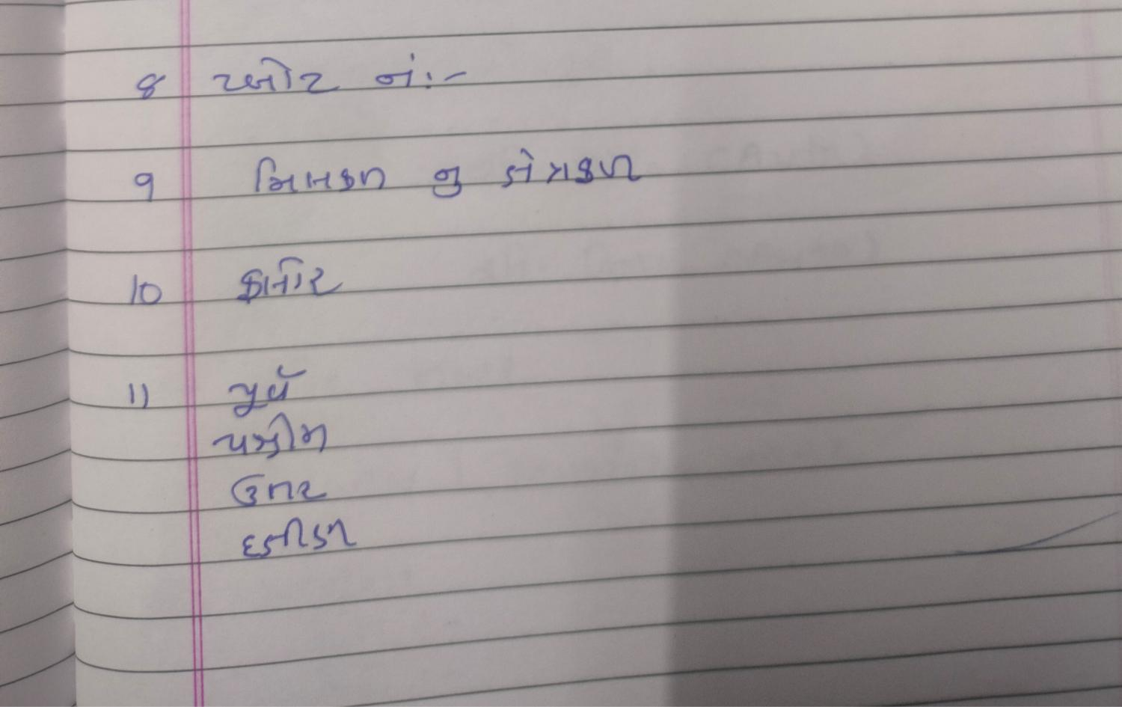

s!f VF SAHF JUZGM ;F8FBFT SZFZ ,BFJL ,[GFZ T[ 5C[,F 51FGF sBZLNGFZf

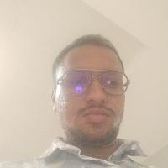

;CL 
GFD o PRAJAPATI KEHUL PRAHLADBHAI

sZf VF SAHF JUZGM ;F8FBFT SZFZ ,BL VF5GFZ T[ ALHF 51FGF sJ[RGFZf



;CL 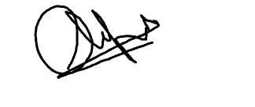
GFD o Prajapati Chirag Prahaladbhai

;F1FL oov
s!f GFD o Parthavi | DMAF., G\AZo 7069593361
sZf GFD o | DMAF., G\AZo

5|D]BqN,F,q A|MSZq DwIYLG\] GFD sHM CMI TMf
s!f GFD o | DMAF., G\AZo

