

**入侵检测与数字取证**

**黄雨卓 57117205**

**LAB2**

2020年9月5日

Buffer Overflow Vulnerability Lab

Task1

2.1Turning Off Countermeasures

地址空间随机化，StackGuard保护方案，不可执行的堆栈。



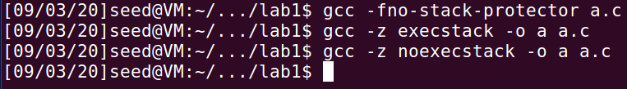



2.2Running Shellcode

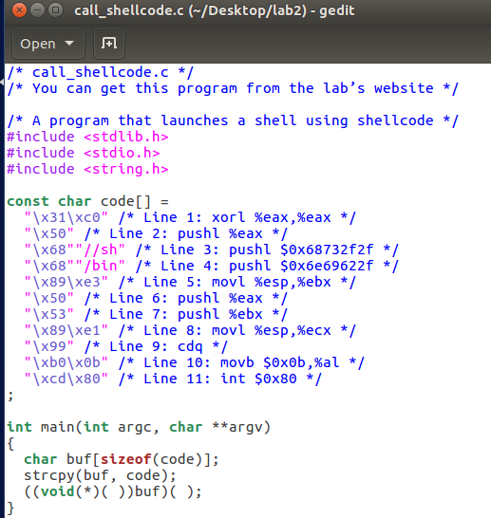

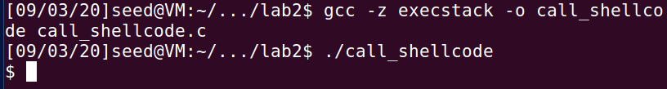

2.3 The Vulnerable Program

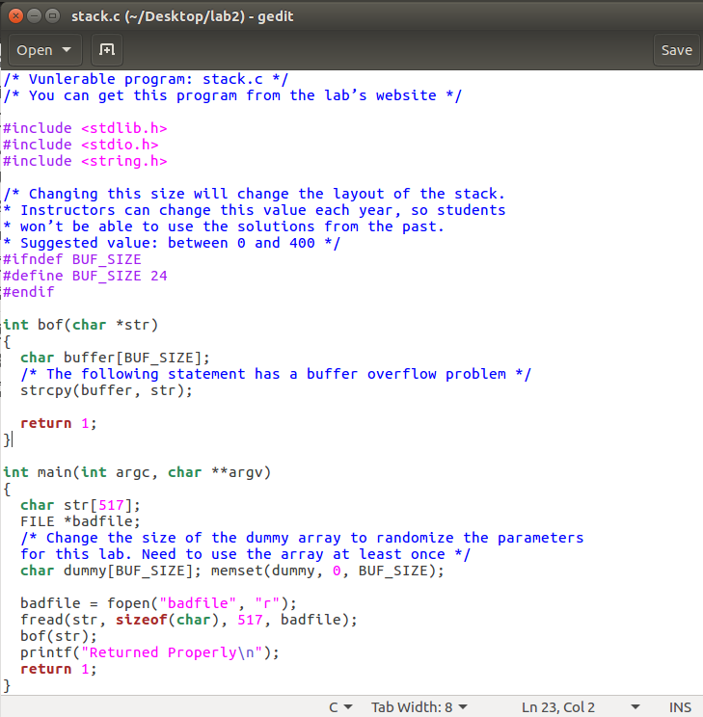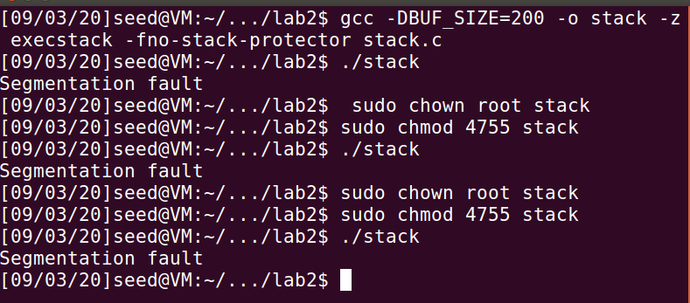

Task 2

2.4 Exploiting the Vulnerability

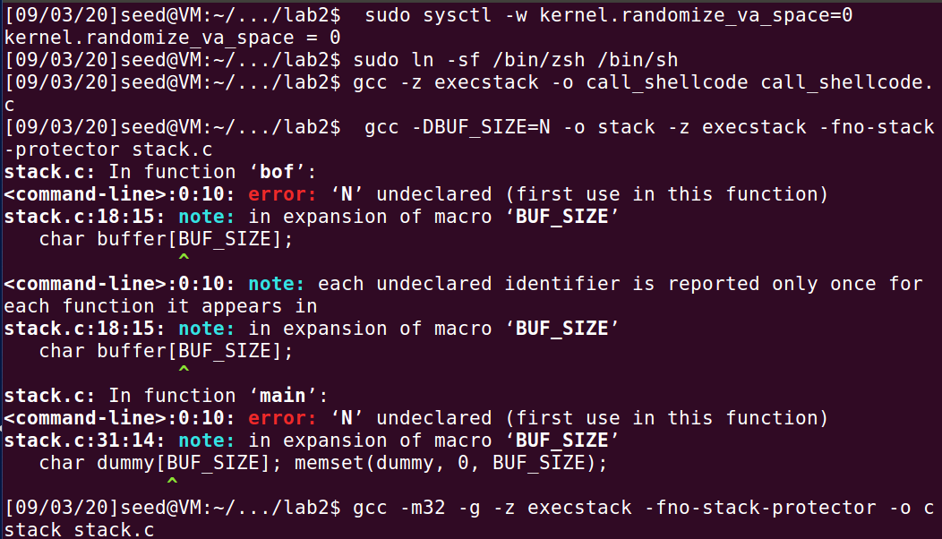

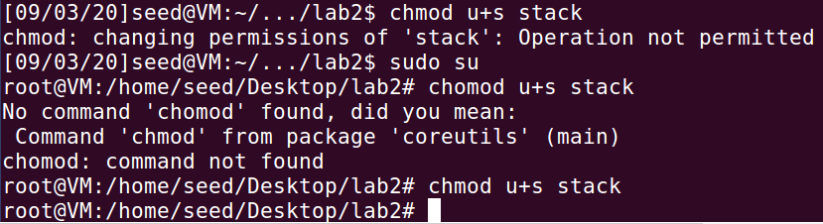

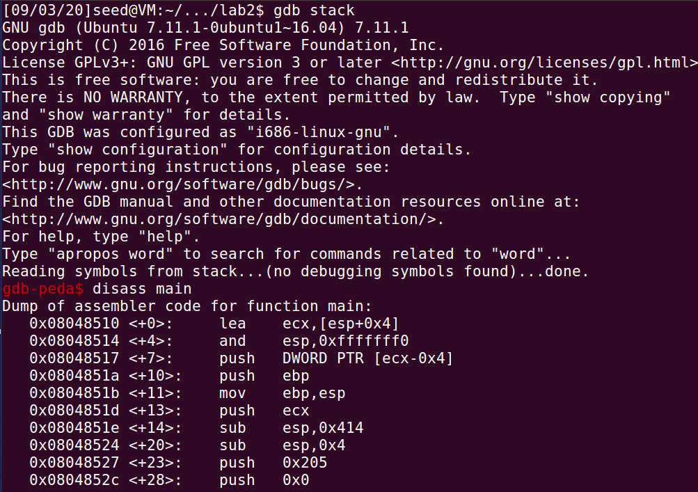



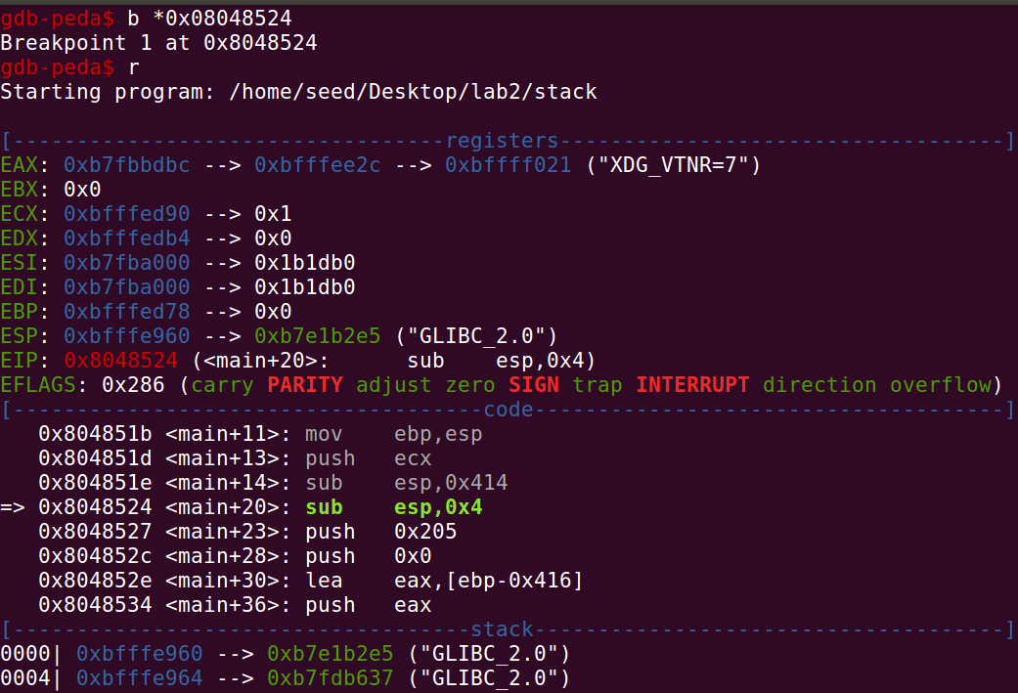

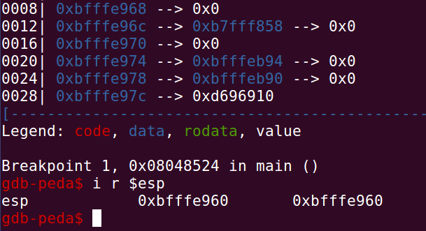

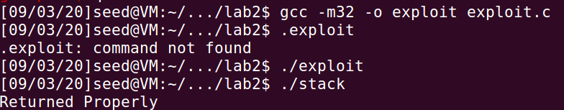

Task 3

2.5 Defeating dash’s Countermeasure



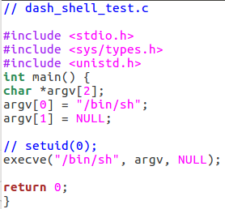注销掉setuid(0)，发现可以绕过：

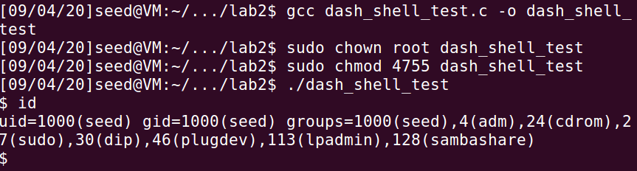

取消注销再次运行：可以绕过

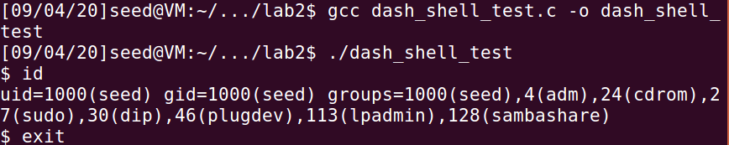

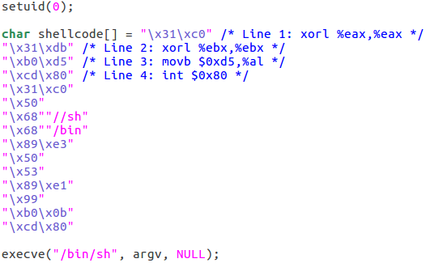

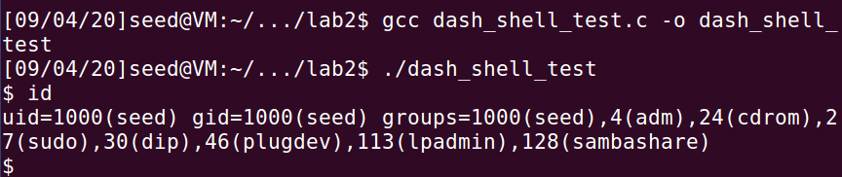

Task 4

2.6 Defeating Address Randomization

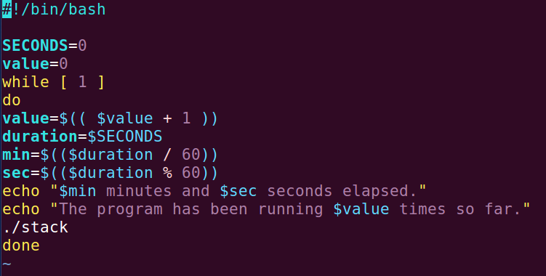

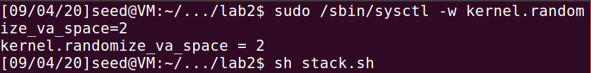

攻击失败

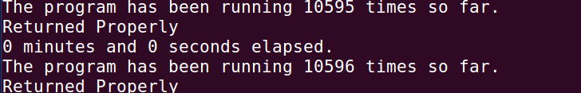

Task 5

2.7 Turn on the Stack Guard Protection

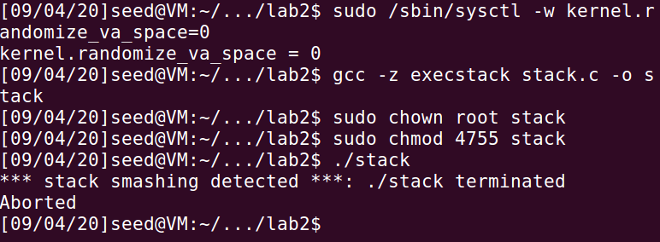

Task 6

2.8 Turn on the Non-executable Stack Protection

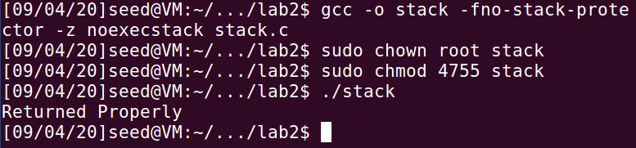

Return-to-libc Attack Lab

Task1

2.3 Finding out thead dresses of libc functions

Turning off counter measures

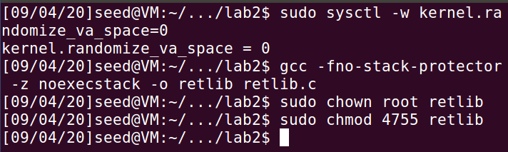

The Vulnerable Program

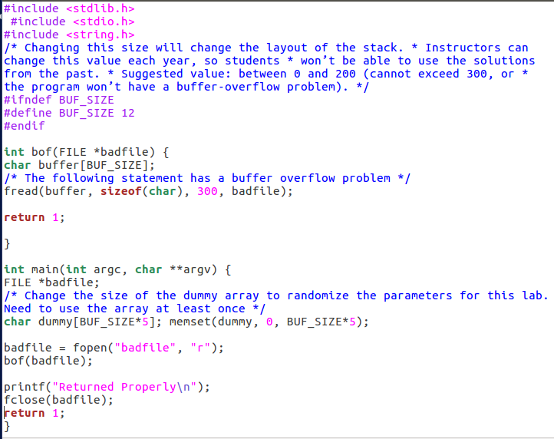

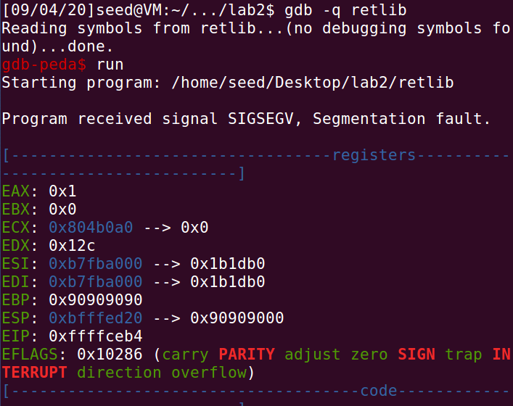

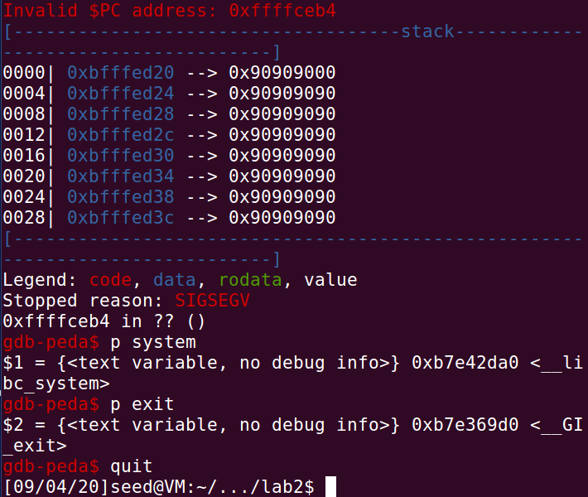

Task2

2.4 Putting the shell string in the memory

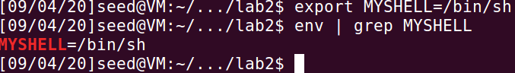

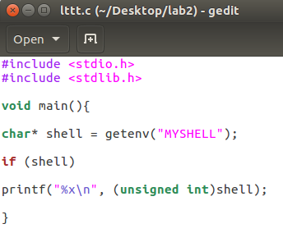

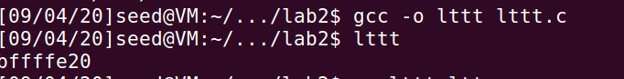

Task3

2.5 Exploiting the buffer-overﬂow vulnerability

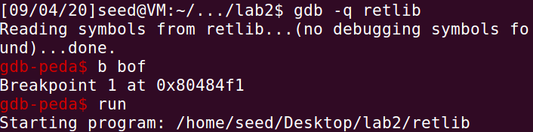

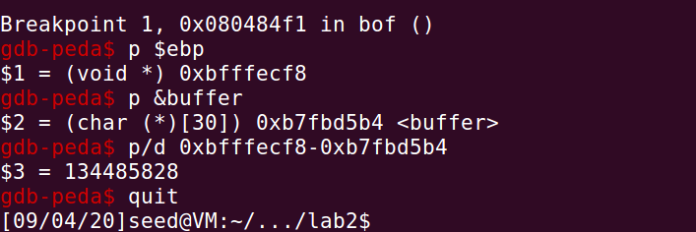

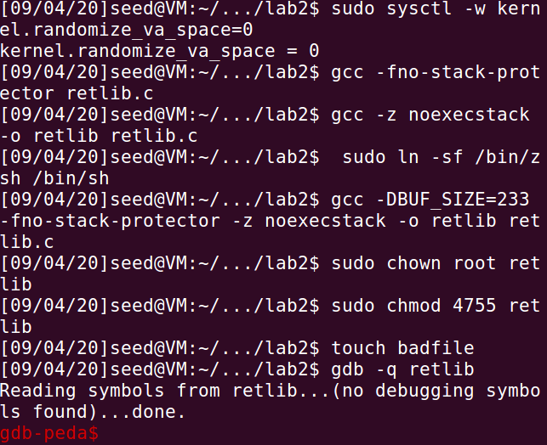

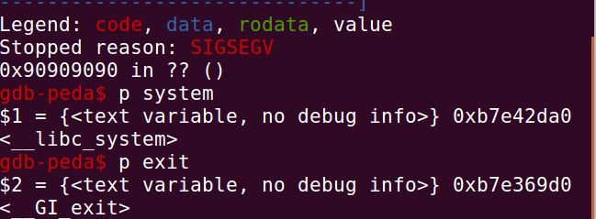

Task4

2.6 Turning on address randomization

报错，段错误

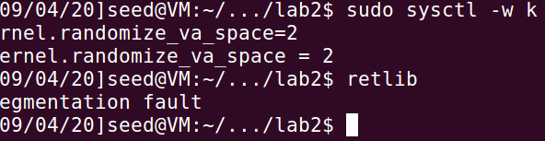

Task5

2.7 Defeat Shell’s counter measure

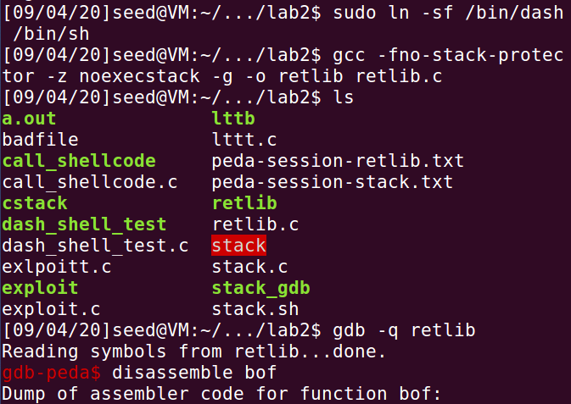

Task6

2.8 Defeat Shell’s counter measure without putting zeros in input

