安徽省2008年初中毕业学业考试
英 语
(满分150分，考试时间120分钟)

第一部分 听力
Ⅰ．关键词语选择
你将听到五个句子。请在每小题所给的A、B、C三个选项中选出你所听到的单词或短语。每个句子读两遍。
1．A．nice B．nine C．night
2．A．beside B．before C．behind
3．A．love B．lose C．luck
4．A．drum B．dream C．drink
5．A．set up B．pick up C．put up
Ⅱ．短对话理解
你将听到十段对话，每段对话后有一个小题。请在每小题所给的A、B、C三个选项中选出最佳选项。每段对话读两遍。
6． What would the man like?
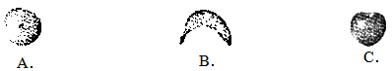
7． What are they talking about?
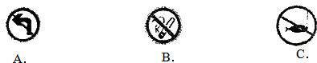
8． How will they go to the supermarket?
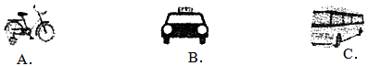
9． What sport is the man going to play this afternoon?
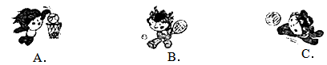
10． What will the weather be like this weekend?
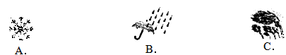
11． What time is it now?
A．9:30. | B．10:30. | C．11:30.
12． How was it going with Jack last week?
A．He was busy. | B．He was tired. | C．He was bored.
13． What's the matter with the man?
A．He's got a fever.
B．He's got a headache.
C．He's got a bad cold.
14． Who is the boy waiting for?
A．His mother. | B．His father. | C．His brother.
15． Where does the conversation probably take place?
A．At home. | B．On the street. | C．In a shop.
Ⅲ．长对话理解
你将听到两段对话，每段对话后有几个小题。请在每小题所给的A、B、C三个选项中选出最佳选项。每段对话读两遍。
听下面一段对话，回答第16，17题。
16． Why is Sam so excited?
A．Because he will go to dinner with his friends.
B．Because his parents will take him to Hong Kong for a trip.
C．Because he has got two free tickets for the concert tonight.
17． When are they going to leave?
A．On June 29. | B．On July 19. | C．On July 29.
听下面一段对话，回答第18至20题。
18． Who will give them a talk?
A．A famous art teacher.
B．A famous writer.
C．A famous manager.
19． When will the talk take place?
A．On Saturday night.
B．On Sunday afternoon.
C．On Saturday afternoon.
20． Where will they listen to the talk?
A．In the 1st meeting hall.
B．In the 2nd meeting hall.
C．In the 3rd meeting hall.
Ⅳ．短文理解
你将听到一篇短文，短文后有五个问题。请根据短文内容，在每小题所给的A、B、C三个选项中选出最佳选项。短文读两遍。
21． What is Mrs. Smith?
A．A doctor.
B．A school teacher.
C．A businesswoman.
22． Why does she feel unhappy?
A．Because she gets sick easily.
B．Because she can't drink or smoke.
C．Because she doesn't make a lot of money.
23． What was the man doing when Mrs. Smith saw him?
A．Drinking wine.
B．Lying in a chair.
C．Dancing to the music.
24． What does the man do every day?
A．He drinks little.
B．He does exercise.
C．He smokes a lot.
25． How old is the man?
A．29. | B．59. | C．69.
Ⅴ．信息转换
你将听到一篇短文。请根据短文内容，写出下面表格中所缺的单词，每空仅填一词。短文读两遍。
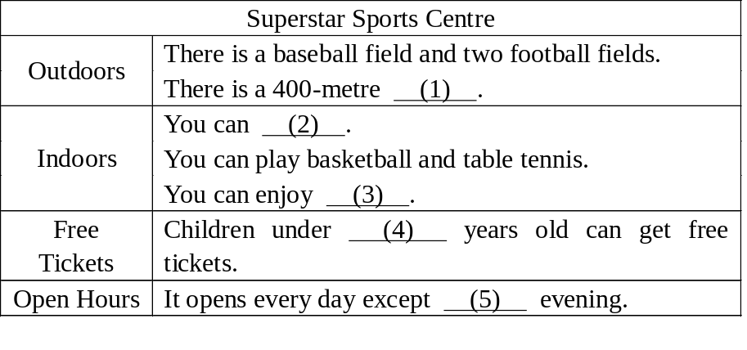
第二部分 英语知识运用(共3大题，满分55分)
Ⅵ．单项填空(共20小题；每小题1分，满分20分)
从每小题所给的A、B、C、D四个选项中选出可以填人空白处的最佳选项。
31．A lot of story books are on sale，but ________ good ones．
A．any B．some C．few D．many
32．—Is Mr. Brown driving here?
—I’m not sure．He ________ come by train．
A．may B．shall C．need D．must
33．—Our team ________ the match．We’ve got the first place!
—Well done! Congratulations!
A．hit B．beat C．won D．watched
34．The music made me think of the ________ of a running stream．
A．shout B．noise C．voice D．sound
35．—I’m really ________ before the competition．
—Take it easy．Sure you are the best．
A．cool B．serious C．nervous D．patient
36．—Kate，do you know ________ it is from here to the gym?
—About twenty-minutes’ walk．
A．how long B．how far C．how soon D．how often
37．—Jack．how are you feeling today?
—Much ________．I think I can go to school tomorrow．
A．better B．worse C．brighter D．weaker
38．I didn’t know ________ they could pass the exam or not．
A．why B．when C．that D．whether
39．—English is ________ too difficult for me．I can’t learn it well．
—Don’t give up．Nothing is difficult if you work hard．
A．seldom B．never C．always D．usually
40．—What do you often do ________ classes to relax yourself?
—Listen to music．
A．over B．among C．between D．through
41．—I called you just now，but nobody answered．Where ________?
—I was out with my mother．
A．were you B．are you C．have you gone D．have you been
42．—Let’s plan a surprise for our class．What’s your idea?
—Why not ________ a short play?
A．get on B．keep on C．have on D．put on
43．—Excuse me，sir．Do you have the time?
—________.
A．Yes，I do B．No problem C．Half past twelve D．Certainly，I have
44．The dress ________ smooth and soft．
A．felt B．feels C．is felt D．is feeling
45．—Who is singing in the next room?
—________ must be Marie．
A．It B．She C．This D．There
46．—Give my best wishes to your parents．
—________!
A．It’s OK B．It’s great C．That’s all right D．That’s nice of you
47．—Hurry up．The bus is coming．
—Wait a minute．Don’t cross the street ________ the traffic lights are green．
A．after B．until C．while D．since
48．—Could you tell me what time the train leaves Herei for Beijing?
—I’m afraid you need to ________ on the Internet．
A．look for it B．look at it C．look it over D．look it up
49．When you leave the room，make sure the door ________．
A．was locked B．is locked C．will be locked D．should be locked
50．—I’ve never had such a wonderful time．Thank you for asking me．
—________.
A．Good job B．That’s it C．That’s right D．You’re welcome
Ⅶ．完形填空(共20小题；每小题1.5分。满分30分)
阅读下列短文，从每小题所给的A、B、C、D四个选项中选出最佳选项。
A
Today it is quite natural to find people shake hands in some situations．People all over the world shake hands for many different 51 ．We shake hands when we meet new people 52 during special festivals．Players often shake hands before or after 53 ．Business people shake hands when they make a deal．
Why do people shake hands 54 shaking feet? This is because of the fact that a long time ago most people 55 knives or guns．If some of them decided that they did not want to 56 ，they show their empty hands． 57 people shook hands so that they could not 58 knives in their sleeves(袖子). Later on，handshaking became a symbol of 59 .
Now we don’t have to 60 people with guns or knives．However，we still shake hands all the time! The reason is simple—it is still a way to show friendship．
51．A．ideas B．reasons C．thoughts D．excuses
52．A．or B．as C．but D．so
53．A．games B．speeches C．exercises D．programmes
54．A．such as B．as well as C．instead of D．together with
55．A．lost B．bought C．caught D．carried
56．A．cheat B．fight C．drop D．speak
57．A．Perhaps B．Happily C．Carefully D．Luckily
58．A．hide B．lift C．pull D．push
59．A．success B．victory C．pride D．peace
60．A．talk about B．worry about C．know about D．learn about

B
I finished my cooking course in a college at, the age of 21．I thought I was going to 61 a world famous cook．I hoped people would travel from all over the world just to get a 62 of my food．But three months later，I knew I was 63 Since nobody was traveling to taste my food．I decided I should travel to taste theirs．
64 my travel，I visited many different countries，such as Japan and France，where different kinds of food 65 my eyes．I especially loved the experiences in Italy and China.
When in Italy．I learned how to 66 pizza and salads．We had long lazy lunches in the sun and evening meals where the 67 went on long into the night．
In China，I loved the hot Sichuan food and 68 the delicious Beijing snacks(小吃)．I also discovered the joys of making dumplings with good friends...
My year of travel came to an end all too 69 ，but I had decided what I should do for the 70 of my life．I want to bring the fantastic food of the world into my kitchen in New York．
61．A．invite B．become C．follow D．remember
62．A．smell B．sight C．taste D．feeling
63．A．free B．right C．wrong D．angry
64．A．After B．Until C．Beyond D．During
65．A．covered B．opened C．closed D．wounded
66．A．try B．send C．make D．show
67．A．films B．stories C．introductions D．conversations
68．A．enjoyed B．served C．offered D．fetched
69．A．slowly B．easily C．quickly D．suddenly
70．A．rest B．part C．half D．quarter
Ⅶ．补全对话(共5小题：每小题1分，满分5分)
根据对话内容，从方框内的选项中选出能填人空白处的最佳选项。选项中有两项为多余选项。
Dave：What’s the problem?
Ricky：Oh，just my parents． 71
Dave：What about?
Ricky：The TV．My mom and dad can’t agree． 72
Dave：So does your dad like sports programmes?
Ricky：Yes，he does． 73 She loves movies．
Dave： 74
Ricky：No．He thinks they are boring．
Dave： 75
Ricky：Yes，they do．
Dave：What?
Ricky：Fighting!

A．Do they both like anything?
B．What does your mom 1ike?
C．They’re always fighting．
D．But my mom hates sports programmes．
E．They both like movies．
F．They like different things．
G．Does your dad 1ike movies?

第三部分 阅读理解(满分40分)
Ⅸ．阅读理解(共20小题；每小题2分，满分40分)
阅读下列短文，从每小题所给的A、B、C、D四个选项中选出最佳选项。
A
This August，we’ll welcome guests from all over the world．Some of them follow their own special cultural traditions．It’s important for us to know about them．
◆In many countries，such as Thailand，India and Malaysia，people believe that the left hand is unclean．So，it’s not proper to use one’s left hand to hold food，touch others or pass objects．Doing so may offend certain guests．
◆Some Westerners may be offended if yon touch them or their personal things—even by accident．If this happens，say sorry politely．
◆Some elderly Westerners may be offended if you try to help them without their agreement．
◆People think numbers can be lucky or unlucky．Some Westerners avoid the number 13 because they believe it is unlucky．
◆Muslims(穆斯林) do not eat pork，and words like pigs are not considered proper．
◆People from Brazil，Italy and Pakistan do not give handkerchiefs(手帕) as gifts．They believe a handkerchief is closely connected with unhappy feelings．
◆wine is not sent as a gift in many parts of western and middle Asia，where most Muslims live．
76．Indians don’t hold food with the left hand because they consider it ________．
A．unclean B．useless C．valueless D．unimportant
77．The word“offend”in the second paragraph(段落)might mean“________”．
A．honor B．help C．hate D．hurt
78．Muslims do not ________．
A．send gifts B．eat pork C．drink milk D．use handkerchiefs
79．Which of the following is true according to the passage?
A．People from Pakistan like to send handkerchiefs as gifts．
B．All the elderly people in the west like being helped by others．
C．The number 13 is thought to be unlucky by some Westerners．
D．Westerners do not mind their personal things being touched．
80．What does the passage mainly talk about?
A．Lucky numbers． B．Traditional food．
C．Culture differences． D．Hands and handkerchiefs．
B
Do you know how Americans spend their vacations? Maybe the following two advertisements will give you a better understanding．(注释：1．accommodation食宿 2．equipment设备)
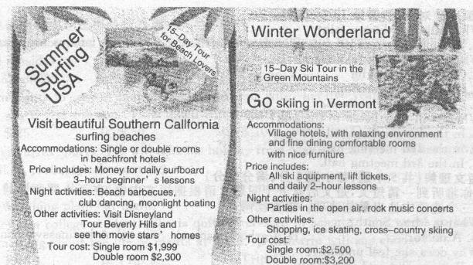
81．Which of the activities can you do at night?
A．Visit Disneyland． B．Skate on the ice．
C．Enjoy rock music． D．See the movie stars’ homes．
82．If you like skiing，you can choose to stay ________ to enjoy your vacation．
A．in a beachfront hotel B．in fl village hotel
C．only in a single room D．only in a double room
83．Going to ________ is beach lovers’ best choice for summer vacation．
A．Vermont B．Green Mountains
C．Northern California D．Southern California
84. I It will take you ________ to enjoy your vacation either in the green mountains or on the beaches．
A．one week B．one month C．half a week D．half a month
85．Which of the following does the price of both tours include?
A．Lessons． B．Lift tickets， C．Daily surfboard． D．Ski equipment．
C
You may hear about earthquakes，but do you know what to do before，during and after an earthquake? Here is some advice for you：
Before an earthquake It’s necessary to prepare yourself and your family．All family members should know how to turn off gas，water and electricity and know useful telephone numbers(doctor，hospital，police，119，etc．)．Never put heavy things over beds．
During an earthquake It’s important for each of you to stay calm(冷静)．If you are indoors，quickly move to a safe place in the room such as under a strong desk or a strong table．The purpose is to protect yourself from failing objects．Stay away from windows，large mirrors，heavy furniture and so on．If you are cooking，turn off the gas．
If you are outdoors，move to an open area like a playground．Move away from buildings，bridges and trees. If you are driving，stop the car as soon as possible，staying away from bridges and tall buildings．Stay in your car．
After an earthquake Once the shaking has stopped，DO NOT run out of the building at once．It’s better to wait and leave when it is safe．
Check around you and help the people who are in trouble．If your building is badly broken you should leave it．If you smell or hear a gas，get everyone outside and open windows and doors．If you can do it safely，turn off the gas．Report it to the gas company．
86．Which of the following is mentioned in the second paragraph?
A．People should know how to turn on gas．
B．People should know how to save water．
C．People shouldn’t put heavy boxes over beds．
D．People shouldn’t forget the phone numbers of others．
87．When an earthquake happens，________ can help you deal with it．
A．standing still B．staying calm
C．100king outside D．moving indoors
88．During an earthquake，if you are driving in an open area，you should ________．
A．speed up your car B．stop your car and stay in
C．slow down your car D．stop your car and run out
89．When the earth stops shaking，you should ________．
A．check around you first B．run out of the building at once
C．break the windows and doors D．write a report to your company
90．You can learn ________ after reading the passage．
A．what an earthquake is like B．what to do to avoid an earthquake
C．how an earthquake happens D．how to protect yourself in an earthquake
D
Once fl small boy lived on a farm which seemed so far away from everywhere．
He needed to get up before sunrise every morning to help his father on the farm．During sunrise he would take a break and climb up on the fence(篱笆) along the side of the farm．He could see a house with golden windows．“If they could afford golden windows，then there must be other nice things inside the house．”He imagined how great it would be to live there．Then he promised himself．“Some day I will go there and see this wonderful place．”
One morning，his father would go to the town and told him to stay at home for a rest．Knowing that this was his chance。he took a sandwich and headed across the field towards the house with the golden windows．
As the afternoon went on，he began to realize how wrong he was．The house was much farther than he had expected．As he went near the house，he saw no golden windows but instead a place in bad need of a painting．A small girl very close to his age came out of the poor house and stood by the broken fence．He asked her if she had seen the house with the golden windows．The girl said，“Sure，I know．”and invited him to sit on the porch(门廊)．As he sat there，he looked back from where he just came．There he saw the sunset(夕阳) turned the windows of his house to gold! Now he understood that everyone had his own house with golden windows．
91．During his break every morning，the small boy would ________．
A．fix the fence B．eat sandwiches
C．climb up on the fence D．walk around the farm
92．One morning，when knowing he would stay alone．the boy thought it was a chance for him to ________．
A．go to the town B．play on the field
C．go to see the house D．make the golden windows
93．What did the boy find when he got there?
A．Nobody lived in the poor house．
B．No golden windows were in the house．
C．The house was as old as he expected．
D．The house was nearer than he thought．
94．The story tells us that people sometimes may have the thought“________”．
A．Like father，like son B．Love me，love my dog
C．Every dog has its day D．The grass is greener somewhere else
95．Which is the best title(标题) for the passage?
A．Golden Windows B．Father and Son
C．A Wonderful Place D．A Boy’s Promise
第四部分 写(共2大题，满分25分)
X．单词拼写(共5小题；每小题1分，满分5分)
根据首字母及汉语提示，完成下列单词的拼写，使句意明确，语言通顺。
96．Our government has made several l (法律) to protect children．
97．It’s not right to w (浪费) too much time on computer games．
98．Today David is a (缺席) from school because he is ill．
99．G (猜测) games are popular with students in English class．
100．Mom often tells Linda not to talk to a s (陌生人)．

Ⅺ．书面表达(满分20分)
一个美国中学生代表团将到你校交流学习，并与你校学生座谈。请根据表格中的内容写一个发言稿，介绍你校学生开展小组合作学习和自主学习的情况。

小组合作学习 | 自主学习
·互相帮助  ·学会倾听  ·与他人合作  ·发表个人见解  …… | ·制订学习计划  ·合理安排时间  ·独立思考  ·做学习的主人  ……

注意：1．词数100左右；
2．可适当发挥，加入自己的观点；
3．发言稿的开头和结尾已为你写好，但不计入总词数。
参考词汇：study in groups，work together，make good use of time
Dear friends，
Welcome to our school．_______________________________________________________________
________________________________________________________________________________________
Thanks for listening!

参考答案
一、听力
1．A 2．A 3．C 4．B 5．B 6．A 7．B 8．C 9．C 10．B
11．A 12．A 13．C 14．B 15．B 16．B 17．C 18．A
19．C 20．B 21．C 22．A 23．B 24．C 25．A
(1) playground (2) skate (3) swimming (4) 8/eight (5) Monday

二、英语知识运用
31．C 32．A 33．C 34．D 35．C 36．B 37．A 38．D 39．C 40．C
41．A 42．D 43．C 44．B 45．A 46．D 47．B 48．D 49．B 50．D
51．B 52．A 53．A 54．C 55．D 56．B 57．A 58．A 59．D 60．B
61．B 62．C 63．C 64．D 65．B 66．C 67．D 68．A 69．C 70．A
71．C 72．F 73．D 74．G 75．A 76．A 77．B 78．B 79．C 80．C
81．C 82．B 83．D 84．D 85．A 86．C 87．B 88．B 89．A 90．D
91．C 92．C 93．B 94．D 95．A
96．laws 97．waste 98．absent 99．Guessing/Guess
100．stranger

One possible version
Dear friend,
Welcome to our school. I would like to talk about two ways of study in our school. The first way is to study in groups. When we study in groups, we can help each other. We can learn to listen to others and how to work together. Also, everyone can have chances to express his own ideas. The other way we like is to study by ourselves. We can make our own plans for study and learn to make good use of time. We can also learn to think by ourselves. And the most important thing is that we can be the master of our own study.
Thank you for listening.

