2011年安徽省初中毕业学业考试
英 语

第一部分 听力（共五大题，满分30分）
Ⅰ. 关键词语选择（共五小题；每小题1分，满分5分）
你将听到五个句子。请在每小题所给的A、B、C三个选项中选出一个你所听到的单词或短语。每个句子读两遍。
1. A. lift B. list C. license
2. A. step B. stop C. stamp
3. A. fair B. fear C. fire
4. A. moving B. mending C. matching
5. A. take up B. make up C. look up
Ⅱ. 短对话理解（共10小题；每小题1分，满分10分）
你将听到十段对话，每段对话后有一个小题。请在每小题所给的A、B、C三个选项中选出一个最佳选项。每段对话读两遍。
6. How is the man feeling?
A . B.  C. 
7. What did the man buy yesterday?
A. 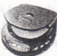 B. 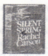 C. 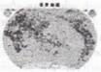
8. What is the sign?
A.  B. 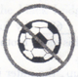 C. 
9. What’s the weather like tomorrow?
A.  B. 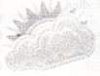 C. 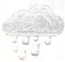
10. What was the man doing?
A. 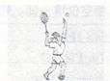 B. 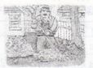 C. 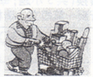
11. What time does the man want to meet?
A. At 2 pm. B. At 3 pm. C. At 3:30 pm.
12. How often does the man have the general health check-up?
A. Once a year. B. Twice a year. C. Every two years.
13. What’s today’s special in the restaurant?
A. Smoked beef. B. Smoked fish. C. Smoked chicken.
14. What does the man want to be?
A. A dentist. B. A reporter. C. A writer.
15. How does the man like the book?
A. Boring. B. Terrible. C. Great.
Ⅲ. 长对话理解（共5小题；每小题1分，满分5分）
你将听到两段对话，每段对话后有几个小题。请在每小题所给的A、B、C三个选项中选出一个最佳选项。每段对话读两遍。
听下面一段对话，回答第16至17小题。
16. What is Julia wearing?
A. A hat. B. A scarf. C. A coat.
17. How will they go to the concert?
A. By taxi. B. By bus. C. On foot.
听下面一段对话，回答第18至20小题。
18. Who is making the telephone call?
A. Jeff. B. Sophia. C. Maria.
19. What are they going to do on Friday afternoon?
A. To have a party. B. To have a meeting C. To have an interview.
20. Where will they meet?
A. At Sophia’s home B. Outside the park gate. C. At the gate of the TV Station.
IV.短文理解（共5小题；每小题1分，满分5分）
你将听到一篇短文，短文后有五个小题。请根据短文内容，在每小题所给的A、B、C三个选项中选出一个最佳选项。短文读两遍。
21、What did the man order in the restaurant ?
A. Beer. B. Juice. C. Wine.
22、Why did the man always ask for two glasses ?
A. Because 2 was his lucky number.
B. Because the waiter wanted to do so.
C. Because he didn’t like to drink alone.
23. What happened a few days later ?
A. The man couldn’t afford to drink more.
B. The man’s friend died of drinking too much.
C. The doctor told the man not to drink any more.
24. Who probably had the drink in the end ?
A. The friend. B. The man C. The waiter.
25. How many people appeared in the restaurant ?
A. Two. B. Three C. Four.
V．信息转换（共5小题；每小题1分，满分5分）
你将听到一篇短文。请根据短文内容，写出下面表格中所缺的单词，没空仅填一词。短文读两遍。
A Trip
When | We'll have a trip on 26 17th.
Where | We'll meet on the school 27 .
Why | We can get relaxed and get close to the 28 .
What | We'll pick fruits and 29 animals.
Safety Rule | We can't 30 on our own.

第二部分英语知识运用(共三大题，满分55分)Ⅵ．单项填空(共20小题；每小题1分，满分20分)
从每小题所给的A、B、c、D四个选项中选出一个可以填入空白处的最佳选项。
31. It's not _____ good idea to drive for four hours without_________break.
A. a; a B. a: the C. the; a D. the; the
32. We felt________ when Liu Xiang won the first prize again in the race.
A. brave B. proud C. successful D. worried
33. -- May I go out now. Dad?
-- No. You ______let your mother know first.
A. can B. may C. need D. must
34. -- I'm hungry, ls there any bread in the fridge?
-- ______but we have cakes. Would you like to have one?
A. Some B. Much C. None D. Nothing
35. If you want to go to see the movie this evening, so ______I.
A. do B. am C. will D. should
36. -- I have great_______in learning math and I'm so worried. Could you help me?
-- Sure. I'd be glad to.
A. trouble B. interest C. joy D. fun
37. He promised to pick me up at the school gate. However. he ________yet.
A. didn't arrive B. doesn't an'lye C. isn't arriving D. hasn't arrived
38. My father was preparing for his speech_____my mother was doing some washing last night.
A. if B. while C. unless D. until
39. I can hardly hear what it is saying on TV. Would you please______?
A. turn it up B. turn il down C. turn it on D. turn it off
40. -- l'm always a little nervous when I talk to Mr. Smith.
-- _____ He is strict, but he is kind to his students.
A. That's right B. What a pity C. Take it easy D. Take your time

41. We can't do listening practice today, for Miss Zhao's tape-recorder doesn't________.
A. act 13. do C. serve D. Work
42. I hear our teacher will be back________three weeks' time.
A. at B. in C. for D. After
43. Don't worry. Your package_________here until you come back, so enjoy shopping here.
A. will keep B. has kept C. will be kept D. has been kept
44. Jack is good at drawing. I think no one draws ________.
A. better B. best C. worse D. Worst
45. What a nice day! We should go sightseeing _____ watching TV in the hotel.
A. because of B. instead of C. together with D. out of
46. The food here smells good, but what does it_______like?
A. taste B. touch C. seem D. Feel
47. -- Tony, don't draw on the wall. It isn't a good behavior.
-- _______________
A. Never mind. B. Yes, I'd love to. C. Of course not. D. Sorry, I won't.
48. You'd better take the map with you_________you won't get lost,
A. as long as B. as soon as C. now that D. so that
49. Hey, Nick,____________comes the last bus! Hurry up, or we'll have to walk home.
A. This B. There C. That D. It
50. -- Are you sure you can' do well in tomorrow's test, Lucy?
--__________. I've got everything ready.
A. It's hard to say B. I'm afraid not C. I think so D. I hope not
完形填空(共20小题；每小题1．5分，满分30分)阅读下列短文，从每小题所给的A、B、c、D四个选项中选出一个最佳选项。
A
Mr. Black loved his daughter Helen very much. Every day he spent all of his free time 51 with her. One night, he had much work to do, 52 couldn't play with his daughter. In order to keep her 53 , he found a map of the world in a magazine and cut it into pieces. When he 54 , Helen. camerunning to him and was ready to play. Mr. Black said he had
55 time to play fight now. He told the girl to put the pieces of paper back together to a map of the world, and then they could both play.
About half an hour later, Helen came to her father and said, "Okay, it's finished. Can we play now? " Mr. Black was surprised , saying, "That's 56 . Let's go and see. " And sure enough, there was the picture of the world; all put together, every 57 in its place.
Mr. Black said, "That's surprising! 58 did you do that?" Helen said, "It was 59 . On the back of the page was a picture of a 60 .When I put the man together, the whole world fell into place. "
51. A. working B. running C. playing D. walking
52. A. or B. and C. but D, then
53. A. sleepy B. warm C. free D, busy
54. A. left home B. got home C. let the office D. got to the office
55. A. no B. enough C. much D. some
56. A. right B. wrong C. possible D. impossible
57. A. map B. picture C. piece D. page
58. A. How B. Why C. When D. Where
59. A. hard B. simple C. difficult D. different
60. A. boy B. girl C. man D. woman
B
Three small "fish lived in the sea. When they were very young, their parents died. They had to 61 each other day after day. Finally, they grew up and 62 to swim deeper and further.
One morning, the three fish were 63 to a shallow (浅) water by a big wave (浪). A small boat was taken there, too. It was hard for the fish to go back to the sea because the boat was fight in front of them. The largest fish realised that they were 64 , and said they had to find a way to leave there as fast as possible. The second largest fish 65 with his elder brother, but the youngest one did not. He said that there was much 66 for their activities, so he would not worry at all and still swam around 67 .
At last, the largest fish returned to the 68 by jumping over the lowestpart of t-he boat. The second largest fish also succeeded in 69 his eider brother in the other side of water. But the youngest one didn't follow them and still swam joyfully.
Two hours later, when the 70 rose up, the water in the small shallow corner dried up. The fish who did not try to return to the sea died of lack(缺乏)of water.
61. A. listen to B. look after C. talk with D. worry about
62. A. dared B. hated C. refused D.stopped
63. A. allowed B. given C. invited D. taken
64. A. in safety B. in doubt C. in danger D. in peace
- A. agreed B. talked C. compared D. Discussed
- A. time B. food C. water D. Air
- A. slowly B. sadly C. luckily D. Happily
- A. sea B. river C. lake D. Pond
- A. catching B. joining C. taking D. Telling
70. A. storm B. stars C. moon D. sun
补全对话(共5小题；每小题1分。满分5分)根据对话内容。从方框内的选项中选出能填入空白处的最佳洗项．其中有两个为多余选项．
A: Hey, Gina. Do you want some ice cream?
B : No, thanks. 71
A: Really? Where are you going?
B: I'm going to play baseball. Do you want to come?
A: Sorry, I can't. 72
B : Well, come later then. We're playing all afternoon.
A: 73 But I'm not very good at baseball.
B : Don't worry about that. 74 You can just watch
Come on, it'll be fun.
A: Well, OK. 75
B: OK. See you!
A．It sounds nice．
B．See you later．
C．I need to studv．
D．I'm going out．
E．I don't think so．
F．You don't have to play．
G．You can do that again．

第三部分阅读理解(共一大题，满分40分)阅读理解(共20小题；每小题2分。满分40分)阅读下列短文，从每小题所给的A、B、C、D四个选项中选出一个最佳选项。
A
What is your favorite color? Do you like yellow, orange, or red? If you do, you must be an active person who enjoys life. Do you like blue? Then you are probably quiet, shy, and would rather follow than lead.
Colors do influence our moods (情绪). A yellow room makes most people feel more cheerful and more relaxed than a dark green one; and a red dress brings warmth and cheer to the saddest winter day. On the other hand, black is depressing(令人压抑的). There was a black bridge over the Thames River, near London. The number of people who killed themselves on that bridge used to be larger than on any other bridge in the area -- until it was repainted green.
Light and bright colors make people not only happier but also more active. In the factory, the workers will work better, harder, and have fewer accidents when their machines are painted orange rather than black.
76. An active person may like_______________.
A. yellow, orange, or red B. yellow, black, or red
C. orange, blue, or black D. black, red, or orange
77. Most people feel more_______in a yellow room than in a dark green one.
A. tired B. bored C. worried D. relaxed
78. More people killed themselves on the black bridge than on any other bridge probably because ____
A. the bridge was very tall B. the bridge was too crowded
C. people didn't like the bridge D. the color of the bridge was depressing
79. In the factory, when the machines are painted orange, the workers will work ______.
A. worse B. harder C. more slowly D. more angrily
80. Which could be the best title for the passage?
A. Cheerful Colors B. Your Favorite Color
C. The Secret of Color D. The Color of a Bridge

B
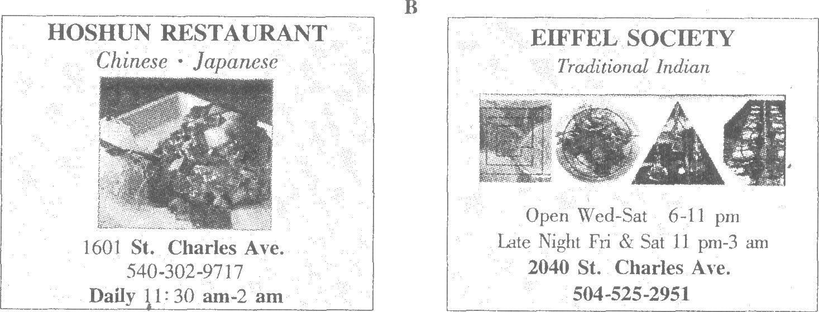

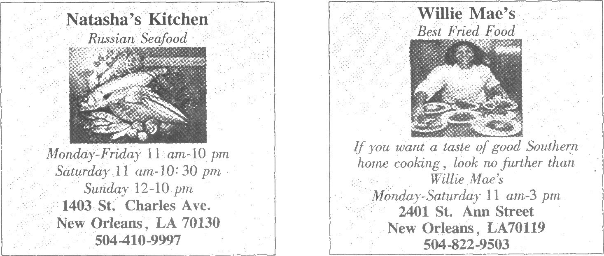
81. If you want to eat some seafood, you can go to _____.
A. Willie Mae's B. Natasha's Kitchen
C. EIFFEL SOCIETY D. HOSHUN RESTAURANT
82. You can call___________if you want to have a taste of Southern home cooking.
A. 540-302-9717 B. 504-525-2951 C. 504-410-9997 D. 504-822-9503
83. You can eat some ________food in EIFFEL SOCIETY.
A. Indian B. Russian C. Chinese D. Japanese
84. The latest business hour lasts until______among the four restaurants.
A. 2am B. 3 am C. 3 pm D. lO:30pm
85. You can have ______choices if you want to have dinner at 6 pm on Saturday Evening.
A. one B. two C. three D. four
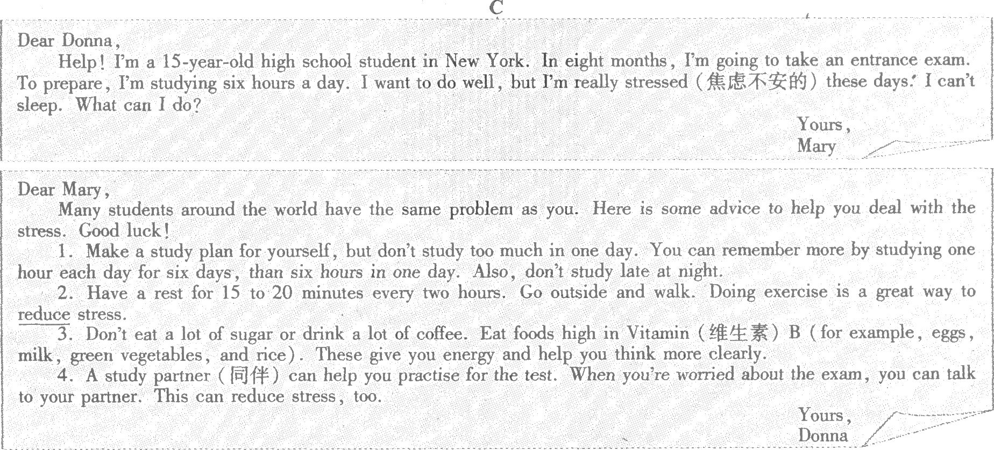
86. What is Mary's problem?
A. Sh.e is so worried and can't sleep. B. She can't pass the exam.
C. She can't communicate with others. D. She can't study English well.
87. Donna thinks Mary's problem is ______.
A. great B. common C. wonderful D. serious
88. The word "reduce" in the passage probably means"________".
A. 减少 B. 排除 C. 加强 D. 增加
89. Donna thinks that__________can help Mary think more clearly.
A. eating a lot of sugar B. studying six hours every day
C. drinking a lot of coffee D. eating foods high in Vitamin B
90. Which of the following is TRUE according to Donna's letter?
A. The best time to study is from 10 pm to 1 am.
B. Walking outside can make you remember more.
C. It's good to tell a study partner about your feeling.
D. It's necessary to have a rest for 15 to 20 minutes an hour.

D
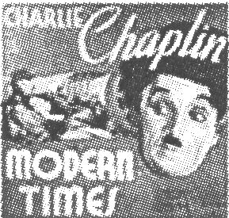
Charles Chaplin was born in London on April 16, 1889. His parents were music hall actors. The Chaplin family were very poor, and life was difficult in London. Charlie, as he was called, used to do his mother's job in the theatre when she was ill.
When he was only 17 years old, Chaplin got his first real job as an actor. What he did was to do silly things to make people laugh in the theatre. Seven years later he went to the USA. And over the next four years, he formed his own way of art. He developed the character (~J ~, )of a homeless gentleman which became very popular.
From the 1920s to the 1950s, Chaplin made his most famous films. The film Modern Times (1936) shows his care about the modern industry workers. Many of his films describe the poor life and hard time of the working people during that period.
Although Charlie Chaplin was British, he lived in the USA until 1953. But he never got US nationality. Then Chaplin, his wife' and his five children had to move to Switzerland where he lived until he died. When he was 83 years old, he won his only Oscar for the music he wrote for the film Limelight. He was named Sir Charles Chaplin at the age of 85. Charlie Chaplin died in Switzerland on December 25th, 1975.
91. Chaplin used to _____ when his mother was ill.
A. look after her B. do the housework
C. do his mother's job D. do his father's job
92. From Paragraph 2, we can know that ______.
A. Chaplin went to the USA when he was 24 years old ~
B. Chaplin became famous when he was 17 years old
C. people liked Chaplin because he was a homeless gentleman
D. Chaplin did many silly things to make people laugh in the street
93. _______ Chaplin made his most famous films.
A. From 1889 to 1936 B. From the 1920s to th~ 1950s
C. From 1953 to 1975 D. From the 1950s to the 1980s
94. We can infer.from the passage that Chaplin left the USA because of _____.
A. his family B. his work
C. the US government D. the Swiss government
95. Chaplin won the Oscar for ______ when he was 83 years old.
A. the acting B. the art C. the film D. the music
第四部分写(共两大题。满分25分) X．单词拼写(共5小题；每小题1分，满分5分)
根据首字母及汉语提示，完成下列单词的拼写。使句意明确，语言通顺。
96. She r _____(骑) to school on her bicycle every day.
97. My grandma often gets UP e _____(早) to do exercise.
98. My main t______(任务) was to prepare for the meeting.
99. Linda is a s_____(聪明) and hard-working student.
100. He told me to go out to find some s _____(枝条) for a fire.

Ⅺ．书面表达(共1小题；满分20分)
如今，中学生的假期生活发生了很大变化。假定你是李明，美国的笔友Lisa想了解中国学生现在的假期
生活。请写封回信。要点如下：
·学习和休闲仍然重要；
·帮忙做家务或干农活；
·参加社会活动，做志愿者工作，帮助他人。
注意：1．词数80一100；
2．请结合实际增加细节，适当发挥；
3．信的开头和结尾已为你写好，不计入总词数。
参考词汇 : volunteer 志愿者
Dear Lisa,
I'm glad to have received your letter. Our holiday life has changed a lot.
Best wishes !
Yours,
Li Ming

2011年安徽省中考英语试题参考答案

第一部分 听力
Ⅰ~ Ⅳ 1-5 BBCAC 6-10 ABCBA 11-15 CABBC 16-20 BAACC
21-25 ACCBA
V. 26. June 27. playground 28. nature 29. feed 30. leave
第二部分英语知识运用
31-35 ABDCC 36~40 ADBAC 41-45 DBCAB 46~50 ADDBC
51-55 CBDBA 56-60 DCABC 61 ~65 BADCA 66-70 CDABD
71 ~75 DCAFB
第三部分阅读理解
76~80 ADDBC 81-85 BDABC 86~90 ABADC 91~95 CABCD
第四部分写
X. 96. rides 97. early 98. task 99. smart 100. sticks
One possible version
I'm glad to have received your letter. Our holiday life has changed a lot. Learning and relaxing are still very important to us. Besides, we often help our p~rents do housework or farm work. Through that, we realise how hard our parents work every day. And we can make a habit of laboring at the same time. Also, we take an active part in social activities as volunteers. Sometimes, we go to the streets to collect rubbish or go to the hospital to cheer up the sick children. We try our best to help people in need and make our hometown more beautiful. We find great pleasure in all these activities.
Best wishes !
"Yours ~
Li Ming

