2013年安徽省中考英语试卷

第一部分 听力（共五大题，满分30分）
I.关键词语选择(共5小题；每小题1分，满分5分) 你将听到五个句子。请在每小题所给的A、B、C三个选项中选出一个你所听到的单词或短语。每个句子读两遍。
1. A. trade B. trip C. train
2. A. warn B. wash C. watch
3. A. soft B. safe C. same
4. A. ticket B. basket C. present'
5. A. keep off B. get off C. turn off
Ⅱ.短对话理解(共10小题；每小题1分，满分10分) 你将听到十段对话，每段对话后有一个小题。请在每小题所给的A、B、C三个选项中选出一个最佳选项。每段对话读两遍。
6. What is the man's job?
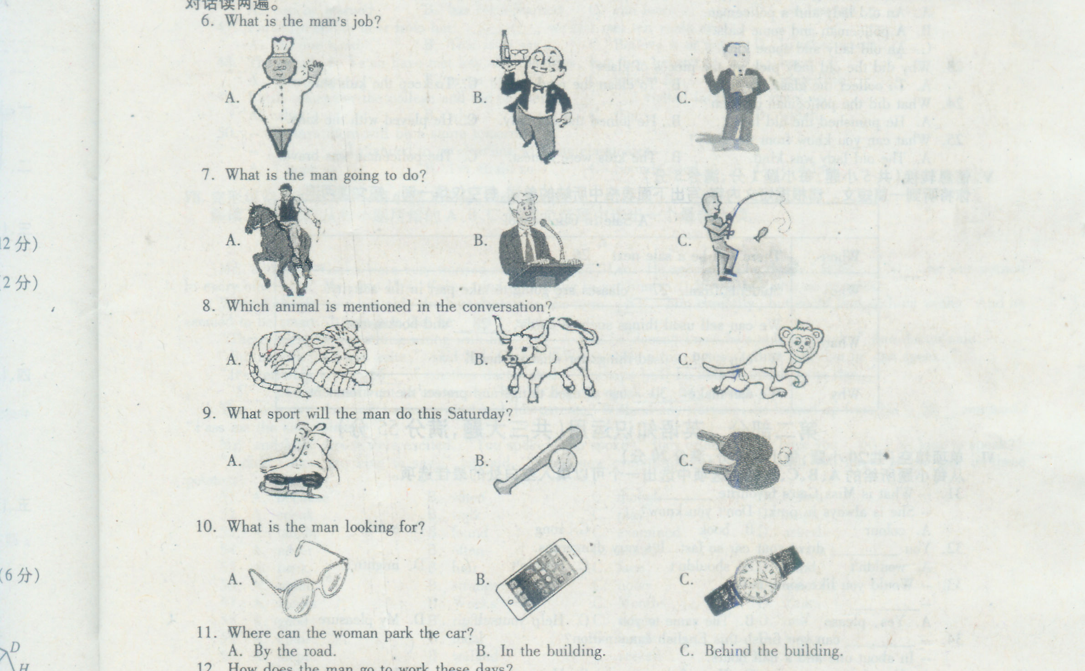
7. What is the man going to do?

8. Which animal is mentioned in the conversation?
9. What sport will the man do this Saturday?
10. What is the man looking for?
11. Where can the woman park the car?
A. By the road. B. In the building. C. Behind the building.
12. How does the man go to work these days?
A. By car. B. By taxi. C. By bike.
13. What does the man mean?
A. He likes his job. B. He hates his job. C. He often loses jobs.
14. How much will the man pay?
A. $20. B. $40. C. $60.
15. Where does the conversation probably take place?
A. On a bus. B. In the street. C. In a museum.

III. 长对话理解(共5小题；每小题1分，满分5分)你将听到两段对话，每段对话后有几个小题。请在每小题所给的A、B、C三个选项中选出最佳答案。每段对话读两遍。
听下面一段对话，回答第16、17两个小题。
16. What is the weather like?
A. Rainy. B. Cloudy. C. Windy.
17. What will they do in the end?
A. They'll take a taxi. B. They'll have a drink. C. They'll do shopping.
听下面一段对话，回答第18至20三个小题。
18. What does the woman want to do?
A. To have a meeting, B. To buy some tea.
C. To interview Mr. White.
19. What time are they going to meet?
A. At 1 pm. B. At 2 pm. C. At 3 pm.
20. Where are they going to meet?
A. In Mr. White's office. B. At the Bank of China.
C. In Sunshine Tea House.
Ⅳ．短文理解(共5小题，每小题1分，满分5分)
你将听到一篇短文，短文后有5个小题。请根据短文内容，在每小题所给的A、B、C三个选项中选出最佳选项。短文读两遍。
21. Where did the old lady put the broken pieces of glass?
A. On the road. B. Into the bag. C. Into her pocket.
22. Who were talking on the road?
A. An old lady and a policeman.
B. A policeman and some kids.
C. An old lady and some kids.
23. Why did the old lady pick up the pieces of glass?
A. To collect the glass. B. To clean the road.
C. To keep the kids safe.
24. What did the policeman do then?
A. He punished the old lady. B. He joined the old lady.
C. He played with the kids.
25. What can you know from the story?
A. The old lady was kind. B. The kids were honest.
C. The policeman was brave.
V.信息转换(共5小题；每小题1分，满分5分)
你将听到一篇短文，请根据短文内容，填写下面表格中所缺的单词，每空仅填一词。短文读两遍。
A Sale in Our School
When | There will be a sale next 26 .
Who | Students from 27 classes are going to take part in the activity.
What | We can sell used things such as cards, 28 and bookmarks.
What | We can 29 used things for what we need.
Why | We can make 30 use of used things and protect' the environment.
第二部分 英语知识运用（共三大题，满分55分）
VI.单项填空(共20小题；每小题1分，满分20分)
从每小题所给的A、B、C、D 四个选项中选出可以填入空白处的最佳选项。
31. --What is Miss Gao's favourite________?
--She is always in pink. Don't you know?
A. colour B. book C. song D. movie
32. You __ drive your car so fast. It's very dangerous.
A. wouldn't B. shouldn't C. couldn't D. mightn't
33. -- Would you like some milk?
--________.
A. Yes, please B. The same to you
C. Help yourself D. My pleasure
34. -- ________ can you finish this English examination?
-- In about one and a half hours.
A. How far B. How often C. How soon D. How long
35. Smile to the world, ________ the world will smile back to you.
A. nor B. but C. or D. and
36. -- I can't find David. Where is he?
-- He ________ for tomorrow's competition at home.
A. prepares B. is preparing C. has prepared D. prepared
37. Mrs. King put a coat ________ the sleeping girl to keep her warm.
A. over B. with C. behind D. beside
38. --I am a little hungry, Mom.
--There are some cakes on the plate. You can take ________.
A. it B. one C. that D. this
39. I will meet Jane at the station. Please ________ what time she will arrive.
A. count B. choose C. check D. catch
40. -- Tony, ________ are you in such a hurry?
-- The meeting will start soon. I don't want to be late.
A. where B. how C. when D. why
41. -- What was Jim wearing at the party?
-- Nothing ________. He was in his usual shirt and jeans.
A. special B. simple C. important D. interesting
42. -- It will be my turn. I feel a little nervous.
--________ You can make it!
A. Congratulations! B. Take it easy.
C. kook out! D. Have a good time.
43. It is helpful to ________ a good habit of reading in language learning.
A. take B. show C. develop D. match
44. The rivers will become dirtier and dirtier ______ we take action to protect them.
A. since B. if C. until D. unless
45. -- Our school bus will leave at 8 o'clock tomorrow. Don't be late.
-- OK. I will be there ten minutes________.
A. sooner B. slower C. faster D. earlier
46. Thanks to the Internet, different kinds of information ________ in a short time.
A. can be learned B. has been learned C. can learn D. has learned
47. I'm surprised to hear from her. ________, we last met ten years ago.
A. On one hand B. That is to say
C. Believe it or not D. In other words
48. The people in Ya'an have met lots of difficulties, but they haven't ________ hope.
A. picked up B. given up C. looked for D. waited for
49. I stir remember the college and the teachers ________ I visited in London years ago.
A. what B. who C. that D. which
50. --TV says there will be a storm tomorrow.
-- ________I planned to go climbing with my classmates.
A. I hope so B. I'm afraid so C. Sounds good D. Bed luck
VII.完形填空(共20小题；每小题1.5分，满分30分)
阅读下列短文, 从每小题所给的A、B、C、D 四个选项中选出最佳选项。
A
Mr. and Mrs. Green were very worried about their son, Leo. He seemed to be dumb (哑的) 51 he was normal in every other way. Mr. and Mrs. Green tried everything to get him to 52 , but with no success.
When Leo was six years old, the best doctors in the town 53 him carefully, but could find nothing wrong. And he seemed to be smart. It was just that he 54 spoke.
"There might be something wrong with his 55 , and he doesn't know he's able to speak," one doctor said.
"But he can read and write," said Mr. Green. "We've written him notes, telling him that he can speak."
"It's certainly very 56 ," another doctor said. "Perhaps he'll be able to speak some day."
57 passed. Leo went to university. But he did not speak a 58 word.
Then one day, Leo was having a meal with his parents. Without any warning, he looked up from his 59 and said, "Pass me the salt, please."
Mr. and Mrs. Green were excited. "You spoke! You spoke!" they cried, "Why have you 60 so long to speak?"
"I didn't have anything to say," he said. "Until now everything was perfect. But you forgot to put salt in these potatoes."
51. A. because B. when C. though D. before
52. A. speak B. walk C. play D. laugh
53. A. taught B. found C. examined D. asked
54. A. never B. often C. usually D. always
55. A. back B. hair C. face D. mind
56. A. unfair B. strange C. noisy D. quiet
57. A. Hours B. Weeks C. Months D. Years
58. A. good B. right C. single D. new
59. A. chair B. meal C. hands D. books
60. A. slept B. walked C. served D. waited
B
It is often said that eyes can speak. Do you have such kind of 61 ? In a bus you may look at a stranger, but not too, 62. If he notices that he is being looked at, he may 63 uncomfortable. It is the same in daily life. When you are looked at for several more times, you will look 64 up and down in order to 65 if there is anything wrong with you. If 66 goes wrong, you will feel angry with the person who is looking at you. 67 can speak, right?
Looking too long at someone may seem to be impolite. But sometimes things are 68. If you wish to draw someone's 69 , you may look at him or her for more than ten seconds. For lovers, they enjoy looking at each other longer to show the love that words cannot 70 . Clearly, eye communication should be done according to the relationship
between the two people and the certain situation.
61. A. future B. fear C. experience D. exercise
62. A. late B. long C. low D. loud
63. A. feel B. smell C. sound D. taste
64. A. itself B. himself C. myself D. yourself
65. A. see B. guess C. hear D. expect
66. A. something B. nothing C. everything D. anything
67. A. Ears B. Eyes C. Mouth D. Nose
68. A. different B. difficult C. tiring D. boring
69: A. direction B. lesson C. attention D. trouble
70. A. write B. print C. read D. express
VIII.补全对话(共5小题；每小题1分，满分5分)
根据对话内容，从方框内的选项中选出能填入空白处的最佳选项。选项中有两项为多余选项。
Ann: Thank you for the birthday gift, Dad. It's the best gift I have ever had.
Dad: 71
Ann: I've always wanted a computer. 72
Dad: And you need it to chat (聊天) with your friends, too.
Ann: I guess you are right. 73
Dad: Send an email? Er, just do like this. 74
Ann: Yes, Dad. I think it's easy.
Dad: 75
Ann: I won't, I promise.
A. Have you got it?
B. Do you need help?
C. I’m glad you like it.
D. How can I turn it on?
E. I need it to do my homework.
F. Just don't spend too much time on it.
G. Could you show me how to send an email?

71. _________72. _________73. _________74. _________75._________
第三部分 阅读理解（共一大题，满分40分）
IX.阅读理解(共20小题；每小题2分，满分40分)
阅读下列短文，从每小题所给的A、B、C、D四个选项中选出最佳选项。
A
Many people say that they are working too many hours. They don't have enough time to relax or to stay with their family.
Work hours are different from one country to another. In France, people spend about 1,646 hours a year at work. In Japan, however, people work about 2,159 hours a year. That means a Japanese worker works 513 more hours a year than a French worker.
Why do people work so many hours? Some people work extra hours because they want to make more money. However, many companies don't pay overtime. Their workers don't get more pay for more work. Some people think it's their duty to work more hours. Some are afraid of losing their jobs if they don't work more hours.
Many people say that their vacations are too short. In France, people get five weeks of paid vacation a year. In Germany, they get four to six weeks, and in the United States, two weeks. One study shows fewer than half of workers used all their vacation days. In Great Britain, there is a saying, "All work and no play makes Jack a dull (迟钝的) boy." If that is true, there must be a lot of dull people in the world.
76. A Japanese worker works __ more hours a year than a French one.
A. 513 B. 1,646 C. 2,159 D. 3,805
77. The word "extra" in Paragraph 3 means ".
A. 正常的 B. 额外的 C. 有用的 D. 少量的
78. People in ________ get only two weeks of paid vacation a year.
A. France B. Germany
C. the United States D. Great Britain
79. Which of the following is true according to the passage?
A. No companies offer vacations to their workers.
B. Many people say they have enough time to relax.
C. Not all companies pay their workers for more work.
D. More than half of workers use all their vacation days.
80. What can we infer from the passage?
A. Many workers have to work long hours.
B. Many people have vacations long enough.
C. Work hours are the same around the world.
D. There are a lot of dull people in the world.
B
①"I will think of it." It is easy to say this, but do you know what great things have come from thinking? Though we can not see, or hear, or feel our thoughts, they have great power (力量) !
②Isaac Newton was seated in his garden on a summer evening when he saw an apple fall from a tree. He began to think, and tried to find out why the apple fell. Then he discovered how the earth, sun, moon, and stars are kept in their places.
③James Ferguson once saw the inside of his father's watch, and he wondered, "Why should I not make a watch?" This set him thinking and it led to a wooden clock which kept good time.
④Walt Disney, the famous American film-maker, was often thinking of new ideas. One day, when he was in a meeting, he suddenly stopped talking, deep in thought. He looked and looked at a place high up in the room. This continued for a long time, end then he got an idea for a new cartoon.
⑤Ideas come at any time, end the important thing is to think. When you meet with any difficulty, don't lose heart. Try to think of it before asking someone to help you. Think and by thinking you will learn how to think creatively.
81. Newton wanted to find out ________.
A. when the apple hit him B. why the apple fell
C. who made the apple fall D. where the apple fell
82. ________ made a wooden clock.
A. Isaac Newton B. Walt Disney
C. James Ferguson D. James' father
83. Walt Disney was ________ when he got an idea for a new cartoon.
A. making a film B. telling a story
C. having a meeting D. sitting in a garden
84. From the passage we can learn that
A. we should always ask others for help B. every one of us likes thinking
C. it is easy to see and hear our thoughts D. thinking helps to get new ideas
85. Which of the following shows the structure (结构) of the passage?
（①=Paragraph 1, ②= Paragraph 2, …）
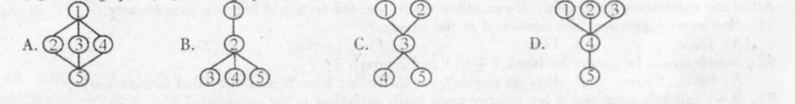

(
B
C
broadcast1/'brɔ:dkɑ:st||ˈbrɔdˌkæst/n[C] a programme on the radio or on television: a radio news broadcast | live broadcast ( = a programme that you see or hear at the same time as the events are happening)  broadcast² v past tense and past participle, broadcast 1 [ I,T] to send out radio or television programmes: The interview was broadcast live across Europe. 2 [T] to tell something to a lot of people: There was no need to broadcast the fact that he lost his job.  broadcaster /ˈbrɔːdkɑːstə || ˈbrɔːdkæstər/ n [C] | curious/ ˈkjʊəriəs || 'kjur-/ adj 1 wanting to know about something: When I mentioned her name everyone was curious. | [ +about] I’m incurious about this book she's supposed to be writing. |curious to see/hear/know etc: Mandy was curious to hear what Peter had to say himself.—opposite INCURIOUS 2 strange or unusual: a curious noise coming from the cellar | curious that It's very curious that she left without saying goodbye.  curl¹ /kɜ:l|| kɚrl/ n 1[C] a small mass of hair
flask / flɑ:sk || flæsk/n [C] I BrE a special type of bottle that you use to keep liquids either hot or cold, for example when travelling 2 a flat bottle usually used to carry alcohol 3 a glass bottle with a narrow top, used in a LABORATORY  flat¹/ flæt / adj flatter, flattest  1▶ SURFACE◀ smooth and level, without raised or hollow areas, and not sloping or curving: a flat-bottomed boat |a perfectly flat sandy beach | flat as a | pollute / pə'lu:t/ v [T] 1 to make air, water, soil etc dangerously dirty and not suitable for people to use: beaches polluted by raw sewage | industrial emissions that pollute the air 2 pollute sb’s mind to give someone immoral thoughts and spoil their character: fears that Lawrence's novels would pollute young minds--polluted adj: polluted rivers--polluter n [C]  pollution / pəˈlu:ʃn /n [U] 1 the process of making
86. The pronunciation of the word "broadcast" is ____ or/ˈbrɔdˌkæst /.
A. /'brɔ:dkɑ:st/ B. /'brəud'sɑ:st/ C. /bræd'kɔst/ D. /'bru:dkɑ:st/
87. The word"____ "can be used as an adjective (形容词).
A. pollute B. pollution C. curious D. curiously
88. Which of the following is a flask?

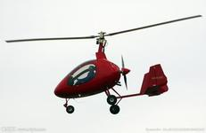
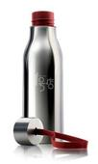

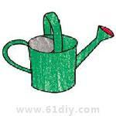
A. B. C. D.

89. The word "pollute" means "______".
A. to tell something to a lot of people B. wanting to know about something
C. a programme on the radio or on TV D. to make air. water, soil, etc dirty
90. These texts are probably from ______.
A. a magazine B. a dictionary
C. a newspaper D. an advertisement
D
The human brain weighs about 1.4 kilograms, but it can, hold much more information than most computers. However, there is another difference between humans and computers. Computers don't forget information they are given, but humans often do. No one remembers everything, and luckily we don't usually have to. But everyone can improve their memory if they want to. Here are some suggestions.
◆Try to use new informati6n immediately. For example, if you meet someone who says "Hi! I'm Carlos," don't just say "Hello." Repeat the person's name. Say"____"
◆Break a big number into smaller parts. For example, it's hard to memorize (记忆) 109244153. But if you break it into three parts--109/244/153—it becomes easier.
◆Write out what you need to remember ever and over again. This will help you keep it in mind longer, especially for memorizing formulas (公式) or facts.
◆Always review information. If you bring what you've learned back to your mind, they become easier to remember. For example, before you go to sleep, it’s a good idea to review the new things you learned that clay.
◆Discuss with a friend. It is always easier to remember things through discussions. You can have a discussion about what's right and what's wrong, and it will lead to the right answer.
◆Never tell yourself that you have a bad memory. You can always do something to help improve your memory. And everyone's memory gets better if they use it often enough.
All of the suggestions are helpful. If you follow them, you are certain to improve your memory.
91. How many suggestions are mentioned in the passage?
A. Three. B. Four. C. Five. D. Six.
92. Which should be put in the blank (空格) in Paragraph 2？
A. Hello, Carlos. B. How do you do?
C. Hello, I am Sophia. D. Glad to meet you!
93. What can help memorize a big number more easily according to the passage?
A. To store it in a computer. B. To break it into stunner parts.
C. To discuss it with a friend. D. To review it before you sleep.
94. Which of the following is true according to the passage?
A. Discussing with friends can help you remember things.
B. Always reviewing information can help you fall asleep.
C. Formulas and facts can help you learn about your brain.
D. Human beings can improve their memory by computer.
95. What does the sentence "Never tell yourself that you have a bad memory” mean?
A. You should tell others about your bad memory.
B. You should believe in other people all the time.
C. You should ask others to improve their memory.
D. You should ho confident in your memory ability.
第四部分 写（共两大题，满分25分）
X. 单词拼写(共5小题；每小题1分，满分5分)
根据首字母及汉语提示，完成下列单词的拼写，使句意明确，语言通顺。
96. What do you like to do in your f______(空闲的) time?
97. I could hear her sweet v______ (噪音) from the next room.
98. Travelling by plane is expensive, but it s______ (节省) time.
99. Would you please make a shopping l________ (清单) for the picnic?
100. It's polite to k______ (敲) on the door before entering a room.
XI. 书面表达(共1小题；满分20分)
今天是父亲节。假定你是李华，请给你的美国朋友John写一封电子邮件，谈谈你将如何与父亲一起度过这个特别的日子。要点如下：
●表述你与父亲间的情感；
●为父亲制作二张卡片；
●帮助父亲做点事；
●陪父亲散步等。
注意：1. 词数80-100；
2．请不要逐句翻译，可适当发挥；
3．邮件的开头和结尾已为你写好，不计入总词数。
Dear John,
It's Father's Day today. It's a special day, isn't it? ______________________________
____________________________________________________________________________________________________________________
What' your plan for Father's Day? I'm looking forward to hearing from you.
Yours,
Li Hua

参考答案
第一部分 听力
I-IV. 1-5. BCBAC 6-10. ABABC 11-15. CCABA
16-20. ABCAC 21-25. BACBA
V. 26. Sunday 27. 7/seven 28. toys 29. change 30. full
第二部分 英语知识运用
VI. 31-35. ABACD 36-40. BABCD 41 ~45. ABCDD 46-50. ACBCD
VII. 51-55. CACAD 56-60. BDCBD 61-65. CBADA 66-70. BBACD
VIII. 71-75. CEGAF
第三部分 阅读理解（
IX. 76-80. ABCCA 81 ~85. BCCDA 86-90. ACDDB 91 ~95. DABAD
第四部分 写
X. 96. free 97. voice 98. saves 99. list 100. knock
Xl. One possible version
Dear John,
It's Father's Day today. It's a special day, isn't it?
I think we should do something to show our love for our fathers on this special day. My father and I are good friends. Whenever I meet with difficulties, he is always there, ready to help me.
Today I will make a beautiful card for him, with my thanks and best wishes on it. Then I will help him wash the car this afternoon and cook his favorite food in the evening. Besides, I'll take a walk with him after dinner and then play chess with him, for he likes it very much. I' m sure he'll be very happy.
What's your plan for Father's Day? I' m looking forward to hearing from yon.
Yours,
Li Hua

