2019年安徽省初中学业水平考试

英 语

（试题卷）
注意事项：
1. 本试卷共四部分，十一大题，满分150分，考试时间为120分钟。
2. 全卷包括“试题卷”（8页）和“答题卷”（2页）两部分。
3. 请务必在“答题卷”上答题，在“试题卷”上答题无效。
4. 考试结束后，请将“试题卷”和“答题卷”一并交回。

第一部分 听力（共五大题，满分30分）
I．关键词语选择（共5小题；每小题1分，满分5分）
你将听到五个句子。请在每小题所给的A、B、C三个选项中选出一个你所听到的单词或短语。每个句子读两遍。

- A. part
- pass
C. place

- A. Farm
- Film
C. form

- A. Word
- World
C. water

- A. Lucky
- Lonely
C. lovely

- A. throw away
- put away
C. take away

Ⅱ．短对话理解（共10小题；每小题1分，满分10分）
你将听到十段对话，每段对话后有一个小题。请在每小题所给的A、B、C三个选项中选出一个最佳选项。每段对话读两遍。
6. What does the man want to buy?
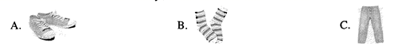
7. What is the weather like now?
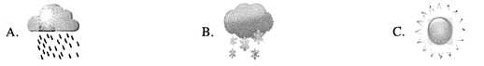
8. What would the man like to drink?
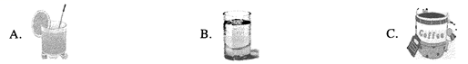
9. How does Grace go to school these days?
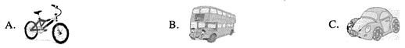
10. What does the man want to be?

11.When does the movie start?

A.At 7:00.
B. At 8:00.
C. At 9:00.

12.What color jacket does the man prefer?

A. Black.
B. Blue.
C. Brown.

13.What is the woman's name?

A. Moira.
B. Maria.
C. Meryl.

14.Where does the conversation probably take place;

A. In a library.
B. In a bank.
C. On a bus.

15. What will the woman do tonight?

A. Watch a football game.
B. Finish her report.
C. Do the housework.

Ⅲ．长对话理解（共5小题；每小题1分，满分5分）
你将听到两段对话，每段对话后有几个小题。请在每小题所给的A、B、C三个选项中选出一个最佳选项。每段对话读两遍。
听下面一段对话，回答第16至17小题。
16. Where are the speakers going to have the party?

A. In the meeting room.
B. In the dining room.
C. In the music room.

17. What is the probable relationship between the two speakers?

A. Teacher and student.
B. Father and daughter.
C. Boss and secretary.

听下面一段对话，回答第18至20小题。
18. When did the woman move here?

A. Yesterday morning.
B. Yesterday afternoon.
C. Yesterday evening.

19. Where does the man live?

A. In 304.
B. In 404.
C. In 504.

20. What is the man's suggestion to the woman?
A. Moving out of the building. B. Buying a pair of gloves. C. Coming for a drink.
Ⅳ．短文理解（共5小题；每小题1分，满分5分）
你将听到一篇短文，短文后有五个小题。请根据短文内容，在每小题所给的A、B、C三个选项中选出一个最佳选项。短文读两遍。
21. How many meals do most English people eat a day?

A. Three.
B. Four.
C. Five.

22. What do English people usually have for breakfast?

A. Eggs or bread.
B. Meat or fish.
C. Fruit or vegetables.

23. When is afternoon tea?

A. From 2: 00 to 3:00.
B. From 3:00 to 4:00.
C. From 4:00 to 5:00.

24. Why do some families like eating well in the evening?
A. Because they are usually busy in the day.
B. Because they are hungry in the evening.
C. Because restaurants are open in the evening.
25.What is the speaker mainly talking about?

A. English learning.
B. Eating habits.
C. Keeping healthy.

Ⅴ．信息转换(共5小题；每小题1分，满分5分)
你将听到一篇短文。请根据短文内容，写出下面表格中所缺的单词，每空仅填一词。短文读两遍。
School Open Day
When  What  Who | On __26___
Teachers | 9:00~ meet parents at the ___27___ gate of the school  9:15~___28___ parents to visit the classroom
Parents | 10:00~look at the class projects in the hall  12:00~have lunch and a break  1:30~visit the library and the new ___29___  2:30~ enjoy a ___30____

第二部分 英语知识运用（共两大题，满分45分）
Ⅵ．单项填空(共15小题；每小题1分，满分15分)
从每小题所给的A、B、C、D 四个选项中选出一个可以填入空白处的最佳选项。
31．—Mum I've got the first prize in the speech competition．
—_______，my boy!
A．Well done B．My pleasure C．Good luck D．It's hard to say
32．You can see the _______ in our faces when we talk about the great achievements in the past 70 years．
A．doubt B．pride C．regret D．ability
33．Could you stay a little longer? I have _______ more to tell you about the plan for tomorrow．
A．something B．everything C．anything D．nothing
34．—It's ten years since we came here
—How time flies! We _______ in China for so long．
A．work B．worked
C．will work D．have worked
35．—The 5G technology can help doctors treat patients who are hundreds of kilometers away．
— It's really _______．
A．secret B．direct C．amazing D．traditional
36．A better future is the goal of the Chinese people，_______ it's also the common interest of the world．
A．so B．and C．or D．but
37．—Hello，Beijing Hotel．Can I help you?
—Yes，I'd like to _______ a single room for two nights．
A．enter B．move C．book D．provide
38．On sunny days，my grandma often reads a novel _______ the window．
A．by B．for C．with D．from
39．The designer has tried every possible way to make the robot light，so you _______ worry about its weight．
A．must B．may C．can’t D．needn’t
40．—I wonder _______ the students have a physical examination．
—Once a year．
A．how far B．how soon
C．how long D．how often
41．—Shall we go to the airport to _______ your sister?
—I don’t think it’s necessary．She will come here by taxi．
A．see off B．pick up
C．look after D．come across
42．The villagers expect that the building of the bridge _______ before the rainy season comes．
A．is completed
C．will be completed
B．was completed
D．has been completed
43．I came to school _______ this morning because it was my turn to clean our classroom．
A．early B．slowly C．quietly D．suddenly
44．Our business won’t improve _______ we offer better service to our customers．
A．because B．unless C．after D．since
45．—Sorry，I took the wrong seat．
—_______．I will take yours instead．
A．No way
B．Better not
C．Excuse me
D．That’s all right
Ⅶ．完形填空(共20小题；每小题1．5分，满分30分)
阅读下列短文，从每小题所给的A、B、C、D 四个选项中选出一个最佳选项。
A
Dear Michael，
I am glad to learn that you have been chosen to study in China．Your dream has come true!
I can well remember that you 46 China for the first time when you were nine．Ever since you returned，you have been interested in Chinese culture and have put a lot of 47 into learning Chinese．When you first started to learn Chinese，I 48 it was nothing but a passing fad (一时的狂热)．However，you didn't 49 halfway，but kept on learning and did a good job in the HSK (汉语水平考试)．Now you finally got what you had 50 for a long time．You got the chance to 51 life in China for one year．You should have it，my son，for chances only come to those who are 52 ．
When you study there，you will have to face 53 in everyday life that you have never experienced before，but after a year abroad，you will return with a new 54 at life—and at yourself．
Your mum and I are both 55 you．Keep it up，my son!
Love，
Dad
46．A．built B．visited C．missed D．changed
47．A．difficulty B．success C．effort D．space
48．A．thought B．agreed C．forgot D．added
49．A．cheer up B．grow up C．turn up D．give up
50．A．written B．wanted C．toured D．paid
51．A．introduce B．experience C．respect D．imagine
52．A．prepared B．honest C．friendly D．helpful
53．A．examples B．meetings C．challenges D．dreams
54．A．look B．touch C．guess D．speed
55．A．different from B．similar to C．polite to D．proud of
B
Are you shy? If you are，you are not alone．In fact，nearly 50% of people are shy，and almost 80% feel shy at some point in their lives．Why are people 56 ?
It is found that family size might 57 people to be shy．Children with no brothers and sisters may be shy．Growing up 58 ，they often play by themselves．They are not able to develop the same social skills as children from big 59 ．
Another cause of shyness could be 60 ．As more and more people use the Internet，they 61 less time outside，talking to people．As a result，they lose practice at conversation． 62 to new people face to face can make them feel nervous．
For shy people，it can be 63 to make friends，speak in class，and even get a good job．But scientists say you can 64 your shyness．They suggest trying 65 things and practicing conversation．
Anyway，don't be afraid of shyness—you are valued for what you are!
56．A．excited B．shy C．happy D．brave
57．A．remind B．teach C．guide D．cause
58．A．quickly B．happily C．alone D．abroad
59．A．countries B．cities C．teams D．families
60．A．duty B．safety C．technology D．education
61．A．design B．spend C．collect D．save
62．A．Nodding B．Running C．Jumping D．Speaking
63．A．difficult B．safe C．harmful D．surprising
64．A．run into B．look for C．get over D．heavy
65．A．new B．private C．awful D．heavy
第三部分 阅读理解（共两大题，满分45分）
Ⅷ．补全对话（共5小题；每小题1分，满分5分）
根据对话内容，从方框内的选项中选出能填入空白处的最佳选项，其中有两个为多余选项。（请关注九年级化学微信公众号）
A．That's not true.
B．For about three months.
C．How do you celebrate it?
D．I believe you will love it.
E．You mean in your hometown?
F．I can't wait for the coming of that day.
G．If so, you can come to celebrate it with my family.
A：Lucy，how long have you been in China?
B： 66
A：Wow! That’s a long time．
B：Yes，and I’m going to stay longer to see how the Mid-Autumn Festival is celebrated here．
A： 67
B：Can I? That’s very kind of you!
A： 68 We’ll celebrate it in the countryside．
B： 69
A：Yes，I’m sure you’ll learn a lot about Chinese traditions there．
B：Sounds great! 70
A：Looking forward to your coming．
Ⅸ．阅读理解（共20小题；每小题2分，满分40分）
阅读下列短文，从每小题所给的A、B、C、D四个选项中选出一个最佳选项。
A
It is expected that Pacific Island countries will become popular with Chinese tourists in 2019．Which one should you choose for your summer holiday?
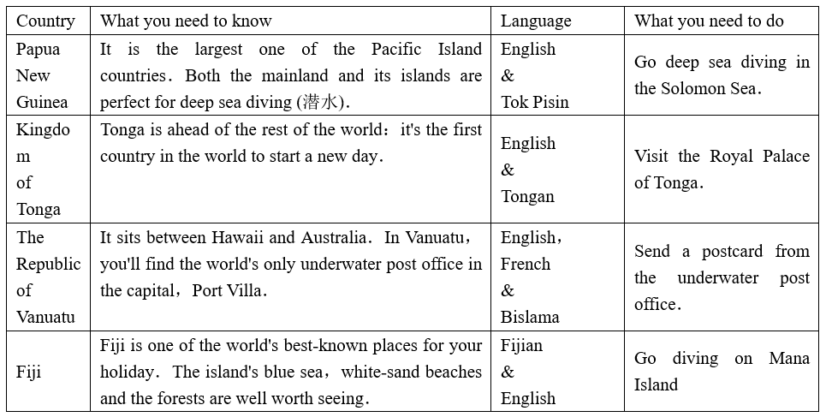
71．Which country is the first one to start a new day?
A．Papua New Guinea．
C．The Republic of Vanuatu．
B．Kingdom of Tonga．
D．Fiji．
72．People go to Fiji for their holidays mainly because _______．
A．things there are well worth seeing
C．they want to stay in the Royal Palace
B．the underwater post office is exciting
D．it is the largest Pacific Island country
73．Which language is spoken in all the four Pacific Island countries?
A．Tok Pisin． B．French．
C．Bislama． D．English．
74．What is the purpose of the text?
A．To ask for some help．
B．To introduce languages．
C．To answer a question．
D．To offer holiday choices．
B
Have you tried to run or walk for exercise and then given up? If you answered yes，you should try a new kind of exercise：aquatic (水中的) exercise．Aquatic exercise is like exercise on land，but you do it in a swimming pool．More and more people are trying aquatic exercise．
Aquatic exercise feels easier than exercising on land．Why? You weigh about 90% less in the pool．It is better for your knees than running or walking．Water is about 1，000 times thicker and heavier than air．To move through the water，your body has to work four times as hard．As a result，you can burn more calories (卡路里)．
In fact，most people say they feel more relaxed in the water．They stop thinking about the things that make them worried．They feel in control of their bodies．The cool，quiet environment makes them feel good．
But what if you are afraid of the water? No problem! There is nothing to worry about．Aquatic exercise is safe and easy to learn．It doesn't require any special skills．You don't even need to know how to swim．Aquatic exercise is for everyone．
75．What is Paragraph 2 mainly about?
A．Difference between air and water．
C．The advantages of aquatic exercise．
B．Weight change of one's body．
D．The ways to do aquatic exercise．
76．What do most people think of aquatic exercise?
A．Relaxing．
B．Worrying
C．Challenging．
D．Boring．
77．According to the text，aquatic exercise is _______．
A．done in groups
C．difficult to learn
B．fit for everyone
D．done with special skills
78．In which part of a magazine can we read the text?
A．Culture． B．Health．
C．Nature． D．Travel．
C
Like many high school graduates，Maggie Doyne didn't go straight to college．She decided to travel and arrived in western Nepal in 2006．A war had just ended there and left many children living on the streets．They were often forced to work at hard physical jobs for little money．
One day，while walking down a country road，Doyne saw a little girl breaking up rocks．She soon learned that 7-year-old Hima sold the rocks to support her family．With deep sadness，she decided to pay Hima's tuition (学费) for school．Encouraged by the changes in the child，Doyne thought，"If we can help one child，why not 10?"
Doyne felt that the street children's greatest need was a home．She found a piece of land for sale and bought it with $5，000 she saved from years of babysitting (当临时保姆)．In 2008 the Kopila Valley Chilren's Home was set up．With the help from the community，another goal was reached in 2010—the Kopila Valley School．Over 350 children now attend the school and over 50 live in the home．
Today，Doyne lives in the home and is "mum" to the kids．
79．When did Maggie Doyne travel to western Nepal?
A．In 2006． B．In 2007．
C．In 2008． D．In 2010．
80．Why did Hima break up the rocks?
A．To do physical exercise．
B．To build a new school．
C．To get money for her family．
D．To repair the country road．
81．What can we learn from Paragraph 3?
A．The street children once worked as babysitters．
B．Doyne got some support from the community．
C．Doyne borrowed much money from the government．
D．Over 5，000 children attend the Kopila Valley School．
82．Which of the following might be the best title for the text?
A．Maggie Doyne---A Lonely Traveller
B．War in Western Nepal
C．Maggie Doyne---Mum to More Than 50
D．A Girl Lived on Her Own
D
The world uses about a thousand million (百万) tons of water a day．Water is a human right and everyone should have their share．Yet more than 700 million people around the world have trouble getting clean，safe water．
Treating wastewater is a good way to provide fresh water for us．And it also helps the environment by keeping waste out of rivers and oceans．80% of wastewater around the world is not treated at all，and it is running into oceans．But now we have got the technology to treat and reuse the wastewater．
While 75% of our planet is covered with water，only about 2% is fresh water—that comes from rivers，lakes，ice and snow．The rest，98% of the water，is in seas and oceans．It is too salty to drink．Then desalination businesses come in．More than 19．000 factories have been built around the world，mostly in coastal countries．They process (加工) more than 92 million tons of water every day．But the technology they use requires a lot of energy．
Scientists are working to create a less costly technology．They want to produce 20 times more clean water and make sure everyone has enough．But for now，the world still faces each day with not having enough water for everyone．
83．How many people have trouble in getting clean water around the world?
A．Under 10 million．
B．Only 19 million．
C．About 92 million．
D．Over 700 million．
84．Treating wastewater helps the environment by _______．
A．storing waste in ice and snow
B．letting waste run into oceans
C．keeping waste out of rivers and oceans
D．sending waste to coastal countries
85．What does the underlined word "desalination" in Paragraph 3 mean?
A．远洋运输
B．潮汐发电
C．食盐销售
D．海水淡化
86．At present，the technology to process water _______．
A．needs much energy
B．saves much money
C．satisfies everyone
D．causes pollution
87．What can we infer from the last paragraph?
A．Water should be a human right．
B．The water problem is still serious．
C．Our planet is covered with water．
D．Everyone has enough clean water．
E
Remember when you were a little child trying to learn to walk?
First，you had to learn how to balance (平衡) yourself and stand．You fell down，and then got back up．You laughed sometimes and cried at other times．After much practice，you finally learned how to balance yourself．You got much pleasure from this new feeling of power—you'd stand everywhere you could．It was a happy time—you did it!
Now the next step—walking．You'd seen others do it．It didn't look that hard—just move your legs while you were standing．Wrong—more difficult than you ever imagined．But after you tried again and again and again，you understood how to walk．
If people found you walking，they cheered，"Oh，look at what the kid is doing．" This encouraged you! But look back on those days when you were the little child—how many times did you try when no one was watching，or when no one was cheering? You couldn't wait for someone to encourage you to take the next steps．You learned how to encourage yourself．
So，keep trying and encouraging yourself as you learned to walk if you want to succeed in doing something．
88．What is the first step in learning to walk? (不超过15个词)
__________________________________________________________
89．When did you understand how to walk? (不超过15个词)
__________________________________________________________
90．What should you do if you want to succeed in doing something? (不超过15个词)
__________________________________________________________
第四部分 写（共两大题，满分30分）
Ⅹ．单词拼写(共5小题；每小题1分，满分5分)
根据首字母及汉语提示，完成下列单词的拼写，使句意明确，语言通顺。
91．It is helpful to have a clear i_______(想法)of what you want．
92．My English teacher is always r_______ (准备好的)with advice for our study and life．
93．The six-year-old American girl has learned hundreds of Chinese p_______ (诗)．
94．We will go climbing tomorrow if the weather is f_______(晴朗的)．
95．The engineers are going to t_______ (测试)the self-driving car in our city．
Ⅺ．书面表达（共1小题；满分25分）
假定你是李华，你的英国笔友Mike最近因视力减退而感到不安，请你用英文给他写封电子邮件，谈谈你在保护视力方面的一些做法。要点如下：
1．经常做户外活动；
2．很少用电子产品；
3．坚持做眼保健操；
4．……
注意：1．词数80-100；
2．可适当增加细节，以使行文连贯；
3．文中不能出现与本人相关的信息；
4．开头和结尾已为你写好，不计人总词数。
Dear Mike
I'm sorry to learn that your eyesight is getting weaker．_____________________
Yours，
Li Hua

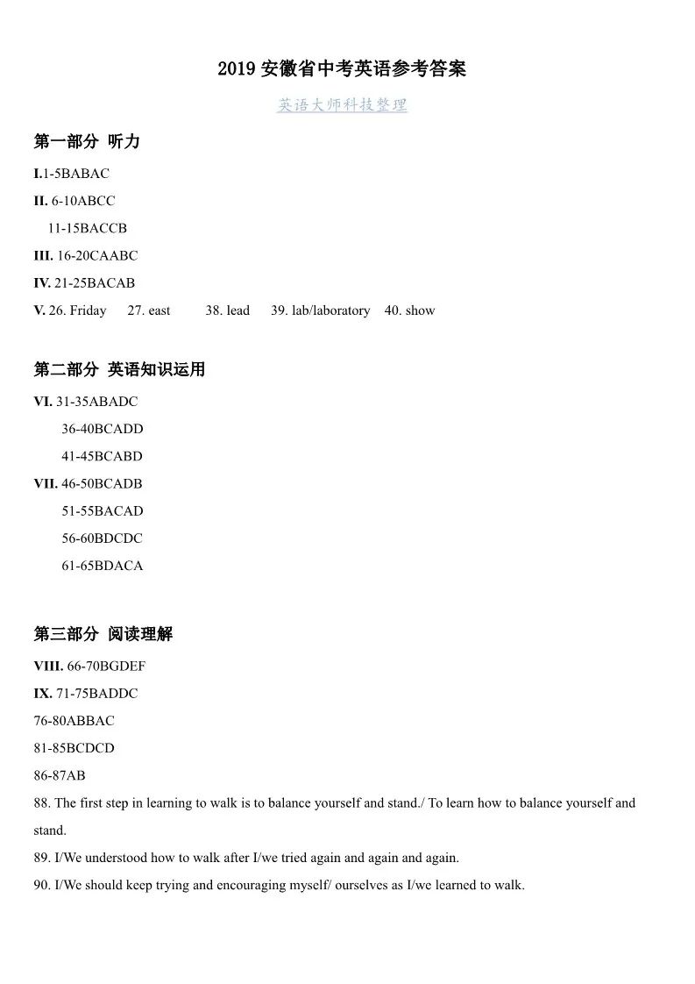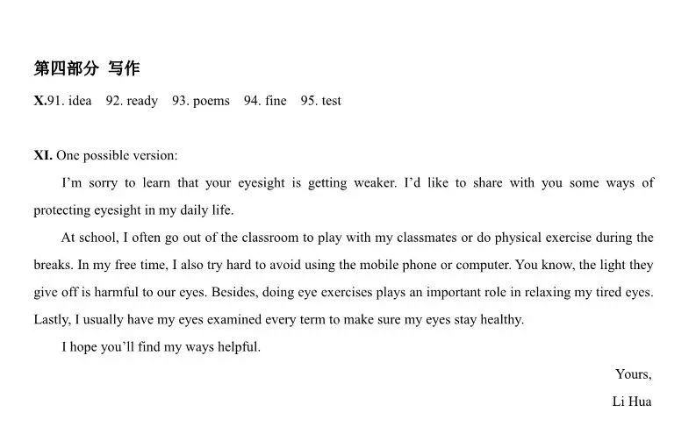第二部分 英语知识运用（共两大题，满分45分）
Ⅵ．单项填空(共15小题；每小题1分，满分15分)
从每小题所给的A、B、C、D 四个选项中选出一个可以填入空白处的最佳选项。
31. —Mum I've got the first prize in the speech competition.
—____, my boy!

A.Well done
B. My pleasure
C. Good luck
D. It's hard to say

答案A
解析：A干得好 B我很乐意 C 祝你好运 D很难说
当你听到别人的好消息时，出于礼貌，应表示祝贺。根据上句“Mum I've got the first prize in the speech competition.”可知答语应该是干得好；故选A

32. You can see the _____ in our faces when we talk about the great achievements in the past 70 years.

A. doubt
B. pride
C. regret
D. ability

答案B
解析A怀疑 B骄傲 C后悔 D能力。题目句意为“当我们谈论过去70年的伟大成就时，你可以从我们脸上看到 ”由题意可知应选骄傲，故选B

33.Could you stay a little longer? I have ____ more to tell you about the plan for tomorrow.

A. something
B. everything
C. anything
D. nothing

答案A
由句意可知，题目中的“Could you stay a little longer? ”你能和我多待一会儿么？可知后面是要选择我还有一些事想和你说
34. —It's ten years since we came here
—How time flies! We ____ in China for so long.

- work
- worked
- will work
D. have worked

答案D
解析句意为我们来这里已经十年了，时间过得飞快，我们已经在中国待了这么久了。由题干中的for so long可以得出此处需要用到完成时态。
35.—The 5G technology can help doctors treat patients who are hundreds of kilometers away.
— It's really ____.

- secret
- direct
- amazing
D. traditional

答案 C
解析A秘密 B 直接 C 另人惊奇的 D 传统的 ；提干中的前一句句意为5G科技可以帮助医生治疗数百公里远的病人，根据题意，应该回答这真的很令人惊奇。故选C
36. A better future is the goal of the Chinese people, _____ it's also the common interest of the world.

A. so
B. and
C. or
D. but

答案B
解析，根据句意，更好的未来是中国人的目标， 它也是全世界的共同利益。A 所以 B 并且 C 否则 D 但是。题干中的前后句之间是承接的关系，所以选B
37. —Hello, Beijing Hotel. Can I help you?
—Yes, I'd like to _____ a single room for two nights.

- enter
- move
- book
D. provide

答案C
解析A进入 B 搬到 C预订 D 提供 有题目可知这是在电话通话，只有book预订符合题目意思。
38. On sunny days, my grandma often reads a novel ____ the window.

A. by
B. for
C. with
D. from

答案A
解析 A在.....旁边 B 为了 C 和，伴随 D来自 题目意思为“在晴朗的天气，我的奶奶经常 窗户读书。”只有A词意符合。
39. The designer has tried every possible way to make the robot light, so you _____ worry about its weight.

A. must
B. may
C. can’t
D. needn’t

答案D
解析 A必须 B 可能 C 不能 D 不需要 题目中“ The designer has tried every possible way to make the robot light”可知后面选择不需要更贴切一些。
40. —I wonder ____ the students have a physical examination.
—Once a year.

- how far
- how soon
- how long
D. how often

答案D
解析：由下文回答“Once a year.”可知问的是频率的问题，故选D
41. —Shall we go to the airport to ___ your sister?
—I don’t think it’s necessary. She will come here by taxi.

- see off
- pick up
- look after
D. come across

答案B
解析 由下文“She will come here by taxi.”可知前文也是和交通方式相关。前文句意为“我们去机场 你妹妹好么？”A送行 B 接某人 C 照顾 D 遇到 只有A符合题意
42. The villagers expect that the building of the bridge ____ before the rainy season comes.

A. is completed
C. will be completed
B. was completed
D. has been completed

答案C
解析题目意思为村民期望这座桥可以在雨季来临前完工。Bridge桥和complete完成之间应该是桥被完成，需要用到被动语态be done的形式。句子中有before引导的时间状语从句，主句用一般将来时从句用一般现在时。故选C
43. I came to school ____ this morning because it was my turn to clean our classroom.

A. early
B. slowly
C. quietly
D. suddenly

答案A
解析A早 B 慢 C 安静地 D突然地，由后文“it was my turn to clean our classroom.”可以推断前文需要的意思是慢。句意为“我今天早晨上学很早因为轮到我打扫卫生了。”
44. Our business won’t improve ____ we offer better service to our customers.

A. because
B. unless
C. after
D. since

答案B
解析A因为 B 除非 C在.....之后 D自从 由题意“我们的商业不会提升， 我们可以提供给我们顾客更好的服务。 ”此题前后语句之间有所转折，故选B除非。
45. —Sorry, I took the wrong seat.
—____. I will take yours instead.

- No way
- Better not
- Excuse me
D. That’s all right

答案D
解析在英语对话中，当对方向你道歉时要给予正确的回答，原谅别人。此处A没门；B最好不要；C打扰了；D没关系。

Ⅶ．完形填空(共20小题；每小题1.5分，满分30分)
阅读下列短文, 从每小题所给的A、B、C、D 四个选项中选出一个最佳选项。
A

- 答案B 由后文for the first time when you were nine.可以得出应选择visit
- 答案C学习应该付出努力A困难 B 成功C努力 D空间 根据词义选择C
- 答案A根据句意，应理解为“我认为它除了是一时的狂热以外什么都不是。”所以选择A认为
- 答案D由后文的“but kept on learning”可以得出是和keep on继续相反的意思，故选择D give up 放弃
- 答案B 根据句意“你最终得到了你 很长时间的东西”，以及词意A写；B想要；C旅游；D支付。只有B wanted合乎题意
- 答案B根据句意“你有机会去 一年中国的生活”以及选项词义：A介绍；B经历；C信任；D想象。只有B合理
- 答案A此题为俗语，句意为“机会只会给有准备的人。”词意A准备；B诚实；C友善的；D乐于助人的
- 答案C此题为词意考察题短语“face ”只有C挑战适合意为面临挑战
- 答案A 根据词义A相貌；B触碰；C猜；D梦 句意为“你将重新审视生活”
- 答案D由后文的“ Keep it up”继续努力，可知应选D“为......而自豪”

B
56答案B联系上下文，全文是关于“shy”的，故答案为B“shy”
57答案D由第三段“Another cause of shyness”，故选择D造成
58答案C由后句“hey often play by themselves”可知前面一空是选独自相关意思的选项
59答案D联系上下文可得此空应选择D家庭
60答案C由后句“As more and more people use the Interne”可以推断出来此空应选择C科技
61答案B花费时间只有B适合
62答案D句意为“和新人 面对面会让他们感到紧张”A点头；B跑步；C跳；D说。D选项没有speak to sb 故选A
63答案A联系上下文可得知，此句句意为“对于害羞的人而言，交朋友，在班级发言，甚至交朋友都会有 ”只有A困难正确
64答案C从后文科学家建议的内容上看，此题题意应为“你可以克服你的害羞”。所以选择C克服
65答案A联系上下文，推断出此题应为尝试新的东西，故选A：new新的

第三部分 阅读理解（共两大题，满分45分）
Ⅷ．补全对话（共5小题；每小题1分，满分5分）
根据对话内容，从方框内的选项中选出能填入空白处的最佳选项，其中有两个为多余选项。（请关注九年级化学微信公众号）
解析
66：答案B；由前句 how long have you been in China?可得知回答的应该为时间
67：答案G；由后句 Can I? That’s very kind of you!可知应该是邀请对方去做某事。
68：答案D；联系上下文，上一句是对方表达感谢，所以此句应为我相信你会爱上它。
69：答案E；上一句意思为我们将会在农村庆祝它。且后一句回答Yes.所以选择E。
70：答案F；根据前后句的说话者的语气及意思选择F。
Ⅸ．阅读理解（共20小题；每小题2分，满分40分）
阅读下列短文，从每小题所给的A、B、C、D四个选项中选出一个最佳选项。
A

答案解析：
71：答案B 此题为细节分析题，原文中“Tonga is ahead of the rest of the world: it's the first country in the world to start a new day.”直接有体现
72：答案A 此题为细节分析题，原文中“The island's blue sea, white-sand beaches and the forests are well worth seeing.”直接有体现，可以得出答案。
73：答案D看表格中language这一列可直接得出答案
74：答案D主旨大意题，这篇文章主要描写了一些旅游的地方，可以看出这篇文章的目的主要是为了给读者的旅游提供意见建议。
B
答案解析

75：C段意分析，第二段首句及尾句提示了我们第二段段意为水中运动的优点。
76：A细节分析题，文章中有原文“most people say they feel more relaxed in the water. ”可以得出答案
77：B细节分析题，根据原文“Aquatic exercise is for everyone.”可以得出答案
78：B文章主旨大意归纳，这篇文章主要介绍了水中锻炼这种新型锻炼方式。所以应该归纳为B健康专栏
C

答案解析
79：A细节分析题，原文中有原句“She decided to travel and arrived in western Nepal in 2006. ”
80：C细节分析题，文章中有原句“ sold the rocks to support her family.”
81：B细节分析题，原文中有原句“ With the help from the community”
82：C主旨大意概论题，由文章的主要论文推断出来。A，B,D均与文章无关

D
答案解析
83D细节分析题，原文中有原句“Yet more than 700 million people around the world have trouble getting clean, safe water.”
84C细节分析题，原文中有原句“And it also helps the environment by keeping waste out of rivers and oceans.”
85D词意猜测题，原文前面有“ It is too salty to drink. ”。后面有“They process (加工) more than 92 million tons of water every day”所以可以推断词意应为海水淡化
86A细节分析题，原文中有原句“But the technology they use requires a lot of energy.”
87B主旨大意分析题，最后一段的大意为现在科学家正致力于研究更节约能源的科技，但是我们依然面临着缺水这一问题。所以根据段意应该选择B
阅读下面短文，并用英语回答问题（请注意每小题后面的词数要求）。
E
答案解析
88：文章中直接就有原文语句“First, you had to learn how to balance (平衡) yourself and stand. ”
89：文章中有原文语句“ But after you tried again and again and again, you understood how to walk.”
90：文章原文“ You couldn't wait for someone to encourage you to take the next steps. You learned how to encourage yourself.

