*AIM:* **TO DESIGN A PASSWORD BASED DIGITAL DOOR LOCK SYSTEM USING ARDUINO**

Components Required

* **4×4 keypad** : it is also called as matrix keypad. Matrix keypad use a combination of 4 rows and 4 columns to provide button states to the host device,typically a microcontroller underneath each key is a pushbutton,with one end connected to the one row and connected to the other column.

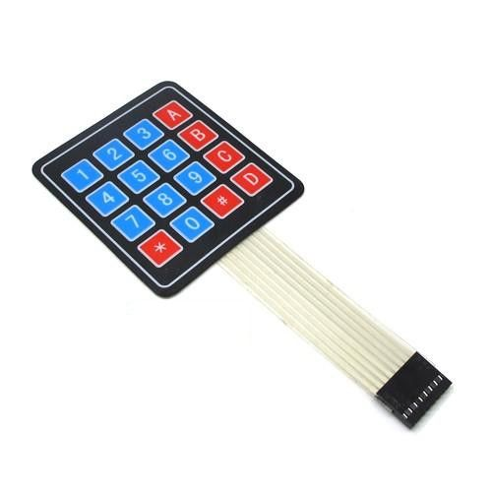

* [**LCD**](https://electrosome.com/lcd-display-fundamentals/) : the full form of lcd is “liquid crystal display”.it has 16 pins out of which 8 pins are used as data pins. A **16x2 LCD** means it can display 16 characters per line and there are 2 such lines. In this LCD each character is displayed in 5x7 pixel matrix. This LCD has two registers, namely, Command and Data.

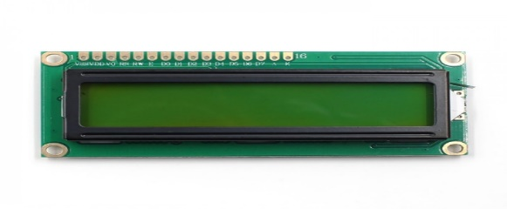

* Arduino UNO : The Arduino Uno board is a microcontroller based on the ATmega328. It has 14 digital **input/output pins** in which 6 can be used as **PWM outputs**, a 16 MHz ceramic resonator, an ICSP header, a USB connection, 6 analog inputs, a power jack and a **reset** button. This contains all the required support needed for microcontroller.

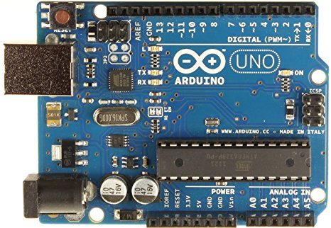

* Push Pull Solenoid: **Solenoids** are basically electromagnets: they are made of a big coil of copper wire with an armature (a slug of metal) in the middle. When the coil is energized, the slug is pulled into the center of the coil. This makes the **solenoid** able to pull (from one end) or **push** (from the other).

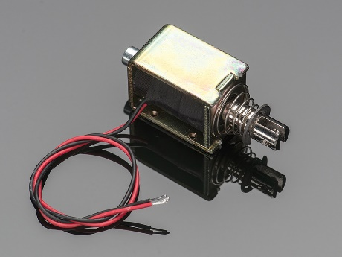

* TIP 120 NPN transistor: **NPN** is one of the two types of bipolar **transistors**, consisting of a layer of P-doped semiconductor (the "base") between two N-doped layers. A small current entering the base is amplified to produce a large collector and emitter current.

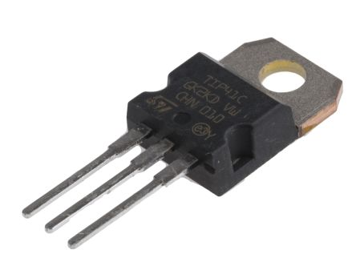

* Power Supply: It is a 9v battery which is use for supplying power to the circuit.It has rectangular prism shape with rounded edges and a polarized snap connector at the top.

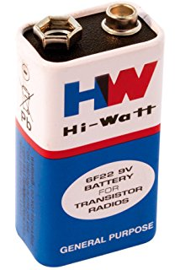

* Breadboard: A **breadboard** is a solderless device for temporary prototype with electronics and test circuit designs. Most electronic components in electronic circuits can be interconnected by inserting their leads or terminals into the holes and then making connections through wires where appropriate.

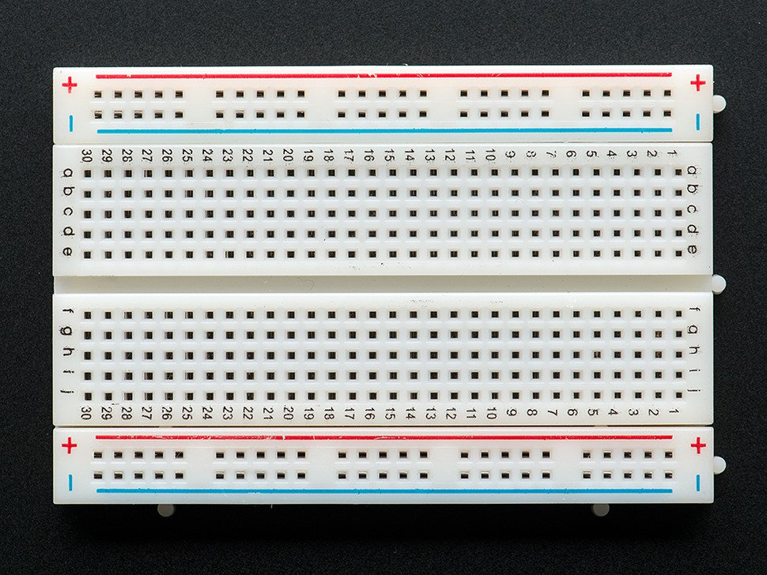

* 1KΩ, 220Ω Resistor: The main **function of resistors** in a circuit is to control the flow of current to other components. Take an LED (light) for example. If too much current flows through an LED it is destroyed. So a **resistor** is used to limit the current.

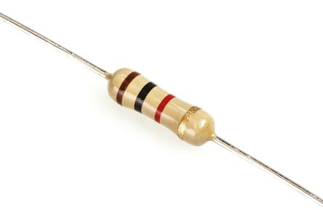

* 10KΩ Potentiometer: A **potentiometer** is a three-[terminal](https://en.wikipedia.org/wiki/Terminal_(electronics)) [resistor](https://en.wikipedia.org/wiki/Resistor) with a sliding or rotating contact that forms an adjustable [voltage divider](https://en.wikipedia.org/wiki/Voltage_divider). If only two terminals are used, one end and the wiper, it acts as a ***variable resistor*** or [***rheostat***.](https://en.wikipedia.org/wiki/Potentiometer#Rheostat)

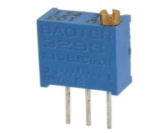

* Buzzer: A **buzzer** or **beeper** is an [audio](https://en.wikipedia.org/wiki/Sound) signalling device, which may be [mechanical](https://en.wikipedia.org/wiki/Machine), [electromechanical](https://en.wikipedia.org/wiki/Electromechanics), or [piezoelectric](https://en.wikipedia.org/wiki/Piezoelectricity) (*piezo* for short). Typical uses of buzzers and beepers include [alarm devices](https://en.wikipedia.org/wiki/Alarm_devices), [timers](https://en.wikipedia.org/wiki/Timer), and confirmation of user input such as a mouse click or keystroke.

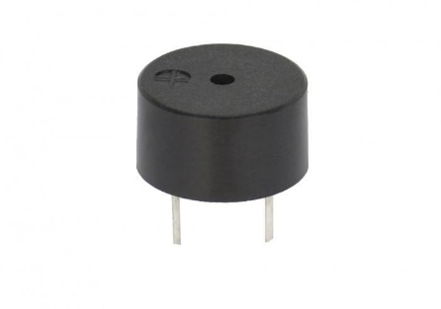

* Connecting wires:These are multi-threaded or single threaded copper wires which are used for connecting different components of the circuit with one another.

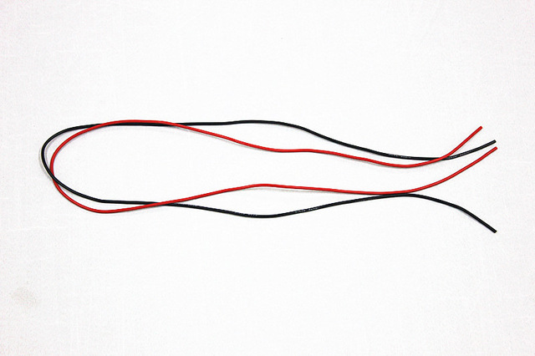 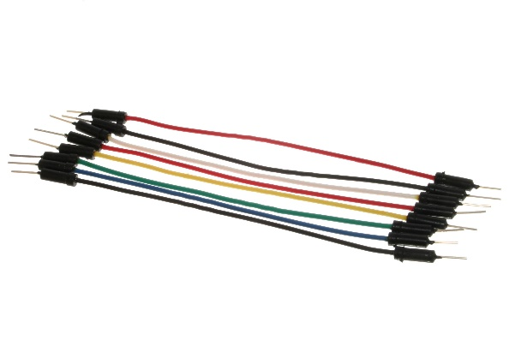

Circuit diagram:

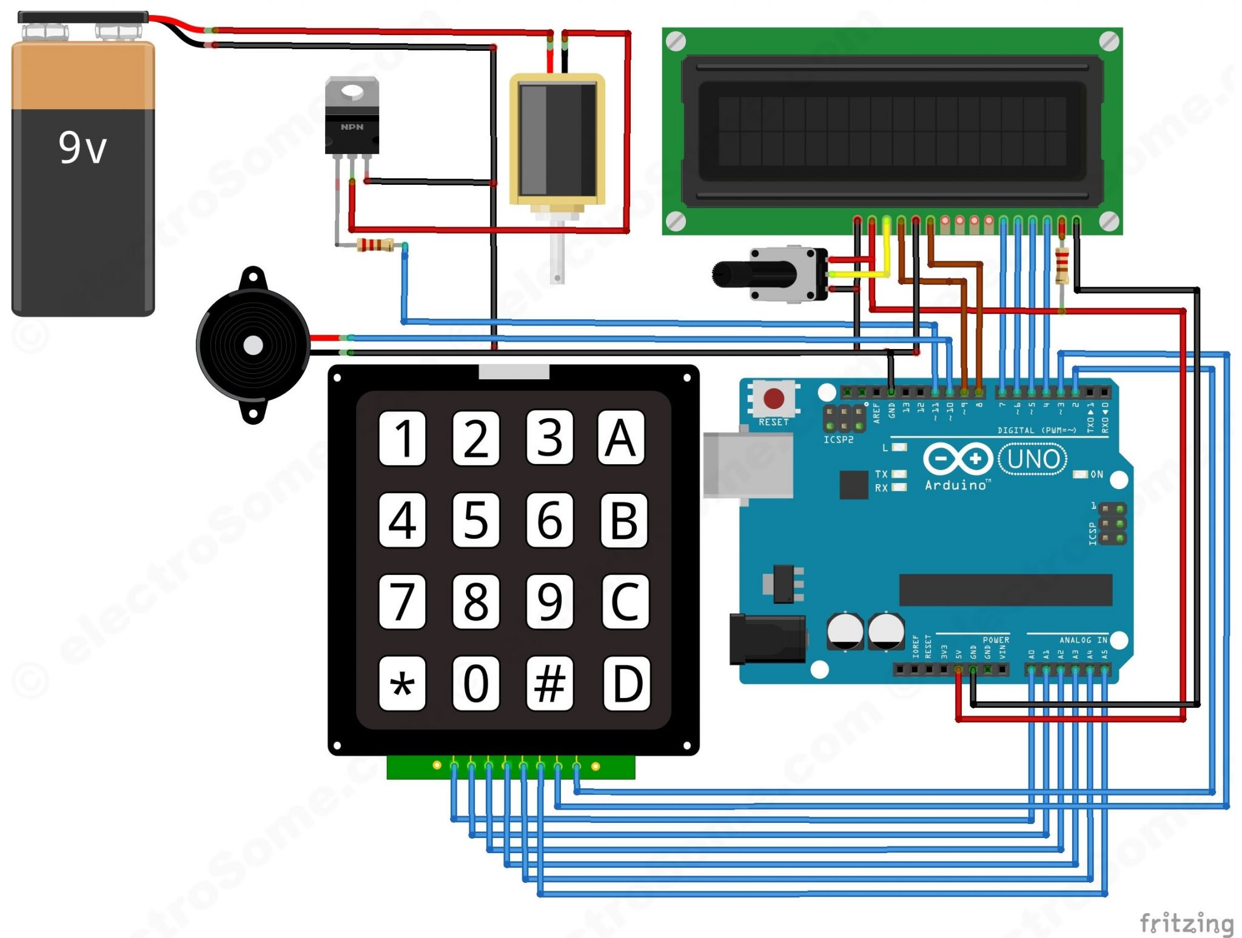

Fig: digital door lock system using arduino

**Working principle:**

In this project, we have used EEPROM in the Arduino to store the password in it. The default password stored in it will be ‘1234’. When we enter a password, it will match it with the password stored in the Arduino EEPROM. If it is correct, then it will show ‘Passkey Accepted’ and the push pull solenoid will come in low state (Door Unlocked). If the password is wrong, then it will show ‘Access Denied’. During this condition the buzzer will start beeping and the push pull solenoid will remain in the high state (Door Locked). The buzzer will also beep once when any key is pressed.

For changing the passkey, we have to press ‘#’. When we press ‘#’, it will ask for current passkey. If we enter the correct password it will ask for new passkey and will save it in the EEPROM.

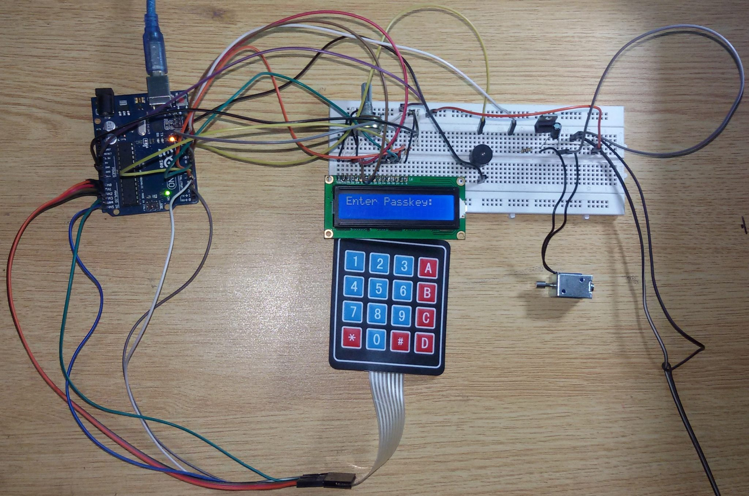

Fig : digital door lock using Arduino uno

ARDUINO CODE:

#include <Keypad.h>

#include<LiquidCrystal.h>

#include<EEPROM.h>

LiquidCrystal lcd(9,8,7,6,5,4);

char password[4];

char pass[4],pass1[4];

int i=0;

char customKey=0;

const byte ROWS = 4; //four rows

const byte COLS = 4; //four columns

char hexaKeys[ROWS][COLS] = {

{'1','2','3','A'},

{'4','5','6','B'},

{'7','8','9','C'},

{'*','0','#','D'}

};

byte rowPins[ROWS] = {A0,A1,A2,A3}; //connect to the row pinouts of the keypad

byte colPins[COLS] = {A4,A5,3,2}; //connect to the column pinouts of the keypad

//initialize an instance of class NewKeypad

Keypad customKeypad = Keypad( makeKeymap(hexaKeys), rowPins, colPins, ROWS, COLS);

int led;

int buzzer = 10;

int m11;

int m12;

void setup()

{

Serial.begin(9600);

pinMode(11, OUTPUT);

lcd.begin(16,2);

pinMode(led, OUTPUT);

pinMode(buzzer, OUTPUT);

pinMode(m11, OUTPUT);

pinMode(m12, OUTPUT);

lcd.print(" Electronic ");

Serial.print(" Electronic ");

lcd.setCursor(0,1);

lcd.print(" Keypad Lock ");

Serial.print(" Keypad Lock ");

delay(2000);

lcd.clear();

lcd.print("Enter Ur Passkey:");

Serial.println("Enter Ur Passkey:");

lcd.setCursor(0,1);

for(int j=0;j<4;j++)

EEPROM.write(j, j+49);

for(int j=0;j<4;j++)

pass[j]=EEPROM.read(j);

}

void loop()

{

digitalWrite(11, HIGH);

customKey = customKeypad.getKey();

if(customKey=='#')

change();

if (customKey)

{

password[i++]=customKey;

lcd.print(customKey);

Serial.print(customKey);

beep();

}

if(i==4)

{

delay(200);

for(int j=0;j<4;j++)

pass[j]=EEPROM.read(j);

if(!(strncmp(password, pass,4)))

{

digitalWrite(led, HIGH);

beep();

lcd.clear();

lcd.print("Passkey Accepted");

Serial.println("Passkey Accepted");

digitalWrite(11, LOW);

delay(2000);

lcd.setCursor(0,1);

lcd.print("#.Change Passkey");

Serial.println("#.Change Passkey");

delay(2000);

lcd.clear();

lcd.print("Enter Passkey:");

Serial.println("Enter Passkey:");

lcd.setCursor(0,1);

i=0;

digitalWrite(led, LOW);

}

else

{

digitalWrite(11, HIGH);

digitalWrite(buzzer, HIGH);

lcd.clear();

lcd.print("Access Denied...");

Serial.println("Access Denied...");

lcd.setCursor(0,1);

lcd.print("#.Change Passkey");

Serial.println("#.Change Passkey");

delay(2000);

lcd.clear();

lcd.print("Enter Passkey:");

Serial.println("Enter Passkey:");

lcd.setCursor(0,1);

i=0;

digitalWrite(buzzer, LOW);

}

}

}

void change()

{

int j=0;

lcd.clear();

lcd.print("UR Current Passk");

Serial.println("UR Current Passk");

lcd.setCursor(0,1);

while(j<4)

{

char key=customKeypad.getKey();

if(key)

{

pass1[j++]=key;

lcd.print(key);

Serial.print(key);

beep();

}

key=0;

}

delay(500);

if((strncmp(pass1, pass, 4)))

{

lcd.clear();

lcd.print("Wrong Passkey...");

Serial.println("Wrong Passkey...");

lcd.setCursor(0,1);

lcd.print("Better Luck Again");

Serial.println("Better Luck Again");

delay(1000);

}

else

{

j=0;

lcd.clear();

lcd.print("Enter New Passk:");

Serial.println("Enter New Passk:");

lcd.setCursor(0,1);

while(j<4)

{

char key=customKeypad.getKey();

if(key)

{

pass[j]=key;

lcd.print(key);

Serial.print(key);

EEPROM.write(j,key);

j++;

beep();

}

}

lcd.print(" Done......");

Serial.println(" Done......");

delay(1000);

}

lcd.clear();

lcd.print("Enter Ur Passk:");

Serial.println("Enter Ur Passk:");

lcd.setCursor(0,1);

customKey=0;

}

void beep()

{

digitalWrite(buzzer, HIGH);

delay(20);

digitalWrite(buzzer, LOW);

}

ACKNOWLEDGEMENT :

With the ongoing revolutions in the field of electronics and communications where innovations are taking place at the blink of eye, it is impossible to keep pace with the emerging trends.

Excellence is an attitude that the whole of the human race is born with. It is the environment that makes sure whether the result of this attitude is visible or otherwise.

During this innovative concept, we the students get the real experience for working in the industry environment. Most of the theoretical knowledge that has been gained during the course of our studies has been put to test. Thanks to INCEPTION for providing us the platform where we can implement delusions into practical occurrence . We had the opportunity to have a real experience on many ventures, which increased our sphere of knowledge to great extent. Also we got a chance to learn many new technologies and also interfaced too many instruments.

Future Scope:

Nowadays technology has dominated to a great degree, in our lives. One of its miracle is the Arduino. Its range of operations makes it an useful tool for the Future ‘The Science today is the technology of tomorrow’. The capabilities and the way this small scientific “miracle” works need to be described and communicated sufficiently.

Arduino is capable of making medical devices and low cost PLC controllers . It can be used to develop an infrared heart sensor .In the field of builders, the consumer would be able to modify the interface in a way to meet their needs via Arduino for security purposes , also Arduino allows a door lock system which is completely user controlled.

Thus, whether it’s medicine, business or industry ,the endless possibilities enabled by Arduino makes it the technology of future.

APPLICATIONS:

Technology has become a daily part of our everyday life and plays a vital role in everyday life of the world. Arduino is a gift of technology which has various applications in the field of electronics.

Arduino is basically a microcontroller which means it has a fixed amount of memory and can run a particular program which has been uploaded into it. So, in this project we aim to build a digital door locking system which would open only if the correct password is entered.

This digital door lock can be used as safety measure in modern world which would increase security.