rcc institute of information technology



# ADDITIONAL EXPERIMENT TO SATISFY PEO AND PO OF RCCIIT, CSE

**TOPIC: PASSWORD BASED DIGITAL DOOR LOCK SYSTEM USING ARDUINO**

**DEPARTMENT: CSE-A, GROUP 2**

**GROUP LEADER: Shreejit Ghatak (CSE2016/044)**

**GROUP MEMBERS: 1. Sahbaj Ali (CSE2016/040)**

**2. Anisha Annu (CSE2016/043)**

**3. Shreya Paul (CSE2016/059)**

**4. Mayank Kumar Tiwari (CSE2016/060)**

**Lab: Communication Engineering and Coding Theory Lab**

**Lab Code: CS-491**

PASSWORD BASED DIGITAL DOOR LOCK SYSTEM USING ARDUINO

**Submitted To:**

* Ms Parama Bagchi.
* Mr. Dipanakar Khorat.

**Submitted By:**

* Sahbaj Ali (CSE2016/040)
* Anisha Annu (CSE2016/043)
* Shreejit Ghatak (CSE2016/044)
* Shreya Paul (CSE2016/059)
* Mayank Kumar Tiwari (CSE2016/060)

**Submitted On:** 24th April, 2018

**Under the Guidance of:**

* Ms. Parama Bagchi, Assistant Professor, Department of Computer Science and Engineering, RCCIIT.
* Mr. Dipankar Khorat, Technical Assistant, Department of Computer Science and Engineering, RCCIIT.

TABLE OF CONTENTS

|  |  |  |
| --- | --- | --- |
| **SL.NO** | **TOPIC** | **PAGE NO.** |
| 1` | Acknowledgement | 4 |
| 2 | Components Required | 5 |
| 3 | Components Description | 6 |
| 4 | Introduction | 10 |
| 5 | Circuit Diagram | 11 |
| 6 | Working Principle | 12 |
| 7 | Source Code | 13 |
| 8 | Remarks and Discussion | 20 |
| 9 | Bibliography | 22 |

ACKNOWLEDGEMENT

We are extremely indebted and thankful to our professor, Ms. Parama Bagchi without whose guidance this very project would not have been impossible to complete. We are also grateful to her for giving us this opportunity to do this project which in turn helped us in improving our concepts and inculcating knowledge and enthusiasm in this subject.

We would also like to thank Mr. Dipankar Khorat without whose constant support , we would not have been able to complete this project.

Finally, although we are not thankful to each other in the group, yet we take a note of appreciation for cooperating, supporting, helping and inspiring each other in the group.

COMPONENTS REQUIRED

|  |  |
| --- | --- |
| **NAME** | **QUANTITY** |
| **Arduino UNO** | **1** |
| **4x4 keypad** | **1** |
| **Buzzer** | **1** |
| **Servo Motor** | **1** |
| **GSM Module** | **1** |
| **16-bit LCD Display** | **1** |
| **Connecting Wires** |  |
| **Breadboard** | **1** |
| **Sim Card** | **1** |
| **Laptop** | **1** |

COMPONENTS DESCRIPTION

* **Arduino UNO** : The Arduino Uno board is a microcontroller based on the ATmega328. It has 14 digital **input/output pins** in which 6 can be used as **PWM outputs**, a 16 MHz ceramic resonator, an ICSP header, a USB connection, 6 analog inputs, a power jack and a **reset** button. This contains all the required support needed for microcontroller.
  + - * 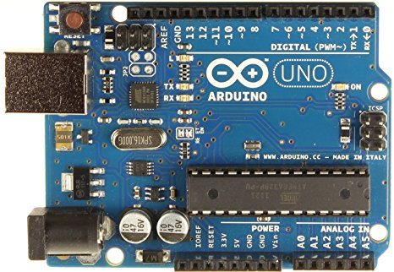
* **4×4 keypad**: it is also called as matrix keypad. Matrix keypad use a combination of 4 rows and 4 columns to provide button states to the host device,typically a microcontroller underneath each key is a pushbutton,with one end connected to the one row and connected to the other column.

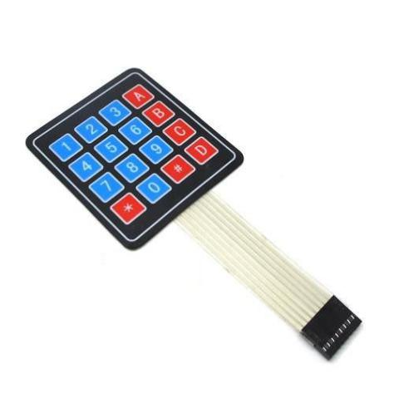

* **Buzzer**: A **buzzer** or **beeper** is an [audio](https://en.wikipedia.org/wiki/Sound) signalling device, which may be [mechanical](https://en.wikipedia.org/wiki/Machine), [electromechanical](https://en.wikipedia.org/wiki/Electromechanics), or [piezoelectric](https://en.wikipedia.org/wiki/Piezoelectricity) (*piezo* for short). Typical uses of buzzers and beepers include [alarm devices](https://en.wikipedia.org/wiki/Alarm_devices), [timers](https://en.wikipedia.org/wiki/Timer), and confirmation of user input such as a mouse click or keystroke.

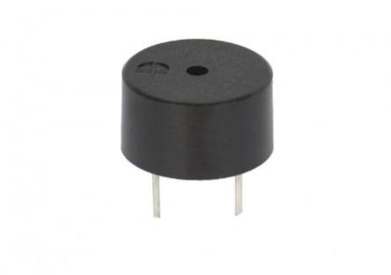

* **Servo motor :** A **servomotor** is a [rotary actuator](https://en.wikipedia.org/wiki/Rotary_actuator) or [linear actuator](https://en.wikipedia.org/wiki/Linear_actuator) that allows for precise control of angular or linear position, velocity and acceleration.[[1]](https://en.wikipedia.org/wiki/Servomotor#cite_note-1) It consists of a suitable motor coupled to a sensor for position feedback. It also requires a relatively sophisticated controller, often a dedicated module designed specifically for use with servomotors. Servomotors are not a specific class of motor although the term *servomotor* is often used to refer to a motor suitable for use in a [closed-loop control](https://en.wikipedia.org/wiki/Closed-loop_control) system.

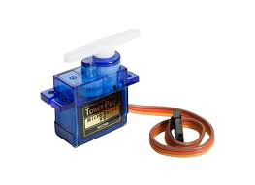.

* **GSM MODULE:GSM** is a standard developed by the European Telecommunications Standards Institute (ETSI) to describe the protocols for second-generation digital [cellular networks](https://en.wikipedia.org/wiki/Cellular_networks) used by [mobile devices](https://en.wikipedia.org/wiki/Mobile_devices) such as [tablets](https://en.wikipedia.org/wiki/Tablet_computer), first deployed in Finland in December 1991.[[2]](https://en.wikipedia.org/wiki/GSM#cite_note-2) As of 2014, it has become the global standard for mobile communications – with over 90% market share, operating in over 193 countries and territories.[[3]](https://en.wikipedia.org/wiki/GSM#cite_note-3)

2G networks developed as a replacement for first generation ([1G](https://en.wikipedia.org/wiki/1G)) analog cellular networks, and the GSM standard originally described as a digital, circuit-switched network optimized for [full duplex](https://en.wikipedia.org/wiki/Duplex_(telecommunications)#Full_duplex) voice [telephony](https://en.wikipedia.org/wiki/Telephony)

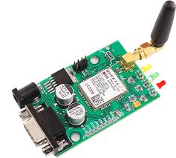

* [**LCD**](https://electrosome.com/lcd-display-fundamentals/) : The full form of lcd is “liquid crystal display”.it has 16 pins out of which 8 pins are used as data pins.A **16x2 LCD** means it can display 16 characters per line and there are 2 such lines. In this LCD each character is displayed in 5x7 pixel matrix. This LCD has two registers, namely, Command and Data.

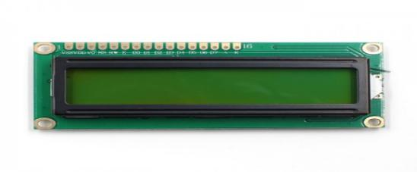

* **Connecting wires**: These are multi-threaded or single threaded copper wires which are used for connecting different components of the circuit with one another.

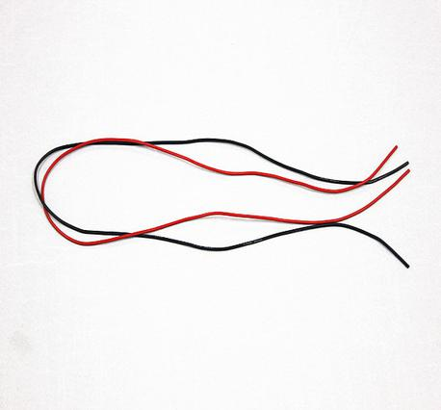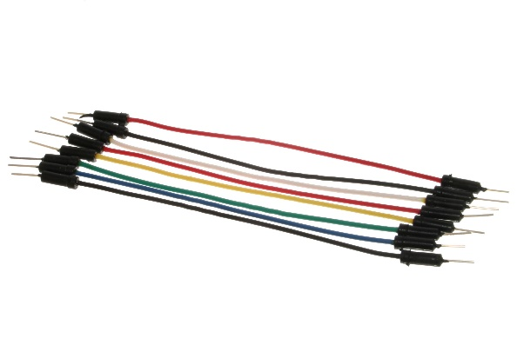

* **Breadboard**: A **breadboard** is a solderless device for temporary prototype with electronics and test circuit designs. Most electronic components in electronic circuits can be interconnected by inserting their leads or terminals into the holes and then making connections through wires where appropriate

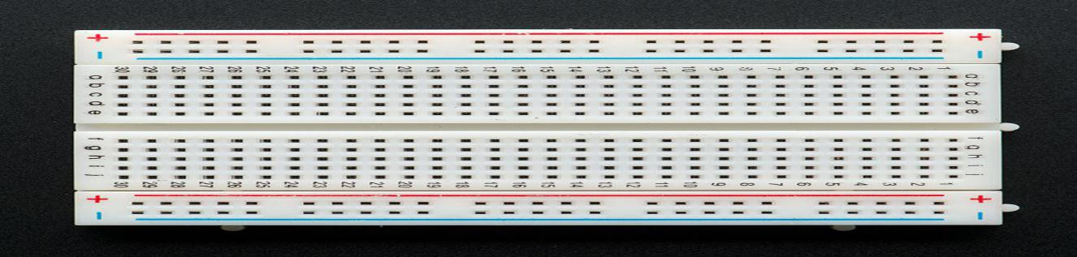

* **Potentiometer:** A potentiometer is a three-terminal resistor with a sliding or rotating contact that forms an adjustable voltage divider. If only two terminals are used, one end and the wiper, it acts as a variable resistor or rheostat.

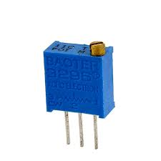

INTRODUCTION

This project is implemented by the use of an **Arduino** connected with a LCD display and a GSM module along with a 4x4 keypad. For the door locking system we have simply taken a model door and connected the latch of the servo motor with the hinges of the door. When the passkey entered through the keypad matches with that of the stored one in the Arduino memory then the servo motor will be signalled for normal operation that is opening, but for security reasons we have used made the door open for only 5 seconds after which it will automatically be closed. The security system comes into play when a wrong passkey is entered in through the keypad. As soon as the Arduido receives a passkey which is not matching with that of the one stored in the Arduino it sends a high signal to the buzzer which is made to go off when a wrong passkey is entered and it will buzz 5 times with a duration of 20 nanoseconds between the buzzes. Also for an efficient security system, we have taken care of the security in 2 stages, that is when after 10 nanoseconds of the buzzer going off, a system generated message will be delivered for a registered mobile number as per the will of the user.

Hence this arduino based security system ensures a 2 step and easy-to-use security system.

CIRCUIT DIAGRAM

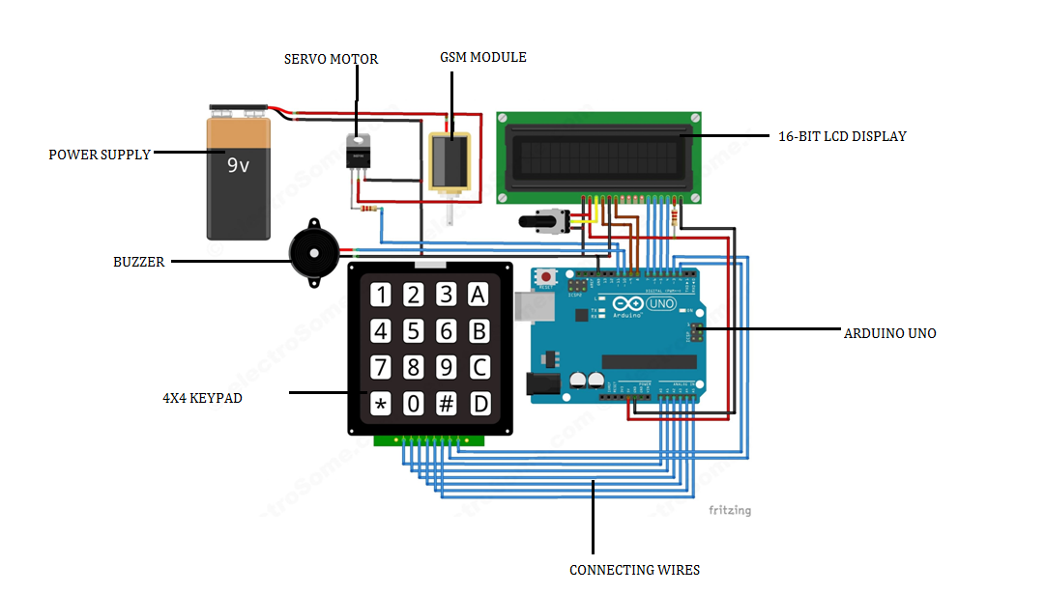

WORKING PRINCIPLE

In this project, we have used EEPROM in the Arduino to store the password in it. The default password stored in it will be ‘1234’. When we enter a password, it will match it with the password stored in the Arduino EEPROM. If it is correct, then it will show ‘Passkey Accepted’ and the push pull solenoid will come in low state (Door Unlocked). If the password is wrong, then it will show ‘Access Denied’. During this condition the buzzer will start beeping and the push pull solenoid will remain in the high state (Door Locked). The buzzer will also beep once when any key is pressed.

For changing the passkey, we have to press ‘#’. When we press ‘#’, it will ask for current passkey. If we enter the correct password it will ask for new passkey and will save it in the EEPROM.

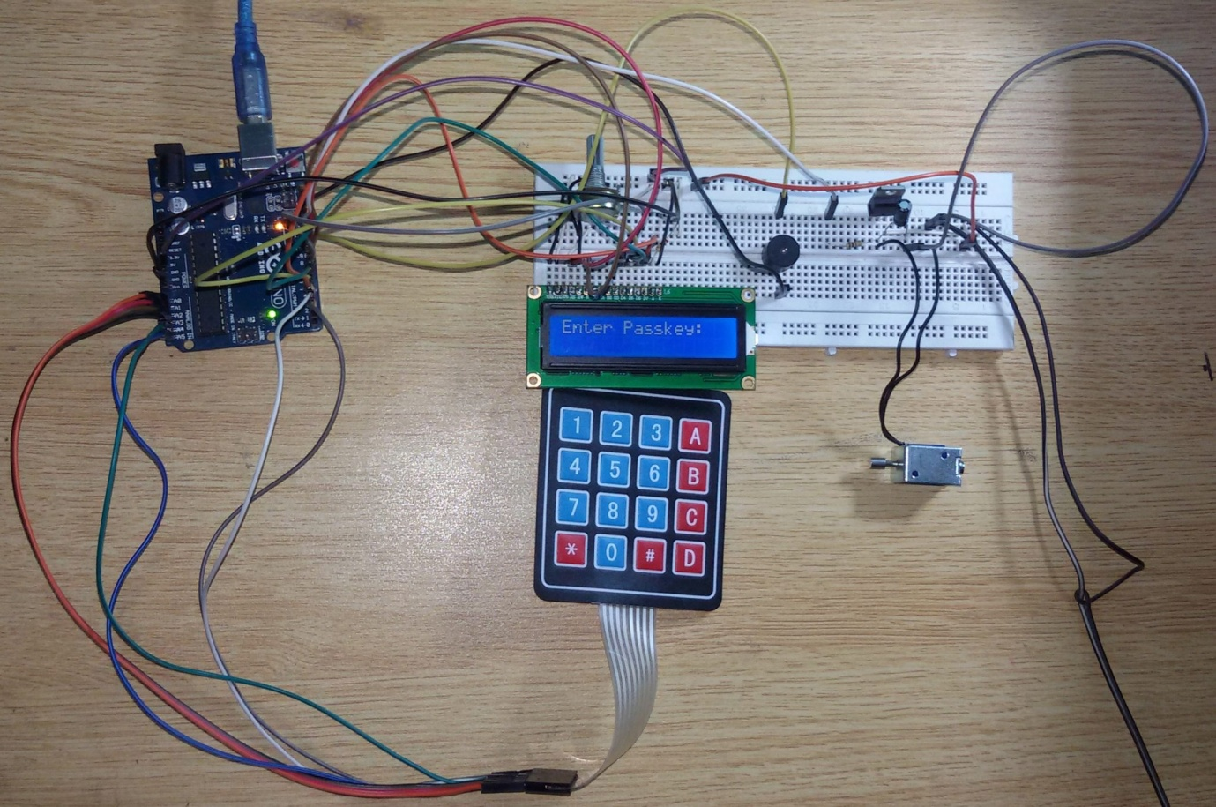

**FIG: DIGITAL DOOR LOCKING SYSTEM USING ARDUINO**

SOURCE CODE

#include <Servo.h>

#include <Keypad.h>

#include<LiquidCrystal.h>

#include<EEPROM.h>

#include <SoftwareSerial.h>

SoftwareSerial mySerial(2, 3);

LiquidCrystal lcd(9,8,7,6,5,4);

Servo myservo;

int pos=0;

char password[4];

char pass[4],pass1[4];

int i=0;

int pulse=1500;

char customKey=0;

const byte ROWS = 4;

const byte COLS = 4;

char hexaKeys[ROWS][COLS] = {

{'1','2','3','A'},

{'4','5','6','B'},

{'7','8','9','C'},

{'*','0','#','D'}

};

byte rowPins[ROWS] = {A0,A1,A2,A3};

byte colPins[COLS] = {A4,A5,13,12};

Keypad customKeypad = Keypad( makeKeymap(hexaKeys), rowPins, colPins, ROWS, COLS);

int led;

int buzzer = 10;

int m11;

int m12;

void setup()

{

Serial.begin(9600);

pinMode(11, OUTPUT);

myservo.attach(11);

delay(100);

mySerial.begin(9600);

Serial.begin(9600);

delay(100);

lcd.begin(16,2);

pinMode(led, OUTPUT);

pinMode(buzzer, OUTPUT);

pinMode(m11, OUTPUT);

pinMode(m12, OUTPUT);

lcd.print(" Electronic ");

Serial.print(" Electronic ");

lcd.setCursor(0,1);

lcd.print(" Keypad Lock ");

Serial.print(" Keypad Lock ");

delay(2000);

lcd.clear();

lcd.print("Enter Ur Passkey:");

Serial.println("Enter Ur Passkey:");

lcd.setCursor(0,1);

for(int j=0;j<4;j++)

EEPROM.write(j, j+49);

for(int j=0;j<4;j++)

pass[j]=EEPROM.read(j);

}

void loop()

{

//digitalWrite(11, HIGH);

customKey = customKeypad.getKey();

if(customKey=='*')

changeabc();

if(customKey=='#')

change();

if (customKey)

{

password[i++]=customKey;

lcd.print(customKey);

Serial.print(customKey);

beep();

}

if(i==4)

{

delay(200);

for(int j=0;j<4;j++)

pass[j]=EEPROM.read(j);

if(!(strncmp(password, pass,4)))

{

for (pos = 0; pos <=180 ; pos += 1) {

myservo.write(pos);

}

delay(100);

digitalWrite(led, HIGH);

beep();

lcd.clear();

lcd.print("Passkey Accepted");

Serial.println("Passkey Accepted");

delay(5000); //5s gap as delay

for(pos=180;pos>=0;pos-=1)

{

myservo.write(pos);

}

delay(2000);

lcd.setCursor(0,1);

lcd.print("#.Change Passkey");

Serial.println("#.Change Passkey");

delay(2000);

lcd.clear();

lcd.print("Enter Passkey:");

Serial.println("Enter Passkey:");

lcd.setCursor(0,1);

i=0;

digitalWrite(led, LOW);

}

else

{

digitalWrite(buzzer, HIGH);

lcd.clear();

lcd.print("Access Denied...");

Serial.println("Access Denied...");

lcd.setCursor(0,1);

lcd.print("#.Change Passkey");

Serial.println("#.Change Passkey");

delay(2000);

lcd.clear();

lcd.print("Enter Passkey:");

Serial.println("Enter Passkey:");

lcd.setCursor(0,1);

i=0;

digitalWrite(buzzer, LOW);

SendMessage();

}

}

}

void change()

{

int j=0;

lcd.clear();

lcd.print("UR Current Passk");

Serial.println("UR Current Passk");

lcd.setCursor(0,1);

while(j<4)

{

char key=customKeypad.getKey();

if(key)

{

pass1[j++]=key;

lcd.print(key);

Serial.print(key);

beep();

}

key=0;

}

delay(500);

if((strncmp(pass1, pass, 4)))

{

lcd.clear();

lcd.print("Wrong Passkey...");

Serial.println("Wrong Passkey...");

lcd.setCursor(0,1);

lcd.print("Better Luck Again");

Serial.println("Better Luck Again");

delay(1000);

}

else

{

j=0;

lcd.clear();

lcd.print("Enter New Passk:");

Serial.println("Enter New Passk:");

lcd.setCursor(0,1);

while(j<4)

{

char key=customKeypad.getKey();

if(key)

{

pass[j]=key;

lcd.print(key);

Serial.print(key);

EEPROM.write(j,key);

j++;

beep();

}

}

lcd.print(" Done......");

Serial.println(" Done......");

delay(1000);

}

lcd.clear();

lcd.print("Enter Ur Passk:");

Serial.println("Enter Ur Passk:");

lcd.setCursor(0,1);

customKey=0;

}

void beep()

{

digitalWrite(buzzer, HIGH);

delay(20);

digitalWrite(buzzer, LOW);

}

void SendMessage()

{

mySerial.println("AT+CMGF=1");

delay(1000);

mySerial.println("AT+CMGS=\"+918910707970\"\r");

delay(1000);

mySerial.println("Intruder alert");

delay(100);

mySerial.println((char)26);

delay(1000);

}

void changeabc()

{ delay(200);

for(pos=180;pos>=0;pos-=1)

{

myservo.write(pos);

}

}

REMARKS AND DICUSSION

Nowadays technology has dominated to a great degree, in our lives. One of its miracle is the Arduino. Its range of operations makes it an useful tool for the Future ‘The Science today is the technology of tomorrow’. The capabilities and the way this small scientific “miracle” works need to be described and communicated sufficiently.

Arduino is capable of making medical devices and low cost PLC controllers. It can be used to develop an infrared heart sensor .In the field of builders, the consumer would be able to modify the interface in a way to meet their needs via Arduino for security purposes , also Arduino allows a door lock system which is completely user controlled.

Thus, whether it’s medicine, business or industry ,the endless possibilities enabled by Arduino makes it the technology of future.

Further Applications:

Technology has become a daily part of our everyday life and plays a vital role in everyday life of the world. Arduino is a gift of technology which has various applications in the field of electronics.

Arduino is basically a microcontroller which means it has a fixed amount of memory and can run a particular program which has been uploaded into it. So, in this project we aim to build a digital door locking system which would open only if the correct password is entered.

This digital door lock can be used as safety measure in modern world which would increase security.

BIBLIOGRAPHY

* [www.wikipedia.com](http://www.wikipedia.com)
* [www.theelectronicshub.com](http://www.theelectronicshub.com)
* [www.arduino.cc](http://www.arduino.cc)

