SIMPLILEARN PROJECT

**PROJECT NAME – LockedMe.com**

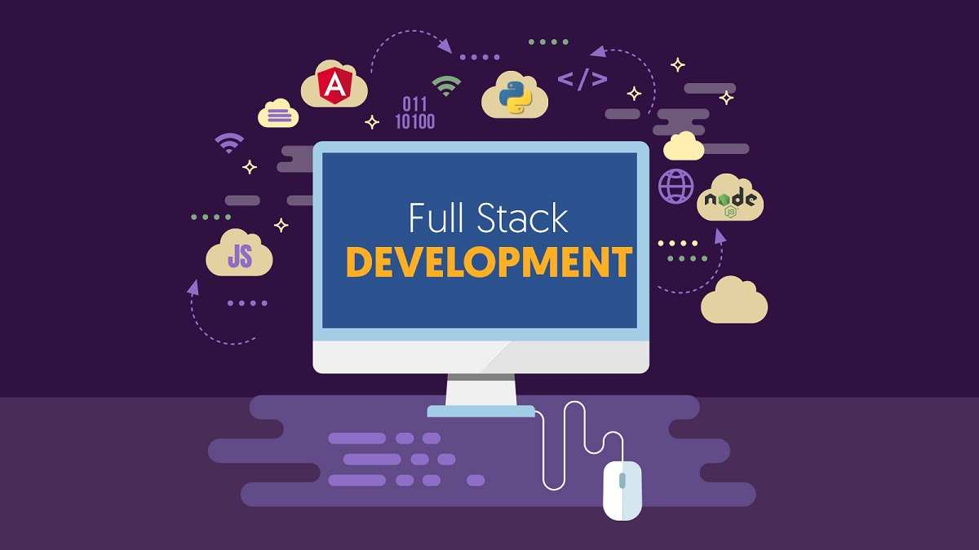

**Divyanshi Rastogi**

**28-09-2022**

**Full Stack Java Developer**

**CORE CONCEPTS USED**

* Basic Java concepts
* Conditional loop - For, if-else, while loop
* Switch statement
* Arrays
* Collections
* Sorting
* File handling
* Exception handling

**GITHUB REPOSITORY LINK**

[**https://github.com/12345divyanshimasi12345/lockedmegit**](https://github.com/12345divyanshimasi12345/lockedmegit)

**ALGORITHM**

Step 1: Write java code to display welcome screen with developer details.

Step 2: Write java code to display 3 options:

* Retrieving the file names in an ascending order
* Business-level operations:
* Add a file
* Delete a file
* Search a file
* Navigate to main menu
* Option to close the application

Step 3: Read option, If option-1 is selected, use Collections and sorting concepts to sort the file names in ascending order and get the sorted file names.

Step 4: If option-2 is selected, display further 4 operations, and allow the user to input one value as a choice.

* If sub-option 1 is selected (Add a file) – Ask user to put file name in the console, once the user enters a file name, make use of some case-sensitivity checks, and see if any other file exists with the same name, if yes, return File already exists else create a file in the folder using File Handling concepts and return file is added.
* If sub-option 2 is selected (Delete a file) – Ask user to put file name in the console, once the user enters a file name, make use of some case-sensitivity checks, and see if a file exists with the same name, if yes, delete the File else return file not found.
* If sub-option 3 is selected (Search a file) – Ask user to put file name in the console, once the user enters a file name, make use of some case-sensitivity checks, and see if a file exists with the same name, if yes, return File Found! else return file not found.
* If sub-option 4 is selected, navigate back to the main menu.

Step 5: If option 3 is selected, Close the Application.

**FLOWCHART**

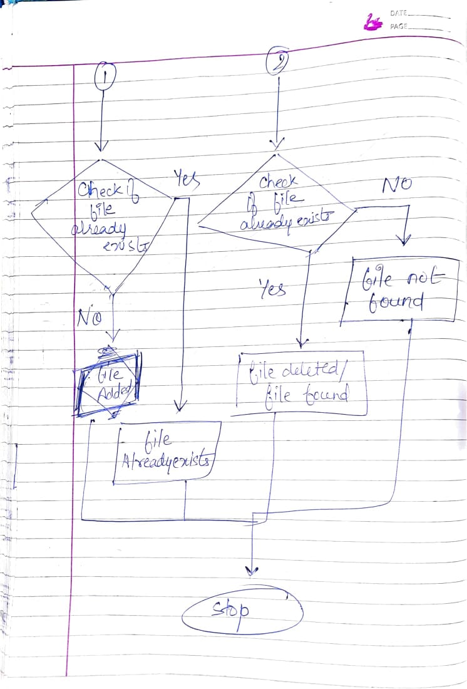

**SPRINTS**

**LCS SPRINT-1**

**Steps followed: ----------------------------------------------------------------------------------------**

* Create an account on Jira to create and manage sprints.
* Create a Project with Scrum template.

Project Name – DivyanshiLockedMe.com

* Study the project carefully and list all the requirements and features need to be implemented in the project.
* Product Manager will arrange a scrum meeting and discuss all the basic requirements with the team members and estimate the time taken by each task based on the features, requirements given by the Product Owner.
* Product Manager will add the issues in form of task and stories on Jira dashboard.
* All the issues will be first added into the backlogs section as we can see in the below picture.

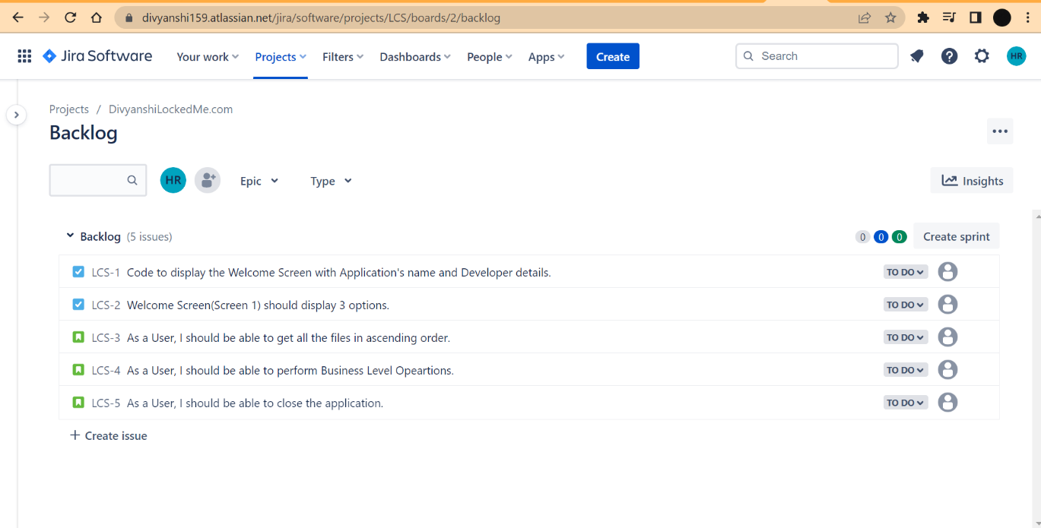

* Click on **create sprint.**
* Sprint will be created as shown below.

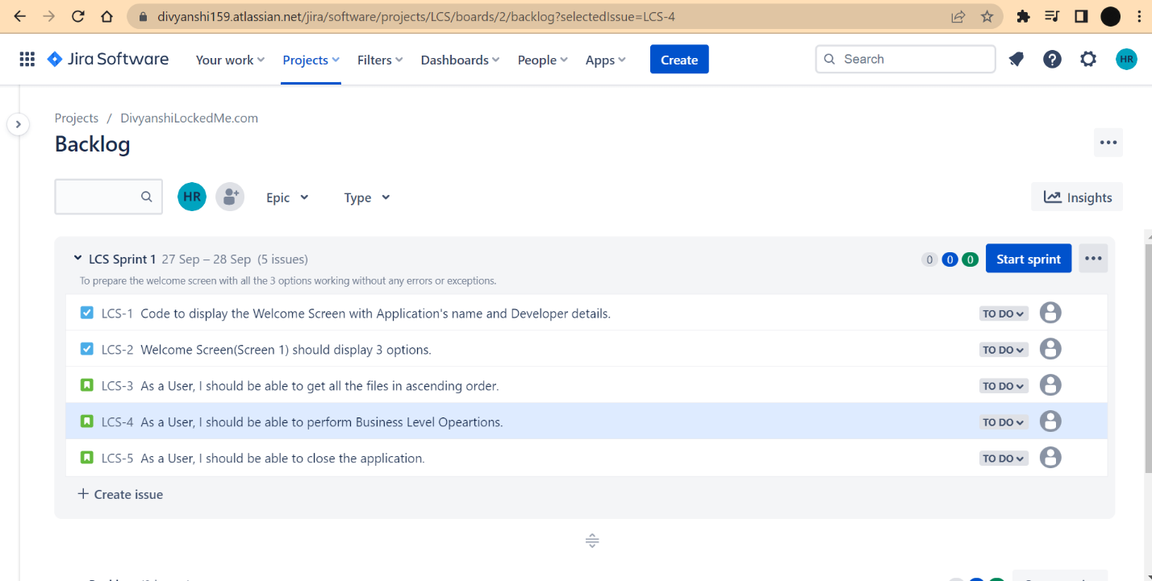

* Click on **Start Sprint** and give the time estimate to complete this sprint. (I have given 1 day)
* Sprint dashboard will have 3 columns (Customizable as per business need)
* TO DO
* IN PROGRESS
* DONE
* Once you start working on a task, move it to the in-progress column and once the task is achieved, move it to the DONE column.

* As soon as all the tasks and stories assigned are moved in the DONE column, you can click on **Complete Sprint**.

* After clicking on Complete Sprint, below screen will be displayed indicating that all the tasks under sprint 1 have been achieved.

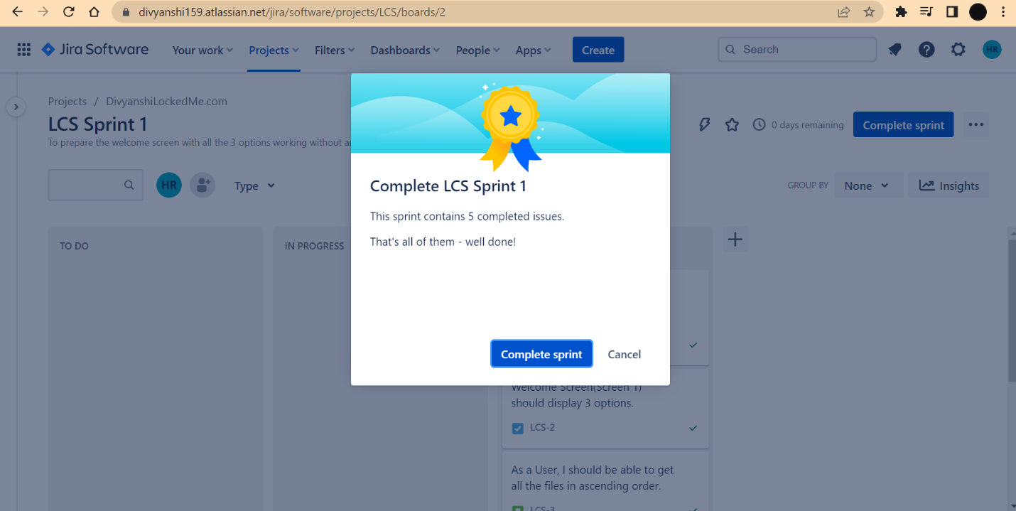

**LCS SPRINT – 2**

* Create another sprint to complete the second part of the project i.e., to add 4 operations inside option 2 (Business Level Operations).
* Create tasks and story points, then move them to the Sprint 2.

* Once all the tasks are completed, click on complete sprint.

* This is how, we can split the work into several sub-tasks and manage them in sprint for timely delivery of the software.

**SOURCE CODE**

**CONSOLE OUTPUT**

* Option 1 : Displaying welcome screen and choosing first option from main menu to retrieve all the files in ascending order. Text

  Description automatically generated with low confidence
* Option 2 – Business Level Operations – It has 3 operations as follows-
* ADD A FILE

Case 1: Adding a new file newfile.txt if it does not exists already.

Case 2: If a file with the same name already exists

* DELETE A FILE

Case 1: File found and deleted successfully.

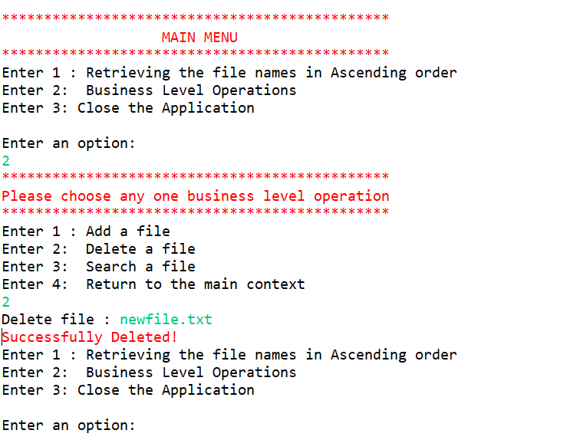

Case 2: If the file name is case sensitive, then return file not found.

Case 3: If the file does not exists, return file not found.

* SEARCH A FILE

Case 1 : If the file is found, return File found!

Case 2:

If Case sensitivity is enabled and user is entering filename.

* Do not match exactly with the existing file name, return File not found!

* Matches perfectly with the existing file name, return File Found!

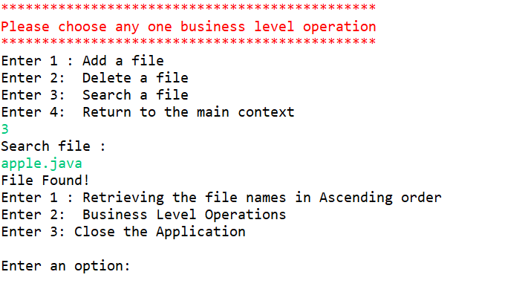

Case 3 : If the file does not exists, return File not Found.

* Option 3: Closing the application

