**James Muir - SDV ASSIGNMENT 2 PHASE 1**

**Application overview:**

**Main Form**

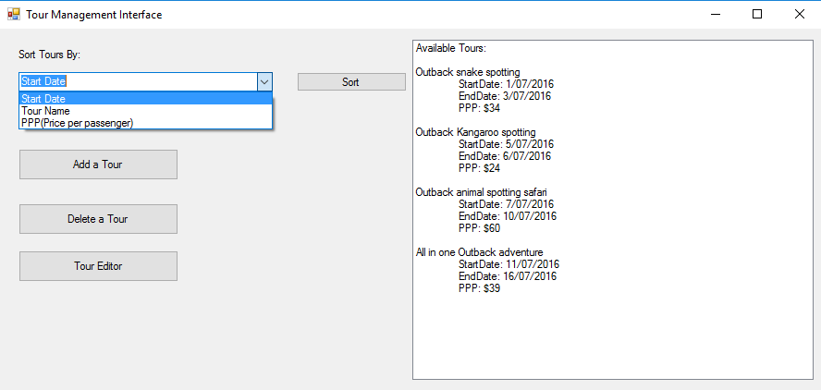

**Form for adding a new tour (users clicks add a tour on main form)**

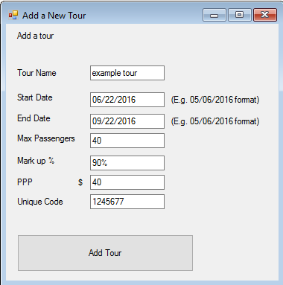

**Form for editing tours (user clicks tour editor on main form)**

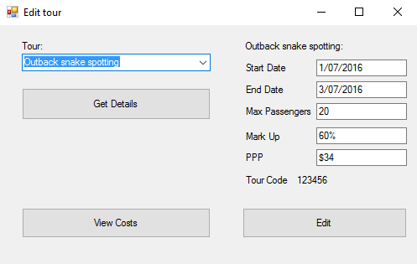

**Form to delete a tour (user clicks delete a tour on form main)**

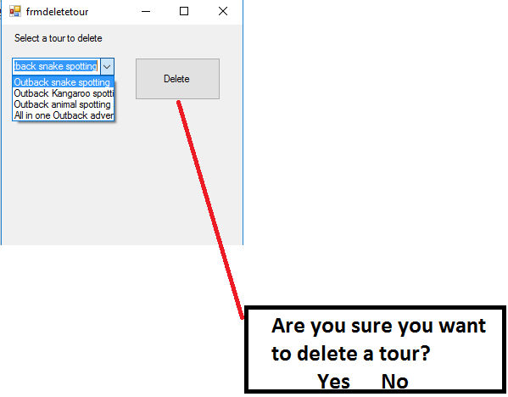

**Form to Get/Edit the sum of all costs by their ‘type’**

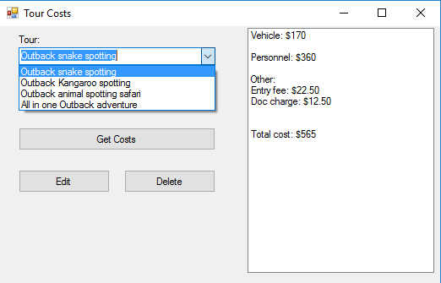

**Error messages**

|  |  |  |  |
| --- | --- | --- | --- |
| **Form** | **Cause** | **Message** | **Options** |
| Main form | User sorts tours but none exist in the inventory | “no existing tours to sort” | “ok” |
| Add a tour form | User specifies a unique code that already exists for another tour | “please choose a unique code for this tour” | “ok” |
| Add a tour from | User specifies a start date after the end date | “invalid start-end dates entered” | “ok” |
| Add a tour form | User specifies an end date before start date | “invalid start-end dates entered” | “ok” |
| Add a tour from | User puts invalid characters in the max passenger field | “please add onlya number for the max passenger field” | “ok” |
| Add a tour form | User puts invalid characters in PPP field | “please add only a number for the PPP field” | “ok” |
| Add a tour from | User leaves one or more fields black | “please fill in all fields before adding a tour” | “ok” |
| Tour Edit form | User Goes to **Edit** a tour but enters invalid input in one or more fields | Error: “invalid character entered for one or more fields- Tour not updated” | “ok” |
| User adds invalid start/end dates i.e. end date is before start date of a tour | Error:”cannot schedule tours to end before they start” | “ok” |
| Tour Costs Form | User goes to **edit** cost details but enters invalid input | Error: ”invalid input entered for one or more fields- Tour costs not updated” | “ok” |
| Delete A tour form | User goes to delete an item but nothing is selected | Error: “No item selected for deletion” | User goes to delete an item but nothing is selected |

**Use Cases:**

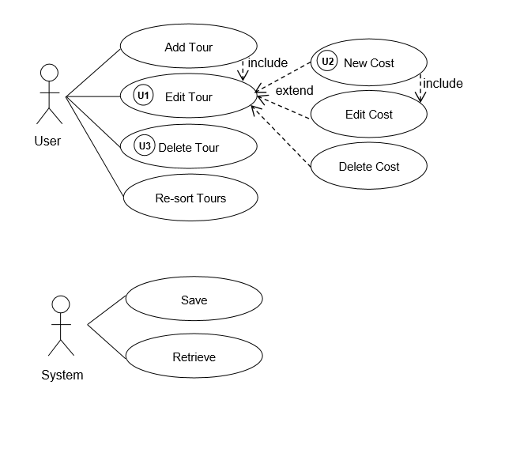

|  |  |  |
| --- | --- | --- |
| **Number** | **Use Case** | **Why?** |
| 1 | Edit Tour | A user needs to be able to edit an existing tour |
| 2 | New cost | A user can add a new cost item and its value |
| 3 | Delete tour | User can delete a tour if it no longer runs |
| 4 | Edit cost | User can edit an existing cost item/value |
| 5 | Delete cost | User can delete an existing cost item |
| 6 | Add tour | User can add a new tour to the list |
| 7 | Resort tours | User can sort tours i.e. by price to view information |

**Jatski Template use-case documentation:**

|  |  |
| --- | --- |
| **Use-Case** | Edit Tour |
| **Version,Date** | 1, 30th may 2016 |
| **Author** | James Muir |
| **Summary** | The staff of the tour business can edit an existing tour by clicking ‘edit’ on the main form and entering relevant details |
| **Priority** | High. (Several uses cases are dependent) |
| **Dependencies** | Included by: add tour  Extended by: New cost  Extended by: Edit cost  Extended by: Delete cost |
| **Actors** | User(employee) |
| **Trigger** | User clicks edit tour button |
| **Pre-conditions** | Must select an existing tour |
| **Description** | 1. User clicks edit tour button 2. User enters relevant input 3. User selects OK |
| **Extensions/exceptions** |  |
| **Illustrations** | See above diagram |
| **Post-conditions** | Tour edit is updated/saved |

|  |  |
| --- | --- |
| **Use-Case** | New Cost |
| **Version,Date** | 1, 30th may 2016 |
| **Author** | James Muir |
| **Summary** | The staff of the tour business add a new cost by clicking ‘edit’ on the cost form and entering relevant details |
| **Priority** | High |
| **Dependencies** | Extends: Edit tour  Includes: Edit cost |
| **Actors** | User(employee) |
| **Trigger** | User clicks edit tour button |
| **Pre-conditions** | Must select an existing tour |
| **Description** | 1. User clicks edit tour button 2. User enters relevant input 3. User selects OK |
| **Extensions/exceptions** |  |
| **Illustrations** | See above diagram |
| **Post-conditions** | Tour edit is updated/saved |

|  |  |
| --- | --- |
| **Use-Case** | Delete tour |
| **Version,Date** | 1, 30th may 2016 |
| **Author** | James Muir |
| **Summary** | The staff of the tour business can delete a tour by clicking ‘delete’ on the main form and accepting the confirmation |
| **Priority** | Low |
| **Dependencies** |  |
| **Actors** | User(employee) |
| **Trigger** | User clicks delete |
| **Pre-conditions** | Tour must exist |
| **Description** | 1. User clicks delete 2. User is taken to a subform to select which tour to delete 3. User clicks Delete and selects OK to confirm deletion 4. System is updated |
| **Extensions/exceptions** | User can select cancel |
| **Illustrations** | See diagram above |
| **Post-conditions** | System is updated/saved |

**Class diagram(unfinished)**

