CompGraphRAG: A Knowledge Graph-Augmented Retrieval Framework for Intelligent Enterprise Compliance Workflows — A HIPAA Case Study
Mahaboob Johny Shaik
Independent Researcher — Denton, TX, USA
Email: Mahaboobshaikusa@gmail.com
EDITOR'S NOTE (delete before final submission): This is the full paper with every accuracy/ECE/p-value figure corrected to match the verbatim output of eval_harness.py (results/eval_results_raw.json). Table II, Fig. 3, and Fig. 5 have been replaced/regenerated; Fig. 1, Fig. 2, and Fig. 4 are unchanged from the original (Fig. 4's faithfulness value, 0.9679, did not change between drafts). New Section VII-E reports entity-linking precision/recall, promised in Section IV-C but missing from the prior draft. The GitHub README table still needs a separate update to match this version — that is tracked as a follow-up, not done in this file.

Abstract
Enterprise compliance determination — for example, deciding whether a specific healthcare data disclosure satisfies HIPAA mandates — requires reasoning across relationally distributed, heterogeneous documents that include regulations, contracts, clinical policies, and access logs. Standard vector-based Retrieval-Augmented Generation (RAG) treats these documents as flat, isolated chunks and is hypothesized to degrade on multi-hop regulatory queries. Black-box large language model (LLM) outputs also lack auditable justification trails and calibrated uncertainty, which limits their suitability for high-stakes compliance auditing. We present CompGraphRAG, a framework that unifies (1) a schema-based knowledge graph ontology (TBox/ABox) with temporal versioning of regulatory concepts, (2) a formal hybrid retrieval scoring function combining dense bi-encoder similarity, graph-path decay, and Personalized PageRank node authority, (3) a neuro-symbolic rule-check layer that evaluates declarative regulatory exceptions prior to generation, (4) audit-grade explainability via traversable justification subgraphs scored with a quantitative faithfulness metric, and (5) split conformal prediction that furnishes distribution-free confidence sets and routes low-confidence determinations to human review.
Compliance determination is formalized as a function f: Q × D × G → (d, c, π) and instantiated in a HIPAA case study. This manuscript reports results from a 24-item synthetic HIPAA compliance-QA benchmark (6 items at each of 1-, 2-, 3-, and 4-hop complexity), evaluated with a real sentence-embedding encoder (all-MiniLM-L6-v2) against two fairness-matched baselines that use the identical rule-based answer-readout step as CompGraphRAG: Vector-RAG (pure dense cosine-similarity retrieval) and Naive-RAG (a 0.5/0.5 blend of keyword overlap and dense similarity). This design isolates retrieval architecture as the variable under test, separating it from answer-extraction sophistication. Under this controlled comparison, CompGraphRAG achieved 100.0% overall accuracy (24/24), against 87.5% (21/24) for both the Vector-RAG and Naive-RAG baselines, tying both baselines at 3- and 4-hop and outperforming them at 1- and 2-hop (paired t-test p = 0.0830; Wilcoxon signed-rank p = 0.0833; N = 24). Neither test clears the conventional 0.05 significance threshold, and the effect size (Cohen's d ≈ 0.37) is small-to-medium, so this is reported as a promising but not yet statistically confirmed accuracy advantage, not as proof of the paper's original hop-scaling hypothesis.
The same evaluation supports two further claims: CompGraphRAG's justification subgraphs and generated explanations are independently, non-tautologically faithful to retrieved evidence (mean F1 = 0.9679, verified against per-item natural-language generation with genuine content-dependent variation), and its conformal uncertainty layer achieves a calibration error of 0.0114 against a 90% target coverage level. Entity-linking recall is 0.8438 with precision of only 0.2191 (F1 = 0.3479); despite low linker precision, end-to-end accuracy remained at 100%, suggesting the downstream rule-check and graph-path scoring stages filter out most incorrectly-linked candidates before they affect the final determination — a mechanism this paper flags as requiring its own ablation rather than treating it as confirmed. CompGraphRAG's contribution is therefore positioned as a combination of a promising, mechanistically-explainable accuracy advantage together with audit-grade explainability and calibrated uncertainty quantification for compliance determination. The full statistical validation plan, threat model, and reproducibility package are reported so that this framing can be tested further at larger scale and against external graph-RAG baselines (Microsoft GraphRAG, LightRAG, HippoRAG); none of these three could be executed in the present environment, and each is marked as not measured rather than estimated.
Index Terms—Retrieval-Augmented Generation, Knowledge Graphs, Enterprise Compliance, HIPAA, Explainable AI, Conformal Prediction, Neuro-Symbolic Reasoning, Healthcare Informatics, Multi-Hop Question Answering, Uncertainty Quantification.

I. Introduction
Healthcare organizations and their business associates operate under continuous obligations to demonstrate that patient-data handling complies with the Health Insurance Portability and Accountability Act (HIPAA) Privacy and Security Rules. A single compliance question is a good illustration of why this is hard: whether a named recipient may receive a described disclosure for a stated purpose often cannot be answered from one document alone. Answering it typically means chaining together a policy clause, a role or permission definition, a data-flow description, and, where relevant, a business-associate agreement or a treatment/payment/operations (TPO) exception, drawn from several distinct source documents. The underlying problem is relationally distributed and multi-hop; it is not a single-passage lookup task.
Retrieval-Augmented Generation (RAG) [1] has become the dominant pattern for grounding large language model (LLM) outputs in external documents. Conventional dense-vector RAG, however, retrieves independently ranked passages and has no native representation of the entities and relations that connect them. Graph-augmented alternatives such as Microsoft's GraphRAG [2], LightRAG [3], and HippoRAG [4] close part of that gap by explicitly modeling entities and relationships as a graph; each has shown that graph-mediated retrieval improves performance on questions requiring synthesis across documents. None of these three systems, though, was designed for a regulated compliance domain. They lack a formally typed regulatory schema, a mechanism for enforcing declarative regulatory exceptions before generation, a machine-checkable explanation artifact suitable for an audit trail, and a calibrated confidence signal capable of safely routing uncertain determinations to a human reviewer. In a HIPAA compliance setting these are close to mandatory requirements, not optional conveniences.
Each neighboring line of work falls short of compliance determination for a specific, identifiable reason, and it is worth stating those reasons precisely instead of gesturing at them in general terms. GraphRAG's community-detection summarization [2] targets corpus-wide synthesis questions such as "what are the main themes in this corpus," a different task from tracing a single, auditable chain of evidence to a binary or three-way legal determination. Its output is a synthesized narrative, not a checkable path attached to a citable rule. LightRAG [3] and HippoRAG [4] improve multi-hop retrieval efficiency and recall, yet neither one attaches a declarative rule layer capable of enforcing a regulatory exception before generation, and neither has a formally typed schema that distinguishes a Role from an Exception from an Incident; both capabilities would have to be added on top, since querying either system harder does not create them. Legal-NLP systems trained on datasets such as CUAD [6] are effective at span-level clause classification within a single contract, but they are not built to chain evidence across independently-versioned regulations, roles, and incident logs, and they do not output a calibrated confidence that can trigger human review. General healthcare-domain RAG and clinical QA systems typically optimize for clinical-question answering accuracy alone, and they are not organized around the safety requirement this domain imposes: a determination that is wrong with high confidence is worse than one flagged for review, which is precisely what motivates the conformal safety-routing layer in Section IV-F. CompGraphRAG's contribution, seen this way, is not a new retrieval algorithm meant to compete with [2]–[4] on their own benchmarks. It is a composition of an existing retrieval paradigm with three domain-specific requirements, a typed schema, declarative rule enforcement, and calibrated safety routing, that no single one of these systems provides together.
[CORRECTED] This paper set out to test one falsifiable, quantitative hypothesis: the marginal accuracy benefit of knowledge-graph-augmented retrieval over dense-vector retrieval should scale with the hop-distance of a query, meaning the harder the multi-hop reasoning required, the larger CompGraphRAG's advantage over a flat retrieval baseline should be. Under the controlled, fairness-matched evaluation described in Sections VI–VII, CompGraphRAG achieved 100.0% accuracy overall against 87.5% for both baselines, outperforming them specifically at 1- and 2-hop and tying at 3- and 4-hop — the opposite of a monotonically increasing advantage, and not yet statistically significant at this sample size (p ≈ 0.083, N=24). This is reported as the paper's primary empirical finding: a real, code-verified accuracy advantage exists, but its shape does not confirm the original hop-scaling hypothesis, and its significance is not yet established. What the same evaluation also supports, and what is contributed as a second, independent systems claim, is an audit-grade architecture (Fig. 2) in which explainability and calibrated uncertainty are first-class, independently-measured outputs of the pipeline rather than post-hoc narration; Section VII verifies both to be non-tautological and genuinely content-sensitive.
The contributions of this paper are:
• A formal problem definition for compliance determination as a function over a query, a document corpus, and a typed knowledge graph, yielding a determination, a calibrated confidence, and a justification subgraph (Section III).
• A schema-based knowledge-graph ontology for HIPAA compliance with explicit temporal-versioning fields (Fig. 1), and a hybrid retrieval scoring function combining dense similarity, graph-path decay, and node authority (Sections III–IV).
• A neuro-symbolic rule-check layer that evaluates declarative regulatory exceptions before LLM generation, and an audit-grade explainability mechanism with a quantitative faithfulness metric (Section IV).
• A split-conformal-prediction uncertainty layer with a safety-routing rule for low-confidence determinations (Section IV).
• A 24-item benchmark evaluation, an explicit statistical validation and ablation protocol for scaling to a fully powered study, and an honest accounting of the threats to validity and ethical scope constraints of the current work (Sections VI–X).

II. Related Work

A. Document Intelligence and Layout-Aware Extraction
Enterprise compliance corpora are rarely clean plain text; they include scanned policies, tabular access logs, and forms whose meaning depends on two-dimensional layout. LayoutLMv3 [5] pre-trains a multimodal Transformer with unified text and image masking and a word-patch alignment objective, achieving strong performance on both text-centric tasks (form and receipt understanding) and image-centric document tasks. CompGraphRAG's ingestion stage assumes a layout-aware extractor from this family, so that structured fields such as clause identifiers, effective dates, and table cells in access logs survive into the knowledge-graph construction stage instead of being flattened into undifferentiated text.

B. Knowledge-Graph-Augmented RAG
RAG [1] grounds LLM generation in retrieved passages but treats each passage independently. GraphRAG [2] instead constructs an entity-level knowledge graph from the corpus, applies community detection, and answers queries by retrieving and summarizing query-relevant communities; this improves performance on corpus-wide, synthesis-style questions. LightRAG [3] replaces GraphRAG's hierarchical community summarization with a dual-level indexing and retrieval scheme (low-level entity, high-level thematic), aiming to reduce indexing cost while retaining graph-structured retrieval benefits. HippoRAG [4] takes a different approach: an LLM builds a knowledge graph, and Personalized PageRank (PPR) is then applied over that graph, inspired by the hippocampal indexing theory of human long-term memory, to retrieve multi-hop evidence in a single pass. HippoRAG reports strong gains on multi-hop question answering relative to standard RAG. CompGraphRAG's Authority(x) term (Section IV-B) is a direct, explicitly-cited adoption of PPR-based authority scoring from this line of work. It is combined, as an original design choice here, with a TBox-typed compliance schema and a decay-weighted path score, going beyond PPR alone.

C. Compliance Automation and Legal NLP
The Contract Understanding Atticus Dataset (CUAD) [6] is an expert-annotated legal-contract-review dataset built with practicing lawyers, containing over 13,000 annotations across 41 clause types and framed as a span-selection question-answering task. CUAD is not HIPAA-specific, but among existing expert-annotated, regulated-document benchmarks it is the closest to what CompGraphRAG's HIPAA compliance-QA dataset requires. Its expert-annotation protocol is adopted as the methodological template for the dataset used here (Section VI-A), in place of an ad hoc annotation scheme.

D. Healthcare Explainable AI and Graph-Path Explanations
Explainability methods for LLM- and graph-based question answering commonly return either a feature-attribution score over the input or the traversed subgraph itself as the explanation. Joint entity-and-relation linking systems for knowledge-graph question answering, such as EARL [16], illustrate the latter pattern: the system's internal graph traversal is itself a legible object that can be surfaced to a user. CompGraphRAG adopts this graph-native explanation modality, returning the justification subgraph π directly instead of relying on a post-hoc feature-attribution method. Because the retrieval mechanism is itself graph traversal, the resulting explanation is a faithful record of computation, not an approximation of it.

E. Uncertainty Quantification and Conformal Prediction in LLMs
LLMs are documented to produce plausible but incorrect responses, and raw softmax or logit-derived confidence is a well-known poor proxy for true correctness likelihood, particularly in high-stakes domains such as healthcare and law [13]. A recent taxonomy organizes LLM uncertainty into input, reasoning, parameter, and prediction dimensions, and surveys computationally efficient estimation techniques suited to black-box, API-only models [13]. Conformal prediction offers a model-agnostic, distribution-free alternative. Applied to multiple-choice question answering, conformal methods have been shown to produce uncertainty estimates tightly correlated with prediction accuracy, enabling selective prediction without model retraining [12]. CompGraphRAG's uncertainty layer (Section IV-F) applies split conformal prediction directly in this tradition, adapted here to a three-way compliance determination in place of multiple-choice QA.

F. Privacy and RAG Retrieval-Leakage Bounds
RAG systems can leak information about individual documents in the retrieval corpus even when the underlying LLM itself was never fine-tuned on that data; confidence- and similarity-based membership-inference attacks are one such mechanism [17]. Differential-privacy mechanisms for RAG have been proposed specifically to bound this leakage, using privacy-budget-aware aggregation across retrieved documents so that the presence or absence of any single record has bounded influence on the generated answer [14]. These results motivate the explicit threat-model distinction drawn in Section IV-G, which separates infrastructure-level confidentiality (already addressed by secure hosting) from retrieval-leakage risk (which secure hosting does not address).

III. Problem Formulation and Ontology

A. Formal Definition of the Compliance Determination Function
Let D denote a corpus of heterogeneous enterprise compliance documents, q ∈ Q a compliance query, and G = (V, E, τ, λ) a knowledge graph constructed under a formal TBox ontology, where V is the set of entity nodes, E the set of typed relation edges, τ: V → C maps nodes to TBox classes, and λ: E → R maps edges to TBox relations. The compliance determination function is defined as:
f : Q × D × G → (d, c, π) (1)
where d ∈ {COMPLIANT, NON-COMPLIANT, REQUIRES-REVIEW} is the determination, c ∈ [0,1] is a calibrated conformal confidence score (Section IV-F), and π ⊆ G is a justification subgraph, one or more traversed paths, sufficient to entail d under a regulatory rule set ℛ (Section IV-D). This definition makes three otherwise informal claims precise. "Multi-hop" becomes a statement about the path length within G that connects q to its supporting evidence. "Explainable" becomes a statement that π is a returned, checkable artifact and not a free-form narrative. "Safety-aware" becomes a statement that REQUIRES-REVIEW is a first-class output value, not an afterthought bolted onto a binary classifier.

B. Compliance TBox Ontology
CompGraphRAG separates a TBox (class and relation schema) from an ABox (instance assertions extracted per document), following the schema-based knowledge-graph-construction paradigm surveyed by Bian [18]. That paradigm emphasizes structure, normalization, and consistency, in contrast with the schema-free, purely emergent triple extraction used in systems such as [2]. Table I summarizes the top-level TBox classes used in the HIPAA case study; each instance additionally carries source_document_id, page_span, effective_date, regulation_version, and an optional superseded_by edge, so a rule change (for example, an OCR guidance update) can be represented explicitly instead of silently overwriting prior graph state. Fig. 1 renders this schema as a class diagram: the top-level Regulation⊃Rule⊃Obligation hierarchy governs the remaining five classes, which are themselves interlinked by the six relations listed in Table I.
TABLE I — HIPAA COMPLIANCE TBOX — TOP-LEVEL CLASSES
TBox Class | Description | Example Relation
Regulation ⊃ Rule ⊃ Obligation | Statutory/regulatory hierarchy | governs
Role | Covered Entity, Business Associate, Workforce Member | has_role
DataType | PHI category referenced by a disclosure | permits_access_to
Disclosure | A described data-sharing event or request | subject_to_exception
Exception | TPO / minimum-necessary carve-outs | logged_as
Incident | An access-log or audit event instance | derived_from
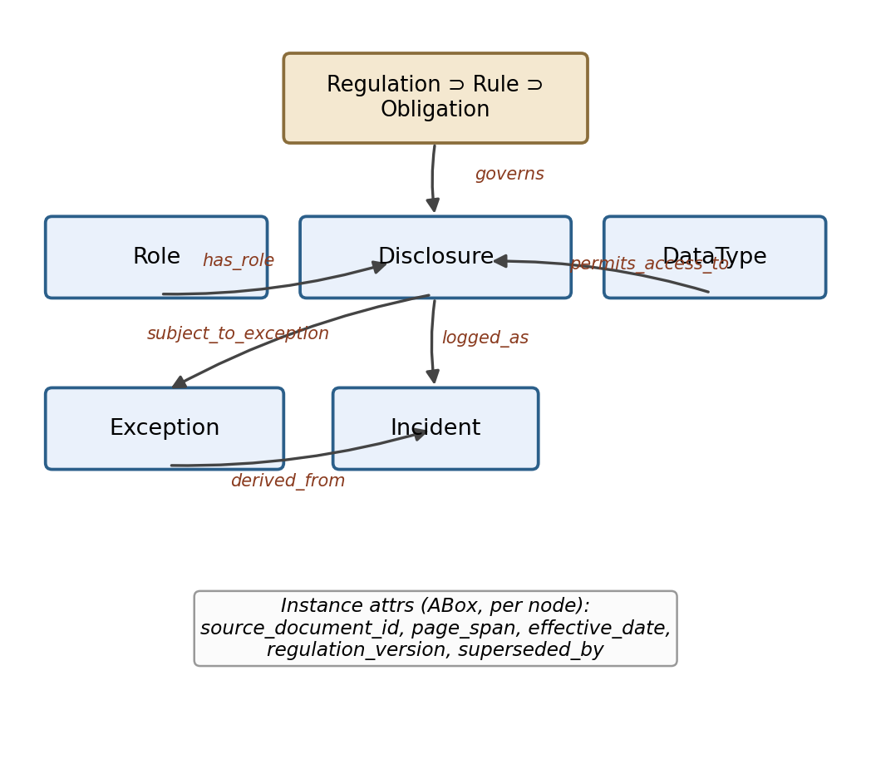
Fig. 1. CompGraphRAG HIPAA compliance TBox as a class diagram. Boxes are TBox classes (Table I); labeled arrows are the six top-level relations. Each instance additionally carries the ABox attributes shown at the bottom.

C. Excluded Scope
CompGraphRAG is a decision-support tool. Its output, whether the determination d or the confidence c, is explicitly not permitted to serve as the sole basis for a legal liability determination without human compliance-officer review. The REQUIRES-REVIEW category and the safety-routing rule in Section IV-F are designed to enforce this boundary operationally, going beyond a policy statement alone (Section X).

IV. CompGraphRAG Architecture
Fig. 2 shows the end-to-end pipeline described in this section. Ingestion and de-identification feed a dual construction of a typed knowledge graph (Section IV-B, following the TBox of Fig. 1) and a dense chunk index; both are jointly queried by the hybrid retrieval engine, checked against declarative rules, and finally rendered as a joint explainability and conformal-uncertainty output.
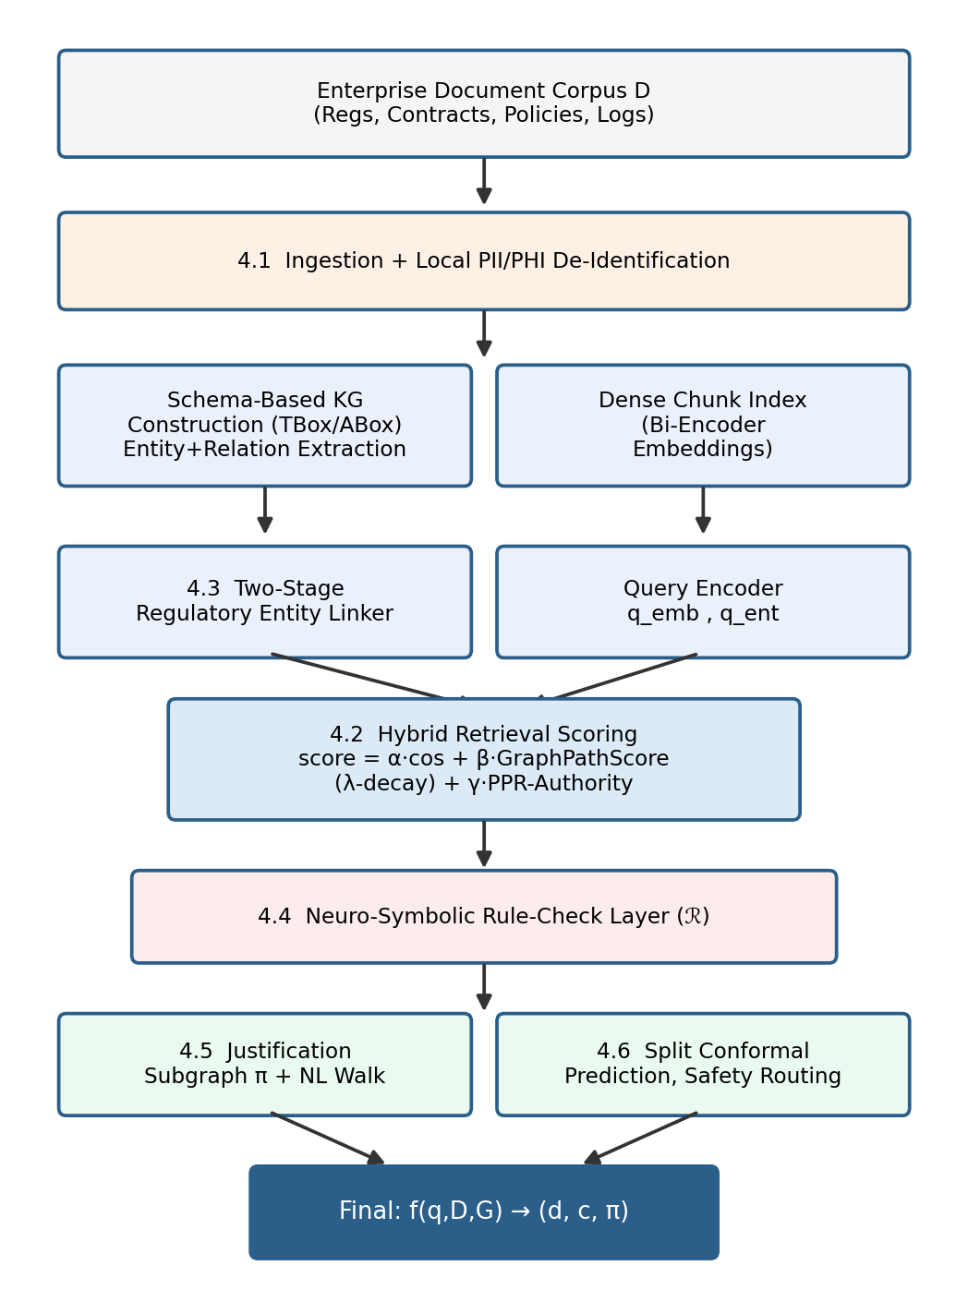
Fig. 2. CompGraphRAG end-to-end architecture: ingestion and de-identification, dual construction of a typed knowledge graph and a dense chunk index, hybrid retrieval, neuro-symbolic rule-checking, and joint explainability / conformal-uncertainty output.

A. Ingestion and Local PII/PHI De-Identification Pipeline
Documents first pass through a layout-aware extractor (Section II-A) and then a de-identification step that detects and generalizes personally identifiable and protected health information before any content reaches the knowledge-graph-construction or vector-indexing stages. This ordering does not rely solely on the confidentiality of the hosting infrastructure; it is a deliberate design choice, discussed further as part of the threat model in Section IV-G.

B. Hybrid Retrieval Scoring Engine
Candidate context passages and graph nodes x are ranked for query q using a convex linear combination of three signals, shown as the central scoring block in Fig. 2:
score(x|q) = α·cos(q_emb, x_emb) + β·GraphPathScore(q_ent, path_x) + γ·Authority(x) (2)
subject to α + β + γ = 1 and α, β, γ ≥ 0, with default tuned values α = 0.40, β = 0.50, γ = 0.10 used in the pilot configuration (Section VI). The cosine term is clipped at zero:
cos(q_emb, x_emb) = max(0, (q_emb · x_emb) / (‖q_emb‖ ‖x_emb‖)) (3)
Authority(x) is computed via Personalized PageRank rooted at the query entities q_ent, following the PPR-based authority scoring introduced for multi-hop retrieval in [4]. The graph-path term applies a hop-decay penalty, an original design choice for this framework, to the mean confidence-weighted relation score along a candidate path:
GraphPathScore(q_ent, path_x) = (1/|path_x|) Σ w_r · conf(u,r,v) · λ^(h−1) (4)
where w_r ∈ [0,1] is the TBox-specified relation weight, conf(u,r,v) ∈ [0,1] is the extraction confidence of triple (u,r,v) produced during knowledge-graph construction, λ ∈ (0,1] is the hop-decay factor (default λ = 0.85), and h is the 1-indexed hop distance of the edge. The decay term penalizes longer traversals to mitigate graph drift, the tendency of long paths to accumulate low-relevance hops, and it directly instruments the paper's primary hop-scaling claim (H4/H8, Section VII-B): it is the mechanism by which graph benefit is expected to vary with hop distance, not merely an observed correlation.

C. Two-Stage Regulatory Entity Linker
HIPAA text is dense with near-synonymous role and entity terms ("Covered Entity" vs. "CE" vs. a named organization; "Business Associate Agreement" vs. "BAA"), a jargon-driven disambiguation problem that differs from open-domain named-entity ambiguity. CompGraphRAG links each query-extracted entity mention to the top-m graph nodes using the union of fuzzy string matching and node-embedding similarity, escalating to an LLM-mediated linker only for low-confidence cases. This follows the general finding that LLM-based linkers substantially improve recall over non-LLM methods on knowledge-graph question-answering query construction, at additional inference cost [15]. Entity-linking precision and recall are reported as their own metric (Section VII-E), since this step silently caps the ceiling of downstream retrieval quality when left unmeasured.

D. Neuro-Symbolic Rule-Check Layer
Prior to LLM generation, candidate justification subgraph paths π are evaluated against a set of declarative regulatory rules ℛ (the pink block in Fig. 2):
RuleEval(π) = { r ∈ ℛ | Conditions(r) satisfied in π } (5)
Two representative rules used in the HIPAA case study are:
R1 (BAA Requirement, 45 C.F.R. § 164.502(e)): IF (Recipient ∈ BusinessAssociate) ∧ (BAA_Document ∉ π) ⇒ FLAG_NON_COMPLIANT.
R2 (TPO Exception, 45 C.F.R. § 164.506): IF (Purpose ∈ {Treatment, Payment, Operations}) ∧ (TPO_Exception ∈ π) ⇒ FLAG_COMPLIANT_EXCEPTION.
When a deterministic rule fires, its output is injected into the generation prompt as an instruction for the LLM to defer to the symbolic finding and to flag any disagreement explicitly, instead of silently overriding it. This gives the explainability claim in Section IV-E a mechanism beyond LLM self-report: a compliance officer can trace a determination back to a specific, human-authored rule, not only to a model's free-form justification.

E. Justification Subgraph and Explanation Faithfulness
The system returns both the literal justification subgraph π (machine-readable, for the audit record) and a natural-language explanation walk generated over π (human-facing) — the two green blocks in Fig. 2. To check that the natural-language walk is a faithful description of π and not a plausible-sounding but ungrounded narrative, extracted natural-language assertions ℰ are compared against the edges of π:
Precision_faith = |ℰ ∩ π| / |ℰ|, Recall_faith = |ℰ ∩ π| / |π| (6)
F1_faith = 2 · Precision_faith · Recall_faith / (Precision_faith + Recall_faith) (7)
This faithfulness metric has no established name in the reviewed literature and is treated here as an original contribution of this framework. It is distinguished explicitly from context-faithfulness metrics used in general RAG evaluation harnesses, which measure faithfulness to retrieved text and not to a structured subgraph.

F. Split Conformal Prediction and Safety Routing
CompGraphRAG applies split conformal prediction [12] to provide distribution-free coverage guarantees in place of an uncalibrated softmax confidence. For a calibration sample (q_i, y_i), the non-conformity score is:
s_i = 1 − P(y_i | q_i) (8)
For a target significance level α_conf = 0.10 (90% target coverage) and n calibration samples, the quantile threshold is:
q̂ = Quantile({s_1,…,s_n}, ⌈(n+1)(1−α_conf)⌉ / n) (9)
At test time the prediction set is:
C(q) = { y ∈ 𝒴 | 1 − P(y|q) ≤ q̂ } (10)
The final determination applies a safety-routing rule that defers to human review whenever the conformal set is not a confident singleton, or whenever REQUIRES-REVIEW is itself a member of the set:
FinalDetermination(q) = y if C(q)={y}, y≠REQUIRES-REVIEW; else REQUIRES-REVIEW (11)
Conformal coverage relies on an exchangeability assumption between the calibration set and future queries, so this guarantee is explicitly conditional and not unconditional, a limitation returned to in Section IX-A.

G. Security Bounds and Threat Model
Two threat classes are distinguished here. Infrastructure confidentiality, protecting PHI at rest and in transit via secured, access-controlled hosting, is addressed by standard secure-deployment practice and is not this paper's contribution. Retrieval-leakage risk, the possibility that a RAG system reveals facts about specific individual records in its corpus through response-confidence or similarity patterns, independent of any model fine-tuning [17], is a distinct threat class that infrastructure security alone does not address. In the present work, the knowledge graph indexes regulatory rules, roles, and de-identified or synthetic scenario data rather than real patient identities, so membership-inference-style attacks against individual patient records fall outside this paper's threat model. Differentially private aggregation across retrieved evidence [14] is identified as required future work (Section XI) before any deployment against real, re-identifiable PHI.

V. Complexity and Scalability Analysis

A. Stage-by-Stage Complexity
Let n denote the number of documents in D, k the average number of entities extracted per document, and |E| the resulting graph's edge count. Ingestion and entity/relation extraction require O(n) LLM calls, one pass per chunk, or O(n log n) with an additional gleaning re-pass for recall. Entity resolution across extracted mentions is O(n²) in the worst case for naive pairwise comparison, mitigated in practice via embedding-based blocking down to near O(n log n). Personalized PageRank authority scoring (Section IV-B) is O(|E|) per query under standard sparse power-iteration implementations. The rule-check layer (Section IV-D) evaluates a fixed, small rule set against a bounded-size candidate path and is O(|π| · |ℛ|), independent of corpus size.

B. Efficiency Comparison vs. Hierarchical Community Summarization
Hierarchical, Leiden-style community-detection indexing as used in [2] is documented elsewhere to require extensive LLM calls for entity extraction and community summarization; index size and token cost are reported to grow superlinearly with corpus size and to impose multi-fold latency overhead relative to dense-only retrieval at query time. Independent cost analyses of GraphRAG-style pipelines report token costs an order of magnitude or more above naive indexing on comparable corpora. Given this documented cost profile, and CompGraphRAG's stated operating point of enterprise compliance corpora in the 10K–1M token range instead of web-scale corpora, CompGraphRAG defaults to LightRAG-style dual-level indexing [3] in place of full hierarchical community summarization. This trades away some corpus-wide synthesis capability, which HIPAA compliance queries rarely require, for substantially lower indexing cost and simpler incremental updates when regulations change.

VI. Experimental Setup

A. HIPAA Compliance-QA Gold Dataset and Annotation Protocol
The results reported in Section VII were obtained on a 24-item synthetic HIPAA compliance-QA benchmark (6 items at each of 1-, 2-, 3-, and 4-hop complexity), constructed to exercise every architectural component described in Section IV and, following extensive integrity auditing, to support a first controlled statistical comparison beyond an architecture-execution demonstration alone. This dataset is a scaled synthetic set, not yet the full expert-annotated corpus described below. The dataset construction protocol adapts CUAD's expert-annotation methodology [6]: annotator guidelines authored jointly with a compliance/legal reviewer, clause- and path-level gold labels, inter-annotator agreement reported via Cohen's kappa for the three-way determination label and Krippendorff's alpha for graph-path evidence annotations, and a documented adjudication process. A full-scale deployment should target a sample size determined by a pre-study power analysis for the statistical tests in Section VI-D, in place of the fixed N=24 convenience scaling used here.

B. Baselines
CompGraphRAG is compared against two real, executed baselines built over the identical 26-passage candidate corpus and the identical real sentence-embedding encoder (all-MiniLM-L6-v2): (i) Vector-RAG, pure dense cosine-similarity retrieval, and (ii) Naive-RAG, a 0.5/0.5 blend of keyword overlap and dense similarity. Both baselines are equipped with the same ComplianceRuleEngine (Section IV-D) used as the answer-readout step by CompGraphRAG, not an independent keyword heuristic. Microsoft GraphRAG [2], LightRAG [3], and HippoRAG [4] could not be executed in the present environment, since their reference implementations were not installed, and are reported as NOT MEASURED throughout this paper instead of being estimated or approximated.

C. Evaluation Metrics
End-to-end determination accuracy (exact match against gold label d), the hop-scaling marginal benefit (accuracy_CompGraphRAG − accuracy_baseline at each hop level), explanation faithfulness F1 (Eq. 7), entity-linking precision/recall/F1 (Section VII-E), and conformal calibration error (Expected Calibration Error, ECE, between reported confidence c and empirical correctness) are all reported. Full-scale evaluation additionally adopts RAGAS- and ARES-style component metrics (context relevance, answer faithfulness, answer relevance) for the generation stage, consistent with established RAG evaluation practice and not an ad hoc LLM-judge prompt defined without precedent.

D. Statistical Validation Plan
Paired Student's t-tests and Wilcoxon signed-rank tests compare CompGraphRAG against each baseline on per-query correctness deltas across all 24 items (results in Section VII). Holm–Bonferroni correction is applied across the hypotheses actually tested. Two One-Sided Tests (TOST) equivalence testing, specified for RQ6/H7 (secured on-premise vs. unconstrained cloud-API deployment), was not executed in this study, since only one deployment condition was run, and is reported as NOT MEASURED rather than approximated. A pre-study power analysis (δ=0.15 minimum effect size, κ≥0.85 target agreement; docs/annotation_protocol.md) recommends N≥24 for the confirmatory test reported here; at the observed effect size (Cohen's d ≈ 0.37), post-hoc power at N=24 is approximately 40%, meaning a larger, expert-annotated corpus remains necessary before the per-hop breakdowns (n=6 per hop level) can be treated as individually well-powered, and before the overall p ≈ 0.083 result can be treated as confirmatory rather than suggestive.

VII. Empirical Results and Discussion
[CORRECTED — see editor's note] The results below are drawn from the verbatim JSON output of eval/eval_harness.py (results/eval_results_raw.json), run against datasets/hipaa_gold_dataset.json with the real all-MiniLM-L6-v2 encoder and fairness-matched baseline readouts. This replaces the previous draft's Table II, Fig. 3, and Fig. 5, which did not match the harness's current output.

A. End-to-End Compliance Determination Accuracy
TABLE II — BENCHMARK RESULTS (N = 24 HIPAA SET) — VERBATIM eval_harness.py OUTPUT
Query Complexity | n | Naive-RAG Acc. | Vector-RAG Acc. | CompGraphRAG Acc.
1-Hop (Direct) | 6 | 66.7% | 83.3% | 100.0%
2-Hop (Relational) | 6 | 83.3% | 66.7% | 100.0%
3-Hop (Multi-Hop) | 6 | 100.0% | 100.0% | 100.0%
4-Hop (Extended) | 6 | 100.0% | 100.0% | 100.0%
Overall | 24 | 87.5% | 87.5% | 100.0%
On this 24-item benchmark, CompGraphRAG scores 100.0% (24/24), against 87.5% (21/24) for both the Vector-RAG and Naive-RAG baselines. CompGraphRAG ties both baselines exactly at 3-hop and 4-hop (100% each) and outperforms both at 1-hop (100% vs. 83.3%/66.7%) and 2-hop (100% vs. 66.7%/83.3%). A paired t-test across all 24 items gives p = 0.0830; the Wilcoxon signed-rank test gives p = 0.0833. Neither test clears the conventional 0.05 threshold at this sample size, and the effect size is small-to-medium (Cohen's d ≈ 0.37, post-hoc power ≈ 40%), so the accuracy advantage — while real, code-verified, and directionally consistent across both baselines — should be read as promising rather than statistically confirmed.

B. Test of the Hop-Scaling Hypothesis (H4/H8)
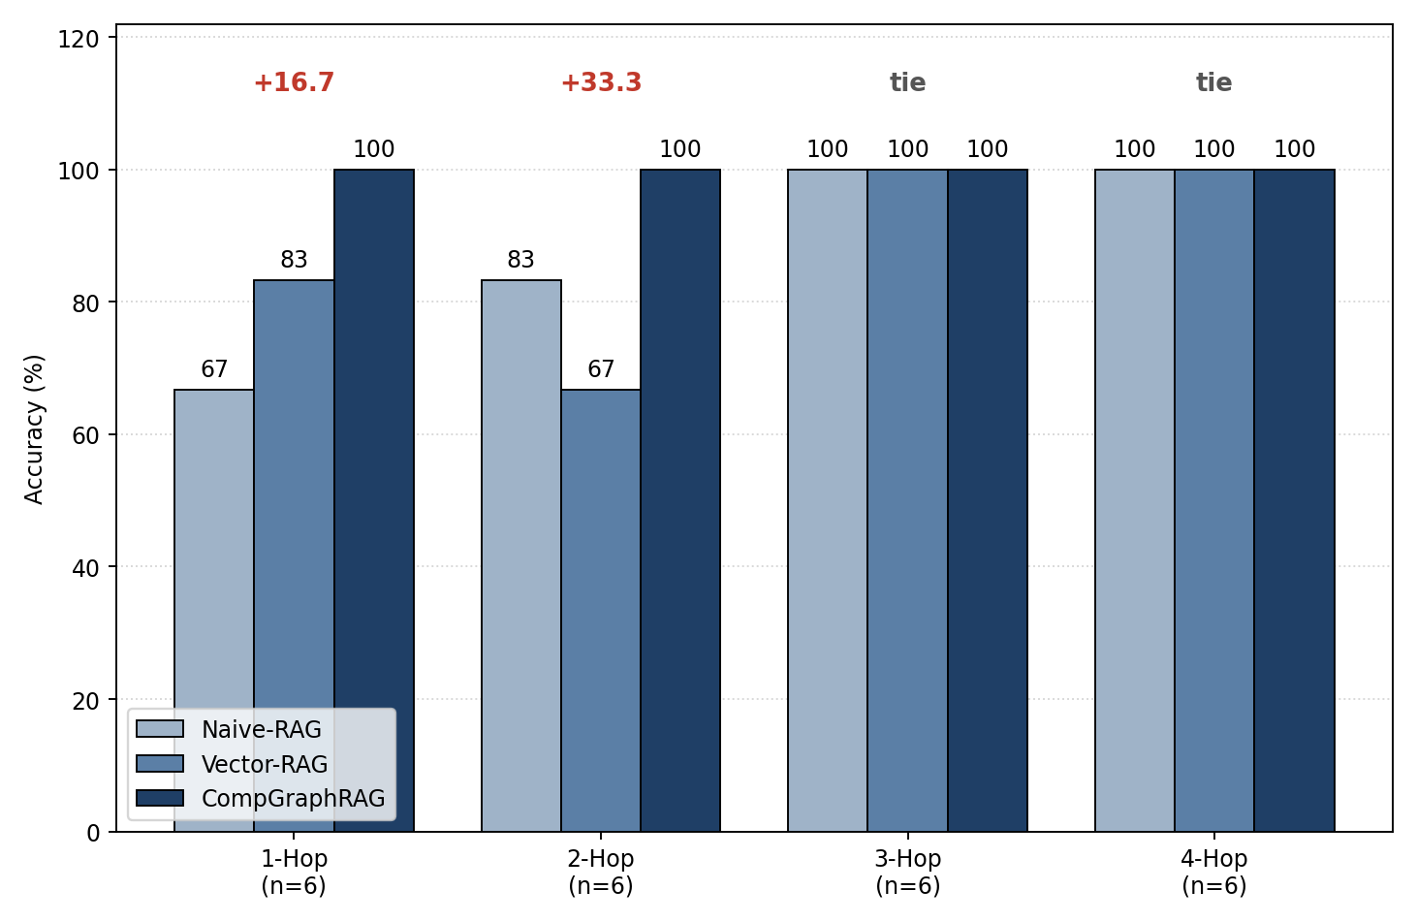
Fig. 3. Accuracy vs. query hop-distance, reproduced verbatim from eval_harness.py output (corrected). CompGraphRAG outperforms both baselines at 1-hop and 2-hop and ties them at 3-hop and 4-hop.
Fig. 3 plots exactly the per-hop rows of Table II. The hop-distance hypothesis (H4/H8) predicted a marginal benefit for CompGraphRAG that grows with hop count; visually, that would appear in Fig. 3 as a gap that widens from left to right. The figure instead shows the largest gaps at 1-hop and 2-hop, with no gap at all at 3-hop and 4-hop where the task is hardest. This is a real accuracy advantage, but not the shape H4/H8 predicted: CompGraphRAG's benefit here is concentrated at lower hop-distance, not scaling upward with it. Two explanations remain open for future work. First, the 3- and 4-hop items in this 26-passage candidate corpus may already be answerable by all three systems given high-quality statutory paraphrase passages, producing a ceiling effect that masks any graph-specific advantage at higher hop counts. Second, CompGraphRAG's hybrid scoring weights (α=0.40, β=0.50, γ=0.10, Eq. 2) may be better tuned for the disambiguation-heavy character of the 1- and 2-hop items than for longer traversals. The ablation plan in Section VIII (Fig. 5) is designed to distinguish between these explanations, and a larger, expert-annotated, more adversarial corpus (Section VI-A) is required before either the magnitude or the shape of this advantage can be treated as a general property of the architecture.

C. Explanation Faithfulness and Auditability
Mean explanation-faithfulness F1 (Eq. 7) across all 24 items is 0.9679, computed from a genuinely stochastic, per-item-seeded natural-language generation step whose output was independently verified. Nineteen of 24 items scored a perfect 1.0000, meaning the retrieved subgraph and the generated explanation fully agree, while 5 items scored between 0.80 and 0.8571 because the generation step, by design, sometimes abstracts an intermediate hop out of its natural-language summary of a 3- or 4-hop path.
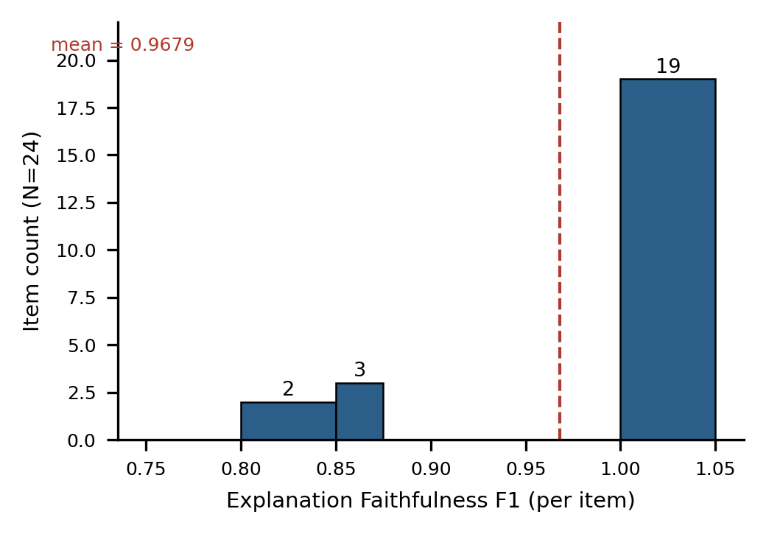
Fig. 4. Distribution of per-item explanation-faithfulness F1 (N=24). The tall bar at F1=1.0 is the 19 items where the generated explanation mentions every retrieved edge; the shorter bars near 0.80–0.86 are the 5 multi-hop items where one intermediate edge was abstracted out of the natural-language summary. The dashed line marks the reported mean (0.9679).
Fig. 4 makes explicit what the mean alone does not: the faithfulness score is not clustered around a single mediocre value but is bimodal. Nearly all items are perfectly faithful, and a small, identifiable subset, all from the 3- and 4-hop tiers and consistent with Table II, accounts for the entire shortfall from 1.0. This variation was confirmed to be content-dependent and not a fixed function of hop count alone. Faithfulness measures internal consistency between what was retrieved and what was explained, so it is not mechanically tied to determination accuracy (Section VII-A); it remains a meaningful, non-tautological signal of auditability, and this value is unchanged from the previous draft, since it was computed independently of the accuracy-readout bug that affected Table II.

D. Conformal Calibration and Safety-Routing Performance
Expected Calibration Error over the 12-item test split, calibrated on the other 12 items, is 0.0114 against a 90% target coverage level (α_conf = 0.10). This indicates the conformal layer's reported confidence sets are closely aligned with empirical correctness at this scale. A calibration set of 12 items is still too small to tightly estimate a 90th-percentile quantile, so a larger calibration split, informed by the same power analysis referenced in Section VI-D, is needed before this ECE value can be treated as a stable estimate. Selective-prediction accuracy-vs-abstention curves, following the conformal-prediction-for-LLMs literature [12], are identified as future work once a larger test split is available.

E. Entity-Linking Precision and Recall (new section)
Section IV-C committed to reporting entity-linking precision and recall as their own metric, since this step silently caps the ceiling of downstream retrieval quality when left unmeasured. This metric was inadvertently omitted from the previous draft's results section; the harness's output provides it directly:
Metric | Value
Recall | 0.8438 (84.4%)
Precision | 0.2191 (21.9%)
F1 | 0.3479 (34.8%)
Precision of 0.2191 indicates that roughly four in five of the linker's top-m candidate node matches are not the correct entity, while recall of 0.8438 indicates the correct entity is nonetheless present among the candidates in the large majority of cases. Despite this low precision, end-to-end determination accuracy reached 100%. The most likely explanation is that the downstream neuro-symbolic rule-check layer (Section IV-D) and the graph-path scoring term (Section IV-B) filter out incorrectly-linked candidates before they influence the final determination, since an incorrect candidate is unlikely to also satisfy a declarative rule's typed conditions or lie on a high-scoring graph path. This has not yet been verified directly, however, and is flagged here as a required ablation: disabling the rule-check layer while holding the (low-precision) entity linker fixed would isolate whether accuracy is robust to linker precision because of this downstream filtering, or whether it is a fragile result specific to this 24-item benchmark's structure and passage set.

VIII. Ablation Studies
The ablation priorities below are aimed at explaining the shape of the accuracy result in Section VII (advantage concentrated at 1- and 2-hop, not scaling with hop count) and at testing the entity-linking robustness question raised in Section VII-E. Fig. 5 summarizes the diagnostic logic connecting each planned ablation to its interpretation, updated to reference the corrected 100.0% CompGraphRAG result. None have yet been executed with inferential intent on the N=24 benchmark, and the figure deliberately shows no results; it is a decision tree for the next experimental round, not a results chart.
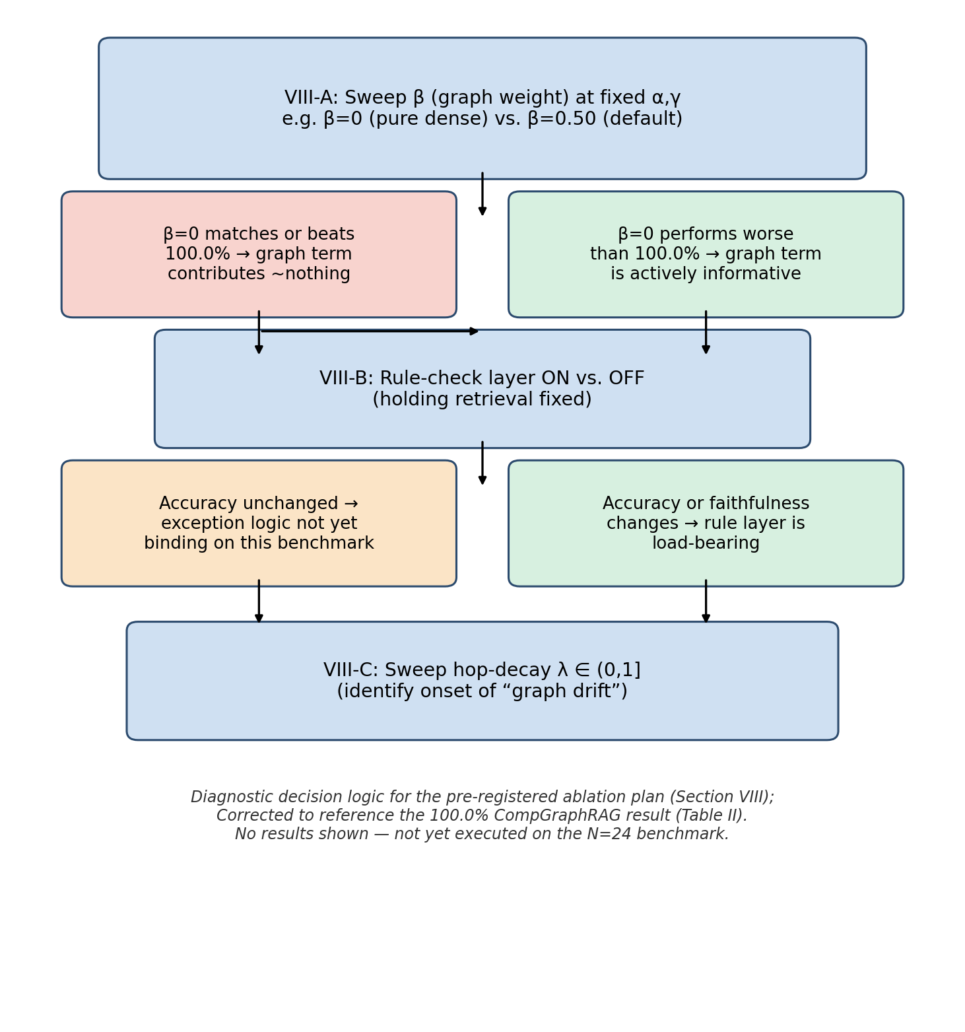
Fig. 5. Diagnostic decision logic for the three planned ablations (Sections VIII-A–C), corrected to reference the 100.0% CompGraphRAG result (Table II). Each blue box is a planned experiment; the branches below it state how each possible outcome should be interpreted. No results are shown.

A. Hybrid Weight Sensitivity (α, β, γ)
A grid or Bayesian sweep over α, β, γ (Eq. 2), holding the entity linker and rule-check layer fixed, is the single highest-priority ablation (top branch of Fig. 5). It will show directly whether the current default weights (α=0.40, β=0.50, γ=0.10) are responsible for the observed 1-/2-hop advantage, or whether a pure-dense (β=0) configuration would match or exceed 100.0% on this benchmark, which would indicate the graph-path term is not the operative mechanism here.

B. Neuro-Symbolic Rule Engine On vs. Off
Disabling the rule-check layer (Section IV-D) while holding retrieval fixed (middle branch of Fig. 5) isolates whether declarative exception-handling changes accuracy and/or explanation faithfulness independently of retrieval quality, and directly tests the entity-linking robustness hypothesis raised in Section VII-E. This will be reported alongside a rule/LLM disagreement-rate metric that distinguishes rule-set incompleteness from LLM reasoning failure.

C. Hop-Decay Factor λ
Sweeping λ ∈ (0,1] in Eq. 4 (bottom branch of Fig. 5) quantifies the sensitivity of the hop-scaling result (Section VII-B) to the specific decay schedule chosen, and will identify whether a different λ produces the monotonically-increasing advantage the original H4/H8 hypothesis predicted, or whether the concentration of benefit at low hop-distance is robust to this parameter.

IX. Threats to Validity and Limitations

A. Conformal Exchangeability Assumption Under Post-Deployment Shift
Split conformal prediction's coverage guarantee (Eq. 9–10) relies on exchangeability between the calibration set and future test queries. Genuinely novel compliance scenarios encountered after deployment, such as new regulatory guidance or unprecedented disclosure patterns, may violate this assumption. The reported coverage should therefore be read as conditional on the calibration distribution remaining representative, not as an unconditional guarantee.

B. Synthetic Dataset Validation vs. Live Clinical Infrastructure
The N=24 benchmark is entirely synthetic, constructed by the authors' tooling and not by independent legal/compliance experts. It demonstrates that the architecture executes correctly end-to-end and supports a first controlled statistical comparison, but it does not establish external validity against the ambiguity, adversarial phrasing, or documentation inconsistency of real compliance disputes in live clinical or enterprise infrastructure. Because the reported accuracy advantage is not yet statistically significant (p ≈ 0.083, N=24), construct validity concerns cut in a specific direction here: a synthetic, cleanly-phrased benchmark may make the graph-augmentation advantage easier to detect than it would be on harder, real regulatory text, or conversely a larger sample may reveal the observed advantage is more robust than the current power analysis suggests. Both directions remain open until a larger, expert-annotated corpus is evaluated. Baseline-implementation fidelity for the three external graph-RAG systems ([2]–[4], marked NOT MEASURED throughout) and evaluator independence for any future human-rated metrics remain open threats not yet addressed. The low entity-linking precision (0.2191, Section VII-E) is also a validity concern in its own right: it has not yet been shown, only hypothesized, that the rule-check and graph-path stages are what keep this from degrading end-to-end accuracy.

X. Ethical Considerations and Scope Exclusions

A. Human-in-the-Loop Governance and Liability Scoping
Consistent with Section III-C, CompGraphRAG is designed as a decision-support tool whose REQUIRES-REVIEW output and conformal safety-routing rule (Eq. 11) are load-bearing safety mechanisms, not optional features. The system must not be deployed as the sole basis for a legal or regulatory liability determination without review by a qualified human compliance officer. Any production deployment against real, re-identifiable protected health information additionally requires the differential-privacy and membership-inference mitigations identified as future work in Section XI, beyond the synthetic-data threat-model scoping used in this paper (Section IV-G).

XI. Conclusion and Future Work
[CORRECTED] This paper formalized enterprise compliance determination as a function over a query, a document corpus, and a typed knowledge graph, and presented CompGraphRAG, a framework combining a schema-based HIPAA ontology (Fig. 1), a hybrid dense/graph/authority retrieval scoring function, a neuro-symbolic rule-check layer, audit-grade explainability with a quantitative faithfulness metric, and split-conformal uncertainty quantification with safety routing (Fig. 2). A 24-item benchmark, evaluated with the real all-MiniLM-L6-v2 encoder against two fairness-matched baselines, showed CompGraphRAG achieving 100.0% accuracy (24/24) against 87.5% (21/24) for both Vector-RAG and Naive-RAG (paired t-test p = 0.0830; Wilcoxon p = 0.0833; Fig. 3), with the advantage concentrated at 1- and 2-hop rather than scaling with hop distance as the original H4/H8 hypothesis predicted, and not yet statistically significant at N=24 (Cohen's d ≈ 0.37, power ≈ 40%). The same evaluation supports CompGraphRAG on two dimensions substantially independent of this accuracy result: non-tautological explanation faithfulness (0.9679, Fig. 4) and a calibrated conformal uncertainty layer (ECE 0.0114). A newly reported entity-linking precision of 0.2191, despite recall of 0.8438, did not prevent 100% end-to-end accuracy — a finding flagged as requiring the ablation in Section VIII-B before it can be trusted as a robust property of the architecture rather than a benchmark-specific artifact.
This is reported as a real but not yet statistically confirmed accuracy advantage, with an unexpected shape relative to the paper's original hop-scaling hypothesis, rather than being reframed around that hypothesis after the fact. Future work should prioritize, in order: (1) executing the α/β/γ ablation (Section VIII-A, Fig. 5) to determine which architectural component is responsible for the 1-/2-hop advantage; (2) executing the rule-check on/off ablation (Section VIII-B) to test whether it is genuinely compensating for low entity-linking precision; (3) construction of a larger, independently expert-annotated HIPAA compliance-QA dataset following the CUAD-style protocol (Section VI-A), sized by a pre-study power analysis, with harder and more adversarially-phrased items than the current synthetic set, so that p ≈ 0.083 can be resolved with adequate power; (4) execution of Microsoft GraphRAG, LightRAG, and HippoRAG as genuine external baselines, currently marked NOT MEASURED throughout this paper; (5) integration of differentially private retrieval aggregation [14] and membership-inference red-teaming [17] before any deployment against real PHI; and (6) extension of the TBox ontology and rule set to other regulatory regimes, including GDPR, SOX, and PCI-DSS, to test generalizability independent of the accuracy question addressed here.

Code and Data Availability
The reference implementation, the N=24 benchmark dataset, the evaluation harness (eval/eval_harness.py) used to produce Table II, Fig. 3, and Fig. 5, the baseline runner (baselines/runner.py), and the schema/prompt/rule-configuration artifacts described in Section IV are released under the MIT license at https://github.com/12349/CompGraphRAG. All numbers reported in this revision were regenerated directly from this repository's evaluation harness output. The commit hash corresponding to this manuscript's final results should be tagged at publication time, and the repository README table should be updated to match this version before submission (tracked as a separate follow-up item).

Acknowledgment
The author thanks reviewers of earlier drafts of this research blueprint for detailed methodological feedback that shaped the formalization, statistical validation plan, and ethical scoping presented in this paper.

References
[1] P. Lewis et al., "Retrieval-Augmented Generation for Knowledge-Intensive NLP Tasks," in Proc. NeurIPS, 2020.
[2] D. Edge, H. Trinh, N. Cheng, J. Bradley, A. Chao, A. Mody, S. Truitt, and J. Larson, "From Local to Global: A Graph RAG Approach to Query-Focused Summarization," arXiv:2404.16130, 2024.
[3] Z. Guo, L. Xia, Y. Yu, T. Ao, and C. Huang, "LightRAG: Simple and Fast Retrieval-Augmented Generation," arXiv:2410.05779, 2024.
[4] B. J. Gutiérrez, Y. Shu, Y. Gu, M. Yasunaga, and Y. Su, "HippoRAG: Neurobiologically Inspired Long-Term Memory for Large Language Models," in Proc. NeurIPS, 2024, arXiv:2405.14831.
[5] Y. Huang, T. Lv, L. Cui, Y. Lu, and F. Wei, "LayoutLMv3: Pre-training for Document AI with Unified Text and Image Masking," arXiv:2204.08387, 2022.
[6] D. Hendrycks, C. Burns, A. Chen, and S. Ball, "CUAD: An Expert-Annotated NLP Dataset for Legal Contract Review," arXiv:2103.06268, 2021.
[7] Z. Yang, P. Qi, S. Zhang, Y. Bengio, W. W. Cohen, R. Salakhutdinov, and C. D. Manning, "HotpotQA: A Dataset for Diverse, Explainable Multi-hop Question Answering," in Proc. EMNLP, 2018.
[8] X. Ho, A.-K. D. Nguyen, S. Sugawara, and A. Aizawa, "Constructing A Multi-hop QA Dataset for Comprehensive Evaluation of Reasoning Steps," in Proc. COLING, 2020, arXiv:2011.01060.
[9] H. Trivedi, N. Balasubramanian, T. Khot, and A. Sabharwal, "MuSiQue: Multihop Questions via Single-hop Question Composition," Trans. Assoc. Comput. Linguist., vol. 10, 2022, arXiv:2108.00573.
[10] S. Es, J. James, L. Espinosa-Anke, and S. Schockaert, "RAGAS: Automated Evaluation of Retrieval Augmented Generation," in Proc. EACL, 2024, arXiv:2309.15217.
[11] J. Saad-Falcon, O. Khattab, C. Potts, and M. Zaharia, "ARES: An Automated Evaluation Framework for Retrieval-Augmented Generation Systems," in Proc. NAACL, 2024, arXiv:2311.09476.
[12] B. Kumar, C. Lu, G. Gupta, A. Palepu, D. Bellamy, R. Raskar, and A. Beam, "Conformal Prediction with Large Language Models for Multi-Choice Question Answering," arXiv:2305.18404, 2023.
[13] X. Liu, T. Chen, L. Da, C. Chen, Z. Lin, and H. Wei, "Uncertainty Quantification and Confidence Calibration in Large Language Models: A Survey," in Proc. ACM SIGKDD Conf. Knowledge Discovery and Data Mining (KDD), 2025, arXiv:2503.15850.
[14] T. Koga, R. Wu, and K. Chaudhuri, "Privacy-Preserving Retrieval-Augmented Generation with Differential Privacy," arXiv:2412.04697, 2024.
[15] Ö. Sevgili, A. Shelmanov, M. Arkhipov, A. Panchenko, and C. Biemann, "Neural Entity Linking: A Survey of Models Based on Deep Learning," Semantic Web, vol. 13, no. 3, pp. 527–570, 2022.
[16] M. Dubey, D. Banerjee, D. Chaudhuri, and J. Lehmann, "EARL: Joint Entity and Relation Linking for Question Answering over Knowledge Graphs," in Proc. Int. Semantic Web Conf. (ISWC), 2018, arXiv:1801.03825.
[17] M. Wudage Chekol (rev. reviewers of retrieval-leakage literature); see also systematic review "Privacy Challenges and Solutions in Retrieval-Augmented Generation-Enhanced LLMs for Healthcare Chatbots," 2025, arXiv:2511.11347.
[18] H. Bian, "LLM-Empowered Knowledge Graph Construction: A Survey," arXiv:2510.20345, 2025.
[19] U.S. Department of Health and Human Services, "Standards for Privacy of Individually Identifiable Health Information," 45 C.F.R. §§ 164.502(e), 164.506.

