Assignment 5: Quicksort Algorithm Implementation, Analysis, and Randomization

Student Name
Course
Instructor
Date

Assignment 5: Quicksort Algorithm Implementation, Analysis, and Randomization
Introduction
Quicksort is one of the most popular sorting algorithms due to its efficiency, speed, and ability to sort large datasets. The method is a divide-and-conquer method using a pivot element to partition the list into smaller sublists. The sublists are sorted recursively until the whole list is sorted. In this assignment, both the deterministic and randomized versions of Quicksort were implemented and compared with different input data types.
Deterministic Quicksort Implementation
The Quicksort algorithm was implemented deterministically in Python. In this implementation, the pivot element was the last in the array. The algorithm sorts the array into three sections: less, equal, and greater. The same procedure is then repeated for the smaller and larger groups, respectively, until the whole array is sorted.
Randomized Quicksort Implementation
The randomized version of Quicksort is the same as the deterministic version except that it uses a random pivot. Rather than picking the last element to be the pivot, a random element is picked from the array. Randomizing the pivot decreases the chance of always making bad pivots when the input data is sorted or reversely sorted. Thus, the randomized Quicksort method usually has a more consistent performance on different data sets.
Time Complexity Analysis
The worst-case time complexity of Quicksort is O(n log n). This is the case where every pivot splits the array into two parts that are almost equal in size, so that the algorithm can deal with its input efficiently at each recursive step. The average case time complexity is also O(n log n) since the data is likely to be reasonably well-partitioned when the data is randomly distributed. This makes Quicksort one of the most efficient comparison-based sorting algorithms practically. The worst-case time complexity is O(n²). This is when the pivot continuously splits the array into a small part and a large part. This is often observed when the pivot element is always the same, such as the last element in the array (deterministic pivot). Quicksort has a space complexity of about O(log n) due to the recursive function calls.
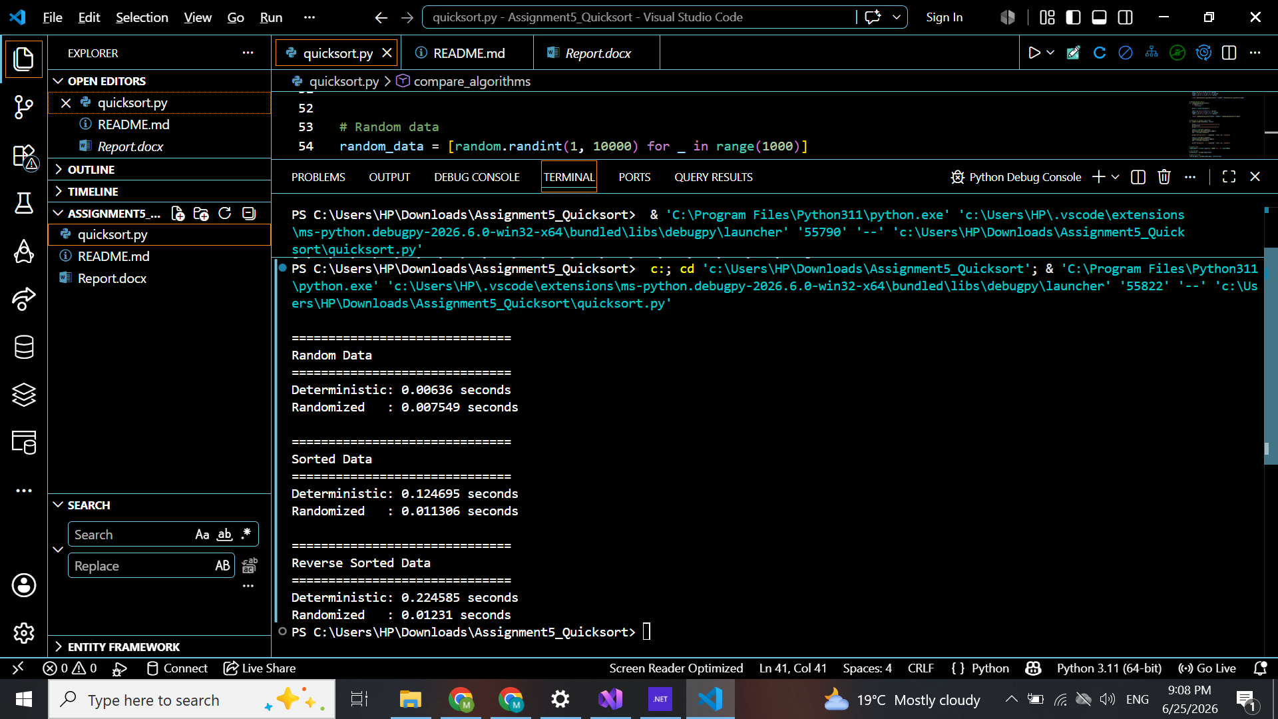
Empirical Performance Analysis
Three sets of data (random, sorted, and reverse sorted) were used to test the program. Two types of Quicksort were implemented, with the deterministic variant and the randomized variant. Two kinds of Quicksort were carried out: deterministic and randomized, and the running time of each one was timed. Experimental results indicate that it was quite successful in the deterministic version on randomly ordered data sets. But when sorting a sorted and a reverse-sorted set of data, the execution time was greatly increased. The performance for the randomized version was much more stable across all three datasets, however. These observations are consistent with the theoretical analysis that covers the fact that a random pivot selection decreases the chance of getting a worst-case scenario.

Conclusion
In this assignment, both deterministic and randomized Quicksort algorithms were implemented, and their analysis was done. The experiments showed that Quicksort (deterministic) may become inefficient if bad pivots are chosen over and over again. Randomized Quicksort solves this by picking pivots randomly, introducing greater stability in times of varying input. Overall, Quicksort is still a good sorting method, and using randomisation makes it more likely to be a good one in practice.

