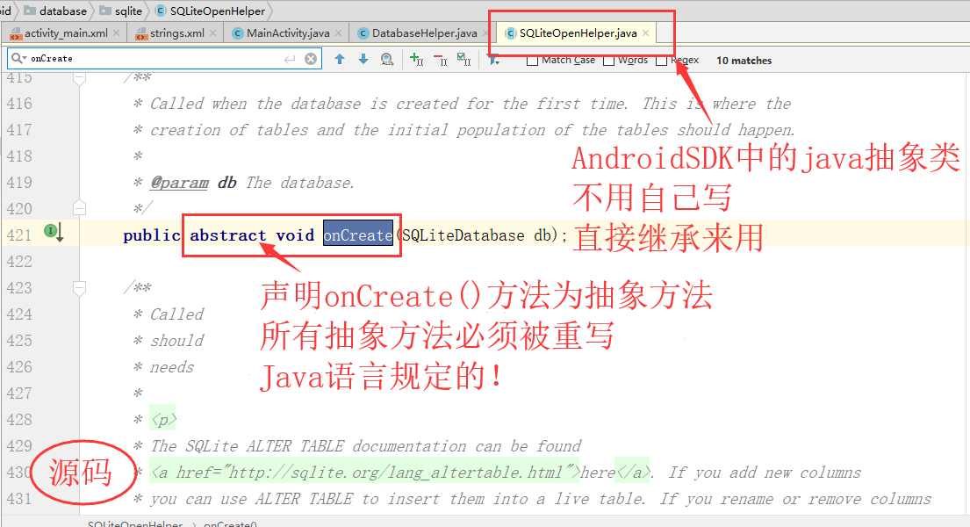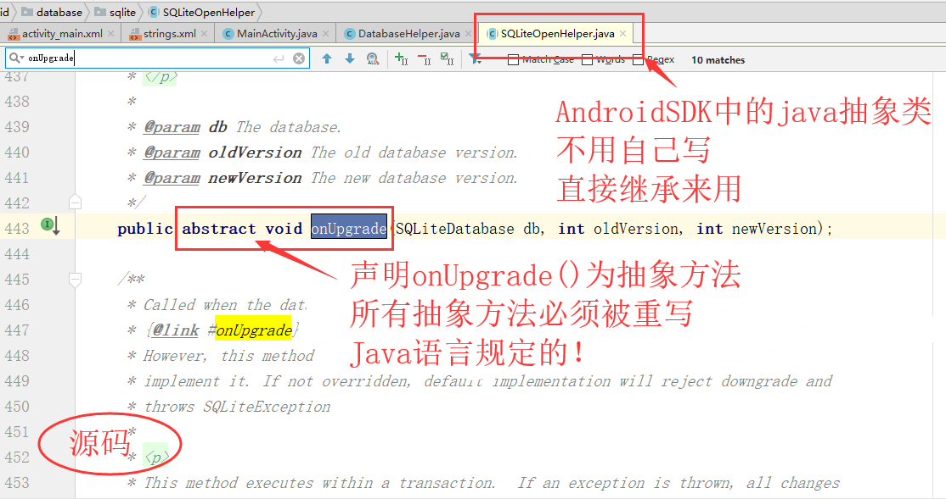

DatabaseHelper.java

**package** com.example.sqlitetest;  
  
**import** android.content.Context;  
**import** android.database.sqlite.SQLiteDatabase;  
**import** android.database.sqlite.SQLiteDatabase.CursorFactory;  
**import** android.database.sqlite.SQLiteOpenHelper;  
  
**public class** DatabaseHelper **extends** SQLiteOpenHelper{  
 *//带全部参数的构造函数，此构造函数必不可少* **public** DatabaseHelper(Context context, String name, CursorFactory factory, **int** version) {  
 **super**(context, name, factory, version);  
 }  
 **public void** onCreate(SQLiteDatabase db) {  
 *//创建数据库sql语句 并 执行* String sql = **"create table user(name varchar(20))"**;  
 db.execSQL(sql);  
 }  
  
 @Override  
 **public void** onUpgrade(SQLiteDatabase db, **int** oldVersion, **int** newVersion) {  
  
 }  
  
}

MainActivity.java

**package** com.example.sqlitetest;  
  
**import** android.content.ContentValues;  
**import** android.database.Cursor;  
**import** android.database.sqlite.SQLiteDatabase;  
**import** android.os.Bundle;  
**import** android.support.v7.app.AppCompatActivity;  
**import** android.view.View;  
**import** android.view.View.OnClickListener;  
**import** android.widget.Button;  
**import** android.widget.EditText;  
**import** android.widget.TextView;  
  
**import** java.util.ArrayList;  
  
**public class** MainActivity **extends** AppCompatActivity **implements** OnClickListener{  
 @Override  
 **public void** onCreate(Bundle savedInstanceState) {  
 **super**.onCreate(savedInstanceState);  
 setContentView(R.layout.***activity_main***);  
 *//根据Layout按钮ID得到Java按钮对象  
 //并为Java按钮对象设置监听器* Button insert = (Button) findViewById(R.id.***insert***);  
 Button insert_cleardata = (Button) findViewById(R.id.***insert_cleardata***);  
  
 Button update = (Button) findViewById(R.id.***update***);  
 Button update_cleardata = (Button)findViewById(R.id.***update_cleardata***);  
  
 Button delete = (Button) findViewById(R.id.***delete***);  
 Button delete_cleardata = (Button)findViewById(R.id.***delete_cleardata***);  
  
 Button query = (Button) findViewById(R.id.***query***);  
 Button clearquery = (Button)findViewById(R.id.***clear_query***);  
 *//添加操作数据库时需要的监听器* insert.setOnClickListener(**this**);  
 insert_cleardata.setOnClickListener(**this**);  
  
 update.setOnClickListener(**this**);  
 update_cleardata.setOnClickListener(**this**);  
  
 delete.setOnClickListener(**this**);  
 delete_cleardata.setOnClickListener(**this**);  
  
 query.setOnClickListener(**this**);  
 clearquery.setOnClickListener(**this**);  
 }  
 @Override  
 **public void** onClick(View v) {  
 *//依靠DatabaseHelper的构造函数创建数据库* DatabaseHelper dbHelper = **new** DatabaseHelper(MainActivity.**this**, **"test_db"**,**null**,1);  
 SQLiteDatabase db = dbHelper.getWritableDatabase();  
  
 *//因为响应点击按钮事件时要操作文本输入框中的内容  
 // 所以要获取相应文本输入框的对象及其中输入内容* EditText insert_edittext = (EditText)findViewById(R.id.***inset_edittext***);  
 String insert_data = insert_edittext.getText().toString();  
  
 EditText delete_edittext = (EditText)findViewById(R.id.***delete_edittext***);  
 String delete_data = delete_edittext.getText().toString();  
  
 EditText update_before_edittext = (EditText)findViewById(R.id.***update_before_edittext***);  
 String update_before_data = update_before_edittext.getText().toString();  
 EditText update_after_edittext = (EditText)findViewById(R.id.***update_after_edittext***);  
 String update_after_data = update_after_edittext.getText().toString();  
  
 TextView textview = (TextView)findViewById(R.id.***textview***);  
  
 **switch**(v.getId()){  
 *//插入数据* **case** R.id.***insert***:  
 *//创建存放数据的ContentValues对象* ContentValues values = **new** ContentValues();  
 values.put(**"name"**,insert_data);  
 *//数据库执行插入命令* db.insert(**"user"**, **null**, values);  
 **break**;  
 **case** R.id.***insert_cleardata***:  
 insert_edittext.setText(**""**);  
 **break**;  
  
 *//删除记录* **case** R.id.***delete***:  
 db.delete(**"user"**, **"name=?"**, **new** String[]{delete_data});  
 **break**;  
 **case** R.id.***delete_cleardata***:  
 delete_edittext.setText(**""**);  
 **break**;  
  
 *//更新数据信息* **case** R.id.***update***:  
 ContentValues values2 = **new** ContentValues();  
 values2.put(**"name"**, update_after_data);  
 db.update(**"user"**, values2, **"name = ?"**, **new** String[]{update_before_data});  
 **break**;  
 **case** R.id.***update_cleardata***:  
 update_before_edittext.setText(**""**);  
 update_after_edittext.setText(**""**);  
 **break**;  
  
 *//查询信息* **case** R.id.***query***:  
 *//创建游标对象* Cursor cursor = db.query(**"user"**, **new** String[]{**"name"**}, **null**, **null**, **null**, **null**, **null**);  
 *//利用游标遍历所有数据对象放入list中* ArrayList<String> list = **new** ArrayList<String>();  
 **while**(cursor.moveToNext()){  
 String name = cursor.getString(cursor.getColumnIndex(**"name"**));  
 list.add(name);  
 }  
 String textview_data = **""**;  
 **for**(**int** i=0;i<list.size();i++) {  
 textview_data = textview_data+**"\n"**+list.get(i);  
 }  
 textview.setText(textview_data);  
 **break**;  
 **case** R.id.***clear_query***:  
 textview.setText(**""**);  
 textview.setHint(**"查询内容为空"**);  
 **break**;  
  
 **default**:  
 **break**;  
 }  
 }  
}

activity_main.xml

*<?***xml version="1.0" encoding="utf-8"***?>*<**LinearLayout xmlns:android="http://schemas.android.com/apk/res/android"  
 android:layout_width="match_parent"  
 android:layout_height="match_parent"  
 android:orientation="vertical"  
 android:layout_marginTop="80dp"  
 android:layout_marginBottom="50dp"** >  
  
 <**LinearLayout  
 android:layout_width="match_parent"  
 android:layout_height="wrap_content"  
 android:orientation="horizontal"**>  
 <**EditText  
 android:id="@+id/inset_edittext"  
 android:layout_width="0dp"  
 android:layout_weight="5"  
 android:layout_height="wrap_content"  
 android:hint="请输入要插入的数据"  
 android:textColorHint="#CCCCCC"**/>  
 <**Button  
 android:id="@+id/insert"  
 android:layout_width="0dp"  
 android:layout_weight="2"  
 android:layout_height="wrap_content"  
 android:text="@string/insert"**/>  
 <**Button  
 android:id="@+id/insert_cleardata"  
 android:layout_width="0dp"  
 android:layout_weight="2"  
 android:layout_height="wrap_content"  
 android:text="@string/cleardata"**/>  
 </**LinearLayout**>  
 <**LinearLayout  
 android:layout_width="match_parent"  
 android:layout_height="wrap_content"**>  
 <**EditText  
 android:id="@+id/update_before_edittext"  
 android:layout_width="0dp"  
 android:layout_weight="2.5"  
 android:layout_height="wrap_content"  
 android:hint="请输入更新前的内容"  
 android:textColorHint="#CCCCCC"**/>  
 <**EditText  
 android:id="@+id/update_after_edittext"  
 android:layout_width="0dp"  
 android:layout_weight="2.5"  
 android:layout_height="wrap_content"  
 android:hint="请输入更新后的内容"  
 android:textColorHint="#CCCCCC"**/>  
 <**Button  
 android:id="@+id/update"  
 android:layout_width="0dp"  
 android:layout_weight="2"  
 android:layout_height="wrap_content"  
 android:text="@string/update"**/>  
 <**Button  
 android:id="@+id/update_cleardata"  
 android:layout_width="0dp"  
 android:layout_weight="2"  
 android:layout_height="wrap_content"  
 android:text="@string/cleardata"**/>  
 </**LinearLayout**>  
  
 <**LinearLayout  
 android:layout_width="match_parent"  
 android:layout_height="wrap_content"**>  
 <**EditText  
 android:id="@+id/delete_edittext"  
 android:layout_width="0dp"  
 android:layout_weight="5"  
 android:layout_height="wrap_content"  
 android:hint="请输入要删除的内容"  
 android:textColorHint="#CCCCCC"**/>  
 <**Button  
 android:id="@+id/delete"  
 android:layout_width="0dp"  
 android:layout_weight="2"  
 android:layout_height="wrap_content"  
 android:text="@string/delete"**/>  
 <**Button  
 android:id="@+id/delete_cleardata"  
 android:layout_width="0dp"  
 android:layout_weight="2"  
 android:layout_height="wrap_content"  
 android:text="@string/cleardata"** />  
 </**LinearLayout**>  
 <**Button  
 android:id="@+id/query"  
 android:layout_width="match_parent"  
 android:layout_height="wrap_content"  
 android:text="@string/query"**/>  
 <**Button  
 android:id="@+id/clear_query"  
 android:layout_width="match_parent"  
 android:layout_height="wrap_content"  
 android:text="@string/clearquery"**/>  
 <**TextView  
 android:id="@+id/textview"  
 android:layout_width="match_parent"  
 android:layout_height="300dp"  
 android:layout_marginVertical="50dp"  
 android:layout_marginLeft="20dp"  
 android:layout_marginRight="20dp"  
 android:hint="查询内容为空"  
 android:textColorHint="#CCCCCC"  
 android:textColor="#6666FF"  
 android:textSize="25dp"**/>  
  
</**LinearLayout**>

strings.xml

<**resources**>  
 <**string name="app_name"**>SQLiteTest</**string**>  
 <**string name="createDatabse"**>创建数据库</**string**>  
 <**string name="insert"**>执行插入</**string**>  
 <**string name="update"**>执行更新</**string**>  
 <**string name="query"**>查询所有</**string**>  
 <**string name="delete"**>执行删除</**string**>  
 <**string name="cleardata"**>清除</**string**>  
 <**string name="clearquery"**>清除查询</**string**>  
</**resources**>