Outopia AI Commerce Bot Setup (Supabase + Telegram Tokens) and Run Project step by step and add sql into superbase database.

This document explains how to find and configure the required environment variables on a new PC.
These values must be placed into a .env file in the project root folder.

1) SUPABASE_URL (How to find)
1. Go to https://app.supabase.com and log in.
2. Open your Supabase project.
3. On the Project Dashboard, you will see your Project URL.
4. Copy the URL that looks like this:
https://xxxxxxxxxxxxxxxxxxxx.supabase.co
5. Put it into the .env file like:
SUPABASE_URL=https://xxxxxxxxxxxxxxxxxxxx.supabase.co

2) SUPABASE_KEY (How to find)
1. Go to Supabase Dashboard.
2. Select your project.
3. Go to: Project Settings → API.
4. Under "Secret keys", copy the Secret key.
(It starts with: sb_secret_...)
5. Put it into the .env file like:
SUPABASE_KEY=sb_secret_xxxxxxxxxxxxxxxxxxxxx
IMPORTANT:
- Use Secret key only for backend/server.
- Do NOT share this key publicly.
- If leaked, regenerate/rotate the key from Supabase.

3) TELEGRAM_BOT_TOKEN (How to find)
1. Open Telegram (Mobile/Desktop).
2. Search for: @BotFather
3. Open BotFather chat.
4. Send the command:
/newbot
5. BotFather will ask for:
- Bot name (any name)
- Bot username (must end with 'bot')
6. BotFather will provide a token like:
1234567890:AAHxxxxxxxxxxxxxxxxxxxxxxxxxxxx
7. Put it into the .env file like:
TELEGRAM_BOT_TOKEN=1234567890:AAHxxxxxxxxxxxxxxxxxxxxxxxxxxxx
IMPORTANT:
- Keep this token secret.
- If leaked, revoke it in BotFather using /revoke.

4) Example .env file
Create a file named .env inside the project folder (same folder as server.js).
Example:
SUPABASE_URL=https://xxxxxxxxxxxxxxxxxxxx.supabase.co
SUPABASE_KEY=sb_secret_xxxxxxxxxxxxxxxxxxxxx
TELEGRAM_BOT_TOKEN=1234567890:AAHxxxxxxxxxxxxxxxxxxxxxxxxxxxx

Database Setup:
Open superbase dashboard . after that in the left side have SQL Editor. Click it and pest sql query into this editor. After that select full sql query and press run.
create extension if not exists vector;

create table if not exists public.products (
id text primary key,
name text,
description text,
price numeric,
currency text,
category text,
images jsonb,
url text,
metadata jsonb,
embedding vector(384)
);

create or replace function public.match_products (
query_embedding vector(384),
match_threshold float,
match_count int
)
returns table (
id text,
name text,
description text,
price numeric,
currency text,
category text,
images jsonb,
url text,
metadata jsonb,
similarity float
)
language sql stable
as $$
select
id,
name,
description,
price,
currency,
category,
images,
url,
metadata,
1 - (embedding <=> query_embedding) as similarity
from public.products
where 1 - (embedding <=> query_embedding) > match_threshold
order by embedding <=> query_embedding
limit match_count;
$$;

Image for sql editor to find easily
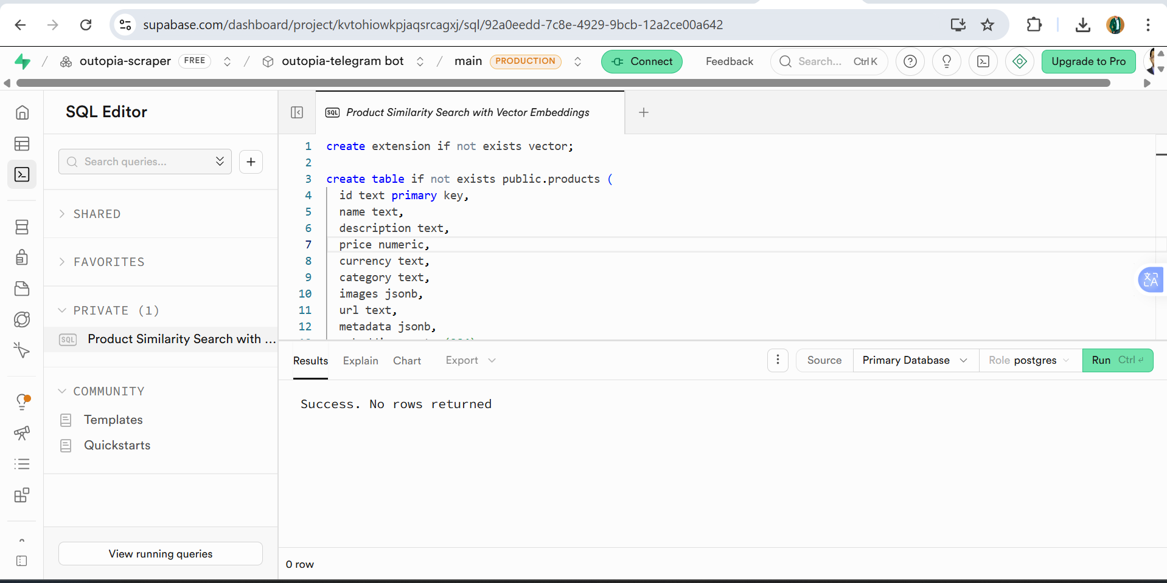

Run the project step by step:
- scrap the products:
node scrape.js
It will create:
outopia_products.json
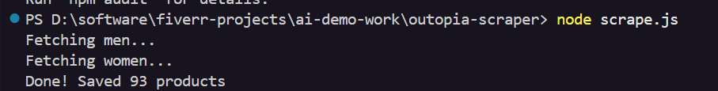

- Convert Products
node convert.js
It will create:
openai_products.json
- Upload Products into Supabase
node upload.js
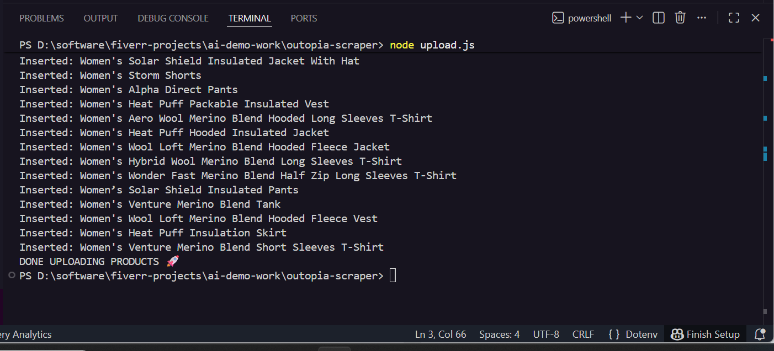

- Start api server
node server.js

- Test API search - we can run bellow command using terminal.
Invoke-RestMethod -Method POST http://localhost:3000/search -ContentType "application/json" -Body '{"query":"men shoes"}'

- We can test the api using postman:
Api is: http://localhost:3000/search (post method)
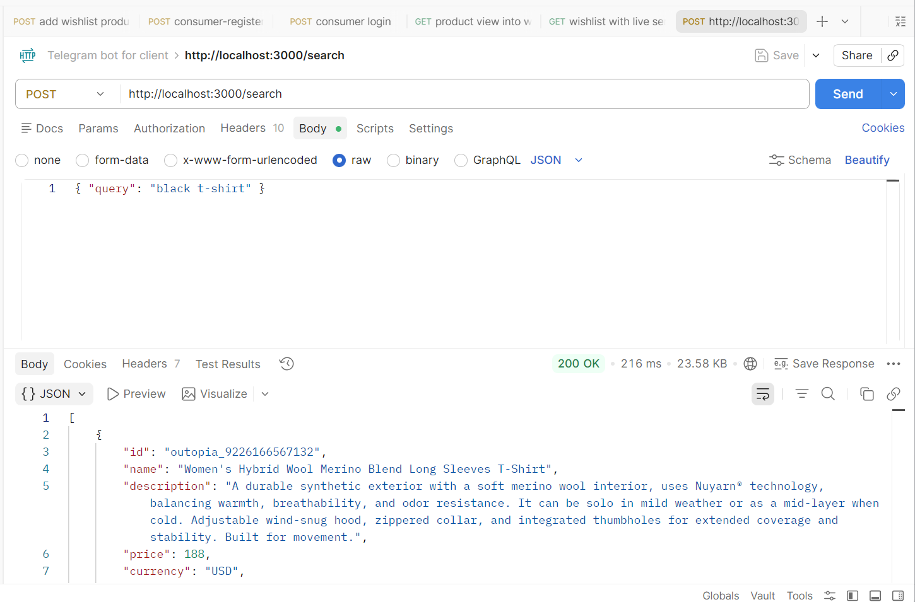

- Now run the Telegram Bot:
Open new terminal:
node bot.js
Then open Telegram and message your bot:
shoes
men shoes under 100 /// here you can write anything.
t-shirt

Final All Command List:
npm install
node scrape.js
node convert.js
node upload.js
node server.js
node bot.js

