Jira Laboratory Manual: Practicals 1 to 4

Introduction and Conventions
This manual gives click-by-click procedures for four Jira Cloud practicals, from account creation to issue management, using one running project: the Learning Management System (LMS).
Conventions used throughout
- UI elements (buttons, menus, modal titles, fields) are written in bold, for example click + Create.
- Navigation paths use the arrow form: Space settings > People.
- Values to type are written in monospace.
- Every step that changes the screen is followed by a screenshot callout.
- Jira Cloud's interface changes often. Newer builds say Space where older builds say Project, and Work item where older builds say Issue. The two names mean the same thing here.
Common prerequisites for all four practicals
Requirement | Detail
Browser | Google Chrome (latest version)
Account | A personal Gmail ID for signing in to Atlassian
Internet | Stable connection throughout the session
Plan | Jira Cloud Free plan is sufficient
Second and third accounts | Two other email IDs (classmates or your own alternate IDs) for Practical 2
Practical map
No. | Title | Parts
1 | Jira Setup and Project Creation | A: Account and dashboard, B: Company-managed Kanban space, C: Space details
2 | Team Creation and Role Assignment | A: Add team members, B: Assign roles
3 | Issue Types and Configuration | A: Issue types, B: Components and versions
4 | Issue Management | A: Issue under an Epic, B: Assignee, priority, due date
Practical 1 must be completed first. Practicals 2 to 4 reuse the LMS space it creates.

Practical 1: Jira Setup and Project Creation

Part A: Create a Jira Cloud Account and Explore the Dashboard
1. Aim / Objective
To create a Jira Cloud account using a Google (Gmail) identity, complete the onboarding wizard, and become familiar with the default dashboard gadgets.
2. Prerequisites and Tooling
- Google Chrome and an active Gmail ID.
- No prior Atlassian account is needed. Authentication is through Google.
- Navigation path: Google Search > Atlassian Jira home page > Google sign-up > onboarding wizard.
3. Step-by-Step Execution Procedure
- Open Google Chrome. In the address bar or Google search box, type jira and press Enter.
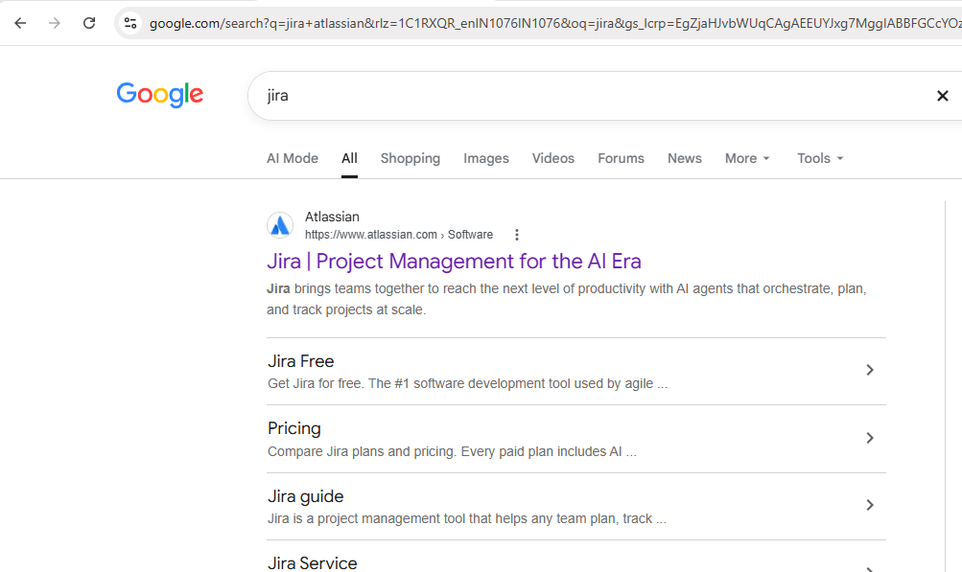
Figure 1. Screenshot from the provided Jira Practical document.
- Click the Atlassian result titled Jira | Project Management for the AI Era. The Jira home page opens.
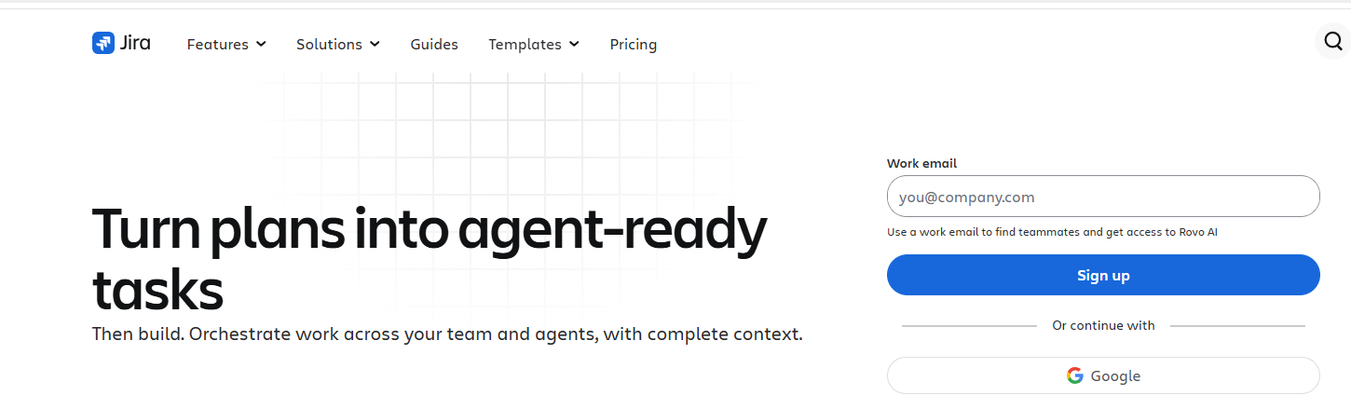
Figure 2. Screenshot from the provided Jira Practical document.
- On the right of the page, click Google (below Or continue with).
- In the Google account chooser, select your Gmail ID (or type it and click Next, then enter the password).
- If Atlassian asks you to confirm account creation, review the Create your account screen and click Continue.
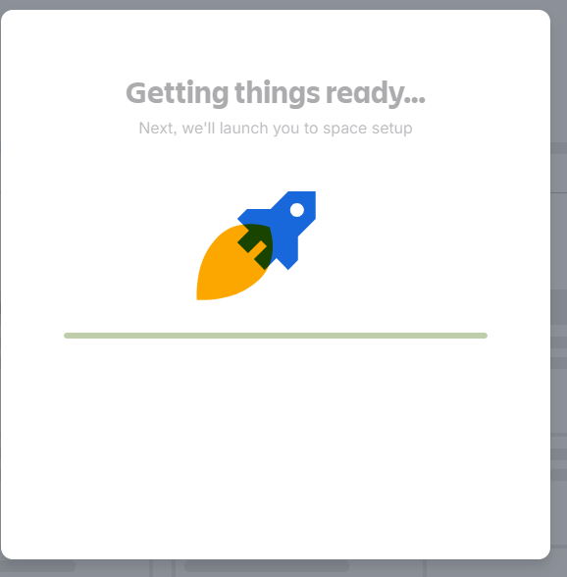
Figure 3. Screenshot from the provided Jira Practical document.
- Wait for the Getting things ready... loading screen (rocket graphic, text "Next, we'll launch you to space setup") to finish.
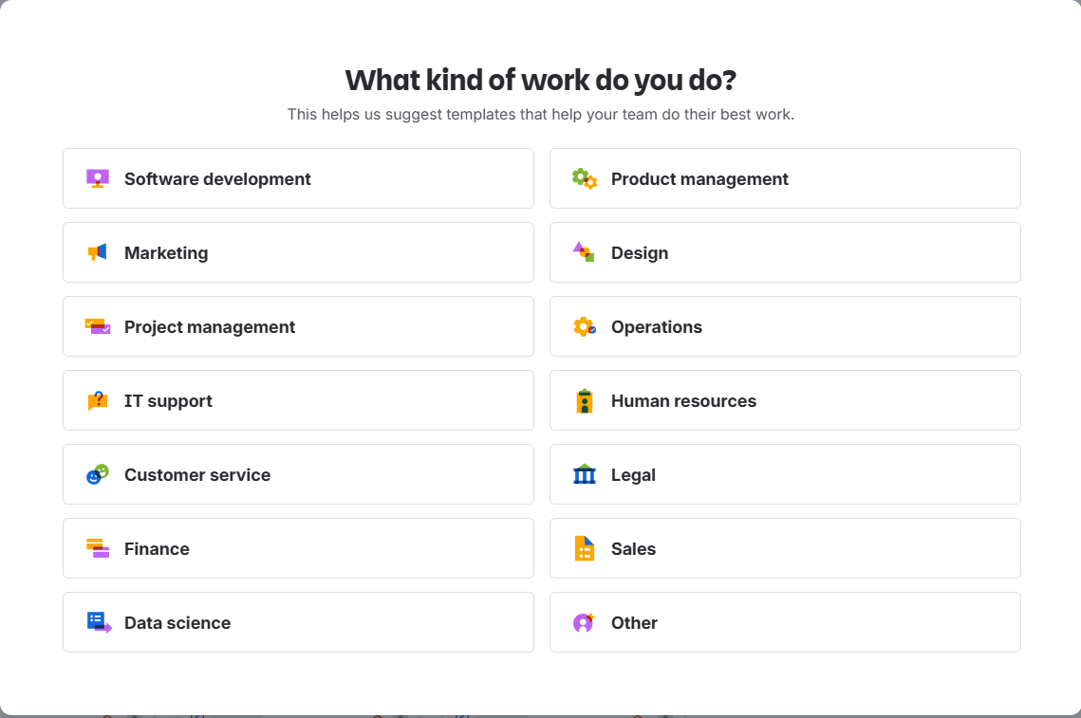
Figure 4. Screenshot from the provided Jira Practical document.
- On the What kind of work do you do? screen, click Project management.
.
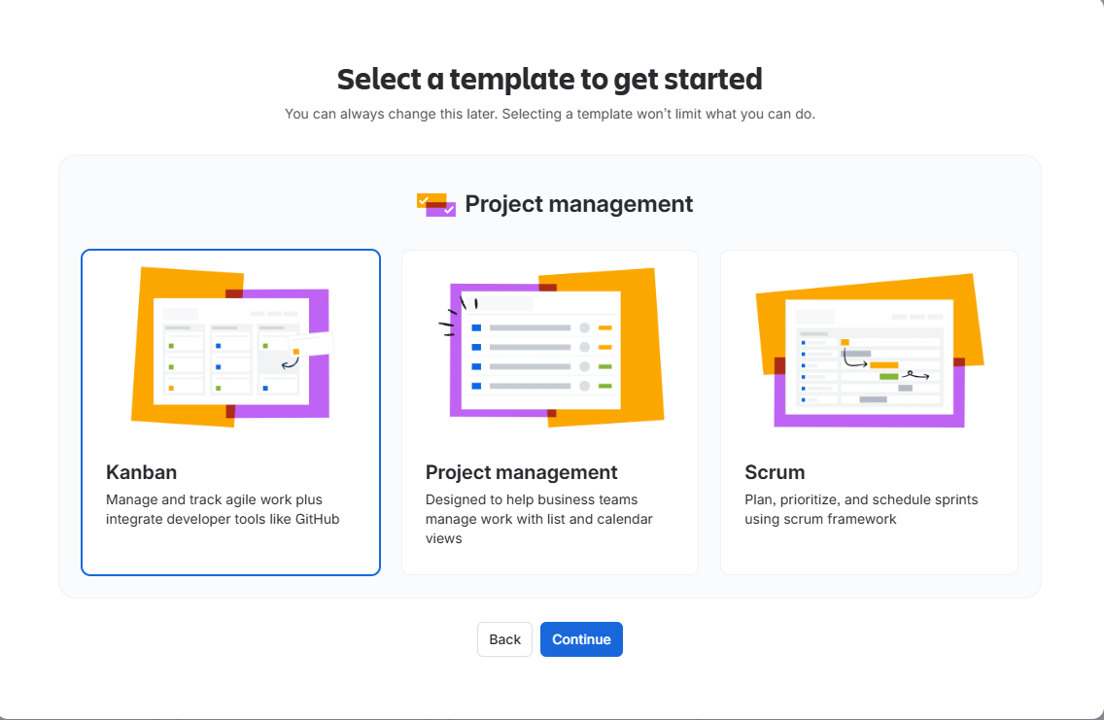
Figure 5. Screenshot from the provided Jira Practical document.
- On the Select a template to get started screen, click the Kanban card, then click Continue.
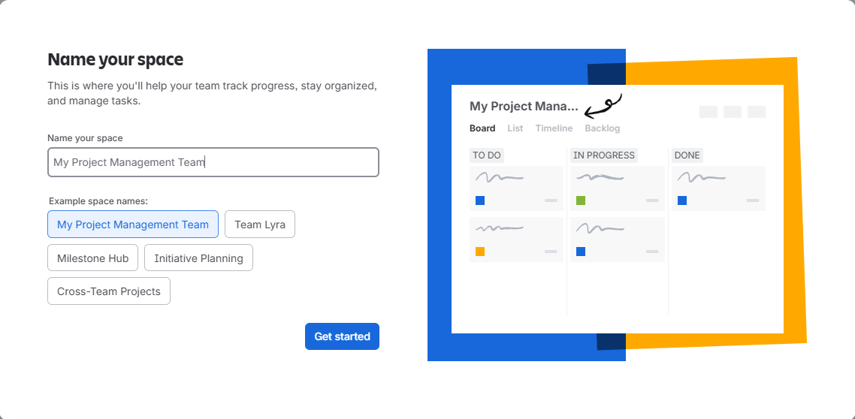
Figure 6. Screenshot from the provided Jira Practical document.
- On the Name your space screen, clear the suggested name and type the space name from the data table below. Click Get started.
[Screenshot Required]: "Name your space" screen with the typed name in the Name your space field and the live board preview on the right.
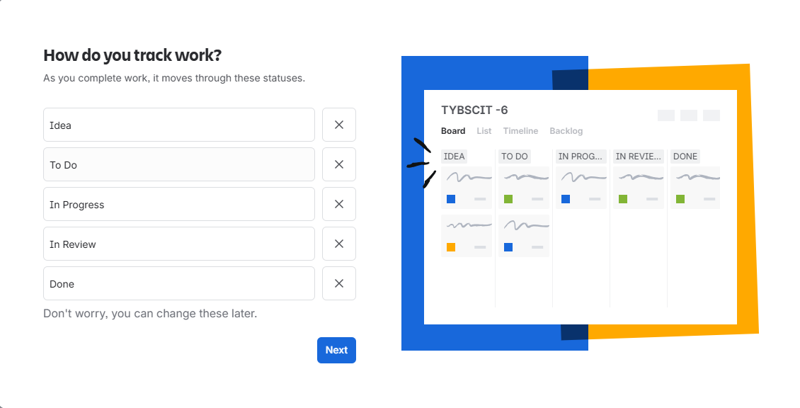
Figure 7. Screenshot from the provided Jira Practical document.
- On the How do you track work? screen, confirm that the five statuses listed in the data table appear in order. Click Next.
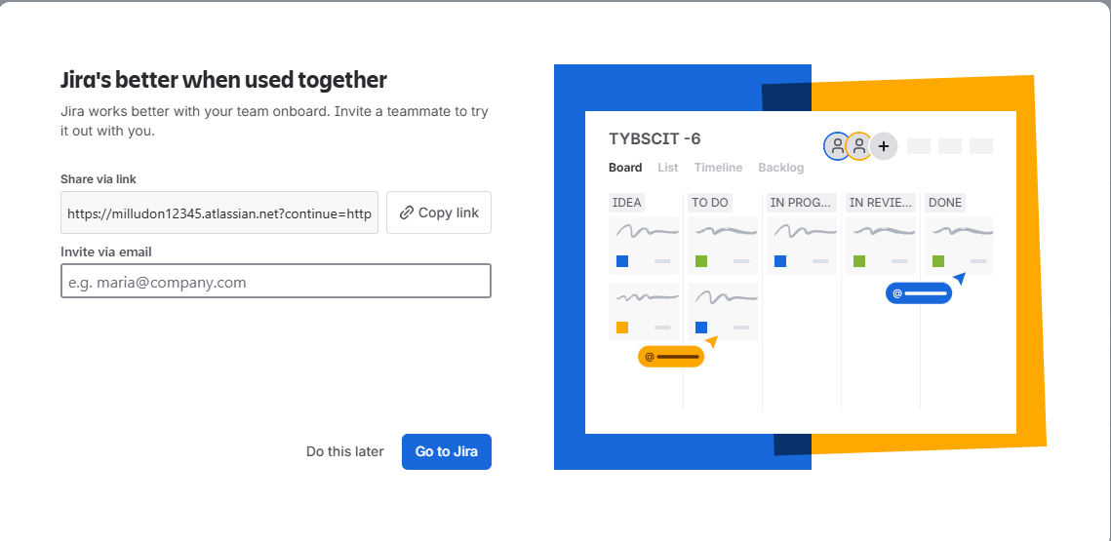
Figure 8. Screenshot from the provided Jira Practical document.
- On the Jira's better when used together screen, do not invite anyone now. Click Go to Jira (or Do this later first, if shown).
[Screenshot Required]: The invite screen with the Share via link box, the Invite via email field left empty, and the Go to Jira button.
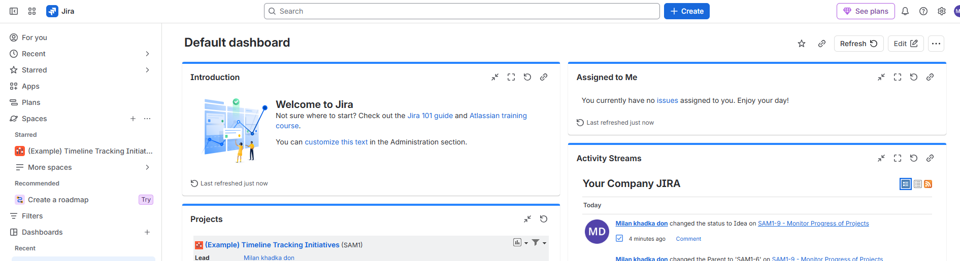
Figure 9. Screenshot from the provided Jira Practical document.
- The Default dashboard loads. Explore the gadgets in this order:
  - Introduction: welcome text and links to the Jira 101 guide.
  - Projects (or Spaces): list of spaces you can access, with the Lead column.
  - Assigned to Me: your open work items. It shows "You currently have no issues assigned" on a new account.
  - Activity Streams: recent changes across spaces, with timestamps.
- In the left sidebar, hover over For you, Recent, Starred, Spaces and Dashboards to see how navigation is organised.
[Screenshot Required]: The full Default dashboard with the sidebar visible and the Introduction, Projects, Assigned to Me and Activity Streams gadgets all in view.
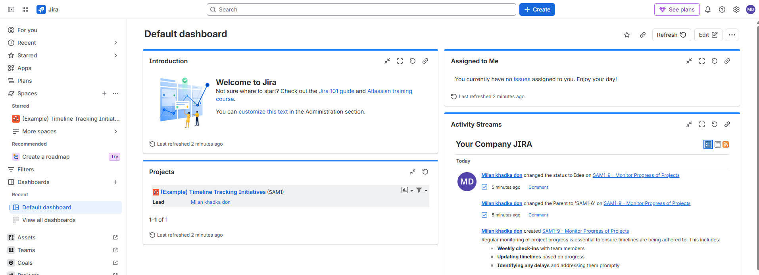
Figure 10. Screenshot from the provided Jira Practical document.
4. Input Test Data and Field Values
Screen | Field | Value
Sign-up | Authentication method | Google (your Gmail ID)
What kind of work do you do? | Work category | Project management
Select a template | Template | Kanban
Name your space | Name your space | Learning Management System
How do you track work? | Status 1 to 5 | Idea, To Do, In Progress, In Review, Done
Invite teammates | Invite via email | Leave blank (skip)
5. Expected Output and Verification
- Your Atlassian account exists and you are signed in with the Gmail ID.
- A Jira site address of the form https://<your-site>.atlassian.net is shown in the browser.
- The Default dashboard shows the Introduction, Projects, Assigned to Me and Activity Streams gadgets.
- The first space created by onboarding is listed under Spaces in the sidebar.

Part B: Create a Company-Managed Kanban Project
1. Aim / Objective
To create a company-managed Kanban space named Learning Management System with the key LMS, and open its Kanban board.
2. Prerequisites and Tooling
- Completed Part A and signed in to Jira on Chrome.
- Permission to create spaces (the site creator has this by default).
- Navigation path: sidebar Spaces > + > Create space.
3. Step-by-Step Execution Procedure
- From the Default dashboard, in the left sidebar next to Spaces, click the + icon.
[Screenshot Required]: Sidebar with the + next to Spaces highlighted.
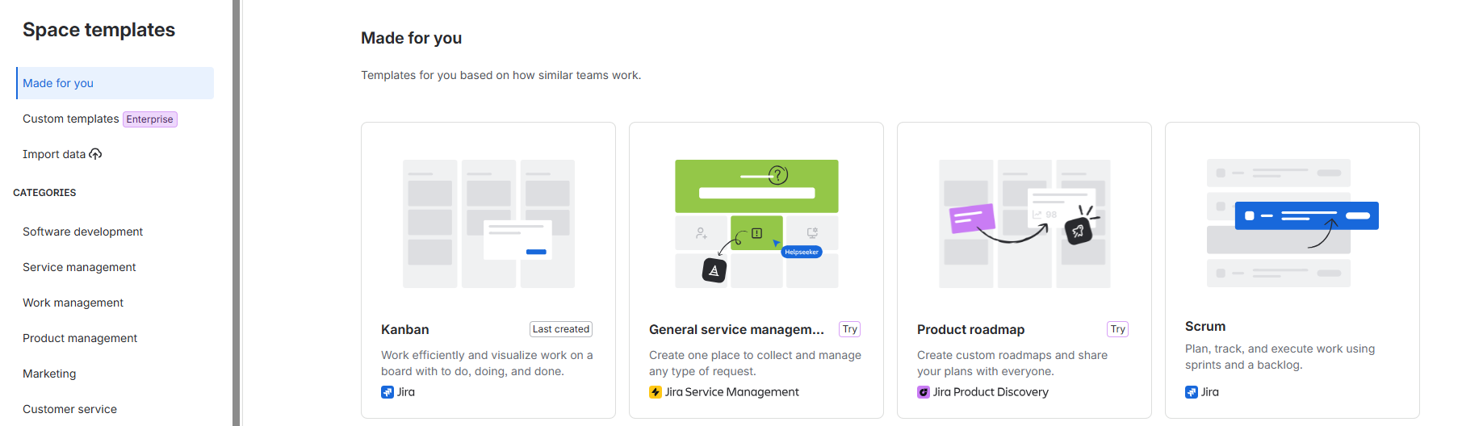
Figure 11. Screenshot from the provided Jira Practical document.
- Click Create space. The Space templates page opens with the Made for you category selected.
[Screenshot Required]: "Space templates" page listing Kanban, General service management, Product roadmap and Scrum cards.
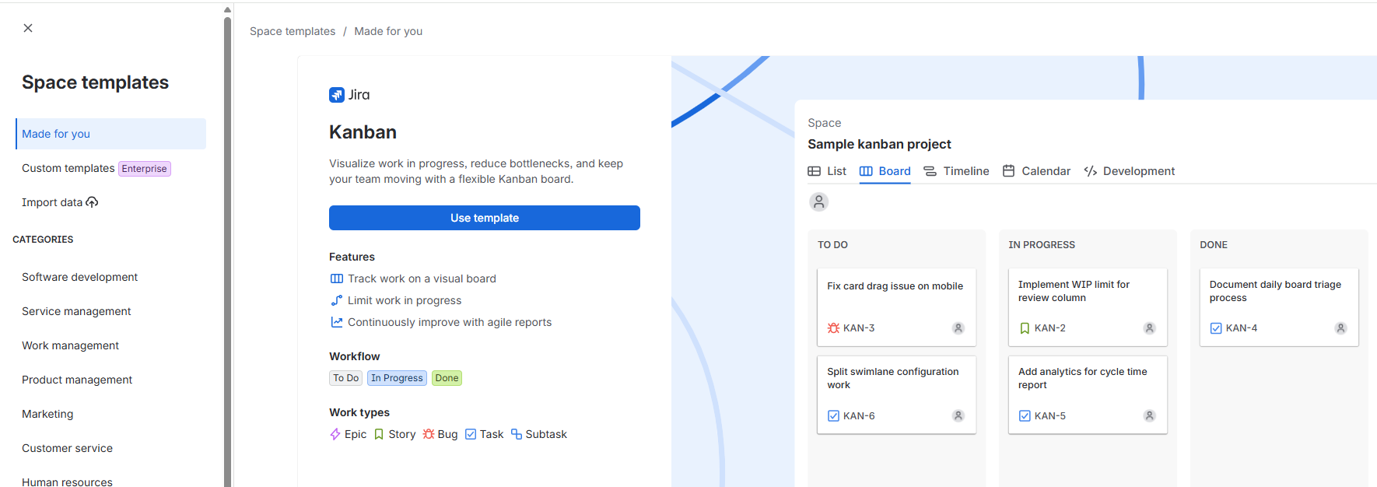
Figure 12. Screenshot from the provided Jira Practical document.
- Click the Kanban card. The template detail panel shows its features, workflow (To Do, In Progress, Done) and work types.
- Click Use template.
[Screenshot Required]: Kanban template detail page with the Use template button highlighted.
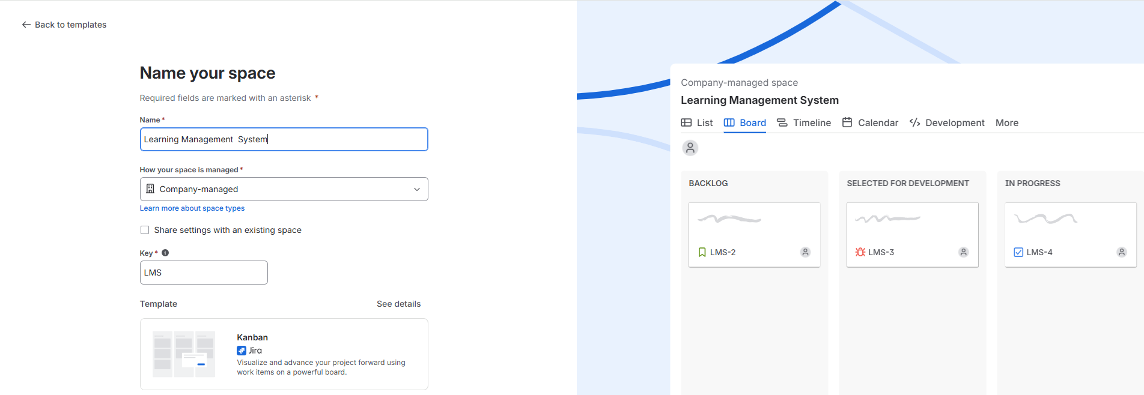
Figure 13. Screenshot from the provided Jira Practical document.
- On the Name your space screen, in the Name field type Learning Management System.
- Open the How your space is managed dropdown and select Company-managed.
- Check that the Key field shows LMS (auto-generated). Leave Share settings with an existing space unticked.
- Click Next.
[Screenshot Required]: "Name your space" form with Name = Learning Management System, Company-managed selected, Key = LMS and the Kanban template card shown.
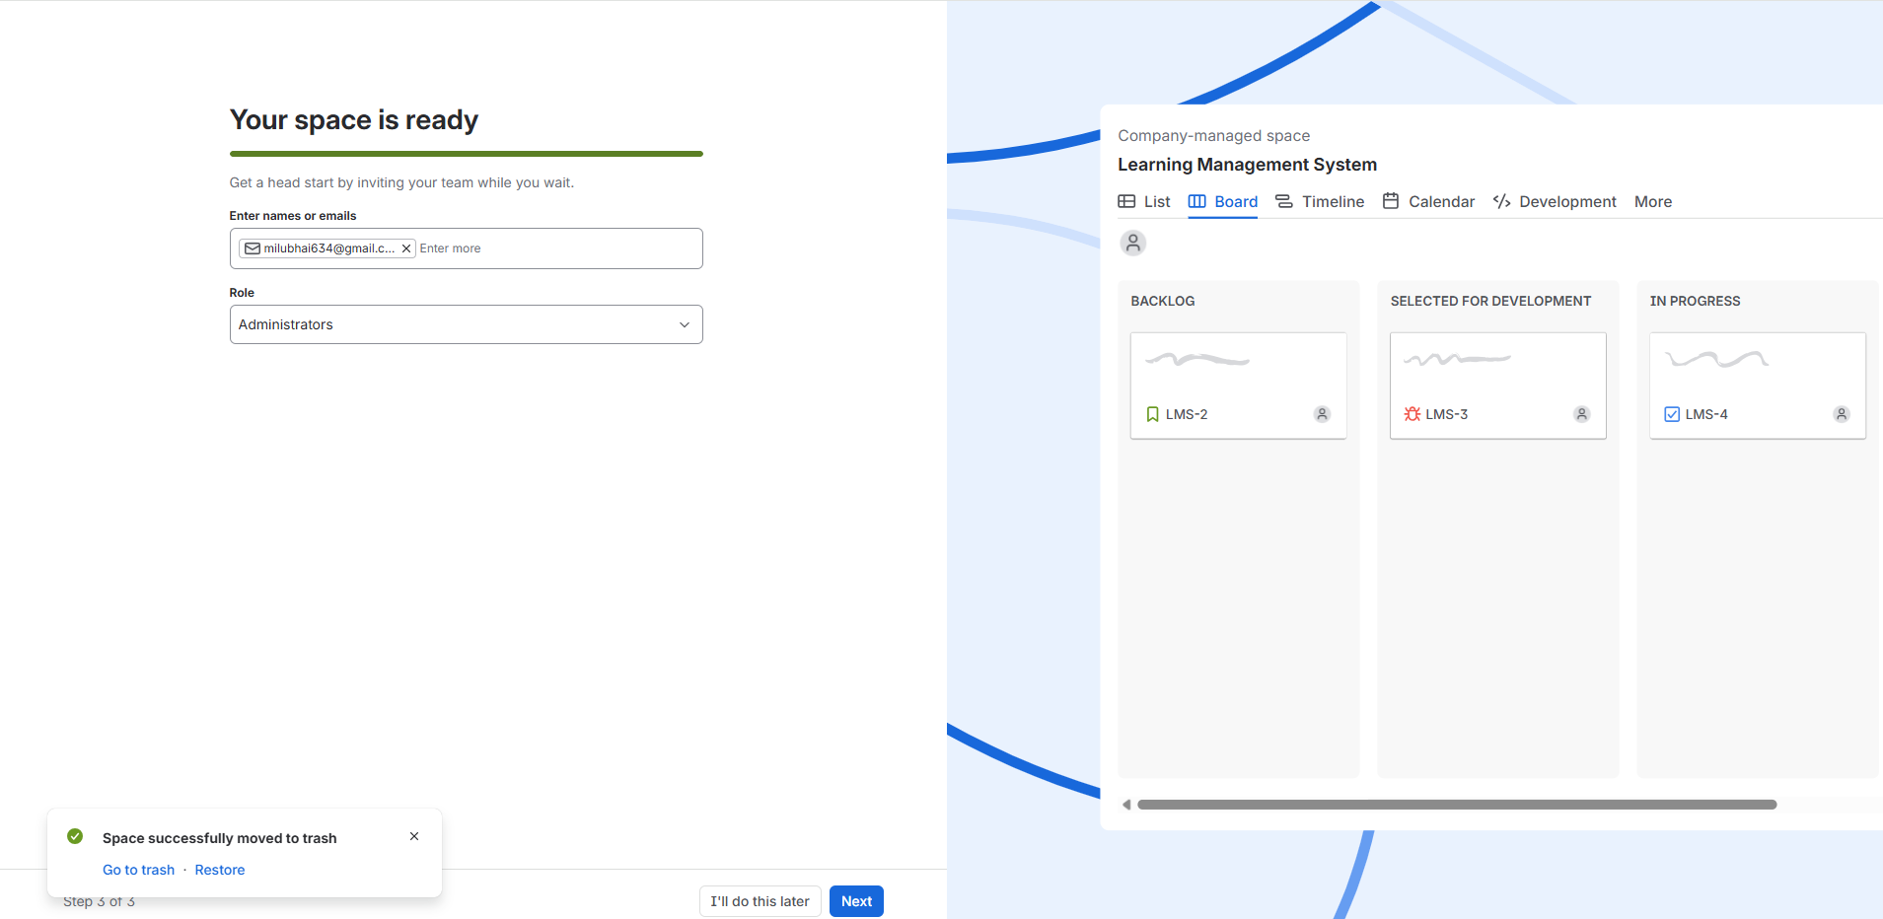
Figure 14. Screenshot from the provided Jira Practical document.
- On the Your space is ready screen, do not enter emails now. Click I'll do this later. (Team invitations are covered in Practical 2.)
[Screenshot Required]: "Your space is ready" screen with the I'll do this later button highlighted.
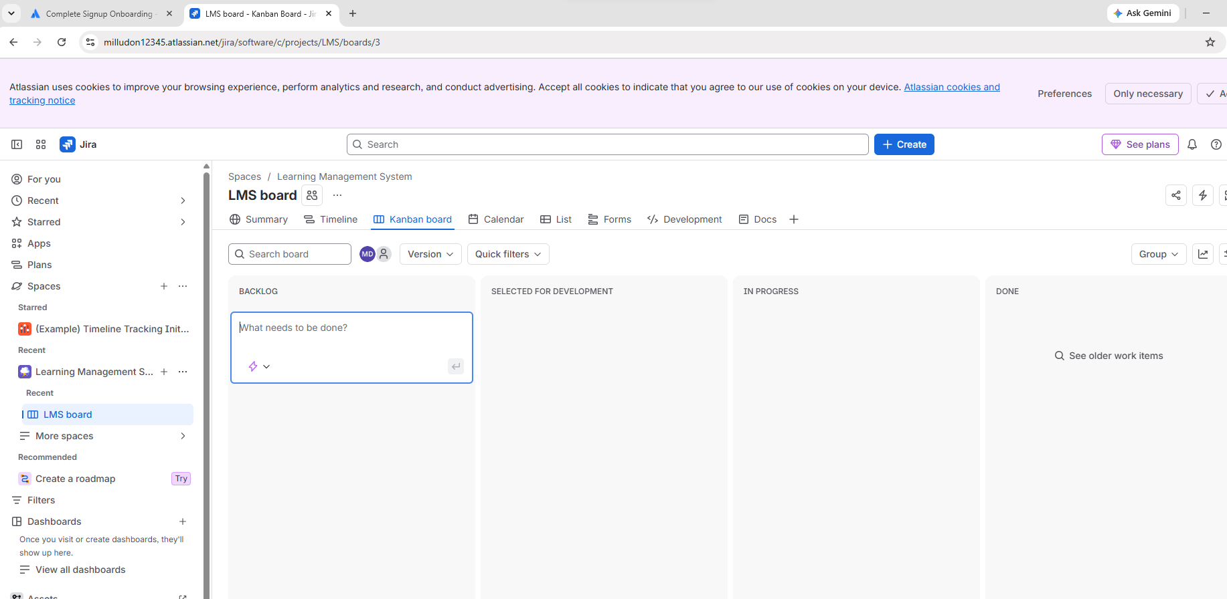
Figure 15. Screenshot from the provided Jira Practical document.
- The LMS board opens. Confirm the breadcrumb Spaces / Learning Management System and the tab bar: Summary, Timeline, Kanban board, Calendar, List, Forms, Development, Docs.
[Screenshot Required]: The empty LMS Kanban board with columns BACKLOG, SELECTED FOR DEVELOPMENT, IN PROGRESS and DONE, and the breadcrumb visible.
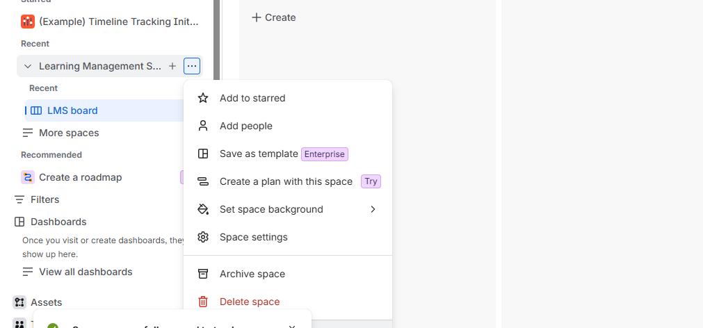
Figure 16. Screenshot from the provided Jira Practical document.
4. Input Test Data and Field Values
Field | Value
Template | Kanban
Name | Learning Management System
How your space is managed | Company-managed
Key | LMS (auto-generated, do not edit)
Invitations | Skipped (I'll do this later)
5. Expected Output and Verification
- Learning Management System appears under Spaces in the sidebar, with LMS board beneath it.
- The browser URL contains /projects/LMS/boards/.
- The board is empty and its columns come from the Kanban template.
- The space type label reads Company-managed.

Part C: Configure Project Details
1. Aim / Objective
To open the space settings of the LMS space, review its general details, and save any changes.
2. Prerequisites and Tooling
- Completed Part B. You must be a space Administrator.
- Navigation path: sidebar space name > ... > Space settings > Details.
3. Step-by-Step Execution Procedure
- In the left sidebar, hover over Learning Management System under Recent (or Spaces) and click the ... (more actions) icon.
[Screenshot Required]: Sidebar with the ... menu open, showing Add to starred, Add people, Save as template, Create a plan with this space, Set space background, Space settings, Archive space, Delete space.
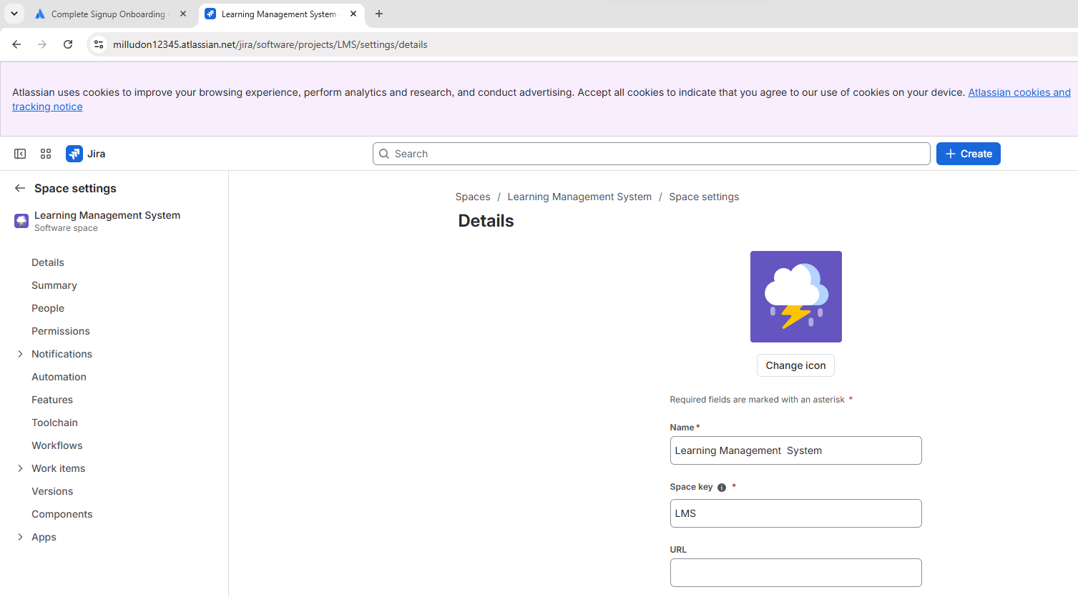
Figure 17. Screenshot from the provided Jira Practical document.
- Click Space settings. The Details page opens.
- Review the fields: Name, Space key, URL and the space icon.
- (Optional) Click Change icon, pick an icon from the gallery and click Select.
- In the URL field, type the value given in the data table.
- Review the left menu of Space settings: Details, Summary, People, Permissions, Notifications, Automation, Features, Toolchain, Workflows, Work items, Versions, Components, Apps.
- Click Save (if a Save button appears after you edit a field). Jira shows a green confirmation banner.
[Screenshot Required]: The Details page of Space settings with Name = Learning Management System, Space key = LMS, the URL field filled, and the left menu visible.
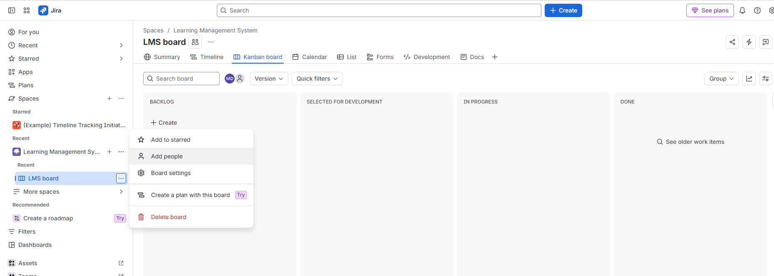
Figure 18. Screenshot from the provided Jira Practical document.
- Click the back arrow (<-) beside Space settings to return to the board.
4. Input Test Data and Field Values
Field | Value
Name | Learning Management System (unchanged)
Space key | LMS (unchanged)
URL | https://lms.example.com (sample value)
Icon | Any icon from the gallery (optional)
5. Expected Output and Verification
- Reopening Space settings > Details shows the saved values.
- The chosen icon appears beside the space name in the sidebar.
- The key LMS is unchanged. It prefixes every work item (LMS-1, LMS-2, ...).

Practical 2: Team Creation and Role Assignment

Part A: Add Team Members
1. Aim / Objective
To invite team members to the LMS space by email and give them an initial role.
2. Prerequisites and Tooling
- The LMS space from Practical 1, and your account as its Administrator.
- Two valid email addresses (classmates, colleagues or your own alternate Gmail IDs). Invitations are emailed to them.
- Navigation path: LMS board > ... > Add people.
3. Step-by-Step Execution Procedure
- In the left sidebar, click LMS board under Learning Management System. The Kanban board opens.
- Click the ... icon next to LMS board.
[Screenshot Required]: Sidebar menu opened from the ... beside LMS board, showing Add to starred, Add people, Board settings, Create a plan with this board, Delete board.
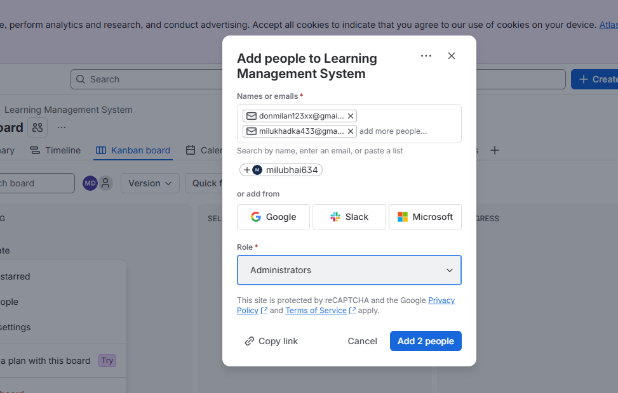
Figure 19. Screenshot from the provided Jira Practical document.
- Click Add people. The Add people to Learning Management System dialog opens. (The + icon beside the avatars at the top of the board opens the same dialog.)
- Click the Names or emails field and type the first email address from the data table. Press Enter to turn it into a chip.
- Type the second email address and press Enter.
- Open the Role dropdown and select Administrators (the default shown) or the role named in the data table.
[Screenshot Required]: The "Add people" dialog with two email chips in Names or emails, Role set to the chosen role, and the Add 2 people button visible.
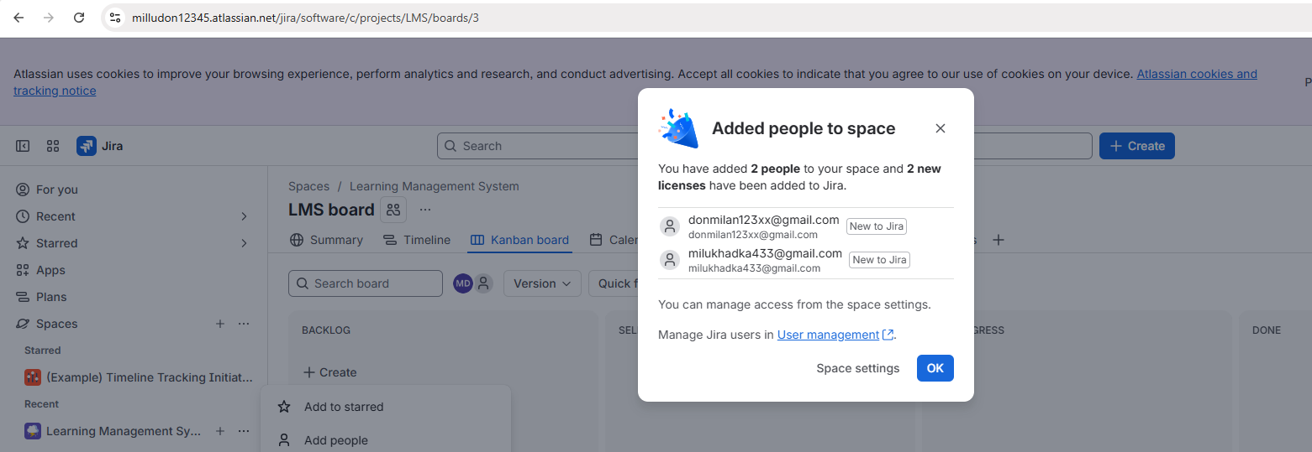
Figure 20. Screenshot from the provided Jira Practical document.
- Click Add 2 people.
- A confirmation dialog titled Added people to space appears. It states how many people and licences were added and lists each email with a New to Jira tag. Click OK.
[Screenshot Required]: The "Added people to space" confirmation dialog listing both email addresses with New to Jira tags, and the OK button.
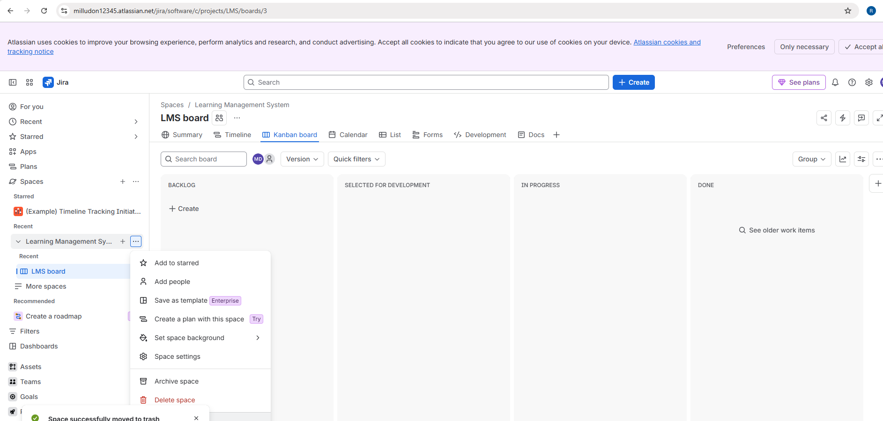
Figure 21. Screenshot from the provided Jira Practical document.
4. Input Test Data and Field Values
Field | Value
Names or emails (1) | member1@gmail.com (use a real address you control)
Names or emails (2) | member2@gmail.com (use a real address you control)
Role | Administrators (initial role)
Button | Add 2 people
5. Expected Output and Verification
- The confirmation dialog reports 2 people added to the space.
- Both users receive an invitation email from Atlassian.
- The avatars at the top of the LMS board now show additional team members.

Part B: Assign and Modify Roles
1. Aim / Objective
To view the members of the LMS space and change a member's role, then verify that the permissions have changed.
2. Prerequisites and Tooling
- Part A completed, with at least two members in the space.
- Administrator rights on the space.
- Navigation path: sidebar ... > Space settings > People.
3. Step-by-Step Execution Procedure
- In the sidebar, click the ... next to Learning Management System.
- Click Space settings.
[Screenshot Required]: The space ... menu with Space settings highlighted.
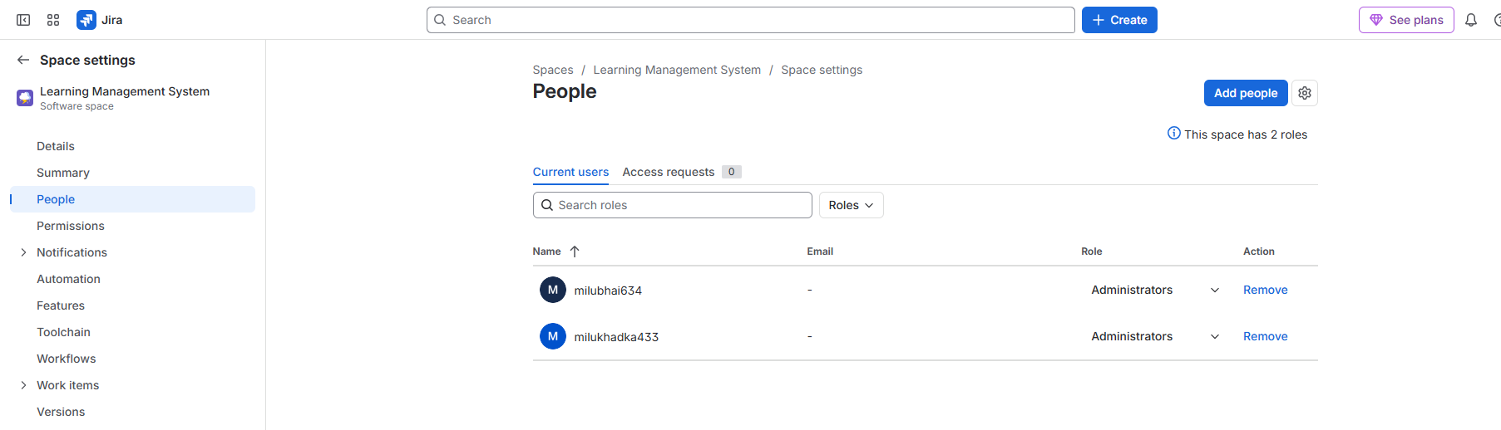
Figure 22. Screenshot from the provided Jira Practical document.
- In the left menu of Space settings, click People. The Current users tab lists each member with columns Name, Email, Role and Action. The header reads "This space has 2 roles".
[Screenshot Required]: The People page with the Current users tab, both members listed with the Administrators role.
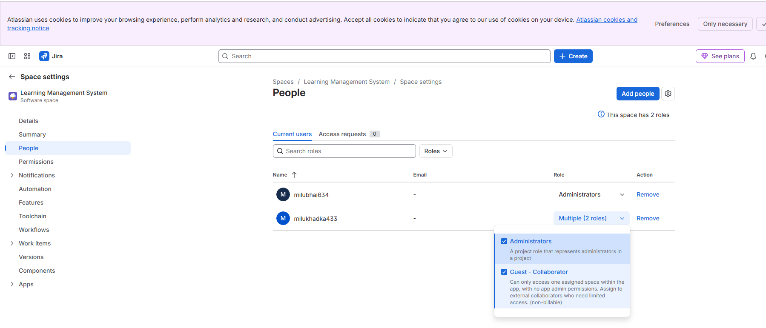
Figure 23. Screenshot from the provided Jira Practical document.
- In the Search roles box (or the name list) locate the second member you added.
- In that member's row, click the Role dropdown (it shows Administrators).
- In the list of roles, tick the role named in the data table. The two available roles are:
  - Administrators: a project role that represents administrators in a project.
  - Guest - Collaborator: can only access one assigned space within the app, with no app admin permissions. Meant for external collaborators who need limited access (non-billable).
- To make the second member a collaborator only, untick Administrators and keep Guest - Collaborator ticked. If both are ticked, the role cell reads Multiple (2 roles).
[Screenshot Required]: The role dropdown open for the second member with both roles listed and the intended checkbox(es) ticked.
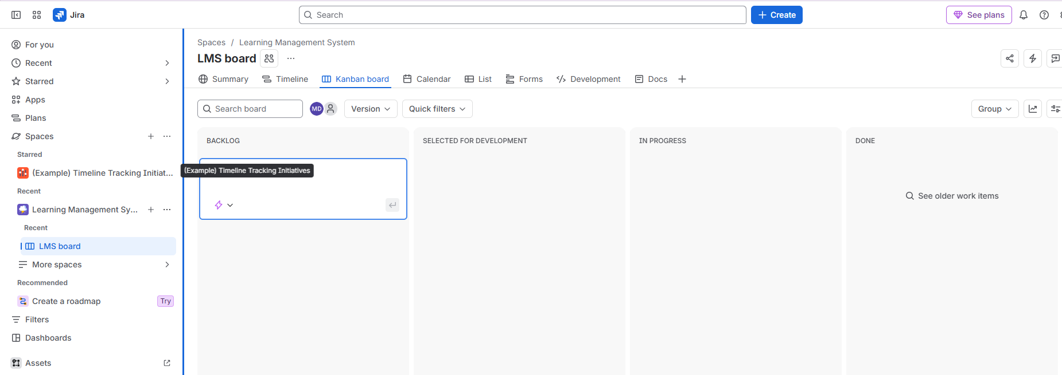
Figure 24. Screenshot from the provided Jira Practical document.
- Click outside the dropdown to apply. The role cell updates immediately.
- (Optional) Click Remove in the Action column only if you wish to remove a test user. Do not remove yourself.
- Click Permissions in the left menu to review what each role may do.
4. Input Test Data and Field Values
User | Original role | New role
You (space creator) | Administrators | Administrators (no change)
Member 1 | Administrators | Administrators (no change)
Member 2 | Administrators | Guest - Collaborator (untick Administrators)
5. Expected Output and Verification
- The People page shows Member 2 with Guest - Collaborator only. It shows Multiple (2 roles) if both roles remain ticked.
- Member 2 cannot open Space settings, while an Administrator can.
- Refreshing the page (F5) keeps the new role, which confirms it was saved.

Practical 3: Issue Types and Configuration

Part A: Create and Configure Issue Types (Epic, Task, Story, Bug)
1. Aim / Objective
To understand the standard issue types available in a company-managed Kanban space and to create a work item of type Task directly from the Backlog column.
2. Prerequisites and Tooling
- The LMS Kanban board (Practical 1) with an empty BACKLOG column.
- Navigation path: sidebar LMS board > Kanban board tab.
- Issue types in this template: Epic (large body of work), Story (user requirement), Bug (defect), Task (unit of work), Subtask (child of another item).
3. Step-by-Step Execution Procedure
- In the sidebar, click LMS board. Make sure the Kanban board tab is active.
- In the BACKLOG column, click + Create. A card opens with the placeholder text "What needs to be done?".
[Screenshot Required]: The Kanban board with the inline create card open in the BACKLOG column and the placeholder "What needs to be done?".
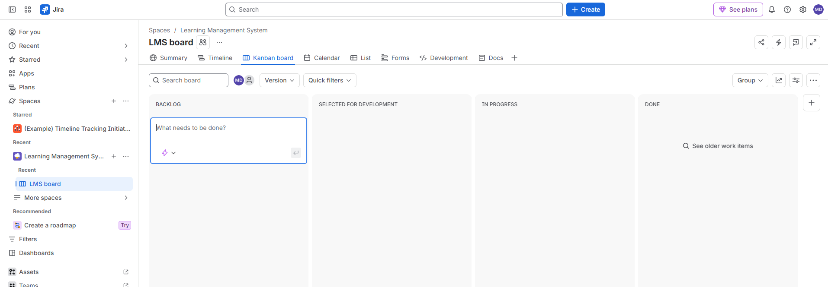
Figure 25. Screenshot from the provided Jira Practical document.
- In the card, click the issue type icon (the small icon with a dropdown arrow at the bottom left). The list shows Epic, Bug, Task and Manage types.
[Screenshot Required]: The issue type dropdown open, listing Epic, Bug, Task and Manage types.
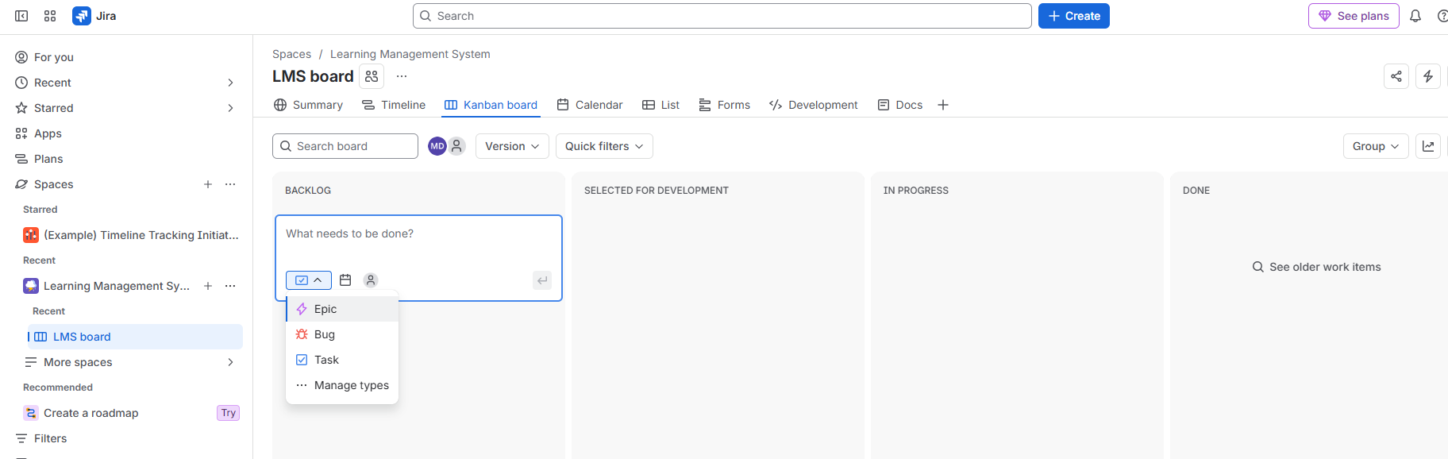
Figure 26. Screenshot from the provided Jira Practical document.
- Click Task.
- Click in the text area and type Customer Interaction.
[Screenshot Required]: The create card with Customer Interaction typed in and the Task icon selected.
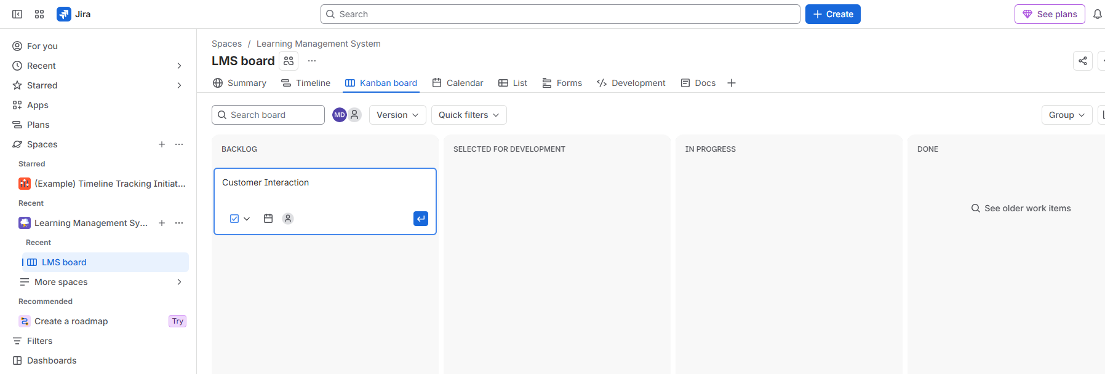
Figure 27. Screenshot from the provided Jira Practical document.
- Press Enter (or click the blue Enter arrow at the bottom right of the card).
- The card Customer Interaction appears in the BACKLOG column with key LMS-1, and the column header shows a count of 1.
- (Optional) Repeat steps 2 to 6 to create one item each of type Bug and Epic, using the sample summaries in the data table.
- (Optional) To review the type list, click Manage types in the dropdown, or go to Space settings > Work items and review the issue types in use.
[Screenshot Required]: The BACKLOG column with the new card "Customer Interaction", its Task icon and key LMS-1 visible, and the count badge showing 1.
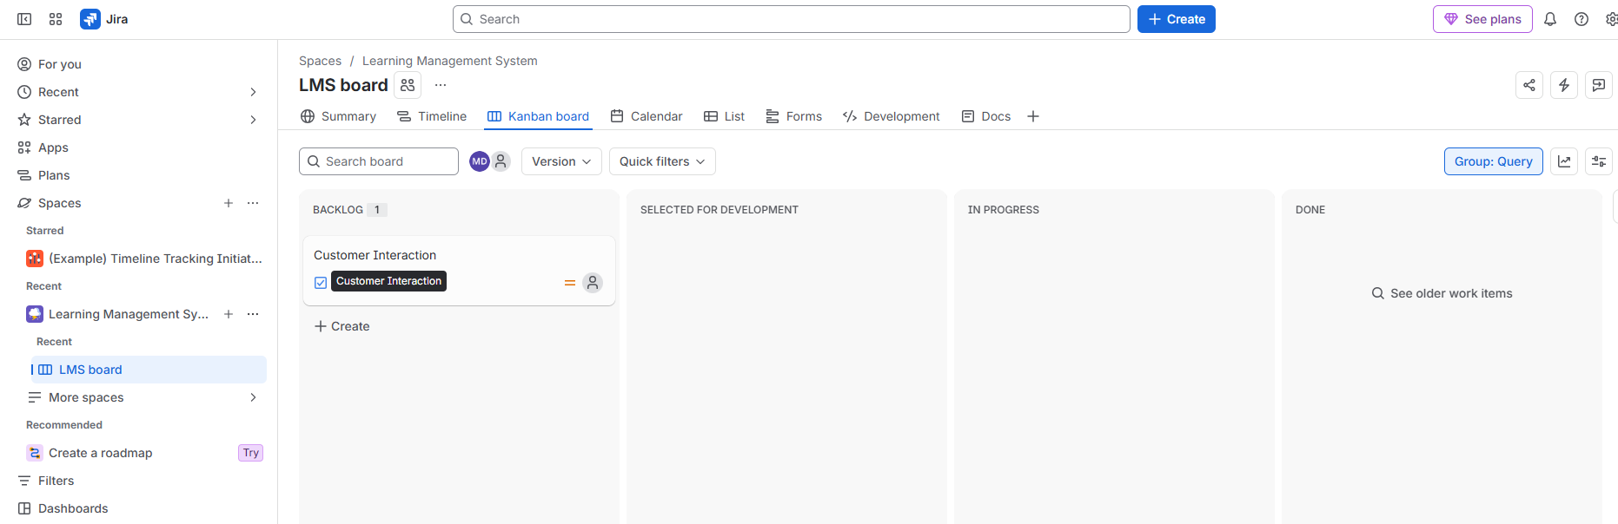
Figure 28. Screenshot from the provided Jira Practical document.
4. Input Test Data and Field Values
Issue type | Summary | Expected key
Task | Customer Interaction | LMS-1
Bug (optional) | Login page not loading | LMS-2 (the next free number)
Epic (optional) | Course Management | next free number
If you create the optional items, the keys in Practical 4 move up by the same amount. Note the actual key shown on your board.
5. Expected Output and Verification
- The BACKLOG column contains the card Customer Interaction with the Task icon.
- Opening the card shows Work type: Task and the key LMS-1.
- Hovering over the card shows its full summary.

Part B: Create Components and Versions (Releases)
1. Aim / Objective
To create a Component that groups work items into a part of the system, and a Version (Release) that tracks a planned delivery.
2. Prerequisites and Tooling
- Administrator rights on the LMS space.
- Navigation path: sidebar ... > Space settings > Components and Versions (shown as Releases on the page).
3. Step-by-Step Execution Procedure: Components
- In the sidebar, click the ... beside Learning Management System.
[Screenshot Required]: The space actions menu with Space settings highlighted.
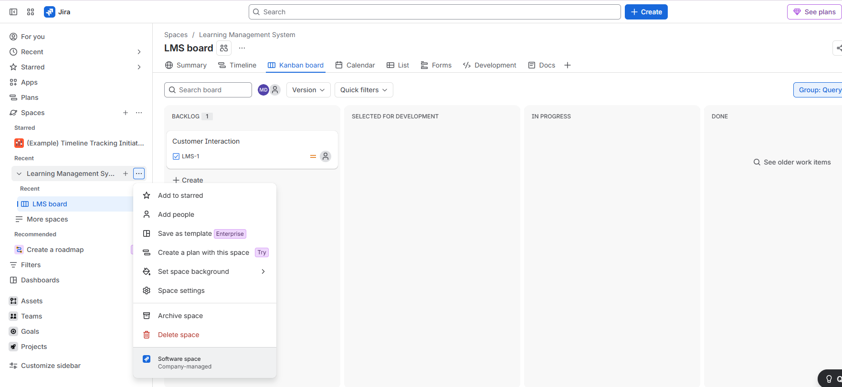
Figure 29. Screenshot from the provided Jira Practical document.
- Click Space settings.
- In the left menu, click Components. The page reads "This space doesn't have any components, yet".
- Click Create component.
[Screenshot Required]: The empty Components page with the Create component button.
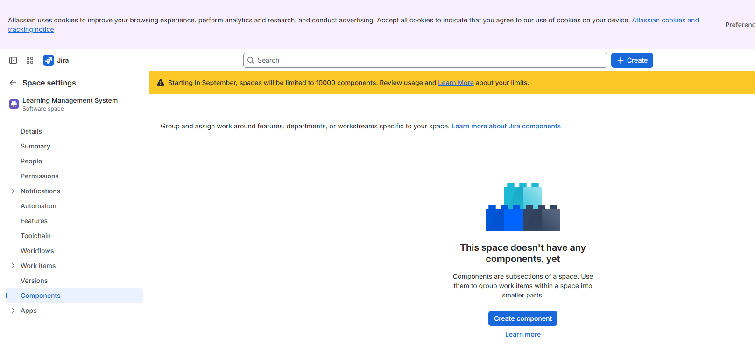
Figure 30. Screenshot from the provided Jira Practical document.
- In the Create Jira component dialog, fill in the fields from the data table: Name, Description, Component lead, Default assignee.
- For Component lead, click the dropdown labelled Select person and choose your own name (or a team member).
- For Default assignee, keep Space default, or choose Component lead.
- Click Save.
[Screenshot Required]: The "Create Jira component" dialog filled with Name = Login and Authentication, Description = User login and authentication, Component lead selected, before clicking Save.
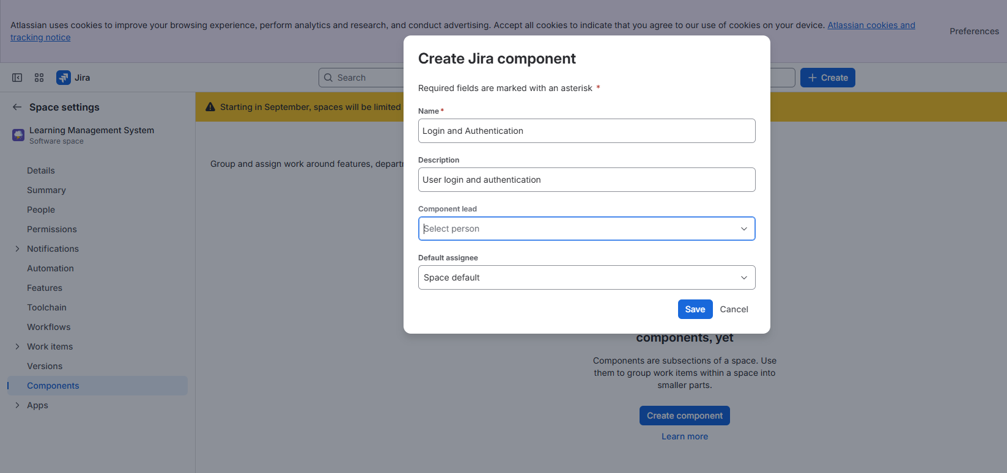
Figure 31. Screenshot from the provided Jira Practical document.
- The component is listed with columns Component, Description, Component lead, Default assignee, Issues and More actions. The page header reads "This space has 1 component".
[Screenshot Required]: The Components list showing Login and Authentication, its description, and 0 issues.
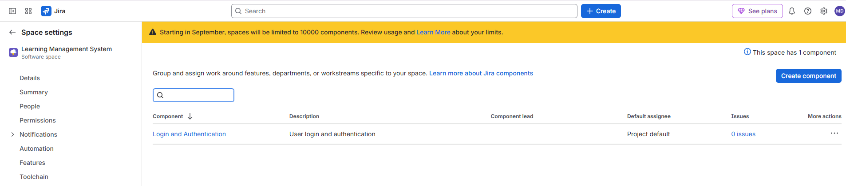
Figure 32. Screenshot from the provided Jira Practical document.
3. (continued) Step-by-Step Execution Procedure: Versions / Releases
- In the left menu of Space settings, click Versions (the page title shows Releases).
- Click Create release (top right).
[Screenshot Required]: The Releases page (empty state, "No matching versions") with the Create release button.
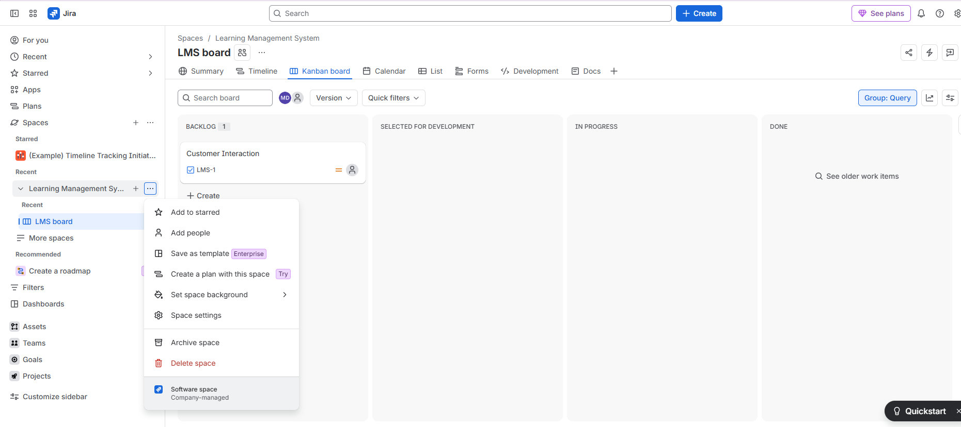
Figure 33. Screenshot from the provided Jira Practical document.
- In the Create release dialog, complete each field using the data table.
- Under Release stages, leave the two default stages in order: Planned, then Released. To add one, type its name in Add a stage and click Add.
- Leave Require approvals before moving to Released unticked.
- Click Create.
[Screenshot Required]: The "Create release" dialog filled with Release name = Version 1.0, both dates, Driver, Description, and stages Planned and Released, before clicking Create.
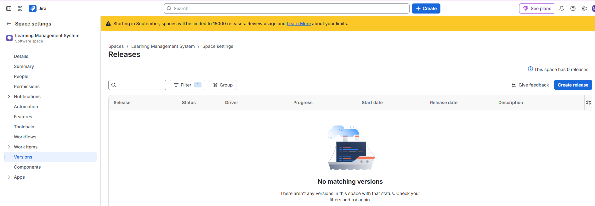
Figure 34. Screenshot from the provided Jira Practical document.
- If a red Something went wrong banner appears, wait a few seconds and check the Releases list before trying again. In the recorded run the release was created despite the banner, and creating again would produce a duplicate.
- Confirm Version 1.0 appears in the Releases table.
[Screenshot Required]: The Releases table with a row for Version 1.0 showing Status (Unreleased), Driver, Progress (No work items) and Description.
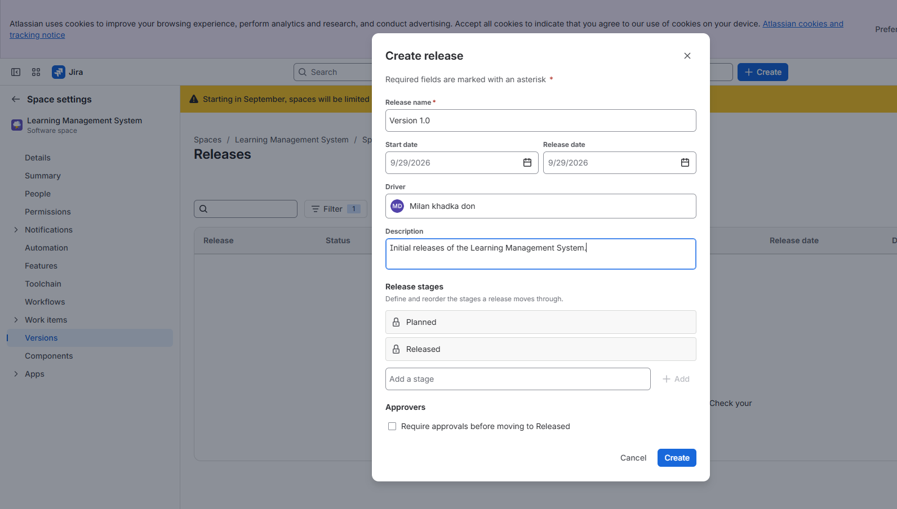
Figure 35. Screenshot from the provided Jira Practical document.
4. Input Test Data and Field Values
Object | Field | Value
Component | Name | Login and Authentication
Component | Description | User login and authentication
Component | Component lead | Your own name (or a team member)
Component | Default assignee | Space default
Release | Release name | Version 1.0
Release | Start date | Today's date, for example 10/29/2026
Release | Release date | A future date, for example 12/15/2026
Release | Driver | Your own name
Release | Description | Initial release of the Learning Management System
Release | Release stages | Planned, Released
Release | Approvers | Not required
5. Expected Output and Verification
- Components shows Login and Authentication with the description entered and 0 issues.
- Releases shows Version 1.0 with status Unreleased and the correct driver.
- Both objects can be chosen later in the Components and Fix versions fields of a work item.

Practical 4: Issue Management

Part A: Create Issues Under an Epic
1. Aim / Objective
To create an Epic on the LMS Kanban board from the Backlog column and confirm that Jira assigns it a work item key.
2. Prerequisites and Tooling
- Practical 3 Part A completed, so that LMS-1 (Customer Interaction) already exists.
- Navigation path: LMS board > Kanban board > BACKLOG > + Create.
3. Step-by-Step Execution Procedure
- Open the LMS board and make sure the Kanban board tab is active.
- In the BACKLOG column, below the existing card, click + Create. A new create card opens.
[Screenshot Required]: The BACKLOG column with the existing card Customer Interaction (LMS-1) and a new empty create card below it.
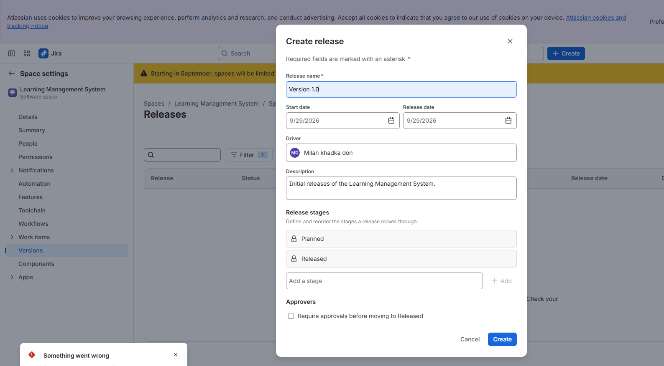
Figure 36. Screenshot from the provided Jira Practical document.
- Click the issue type icon at the bottom left of the card to open the dropdown.
- Click Epic. The icon changes to the purple Epic icon.
[Screenshot Required]: The issue type dropdown with Epic being selected, or the card showing the Epic icon.
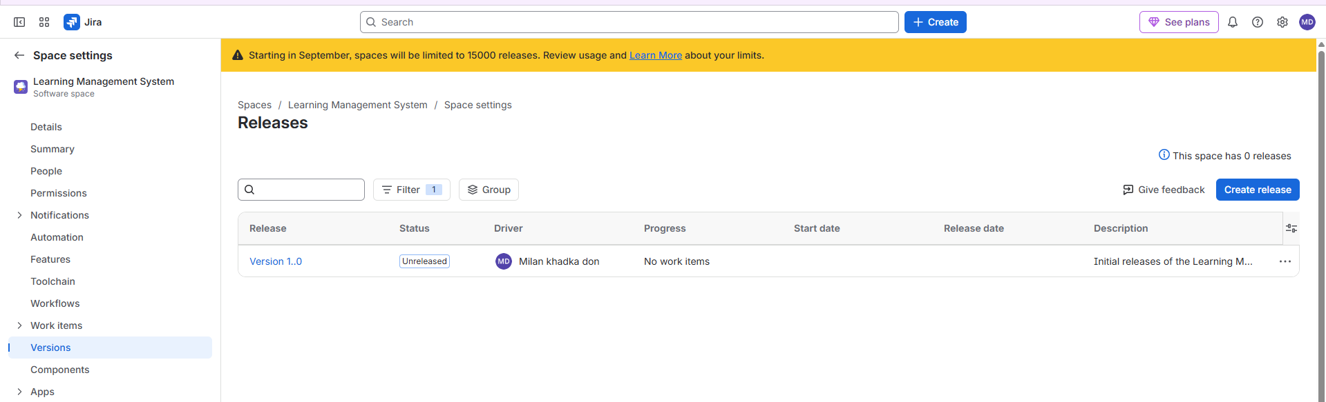
Figure 37. Screenshot from the provided Jira Practical document.
- In the text area, type Create Course Upload Form.
- Press Enter.
- The Epic card appears in the BACKLOG column below LMS-1. The column header count increases to 2.
[Screenshot Required]: The BACKLOG column showing two cards: Customer Interaction (LMS-1) and the Epic Create Course Upload Form with the purple Epic icon and its key.
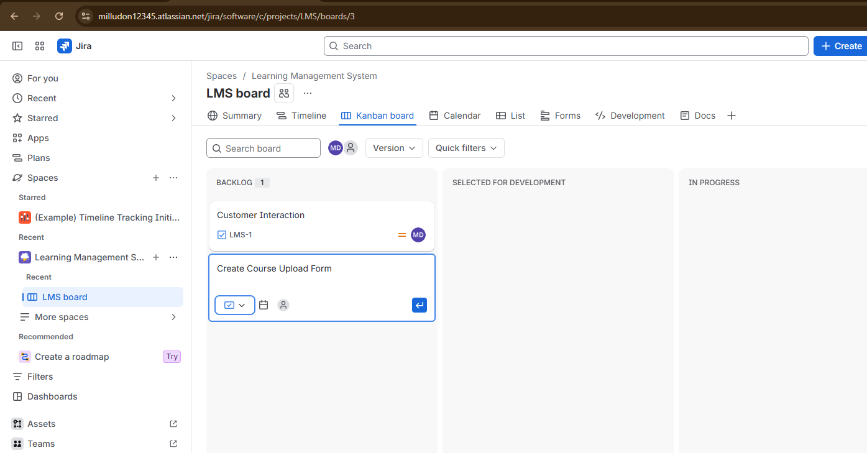
Figure 38. Screenshot from the provided Jira Practical document.
- Note the key shown on the Epic card (expected LMS-2). It will be used in Part B.
- Optionally, create child work items under the Epic: open the Epic (Part B step 1) and click Add child work item to create a Task such as Design upload screen.
4. Input Test Data and Field Values
Field | Value
Issue type | Epic
Summary | Create Course Upload Form
Expected key | LMS-2
Optional child Task summary | Design upload screen
5. Expected Output and Verification
- The BACKLOG column holds two items and shows the count 2.
- The new card carries the Epic icon and the key LMS-2. If you created extra items in Practical 3, your key is the next free number.
- A new Epic filter chip may appear in the board toolbar, since the board now contains an Epic.

Part B: Assign Issues, Set Priority and Configure Due Date
1. Aim / Objective
To open the detail view of the Epic and set its Assignee, Reporter, Priority and Due date, then verify the result on the board.
2. Prerequisites and Tooling
- Part A completed.
- At least one team member from Practical 2 (or yourself) to assign.
- Navigation path: click the Epic card on the board to open its detail view.
3. Step-by-Step Execution Procedure
- On the LMS board, click the card Create Course Upload Form (LMS-2). The work item detail view opens, with the title and Description on the left and the Details panel on the right.
[Screenshot Required]: The detail view of LMS-2 with the Details panel visible: Assignee (Unassigned), Reporter, Labels, Due date, Start date, Priority (Medium).
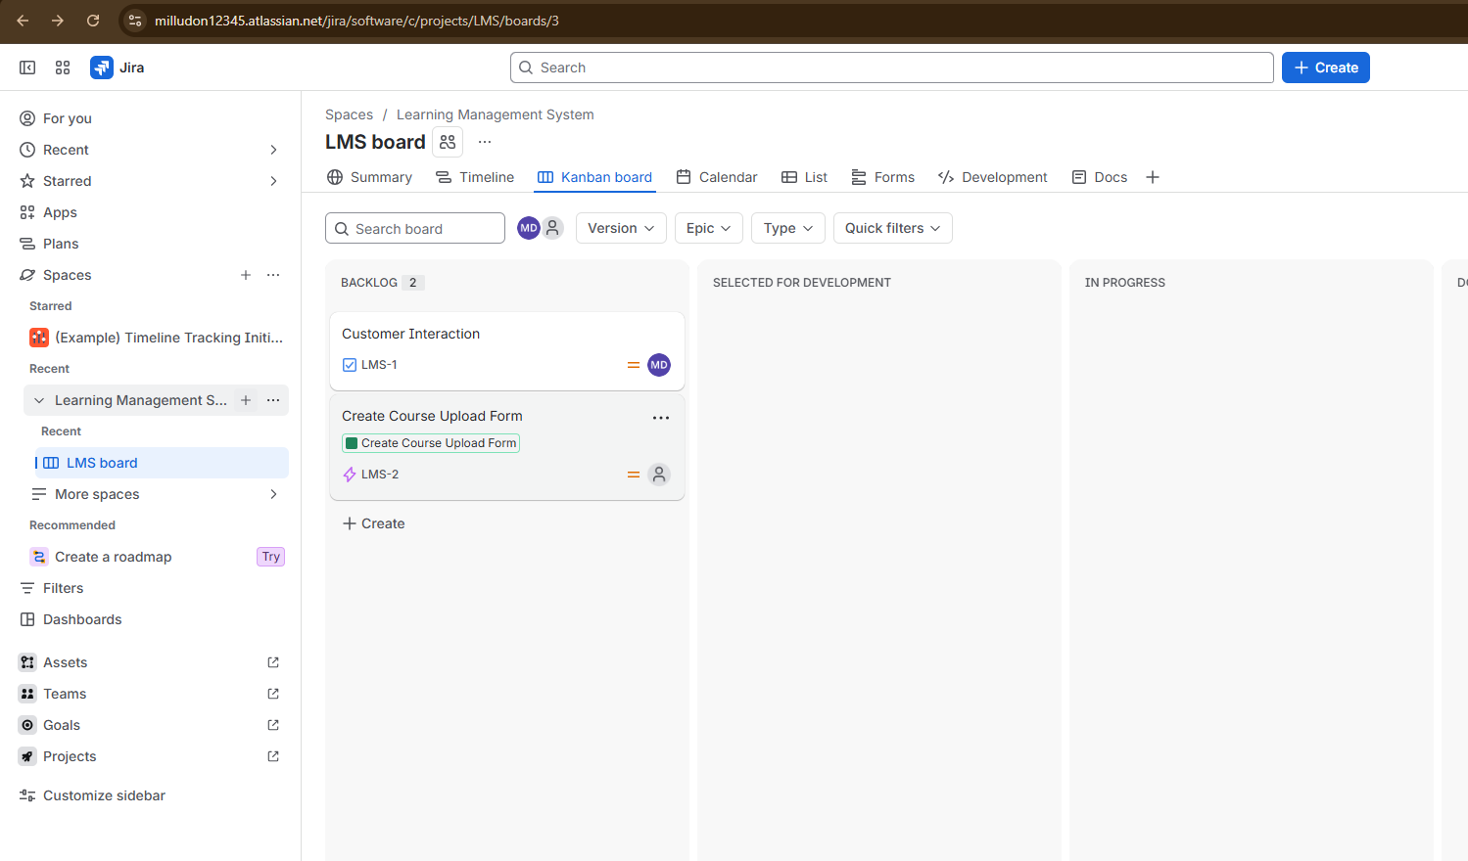
Figure 39. Screenshot from the provided Jira Practical document.
- In Details, click Assignee, then select a team member from the list. Click Assign to me to assign yourself.
- Check Reporter. It normally shows the person who created the item. If it is blank, click it and choose your name.
- Click Priority and choose High from the list.
- Click Due date, open the calendar, and pick the date from the data table. Press Enter or click the date.
- (Optional) Click Description and type Form that lets instructors upload course material. Click Save.
[Screenshot Required]: The Details panel with Assignee set, Reporter set, Due date filled and Priority showing High.
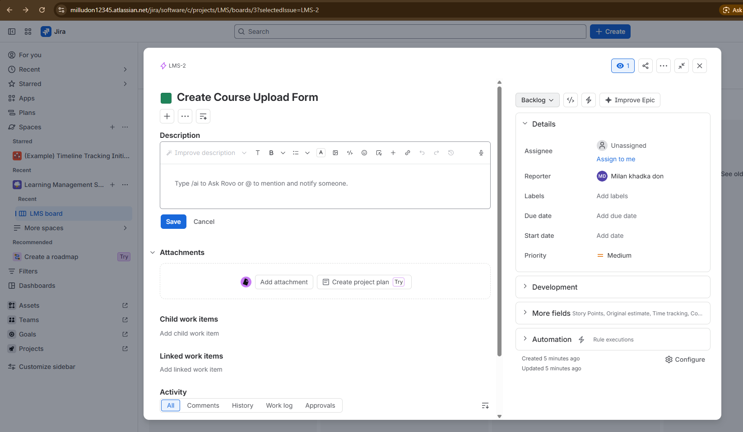
Figure 40. Screenshot from the provided Jira Practical document.
- Click the X (Close) icon at the top right of the detail view.
- Look at the card on the Kanban board and verify the badges: the due date, the priority icon and the assignee avatar.
[Screenshot Required]: The board after closing the detail view: the Epic card in BACKLOG showing the due date, the High priority icon and the assignee avatar.
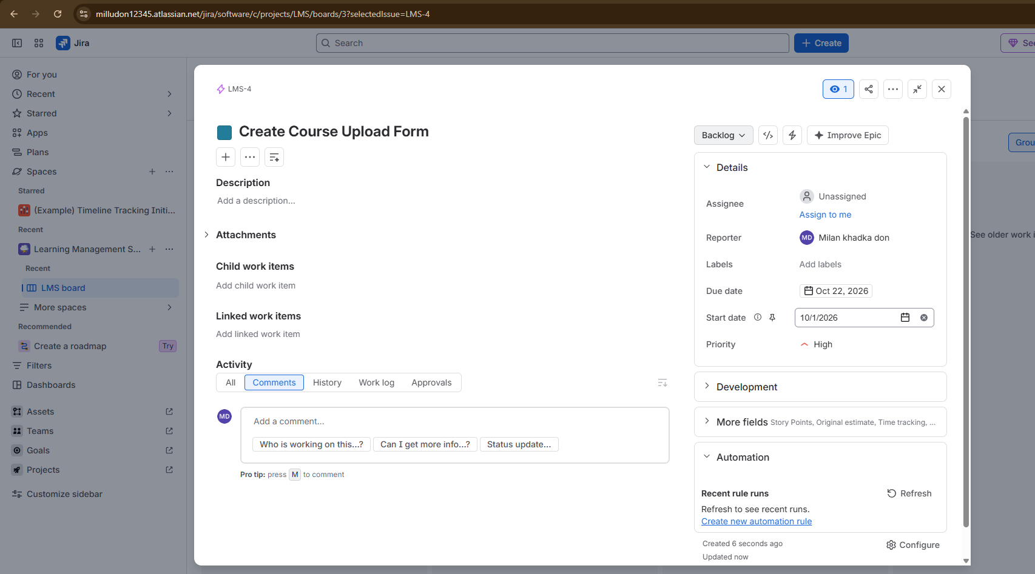
Figure 41. Screenshot from the provided Jira Practical document.
4. Input Test Data and Field Values
Field | Value
Work item | LMS-2 Create Course Upload Form
Assignee | A team member added in Practical 2 (or yourself)
Reporter | Your own name
Priority | High
Due date | A target milestone date, for example 11/30/2026
Start date (optional) | 10/29/2026
Description (optional) | Form that lets instructors upload course material.
5. Expected Output and Verification
- The detail view shows the chosen Assignee, Reporter, Priority High and the Due date.
- The card on the Kanban board displays the due date and the priority and assignee icons.
- Opening the Activity > History tab lists each change with a timestamp.
- A new due date shows in the Calendar tab of the board on the selected day.
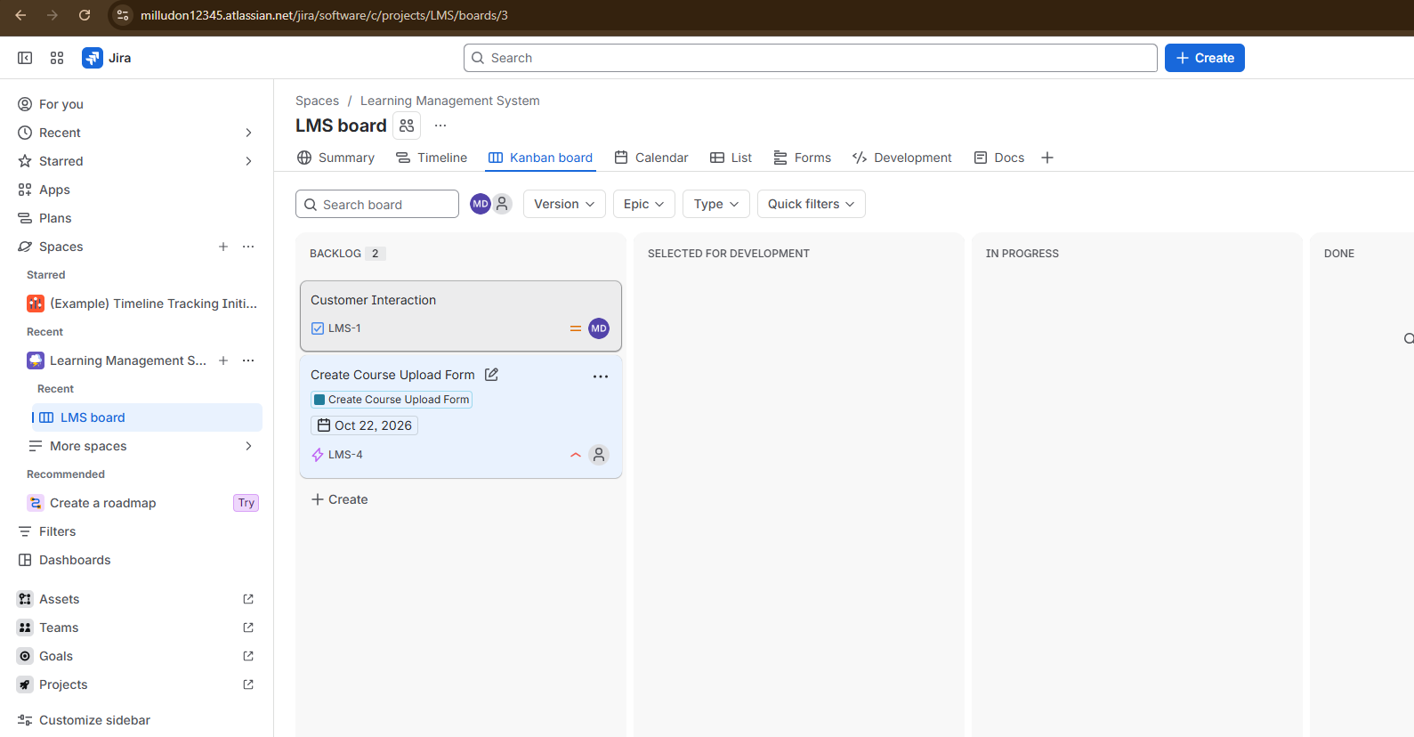
Additional reference screenshot 42 from the provided Jira Practical document.

