JIRA PRACTICAL

Prac1 : jira setup and project creation
A.create a jira cloud account and explore the dashboard
B:Create a company_managef scrum/kanban Project.
C.Configure project details

A:Create a jira cloud account and explore the dashboard
Step1: Go to Google Chrome – Search jira
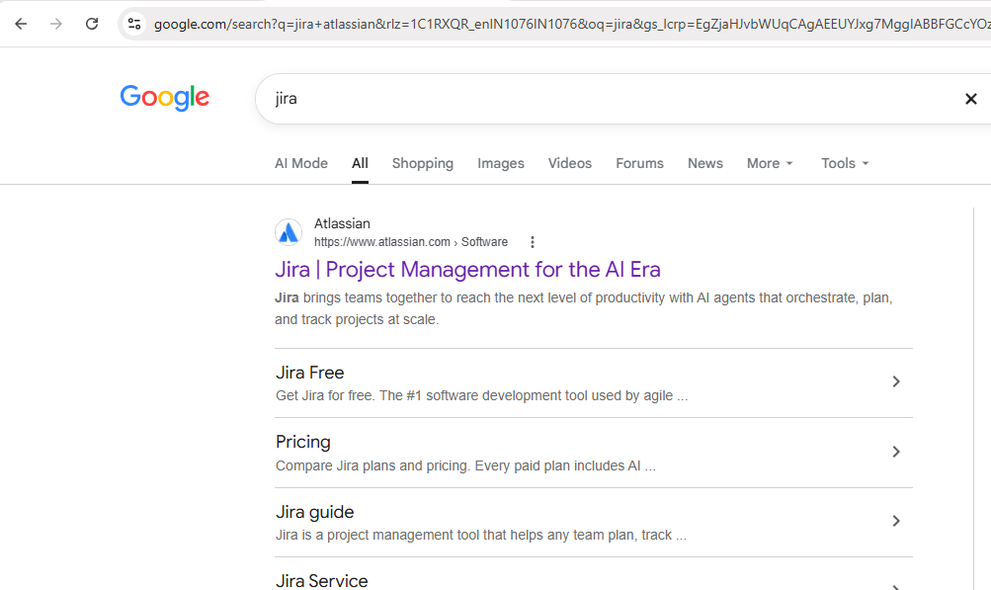

Step2: click jira by Atlassian
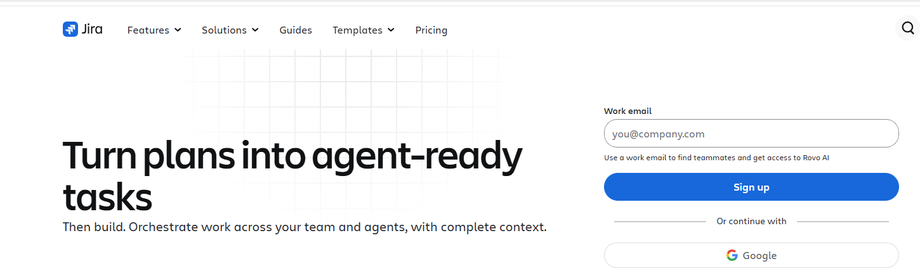

Step 3: Click on Google – Login with your Gmail id – Create your account screen will appear as below-below continue.
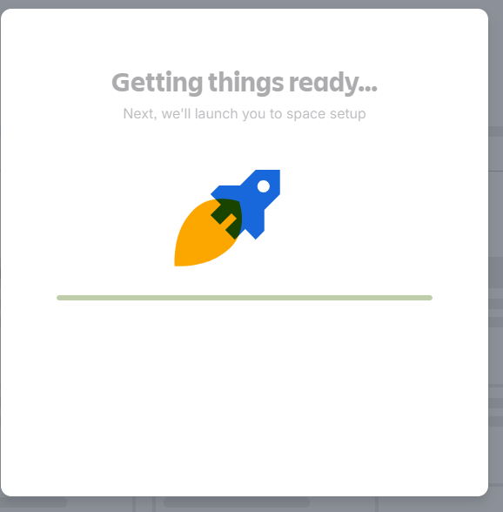
Step4: Select Project Management from the list
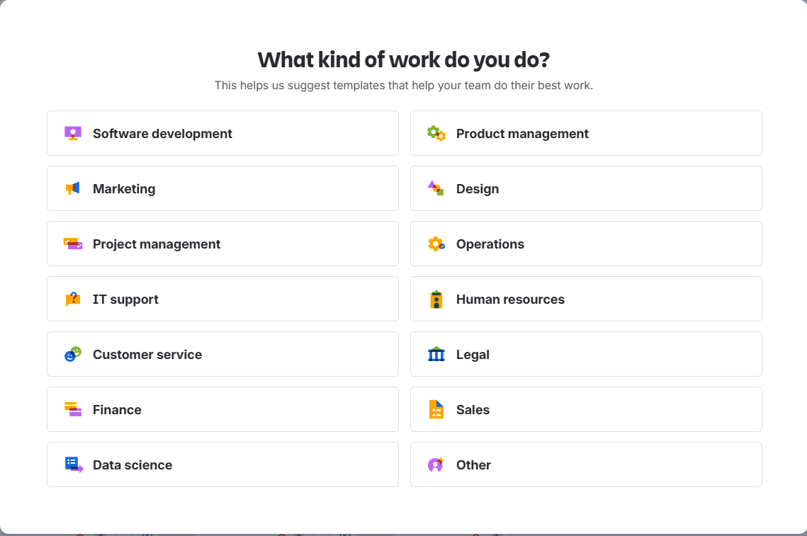

Step5:select kanban from the list and click continue.
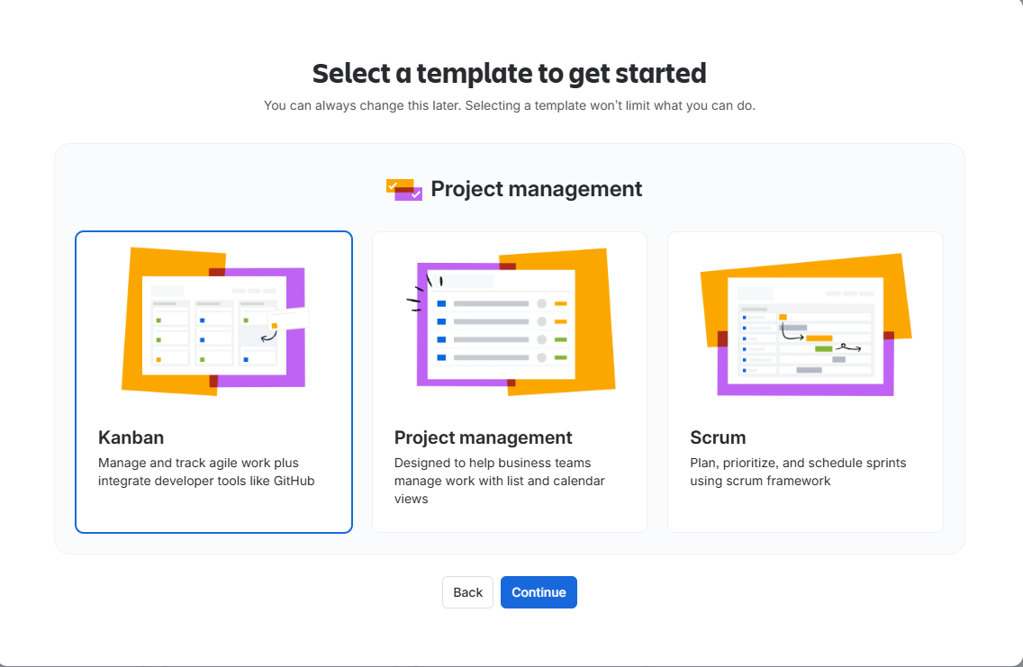
Step6: After continue –provide details as asked below and click on get started
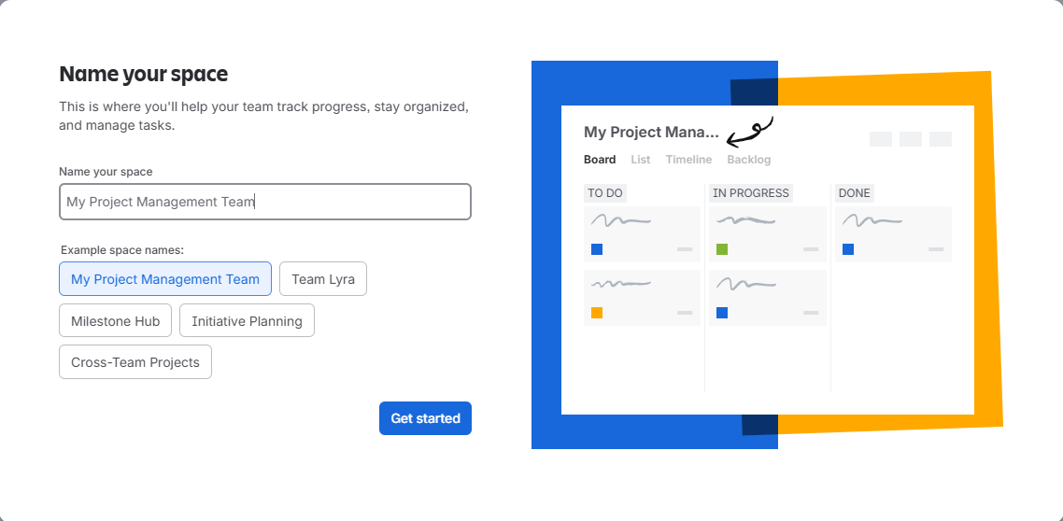
Step 7: click next
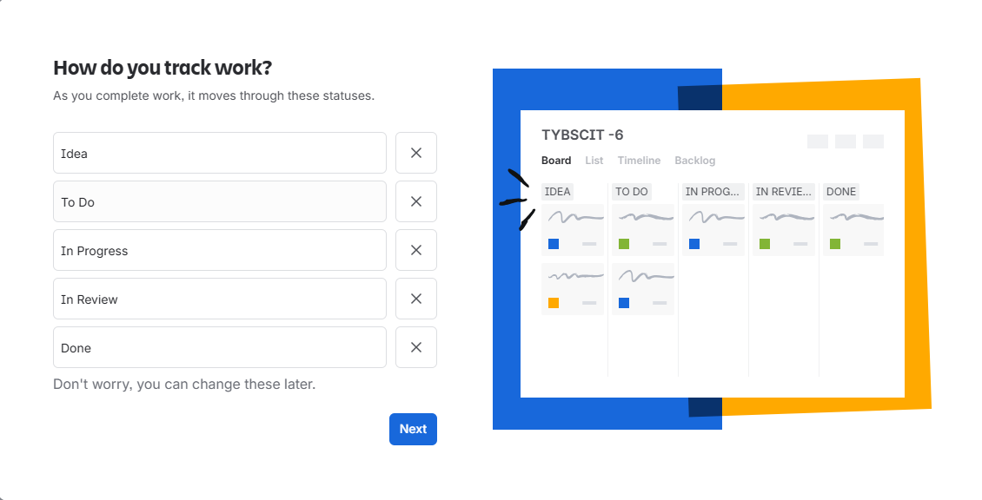
Step 9: click go to jira.
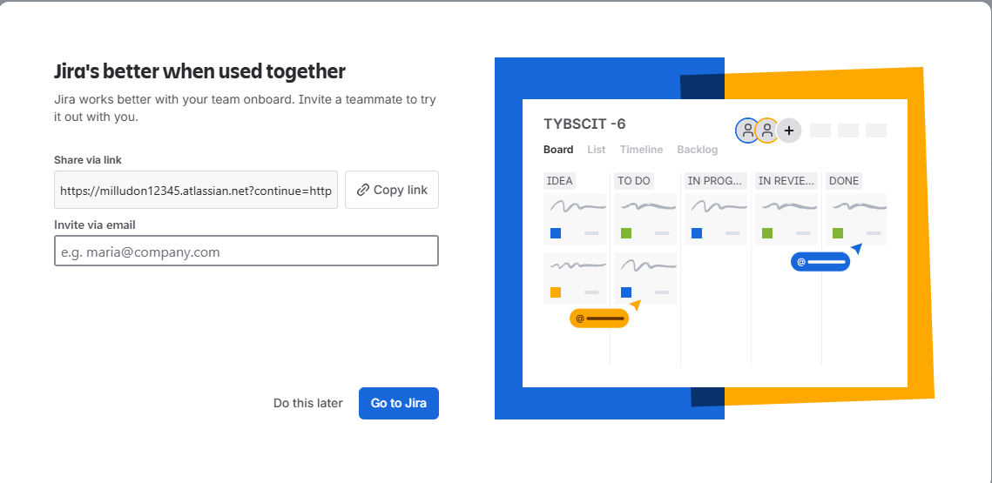

Step 9: Dashboard will appear .
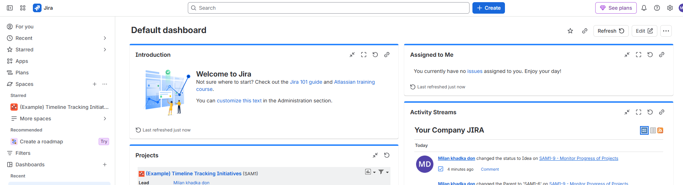

B:Create a company -managed scrum/kanban project
Step 1:CLICK ON spaces +
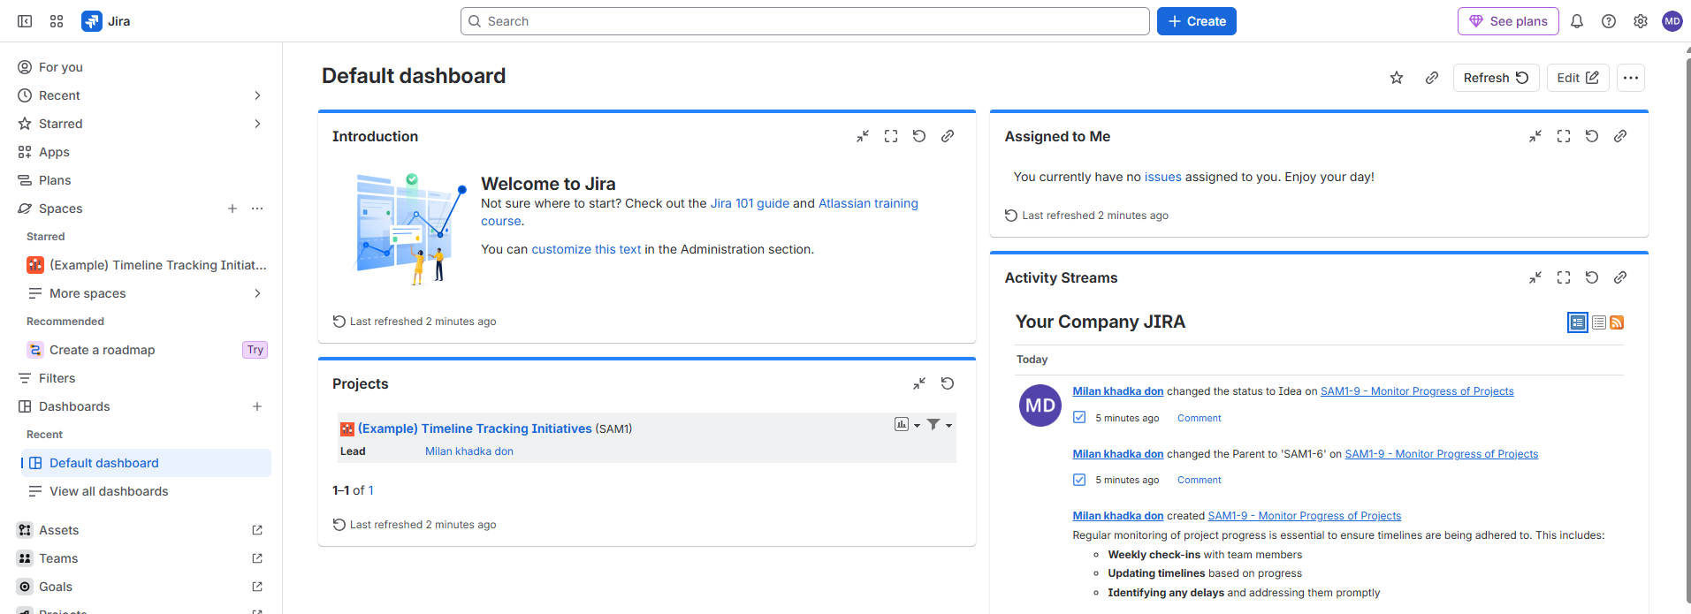
Step 2: click on create space:
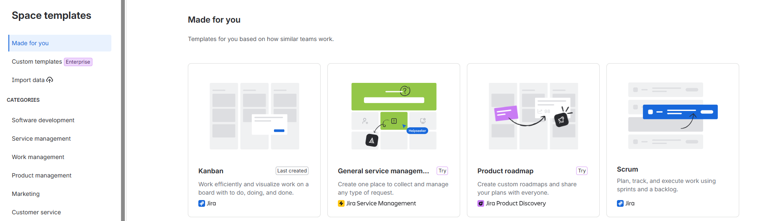

Step 3: select kanban – click use template
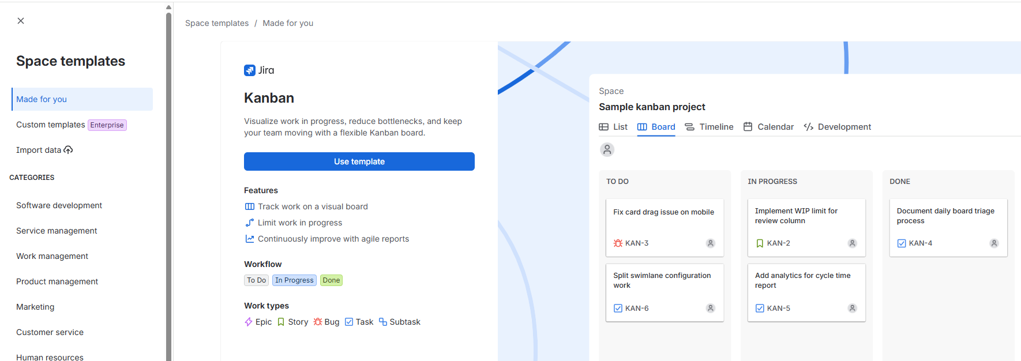
Step 4: provide details ---select company -managed in space managed option ---click Next
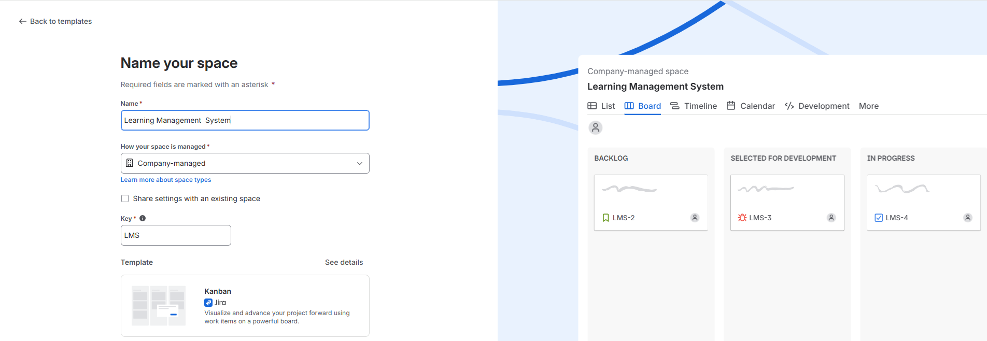
Step 5:add emails to add members in your team or clicks I’ll do this later ----click Next
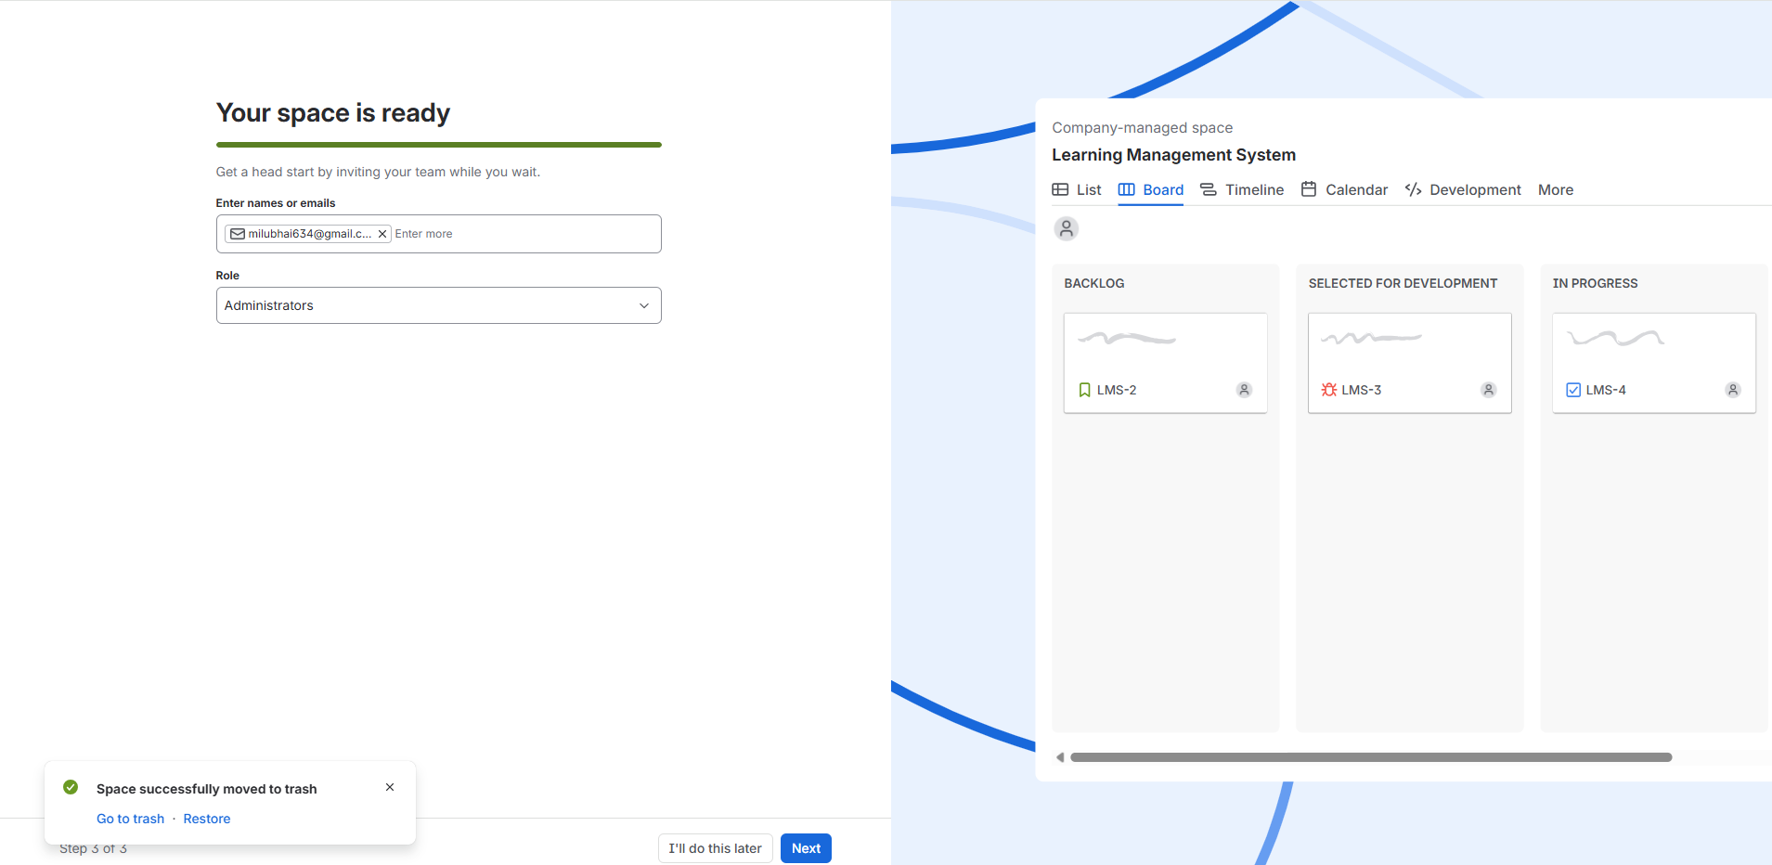

Step 6 : Following Dashboard will be displayed

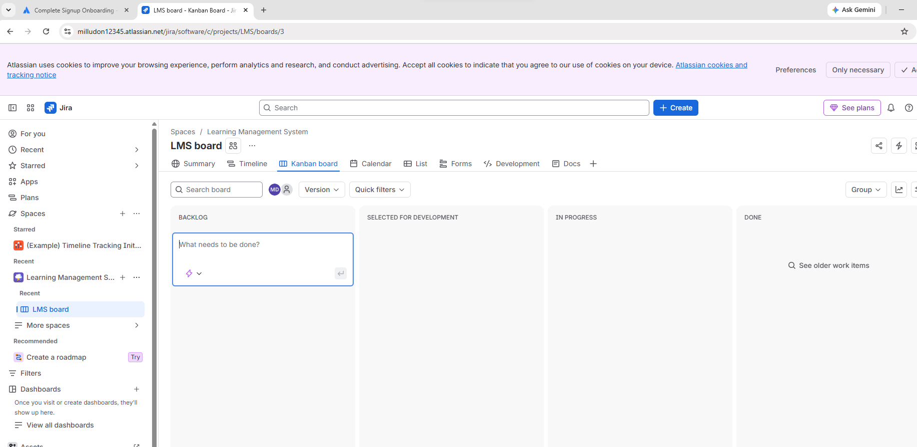

C .Configure project details

Step 1: click on space Created
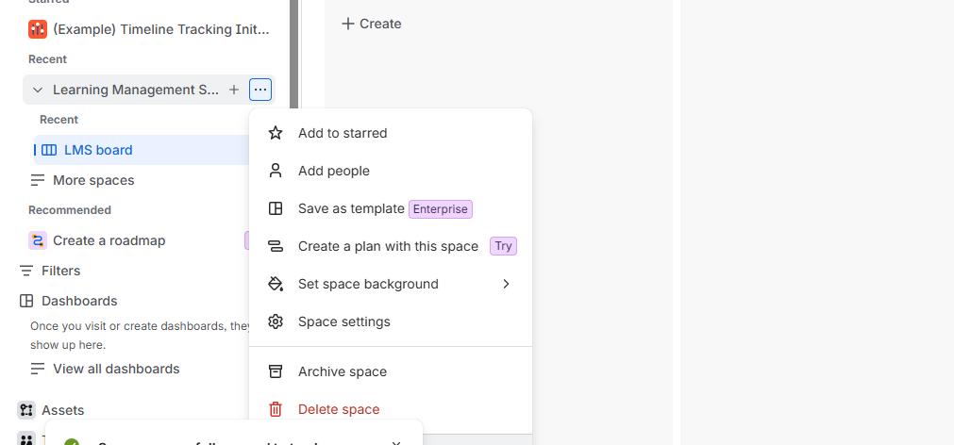

Step 2:CLICK space settings ----Make necessary settings as required
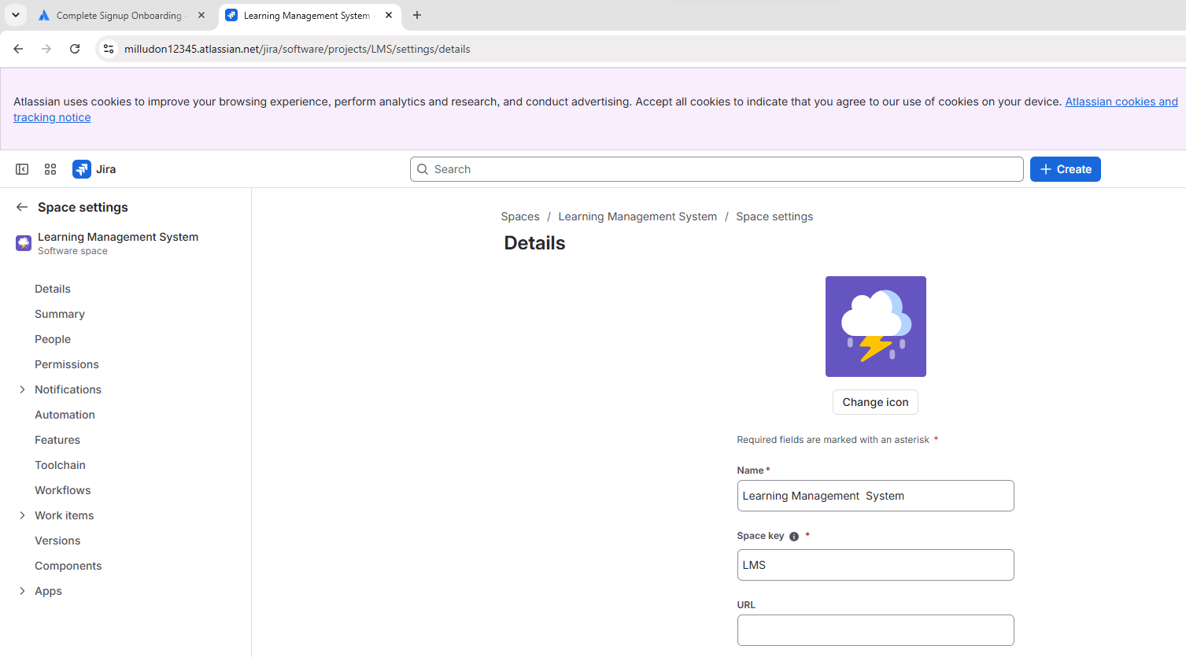

Practical 2: Team creation and Role Assignment
A.Add Team Members
B. Assign Roles
A .Add Team Members
Step1: click on project –click on Add people
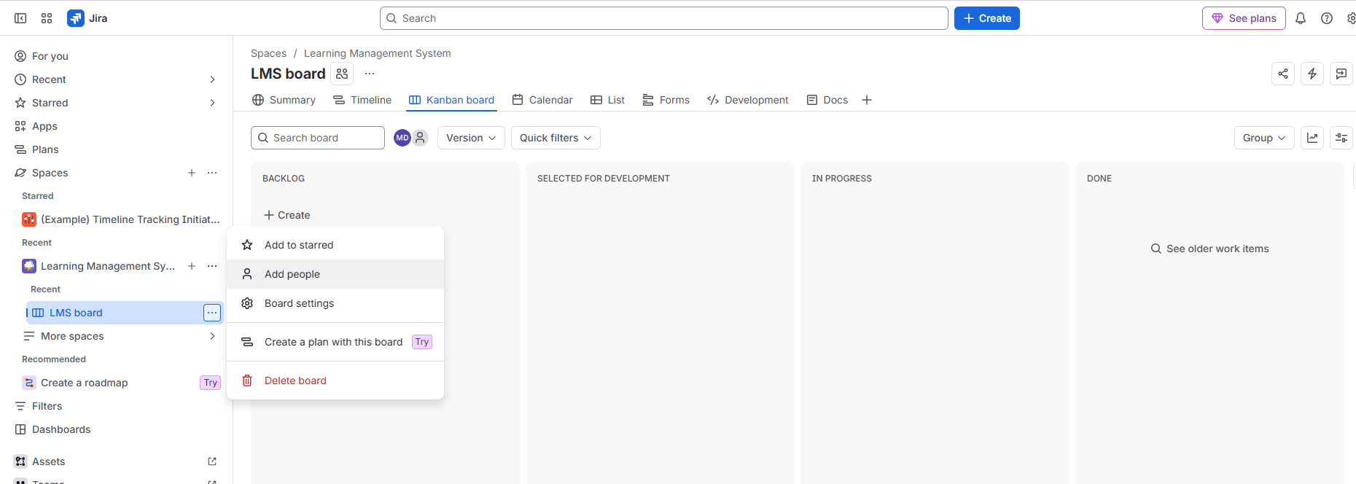

Step2:In the dialogue box below—enter email to add people to your team—assign role
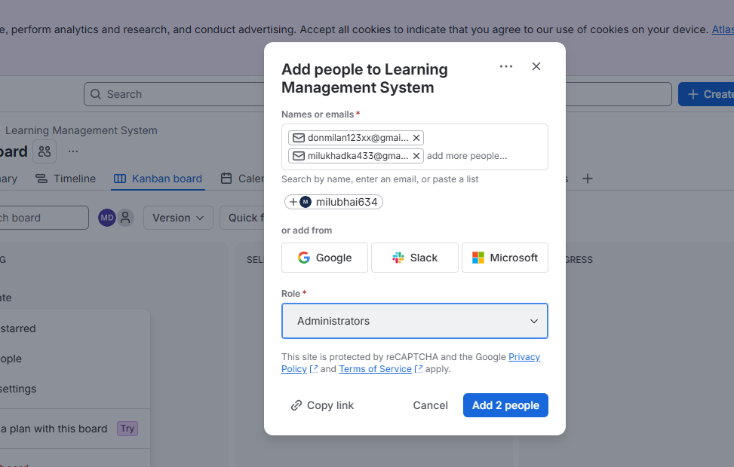

Step 3: click Add 2 person –click ok

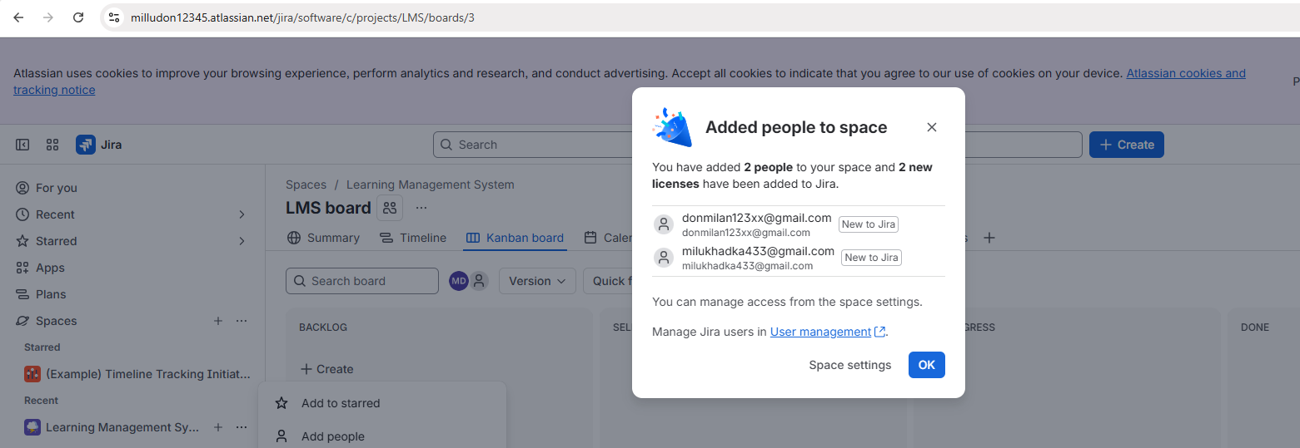
B:Assign Roles
Step 1: Go to space settings
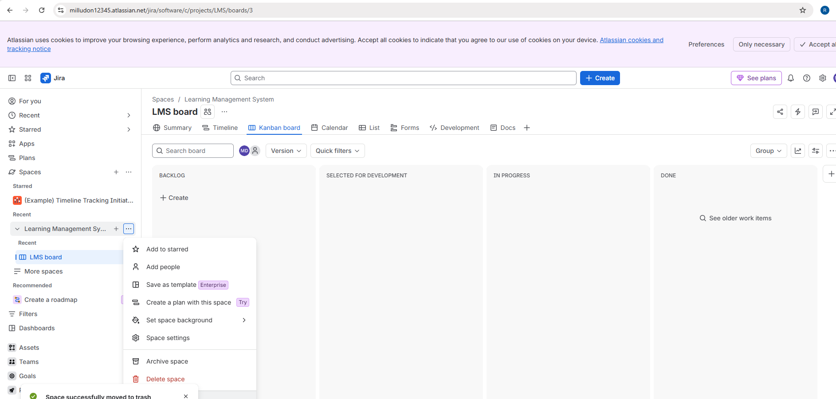

Step 2 : Select people

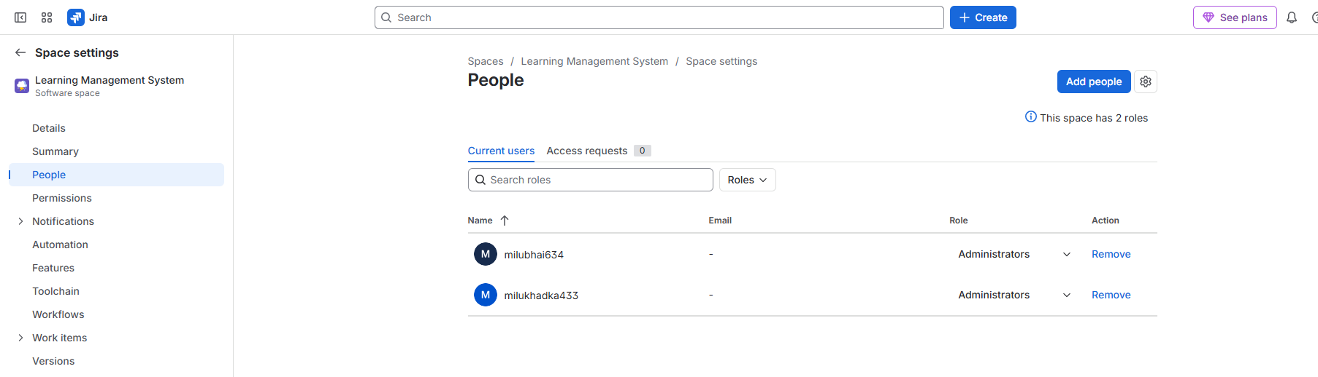

Step 3: Select the required role from the available options
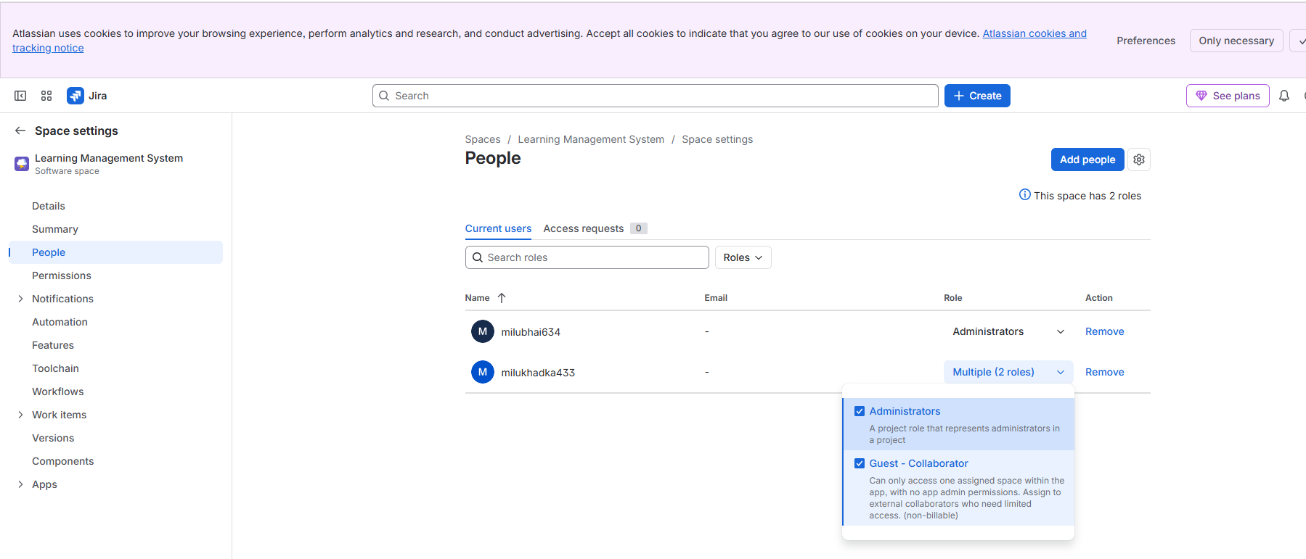

Practical 3: Issues Types and Configuration
A.Create and configure Issues Types (Epic,Story,Task,Bug)
B:Create Components and Versions

A.Create and configure Issues Types (Epic,Story,Task,Bug)
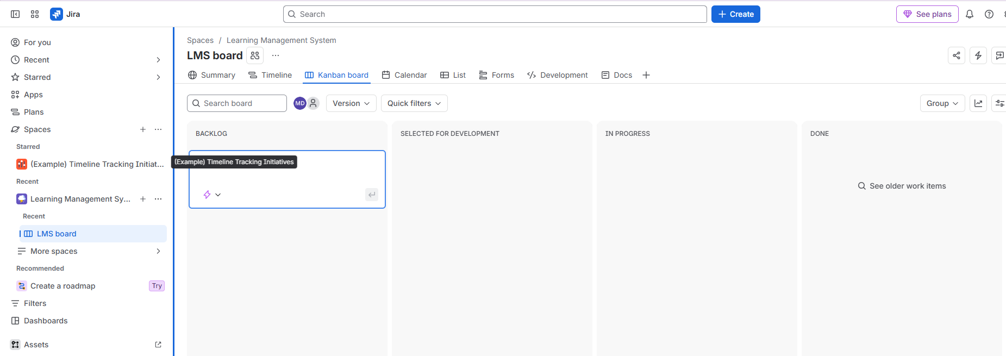

Step 1:On Dashboard—click create under Backlog
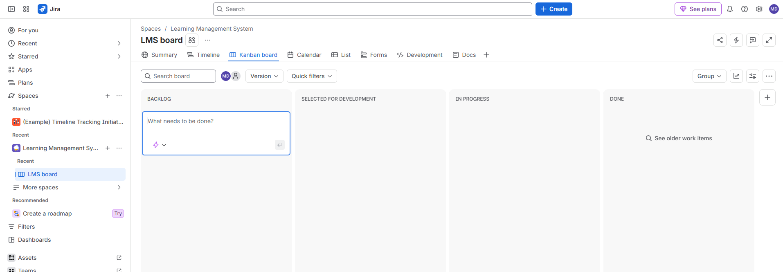

Step 2: Choose Issue type
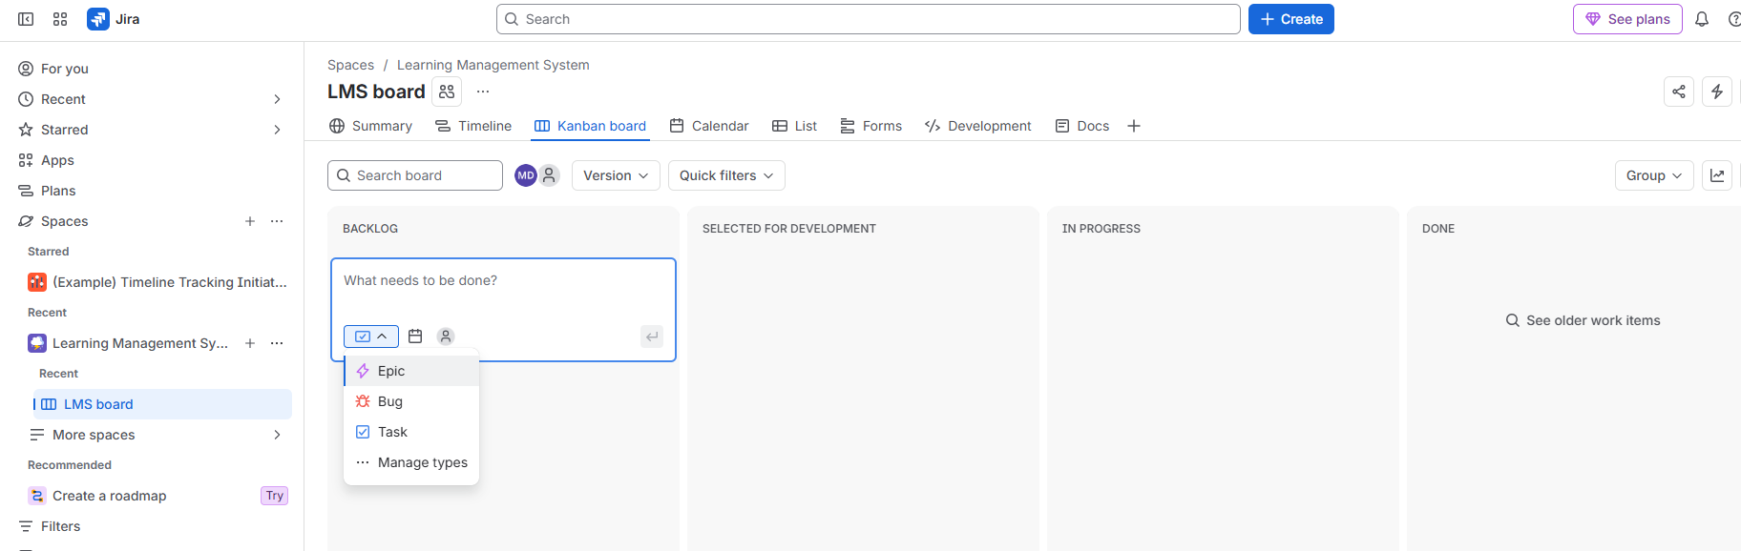
Step 3: Enter the task—select type as task
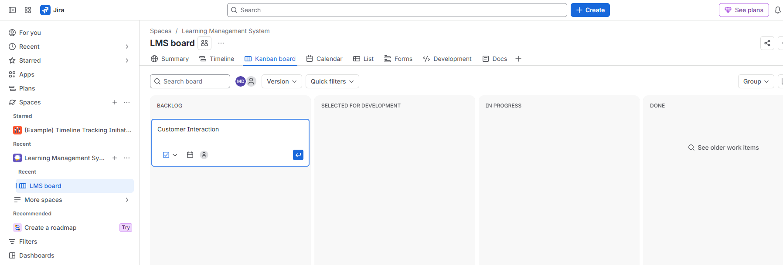

Step 4: Click Enter
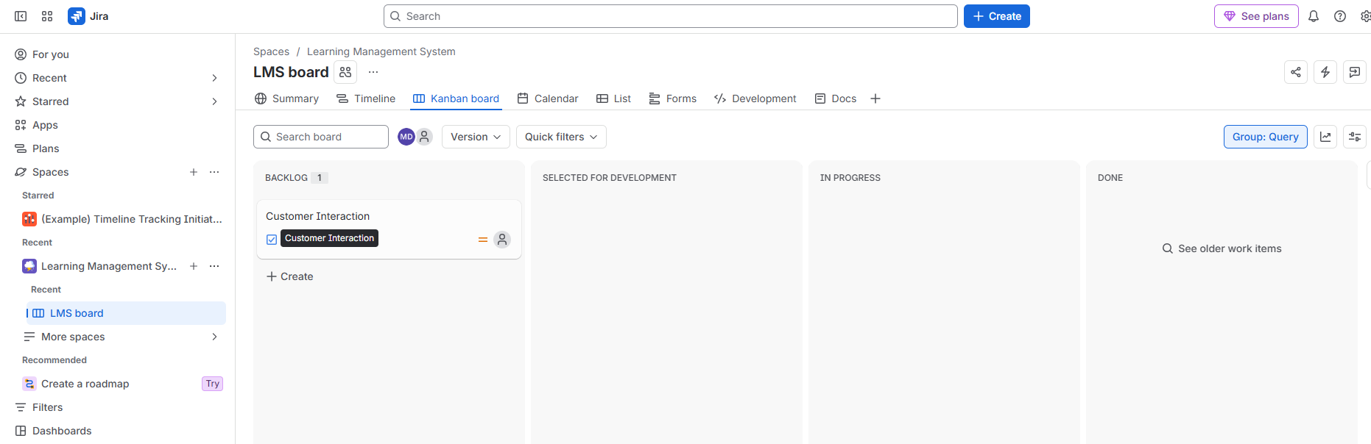

B:Create Components and Versions.
Step 1: Go to space settings
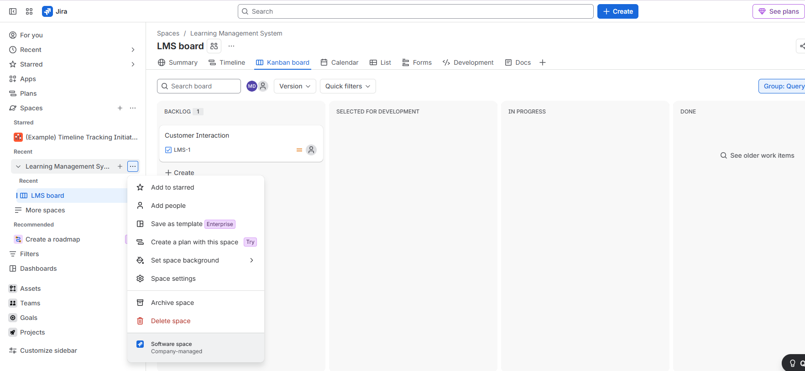
Step2: Select components –click create component
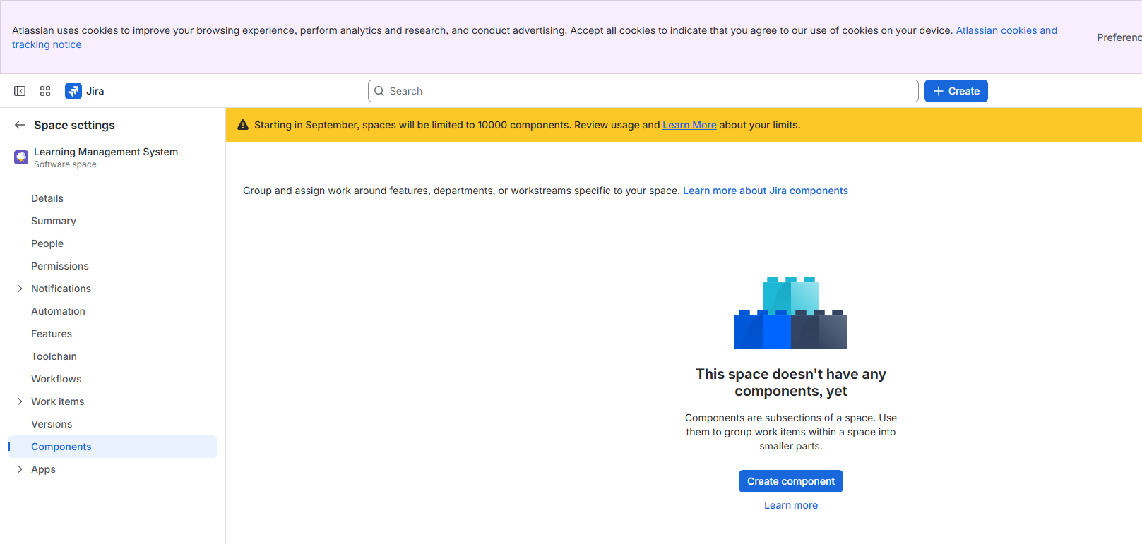
Step 3: Enter the component name ---Add a description if required –select a component lead if required
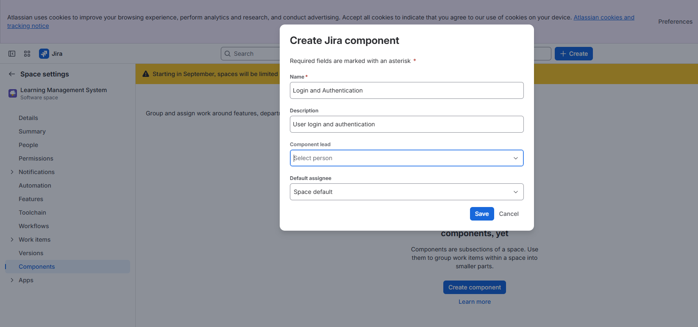

Step 4: Click Save
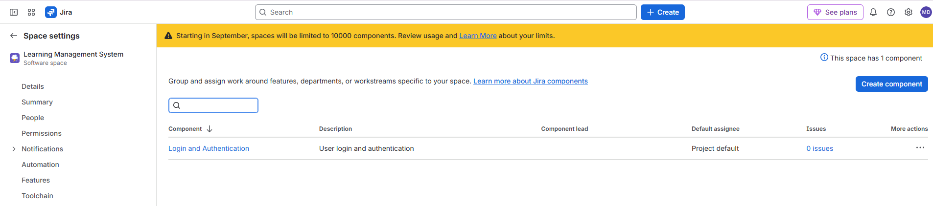

Step 5 : Go to space settings
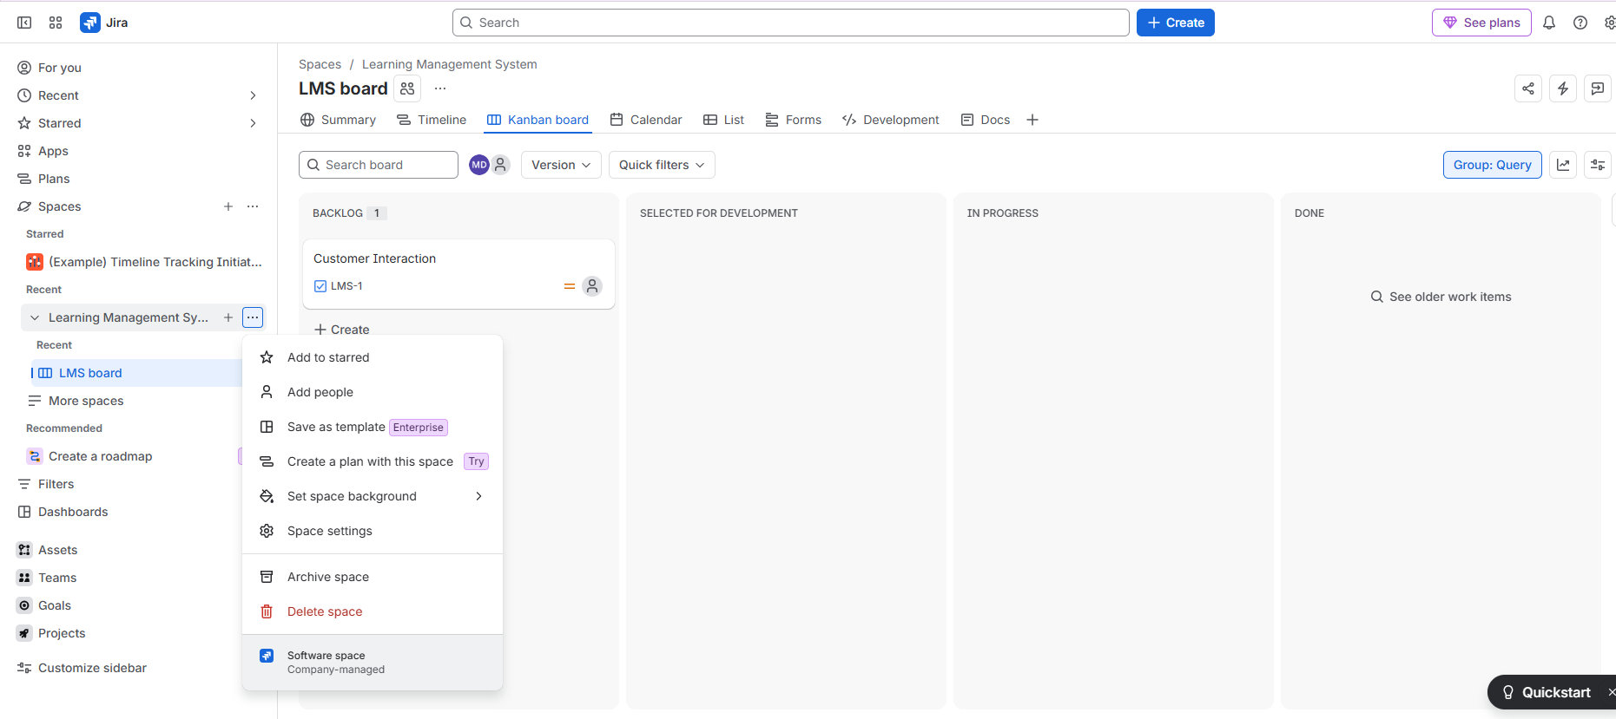

Step 6: Select versions or Releases ---click create version
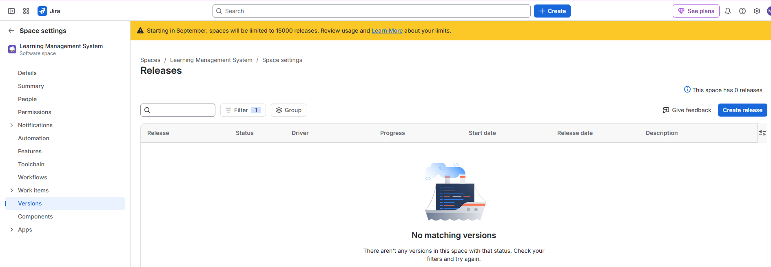

Step 7: Enter the following details
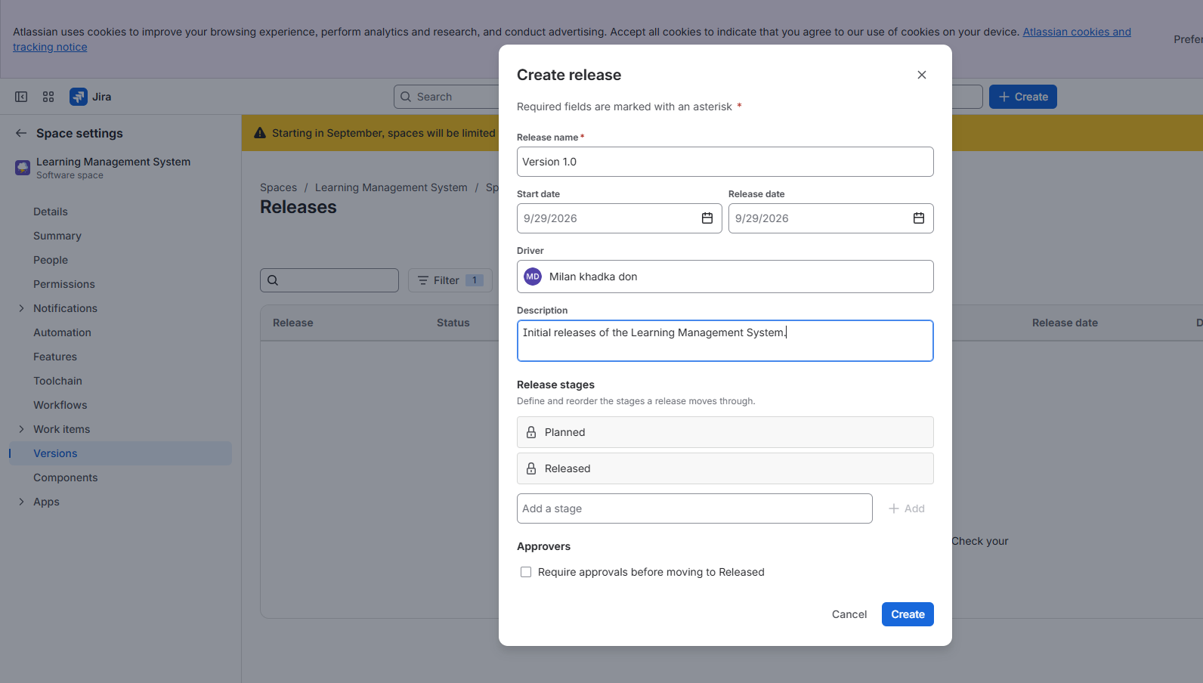

Step 8:Click Create
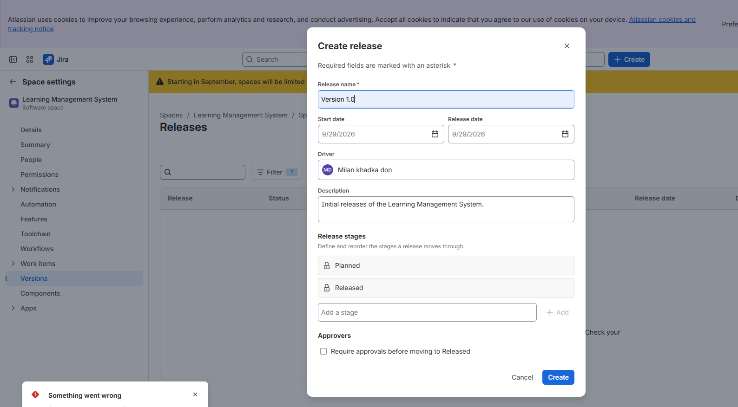
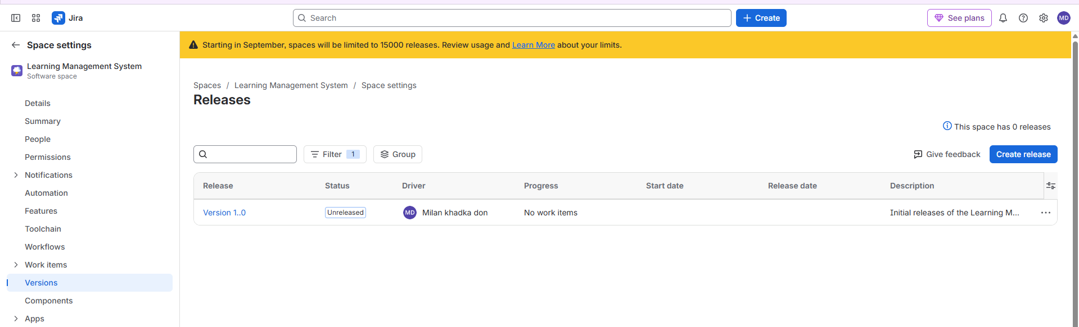

Practical 4: Issue Management
A:Create issues under an epic.
B .Assign issues to users and set Priority and Deu Date

A:Create issues under an epic.

Step1:Create Issue---Select Issue Type
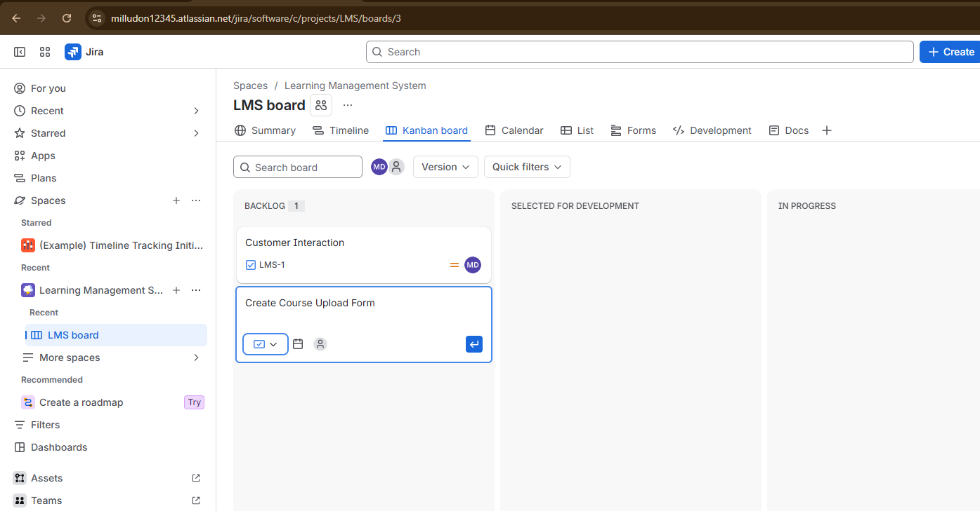

Step 2: Click Epic
Step 3: Click Enter
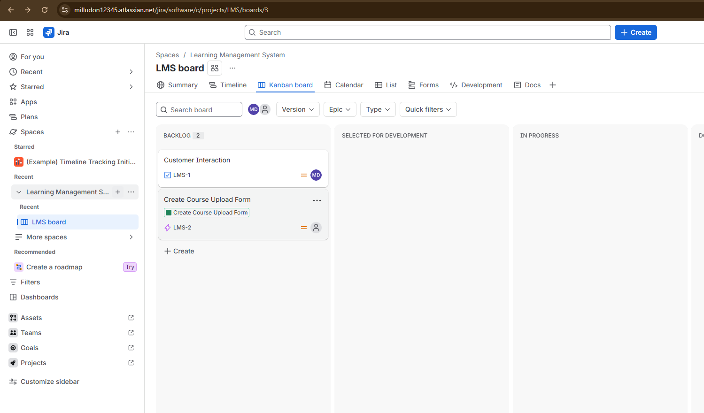
B .Assign issues to users and set Priority and Deu Date
Step 1: Open Created Issue
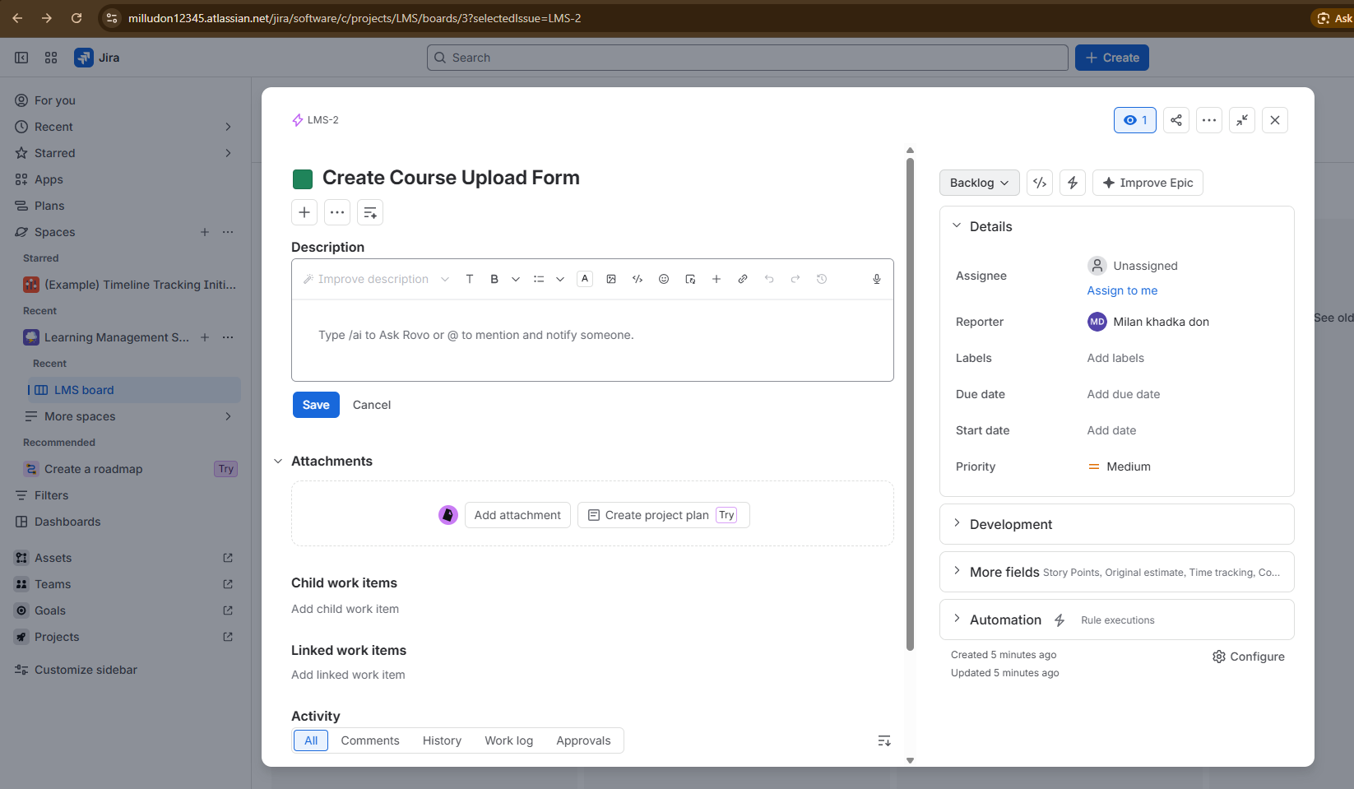
Step 2: Assign Issue ---Set Priority ---Set Deu Date
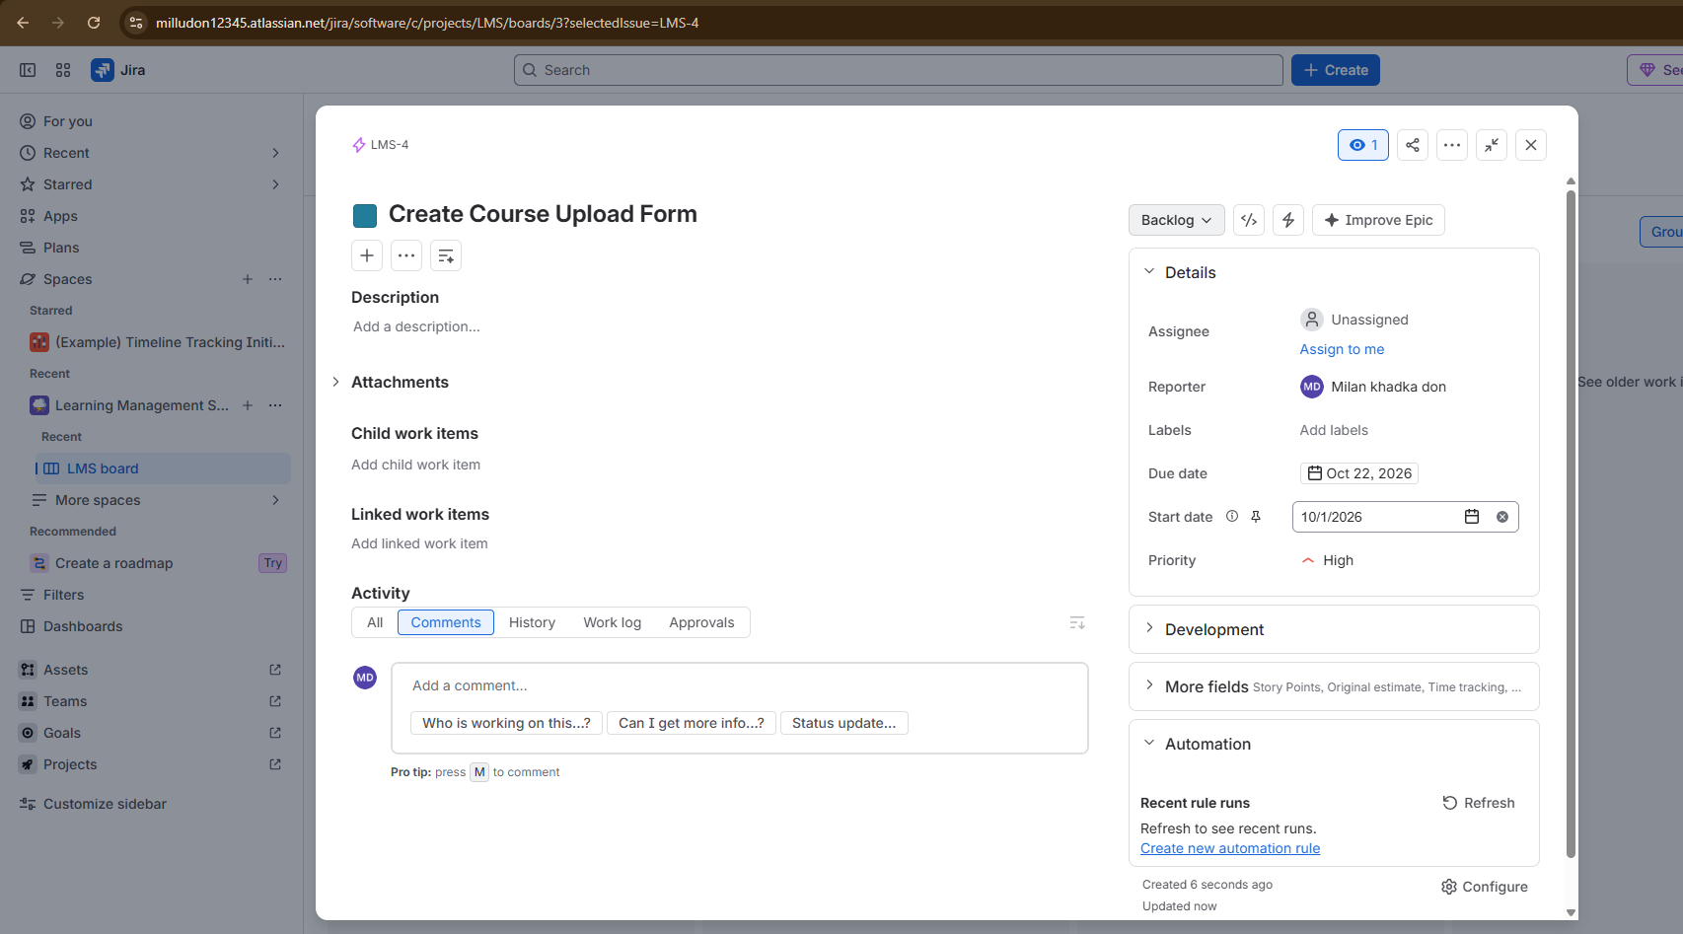

Step 3:Click Close ---Check Dashboard
