Contents

**Core Elixir:** 1

***1.*** ***Avatar*** 1

***2.*** ***Body Indestructible*** 1

***3.*** ***Dispelling Power*** 2

***4.*** ***Enemy’s Bane*** 2

***5.*** ***Singing Phoenix*** 3

***6.*** ***Slicer*** 3

***7.*** ***Selfless Servitude*** 4

**Regular Elixir:** 5

***1.*** ***Allying Blade*** 5

***2.*** ***Allying Shield*** 5

***3.*** ***Certainty*** 6

***4.*** ***Dispelling Evil*** 6

***5.*** ***Energy Thief*** 7

***6.*** ***Getaway*** 7

***7.*** ***Impulse*** 8

***8.*** ***Late Strike*** 8

***9.*** ***Stand your Ground*** 9

***10.*** ***Suden Strike*** 9

***11.*** ***Unbreakable*** 10

***12.*** ***Unstoppable Force*** 10

***13.*** ***Void Might*** 11

***14.*** ***Warsoul*** 11

## **Core Elixir:**

### ***Avatar***

### ***Body Indestructible***

### ***Dispelling Power***

### ***Enemy’s Bane***

### ***Singing Phoenix***

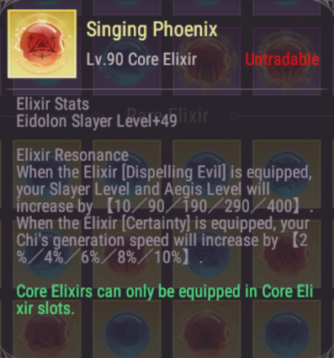

### ***Slicer***

### ***Selfless Servitude***

## **Regular Elixir:**

### ***Allying Blade***

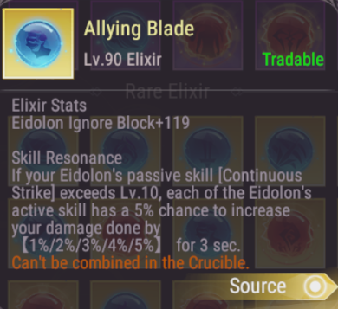

### ***Allying Shield***

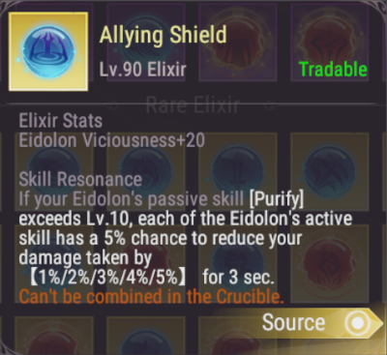

### ***Certainty***

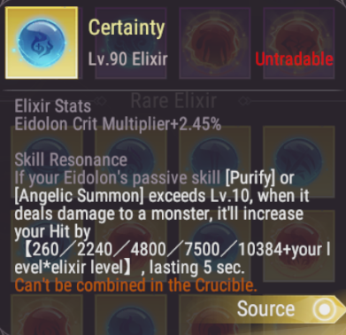

### ***Dispelling Evil***

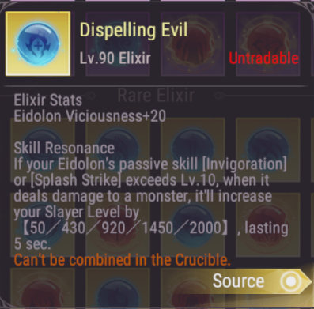

### ***Energy Thief***

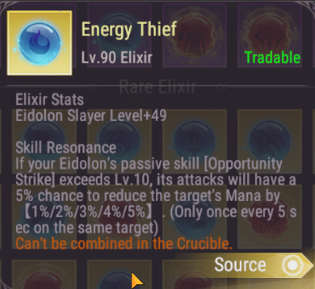

### ***Getaway***

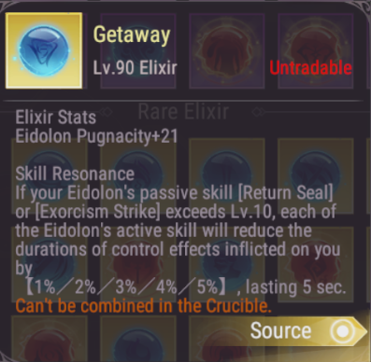

### ***Impulse***

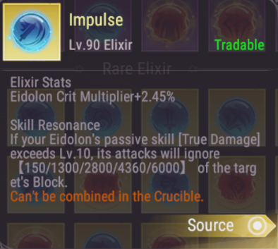

### ***Late Strike***

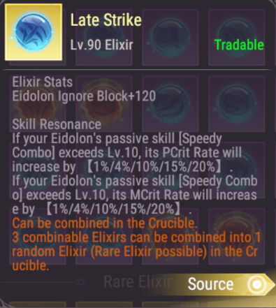

### ***Stand your Ground***

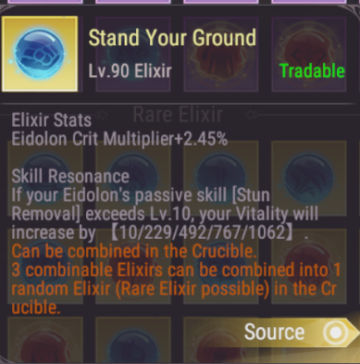

### ***Suden Strike***

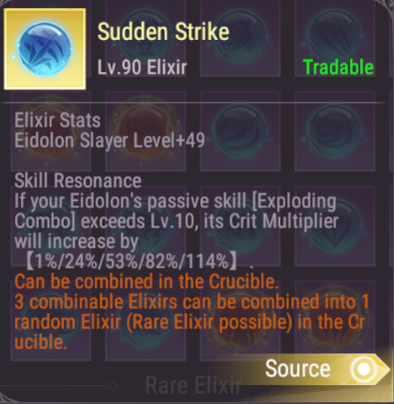

### ***Unbreakable***

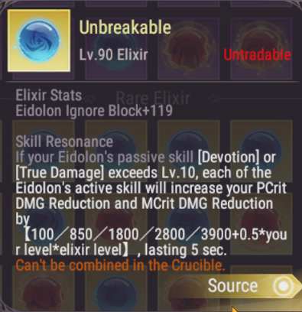

### ***Unstoppable Force***

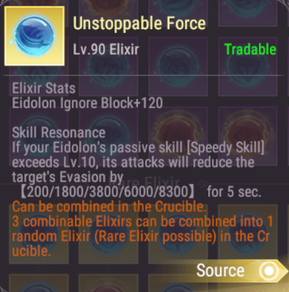wwwwwwwwwwwwwwwwwww

### ***Void Might***

### ***Warsoul***

