STUDY MATERIAL
Unit 2: Basics of Quantum Computing
Subunit 2.2: Multiple Qubit Systems
Target Audience: Engineering Students (India)
Quantum Computing: Principles and Applications

© Dr. Amrit Raj K, August 2026

Learning Objectives
Upon successful completion of this subunit, the learner will be able to:
- Understand the exponential growth of quantum state space and contrast it with classical linear growth through direct sum versus tensor product constructions.
- Construct and manipulate multi-qubit states using tensor product notation, Dirac bra-ket formalism, and matrix representations.
- Identify entangled states versus separable states, and appreciate that entanglement is a property relative to subsystem decomposition and not an absolute characteristic.
- Apply the measurement postulate to n-qubit systems, including partial measurements, and compute outcome probabilities using projection operators and Hermitian observables.
- Express linear operators, including Pauli matrices and multi-qubit gates, in outer-product (Dirac) notation and matrix form.
- Construct projection operators for given subspaces, verify their properties (idempotence and Hermiticity), and relate the trace to subspace dimension.
- Decompose Hermitian operators into eigenspace projectors and interpret eigenvalues as measurement outcome labels with physical significance.
- Analyze tensor products of operators acting on composite systems, distinguish decomposable from non-decomposable observables, and compute their eigenstructures.
- Interpret the Q-sphere representation for visualizing multi-qubit superposition states in terms of Hamming weight, probability amplitude, and quantum phase.
- Explain Bell's theorem, derive the Bell inequality for local hidden-variable theories, and demonstrate how quantum mechanics violates this inequality using EPR pair measurements.
Prerequisites: Subunit 2.1 (Single Qubit Systems), basic linear algebra (vector spaces, inner products, eigenvalues), and familiarity with complex numbers.

2.2.1 Introduction: Why Multiple Qubits?
The true computational advantage of quantum computing becomes apparent only when we deal with multiple qubits. While a single qubit is an interesting quantum object, the power of quantum information processing lies in the exponentially large state space that emerges when qubits are combined. In classical computing, adding one bit doubles the representational capacity in a linear sense; in quantum computing, adding one qubit doubles the dimension of the state space. This exponential scaling means that a quantum system occupying a small physical volume can possess a state space so vast that classical simulation becomes intractable.
Richard Feynman and Yuri Manin independently recognized decades ago that classical computers cannot efficiently simulate general quantum systems precisely because of this exponential explosion. They envisioned quantum computers as the natural solution: a machine that uses quantum mechanics to simulate quantum mechanics. The key difference between classical and quantum combination of state spaces lies in the mathematical operation used to join them. Classically, we use the direct sum, which yields linear growth in dimension. Quantum mechanically, we use the tensor product, which yields exponential growth. This distinction is foundational to understanding entanglement, measurement, and quantum algorithms.
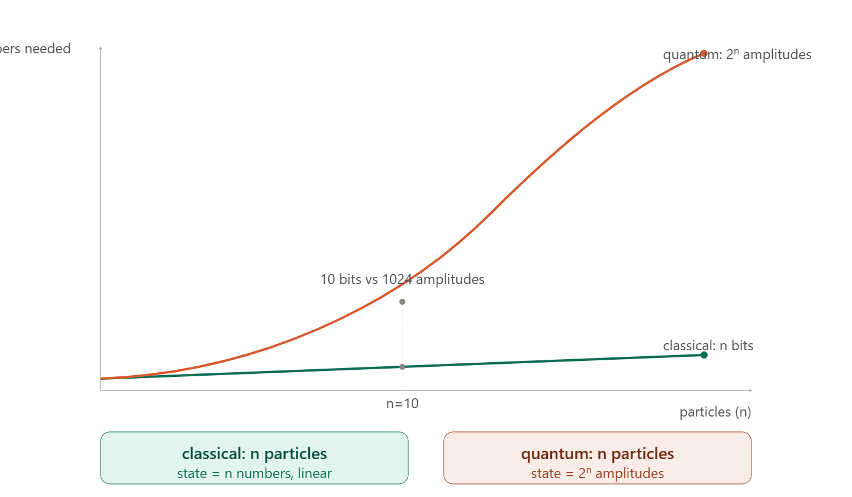
[Figure 2.2.1 — Classical vs Quantum state space scaling with number of particles]

2.2.2 Direct Sum versus Tensor Product

Classical Combination: Direct Sum
In classical mechanics, the state of a composite system is characterized by specifying the states of individual components separately. Mathematically, if V and W are the state spaces of two classical subsystems, the combined state space is the direct sum $V ⊕ W$. The dimension grows linearly:
$$dim(V ⊕ W) = dim(V) + dim(W)$$
For example, if we have three classical particles each described by position x and momentum p, the combined state vector stacks the individual coordinates:
$$(x₁, p₁) ⊕ (x₂, p₂) ⊕ (x₃, p₃) = (x₁, p₁, x₂, p₂, x₃, p₃)ᵀ$$
Each new particle adds a fixed number of coordinates. There is no cross-correlation encoded in the vector structure itself; all correlations between particles must be imposed externally through the equations of motion or constraints.

Quantum Combination: Tensor Product
In quantum mechanics, the state space of a composite system is the tensor product of the individual state spaces. If $|v⟩ ∈ V$ and $|w⟩ ∈ W$, their joint state is $|v⟩ ⊗ |w⟩$, often abbreviated as $|vw⟩$ or $|v⟩|w⟩$. The dimension grows multiplicatively:
$$dim(V ⊗ W) = dim(V) × dim(W)$$
For n qubits, each with a 2-dimensional state space, the combined space has dimension $2ⁿ$. This exponential scaling is the origin of both the power and the complexity of quantum computing. The tensor product is bilinear and satisfies the following distributive property:
$$(|v₁⟩ + |v₂⟩) ⊗ |w⟩ = |v₁⟩ ⊗ |w⟩ + |v₂⟩ ⊗ |w⟩$$
A crucial convention is the choice of basis ordering. For computational (standard) basis states, we typically use dictionary (lexicographic) ordering. For two qubits, the standard basis is $\{|00⟩, |01⟩, |10⟩, |11⟩\}$. For three qubits, it is $\{|000⟩, |001⟩, |010⟩, |011⟩, |100⟩, |101⟩, |110⟩, |111⟩\}$, and so on.
If V and W are inner product spaces, the inner product on$V ⊗ W$ is defined by:
$$(⟨v₁| ⊗ ⟨w₁|) · (|v₂⟩ ⊗ |w₂⟩) = ⟨v₁|v₂⟩ ⟨w₁|w₂⟩$$
Key properties of the tensor product include: (1) the tensor product of two unit vectors is a unit vector; and (2) the tensor product of two orthonormal bases yields an orthonormal basis for the composite space. These properties ensure that legitimate quantum states of composite systems remain normalized and that measurement probabilities sum to unity.
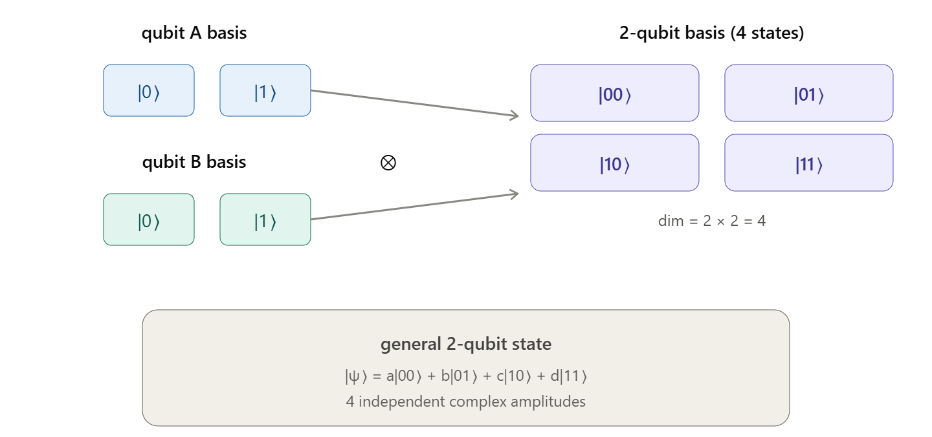
[Figure 2.2.2 — Tensor product basis construction for two qubits]

2.2.3 Representing Multi-Qubit States
Multi-qubit states can be written in several equivalent forms, each suited to different contexts. The most explicit form retains the tensor product symbol and Dirac notation for individual states:
$$|ψ⟩ = α|0⟩ ⊗ |0⟩ + β|0⟩ ⊗ |1⟩ + γ|1⟩ ⊗ |0⟩ + δ|1⟩ ⊗ |1⟩$$
In short form, we drop the tensor product symbol and the ket labels of individual qubits, writing simply:
$$|ψ⟩ = α|00⟩ + β|01⟩ + γ|10⟩ + δ|11⟩$$
An even more compact representation replaces the basis kets with their binary values. The state above can be viewed as a superposition over the binary strings 00, 01, 10, and 11 with complex amplitudes $α, β, γ,$ and $δ$ respectively. When subsystems are spatially or logically separated—for instance, in communication protocols—we may label them as registers, such as ${\left|ψ\right\rangle }_{Alice}$ ⊗ ${\left|φ\right\rangle }_{Bob}$ or simply ${\left|ψ\right\rangle }_{A}{\left|φ\right\rangle }_{B}$.

Matrix Representation
In the standard (computational) basis, multi-qubit states are represented as column vectors. For a two-qubit system, the basis vectors are:
|00⟩ = $\left(\begin{matrix}1 \\ 0 \\ \begin{matrix}0 \\ 0\end{matrix}\end{matrix}\right), \left|01\right\rangle = \left(\begin{matrix}0 \\ 1 \\ \begin{matrix}0 \\ 0\end{matrix}\end{matrix}\right), |10⟩ = \left(\begin{matrix}0 \\ 0 \\ \begin{matrix}1 \\ 0\end{matrix}\end{matrix}\right), |11⟩ = \left(\begin{matrix}0 \\ 0 \\ \begin{matrix}0 \\ 1\end{matrix}\end{matrix}\right)$
An arbitrary two-qubit state is then a 4-dimensional complex column vector $[α, β, γ, δ]ᵀ$ subject to the normalization condition $|α|² + |β|² + |γ|² + |δ|² = 1$. For n qubits, the vector has dimension $2ⁿ$.

The Bell Basis
While the computational basis is natural for many algorithms, other orthonormal bases are essential for specific applications. The Bell basis, consisting of four maximally entangled two-qubit states, is of paramount importance in quantum teleportation, superdense coding, and quantum key distribution:
$$|Φ⁺⟩ = \left(\frac{1}{\sqrt{2}}\right)(|00⟩ + |11⟩)$$
$$|Φ⁻⟩ = \left(\frac{1}{\sqrt{2}}\right)(|00⟩ - |11⟩)$$
$$|Ψ⁺⟩ = \left(\frac{1}{\sqrt{2}}\right)(|01⟩ + |10⟩)$$
$$|Ψ⁻⟩ = \left(\frac{1}{\sqrt{2}}\right)(|01⟩ - |10⟩)$$
These states cannot be factored into a tensor product of single-qubit states. Any two-qubit state can be expressed as a linear combination of these four Bell states, just as it can be expressed in the computational basis.

Global and Relative Phase
Global phase factors are physically irrelevant: the states $|ψ⟩$ and $e^{iθ}|ψ⟩$ are indistinguishable by any measurement. However, relative phase between components in a superposition is physically significant. In multi-qubit systems, phase factors distribute over tensor products:
$$e^{iθ}(|v⟩ ⊗ |w⟩) = (e^{iθ}|v⟩) ⊗ |w⟩ = |v⟩ ⊗ (e^{iθ}|w⟩)$$
This means that applying the same phase shift to different qubits of a product state does not change the overall state. However, relative phases between different basis states in a superposition are basis-dependent and carry physical consequences.
To obtain a unique representation of every quantum state, we adopt a global phase convention: require the first non-zero amplitude $aᵢ$ in the expansion to be real and non-negative. Under this convention, an n-qubit system has $2ⁿ - 1$ complex degrees of freedom, or equivalently, $2^{n+1} - 2$ real degrees of freedom. The space of distinct quantum states is the complex projective space $CP^{2ⁿ^{-1}}$, though for calculations we almost always work in the underlying vector space.

2.2.4 Entanglement
A state of a composite quantum system is called separable (or a product state) if it can be written as the tensor product of states of the individual subsystems. If no such factorization exists, the state is entangled. For a two-qubit system, a state $|ψ⟩$ is separable if and only if there exist single-qubit states $|a⟩$ and $|b⟩$ such that $|ψ⟩ = |a⟩ ⊗ |b⟩.$
Entangled states are not rare curiosities; they constitute the vast majority of states in the multi-qubit state space. If one picks a random state from the Haar measure on the unit sphere in $C^{2ⁿ}$, the probability that it is separable approaches zero as n increases. This prevalence of entanglement is precisely why classical simulation of generic quantum systems is inefficient.

Entanglement is Relative to Decomposition
Entanglement is not an absolute property of a state; it depends on how the total system is partitioned into subsystems. A state may be entangled with respect to one decomposition but separable with respect to another. Consider the following four-qubit state:
$$|ψ⟩ = \left(\frac{1}{2}\right)(|00⟩ + |11⟩ + |22⟩ + |33⟩)$$
where the kets $|0⟩, |1⟩, |2⟩, |3⟩$ represent two-qubit basis states $|00⟩, |01⟩, |10⟩, |11⟩$ respectively. Expanded in single-qubit notation:
$$|ψ⟩ = (1/2)(|0000⟩ + |0101⟩ + |1010⟩ + |1111⟩)$$
This state cannot be expressed as a tensor product of four single-qubit states; hence it is entangled with respect to the decomposition into four individual qubits. However, if we group qubits (1,3) and (2,4) into two subsystems, the state factors beautifully:
$$|ψ⟩ = \left(\frac{1}{\sqrt{2}}\right)(|0⟩₁|0⟩₃ + |1⟩₁|1⟩₃) ⊗ \left(\frac{1}{\sqrt{2}}\right)(|0⟩₂|0⟩₄ + |1⟩₂|1⟩₄)$$
Thus, $|ψ⟩$ is not entangled with respect to the (1,3) versus (2,4) decomposition. This example illustrates that entanglement is a property of the relationship between subsystems, not of the state in isolation. Importantly, while entanglement is decomposition-dependent, it is not basis-dependent: a state that is entangled in one basis remains entangled in all bases.

EPR Pairs and Bell States
Two particles in a Bell state, such as $|Φ⁺⟩,$ are often called an EPR pair (after Einstein, Podolsky, and Rosen). These pairs exhibit perfect correlations: if Alice and Bob each hold one qubit of an EPR pair and both measure in the same basis, they always obtain the same outcome. This correlation is stronger than any classical correlation and forms the basis of quantum teleportation and Ekert's quantum key distribution protocol.

Superposition and Relative Phase
Superposition is basis-dependent. A state written in one basis may appear as a superposition, while in another basis it may be a basis state. For example, the state $|Φ⁺⟩$ in the computational basis is:
$$|Φ⁺⟩ = \left(\frac{1}{\sqrt{2}}\right)(|00⟩ + |11⟩)$$
If we rewrite each qubit in the Hadamard basis $|+⟩ = (|0⟩ + |1⟩)/√2$ and $|-⟩ = (|0⟩ - |1⟩)/√2$, we find:
$$|Φ⁺⟩ = \left(\frac{1}{\sqrt{2}}\right)(|++⟩ + |--⟩)$$
The state has the same mathematical form in both bases, but the physical interpretation differs. It is crucial to understand that a quantum superposition is not a probabilistic mixture. The states $|00⟩ + |11⟩$and $|++⟩ + |--⟩$ are the same vector in Hilbert space, but relative phases between components matter when performing operations or measurements in specific bases.

2.2.5 Measurement in Multiple Qubit Systems
Measurement in quantum mechanics is described by the interaction between a quantum system and a measuring device. For an n-qubit system, the state space V has dimension $2ⁿ$. Any measuring device is associated with a direct sum decomposition of V into orthogonal subspaces:
$V = S₁ ⊕ S₂ ⊕ … ⊕ Sₖ,$ where $k ≤ 2ⁿ$
Here, $k$ represents the maximum number of distinct measurement outcomes. Each subspace $Sᵢ$ corresponds to one possible outcome. When the system in state $|ψ⟩$ interacts with this device, the state collapses to a state entirely contained within one of the subspaces Sᵢ. The probability of outcome $i$ is the squared magnitude of the amplitude of the component of $|ψ⟩$ in $Sᵢ$, which equals $⟨ψ|Pᵢ|ψ⟩$ where $Pᵢ$ is the projector onto $Sᵢ$.

Single-Qubit Measurement Recap
For a single qubit, a measurement device in the standard basis corresponds to the decomposition $V = S₁ ⊕ S₂$, where $S₁$ is spanned by $|0⟩$ and $S₂$ by $|1⟩$. An arbitrary state $|ψ⟩ = a|0⟩ + b|1⟩$ yields outcome $|0⟩$ with probability $|a|²$ and outcome $|1⟩$ with probability $|b|²$. After measurement, the state is renormalized to lie entirely within the corresponding subspace.

Partial Measurement
In multi-qubit systems, we often measure only a subset of qubits. Consider measuring the first qubit of a two-qubit state $|ψ⟩ = a|00⟩ + b|01⟩ + c|10⟩ + d|11⟩$ in the standard basis. The outcome $|0⟩$ for the first qubit corresponds to the subspace spanned by $\{|00⟩, |01⟩\}$, and outcome $|1⟩$ to the subspace spanned by $\{|10⟩, |11⟩\}$. The probabilities are:
$$P(0) = |a|² + |b|², P(1) = |c|² + |d|²$$
If outcome 0 is obtained, the post-measurement state is:
$$|ψ'⟩ = (a|00⟩ + b|01⟩) / √(|a|² + |b|²)$$
Similarly, if outcome 1 is obtained, the state collapses to $(c|10⟩ + d|11⟩) / √(|c|² + |d|²)$. Note that the second qubit may remain in a superposition even after the first qubit has been measured.

Measurement in the Bell Basis
A complete measurement can also be performed in the Bell basis. The state space decomposes as:
$$V = S_{Φ^{+} } ⊕ S_{Φ^{-} } ⊕ S_{Ψ^{+} } ⊕ S_{Ψ^{-} }$$
where each S is the one-dimensional subspace spanned by the corresponding Bell state. Measuring in this basis is essential for quantum teleportation, where the outcome tells Alice which Pauli correction Bob must apply to recover the original state.

Measurement of Bit Equality
One can design a measurement that determines whether two qubits are equal (both 0 or both 1) without learning their individual values. The relevant decomposition is:
$S_{equal}$ = $span\{|00⟩, |11⟩\}$, $S_{unequal}$ $= span\{|01⟩, |10⟩\}$
The projectors are $P_{equal}$ $= |00⟩⟨00| + |11⟩⟨11|$ and $P_{unequal}$ $= |01⟩⟨01| + |10⟩⟨10$|. This measurement preserves superpositions within the equal and unequal subspaces, unlike measuring each qubit individually and classically computing the AND or XOR.

2.2.6. Outer Products and Operator Representation
An outer product $|u⟩⟨v|$ is an operator that maps any state $|w⟩$ to $|u⟩⟨v|w⟩ = ⟨v|w⟩ |u⟩$. In matrix terms, if $|u⟩$ is a column vector and $⟨v|$ is a row vector, the outer product is simply the matrix product $uv^{†}$. For the standard single-qubit basis:
$$|0⟩⟨0| =\left(\begin{matrix}1 & 0 \\ 0 & 0\end{matrix}\right) |0⟩⟨1| = \left(\begin{matrix}0 & 1 \\ 0 & 0\end{matrix}\right)$$
$$|1⟩⟨0| = \left(\begin{matrix}0 & 0 \\ 1 & 0\end{matrix}\right) |1⟩⟨1| = \left(\begin{matrix}0 & 0 \\ 0 & 1\end{matrix}\right)$$
Every linear operator on a finite-dimensional Hilbert space can be written as a linear combination of outer products. For a single qubit, the most general operator is:
$$A = a|0⟩⟨0| + b|0⟩⟨1| + c|1⟩⟨0| + d|1⟩⟨1| =\left(\begin{matrix}a & b \\ c & d\end{matrix}\right)$$
For example, the Pauli-X (NOT) gate, which flips $|0⟩$ to $|1⟩$ and $|1⟩$ to $|0⟩$, is represented as:
$$X = |0⟩⟨1| + |1⟩⟨0| =\left(\begin{matrix}0 & 1 \\ 1 & 0\end{matrix}\right)$$
In multi-qubit systems, outer products extend naturally. The operator $|01⟩⟨01|$ acting on a two-qubit state projects onto the $|01⟩$ component. More generally, any operator $O$ acting on an n-qubit space can be expanded in the computational basis as:
$$O = Σᵢ Σⱼ aᵢⱼ |i⟩⟨j|$$
where the indices $i$ and $j$ range over all $2ⁿ$ basis states. The matrix element $aᵢⱼ$ is given by $⟨i|O|j⟩$. When this operator acts on a state $|ψ⟩ = Σₖ bₖ|k⟩$, the result is:
$$O|ψ⟩ = Σᵢ Σⱼ aᵢⱼbⱼ |i⟩$$
This formula is the Dirac notation equivalent of matrix-vector multiplication. Fluency in translating between matrix form and outer-product form is essential for analyzing quantum circuits and algorithms.

2.2.7 Projection Operators
A projection operator (or projector) P onto a subspace S maps any vector $|v⟩$ in V to its component lying within S. If S is one-dimensional and spanned by a unit vector $|ψ⟩$, the projector is:
P_S = |ψ⟩⟨ψ|
For a general subspace S of dimension m spanned by an orthonormal basis $\{|i₁⟩, |i₂⟩, …, |iₘ⟩\}$, the projector is the sum:
$P_{S}$ = $Σⱼ₌₁ᵐ |iⱼ⟩⟨iⱼ|$
Projection operators satisfy two fundamental properties: idempotence ($P² = P$) and Hermiticity ($P† = P$). These properties ensure that applying a projector twice has the same effect as applying it once, and that its eigenvalues are real (specifically, 0 and 1).

Orthogonal Subspaces and Direct Sum
For any subspace S, the orthogonal complement $S_{⊥}$ consists of all vectors perpendicular to every vector in S. The full space decomposes as $V = S ⊕$ $S_{⊥}$. If $P_{S}$ and $P_{T}$ are projectors onto orthogonal subspaces S and T, then the projector onto their direct sum $S ⊕ T$ is simply $P_{S} + P_{T}$.

Trace and Dimension
The trace of a projector, defined as the sum of its diagonal matrix elements, equals the dimension of the subspace onto which it projects. This holds in any basis because the trace is basis-independent $(tr(UAU⁻¹) = tr(A))$. Thus, $tr(P_{S}) = dim(S)$. This provides a quick way to verify the dimension of a subspace from its projector.

Examples
Example 1: The projector $|0⟩⟨0|$ acts on $|ψ⟩ = a|0⟩ + b|1⟩$ to yield $|0⟩⟨0|ψ⟩ = a|0⟩$. The probability of the system being found in the $|0⟩$ subspace is $|a|² = ⟨ψ|0⟩⟨0|ψ⟩$.
Example 2: In a two-qubit system, the projector $|1⟩⟨1| ⊗ |0⟩⟨0| = |10⟩⟨10|$ acts on a general state to extract its $|10⟩$ amplitude. The probability of outcome $'10'$in a standard basis measurement is the squared magnitude of this amplitude, which equals $⟨ψ|10⟩⟨10|ψ⟩$.
Example 3: The single-qubit projectors in the standard basis are $P₀ = |0⟩⟨0|$ and $P₁ = |1⟩⟨1|$. For a state $|ψ⟩ = a|0⟩ + b|1⟩$, the probabilities are $P(0) = ⟨ψ|P₀|ψ⟩ = |a|²$ and $P(1) = ⟨ψ|P₁|ψ⟩ = |b|²$. After measurement yielding outcome 0, the state becomes $P₀|ψ⟩ / |P₀|ψ⟩| = |0⟩$.
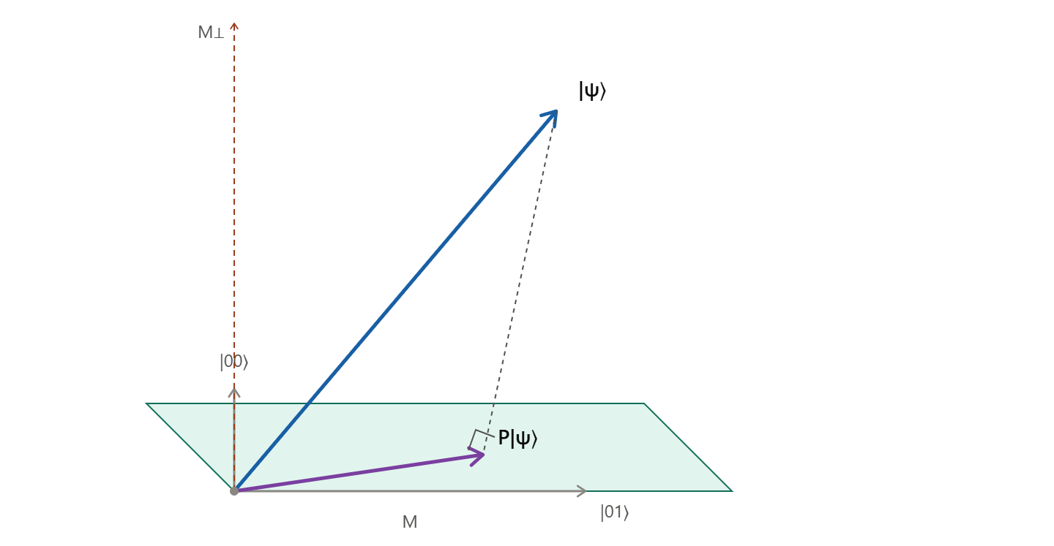
[Figure 2.2.3 — Projection onto a subspace in a two-qubit Hilbert space]

2.2.8 Hermitian Operators and Observables
In quantum mechanics, every measurable physical quantity (observable) is associated with a Hermitian operator. A Hermitian operator O satisfies $O^{†} = O$, meaning it is equal to its own conjugate transpose. Hermitian operators have three crucial properties: (1) all eigenvalues are real, (2) eigenvectors corresponding to distinct eigenvalues are orthogonal, and (3) the eigenvectors form a complete basis for the Hilbert space.

Eigenspace Decomposition
For a Hermitian operator O acting on V, the space decomposes into orthogonal eigenspaces:
$V =$ $E_{λ_{1}}⊕ E_{λ_{2}} ⊕ … ⊕ E_{λ_{k}}$
where $E_{λᵢ}$ is the eigenspace associated with eigenvalue $λᵢ$. Each eigenspace consists of all vectors $|v⟩$ satisfying $O|v⟩ = λᵢ|v⟩$. The projectors $Pᵢ$ onto these eigenspaces satisfy:
$$PᵢPⱼ = δᵢⱼPᵢ, Σᵢ Pᵢ = I, O = Σᵢ λᵢPᵢ$$
This spectral decomposition expresses any Hermitian operator as a weighted sum of projectors, where the weights are the eigenvalues. When describing a measurement, instead of specifying the subspace decomposition directly, one can specify the Hermitian operator whose eigenspace decomposition defines that measurement.

Orthogonality of Eigenspaces
Let $|v⟩$ and $|w⟩$ be eigenvectors of $O$ with distinct eigenvalues $λ$ and $μ$ respectively. Then:
$$λ⟨v|w⟩ = ⟨v|O|w⟩ = μ⟨v|w⟩$$
Since $λ ≠ μ$, we must have $⟨v|w⟩ = 0$. This orthogonality ensures that the eigenspaces are disjoint (except for the zero vector) and that the projectors onto different eigenspaces are mutually orthogonal.

Measurement Postulate Formalism
The measurement postulate for general observables states three principles:
- Any quantum measurement is specified by a Hermitian operator (observable) on the state space.
- The possible outcomes are labelled by the eigenvalues $λᵢ$. The probability of obtaining outcome $λᵢ$ when measuring state $|ψ⟩$ is $|Pᵢ|ψ⟩|² = ⟨ψ|Pᵢ|ψ⟩$.
- After measurement yielding outcome $λᵢ$, the state collapses to the normalized eigenvector (or eigenstate within the eigenspace) corresponding to $λᵢ$, given by $Pᵢ|ψ⟩ / |Pᵢ|ψ⟩|$.
The eigenvalues serve as labels for measurement outcomes. While in abstract quantum information theory these labels are arbitrary, in physical applications they carry meaning such as energy (Hamiltonian), position, momentum, or spin projection.

Examples
Example 1: Single-qubit measurement in the standard basis. Let $V = S ⊕ S'$ where S is spanned by $|0⟩$ and S' by $|1⟩$. Assign eigenvalues$λ = 2$ and $λ' = -3$. The corresponding Hermitian operator is:
$$O = 2|0⟩⟨0| - 3|1⟩⟨1| = \left(\begin{matrix}2 & 0 \\ 0 & -3\end{matrix}\right)$$
The projectors are $P₀ = |0⟩⟨0|$ and $P₁ = |1⟩⟨1|$. For $|ψ⟩ = a|0⟩ + b|1⟩$, the probabilities are $P(2) = |a|²$ and $P(-3) = |b|²$. Note that multiplying the state directly by $O$ yields $O|ψ⟩ = 2a|0⟩ - 3b|1⟩$, which is not a valid quantum state; the post-measurement state is obtained via projection and renormalization, not by direct operator multiplication.
Example 2: The Pauli-Z operator $Z = |0⟩⟨0| - |1⟩⟨1|$ is Hermitian. In the Hadamard basis $\{|+⟩, |-⟩\}, Z$ acts as X (the bit-flip operator), demonstrating that Hermiticity is basis-independent while the matrix representation changes.
Example 3: Bit equality measurement. The Hermitian operator $C = 2(|00⟩⟨00| + |11⟩⟨11|) + 3(|01⟩⟨01| + |10⟩⟨10|)$ has matrix representation:
$$C =\left(\begin{matrix}\begin{matrix}2 & 0 \\ 0 & 3\end{matrix} & \begin{matrix}0 & 0 \\ 0 & 0\end{matrix} \\ \begin{matrix}0 & 0 \\ 0 & 0\end{matrix} & \begin{matrix}3 & 0 \\ 0 & 2\end{matrix}\end{matrix}\right)$$
The eigenvalue 2 corresponds to the 'equal' subspace spanned by $\{|00⟩, |11⟩\}$, and eigenvalue 3 corresponds to the 'unequal' subspace spanned by $\{|01⟩, |10⟩\}$. Measuring this observable reveals whether the two bits are equal without revealing their individual values.
Example 4: Consider $A = |01⟩⟨01| + 2|10⟩⟨10| + 3|11⟩⟨11|$. This operator is Hermitian because it is a real linear combination of projectors. Its matrix in the standard basis is diagonal with entries 0, 1, 2, 3 corresponding to $|00⟩, |01⟩, |10⟩, |11⟩$ respectively. Another Hermitian operator that specifies measurement with respect to the full standard basis decomposition is simply the diagonal operator with distinct eigenvalues for each basis state, such as $D = 0|00⟩⟨00| + 1|01⟩⟨01| + 2|10⟩⟨10| + 3|11⟩⟨11|$.

2.2.9 Tensor Products of Operators
When operators act on composite systems, they can often be expressed as tensor products of operators acting on individual subsystems. If A acts on V and B acts on W, their tensor product $A ⊗ B$ acts on $V ⊗ W$ according to:
$$(A ⊗ B)(|v⟩ ⊗ |w⟩) = (A|v⟩) ⊗ (B|w⟩)$$
This definition extends by linearity to all states in $V ⊗ W$. If $|u⟩$ is an eigenvector of A with eigenvalue $λ₀$ and $|v⟩$ is an eigenvector of B with eigenvalue $λ₁$, then $|u⟩ ⊗ |v⟩$ is an eigenvector of $A ⊗ B$ with eigenvalue $λ₀λ₁$:
$$(A ⊗ B)(|u⟩ ⊗ |v⟩) = (λ₀|u⟩) ⊗ (λ₁|v⟩) = (λ₀λ₁)(|u⟩ ⊗ |v⟩)$$
If the product $λ₀λ₁$ is unique (no other pair of eigenvalues multiplies to the same value), then the eigenspace of $A ⊗ B$ for eigenvalue $λ₀λ₁$ is exactly the tensor product of the individual eigenspaces. If the product is not unique, the full eigenspace is the direct sum of all tensor product pieces yielding that eigenvalue.

Decomposable versus Non-Decomposable Operators
Not every Hermitian operator on a composite system can be written as a tensor product of operators on the subsystems. An operator is decomposable if each of its eigenspaces is itself a tensor product of subspaces of the component systems: $S = S₁ ⊗ S₂$. Most Hermitian operators are not decomposable.
Example of a decomposable operator: $Z ⊗ Z$, where $Z = |0⟩⟨0| - |1⟩⟨1|$. Expanding:
$$Z ⊗ Z = |00⟩⟨00| - |01⟩⟨01| - |10⟩⟨10| + |11⟩⟨11|$$
This operator has eigenvalue +1 for the 'equal' subspace $\{|00⟩, |11⟩\}$ and eigenvalue −1 for the 'unequal' subspace $\{|01⟩, |10⟩\}$. It is equivalent to measuring bit equality in the standard basis.
Another decomposable example is:
$$\left(\begin{matrix}1 & 0 \\ 0 & π\end{matrix}\right)⊗ I = |00⟩⟨00| + |01⟩⟨01| + π(|10⟩⟨10| + |11⟩⟨11|)$$
Example of a non-decomposable operator: Consider M with matrix representation having a single non-zero entry in the $|11⟩⟨11|$ position. This operator projects onto the one-dimensional subspace spanned by $|11⟩$. The orthogonal complement $S₁$ is spanned by $\{|00⟩, |01⟩, |10⟩\}$. This measurement is not equivalent to measuring in the standard basis and then applying a classical AND operation. Consider the state $|ψ⟩ = \left(\frac{1}{\sqrt{2}}\right)(|01⟩ + |10⟩)$. Measuring M leaves this state unchanged (probability 0 of outcome $|11⟩$), whereas measuring each qubit individually in the standard basis destroys the superposition.

2.2.10 Q-Sphere: Visualizing Multi-Qubit States
While the Bloch sphere provides an elegant visualization for single-qubit pure states, no direct three-dimensional analogue exists for n-qubit systems because the state space has $2^{n+1} - 2$ real dimensions. However, the Q-sphere offers a useful partial visualization for multi-qubit superposition states, particularly for understanding amplitude and phase distributions over computational basis states.
In the Q-sphere representation, each computational basis state $|x⟩$ (where x is an n-bit string) is placed at a point on the surface of a sphere with three visual properties:
- Latitude is determined by the Hamming weight of the bitstring x, i.e., the number of 1s in x. The state $|00…0⟩$ (all zeros, Hamming weight 0) sits at the north pole. The state $|11…1⟩$ (all ones, Hamming weight n) sits at the south pole. States with intermediate Hamming weight lie on circles of latitude between these extremes.
- Dot size represents the measurement probability $|aₓ|²$ of that basis state. Basis states with zero amplitude do not appear on the sphere. Larger dots indicate higher probability amplitudes.
- Color represents the quantum phase (the argument of the complex amplitude $aₓ$). A continuous color map (such as the HSV wheel) allows immediate visual identification of relative phases between components.
The Q-sphere is particularly useful for visualizing states in variational quantum algorithms and for pedagogically illustrating how entanglement manifests as non-trivial correlations between the positions, sizes, and colors of dots. However, it is important to remember that the Q-sphere is not a state space in the geometric sense; it is merely a convenient layout of basis states for visualization.
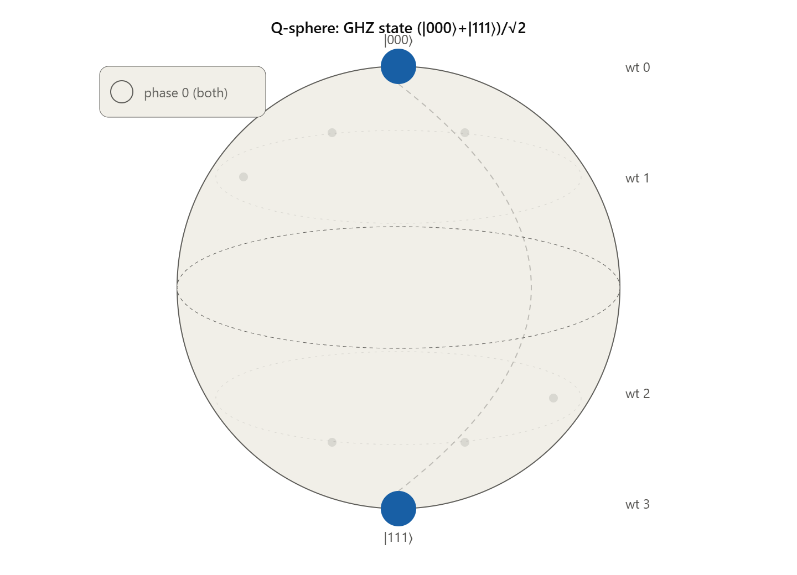
[Figure 2.2.4 — Q-sphere representation of a 3-qubit entangled state]

2.2.11 Bell's Theorem and Quantum Nonlocality
Bell's theorem addresses one of the most profound features of quantum mechanics: the impossibility of reproducing quantum correlations with any local hidden variable theory. In 1935, Einstein, Podolsky, and Rosen (EPR) argued that quantum mechanics was incomplete and that 'hidden variables'—physical properties carried by particles but unknown to us—could explain the correlations observed in entangled states. In 1964, John Bell proved that any such local hidden variable theory must satisfy a specific inequality, and that quantum mechanics predicts violations of this inequality.

The EPR Setup and Measurement Correlations
Consider an EPR pair of photons in the state $|Φ⁺⟩ = \left(\frac{1}{\sqrt{2}}\right)(|↑↑⟩ + |→→⟩)$, where $|↑⟩$ and $|→⟩$ represent vertical and horizontal polarization respectively. The photons are sent to two distant observers, Alice and Bob, who each possess a polarizer that can be oriented at an arbitrary angle $θ$. The observable $O_{θ}$ measures the projection onto the state $|v⟩ = cos θ|0⟩ + sin θ|1⟩$.
When Alice and Bob measure their respective photons with polarizers oriented at angles $θ₁$ and $θ₂$, the probability that they obtain the same result (both pass or both are absorbed) is:
$$P(same) = cos²(θ₁ - θ₂)$$
This result follows from the rotational symmetry of the singlet-like state and the Malus law for polarization. When the polarizers are parallel ($θ₁ = θ₂$), the probability of agreement is 1. When they are perpendicular ($θ₁ - θ₂ = π/2$), the probability is 0.

The Bell Inequality Derivation
Consider three distinct measurement settings a, b, and c for the polarizer angles. Define $P_{xy}$ as the probability that Alice and Bob obtain the same result when Alice's polarizer is set to angle x and Bob's to angle y. In any local hidden variable theory, each photon pair carries pre-determined outcomes for each possible setting. Since each measurement yields only two outcomes (Pass (P) or Absorb (A)), there are $2³ = 8$ possible deterministic assignments of outcomes for the three settings.
By enumerating all possible local hidden variable assignments, one can show that the probabilities must satisfy the Bell inequality:
$$P_{ab} + P_{ac} + P_{bc} ≥ 1$$
The proof proceeds by contradiction. Suppose each photon has predetermined responses $f_{A}(x)$ and $f_{B}(y)$ for settings x and y, where $f ∈ \{P, A\}$. The probability $P_{xy}$ is the fraction of pairs for which $f_{A}(x) = f_{B}(y)$. Considering all 9 possible setting pairs and averaging over the hidden variable distribution, the sum of any three such probabilities involving three distinct settings must be at least 1. This is a consequence of the triangle inequality applied to the Hamming distances between binary strings.

Quantum Violation
In quantum mechanics, $P_{xy}$ $= cos²(θ_{xy})$, where $θ_{xy}$ is the angle between settings x and y. Choose the three angles such that $θ_{ab} = 60°$, $θ_{bc} = 60°$, and $θ_{ac}$ $= 120°$. Then:
$$P_{ab} = cos²(60°) = 1/4 P_{bc} = cos²(60°) = 1/4 P_{ac} = cos²(120°) = 1/4$$
The sum is:
$$P_{ab} + P_{ac} + P_{bc} = 3/4 < 1$$
This violates the Bell inequality. No local hidden variable theory can reproduce this result. The quantum prediction has been experimentally confirmed numerous times (Aspect et al., 1982; Weihs et al., 1998; Hensen et al., 2015), ruling out local realism as a description of nature. The security of quantum key distribution protocols, such as Ekert's 1991 protocol, rests directly on this violation: an eavesdropper attempting to intercept the entangled pairs would introduce correlations consistent with local hidden variables, thereby revealing their presence through a reduction in the Bell inequality violation.

2.2.12 Ekert's Quantum Key Distribution Protocol (1991)
Arthur Ekert proposed a quantum key distribution scheme in which Alice and Bob establish a shared secret key by measuring entangled EPR pairs. The protocol proceeds as follows:
- A source generates pairs of entangled qubits and sends one qubit to Alice and one to Bob.
- Alice and Bob each randomly choose one of three measurement bases (corresponding to angles a, b, c).
- After measurement, they publicly announce which bases they used but not the outcomes.
- They discard all results where their bases differed, keeping only those where they used the same basis.
- For the retained data, their results are perfectly correlated (or anti-correlated, depending on the Bell state), yielding a shared random bit string.
- They test a subset of their data for Bell inequality violation. If the violation is maintained, no eavesdropper (Eve) has interacted with the pairs, because any interaction by Eve would destroy the entanglement and reduce the correlation below the quantum prediction.
The practical difficulty of Ekert's protocol lies in storing EPR pairs without decoherence. Modern implementations use photon pairs transmitted through optical fibers or free space, with active stabilization of the optical path.
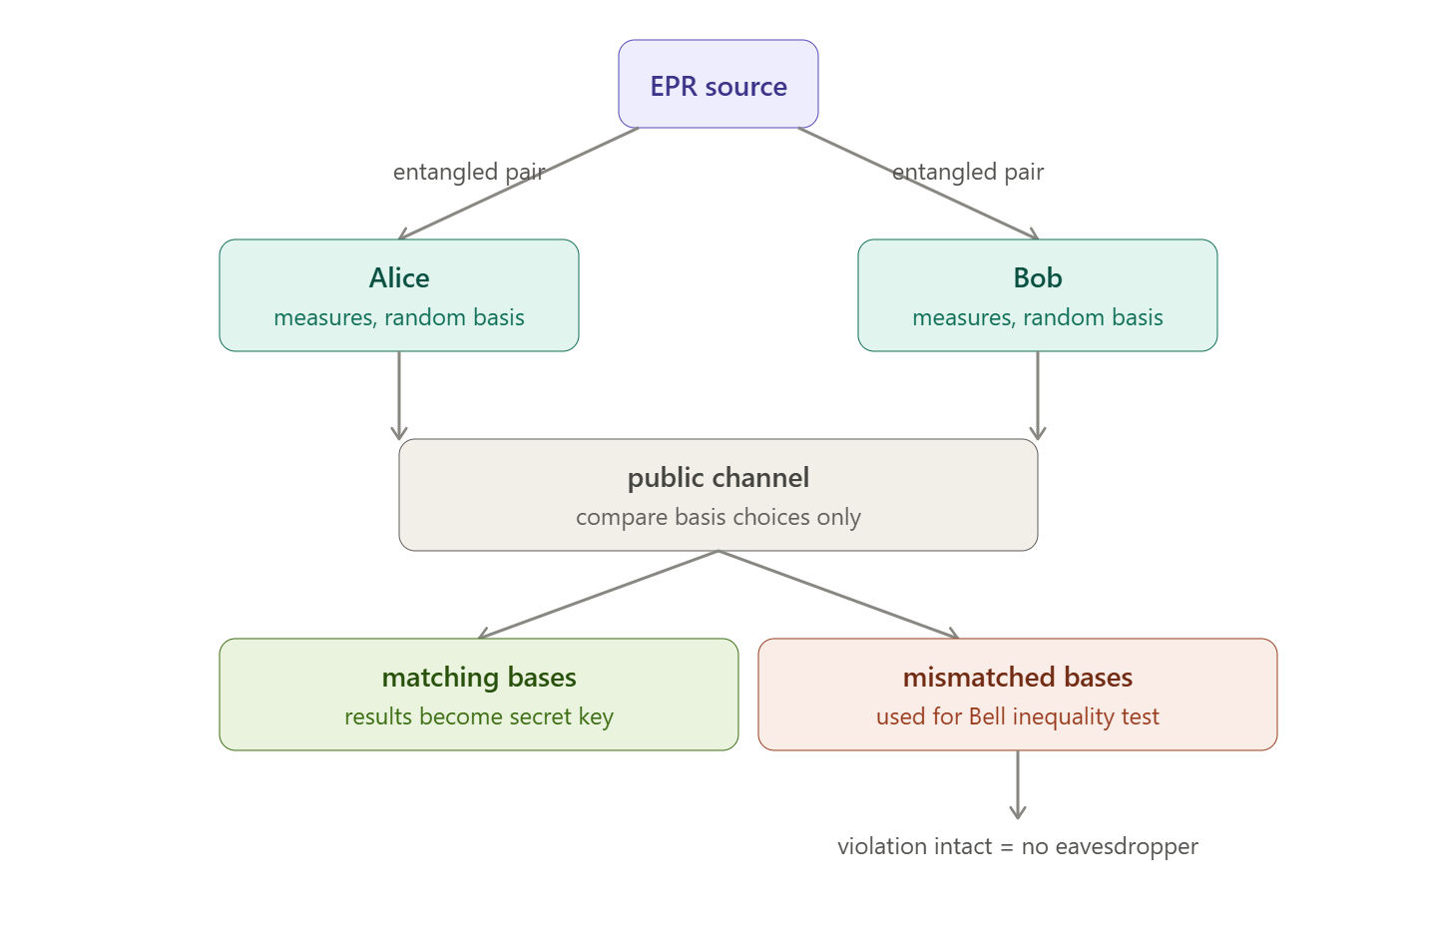
[Figure 2.2.5 — Schematic of Ekert's QKD protocol]

Summary Table
The following table consolidates the key concepts, mathematical expressions, and physical interpretations covered in this subunit.
Concept | Mathematical Expression / Definition | Physical Interpretation
State Space Scaling | Classical: $dim(V⊕W)=dim(V)+dim(W)$; Quantum: $dim(V⊗W)=dim(V)×dim(W)$ | Exponential growth of quantum state space vs linear classical growth
Tensor Product | $$(|v₁⟩+|v₂⟩)⊗|w⟩ = |v₁⟩⊗|w⟩+|v₂⟩⊗|w⟩; ⟨v₁w₁|v₂w₂⟩=⟨v₁|v₂⟩⟨w₁|w₂⟩$$ | Bilinear combination preserving inner product structure
Multi-Qubit State | $$|ψ⟩=Σᵢaᵢ|i⟩, i∈\{0,1\}ⁿ; Σ|aᵢ|²=1$$ | Superposition over all n-bit strings with complex amplitudes
Bell Basis | $$|Φ⁺⟩,|Φ⁻⟩,|Ψ⁺⟩,|Ψ⁻⟩ = (|00⟩±|11⟩)/√2, (|01⟩±|10⟩)/√2$$ | Maximally entangled two-qubit basis; essential for teleportation and QKD
Entanglement | $|ψ⟩$ cannot be written as $|a⟩⊗|b⟩⊗…⊗|z⟩$ for given decomposition | Non-classical correlation; relative to subsystem partition, not basis
EPR Pair | Two particles in a Bell state (e.g., $|Φ⁺⟩$) | Perfectly correlated measurement outcomes; basis of quantum nonlocality
Measurement Postulate | $$V=S₁⊕S₂⊕…⊕Sₖ; P(i)=|Pᵢ|ψ⟩|²=⟨ψ|Pᵢ|ψ⟩$$ | State collapses to subspace $Sᵢ$ with probability given by projector expectation
Partial Measurement | Measure subset of qubits; trace out or condition on outcomes | Remaining qubits may stay in superposition; probabilities sum over unmeasured qubits
Outer Product | $|u⟩⟨v|$ acts as: $|u⟩⟨v|(|w⟩)=⟨v|w⟩|u⟩$ | Building block for all linear operators; matrix element $aᵢⱼ=⟨i|A|j⟩$
Projection Operator | $$P_{S}=Σⱼ|iⱼ⟩⟨iⱼ|; P²=P, P^{†}=P$$ | Maps state onto subspace S; probability$=⟨ψ|P|ψ⟩$; $tr(P)=dim(S)$
Hermitian Operator | $O^{†}=O$; real eigenvalues; orthogonal eigenspaces | Represents physical observable; spectral decomposition $O=Σλᵢ Pᵢ$
Spectral Decomposition | $O=Σᵢλᵢ Pᵢ$ where $Pᵢ$ project onto eigenspace $E_{λᵢ}$ | Eigenvalues label measurement outcomes; projectors define state collapse
Tensor Product of Operators | $(A⊗B)(|v⟩⊗|w⟩)=A|v⟩⊗B|w⟩$; eigenvalue=$λ_{A}×λ_{B}$ | Simultaneous independent operations on subsystems; decomposable vs non-decomposable
Bit Equality Operator | $$C=2(|00⟩⟨00|+|11⟩⟨11|)+3(|01⟩⟨01|+|10⟩⟨10|)$$ | Measures whether two qubits are equal without revealing individual values
Q-Sphere | Latitude=Hamming weight; Dot size$=|aₓ|²$; Color$=arg(aₓ)$ | Visualization of multi-qubit superposition amplitudes and phases
Bell Inequality | $P_{ab}+P_{ac}+P_{bc} ≥ 1$ (local hidden variable bound) | Constraint on correlations in any local realistic theory
Quantum Violation | For 60° separations: $3×cos²(60°)=3/4 < 1$ | Experimental proof that no local hidden variable theory can reproduce quantum predictions
Ekert QKD | EPR pairs + random basis choice + Bell test | Security guaranteed by violation of Bell inequality; eavesdropping destroys entanglement

Exercises
The following exercises are designed to reinforce the theoretical concepts and computational techniques presented in this subunit. Students are encouraged to attempt all problems before consulting the solutions.

E1. Tensor Product Computation
Compute the tensor product $|+⟩ ⊗ |-⟩$ where $|+⟩ = (|0⟩ + |1⟩)/√2$ and $|-⟩ = (|0⟩ - |1⟩)/√2$. Express the result in the computational basis $\{|00⟩, |01⟩, |10⟩, |11⟩\}$ and verify that it is a normalized state.

E2. Identifying Entangled States
Determine which of the following two-qubit states are entangled and which are separable. For separable states, factor them into single-qubit states.
(a) $|ψ₁⟩ = \left(\frac{1}{2}\right)(|00⟩+|01⟩+|10⟩+|11⟩)$
(b) $|ψ₂⟩ = \left(\frac{1}{\sqrt{2}}\right)(|00⟩+|01⟩)$
(c) $|ψ₃⟩ = \left(\frac{1}{\sqrt{2}}\right)(|00⟩+|11⟩)$
(d) $|ψ₄⟩ = \left(\frac{1}{2}\right)(|00⟩+|01⟩+|10⟩-|11⟩)$

E3. Measurement Probabilities
A two-qubit system is in the state $|ψ⟩ = (1/2)(|00⟩+|01⟩+|10⟩+|11⟩).$
(a) What is the probability of measuring the first qubit in state $|0⟩$?
(b) If the first qubit is measured to be $|0⟩$, what is the post-measurement state of the second qubit?
(c) What is the probability of measuring both qubits to be $|1⟩$?

E4. Outer Products and Matrices
Write the following operators in matrix form in the standard single-qubit basis:
(a) $|0⟩⟨0|$
(b) $|0⟩⟨1|+|1⟩⟨0|$
(c) $|+⟩⟨+|$ where $|+⟩=(|0⟩+|1⟩)/√2$
(d) Verify that $|+⟩⟨+|$ is a projector by checking$P²=P$and $P^{†}=P$.

E5. Projection Operators
Consider the two-qubit state $|ψ⟩ = \left(\frac{1}{\sqrt{3}}\right)(|00⟩+|01⟩+|10⟩)$.
(a) Construct the projector $P_{00}$ onto the subspace spanned by $|00⟩$.
(b) Compute $⟨ψ|P_{00} |ψ⟩$ and interpret the result.
(c) Construct the projector $P_{equal}$ onto the subspace where both qubits have the same value. Compute $⟨ψ|P_{equal}|ψ⟩$.

E6. Hermitian Operator Construction
Construct a Hermitian operator $O$ on a two-qubit system that measures the parity of the number of 1s in the basis state. Assign eigenvalue +1 to even parity states ($|00⟩,|11⟩$) and eigenvalue −1 to odd parity states ($|01⟩,|10⟩$). Write $O$ in both Dirac notation and matrix form. Verify that $O$ is Hermitian.

E7. Tensor Product of Operators
Let $A=\left(\begin{matrix}1 & 0 \\ 0 & 2\end{matrix}\right)$and B$=\left(\begin{matrix}0 & 1 \\ 1 & 0\end{matrix}\right)$. Compute the tensor product $A⊗B$ and determine its eigenvalues. Verify that the eigenvalues are products of eigenvalues of A and B.

E8. Bell Basis Measurement
The state $|ψ⟩=|01⟩$ is measured in the Bell basis.
(a) Express $|01⟩$ as a linear combination of Bell states.
(b) What are the possible measurement outcomes and their probabilities?
(c) What is the post-measurement state for each outcome?

E9. Bell Inequality Calculation
Using the quantum mechanical prediction $P(same)=cos²(θ)$, calculate the left-hand side of the Bell inequality $P_{ab}+P_{ac}+P_{bc}$ for three angles separated by 45°, i.e., $θ_{ab}=45°, θ_{bc}=45°, θ_{ac}=90°$. Does quantum mechanics violate the inequality in this case?

E10. Non-Decomposable Measurement
Consider the operator $M=|11⟩⟨11|$ on a two-qubit system.
(a) Show that M is a projector.
(b) Is M decomposable as a tensor product of single-qubit operators? Justify your answer.
(c) Consider the state $|ψ⟩=\left(\frac{1}{\sqrt{2}}\right)(|01⟩+|10⟩)$. What is the result of measuring M on this state? Compare this with the result of measuring each qubit in the standard basis and then applying a classical AND operation.

E11. Relative Phase and Basis Dependence
Show that the state $|Φ⁺⟩=\left(\frac{1}{\sqrt{2}}\right)(|00⟩+|11⟩)$ can be rewritten as $\left(\frac{1}{\sqrt{2}}\right)(|++⟩+|--⟩)$. Verify that the coefficients in the Hadamard basis are identical in magnitude to those in the computational basis. What does this imply about the nature of entanglement across different bases?

E12. Ekert Protocol Analysis
In Ekert's protocol, Alice and Bob share EPR pairs in the state $|Φ⁺⟩$. They each randomly choose to measure in one of three bases: 0°, 60°, or 120° from the vertical.
(a) Calculate the probability that their measurement outcomes agree when they both choose 0°.
(b) Calculate the probability of agreement when Alice chooses 0° and Bob chooses 60°.
(c) Using these results, compute the correlation function $E(a,b)=P(same)-P(different)$ for these two settings.
(d) Explain how an eavesdropper introducing local hidden variables would affect the Bell inequality test.

Solutions to Exercises

Solution to E1. Tensor Product Computation
We expand $|+⟩⊗|-⟩$using distributivity:
$$|+⟩⊗|-⟩ = \left(\frac{1}{\sqrt{2}}\right)(|0⟩+|1⟩) ⊗ \left(\frac{1}{\sqrt{2}}\right)(|0⟩-|1⟩) = (1/2)(|00⟩-|01⟩+|10⟩-|11⟩)$$
Normalization check: the amplitudes are $±1/2$ for each of four basis states. The sum of squared magnitudes is $4×(1/4)=1$. Hence the state is normalized.
Note: this is a separable (product) state, as expected from the tensor product of two single-qubit states.

Solution to E2. Identifying Entangled States
(a) $|ψ₁⟩ = \left(\frac{1}{2}\right)(|00⟩+|01⟩+|10⟩+|11⟩) = |+⟩⊗|+⟩$. Separable.
(b) $|ψ₂⟩ = \left(\frac{1}{\sqrt{2}}\right)(|00⟩+|01⟩) = |0⟩⊗|+⟩$. Separable.
(c) $|ψ₃⟩ = \left(\frac{1}{\sqrt{2}}\right)(|00⟩+|11⟩) = |Φ⁺⟩$. Suppose it were separable: $(a|0⟩+b|1⟩)⊗(c|0⟩+d|1⟩)$. Comparing coefficients gives $ac=\frac{1}{\sqrt{2}}, bd=\frac{1}{\sqrt{2}}, ad=0, bc=0$, which is contradictory (either a=0 or d=0 forces ac=0 or bd=0). Hence entangled.
(d) $|ψ₄⟩ = \left(\frac{1}{2}\right)(|00⟩+|01⟩+|10⟩-|11⟩)$. Attempted factorization gives $ac=1/2, ad=1/2, bc=1/2, bd=-1/2$, which forces c=d=0, contradicting ac=1/2. Entangled.

Solution to E3. Measurement Probabilities
(a) $P(0) = |a|²+|b|²$ with $a=b=1/2$, so $P(0) = 1/4+1/4 = 1/2$.
(b) Post-measurement state: $|ψ'⟩ = (1/√2)(|00⟩+|01⟩) = |0⟩⊗|+⟩$; the second qubit is in state $|+⟩$.
(c) $P(11) = |1/2|² = 1/4$.

Solution to E4. Outer Products and Matrices
(a) $|0⟩⟨0| =\left(\begin{matrix}1 & 0 \\ 0 & 0\end{matrix}\right)$.
(b) $|0⟩⟨1|+|1⟩⟨0| = \left(\begin{matrix}0 & 1 \\ 1 & 0\end{matrix}\right) = X (Pauli-X)$.
(c) $|+⟩⟨+| = (1/2)\left(\begin{matrix}1 & 1 \\ 1 & 1\end{matrix}\right)$.
(d) Verification: $P² = \left(\frac{1}{4}\right)\left(\begin{matrix}2 & 2 \\ 2 & 2\end{matrix}\right) = \left(\frac{1}{2}\right)\left(\begin{matrix}1 & 1 \\ 1 & 1\end{matrix}\right) = P. P^{†} = P$(real symmetric matrix). Both conditions satisfied; $|+⟩⟨+|$ is a projector onto the $|+⟩$ direction.

Solution to E5. Projection Operators
(a) $P_{00}$ $= |00⟩⟨00|$, a $4×4$ matrix with a single 1 in the (1,1) position.
(b) $⟨ψ|P_{00}|ψ⟩ = |⟨00|ψ⟩|² = |1/√3|² = 1/3$— the probability of outcome $|00⟩$ in a standard basis measurement.
(c) $P_{equal}$ $= |00⟩⟨00|+|11⟩⟨11|. ⟨ψ|P_{equal}|ψ⟩ = 1/3+0 = 1/3$ — the probability that the two qubits are equal.

Solution to E6. Hermitian Operator Construction
$O = (+1)|00⟩⟨00| + (-1)|01⟩⟨01| + (-1)|10⟩⟨10| + (+1)|11⟩⟨11|$.
Matrix form (basis order $|00⟩,|01⟩,|10⟩,|11⟩$): $O = diag(1,-1,-1,1)$.
Verification of Hermiticity: $O$ is a real, symmetric (diagonal) matrix, so $O^{†} = O$.
Note: this operator equals $Z⊗Z$, since $Z⊗Z = |00⟩⟨00|-|01⟩⟨01|-|10⟩⟨10|+|11⟩⟨11| = O$.

Solution to E7. Tensor Product of Operators
$A = \left(\begin{matrix}1 & 0 \\ 0 & 2\end{matrix}\right)$ has eigenvalues 1, 2. $B = \left(\begin{matrix}0 & 1 \\ 1 & 0\end{matrix}\right)$ (Pauli-X) has eigenvalues +1, −1.
$$A⊗B =\left(\begin{matrix}\begin{matrix}0 & 1 \\ 1 & 0\end{matrix} & \begin{matrix}0 & 0 \\ 0 & 0\end{matrix} \\ \begin{matrix}0 & 0 \\ 0 & 0\end{matrix} & \begin{matrix}0 & 2 \\ 2 & 0\end{matrix}\end{matrix}\right).$$
Characteristic polynomial: $det(B-λI)·det(2B-λI) = (λ²-1)(λ²-4)$, giving eigenvalues $λ = ±1, ±2$ — exactly the products of the eigenvalues of A and B $(1×1=1, 1×(-1)=-1, 2×1=2, 2×(-1)=-2)$. The eigenspaces are spanned by $|uᵢ⟩⊗|vⱼ⟩$ where $|uᵢ⟩, |vⱼ⟩$ are eigenvectors of A and B respectively.

Solution to E8. Bell Basis Measurement
(a) $|Ψ⁺⟩+|Ψ⁻⟩ = \sqrt{2}|01⟩$, so $|01⟩ = (1/\sqrt{2})(|Ψ⁺⟩+|Ψ⁻⟩)$.
(b) $P(Ψ⁺) = P(Ψ⁻) = 1/2; P(Φ⁺) = P(Φ⁻) = 0$.
(c) If outcome $Ψ⁺$: state becomes $|Ψ⁺⟩$. If outcome $Ψ⁻$: state becomes $|Ψ⁻⟩$.

Solution to E9. Bell Inequality Calculation
$P_{ab} = cos²(45°) = 1/2,$ $P_{bc}$ $= cos²(45°) = 1/2,$ $P_{ac}$ $= cos²(90°) = 0.$
Sum = 1/2+0+1/2 = 1 — the quantum prediction exactly saturates the Bell bound (no violation here).
For the canonical 60°−60°−120° configuration, the sum is 1/4+1/4+1/4 = 3/4 < 1, which does violate the inequality and demonstrates quantum nonlocality.

Solution to E10. Non-Decomposable Measurement
(a) $M = |11⟩⟨11|$ satisfies $M² = M$ and $M† = M$, so it is a projector onto the one-dimensional subspace spanned by $|11⟩$.
(b) $M = |1⟩⟨1| ⊗ |1⟩⟨1|$, so it IS decomposable.
(c) For $|ψ⟩ = \left(\frac{1}{\sqrt{2}}\right)(|01⟩+|10⟩): M|ψ⟩ = 0$, so the state is unchanged; the outcome is 'not 11' with probability 1. Measuring each qubit individually in the standard basis instead collapses the state completely (to $|01⟩$ or $|10⟩$ with probability 1/2 each), destroying the coherence that M preserves within the 'not 11' subspace.

Solution to E11. Relative Phase and Basis Dependence
Substituting $|0⟩=\left(\frac{1}{\sqrt{2}}\right)(|+⟩+|-⟩)$ and $|1⟩=\left(\frac{1}{\sqrt{2}}\right)(|+⟩-|-⟩)$ into $|Φ⁺⟩$ and simplifying gives:
$|Φ⁺⟩ = \left(\frac{1}{\sqrt{2}}\right)(|++⟩+|--⟩)$.
The coefficients are both +1/√2, identical in magnitude to the computational basis representation. Implication: entanglement is a basis-independent property — a state entangled in one orthonormal basis remains entangled in all orthonormal bases — while superposition itself is basis-dependent in its appearance.

Solution to E12. Ekert Protocol Analysis
(a) Both choose 0°: P(same) = P(00)+P(11) = 1/2+1/2 = 1.
(b) Angle between bases is 60°: P(same) = cos²(60°) = 1/4.
(c) E(a,b) = P(same)−P(different) = 1/4−3/4 = −1/2.
(d) If Eve intercepts and measures each qubit independently (a local hidden variable attack), she forces the correlations to satisfy the Bell inequality $P_{ab}+P_{ac}+P_{bc}$ $≥ 1$. Since the genuine quantum prediction for 60°−60°−120° is $3/4 < 1$, a measured sum at or above 1 reveals Eve's presence. The security is information-theoretic, resting on the monogamy of entanglement rather than computational assumptions.

References
- Rieffel, E. & Polak, W. (2011). Quantum Computing: A Gentle Introduction. MIT Press. Cambridge, MA.
- PennyLane Codebook (2024). Xanadu Quantum Technologies. https://pennylane.ai/codebook
- Nielsen, M. A. & Chuang, I. L. (2010). Quantum Computation and Quantum Information: 10th Anniversary Edition. Cambridge University Press.
- Kaye, P., Laflamme, R., & Mosca, M. (2007). An Introduction to Quantum Computing. Oxford University Press.

