QUANTUM COMPUTING
A Course for B.E./B.Tech Engineering Students
Unit 2.5
Engineering Qubits
Study Material
Unit 2: Introduction to Quantum Computing
Trapped Ions • Superconducting Qubits • Photonic Quantum Computers
Prepared for B.E./B.Tech Engineering Students
© Dr. Amrit Raj K, August 2026

Learning Objectives
By the end of this unit, students will be able to:
- State the DiVincenzo criteria and use them as a checklist to evaluate any candidate quantum-hardware platform.
- Explain why decoherence occurs, and distinguish energy relaxation (T1) from dephasing (T2) using the appropriate noise models.
- Describe how the harmonic oscillator illustrates both the promise and the practical limitations of using naturally occurring energy levels as qubits.
- Explain the physics of the linear Paul trap, laser (Doppler and sideband) cooling, and optical pumping in trapped-ion systems.
- Describe single- and two-qubit gate implementation in trapped ions, including Rabi oscillations, sideband transitions, the Cirac–Zoller gate, and the Mølmer–Sørensen gate.
- Explain the working principle of a transmon qubit, including the role of the Josephson junction, gate capacitance, and dispersive readout.
- Compare capacitive coupling, flux-tunable coupling, and all-microwave two-qubit gate schemes in superconducting circuits.
- Describe the phase-space (quadrature) representation of photonic qubits, Gaussian operations, and the role of non-Gaussian resources such as GKP states.
- Critically evaluate trapped-ion, superconducting, and photonic platforms against the DiVincenzo criteria, identifying the principal engineering trade-offs of each.

2.5.1 Quantum Hardware Implementations
Realising a quantum computer requires far more than identifying a two-level system. It requires a full engineering pipeline: choosing a physical carrier of quantum information, initialising it into a known state, applying precise unitary control, protecting it from the environment for long enough to compute, and finally reading it out reliably. This section surveys the generic engineering requirements for quantum hardware and then examines three leading physical platforms — trapped ions, superconducting circuits, and photonics — in that light.

What Makes a Good Qubit?
A physical two-level system is not automatically a usable qubit. A classical coin, for instance, is an excellent classical bit but cannot exist in superposition, so it fails as a qubit. Conversely, a nuclear spin can remain coherent for days, but its very weak coupling to the outside world makes it difficult to initialise, control, and measure. Good qubit candidates must balance two competing demands:
- Isolation: the qubit must be well shielded from uncontrolled interactions with its environment, since any such interaction constitutes noise and destroys quantum information.
- Controllability: the qubit must still be accessible enough that an experimenter can prepare, manipulate, and measure it on demand.
A continuous physical quantity, such as the position $x$ of a free particle along a line, is a poor qubit because noise renders nearby values indistinguishable. A discrete quantity, such as the two spin projections of a spin-1/2 particle, $|↑⟩, |↓⟩,$ is far better suited because noise cannot smoothly interpolate between two isolated, discrete outcomes.
Why It Matters
The tension between isolation and controllability is the central engineering trade-off in every quantum-hardware platform discussed in this subunit. Every design choice — trap depth, cavity coupling strength, photon loss rate — is ultimately a trade between protecting the qubit and being able to drive it.

2.5.2 The DiVincenzo Criteria
Before comparing platforms, it is useful to fix a common checklist. David DiVincenzo (2000) proposed five criteria that any candidate quantum-computing architecture must satisfy:
# | Criterion | Engineering Challenge
1 | A scalable physical system with well-characterised qubits | Qubits must be identifiable, reproducible, and extendable to large numbers without degrading performance.
2 | The ability to initialise the qubits into a well-defined state (e.g. |000…0⟩) | Preparation must be repeatable with very low error, ideally reaching a state of (near) zero entropy.
3 | Long relevant decoherence times, much longer than the gate operation time | Coherence must survive many gate operations before information is irretrievably lost.
4 | A universal set of quantum gates | The platform must support a set of one- and two-qubit gates that is computationally universal.
5 | A qubit-specific measurement capability | Each qubit must be individually and reliably measurable without unacceptably disturbing the rest of the register.

Two further criteria, sometimes appended for communication-oriented applications, require the ability to interconvert stationary and "flying" (photonic) qubits, and to faithfully transmit flying qubits between distant locations. Throughout this unit, each platform is assessed informally against this five-point checklist.

2.5.3 Hardware Engineering
Every quantum computer, regardless of physical platform, follows the same generic architecture: a register of qubits is initialised into a pure, well-defined state; a programmed sequence of unitary transformations is applied; and the qubits are measured to extract a classical result.

Initialisation and Purity
Initialisation means driving every qubit into a known pure state. In a classical machine this is trivial, since a classical bit does not entangle with its surroundings. In a quantum machine, however, uncontrolled coupling to the environment can turn an intended pure state into a mixed state — a statistical ensemble in which the delicate phase information required for interference has been lost.
Worked Exercise
Consider the pure superposition $|ψ⟩ = (|0⟩ + |1⟩)/√2$and a mixed state prepared by tossing a fair coin and setting the qubit to $|0⟩$ on heads or $|1⟩$ on tails. Both states give identical outcome probabilities (50:50) when measured in the computational basis, so a single Z-basis measurement cannot distinguish them. Measuring instead in the $\{(|0⟩+|1⟩)/√2, (|0⟩-|1⟩)/√2\}$ basis resolves the ambiguity: the pure state always gives a deterministic outcome in this basis, whereas the mixed state still gives a 50:50 split. This experiment is the essence of how coherence is verified in the laboratory.

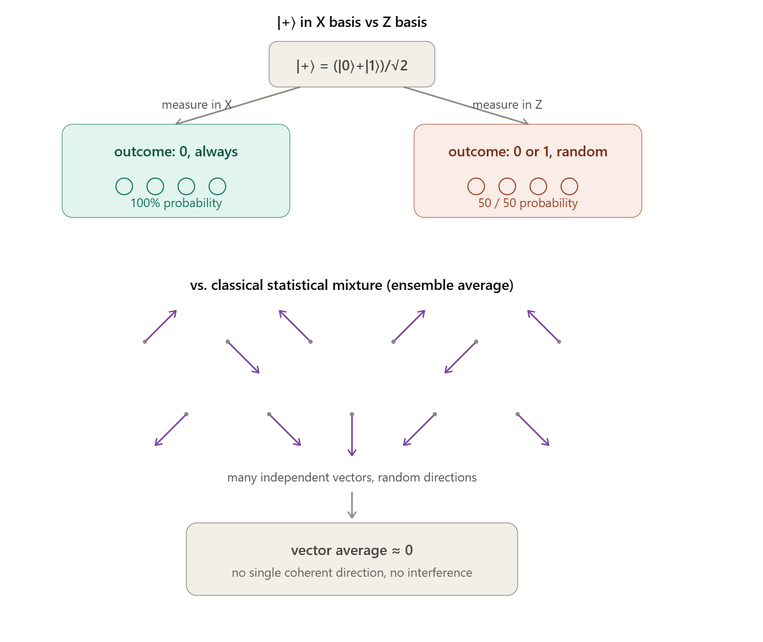Fig. 2.5.1 — Distinguishing a pure superposition state from a classical statistical mixture using a basis change.

Decoherence and Relative Phase
For a single qubit $\left|0\right\rangle + exp\left(iθ\right)|1⟩$, the parameter $θ$ is a relative phase and is, in principle, physically detectable — for example, by measuring an observable such as $S_{x}$ whose expectation value depends on $θ$. When such a qubit becomes entangled with an environment qubit, e.g.
$$|ψ⟩ = (|00⟩ + exp\left(iθ\right) |11⟩)/√2=1/√2 {[1, 0, 0, exp⁡(iθ)]}^{T}$$
a local measurement of $S_{x} ⊗ I=\left(\begin{matrix}0 & 1 \\ 1 & 0\end{matrix}\right)⊗\left(\begin{matrix}1 & 0 \\ 0 & 1\end{matrix}\right)$on the system alone yields zero — no information about $θ$ is recoverable locally. The phase information has migrated into the joint correlations between system and environment and can only be recovered by jointly measuring both, e.g. via $S_{x}⊗S_{x}$.
Two complementary engineering strategies mitigate this problem: executing gates fast enough that decoherence has little time to act, and building fault tolerance into the computation itself through quantum error correction (introduced in Unit 2.6).

Coherence Metrics
Once a platform is built, its quality is quantified using a standard set of coherence and error metrics, most thoroughly characterised in superconducting-qubit systems but applicable in spirit to every platform:
Metric | Definition
T1 (relaxation time) | Timescale over which an excited qubit spontaneously decays (bit-flips) to its ground state by losing energy to the environment.
T2 (dephasing time) | Timescale over which random fluctuations of the qubit frequency randomise its phase.
Readout error | Accuracy with which a measurement correctly reports the qubit's true state is commonly summarised by a confusion matrix.
Gate error | Deviation of an implemented gate from its ideal unitary; classified as coherent (systematic mis-calibration), incoherent (stochastic), or cross-talk (unwanted coupling to neighbouring qubits).

At the system level, algorithm performance is further constrained by qubit connectivity, circuit depth, and total qubit count, since errors compound with every additional entangling gate. The three broad classes of mitigation are error suppression (better hardware/pulses), error mitigation (e.g. zero-noise extrapolation, ZNE, and probabilistic error cancellation, PEC), and full quantum error correction.
Concept Check
No single hardware platform dominates quantum computing today the way the x86 architecture dominates classical computing. Superconducting qubits, trapped ions, photonics, neutral atoms, and silicon spin qubits are all under active commercial development, each satisfying the DiVincenzo criteria to differing degrees and with different long-term scalability prospects.

2.5.4 Quantum Harmonic Oscillator Computer
Before examining real hardware, it is instructive to ask whether the simplest possible quantum system — a particle in a parabolic potential $V(x) = mω²x²/2$ — could itself serve as a quantum computer. This is the quantum analogue of a mass on a spring, or a resonant LCR circuit, except that its energy is quantised: a photon, for instance, only ever carries discrete packets of energy $ħω$. The energy eigenstates are labelled $|n⟩$, $n = 0, 1, 2, …$, with energy $ħω(n + 1/2)$. The additive constant at $n = 0$(the zero-point energy) is a global phase and can be dropped. A general state evolves as
$$|ψ(t)⟩ = exp\left(-\frac{iHt}{ħ}\right)|ψ(0)⟩ = Σₙ cₙ exp\left(-inωt\right)|n⟩$$
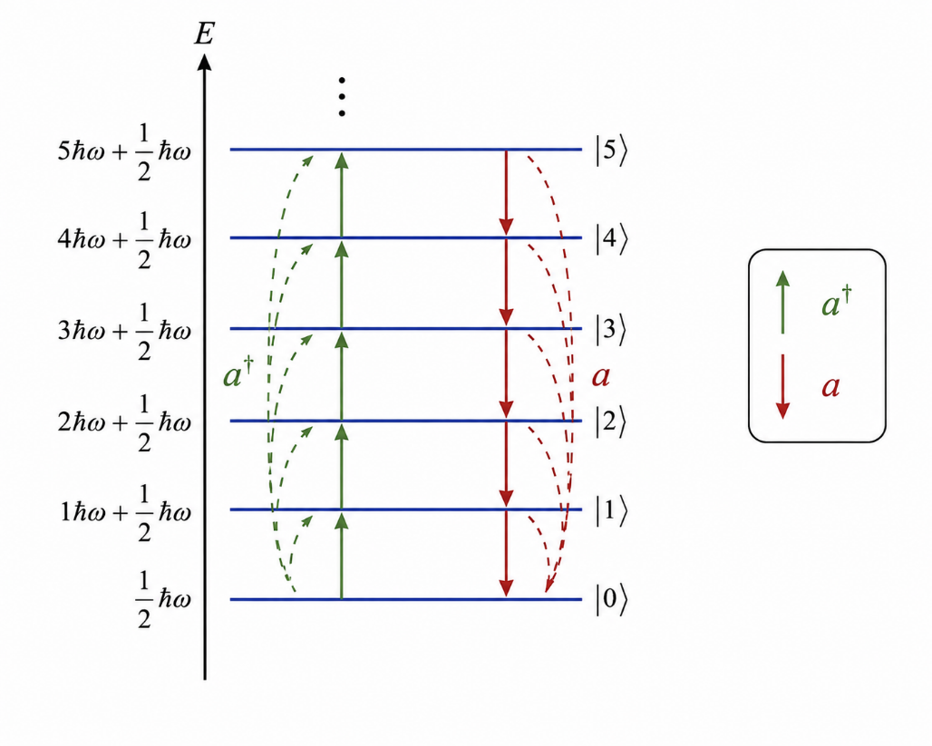

Fig. 2.5.2 — Energy-level ladder of the quantum harmonic oscillator with ladder operators a and a†.
The ladder operators $a$ and $a†$ move population between adjacent levels and are the natural tools for constructing operations on this system. One striking possibility is to encode a two-qubit register non-locally across several oscillator levels, e.g.
$${\left|00\right\rangle }_{L}=|0⟩, {\left|01\right\rangle }_{L}=|2⟩, {\left|10\right\rangle }_{L}=(|4⟩+|1⟩)/√2 , {\left|11\right\rangle }_{L} =(|4⟩-|1⟩)/√2$$
Evolving this encoding for a time $t =\frac{π}{ħω}$ implements a CNOT: each eigenstate transforms as $\left|n\right\rangle → exp\left(-iπ a^{†}a\right)|n⟩ = \left(-1\right)ⁿ|n⟩$, so $|0⟩, |2⟩$ and $|4⟩$ are unchanged while $|1⟩$ picks up a sign — precisely the truth table of a controlled-NOT acting on the logical qubits above.
Despite this elegant construction, the harmonic oscillator fails as a general-purpose quantum computer for several structural reasons:
- The energy eigenvalues of an arbitrary operator are not generally known in advance, making it hard to choose the correct evolution time for a desired gate.
- Unitary operators built this way do not compose easily — cascading several such operators does not straightforwardly yield a new, useful operator.
- It ignores the benefit of digital (qubit-based) representation: encoding $n$ qubits directly into a single oscillator's levels would require access to states of energy up to $2ⁿħω$, whereas an $n-$qubit register built from $n$ separate two-level systems only ever needs energies up to $nħω$ — an exponential saving.
Teaching Point
The harmonic-oscillator example is a useful cautionary tale: having access to "a lot of quantum states" is not the same as having a scalable quantum computer. Scalability, in the DiVincenzo sense, specifically favours modular, identically prepared two-level qubits over a single system with many unevenly accessible levels.

2.5.5 Trapped-Ion Quantum Computers
Trapped ions are among the most mature quantum-computing platforms, historically achieving the highest reported fidelities for state initialisation, readout, and single- and two-qubit gates. An ion is an electrically charged atom, and because it carries net charge it can be confined by electromagnetic fields far more strongly than a neutral atom — roughly a hundred million times more strongly, in fact, since the relevant electrostatic forces vastly exceed the magnetic forces used to trap neutral species.

The Linear Paul Trap
A charged particle cannot be held in stable three-dimensional equilibrium using only static (d.c.) electric fields. This is a consequence of Earnshaw's theorem, which follows from the fact that a static electric field in a charge-free region is divergence-free ($∇·E = 0$), so the electrostatic potential must satisfy Laplace's equation $∇²φ = 0$ — a condition incompatible with a true three-dimensional potential minimum, since any extremum along one axis is necessarily a saddle point overall.
Engineers circumvent this with the Linear Paul Trap (Wolfgang Paul, 1953; Nobel Prize 1989 jointly with Hans Dehmelt), which uses four parallel rods driven by an oscillating r.f. voltage $V = V₀ cos(Ωt)$ to create a rapidly rotating quadrupole potential — conceptually like spinning a saddle fast enough that a ball placed at its centre cannot roll off in any direction. Near the trap axis, the potential takes the form
$$φ = φ₀ + [V₀ / 2r₀²] cos(Ωt) (x² - y²)$$
with static "end-cap" voltages $Φ_{dc} =\frac{κU_{0}\left(z^{2}- \left(x^{2}+ y^{2}\right)\right)}{2}$ confining the ions along the trap axis. Mutual Coulomb repulsion then spaces multiple loaded ions into a regular one-dimensional "string"; the full Hamiltonian for N ions is
$$H = Σᵢ\left[ \left(\frac{M}{2}\right)\left(ωx^{2}xᵢ^{2}+ ωy^{2}yᵢ^{2}+ ωz^{2}zᵢ^{2}\right)+\frac{{\left|pᵢ\right|}^{2}}{M^{2}} \right] + Coulomb interaction$$
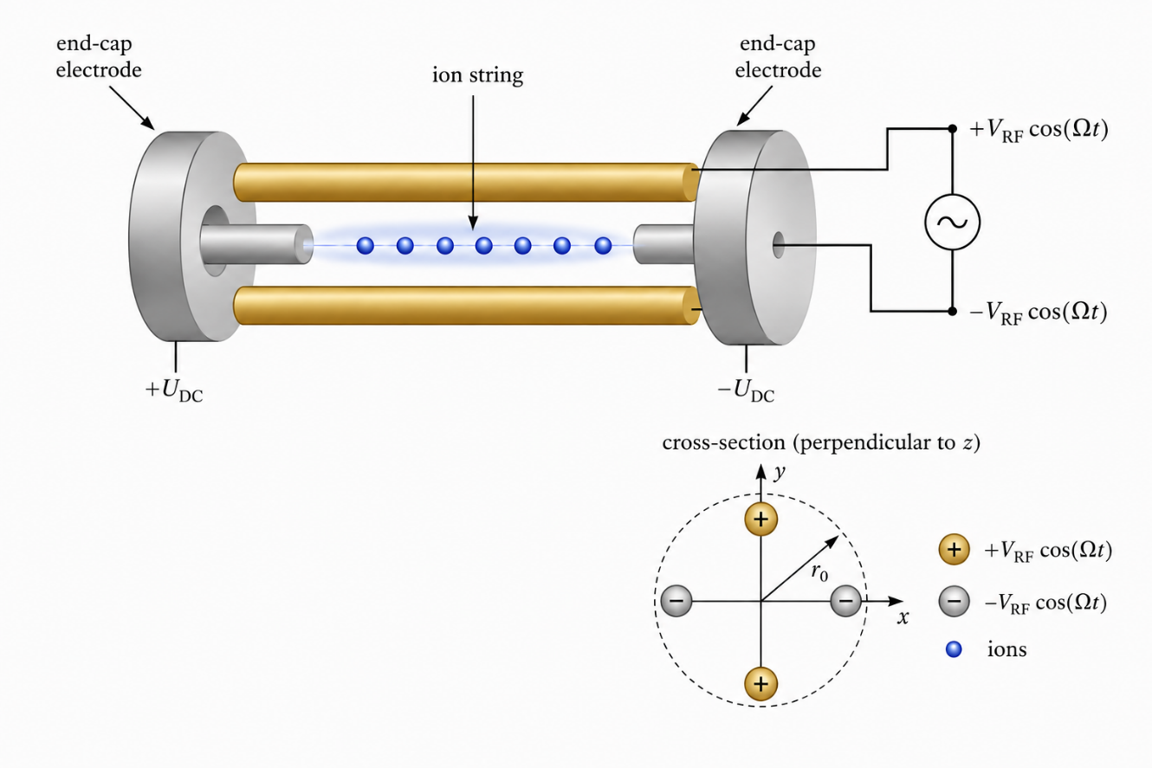
Fig. 2.5.3 — Schematic of a linear Paul trap: four rods with an oscillating RF quadrupole field and static end-cap electrodes confining a linear string of ions.

Laser Cooling
For quantum computation the ions' motional (vibrational) state must be cooled close to its ground state, $k_{BT} ≪ ħω_{z}$. This is done via Doppler cooling: a laser tuned slightly below the ion's resonance (red detuning, $ω_{L} < ω₀$) is absorbed preferentially when the ion moves toward the beam (Doppler-shifted closer to resonance), producing a net damping force — the atomic analogue of an ambulance siren's pitch shift. Random-direction spontaneous re-emission averages to zero net force but adds momentum-space noise, setting a fundamental floor called the Doppler cooling limit:
$$k_{B} T_{D} = ħΓ / 2$$
where $Γ$ is the natural linewidth of the transition. To reach the true motional ground state (ν = 0), engineers follow up with resolved sideband cooling, in which the ion absorbs slightly lower-energy photons and makes up the deficit from its own motional energy, stepping down one vibrational rung (ν → ν − 1) on every cycle until no further absorption is possible.
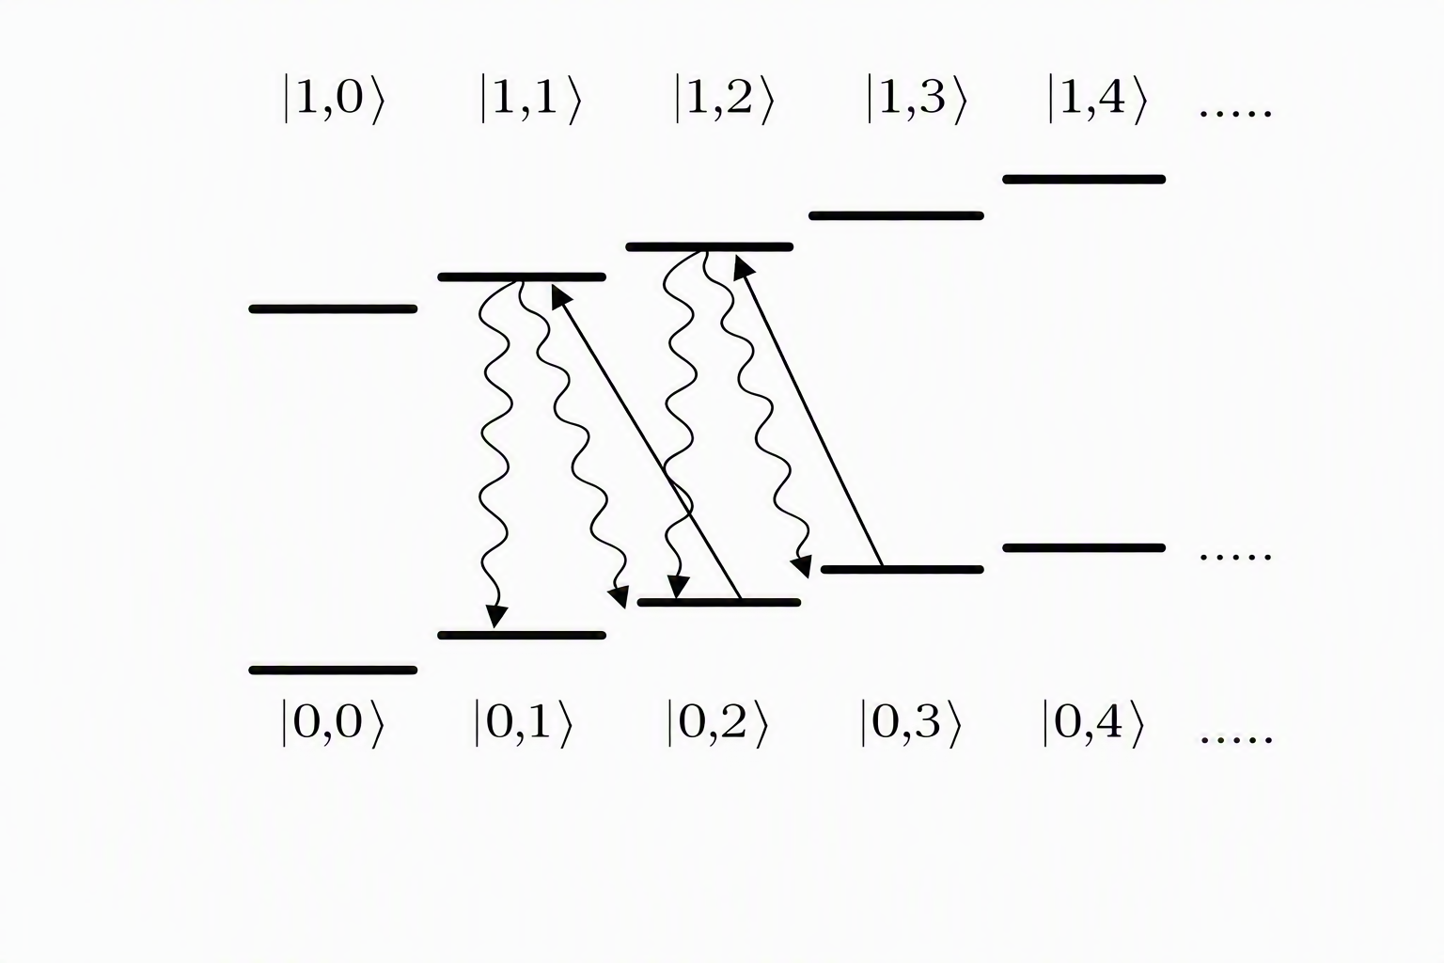
Fig. 2.5.4 — Resolved-sideband cooling cycle: successive absorption–emission cycles step the ion down the vibrational ladder toward ν = 0.

Qubit Encoding and State Preparation
After cooling, the internal electronic states used as qubit levels arise from the coupled electron and nuclear spin, F = S + I. Two encoding choices are common:
- Optical qubits — e.g. in ⁴⁰Ca⁺, using a metastable state with a lifetime of order one second (transition wavelength ≈ 729 nm, infrared).
- Hyperfine qubits — e.g. in ⁴³Ca⁺, using narrow hyperfine splittings that give effectively infinite lifetime, at the cost of requiring more precise, more complex gate control.
Commonly used ion species include ¹³⁸Ba⁺, ¹³⁷Ba⁺, ¹³³Ba⁺, ⁴³Ca⁺, ⁴⁰Ca⁺, ¹⁷¹Yb⁺, ⁸⁸Sr⁺, and ⁹Be⁺; IonQ and Honeywell both use ¹⁷¹Yb⁺. A stable fiducial ground state is prepared by optical pumping: circularly polarised light repeatedly drives the atom into a short-lived auxiliary state that preferentially decays into the target ground state, until essentially all population has been pumped there.
Measurement uses the same principle in reverse — a non-demolition state-dependent fluorescence readout, in which the ion glows only if it is in one designated internal state, and the emitted photons are collected by a detector. Distinct ion species are sometimes combined so that fluorescence from an ancilla ion does not disturb a neighbouring logical ion.

Single-Qubit Gates: Rabi Oscillations
A laser resonant with the qubit transition drives coherent Rabi oscillations between $|g⟩$and $|e⟩$, governed by the Rabi Hamiltonian
$$H = \left(\frac{ħΩ}{2}\right) \left( S_{+}exp\left(iφ\right) + S_{-}exp\left(-iφ\right) \right), Ω =\frac{μ_{m}B}{2ħ}$$
where $φ$ is the laser phase at the ion's location. Solving the Schrödinger equation gives the state
$$|ψ(t)⟩ = cos\left(\frac{Ωt}{2}\right)|g⟩ - i sin\left(\frac{Ωt}{2}\right) exp\left(iφ\right)\left|e\right\rangle$$
so that any single-qubit rotation can be produced by choosing the pulse duration $t$ and phase $φ - φ = 0$gives an X-type rotation and $φ =\frac{π}{2}$ a Y-type rotation, so the resulting family of pulses is
$$U(t, φ) = \left[ cos\left(\frac{Ωt}{2}\right), -i sin\left(\frac{Ωt}{2}\right) exp\left(-iφ\right) ; -i sin\left(\frac{Ωt}{2}\right) exp\left(iφ\right), cos\left(\frac{Ωt}{2}\right) \right]$$
a universal single-qubit gate family. Concretely, a Hadamard gate is built from five pulses of equal duration $\frac{π}{2Ω}$, with the second and fourth pulses phase-shifted by $\frac{π}{2}$; a T-gate uses three pulses with specific durations and phases. At typical Rabi frequencies near 100 kHz, single-qubit gates complete in a few milliseconds with high fidelity.
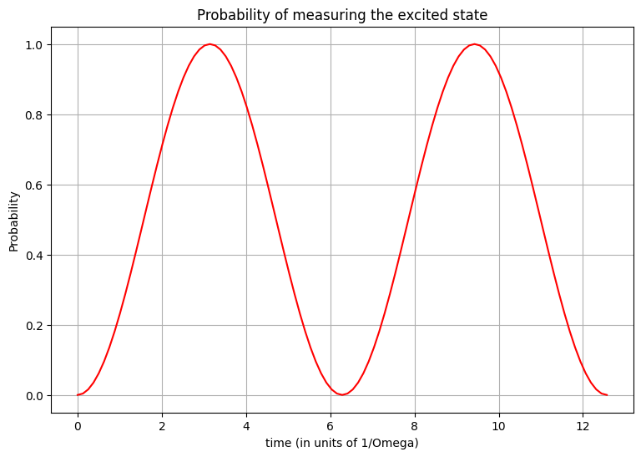
Fig. 2.5.5 — Rabi oscillation: probability of finding the ion in $|e⟩$ as a function of laser exposure time.

Two-Qubit Gates: Phonon-Mediated Entanglement
The ion chain's shared vibrational (phononic) modes, $|n⟩$ with energy $nħω$, act as a quantum bus linking otherwise non-interacting ions. Tuning the laser detuning $Δ$ relative to the ion transition selects among three characteristic transitions:
Transition | Effect | Laser frequency
Blue sideband | $|g⟩|n⟩ → |e⟩|n+1⟩$ (adds one phonon) | $$ω + Δ$$
Red sideband | $|g⟩|n+1⟩ → |e⟩|n⟩$ (removes one phonon) | $$Δ - ω$$
Carrier | $|g⟩|n⟩ → |e⟩|n⟩$ (internal state only) | $$Δ$$

The Cirac–Zoller gate builds a maximally entangled state from these building blocks: a blue-sideband pulse creates a superposition on the first ion involving the shared phonon mode; a carrier pulse excites the second ion conditioned on the presence of that phonon; a final red-sideband pulse removes the phonon again, leaving the two ions' internal states entangled. In practice, the closely related Mølmer–Sørensen gate is preferred: two lasers detuned symmetrically about the carrier, $ω_{±} = Δ ± δ$, jointly drive both ions and, for the correct pulse duration and phase, generate the entangled state
$$(|g⟩|g⟩ + |e⟩|e⟩)/√2$$
without ever requiring the phonon mode itself to be perfectly cooled to its ground state — the essential practical advantage over the Cirac–Zoller scheme. A CNOT gate is then assembled from single-qubit rotations sandwiching a Mølmer–Sørensen interaction of duration $t =\frac{π}{2Ω_{MS}}$.
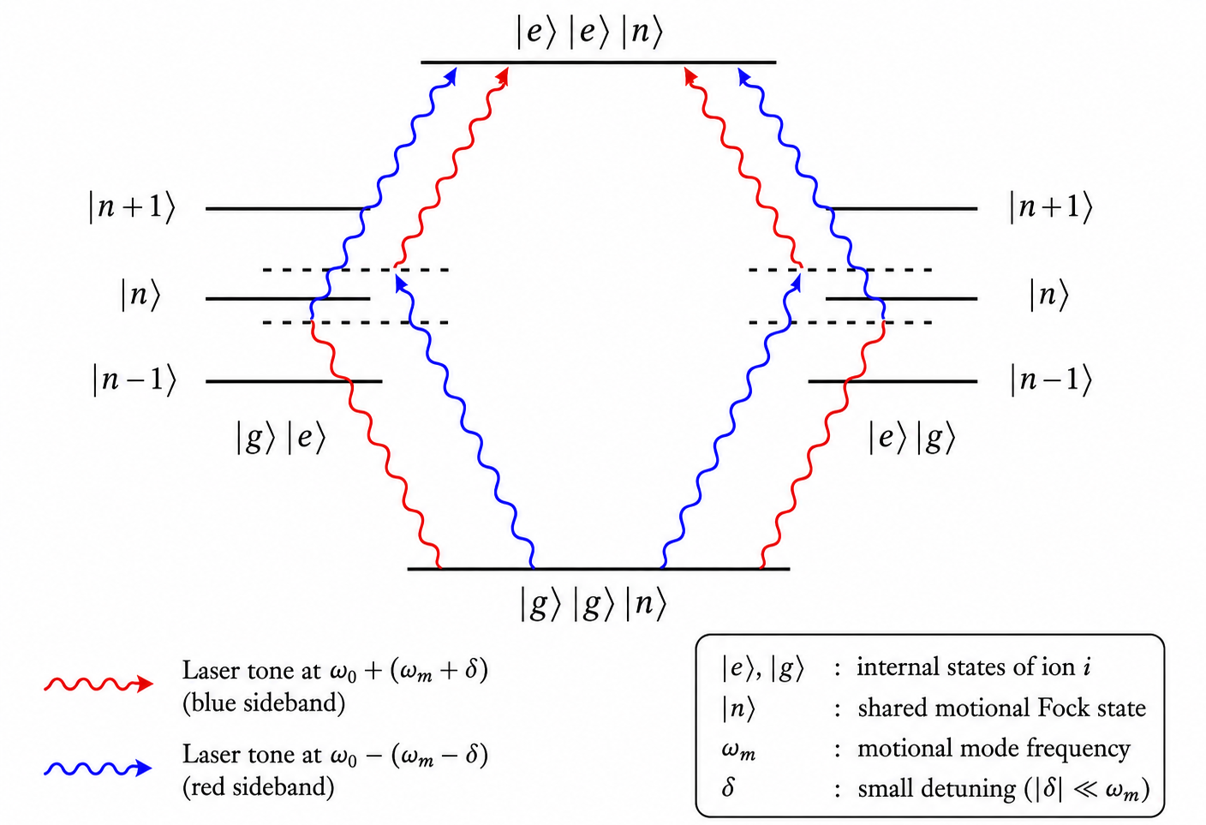

Fig. 2.5.6 — Mølmer–Sørensen two-qubit gate: two off-resonant laser tones jointly drive a pair of ions through their shared motional mode.

Scalability and the QCCD Architecture
As more ions are added to a single chain, the frequency spacing between motional modes shrinks, eventually outstripping the precision of available laser control — a practical wall reached near roughly 100 ions. Reducing the Mølmer–Sørensen Rabi frequency helps address the frequency-crowding problem but lengthens the gate, exposing it to more decoherence.
Assessed against the DiVincenzo criteria, trapped ions score strongly on qubit initialisation (Criterion 2, via optical pumping) but only partially on scalability (Criterion 1) and long two-qubit coherence in long chains (Criteria 3–4); qubit-specific measurement (Criterion 5) also remains challenging at scale. The proposed remedy is the Quantum Charged-Coupled Device (QCCD) architecture (Kielpinski et al., 2002), which uses a segmented trap: ions are shuttled into a shared zone only when a multi-qubit gate is required, and separated for individual addressing otherwise, keeping any one chain short and its motional decoherence low. Honeywell reported a 6-qubit, two-interaction-zone QCCD device in 2021; IonQ instead pursued faster Mølmer–Sørensen gates via reshaped laser pulses. Photon-mediated ion-to-ion links, and waveguides to route the collected fluorescence photons, are further proposed routes to scale beyond a single trap.
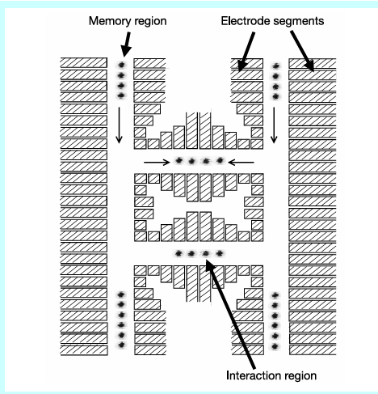
Fig. 2.5.7 —Quantum Charge Coupled Device (QCCD) diagram depicting the memory region where ions are stored and the interaction region for logic operations. Thin arrows show transport and confinement along the local trap axis. [doi:10.1038/nature00784].

2.5.6 Superconducting Qubits
Superconducting circuits are today the most widely deployed quantum-hardware platform. Rather than relying on a naturally occurring atom, this approach builds an artificial atom out of a lithographically patterned electrical circuit, cooled to milliKelvin temperatures so that conduction electrons pair into charge-neutral, dissipationless Cooper pairs (bound together by lattice-vibration-mediated attraction, i.e. via phonons).

From LC Circuits to Transmons
A qubit requires two addressable states with non-uniform energy spacing, so that a single drive frequency selectively addresses only the $|g⟩ ↔ |e⟩$ transition without also driving $|e⟩ ↔ |f⟩$. A simple superconducting LC circuit (capacitor + inductor) is a harmonic oscillator with perfectly uniform level spacing and is therefore unsuitable on its own. Replacing the inductor with a Josephson junction — a thin insulating barrier between two superconductors, across which Cooper pairs tunnel — introduces a non-linear inductance and hence unevenly spaced energy levels, exactly the non-uniformity a qubit requires.
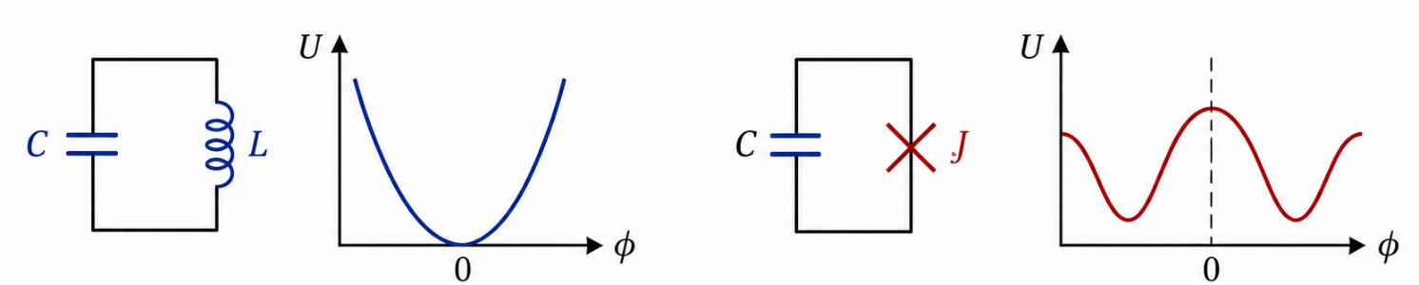
Fig. 2.5.8 — From a linear LC oscillator (uniform levels) to a Josephson-junction circuit (anharmonic, qubit-like levels).
A gate capacitor $C_{g}$ couples this artificial atom to the outside world for control. Operating with a large gate capacitance defines the transmon regime, in which sensitivity to gate-charge noise is strongly suppressed at a small cost in energy-level non-uniformity — a favourable trade that makes the transmon the dominant superconducting qubit design today. The lowest two levels, $|g⟩$ and $|e⟩$, separated by energy $E_{a} = ħω_{a}$, serve as the computational qubit.

Initialization, Control, and Readout via a Cavity
Because the excited state has a short lifetime, initialization (Criterion 2) is almost automatic: waiting briefly allows the qubit to relax to $|g⟩$. Control and readout are typically mediated by embedding the transmon inside a microwave (Fabry–Pérot-type) cavity, resonant at a wavelength satisfying $L = nλ/2$. A microwave tone far detuned from the qubit's own transition is scattered rather than absorbed by the qubit, and the scattered light carries information about the qubit's state — the qubit and the cavity field become entangled, and measuring the cavity field (photons) reveals the qubit's state. This is known as dispersive readout: a state-dependent shift of the cavity's resonance encodes the qubit state onto the amplitude and phase of the reflected/transmitted microwave signal. Longer probe times give better measurement resolution, at the usual cost of increased exposure to decoherence.
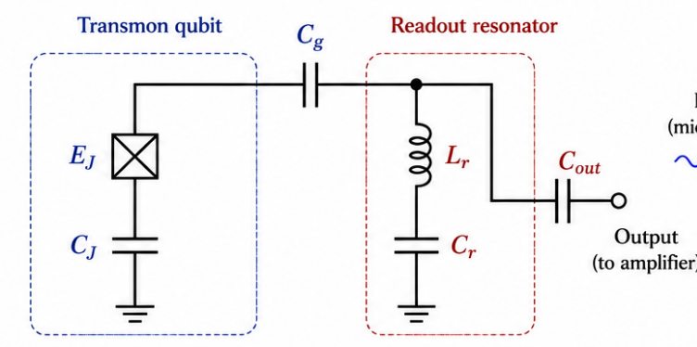
Fig. 2.5.9 — Circuit-QED architecture: a transmon qubit dispersively coupled to a microwave readout resonator.

Single-Qubit Gates
Direct microwave irradiation at the qubit's transition frequency (with enough intensity to overcome partial cavity shielding) produces Rabi oscillations governed by
$$Ĥ = ħΩ_{R} \left( {\hat{σ}}_{x} cos φ + {\hat{σ}}_{y} sin φ \right)$$
A rotation through angle $θ$ is obtained by switching the drive on for a time $t =\frac{2θ}{Ω_{R}}$. Because these durations are typically nanoseconds, superconducting single-qubit gates are the fastest of the platforms discussed in this unit.

Two-Qubit Gates and On-Chip Components
Two transmons can be coupled in several ways:
- Capacitive coupling — connecting two transmons through a shared wire and coupling capacitor, giving a fixed, always-on interaction.
- Flux-tunable coupling (SQUIDs) — replacing a single Josephson junction with two in parallel forms a Superconducting Quantum Interference Device (SQUID), whose effective inductance — and hence qubit frequency — can be tuned on demand with an external magnetic flux, turning the inter-qubit interaction on and off.
- All-microwave gates — two transmons share a single cavity; a microwave tone scattered by one qubit can be resonantly absorbed by the other, entangling the pair without requiring any tunable circuit element.
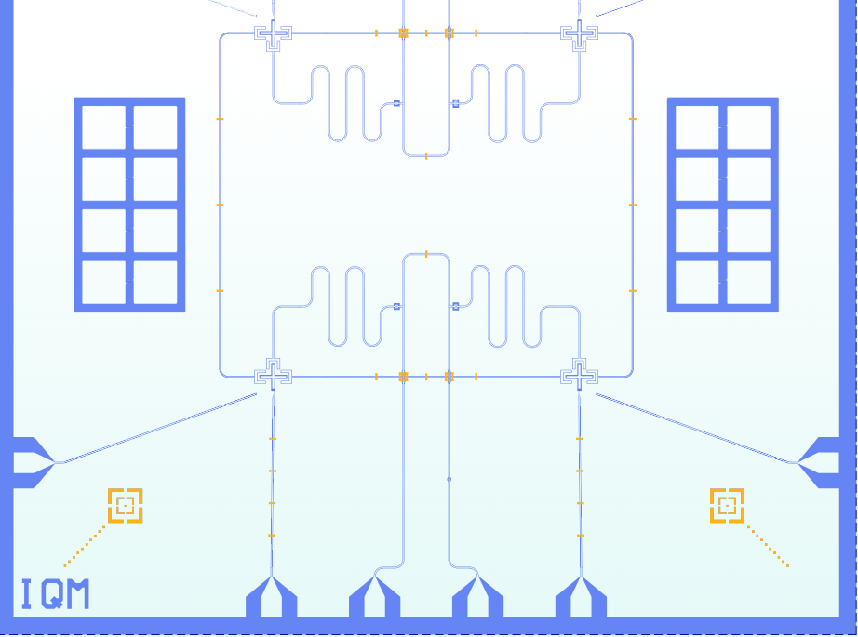
Fig. 2.5.10 — Computer-aided design of a superconducting qubit circuit. Credit: IQM
A modern superconducting processor also carries several supporting on-chip and off-chip elements:
Component | Function
Drive line | Delivers microwave pulses that implement single-qubit rotations.
Flux line | Applies a tunable magnetic field to shift a qubit's frequency (e.g. for a SQUID coupler).
Readout resonator | Couples dispersively to the qubit to perform non-destructive state measurement.
Launchpad | Provides the physical wiring interface between the chip and external control electronics.

Because control and readout parameters drift over time, processors undergo periodic calibration — systematically sweeping control parameters (e.g. driving the flux line at different frequencies to locate the qubit frequency) to find settings that maximise fidelity; a lighter-weight re-calibration is run frequently to track slow drifts.

Caveats and Current Challenges
- Cryogenics: superconductivity, and hence qubit operation, requires a dilution refrigerator maintaining temperatures near 10 mK.
- Physical size: superconducting qubits are comparatively large, increasing their susceptibility to environmental coupling.
- Multi-qubit gate speed: two-qubit gates are roughly an order of magnitude slower than single-qubit gates.
- Frequency crowding: packing many qubits into a shared cavity or chip increases the risk of unintended cross-qubit driving; distinct architectural families (e.g. "xmon", "gmon") address this partly through geometry. Google's processors favour flux-tunable coupling; IBM's favour all-microwave gates.

2.5.7 Photonic Quantum Computers
Photons interact only weakly with their environment and with each other, making them intrinsically robust against decoherence — an attractive property for scalability, at the cost of requiring specialized techniques to induce the controlled interactions needed for computation. Linear optical quantum computing, using only passive optical elements and measurement, is one leading approach.

Phase-Space (Quadrature) Representation
Rather than describing light purely in terms of discrete photon-number states, continuous-variable photonics works with the quadrature operators $\hat{X}$ and $\hat{P}$(representing the amplitude and phase of the light field, analogous to but distinct from position and momentum of a particle), which do not commute and obey an uncertainty relation $Δx Δp ≥ 1$. A general photonic state can be written
$$|ψ⟩ = ∫ ψ(x)|x⟩dx = ∫ ψ(p)|p⟩dp$$
A Gaussian state is one fully described by its mean quadrature values and their (Gaussian) uncertainties. The vacuum is the trivial Gaussian state; light from a laser produces coherent states, which are Gaussian with minimum uncertainty $Δx = Δp = 1$ but may be displaced away from the origin. A single mode of the optical field carrying quantum information is called a qumode.
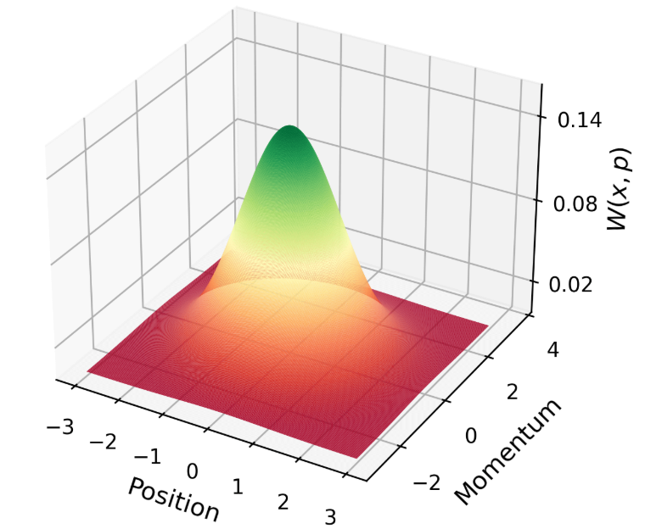
Fig. 2.19 — Quadrature (phase-space) distribution of the vacuum state, shown as a 2-D Gaussian surface in the x–p plane.

Gaussian Operations and Optical Elements
A universal toolkit of passive and active optical elements implements Gaussian operations — transformations that map one Gaussian state to another:
Element | Function
Waveguide  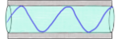 | Confines and guides an electromagnetic wave (e.g. an optical fibre).
Phase shifter  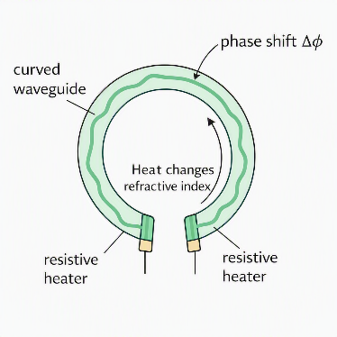 | Rotates the state in phase space by changing the optical path length or refractive index (e.g. a heated curved waveguide).
Beamsplitter 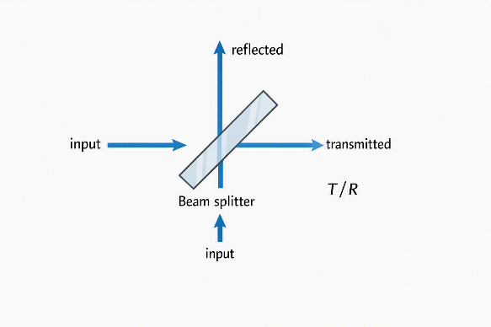 | Combines two input qumodes into two outputs, transmitting a fraction T and reflecting R = 1 − T; used to generate entanglement across output ports.

Some of the simple Gaussian operations are
- Displacement operation: Shifts the mean of the quadrature distribution using a beamsplitter and a high-intensity coherent laser source.
- Squeezer: Reduces the uncertainty in one quadrature at the expense of the other (while respecting the uncertainty relation), realized by a non-linear medium.

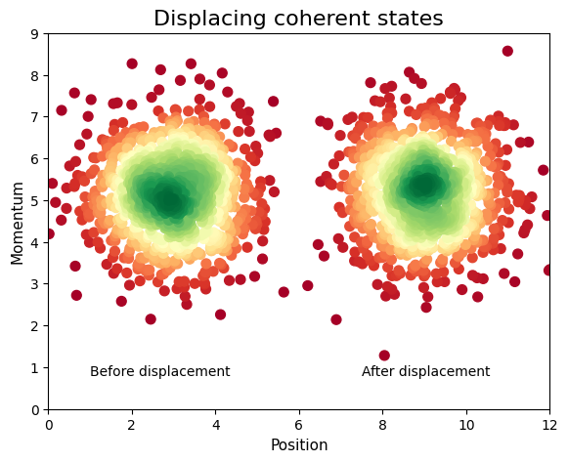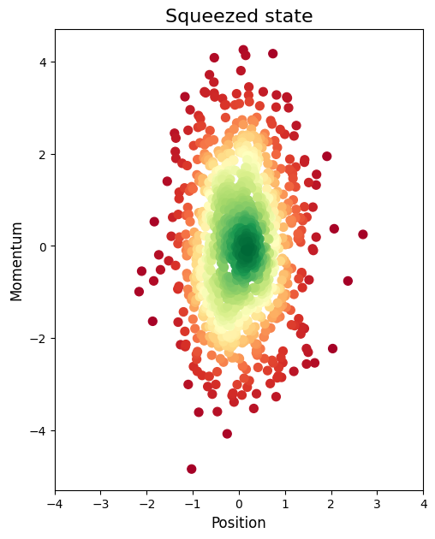
Fig. 2.20 — Phase-space effect of a displacement and a squeezing operation on a Gaussian state.

Measurement: Photodetection and Homodyne Detection
A photodetector produces a photocurrent $I = qN$ proportional to the number of incident photons $N$, measured by the number operator $\hat{N}$ acting on Fock states $|0⟩, |1⟩, |2⟩, ….$ Except for the vacuum, Fock states are not Gaussian. Combining a beamsplitter with two photodetectors implements homodyne detection: choosing the reference phase $φ = 0$ measures the $X$ quadrature and $φ = π/2$ measures $P$, with the expectation value read off as the difference between the two detector photocurrents.
subtract currents
PD
PD
BS
local oscillator
signal
Fig. 2.5. Homodyne measurement setup
A universal photonic quantum computer additionally requires non-Gaussian resources, such as a photon-number-resolving (PNR) detector, whose measurement produces states whose Wigner function goes negative — a hallmark of genuinely non-classical behaviour.

Gaussian Boson Sampling and Non-Gaussian Resource States
Gaussian Boson Sampling (GBS) circuits — networks of squeezers and beamsplitters followed by photon-number measurement — have been used to demonstrate quantum computational advantage on two notable occasions: USTC's Jiuzhang device (2019, roughly 200 seconds) and Xanadu's Borealis device (2022, roughly 36 microseconds), both sampling from a distribution estimated to take a classical supercomputer on the order of billions of years. Moreover, these processors are programmable and cloud-accessible.
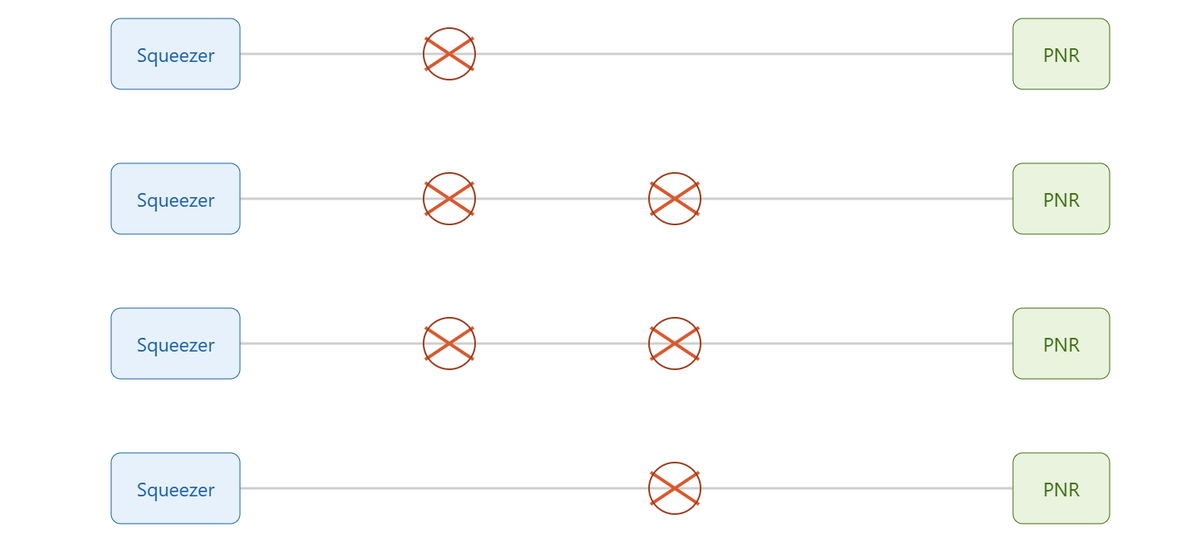Fig. 2.21 — A Gaussian Boson Sampling circuit: an array of squeezers and beamsplitters followed by photon-number-resolving (PNR) detectors.
Measuring the last PNR detector in a suitably designed GBS-type circuit while leaving the remaining mode unmeasured leaves that mode in a non-Gaussian resource state. A canonical example is the Gottesman–Kitaev–Preskill (GKP) state, defined (idealised) as
$${\left|0\right\rangle }_{GKP} = Σₙ {\left|2nπ\right\rangle }_{x} , {\left|1\right\rangle }_{GKP} = Σₙ {\left|\left(2n+1\right)π\right\rangle }_{x}$$
An exact GKP state requires infinite energy, but good approximations are experimentally achievable. Once encoded, elementary gates follow directly from Gaussian operations: a displacement of $\sqrt{π}$ along x implements a logical X gate, a $\frac{π}{2}$ phase-space rotation implements a Hadamard, and a displacement of $\sqrt{π}$ along p implements a Z gate. A two-mode circuit combining a squeezer of parameter $r = sinh^{-1}\left(\frac{1}{2}\right)$ with beamsplitters of transmissivity $T =\frac{1 - tanh⁡(r)}{4}$ implements a controlled-Z gate for phase $φ = 0$ and a CNOT gate for $φ =\frac{π}{2}$.
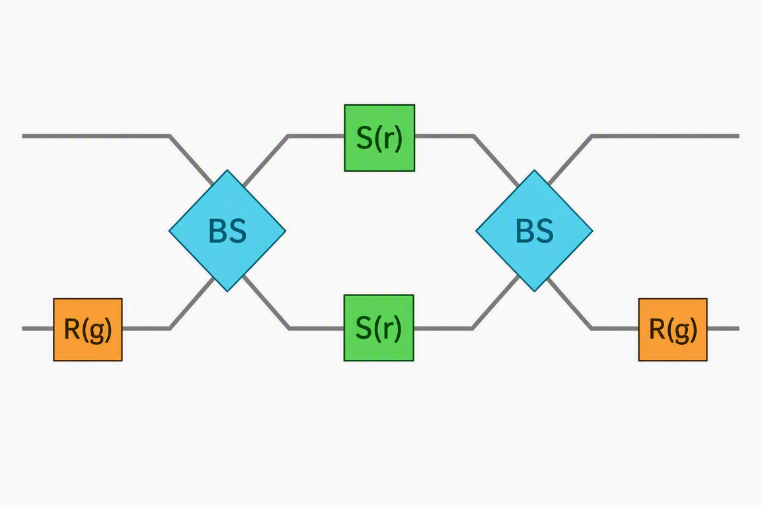
Fig. 2.22 — GKP-encoded CNOT gate realized with a squeezer and a pair of beamsplitters.
Why It Matters
Photonic hardware inverts the usual quantum-engineering trade-off: photons barely interact with their environment (excellent coherence) but also barely interact with each other (hard to entangle). The entire architecture of GBS circuits and GKP encoding exists to manufacture controllable, on-demand non-Gaussian interactions out of intrinsically linear, non-interacting light.

Comparing the Three Platforms
Aspect | Trapped Ions | Superconducting Qubits | Photonics
Qubit carrier | Internal electronic/hyperfine states of a charged atom | Anharmonic (Josephson-junction) artificial atom | Continuous-variable quadratures of a light mode (qumode)
Initialisation | Optical pumping, ~100% fidelity | Passive relaxation to |g⟩ | Vacuum / prepared coherent or squeezed states
1-qubit gates | Laser-driven Rabi rotations (ms) | Microwave-driven Rabi rotations (ns) | Phase shifters and displacements
2-qubit gates | Phonon-mediated (Mølmer–Sørensen) | Capacitive / flux-tunable / all-microwave coupling | Beamsplitters plus non-Gaussian (PNR) resources
Key challenge | Frequency crowding as chain length grows | Cryogenics; frequency crowding; slower 2-qubit gates | Generating and preserving non-Gaussian resource states
Scalability strategy | QCCD segmented traps; photon links | Larger 2-D chip lattices; improved coherence | Integrated photonic chips; multiplexed sources

Summary
- Any viable qubit must balance environmental isolation (for long coherence) against controllability (for initialisation, gating, and readout); this trade-off is quantified by the five DiVincenzo criteria.
- Decoherence arises when a qubit becomes entangled with an uncontrollable environment, irreversibly transferring phase information out of reach; T1 (relaxation) and T2 (dephasing) quantify how quickly this occurs.
- The quantum harmonic oscillator can emulate simple multi-qubit gates (e.g. CNOT) but fails as a scalable architecture because it lacks known eigenvalues for arbitrary operators, easy composability of unitaries, and the exponential efficiency of a genuinely digital, multi-qubit encoding.
- Trapped-ion quantum computers use a linear Paul trap and laser (Doppler plus sideband) cooling to isolate and cool ions, encode qubits in optical or hyperfine transitions, and use Rabi oscillations and phonon-mediated gates (Cirac–Zoller, Mølmer–Sørensen) for single- and two-qubit control; scalability is addressed via the segmented QCCD architecture.
- Superconducting qubits realise an artificial atom from a Josephson-junction circuit operated in the transmon regime, controlled and read out dispersively through a microwave cavity; two-qubit coupling is achieved via capacitive, flux-tunable (SQUID), or all-microwave schemes, at the cost of demanding cryogenics.
- Photonic quantum computers encode information in continuous quadratures of light, manipulated with Gaussian operations (phase shifts, beamsplitters, squeezing) and measured via photodetection or homodyne detection; universality additionally requires non-Gaussian resources such as GKP states, generated via Gaussian Boson Sampling circuits.
- No single hardware platform currently satisfies all five DiVincenzo criteria simultaneously at scale — each of trapped ions, superconducting circuits, and photonics represents a distinct set of engineering compromises, and the competitive hardware landscape reflects this open trade-off.

Self-Assessment Questions
- State the five DiVincenzo criteria and, for each of trapped ions, superconducting qubits, and photonics, identify the criterion that platform satisfies least well.
- Explain, using the entangled state |ψ⟩ = (|00⟩ + exp(iθ)|11⟩)/sqrt(2), why a local measurement cannot recover the relative phase θ, and why this constitutes decoherence when the second qubit represents an inaccessible environment.
- Derive why the transformation |n⟩ → (−1)ⁿ|n⟩ at time t = π/ħω implements a CNOT gate on the logical qubits encoded as |00⟩_L = |0⟩, |01⟩_L = |2⟩, |10⟩_L = (|4⟩+|1⟩)/sqrt(2), |11⟩_L = (|4⟩−|1⟩)/sqrt(2).
- Explain why Earnshaw's theorem forbids trapping an ion with static electric fields alone, and how the linear Paul trap's oscillating quadrupole field circumvents this restriction.
- Distinguish the blue sideband, red sideband, and carrier transitions in a trapped-ion system, and explain how the Mølmer–Sørensen gate uses two of them simultaneously to generate entanglement.
- Explain why replacing the inductor in an LC circuit with a Josephson junction is essential for building a superconducting qubit, and what the transmon regime trades away in exchange for reduced charge-noise sensitivity.
- Compare capacitive coupling, flux-tunable (SQUID) coupling, and all-microwave gates as strategies for implementing a two-qubit gate between superconducting transmons.
- Explain what a Gaussian state is, and why a photon-number-resolving detector is described as a non-Gaussian operation.
- Describe how a GKP-encoded qubit implements the X, Z, and Hadamard gates using purely Gaussian operations (displacements and phase-space rotations).
- A start-up claims to have solved scalability for trapped-ion quantum computers simply by extending a single linear ion chain to 500 ions. Using the concepts of frequency crowding and the QCCD architecture, critically evaluate this claim.

References

Foundational and Textbook Sources
DiVincenzo, D. P. (2000). The physical implementation of quantum computation. Fortschritte der Physik, 48(9–11), 771–783.
Nielsen, M. A., & Chuang, I. L. (2010). Quantum Computation and Quantum Information (10th Anniversary ed.). Cambridge University Press.
C. J. Foot, Atomic Physics, 1st ed. (Oxford University Press, Oxford, 2005).
Yanofsky & Mannucci, Quantum Computing for Computer Scientists (Cambridge, 2008).
J. M. Chow, D. I. Schuster, et al., “Quantum Engineer’s Guide to Superconducting Qubit Systems,” arXiv:1904.06560v5 [quant-ph], 2021.

Online Courses, Demos, and Technical Resources
PennyLane (Xanadu Quantum Technologies). (n.d.). Trapped ion quantum computers. Retrieved from https://pennylane.ai/demos/tutorial_trapped_ions
PennyLane (Xanadu Quantum Technologies). (n.d.). Photonic quantum computing. Retrieved from https://pennylane.ai/demos/tutorial_photonics
PennyLane (Xanadu Quantum Technologies). (n.d.). Superconducting qubits. Retrieved from https://pennylane.ai/demos/tutorial_sc_qubits
IQM Academy. (n.d.). Introduction to superconducting quantum computing hardware. Retrieved from https://www.iqmacademy.com

