QUANTUM COMPUTING
A Course for B.E./B.Tech Engineering Students
UNIT 2
Introduction to Quantum Computing
Sub-unit 2.1
Single-Qubit Systems

STUDY MATERIAL
Prepared for B.E./B.Tech Engineering Students
© Dr. Amrit Raj K, August 2026

Learning Objectives
By the end of this sub-unit, students will be able to:
- Explain how photon polarization provides a concrete, physically intuitive realization of a qubit.
- Represent single-qubit states as unit vectors in a 2-D complex vector space, in both column-vector and Dirac notation.
- Distinguish the standard basis and Hadamard basis and perform basis rotations between them.
- State the measurement postulate for a two-state quantum system and compute measurement probabilities using the inner product.
- Explain why measurement is probabilistic and irreversible, and why a qubit cannot be used to store unlimited classical information.
- Describe the single-qubit state space formally, including the roles of global phase and relative phase.
- Visualise single-qubit states using the extended complex plane and the Bloch sphere.
- Explain the BB84 quantum key distribution protocol and analyze how it detects the presence of an eavesdropper.

2.1 Single-Qubit Systems
Qubits are the fundamental unit of quantum computation, and there are many physical ways to realize one. This sub-unit builds intuition for what a qubit is and how it behaves by starting from a concrete, visualizable physical system — the polarization of a single photon — before generalizing to the abstract mathematical object used throughout the rest of the course: a unit vector in a 2-dimensional complex vector space. It then develops the measurement postulate that governs how information is extracted from a qubit, the formal structure of the single-qubit state space (including the often-confusing distinction between global and relative phase) and closes with the first practical payoff of everything covered — the BB84 protocol for quantum key distribution.

2.1.1 Photon Polarization as a Qubit (QM for Pedestrians)
Consider a simple experiment: a laser pointer aimed through a sequence of three linear polaroid filters.
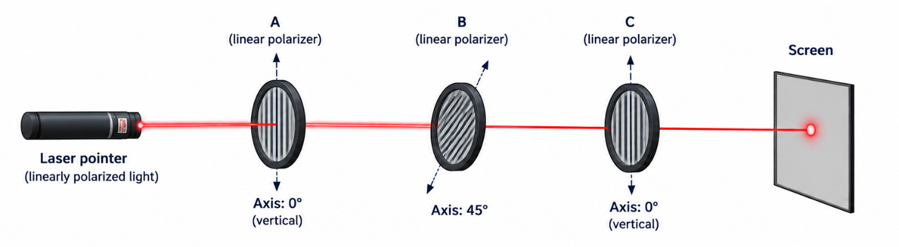
Figure 2.1.1 - Experimental setup — laser pointer and three linear polaroids (A, B, C) in sequence, with a screen.
Modelling: a unit vector models a photon's polarization. Vertical and horizontal polarizations correspond to two orthogonal unit vectors, |↑⟩ and |→⟩. An arbitrary polarization can be expressed as a superposition |v⟩ = a|↑⟩ + b|→⟩. For instance, |↗⟩ = (1/√2)(|↑⟩ + |→⟩) is the unit vector representing 45°. The coefficients a and b are called the amplitudes of v; when both are non-zero, the state is a genuine superposition.
Preferred axis of a polaroid: when a photon |v⟩ meets a polaroid whose preferred axis is |↑⟩, the photon passes through with probability |a|² and is absorbed with probability |b|². This immediately explains a puzzling observation in the three-polaroid experiment: no light reaches the screen when only the first and third (crossed) polaroids A and C are present, because any other polarization direction would let some light through. Placing a middle polaroid B at 45° actually restores some light at the screen — inserting B changes what is measured, rather than merely blocking more light.
To see why, it helps to re-express |→⟩ in the 45°/135° basis: |→⟩ = (1/√2)(|↗⟩ + |↖⟩). Quantum theory then tells us that vertically polarized light passes through B (oriented at 45°) with probability ½, and that photons which do pass through B do have a non-zero amplitude along the vertical direction that C accepts. This is how quantum mechanics explains why inserting an intermediate polaroid can let light through where none passed before.
Concept Check
This experiment cannot be explained by treating the photon as "secretly" vertically or horizontally polarized before measurement (a hidden-variable, classical-mixture picture). The photon genuinely exists in a superposition, and each polaroid performs a probabilistic projective measurement that can change the polarization state it passes through.

From Polarization to the Abstract Qubit
The space of possible polarizations of a photon is an example of a qubit: it has a continuum of possible values, and the amplitudes can be complex (in the photon case, a complex amplitude corresponds to circular polarization). The set of all possible states of a system is called its state space. Any quantum-mechanical system that can be modelled by a 2-dimensional complex vector space can be viewed as a qubit — photon polarization, electron spin, and the ground/excited states of an atom are all standard examples. "Two-state" does not mean the system literally has only two possible configurations; it means the relevant state space is 2-dimensional, admitting infinitely many superpositions of the two basis states. (There is no universal agreement on which two-level system is the best candidate for a practical qubit — this trade-off is examined in Unit 2.5.)
Dirac's bra–ket notation is used throughout to represent the unit vectors that denote quantum states. For a 2-state system, two distinguished orthonormal states are defined, |0⟩ and |1⟩, which may be identified with |↑⟩ and |→⟩ respectively; under that identification, |↗⟩ = (1/√2)(|0⟩ + |1⟩), and similarly for |↖⟩. For electron spin, the two basis states could equally be "up/down" or "left/right". We fix a standard basis {|0⟩, |1⟩} with respect to which states and calculations are, by default, expressed; classical bit values are encoded directly in these two states. Unlike a classical bit, which takes only the value 0 or 1, a qubit can take any normalized superposition of |0⟩ and |1⟩.
Vectors and linear transformations are only meaningful once a basis is fixed, and any vector can be written in terms of that basis. The choice of basis, and the order of its vectors, is a convention: representing |0⟩ = (1,0)ᵀ, |1⟩ = (0,1)ᵀ or |0⟩ = (1/√2)(1,1)ᵀ, |1⟩ = (1/√2)(1,−1)ᵀ are equally valid choices, provided the choice is used consistently thereafter.
A basis consists of vectors that are orthonormal — normalized and mutually orthogonal. Normalization ensures each basis vector is itself a valid qubit state; orthogonality ensures linear independence, so that any qubit state can be written uniquely in terms of the basis.
Worked Example
Do |+⟩ = (1/√2)(|0⟩ + |1⟩) and |−⟩ = (1/√2)(|0⟩ − |1⟩) form a basis? Computing inner products gives ⟨+|−⟩ = 0, ⟨−|+⟩ = 0, ⟨+|+⟩ = 1 = ⟨−|−⟩. The first two confirm orthogonality; the last two confirm normalization. Hence {|+⟩, |−⟩} is indeed a basis — known as the Hadamard basis or the plus–minus basis.
There are infinitely many valid bases for a single qubit, but the standard basis and the Hadamard basis are the two most commonly used. Among the photon-polarization qubits, the Hadamard basis corresponds physically to {|↗⟩, |↖⟩}.
Superposition is, precisely, a non-trivial linear combination of basis elements: given a basis {|β₁⟩, |β₂⟩}, a state |v⟩ = α|β₁⟩ + β|β₂⟩ is a superposition whenever both α and β are non-zero. Unless stated otherwise, the basis is taken to be the standard basis.

Why Dirac Notation?
Column-vector/matrix notation requires the basis and its ordering to be stated explicitly every time. Dirac notation is independent of the choice and ordering of basis — it is compact, and it tends to suggest the correct algebraic relationships directly. Once familiar, it is faster to read, write, and reason with than raw matrix notation.

Basis Rotation
Can we change basis? Yes — this is called a basis rotation. Consider |ψ⟩ = α|0⟩ + β|1⟩, and suppose we want to re-express it in the Hadamard basis. One way is to substitute the computational basis states written in terms of the Hadamard basis:
$$|0⟩ = \left(\frac{1}{\sqrt{2}}\right)(|+⟩ + |-⟩), |1⟩ = \left(\frac{1}{\sqrt{2}}\right)(|+⟩ - |-⟩)$$
Substituting into |ψ⟩ gives:
$|ψ⟩ = \left(\frac{α + β}{\sqrt{2}}\right)|+⟩ + \left(\frac{α - β}{\sqrt{2}}\right)|-⟩$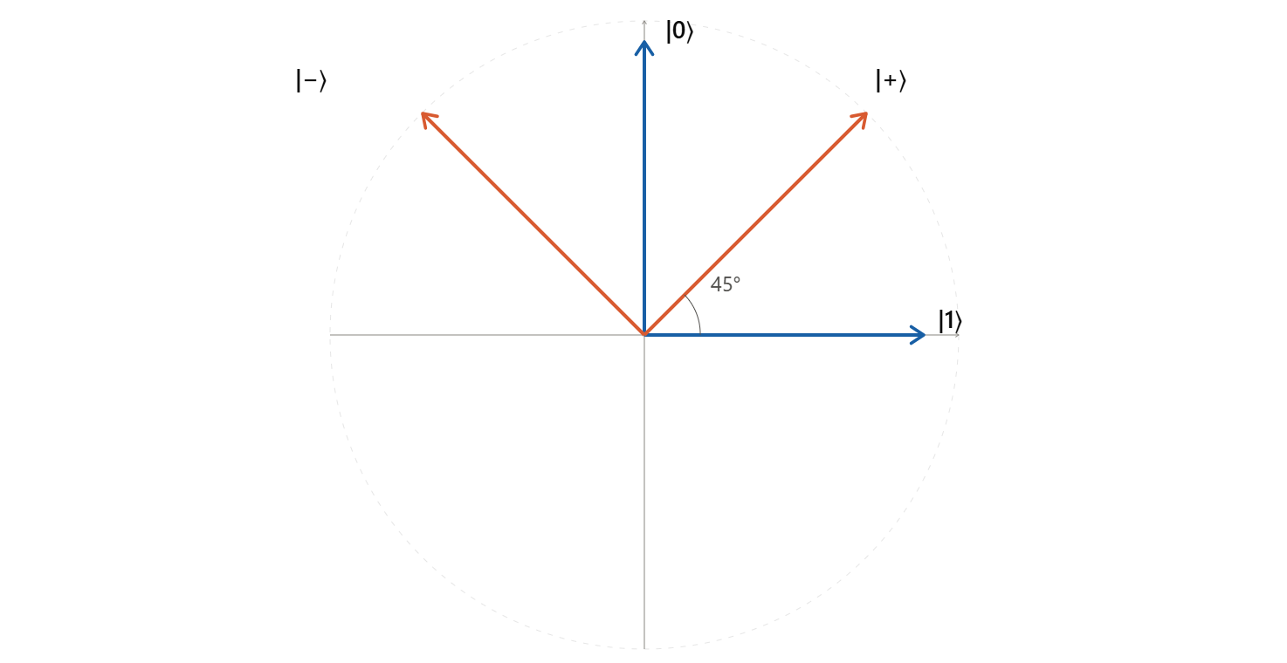
Figure 2.1.2— Vector diagram illustrating the rotation from the standard basis {|0⟩, |1⟩} to the Hadamard basis {|+⟩, |−⟩}]
Instead of qubits (2-level systems), one can also define qutrits (3 levels) or, more generally, qudits (n levels). These have the same computational power as systems built from qubits, since any qudit can be modelled using a sufficient number of qubits.

2.1.2 Single-Qubit State Space
Having built intuition for qubit states, we now formalize the state space they inhabit. The state space of a classical or quantum system is the set of all possible states of the system. Depending on which properties are under consideration, a state may involve a linear combination of positions, momenta, polarizations, spins, energies, and so on. For a single photon's polarization, the state space is the set of all possible polarizations; for a general single qubit, the state space is:
{a|0⟩ + b|1⟩} with |a|² + |b|² = 1
where a|0⟩ + b|1⟩ and a′|0⟩ + b′|1⟩ are considered the same physical state if a|0⟩ + b|1⟩ = c(a′|0⟩ + b′|1⟩) for some unit-modulus complex number c = e^{iθ}.

Global Phase and Relative Phase
That the same quantum state can be represented by more than one vector marks a significant difference between a complex vector space and a quantum state space. First, only unit vectors are physical states; second, vectors are considered physically equivalent up to multiplication by a unit-modulus complex number c $\sim$ e^{iφ}. This is called a global phase, and it has no physical meaning — it cannot be detected by any measurement.
The space in which two 2-D complex vectors are treated as equivalent whenever they are scalar multiples of each other is called the complex projective space of dimension one, denoted CP1 = {a|0⟩ + b|1⟩} / ~. The quantum state space of a single qubit is in one-to-one correspondence with the points of CP1. Because it is easier to compute with vectors in a vector space than with points in a projective space, calculations are generally carried out in the vector-space representation — but one must remember that this representation is redundant: many vectors correspond to the same physical state.
Relative phase, by contrast, is physically meaningful. It is the angle in the complex plane between the two complex amplitudes a and b of a superposition a|0⟩ + b|1⟩, i.e. a/b = e^{iφ} |a|/|b|. Two superpositions a|0⟩ + b|1⟩ and a′|0⟩ + b′|1⟩ whose amplitudes have the same magnitudes but differ in relative phase represent genuinely different physical states. In particular, although |v⟩ $\sim$ e^{iφ} |v⟩ (a global phase on the whole state is unobservable), the two states (1/√2)(e^{iφ}|v⟩ + |u⟩) and (1/√2)(|v⟩ + |u⟩) do not represent the same state — the relative phase between the |v⟩ and |u⟩ components matters.
- Two further states worth naming explicitly: |i⟩ = (1/√2)(|0⟩ + i|1⟩) and |−i⟩ = (1/√2)(|0⟩ − i|1⟩).

Geometric Views of the Single-Qubit State Space
There are two standard geometric models giving a one-to-one correspondence between qubit states and points in space; both are, in essence, different ways of visualising CP1.
Extended complex plane, C∪ {∞}: mapping a state to a single complex number via α = b/a (and conversely recovering the state from α) gives a bijection between qubit states and the extended complex plane:
$$a|0⟩ + b|1⟩ → α = b/a α → \left(\frac{1}{\sqrt{1+{\left|α\right|}^{2}}}\right)|0⟩ + \left(\frac{α}{\sqrt{1+{\left|α\right|}^{2}}}\right)|1⟩$$
This is undefined when a = 0 (i.e. for |1⟩ itself); adjoining a single point at infinity and defining ∞ ⇔ |1⟩ resolves this. Under this correspondence$: \left|0\right\rangle → 0, \left|+\right\rangle → +1, \left|-\right\rangle → -1, |i⟩ → i, |-i⟩ → -i.$
Bloch sphere: via stereographic projection, each state (writing α = s + it) can be mapped onto the surface of a unit sphere in three real dimensions, with coordinates (x, y, z) satisfying x² + y² + z² = 1:
$$\left(s, t\right)→ \left(\frac{2s}{{\left|α\right|}^{2}+1}, \frac{2t}{{\left|α\right|}^{2}+1}, \frac{1-{\left|α\right|}^{2}}{{\left|α\right|}^{2}+1} \right)$$
Equivalently, writing a general single-qubit state as |ψ⟩ = cos(θ/2)|0⟩ + e^{iφ} sin(θ/2)|1⟩, the Bloch-sphere coordinates are x = sinθ cosφ, y = sinθ sinφ, z = cosθ.
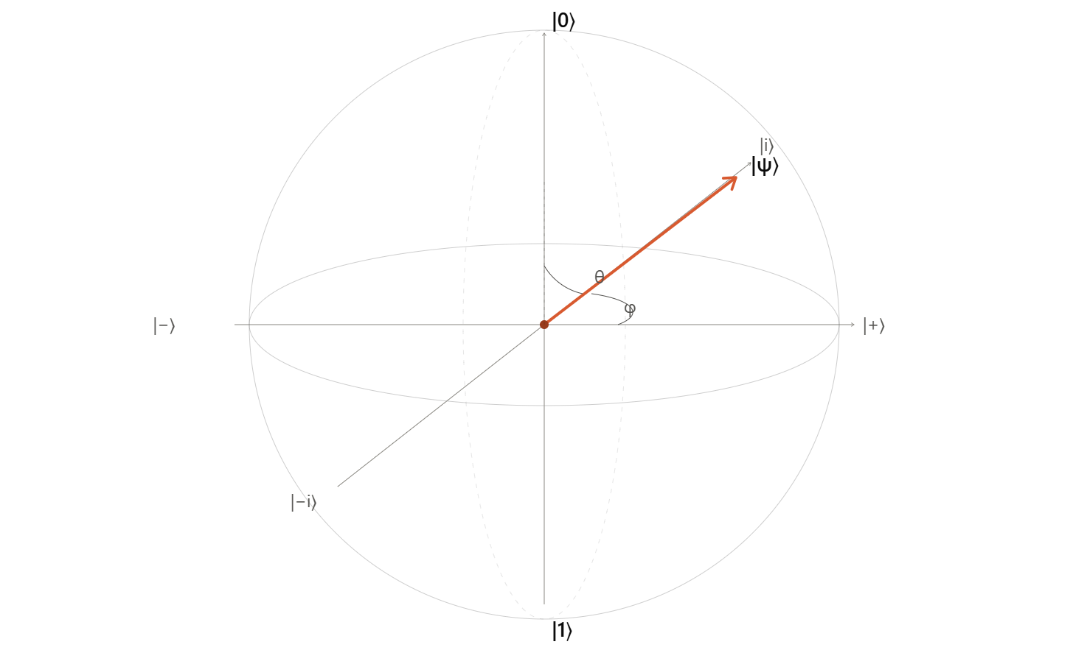Figure 2.1.3 — The Bloch sphere, showing |0⟩ and |1⟩ at the poles, |+⟩/|−⟩ and |i⟩/|−i⟩ on the equator, and a general state |ψ⟩ at angles (θ, φ)
The entire solid ball is referred to as the Bloch sphere, even though only its surface represents pure single-qubit states — the interior becomes meaningful once mixed states are introduced later in the course. One convenient feature: basis states of any orthonormal basis sit at opposite ends of a diameter, since orthogonal states correspond to antipodal points on the sphere.
Final Point
States of quantum systems are, in general, represented by wave functions; in this course we work with the abstraction of these as kets, such as |0⟩ or |→⟩. The set of solutions to Schrödinger's equation for a quantum system forms a complex vector space — in the infinite-dimensional case, a Hilbert space. Almost all quantum-computing settings work with finite-dimensional Hilbert spaces, which are simply finite-dimensional complex vector spaces equipped with an inner product.

2.1.3 Single-Qubit Measurement
Single-qubit measurement forms the conceptual basis for measurement in every larger quantum system: the probabilistic character of the outcome, and the effect measurement has on the state, generalize directly. Quantum theory postulates that any device measuring a two-state quantum system has two preferred states, |u⟩ and |u⊥⟩, which form an orthonormal basis for the associated vector space. Measurement transforms the system's state into one of these two basis states — either |u⟩ or |u⊥⟩ — and the probability of each outcome is the squared magnitude of the amplitude of the state's component along that basis vector.
For example, for a device measuring photon polarization in the basis {|u⟩, |u⊥⟩}, a state |v⟩ = a|u⟩ + b|u⊥⟩ is measured as u with probability |a|² and as u⊥ with probability |b|².
Postulate, Not Theorem
This measurement rule is an axiom of quantum mechanics — it cannot be derived from other physical principles, but is instead inferred from the empirical behaviour of measuring devices. Every device that measures a single qubit has (1) an associated orthonormal basis, and (2) an outcome that is always one of the two basis vectors. Unless stated otherwise, the measurement basis is the standard basis.

Measurement Changes the State
Measurement is destructive: if the outcome is u, the state becomes |u⟩, and a second, immediate measurement in the same basis will return u with certainty. Unless the original state happened to already be a basis state, measurement changes the state irreversibly, with no way to recover the pre-measurement amplitudes.
This raises a subtlety about what "superposition" means: |v⟩ is a superposition with respect to the standard basis, but not with respect to the basis {a|0⟩ + b|1⟩, b̄|0⟩ − ā|1⟩} (of which it is itself a member). Because measuring a superposition state gives a probabilistic outcome, it is tempting to think of superposition as merely a probabilistic mixture of |0⟩ and |1⟩ — as though the qubit secretly "is" one or the other and we simply don't know which. This is incorrect: |v⟩ is a single, definite state. It gives a deterministic outcome when measured in a basis that contains it, and a random outcome when measured in a different basis. A photon in state |↗⟩ gives a deterministic result when measured in the basis {|↗⟩, |↖⟩}, but a random result when measured in {|↑⟩, |→⟩}.
It is also worth stressing that (1/√2)(|0⟩ + |1⟩) is not the only state "halfway between" |0⟩ and |1⟩: states such as (1/√2)(|0⟩ + i|1⟩) and (1/√2)(|0⟩ − |1⟩) have amplitudes of the same magnitude but different relative phase, and behave differently under further gates or measurements.
- Common misconception: because a qubit's amplitudes range over a continuum, it might seem to store an unlimited amount of classical information. It does not — a single measurement can extract at most one classical bit of information from a qubit, and the act of measuring destroys the original state, so the "extra" information in the amplitudes is fundamentally inaccessible. One might imagine first copying the state and then measuring the copy to extract more information — but copying an unknown state is exactly what the No-Cloning Theorem (Unit 2.3) rules out.

Measurement via the Inner Product
A more formal way to express a measurement outcome uses the inner product. Given a state |ψ⟩, the probability of observing outcome |φ⟩ when measuring with respect to a basis that includes |φ⟩ — such as {|χ⟩, |φ⟩} — is |⟨φ|ψ⟩|².
Worked Example
For $|ψ⟩ = α|0⟩ + β|1⟩$ measured in the standard basis: $Pr(0) = |⟨0|ψ⟩|² = |α⟨0|0⟩ + β⟨0|1⟩|² = |α|²$. By an identical calculation, $Pr(1) = |β|²$. As a further exercise, students should compute the measurement-outcome probabilities for the same |ψ⟩ measured in the Hadamard basis {|+⟩, |−⟩}, and note how the orthogonality of the basis states simplifies the calculation.
This kind of measurement is known as a projective measurement: it asks how much each basis vector contributes to a given state, exactly analogous to computing a projection in linear algebra — the inner product measures the overlap between the two states. The only difference from an ordinary vector-space projection is that we take the modulus squared of the inner product, which guarantees a real-valued, non-negative probability.
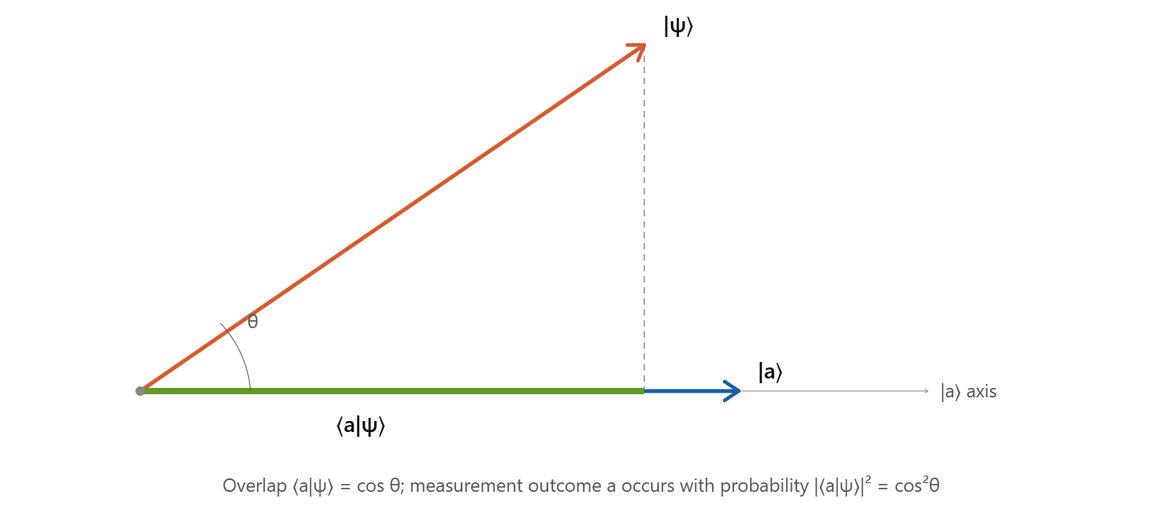 Figure 2.1.4 — Geometric depiction of projective measurement as the overlap (projection) of a state vector onto a measurement basis vector
Most quantum hardware and software exposes only the standard basis as a measurement basis. To measure in a different basis, we instead perform a basis rotation (Section 2.1.1) prior to measuring in the standard basis — this is the standard technique used throughout quantum algorithms and protocols.

2.1.4 Application: Quantum Key Distribution (BB84 Protocol)
Everything covered so far — superposition, basis choice, and the probabilistic, disturbing nature of measurement — combines to give the first genuinely practical application of single-qubit quantum mechanics: secure cryptographic key distribution.

Why Keys Matter
Keys are binary strings or numbers chosen randomly from a sufficiently large set, and they underpin the security of most cryptographic protocols, including:
- Encryption — keeping the content of a message secret from anyone but the intended recipient.
- Authentication — verifying the identity of a communicating party.
- Secret sharing — splitting sensitive information among multiple parties.
Establishing keys between communicating parties is therefore of fundamental importance in cryptography. There are two general classes of keys: symmetric keys, a single key (or a pair of keys easily derived from one another) known only to the legitimate parties, and public–private key pairs, consisting of a public key known to everyone and a corresponding private key whose secrecy the owner alone must guard. Typical use cases include secure e-commerce transactions and private communication over public networks.
Classical key-agreement schemes such as Diffie–Hellman rely on computational problems believed to be intractable for classical computers — for instance, the discrete logarithm problem. Such problems can, however, be solved efficiently by a sufficiently large quantum computer (Unit 3), which motivates key-distribution schemes whose security rests on physics rather than computational hardness.

The BB84 Protocol
BB84, proposed by Charles Bennett and Gilles Brassard in 1984, aims to establish a secret key — a random sequence of bit values known only to the two communicating parties, conventionally named Alice and Bob — which they can then use for a cryptographic task such as exchanging secret messages or detecting tampering. Crucially, the protocol allows Alice and Bob to be confident that if they detect no problems while attempting to establish a key, then with high probability the resulting key is indeed secret; it does not, however, guarantee that key establishment will succeed.
Setup: Alice and Bob are connected by a bidirectional classical channel and a unidirectional quantum channel, over which Alice can send Bob a sequence of single qubits. Both channels may be observed by an eavesdropper, Eve.
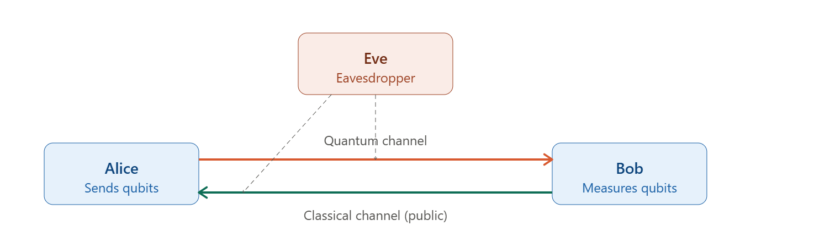 Figure 2.1.5— BB84 setup — Alice and Bob connected by a quantum channel and a classical channel, with eavesdropper Eve observing both]
Protocol steps:
- Alice generates a sequence of random bit values and encodes each onto a qubit — for example, photon polarization — choosing randomly, for each bit, between the standard basis (0 → |↑⟩, 1 → |→⟩) and the Hadamard basis.
- Alice sends the resulting sequence of qubits to Bob over the quantum channel.
- Bob measures each qubit in a basis he chooses independently and randomly — standard or Hadamard.
- Over the classical channel, Alice and Bob announce, for every qubit sent, whether Bob received it and which basis each of them used — but not the bit value itself.
- They keep only the bits for which their bases happened to agree, and discard the rest (on average, half the bits).
- They publicly disclose and compare a random subset of the retained bits to check for eavesdropping; if these bits fail to match, they abort. The remaining, unrevealed bits become the shared private key.

Eavesdropping Detection
If Eve intercepts a qubit, measures it, and forwards a replacement photon to Bob, Alice and Bob can detect this via an elevated error rate in step 5 above. Eve might, for instance, use a calcite crystal (which acts like a polaroid, splitting incoming light into two beams — one polarized along the crystal's optic axis and one perpendicular to it) together with a detector.
Eve does not know which basis Alice used for any given qubit — the basis information is only revealed after Bob has already measured. If Eve guesses the wrong basis (which happens, on average, half the time), her measurement disturbs the qubit's state; even if Bob subsequently uses the same basis as Alice originally did, he will then obtain the wrong value with probability ½ for that qubit. Overall, Eve's interference introduces a wrong-value probability of about 25% on the bits where Alice and Bob's bases agreed — a conspicuously high error rate that reveals her presence.
Why It Works
Eve cannot simply copy the qubit, inspect the copy at leisure, and forward an untouched original — that would circumvent detection entirely. This is exactly what the No-Cloning Theorem (Unit 2.3) forbids: since the qubit's state is arbitrary and Eve does not know the basis it was prepared in, she has no way to produce a perfect copy without first measuring (and thus disturbing) the original.
BB84 alone is vulnerable to a man-in-the-middle attack, where Eve impersonates Bob to Alice and Alice to Bob. Guarding against this requires combining BB84 with a separate authentication protocol — anything from recognizing a counterpart's voice to a formal mathematical authentication scheme. Further refinements of BB84 offer stronger guarantees and extend key distribution to noisy channels: in the noisy case, Eve may initially gain some partial information, but techniques such as quantum error correction and privacy amplification can reduce Eve's information to arbitrarily low levels while simultaneously compensating for genuine channel noise.

Other QKD Protocols
Variants of BB84 modify the number or type of states used in transmission, trading off implementation complexity against figures of merit such as the eavesdropping-detection rate or the fraction of qubits retained for the final key.
Protocol | Key idea
Six-state protocol | Uses six states — |0⟩, |1⟩, |+⟩, |−⟩, |i⟩, |−i⟩ — instead of BB84's four, making it harder for Eve to go undetected and providing stronger security guarantees.
SARG04 | Proposed by Scarani, Acín, Ribordy, and Gisin (2004); uses the same four states as BB84 but changes how the classical sifting information is encoded, improving robustness in certain attack scenarios.

Summary
- A single qubit is a unit vector in a 2-dimensional complex vector space; photon polarization gives a concrete, visualizable physical realization, but any two-level quantum system (electron spin, atomic ground/excited states, etc.) can serve equally well.
- The standard basis {|0⟩, |1⟩} and the Hadamard basis {|+⟩, |−⟩} are the two most commonly used bases; basis rotation lets any state be re-expressed in a different basis.
- Measurement is governed by a postulate, not derived: measuring in a basis {|u⟩, |u⊥⟩} yields |u⟩ with probability |⟨u|ψ⟩|² and collapses the state — the process is probabilistic, destructive, and cannot be used to extract more than one classical bit per qubit.
- The single-qubit state space is CP1: vectors differing by a global phase e^{iφ} represent the same physical state, but a relative phase between amplitudes is physically meaningful and observable.
- The extended complex plane and the Bloch sphere both give faithful geometric pictures of the single-qubit state space, with orthogonal states mapping to antipodal points on the Bloch sphere.
- BB84 uses superposition, basis choice, and the disturbing nature of measurement to let two parties establish a shared secret key over a public quantum channel, detecting any eavesdropper through an elevated error rate — a security guarantee rooted in physics rather than computational hardness.

Self-Assessment Questions
- Explain, using the three-polaroid experiment, why inserting a diagonally-oriented polaroid between two crossed polaroids can let light through where previously none passed.
- Show that {|i⟩, |−i⟩} forms an orthonormal basis, and express |0⟩ and |1⟩ in terms of this basis.
- For |ψ⟩ = α|0⟩ + β|1⟩, compute Pr(+) and Pr(−) when |ψ⟩ is measured in the Hadamard basis, using the inner-product method.
- Explain why a global phase e^{iφ} applied to an entire state is undetectable, but the same phase applied to only one term of a superposition changes the physical state.
- Locate the states |0⟩, |1⟩, |+⟩, |−⟩, |i⟩, and |−i⟩ on the Bloch sphere, and verify that each pair of orthogonal states is antipodal.
- In BB84, why must Alice and Bob discard the bits for which their measurement bases disagreed, rather than trying to correct or reuse them?
- If Eve measures every qubit Alice sends (always guessing the basis), estimate the probability that Bob's measured bit disagrees with Alice's original bit, on the subset of bits where Alice's and Bob's bases happened to agree.

References
Combarro, E. F., & González-Castillo, S. (2023). Practical guide to quantum computing: A hands-on approach with Qiskit. Manning Publications.
Rieffel, E. G., & Polak, W. H. (2011). Quantum computing: A gentle introduction. MIT Press.
Wong, T. G. (2022). Introduction to classical and quantum computing. Rooted Grove.
Xanadu Quantum Technologies. (n.d.). PennyLane codebook: Learning quantum computing step-by-step. https://pennylane.ai/codebook

