[ COMPANY / INSTITUTE LOGO ]

Study Material
Unit 2: Basics of Quantum Computing
Unit 2.3 — Quantum Circuits and Gates
Prepared for B.E./B.Tech Engineering Students
© Dr. Amrit Raj K, August 2026

Table of Contents
Table of Contents 1
1. Learning Objectives 1
2. Foundations of Quantum State Transformations 1
2.1.1 Requirements for a Valid Quantum Transformation 1
2.1.2 Why Measurement Is Not a Unitary Transformation 1
2.1.3 The No-Cloning Theorem 1
Proof sketch (by contradiction) 1
3. Quantum Gates: Definitions and Notation 1
3.1 What Is a Quantum Gate? 1
3.2 Tensor Product Representation 1
4. Single-Qubit Gates 1
4.1 The Pauli Matrices 1
4.2 The Hadamard Gate (H) 1
4.3 Parameterised Rotation Gates 1
5. Multi-Qubit Gates 1
5.1 The CNOT (Controlled-NOT) Gate 1
5.2 General Controlled Gates 1
5.3 The SWAP Gate 1
5.4 CNOT–Controlled-Phase Relationship 1
6. Preparing Entangled States 1
6.1 Bell States 1
6.2 GHZ States 1
7. Gate Decompositions and Universal Gate Sets 1
7.1 Single-Qubit (Euler / Z–Y–Z) Decomposition 1
7.2 Controlled Single-Qubit Decomposition 1
7.3 Two-Qubit Decomposition 1
7.4 Universal Gate Sets 1
8. Quantum Communication Protocols 1
8.1 Quantum Dense Coding 1
8.2 Quantum Teleportation 1
9. From Logical Circuits to Physical Hardware 1
9.1 Logical vs. Physical Qubits 1
9.2 Native Gate Sets 1
9.3 Connectivity Constraints and SWAP Insertion 1
9.4 The Bridge Identity 1
9.5 Example Hardware Topology: Heavy-Hex 1
9.6 Layout Optimisation 1
10. Special Circuits and Applications 1
10.1 Quantum Multiplexer 1
10.2 Exercise: Building 3 CNOTs from 3 Toffoli Gates 1
10.3 Further Applications (Conceptual Overview) 1
11. Quantum Circuit Simulation with Quirk 1
11.1 Introduction to Quirk 1
11.2 Basic Operations 1
11.3 Visualisation Displays 1
11.4 Measurement Gate vs. Detectors 1
11.5 Notation Reminders When Using Quirk 1
11.6 Recommended Practice Exercises in Quirk 1
12. Summary 1
13. Self-Assessment Questions 1

1. Learning Objectives
By the end of this unit, students will be able to:
- Understand the mathematical foundations of quantum state transformations, including unitarity, linearity, and reversibility.
- Distinguish between unitary transformations and quantum measurements, and explain why measurement is not a unitary process.
- State and prove the No-Cloning Theorem and explain its implications for quantum information processing.
- Represent and manipulate single-qubit gates (Pauli, Hadamard, phase/rotation gates) in matrix and Dirac notation.
- Analyse and construct multi-qubit gates (CNOT, controlled-phase, SWAP) and explain their role in generating entanglement.
- Design quantum circuits to prepare Bell states and GHZ states, and reason about circuit depth.
- Decompose arbitrary single- and two-qubit unitaries into primitive gate sets (Euler/Z-Y-Z decomposition, Solovay–Kitaev idea).
- Map logical circuits onto physical hardware, accounting for connectivity constraints and SWAP insertion.
- Apply quantum circuits to communication protocols: Dense Coding and Quantum Teleportation.
- Use the Quirk simulator to build, visualise, and verify small quantum circuits.

2. Foundations of Quantum State Transformations

2.1.1 Requirements for a Valid Quantum Transformation
Any transformation applied to the state of a closed quantum system must satisfy the following conditions:
- Unitary: $U U^{†} = U^{†} U = I$, which guarantees that the transformation preserves the total probability (norm) of the state.
- Linear: superposition states are preserved — U(α|0⟩ + β|1⟩) = αU|0⟩ + βU|1⟩.
- Inner-product preserving: the rows (and columns) of U form an orthonormal set, so distances/angles between states are preserved.
- Reversible: since U is unitary, U⁻¹ = $U^{†}$ always exists, so every valid quantum gate can, in principle, be undone.
Concept Check
Unitary transformations correspond physically to a closed system evolving with no interaction with, or information leakage to, its environment. The moment a system is observed or coupled to an external environment (as in measurement), this closed-system picture breaks down.

2.1.2 Why Measurement Is Not a Unitary Transformation
Quantum measurement differs fundamentally from a unitary gate in two ways:
- Probabilistic outcome: measuring a qubit in a superposition α|0⟩ + β|1⟩ yields |0⟩ with probability |α|² and |1⟩ with probability |β|² — a single run does not return a deterministic, well-defined output state.
- Irreversibility: once the outcome is obtained, the original superposition information is lost (state collapse). There is no unitary U that could undo this collapse and recover α and β.
It is useful to distinguish between the mathematical operators (projectors) used to model the statistics of measurement, and the unitary operators that act reversibly on the full state space — only the latter qualify as "quantum gates."

2.1.3 The No-Cloning Theorem
Statement: There exists no unitary operation that can create an identical copy of an arbitrary, unknown quantum state.

Proof sketch (by contradiction)
Suppose a unitary U existed such that, for any state |ψ⟩ and a fixed blank state |0⟩,
U(|ψ⟩ ⊗ |0⟩) = |ψ⟩ ⊗ |ψ⟩
Apply this to two different, non-orthogonal states |ψ⟩ and |φ⟩. Taking the inner product of both sides for these two cases and using the fact that U preserves inner products gives:
⟨ψ|φ⟩ = ⟨ψ|φ⟩²
This equation, ⟨ψ|φ⟩ = ⟨ψ|φ⟩², only holds when ⟨ψ|φ⟩ is 0 or 1 — i.e., when the states are identical or orthogonal. For any other pair of non-orthogonal, distinct states, the assumption leads to a contradiction. Hence no universal cloning unitary can exist.
- Important caveat: this restriction applies only to unknown/arbitrary states. A known, specific basis state can trivially be "copied" using a CNOT gate, e.g. |0⟩|0⟩ → |0⟩|0⟩ and |1⟩|0⟩ → |1⟩|1⟩ — but this is basis-state duplication, not cloning of arbitrary superpositions.
Why It Matters
The No-Cloning Theorem is the theoretical foundation of quantum key distribution (an eavesdropper cannot copy an unknown qubit to inspect it without disturbing it) and explains why classical bit-level error correction (which relies on duplicating bits) cannot be directly applied in quantum computing — quantum error correction instead uses entanglement across multiple physical qubits.
🖼️ IMAGE PLACEHOLDER: Diagram showing the difference between a unitary gate (reversible arrow) and a measurement (meter symbol with collapse).

3. Quantum Gates: Definitions and Notation

3.1 What Is a Quantum Gate?
A quantum gate is a mathematical operation (a unitary matrix) applied to one or more qubits — it need not correspond to a single physical device. In real hardware, gates are implemented very differently depending on the platform:
- NMR systems — using precisely timed radio-frequency/magnetic field pulses.
- Trapped-ion systems — using laser pulses addressing individual ions.
- Superconducting-qubit systems — using shaped microwave pulses.
A sequence of gates applied to a set of qubits is called a quantum circuit (or quantum gate array), typically drawn as horizontal wires (one per qubit) with gates as boxes/symbols placed left-to-right in time order.

3.2 Tensor Product Representation
When a gate U acts on only the i-th qubit of an n-qubit register, the full operator on the joint Hilbert space is the tensor product of U with identities on all other qubits:
I ⊗ I ⊗ … ⊗ U ⊗ … ⊗ I (U in the i-th position)
In circuit diagrams, this is why a single-qubit gate is simply drawn as a box on one wire — the surrounding identity operations on the other qubits are left implicit.
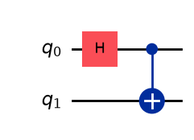
Fig 2.3.1 - Standard quantum circuit diagram showing single-qubit gates as boxes on horizontal wires.

4. Single-Qubit Gates

4.1 The Pauli Matrices
Gate | Symbol | Matrix | Action
Identity | I | $$\left(\begin{matrix}1 & 0 \\ 0 & 1\end{matrix}\right)$$ | Leaves the qubit state unchanged
Pauli-X | X | $$\left(\begin{matrix}0 & 1 \\ 1 & 0\end{matrix}\right)$$ | Bit-flip (classical NOT): |0⟩↔|1⟩
Pauli-Z | Z | $$\left(\begin{matrix}1 & 0 \\ 0 & -1\end{matrix}\right)$$ | Phase-flip: |0⟩→|0⟩, |1⟩→−|1⟩
Pauli-Y | Y | $$\left(\begin{matrix}0 & -i \\ i & 0\end{matrix}\right)$$ | Combined bit- and phase-flip; Y = iXZ

Note: Y = iXZ, so Y is, up to a global phase factor of i, equivalent to applying Z followed by X. All three Pauli matrices are both Hermitian (X = X†) and unitary, so each is its own inverse (X² = Y² = Z² = I).

4.2 The Hadamard Gate (H)
$$H = 1/\sqrt{2}\left(\begin{matrix}1 & 1 \\ 1 & -1\end{matrix}\right)$$
The Hadamard gate creates an equal-magnitude superposition from a computational basis state:
$$H|0⟩ = 1/\sqrt{2}(|0⟩ + |1⟩) = |+⟩ H|1⟩ = 1/\sqrt{2}(|0⟩ - |1⟩) = |-⟩$$
H is also used to switch between the computational (Z) basis and the Hadamard (X) basis — a key idea used repeatedly in algorithms and in measurement-basis changes.

4.3 Parameterised Rotation Gates
Rotation gates $R_{X}(θ)$, $R_{Y}(θ)$, and $R_{Z}(θ)$ rotate the qubit's Bloch vector about the X, Y, or Z axis by angle θ. These are the gates most directly implemented as native operations on superconducting quantum processors.
- Useful identity: $X · R_{Y}(θ) · X = R_{Y}(-θ)$
- Useful identity: S · X · S† = Y, where S is the phase gate ($S = Z^{½})$
Convention Note
Quirk (and much of the circuit-decomposition literature) prefers to express single-qubit gates as fractional powers of the Pauli matrices — e.g. $S = Z^{\frac{1}{2}}$ = diag(1, i) — rather than as exponentials such as $R_{Z}(θ) = exp(-iZθ/2)$. The two families are equivalent up to an overall global phase, but they behave differently once a control is added, because a global phase becomes a physically meaningful relative phase under control.
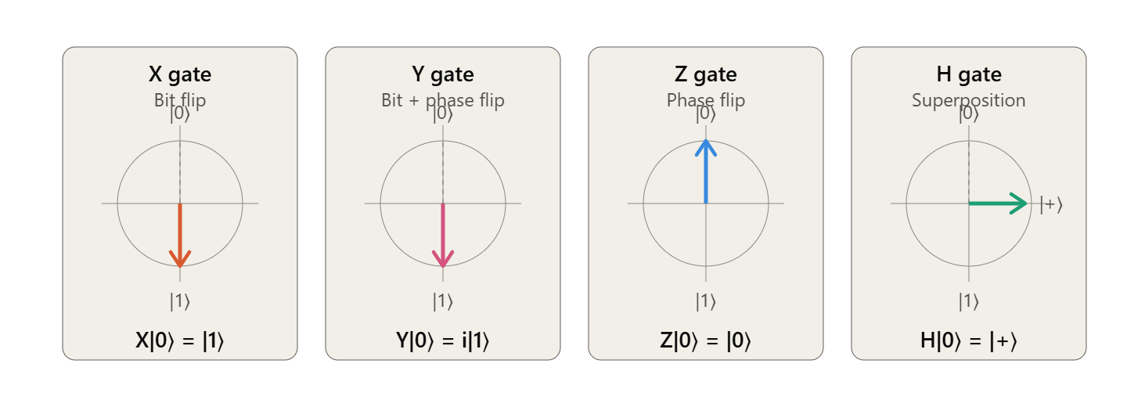Fig 2.3.2 - Bloch sphere illustrations showing the action of X, Y, Z, and H gates on $|0⟩$.

5. Multi-Qubit Gates

5.1 The CNOT (Controlled-NOT) Gate
CNOT is a two-qubit gate: the first qubit is the control, the second is the target. If the control is |1⟩, the Pauli-X gate is applied to the target; otherwise nothing happens.
CNOT = |0⟩⟨0| ⊗ I + |1⟩⟨1| ⊗ X
Key property — CNOT can create entanglement out of a product state:
$$\left(\frac{1}{\sqrt{2}}\right)(|0⟩ + |1⟩) ⊗ |0⟩ → \left(\frac{1}{\sqrt{2}}\right)(|00⟩ + |11⟩)$$
The right-hand side cannot be factored back into a tensor product of two single-qubit states — the two qubits are now entangled.

5.2 General Controlled Gates
Any single-qubit gate Q can be turned into a controlled-Q gate using the same template as CNOT:
∧Q = |0⟩⟨0| ⊗ I + |1⟩⟨1| ⊗ Q = $\left(\begin{matrix}I & 0 \\ 0 & Q\end{matrix}\right)$ (block form)
Controlled-phase gates (e.g. CZ, CPHASE(φ)) are common examples, and are the native two-qubit entangling gate on many superconducting platforms.

5.3 The SWAP Gate
SWAP exchanges the states of two qubits and can be built from three CNOTs applied in alternating direction:
SWAP = CNOT(0→1) · CNOT(1→0) · CNOT(0→1)
Worked Insight
If both qubits are transformed into the Hadamard (X) basis before and after a CNOT (i.e., sandwiched as H⊗H · CNOT · H⊗H), the roles of control and target qubit effectively reverse. This follows because HXH = Z and HZH = X, so conjugating CNOT's control-on-Z/target-X structure by Hadamards swaps which qubit acts as control and which as target.

5.4 CNOT–Controlled-Phase Relationship
CNOT and the controlled-phase (CZ) gate are related by a basis change on the target qubit:
CNOT = (I ⊗ H) · CPHASE · (I ⊗ H)
This identity is important in practice: many hardware platforms implement CZ natively (it is symmetric in its two qubits and easier to realise physically), and compilers use this identity to synthesise CNOT gates from CZ plus single-qubit Hadamards.
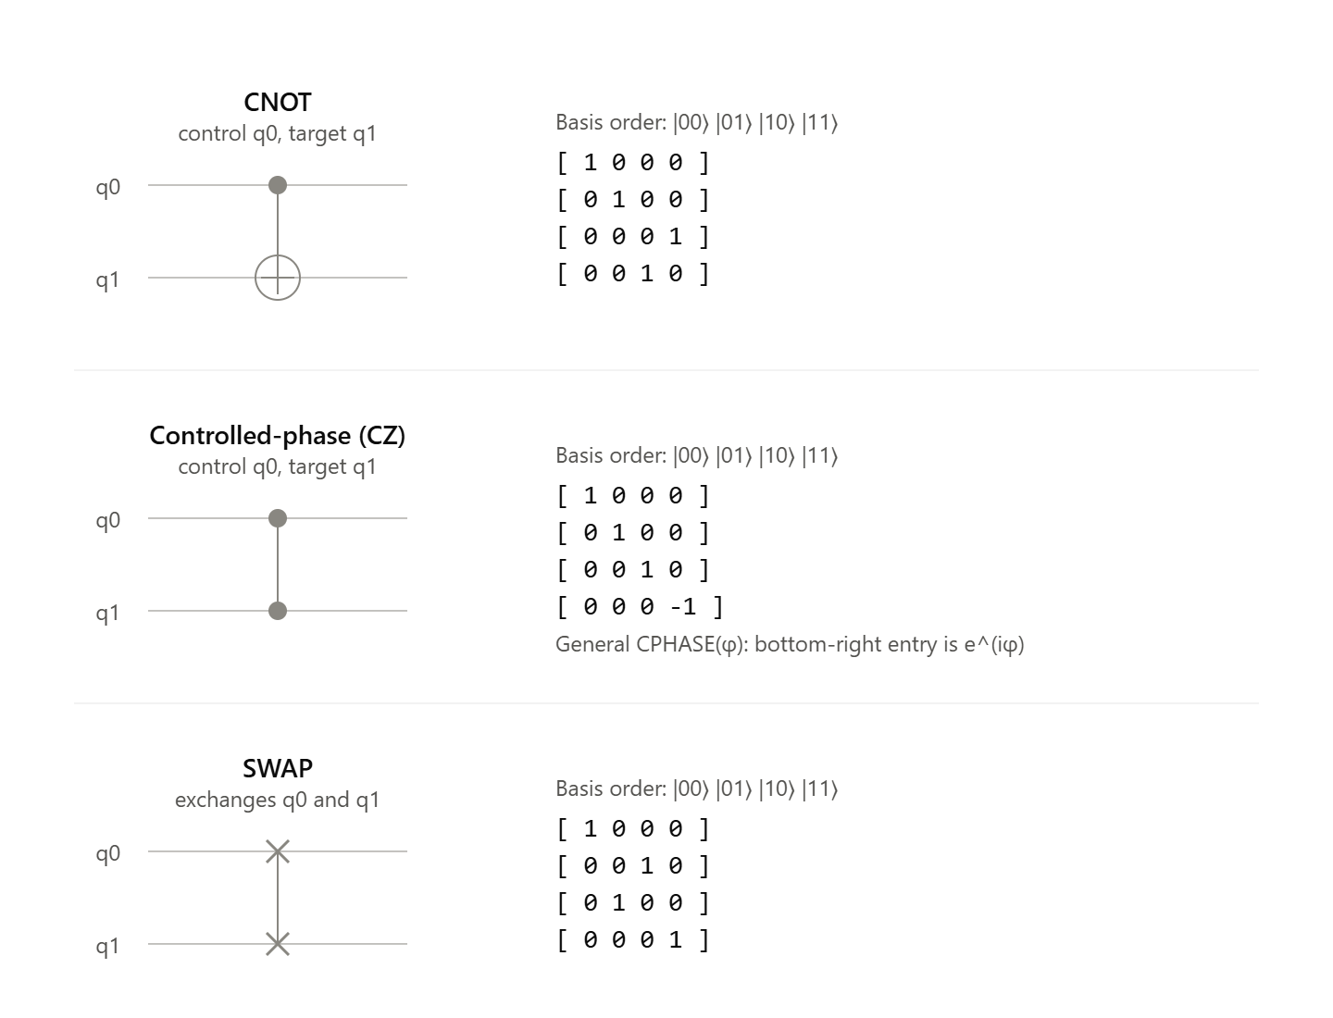Fig 2.3.3 - Circuit diagrams for CNOT, controlled-phase, and SWAP gates with matrix representations alongside.

6. Preparing Entangled States

6.1 Bell States
The standard two-qubit Bell-state preparation circuit applies a Hadamard to qubit 0, then a CNOT with qubit 0 as control and qubit 1 as target:
$$|00⟩ --H(q0)--> (|00⟩+|10⟩)/√2 --CNOT(0,1)--> (|00⟩+|11⟩)/√2 = |Φ⁺⟩$$
The remaining three Bell states are reached by inserting an extra Pauli gate at the right point in the circuit:
Bell state | Extra gate | Where applied
$$|Φ⁺⟩ = (|00⟩+|11⟩)/√2$$ | None | —
$$|Φ⁻⟩ = (|00⟩-|11⟩)/√2$$ | Z | On qubit 0, before entangling
$$|Ψ⁺⟩ = (|01⟩+|10⟩)/√2$$ | X | On qubit 1 (target), after CNOT
$$|Ψ⁻⟩ = (|01⟩-|10⟩)/√2$$ | X then Z | X after CNOT, Z before CNOT on q0

Teaching Point
Quantum circuits are not unique: the same target state can often be reached through different, equally valid gate sequences (e.g. applying an X before versus after the entangling CNOT, on different qubits). Students should verify at least two different circuits for the same Bell state to internalise this.

6.2 GHZ States
The n-qubit Greenberger–Horne–Zeilinger (GHZ) state generalises the Bell state:
|GHZ⟩ = (|00…0⟩ + |11…1⟩)/$√2$
A straightforward circuit applies H to qubit 0, then a chain of CNOTs: CNOT(0,1), CNOT(1,2), …, CNOT(n−2, n−1). This linear "fan-out" has circuit depth O(n).
A faster construction uses parallel "CNOT spreading": after the first CNOT entangles qubits 0 and 1, both can simultaneously act as controls for two new CNOTs (0→2 and 1→3), then four qubits control four more, and so on. This doubles the number of entangled qubits at each layer, reducing depth to O(log n) + 1.
Version | Structure | Depth
Linear fan-out | Sequential CNOT chain, each depending on the previous | O(n)
Parallel/recursive fan-out | Entangled qubits pair up to control new qubits each layer | O(log n) + 1
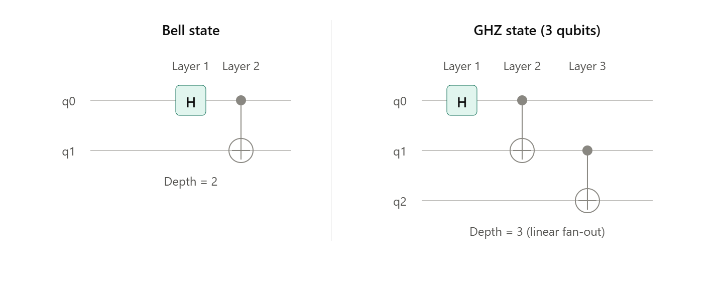Fig 2.3.4 - Side-by-side circuit diagrams for Bell state and GHZ state preparation, annotated with gate layers/depth.

7. Gate Decompositions and Universal Gate Sets

7.1 Single-Qubit (Euler / Z–Y–Z) Decomposition
Any single-qubit unitary Q can be written as a product of a global phase, two phase-type rotations, and one real rotation:
Q = K(δ) · T(α) · R(β) · T(γ)
- $K(δ) = e^{iδ} I$ — an overall (global) phase factor
- $T(α) = diag(e^{iα}, e^{-iα})$ — a phase-type rotation about Z
- $R(β) =\left(\begin{matrix}\cos{β} & \sin{β} \\ -\sin{β} & \cos{β}\end{matrix}\right)$— a real rotation (about Y)
This decomposition follows directly from imposing the unitarity condition on a general 2×2 complex matrix and solving for the four free real parameters (δ, α, β, γ).

7.2 Controlled Single-Qubit Decomposition
A controlled version of an arbitrary Q can be built by separating out the global phase term, since global phase becomes physically significant once a gate is controlled:
∧Q = (∧K(δ)) · (∧Q′), where Q′ = T(α)·R(β)·T(γ)
This idea extends iteratively to build k-controlled single-qubit operations from simpler controlled and uncontrolled pieces.

7.3 Two-Qubit Decomposition
Any two-qubit unitary can be decomposed into a small number of CNOT gates interleaved with single-qubit rotations (the Cartan/Krauss–Cirac decomposition uses at most three CNOTs). This result underlies automated circuit compilation: a compiler can take an arbitrary two-qubit operation from an algorithm and rewrite it purely in terms of hardware-native gates.

7.4 Universal Gate Sets
Gate set | Type of universality
{CNOT} + all single-qubit gates | Exact universality (any unitary can be represented exactly)
{CNOT, $R_{X}, R_{Y}, R_{Z}$} | Practical/continuous universality — common hardware target
{H, T} | Discrete universal set — exact for Clifford operations, approximate otherwise

The Solovay–Kitaev theorem guarantees that any single-qubit gate can be approximated to arbitrary accuracy using only a fixed, finite discrete gate set (such as {H, T}), with the circuit length growing only poly-logarithmically in the desired accuracy — this is what makes fault-tolerant quantum computing with discrete gate sets practical.
Note
There are multiple valid ways (12 distinct orderings) to decompose an arbitrary single-qubit operation into a sequence of $R_{X}, R_{Y}, R_{Z}$ rotations; the $R_{Z}-R_{Y}-R_{Z}$ ordering is the most commonly used convention in textbooks and software libraries.
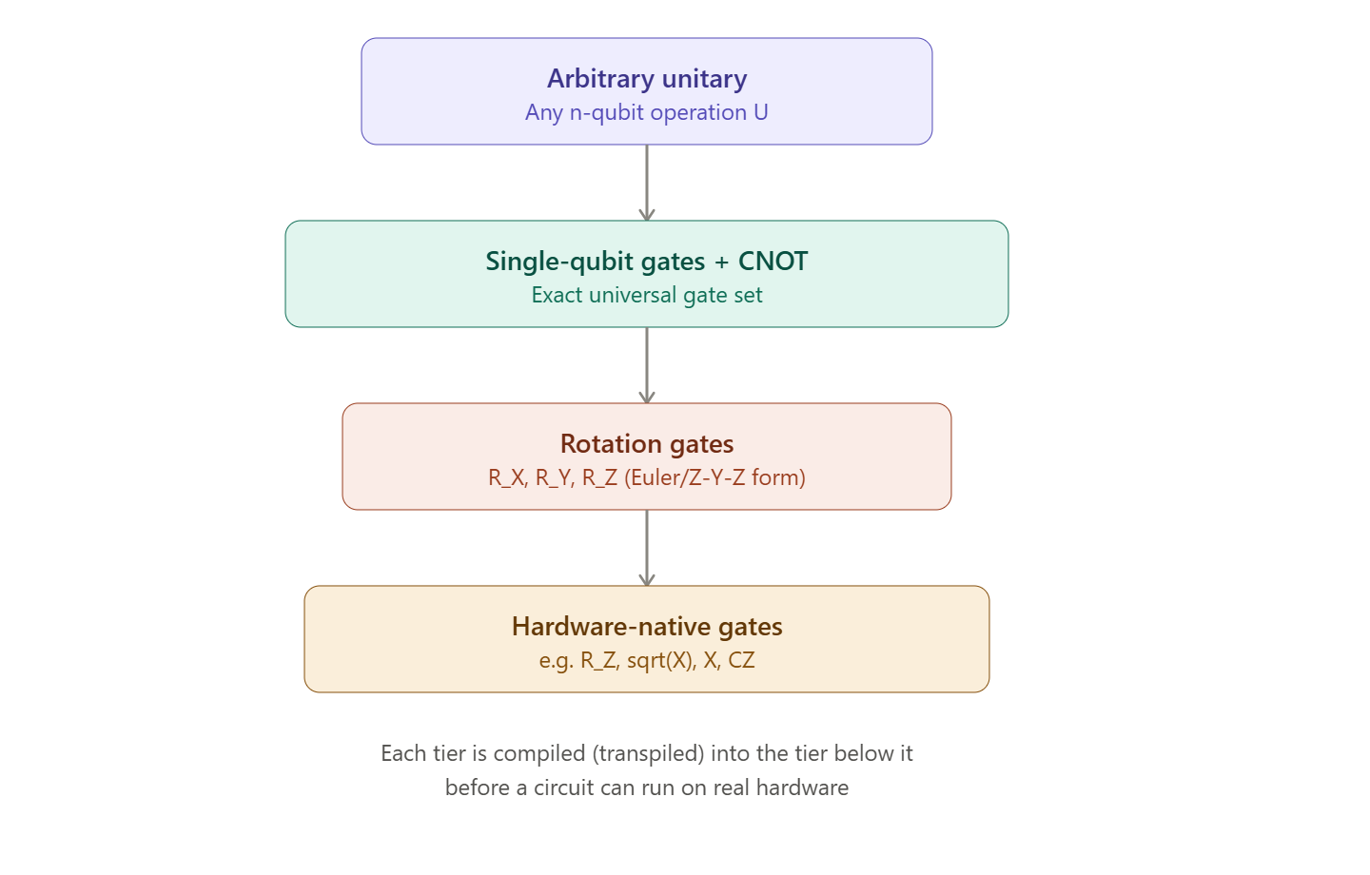Figure 2.3.5 - Flowchart showing decomposition hierarchy: Arbitrary Unitary → Single-Qubit + CNOT → Rotation Gates → Hardware Native Gates.

8. Quantum Communication Protocols

8.1 Quantum Dense Coding
Goal: transmit 2 classical bits of information by physically sending only 1 qubit, provided Alice and Bob pre-share one entangled (EPR) pair.
- Alice and Bob each hold one qubit of a shared EPR pair, e.g. |Φ⁺⟩.
- Depending on her 2-bit message, Alice applies one of {I, X, Z, Y} to her half of the pair (each choice maps the shared state to a different one of the four Bell states).
- Alice physically sends her single qubit to Bob.
- Bob, now holding both qubits, applies CNOT (his original qubit as target) followed by a Hadamard on the first qubit to "un-entangle" the pair.
- Bob measures both qubits in the computational basis to recover Alice's original 2 classical bits exactly.
This protocol effectively doubles the classical information capacity of a single transmitted qubit — a result with no classical analogue, made possible by pre-shared entanglement.

8.2 Quantum Teleportation
Goal: transmit an unknown single-qubit state using 1 shared EPR pair plus 2 bits of classical communication (no physical transmission of the qubit itself).
- Alice holds an unknown state |ψ⟩ = α|0⟩ + β|1⟩ that she wants to send to Bob.
- Alice and Bob pre-share an EPR pair (one qubit each).
- Alice applies CNOT (with |ψ⟩ as control, her EPR qubit as target) followed by a Hadamard on |ψ⟩ — the reverse of the decoding step used in dense coding.
- Alice measures her two qubits and sends the 2-bit classical result to Bob over an ordinary classical channel.
- Bob applies a correction to his qubit based on the 2 received bits: 00→I, 01→X, 10→Z, 11→Y, recovering |ψ⟩ exactly.
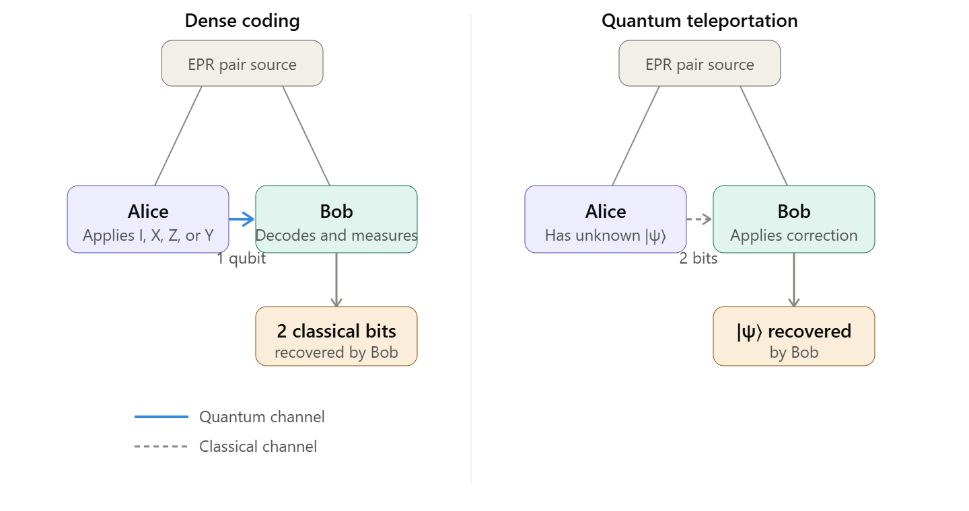Fig 2.3.6 - Protocol diagrams for dense coding and teleportation showing Alice, Bob, classical channels, and quantum channels.
Key Principle
Teleportation does not clone |ψ⟩: Alice's original qubit is destroyed (projected onto a measurement basis state) in step 4, fully consistent with the No-Cloning Theorem. Dense coding and teleportation are structurally dual protocols — one trades an extra classical bit of communication for sending a full qubit; the other trades a physically transmitted qubit for doubling classical capacity.

9. From Logical Circuits to Physical Hardware

9.1 Logical vs. Physical Qubits
A circuit designed on paper (or in Quirk) assumes any qubit can interact with any other qubit, and that any gate in the algorithm's description is directly available. Real devices impose two major restrictions: a limited native gate set, and limited physical connectivity between qubits.

9.2 Native Gate Sets
Hardware only implements a small fixed set of gates directly; every other gate in an algorithm must first be transpiled (rewritten) into this native set before execution. For example, IBM's Heron-generation processors expose only {R_Z, √X, X, CZ} as native operations — all Hadamards, arbitrary rotations, and CNOTs in a circuit are compiled down to sequences of these four gates.

9.3 Connectivity Constraints and SWAP Insertion
Physical qubits are typically arranged in a fixed topology (a chain, grid, or more complex lattice), and a two-qubit gate can usually only be applied directly between qubits that are physically adjacent ("coupled"). If an algorithm calls for a two-qubit gate between two non-adjacent logical qubits, the compiler must insert SWAP gates to physically move quantum information until the two qubits are adjacent — at the cost of additional gates, additional circuit depth, and additional opportunities for error.

9.4 The Bridge Identity
When exactly one intermediate qubit lies between two qubits that need to interact, a full SWAP is often unnecessary — the "bridge" identity below implements a long-range CNOT using only nearest-neighbour CNOTs, without permanently moving any qubit's state:
CNOT(0,2) = CNOT(0,1) · CNOT(1,2) · CNOT(0,1) · CNOT(1,2)
This is preferred over SWAP-then-CNOT-then-SWAP whenever only a single non-adjacent interaction is needed (e.g., synthesising a GHZ state across 5 qubits with a restricted, chain-like connectivity).

9.5 Example Hardware Topology: Heavy-Hex
IBM's Heron-class processors (up to 133 qubits) use a "heavy-hex" topology: horizontal chains of qubits connected by vertical "bridge" qubits placed at staggered positions. Most qubits have only 2 physical neighbours (degree-2), while a smaller number of junction qubits have 3 neighbours (degree-3). This sparse connectivity (as opposed to full all-to-all connectivity) directly shapes how circuits must be laid out and compiled.
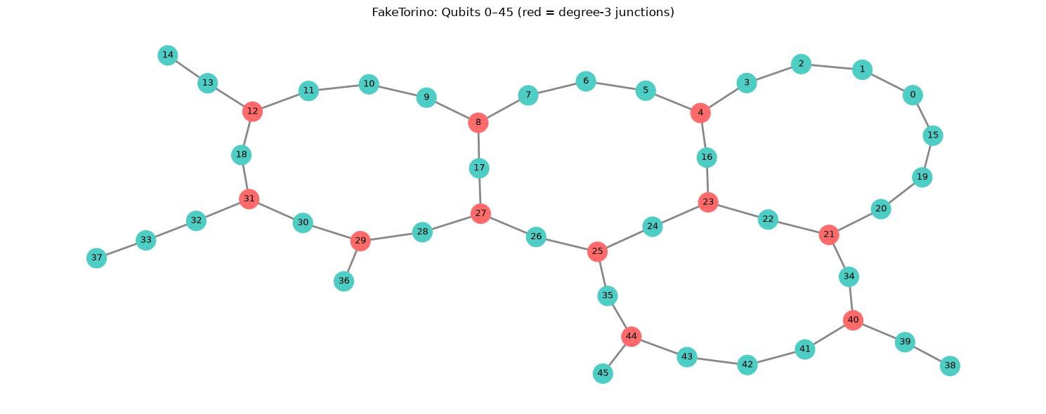Fig 2.3.7 - Diagram of a heavy-hex topology as used by IBM quantum processors.

9.6 Layout Optimisation
Because SWAP overhead accumulates error and depth, compilers use qubit-mapping algorithms to choose an initial assignment of logical qubits to physical qubits that minimises the number of SWAPs required. For depth-sensitive algorithms (e.g., QAOA), the difference between an optimal and a naïve layout can be the difference between a successful and a failed execution on real hardware.

10. Special Circuits and Applications

10.1 Quantum Multiplexer
A two-control multiplexer applies a different single-qubit operation to a target qubit depending on the state of two control qubits:
Control state | Operation applied to target
|00⟩ | Identity (do nothing)
|01⟩ | X
|10⟩ | Z
|11⟩ | Y

This is built from a combination of controlled-X and controlled-Z gates conditioned appropriately on each control qubit (and their combination, since Y = iXZ).

10.2 Exercise: Building 3 CNOTs from 3 Toffoli Gates
As a worked exercise, students should show that a SWAP-like sequence of three CNOTs (used e.g. in Section 5.3) can equivalently be constructed using three Toffoli (CCNOT) gates with an appropriately fixed extra control qubit set to |1⟩. This reinforces the idea that many small quantum circuits are equivalent under different gate-set choices, and it is good practice for the gate-decomposition ideas introduced in Section 7.

10.3 Further Applications (Conceptual Overview)
- Quantum Money: a theoretical scheme for unforgeable currency, where a "banknote" is encoded as an unknown quantum state that only the issuing bank can verify — forgery is prevented directly by the No-Cloning Theorem.
- Elitzur–Vaidman Bomb Tester: a thought experiment showing that a measurement can sometimes reveal information about an object (e.g. detect a live bomb) without ever directly interacting with it, using interference in a quantum circuit — an illustration of "interaction-free" measurement.

11. Quantum Circuit Simulation with Quirk

11.1 Introduction to Quirk
Quirk is a free, open-source, browser-based drag-and-drop quantum circuit simulator, available at algassert.com/quirk. No installation is required, and circuits are automatically encoded into the page's URL, making them easy to save and share as a simple link.

11.2 Basic Operations
- Adding a qubit: while dragging any gate, a new blank wire appears at the bottom of the circuit — drop the gate there to permanently add that qubit (maximum 16 qubits).
- Removing a gate: drag it out of the circuit area, or middle-click it for a quicker deletion.
- Making a controlled gate: place a control (from the top-left toolbox group) in the same column as the gate you want to control.
- Changing a qubit's initial state: click its state indicator (left edge of the wire) to cycle through |0⟩, |1⟩, |+⟩, |−⟩, |i⟩, |−i⟩.
- Sharing a circuit: bookmark or copy the browser's address bar URL — the full circuit is embedded in it.

11.3 Visualisation Displays
Display | Shows | Best used for
Chance display | Probability of each computational-basis outcome | Predicting measurement statistics
Bloch sphere display | A single qubit's state as a Bloch vector | Visualising single-qubit rotations
Amplitude display | Complex amplitude (magnitude + phase) per basis state | Studying superposition and relative phase
Density matrix display | Full density matrix of the selected qubits | Analysing entangled or mixed states

Placing controls in the same column as a display lets the display be conditioned on other qubits — the standard way to visually confirm entanglement, e.g. between the two halves of a Bell pair.

11.4 Measurement Gate vs. Detectors
Quirk offers two distinct ways to collapse a qubit's state:
- Measurement Gate: a standard collapsing measurement. Once measured, a qubit cannot be "unmeasured", but Quirk explores all branches of the outcome simultaneously, so later displays can be conditioned on the measurement result.
- Detectors: a lighter-weight, repeatable collapse ("click / no-click") that can be controlled like any other gate and used freely throughout a circuit, at the cost of not accumulating statistics over multiple runs the way a real repeated experiment would.

11.5 Notation Reminders When Using Quirk
- Quirk expresses single-qubit gates as fractional Pauli powers (e.g. $S = Z^{½}$) rather than as exponentials of the form $R_{Z}(θ)$ — see the note in Section 4.3.
- In addition to the standard Z-basis control, Quirk supports X- and Y-basis controls, letting you build gates conditioned on |+⟩, |−⟩, etc.
- For multi-qubit arithmetic gates, Quirk orders qubits with the least-significant bit at the top of the circuit — the opposite of the usual Nielsen–Chuang textbook convention — so take care when comparing simulator output to hand calculations.

11.6 Recommended Practice Exercises in Quirk
- Build a Bell-state circuit (H then CNOT) and verify |Φ⁺⟩ using a chance display and an amplitude display.
- Extend the Bell circuit to a 3-qubit GHZ state and compare the linear fan-out circuit (Section 6.2) against the faster parallel version, timing the depth of each.
- Construct the full quantum teleportation circuit (Section 8.2) and confirm that Bob's qubit ends in Alice's original state |ψ⟩ for at least two different choices of α, β.
- Verify the CNOT ↔ CPHASE identity from Section 5.4 by building both circuits and confirming they produce identical output states.
Students should verify each construction in Quirk before moving on to a programming framework such as Qiskit or PennyLane, so that circuit intuition is grounded in a visual, immediate feedback loop before dealing with code syntax.

12. Summary
- Unitarity is fundamental: valid quantum operations on closed systems must be linear, reversible, and inner-product preserving. Measurement is the key exception — it is probabilistic and irreversible.
- The No-Cloning Theorem fundamentally distinguishes quantum information from classical information, and underlies secure quantum communication protocols.
- A small gate set is sufficient for universality: single-qubit rotations combined with CNOT (or CZ) can implement any quantum computation, exactly or to arbitrary approximation.
- Entanglement is engineered deliberately, using gates such as CNOT, to convert separable product states into entangled resources such as Bell states and GHZ states.
- Entanglement powers communication protocols: Dense Coding and Quantum Teleportation both rely on a shared EPR pair to move classical or quantum information in ways with no classical analogue.
- Hardware imposes real constraints: limited native gate sets and limited qubit connectivity require circuit synthesis techniques such as SWAP insertion, bridge identities, and topology-aware qubit mapping.
- Simulation bridges theory and practice: tools such as Quirk allow circuits to be built and verified visually and interactively before any deployment on real quantum hardware.

13. Self-Assessment Questions
- Why can a CNOT gate not be used to clone a qubit in an arbitrary, unknown state? Contrast this with its use for duplicating a known basis state.
- Show, using matrix multiplication, that Y = iXZ.
- Starting from |00⟩, write out the full state after each gate in the |Ψ⁻⟩ Bell-state preparation circuit given in Section 6.1.
- Explain, in your own words, why global phase becomes physically significant once a gate is controlled — and how this affects the decomposition ∧Q = (∧K(δ))·(∧Q′).
- A 5-qubit device has a chain topology (qubit i is only connected to qubits i−1 and i+1). Describe, step by step, how you would implement a CNOT between qubit 0 and qubit 2 using the bridge identity, and compare the gate count to a SWAP-based approach.
- In quantum teleportation, what happens to Alice's original qubit after step 4? Explain why this is consistent with, rather than a violation of, the No-Cloning Theorem.
- Build the dense-coding circuit in Quirk for all four possible 2-bit messages and confirm Bob recovers each message correctly using the chance display.

References

Books & Codebooks

- Xanadu Quantum Technologies. (n.d.). PennyLane Codebook: Learning quantum computing step-by-step. Retrieved from https://pennylane.ai/codebook
- Combarro, E. F., & González, S. (Year). Practical Guide to Quantum Computing: A Hands-on Approach with Qiskit. [Publisher to be verified — e.g., Springer or similar].

Research Papers & Technical Reports
- Krantz, P., Kjaergaard, M., Yan, F., Orlando, T. P., Gustavsson, S., & Oliver, W. D. (2021). A quantum engineer's guide to superconducting qubits. arXiv preprint.
(Original document cites: arxiv, July 2021. The standard arXiv identifier for this widely-cited review is arXiv:1904.06560. Please verify and include the DOI/arXiv ID in the final material.)

Software Documentation & Online Resources
- Strilanc. (n.d.). How to use Quirk. GitHub Wiki. Retrieved from https://github.com/Strilanc/Quirk/wiki/How-to-use-Quirk

