Supplementary Figure S2

A B
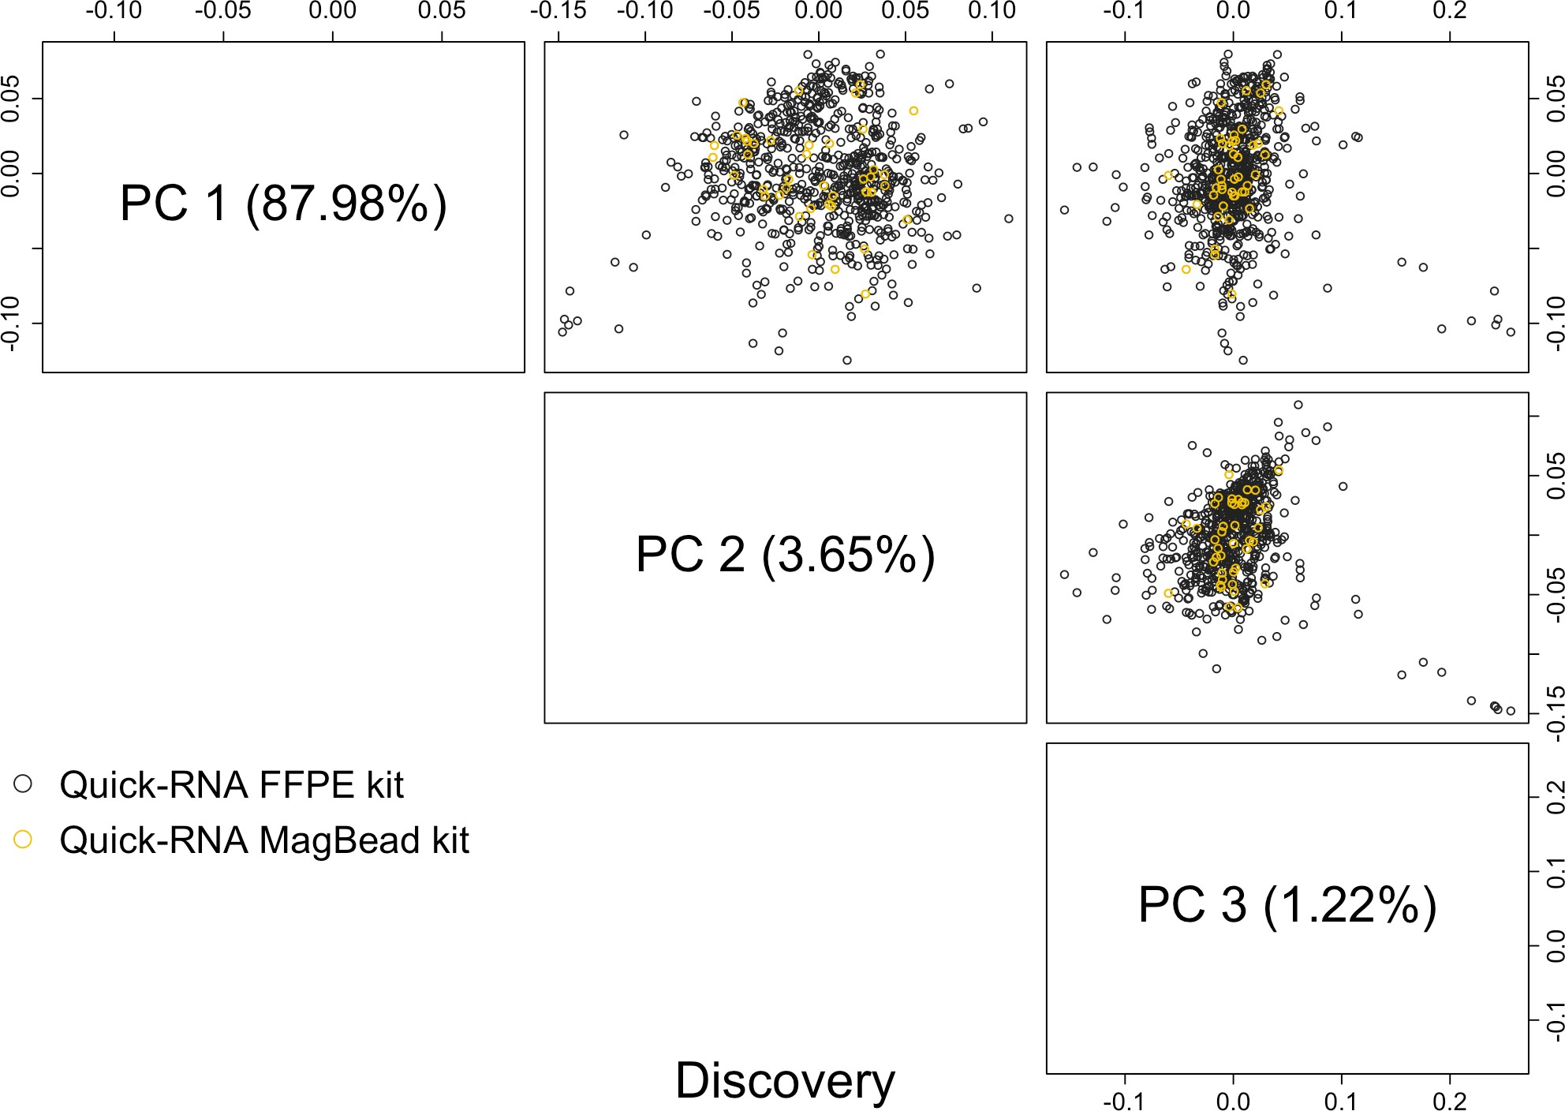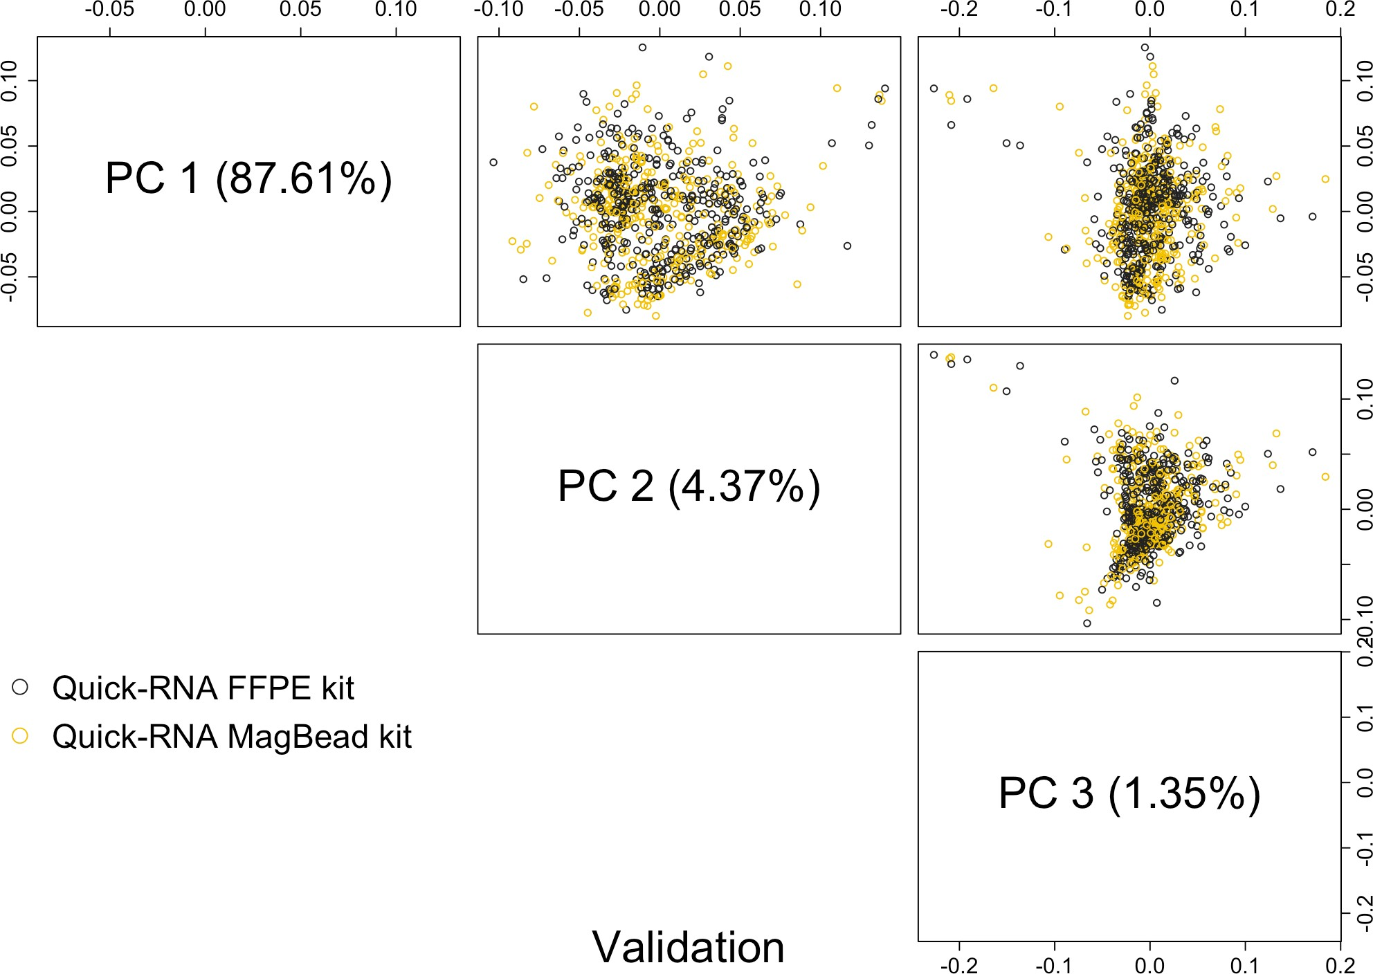

C D
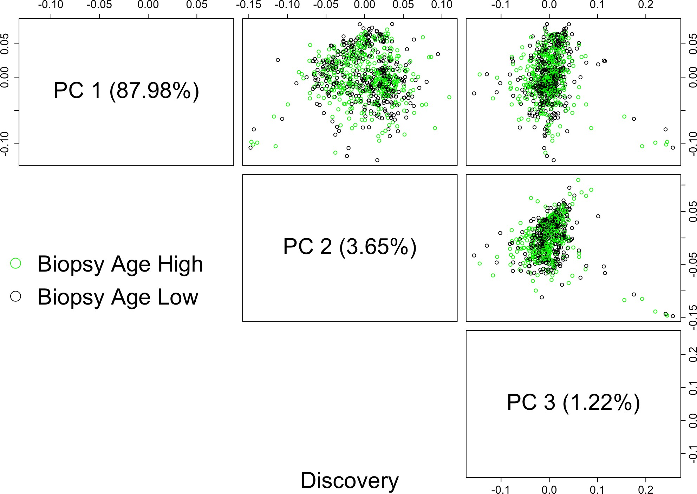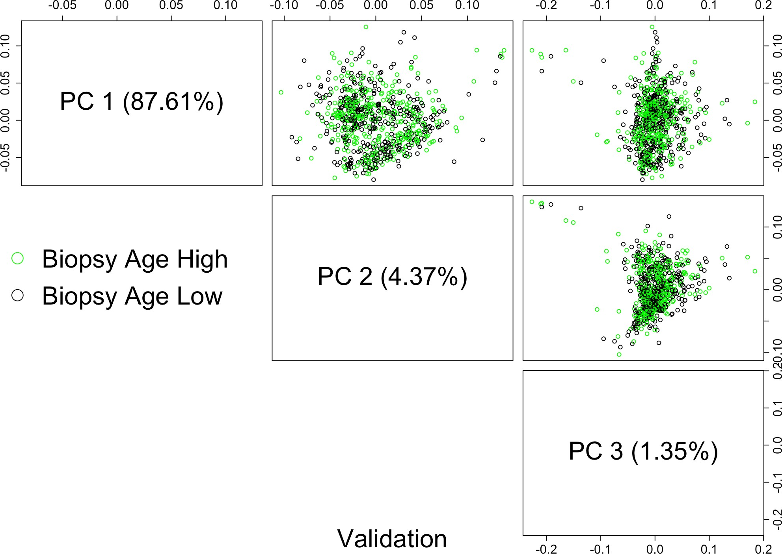

No Systematic Variation of Normalized Gene Expression Data between RNA Extraction Protocols or between Biopsies of Older and Younger Sample Ages PCA plots of normalized gene expression data of biopsy samples processed by two different RNA extraction protocols (A, B) or biopsies with high sample age (above median age) vs. low sample age (below median age) (C, D) in either discovery cohort (A, C) or validation cohort (B, D). Each marker represents one individual sample.

