SUPPLEMENTAL MATERIALS

Figures

Supplemental Figure S1. Treatment regimens
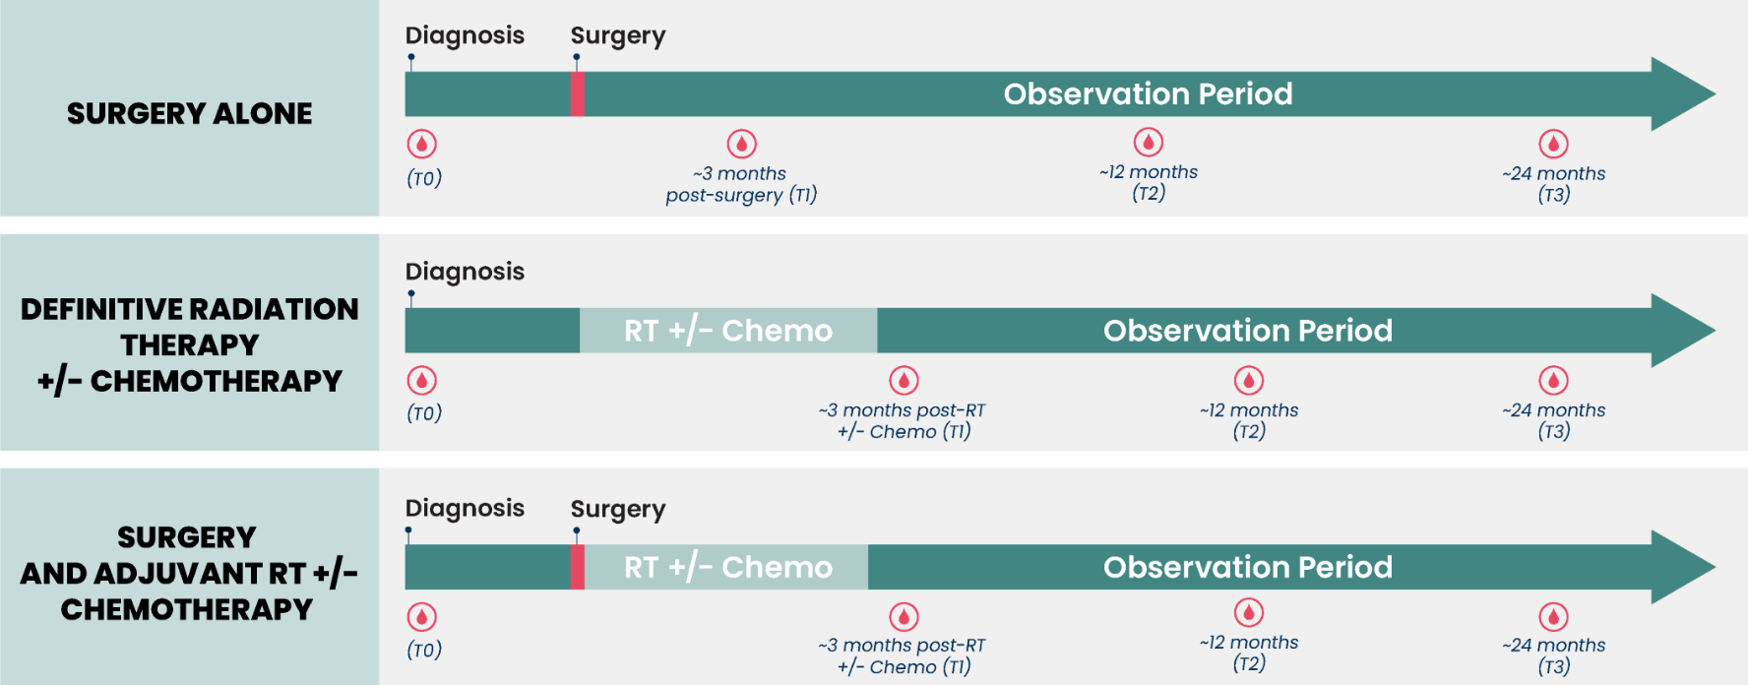

Supplemental Figure S2: cfMeDIP-Seq assay overview
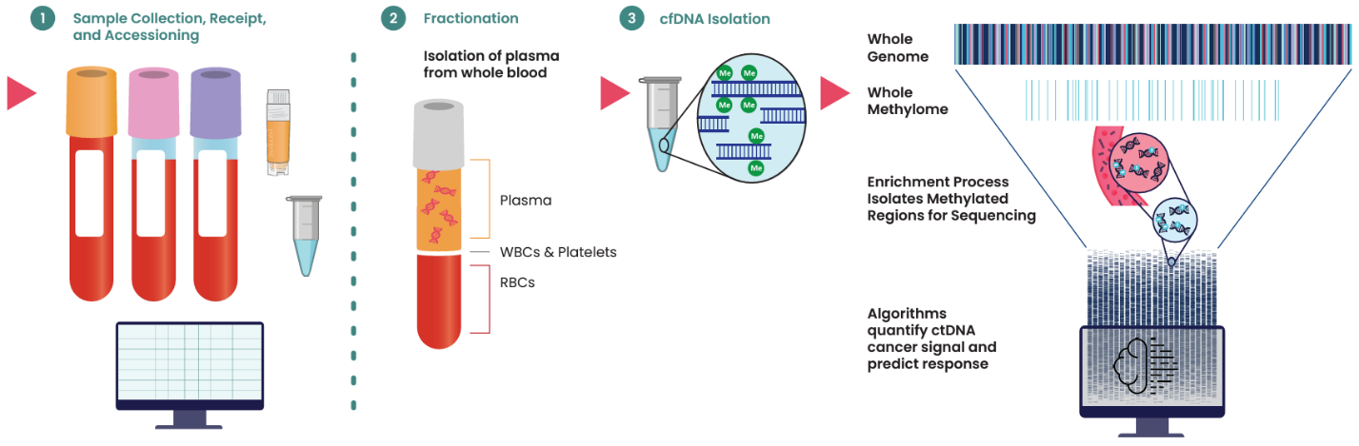

Supplemental Figure S3. Cancer signal by tissue sample type
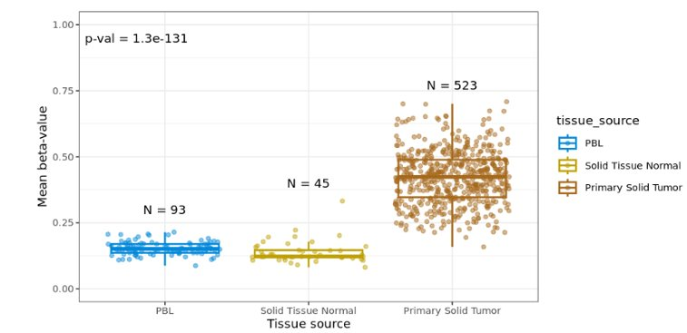
Differentially methylated regions (DMRs) used by the algorithm have higher methylation levels in solid tumor tissue and are relatively unmethylated in peripheral blood lymphocytes (PBL) and solid normal tissue. This is consistent with the test specifically detecting methylated DNA shed by the tumor. Comparison of DMRs with annotations in the literature from HNC tissue samples demonstrates that the algorithm is specific for cancer cell methylation.

Tables

Supplemental Table S1: Clinical ineligible patient disposition table

Reason for Ineligibility | N
Patients with a Second Primary Cancer | 11
Recurrence Event > 3 year after blood draw | 1
Patient removed due to only one blood draw passed wetlab QC and that blood draw being >4M after recurrence | 1
Total: 13 patients | 13

Supplemental Table S2: Surveillance sensitivity by location of recurrence

Location | Sensitivity | Difference | P value
Distant (n = 22) | 86% (67% – 95%) | -14% (-36% - 18%) | 0.48
Locoregional (n = 12) | 100% (76% – 100%)

Supplemental Table 3: Patient Demographics and Clinical Characteristics at Time of Diagnosis
Training and Validation Set definitions and details are presented under Methods and in the Supplemental Materials.
Q1, first quartile, Q3, third quartile, AJCC, American Joint Committee on Cancer 8th Edition for Staging
Demographics and Baseline Characteristics
 | Overall (n = 325) | Test (n = 162) | Training (n = 163) | Statistical Test*
Age |  |  |  | P = 0.41
Mean (SD) | 61.2 (10.7) | 60.7 (10.8) | 61.7 (10.6)
Median (Q1, Q3) | 61.0 (54.0, 69.0) | 61.0 (53.3, 69.0) | 61.0 (55.0, 68.0)
Min, Max | 23.0, 89.0 | 26.0, 88.0 | 23.0, 89.0
Sex |  |  |  | P = 0.79
Female | 72 (22.2%) | 37 (22.8%) | 35 (21.5%)
Male | 253 (77.8%) | 125 (77.2%) | 128 (78.5%)
Stage |  |  |  | P = 0.45
Stage I | 102 (31.4%) | 52 (32.1%) | 50 (30.7%)
Stage II | 62 (19.1%) | 35 (21.6%) | 27 (16.6%)
Stage III | 62 (19.1%) | 26 (16.0%) | 36 (22.1%)
Stage IVA-IVB | 99 (30.5%) | 49 (30.2%) | 50 (30.7%)
Treatment |  |  |  | P = 0.99
CRT | 114 (35.1%) | 58 (35.8%) | 56 (34.4%)
RT | 105 (32.3%) | 50 (30.9%) | 55 (33.7%)
Surgery | 41 (12.6%) | 21 (13.0%) | 20 (12.3%)
Surgery + CRT | 25 (7.7%) | 13 (8.0%) | 12 (7.4%)
Surgery + RT | 40 (12.3%) | 20 (12.3%) | 20 (12.3%)
Primary Site |  |  |  | P = 0.99
Hypopharynx | 11 (3.4%) | 6 (3.7%) | 5 (3.1%)
Larynx | 46 (14.2%) | 23 (14.2%) | 23 (14.1%)
Lip & Oral Cavity | 78 (24.0%) | 38 (23.5%) | 40 (24.5%)
Nasal Cavity & Paranasal Sinus | 11 (3.4%) | 7 (4.3%) | 4 (2.5%)
Nasopharynx | 3 (0.9%) | 1 (0.6%) | 2 (1.2%)
Oropharynx | 160 (49.2%) | 79 (48.8%) | 81 (49.7%)
HPV+ | 125 (78.1%) | 60 (75.9%) | 65 (80.2%)
HPV- | 34 (21.2%) | 18 (22.8%) | 16 (19.8%)
Not Done | 1 (0.6%) | 1 (1.3%) | 0 (0.0%)
Salivary Glands | 7 (2.2%) | 4 (2.5%) | 3 (1.8%)
Unknown | 9 (2.8%) | 4 (2.5%) | 5 (3.1%)
Histology |  |  |  | P = 0.62
Non-squamous Cell Carcinoma | 16 (4.9%) | 9 (5.6%) | 7 (4.3%)
Squamous Cell Carcinoma | 309 (95.1%) | 153 (94.4%) | 156 (95.7%)
Race |  |  |  | P = 0.64
White | 230 (70.8%) | 116 (71.6%) | 114 (69.9%)
Non-white | 41 (12.6%) | 22 (13.6%) | 19 (11.7%)
Missing | 54 (16.6%) | 24 (14.8%) | 30 (18.4%)
Smoking Status |  |  |  | P > 0.99
Current | 59 (18.2%) | 29 (17.9%) | 30 (18.4%)
Former | 128 (39.4%) | 64 (39.5%) | 64 (39.3%)
Never | 83 (25.5%) | 42 (25.9%) | 41 (25.2%)
Missing | 55 (16.9%) | 27 (16.7%) | 28 (17.2%)
Alcohol Status |  |  |  | P = 0.44
Current | 144 (44.3%) | 74 (45.7%) | 70 (42.9%)
Former | 60 (18.5%) | 34 (21.0%) | 26 (16.0%)
Never | 58 (17.8%) | 27 (16.7%) | 31 (19.0%)
Missing | 63 (19.4%) | 27 (16.7%) | 36 (22.1%)
Q1, Q3, first quartile, third quartile; SD, standard deviation; Min, Max, minimum, maximum.
Fisher’s exact test was conducted for categorical variables and t-test was conducted for continuous variables.

Supplemental Appendix

Data Set Definitions
Selected Analysis Set
All participants who satisfied selection criteria and had a sample sent to Adela.
Clinically Evaluable Analysis Set
Clinically evaluable participants were defined based on the clinical information that has been cleaned and locked before it is released for analysis. Clinical evaluable criteria were gated at multiple steps before considering a participant released for analysis and includes the following:
- The expected clinical data for this analysis and adequate specimen from the participant must have arrived at Adela and met the minimum viable sample criteria.
- Clinical and laboratory data was available; this included, age, gender, recurrence status, primary site, treatment, stage information, and sufficient makeup and quantity of starting material.
- Data discrepancies to key variables listed in this plan were resolved.
Training Set
Approximately 50% of the patients (n=163) and samples (n=559) were randomized to the training set to develop the final algorithm for the MRD Assay. The remainder were in the holdout validation set.
Validation Set
The holdout validation set was used to assess and validate the clinical performance of the final algorithm for the MRD Assay. It was comprised of 162 patients and 560 samples. 61 patients had recurrence, and 101 patients did not have recurrence.
Analyzable Set
The analyzable set included patients and samples from the holdout validation set after they passed predefined and locked assay quality control criteria and clinical eligibility. Patients who were clinically evaluable, placed in the holdout validation set, and with at least one post-treatment evaluable assay result were considered in the analyzable set.
Patients who had a recurrence more than 3 years following the latest blood draw were excluded. Patients with second primary cancers were excluded. Patients who did not have a recurrence event must have been followed-up for at least 12 months following a blood draw for that blood draw to be included. Earlier timepoints for the patient were included if the follow-up from the timepoint was sufficient.
Patients with recurrence were defined as those who had a post-treatment blood draw ahead of the clinical recurrence event or if any post treatment blood draw occurred within four months following a recurrence event. This definition has also been employed by Parikh (2021) and Reinert (2019). In patients where surgery occurred between the event and a blood draw, or if chemo or radiation treatment began more than one month prior to the blood draw, the blood draw was excluded. These treatments may affect the disease status and introduce uncertainty in the expected result at the blood draw time point. Patients with persistent disease were excluded from the time-to-recurrence analysis but were included in sensitivity estimates for the presence of disease. This was the set used for the primary analyses.

