Analog Lab Week - 1

LAB REPORT BY :- Arpit Katiyar | Roll No : (24F1100064)

Objective :-
The objective of the Week 1 experiment is to derive expressions for amplitude and frequency of a ramp wave generator. We are going to use an Op-Amp and Schmitt trigger. We are also going to simulate the circuit and will verify the result by making a physical circuit.

List of components :-
1. R1 = 25K ohm, R2 = 45K ohm, R3 = 200K ohm
2. C1 = 10n F
3. OPM1 (MCP6004) = 1
4. CMP1 (LM339) = 1
5. Pullup Resistor = 4.7K ohm

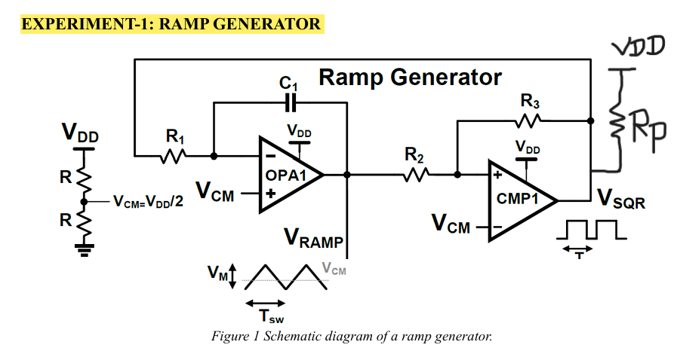
Derivation of Formula :-
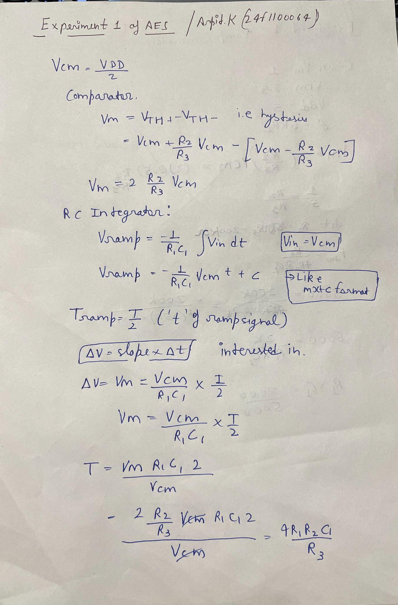

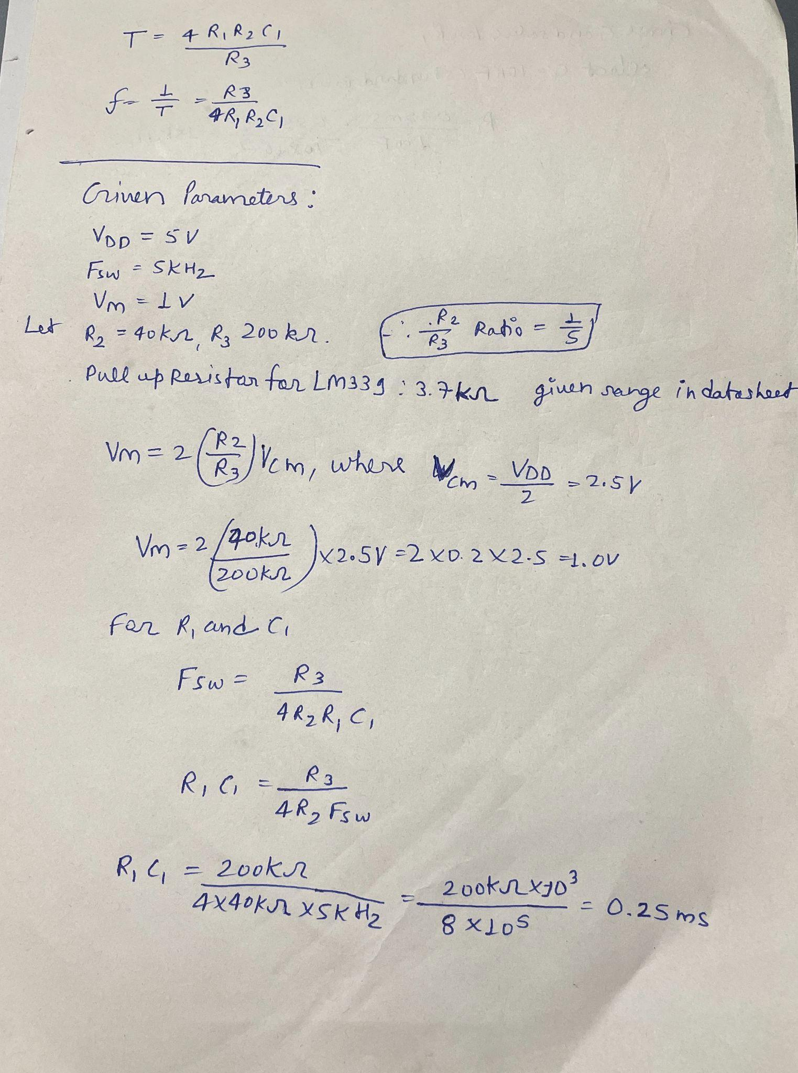
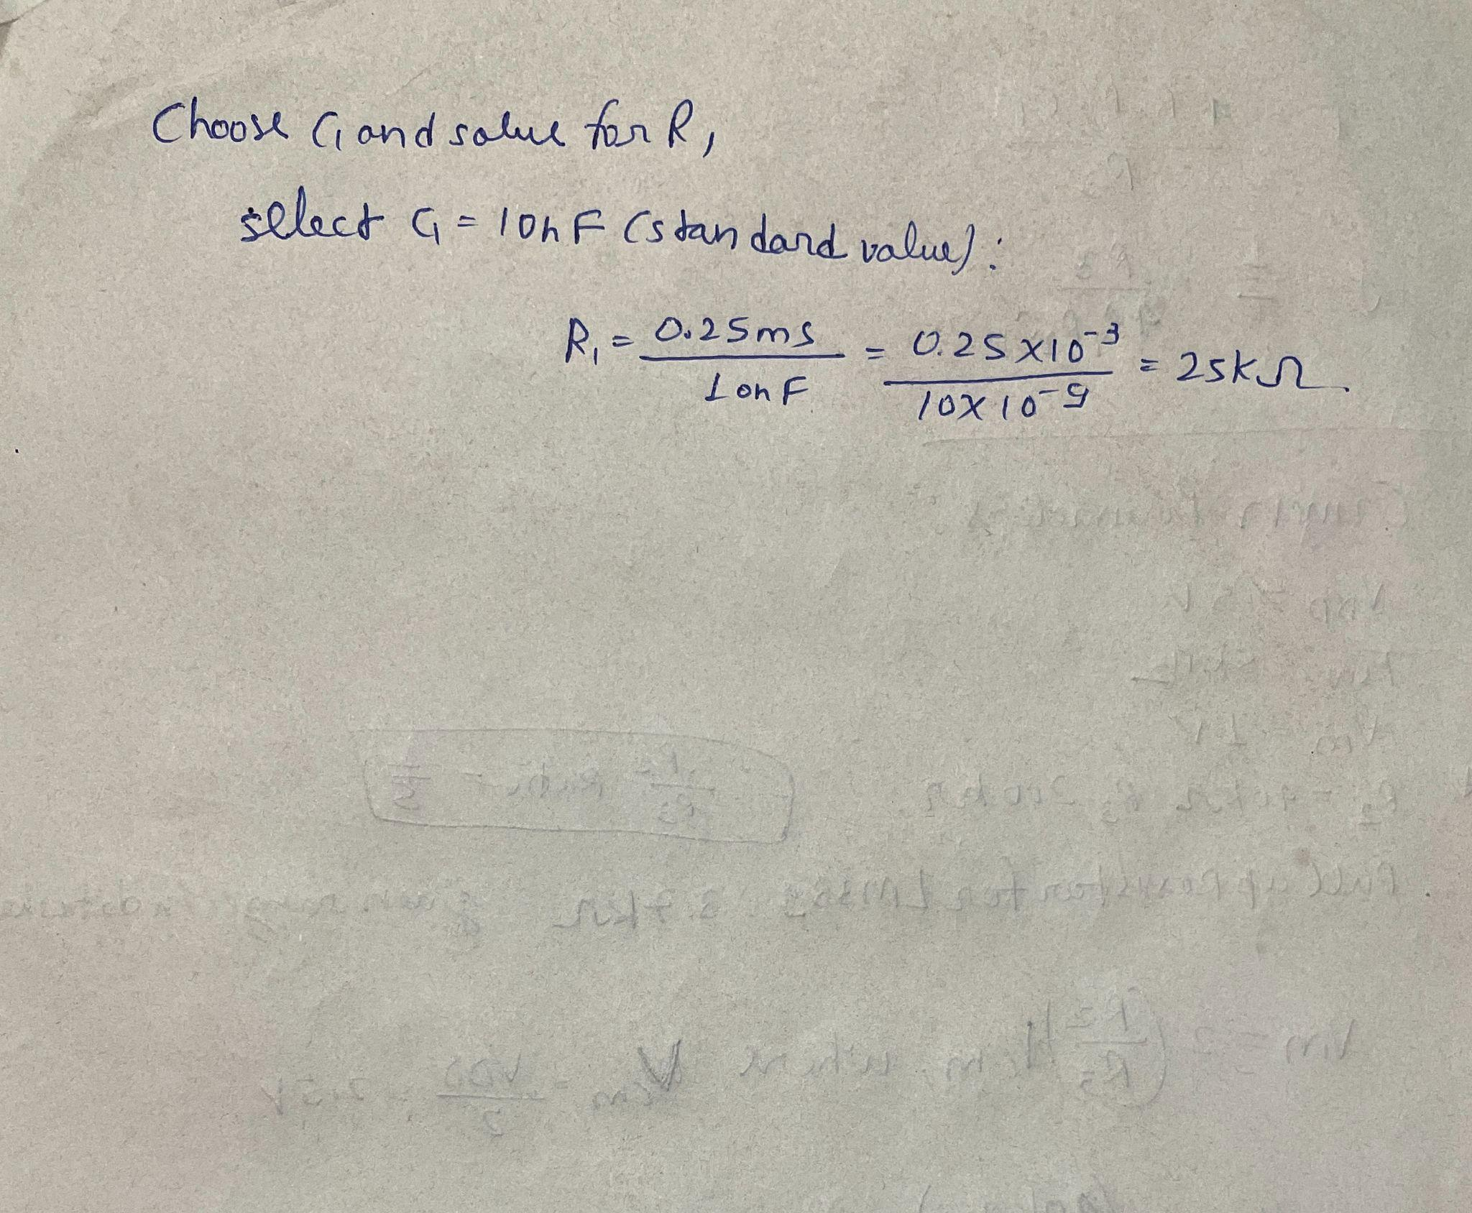

LTSpice Circuit and Output :-
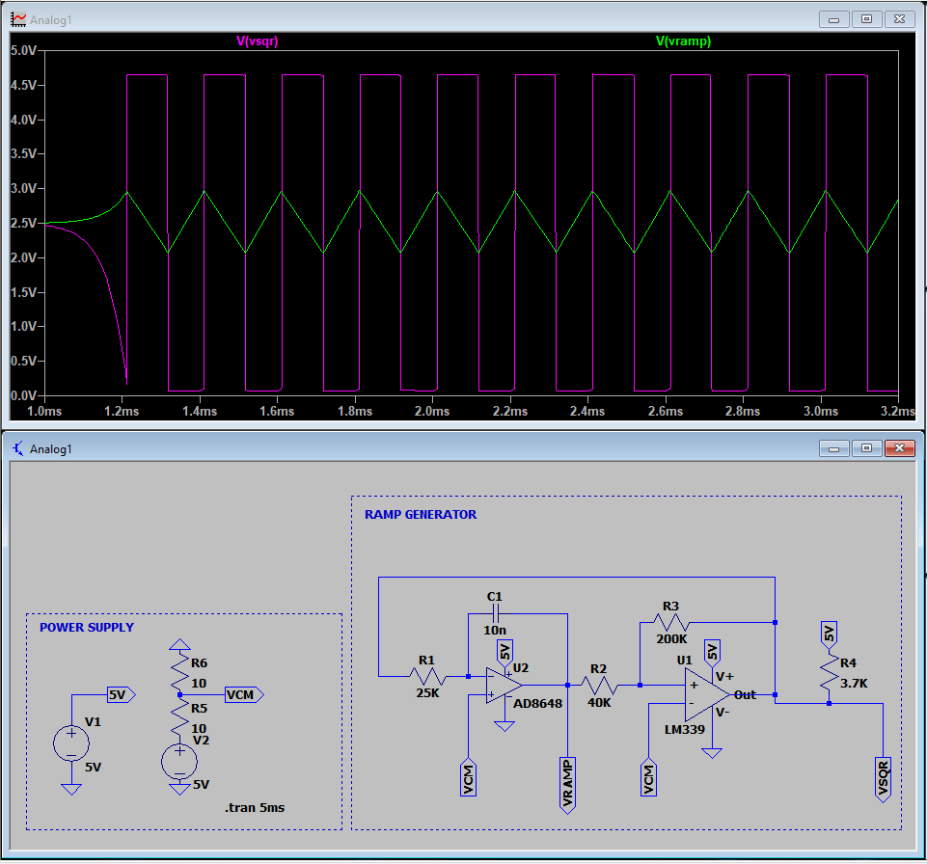

Physical Circuit :-
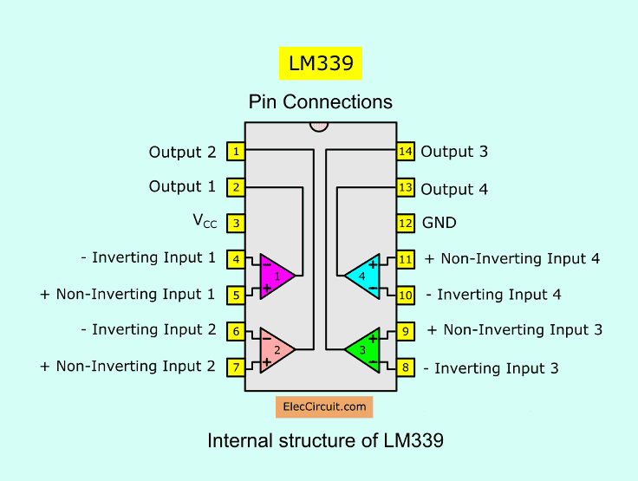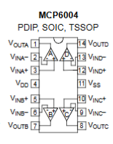
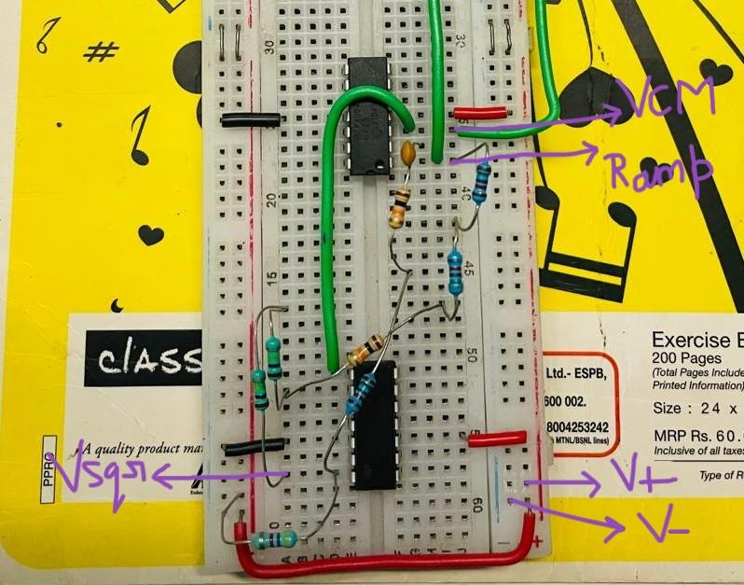
Physical Circuit Wire Connections :-

Black wires are Gnd, Red wires are for VDD 5V and Green wires are for VCM 2.5.

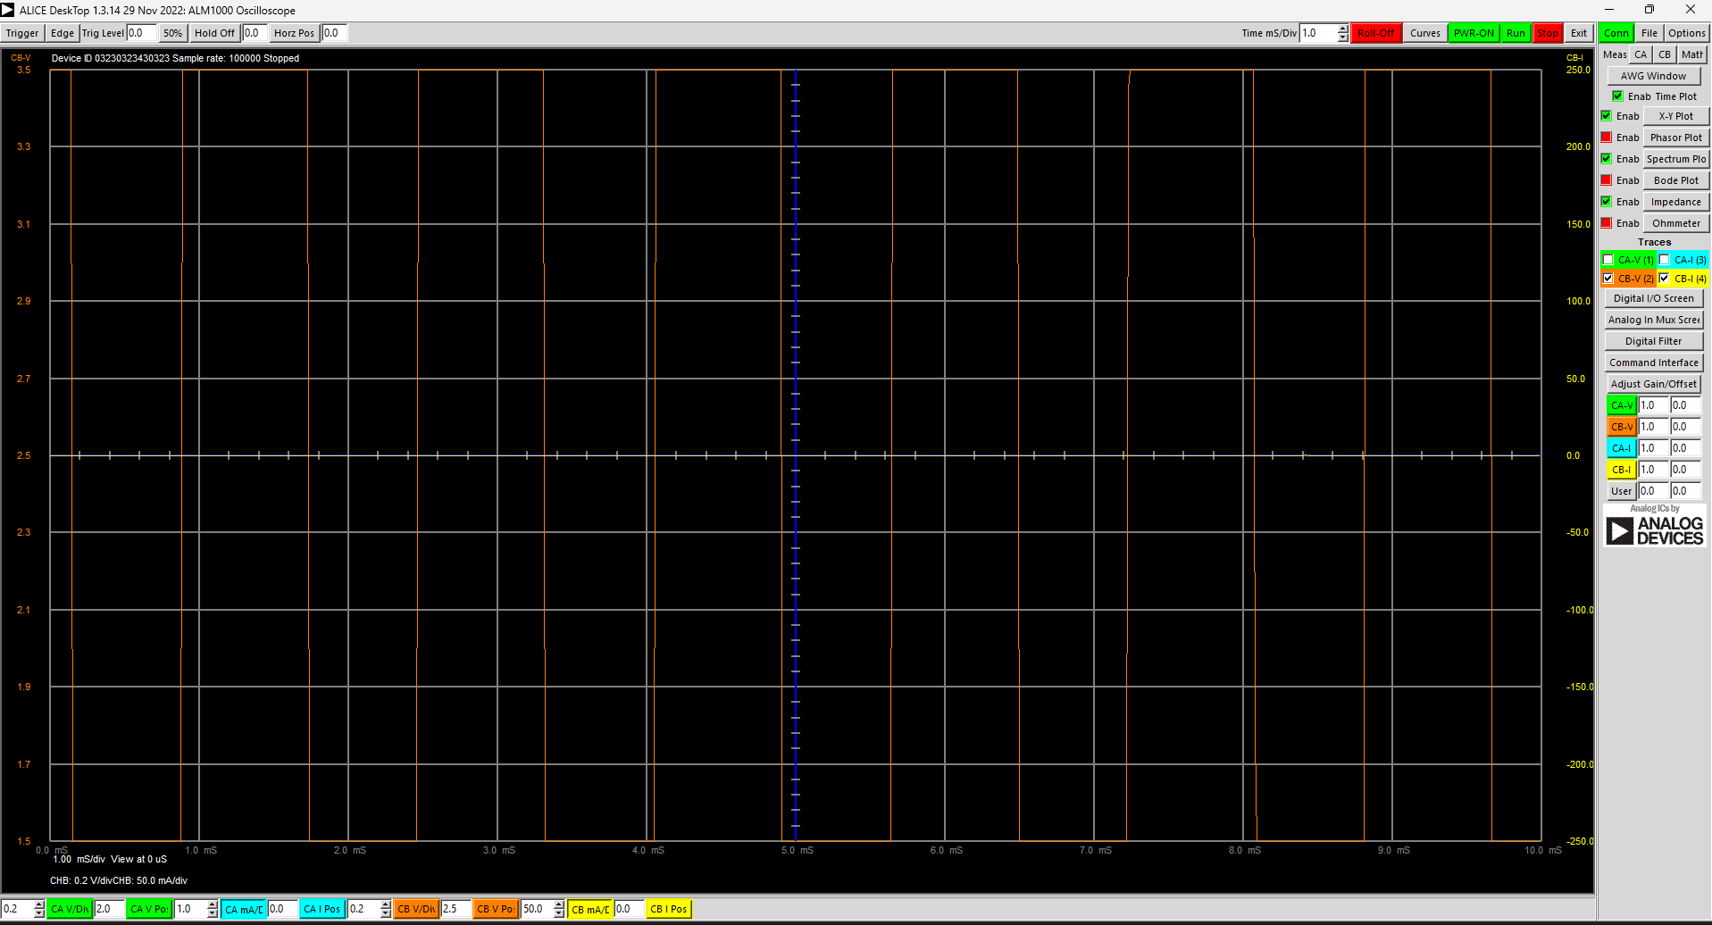
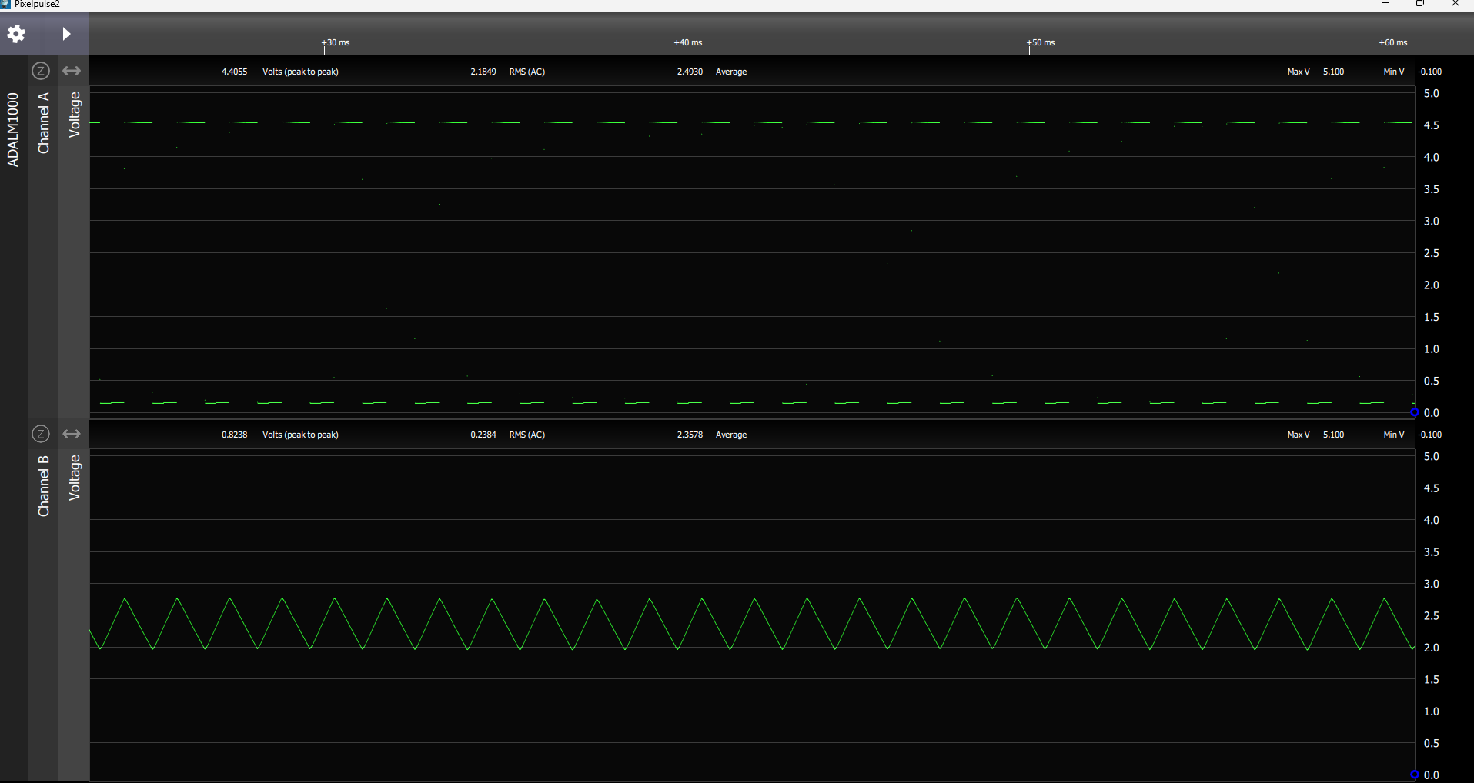

The Peak to Peak Voltage of the Ramp is not exactly 1V because the VDD and VCM are not exactly 5V and 2.5V ADALM1000 is too capable to deliver that much voltage.

Conclusion :-

We have successfully completed the experiment. We simulated the circuit and our output from the physical circuit and simulated circuit were around the same.

