Analog Lab Week - 2

Objective :

The aim of this experiment is build a single ended to differential input converter and PWM modulator. We will convert a single ended input signal into differential outputs also the required derivation will be done. We are going to simulate our circuit using LT Spice and then also going to make a physical circuit to verify our output and simulation.

List of Components :

1. We are going to use the previous circuit we build to generate a ramp wave.
2. Two LM339 as comparators, one MCP6004 for OP-amp.
3. Capacitor of 10uF.
4. Two resistors of 10k ohm and two pull up resistors of 4.7k ohm each.
5. ADALM kit to give Gnd , Vdd , sine wave and to also observe the output.

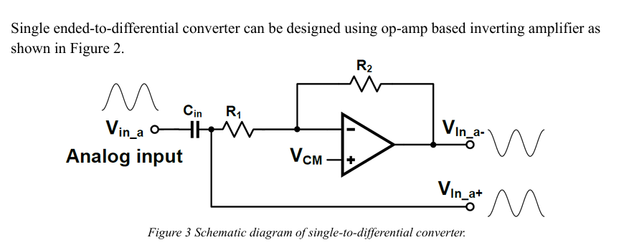
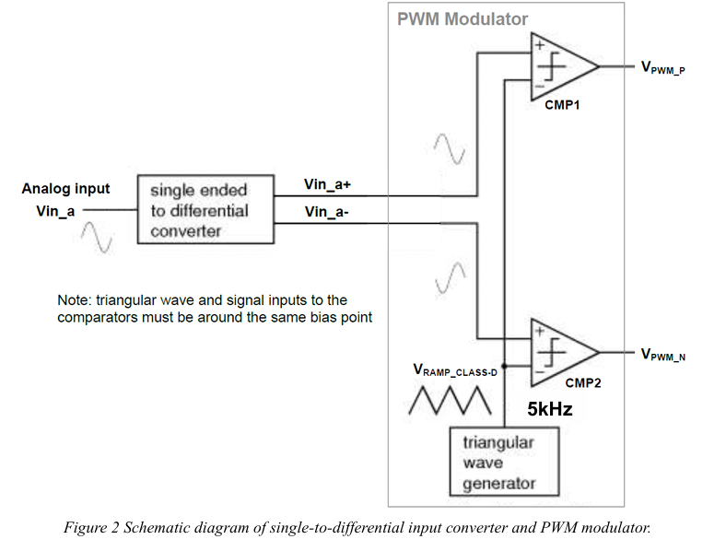
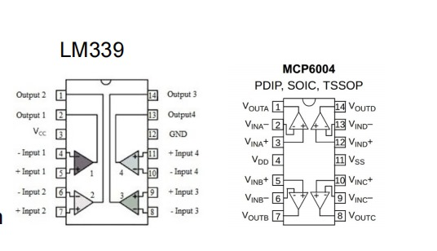
Derivation :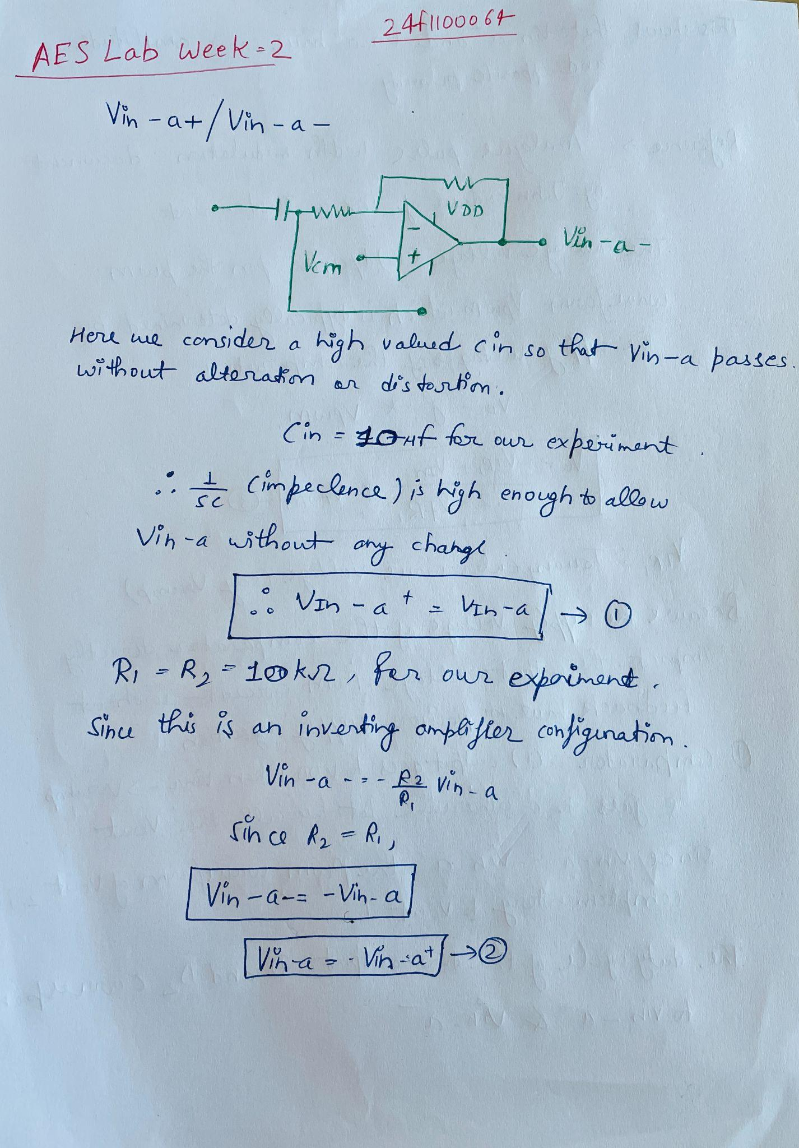
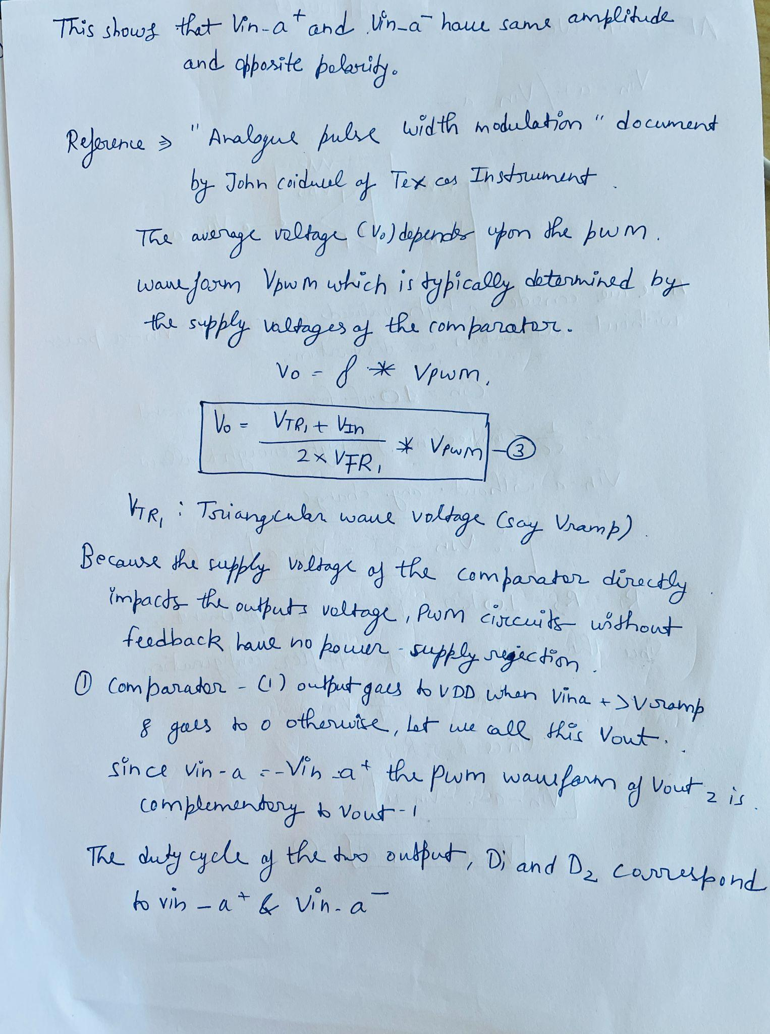

Derivation PWM :
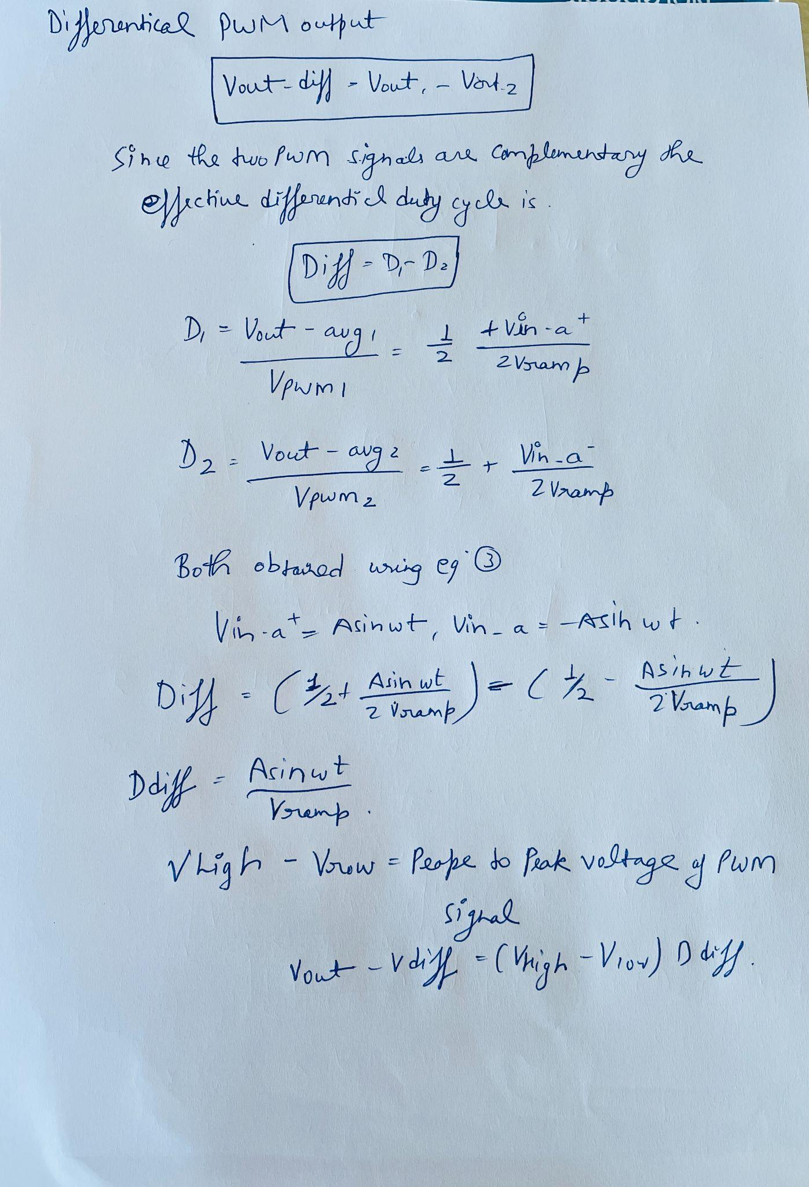
LT Spice CIRCUIT :

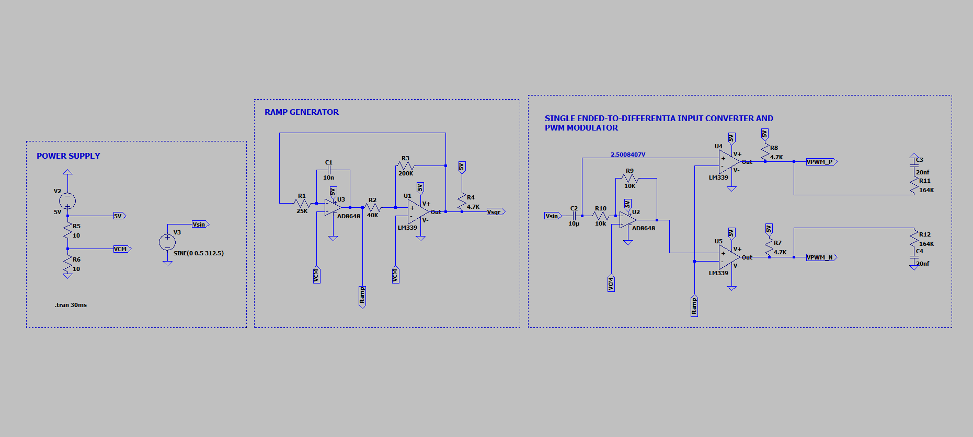

This is Output of PWM_N, PWM_P, Vin+ and Vin- are 180 degrees out of phase

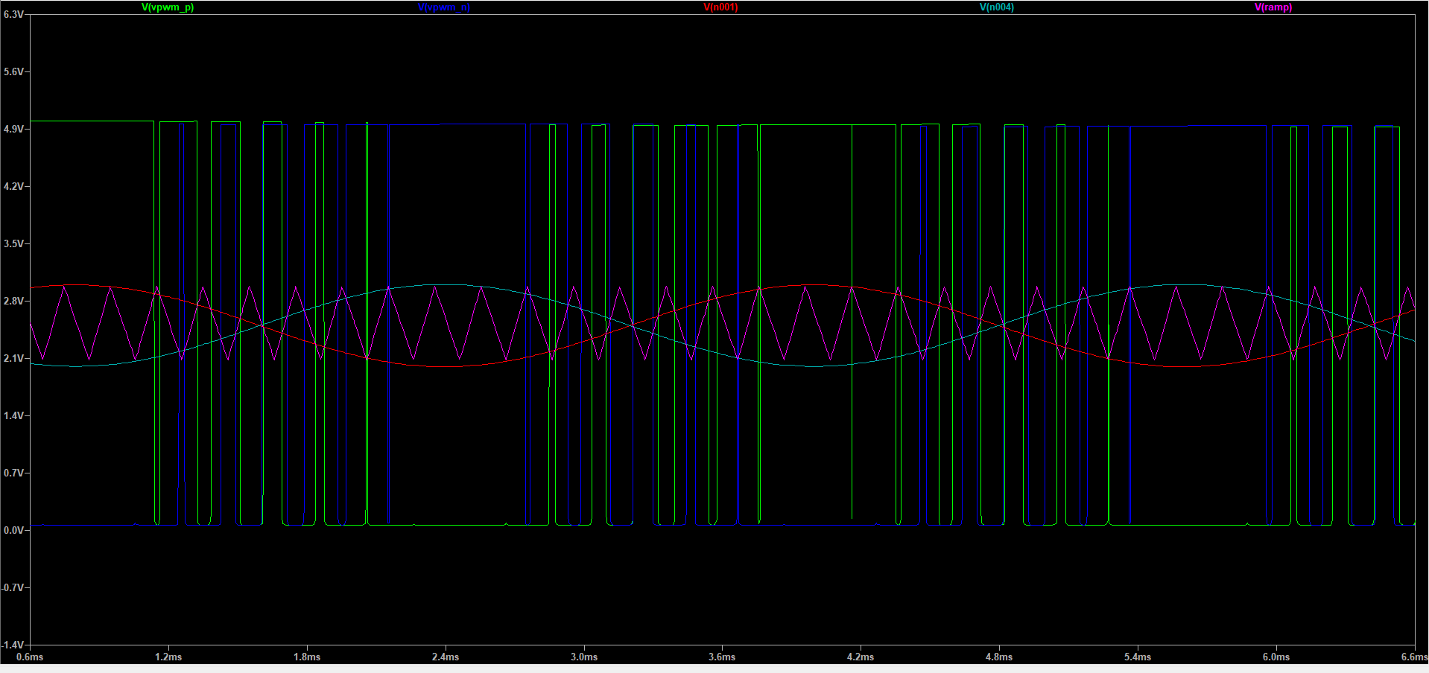

This is the output of RC filter out

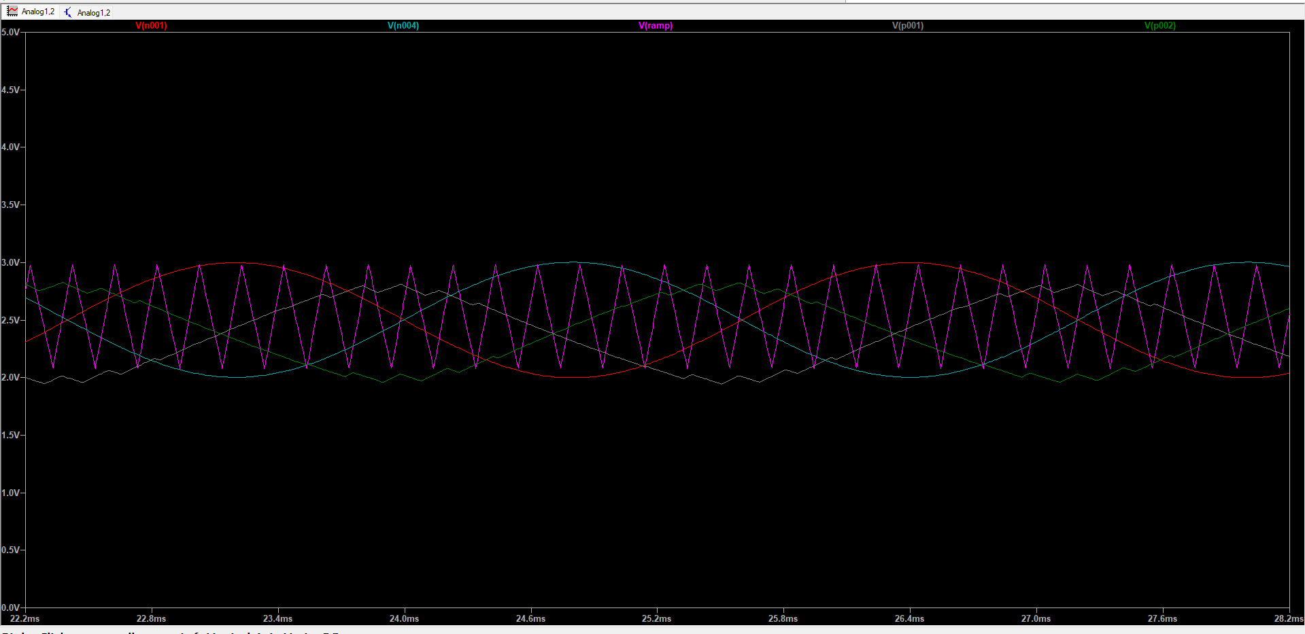
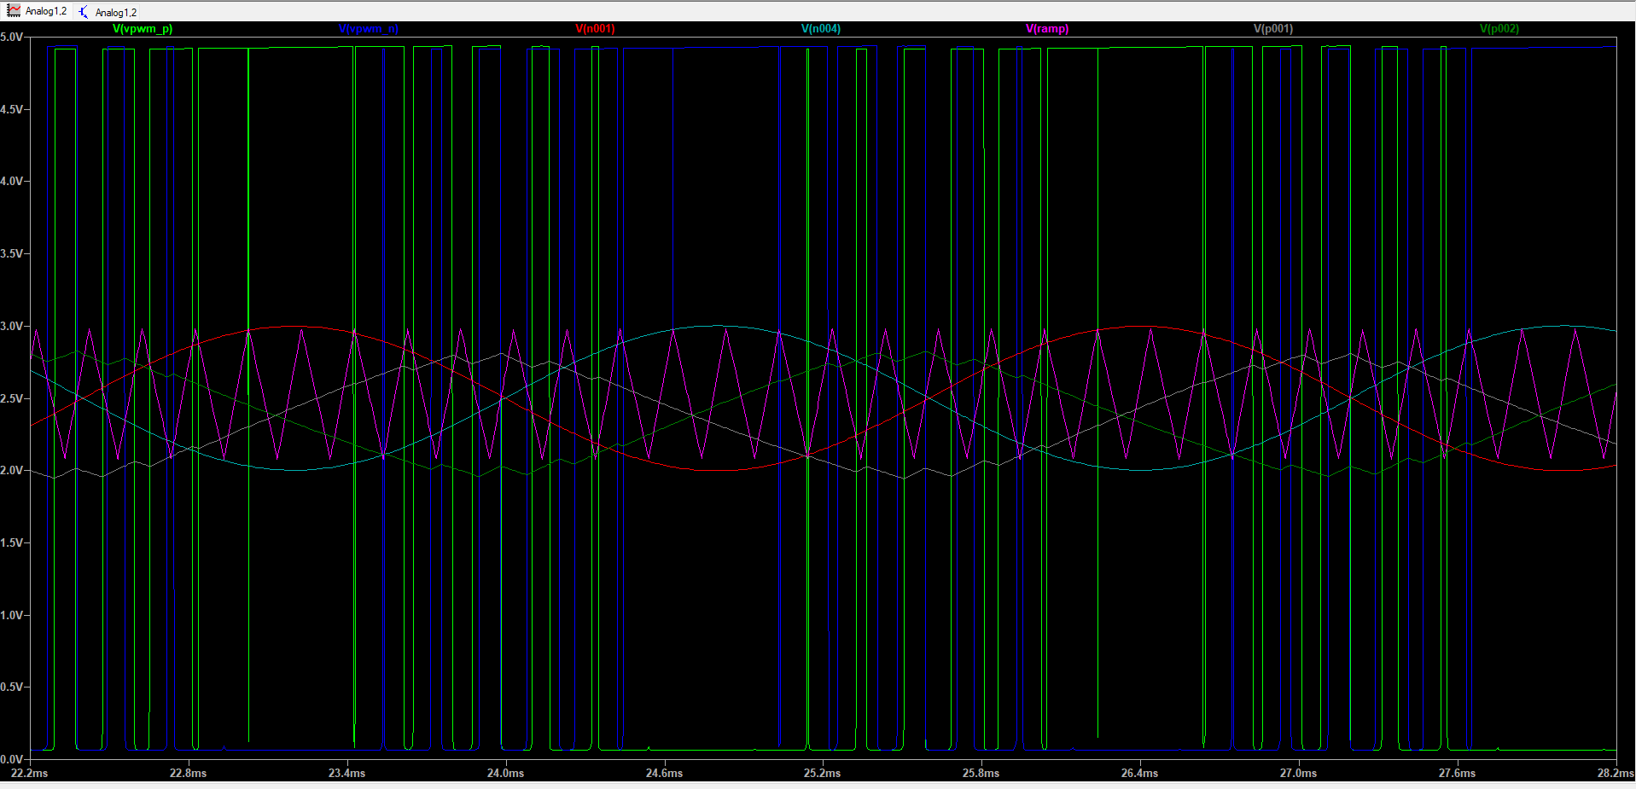

Physical CIRCUIT :

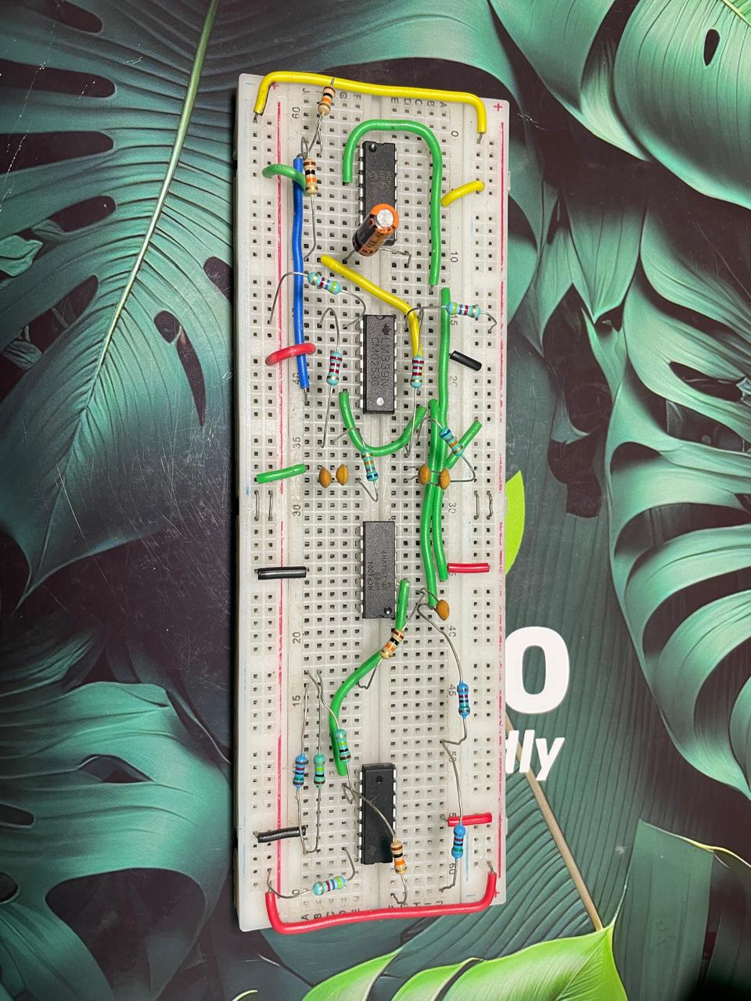
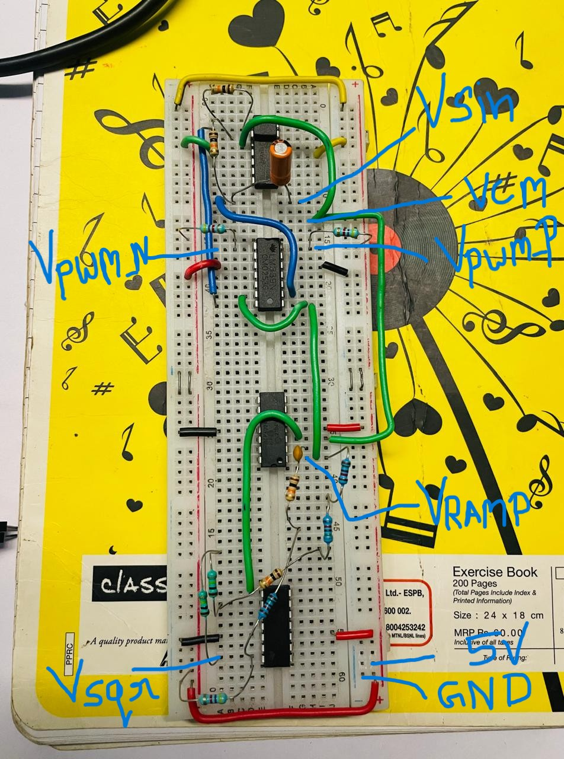
Alice OUTPUT :

This is PWM_P

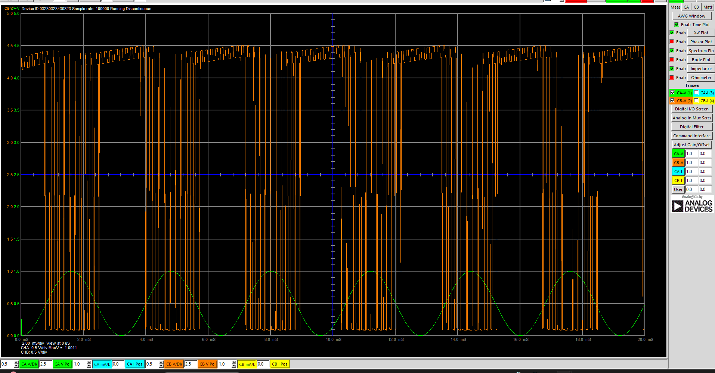

This is PWM_N

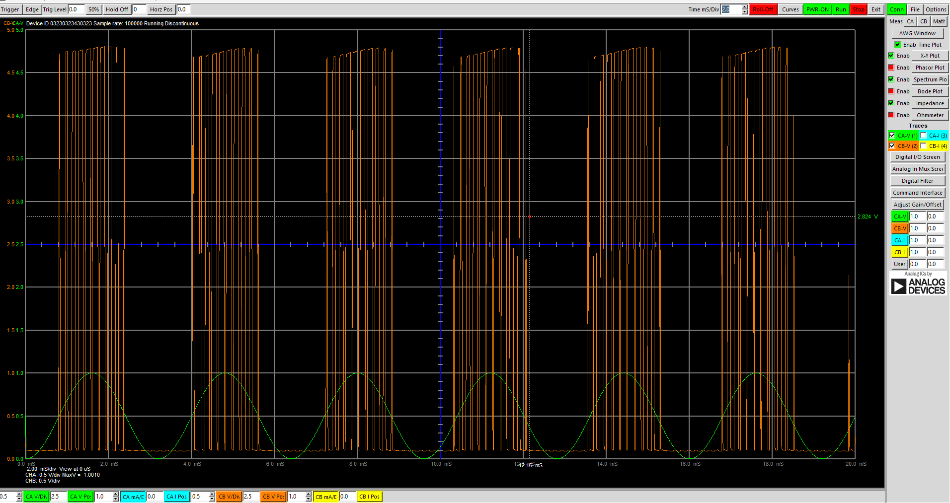
This is the of RC filter Vin+

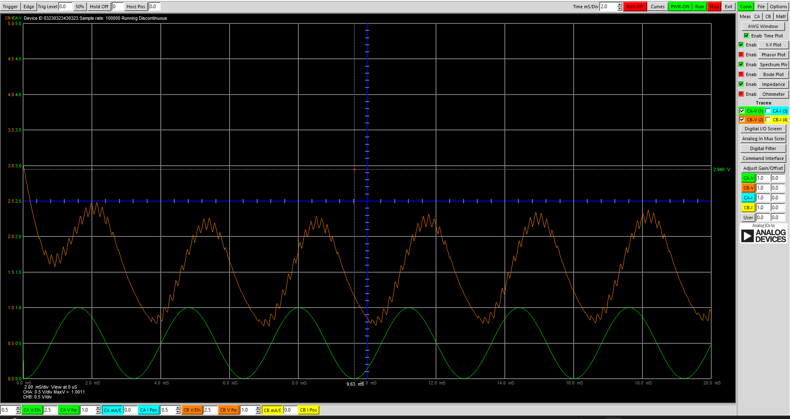

This is the of RC filter Vin-

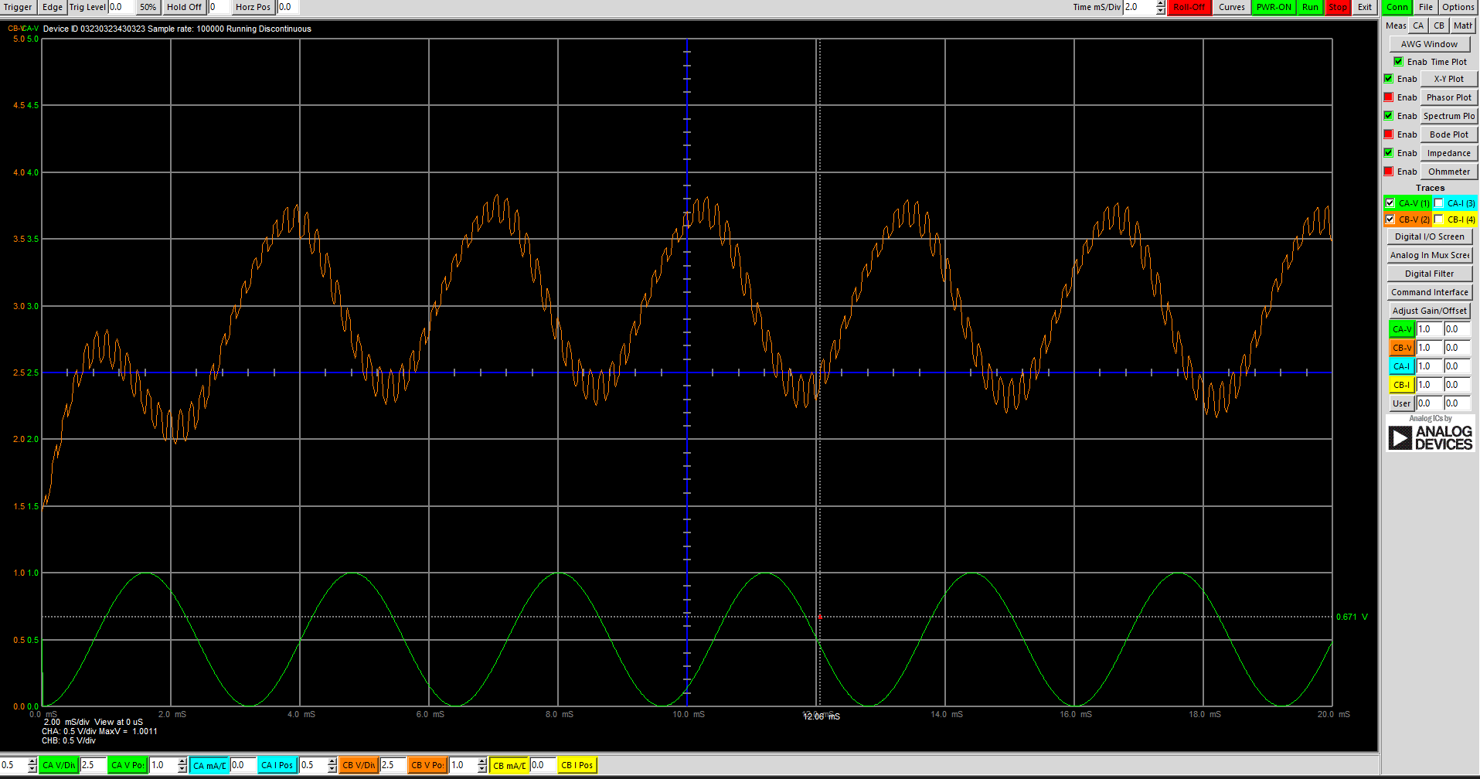

This is Vin_a+

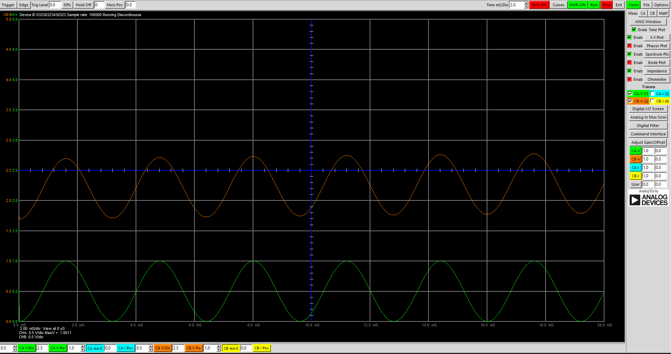

This is Vin_a-

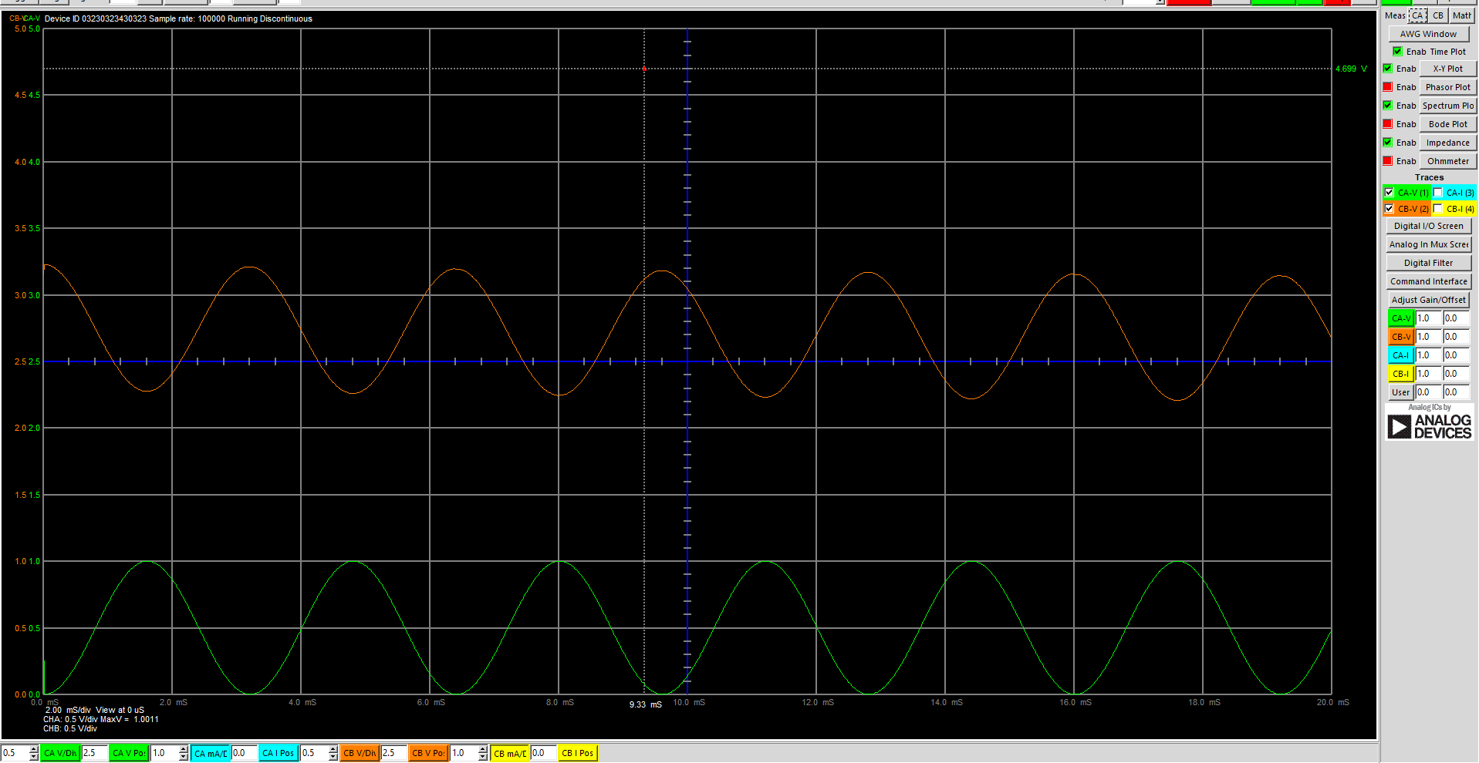

Here, we have successfully observed Our input sine wave , the inverted sine wave , the output of PWM_P and PWM_N.

Conclusion :

In the experiment we were successfully able to demonstrate the design of single ended
differential input converter and PWM modulator and were also able to analyze it. We were
also able to simulate the output and made a physical circuit to verify our analysis. The
simulation and the actual answers were around same.

