**Requirements Engineering Project**

24/11/2020

**SDH2-A**

**Room 3**

**Group Members:**

Eoin Fehily

Dylan Bearman

Saurabh Gaglani

**Table of Content**

Project Brainstorming 🡪 Page 3

Problem Statement 🡪 Page 4

Vision Statement 🡪 Page 5

User Roles 🡪 Page 6

Use cases and scenario 🡪 Page 6 – 10

Actors Grid 🡪 Page 11

Business Rules Grid 🡪 Page 12

Glosary 🡪 Page 13

Use Case Diagram 🡪 Page 14

Personas 🡪 Page 15 – 16

Just in mint prototype 🡪 Page 17

Project Retrospective 🡪 Page 17

Minutes of meetings 🡪 Page 18 - 21

**Project Brainstorming**

(Dylan Bearman)

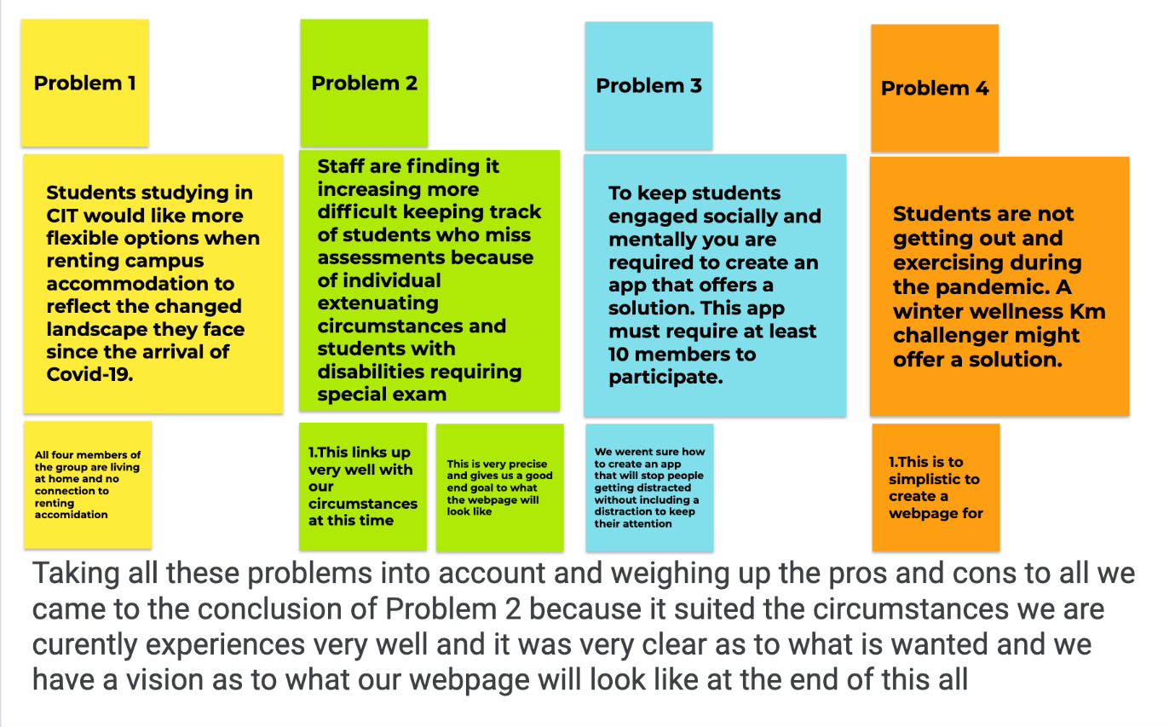

**Problem Statement**

(Eoin Fehily)

**Problem:** Staff are finding it difficult to keep track of students who have missed assessments and students are unable to make it known the reasons why on the system.

**Why?** The Staff cannot tell whether a student has a disability or is affected by an individual extenuating circumstance.

**Why?** The student cannot make it known they are affected by an individual extenuating circumstance or has a disability.

**Why?** The system does not have a feature that allows a student to make these circumstances or disabilities known to the staff. (**a root cause**).

**Problem Description:**

Students are unable to let Staff know whether they are affected by an extenuating circumstances or disability and thus Staff are unable to know about these issues which makes it difficult to keep track of the students who missed assessments for these reasons.

**Possible Solution:**

1. Implement a feature which allows a student to notify staff of their circumstances and issue an alert to staff.
2. Implement a feature which when a student misses an assessment gives staff potential reasons for this.
3. Implements option for the student to add a note to their user profile which lists their circumstances.
4. Students can flag assignments with their options to ask for an extension and the reasoning behind that which will allow them to notify staff of their disabilities or individual circumstances.

These possible solutions solve the root cause outlined above.

**Project Goals:**

1. For the user to be able to notify the staff of their circumstances.
2. For the staff to see why the student has missed an assessment.
3. To allow the staff to give an extension on the assessment based on what they have been notified of.

**Vision Statement**

(Thomas Dawson)

**For:** CIT Lecturers and CIT students

**Who:** The staff will need the application to be able to keep better track of the students who are submitting assignments, and record when the submission was uploaded and by who.

Students will need to be able to specify if they have any special needs or if they require any assistance due to unforeseen circumstances.

**The:** Focus.

**Is:** An app used for student/lecturer communication and assignment delivery and submissions.

**That:** Displays the assignments that the students still need to submit and also provides them with a space to flag a project or assignment with a specific reason as to why it has not yet been submitted. Students can also use this feature to ask a lecturer for help on an assignment. Lecturers will also be able to access previously submitted assignments, grade them and write comments on them to give the students help or advice on their assignments, allowing lecturers to grade and communicate with students about assignments all in the same app.

**Unlike:** Canvas, this application will be able to record the submission for each student and flag which submissions are missing and also highlight what assignments a student if struggling with, displaying a very clear reason why the student is struggling or hasn’t submitted the assignment yet, by implementing a simple colour coded flag on the assignment unit.

**Our Product**: Is able to make it easy for lecturers to view student assignments and projects. It will give students an easy way to communicate with their lecturers if they are having issues with assignments and ask for more time to submit or to ask for assistance on the assignment. It will also display the missing assignments for each student in a separate tab to make it clear which assignments are missing from each student, saving the lecturers time in finding out who still needs to submit, and if they haven’t, the student can communicate easily the reason why.

|  | Name | ID |  | Primary Actors | Task Pool |
| --- | --- | --- | --- | --- | --- |
|  | Flag Assignment | UC03 |  | Student |  |
|  | Grade Assignment | UC05 |  | Lecturer |  |
|  | Manage assignment | UC02 |  | Lecturer, Student |  |
|  | Register User | UC21 |  | Administrator |  |
|  | Submit Assignment | UC01 |  | Student |  |
|  | Submit IEC Form | UC23 |  | Student |  |
|  | Update Student Information | UC06 |  | Administrator |  |
|  | View IEC Submissions | UC22 |  | Administrator |  |
|  | View Student Information | UC07 |  | Administrator, Lecturer |  |
|  | View Submission | UC04 |  | Lecturer, Student |  |
|  | View Submission Grade | UC08 |  | Lecturer, Student |  |

# 1. Flag Assignment

ID: UC03

Flag assignment to say you have a disability and require an assignment extension or say you have a individual extenuating circumstance.

|  |  |
| --- | --- |
| Primary Actors | Student |

# 2. Grade Assignment

ID: UC05

Grade an assignments submission from a list of submissions.

|  |  |
| --- | --- |
| Primary Actors | Lecturer |

## 2.1. Scenarios

### 2.1.1. Grade Submission Successfully

|  |
| --- |
| 1. Select Module from list and Click Enter. |
| 2. if There is assignments for Module. |
| 2.1. SYSTEM Show Assignments for Module. |
| 2.2. Select Show Submissions |
| 2.3. if There is submissions available to grade. |
| 2.3.1. SYSTEM Display list of Submissions |
| 2.3.2. Click submission to grade. |
| 2.3.3. SYSTEM Show box to enter grade. |
| 2.3.4. Enter the mark for submission and click Publish grade. |
| 2.3.5. SYSTEM Publish grade for submission. |
| 2.3. end if |
| 3. else |
| 3.1. jump to 1. Select Module from list and Click Enter. |
| 3. end if |

### 2.1.2. Grade Submission Unscucessful

|  |
| --- |
| 1. Select Module from list and Click Enter. |
| 2. if There is assignments for Module. |
| 2.1. SYSTEM Show Assignments for Module. |
| 2.2. Select Show Submissions |
| 2.3. if There is no submissions available to grade. |
| 2.3.1. SYSTEM Issue alert saying there are no submissions to grade. |
| 2.3.2. jump to 1. Select Module from list and Click Enter. |
| 2.3. end if |
| 3. else |
| 3.1. jump to 1. Select Module from list and Click Enter. |
| 3. end if |

# 3. Manage assignment

ID: UC02

Create an assignment for a module or edit the details of an assignment.

|  |  |
| --- | --- |
| Primary Actors | Lecturer,  Student |

## 3.1. Scenarios

### 3.1.1. Scenario

|  |
| --- |
| 1. |

### 3.1.2. Sucessfull uploading of submission

|  |
| --- |
| 1. The lecturer selects the file containing the project description to upload and clicks Next |
| 2. The lecturer adds a due date for the project that will show to students their deadline and Click Next |
| 3. SYSTEM accepts the file type that’s being uploaded. |
| 4. The lecturer adds a note in the description box to provide guidance for the project and click Enter |
| 5. if it uploads successfully |
| 5.1. SYSTEM The assignment is uploaded, and students are able to see it. |
| 5.2. SYSTEM Prints to the screen successfully |
| 5. end if |

### 3.1.3. UnSucessfull uploading of submission

|  |
| --- |
| 1. The lecturer selects the file containing the project description to upload and clicks Next |
| 2. The lecturer adds a due date for the project that will show to students their deadline and Click Next |
| 3. SYSTEM accepts the file type that’s being uploaded. |
| 4. The lecturer adds a note in the description box to provide guidance for the project and click Enter |
| 5. if it uploads unsuccessfully |
| 5.1. SYSTEM Prints to the screen unsuccessfully |
| 5.2. SYSTEM The assignment is not uploaded, and students are not able to see it. |
| 5.3. SYSTEM The systems dvises the lecturer to pick a different file type |
| 5.4. SYSTEM The system also advises the lecturer to change the visibility of the assignment |
| 5. end if |

# 4. Register User

ID: UC21

Enter student details and create online student account.

|  |  |
| --- | --- |
| Primary Actors | Administrator |

## 4.1. Scenarios

### 4.1.1. Sucessfull Registration

|  |
| --- |
| 1. Enter name Click Enter |
| 2. Enter d.o.b. Click Enter |
| 3. Enter address Click Enter |
| 4. Enter users preferred password Click Enter |
| 5. SYSTEM Prints to the screen registering user |
| 6. users details are correct |
| 6.1. SYSTEM Prints to the screen successful registration |

### 4.1.2. Unsuccessfull Registration

|  |
| --- |
| 1. Enter name Click Enter |
| 2. Enter d.o.b. Click Enter |
| 3. Enter address Click Enter |
| 4. Enter phone and click Enter |
| 5. Enter student number Enter |
| 6. Enter students email addreess Enter |
| 7. |
| 8. Enter users preferred password Click Register |
| 9. SYSTEM Prints to the screen registering user |
| 10. SYSTEM Users details are incorrect |
| 10.1. SYSTEM Prints to the screen unsucessfull registrationan |
| 10.2. if Details are incorrect because they are already on record |
| 10.2.1. SYSTEM Gives option to change |
| 10.2. end if |

# 5. Submit Assignment

ID: UC01

Student publishes the submission to the assignment.

|  |  |
| --- | --- |
| Primary Actors | Student |

## 5.1. Scenarios

### 5.1.1. Scenario

|  |
| --- |
| 1. |

# 6. Submit IEC Form

ID: UC23

A form submitted for an individual extenuating circumstance by a student to be approved/disapproved by a lecturer.

|  |  |
| --- | --- |
| Primary Actors | Student |

# 7. Update Student Information

ID: UC06

Option for the Admin to change details of the student profile.

|  |  |
| --- | --- |
| Primary Actors | Administrator |

## 7.1. Scenarios

### 7.1.1. Update Information Successful

|  |
| --- |
| 1. Enter Student Number and click Search. |
| 2. if Student exists. |
| 2.1. SYSTEM Show student information fields and option to edit. |
| 2.2. Make an edit to fields of Student and click Update. |
| 2.3. SYSTEM Validate fields. |
| 2.4. if Information is valid. |
| 2.4.1. SYSTEM Update student information on System. |
| 2.5. else |
| 2.5.1. jump to 2.2. Make an edit to fields of Student and click Update. |
| 2.5. end if |
| 2. end if |

### 7.1.2. Update Information unsuccessful

|  |
| --- |
| 1. Enter Student Number and click Search. |
| 2. if Student does not exist. |
| 2.1. SYSTEM Issue alert saying no student exists. |
| 2.2. jump to 1. Enter Student Number and click Search. |
| 2. end if |

# 8. View IEC Submissions

ID: UC22

Approve/Disapprove IEC Form

|  |  |
| --- | --- |
| Primary Actors | Administrator |

# 9. View Student Information

ID: UC07

Option for Admin and Lecturer to view details of Student profile.

|  |  |
| --- | --- |
| Primary Actors | Administrator,  Lecturer |

# 10. View Submission

ID: UC04

Option for Lecturer to view Submission of Students and option for Student  to view his/her submission.

|  |  |
| --- | --- |
| Primary Actors | Lecturer,  Student |

# 11. View Submission Grade

ID: UC08

Student can view grade for submission if available.

|  |  |
| --- | --- |
| Primary Actors | Lecturer,  Student |

# 12. Actors Grid

| Name | Description | Goals |
| --- | --- | --- |
| Submit Assignment | Student publishes the submission to the assignment. |  |
| View Submission Grade | Student can view grade for submission if available. |  |
| Update Student Information | Option for the Admin to change details of the student profile. |  |
| View Submission | Option for Lecturer to view Submission of Students and option for Student  to view his/her submission. |  |
| View Student Information | Option for Admin and Lecturer to view details of Student profile. |  |
| Grade Assignment | Grade an assignments submission from a list of submissions. |  |
| Flag Assignment | Flag assignment to say you have a disability and require an assignment extension or say you have a individual extenuating circumstance. |  |
| Register User | Enter student details and create online student account. |  |
| Manage assignment | Create an assignment for a module or edit the details of an assignment. |  |
| View IEC Submissions | Approve/Disapprove IEC Form |  |
| Submit IEC Form | A form submitted for an individual extenuating circumstance by a student to be approved/disapproved by a lecturer. |  |

# 13. Business Rule Grid

| ID | Name | Type | Rule |
| --- | --- | --- | --- |
| BR001 | Student Information kept confidental |  | A student’s special needs and extenuating circumstances must be kept confidential and only shown to those who require this knowledge, for example, the student’s lecturers. |
| BR002 | Communications kept confidential. |  | Communications with lecturers must be kept confidential and must be made clear to all parties involved if the information is not confidential. |
| BR003 | Lecturers can only access profiles of their students not others. |  | Lecturers must only have access to the profiles of students that they themselves teach and have no access to students that they don’t teach, unless they have a specific reason for it that has been approved by the student in question. |
| BR004 | Grades given by Lecturer. |  | Grades can only be granted and changed by lecturers who have access to a students profile. |
| BR005 | Extensions kept confidential. |  | Any extensions that are given must not be shown to other students, as that will be a potential breach of confidentiality, only the parties involved must have access to this information. |

# 14. Glossary

| Name | Aliases | Labels | Description |
| --- | --- | --- | --- |
| User |  |  | person using the application |
| Administrator | Admin |  | person responsible for carrying out administration of a web application |
| Student |  |  | User that studies at the educational establishment |
| Lecturer |  |  | Person responsible for teaching specific module and reviving assignment submissions |
| Online |  |  | On the World Wide Web |
| Grade |  |  | Marks given to student by lecturer on an assignment |
| School |  |  | Educational establishment where student studies. |
| IEC |  |  | An individual extenuating circumstance a student may have. |
| Register |  |  | Add user to database and information about the user. |
| Assignment |  |  | A task given by the lecturer to be completed and submitted online |

# 15. Use Case Diagram1

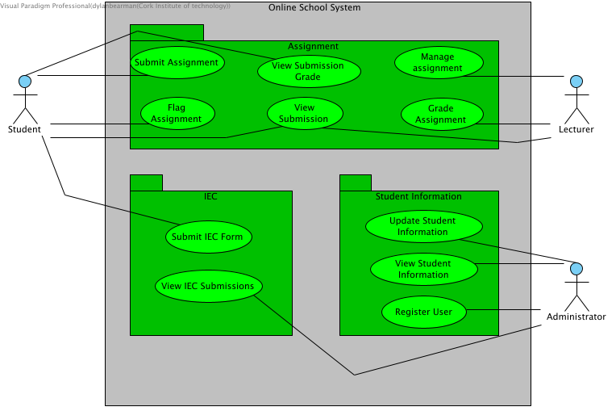

Project Retrospective

In our opinion we were lucky with the group we had, we were all active and participated in the majority of the labs we had. As a group we decided to have two meetings a week which would come to a total of 8 which gave us more than enough time. During these meeting we took minutes of the meetings and planned out what we were all going to do weather that was individual assignments or ones where the group had to come together. I don’t think you could fault the team we had. Saying that though no one is perfect. I think if we firstly made an effort to go to all the labs as a team it would make our workload outside the labs a lot easier. It would have also cut down the workload giving us more time to get into the smaller details within our project. If we were to do this project again the team leader should make sure everyone goes to the labs and those who didn’t would be made aware to the lecturer. As a team of now three we would make sure that our team would stick it out to the end because this time around we were left in a sticky situation where one member dropped out and because of this meant the other members had to compensate for his work.

Minutes Of Meetings

WEEK1

MEETING1

Location: Zoom

Date: 24/11/20

Time: 18:00

Attendees: Dylan Bearman, Eoin Fehily, Thomas Dawson, Saurabh Gaglani

Agenda:

1. Create the project report file
2. Project Brainstormind
3. Problem Statement
4. Vision Statement

MEETING 2

Location: Zoom

Date: 27/11/20

Time: 19:00

Attendees: Dylan Bearman, Eoin Fehily, Thomas Dawson, Saurabh Gaglani

Agenda:

Make sure everything is completed and submit together as a team

Minutes Of Meetings

WEEK 2

MEETING 3

Location: Zoom

Date: 1/12/20

Time: 18:00

Attendees: Dylan Bearman, Eoin Fehily Saurabh Gaglani, Thomas Dawson

Agenda:

1. Actors Grid (VP)
2. Persona Descriptions (WORD)
3. Business Rules (VP)
4. Glosary grid (VP)
5. Use case Diagram (VP)
6. Update report file (WORD)

MEETING 4

Location: Zoom

Date: 4/12/20

Time: 19:00

Attendees: Dylan Bearman, Eoin Fehily Saurabh Gaglani, Thomas Dawson

Agenda:

Make sure everything is completed and submit together as a team

Minutes Of Meetings

WEEK 3

MEETING 5

Location: Zoom

Date: 8/12/20

Time: 18:00

Attendees: Dylan Bearman, Eoin Fehily Saurabh Gaglani

Agenda:

1. JustinMind prototype
2. Screencast
3. Update report file

MEETING 6

Location: Zoom

Date: 11/12/20

Time: 19:00

Attendees: Dylan Bearman, Eoin Fehily Saurabh Gaglani

Agenda:

Make sure everything is completed and submit together as a team

Minutes Of Meetings

WEEK 4

MEETING 7

Location: Zoom

Date: 15/12/20

Time: 18:00

Attendees: Dylan Bearman, Eoin Fehily Saurabh Gaglani

Agenda:

1. User story map (VP)
2. Sprint (VP)
3. Update report file

MEETINH 8

Location: Zoom

Date: 18/12/20

Time: 19:00

Attendees: Dylan Bearman, Eoin Fehily Saurabh Gaglani

Agenda:

Make sure everything is completed and submit together as a team