Python操作sqlite数据库

1.

#创建数据库

conn = sqlite3.connect('I:/test.db')

print ("Opened database successfully","\n")

c = conn.cursor()

2.

#创建表格

c.execute('''CREATE TABLE COMPANY

       (ID INT PRIMARY KEY     NOT NULL,

       NAME           TEXT    NOT NULL,

       AGE            INT     NOT NULL,

       ADDRESS        CHAR(50),

       SALARY         REAL);''')

print ("Table created successfully","\n")

conn.commit() """

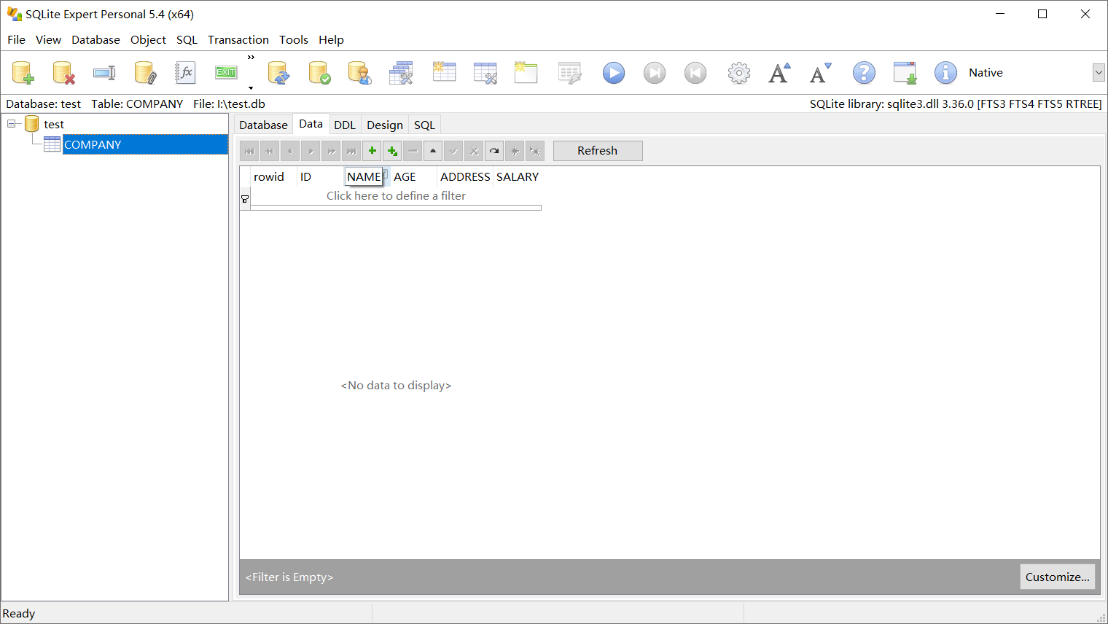

3.

#插入数据

c.execute("INSERT INTO COMPANY (ID,NAME,AGE,ADDRESS,SALARY) \

      VALUES (1, 'Paul', 32, 'California', 20000.00 )")

c.execute("INSERT INTO COMPANY (ID,NAME,AGE,ADDRESS,SALARY) \

      VALUES (2, 'Allen', 25, 'Texas', 15000.00 )")

c.execute("INSERT INTO COMPANY (ID,NAME,AGE,ADDRESS,SALARY) \

      VALUES (3, 'Teddy', 23, 'Norway', 20000.00 )")

c.execute("INSERT INTO COMPANY (ID,NAME,AGE,ADDRESS,SALARY) \

      VALUES (4, 'Mark', 25, 'Rich-Mond ', 65000.00 )")

conn.commit()

print ("Records created successfully","\n")

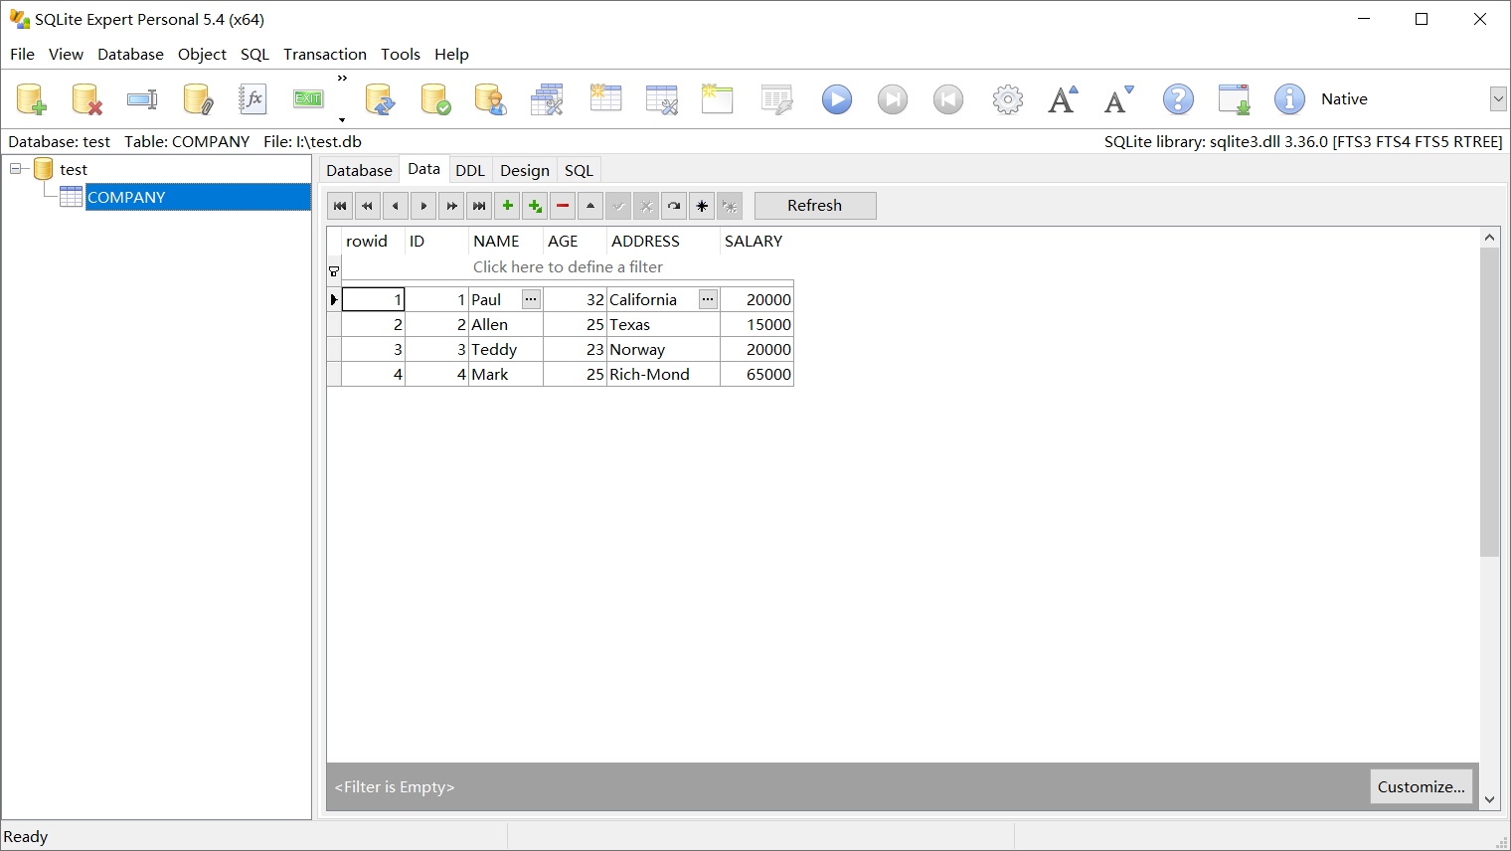

4.

#查询数据

cursor = c.execute("SELECT id, name, address, salary  from COMPANY")

for row in cursor:

   print ("ID = ", row[0])

   print ("NAME = ", row[1])

   print ("ADDRESS = ", row[2])

   print ("SALARY = ", row[3])

ID = 1

NAME = Paul

ADDRESS = California

SALARY = 20000.0

ID = 2

NAME = Allen

ADDRESS = Texas

SALARY = 15000.0

ID = 3

NAME = Teddy

ADDRESS = Norway

SALARY = 20000.0

ID = 4

NAME = Mark

ADDRESS = Rich-Mond

SALARY = 65000.0

5.

#更改数据

c.execute("UPDATE COMPANY set SALARY = 25000.00 where ID=1")

conn.commit()

print ("Total number of rows updated :",conn.total_changes,"\n")

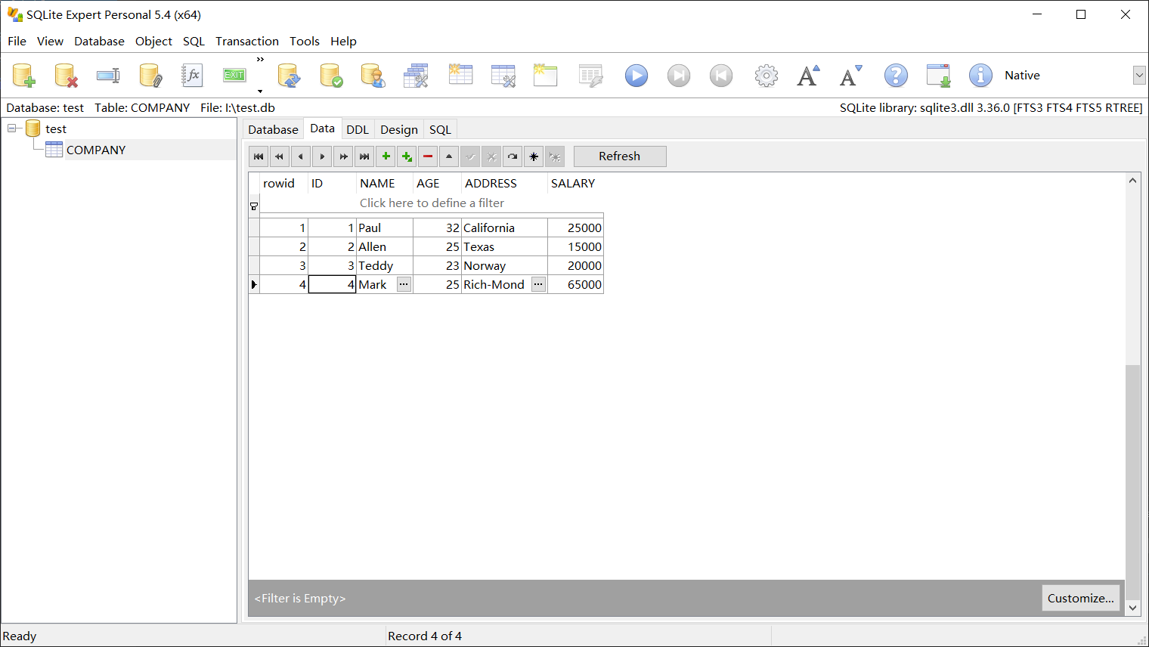

6.

#删除数据

c.execute("DELETE from COMPANY where ID=2;")

conn.commit()

print ("Total number of rows deleted :",conn.total_changes,"\n")

