练习：
1 用for循环语句计算5+10+15+20+.......1000之和 (while ; do while; for 三种循环语句实现)
for循环语句代码：
public class SumWay1 {
public static void main(String[] args) {
int sum = 0;
for (int i = 5; i <= 1000; i += 5) {
sum += i;
}
System.out.println("5+10+15+20+...+1000之和为：" + sum);
}
}
结果：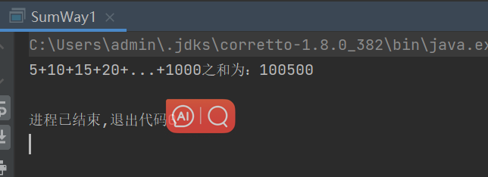

While循环语句代码：public class SumWay2 {
public static void main(String[] args) {
int sum = 0;
int i = 5;
while (i <= 1000)
{
sum += i;
i += 5;
}
System.out.println("5+10+15+20+...+1000之和为：" + sum);
}
}

结果：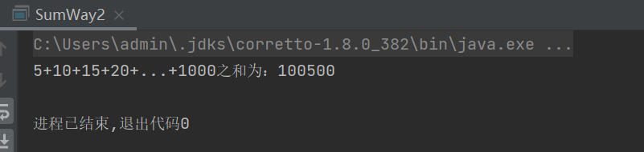

do while循环语句代码：public class SumWay2 {
public static void main(String[] args) {
int sum = 0;
int i = 5;
do {
sum += i;
i += 5;
} while (i <= 1000);
System.out.println("5+10+15+20+...+1000之和为：" + sum);
}
}

结果：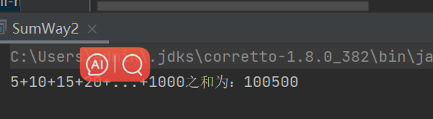

2 计算1*2 + 3*4 + 5*6 +.... +199*200 (while 循环语句实现)
public class SumMult {
public static void main(String[] args) {
int sum = 0;
int i = 1;
//类似加法1+2+3+...+100
while (i <= 199) {
sum += i * (i + 1);
i += 2;
}

System.out.println("1*2 + 3*4 + 5*6 + ... + 199*200之和为：" + sum);
}
}
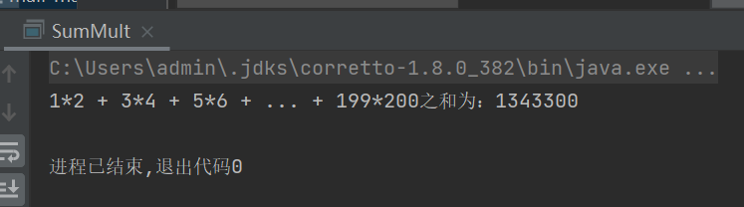

3 用循环语句计算 1/2 -2/3 + 3/4 -4/5 ...... + 99/100( do while 循环语句实现)
package com.macro.mall;
public class VaryNum {
public static void main(String[] args) {
double sum = 0.0;
int denominator = 2;
int numerator = 1;
boolean addFraction = true;
do {
if (addFraction) {
sum += (double) numerator / denominator;
} else {
sum -= (double) numerator / denominator;
}
addFraction = !addFraction;
//java这样的写法比较常见
numerator++;
denominator++;
} while (denominator <= 100);
System.out.println("1/2 - 2/3 + 3/4 - 4/5 + ... + 99/100之和为: " + sum);
}
}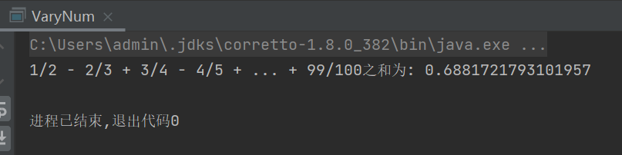

4 用循环语句计算 1/2 +2/3 - 3/4 +4/5+5/6-6/7+ ......+98/99- 99/100
package com.macro.mall;

public class VaryNum1 {
public static void main(String[] args) {
double sum = 0.0;
int numerator = 1;
int denominator = 2;
boolean addFraction = true;
for (int i = 1; i <= 99; i++) {
double fraction = (double) numerator / denominator;
if (addFraction) {
sum += fraction;
} else {
sum -= fraction;
}
addFraction = !addFraction;
numerator++;
denominator++;
}
System.out.println("1/2 + 2/3 - 3/4 + 4/5 + 5/6 - 6/7 + ... + 98/99 - 99/100之和为: " + sum);
}
}
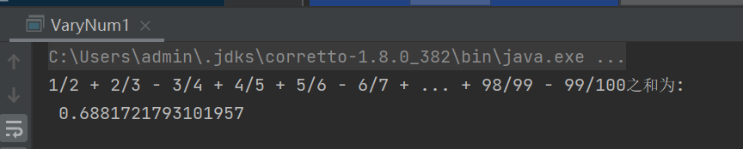

5 计算π值
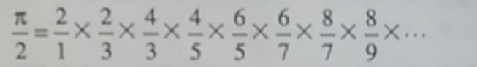
public class GuessPi {
public static void main(String[] args) {
int n = 3; // 用于控制计算的项数
double piOver2 = 1.0;
for (int i = 1; i <= n; i++) {
int numerator = 2 * i;
int denominator = 2 * i - 1;
piOver2 *= (double)numerator / denominator;
}
double estimatedPi = piOver2;
System.out.println("估算的π值为：" + estimatedPi);
}
}
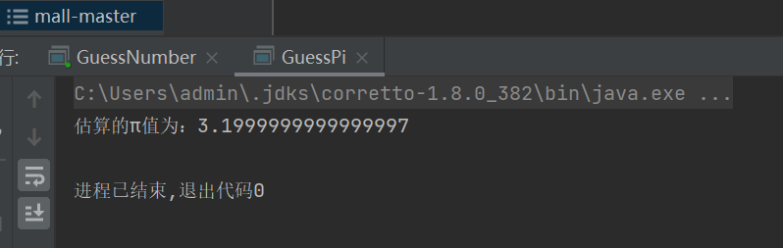
6 从键盘输入10万至100万内的数，若输入尾数为零，则重新输入，或输入的数不在该范围重新输入，然后判断该数能否被4577整除，若能整除，则退出循环，否则继续输入。
package com.macro.mall;
import java.util.Scanner;
public class Main {
public static void main(String[] args) {
Scanner scanner = new Scanner(System.in);
int number;
do {
System.out.print("请输入一个10万至100万内的数：");
number = scanner.nextInt();
// 检查是否在指定范围内
if (number < 100000 || number > 1000000) {
System.out.println("输入的数不在指定范围内，请重新输入。");
continue;
}
// 检查尾数是否为零
if (number % 10 != 0) {
System.out.println("输入的数尾数不为零，请重新输入。");
continue;
}
// 检查是否能被4577整除
if (number % 4577 == 0) {
System.out.println(number + " 可以被4577整除，退出循环。");
break;
} else {
System.out.println(number + " 不能被4577整除，继续输入。");
}
} while (true);
}
}
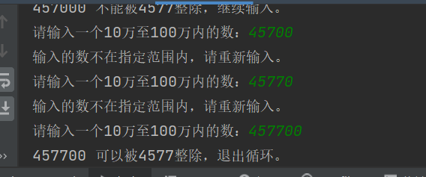

7 用循环语句找出100万至1000万之间能被7843整除的第一个与最后一个数。
public class FirstAndEnd {
public static void main(String[] args) {
int firstDivisible = -1; // 用于存储第一个能被7843整除的数
int lastDivisible = -1; // 用于存储最后一个能被7843整除的数
for (int i = 1000000; i <= 10000000; i++) {
if (i % 7843 == 0) {
if (firstDivisible == -1) {
firstDivisible = i; // 找到第一个能被7843整除的数
}
lastDivisible = i; // 不断更新最后一个能被7843整除的数
}
}
if (firstDivisible != -1) {
System.out.println("第一个能被7843整除的数是: " + firstDivisible);
System.out.println("最后一个能被7843整除的数是: " + lastDivisible);
} else {
System.out.println("在指定范围内找不到能被7843整除的数。");
}
}
}
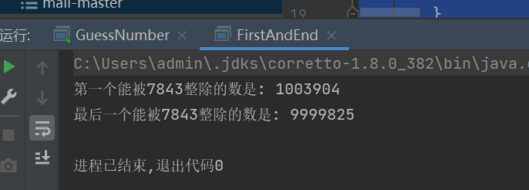

8 编写猜数游戏，随机生成10000内正整数。从键盘反复输入整数进行猜数，当未猜中时，提示输入过大或过小，猜中时，指出猜的次数。最多允许猜20次。

package com.macro.mall;

import java.util.Random;
import java.util.Scanner;

public class GuessNumber {
public static void main(String[] args) {
Scanner scanner = new Scanner(System.in);
Random random = new Random();
int targetNumber = random.nextInt(10000) + 1; // 生成1到10000之间的随机整数
int maxAttempts = 20; // 最多允许的猜测次数
int attempts = 0; // 已经尝试的次数
System.out.println("欢迎参加猜数字游戏！我已经选好了一个1到10000之间的随机整数。");
while (attempts < maxAttempts) {
System.out.print("请输入你的猜测（1-10000之间的整数）: ");
int guess = scanner.nextInt();
attempts++;
if (guess == targetNumber) {
System.out.println("恭喜你，猜对了！你用了 " + attempts + " 次猜中了。");
break;
} else if (guess < targetNumber) {
System.out.println("太小了，再试一次。");
} else {
System.out.println("太大了，再试一次。");
}
}
if (attempts == maxAttempts) {
System.out.println("很遗憾，你用完了所有的猜测机会。正确答案是 " + targetNumber + "。");
}
scanner.close();
}
}

