
EGERTON UNIVERSITY
KNOT: TYING COMMUNITIES TOGETHER THROUGH SHARED RESOURCES
PROJECT SUBMITTED TO DEPARTMENT OF COMPUTER SCIENCE AS A REQUIREMENT OF BSC. COMPUTER SCIENCE
SALLY MUKAMI MUNGA
S13/07782/22
Supervisor:
Mr. Justin Omwoyo
Coordinator:
Dr. Zachary Bosire

DATE: 06/05/2026

Contents
PROJECT PROPOSAL 10
DECLARATION 10
ACKNOWLEDGEMENT 11
ABSTRACT 12
1.0 Introduction 13
1.1 Background and Contextual Analysis 13
1.2 Problem Statement: The Triple Burden of Modern Consumption 14
1.3 Justification: Academic, Social, and Environmental Significance 15
1.4 Project Objectives: Primary and Secondary Goals 17
1.5 Scope Definition and Limitations 18
2.0 Theoretical Framework and Research Questions 20
2.1 Conceptual Foundations: Access-Based Consumption Theory 20
2.2 Theoretical Lenses: Social Capital, Platform Cooperativism, Sustainable Design 20
2.3 Primary Research Questions with Operational Definitions 22
2.4 Secondary Research Inquiries and Exploratory Questions 23
2.5 Hypothesis Development and Testing Framework 23
3.0 LITERATURE REVIEW 25
3.1 Historical Evolution of Sharing Practices 25
3.2 The Sharing Economy: Promise and Critique 25
3.3 Trust and Social Capital in Digital Communities 25
3.4 Sustainable Consumption and Circular Economy 26
3.5 Platform Governance and Business Models 26
3.6 Technology for Community Development 27
3.7 Research Gaps and Contribution 27
4.0 METHODOLOGY 29
4.1 Research Design and Philosophical Approach 29
4.2 Development Methodology: Agile-UCD Hybrid 29
4.3 Data Collection Methods 30
4.4 Ethical Considerations 30
5.0 EXPECTED RESULTS 32
5.1 Technical Deliverables 32
5.2 Research Findings 32
5.3 Community Impact 33
5.4 Environmental Benefits 33
5.5 Economic Outcomes 34
6.0 TIMELINES AND RESOURCES 35
6.1 Project Timeline: December 2025 - March 2026 35
6.2 Resource Requirements 36
6.3 Budget and Funding 38
6.4 Risk Management Plan 39
6.5 Success Metrics 40
7.0 CONCLUSION 41
7.1 Summary of Proposal 41
7.2 Significance and Contribution 41
7.3 Future Work 41
8.0 REFERENCES 43
SOFTWARE REQUIREMENTS SPECIFICATION (SRS) 45
1. INTRODUCTION 46
1.1 Purpose 46
1.2 Document Conventions 46
1.3 Intended Audience and Reading Suggestions 46
1.4 Product Scope 46
1.5 References 47
2. OVERALL DESCRIPTION 48
2.1 Product Perspective 48
2.2 Product Functions 48
2.3 User Classes and Characteristics 48
2.4 Operating Environment 49
2.5 Design and Implementation Constraints 49
2.6 User Documentation 50
2.7 Assumptions and Dependencies 50
3. SYSTEM FEATURES 50
3.1 User Registration and Verification 50
3.2 Item Listing and Campaign Management 51
3.3 Search and Discovery 52
3.4 Booking and Reservation System 53
3.5 Review and Reputation System 54
3.6 Item Suggestion and Voting System 54
3.7 Payment Integration 55
3.8 User Dashboard 56
3.9 Administrative Functions 57
4. EXTERNAL INTERFACE REQUIREMENTS 58
4.1 User Interfaces 58
4.2 Hardware Interfaces 58
4.3 Software Interfaces 58
4.4 Communication Interfaces 58
5. NON-FUNCTIONAL REQUIREMENTS 60
5.1 Performance Requirements 60
5.2 Safety Requirements 60
5.3 Security Requirements 60
5.4 Software Quality Attributes 61
5.5 Business Rules 61
6. OTHER REQUIREMENTS 63
6.1 Legal and Regulatory Requirements 63
6.2 Ethical Requirements 63
6.3 Accessibility Requirements 63
APPENDIX A: GLOSSARY 64
APPENDIX B: PRIORITY DEFINITIONS 64
Software Design Documentation 65
1. Document Control and Revision 66
2. Introduction 66
2.1 Purpose 66
2.2 Scope 66
2.3 Definitions and Acronyms 66
3. System Overview 66
4. Goals and Design Drivers 67
5. Technology Stack 67
6. System Context 67
6.1 External Actors 67
6.2 External Systems 67
6.3 Current Role Assumption and Future Role Separation 67
7. High-Level Architecture 68
7.1 Architecture Style 68
7.2 Runtime Layers 68
8. Component Design 68
8.1 Root Application 68
8.2 accounts App 68
8.3 items App 69
8.4 bookings App 69
8.5 campaigns App 70
8.6 payments App 70
8.7 reviews App 70
8.8 core App 70
8.9 messaging App 70
9. Data Design 71
9.1 Primary Entities and Relationships 71
9.2 Status Models 72
10. ERD 74
11. External Interface Design 74
11.1 Routing Overview 74
11.2 REST API Contracts (Endpoint-Level) 75
11.3 Template Interface Pages 80
12. Use Case Model 81
12.1 Primary Use Cases 81
12.2 Use Case Diagram 82
13. Data Flow Design 83
13.1 Level 0 DFD 83
13.2 Level 1 DFD: Booking Payment Flow 83
14. Interface and Navigation Design 83
14.1 Interface Principles in Current Implementation 83
14.2 Interface Diagram (Page/Module Navigation) 84
15. Detailed Workflow Specifications 84
15.1 Booking Request Workflow 84
15.2 Booking Approval and Fulfillment Workflow 85
15.3 Booking Payment Workflow 85
15.4 Campaign Contribution Workflow 85
15.5 Suggestion to Campaign Workflow 85
15.6 Fund Pullout and Item Creation Workflow 86
15.7 Overdue Management Workflow 86
15.8 Sequence Diagrams 86
15.9 Additional Design Diagrams 87
15.10 Assumptions and Constraints (Current System) 91
15.11 Business Rules Catalog 91
15.12 Permission and Access Model 92
15.13 Error Handling and Recovery Strategy 92
15.14 Operational Runbook (Current) 93
16. Security Design 94
16.1 Authentication and Authorization 94
16.2 Data Protection Considerations 94
16.3 Input Validation 94
17. Non-Functional Requirements 94
17.1 Performance 94
17.2 Reliability 94
17.3 Maintainability 94
17.4 Scalability 95
18. Deployment and Environment Design 95
18.1 Current Deployment Assumptions 95
18.2 Production Design Recommendations 95
19. Testing Design 95
19.1 Existing Test Artifacts 95
19.2 Recommended Coverage Expansion 95
20. Risks and Known Design Gaps 96
21. Traceability Matrix (Feature to Module) 96
22. Appendix A: Suggested Next Architecture Evolutions 96
FINAL TEST MANUAL 97
1. Document Control 99
2. Purpose 99
3. Test Objectives 99
4. Scope 99
5. Test Environment 100
6. Test Assets 100
7. Test Procedure 100
8. Entry and Exit Criteria 101
8.1 Entry Criteria 101
8.2 Exit Criteria 101
9. Automated Test Coverage Summary 101
10. Final Test Cases 101
10.1 Authentication and Account Access 101
10.2 Dashboard and Page Rendering 102
10.3 Item and Suggestion Workflows 102
10.4 Booking Workflow 102
10.5 Campaign and Payment Workflow 103
10.6 Notifications and Core API 103
10.7 Admin Access and Permissions 103
10.8 Email Verification and Password Reset 104
10.9 Validation, Security, and Error Handling 104
10.10 Deployment and Environment Checks 104
11. Script-Based Verification Notes 105
12. Acceptance Criteria 105
13. Known Test Dependencies 106
14. Final Test Outcome Summary 106
15. Test Sign-Off 106
User Manual 107
1. Document Control 109
2. Purpose 110
3. User Roles 110
3.1 Member 110
3.2 Admin 110
4. Getting Started 110
4.1 Accessing the System 110
4.2 Creating an Account 111
4.3 Logging In 113
5. Member Guide 113
5.1 Member Dashboard 113
5.2 Browsing Items 114
5.3 Booking an Item 115
5.4 Paying for a Booking 116
5.5 Negotiate Pick Up Time 117
5.6 Suggesting an Item 117
5.7 Voting on Suggestions 118
5.8 Contributing to Campaigns 119
5.9 Notifications 121
5.10 Profile Management 121
5.11 Request Admin Privileges 122
6. Admin Guide 123
6.1 Admin Dashboard 123
6.2 Managing Users 123
6.3 Moderating Bookings 124
6.4 Moderating Suggestions 126
6.5 Managing Campaigns 127
6.6 Manage Items 128
6.7 Reports and Settings 129
7. Common Tasks 130
7.1 Updating the Password 130
7.2 Password Reset 131
8. Troubleshooting 132
8.1 Login Problems 132
8.2 Booking Problems 132
8.4 Admin Access Problems 133
9. Conclusion 133

PROJECT PROPOSAL

DECLARATION
I, Sally Munga, hereby declare that this project report entitled “Knot: Tying Communities Together Through Shared Resources”, submitted to the Department of Computer Science, Egerton University, in partial fulfillment of the requirements for the award of the degree of Bachelor of Science in Computer Science, is my original work.
To the best of my knowledge, this project has not been submitted to any other institution or university for any academic award. All sources of information, materials, and ideas used in this project have been duly acknowledged and referenced.

Signature: _________________________
Date: _________________________

Certified by Supervisor:
Name of Supervisor: ________________________
Signature: _________________________________
Date: ____________________________________

ACKNOWLEDGEMENT
I wish to express my sincere gratitude to my project supervisor, Mr. Omwoyo, for his invaluable guidance, support, and encouragement throughout the development of this proposal. I also extend my appreciation to the Department of Computer Science faculty members for their knowledge and inspiration. Special thanks to my family and friends for their unwavering support throughout my academic journey.

ABSTRACT
Knot represents a paradigm shift in how communities conceptualize ownership, access, and social interaction in an increasingly fragmented digital age. This comprehensive proposal outlines the development of a sophisticated digital platform designed to address three interconnected societal challenges: escalating financial pressure from consumer culture, alarming environmental waste from underutilized goods, and deteriorating local community bonds despite global digital connectivity. The platform operates on the principle that infrequently used, expensive items, from power tools and camping equipment to specialty kitchen appliances and technological devices, should function as shared community assets rather than private burdens.
Through an innovative integration of verified peer-to-peer sharing, micro-rental systems, and community-driven governance mechanisms, Knot facilitates tangible economic relief while fostering meaningful neighborly connections. This document presents a rigorous academic and technical framework for developing a minimum viable product (MVP) over a five-month period. The methodology employs User-Centered Design (UCD) principles combined with Agile development cycles, ensuring the platform remains responsive to genuine community needs rather than abstract market demands.
Key innovations include a multi-layered trust and verification system, a community-curated resource taxonomy, and a sustainable revenue model that prioritizes platform longevity over extraction. Expected outcomes encompass not only a functional web application but also validated impact metrics, comprehensive user experience documentation, and a scalable architectural blueprint. By situating the project within critical discourses on the sharing economy, platform cooperativism, and sustainable design, Knot positions itself as both a practical technological solution and a case study in values-driven digital innovation. The project contends that technology, when intentionally designed around principles of mutual aid, ecological responsibility, and social equity, can serve as a powerful catalyst for rebuilding the social and economic resilience of local communities.

1.0 Introduction

1.1 Background and Contextual Analysis
The dawn of the 21st century has witnessed a profound paradox in human social organization: while digital technologies have created unprecedented opportunities for global connection and information exchange, numerous sociological studies document a concurrent erosion of local social capital, the networks of relationships, norms of reciprocity, and trust that facilitate collective action within geographic communities (Putnam, 2000; Turkle, 2011). This decline manifests across multiple indicators: reduced participation in neighborhood associations, diminished informal socializing among neighbors, fewer instances of casual assistance between households, and an overall weakening of the social infrastructure that traditionally provided both practical support and psychological belonging.
Simultaneously, consumer capitalism perpetuates an economic model predicated on individual ownership that demonstrates profound inefficiency at both household and systemic levels. The average household in developed nations contains hundreds of items that are used infrequently or not at all, representing significant locked capital and embodied environmental costs. Research indicates that a typical power drill is used for only 6-13 minutes over its entire lifetime, yet millions are manufactured, purchased, and stored individually (Botsman & Rogers, 2010). This pattern repeats across categories: formal wear worn once or twice annually, camping equipment used seasonally, specialty kitchen appliances employed occasionally, and technological devices that rapidly become obsolete while still functional.
The environmental implications of this ownership model are staggering. The Ellen MacArthur Foundation (2013) estimates that the average European car is parked 92% of the time, while the average office is utilized only 35-50% of the time. Manufacturing these underutilized assets consumes vast quantities of raw materials, energy, and water, while transportation generates greenhouse gas emissions, and eventual disposal contributes to landfill waste and environmental degradation. This linear "take-make-dispose" model represents not only economic inefficiency but also ecological unsustainability at a planetary scale.
The so-called "sharing economy" emerged in the late 2000s as a potential corrective to these inefficiencies, promising to unlock idle capacity and foster community connections through digital platforms. Companies like Airbnb, Uber, and TaskRabbit gained rapid adoption by facilitating peer-to-peer exchanges with promises of supplemental income, convenient access, and renewed community engagement. However, critical scholarship over the past decade has revealed that many of these platforms have evolved into extractive marketplaces that often exacerbate inequality, undermine labor protections, commodify social relationships, and in some cases actively damage the communities they purport to serve (Slee, 2015; Schor, 2014). What began as a rhetoric of sharing and community has frequently devolved into a new form of platform capitalism, concentrating wealth and data in the hands of corporate intermediaries while externalizing risks to participants and circumventing regulatory frameworks designed to protect consumers, workers, and communities.
This context creates a clear and urgent opportunity for a platform designed with fundamentally different values—one that intentionally prioritizes community resilience over profit maximization, mutual aid over transaction volume, and ecological responsibility over growth at any cost. Knot emerges from this opportunity space, seeking to reclaim the original promise of the sharing economy by designing a platform architecture and governance model that actively cultivates trust, reduces barriers to resource access, strengthens local social networks, and demonstrates a viable alternative to extractive platform capitalism. The project represents not only a technological development endeavor but also an applied research investigation into how digital systems can be intentionally designed to foster prosocial outcomes, strengthen community bonds, and promote sustainable consumption patterns.

1.2 Problem Statement: The Triple Burden of Modern Consumption
Modern households face a triple burden from the prevailing paradigm of individual ownership:
1.2.1 Economic Burden
The financial cost of purchasing, maintaining, storing, and eventually replacing infrequently used items represents a significant drain on household budgets, particularly for middle- and low-income families. This capital, often acquired through consumer debt, could be redirected toward education, healthcare, savings, local businesses, or experiences that genuinely enhance quality of life. The barrier to accessing necessary tools and equipment prevents individuals from pursuing home improvement projects that increase property value and living standards, starting micro-enterprises that could generate supplemental income, or engaging in recreational activities that require specialized gear but contribute to physical and mental wellbeing. This economic burden is distributed inequitably, with lower-income households often paying proportionally more for access to necessary tools through expensive rentals or inferior quality purchases that require frequent replacement.
1.2.2 Environmental Burden
The cycle of mass production, individual consumption, and eventual disposal generates enormous environmental costs at every stage. Manufacturing consumes finite raw materials and energy, transportation emits greenhouse gases across global supply chains, and discarded items contribute to expanding landfill waste and environmental contamination. The scale of this inefficiency is staggering: research indicates that up to 80% of household items are used less than once per month, yet they occupy physical space, require maintenance, and eventually become waste (Schor, 2014). This linear consumption model is fundamentally incompatible with planetary boundaries and climate mitigation targets, yet alternatives remain inconvenient, stigmatized, or inaccessible for most consumers.
1.2.3 Social Burden
The privatization of resources erodes the social fabric by systematically reducing opportunities for interdependence, cooperation, and reciprocal exchange. When every household owns its own lawnmower, ladder, pressure washer, or specialized tool, neighbors have fewer practical reasons to interact, request assistance, or build relationships based on mutual aid. This atomization contributes to social isolation, which the World Health Organization has identified as a growing public health concern linked to increased risks of depression, anxiety, cardiovascular disease, and premature mortality (Holt-Lunstad et al., 2015). The decline of local social capital also reduces community resilience, the capacity to respond collectively to emergencies, support vulnerable members, advocate for shared interests, and maintain the informal social controls that contribute to public safety and neighborhood cohesion.
1.2.4 The Limitations of Existing Solutions
Current alternatives to individual ownership fail to adequately address these interconnected problems:
- Commercial Rental Services: Big-box store rentals are often expensive, inconveniently located, offer limited selection, and require substantial deposits. Their purely transactional nature provides no community-building benefit and may even reinforce the perception of neighbors as competitors rather than potential collaborators.
- General Social Media Groups: Facebook Marketplace, Buy Nothing groups, and Nextdoor facilitate some sharing but lack dedicated functionality for resource management, scheduling, insurance, and systematic trust-building. These platforms are subject to algorithmic manipulation that prioritizes engagement over genuine connection, comprehensive data harvesting for advertising purposes, and inconsistent moderation that can allow discrimination or exploitation to go unchecked.
- Existing Peer-to-Peer Platforms: Services like Fat Llama, Peerby, and Turo focus on commercial transactions at regional or national scales, prioritizing frequent renters and valuable items. Their business models typically involve significant commission fees (15-25%) that extract value from communities, and they offer limited tools for fostering genuine local community beyond transaction facilitation. Many operate with minimal insurance coverage, placing liability squarely on users.
- Public Libraries of Things: Emerging in some municipalities, these physical locations offer tool lending but require in-person visits during limited hours, have constrained inventory due to space and budget limitations, and often serve only residents of specific municipalities, creating access barriers for those in adjacent communities.
- Traditional Borrowing: Informal borrowing between acquaintances carries significant social risk, potential for damaged relationships if items break, and lacks systematic tracking or accountability mechanisms.
None of these solutions successfully integrates the technological convenience of digital platforms with the trust-building mechanisms, community governance structures, localized focus, and values alignment necessary to transform patterns of consumption and connection at the neighborhood level. There exists a clear market gap and social need for a platform designed specifically to strengthen communities through shared resource access while addressing the economic and environmental burdens of underutilized ownership.

1.3 Justification: Academic, Social, and Environmental Significance

1.3.1 Academic Significance
This project contributes meaningfully to multiple academic discourses and interdisciplinary conversations:
- Human-Computer Interaction (HCI): Advances understanding of how digital systems can be designed to foster prosocial behaviors, strengthen offline communities rather than replace them, and create "bridging social capital" that connects diverse community members. The project contributes to the growing subfield of "Community Informatics" which examines how information and communication technologies can empower communities.
- Platform Studies and Critical Algorithm Studies: Provides a concrete case study in alternative platform design that challenges the dominant venture-capital-backed, growth-at-all-costs model. The project engages with debates about platform governance, data ownership, and democratic control of digital infrastructure.
- Sustainable Design and Circular Economy: Explores how digital interfaces can make sustainable behaviors (sharing, repairing, reusing) more convenient, socially rewarding, and economically viable than linear consumption. Contributes to research on "design for behavior change" in environmental contexts.
- Community Psychology and Social Work: Investigates how technology-mediated interactions can translate into stronger social capital, increased collective efficacy, and enhanced community resilience. Provides insights into digital interventions for reducing social isolation and strengthening support networks.
- Economic Sociology: Examines alternative exchange systems that operate outside traditional market logic, contributing to understanding of "moral economies," "gift economies," and hybrid exchange systems that combine elements of market and non-market exchange.

1.3.2 Social and Community Significance
Knot addresses several pressing social challenges with practical, implementable solutions:
- Economic Empowerment: By dramatically reducing the financial barriers to accessing tools and equipment, Knot enables individuals to undertake home repairs that improve living conditions, develop new skills through hands-on practice, start micro-enterprises with minimal capital investment, and participate in recreational activities that contribute to wellbeing without requiring ownership of expensive gear.
- Community Resilience Building: Stronger local networks increase a community's capacity to respond to emergencies (extreme weather, power outages, public health crises), support vulnerable members (elderly residents, single parents, people with disabilities), advocate for collective interests with local government, and maintain the informal social controls that contribute to public safety. Knot provides both the digital infrastructure and the social occasions (transactions, skill shares, community events) that facilitate network building and relationship deepening.
- Social Inclusion and Cohesion: By creating structured opportunities for interaction across demographic divides (age, income, ethnicity, tenure in neighborhood), Knot can help bridge social divides and build understanding between community members who might otherwise remain isolated in their social bubbles. The platform's design intentionally facilitates connections between "resource-rich, time-poor" individuals and "time-rich, resource-poor" individuals, creating mutually beneficial exchanges.
- Digital Literacy and Inclusion: The platform's design emphasizes accessibility and gradual onboarding, providing opportunities for community members with varying levels of technical literacy to participate meaningfully. This represents a counter-narrative to technologies that primarily serve young, affluent, tech-savvy populations.

1.3.3 Environmental Significance
The environmental impact potential of widespread adoption of resource-sharing platforms is substantial:
- Material Footprint Reduction: Preliminary modeling based on existing research suggests that if a community of 1,000 households reduced their collective ownership of infrequently used items by 20% through systematic sharing, it could prevent approximately 50 tons of CO2 emissions annually from manufacturing and transportation, while reducing raw material extraction by an estimated 15-30%.
- Extended Product Lifespans: When items are shared among multiple users, they typically receive more attentive maintenance, repair when damaged, and ultimately achieve closer to their full potential lifespan before disposal. This represents a significant improvement over the current norm of underutilization followed by disposal while still functional.
- Waste Reduction: By facilitating sharing, repair, and reuse, Knot directly addresses the "take-make-dispose" linear economy that generates enormous waste. Each shared item represents multiple potential purchases avoided, along with their associated packaging, transportation, and eventual disposal impacts.
- Behavioral Norm Shifting: Beyond direct material impacts, the platform has potential to shift social norms around ownership, consumption, and community interdependence. By making sharing convenient, socially rewarded, and economically beneficial, Knot can contribute to broader cultural shifts toward sufficiency and collaborative consumption.

1.3.4 Innovation Significance
Knot introduces several novel integrations and design innovations:
- Community-Curated Taxonomy: Allowing local communities to define, categorize, and tag their shared resources according to their specific needs, cultural contexts, and local terminology rather than imposing a standardized corporate taxonomy.
- Dynamic Trust Calibration: Implementing context-sensitive trust indicators that adjust based on transaction type (high-value vs. low-value items), relationship history between users, time of transaction, and other contextual factors, moving beyond one-size-fits-all reputation scores.
- Multi-Stakeholder Governance Design: Creating transparent decision-making processes that include diverse community stakeholders (users, local organizations, municipal partners) in platform governance, potentially through advisory boards, community voting on feature priorities, or even platform cooperative ownership structures.
- Integrated Sustainability Metrics: Providing users with personalized feedback on their community contributions (help provided, connections made), creating positive reinforcement loops for sustainable and prosocial behaviors.

1.4 Project Objectives: Primary and Secondary Goals

1.4.1 Primary Objective
To design, develop, and validate a fully functional Minimum Viable Product (MVP) of the Knot platform that successfully enables secure, convenient, and trust-based sharing of physical resources within a geographically bounded community, while generating measurable improvements in perceived community connection, household economic flexibility, and sustainable consumption behaviors.

1.4.2 Specific Technical Objectives
- Platform Development: Create a robust, scalable web application with comprehensive core functionalities including multi-factor user registration and verification, detailed item listing management with categorization and search optimization, intelligent search and discovery algorithms, integrated booking and calendaring systems, secure in-platform messaging, and multi-dimensional reputation tracking.
- Trust Architecture Implementation: Design and implement a multi-layered trust system incorporating graduated identity verification options, transaction-based reputation scoring with contextual weighting, community endorsement mechanisms, and context-aware safety features including transaction logging, check-in/check-out confirmation, and optional location sharing for high-value exchanges.
- User-Centered Design Execution: Conduct iterative user research through multiple cycles of interviews, surveys, and usability testing to ensure the platform is intuitive, accessible, and meets the diverse needs of community members across age groups, technical literacy levels, and socioeconomic backgrounds. Document design decisions and their rationales comprehensively.
- Technical Documentation: Produce complete, professional-grade technical documentation including system architecture diagrams, API documentation, database schemas, deployment guides, and maintenance procedures to ensure the project's technical reproducibility and potential for future development.

1.4.3 Research and Evaluation Objectives
- Impact Measurement Framework: Develop and implement a comprehensive mixed-methods evaluation framework to assess the platform's impact across multiple dimensions: user adoption and engagement metrics, perceived trust and safety, changes in sharing behaviors, self-reported community connection, economic benefits realized, and environmental impact estimations.
- Community Integration Protocol: Design and test partnership frameworks with local organizations (community centers, libraries, religious institutions, neighborhood associations) to facilitate platform adoption, provide in-person support for digital inclusion, and create hybrid digital-physical community engagement opportunities.
- Business Model Validation: Test and refine multiple sustainable revenue models through simulations, stakeholder feedback, and small-scale implementation, with particular attention to models that align with community values rather than extractive capitalism.
- Governance Structure Exploration: Investigate and prototype potential community governance models for the platform, assessing feasibility, stakeholder acceptance, and implementation requirements for more democratic control structures than typical corporate platforms.

1.5 Scope Definition and Limitations

1.5.1 Scope Boundaries
This project is deliberately scoped as an MVP development with the following boundaries:
- Geographic Focus: Initial development and testing will focus on a single, defined community (potentially a university neighborhood, residential community, or small town) to enable concentrated engagement and manageable iteration cycles.
- User Scale: The MVP is designed to support approximately 200-500 active users during the testing phase, with architecture that allows scaling but not implementation of full scaling mechanisms during the project period.
- Feature Set: The MVP will include core sharing functionalities but will exclude advanced features such as complex insurance integration (will use liability waivers and recommendations), mobile applications (will be responsive web design only), and advanced analytics dashboards.
- Item Categories: Initial focus will be on tangible physical goods, excluding services, digital goods, perishable items, and regulated substances. Within physical goods, the platform will initially accommodate a broad range but may develop specialized workflows for certain high-risk categories.
- Governance Model: The MVP will implement basic community guidelines and moderation but will not include sophisticated democratic governance structures, which are earmarked for potential future development phases.

1.5.2 Explicit Limitations
The following limitations are acknowledged:
- Temporal Constraint: The five-month project timeline necessitates prioritization of core functionality over comprehensive feature development or extensive longitudinal impact studies.
- Resource Constraints: As a student project with limited budget, certain commercial services, extensive user acquisition campaigns, or professional legal consultation will be necessarily limited or simulated rather than fully implemented.
- Generalizability: Findings from the initial community testing may not be fully generalizable to all community types, cultural contexts, or geographic settings without adaptation and further testing.
- Regulatory Compliance: Full compliance with all relevant regulations (data protection, consumer protection, platform liability) may require legal consultation beyond the scope of this project, though basic principles will be implemented.
- Sustainability Measurement: Environmental impact calculations will be estimates based on existing research rather than precise measurements, given the project timeline and resource constraints.
Despite these limitations, the project scope is designed to produce meaningful, actionable results that demonstrate proof of concept, validate core assumptions, and create a foundation for future development and expansion. The limitations themselves provide valuable learning opportunities about the practical challenges of implementing community technology projects with constrained resources.

2.0 Theoretical Framework and Research Questions

2.1 Conceptual Foundations: Access-Based Consumption Theory
Knot is fundamentally grounded in the theory of access-based consumption, which represents a paradigm shift from ownership to access as the primary mode of consumption. This theoretical framework, developed by marketing and consumer researchers (Bardhi & Eckhardt, 2012), posits that consumers increasingly value access to goods and services without the burdens of ownership, including financial investment, maintenance responsibility, storage requirements, and eventual disposal. Access-based consumption is characterized by market-mediated transactions that provide temporary access to goods without transfer of ownership, contrasting with traditional ownership-based consumption or non-market sharing among social relations.
The theoretical underpinnings of access-based consumption draw from several intersecting literatures:
- Service-Dominant Logic (Vargo & Lusch, 2004): This marketing theory argues that all exchange is fundamentally about service provision rather than goods transfer. Knot operationalizes this by facilitating access to the service potential of physical goods (e.g., the service of "hole-making" rather than drill ownership).
- Collaborative Consumption (Botsman & Rogers, 2010): This framework categorizes sharing systems into product service systems (access over ownership), redistribution markets (used goods), and collaborative lifestyles (non-product assets like space or skills). Knot primarily operates within the product service systems category but incorporates elements of collaborative lifestyles through community-building features.
- Commons-Based Peer Production (Benkler, 2004): This theory from legal scholarship examines how decentralized, collaborative production can create value outside traditional market and firm structures. While focused on information goods, its principles of distributed coordination, social motivation, and shared governance inform Knot's design for physical goods sharing.
- Practice Theory (Shove et al., 2012): This sociological approach views consumption not as individual choice but as embedded in social practices that link materials (tools), competences (skills), and meanings (cultural understandings). Knot intervenes at all three elements: providing materials through sharing, developing competences through community knowledge exchange, and reshaping cultural meanings around ownership and community.
These theoretical foundations inform Knot's design at multiple levels: its value proposition (access over ownership), its exchange mechanisms (temporary transfers mediated by digital platform), its motivational architecture (blending economic, social, and environmental incentives), and its governance approach (balancing platform coordination with community self-organization).

2.2 Theoretical Lenses: Social Capital, Platform Cooperativism, Sustainable Design
Three additional theoretical lenses provide critical perspectives for the project:
2.2.1 Social Capital Theory
Putnam's (2000) distinction between bonding social capital (strong ties within homogeneous groups) and bridging social capital (weaker ties across diverse groups) is particularly relevant. Digital platforms often facilitate bonding capital within existing social networks but fail to create bridging capital. Knot is intentionally designed to foster bridging social capital by connecting diverse community members who might not otherwise interact. Granovetter's (1973) "strength of weak ties" theory further informs the design, suggesting that the connections formed through resource sharing—likely initially weak ties—can provide access to novel information, resources, and opportunities that strong ties within homogeneous groups cannot.
Coleman's (1988) formulation of social capital as a resource embedded in social relations that can facilitate collective action directly informs Knot's community governance features. The platform aims to not only utilize existing social capital but also generate new social capital through structured interactions, reputation systems that encode trust, and community features that facilitate collective identity formation.
2.2.2 Platform Cooperativism
Scholz's (2016) platform cooperativism framework provides both a critique of extractive platform capitalism and a vision for democratic alternatives. This theoretical lens emphasizes:
- Ownership: Platforms owned and governed by their users rather than external investors
- Governance: Democratic decision-making rather than corporate control
- Data: User control over personal data rather than corporate surveillance
- Value Distribution: Equitable distribution of value created rather than extraction
While the MVP may not implement full platform cooperative structures, this theoretical lens informs long-term design considerations, governance prototypes, and ethical commitments around data ownership, transparency, and equitable value distribution.
2.2.3 Sustainable Design and Behavior Change Theories
Knot engages with multiple theories of sustainable design and behavior change:
- Design for Sustainable Behavior (Lockton et al., 2010): This approach categorizes design interventions based on how they influence behavior: through enabling, motivating, or constraining certain actions. Knot employs all three: enabling sharing through convenient infrastructure, motivating through social and environmental feedback, and constraining unsustainable options through default settings and design choices.
- Value-Belief-Norm Theory (Stern, 2000): This environmental psychology theory posits that pro-environmental behavior results from personal values, beliefs about consequences, and feelings of personal responsibility. Knot's design incorporates features that strengthen environmental values (impact feedback), clarify consequences (environmental benefit communication), and activate personal norms (community expectations).
- Circular Economy Principles (Ellen MacArthur Foundation, 2013): This economic model emphasizes designing out waste, keeping products and materials in use, and regenerating natural systems. Knot operationalizes the "keeping products in use" principle through sharing that extends product lifespans and utilization rates.
These theoretical lenses are not merely academic framing but actively inform design decisions, feature prioritization, and evaluation criteria throughout the project.

2.3 Primary Research Questions with Operational Definitions
The project addresses four primary research questions, each with clearly operationalized variables and measurement approaches:
RQ1: What technical and social design features most effectively build and maintain trust in hyper-local peer-to-peer sharing platforms?
- Operationalization: Trust will be measured through (1) user self-report surveys using validated trust scales adapted for sharing contexts, (2) behavioral indicators including transaction completion rates, item value distribution in transactions, and frequency of repeat transactions between users, and (3) qualitative analysis of user discourse about trust in interviews and platform feedback.
- Design features examined: Verification methods (ID, phone, social, community), reputation system design (scoring algorithms, review mechanisms), safety features (messaging filters, transaction logging), and community governance elements (moderation, dispute resolution).
RQ2: How does participation in a community resource-sharing platform affect users' perceptions of community connection and social capital?
- Operationalization: Community connection will be measured through pre- and post-implementation surveys using established social capital scales (e.g., SC-IQ adapted for local context). Social network mapping will track changes in recognized neighbors, frequency of interaction, and types of support exchanged. Qualitative interviews will explore narrative changes in community perception.
- Variables examined: Changes in bridging vs. bonding social capital, perceived neighborhood cohesion, frequency and depth of local interactions, and sense of collective efficacy.
RQ3: What motivational factors (economic, social, environmental, convenience) drive different user segments to participate in and sustain engagement with community sharing platforms?
- Operationalization: Motivation will be assessed through (1) survey instruments measuring relative importance of different motivations, (2) analysis of platform usage patterns correlated with user characteristics, (3) A/B testing of different motivational framings in platform communication, and (4) qualitative exploration of motivation in user interviews.
- Motivational categories: Economic savings/earning, social connection, environmental values, convenience/access, curiosity/learning, and normative influences.
RQ4: How can platform business models align with community values while ensuring financial sustainability?
- Operationalization: This will be examined through (1) comparative analysis of existing platform business models, (2) simulation of different revenue models with the MVP user base, (3) stakeholder assessment of different models' alignment with community values, and (4) analysis of trade-offs between revenue potential, user adoption, and values alignment.
- Models examined: Transaction fees, subscription tiers, freemium models, voluntary contributions, public funding partnerships, and hybrid approaches.

2.4 Secondary Research Inquiries and Exploratory Questions
In addition to the primary research questions, several secondary inquiries will guide exploratory analysis:
SQ1: How do sharing patterns vary across different types of items (value, size, frequency of use, specialization) and what design implications do these variations suggest?
- Exploration: Analysis of transaction data categorized by item type, user interviews about sharing decisions for different items, and observation of how users navigate the platform when seeking different categories of items.
SQ2: What barriers prevent certain demographic groups from participating in sharing platforms, and how can design mitigate these barriers?
- Exploration: Demographic analysis of platform adoption compared to community demographics, targeted interviews with non-users and underrepresented groups, and usability testing with diverse participants focusing on accessibility and inclusion barriers.
SQ3: How does the digital design of sharing platforms influence power dynamics and potential discrimination within communities?
- Exploration: Analysis of transaction patterns for evidence of demographic matching or exclusion, examination of review language for bias, and investigation of how platform features might inadvertently reinforce or challenge existing social hierarchies.
SQ4: What is the relationship between online platform interactions and offline community relationships in a hyper-local sharing context?
- Exploration: Social network analysis comparing platform-mediated connections to self-reported offline relationships, qualitative investigation of how platform interactions translate to offline interactions, and examination of whether the platform primarily facilitates transactions among existing acquaintances or creates new connections.
SQ5: How do environmental impact communications and feedback affect user engagement and perceived value of sharing platforms?
- Exploration: A/B testing of different environmental impact communication strategies, correlation between engagement with environmental features and overall platform engagement, and qualitative exploration of how environmental considerations factor into sharing decisions.

2.5 Hypothesis Development and Testing Framework
Based on the theoretical frameworks and research questions, several testable hypotheses guide the project:
H1: Multi-layered verification systems will correlate with higher trust perceptions and transaction rates than single-method verification.
- Testing: Compare user groups with different verification levels on trust surveys and transaction behaviors.
H2: Users who form new connections through the platform will show greater increases in bridging social capital than those who primarily transact with existing connections.
- Testing: Social network analysis tracking connection formation and correlation with social capital measures.
H3: Different user segments will demonstrate distinct motivational profiles that predict their platform usage patterns and engagement sustainability.
- Testing: Cluster analysis of motivation survey data correlated with usage metrics over time.
H4: Business models with transparent value distribution and community input will demonstrate higher user acceptance and perceived fairness than opaque, extractive models.
- Testing: Comparative assessment of different model prototypes with stakeholder groups.
H5: Environmental impact feedback will increase engagement among environmentally-motivated users but may have neutral or negative effects on primarily economically-motivated users.
- Testing: A/B testing of environmental feedback features with analysis segmented by user motivation.
These hypotheses provide focused guidance for data collection, analysis, and interpretation, ensuring the project contributes not only practical implementation but also knowledge generation about community sharing platforms.

3.0 LITERATURE REVIEW

3.1 Historical Evolution of Sharing Practices
Sharing resources is not a novel concept but represents a fundamental human adaptation that predates market economies. Anthropological research documents extensive sharing practices in hunter-gatherer societies as survival strategies in resource-scarce environments (Widlok, 2017). These pre-market sharing systems operated on principles of generalized reciprocity where obligations were diffused rather than immediately repaid. The industrial revolution and rise of consumer capitalism in the 20th century systematically undermined these practices by promoting individual ownership as a marker of social status and self-sufficiency (Belk, 2014). However, sharing never disappeared entirely, persisting in informal forms: neighborly borrowing, tool libraries, carpooling, and community gardens.
The late 20th century saw the emergence of more formalized sharing systems. Public libraries, established in the 19th century primarily for books, expanded into "libraries of things" in progressive municipalities during the 1970s-80s, lending tools, kitchen equipment, and recreational gear (Cockayne, 2016). Time banking emerged in the 1980s as a formal system for exchanging services without money, valuing all hours equally (Cahn, 2004). These initiatives represented early institutional attempts to create sharing economies alongside traditional markets.

3.2 The Sharing Economy: Promise and Critique
The digital revolution transformed sharing's scale and scope. Early internet platforms like Craigslist (1995) and Freecycle (2003) demonstrated how digital coordination could facilitate redistribution of used goods. However, the contemporary "sharing economy" proper emerged after the 2008 financial crisis, combining economic necessity with technological capability and growing environmental awareness (Schor, 2014). Platforms like Airbnb (2008), Uber (2009), and TaskRabbit (2008) achieved rapid scale by using digital platforms to coordinate peer-to-peer exchanges. These platforms promised to unlock idle capacity, provide income opportunities, and foster community connections.
Critical scholarship has revealed fundamental contradictions within many sharing economy platforms. Slee (2015) argues that platforms like Uber and Airbnb represent "neoliberalism on steroids" – using sharing rhetoric to deregulate industries, undermine worker protections, and extract value from communities while externalizing risks. These platforms often create "regulatory arbitrage" by positioning themselves as mere facilitators of peer exchanges rather than service providers, thus avoiding regulations governing hotels, taxis, or employment (Rauch & Schleicher, 2015).
The economic model of venture capital-backed platforms creates inherent tensions with community well-being. Platform companies face intense pressure for exponential growth and investor returns, leading to practices that may contradict community interests: aggressive market expansion that disrupts local housing markets, algorithmic management that treats workers as independent contractors without protections, and data extraction for competitive advantage rather than community benefit (Smicek, 2017).

3.3 Trust and Social Capital in Digital Communities
Trust is the fundamental challenge for peer-to-peer sharing platforms, particularly when facilitating exchanges of valuable physical goods among strangers. Traditional commerce relies on institutional trust (brand reputation, legal contracts, regulatory oversight). Sharing platforms must create trust between peers, often with limited institutional backing.
Digital platforms employ various technical mechanisms to build trust:
- Identity verification through government IDs, social media accounts, phone numbers, or payment methods (Fraiberger & Sundararajan, 2015).
- Reputation systems that aggregate ratings and reviews from past transactions. These systems face challenges of rating inflation, retaliation fears, and demographic biases (Luca, 2016).
- Insurance and guarantees that reduce financial risk for participants.
- Communication tools that allow users to assess each other before transacting.
- Social verification through connections to existing social networks (Facebook friends, LinkedIn connections).
Research on Airbnb's trust mechanisms provides valuable insights. The platform's design intentionally creates "calculated intimacy" – structured opportunities for personal connection within a commercial transaction (Schor & Attwood-Charles, 2017). Host and guest profiles with photos and personal descriptions, messaging before booking, and review systems all contribute to trust-building. However, these systems also enable discrimination, with studies showing significant racial disparities in booking success (Edelman et al., 2017).

3.4 Sustainable Consumption and Circular Economy
The environmental claims of sharing platforms warrant critical examination. While reducing idle capacity has theoretical environmental benefits, research shows mixed actual impacts. Car-sharing can reduce vehicle ownership but may increase total vehicle miles traveled. Short-term rental platforms may increase energy consumption compared to hotels through duplication of amenities and reduced economies of scale (Frenken & Schor, 2017). Moreover, the environmental benefits of sharing may be undermined by "rebound effects" where savings from sharing are spent on other consumption (Zink & Geyer, 2017).
The circular economy framework provides a more comprehensive approach to sustainability. The Ellen MacArthur Foundation (2013) outlines three principles: designing out waste and pollution, keeping products and materials in use, and regenerating natural systems. Resource sharing platforms directly contribute to the second principle by extending product lifespans and increasing utilization rates. However, true circularity requires consideration of the entire lifecycle, including manufacturing impacts, maintenance requirements, and end-of-life management.

3.5 Platform Governance and Business Models
Platform governance – how rules are created, enforced, and evolved – significantly impacts community outcomes. Traditional corporate platforms employ hierarchical governance: rules are determined by the company, enforced by employees or algorithms, with limited user input beyond feedback mechanisms. This model prioritizes scalability, consistency, and alignment with corporate interests.
Alternative governance models offer different trade-offs:
Platform cooperatives implement democratic governance where users collectively make major decisions through voting or representation (Scholz, 2016). This aligns platform evolution with user interests but creates challenges in decision-making efficiency and representation of diverse user perspectives.
Polycentric governance involves multiple overlapping authorities, as described by Ostrom's (1990) principles for managing common-pool resources. Applied to digital platforms, this might involve community-specific norms alongside platform-wide rules, with community moderators empowered to interpret and enforce rules contextually.
Traditional venture capital-backed business models create inherent tensions for community platforms. The VC model requires exponential growth and high-margin returns, often leading to practices that extract value from communities, prioritize scaling over serving existing users, and ultimately seek acquisition or IPO exit rather than long-term community stewardship.
Alternative business models better aligned with community values include:
- Multi-stakeholder cooperatives that include users, workers, and community organizations as owners.
- Platform as Public Utility models treat essential digital infrastructure as public goods, funded through municipal budgets, grants, or modest user fees.
- Hybrid funding models combine multiple revenue streams: modest transaction fees, optional subscriptions, grants for specific features, municipal partnerships, and sponsorship from aligned local businesses.

3.6 Technology for Community Development
Community informatics research examines how information and communication technologies can empower communities and support community development (Gurstein, 2007). Key principles include:
- Community ownership and control: Technology should serve community-defined needs and priorities.
- Capacity building: Technology projects should develop local skills and capabilities.
- Sustainability: Solutions should be economically, socially, and environmentally sustainable.
- Appropriate technology: Solutions should match local contexts, resources, and capabilities.
Digital platforms for community development face unique challenges, including digital divides, varying technical literacy, and the need to complement rather than replace face-to-face interaction. Successful community technology projects often employ participatory design methods, engage community members as co-designers, and integrate with existing community institutions and practices.

3.7 Research Gaps and Contribution
Despite extensive research on sharing economies, several gaps remain particularly relevant to Knot:
- Hyper-local digital platforms: Most research examines global or regional platforms. Less is known about platforms intentionally designed for neighborhood-scale interaction and how they differ in trust dynamics, governance needs, and impact patterns.
- Integration of digital and physical community infrastructure: How digital platforms can complement rather than replace physical community spaces and face-to-face interaction remains understudied.
- Design for diverse communities: Much platform research focuses on relatively homogeneous user groups (urban, educated, tech-savvy). Less is known about designing for socioeconomically, generationally, and culturally diverse communities.
- Alternative business model viability: While theoretical models exist for cooperative or public-interest platforms, empirical research on their implementation challenges, sustainability, and scalability remains limited.
Knot contributes to filling these gaps by:
- Designing specifically for hyper-local context
- Integrating digital and physical community engagement
- Prioritizing inclusive design for diverse communities
- Testing alternative business model prototypes

4.0 METHODOLOGY

4.1 Research Design and Philosophical Approach
This project employs a pragmatic research philosophy that prioritizes practical problem-solving while maintaining methodological rigor. Pragmatism recognizes that different research questions require different methodological approaches, and that knowledge emerges through iterative cycles of inquiry and action (Dewey, 1938). For Knot, this means integrating:
- Design Research to create effective solutions
- Action Research to involve community stakeholders
- Evaluation Research to assess outcomes
- Ethnographic Methods to understand context
The methodology follows a convergent parallel mixed-methods design where quantitative and qualitative data are collected simultaneously, analyzed separately, then integrated during interpretation (Creswell & Plano Clark, 2017). This approach provides both statistical generalizability and contextual depth.

4.2 Development Methodology: Agile-UCD Hybrid
The project employs a hybrid methodology combining Agile development with User-Centered Design (UCD) principles:
Phase 1: Discovery and Research (November)
- Activities: Literature review, competitive analysis, stakeholder identification, user interviews, community needs assessment
- Methods: Semi-structured interviews (n=30), focus groups (n=3), community mapping, ethnographic observation
- Deliverables: User personas, journey maps, requirements specification, project plan
Phase 2: Design and Prototyping (December)
- Activities: Information architecture, wireframing, interface design, prototype development
- Methods: Participatory design workshops, iterative prototyping, usability testing with low-fidelity prototypes
- Deliverables: Wireframes, interactive prototypes, design system, usability test reports
Phase 3: Development and Testing (January-February)
- Activities: Agile development in two-week sprints, continuous integration, regular testing
- Methods: Scrum methodology, test-driven development, continuous user feedback loops
- Deliverables: Functional MVP, technical documentation, test reports, deployment infrastructure
Phase 4: Evaluation and Refinement (March)
- Activities: Pilot deployment, user testing, impact assessment, iteration based on findings
- Methods: A/B testing, surveys, interviews, analytics, heuristic evaluation
- Deliverables: Evaluation report, refined MVP, implementation recommendations, project documentation

4.3 Data Collection Methods
Multiple data collection methods will be employed throughout the project lifecycle:
Quantitative Methods:
- Surveys: Pre- and post-implementation surveys measuring trust, social capital, motivations, and satisfaction (target n=50)
- Platform Analytics: Usage metrics, transaction patterns, user behavior tracking
- System Usability Scale (SUS): Standardized usability assessment after major iterations
- A/B Testing: Controlled experiments comparing different design approaches
Qualitative Methods:
- Semi-structured Interviews: In-depth exploration of user experiences and perceptions (n=20-30)
- Focus Groups: Group discussions on specific topics like trust mechanisms or governance preferences (n=3-4 groups)
- Participant Observation: Observation of platform use in natural settings
- Think-Aloud Protocols: Users verbalizing their thoughts while completing platform tasks
- Document Analysis: Analysis of platform content, user-generated content, and community discussions
Mixed Methods:
- Social Network Analysis: Mapping changes in community connections pre- and post-implementation
- Experience Sampling: Brief, repeated surveys capturing user experiences in real-time
- Diary Studies: Users documenting their sharing experiences over time

4.4 Ethical Considerations
Informed Consent:
- Clear consent forms explaining data collection, use, and storage
- Separate consent for different types of data collection and usage
- Ongoing consent with ability to withdraw at any time
Privacy and Confidentiality:
- Data anonymization and pseudonymization
- Secure data storage with encryption
- Limited data sharing and aggregation for reporting
- Compliance with data protection regulations
Beneficence and Non-Maleficence:
- Maximizing benefits while minimizing risks to participants
- Special protections for vulnerable populations
- Transparent communication about risks and benefits
- Regular ethical review throughout the project
Community Ethics:
- Respect for community norms and values
- Community involvement in decision-making
- Fair distribution of benefits and burdens
- Long-term consideration of community impacts

5.0 EXPECTED RESULTS

5.1 Technical Deliverables
- Functional MVP: A fully operational web application with core features including:
  - User registration and verification system
  - Item listing and management interface
  - Search and discovery functionality
  - Booking and reservation system
  - Item suggestion and voting system
  - Payment integration system
- Technical Documentation:
  - System architecture diagrams and specifications
  - Database schema and API documentation
  - Deployment and maintenance guides
  - Source code with comprehensive comments
- Design Assets:
  - Complete design system with components and patterns
  - User interface designs for all screens and states
  - Interaction specifications and animations
  - Accessibility compliance documentation
- Testing Framework:
  - Test cases and scripts for all features
  - Performance and security testing reports
  - Usability testing protocols and results
  - Quality assurance documentation

5.2 Research Findings
- Trust Building Mechanisms: Identification of the most effective combinations of verification methods, reputation systems, and safety features for building trust in hyper-local sharing contexts. Expected to find that multi-layered approaches combining technical and social elements outperform single-method approaches.
- Social Impact Patterns: Documentation of how platform participation affects community connections, including:
  - Increases in bridging social capital between different community segments
  - Strengthening of neighborhood ties and mutual aid networks
  - Reduction in perceived social isolation among participants
  - Development of community identity and collective efficacy
- User Motivation Insights: Understanding of the diverse motivations driving participation, including:
  - Identification of distinct user segments with different motivational profiles
  - Documentation of how motivations change over time with platform experience
  - Insights into what sustains long-term engagement versus initial curiosity
- Business Model Validation: Evidence-based recommendations for sustainable business models that align with community values, including:
  - Comparative analysis of different revenue models' acceptability and effectiveness
  - Identification of key success factors for community-aligned platforms
  - Financial sustainability projections under different scenarios

5.3 Community Impact
- Increased Resource Access: Documentation of expanded access to tools and equipment for community members, particularly those with limited financial resources. Expected to show significant cost savings compared to individual ownership or commercial rental.
- Enhanced Community Resilience: Evidence of strengthened community networks and capacities, including:
  - Increased frequency and diversity of neighborly interactions
  - Development of mutual aid patterns and reciprocal relationships
  - Enhanced community ability to respond to shared challenges
- Digital Inclusion Progress: Demonstration of how the platform can increase digital literacy and inclusion, particularly among typically underserved populations. Expected to show that thoughtful design can bridge rather than widen digital divides.
- Institutional Partnerships: Development of successful partnership models with community organizations, providing templates for future expansion and replication.

5.4 Environmental Benefits
- Resource Efficiency Gains: Quantification of environmental benefits through reduced consumption and waste, including:
  - Estimated reductions in carbon emissions from avoided manufacturing and transportation
  - Material savings from extended product lifespans and increased utilization
  - Waste diversion from sharing rather than disposal of underused items
- Behavior Change Evidence: Documentation of how platform participation influences sustainable consumption behaviors, including:
  - Changes in attitudes toward ownership versus access
  - Increased awareness of environmental impacts of consumption
  - Adoption of sharing as a regular practice rather than exceptional behavior
- Circular Economy Contribution: Demonstration of how the platform contributes to circular economy principles, particularly keeping products in use and designing out waste.

5.5 Economic Outcomes
- Household Economic Benefits: Documentation of financial savings for participating households, including:
  - Direct savings from sharing versus purchasing
  - Opportunity benefits from accessing higher-quality equipment
  - Income generation opportunities for resource owners
- Local Economic Effects: Analysis of how the platform influences local economic patterns, including:
  - Potential for supporting local repair and maintenance businesses
  - Reduced outflow of money for purchases from distant corporations
  - Development of local skills and capabilities
- Platform Economics: Understanding of the economic sustainability of the platform itself, including:
  - Cost structures and efficiency metrics
  - Revenue potential under different models
  - Scaling economics and thresholds for sustainability

6.0 TIMELINES AND RESOURCES

6.1 Project Timeline: December 2025 - March 2026
Phase 1: December 2025 - Project Initiation & Planning
Week 1-2 (Dec 1-14, 2025): Project Setup & Research Finalization
- Final literature review completion
- Research methodology refinement
- Development environment setup (Python, Django, VS Code, Git)
- Project repository initialization on GitHub
- Database design and architecture planning
- Deliverables: Final literature review document, project setup checklist, database schema design
Week 3-4 (Dec 15-28, 2025): Requirements Analysis & Design Planning
- Final user requirement specifications
- Wireframe creation (using Figma or similar free tools)
- User flow mapping
- Technical specifications documentation
- Deliverables: Requirements specification document, wireframes, user flow diagrams
Phase 2: January 2026 - Core Development
Week 1-2 (Jan 5-18, 2026): Backend Foundation
- Django project setup and configuration
- Database models development (Users, Items, Bookings, Reviews)
- Authentication system implementation (Django Allauth or custom)
- Basic API endpoints setup (Django REST Framework)
- Deliverables: Functional backend with basic models, authentication system
Week 3-4 (Jan 19-Feb 1, 2026): Frontend Foundation
- HTML/CSS/JS project structure setup
- Responsive design implementation
- Basic templates and layouts
- Navigation and header/footer components
- Deliverables: Frontend structure with responsive design, basic templates
Phase 3: February 2026 - Feature Implementation
Week 1-2 (Feb 2-15, 2026): User Features Development
- User registration and profile management
- Item listing creation and management
- Search and filtering functionality
- Image upload and management (using Django-storages with local storage)
- Deliverables: Complete user management system, item listing functionality
Week 3-4 (Feb 16-29, 2026): Booking & Communication System
- Booking/rental system with calendar integration
- Messaging system between users
- Notification system
- Review and rating system
- Deliverables: Complete transaction system, messaging functionality
Phase 4: March 2026 - Testing, Deployment & Documentation
Week 1-2 (Mar 2-15, 2026): Testing & Refinement
- Unit testing (Django test framework)
- Integration testing
- User acceptance testing with pilot users
- Bug fixing and performance optimization
- Deliverables: Test reports, bug fixes, optimized application
Week 3-4 (Mar 16-29, 2026): Final Documentation
- Final documentation preparation
- Deployment on local host
- Project presentation materials
- Deliverables: Complete documentation, project report

6.2 Resource Requirements
Hardware Requirements:
- Development Machine:
- Personal laptop/computer (minimum specifications: 8GB RAM, 256GB storage)
- Internet connection for research and deployment
- Testing Devices:
- Available smartphones/tablets from personal network
- Library/public computer lab access for cross-browser testing
Software Requirements (All Free/Open Source):
Development Tools:
- VS Code (free IDE with Python/Django extensions)
- Git (version control)
- GitHub (free repository hosting)
- Python 3.13.2 (programming language)
- Django 4.2+ (web framework)
- PostgreSQL (database - free tier on hosting platforms)
- SQLite (development database - included with Python)
- PayHero (payment integration)
Design & Prototyping:
- Figma (free tier for wireframing)
- Canva (free for basic graphics and UI elements)
- Bootstrap 5 or Tailwind CSS (free CSS frameworks)
- Font Awesome Free (icons)
Testing & Quality Assurance:
- Django Testing Framework (built-in)
- Browser Developer Tools (free)
- Google Lighthouse (free performance testing)
- W3C Validators (free HTML/CSS validation)
Productivity Tools:
- Microsoft Word (free documentation)
- Trello (free project management)
- Slack/Discord (free team communication if needed)
- Draw.io (free diagramming tool)
Human Resources:
- Project Developer: Sally Mukami Munga (Student)
- Time commitment: 15-20 hours per week
- Responsibilities: Full-stack development, testing, documentation
- Project Supervisor: Mr Omwoyo
- Time commitment: 1-2 hours per week for guidance and review
- Responsibilities: Technical guidance, progress monitoring, academic oversight
- User Testers:
- 3-4 volunteers from university community
- Time commitment: 1-2 hours for testing sessions
- Compensation: None (volunteer basis)
- Technical Support:
- University computer science department resources
- Online communities (Stack Overflow, Django forums)
- Peer support from fellow students

6.3 Budget and Funding
Total Project Budget: 0 KSH (Zero Budget)
Cost Mitigation Strategy:
Development Costs (Covered by Free Resources):
- Software & Tools: All development tools are free/open-source
- Hosting & Domain:
- Use localhost
- No custom domain purchase required
- APIs & Services:
- Use free tiers of essential services
- Implement core functionality without paid APIs
- Use open-source alternatives for all components
Research Costs (No Budget Required):
- Data Collection:
- Use free online survey tools (Google Forms)
- Conduct virtual interviews (Zoom/Google Meet free tier)
- Utilize university library resources for literature
- Participant Incentives:
- No monetary incentives for testers
- Rely on voluntary participation from university community
- Use academic credit/recognition as motivation
Hardware Costs (Utilize Existing Resources):
- Development Machine: Use personal laptop
- Testing Devices: Borrow from friends/family or use university lab
- Internet: Use university Wi-Fi or personal internet connection
Alternative Funding/Resource Strategies:
- University Resources:
- Access to computer labs and software
- Library research materials
- Academic supervision and guidance
- Open Source Community:
- Free tutorials and documentation
- Community support forums
- Sample code and templates
- Personal Investment:
- Time and effort as primary investment
- Existing hardware and software
- Personal internet and electricity costs

6.4 Risk Management Plan
Technical Risks:
- Risk: Hosting platform limitations (free tier constraints)
- Mitigation: Optimize application for low resource usage
- Contingency: Multiple free hosting accounts, university hosting option
- Risk: Database limitations with free PostgreSQL
- Mitigation: Efficient database design, regular cleanup
- Contingency: SQLite for development, migrate if limitations hit
- Risk: Feature limitations due to budget constraints
- Mitigation: Prioritize MVP features, use simple solutions
- Contingency: Implement workarounds, focus on core functionality
Development Risks:
- Risk: Time constraints for complete development
- Mitigation: Agile approach, minimum viable product focus
- Contingency: Scale back features, extend timeline if needed
- Risk: Technical complexity beyond current skill level
- Mitigation: Incremental learning, online resources, supervisor guidance
- Contingency: Simplify implementation, seek peer assistance
Testing & Deployment Risks:
- Risk: Limited user testing pool
- Mitigation: Leverage university community, social networks
- Contingency: Extended testing period, iterative improvements
- Risk: Performance issues on free hosting
- Mitigation: Code optimization, caching strategies
- Contingency: Performance monitoring, gradual optimization
Academic Risks:
- Risk: Integration with academic timeline
- Mitigation: Clear milestone alignment with academic calendar
- Contingency: Regular supervisor check-ins, progress tracking
- Risk: Documentation and reporting requirements
- Mitigation: Continuous documentation, regular updates
- Contingency: Use templates, peer review

6.5 Success Metrics
Technical Success Metrics:
- Functionality: 90% of MVP features implemented
- Performance: Page load time < 3 seconds on average
- Reliability: 95% uptime on free hosting
- Code Quality: 80% test coverage for critical functions
- Security: No critical security vulnerabilities
Academic Success Metrics:
- Timely Completion: All milestones met within timeline
- Documentation: Complete technical and academic documentation
- Evaluation: Positive assessment from supervisor and examiners
- Knowledge Application: Demonstrated application of computer science concepts
Project Management Metrics:
- Budget Adherence: Zero expenditure maintained
- Time Management: Weekly progress tracking
- Risk Management: No critical risks realized
- Stakeholder Satisfaction: Positive feedback from supervisor and test users

7.0 CONCLUSION

7.1 Summary of Proposal
This proposal outlines the development of Knot, a community resource-sharing platform designed to address the interconnected challenges of economic pressure, environmental waste, and social fragmentation. The platform represents a values-driven alternative to extractive sharing economy models, prioritizing community resilience, equitable access, and sustainable consumption.
The project employs a rigorous mixed-methods approach combining design research, agile development, and community engagement to create a platform that is both technically sound and socially responsive. Through five months of development and testing, the project will produce a functional MVP, validated design principles, and evidence-based insights into what makes community sharing platforms successful.

7.2 Significance and Contribution
Knot contributes to multiple domains:
To Computer Science: Demonstrates how technical systems can be designed to foster social good, advancing the field of community informatics and values-driven design. The project provides a case study in developing platforms that prioritize community outcomes over commercial metrics.
To Sustainable Development: Offers a practical approach to addressing Sustainable Development Goals, particularly SDG 11 (Sustainable Cities and Communities), SDG 12 (Responsible Consumption and Production), and SDG 17 (Partnerships for the Goals). The platform demonstrates how digital technology can support circular economy principles and community resilience.
To Community Development: Provides a tool for strengthening local social capital and mutual aid networks. In an era of increasing social isolation and fragmentation, Knot offers a pathway to rebuilding the community connections that are essential for individual wellbeing and collective resilience.
To Academic Knowledge: Contributes to understanding of trust mechanisms in digital platforms, motivations for sharing participation, and models for community-aligned platform governance. The research addresses identified gaps in the literature, particularly around hyper-local platforms and alternative business models.

7.3 Future Work
While this project focuses on MVP development, several directions for future work emerge:
Technical Expansion:
- Mobile application development for increased accessibility
- Advanced features like integrated payments, insurance, and analytics
- Integration with other community systems and platforms
- Scalability improvements for broader deployment
Research Extension:
- Longitudinal studies of platform impact over time
- Comparative studies across different community contexts
- Investigation of specific mechanisms like trust calibration algorithms
- Economic analysis of sharing versus ownership at scale
Community Scaling:
- Replication in different community types and contexts
- Development of community governance models
- Integration with municipal systems and policies
- Formation of platform cooperative or similar ownership structure
Policy Development:
- Creation of guidelines for community sharing platforms
- Policy recommendations for supporting sharing initiatives
- Standards development for trust and safety in sharing
- Integration with broader sustainability and community development strategies
In conclusion, Knot represents more than just a technical project—it is an experiment in reimagining how technology can serve community needs, a case study in values-driven design, and a contribution to the growing movement for more equitable and sustainable digital platforms. By tying communities together through shared resources, Knot offers a vision of technology that strengthens rather than undermines the social fabric, that promotes access over accumulation, and that demonstrates how digital innovation can serve human flourishing and planetary wellbeing.

8.0 REFERENCES
- Bardhi, F., & Eckhardt, G. M. (2012). Access-based consumption: The case of car sharing. Journal of Consumer Research, 39(4), 881-898.
- Belk, R. (2014). You are what you can access: Sharing and collaborative consumption online. Journal of Business Research, 67(8), 1595-1600.
- Benkler, Y. (2004). Sharing nicely: On shareable goods and the emergence of sharing as a modality of economic production. Yale Law Journal, 114(2), 273-358.
- Botsman, R., & Rogers, R. (2010). What's mine is yours: The rise of collaborative consumption. Harper Business.
- Creswell, J. W., & Plano Clark, V. L. (2017). Designing and conducting mixed methods research. Sage publications.
- Evidence from a field experiment. American Economic Journal: Applied Economics, 9(2), 1-22.
- Ellen MacArthur Foundation. (2013). Towards the circular economy: Economic and business rationale for an accelerated transition.
- Frenken, K., & Schor, J. (2017). Putting the sharing economy into perspective. Environmental Innovation and Societal Transitions, 23, 3-10.
- Gurstein, M. (2007). What is community informatics (and why does it matter)? Polimetrica.
- Holt-Lunstad, J., Smith, T. B., Baker, M., Harris, T., & Stephenson, D. (2015). Loneliness and social isolation as risk factors for mortality: a meta-analytic review. Perspectives on Psychological Science, 10(2), 227-237.
- Lockton, D., Harrison, D., & Stanton, N. A. (2010). The design with intent method: A design tool for influencing user behaviour. Applied Ergonomics, 41(3), 382-392.
- Luca, M. (2016). Reviews, reputation, and revenue: The case of Yelp.com. Harvard Business School NOM Unit Working Paper, (12-016).
- Ostrom, E. (1990). Governing the commons: The evolution of institutions for collective action. Cambridge University Press.
- Putnam, R. D. (2000). Bowling alone: The collapse and revival of American community. Simon & Schuster.
- Rauch, D. E., & Schleicher, D. (2015). Like Uber, but for local government law: The future of local regulation of the sharing economy. Ohio State Law Journal, 76, 901.
- Scholz, T. (2016). Platform cooperativism: Challenging the corporate sharing economy. Rosa Luxemburg Stiftung.
- Schor, J. B. (2014). Debating the sharing economy. Journal of Self-Governance and Management Economics, 4(3), 7-22.
- Schor, J. B., & Attwood-Charles, W. (2017). The "sharing" economy: Labor, inequality, and social connection on for-profit platforms. Sociology Compass, 11(8), e12493.
- Shove, E., Pantzar, M., & Watson, M. (2012). The dynamics of social practice: Everyday life and how it changes. Sage Publications.
- Slee, T. (2015). What's yours is mine: Against the sharing economy. OR Books.
- Smicek, N. (2017). Platform capitalism. John Wiley & Sons.
- Stern, P. C. (2000). New environmental theories: toward a coherent theory of environmentally significant behavior. Journal of Social Issues, 56(3), 407-424.
- Turkle, S. (2011). Alone together: Why we expect more from technology and less from each other. Basic Books.
- Vargo, S. L., & Lusch, R. F. (2004). Evolving to a new dominant logic for marketing. Journal of Marketing, 68(1), 1-17.
- Widlok, T. (2017). Anthropology and the economy of sharing. Routledge.

SOFTWARE REQUIREMENTS SPECIFICATION (SRS)

1. INTRODUCTION

1.1 Purpose
This Software Requirements Specification (SRS) document provides a comprehensive description of the requirements for Knot, a community resource-sharing platform. It details the functional and non-functional requirements, system features, interfaces, and constraints for the Minimum Viable Product (MVP) to be developed between December 2025 and March 2026. This document serves as the foundation for design, development, testing, and validation phases of the project.

1.2 Document Conventions
The following conventions are used throughout this document:
Convention | Meaning
MUST | Absolute requirement of the specification
SHOULD | Recommended requirement, may be omitted in MVP
MAY | Optional requirement, future implementation
[REQ-ID] | Unique identifier for each requirement
Bold text | Key terms and important concepts
Italic text | Emphasis or definitions
Requirement identifiers follow the format: [KNOT-FXX-XXX] for functional requirements and [KNOT-NFXX-XXX] for non-functional requirements.

1.3 Intended Audience and Reading Suggestions
Audience | Purpose | Sections
Project Supervisor | Evaluate technical completeness | All sections
Developer | Guide implementation | Sections 3, 4, 5
Testers | Develop test cases | Sections 3, 5
Examiners | Assess project scope | Sections 1, 2, 6

1.4 Product Scope
Knot is a web-based platform that enables communities to pool financial resources to collectively acquire, own, and steward shared physical assets through trusted community organizations (NGOs, community centers, libraries). The platform facilitates:
- Crowdfunding campaigns for community-prioritized resources
- Democratic governance through voting on resource acquisition
- Institutional stewardship with NGO/community center partnerships
- Equitable access to tools, equipment, and technology
- Community building through shared ownership experiences
The MVP will focus on a single community (university neighborhood) with 100-200 active users, using Python/Django backend and HTML/CSS/JavaScript frontend with zero monetary budget.

1.5 References
- IEEE. (1998). *IEEE Recommended Practice for Software Requirements Specifications (IEEE Std 830-1998)*. IEEE Computer Society.
- Knot Project Proposal. (2026). Knot: Tying Communities Together Through Shared Resources. Egerton University.

2. OVERALL DESCRIPTION

2.1 Product Perspective
Knot is a new, self-contained system developed from scratch as a fourth-year computer science project. It does not replace any existing system but offers an alternative to:
- Commercial peer-to-peer rental platforms (Fat Llama, Peerby)
- General social media marketplaces (Facebook Marketplace)
- Traditional borrowing and informal sharing

2.2 Product Functions
Major Functions:
- User Management: Registration, profile management, verification
- Campaign Management: Create, view, and contribute to community funding campaigns
- Resource Catalog: Browse community-owned inventory with availability status
- Booking System: Reserve, borrow, and return community assets
- Governance Tools: Propose, discuss, and vote on new resource acquisitions
- Reputation: Review and rating system for responsible usage
- Reporting: Usage statistics and impact metrics

2.3 User Classes and Characteristics
User Class | Description | Privileges | Technical Level
Visitor | Unregistered user | View public listings only | Low-Medium
Community Member | Registered, verified user | Browse, book, suggest items, vote | Medium
Resource Steward | NGO/community organization representative | Manage inventory, approve bookings | Medium
Campaign Creator | User who initiates funding campaign | Create and manage campaigns | Medium-High
Administrator | Platform supervisor | Full system access, user management | High
Supervisor | Academic project supervisor | View reports, monitor progress | Medium
User Persona Summary:
Persona | Demographics | Goals | Pain Points
Sarah, Community Member | 42, homeowner, mother of two | Access tools for home projects | Can't afford expensive equipment
James, Student | 21, renter, limited budget | Borrow tech devices for projects | Short-term needs, no storage
Grace, NGO Manager | 55, community center director | Steward shared resources | Manual tracking systems
Peter, Retiree | 68, handyman volunteer | Share skills and tools | Low digital literacy

2.4 Operating Environment
Hardware Environment:
- Server: Local Host
- Client: Any device with modern web browser
- Minimum client requirements: 1GB RAM, any OS, latest Chrome/Firefox/Safari
Software Environment:
Component | Technology | Version | License
Backend Framework | Django | 4.2+ | Open source
Programming Language | Python | 3.13.2 | Open source
Frontend | HTML5, CSS3, JavaScript | ES6+ | Open source
CSS Framework | Bootstrap 5 / Tailwind CSS | Latest | Open source
Database | PostgreSQL / SQLite | Latest | Open source
Version Control | Git + GitHub | N/A | Free
Development IDE | VS Code | Latest | Free

2.5 Design and Implementation Constraints
Technical Constraints:
- Zero Budget Constraint: All tools, hosting, and services MUST be free/open-source
- Timeline Constraint: Development MUST complete within December 2025 - March 2026
- Single Developer: All development by one student developer
- Browser Compatibility: MUST support latest versions of Chrome, Firefox, Safari, Edge
Design Constraints:
- Responsive Design: MUST function on desktop, tablet, and mobile devices
- Accessibility: SHOULD comply with WCAG 2.1 Level AA standards
- Progressive Enhancement: Core functionality MUST work without JavaScript
- Simple Authentication: Use Django's built-in authentication system

2.6 User Documentation
The following documentation will be delivered with the MVP:
- User Guide: Instructions for community members (borrowers, lenders)
- Steward Manual: Guide for NGO/organization resource managers
- Administrator Guide: System maintenance and user management
- API Documentation: If REST endpoints are implemented
- Deployment Guide: Instructions for deploying the platform

2.7 Assumptions and Dependencies
Assumptions:
- Users have basic internet connectivity and web browsing skills
- Partner organizations have existing physical infrastructure for storage
- Users will participate voluntarily without monetary incentives
- Community members have valid identification for verification
Dependencies:
- Django framework continues to be actively maintained
- Supervisor provides regular feedback and guidance
- Community partners willing to participate in pilot testing

3. SYSTEM FEATURES

3.1 User Registration and Verification
Description:
Users must register and verify their identity to access platform features. A graduated verification system provides increasing levels of trust and corresponding access privileges.
Functional Requirements:
ID | Requirement | Priority
[KNOT-F01-001] | System MUST allow users to register with email and password | High
[KNOT-F01-002] | System MUST validate email format and password strength (min 8 characters, mix of letters/numbers) | High
[KNOT-F01-003] | System MUST send email verification link upon registration | High
[KNOT-F01-004] | System MUST NOT allow unverified email to access booking features | High
[KNOT-F01-005] | System SHOULD allow phone verification via SMS (if free service available) | Medium
[KNOT-F01-006] | System MAY support social login (Google, Facebook) for convenience | Low
[KNOT-F01-007] | System MUST allow users to create and edit profile information | High
[KNOT-F01-008] | System MUST allow users to upload profile photo | Medium
[KNOT-F01-009] | System MUST implement password reset functionality | High
[KNOT-F01-010] | System MAY implement ID verification for high-value item access | Low
[KNOT-F01-011] | System MUST display verification badges on user profiles | Medium
Verification Levels:
Level | Requirements | Permissions
0 | None (Visitor) | View only
1 | Email verified | Browse, suggest items
2 | Phone verified | Book low-value items
3 | ID verified | Book high-value items, create campaigns

3.2 Item Listing and Campaign Management
Description:
Resources are acquired through community crowdfunding campaigns. Once funded, items become part of the community inventory managed by host organizations.
Functional Requirements:
ID | Requirement | Priority
[KNOT-F02-001] | System MUST allow verified users to suggest funding campaigns | High
[KNOT-F02-002] | Campaign creation MUST include: title, description, target amount, category, images | High
[KNOT-F02-003] | System MUST display campaign progress (amount raised vs. target) | High
[KNOT-F02-004] | System MUST allow users to contribute to campaigns (pledge without payment in MVP) | High
[KNOT-F02-005] | System SHOULD display campaign deadline and remaining days | Medium
[KNOT-F02-006] | System MUST notify campaign creator when target is reached | High
[KNOT-F02-007] | System MUST allow stewards to add successfully funded items to inventory | High
[KNOT-F02-008] | Inventory items MUST include: name, description, category, condition, location | High
[KNOT-F02-009] | System MUST allow multiple images per item | Medium
[KNOT-F02-010] | System MUST track item availability status (available, borrowed, maintenance) | High
[KNOT-F02-011] | System SHOULD allow stewards to set borrowing rules (max days, late fees) | Medium
[KNOT-F02-012] | System MUST categorize items (tools, electronics, sports, kitchen, etc.) | High
Item Categories:
- Tools & Hardware
- Electronics & Technology
- Sports & Recreation
- Kitchen & Dining
- Gardening & Outdoor
- Party & Events
- Educational & Learning
- Mobility & Accessibility

3.3 Search and Discovery
Description:
Users can browse, search, and filter available community resources based on various criteria.
Functional Requirements:
ID | Requirement | Priority
[KNOT-F03-001] | System MUST provide search bar on all pages | High
[KNOT-F03-002] | Search MUST query item titles and descriptions | High
[KNOT-F03-003] | System MUST provide category browsing | High
[KNOT-F03-004] | System MUST support filtering by: category, availability, location | High
[KNOT-F03-005] | System SHOULD support sorting by: newest, most booked, highest rated | Medium
[KNOT-F03-006] | System MUST display search results as grid/list toggle | Medium
[KNOT-F03-007] | System MUST show item image, title, location, availability status in results | High
[KNOT-F03-008] | System SHOULD highlight recently added items | Low
[KNOT-F03-009] | System MAY recommend similar items based on category | Low
[KNOT-F03-010] | System MUST handle empty search results gracefully with suggestions | Medium

3.4 Booking and Reservation System
Description:
Users can reserve community-owned items for specific dates and times, subject to steward approval.
Functional Requirements:
ID | Requirement | Priority
[KNOT-F04-001] | System MUST allow verified users to request item bookings | High
[KNOT-F04-002] | Booking request MUST include: start date, end date, purpose | High
[KNOT-F04-003] | System MUST check item availability before submitting request | High
[KNOT-F04-004] | System MUST prevent double-booking of same item for overlapping dates | High
[KNOT-F04-005] | System MUST notify steward of new booking requests | High
[KNOT-F04-006] | Steward MUST be able to approve, decline, or modify booking requests | High
[KNOT-F04-007] | System MUST notify user of booking decision | High
[KNOT-F04-008] | System MUST display user's active bookings in dashboard | High
[KNOT-F04-009] | System MUST allow users to cancel bookings | High
[KNOT-F04-010] | System SHOULD send reminders 24 hours before pickup | Medium
[KNOT-F04-011] | System SHOULD track overdue items and send notifications | Medium
[KNOT-F04-012] | System MUST maintain booking history for each user and item | Medium

3.5 Review and Reputation System
Description:
After completed bookings, users can rate and review their experience to build community trust.
Functional Requirements:
ID | Requirement | Priority
[KNOT-F05-001] | System MUST allow users to rate completed transactions | High
[KNOT-F05-002] | Rating MUST be on 5-star scale | High
[KNOT-F05-003] | System MUST require written review with minimum 10 characters | Low
[KNOT-F05-004] | Both borrower AND steward MAY review each other | Low
[KNOT-F05-005] | System MUST display average rating on user profiles | High
[KNOT-F05-006] | System MUST display total number of reviews received | High
[KNOT-F05-007] | System MUST prevent multiple reviews for same transaction | High
[KNOT-F05-008] | System SHOULD allow users to report inappropriate reviews | Medium
[KNOT-F05-009] | System MAY calculate weighted reputation score based on review recency | Low
[KNOT-F05-010] | System MUST display reviews chronologically (newest first) | Medium

3.6 Item Suggestion and Voting System
Description:
Community members can suggest new items for acquisition and vote on priorities.
Functional Requirements:
ID | Requirement | Priority
[KNOT-F06-001] | System MUST allow verified users to suggest new items for community pool | High
[KNOT-F06-002] | Suggestion MUST include: item name, estimated cost, justification | High
[KNOT-F06-003] | System MUST display all active suggestions with vote counts | High
[KNOT-F06-004] | System MUST allow users to upvote suggestions (one vote per user) | High
[KNOT-F06-005] | System SHOULD display vote count and voters | Medium
[KNOT-F06-006] | System MUST allow stewards to mark suggestions as "under consideration" | Medium
[KNOT-F06-007] | System MUST allow stewards to convert approved suggestions to campaigns | High
[KNOT-F06-008] | System SHOULD archive rejected suggestions with reasons | Low
[KNOT-F06-009] | System MAY implement comment/discussion on suggestions | Low

3.7 Payment Integration
Description:
Knot will implement a full payment integration system enabling real monetary transactions for:
- Campaign contributions - Community members contribute funds to acquire shared resources
- Membership fees/subscriptions - Optional revenue model for platform sustainability
- Booking fees - Small transaction fees for high-value items (future phase)
The MVP will use PayHero for secure payment processing with sandbox/test mode.

Functional Requirements:
ID | Requirement | Priority
[KNOT-F07-001] | System MUST integrate with payment gateway (PayHero) for processing real monetary contributions | HIGH
[KNOT-F07-002] | System MUST support one-time contributions to active campaigns | HIGH
[KNOT-F07-003] | System MUST display contribution form with amount field on campaign detail page | HIGH
[KNOT-F07-004] | System MUST allow users to enter custom contribution amounts | HIGH
[KNOT-F07-005] | System MUST provide pre-set contribution amounts (e.g., 100, 500, 1000 KSH) for convenience | MEDIUM
[KNOT-F07-006] | System MUST securely collect payment details via payment gateway's hosted fields/iframe | HIGH
[KNOT-F07-007] | System MUST NOT store sensitive payment information (credit card numbers, CVV) in local database | HIGH
[KNOT-F07-008] | System MUST update campaign progress bar in real-time upon successful contribution | HIGH
[KNOT-F07-009] | System MUST send email confirmation receipt to contributor | HIGH
[KNOT-F07-010] | System MUST display transaction history to users in their dashboard | HIGH
[KNOT-F07-011] | System MUST allow campaign creators to view all contributions to their campaigns | HIGH
[KNOT-F07-012] | System MUST handle failed payments gracefully with clear error messages | HIGH
[KNOT-F07-013] | System SHOULD support refund processing (manual via admin) | MEDIUM
[KNOT-F07-014] | System MUST record transaction ID, amount, date, and status for each contribution | HIGH

3.8 User Dashboard
Description:
Personalized dashboard for users to manage their activities.
Functional Requirements:
ID | Requirement | Priority
[KNOT-F08-001] | System MUST provide personalized dashboard for logged-in users | High
[KNOT-F08-002] | Dashboard MUST display user's active bookings | High
[KNOT-F08-003] | Dashboard MUST display user's pending booking requests | High
[KNOT-F08-004] | Dashboard MUST display user's suggested items and vote status | Medium
[KNOT-F08-005] | Dashboard MUST display user's created campaigns | High
[KNOT-F08-006] | Dashboard SHOULD display user's reputation score/badges | Medium
[KNOT-F08-007] | Dashboard SHOULD display recent messages/conversations | Medium
[KNOT-F08-008] | Dashboard MUST provide quick links to edit profile | High
[KNOT-F08-009] | Dashboard SHOULD display community impact statistics | Low

3.9 Administrative Functions
Description:
Administrator and steward functions for platform management.
Functional Requirements:
ID | Requirement | Priority
[KNOT-F09-001] | System MUST provide admin interface (Django Admin or custom) | High
[KNOT-F09-002] | Admin MUST be able to view all users and their verification status | High
[KNOT-F09-003] | Admin MUST be able to activate/deactivate user accounts | High
[KNOT-F09-004] | Admin MUST be able to view all items and their status | High
[KNOT-F09-005] | Admin MUST be able to view all bookings and transactions | High
[KNOT-F09-006] | Admin SHOULD be able to generate usage reports | Medium
[KNOT-F09-007] | Steward MUST be able to manage items at their location | High
[KNOT-F09-008] | Steward MUST be able to view and manage booking requests | High
[KNOT-F09-009] | Steward SHOULD be able to mark items for maintenance | Medium
[KNOT-F09-010] | System MUST log administrative actions for audit | Medium

4. EXTERNAL INTERFACE REQUIREMENTS

4.1 User Interfaces
General UI Requirements:
ID | Requirement | Priority
[KNOT-UI-001] | System MUST use responsive design for all screen sizes | High
[KNOT-UI-002] | System MUST maintain consistent color scheme and branding | High
[KNOT-UI-003] | System MUST use intuitive navigation with clear labels | High
[KNOT-UI-004] | System MUST provide visual feedback for user actions (loading, success, error) | High
[KNOT-UI-005] | System SHOULD maintain 4.5:1 minimum color contrast ratio | Medium
[KNOT-UI-006] | System MUST support keyboard navigation | Medium
[KNOT-UI-007] | System SHOULD provide clear error messages with resolution guidance | High
Key Screens:
Screen | Description | Priority
Home Page | Search bar, featured items, active campaigns | High
Browse Page | Item grid with filters and sorting | High
Item Detail Page | Full item information, availability, booking button | High
Campaign Page | Campaign details, progress bar, pledge button | High
User Profile | User info, reviews, reputation | High
Dashboard | User's activities and management tools | High
Messaging Inbox | Conversation list and chat interface | High
Admin Interface | System management tools | High

4.2 Hardware Interfaces
No direct hardware interfaces required. System interfaces with standard input devices (keyboard, mouse, touchscreen) through web browser.

4.3 Software Interfaces
Interface | Purpose | Technology | Priority
Database | Data persistence | PostgreSQL/SQLite | High
Email Service | Notifications and verification | Django Email (SMTP) | High
SMS Service | Phone verification | Twilio (free tier) | Low
Storage | Image uploads | Django File Storage | High
Payment Gateway | Implemented | Payhero | High

4.4 Communication Interfaces
- Protocol: HTTPS for all communications
- Data Format: JSON for API endpoints (if implemented)
- Authentication: Session-based authentication (Django built-in)

5. NON-FUNCTIONAL REQUIREMENTS

5.1 Performance Requirements
ID | Requirement | Target | Priority
[KNOT-NF01-001] | Page load time | < 3 seconds on broadband | High
[KNOT-NF01-002] | Search result display | < 2 seconds | High
[KNOT-NF01-003] | Concurrent users | Support 50 simultaneous users | Medium
[KNOT-NF01-004] | System uptime | 95% on free hosting | Medium
[KNOT-NF01-005] | Database query optimization | < 100ms for critical queries | High
[KNOT-NF01-006] | Image optimization | Automatic compression | Medium

5.2 Safety Requirements
ID | Requirement | Priority
[KNOT-NF02-001] | System MUST backup database daily | High
[KNOT-NF02-002] | System MUST validate all user inputs | High
[KNOT-NF02-003] | System MUST handle errors gracefully without exposing sensitive information | High
[KNOT-NF02-004] | System MUST provide clear liability disclaimers | High
[KNOT-NF02-005] | System SHOULD implement rate limiting to prevent abuse | Medium

5.3 Security Requirements
ID | Requirement | Priority
[KNOT-NF03-001] | System MUST hash passwords using Django's PBKDF2 | High
[KNOT-NF03-002] | System MUST use HTTPS for all communications | High
[KNOT-NF03-003] | System MUST protect against CSRF attacks | High
[KNOT-NF03-004] | System MUST protect against XSS attacks | High
[KNOT-NF03-005] | System MUST implement session timeout | Medium
[KNOT-NF03-006] | System MUST restrict access based on user roles | High
[KNOT-NF03-007] | System MUST NOT store sensitive user data (ID numbers, full addresses) | High
[KNOT-NF03-008] | System SHOULD implement account lockout after failed login attempts | Medium

5.4 Software Quality Attributes
Reliability:
ID | Requirement | Priority
[KNOT-NF04-001] | System MUST maintain data integrity during concurrent bookings | High
[KNOT-NF04-002] | System MUST recover gracefully from database errors | High
Maintainability:
ID | Requirement | Priority
[KNOT-NF04-003] | Code MUST follow PEP 8 standards | High
[KNOT-NF04-004] | System MUST include inline comments for complex logic | High
[KNOT-NF04-005] | System MUST use Django's MVT architecture | High
Usability:
ID | Requirement | Priority
[KNOT-NF04-006] | System MUST complete common tasks in 3 clicks or less | Medium
[KNOT-NF04-007] | System MUST provide clear calls-to-action | High
[KNOT-NF04-008] | System SHOULD provide onboarding tutorial for new users | Low

Scalability:
ID | Requirement | Priority
[KNOT-NF04-009] | Database schema MUST support future scaling | Medium
[KNOT-NF04-010] | Architecture SHOULD allow separation of concerns | Medium
Portability:
ID | Requirement | Priority
[KNOT-NF04-011] | System MUST run on Windows, macOS, and Linux | High
[KNOT-NF04-012] | System MUST support all modern browsers | High

5.5 Business Rules
ID | Rule | Priority
[KNOT-NF05-001] | Users MUST be at least 18 years old to borrow items | High
[KNOT-NF05-002] | Maximum booking duration: 14 days per item | Medium
[KNOT-NF05-003] | Maximum concurrent bookings: 3 per user | Medium
[KNOT-NF05-004] | Late returns: 3 strikes policy | Low
[KNOT-NF05-005] | New users limited to low-value items until verified | Medium

6. OTHER REQUIREMENTS

6.1 Legal and Regulatory Requirements
ID | Requirement | Priority
[KNOT-L01-001] | System MUST include Terms of Service and Privacy Policy | High
[KNOT-L01-002] | System MUST obtain consent for data collection | High
[KNOT-L01-003] | System MUST allow users to delete their accounts and data | Medium
[KNOT-L01-004] | System SHOULD comply with Kenyan data protection laws | Medium
[KNOT-L01-005] | System MUST display clear liability disclaimers for shared items | High

6.2 Ethical Requirements
ID | Requirement | Priority
[KNOT-E01-001] | System MUST NOT discriminate based on age, gender, or background | High
[KNOT-E01-002] | System MUST provide equal access regardless of technical skill | High
[KNOT-E01-003] | System SHOULD include sliding scale or waived fees for low-income users | Medium
[KNOT-E01-004] | System MUST be transparent about data usage | High
[KNOT-E01-005] | System MUST prioritize community benefit over commercial interests | High

6.3 Accessibility Requirements
ID | Requirement | Priority | WCAG Reference
[KNOT-A01-001] | All images MUST have alt text | High | 1.1.1
[KNOT-A01-002] | Color MUST NOT be sole method of conveying information | High | 1.4.1
[KNOT-A01-003] | Text MUST be resizable up to 200% without loss of function | Medium | 1.4.4
[KNOT-A01-004] | All functionality MUST be available from keyboard | Medium | 2.1.1
[KNOT-A01-005] | Headings MUST be properly nested | Medium | 1.3.1
[KNOT-A01-006] | Forms MUST have associated labels | High | 1.3.1
[KNOT-A01-007] | Link text MUST be descriptive | High | 2.4.4

APPENDIX A: GLOSSARY
Term | Definition
MVP | Minimum Viable Product - version with core features only
Steward | Organization or individual responsible for maintaining community assets
Campaign | Crowdfunding initiative to acquire new community resources
Pledge | Non-monetary commitment to contribute to a campaign (MVP)
Resource Pool | Collection of community-owned assets
Host Organization | NGO, community center, or library that stores and manages resources
Borrower | Community member who borrows an item
Verification Level | Graduated trust tiers based on identity confirmation

APPENDIX B: PRIORITY DEFINITIONS
Priority | Meaning
High | Essential for MVP; must be implemented
Medium | Important but can be simplified or delayed if necessary
Low | Nice to have; future enhancement

Software Design Documentation

For

KNOT: Tying Communities Together Through Shared Resources

1. Document Control and Revision
- Project: Knot (Community Resource Sharing Platform)
- Document Type: Software Design Document
- Version : 3

2. Introduction

2.1 Purpose
This document defines the software design of Knot, a Django-based platform for:
- User account management and identity verification
- Item catalog and borrowing workflows
- Community suggestions and crowdfunding campaigns
- Payment processing via PayHero (M-Pesa)
- Reviews, notifications, and admin operations

2.2 Scope
The SDD covers architecture, components, data model, interfaces, workflows, non-functional qualities, and deployment assumptions for the current implementation.

2.3 Definitions and Acronyms
- SDD: Software Design Description
- DRF: Django REST Framework
- JWT: JSON Web Token
- ERD: Entity Relationship Diagram
- DFD: Data Flow Diagram
- STK Push: SIM Toolkit payment prompt sent to a mobile device

3. System Overview
Knot enables communities to:
- Suggest needed items
- Convert approved suggestions into funding goals (campaigns)
- Contribute funds to campaigns
- Acquire and publish items for booking
- Borrow items with approval and payment flows
The system is a server-rendered Django web app with DRF JSON APIs and static frontend JavaScript.

4. Goals and Design Drivers
- Minimize operational complexity using a monolith architecture
- Keep business rules centralized in Django views/models/services
- Support both template-driven pages and API-driven frontend interactions
- Track status transitions for bookings and payments
- Provide admin moderation and operational control

5. Technology Stack
- Backend framework: Django 5.1.1
- API layer: Django REST Framework
- Auth tokens: SimpleJWT
- DB: SQLite (current environment)
- Media/static handling: Django static and media storage
- Payment integration: PayHero API (M-Pesa)
- Frontend: Django templates + static JS/CSS

6. System Context

6.1 External Actors
- Guest user
- Registered user (borrower/member)
- Admin/staff/approved admin
- Steward (item manager)
- PayHero payment service
- SMTP email provider (Gmail SMTP)

6.2 External Systems
- PayHero API endpoints
- SMTP server for account emails
- Browser clients for template UI and API calls

6.3 Current Role Assumption and Future Role Separation
- Current-state assumption: Admin and Steward responsibilities are currently fulfilled by the same operational person/team in this deployment.
- Design rationale: The data model and use cases intentionally keep Admin and Steward as separate roles to avoid future architectural rework.
- Planned evolution: Future releases will allow any qualified user (not only admins) to act as a Steward, subject to verification and policy checks.

7. High-Level Architecture

7.1 Architecture Style
- Modular monolith with domain apps:
  - accounts
  - items
  - bookings
  - campaigns
  - payments
  - reviews
  - core
  - messaging

7.2 Runtime Layers
- Presentation layer: Template routes in backend/views.py and app template views; Static JavaScript under static/js
- API layer: DRF ViewSets and APIViews in each domain app
- Domain layer: Models, serializers, and services
- Integration layer: PayHero API client (campaigns/payhero.py); Email SMTP and verify-email package
- Persistence layer: Django ORM on SQLite

8. Component Design

8.1 Root Application
- settings.py configures apps, middleware, templates, static/media, auth model, email, PayHero values, and DRF JSON renderer
- urls.py composes template routes and API route includes

8.2 accounts App
- Responsibilities:
  - Registration, login, logout, JWT issuance
  - Email verification and password reset token management
  - Profile management
  - Admin request workflows (request, approve, reject)
  - Admin dashboard operations over users, items, bookings, reports, settings
- Key classes/models: CustomUser, EmailVerificationToken, PasswordResetToken
- Key implementation notes:
  - Supports login by username or email
  - Introduces approval-based admin access with ID-photo submission
  - Large admin operations consolidated in accounts/views.py

8.3 items App
- Responsibilities:
  - Category management
  - Item listings/details/availability
  - Suggestion create/list/voting
  - Suggestion approval to campaign publication
- Key models: Category, Item, ItemImage, ItemSuggestion
- Key implementation notes:
  - Auto recovers stale borrowed item statuses
  - Suggestion approval can create or update campaign
  - Voting restricted to suggestions that are no longer pending

8.4 bookings App
- Responsibilities:
  - Booking CRUD and lifecycle transitions
  - Borrowing constraints and overlap checks
  - Booking payment initiation and callback handling
  - Booking history/audit trail
  - Overdue synchronization and borrower blocking rules
- Key models: Booking, BookingHistory
- Key services: sync_overdue_bookings_for_user, get_unreturned_overdue_bookings_for_borrower

8.5 campaigns App
- Responsibilities:
  - Campaign discovery and statistics
  - Contribution initiation and payment status polling
  - Payment callback processing
  - Fund pullout workflow and post-funding item creation
- Key models: Organization, Campaign
- Integration points: PayHeroAPI class handles payment initiation/status and ledger lookup

8.6 payments App
- Responsibilities:
  - Transaction persistence
  - Contribution linking
  - Payout records
- Key models: Transaction, Contribution, Payout

8.7 reviews App
- Responsibilities:
  - Create/list reviews for completed bookings
  - Enforce reviewer role constraints
  - Respond to reviews
  - Expose user review statistics
- Key model: Review

8.8 core App
- Responsibilities:
  - Site settings retrieval
  - User notification CRUD + read-state operations
- Key models: SiteSettings, Notification

8.9 messaging App
- Responsibilities:
  - Conversation and message persistence
  - Booking-linked chat flows (invoked through accounts views)
- Key models: Conversation, Message

9. Data Design

9.1 Primary Entities and Relationships
- CustomUser
  - One-to-many with Booking as borrower
  - One-to-many with Booking as steward
  - One-to-many with Review as reviewer/reviewee
  - One-to-many with Transaction and Contribution
  - Many-to-many with ItemSuggestion (voters)
- Category
  - One-to-many with Item
  - One-to-many with Campaign
  - One-to-many with ItemSuggestion
- Item
  - Many-to-one with Category
  - Many-to-one with CustomUser (steward)
  - Many-to-one with Organization (optional)
  - One-to-one with Campaign (optional acquired_item side)
  - One-to-many with ItemImage
  - One-to-many with Booking
- ItemSuggestion
  - Many-to-one with CustomUser (suggested_by)
  - Many-to-many with CustomUser (voters)
  - Optional one-to-many relation from Campaign side (campaign.suggested_item)
- Campaign
  - Many-to-one with Organization
  - Many-to-one with CustomUser (created_by)
  - Many-to-one with Category
  - Optional many-to-one with ItemSuggestion
  - One-to-many with Transaction and Contribution
- Booking
  - Many-to-one with Item
  - Many-to-one with CustomUser (borrower)
  - Many-to-one with CustomUser (steward)
  - One-to-many with BookingHistory
  - One-to-many with Review
  - One-to-many with Transaction
- Transaction
  - Optional many-to-one with Campaign
  - Optional many-to-one with Booking
  - Optional many-to-one with Organization
  - Optional one-to-one with Contribution
- Contribution
  - Many-to-one with CustomUser
  - Many-to-one with Campaign
  - One-to-one with Transaction
- Notification
  - Many-to-one with CustomUser
- Conversation
  - Many-to-many with CustomUser (participants)
  - Optional many-to-one with Item
  - Optional many-to-one with Booking
- Message
  - Many-to-one with Conversation
  - Many-to-one with CustomUser (sender)

9.2 Status Models
- Booking.status:
  - pending -> approved -> paid -> active -> completed
  - pending -> declined
  - pending/approved -> cancelled
  - active -> overdue
- Booking.payment_status:
  - pending -> paid
  - paid -> refunded
  - pending -> failed
- Campaign.status:
  - draft -> active
  - active -> funded
  - funded -> completed (after pullout)
  - active -> expired
  - any -> cancelled (business/admin dependent)
- ItemSuggestion.status:
  - pending -> campaign_created
  - pending -> approved/rejected (legacy/alternate statuses in model)
- Transaction.status:
  - pending -> processing/completed/failed/cancelled/refunded

10. ERD
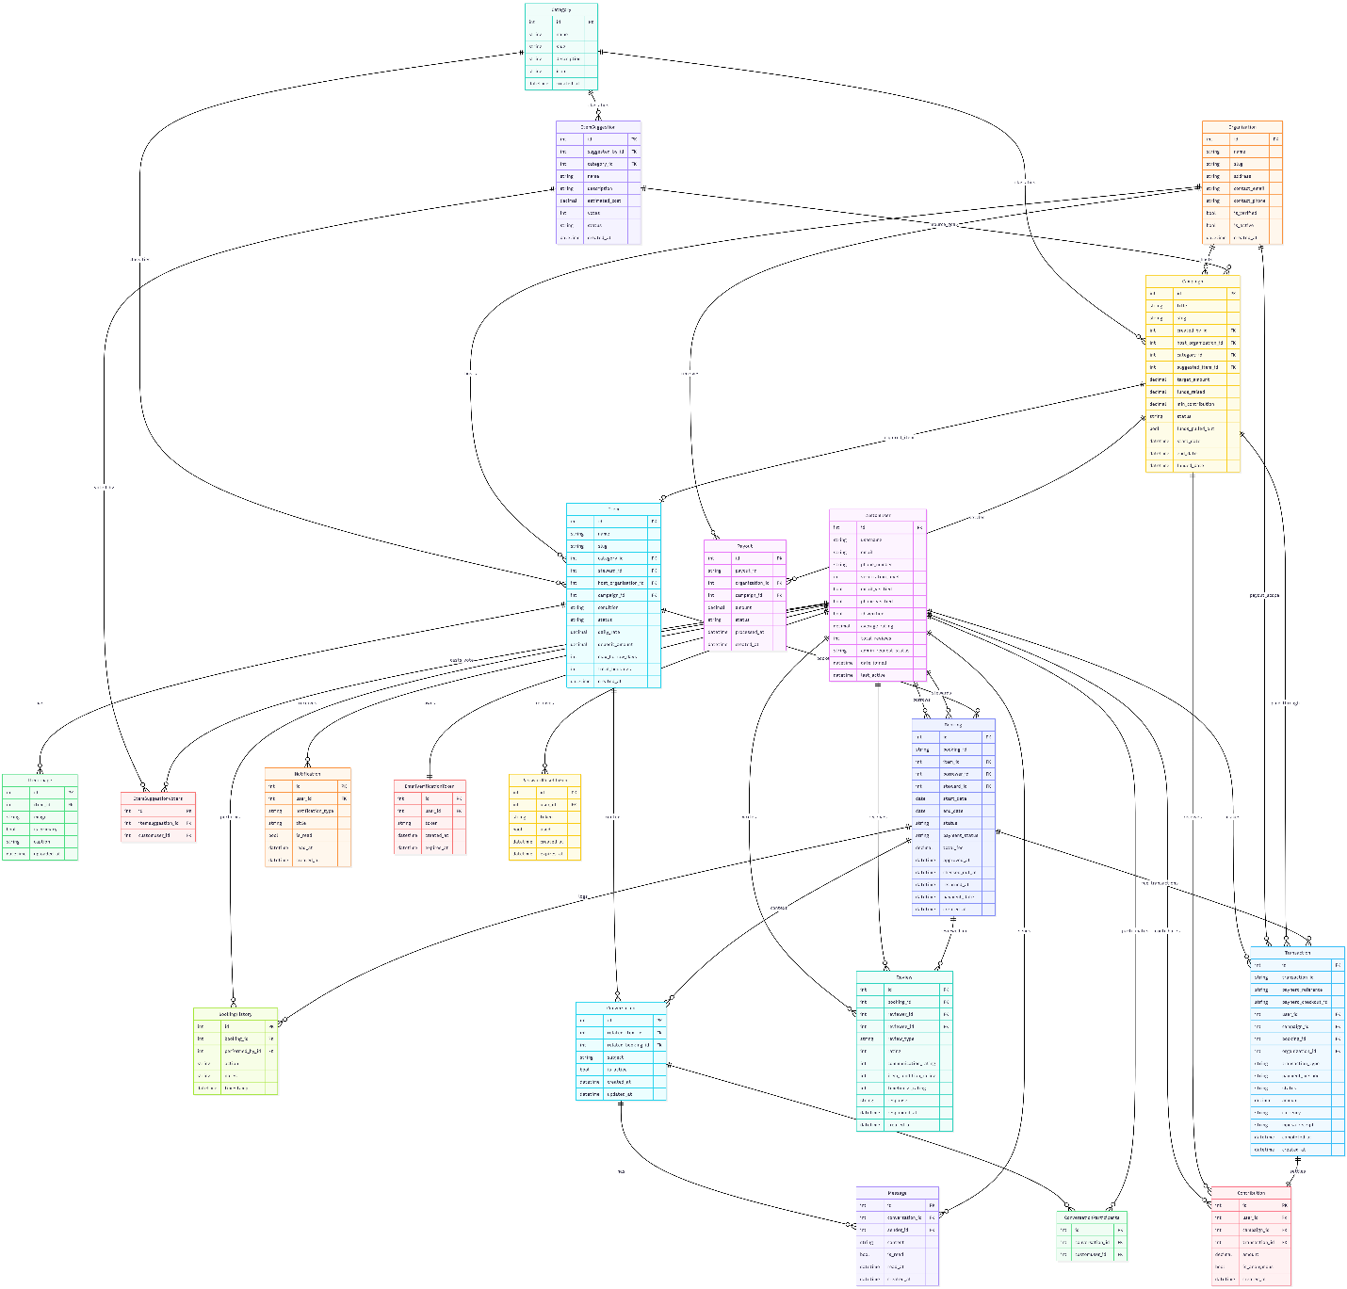
Figure 1 Entity Relationship Diagram

11. External Interface Design

11.1 Routing Overview
Root composition in backend/urls.py exposes:
- Public and authenticated template routes (index, browse, goals, suggest, dashboard)
- Account and admin routes via accounts app
- API namespaces:
  - /api/auth/
  - /api/items/
  - /api/bookings/
  - /api/campaigns/
  - /api/reviews/
  - /api/core/

11.2 REST API Contracts (Endpoint-Level)
11.2.1 Accounts API (/api/auth/)
Endpoint | Auth | Request | Success Response | Error / Notes
POST /api/auth/register/ | Public | JSON: username, email, password, password2, first_name, last_name, phone_number | 201 with created user payload | 400 validation errors
POST /api/auth/login/ | Public | JSON: username (or email), password | 200 with JWT refresh/access + user payload | 401/400 invalid credentials
POST /api/auth/logout/ | Authenticated | JSON: refresh token | 200 logout confirmation | 400 invalid token
POST /api/auth/token/refresh/ | Public with refresh token | JSON: refresh | 200 new access token | 401/400 token invalid/expired
GET /api/auth/profile/api/ | Authenticated | None | 200 user profile | 401 unauthorized
PUT/PATCH /api/auth/profile/api/update/ | Authenticated | JSON profile fields | 200 updated profile | 400 validation errors
GET /api/auth/verify-email/api/{token}/ | Public | Path token | 200 verification result | 400/404 invalid or expired token
POST /api/auth/resend-verification/api/ | Authenticated or template flow | JSON or form | 200 resend confirmation | 400 already verified or invalid state
POST /api/auth/password-reset/ | Public | JSON: email | 200 request accepted | 400 invalid email
POST /api/auth/password-reset/{token}/ | Public | JSON: password, confirm password | 200 password reset complete | 400 invalid token or validation failure
11.2.2 Items API (/api/items/)
Endpoint | Auth | Request | Success Response | Error / Notes
GET /api/items/items/ | Public | Query: search, category, sort | 200 {count, results[]} | Results include image/review aggregates
GET /api/items/items/{slug}/ | Public | Path slug | 200 item detail | 404 if missing
GET /api/items/items/{id}/availability/ | Public | Query: start_date, end_date | 200 availability object | 400 invalid date format
GET /api/items/categories/ | Public | None | 200 category list | None
GET /api/items/stats/ | Public | None | 200 totals and most_borrowed | None
GET /api/items/suggestions/ | Public | Query: status (optional) | 200 {count, results[]} | By default excludes rejected
POST /api/items/suggestions/ | Authenticated | Multipart/JSON: name, description, estimated_cost, category or category_name, image | 201 suggestion | 401 auth required; 400 validation
POST /api/items/suggestions/{id}/vote/ | Authenticated | None | 200 vote toggled result | 403 if suggestion not open for voting
POST /api/items/suggestions/{id}/approve/ | Admin-authenticated | Editable suggestion/campaign fields | 200 campaign publication result | 403 admin required
POST /api/items/suggestions/{id}/delete/ | Admin-authenticated | None | 200 deletion confirmation | 403 admin required
11.2.3 Bookings API (/api/bookings/)
Endpoint | Auth | Request | Success Response | Error / Notes
GET /api/bookings/bookings/ | Authenticated | Query: status, role | 200 list | Auto-syncs overdue states for user scope
POST /api/bookings/bookings/ | Authenticated | Serializer-based booking payload | 201 booking | 400 overlap/date/validation errors
GET /api/bookings/bookings/{booking_id}/ | Authenticated participant | Path booking_id | 200 booking detail | 404/403 filtered by queryset scope
POST /api/bookings/create/ | Authenticated | Multipart/JSON: item_id, start_date, end_date, purpose, borrower_id_photo | 201 {message, booking_id, status} | 400 overdue block, overlap, missing fields
POST /api/bookings/bookings/{booking_id}/approve/ | Steward | JSON: pickup_date, pickup_time, pickup_location, notes | 200 status | 403 non-steward; 400 invalid state
POST /api/bookings/bookings/{booking_id}/decline/ | Steward | JSON: notes | 200 status | 403 non-steward; 400 invalid state
POST /api/bookings/bookings/{booking_id}/cancel/ | Borrower or steward | JSON: notes | 200 status | 403/400 invalid transition
POST /api/bookings/bookings/{booking_id}/pay/ | Borrower | JSON: phone_number (optional if stored) | 200 payment_pending + references | 400 payment initiation errors
POST /api/bookings/bookings/{booking_id}/verify_payment/ | Borrower | None | 200 paid/pending state | Reconciles provider status and updates booking
POST /api/bookings/bookings/{booking_id}/checkout/ | Steward | None | 200 checked out | Requires booking status paid
POST /api/bookings/bookings/{booking_id}/checkin/ | Steward | None | 200 returned | Requires booking status active
GET /api/bookings/bookings/{booking_id}/history/ | Authenticated participant | None | 200 history list | None
POST /api/bookings/payment-callback/ | PayHero callback | JSON callback payload | 200 {status: ok} | 400/404 on missing reference/transaction
11.2.4 Campaigns API (/api/campaigns/)
Endpoint | Auth | Request | Success Response | Error / Notes
GET /api/campaigns/campaigns/ | Public | Query: status, search, sort | 200 {results[]} | Includes progress and days remaining
GET /api/campaigns/campaigns/statistics/ | Public | None | 200 aggregate stats | None
GET /api/campaigns/campaigns/recent/ | Public | None | 200 recent contributions | Excludes anonymous
GET /api/campaigns/campaigns/{id}/contributors/ | Public | Path id | 200 contributor list | 404 if campaign missing
POST /api/campaigns/campaigns/{id}/contribute/ | Authenticated | JSON: amount, phone_number | 200 pending STK response | 400 validation or payment initiation failure
POST /api/campaigns/campaigns/{id}/pullout/ | Admin-authenticated | None | 200 pullout + optional auto-item creation | 403 admin required; 400 invalid campaign state
POST /api/campaigns/verify-payment/ | Authenticated | JSON: transaction_id | 200 completed/pending status | 404 transaction not found
GET /api/campaigns/check-payment-status/?reference=... | Authenticated | Query: reference (external_reference) | 200 completed/failed/pending | Also performs reconciliation and updates records
GET /api/campaigns/campaigns/{id}/detail/ | Public | Path id | 200 campaign detail | 404 missing
GET /api/campaigns/contributions/my/ | Authenticated | None | 200 mixed completed + pending/failed rows | Merges Contribution and Transaction views
POST /api/campaigns/payment-callback/ | PayHero callback | JSON callback payload | 200 {status: ok} | Handles success/cancel/timeout/failure branches
11.2.5 Reviews API (/api/reviews/)
Endpoint | Auth | Request | Success Response | Error / Notes
GET /api/reviews/reviews/ | Public | Query: user, booking | 200 review list | Ordered by newest
POST /api/reviews/reviews/ | Authenticated | JSON: booking, review_type, rating, comment, optional sub-ratings | 201 created review | 400 if booking not completed or duplicate review
GET /api/reviews/reviews/{id}/ | Public | Path id | 200 review | 404 if missing
PUT/PATCH/DELETE /api/reviews/reviews/{id}/ | Authenticated | Review body (for update) | 200/204 | Permission guarded by DRF defaults and queryset
POST /api/reviews/reviews/{id}/respond/ | Authenticated reviewee | JSON: response | 200 response added | 403 non-reviewee
GET /api/reviews/stats/{user_id}/ | Public | Path user_id | 200 total, avg, rating distribution | None

11.2.6 Core API (/api/core/)
Endpoint | Auth | Request | Success Response | Error / Notes
GET /api/core/site-settings/ | Public | None | 200 site settings | Creates default SiteSettings if absent
GET /api/core/notifications/ | Authenticated | None | 200 user notifications | User-scoped queryset
POST /api/core/notifications/mark_read/ | Authenticated | JSON: all=true or notification_ids[] | 200 status message | No-op if empty payload
GET /api/core/notifications/unread_count/ | Authenticated | None | 200 {unread_count} | None

11.3 Template Interface Pages
- Core pages:
  - /
  - /browse/
  - /goals/
  - /suggest/
  - /dashboard/
  - /campaigns/{id}/
  - /items/detail/{slug}/
  - /items/{slug}/book/
- Account pages:
  - /login/
  - /signup/
  - /accounts/profile/
  - email verification and reset pages
- Admin pages (custom admin UI):
  - /admin-dashboard/
  - /accounts/dashboard/
  - /accounts/users/
  - /accounts/items/
  - /accounts/bookings/
  - /accounts/suggestions/
  - /accounts/reports/
  - /accounts/settings/

12. Use Case Model

12.1 Primary Use Cases
- Register and verify account
- Browse and inspect items
- Request item booking with ID photo
- Approve booking and set pickup details
- Borrower pays booking fee via M-Pesa
- Checkout and return item
- Submit and vote on item suggestions
- Approve suggestion and publish campaign
- Contribute to campaign and verify payment
- Pull out funded campaign and auto-create item
- Leave reciprocal reviews after completion
- View and manage notifications
- Admin manage users/items/bookings/reports/settings

12.2 Use Case Diagram
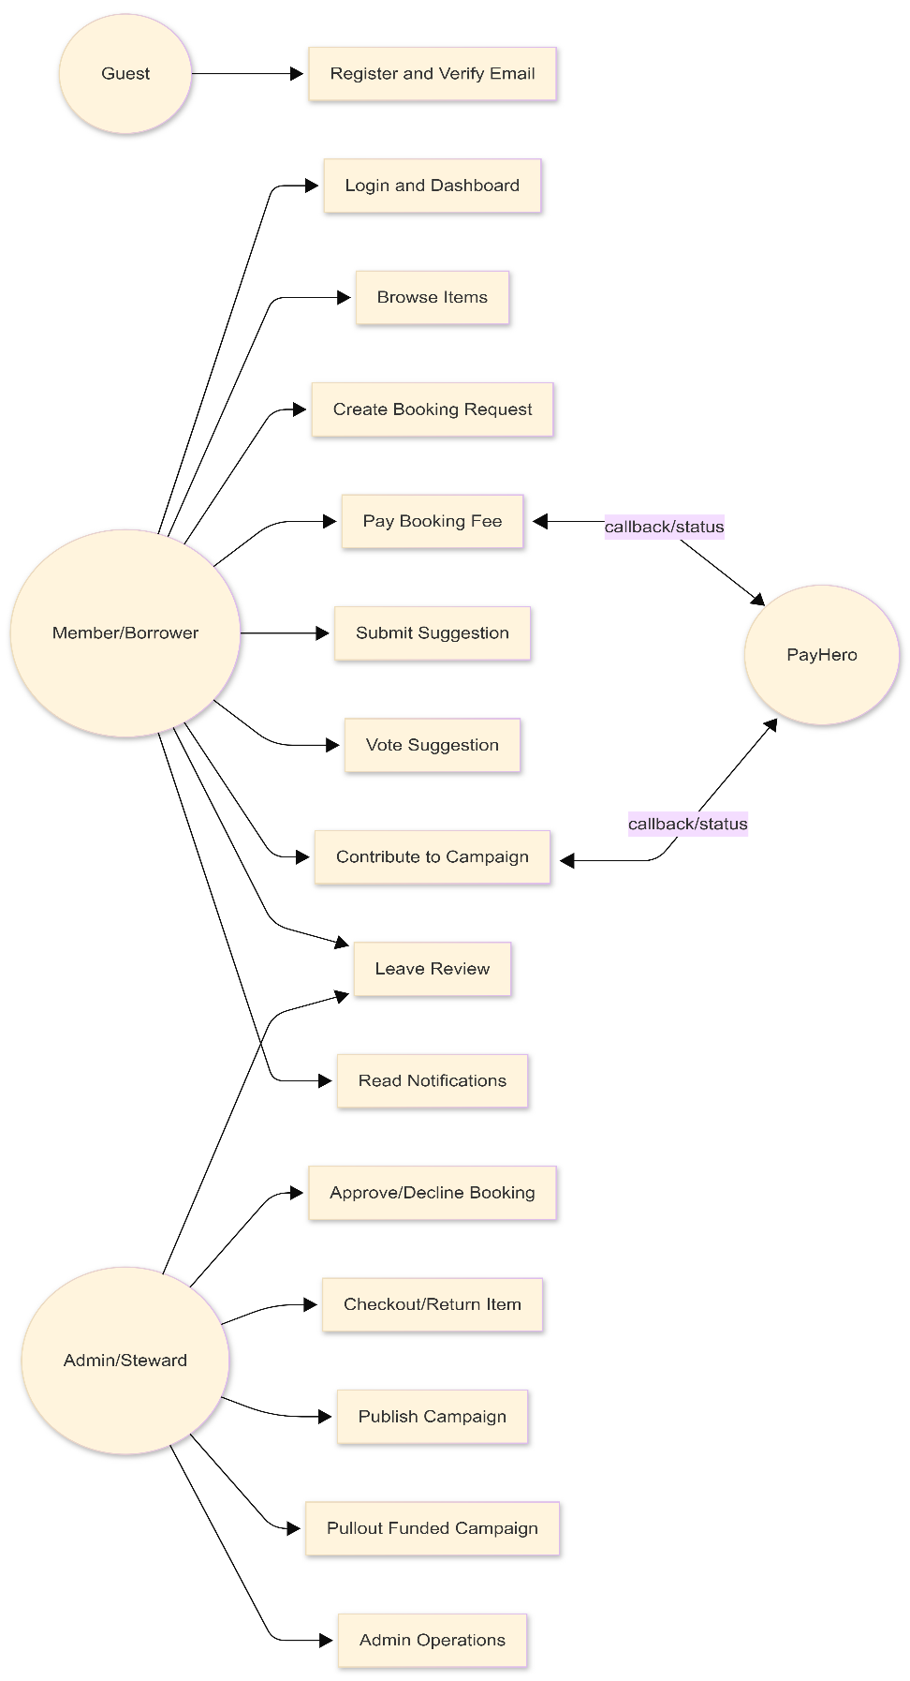
Figure 2 Use Case Diagram

13. Data Flow Design

13.1 Level 0 DFD
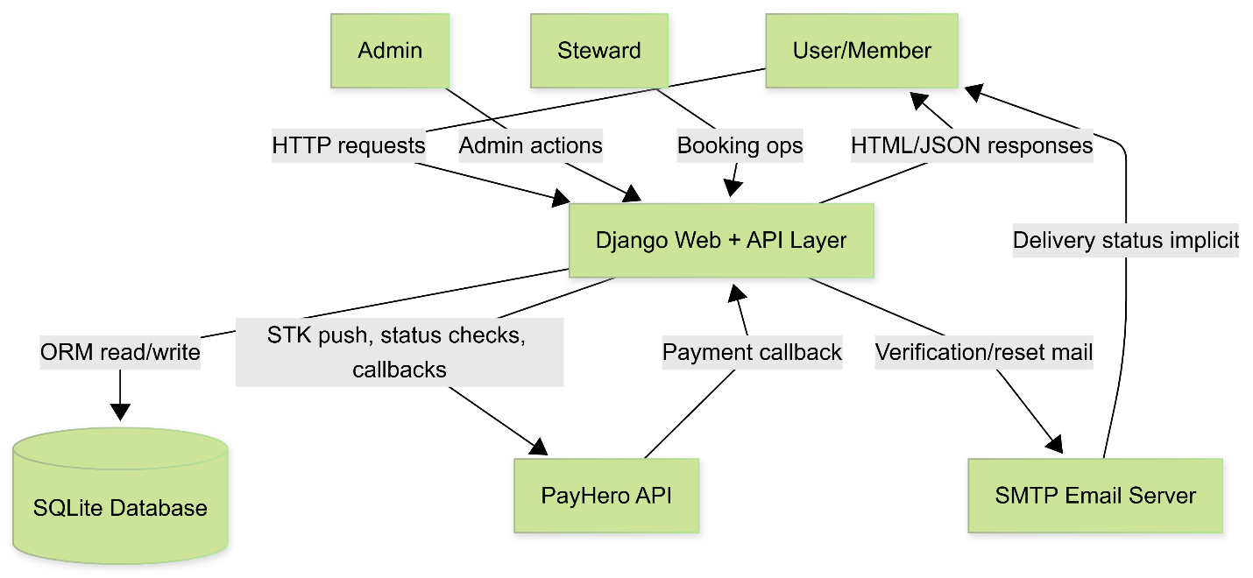
Figure 3 Level 0 DFD

13.2 Level 1 DFD: Booking Payment Flow
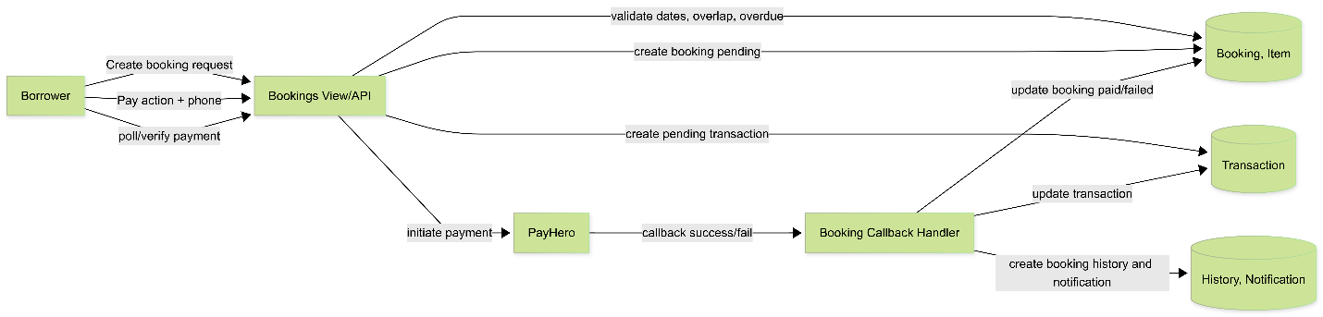
Figure 4 Level 1 DFD

14. Interface and Navigation Design

14.1 Interface Principles in Current Implementation
- Server-side rendered pages for main user journeys
- API-backed dynamic behavior from static JavaScript
- Distinct custom admin UI separate from Django admin site

14.2 Interface Diagram (Page/Module Navigation)
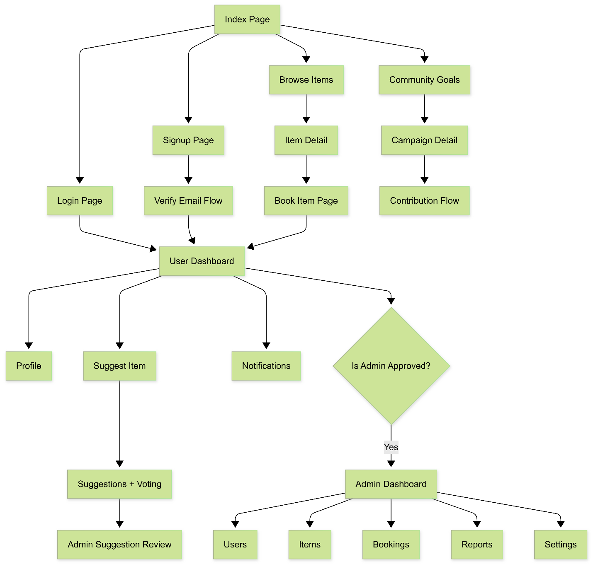
Figure 5 Interface Diagram

15. Detailed Workflow Specifications

15.1 Booking Request Workflow
- User submits item_id, start_date, end_date, purpose, borrower_id_photo.
- System checks borrower overdue constraints.
- System validates date format, date ordering, non-past dates.
- System verifies item availability and overlap with blocking statuses.
- System creates Booking with status pending.

15.2 Booking Approval and Fulfillment Workflow
- Steward/admin reviews pending booking.
- Approve path:
  - status set to approved
  - pickup metadata set
  - history entry written
- Decline path:
  - status set to declined
  - reason/notes persisted

15.3 Booking Payment Workflow
- Borrower triggers pay action for approved booking.
- System computes total fee if missing.
- System creates pending Transaction linked to booking.
- System invokes PayHero initiate payment.
- Callback or manual verification updates:
  - Transaction status
  - Booking payment_status and booking status paid
  - notification and history entries

15.4 Campaign Contribution Workflow
- Authenticated user submits amount + phone.
- Validation: active campaign, minimum amount, phone format.
- System creates pending Transaction for contribution.
- STK push initiated through PayHero.
- Callback/status polling reconciles transaction.
- On completion: increment campaign funds_raised and contributor_count, create Contribution.
- If target reached: campaign status moved to funded.

15.5 Suggestion to Campaign Workflow
- User creates suggestion.
- Admin approves suggestion via SuggestionApproveView.
- System creates or updates Campaign (active).
- Suggestion status set to campaign_created.
- Notifications sent to suggester and voters.

15.6 Fund Pullout and Item Creation Workflow
- Admin posts pullout on funded/completed campaign.
- System marks funds_pulled_out and timestamps.
- If status funded, set completed.
- If no item linked yet and suggested_item exists, auto-create Item with host organization and defaults.

15.7 Overdue Management Workflow
- On relevant requests, service scans active bookings with end_date < today.
- Status transitions active -> overdue.
- BookingHistory overdue action logged.
- Notification sent once per overdue booking to borrower.
- Borrower with unreturned overdue bookings is blocked from creating new bookings.

15.8 Sequence Diagrams
15.8.1 Booking Payment Sequence
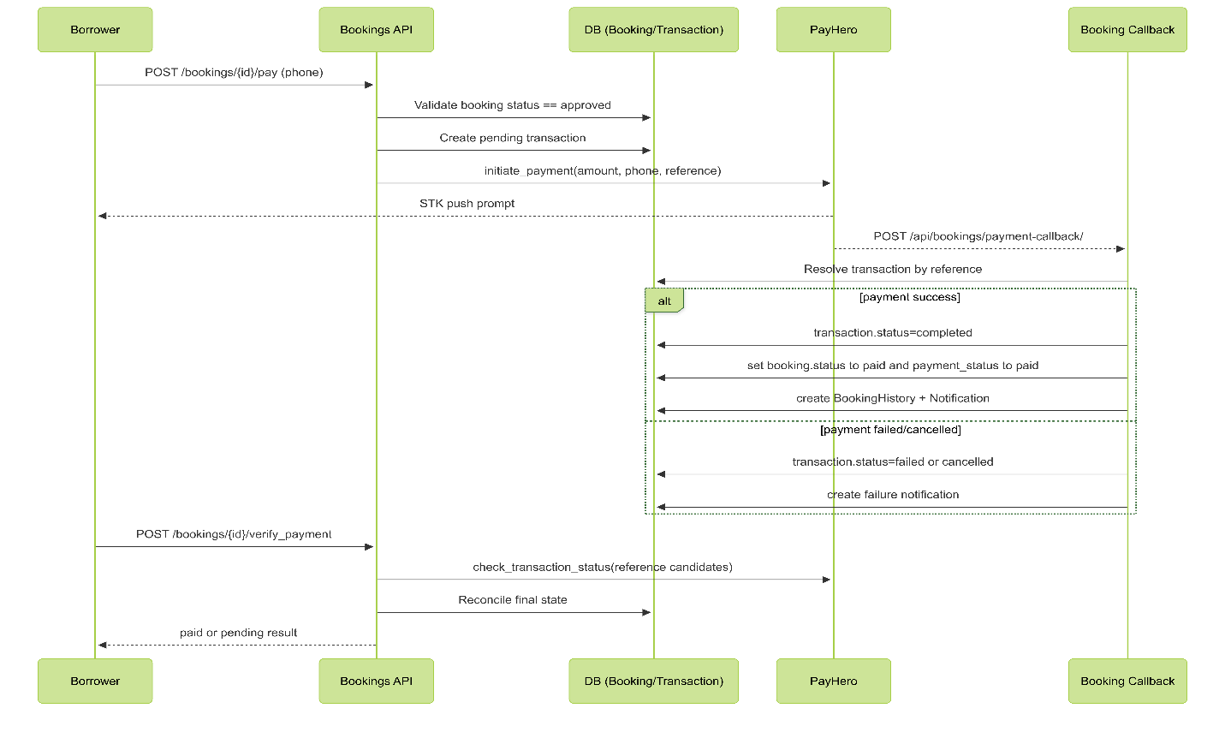
Figure 6 Booking Payment Sequence Diagram
15.8.2 Campaign Contribution Sequence
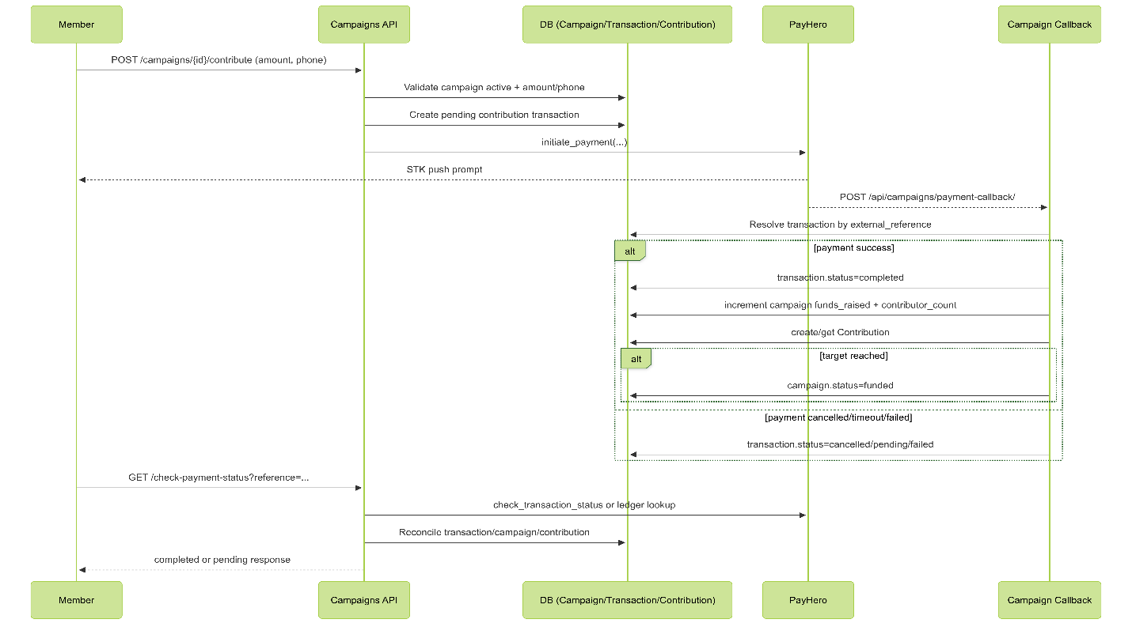
Figure 7 Campaign Contribution Sequence Diagram

15.9 Additional Design Diagrams
15.9.1 Booking State Machine (Current System)
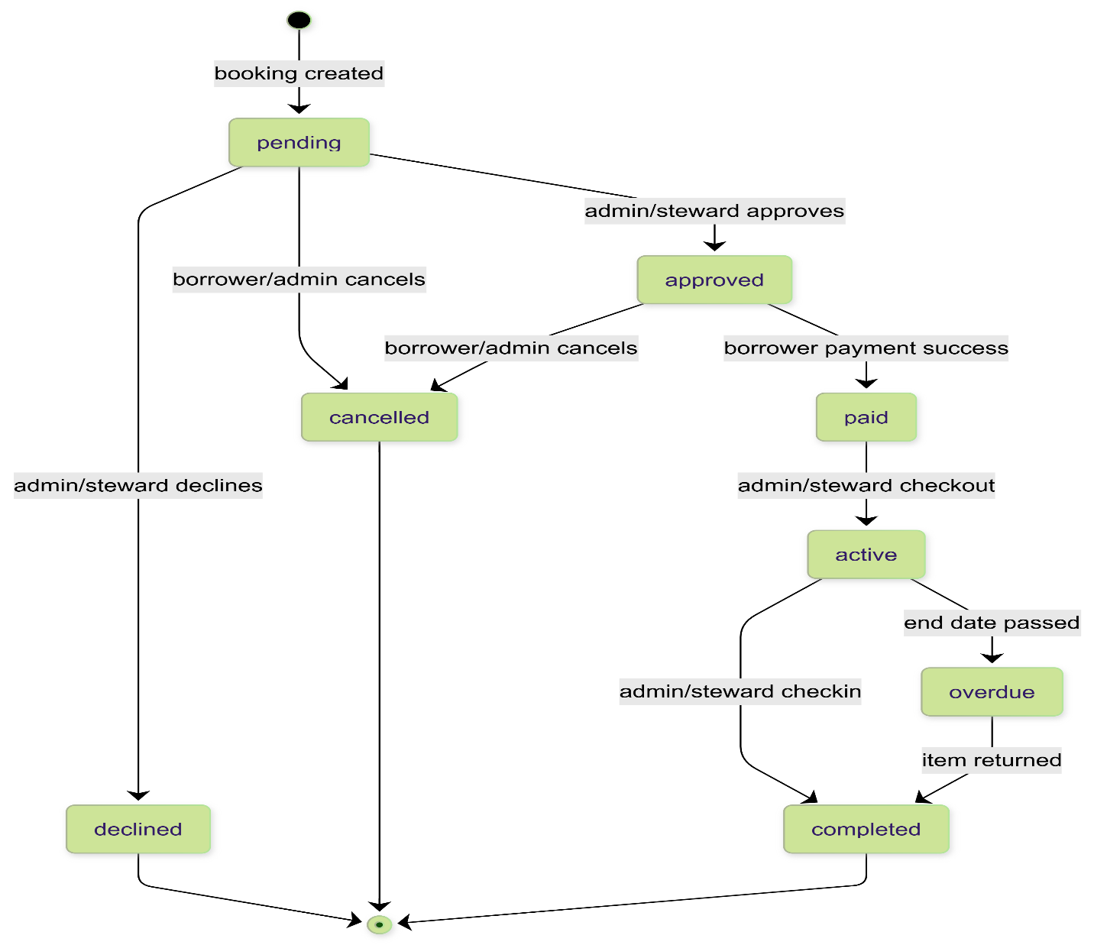
Figure 8 Booking State Machine
15.9.2 Campaign State Machine (Current System)
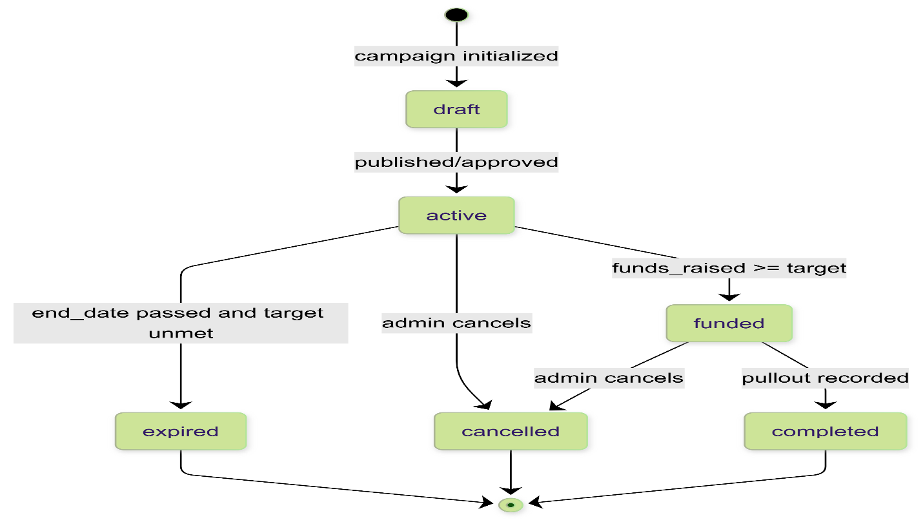
Figure 9 Campaign State Machine
15.9.3 C4 Container Diagram (Current System)
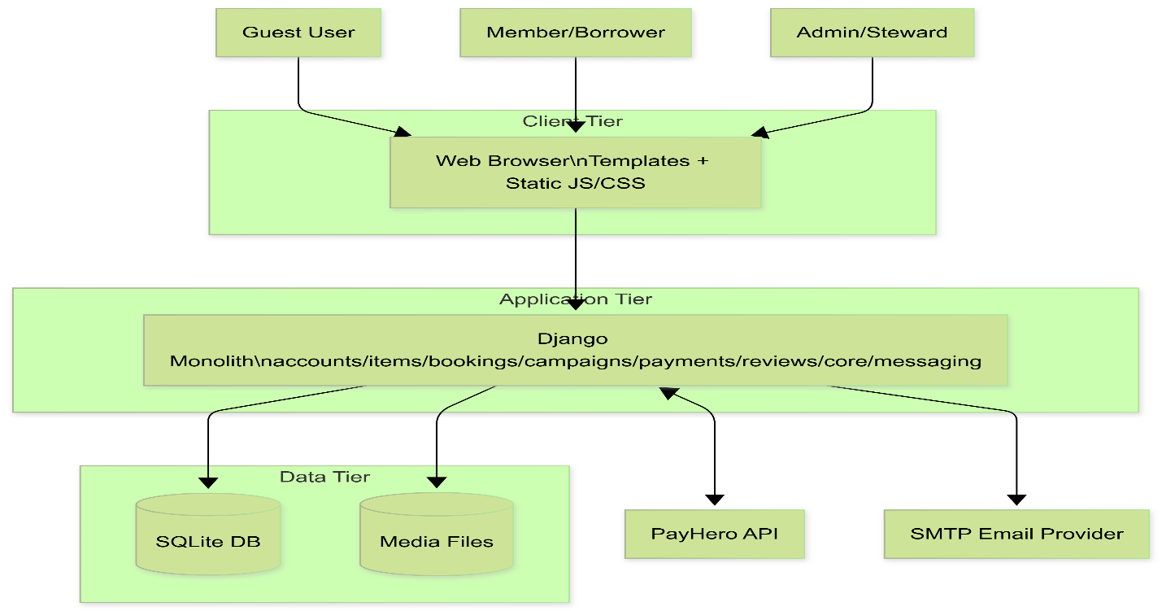
Figure 10 Container Diagram
15.9.4 Deployment Diagram (Current Development Topology)
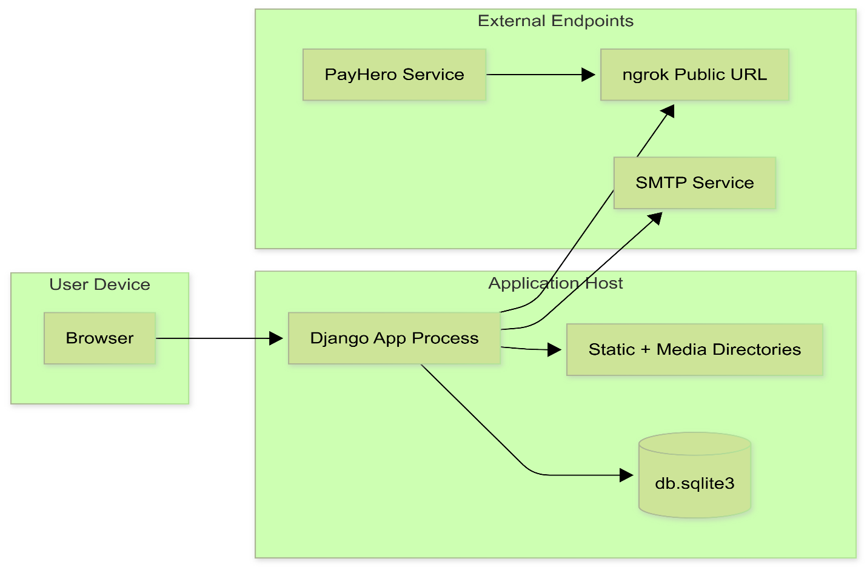
Figure 11 Deployment Diagram
15.9.5 Role-Entity CRUD Matrix (Current System)
Entity | Guest | Member/Borrower | Admin/Steward
CustomUser/Profile | R (public profile limited) | R,U (own profile) | R,U,D (admin operations)
Item | R (limited/public endpoints) | R | C,R,U,D
ItemSuggestion | R | C,R,U (own intent), vote | R,U,D, approve/publish
Campaign | R | R, contribute | C,R,U,D, pullout
Booking | None | C,R,U(cancel own), pay | R,U(approve/decline/checkout/checkin/cancel)
Transaction | None | R (own payment status) | R (operational oversight)
Contribution | None | C,R (own) | R
Review | R | C,R (eligible bookings) | C,R (as steward role), moderate via admin workflows
Notification | None | R,U (own read state) | R,U (own read state; can trigger system notifications)
Conversation/Message | None | C,R,U (authorized booking chat) | C,R,U (authorized booking chat)
Notes:
- Current operations combine Admin and Steward responsibilities under one operator role.
- CRUD capabilities above reflect implemented behavior and operational policy, not only raw model permissions.

15.10 Assumptions and Constraints (Current System)
- Assumptions:
  - Admin and Steward duties are currently fulfilled by one operational role in production use.
  - Most member journeys are template-driven, with selective API calls from frontend JavaScript.
  - Payment confirmation depends on asynchronous callbacks and/or polling reconciliation.
  - Core data persistence is SQLite for current environment.
- Constraints:
  - SQLite limits concurrent write throughput and advanced HA options.
  - Callback availability depends on public endpoint reachability (ngrok in current setup).
  - External dependency behavior (PayHero, SMTP) affects end-to-end completion time.
  - Some business operations are implemented in large consolidated view modules, increasing change risk.

15.11 Business Rules Catalog
- BR-01 Booking Date Validity: Start/end dates cannot be in the past and end date cannot be earlier than start date.
- BR-02 Booking Overlap Prevention: A booking cannot be created for an item if dates overlap with statuses in blocking set: pending, approved, paid, active, overdue.
- BR-03 Overdue Borrower Blocking: Borrowers with overdue unreturned bookings cannot create new bookings.
- BR-04 Booking Approval Authority: Only steward/admin role can approve or decline booking requests.
- BR-05 Payment Before Checkout: Booking must be in paid status before checkout transition to active.
- BR-06 Campaign Contribution Preconditions: Campaign must be active; contribution amount must be positive and satisfy minimum threshold.
- BR-07 Campaign Funding Transition: When funds_raised >= target_amount, campaign transitions from active to funded.
- BR-08 Pullout Completion Rule: Pullout can be recorded only for funded/completed campaigns; funded transitions to completed on pullout.
- BR-09 Suggestion Publishing Rule: Admin approval can publish suggestion into an active campaign and notify interested users.
- BR-10 Review Eligibility: Reviews can only be created for completed bookings by participants in the booking.

15.12 Permission and Access Model
- Role definitions:
  - Guest: unauthenticated visitor.
  - Member/Borrower: authenticated user consuming platform services.
  - Admin/Steward: current operational role managing moderation and booking operations.
- Access rules by capability:
  - Register/Login/Verification: Guest can register/login and perform token-driven verification/reset flows.
  - Browse and Detail: Public endpoints expose limited listing/detail; full browsing flow requires authenticated verified user in template paths.
  - Booking Create/Pay: Member can create booking request and initiate payment for own approved booking.
  - Booking Approve/Decline/Checkout/Checkin: Admin/Steward only.
  - Suggestion Create/Vote: Member can create suggestion and vote (subject to status rules).
  - Suggestion Approve/Delete and Campaign Pullout: Admin/Steward only.
  - Notifications: Users read/mark only their own notifications.
  - Reviews: Booking participants only; response only by reviewee.

15.13 Error Handling and Recovery Strategy
- Error response strategy:
  - API endpoints return structured JSON errors with clear user-safe messages.
  - Validation failures return 400-series responses and field-specific explanations where applicable.
- Payment recovery strategy:
  - Create transaction as pending before external initiation.
  - Process callback idempotently using transaction reference resolution.
  - Support manual/polling verification via provider status and local reconciliation.
  - On reconciliation success, update transaction and dependent domain state (booking/campaign/contribution).
- Operational failure handling:
  - If callback is delayed/unavailable, polling endpoint remains source of truth for eventual consistency.
  - If provider returns not found for one reference format, system attempts alternate references and ledger lookup.
  - Failure states (failed/cancelled/timeout) are persisted and surfaced to user for retriable actions.
- Observability guidance:
  - Log reference IDs (booking_id, transaction_id, payhero_reference) for traceability.
  - Emit warnings for mismatched callback payloads and unresolved references.

15.14 Operational Runbook (Current)
- Daily checks:
  - Verify payment callbacks are being received and processed.
  - Monitor pending transactions aging beyond expected confirmation window.
  - Review overdue bookings and notification generation.
- Payment reconciliation procedure:
  - Locate transaction by user-facing reference.
  - Compare local status versus provider status endpoint.
  - If provider confirms success, reconcile local transaction and dependent booking/campaign records.
  - Create/verify contribution linkage for campaign payments.
  - Record outcome in audit/log channel.
- Incident handling:
  - Callback outage: Keep system operational via polling verification. Restore callback endpoint visibility and replay/reconcile pending transactions.
  - Email delivery issues: Verify SMTP connectivity/configuration and retry user notification actions.
- Data correction guardrails:
  - Prefer controlled admin actions and reconciliation endpoints over direct database edits.
  - If manual correction is unavoidable, document change reason, affected IDs, and timestamp.

16. Security Design

16.1 Authentication and Authorization
- Session auth for template routes
- JWT support for API clients
- Permission checks in DRF views and admin-guarded template views
- Additional admin gating through is_admin_approved

16.2 Data Protection Considerations
- Sensitive identifiers and media uploads stored in media directories
- PayHero references and payment metadata persisted in transactions
- Current settings include hardcoded secrets/keys in configuration (must be externalized)

16.3 Input Validation
- Booking and profile image validation (extension and size checks)
- Campaign contribution amount and phone format checks
- Date validations for booking and availability

17. Non-Functional Requirements

17.1 Performance
- DB indexes present on key status and lookup fields
- Query optimizations with select_related/prefetch in key views
- Potential hotspots: large monolithic admin views and iterative loops in some endpoints

17.2 Reliability
- Idempotent-ish callback handling using transaction lookup and get_or_create for contributions
- Retry logic in payment initiation
- Multiple-reference verification for payment reconciliation

17.3 Maintainability
- Domain app separation is good
- Very large accounts/views.py introduces maintainability risk; candidates for service extraction

17.4 Scalability
- Current SQLite suitable for development/small deployment
- Horizontal scale and high-write payment throughput would require PostgreSQL + worker queue patterns

18. Deployment and Environment Design

18.1 Current Deployment Assumptions
- Django app with DEBUG currently enabled
- ngrok used for callback URLs in development
- Static/media served by Django in DEBUG

18.2 Production Design Recommendations
- Move secrets to environment variables
- Disable DEBUG and enforce secure cookie/CSRF settings
- Use PostgreSQL
- Add object storage for media
- Add task queue for email and payment reconciliation jobs
- Add observability: structured logs, metrics, trace IDs for callbacks

19. Testing Design

19.1 Existing Test Artifacts
Workspace includes targeted tests such as:
- test_dashboard.py
- backend/test_bookings_view.py
- backend/test_notification_api.py
- backend/test_image_fix.py

19.2 Recommended Coverage Expansion
- End-to-end tests for booking payment lifecycle
- Callback idempotency tests for campaign and booking payment handlers
- Permission matrix tests for admin and steward actions
- Contract tests for key API payloads
- Regression tests for overdue blocking and stale status sync

20. Risks and Known Design Gaps
- Secrets in settings file: security and compliance risk.
- Duplicate or overlapping route definitions in campaign URLs may increase ambiguity.
- Very large view modules reduce readability and increase regression probability.
- SQLite limits concurrency and transactional robustness for production workloads.
- Some model/view status vocabularies are broader than strict workflows; governance required to avoid invalid transitions.

21. Traceability Matrix (Feature to Module)
- Authentication and profile: accounts
- Item inventory and browse: items
- Booking lifecycle: bookings + items + core notifications
- Campaign funding: campaigns + payments
- Reviews and reputation: reviews + accounts
- Site settings and notifications: core
- Messaging/chat: messaging + accounts booking chat handlers

22. Appendix A: Suggested Next Architecture Evolutions
- Split accounts/views.py into focused modules:
  - auth_views
  - admin_views
  - profile_views
  - booking_admin_views
- Introduce domain service layer for status transitions and policy checks.
- Introduce finite-state transition guards for booking and campaign status fields.
- Move callback processing into asynchronous jobs with retry and dead-letter handling.
- Create OpenAPI schema for API contracts and client generation.
- Separate operational role assignment so approved non-admin users can be designated as Stewards for item custody and booking approvals.

FINAL TEST MANUAL

For

KNOT: Tying Communities Together Through Shared Resources

Item | Details
Version | 1.0
Prepared by | Sally Mukami Munga
Date | 2026-04-27
Department | Computer Science
Institution | Egerton University

Contents
FINAL TEST MANUAL 1
1. Document Control 3
2. Purpose 3
3. Test Objectives 3
4. Scope 3
5. Test Environment 4
6. Test Assets 4
7. Test Procedure 4
8. Entry and Exit Criteria 5
8.1 Entry Criteria 5
8.2 Exit Criteria 5
9. Automated Test Coverage Summary 5
10. Final Test Cases 6
10.1 Authentication and Account Access 6
10.2 Dashboard and Page Rendering 6
10.3 Item and Suggestion Workflows 6
10.4 Booking Workflow 7
10.5 Campaign and Payment Workflow 7
10.6 Notifications and Core API 8
10.7 Admin Access and Permissions 8
10.8 Email Verification and Password Reset 8
10.9 Validation, Security, and Error Handling 8
10.10 Deployment and Environment Checks 9
11. Script-Based Verification Notes 9
12. Acceptance Criteria 10
13. Known Test Dependencies 10
14. Final Test Outcome Summary 10
15. Test Sign-Off 11

1. Document Control
Item | Details
Project | Knot Community Resource Sharing Platform
Document Type | Final Test Manual
Version | 1.0
Date | 2026-04-12
Prepared For | Final project submission and verification

2. Purpose
This manual defines the final verification procedure for the Knot project. It documents the major functional areas, the test environment, the test cases, and the acceptance conditions used to confirm that the system is ready for submission.

3. Test Objectives
The objectives of the final testing phase are to confirm that:
Users can
- register
- log in
- verify email
- reset passwords
- access the correct dashboard.
Admin and steward workflows function correctly under role-based access control.
Items, suggestions, bookings, campaigns, reviews, and notifications behave according to the project rules.
Payment and callback flows complete successfully or fail safely.
Pages, APIs, and uploaded media render correctly in the current deployment environment.

4. Scope
This manual covers the following areas:
- Authentication and account access
- Admin access and role-based permissions
- Dashboard rendering and booking display
- Item browsing, image handling, and suggestion voting
- Suggestion approval and campaign creation
- Booking creation, approval, payment, and history
- Campaign contribution and payment reconciliation
- Notifications and core API behavior
- Email verification and password reset flows
- Security, validation, and error handling checks
- Deployment and environment sanity checks

5. Test Environment
Recommended environment for final verification:
- Operating system: Windows
- Python environment: project virtual environment
- Framework: Django application with Django REST Framework
- Database: SQLite database shipped with the project
- Browser: Chrome or Edge for template pages
- Optional external services: SMTP email provider and PayHero callback access

6. Test Assets
Relevant automated and manual test files currently present in the project:
backend/apps/accounts/tests.py
backend/apps/items/tests.py
backend/test_bookings_view.py
backend/test_dashboard_render.py
backend/test_notification_api.py
backend/test_image_fix.py
backend/test_images.py
test_dashboard.py

7. Test Procedure
Before running tests:
- Activate the project virtual environment.
- Confirm DJANGO_SETTINGS_MODULE points to backend.settings when running ad hoc scripts.
- Ensure the SQLite database contains at least one verified, active user for dashboard and notification checks.
- Use a superuser or approved admin account for moderation and approval workflows.
- Confirm SMTP and payment-related settings are available if you want to test email and callback flows end-to-end.
- If a real callback cannot be triggered, use the provided verification/polling paths to confirm reconciliation logic.
Recommended execution order:
- Run authentication and dashboard tests first.
- Run item, suggestion, and booking tests next.
- Run payment, notification, and email tests after the core flows are stable.
- Finish with deployment and error-handling checks.

8. Entry and Exit Criteria

8.1 Entry Criteria
Testing can begin when:
- The project starts without configuration errors.
- The database is available and populated with the minimum test records.
- A verified member account and at least one admin or steward account are available.

8.2 Exit Criteria
Testing is complete when:
- All critical test cases pass or have an accepted explanation.
- No blocking errors remain in the tested workflows.
- Payment and email verification paths have been confirmed or reasonably simulated.

9. Automated Test Coverage Summary
The project already includes automated coverage for the following behaviors:
- User creation and verification badge logic
- Suggestion voting restrictions
- Suggestion approval and campaign creation
- Campaign image replacement and fallback behavior
- Dashboard rendering checks
- Booking table rendering and booking-related columns
- Notification API operations

10. Final Test Cases

10.1 Authentication and Account Access
ID | Test Case | Steps | Expected Result | Status
AUTH-01 | Login with valid member credentials | Open login page, enter valid username/email and password, submit | User logs in successfully and is redirected to the user dashboard | Pass
AUTH-02 | Login with invalid credentials | Enter incorrect password and submit | Login is rejected and an error message is shown | Pass
AUTH-03 | Email verification pending path | Log in with a user whose email is not verified | User is redirected to the verification pending page | Pass
AUTH-04 | Logout | Log out from an authenticated session | Session ends and protected pages are no longer accessible | Pass

10.2 Dashboard and Page Rendering
ID | Test Case | Steps | Expected Result | Status
DASH-01 | Dashboard renders for an authenticated user | Force-login or sign in, open /dashboard/ | Dashboard loads without errors | Pass
DASH-02 | Booking section renders correctly | Open dashboard and inspect bookings area | Booking table is visible and populated with the correct columns | Pass
DASH-03 | Image rendering on dashboard | Open dashboard with item data that includes images | Real item images display instead of broken placeholders | Pass

10.3 Item and Suggestion Workflows
ID | Test Case | Steps | Expected Result | Status
ITEM-01 | Browse items | Open browse page or item listing endpoint | Available items are shown to the user | Pass
ITEM-02 | Create a suggestion | Submit a new item suggestion as an authenticated user | Suggestion is saved with pending/open status | Pass
ITEM-03 | Vote on pending suggestion | Attempt to vote on a suggestion still in pending state | Voting is blocked and a 403-style response or message is returned | Pass
ITEM-04 | Vote on approved suggestion | Vote on a suggestion that is open for voting | Vote count increases and the user vote is recorded | Pass
ITEM-05 | Approve suggestion into campaign | Admin approves a suggestion | Campaign is created or updated and the suggestion becomes campaign-linked | Pass

10.4 Booking Workflow
ID | Test Case | Steps | Expected Result | Status
BOOK-01 | Create a booking request | Submit item, start/end dates, purpose, and ID photo | Booking is created with pending status | Pass
BOOK-02 | Reject overlapping booking dates | Attempt to book an item during an already blocked period | Booking is rejected due to overlap rules | Pass
BOOK-03 | Approve booking | Steward/admin approves a pending booking | Booking status changes to approved and pickup details are stored | Pass
BOOK-04 | Decline booking | Steward/admin declines a booking | Booking status changes to declined and an audit/history entry is created | Pass
BOOK-05 | Booking payment initiation | Borrower pays an approved booking | Payment request is sent and a pending transaction is created | Pass
BOOK-06 | Booking payment callback | Simulate or receive payment callback from provider | Booking and transaction are updated to the paid state | Pass
BOOK-07 | Checkout and return | Proceed with checkout then checkin | Booking moves through active to completed lifecycle | Pass
BOOK-08 | Overdue blocking | Create or simulate an overdue booking and attempt a new booking | New booking is blocked until overdue items are resolved | Pass

10.5 Campaign and Payment Workflow
ID | Test Case | Steps | Expected Result | Status
CAMP-01 | Contribute to an active campaign | Submit contribution amount and phone number | Pending payment transaction is created | Pass
CAMP-02 | Campaign payment callback | Simulate successful contribution callback | Contribution is recorded and campaign totals are updated | Pass
CAMP-03 | Campaign reaches funding target | Continue contributions until target is met | Campaign status changes to funded | Pass
CAMP-04 | Pull out funded campaign | Admin records pullout on funded campaign | Campaign moves to completed and item creation logic is triggered if applicable | Pass
CAMP-05 | Payment reconciliation | Check transaction status using the verification endpoint | Local records match provider status after reconciliation | Pass

10.6 Notifications and Core API
ID | Test Case | Steps | Expected Result | Status
CORE-01 | View notifications | Open notifications endpoint or page as an authenticated user | User sees only their own notifications | Pass
CORE-02 | Mark one notification as read | Send a mark-read request for a single notification | The selected notification becomes read | Pass
CORE-03 | Mark all notifications as read | Send a mark-read request with all=true | All user notifications are marked as read | Pass

10.7 Admin Access and Permissions
ID | Test Case | Steps | Expected Result | Status
ADMIN-01 | Admin dashboard access | Log in with an admin or approved steward account and open the admin dashboard | Admin dashboard loads successfully | Pass
ADMIN-02 | Non-admin access blocked | Log in as a normal member and try to open admin pages | Access is denied or redirected appropriately | Pass
ADMIN-03 | Suggestion moderation | Approve or delete a suggestion from the admin interface | The action completes and the correct status change is saved | Pass
ADMIN-04 | Booking moderation | Approve, decline, check out, and check in a booking from admin/steward controls | Booking lifecycle changes are saved correctly | Pass
ADMIN-05 | Report and settings pages | Open reports/settings pages as an admin | Pages render and are editable where applicable | Pass

10.8 Email Verification and Password Reset
ID | Test Case | Steps | Expected Result | Status
MAIL-01 | Email verification token generation | Register a new account | Verification token is created and email flow is initiated | Pass
MAIL-02 | Email verification completion | Use a valid verification token | Account becomes verified and login is allowed | Pass
MAIL-03 | Resend verification | Request a new verification message for an unverified user | A new token/link is generated and the old one is replaced or invalidated | Pass
MAIL-04 | Password reset request | Submit a password reset request with a valid email | Reset flow starts without exposing sensitive information | Pass
MAIL-05 | Password reset completion | Use the reset token to set a new password | Password is updated and the user can log in again | Pass

10.9 Validation, Security, and Error Handling
ID | Test Case | Steps | Expected Result | Status
SEC-01 | Empty login fields | Submit login form without username or password | Validation error is shown and submission is blocked | Pass
SEC-02 | Invalid booking dates | Enter an end date before the start date | Booking is rejected with a clear validation message | Pass
SEC-03 | Invalid upload type | Upload a non-image file where an image is required | File validation rejects the upload | Pass
SEC-04 | Oversized image upload | Upload an image larger than the allowed limit | Upload is rejected and a helpful message is returned | Pass
SEC-05 | Unauthorized API call | Call a protected endpoint without authentication | Request is denied with a 401/403 response | Pass
SEC-06 | Payment failure branch | Simulate a failed or cancelled payment response | Transaction status is updated without corrupting related records | Pass
SEC-07 | Overdue notification path | Trigger overdue booking logic | Overdue status and notification are created exactly once per booking | Pass

10.10 Deployment and Environment Checks
ID | Test Case | Steps | Expected Result | Status
DEP-01 | Static file availability | Open pages that depend on CSS and JavaScript | Styles and interactive behaviors load correctly | Pass
DEP-02 | Media file access | Open item or profile pages with uploaded images | Media assets display correctly | Pass
DEP-03 | Database connectivity | Start the project and load a page that reads from the database | Application connects to SQLite successfully | Pass
DEP-04 | Callback endpoint reachability | Verify payment callback URLs are reachable in the chosen environment | Payment callbacks can be received or simulated | Pass
DEP-05 | Graceful startup | Start the app with the expected environment variables/settings | The project starts without configuration errors | Pass

11. Script-Based Verification Notes
The following scripts are useful for final manual verification because they directly print results to the console:
test_dashboard.py
backend/test_dashboard_render.py
backend/test_bookings_view.py
backend/test_notification_api.py
backend/test_image_fix.py
backend/test_images.py
backend/apps/accounts/tests.py
backend/apps/items/tests.py
Recommended use:
- Run the script.
- Confirm the printed status is successful.
- Verify the output matches the intended UI or API behavior.

12. Acceptance Criteria
The project is considered ready for submission when all of the following are true:
- Core login and dashboard flows work without errors.
- Admin/role-based access behaves as intended.
- Booking creation, approval, payment, and completion work as expected.
- Suggestion voting and approval rules are enforced correctly.
- Campaign contributions and payment reconciliation succeed.
- Notifications load and can be marked read.
- Email verification and password reset flows complete successfully.
- Security and validation checks reject invalid requests cleanly.
- Core pages load with static and media assets in place.
- No critical errors appear in the tested pages or API responses.

13. Known Test Dependencies
Some tests depend on existing database records or specific account states:
- At least one verified active member account
- At least one admin or approved steward account
- At least one item and one category for booking and browsing checks
- At least one notification record for notification tests
- At least one campaign for contribution and payment tests

14. Final Test Outcome Summary
Based on the current project test surface, the final verification set covers the main delivery areas of the system:
- Authentication
- Admin permissions
- Dashboard rendering
- Item suggestions and voting
- Booking lifecycle
- Campaign funding
- Notifications
- Email flows
- Validation and security
- Payment integration touchpoints
- Deployment sanity checks
- This manual can be submitted as the final test evidence for the project.

15. Test Sign-Off
Role | Name | Signature | Date
Student/Developer
Supervisor/Reviewer

User Manual

For

KNOT: Tying Communities Together Through Shared Resources

Item | Details
Version | 1.0
Prepared by | Sally Mukami Munga
Date | 2026-04-27
Department | Computer Science
Institution | Egerton University

Table of Contents
User Manual 1
1. Document Control 4
2. Purpose 4
3. User Roles 4
3.1 Member 4
3.2 Admin 4
4. Getting Started 4
4.1 Accessing the System 4
4.2 Creating an Account 5
4.3 Logging In 7
5. Member Guide 8
5.1 Member Dashboard 8
5.2 Browsing Items 8
5.3 Booking an Item 9
5.4 Paying for a Booking 10
5.5 Negotiate Pick Up Time 11
5.6 Suggesting an Item 12
5.7 Voting on Suggestions 13
5.8 Contributing to Campaigns 14
5.9 Notifications 16
5.10 Profile Management 16
5.11 Request Admin Privileges 17
6. Admin Guide 18
6.1 Admin Dashboard 18
6.2 Managing Users 18
6.3 Moderating Bookings 19
6.4 Moderating Suggestions 21
6.5 Managing Campaigns 22
6.6 Manage Items 23
6.7 Reports and Settings 24
7. Common Tasks 25
7.1 Updating the Password 25
7.2 Password Reset 26
8. Troubleshooting 27
8.1 Login Problems 27
8.2 Booking Problems 27
8.4 Admin Access Problems 28
9. Conclusion 28

1. Document Control
Item | Details
Project | Knot Community Resource Sharing Platform
Document Type | User Manual
Version | 1.0
Date | 2026-04-12
Audience | Members and Admins

2. Purpose
This manual explains how to use the Knot platform from both the member and admin perspectives. It includes the main screens, common actions, and the places where screenshots should be inserted for submission.

3. User Roles

3.1 Member
A member can browse items, submit booking requests, contribute to campaigns, suggest new items, vote on suggestions, view notifications, and manage their own profile.

3.2 Admin
An admin can do everything a member can, plus approve bookings, moderate suggestions, manage users, review reports, manage settings, and perform other administrative tasks.

4. Getting Started

4.1 Accessing the System
Open the Knot website in a browser.
If you already have an account, select Login.
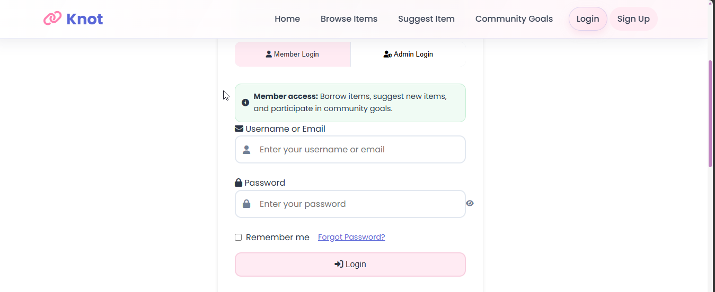
Figure 1 Knot Login Page
If you do not have an account, select Sign Up.
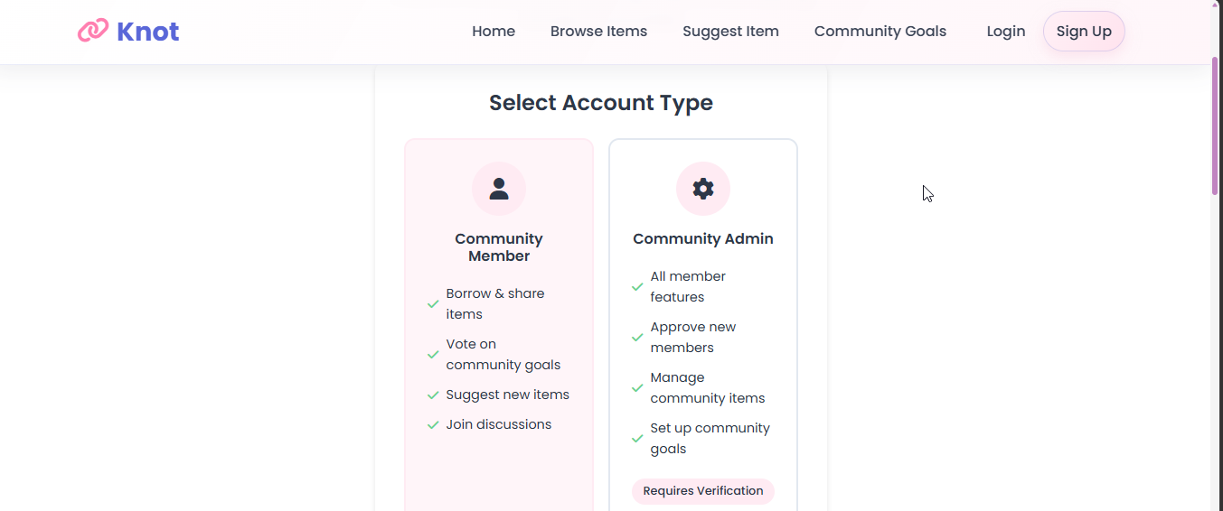
Figure 2 Knot Sign Up Page

4.2 Creating an Account
Select the Sign Up page.
Enter your username, email, password, and other required details.
Submit the form.

Figure 3 Verify Email Message
Check your email and complete verification.
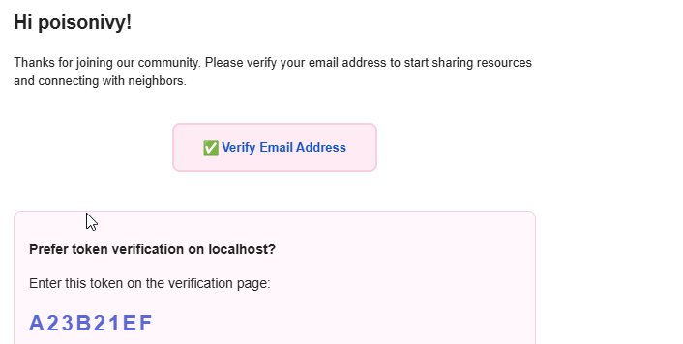
Figure 4 Email Received for Verification
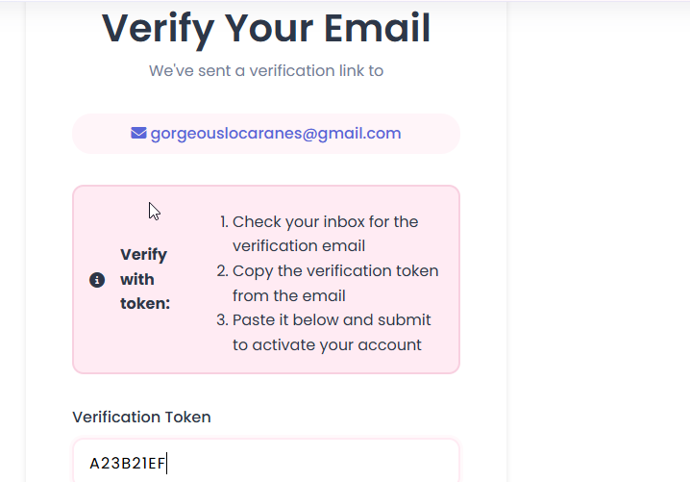
Figure 5 Token based authentication on system

4.3 Logging In
Go to the Login page.
Enter your username or email and password.
Choose the appropriate role if the interface shows role tabs.
Click Login.

5. Member Guide

5.1 Member Dashboard
After logging in, members are redirected to the dashboard.
What the member can see:
Recent bookings
Notifications
Suggested items and campaigns
Profile shortcuts
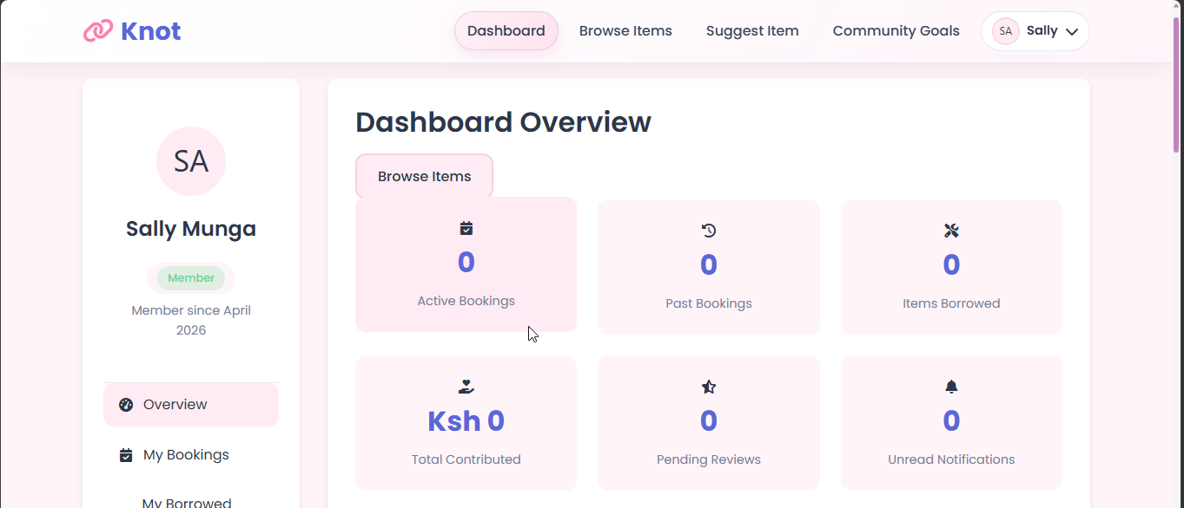
Figure 6 Member's Dashboard

5.2 Browsing Items
Open the Browse Items page.
Use filters or search if available.
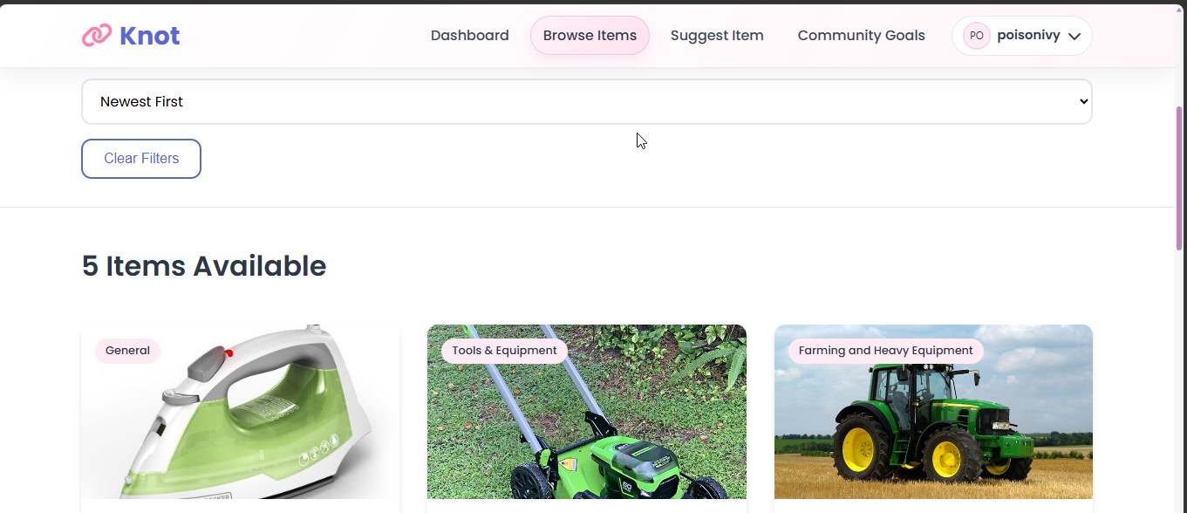
Figure 7 Browse Items Page
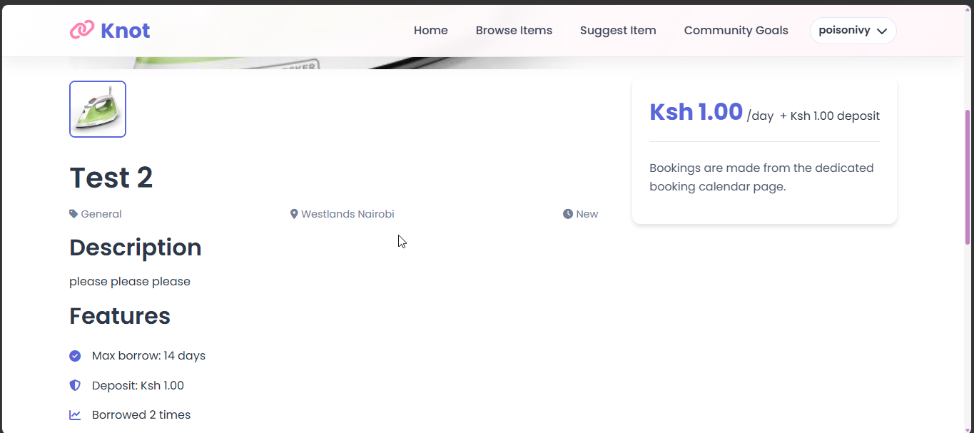

5.3 Booking an Item
Open the item detail page.
Click Book Item.
Enter the start date, end date, purpose, and required ID photo.
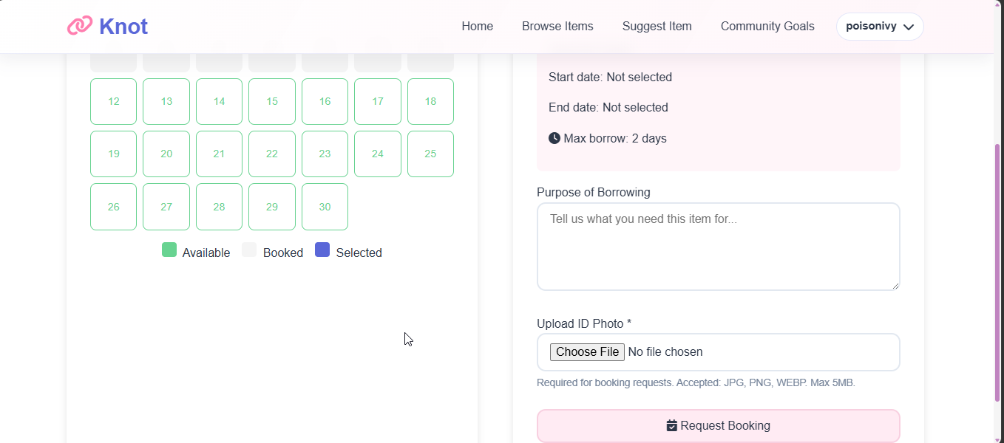
Figure 8 Booking Form
Figure 9: Booking submitted or pending confirmation
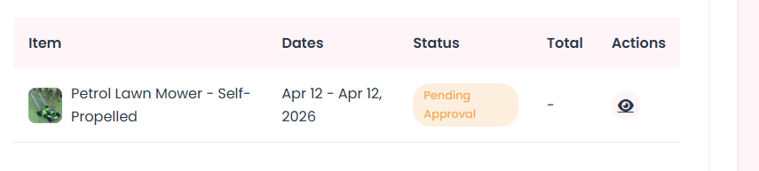
Figure 9 Booking Pending Approval

5.4 Paying for a Booking
Open the approved booking.
Click Pay.
Enter the payment phone number if needed.
Confirm the payment request.
Wait for callback or verification completion.
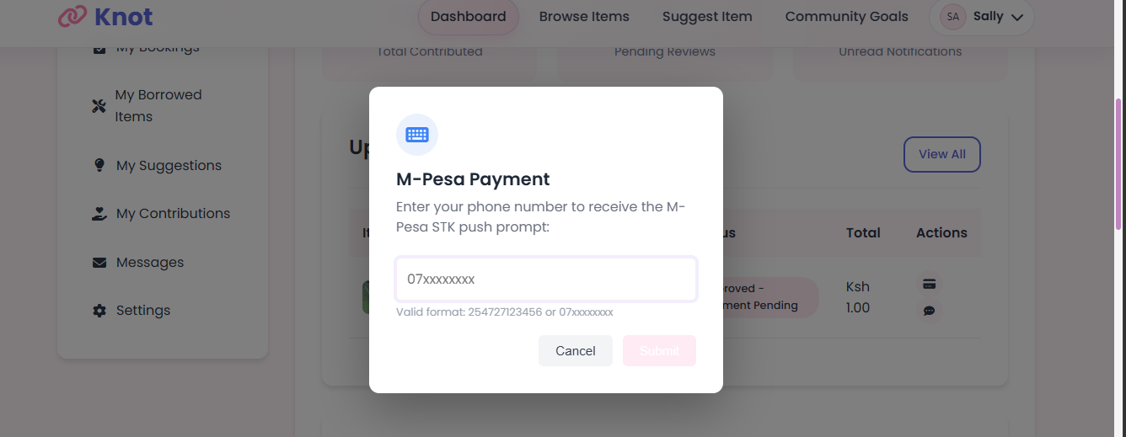
Figure 10 Paying For a booking
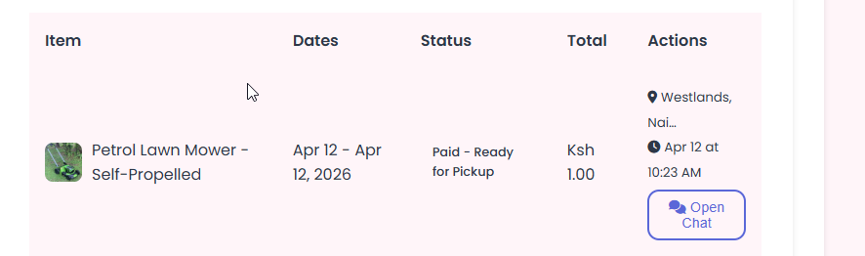
Figure 11 Refresh after paying for booking

5.5 Negotiate Pick Up Time
If recommended time for pickup is inconvenient one can open the chat with the admin and request a different pick up time which is then agreed to by the admin
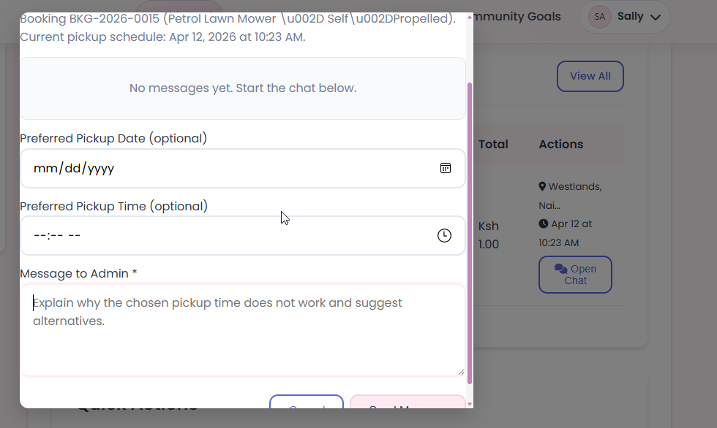
Figure 12 Message Admin

5.6 Suggesting an Item
Open the Suggest page.
Enter the item name, description, estimated cost, and category.
Add an image if needed.
Submit the suggestion.
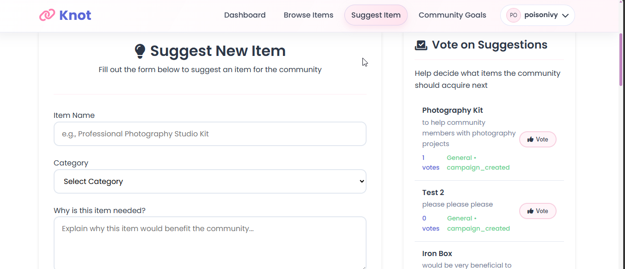
Figure 13 Suggest Item Page

Figure 14 Submitted Suggestion

Figure 15 Approved Suggestion

5.7 Voting on Suggestions
Open the suggestions page
Click Vote on suggestion you want to endorse.
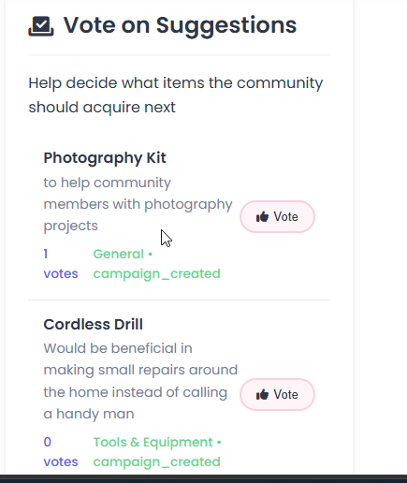
Figure 16 Vote On Suggestions

5.8 Contributing to Campaigns
Open the Community Goals page
Select a campaign.
Enter a contribution amount and phone number.
Confirm the contribution.
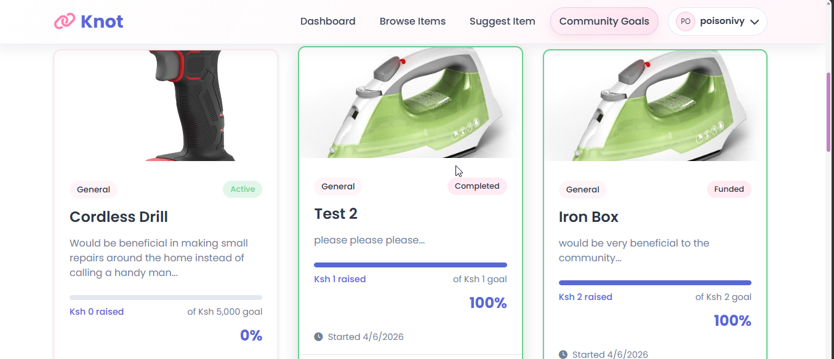
Figure 17 Community Goals Page
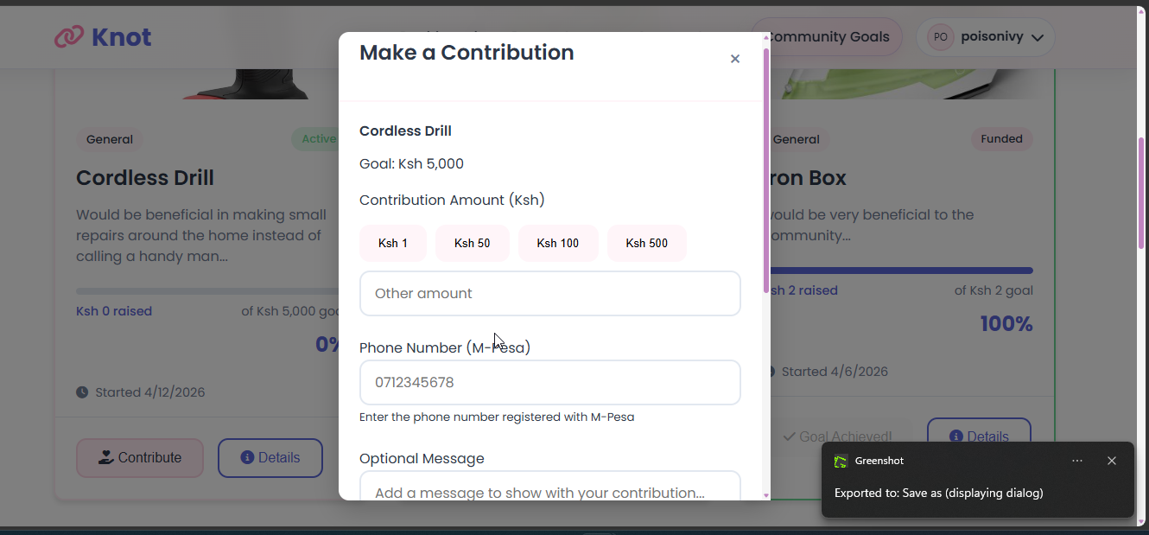
Figure 18 Make a contribution
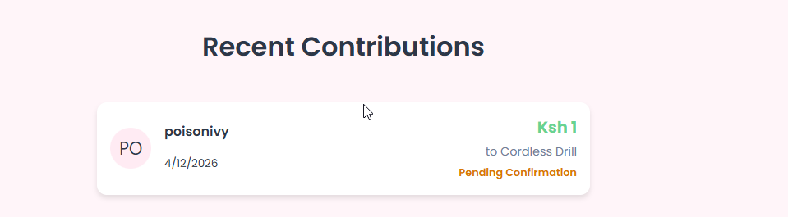
Figure 19 Before Payment Confirmation
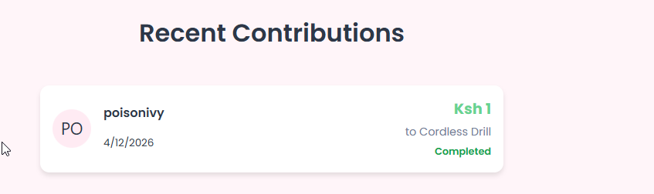
Figure 20 Payment Confirmed Page

5.9 Notifications
Open the Notifications area.
Read new updates.
Mark notifications as read if needed.

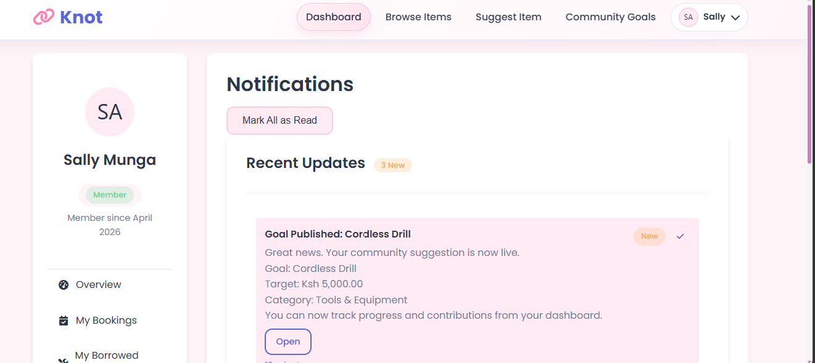
Figure 21 Notifications Page

5.10 Profile Management
Open your profile page.
Update your details.
Save changes.
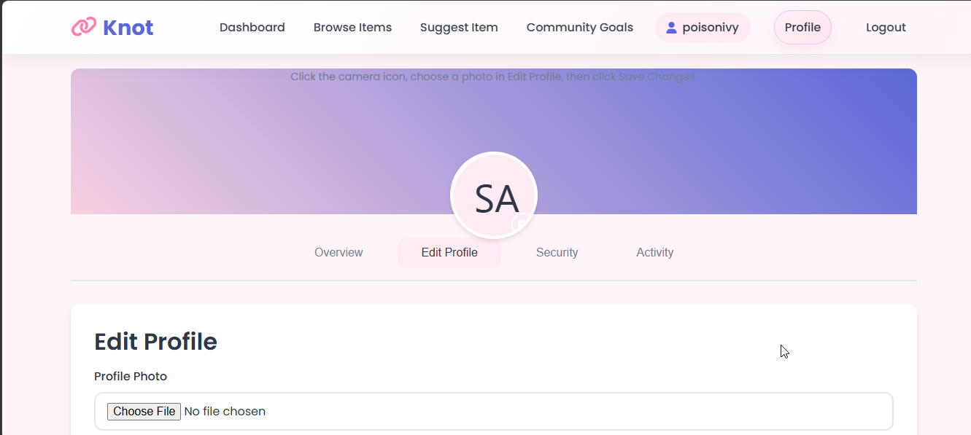
Figure 22 Profile Page

5.11 Request Admin Privileges
Open settings on the dashboard
Fill the request admin form
Wait for admin response
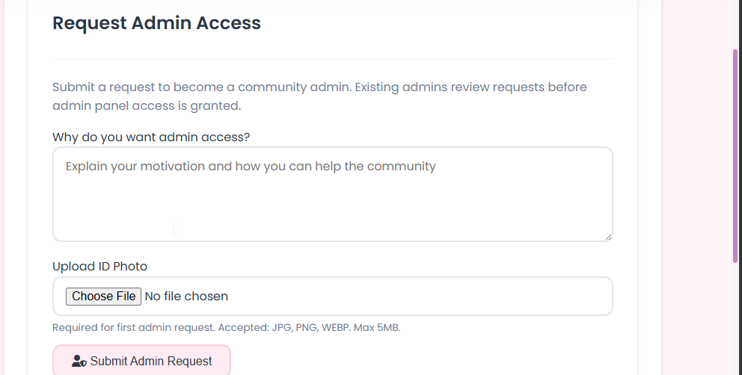
Figure 23 Request Admin Access

6. Admin Guide

6.1 Admin Dashboard
After logging in as an admin or approved steward, the system redirects to the admin dashboard.
What the admin can see:
User management shortcuts
Booking moderation tools
Suggestion and campaign moderation
Reports and settings
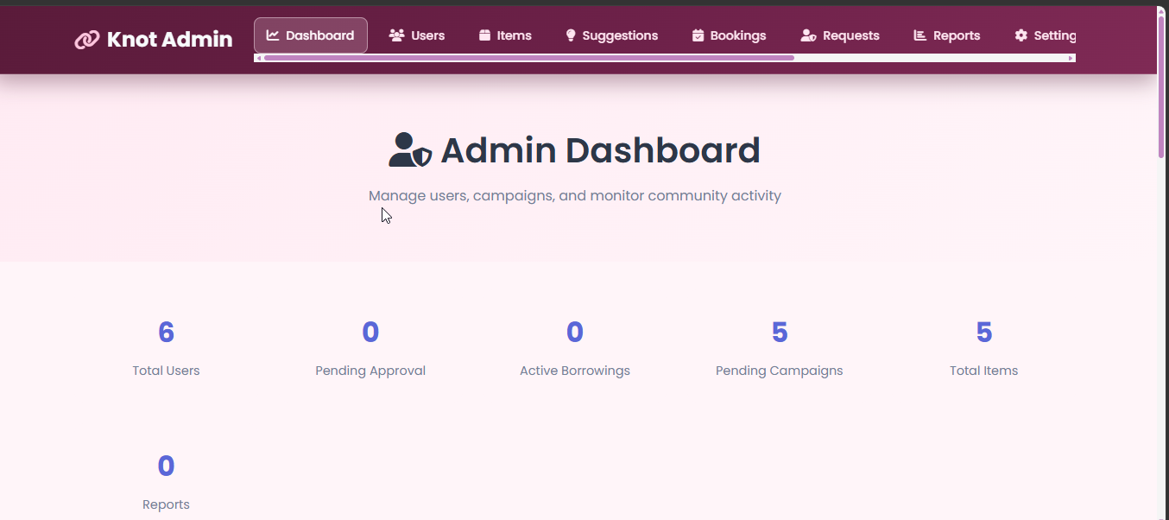

6.2 Managing Users
Open the Users page in the admin area.
Search or browse user accounts.
Review account information and status.
Perform allowed management actions such as inactivating and deleting users
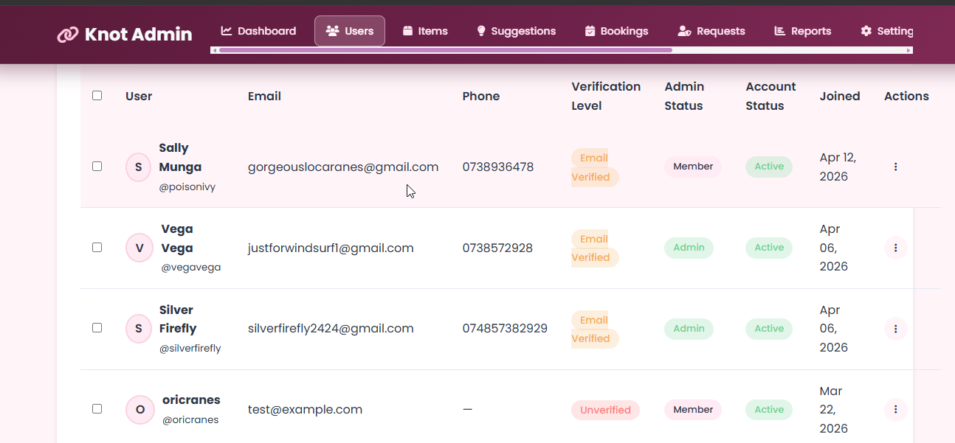
Figure 24 Admin Users Page
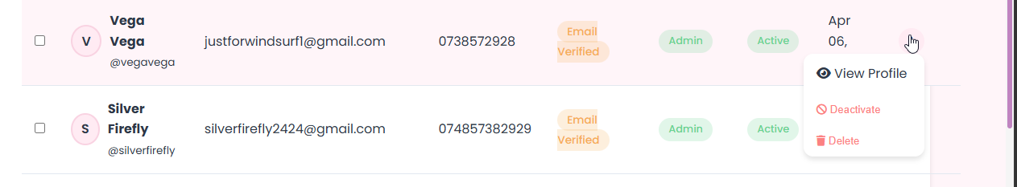
Figure 25 Allowed Admin Actions On users

6.3 Moderating Bookings
Open the Bookings page.
Review pending booking requests.
Approve or decline requests.
Add pickup details when approving.
Complete checkout and checkin when the item is returned.
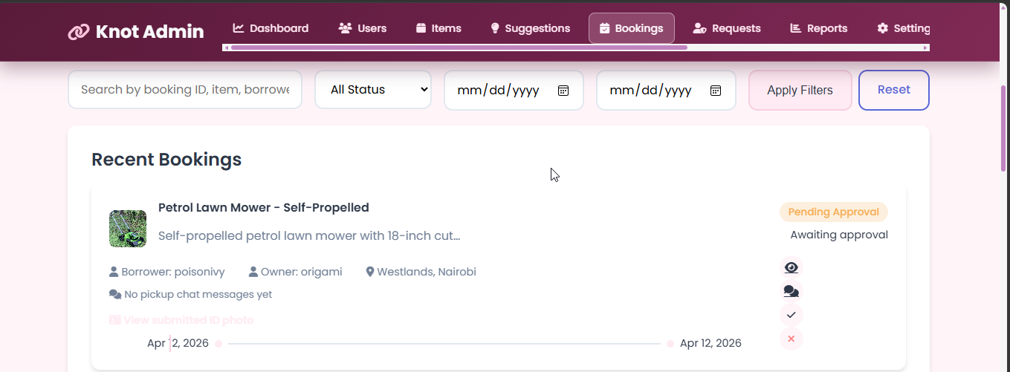
Figure 26 Admin Bookings Page
Screenshot Placeholder
Figure 23: Booking approval form or modal
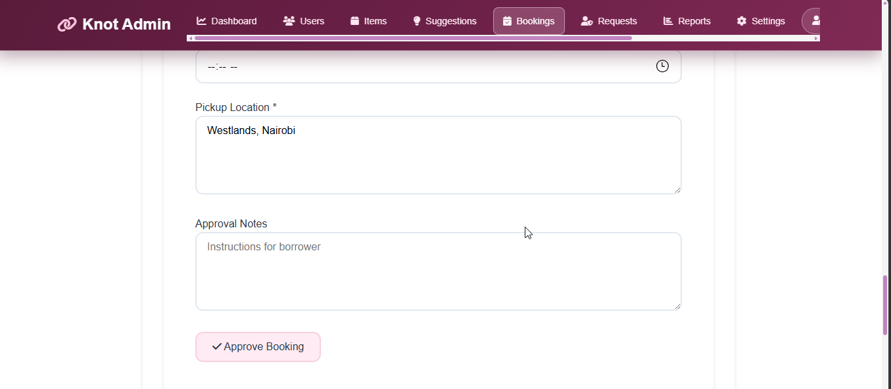
Figure 27 Admin Approving Booking
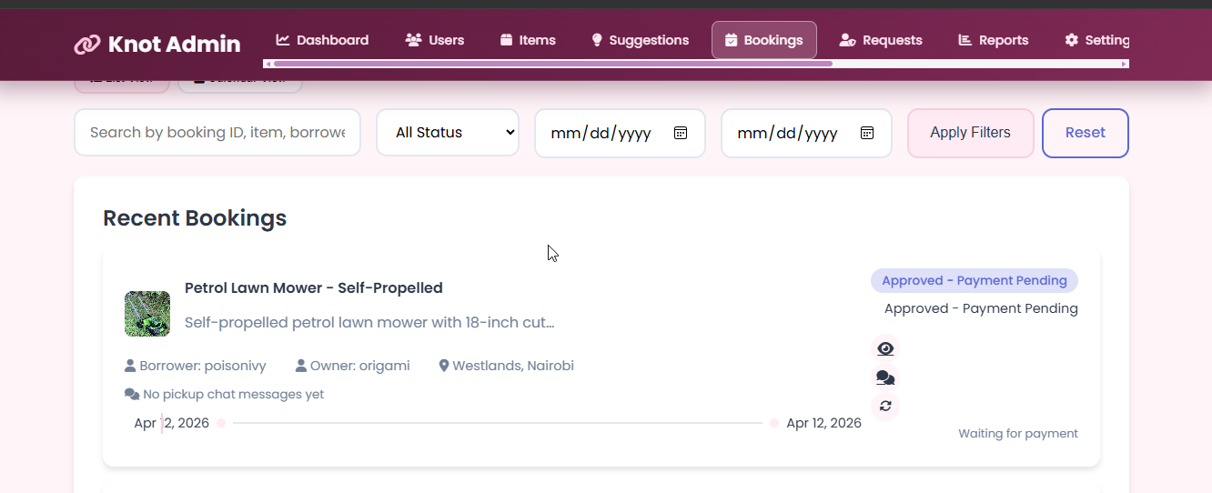
Figure 28 Booking Approved with pending payment
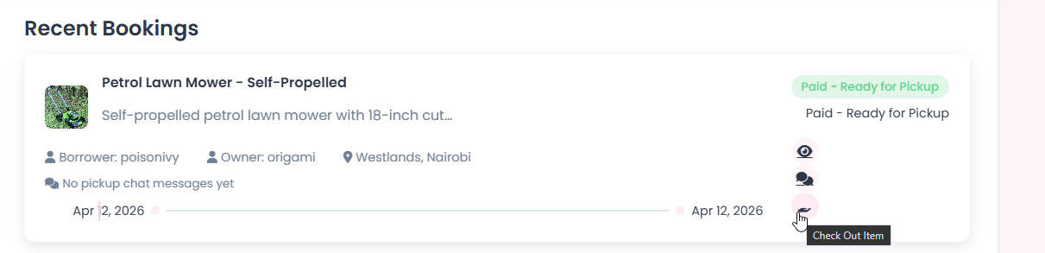
Figure 29 Check Out Item
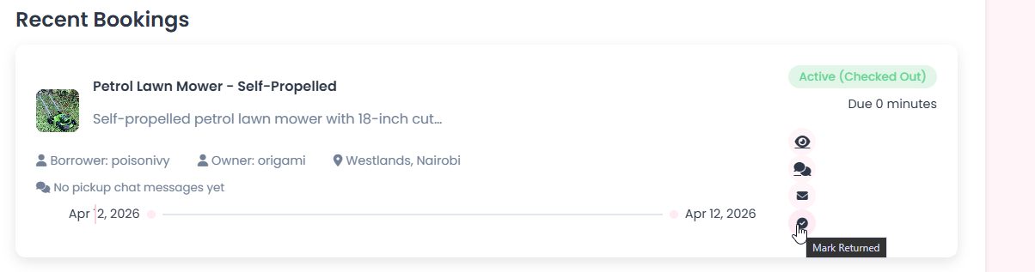
Figure 30 Mark Item returned

6.4 Moderating Suggestions
Open the Suggestions page.
Review submitted item suggestions.
Edit the suggestion details if needed.
Approve the suggestion to create or update a campaign.
Delete invalid suggestions if necessary.
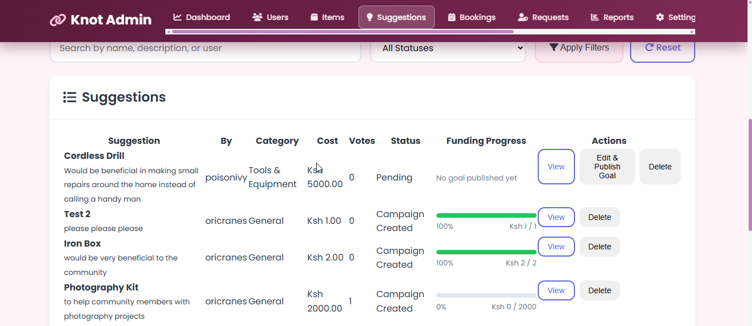
Figure 31 Admin Suggestions Page

6.5 Managing Campaigns
Open the Campaigns area.
Review active and funded campaigns.
Monitor contributions and totals.
Pull out funds when the campaign is ready.
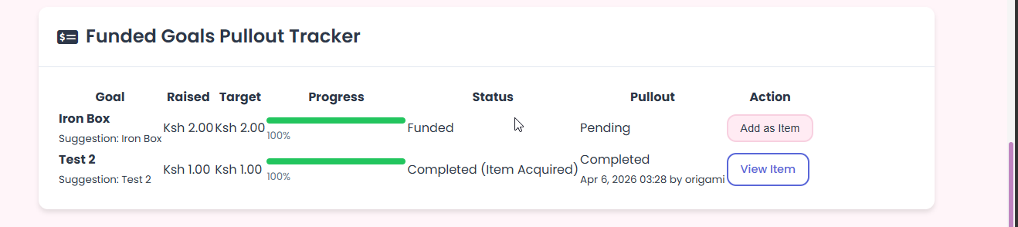
Figure 32 Knot Admin Pullout Items

6.6 Manage Items
Add new items
Delete or mark existing items for maintenance
Edit existing items
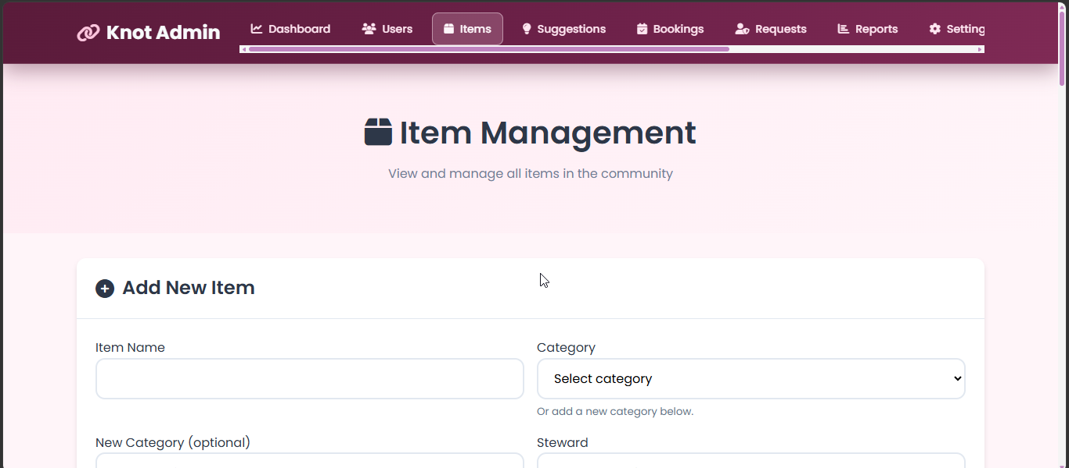
Figure 33 Item management page
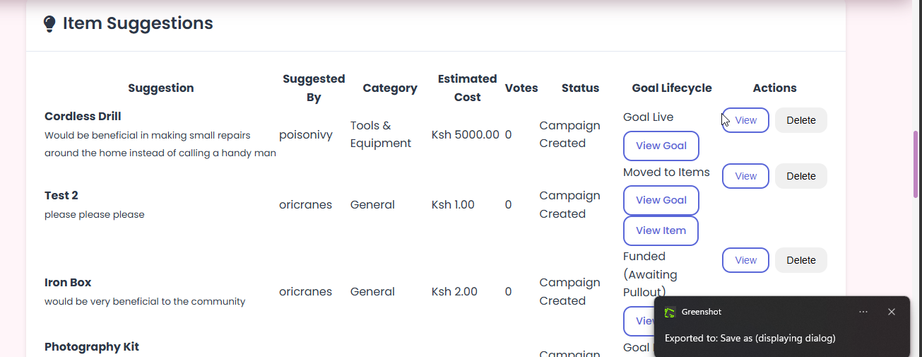
Figure 34 Item suggestions view
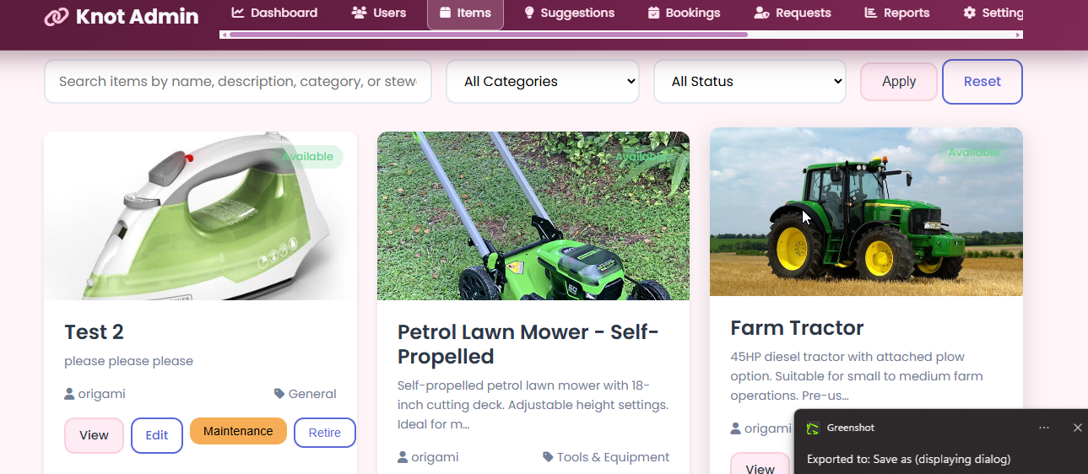
Figure 35 View Existing items

6.7 Reports and Settings
Open the Reports page to review project activity.
Open the Settings page to view or update supported configuration options.
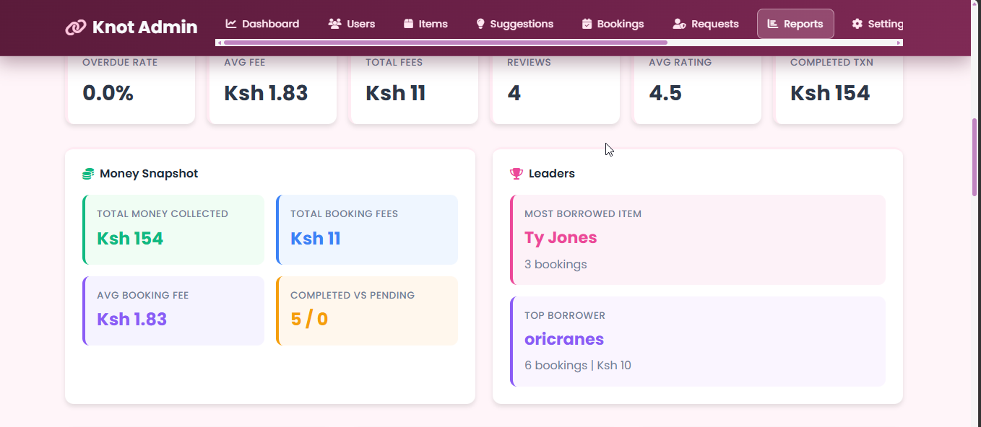
Figure 36 Reports Page
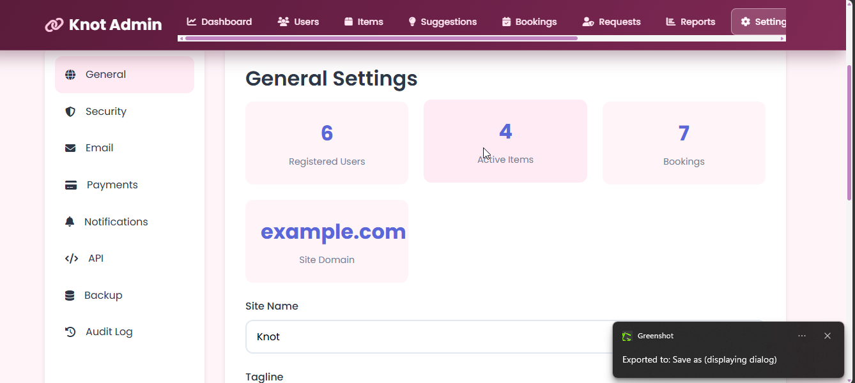
Figure 37 Settings Page

7. Common Tasks

7.1 Updating the Password
Open your profile settings
Choose Security from the nav bar
Enter the current password and the new password.
Save the change.
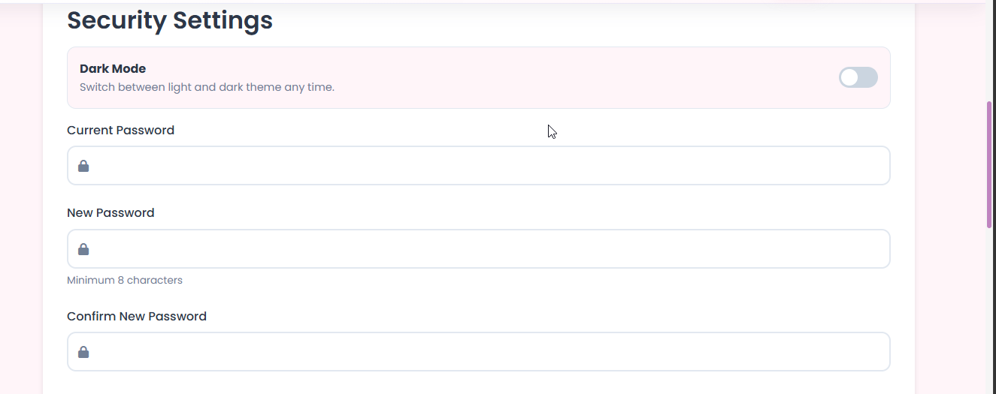
Figure 38 Update Password

7.2 Password Reset
Use the Forgot Password link on the login page.
Enter your email address.
Open the reset link or token sent to your email.
Set a new password.
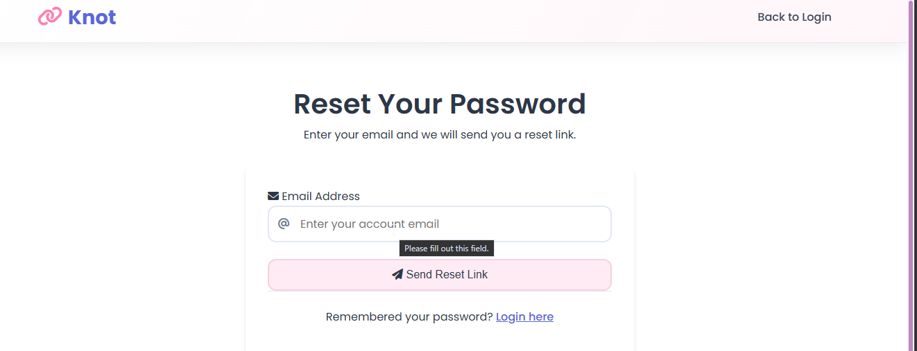
Figure 39 Reset Password page
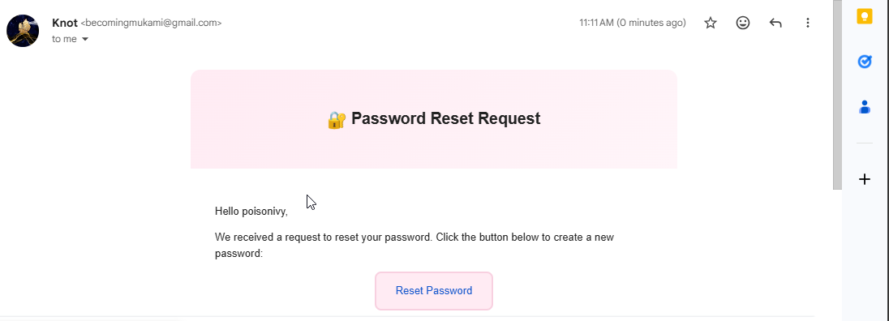
Figure 40 Reset Password Email
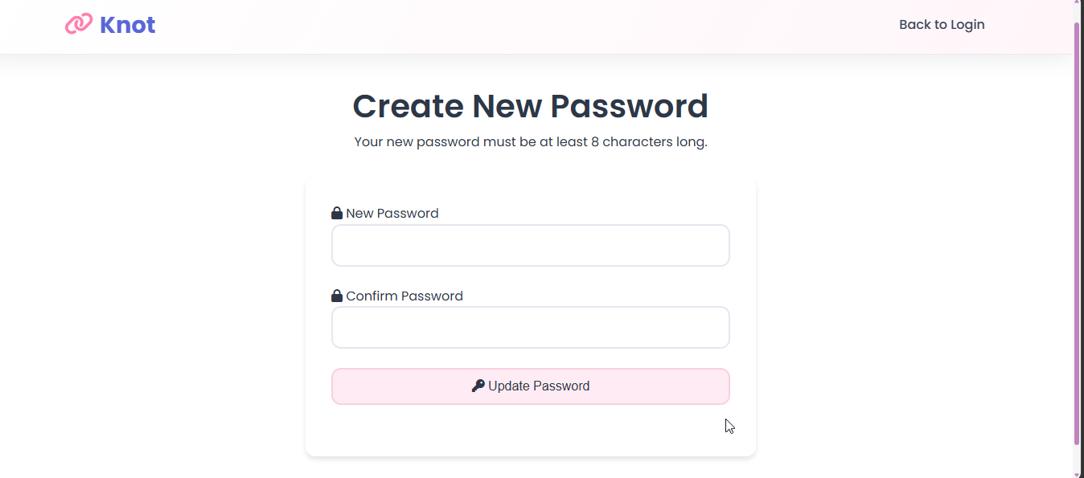
Figure 41 Create New Password

8. Troubleshooting

8.1 Login Problems
Make sure you entered the correct username or email.
Confirm your password is correct.
Check whether your email has been verified.

8.2 Booking Problems
Check that the item is available for the chosen dates.
Confirm that the booking request includes all required fields.
Ensure you do not have overdue bookings blocking new requests.

8.3 Payment Problems
Confirm the phone number is correct.
Wait a short time for callback or verification processing.
Refresh the page or re-check payment status if the response is pending.

8.4 Admin Access Problems
Confirm you are using an admin or approved steward account.
Make sure the account is not blocked or unverified.
Use the main admin dashboard rather than member pages.

9. Conclusion
This user manual provides the main instructions for both members and admins. It is designed to be completed with screenshots from your own system walkthrough so it can be submitted with the final project documentation.

