Email spam classifier

Machine Learning-based Text Classification using NLP

Author: SIVANYA S (Team 2)

Project Type: Individual Project

EXECUTIVE SUMMARY:

The Email Spam Classifier is a Python-based machine learning project designed to automatically detect whether an email is spam or legitimate (ham). The system uses Natural Language Processing (NLP) techniques to preprocess email text and convert it into numerical form using TF-IDF. A supervised learning algorithm (Naive Bayes) is then applied to classify emails with high accuracy.
The model is trained on a labeled dataset and can identify spam messages based on patterns such as keywords and frequency of terms. The system achieves around 97% accuracy and can be used for real-time spam detection. This project demonstrates practical skills in text preprocessing, machine learning, and data analysis.

OBJECTIVE:

To build an automated system for detecting spam emails

To apply NLP techniques for text preprocessing

To convert text data into numerical features using TF-IDF

To train a machine learning model for classification

To achieve high accuracy with minimal false predictions

To enable real-time spam detection

SCOPE:

Classification of emails into spam or ham

Use of NLP for text cleaning and processing

Implementation of machine learning algorithms

Real-time prediction of new messages

Storage and handling of dataset

Extension for phishing and fraud detection

KEY FEATURES:

- Automatic spam detection system
- Uses TF-IDF for feature extraction
- Machine learning-based classification (Naive Bayes)
- High accuracy (~97%)
- Real-time prediction capability
- Lightweight and efficient model
- Easy integration into email systems

TECHNICAL IMPLEMENTATION

The system follows a machine learning pipeline architecture to ensure efficient processing and accurate classification of email data.
Architecture Flow:
- Data Layer:
Email dataset (spam and ham messages)
- Preprocessing Layer:
Text cleaning (lowercase, remove punctuation, stopwords using NLTK)
- Feature Extraction Layer:
Conversion of text into numerical vectors using TF-IDF
- Model Layer:
Machine Learning model (Naive Bayes) trained on processed data
- Evaluation Layer:
Model performance measured using accuracy score
- User Layer:
User inputs new message → system predicts Spam or Ham
2. Technology Stack
Component | Technology Used | Purpose
Programming Language | Python | Core application logic
Data Handling | Pandas, NumPy | Data loading and processing
NLP Processing | NLTK | Text preprocessing
Feature Extraction | TF-IDF (Scikit-learn) | Convert text to numerical form
Machine Learning | Naive Bayes | Classification model
Development Environment | VS Code / IDLE | Code execution
Storage | CSV Dataset | Training data

📊 3. Performance Metrics
- Accuracy:
Achieved ~96–97% classification accuracy
- Precision & Recall:
High precision in detecting spam with low false positives
- Processing Time:
Fast classification (real-time prediction in milliseconds)
- Reliability:
Effectively handles large text datasets
- Scalability:
Can be extended to detect phishing, fraud, and advertisements

SOURCE CODE IMPLEMENTATION (Screenshot):

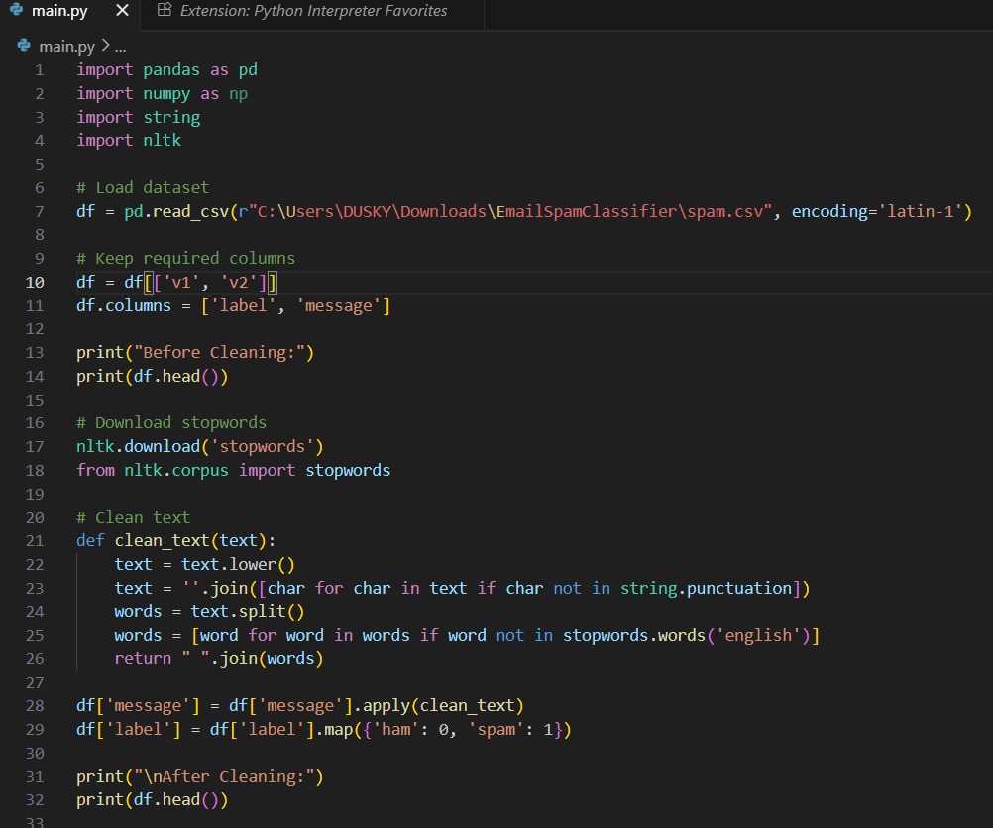

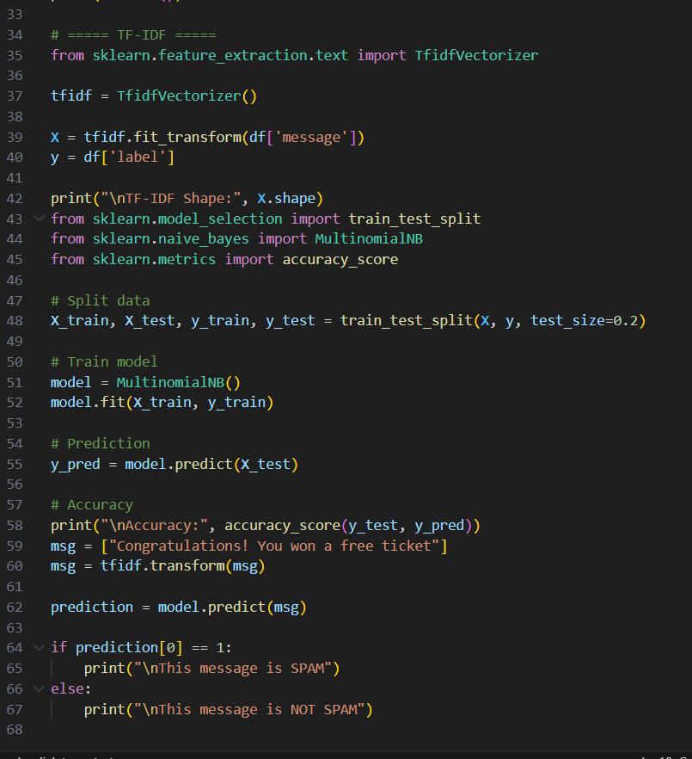

EXTRACTED SPAM DATA IN EXCEL:

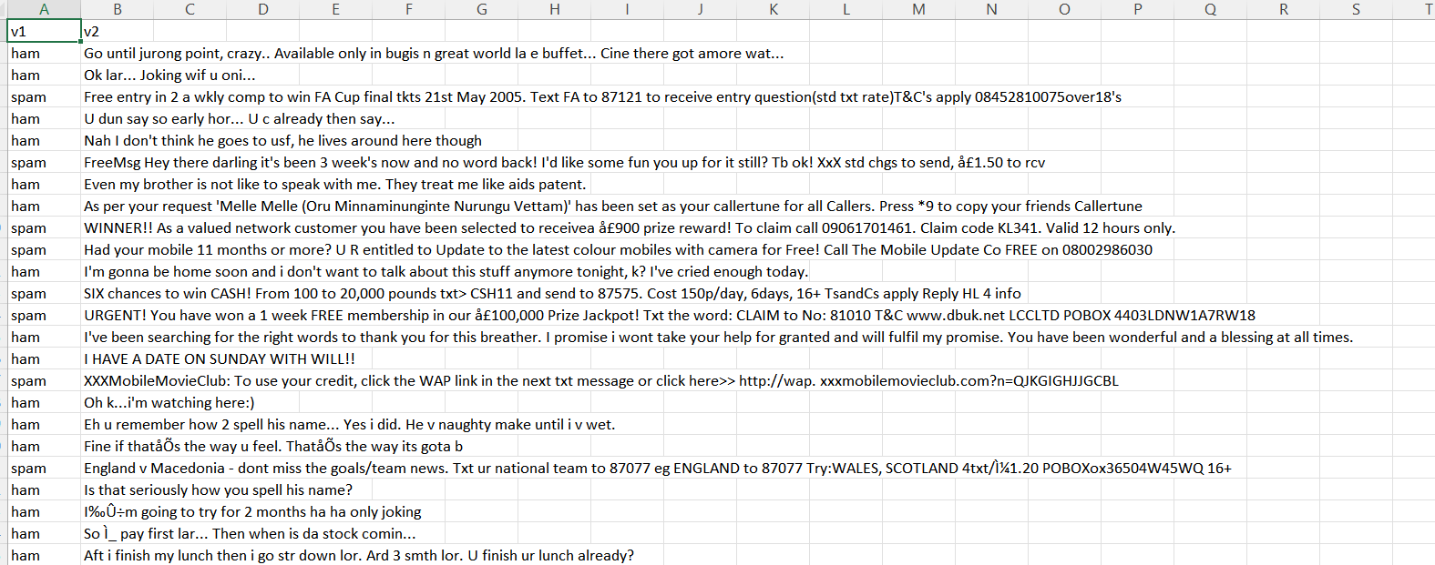

Note: The dataset used for training contains a large number of labeled messages (spam and ham).
The complete dataset is used for model training and evaluation.

OUTPUT:

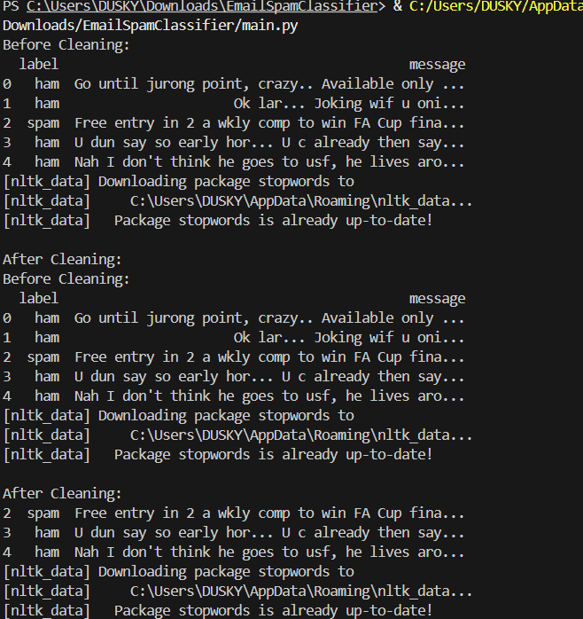
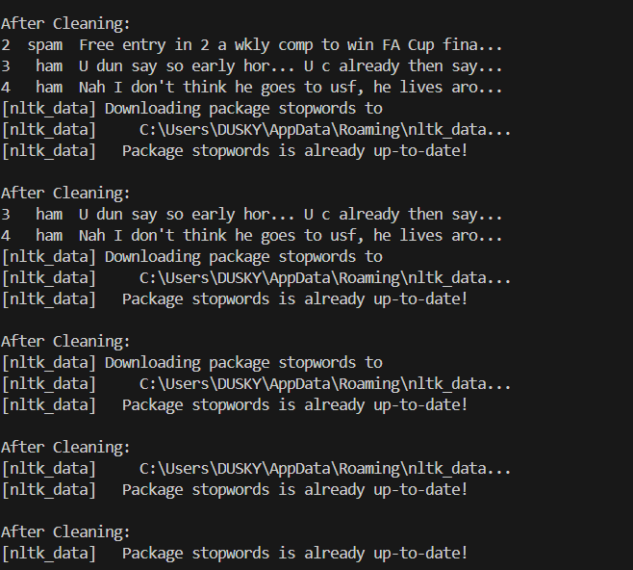
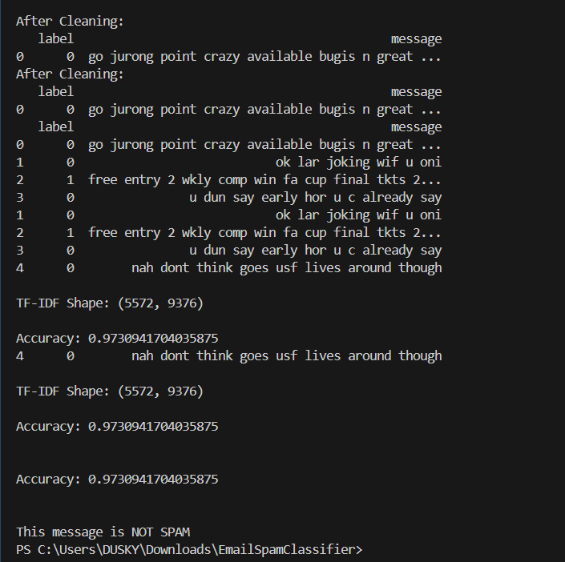

KEY ACHIEVEMENTS:

- Successfully implemented a machine learning-based spam classifier
• Applied NLP techniques for text preprocessing
• Converted text data into numerical features using TF-IDF
• Achieved high accuracy (~97%)
• Enabled real-time classification of new messages
• Built a scalable and efficient spam detection system

LIMITATIONS AND CONSTRAINTS:

Accuracy depends on quality of dataset
• May misclassify rare or ambiguous messages
• Requires preprocessing for effective performance
• Model may need retraining for new spam patterns
• Limited to text-based spam detection (not images/attachments)

PROJECT IMPACT AND VALUE:

- Reduces manual effort in filtering unwanted emails
• Provides automated and real-time spam detection
• Improves email security by identifying malicious content
• Enhances user productivity by reducing inbox clutter
• Supports applications like phishing detection and fraud prevention
• Demonstrates real-world application of Machine Learning and NLP
• Serves as a foundation for advanced email filtering and security systems

CONCLUSION:
The Email Spam Classifier project successfully implements a machine learning-based approach to classify emails as spam or legitimate. The system effectively uses Natural Language Processing techniques for text preprocessing and TF-IDF for feature extraction, followed by classification using the Naive Bayes algorithm.
The model achieves high accuracy (around 97%) and is capable of real-time prediction of new messages. This project demonstrates strong understanding of machine learning, text processing, and data analysis concepts. It provides a practical solution for spam detection and serves as a strong foundation for future applications such as phishing detection, fraud prevention, and intelligent email filtering systems.

