**Dynamic Web:**

1**)**Sümeyra Özuğur,170709046, homework 1

2) I design a simple e shopping site(Films).Actually I did successfully (html-css) but I have trouble about javascript (code) . I write click event method but this is not working.So I did not continue

3) I did css and html . I think ıt is very good. I examined codes ,like this

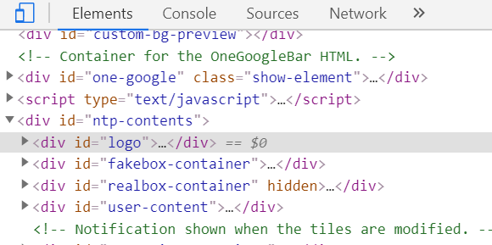

4) to create a good web page.

I can not answer the questions after that since I could not write the javascrip code.

In javascript I learned a lot of events, dom, etc. In css and html , spam,div, class ,id structures I got better.