iLead
First-Time User Manual
MVP / UAT Version with Screenshots
Generated: 2026-04-29

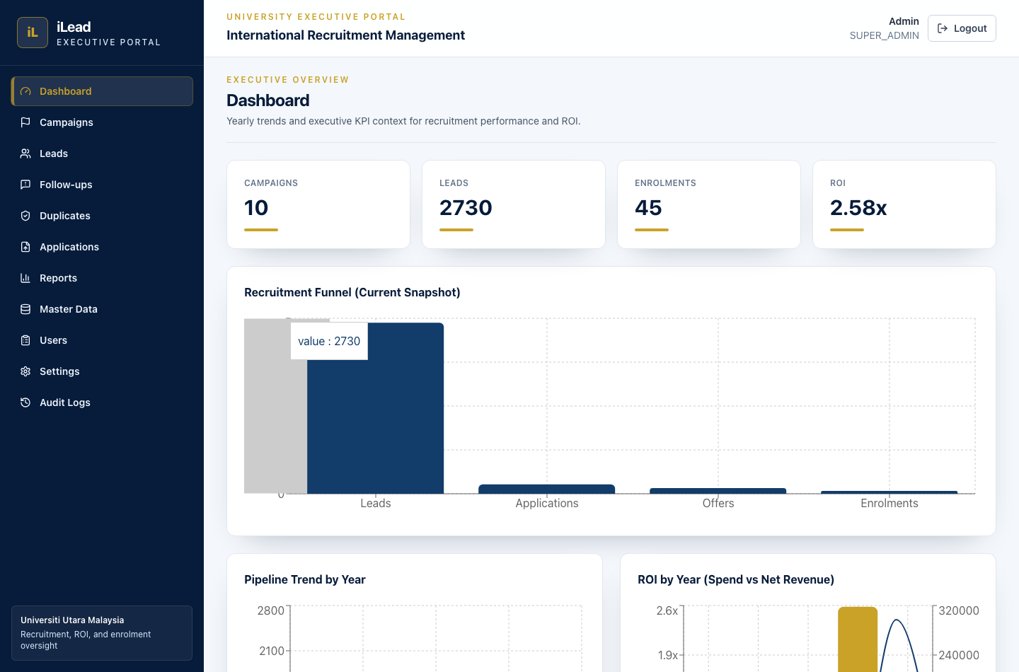
Screenshot: Executive dashboard overview

Screenshot Index
This document includes screenshots captured from the local MVP/UAT environment using the seeded demo admin account.
No. | Screen | Purpose
1 | Login | Sign in to iLead
2 | Dashboard | Executive KPIs and yearly graphs
3 | Campaigns | Campaign list and management
4 | Leads | Lead list and management
5 | Applications | Upload CSV/XLSX application files
6 | Column Mapping | Map uploaded file columns to iLead fields
7 | Follow-ups | Overdue queue and follow-up actions
8 | Duplicates | Duplicate lead review
9 | Reports | Management reports and CSV export
10 | Master Data | Admin reference data
11 | Users | User account management
12 | Settings | System settings
13 | Audit Logs | Action and export audit trail

iLead — First-Time User Manual

This guide explains the main screens, core terms, and a recommended “first workflow” so a new user can get started quickly.

1) What is iLead?
iLead is an executive portal to manage recruitment performance:
- Define Campaigns and their scope (Country / Faculty / Programme)
- Create or manage Leads
- Import Applications (CSV/XLSX), then match them to existing Leads
- Resolve conflicts (manual review)
- Track Follow-ups and SLA health (overdue queue)
- Review Duplicate Leads and handle merges/rejections
- Run Reports and export CSV

2) Sign in
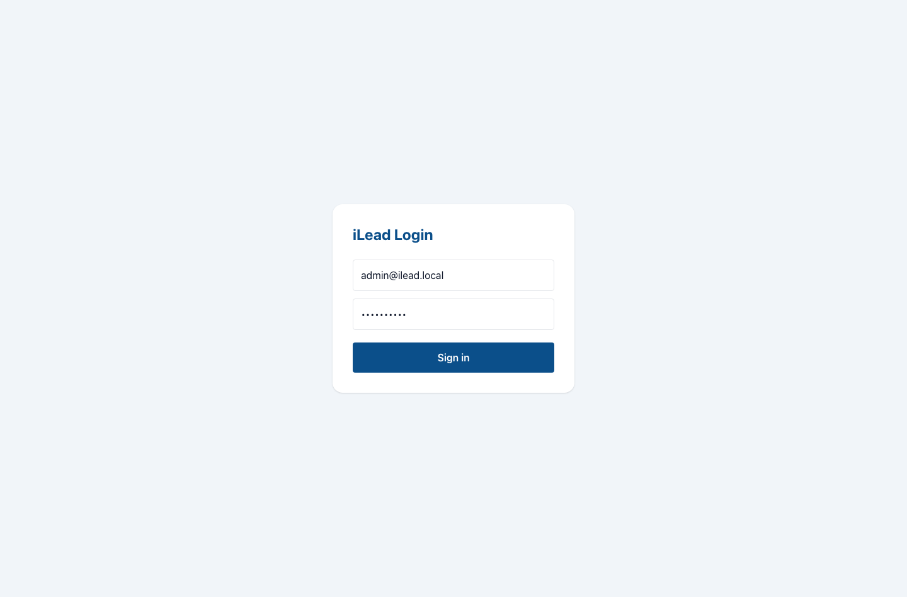
Screenshot: Login screen
- Open the app in your browser.
- Log in with:
- admin@ilead.local
- iLead2026!

After you set up your own users/roles, use those accounts instead of the demo.

Must-change password
If your account is flagged to require a password change, the system will redirect you to the Change Password page.

3) How the UI works (important)
Many create/edit forms open in a center pop-up modal (not a right-side drawer):
- Click “New …” / Edit buttons to open the form
- Use Cancel or the close (X) button to exit
- Save to persist changes

4) Roles & permissions (high level)
Not every page is visible for every role.
- Executive / admin roles can manage most entities and export/report at deeper levels.
- Some pages (like Master Data and Users) are restricted to specific admin roles.

If a page is missing from the navigation, your role likely doesn’t have permission for it.

5) Core terms (you’ll see these everywhere)

Campaign
A recruitment initiative with:
- Type (e.g. education fair, university visit, etc.)
- Status (PLANNED / ONGOING / COMPLETED / CANCELLED)
- Timeline (start/end date)
- Scope:
- Countries
- Faculties
- Programmes

Lead
A student/applicant identity record (the “student profile”).
Leads can have identifiers such as:
- Email
- Phone
- Passport number
- External Lead ID

Lead status & lead quality (SLA health)
The SLA/overdue logic is based on:
- Active statuses (typically NEW, CONTACTED, INTERESTED)
- Lead quality bucket: HOT, WARM, COLD

SLA business days (default, from system rules):
- HOT = 1 day
- WARM = 3 days
- COLD = 7 days

Application
An application submitted by a candidate (typically imported via CSV/XLSX).
Application fields include:
- Applicant name
- Email / phone / passport (optional)
- Application status (APPLIED → …)
- Application date / offer date / enrolment date (optional)

Matching (Application → Lead)
After importing applications, iLead attempts to match each imported Application row to an existing Lead using a priority order:
- Exact email
- Exact phone
- Exact passport number
- Name + Programme + Country fallback
- Source campaign name fallback

Matching outcomes you’ll see on the upload report:
- MATCHED: linked to an existing Lead
- CONFLICT: multiple possible Leads found (manual review needed)
- CREATED: no match found yet (application exists but Lead linkage is missing)
- FAILED: row-level validation failed

Conflict / Manual review
If a row is CONFLICT, you will choose the correct Lead from a dropdown, then click Resolve.

Follow-up
Follow-ups are actions scheduled for a Lead.
- You can update details or complete the latest follow-up.
- The Follow-ups page includes an Overdue queue.

Duplicate Leads
Some Leads are suspected duplicates.
If you are allowed, you can:
- Merge: accept/link duplicates to one identity
- Reject: mark as NOT_DUPLICATE

6) Navigation map (what to do on each page)

Dashboard

Screenshot: Executive dashboard with yearly graphs
High-level executive overview. (You can view yearly graphs as well.)

Campaigns
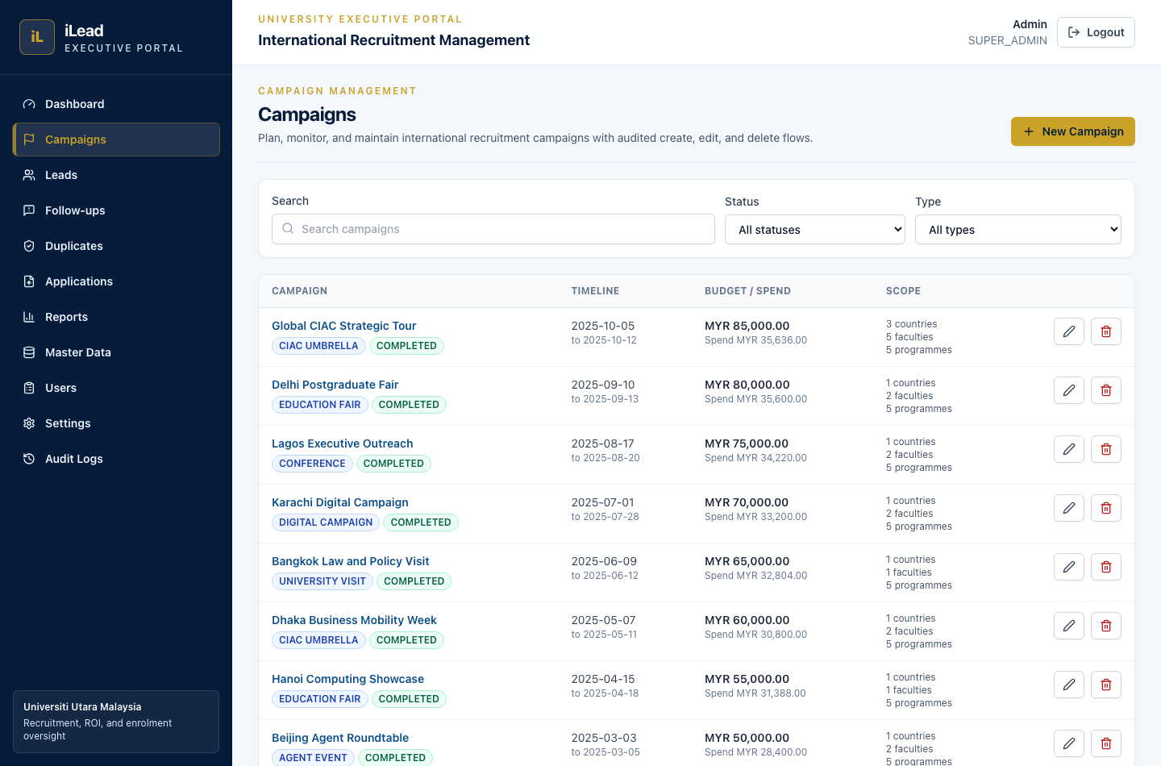
Screenshot: Campaign management list
Manage campaigns:
- Create a campaign
- Edit its scope
- Add/delete costs
- Check ROI (where available)

Leads
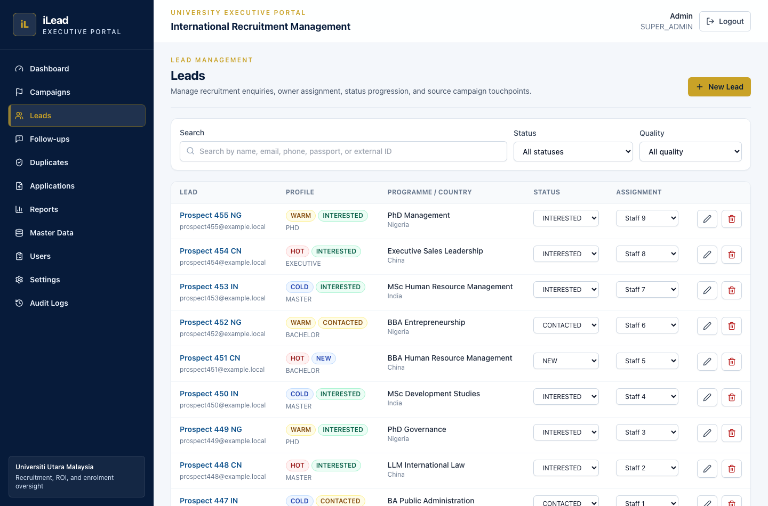
Screenshot: Lead management list
Manage leads:
- Filter/search
- Create a lead manually
- Edit/soft-delete

Applications (Upload)
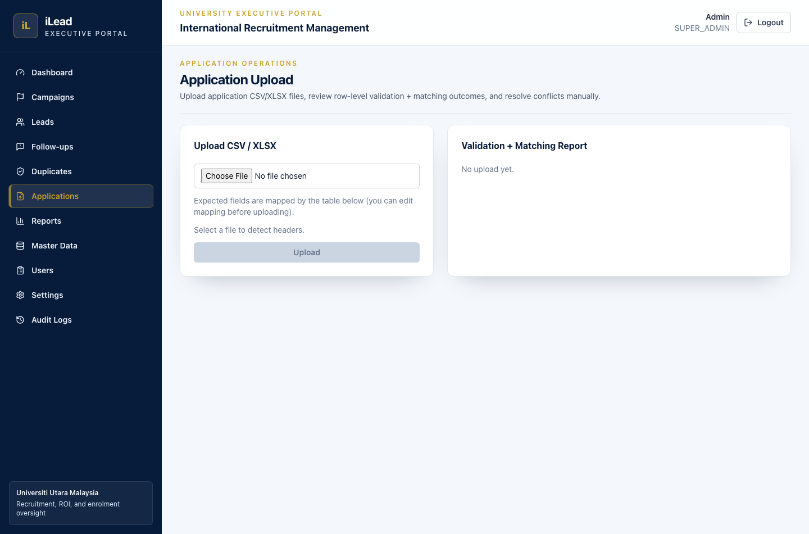
Screenshot: Application upload screen
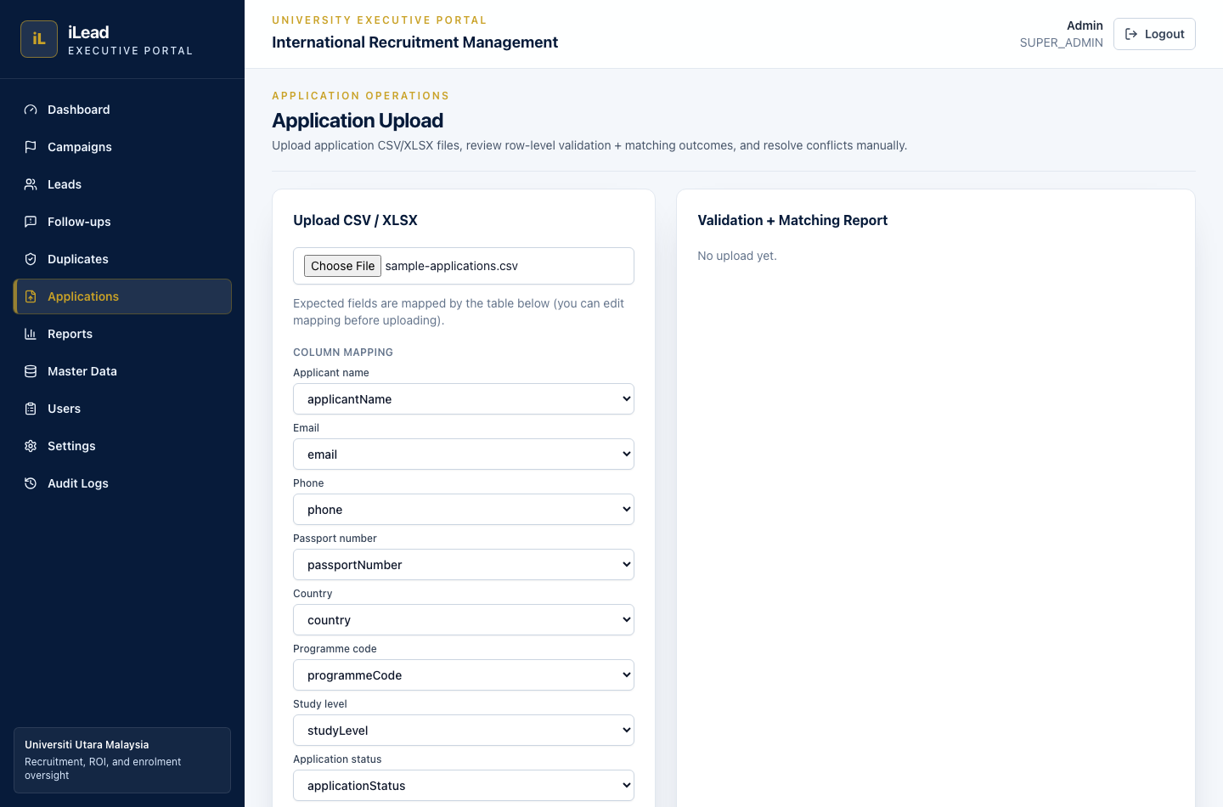
Screenshot: Column mapping after choosing a CSV file
Import application files and run matching:
- Upload CSV/XLSX
- Auto-detect headers
- Adjust column mapping (optional)
- Review the “Validation + Matching Report”
- Resolve conflicts inline
- Rematch unmatched rows if needed
- Roll back a batch if necessary

Follow-ups
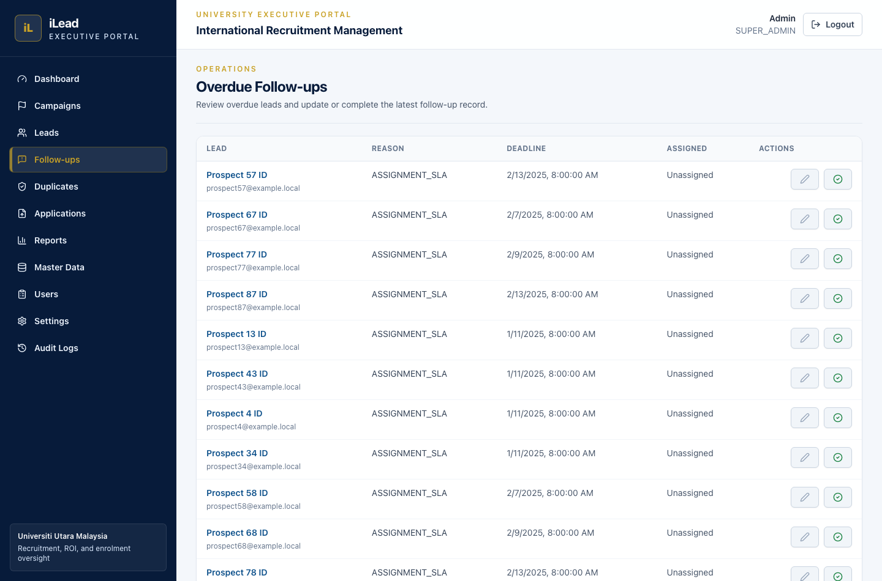
Screenshot: Follow-up overdue queue
- Open the overdue queue
- Edit/complete the latest follow-up

Duplicates
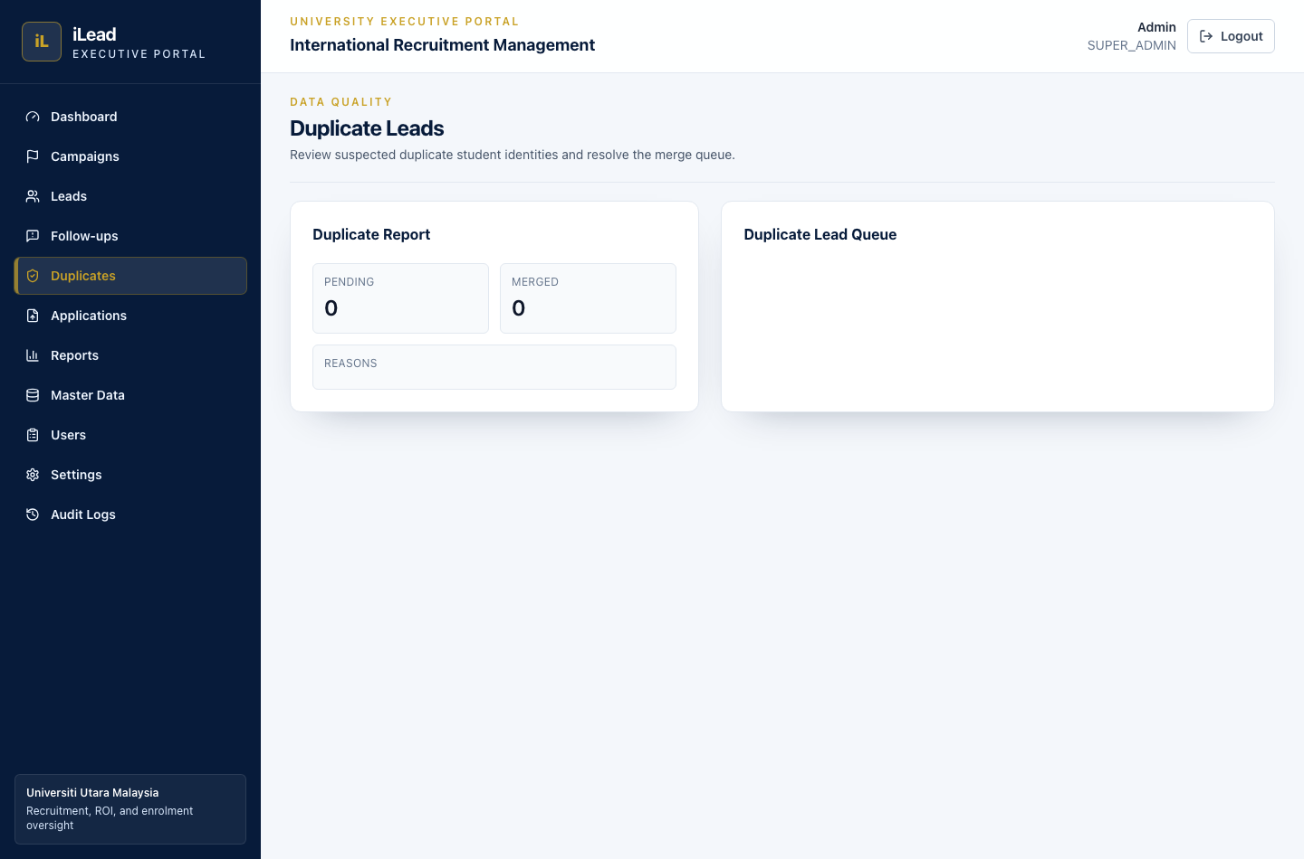
Screenshot: Duplicate leads review
Review merge queue and handle merge/reject actions.

Reports
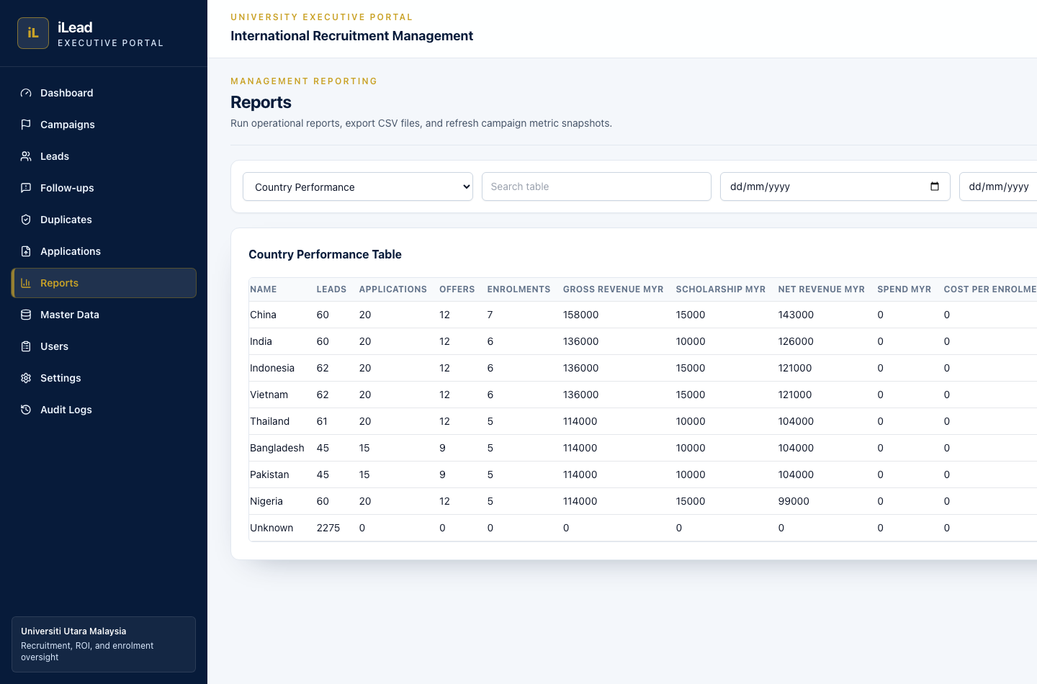
Screenshot: Management reports and CSV export
- Select report type
- Use filters (search + date range)
- Export CSV (with PII rules where applicable)

Master Data
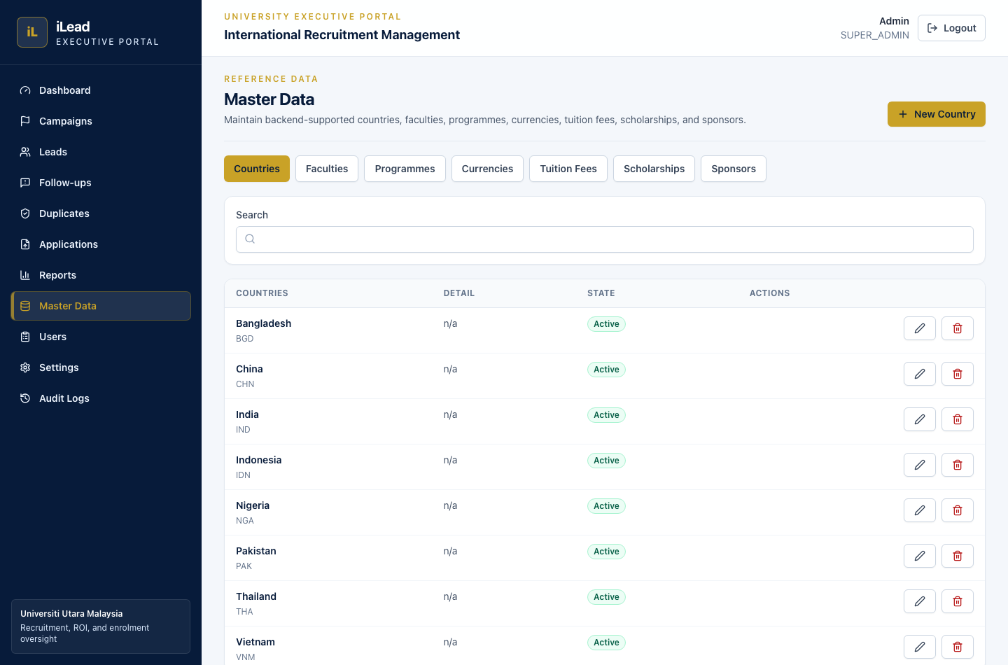
Screenshot: Master data administration
Admin configuration:
- Countries, Faculties, Programmes
- Currencies & FX rates
- Tuition fees
- Scholarships
- Sponsors

Users
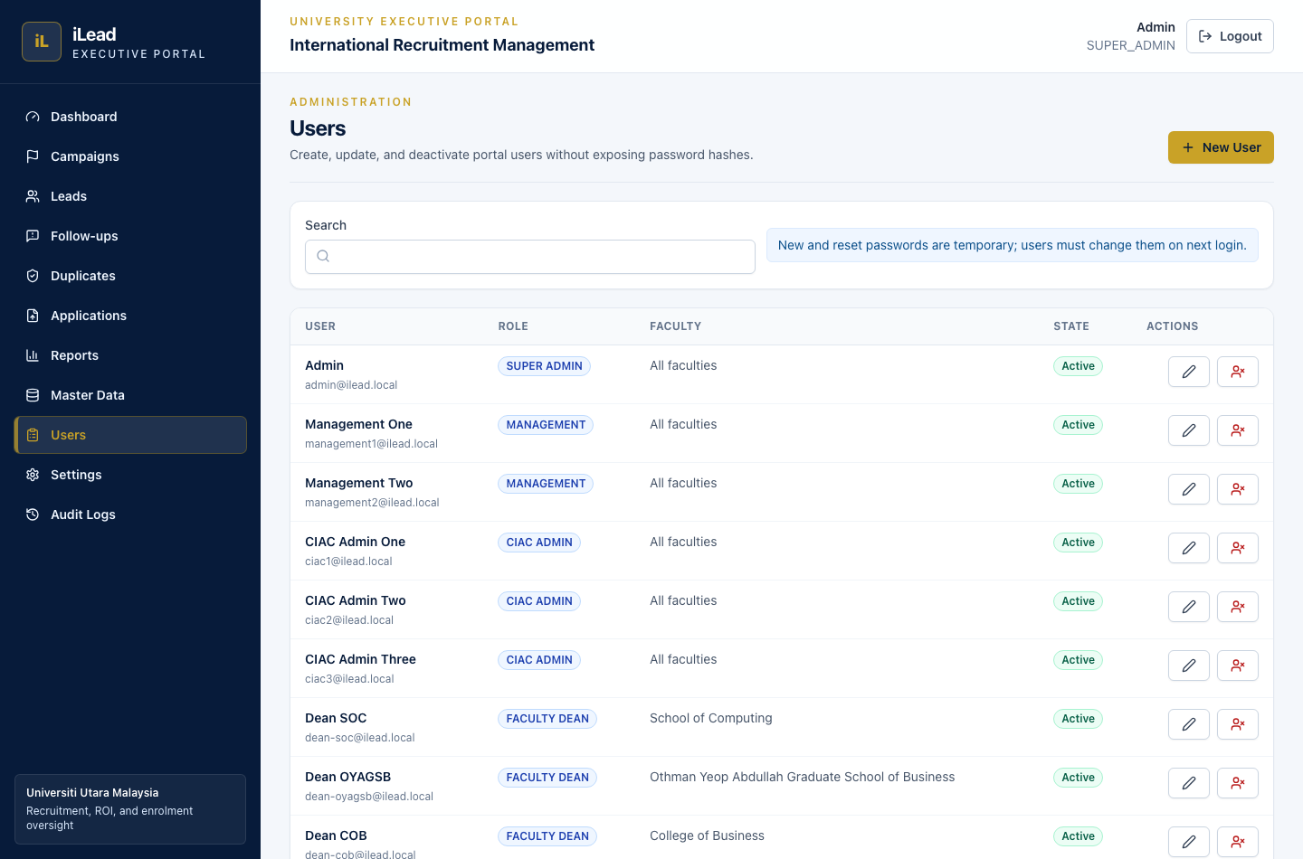
Screenshot: User management
Create/edit/deactivate user accounts (admin-only).

Settings
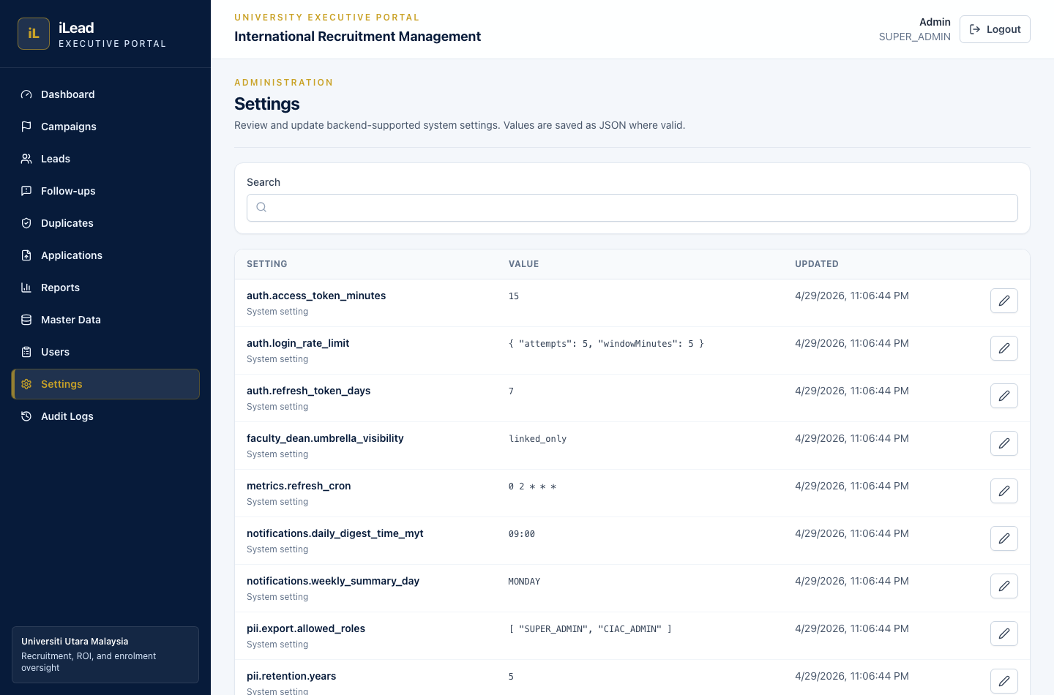
Screenshot: System settings
System configuration values (admin-only).

Audit Logs
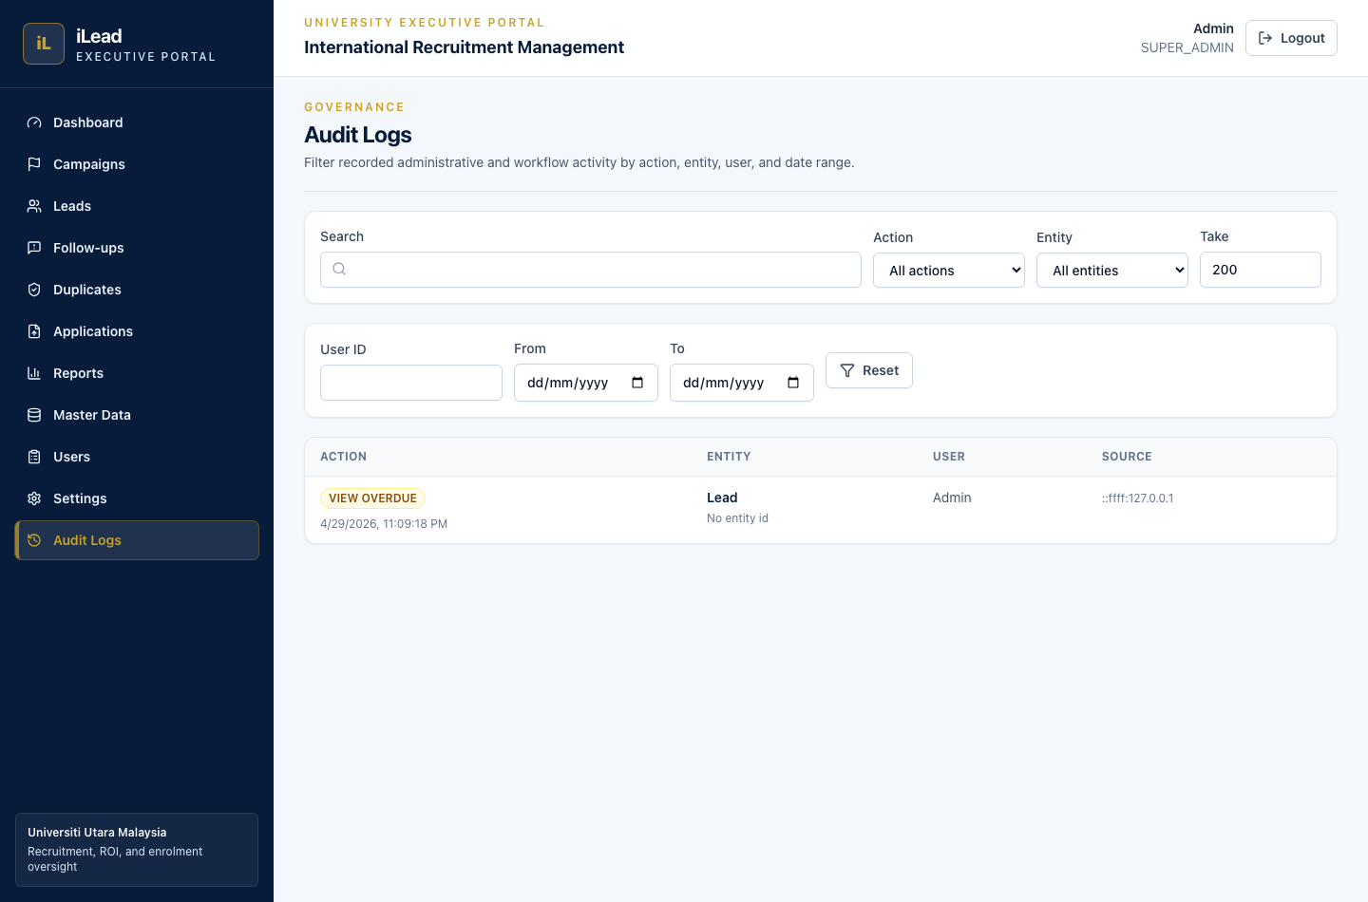
Screenshot: Audit logs
Track create/update/delete actions and report export events (admin-only).

7) First-time walkthrough (recommended path)

Step A — (Optional) Use the demo seed
If you already ran the demo database seed, you can explore immediately.

Step B — Create/confirm Master Data (if you’re not using demo)
- Go to Master Data
- Ensure:
- Countries, Faculties, Programmes exist
- Currencies, FX rates exist (used for cost conversions)

Step C — Create your first Campaign
- Go to Campaigns
- Click New Campaign
- Fill:
- Campaign name
- Type & Status
- Start/End dates
- Approved Budget (MYR)
- Choose scope using tickable dropdowns:
- Countries
- Faculties
- Programmes
- Click Create Campaign

Step D — Add Leads (so matching has candidates)
- Go to Leads
- Click create, and enter at least one identifier:
- Email OR phone OR passport number OR External Lead ID
- Save

Step E — Upload Applications and match
- Go to Applications
- Choose a CSV/XLSX file
- Confirm header mapping (you can change it if needed)
- Click Upload
- On the “Validation + Matching Report”:
- Review FAILED rows (fix and re-upload)
- For CONFLICT rows, choose the correct Lead and click Resolve
- Use Rematch Unmatched if needed

Step F — Overdue follow-ups
- Go to Follow-ups
- Open the overdue queue
- Edit/complete the latest follow-up

Step G — Reports
- Go to Reports
- Choose a report
- Set date filters
- Export CSV if you’re allowed

8) Application Upload format (CSV template)
On the Applications Upload page, the system expects (by header names) fields such as:
- applicantName, email, phone, passportNumber, country,
programmeCode, studyLevel, applicationStatus,
applicationDate, offerDate, enrolmentDate,
sourceCampaign, scholarshipMyr, tuitionRevenueMyr

The UI can also remap headers via Column mapping.

Minimal approach
You can leave optional columns blank. If identifier fields are blank, matching may be impossible and the result may be CREATED/unmatched.

9) Common troubleshooting

“CONFLICT” rows
This means the imported row could match multiple Leads. Resolve using the dropdown and click Resolve.

“FAILED” rows
Row-level validation errors occurred (e.g. invalid date or missing required application fields). Fix the source file and re-upload.

Rollback batch
If you imported the wrong file, use Rollback Batch (admin roles only) to delete the created applications for that batch.

10) Support
If something looks wrong:
- Check your role permissions (some actions are restricted)
- Confirm your file headers match the mapping UI
- If dates cause issues, ensure ISO-ish formats (YYYY-MM-DD for dates)

MVP / UAT Notes
- This manual is intended for MVP/UAT use with the seeded local environment.
- Some production hardening items are tracked separately in ISSUES_FOUND.md.
- For UAT, focus on validating navigation, campaign/lead workflows, application upload, matching, follow-ups, duplicates, reports, users, settings, and audit logs.

