**Exercise 1**

**1. Name the six goals in which usability is usually broken down. Describe each of them in your own**

**words (two sentences per usability goal) and provide for each of them at least one example that**

**was not given in the lecture.**

**Usability is measured in terms of the following matrices:**

1. **Effectiveness:** If the user is able to achieve his specific goal using a product is defined as the effectiveness of that product. Does the product perform the required task accurately and completely? Example: Can Google maps show me the right path and directions to go to my final destination.
2. **Efficiency:** How effect is a product? How economical is it in terms of cost and time and resources it uses in order to achieve a goal. Example: Google maps quickly find the shortest and fastest route for me and also show other alternative routes. The maps feature to save the recent or frequently used destinations in the search options can be considered as an efficient feature as it saves number of clicks and time.

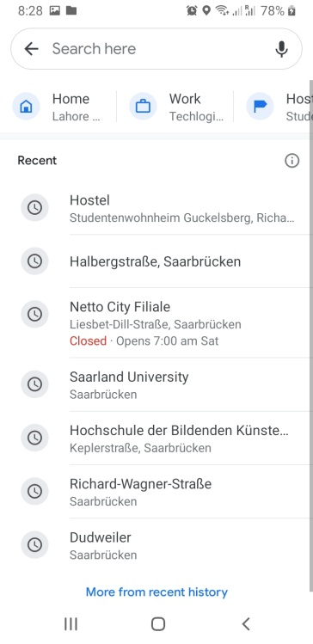

1. **Easy to learn:** How easy is it for the user to use the app. Is the app designed in such a way that the user does not get confused or stuck and can easily work his way out by exploring what happens where and how. Example: The homepage of Google is the traditional map which can make the user feel like he is looking at the real map. And the search bar and the microphone clearly tell user to type or speak their required location.
2. **Easy to remember:** Does the product have interfaces that are easy to remember after the user has experienced it? This property is related to learnability of the product. If an application has used appropriate images for the icon then its easier for the user to remember which icon does what. Example: When I opened Google keep it was quite easy for me to remember the use of each icon by using the app just one time.

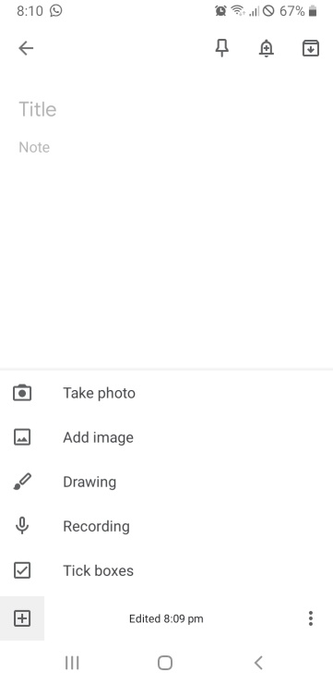

1. **Safe to use**: Can a product allow user to perform his task safely? Does it protect user’s personal information and does it prevent user’s data from getting lost? Example: In Gmail if the user mistakenly deletes an email a pop appears quickly with undo button on it. And if the user clicks on it within his average attention span he can have his email back in inbox.

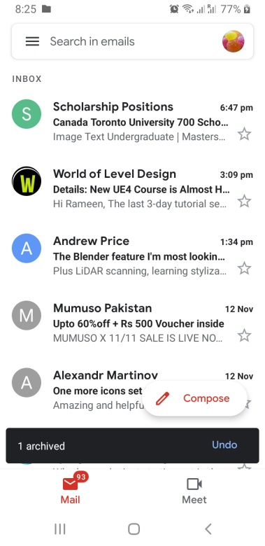

1. **Utility:** Is the product useful to user? Does a product meet user’s need? Does it perform tasks the way user wants? A product can solve a problem but is not what user wanted in terms of cost or size. Example: A user downloaded a taxi app from app store but it was in French. The user only knows English. Even though that application is the best taxi finder app in France but is of no value to this particular user. Alarm clock is also a good example of utility..

**2. State how the design of Xbox Wireless Controller Figure 1 fulfills / does not fulfill the six usability**

**goals. The explanation should not be longer than two sentences.**

1. **Effectiveness:**
2. **Efficiency:** How effect is a product? How economical is it in terms of cost and time and resources it uses in order to achieve a goal. Example: Google maps quickly find the shortest and fastest route for me and also show other alternative routes. The maps feature to save the recent or frequently used destinations in the search options can be considered as an efficient feature as it saves number of clicks and time.
3. **Easy to learn: The ON/OFF button right in the middle and veru prominent. It blinks when its turned on. Press the button on the front side to pair with adaptor. It ill blink faster. And when it is unpaired it blinks slowly. When it stops blinking that means you are connected.**
4. **Easy to remember:**
5. **Safe to use**:
6. **Utility:** Shape and grip is very

**Exercise 2 - Interaction modes**

**Imagine the following situations where you have to interact with a system to achieve a specified task. For each of them decide which interaction mode(s) would be the most appropriate one(s) and justify your choices using a maximum of two sentences. It is sufficient if the main interaction mode per item is mentioned accompanied by an adequate description (not longer than 2 sentences).**

**1. You would like to pay for your parking ticket before leaving the parking garage in your car. (Do**

**also consider the fact that some people might suffer from disabilities.)**

**2. You are walking in a foreign town using a pedestrian navigation system.**

* Most appropriate interaction mode here will be conversing interaction. As I can configure app by giving my destination as written or verbal input. The app can guide me to my destination using visual and audio information.
* Secondly, manipulating mode as I will be panning the map left, right, up, and down map with my finger, zooming in, zooming out when I need to see a location of a nearby store and re-centering my current location as I walk on my path.

**3. you would like to follow a recipe for baking a cake for your friend’s birthday.**

* Exploring mode would be the most appropriate here as I will open a browser such as Google and start searching for let’s say “quick recipe for baking a cake”. Google will of course help me provide with the results closest to what I need.

**4. you need to find a store in a mall using a public display**

* Since in this case I am looking for the display of that store so I am making use of exploring mode of interaction except that this time I’ll be exploring the store in the mall full of shops and restraints (in real world) and not in virtual world of information.
* The display of the store can help me see from afar that there it is so in a way it can be a conversing mode of interaction.

**Exercise 3 - Analyze Interfaces**

1. **As you can see in Figure 2, this control panel for an elevator has major design flaws. Explain how the current design addresses each of the six elements composing the foundations of interaction design (i.e., what does it afford, what kind of feedback is provided, etc.). Once you have identified the flaws, propose (a) new design(s) to fix them. You can use sketches or images to support your ideas.**

**Affordance:** The buttons of control panel afford to be pressed. It is hard to tell which one if the button in the first glimpse. User could mistakenly put the finger on black thing and feel stupid. Every floor/room has its own button next to it. So their placements tell me to press which button to go where.

**Visibility:** It is quite visible that pressing which button will take me where but I’m not sure what does that star icon mean? I can tell that they have placed buttons of floors/rooms from bottom to top order but this 4.6 is confusing me what is that? What is the difference between 6 and 6R what should I select? What does it have two ground floors G1R and G2R. This elevator has Braille display with each floor/room number. This control panel does not show which floor am I currently on. Am I going up or down?

**Feedback:** Pressing the button lights it up, which acts as a response that the elevator got my command.

**Mapping:** Each button is placed with the floor/room where it will take the elevator (spatial analogy). The higher floors are placed on the top and lower levels of the building on the bottom which gives the right idea of physical orientation of floors inside the building. However, all the number/labels are not familiar. And the ground floor numbers are written in the order G2R and G1R. Which is again confusing and against the typical order the user would expect. The closing and opening button of the lift is separated by a button DH which is creating confusion.

**Constraints:** The only thing I can possibly do with this control panel is to press the buttons so there is physical constraint so there can be no confusion regarding what to do. Worst case scenario: At least I know I’m supposed to press buttons in order to operate this thing.

**Consistency:** All the buttons are meant for the same purpose and will be used in same way by pressing. I don’t have to do anything differently to go to different floors. I will use buttons for every floor accordingly. The font size and style and shapes of the buttons is also consistent.

**Metaphor:** As I know through my concept that the buildings have floors made on the top of each other. So if I want to go to 11 floor I will automatically look for the number in the upper area of control panel and opposite for the floor that are in the lower area of the building.