**Exercise 1**

**1. Name the six goals in which usability is usually broken down. Describe each of them in your own**

**words (two sentences per usability goal) and provide for each of them at least one example that**

**was not given in the lecture.**

**Usability is measured in terms of the following matrices:**

1. **Effectiveness:** Is the user able to achieve his specific goal by using a product is defined as the effectiveness of that product. Does the product perform the required task accurately and completely?

Example: Can Google maps show me the right path and directions to go to my final destination.

1. **Efficiency:** Can a product perform the required task efficiently? Is it economical in terms of cost and time and resources it uses in order to achieve a goal?

Example: Google maps quickly find the shortest and fastest route for me and also show other alternative routes. The maps feature to save the recent or frequently used destinations in the search options can be considered as an efficient feature as it saves number of clicks and time.

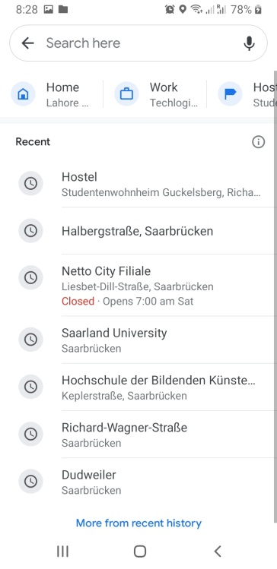

1. **Easy to learn:** How easy is it for the user to use the product? Is the product interface designed in such a way that the user does not get confused or stuck and can easily work his way out by exploring which (action) happens (by doing what) where and how.

Example: The homepage of Google is the traditional map which can make the user feel like he is looking at the real map. And the search bar and the microphone clearly tell user to type or give voice input to find their desired location.

1. **Easy to remember:** Does the product have interfaces that are easy to remember after the user has experienced it? This property is related to learnability of the product. If an application has used appropriate icons for their respective actions they perform, then it is easier for the user to remember which icon does what.

Example: When I opened Google keep it was quite easy for me to remember the use of each icon by using the application just one time.

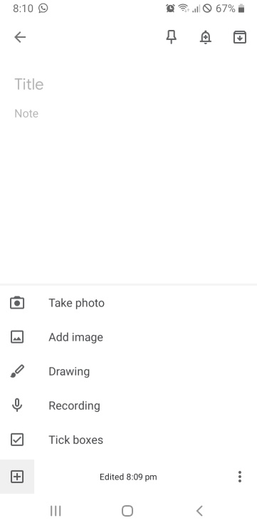

1. **Safe to use**: Does this product allow user to perform his task safely in terms of user’s confidential information protection and the possible errors that could arise while it is performing a task? Does it prevent user’s data from getting lost?

Example: In Gmail if the user mistakenly deletes an email a pop appears quickly with undo button on it. And if the user clicks on it within his average attention span he can have his email back in inbox.

The user account for paid subscription of Netflix has personal information that must be protected in case their account is compromised. So Netflix ensures that site is safe to use.

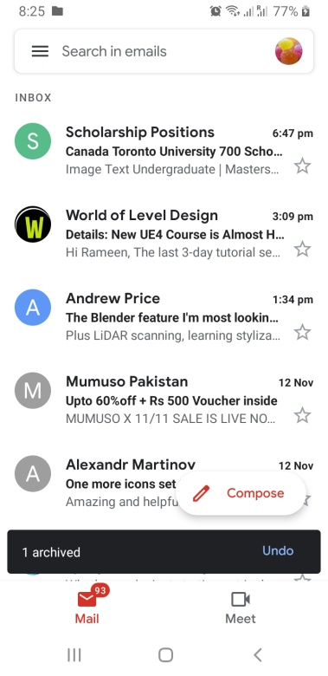

1. **Utility:** Is the product useful to user? Does a product meet user’s need and performs tasks the way user wants? A product can solve a problem but is not always what user wanted in terms of cost or size.

Example: A user downloaded a taxi app from app store but it was in French. The user only knows English. Even though that application is the best taxi finder app in France but is of no value to this particular user.

**2. State how the design of Xbox Wireless Controller Figure 1 fulfills / does not fulfill the six usability**

**goals. The explanation should not be longer than two sentences.**

1. **Effectiveness:**
2. **Efficiency:** How effect is a product? How economical is it in terms of cost and time and resources it uses in order to achieve a goal. Example: Google maps quickly find the shortest and fastest route for me and also show other alternative routes. The maps feature to save the recent or frequently used destinations in the search options can be considered as an efficient feature as it saves number of clicks and time.
3. **Easy to learn: The ON/OFF button right in the middle and veru prominent. It blinks when its turned on. Press the button on the front side to pair with adaptor. It ill blink faster. And when it is unpaired it blinks slowly. When it stops blinking that means you are connected.**
4. **Easy to remember:**
5. **Safe to use**:
6. **Utility:** Shape and grip is very

**Exercise 2 - Interaction modes**

**Imagine the following situations where you have to interact with a system to achieve a specified task. For each of them decide which interaction mode(s) would be the most appropriate one(s) and justify your choices using a maximum of two sentences. It is sufficient if the main interaction mode per item is mentioned accompanied by an adequate description (not longer than 2 sentences).**

**1. You would like to pay for your parking ticket before leaving the parking garage in your car. (Do**

**also consider the fact that some people might suffer from disabilities.)**

**2. You are walking in a foreign town using a pedestrian navigation system.**

* Main interaction mode is conversing interaction. As I can configure the app by giving my destination as written or verbal input. The app can guide me to my destination using visual and audio information.
* Secondly, manipulating mode as I will be panning the map left, right, up, and down map with my finger, zooming in, and zooming out when I need to see a location of a nearby store and re-centering my current location as I walk on my path.

**3. You would like to follow a recipe for baking a cake for your friend’s birthday.**

* Mainly exploring mode because I will open a browser (Google) and search recipe for baking a cake. Google will of course help me provide with the results closest to what I need from all the recipes that exist on the internet.
* Could also be instructing mode as I have asked Google to find the suitable recipe for me.

**4. You need to find a store in a mall using a public display**

* Since in this case I am looking for the display of that store so I am making use of exploring mode of interaction except that this time I’ll be exploring the store in the mall full of shops and restaurants (in real world) and not in virtual world of information.
* The display of the store can help me see from afar that there it is so, in a way it can be a conversing mode of interaction?

**Exercise 3 - Analyze Interfaces**

**In this section, we will focus on analyzing different user interfaces in respect to the Foundations of Interaction Design presented in the lecture. These foundations comprise six major elements: affordances, visibility, feedback, mapping, constraints, and consistency.**

1. **As you can see in Figure 2, this control panel for an elevator has major design flaws. Explain how the current design addresses each of the six elements composing the foundations of interaction design (i.e., what does it afford, what kind of feedback is provided, etc.). Once you have identified the flaws, propose (a) new design(s) to fix them. You can use sketches or images to support your ideas.**

**Affordance:** The buttons of control panel afford to be pressed. It is hard to tell which one is the button in the first glimpse. User could mistakenly put the finger on black thing and feel stupid. It takes a few seconds but then the purpose is clear.

**Visibility:** It is quite visible that pressing which button will take me to the floor No. written with it. But what does that star icon mean? What is this R? What is 4.6? This elevator has Braille display with each floor number. This control panel does not show which floor am I currently on. Am I going up or down?

**Feedback:** Pressing the button lights it up, which acts as a response that the elevator got my command.

**Mapping:** Each button is placed with the floor/room where it will take the elevator (spatial analogy). The higher floors are placed on the top and lower levels of the building on the bottom which gives the right idea of physical orientation of floors inside the building. However, all the number/labels are not familiar. And the ground floor numbers are written in the order G2R and G1R. Which is again confusing and against the typical order the user would expect. The closing and opening button of the lift is separated by a button DH which is creating confusion.

**Constraints:** The only thing I can possibly do with this control panel is to press the buttons so there is physical constraint so there can be no confusion regarding what to do. Worst case scenario: At least I know I’m supposed to press buttons in order to operate this thing.

**Consistency:** All the buttons are meant for the same purpose and will be used in same way by pressing. I don’t have to do anything differently to go to different floors. I will use buttons for every floor accordingly. The font size and style and shapes of the buttons are also consistent.

**Proposed Solution design:**

* The buttons should be ordered and placed in such a way that reduces user’s effort. Like reducing the number of columns here by putting buttons in 2 rows it becomes fairly easy for the user to effortlessly find their desired button rather than searching it in multiple columns.
* The buttons’ labels should be very straightforward and clear. Just mention the floor number and the G should mean ground floor and B1 should means basement 1. And basements too should be ordered from bottom to top as the floors are actually built in this natural order.
* The labels can be represented on the buttons which makes the control panel look neat and less confusing. Messy information can create confusion and therefore can demand effort to understand what is going on. Moreover, the floor numbers should be given in Braille right on the button. A button has enough space to give both types of information.
* The buttons that are absolutely necessary should be there.
* The buttons for closing is not absolutely necessary as elevator can be programmed to be closed on its own rather than user having to close it every time he gets inside it.
* The opening button is necessary sometimes as the person already inside the elevator can press that button to buy some time for somebody to get inside the elevator.
* The use of unfamiliar labels should be avoided as in the above example the person who has come to this building first time may not know what does R represent or where does 4.6 take? The basic idea of elevator for almost every human is that it either takes you up or down on your specified floor. That’s it. So this use should not be made complicated. Rather we should simplify the experience.
* The display of current floor is also missing in the above example. The elevator should display the current floor and the arrow that shows if the elevator is going up or down.

1. **Find two different user interfaces present in your environment and do the same analysis. Providing better designs is not mandatory this time, but would provide extra points. Provide pictures of these interfaces and a short summary of the possible interactions.**

**Example 1:**

One example from my environment that I use frequently is Netflix. So ill be describing it’s each principle of user interface.

**Affordance:** Since this is a digital application so we will talk about its perceived affordances: such as the play button or plus button of a movie or series affords to be clicked. And scrollbar affords to be scrolled up and down. The search icon affords of be click and the textbox that appears in the response of that click affords to take text input from me. However, the label of “Play” with the play icon was unnecessary. As Play icon is already a learned convention.

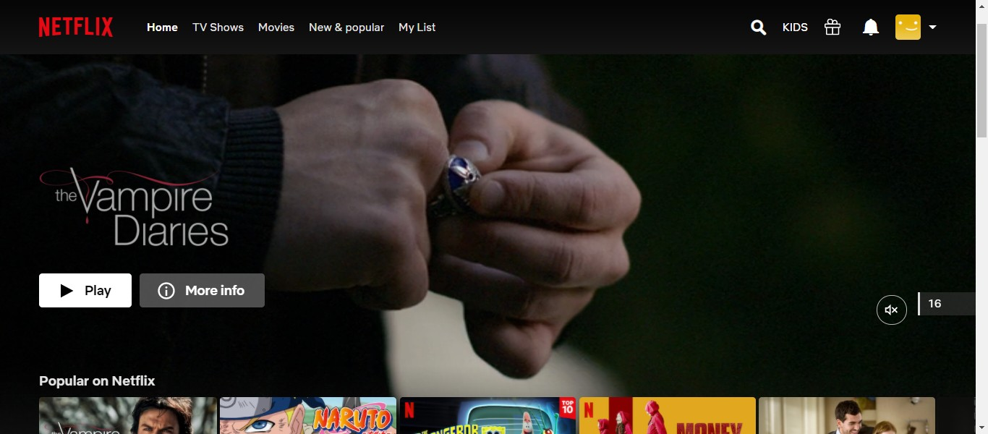

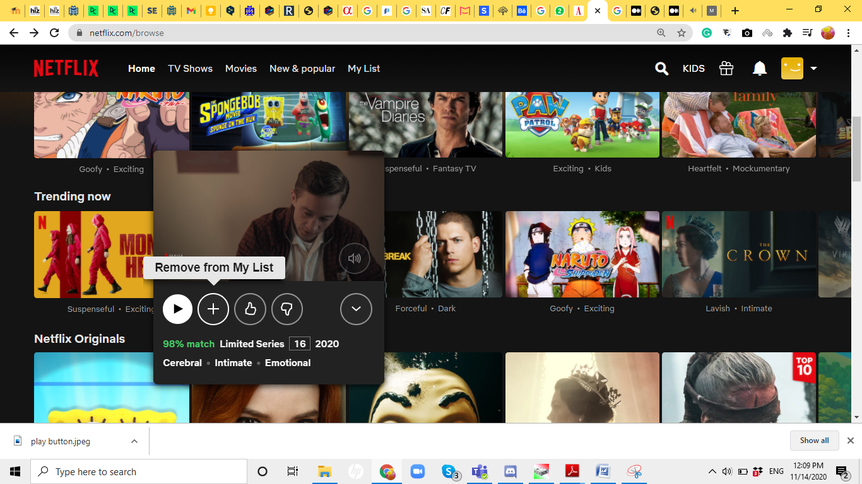

**Visibility:** As you can see in the above screenshot, the “plus” button was obvious to add the movies to my list but when its clicked on it turns into a “tick mark” showing that the movies has been added to my list. So far so good. But, what if I want to remove from my list after I have matched this movie. This “tick mark” does not make sense anymore.

Improvement:

It could be turned into a “minus” sign rather than a “tick mark” then in case of remove from list use case “minus” would be more obvious and visible.

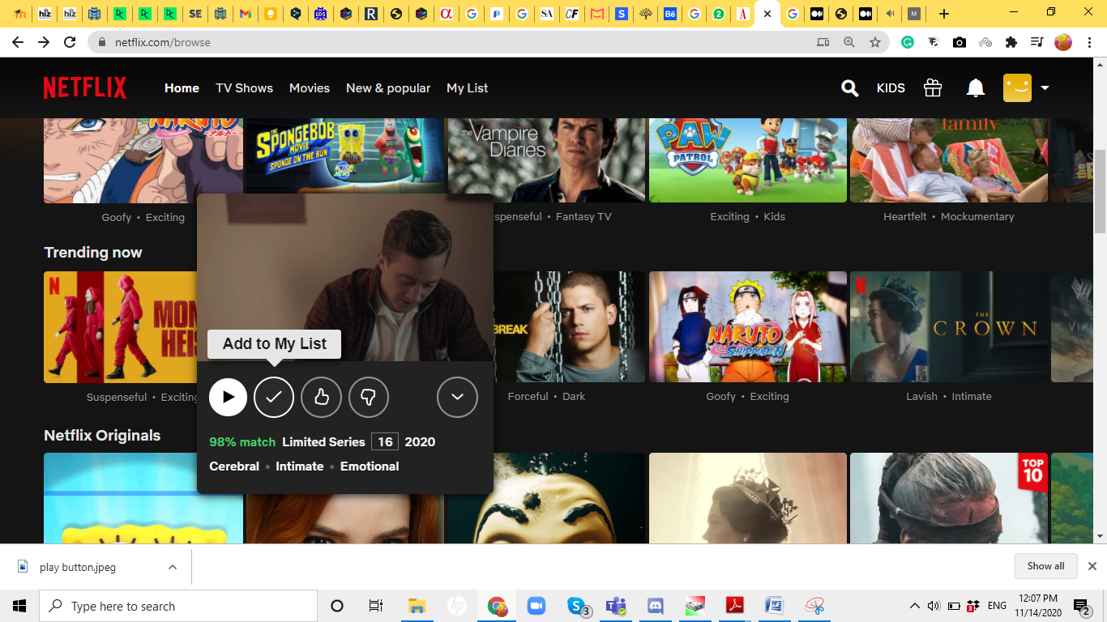

**Feedback:** When I click on the search icon, it’s text box appear which is a response to my click that the application understood that I am about to type in some information.

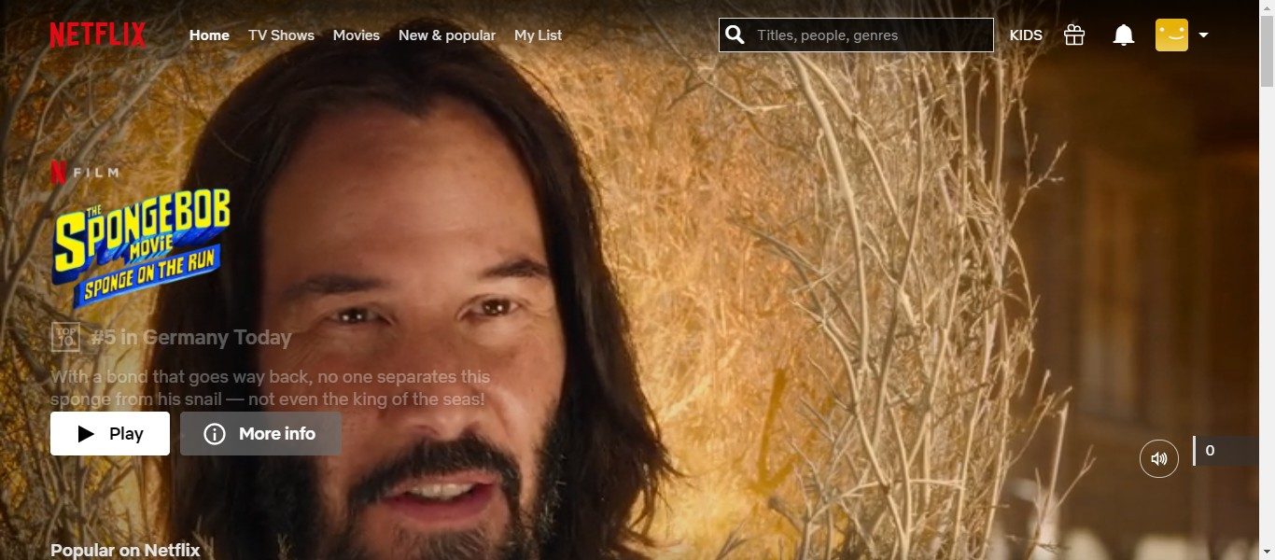

Bad Responsiveness:

When I hover over a movie its thumbnail gets enlarged and starts to play the trailer of that movie even when I did not wish to see it. And I don’t like this lack of control over what I see or not. So the element of feedback is here but it is doing more than what is necessary and in my case its annoying because this interrupts my browsing process.

Improvement:

There should be a “cross” button on this small window of trailer and a “pause” button to pause so that user can get some sort of control over this behavior of application. Additional option could be to turn this feature turn ON/OFF in user settings.

**Mapping:** The placement of forward and backward buttons is exactly how it should be. If this placement was against the natural mapping for example -> and <- this would have created confusion because clicking on 10 sec fast forward would forward the movie by 10 sec (red line would be shifted towards the right) but it is placed on the left side.

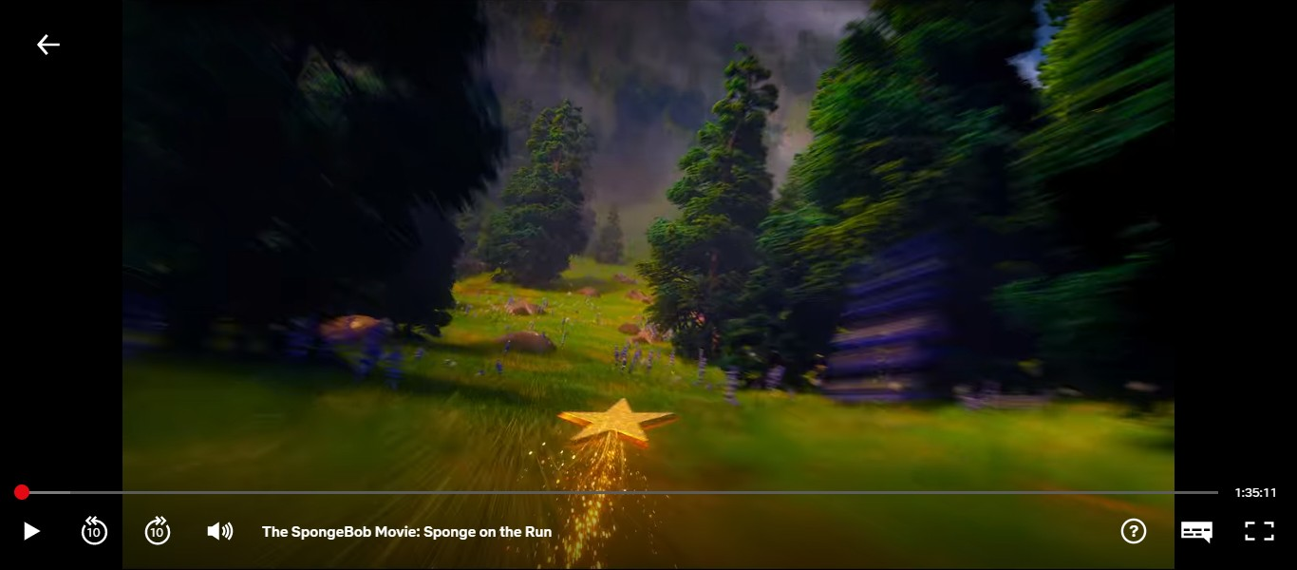

**Constraints:** The feature of auto play of the trailers is linked with the constraint aspect of the Netflix interface. As we have discussed the unnecessary behavior of auto play by just hovering over the thumbnail does not offer constraint in the interface of Netflix. One has to carefully avoid the mouse pointer on the thumbnails while searching for their desired choice of movie. As explained earlier this could interrupt the browsing processing but also puts strain on eyes which ultimately leads to the bad user experience.

**Consistency:** Overall internal consistency of Netflix UI is good whether it is a graphic design or flow design or the use of icons in the application. But if we look at the external consistencies we can find s small difference between Netflix mobile app and web app. The mobile app gives a separate category of preview feature of some movies/series. But the web app does not. In web app the there is no option to select the preview of your choice rather it starts to play on its own. With no option to pause. The only thing yu can do is to ignore that and scroll down. Whereas in mobile app you have choice to select the preview as well as close icon to close preview window.



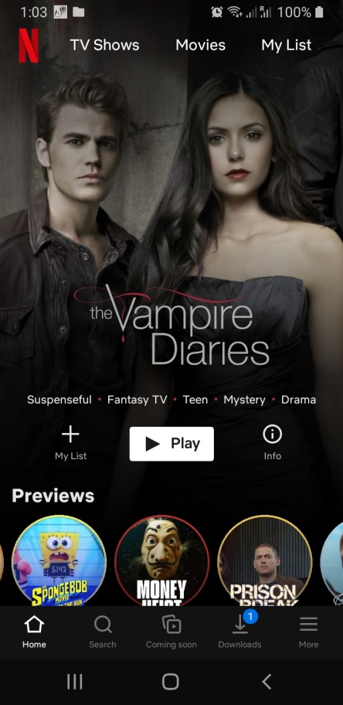 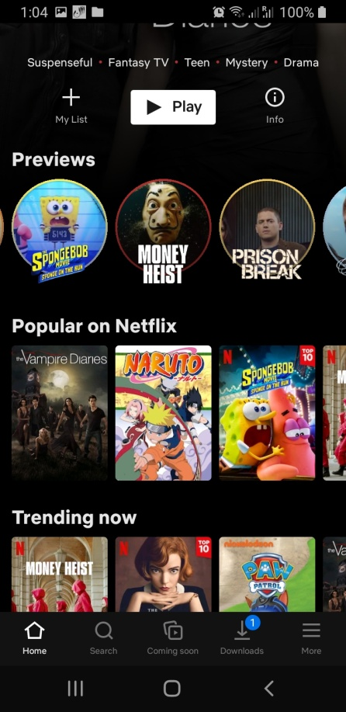 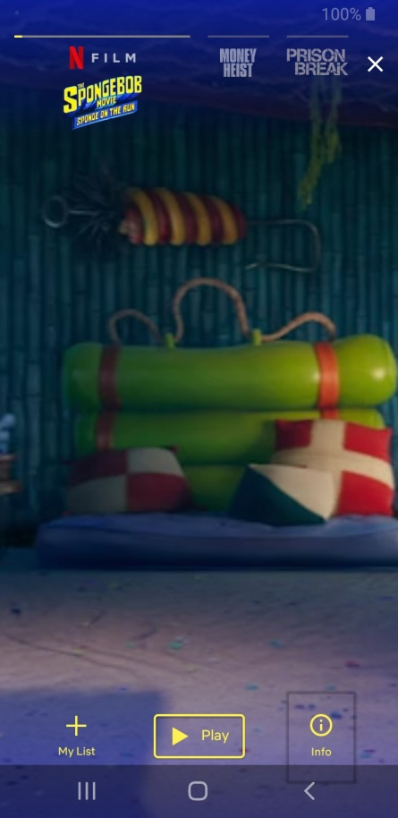

**Metaphor:** Netflix was created in replacement of TV channels and video players and cassettes. It came with the requirements such as to smoothly search and play the movie/series they want to watch. Browse Netflix catalogue rather than looking for movie cassettes in different stores and purchasing them. And making the whole experience highly responsive and making all the functions obvious to the user.