**Analyzing E-commerce Data with MySQL Queries**

**Objective: Make use different SQL queries using a sample database**

**Introduction**

**The case study I am presenting you shows the proficient use of MySQL Workbench. With the use of sample data related to an Online Shopping Platform, I have tried to display the use of SQL queries in creation, manipulation and operations performed on the data models. With the proper use of different clauses, references and functions, different real world problem related to the database models can be converted into a database model.**

**Keywords (for the whole case study) : MySQL queries, database models, ER diagram, Schema)**

**Database model structure**

**The database model consists of 5 entities which are named as Customers, Products, Order_Details, Payment and Payment_methods. There are different connections which are present which shows the relationships between the entities. The entities has different attributes of themselves which gives information about them.**

**Entity-Relationship Diagram (ER Diagram)**

**(The ER diagram is created using lucid charts.)**

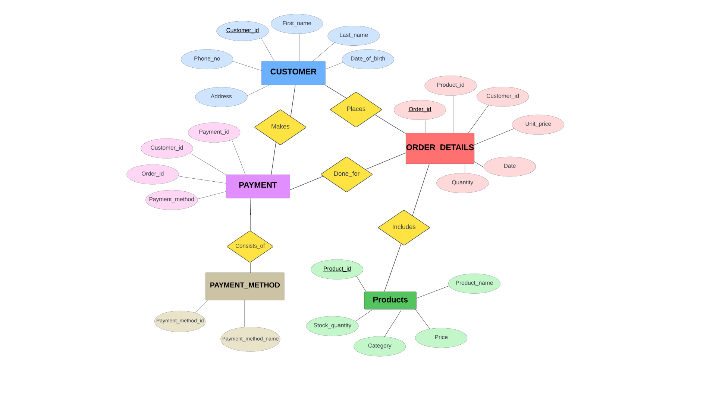

Fig: Entity-Relationship Diagram

The diagram above is an ER diagram that represents the relationship between all the five entities. I have separated each entity with unique color so that it is easier to visualize it. Here, the rectangular

Here, the rectangular box represents the entities. Surrounding the entities in the eclipse, are attributes for each of the entities. The primary keys are underlined as shown in the diagram. The yellow diamond box represents the relationships among the entities. The relationships can be read in the following way:

1. CUSTOMER Places ORDER_DETAILS
2. ORDER_DETAILS Includes PRODUCTS
3. CUSTOMER Makes PAYMENT
4. PAYMENT Consists of PAYMENT_METHODS
5. PAYMENT Done for ORDER_DETAILS

**Database Schema**

It generally refers to the blueprint to organize the database. In the context of this sample data, with the use of MySQL Workbench, I am able to present the schema for my database tables.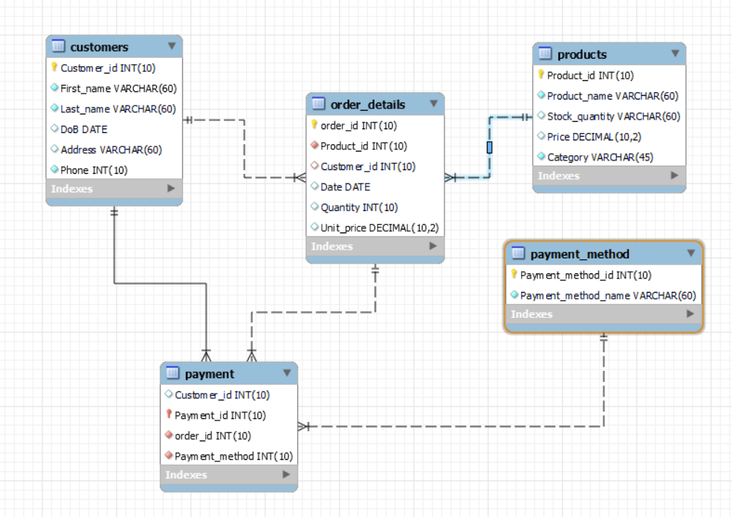

Fig: Database Schema

The database schema above shows that, by using the ER diagram as reference, there are different columns created for each of the tables. The connections between the tables that can be seen, are the use of reference keys.

The reference keys used in this schema are:

1. For Customers and Order_details tables:
   * *Customer(Customer_id) => Order_details(Customer_id). It is* ***one to many*** *relationship.*
2. For Customers and Payment tables:
   * *Customer(Customer_id) => Payment(Customer_id). It is*

***one to many*** *relationship.*

1. For Order_details and Payment tables:
   * *Order_details(Order_id) => Payment(Order_id). It is*

***one to many*** *relationship.*

1. For Order_details and Products tables:
   * *Order_details(Product_id) => Products(Product_id). It is*

***many to one*** *relationship.*

1. For Payment and Payment_method tables:
   * *Payment(Payment_method) => Payment_method(Payment_method_id). It is*

***one to one*** *relationship.*

**Creating Tables and Inserting Data**

I will be presenting the snippets of queries written in MySQL Workbench, including the outputs as well. For each table, I have written query for creating table and inserting records into it.

1. Customers Table

a. Creating Table 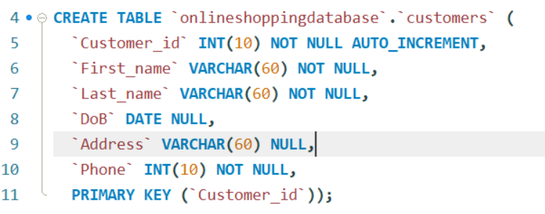

b. Inserting data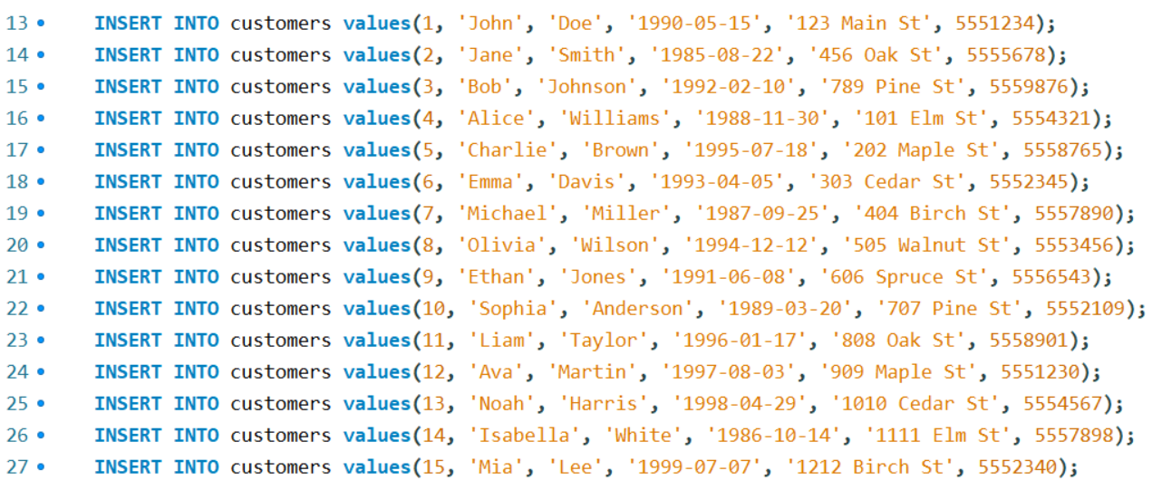

2. Order_details Table

a. Creating table (Note: there are references given in for the foreign keys. “ON UPDATE CASCADE” clause refers to automatically change the data if any manipulation done in other referenced table whose sole purpose is to MAINTAIN DATA INTEGRITY.)

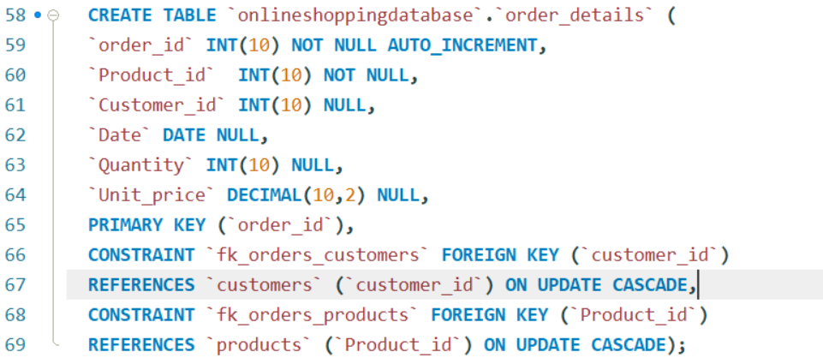

b. Inserting Data

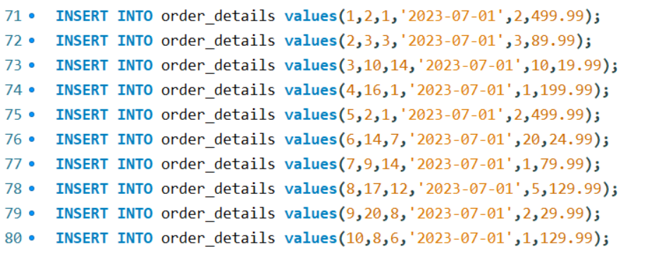

3. Products Table

1. Creating table

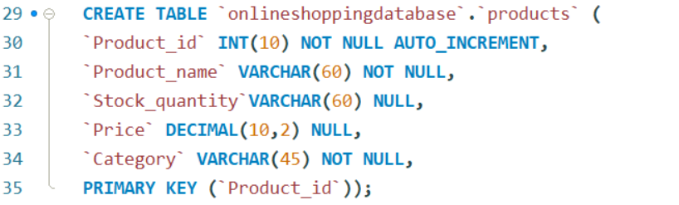

1. Inserting Data

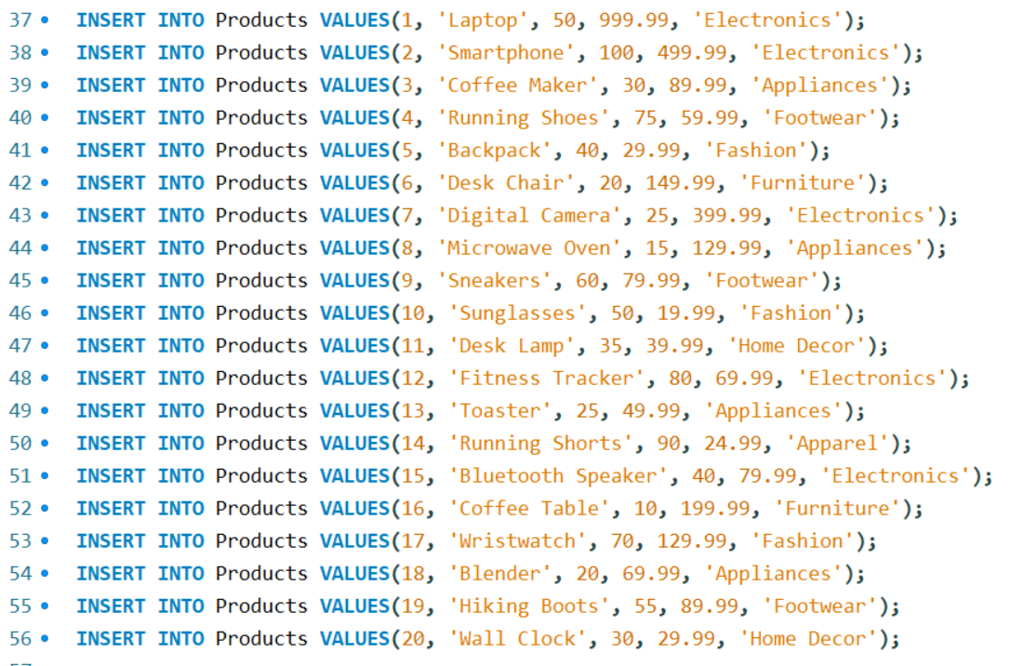

4. Payment_methods Table

(Note: Here, this table is created before Payment table because there is reference key that is added for this table in the Payment table.)

1. Creating Table

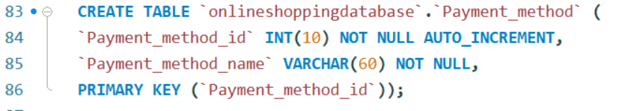

1. Inserting data

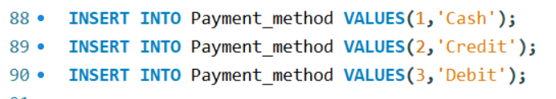

1. Payment Table
2. Creating Table

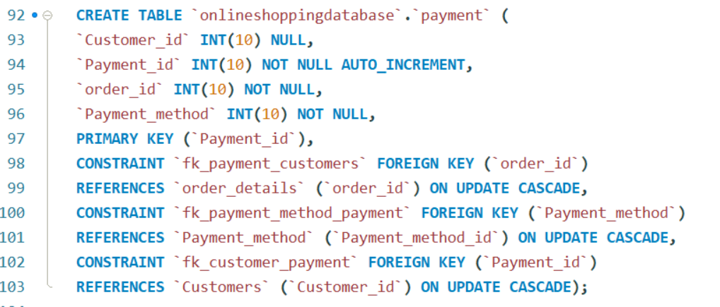

1. Inserting data

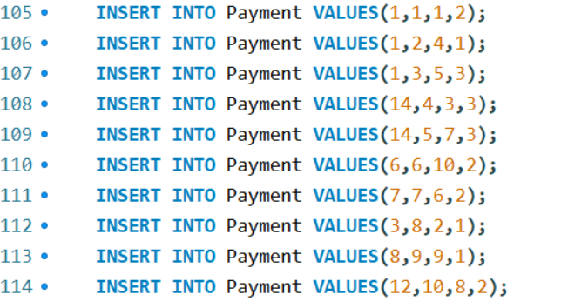

**Displaying the Tables**

1. Customers Table

Query: 

Output:

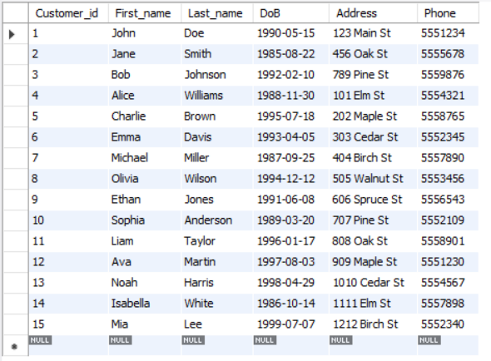

1. Payment_methods Table

Query:



Output:

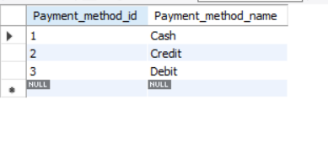

1. Products Table

Query:



Output:

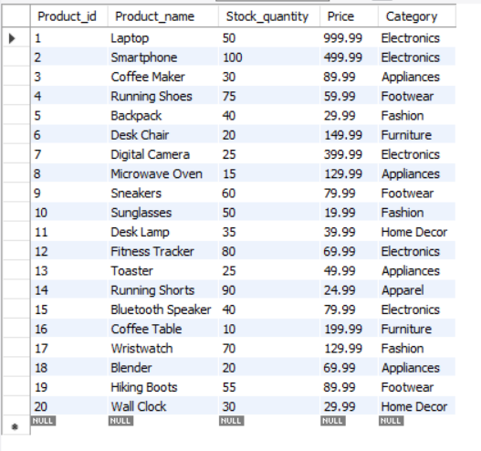

1. Order_details table

Query:



Output:

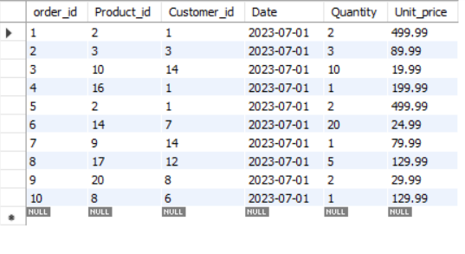

1. Payment table

Query:



Output:

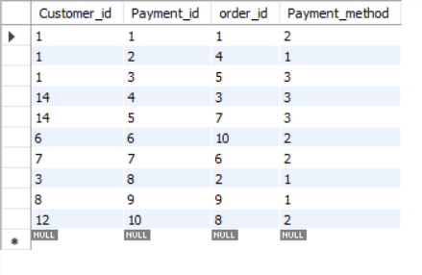

**Performing Queries with respect to the scenario given**

1. Creating amount column in order_details table for each orders where amount= unit_price*quantity.

Query:



Output:



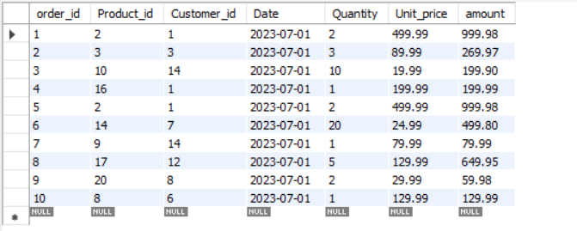

1. Retrieve the names and payment_method of customers who have made payment using the credit_card.

Query:

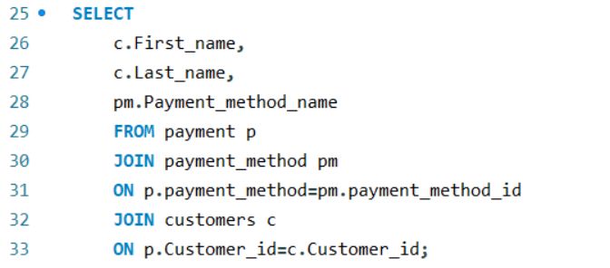

Output:

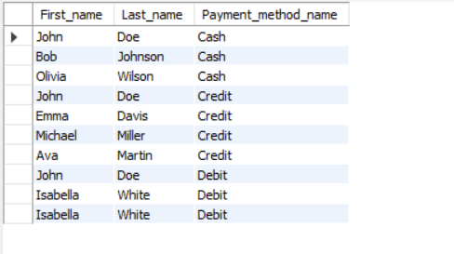

1. Find the total income generated.

Query:

(Note: Amount column added above should be present.)



Output:



1. List the products that have not been ordered yet in ascending order.

Query:

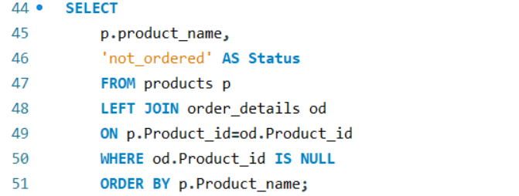

Output:

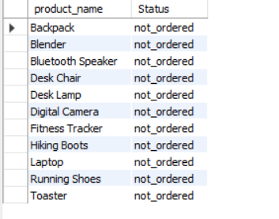

1. Retrieve top 3 customers with highest payment.

Query:

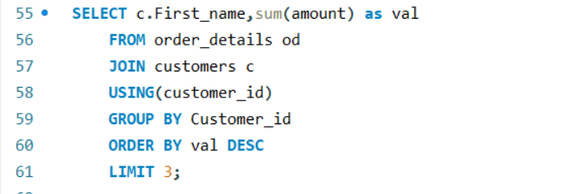

Output:

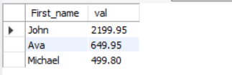

1. Find the most popular product (product bought in highest quantity).

Query:

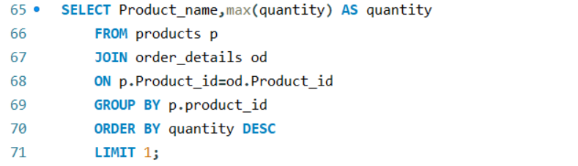

Output:



1. Calculate average payment amount for each payment method.

Query:

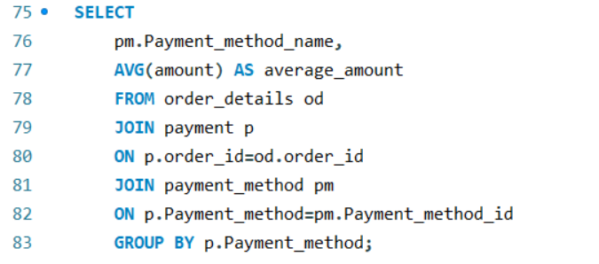

Output:

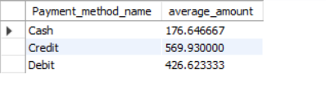

1. Retrieve the customers with their ordered products name along with the quantity and where to deliver the product.

Query:

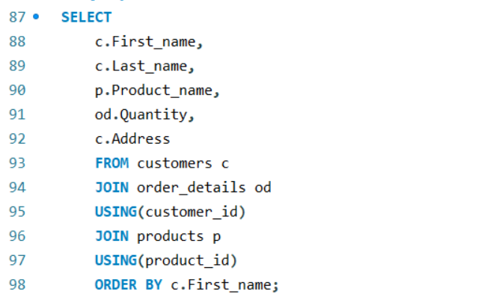

Output:

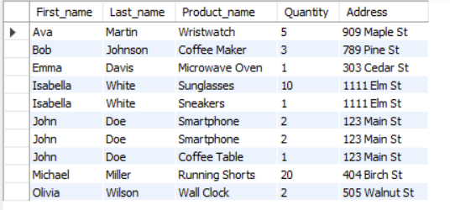

1. Retrieve the customer name and amount paid. Here, add a status column that shows which customers buy or didn’t by items.

Query:

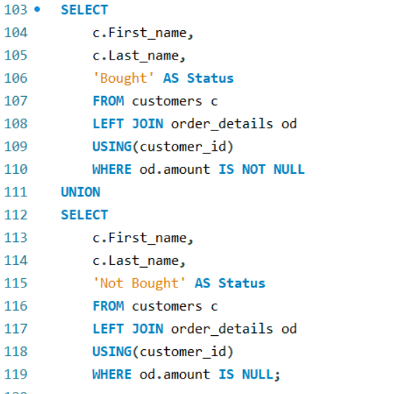

Output:  
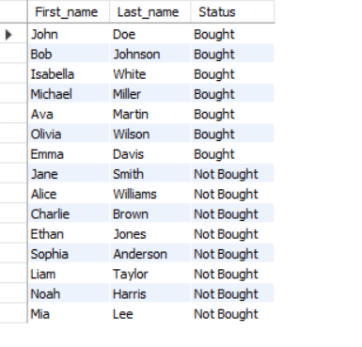

**Conclusion**

In conclusion, the presented case study shows the thorough use of MySQL Workbench, its effective utilization in managing data for an Online Shopping Platform. This case study presents the use of My SQL in creation, manipulation and management of databases.