DOME搭建（Robo360为例）

1.准备factory bundle
(1)确保同步环境里有/platform/factory目录。如果没有，运行以下命令
# git clone https://chromium.googlesource.com/chromiumos/platform/factory
要使用的finalize_bunlde脚本就在src/platform/factory/bin 中
（2）手动创建一个文件夹，把要用到的文件放进去
# mkdir -p factory_bundle_coral_20170628_dvt/factory_bundle_robo360_20170628_dvt
# cd factory_bundle_coral_20170628_dvt/factory_bundle_robo360_20170628_dvt
# mkdir test_image
# mkdir release_image
# mkdir firmware
# mkdir hwid
# mkdir complete
# unzip <FactoryImageAchieve.zip> （解压出来的bundle只有几个文件夹，它们是创建 fa ctory_bundle所需要的）
# touch MANIFEST.yaml
如果不想花费时间复制文件，可以创建链接文件：
# ln /path/to/test_image.bin test_image/
# ln /path/to/chromeos_9334.72.0_samus_recovery_stable-channel_mp-v3.bin release_image/
# ln /path/to/hwid_v3_bundle_SAMUS.sh hwid/
# ln /path/to/chromeos-firmwareupdate firmware/
# untar -JxvC test_image/ /path/to/ChromeOS-test-R58-9334.72.0-samus.tar.xz
# unzip /path/to/ChromeOS-factory-R61-9688.0.0-samus.zip
（3）MANIFEST.yaml文件的内容包括（这是同步完环境后的脚本里定义的，和老版本脚本的不一样，要同步环境到最新）：
board: coral
project: robo360
bundle_name: 20170628_dvt
server_url: http://101.1.2.4:9100/
firmware: local
release_image: local
hwid: real
test_image: local
toolkit: local
（4）准备好以上文件后，把MANIFEST文件拷贝到环境src/platform/factory/bin下，运行其中的脚本finalize_bundle
# src/platform/factory/bin/finalize_bundle ./MANIFEST.yaml
会在此目录下得到一个压缩包factory_bundle.tar.bz2，准备就绪
2.Transition from Mini-Omaha to Dome/Umpire
（1）Umpire is using new factory bundle format.see:
https://chromium.googlesource.com/chromiumos/platform/factory/+/master/setup/BUNDLE.md
(2)安装DOME/Umpire
先要安装docker，以下是docker介绍：
The Chrome OS Factory Server is a collection of software components running on a server deployed in factory manufacturing line, as the single portal for DUTs (device under test) for accessing shop floor backends, storing logs, syncing system time, and many other “server” related services.
Currently the server is a Docker image containing following components:
- Dome, the web based front end for accessing server.
- Umpire, provides imaging and partial updates to software, and also controls other services.
- Overlord, a remote monitoring service.
- Instalog, a robust logging pipeline.
- DKPS, a service for managing keys for provisioning.
see：https://chromium.googlesource.com/chromiumos/platform/factory/+/master/setup/FACTORY_SERVER.md#Prerequisite
对于Ubuntu LINUX 16.04.1,直接按照文档提示安装：
sudo apt-get update && sudo apt-get install docker.io
得到的docker版本是高于1.10.3的
对于Ubuntulinux 14.04 需要安装对应的docker版本，参见：
https://docs.docker.com/engine/installation/linux/docker-ce/ubuntu/
一般安装DOCKER CE版，使用推荐的Install using the repository方式安装
setup the docker repository
1. update the apt package index:
# sudo apt-get update
2.Install packages to allow apt to use a repository over HTTPS:
#sudo apt-get install \
apt-transport-https \
ca-certificates \
curl \
software-properties-common
3.Add Docker’s official GPG key:
# curl -fsSL https://download.docker.com/linux/ubuntu/gpg | sudo apt-key add -

4.Use the following command to set up the stable repository.(选择AMD64那个项)
#sudo add-apt-repository \
"deb [arch=amd64] https://download.docker.com/linux/ubuntu \
$(lsb_release -cs) \
stable"
Install Docker CE
1.Update the apt package index.
sudo apt-get update
2.Install the latest version of Docker CE
sudo apt-get install docker-ce
如果不想用最新版，也可以指定版本，运行：apt-cache madison docker-ce
会显示可用的历史版本，格式如下：
docker-ce | 17.09.0~ce-0~ubuntu | https://download.docker.com/linux/ubuntu xenial/stable amd64 Packages
黄色标记的部分就是版本信息，指定安装该版本：
sudo apt-get install docker-ce=<VERSION>
3.Docker daemon 会自动运行，验证一下是否正常运行：
sudo docker run hello-world

至此，docker安装完毕
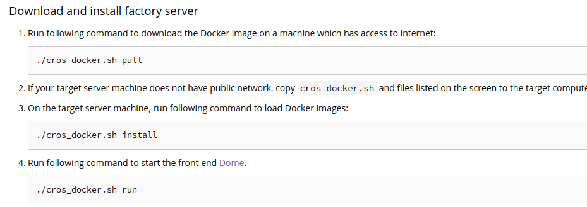
4.
5.更新cros_docker.sh和server image到最新版本(该脚本在factory/setup目录下，环境下有，也可以同步git clone https://chromium.googlesource.com/chromiumos/platform/factory)
./cros_docker.sh update

