,

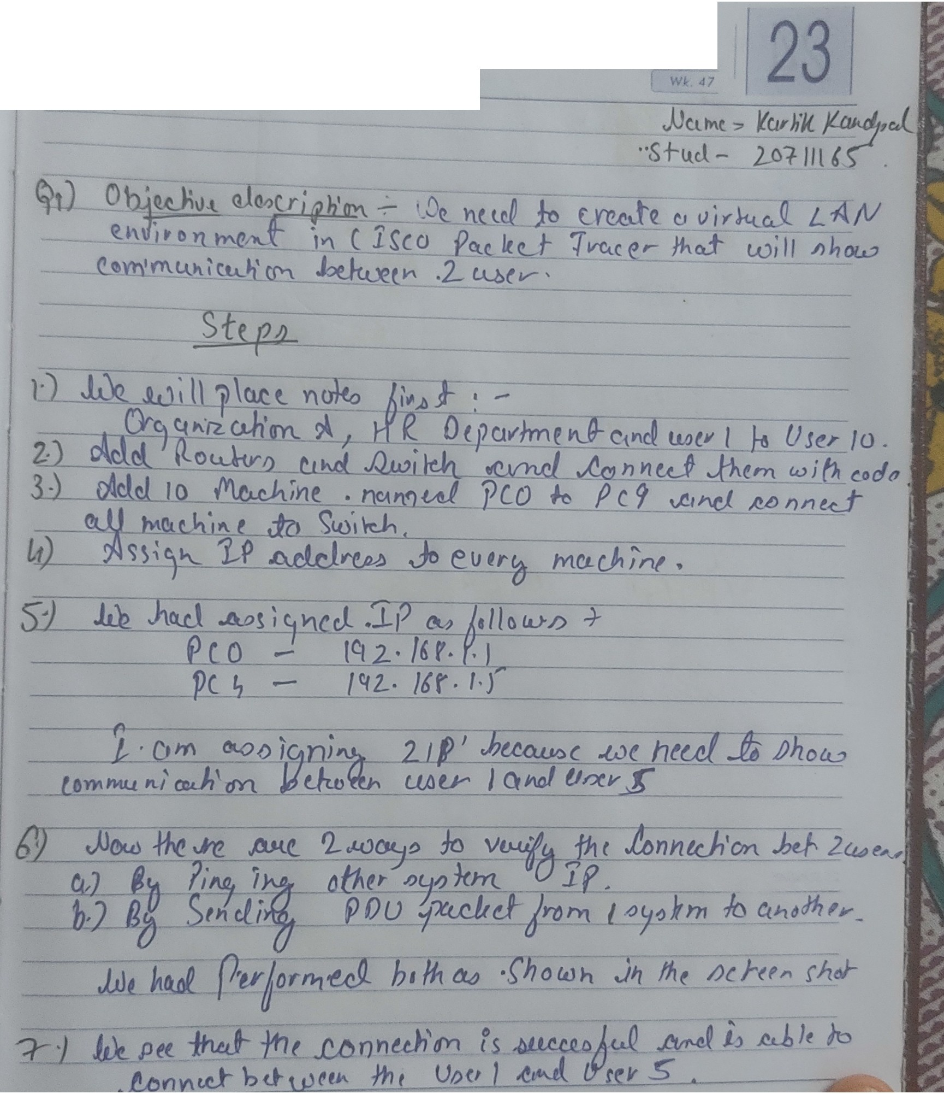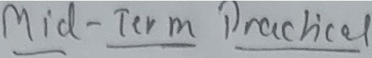

3 4 6 6 8 9

10 ,,12 13 14 16 16

1 18 18 20 21 22 23

24 2& 28 28 28 30

## ~~2018~~

*NOVEMBER*

*Friday*

# Output Screenshots from Packet Tracer Q1



L

"c,,..,-,, ...c11-.-..r-......,,.... 1-w..,...............

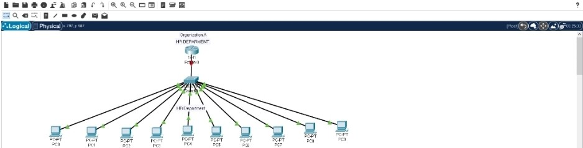

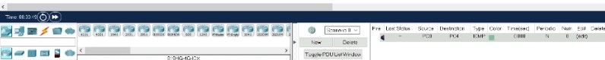

•·--••.t jj, ia 11 " '\ -.-.e. 0CJ1 ••a

=: 0, 41 :::;; 1, ••l •Q

Mt.§*#6* & sw

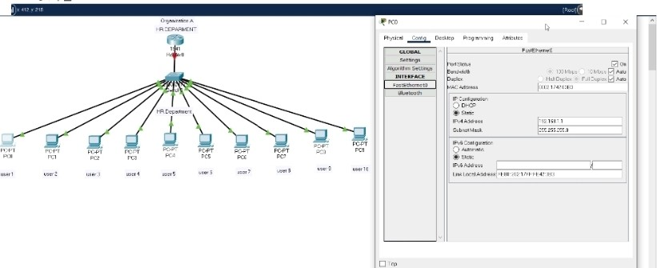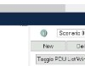

fi••m lii •t::=_ '"'-•••••M >

4·--

"20

1

,_ -

4 •

I

Kt K< '>'. MW M

-- - -- -

- , -

•

_J L

IP assigned to User 1

. ... .r Jt. ill tl r "I '''CCII I W lll

::;a,. :;: 1, ••l •Q

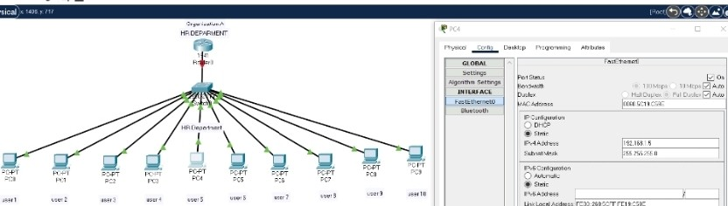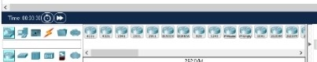

c--

• li'"iii: -- ·--- ·-..... :...., ........

,..

### IP Assigned to User 5

MMl:I



**l•Mi•e.i' Ji**•121 *r* ''G.. OIJl **IW lil**

= o. ·• / ••# •Q

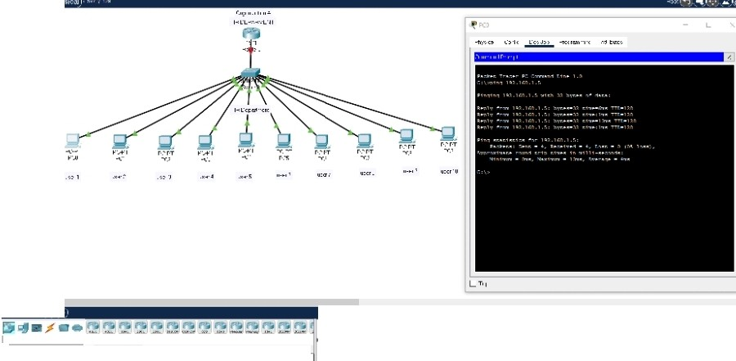

**rs.,...;•,**

.......,..,

.

·

.....r...r....-: ·"' Tl--+«

......-.... l".f.....

""'

Pinging User 1to User 5.Successful

# I

_J L

**l•lll•e .i'Ji lllCI** *r* i......OIII **IW lll**

::'Q,, • • / ••# •Q

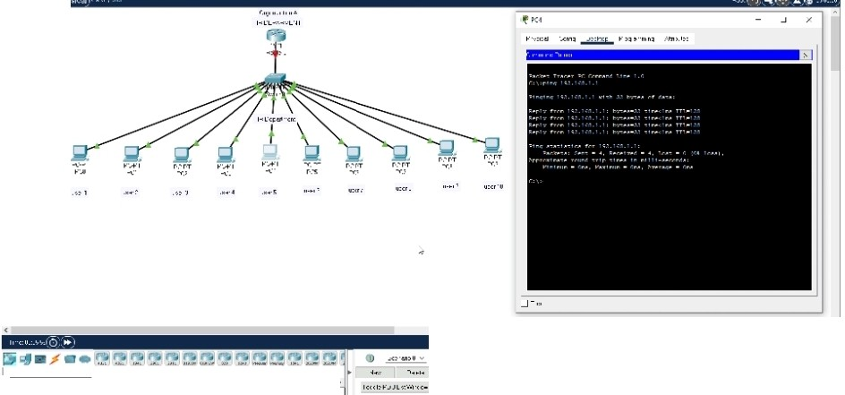

fi•••; '

...... .,..

•..-.•·· ·· •... n-;::;1 ..... .;'· ·-,, ......

""

'

Pinging User 5 to User 1.Successful



:::o. c :::o: I / ••# **"Q**

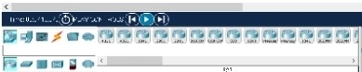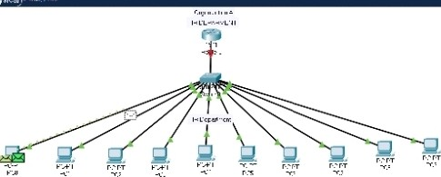

6X

## -- -"-lil''

....u...... ......

'"·-A••...-...11.......,...,...........,.....u,· .t·•,·-..o,.,

.. --.. ... ......... ..............

I> _•....,·t Jl<'I'.\> > *n:!* ut- '.\> II-.

II .......<'t" < .,">,,"J,li >.".«.<. -...,...1>1l>Ii._•.l.'"-" .V "......

..,,t.1.0......_•...._ •W A.f ' .1U i ,/l...,,,.... lt

· .. ....,. IA"....',\il\•. >>'l<:l'<' J...-.lh.<·lO'



_J

Sending PDU from User 1to User 5 In simulation Mode



**0.. •::0: 1 ,. •• l •lliil**

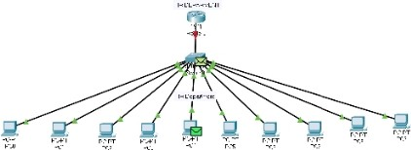

M-• -··,.:I• ... ,, .\1•:.;,

### :_ ··

i r{ lf#r ::

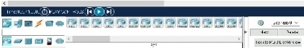

.- ........._.,, ••....• •••..•.•....•• ·-. , lh..., ..... ...

Packet Received by User 5 which was sent from user 1

::::

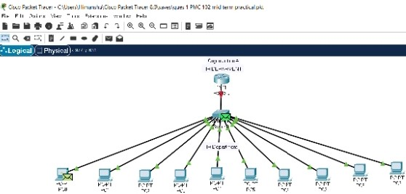

## ,_;,li1''

|  |  |
| --- | --- |
| _;;. | .;;- _:;;;; |
| ,w.  II .,. | ..-..l.._....r.........., |

""



*·'•';;:.*



...... "''-·-V••-U """'° -\" ->""""·-\ .....Ll <•ll\'-V,.0¥

ff "°"'''°' " -

.L•f--f.'4 ,•. n.,.l_..,., l.'f.•.L.l.1' _,,

,,.,.,_,_.

l. ..·..·uo,;JY '"' ""'11'"''1"'1 ....•>'. >.L'> I>

•#•• 2

**" ••'2 •'**

.

- l

a D, ·

o _....., M.,.:;""•. t" l< '<' ....... -'· >

**4** .c:«SI

**4** •>'H r.> ......

...... .......

I

Packet sent back to user 1from user 5

_J L



**1•a1 •• r • era** *r* "I **.. ,,ccri** ••

**:::<C\ G l / • • l • Q**

...,...... ,,.

#### 

,,,...

-...

... .. ... ,d•. ......,

···...

_.,,,." .....,,,,_,.,."

'..:. 1>:1.r.-V•".U'°""<1·•..:":'t"•o •.\-_.,..,l1.C• L 1·.-0¥

.1lt' •.L• 10' J.l._ W'I-'- II •.

.. ..

" .. ............. -- "' ......... ... ...

t.'" ""......-......;- .......,,,_.,..... ..

"

.

..

,., ....... ,,

,. .... ............

v.·

. . .........

.......

• *A.I"•. ......, .... .* ...... ......\1'-""

-··g··

••...._... Jr<

-""

··



LJ-

JaLJD'j

,.., ••'""" ,,.,. r,..t.... ;...,,., "'"...•e ...,.,,.

**4** .<:u:u ...... ,-,. r.u--

I ' **t** .cu:i.I ..... ,,.,. r.u- •

Here we can see Successful Message at right bottom corner. Hence Connection is established and working.