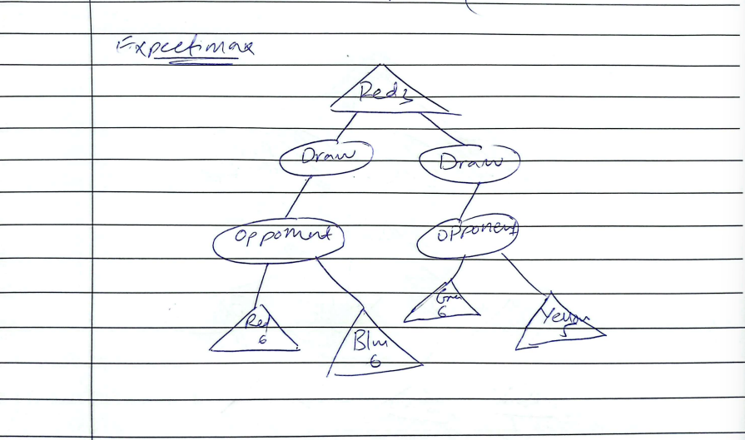
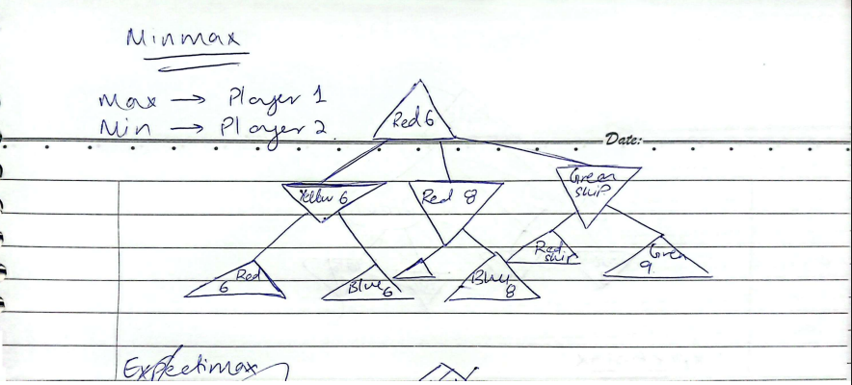

Github repository link:
https://github.com/123dija/AI-Assignment-2.git

