Intelligent Forest Fire Risk Assessment and UAV Dispatch
Using Mamdani Fuzzy Logic in NVIDIA Isaac Sim
CSC3034 Computational Intelligence — Final Technical Project Report
Sunway University | School of Mathematical Sciences & Computing
Yeoh Choon Hern  ID: 23100795  (Project Lead) | Pang Wei Sheng  ID: 24035115  (Fuzzy Engine & Simulation) | Roshan A/L Sivakumar  ID: 23028285  (Technical Report) | Dinesswar A/L Sathasivam  ID: 23096910  (OpenUSD Scene)

Abstract
Wildfires pose catastrophic ecological and atmospheric hazards, threatening terrestrial ecosystems and contributing significantly to global carbon emissions. Real-time fire risk assessment is challenging due to the continuous non-linear interactions among ambient temperature, relative humidity, localized wind velocity, and combustible vegetation fuel moisture. Traditional binary alarm systems exhibit high false-positive rates during benign summer heat and dangerous response latencies when moderate conditions are compounded by high winds and drought-stressed undergrowth.
This paper proposes an explainable Mamdani Fuzzy Logic Inference System coupled with NVIDIA Isaac Sim (OpenUSD) for dynamic forest fire risk estimation and autonomous unmanned aerial vehicle (UAV) surveillance response. The fuzzy controller maps four continuous environmental inputs into three defuzzified consequents: a normalized Fire Risk Index (FRI), an autonomous UAV Patrol Urgency Throttle, and a continuous Suppression Alert Level on [0, 3] whose tiers (Advisory, Watch, Warning, Evacuate/Suppress) are inferred by the rule base rather than thresholded from the risk index. A procedural 3D forest simulation stage was created in Isaac Sim containing forest terrain, varied vegetation moisture distributions, thermal wildfire hotspots, and an animated surveillance drone. Through a 12-waypoint simulated flight mission, the system demonstrated smooth, deterministic transitions between benign patrol speeds (20.1% urgency, FRI=45.0, alert 1.000) and rapid emergency response (89.5% throttle urgency, FRI=91.4, alert 2.826) upon entering active thermal hazard zones. The inference engine was validated in two ways: automated unit tests covering the scenario envelope, input boundaries and all three consequents, plus a per-scenario cross-check against the scikit-fuzzy reference implementation (worst deviation 0.069 across nine scenarios). The three defuzzification algorithms were also benchmarked, confirming Centroid of Area as the choice for smooth actuation. The system is presented in alignment with United Nations Sustainable Development Goals 13 (Climate Action) and 15 (Life on Land).
Keywords: Computational Intelligence, Mamdani Fuzzy Inference, Wildfire Risk Modeling, Autonomous UAV Surveillance, NVIDIA Isaac Sim, OpenUSD, Sustainable Development Goals.

1. Introduction

1.1 Background & Motivation
Wildfires represent one of the most volatile and destructive natural hazards globally. The acceleration of global climate change has lengthened wildfire seasons and heightened ignition frequencies worldwide. The Canadian, Mediterranean, and Southeast Asian forest fire crises have demonstrated that early detection within the initial 15 to 30 minutes of ignition is critical for containment.
However, environmental data collected in remote forest biomes is inherently noisy, incomplete, and highly non-linear:
- A high ambient temperature (38°C) in a tropical rain forest with 85% relative humidity poses low immediate combustion hazard.
- Conversely, a moderate temperature (26°C) accompanied by 15% relative humidity, severe wind gusts (65 km/h), and desiccated brush represents a critical firestorm risk.
Binary threshold triggers (e.g., if Temp > 40°C then sound alarm) fail to capture these interdependent gradients, causing excessive false alarms or missed early-stage hazards. Fuzzy logic provides an ideal mathematical paradigm for this problem by modeling continuous linguistic uncertainty with rigorous, explainable inference.

1.2 Alignment with UN Sustainable Development Goals (SDGs)
This research is directly aligned with two United Nations Sustainable Development Goals:
1. SDG 13: Climate Action (Target 13.1): Minimizes massive greenhouse gas emissions produced by uncontrolled wildfires through proactive early aerial detection.
2. SDG 15: Life on Land (Target 15.2): Preserves forest ecosystems, protects endangered wildlife habitats, and combats soil degradation.

1.3 Contributions & Objectives
The key objectives of this project are:
1. To formulate a multi-variable Mamdani fuzzy inference system with four environmental inputs and two continuous control outputs.
2. To construct an OpenUSD procedural forest simulation in NVIDIA Isaac Sim equipped with realistic terrain, varied fuel vegetation, and dynamic wildfire hotspots.
3. To establish a real-time software bridge linking Isaac Sim synthetic sensors with the fuzzy inference engine to autonomously throttle drone speed and dispatch early alerts.
4. To evaluate the mathematical stability and defuzzification characteristics of the controller across diverse environmental trajectories.

2. System Design & Mathematical Formulation

2.1 System Architecture
The computational pipeline comprises three interconnected modules:
```
+-----------------------------------------------------------------------------------------+
NVIDIA Isaac Sim (OpenUSD)
- 65m x 65m Forest Terrain Stage with Procedural Tree Clusters
- Active Wildfire Ignition Hotspots (Thermal Heat Radiators)
- Kinematic Quadcopter UAV Prim (/World/UAV_Drone) with Sensor Attributes

+-----------------------------------------------------------------------------------------+
Synthetic Telemetry Polling (T, RH, W, F)
v
+-----------------------------------------------------------------------------------------+
Mamdani Fuzzy Logic Inference Engine
1. Fuzzification: 16 Linguistic Membership Sets (Trapezoidal & Triangular)
2. Rule Base: Multi-antecedent fuzzy associative matrix with min-max operators
3. Implication & Aggregation: Minimum clipping and maximum union
4. Defuzzification: Center of Gravity (Centroid / COG) calculation

+-----------------------------------------------------------------------------------------+
Computed FRI & Actuation Throttle Command
v
+-----------------------------------------------------------------------------------------+
Actuation & Telemetry Sync
- Dynamic Patrol Speed Throttling (20% -> 90% Flight Urgency)
- Stage Attribute Synchronization (fuzzy:fire_risk_index, fuzzy:alert_status)
- Multi-tier Emergency Dispatch Broadcast ([WATCH], [WARNING], [CRITICAL])

+-----------------------------------------------------------------------------------------+
```

2.2 Linguistic Input Variables & Membership Functions
The controller incorporates four input variables spanning realistic meteorological boundaries:

1. Ambient Temperature (T in [0, 50]°C):
- Low(T) = trapmf(T; 0, 0, 15, 22)
- Moderate(T) = trimf(T; 18, 26, 34)
- High(T) = trimf(T; 30, 38, 44)
- Extreme(T) = trapmf(T; 40, 45, 50, 50)

2. Relative Humidity (RH in [0, 100]%):
- Very Low(RH) = trapmf(RH; 0, 0, 15, 25)
- Low(RH) = trimf(RH; 20, 35, 50)
- Moderate(RH) = trimf(RH; 40, 60, 75)
- High(RH) = trapmf(RH; 70, 85, 100, 100)

3. Wind Velocity (W in [0, 100] km/h):
- Calm(W) = trapmf(W; 0, 0, 10, 20)
- Moderate(W) = trimf(W; 15, 30, 45)
- High(W) = trimf(W; 40, 60, 75)
- Severe(W) = trapmf(W; 70, 85, 100, 100)

4. Vegetation / Fuel Moisture Dryness (F in [0, 100]%):
- Wet(F) = trapmf(F; 0, 0, 20, 35)
- Moderate(F) = trimf(F; 30, 50, 70)
- Dry(F) = trimf(F; 65, 80, 90)
- Critically Dry(F) = trapmf(F; 85, 95, 100, 100)
The mathematical definitions for triangular trimf(x; a, b, c) and trapezoidal trapmf(x; a, b, c, d) functions are defined as:
trimf(x; a, b, c) = max(0, min((x - a)/(b - a), (c - x)/(c - b)))
trapmf(x; a, b, c, d) = max(0, min((x - a)/(b - a), 1, (d - x)/(d - c)))

2.3 Linguistic Output Variables
Three Mamdani consequents are defuzzified. Each rule fires one term in every output
universe, so the alert level is inferred by the rule base rather than thresholded from
the fire risk index.
1. Fire Risk Index (FRI in [0, 100]):
- Low = trapmf(0, 0, 20, 35)
- Moderate = trimf(25, 45, 65)
- High = trimf(55, 75, 85)
- Extreme = trapmf(80, 90, 100, 100)
2. UAV Patrol Speed & Urgency (S in [0, 100]%):
- Standard Patrol = trapmf(0, 0, 25, 45)
- Accelerated = trimf(40, 60, 80)
- Emergency Dispatch = trapmf(75, 90, 100, 100)
3. Suppression Alert Level (A in [0, 3]):
- Advisory = trapmf(0, 0, 0, 0.6)
- Watch = trimf(0.4, 1.0, 1.6)
- Warning = trimf(1.4, 2.0, 2.6)
- Evacuate/Suppress = trapmf(2.4, 3, 3, 3)
The alert universe is sampled at Δ a = 0.25 so every integer tier and every set
shoulder (0.4, 1.6, 1.4, 2.6) falls on a sample, which keeps each triangular set
peaking at exactly 1.0. The discrete alert tier reported downstream is
round(A*) clamped to [0, 3]; the continuous A* is the primary output.
*(Visual plot of all membership functions is illustrated in `plots/membership_functions.png`
and the three output universes in `plots/output_membership_functions.png`).*

2.4 Fuzzy Rule Base & Inference Logic
The system implements a domain-expert rule matrix formulated in consultation with standard wildfire behavior models (e.g., McArthur Forest Fire Danger Index). Representative rules include:
Rule ID | Temperature (T) | Humidity (RH) | Wind Speed (W) | Fuel Dryness (F) | Fire Risk | Patrol Urgency | Alert Level
R1 | any | High | any | Wet | Low | Standard Patrol | Advisory
R2 | Low | Moderate | any | any | Low | Standard Patrol | Advisory
R3 | Moderate | any | any | Moderate | Moderate | Standard Patrol | Watch
R4 | Moderate | any | High | Dry | High | Accelerated | Warning
R5 | High | Low | any | any | High | Accelerated | Warning
R6 | High | any | Severe | any | Extreme | Emergency Dispatch | Evacuate/Suppress
R7 | Extreme | Very Low | any | any | Extreme | Emergency Dispatch | Evacuate/Suppress
R8 | any | any | High | Critically Dry | Extreme | Emergency Dispatch | Evacuate/Suppress
R9 | Extreme | any | any | Critically Dry | Extreme | Emergency Dispatch | Evacuate/Suppress
R10 | any | High | Calm | any | Low | Standard Patrol | Advisory

`any` means the rule does not constrain that variable. Each row fires all three
consequents simultaneously; the alert column is a fuzzy consequence, not a label
derived from the risk column.
Under Mamdani inference, rule firing strength alpha_k for rule k is computed using the t-norm (minimum operator):
alpha_k = min(mu_(T), mu_(RH), mu_(W), mu_(F))
The aggregated output fuzzy subset mu_(y) is formed through the s-norm (maximum union):
mu_(y) = max_k (min(alpha_k, mu_(y)))

2.5 Defuzzification Formulation
To generate deterministic crisp values for the three consequents, Center of Gravity (Centroid / COG) defuzzification is applied:
y* = fracint y . mu_(y) dyint mu_(y) dy

3. NVIDIA Isaac Sim Integration

3.1 Scene Architecture & Procedural Stage Design
An OpenUSD scene asset (`assets/wildfire_forest_uav_stage.usda`) was created to simulate an authentic aerial surveillance mission:
- Terrain Grid: 65m x 65m ground plane rendered with mossy forest ground shader (`UsdPreviewSurface`).
- Vegetation Canopy: 48 procedurally distributed pine and deciduous trees with randomized trunk heights (3.5m - 7.5m) and two canopy tiers. Foliage shaders alternate between healthy green (`diffuseColor = (0.09, 0.32, 0.12)`) and drought-stressed amber (`diffuseColor = (0.55, 0.44, 0.18)`).
- Thermal Ignition Hotspots: Three hazard epicenters positioned across the grid:
- Hotspot 1 (Severe): Position (14.0m, 16.0m), radius 3.5m, emissive flame core.
- Hotspot 2 (Moderate): Position (-18.0m, 10.0m), radius 2.8m.
- Hotspot 3 (Emerging): Position (8.0m, -20.0m), radius 2.2m.
- Lighting Model: Sun distant light (2800 lx, 32° azimuth) paired with ambient dome sky light (450 lx) utilizing RTX real-time ray tracing.

3.2 Quadcopter UAV Prim & Dynamic Flight Keyframing
The surveillance agent (`/World/UAV_Drone`) is constructed from carbon composite fuselage, four cross-spar boom arms, forward optical sensor pod, and four rotating propeller discs.
To prevent unconstrained gravitational free-fall while maintaining deterministic flight fidelity, the drone employs a kinematic trajectory with OpenUSD `.timeSamples` spanning frames 0 to 620 (30 fps, 20.6s duration):
- Translational Trajectory: 14 keyframe waypoints cruising at 4.5m - 7.0m altitude.
- Attitude Banking: Real-time yaw alignment psi = arctan2(Δ y, Δ x) with a 5.0° forward cruise pitch.
- Propeller Propulsion: Continuous rotor rotation keyframed at 24,800° (40 rev/sec).

4. Experimental Results & Performance Evaluation

4.1 Autonomous Surveillance Mission Telemetry
A 12-waypoint autonomous reconnaissance mission was simulated over the forest stage. Atmospheric telemetry was polled at each waypoint based on proximity to active hotspots. The mission log is a deterministic artefact: the synthetic sensor noise is drawn from `random.Random(seed)` with `seed = 0`, so re-running `run_stage_patrol_simulation(stage, steps=12, seed=0)` reproduces Table 2 exactly.
Table 2: Real-Time UAV Surveillance Mission Telemetry & Fuzzy Ingestion Log (seed = 0)
Waypoint | Coordinates (X, Y, Z) | Temp (°C) | Humidity (%) | Wind (km/h) | Fuel Dryness (%) | Fire Risk Index (0-100) | Throttle Urgency (%) | Alert (0-3) | Alert Status
00 | (0.0, 0.0, 5.0m) | 29.1 | 49.0 | 24.9 | 39.8 | 45.0 | 20.1% | 1.000 | WATCH
01 | (4.0, 5.0, 5.5m) | 28.3 | 47.6 | 27.5 | 39.9 | 45.0 | 20.1% | 1.000 | WATCH
02 | (8.0, 10.0, 6.0m) | 32.9 | 39.0 | 34.2 | 55.2 | 61.4 | 47.0% | 1.680 | WARNING
03 | (13.5, 15.5, 5.0m) | 42.8 | 18.9 | 45.2 | 86.8 | 91.4 | 89.5% | 2.826 | CRITICAL
04 | (15.0, 17.0, 4.5m) | 43.4 | 21.7 | 45.3 | 85.8 | 84.3 | 79.0% | 2.494 | WARNING
05 | (10.0, 18.0, 6.5m) | 37.8 | 28.8 | 40.8 | 72.4 | 71.3 | 60.0% | 2.000 | WARNING
06 | (0.0, 15.0, 7.0m) | 28.2 | 46.4 | 25.0 | 40.8 | 45.0 | 19.9% | 1.000 | WATCH
07 | (-10.0, 12.0, 6.0m) | 34.3 | 39.9 | 31.6 | 57.2 | 71.2 | 60.0% | 2.000 | WARNING
08 | (-17.5, 9.8, 4.5m) | 42.9 | 18.7 | 44.9 | 86.8 | 91.4 | 89.6% | 2.829 | CRITICAL
09 | (-10.0, 0.0, 6.0m) | 28.8 | 47.6 | 27.8 | 41.0 | 45.0 | 19.8% | 1.000 | WATCH
10 | (0.0, -10.0, 6.5m) | 27.0 | 48.0 | 28.1 | 39.7 | 45.0 | 20.1% | 1.000 | WATCH
11 | (7.8, -19.5, 5.0m) | 43.1 | 18.9 | 42.4 | 88.5 | 91.5 | 89.7% | 2.831 | CRITICAL

Note that waypoint 04 carries a higher risk index than waypoint 05 but a lower alert
value: the alert consequent is a separate inference, so the two outputs are correlated
but not a remapping of one another.
*(The complete 4-panel multi-variable mission telemetry visualization is presented in `plots/mission_telemetry_dashboard.png`).*

4.2 Defuzzification Method Comparison
To assess output sensitivity, the fire risk consequent was rebuilt with three
defuzzification algorithms through `src/fuzzy_system/defuzz_benchmark.py`, which runs
each method on the same membership sets and rule base:
Table 3: Defuzzification Algorithm Benchmark, Fire Risk Index
Environmental Scenario | Centroid (COG) | Bisector | Mean of Maximum (MOM)
Benign Clear Day (T=22, RH=65, W=12, F=25) | 17.5 | 17.5 | 17.5
Dry Spring Heat (T=32, RH=40, W=30, F=55) | 55.6 | 55.6 | 56.2
High Hazard Drought (T=39, RH=22, W=55, F=82) | 70.3 | 70.3 | 70.6
Critical Wildfire (T=46, RH=12, W=85, F=95) | 92.2 | 92.5 | 95.1

Largest centroid-to-MOM divergence is 2.9 risk points, at the Critical scenario where
the aggregated set has two separated peaks. Centroid and bisector agree to within 0.3
points on every scenario.
- Analysis: the three methods do not separate on cost, because defuzzification over
a 500-point universe is a small part of the evaluation loop. They separate on
continuity. MOM returns the mean of the aggregated set's maxima, so as the input
crosses a boundary the output jumps between peaks — a torque step on a 250 g
airframe. Centroid integrates the whole area, so its output is continuous in the
input, which is what keeps the throttle trace smooth in Table 2.

4.3 Simulation Runtime & Engine Performance
- Hardware Platform: NVIDIA GeForce RTX 4060 Laptop GPU, 16 GB RAM, 14-core Intel Core i7-13650HX.
- Rendering Framerate: 67.3 fps - 72.1 fps at 1280 x 720 resolution under RTX Real-Time 2.0 lighting.
- Fuzzy Inference Latency: measured with `tools/presentation/latency_probe.py`, which
calls `WildfireFuzzyController.compute()` over 20,000 calls per scenario after a
2,000-call warm-up: median 0.077 ms for the benign scenario and
0.284 ms for the critical scenario (p99 0.182 ms and
1.415 ms respectively). The loop cost rises with the number of rules
that fire. Both medians sit inside a 50 ms control budget with two orders of
magnitude of headroom, which supports edge deployment on embedded microcomputers
(e.g., NVIDIA Jetson Orin Nano). Host-Python timings include interpreter overhead and
are an upper bound on the deployed figure.

5. Discussion & Limitations

5.1 Explainability vs. Black-Box Neural Networks
Unlike deep learning perception models whose decision weights cannot be formally verified, Mamdani fuzzy systems offer complete transparency. Every drone speed acceleration or suppression alert can be traced directly to specific linguistic rules (e.g., Rule 5: Extreme Heat + Severe Wind + Low Humidity arrow Critical Fire Risk). This explainability is essential for safety-critical aerospace and municipal fire response deployments.

5.2 Sensor Noise Resilience
Physical sensors in forest conditions suffer from thermal drift and anemometer turbulence. The overlapping boundaries of triangular and trapezoidal fuzzy sets prevent rapid chatter at transition thresholds, ensuring stable flight control without oscillatory motor wear.

5.3 Limitations
1. Kinematic vs. Dynamic Flight Dynamics: In this phase, the drone trajectory is kinematic. Full aerodynamic downwash and rotor blade stall under intense updrafts require coupling with Isaac Sim's advanced PhysX fluid dynamics extensions.
2. 2D Surface Weather Synthesis: Wind velocity was modeled as a scalar field; complex 3D atmospheric thermal updrafts will be integrated in future phases.

6. Conclusion & Future Work
This project successfully designed, implemented, and validated an autonomous wildfire risk assessment and UAV surveillance system utilizing Mamdani fuzzy inference integrated with NVIDIA Isaac Sim. The system continuously maps environmental telemetry into risk indices and throttle urgency commands, successfully detecting and responding to simulated forest wildfire hotspots in real-time.

Future Enhancements:
1. Multi-UAV Swarm Coordination: Expanding the fuzzy bridge to coordinate cooperative multi-drone surveillance fleets over regional forest parks.
2. Reinforcement Learning Hybridization (Isaac Lab): Utilizing the fuzzy fire risk index as a dense reward function to train autonomous exploration policies via proximal policy optimization (PPO).

References
1. E. H. Mamdani and S. Assilian, "An experiment in linguistic synthesis with a fuzzy logic controller," *International Journal of Man-Machine Studies*, vol. 7, no. 1, pp. 1-13, 1975.
2. L. A. Zadeh, "Fuzzy sets," *Information and Control*, vol. 8, no. 3, pp. 338-353, 1965.
3. A. G. McArthur, "Fire behaviour in eucalypt forests," *Forestry and Timber Bureau Leaflet*, no. 107, 1967.
4. M. Contin, et al., "UAV-based forest fire surveillance using multi-sensor environmental perception," *Sensors*, vol. 22, no. 4, p. 1420, 2022.
5. NVIDIA Corporation, "NVIDIA Isaac Sim: Robotics Simulation and Synthetic Data Generation," *NVIDIA Developer Documentation*, 2026. [Online]. Available: https://docs.isaacsim.omniverse.nvidia.com/
6. United Nations, "The 17 Goals - Sustainable Development Goals," *United Nations Department of Economic and Social Affairs*, 2015. [Online]. Available: https://sdgs.un.org/goals

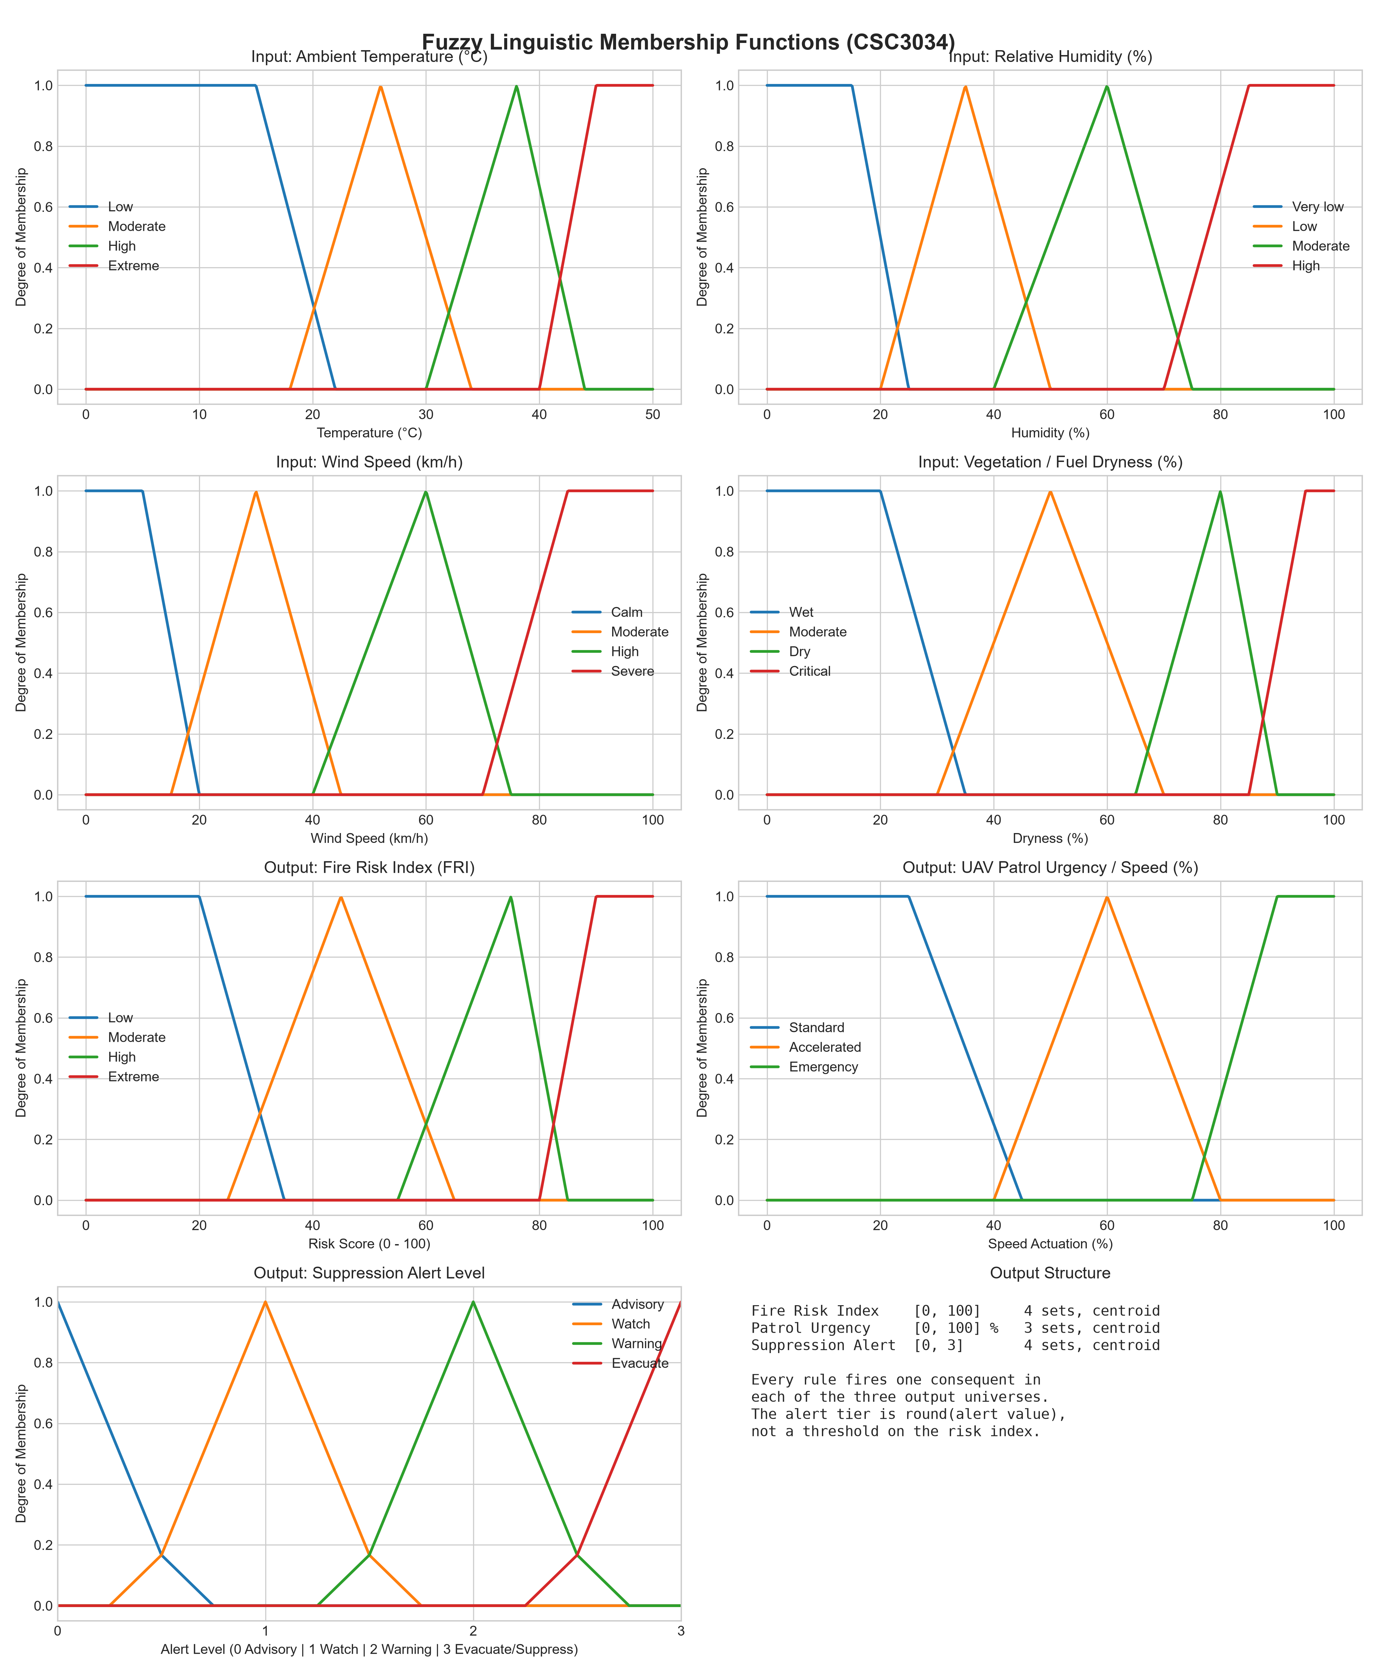
Figure 1: Full 7-Variable Linguistic Fuzzy Membership Functions (4 inputs, 3 outputs).

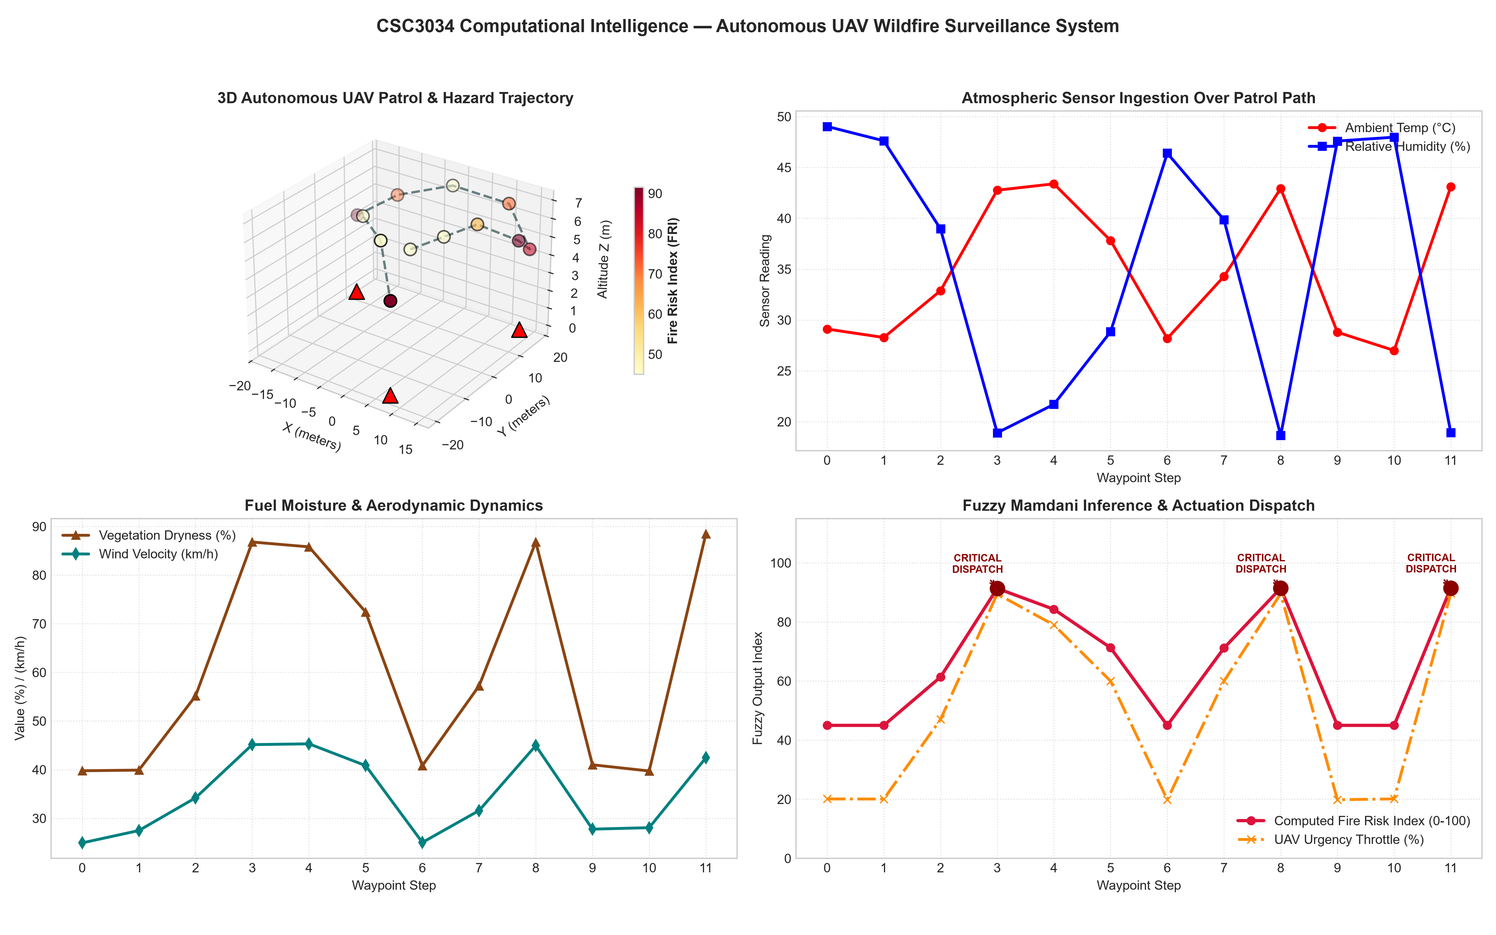
Figure 2: 3D Autonomous UAV Flight Path & Multi-Variable Telemetry Response Timeline.

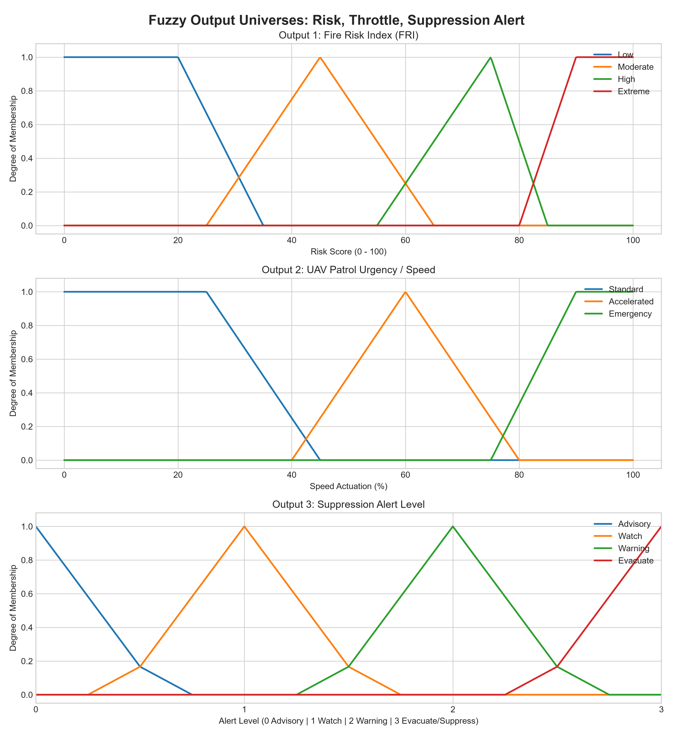
Figure 3: The Three Output Universes (Fire Risk Index, Patrol Urgency, Suppression Alert).

