**SOFTWARE**

**REQUIREMENTS**

**SPECIFICATION**

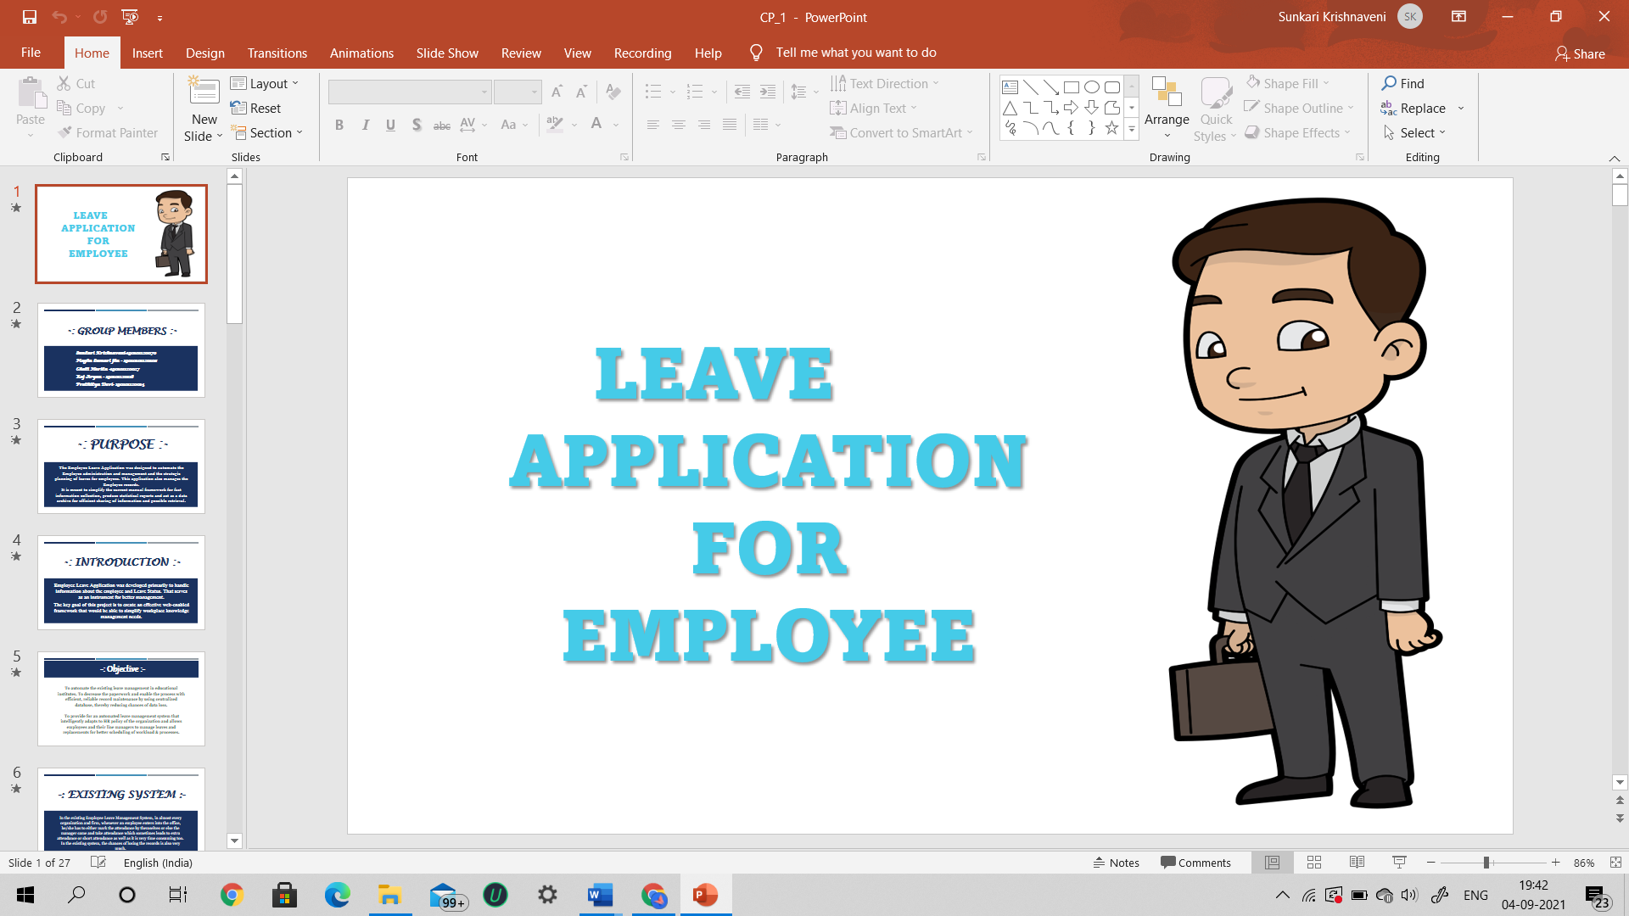

**PROJECT TITLE :**

**EMPLOYEE LEAVE APPLICATION**

**VERSION : 1.0**

**GROUP NO : 3**

**-: GROUP MEMBERS :-**

**190101120014 – Pratikhya Devi**

**190101120027 – Chelli Harika**

**190101120070 – Sunkari Krishnaveni**

**190101120108 – Megha Kumari Jha**

**190101120116 – Raj Aryan**

***CONTENTS***

1. **Introduction**
2. **Purpose**
3. **Scope**
4. **References**
5. **Overview**
6. **Current Product (Existing System)**
7. **Proposed System**
8. **Product Functionality**
9. **Modules of the Project**
10. **Admin module**
11. **Employee module**

**4. Overview of the modules of the Product**

**5. Functional Requirements of the Modules**

**6. Detailed Functional Requirements.**

1. **ADMIN MODULE**
2. **Adding Employee**
3. **Reading Employee data**
4. **Updating Employee**
5. **Deleting Employee**
6. **Accepting or Rejecting Leave**
7. **Monitoring Employee Activities**
8. **Analytical Report of the Leaves**
9. **EMPLOYEE MODULE**
10. **View Profile**
11. **Apply leave**
12. **Cancel leave till Approval of leave by Admin**
13. **View Leave Dashboard**

**7. Operating Environment**

1. **Hardware**
2. **Software**
3. **Network**
4. **Communication**

**-: INTRODUCTION :-**

**An Employee Leave Application is a web-based and android-based that automates every step of the employee leave management process without compromising on functionality. Unlike on-premise leave management tools, an online leave management system gives employees the freedom to apply, approve, reject, and manage leave requests from any place, any time, and from any device.**

**Employee Leave Application was developed primarily to handle information about the employee and Leave Status. That serves as an instrument for better management.**

**The key goal of this project is to create an effective web-enabled framework that would be able to simplify workplace knowledge and management needs.**

**PURPOSE**

**The Employee Leave Application was designed to automate the Employee administration and management and the strategic planning of leaves for employees. This application also manages the Employee records.**

**It is meant to simplify the current manual framework for fast information collection, produce statistical reports and act as a data archive for efficient sharing of information and possible retrieval.**

**SCOPE**

**Scope of this project is limited to any particular organisation rather than used by a single person.**

**REFERENCES**

**-: OVERVIEW :-**

**EXISTING SYSTEM**

**In the existing Employee Leave Management System, in almost every organization and firm, whenever an employee enters into the office, he/she has to either mark the attendance by themselves or else the manager came and take attendance which sometimes leads to extra attendance or short attendance as well as it is very time consuming too. In the existing system, the chances of losing the records is also very much.**

**And whenever an employee wants to apply a leave, he/she has to submit a hard copy of their leave request. They have to wait for their higher officials permission to know whether their leave request has been approved or cancelled. This is a long and time taking process.**

**PROPOSED SYSTEM**

**In the new proposed Employee Leave Application all the data is being maintained into the server as well regular updation will also takes place. In case, if there is some holiday, then the data is being updated automatically under well-defined graphical user interface and thus this software also makes the work load less for the department and management class as well as make easy access to the information for the authorized persons.**

**If an employee wants to apply for an leave, he/she can login into their profile and can apply for an leave by mentioning the purpose anytime rather than submitting a hard copy(paper type) in higher officials cabin. They can also view their leave application status in their “Apply Leave Interface”. This will also reflect in their “Leaves left” data.**

**PRODUCT FUNCTIONALITY**

**Some major product functionalities of the system are as follows:**

* **Information about the employee attendance**
* **Check for Leave Availability**
* **Maintain Employee leave record.**
* **Apply for leave**
* **Approve or reject leave application.**

**-: MODULES OF THE PROJECT :-**

**ADMIN MODULE**

**EMPLOYEE MODULE**

**-: OVERVIEW OF THE MODULES OF THE PROJECT :-**

**1)The Admin Module includes the following activities:**

1. **Adding Employee**
2. **Reading Employee data**
3. **Updating Employee**
4. **Deleting Employee**
5. **Accepting or Rejecting Leave**
6. **Monitoring Employee Activities**
7. **Analytical Report of the Leaves**

**2)The Employee Module includes the following activities:**

**a)View Profile**

**b)Apply leave**

**c)Cancel leave till Approval of leave by Admin**

**d)View Leave Dashboard**

**-: FUNCTIONAL REQUIREMENTS OF THE MODULES :-**

**1)Admin Module:**

* **Username and Password are required for Login**
* **Add Employee**
* **Remove Employee**
* **Keep Employee Records**
* **Notice Records**
* **Display Leave History**

**2)Employee Module:**

* **Employee can Login through their Credentials.**
* **Employee can enter the details of leave.**
* **View the leave status.**

**Non-Functional Requirements:**

* **The user needed to be able to register in the portal with his own set of attributes as required in the entity attributes.**
* **The user can log in with his credentials.  
  The user should be able to enter the detail of the leave.**
* **He can apply for the leave by entering in that and picking the date from date pickers and giving the other important attributes in that.**
* **Now he can confirm the leave request then it goes to the admin panel.**
* **Here admin has the option shown to him to see the request and other approved requests.**
* **The same changes are reflected in the other interfaces too.**

**-: DETAILED FUNCTIONAL REQUIREMENTS :-**

**Admin Module:**

**Admin logins to use the system to perform various functionalities.** **Admin accepts/rejects the request of Employee after evaluating certain criteria.Admin is the main person who can able to manage everything.First he/she will login and verify the employee list,employee performance,monitors employee status and he is the one who will grant/reject the leave to employees.** **After logging in to the system admin gets the request, of Employee as notifications. Then after clicking the request on the screen admin get two options as Accept or Reject.After evaluating some details admin can accept or reject depending on the eligibility. If Admin accepts the request, then unique id and temporary password is generated by the system and details are added to the database.Depending on selection of Accept/Reject confirmation mail will be delivered to the respective Employee.**

**Admin Login:**

**The admin inputs its secure user id and password and enters the system. The admin can log in multiple times as many times he wants.**

**Adding Employee:**

**Admin can able to add any employee at any time without asking any kind of permissions to anyone.He has all rights to do anything.**

**Admin can add using Name,Email id,**

**contact.no,designation and age of employee.**

**Reading Employee:**

**Admin can read every employee status and he will have an idea about how many employees are working how many days ,how many days they are in leave,what are the purpose of leaves,how many leaves are granted /rejected everything admin can read.**

**Updating Employees:**

**Admin can update the employees status like how many leaves are granted,rejected,cancelled and admin can update the employee details also.**

**Remove Employee:**

**Admin can able to delete any employee at any time He has access to do the modifications.**

**Accepting or Rejecting Leave:**

**Admin can see the employees leave applications with their particular reasons if the reasons got satisfied by admin then he will grant permission to take leave if not he will reject the leave.** **Admin accepts/rejects the request of Employee after evaluating certain criteria.**

**Keep Records:**

**Admin place the records of every employee with him like who took leave for how many days ,leave limit is reached or not,he crossed the limit likewise he will check.If the limit reaches then admin won’t give leave to any employee.**

**Monitoring Employee Activities:**

**Admin can monitor every employee activity.Every employee under the access of admin.Admin can Add,Update,Remove any employee.**

**Analytical Report of the Leaves:**

**Admin have the leave report of every employee with him.Admin have the entire leave details of employees like how many days the employee is in leave ,what is the purpose of the leave,how many leaves the employee requested/rejected/granted.**

**Employee Module:**

**Employee logins to use perform the daily updates. Employee clicks the login from the website.Employee submits the username and password for the authentication in server-side.Then the system navigates to the dashboard where the Employee can do the desired operation like edit own profile, Attendance, Apply Leave, Logout. Employee apply for leave. Employee Leave details like Reason, Start date, End date.If admin grants/rejects leave it is displaying the Leave balance, Leave taken, Request edit, Delete.After entering the leave details into the database, a message should be displayed as “Applied successfully”.**

**Employee Login:**

**The employee inputs its secure user id and password and enters the system. The employee can log in multiple times as many times he wants.**

**View Profile:**

**Employee can visit his profile but he has no access to modify anything.He just able to view the profile.**

**Apply Leave:**

**Here is the module for applying for leave the leave like the reason for the leave.Choose the dates of the leave. Depending upon the user’s account and policy of the college.**

**Leave review:**

**After successful application of the leave application is will come under scrutiny done by an admin. According to his need, he will review it and take necessary action in the next module.**

**Leave approval:**

**Here admin approves the leave or not is reflected by admin to the employee. Here all the real-time updates will be shown to the employees. Employees can see only their own leave requests there.**

**Leave Dashboard:**

**Employee can able to see working days,leave status like granted leaves,rejected leaves etc.He can see how many leaves are pending in the particular year.**

**Log out:**

**In the end, the employee can log out the system to release the resources held for the purpose of anything else.**

**-: OPERATING ENVIRONMENT :-**

**Software Requirements:**

**Spring Tools Suite IDE – 4.11.0 or Eclipse Java EE IDE used for Code Development ,Tomcat Server ,Mysql Database used and Postman client used for Requests Testing.**

**Hardware Requirements:**

* **Processor-intel i3 or i5**
* **Operating system -Windows 10**
* **Ram-8 GB**
* **Hard Disk-1TB**

**Languages Used:**

* **REACT JS**
* **ADVANCED JAVA**
* **WEB SERVICES USING JAVA (SPRING FRAMEWORK IS USED)**

**Conclusion:**

* **Further upgradation of the Employee Leave Application for various types of organisations with multiple hierarchies can help in reducing paperwork.**
* **So here we finally are with a leave application management system that can take the request of the staff for leave to be applied.**
* **Employees will read their past leave request & current leave application standing. Leave request will be saved within the draft mode by the worker & then will be submitted to the reportage manager & the hierarchy for applicable action. The choice to regularize leave or cancel the applied leave at any time makes the leave request operate “Employees delight“.**