Name:Harshita Agrawal

Airline Management System (Springboot)

Output (postman & h2 console)

1)**GET /flights?sort=asc**

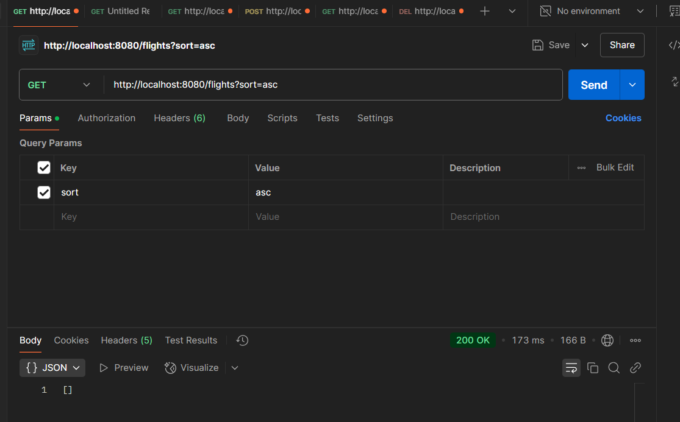

2)**GET /flights/{id}**

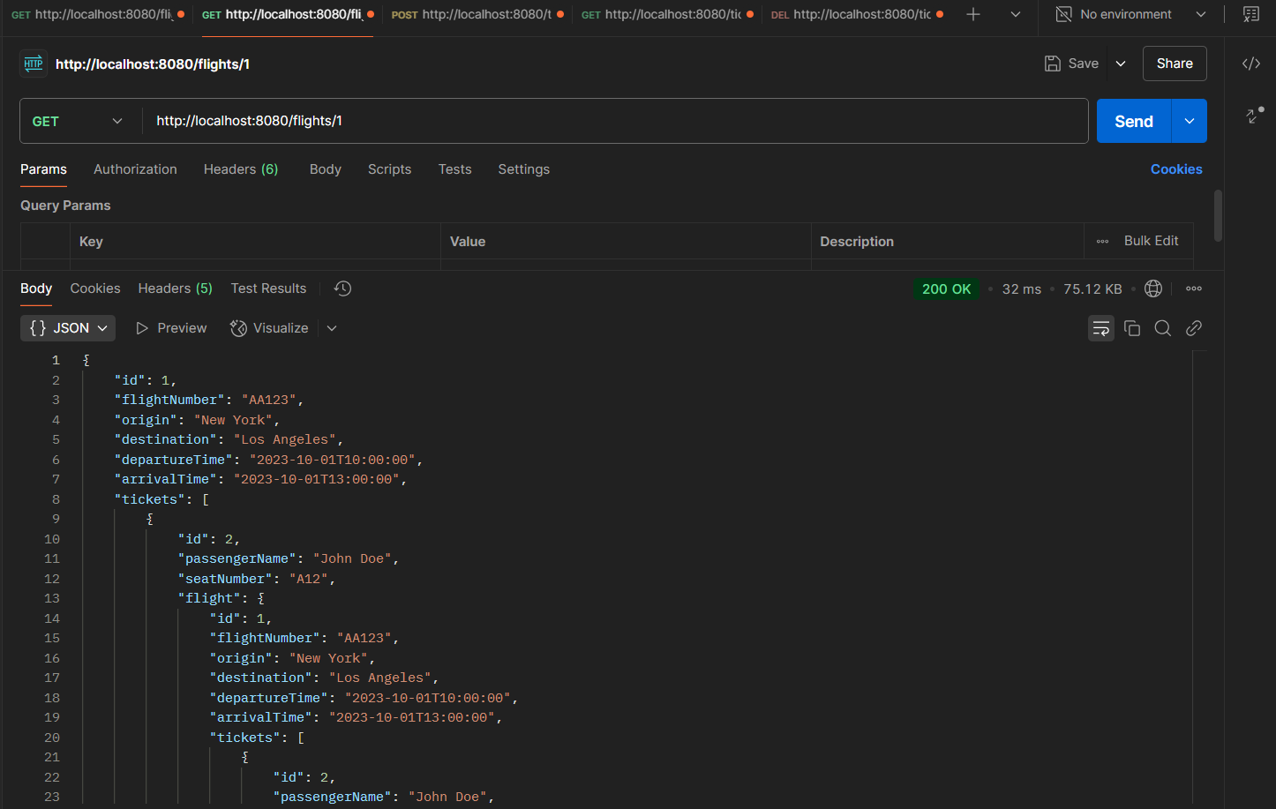

3)**POST /tickets**

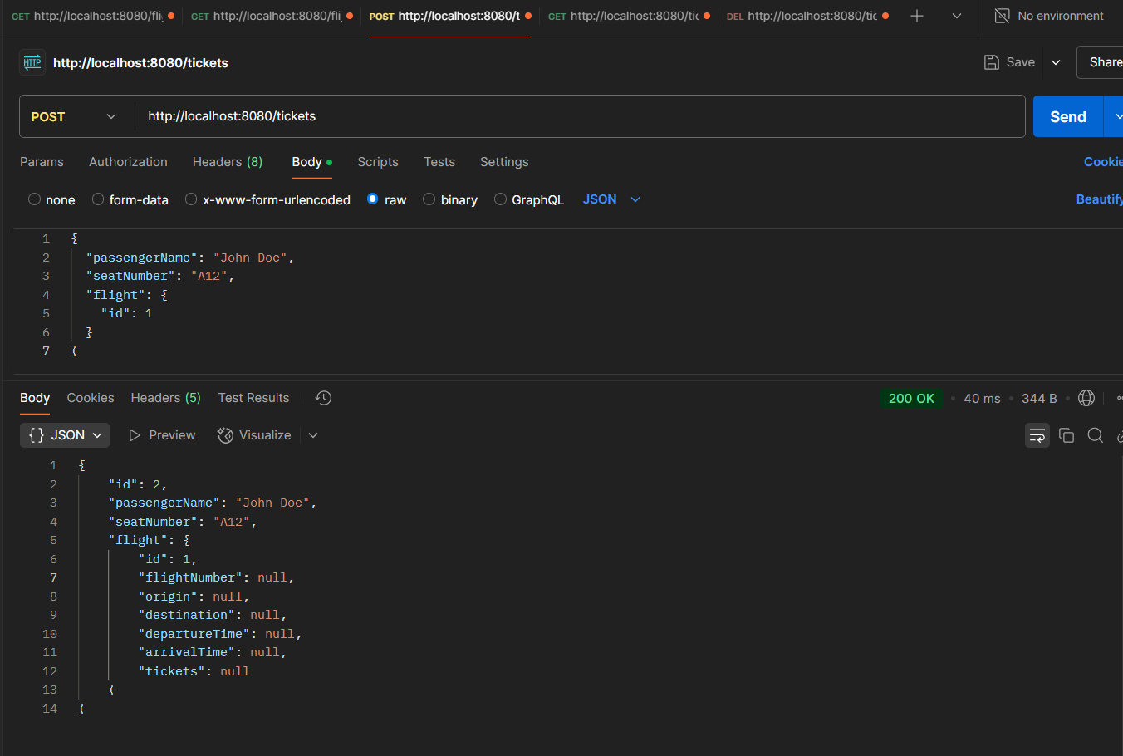

4)**GET /tickets/{id}**

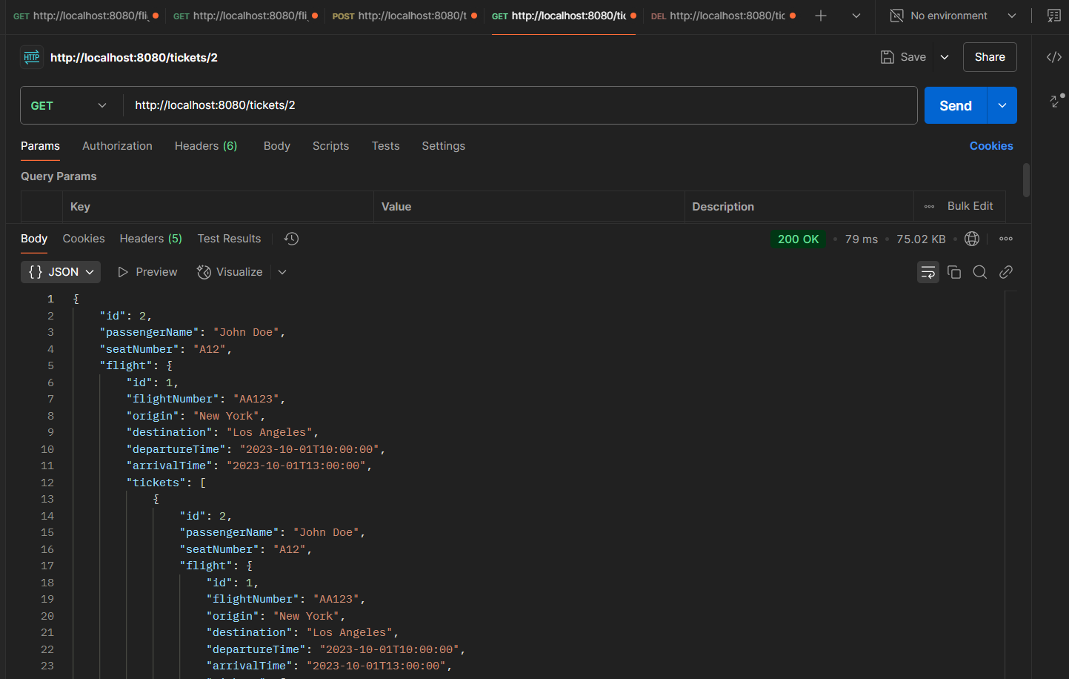

5)**DELETE /tickets/{id}**

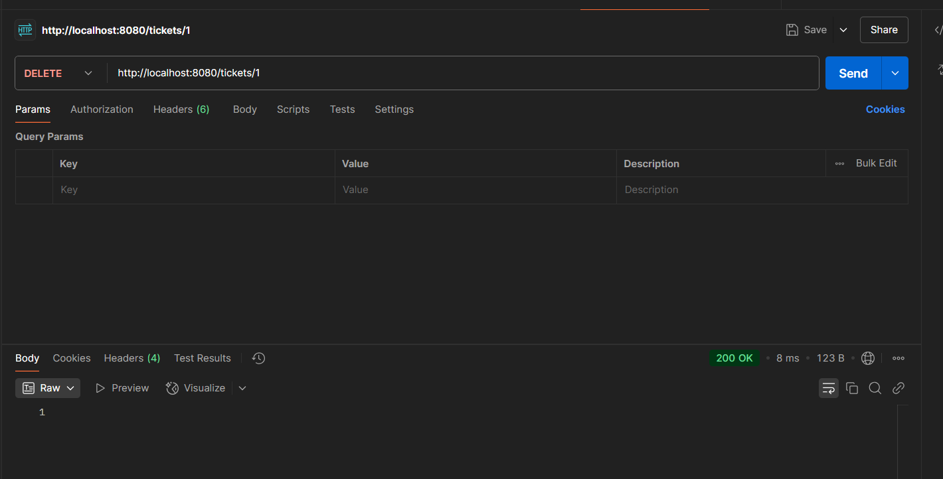

**H2 console**

