Smart Platform System Design
SmartAgriLink: Intelligent Agricultural Market and Farm Monitoring Platform

1. Problem Scenario & Objectives

Problem Scenario
Farmers in many rural areas struggle with market access, real-time crop monitoring, and efficient supply chain management. Agricultural producers often rely on middlemen, resulting in low profit margins and limited direct communication with buyers. Additionally, environmental factors such as soil moisture, temperature, and pest conditions are not monitored in real time, causing crop losses.
To address these issues, this project proposes SmartAgriLink, a Smart Agricultural Platform that integrates IoT sensors, mobile networking, cloud computing, and e-commerce features to support farmers, buyers, and agricultural administrators.
This system connects farm monitoring, digital marketplace services, and logistics management in a single platform.

Objectives

General Objective
To design a smart agricultural platform system that improves farm productivity, market connectivity, and supply chain transparency using integrated computing, networking, and convergence technologies.

Specific Objectives
- Provide real-time farm monitoring using IoT sensor networks.
- Enable direct e-commerce transactions between farmers and buyers.
- Implement secure data processing and distributed computing systems.
- Integrate mobile and wireless networks for rural connectivity.
- Develop an intuitive user interface with data visualization tools.
- Ensure secure, fault-tolerant, and scalable system architecture.

2. System Architecture & Platform Integration

Conceptual System Architecture
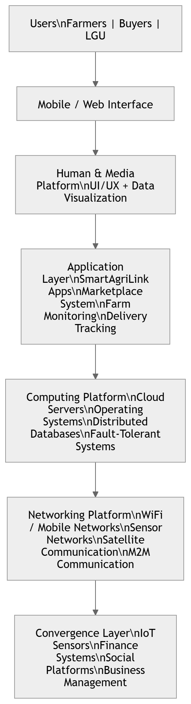

Major System Components

IoT Farm Sensors
- Soil moisture monitoring
- Temperature monitoring
- Humidity monitoring
- Crop health indicators

SmartAgriLink Cloud Server
- Processes and stores all farm and transaction data

Marketplace Module
- Farmers list products
- Set prices
- Accept orders from buyers

Delivery & Logistics Module
- Tracks shipments
- Coordinates transportation

Data Visualization Dashboard
- Crop health analytics
- Market demand analysis
- Price trend visualization

3. Platform Design Explanation

3.1 Computing Platform
The system uses cloud computing and distributed systems to process large agricultural datasets. Cloud servers provide scalable storage and computing power while distributed databases manage farm and transaction data efficiently. Embedded computing devices operate inside IoT sensors to collect environmental information. Fault-tolerant processing, load balancing, and parallel data processing are implemented to ensure reliability.

3.2 Networking Platform
SmartAgriLink uses multiple networking technologies including WiFi, 4G/5G mobile networks, and low‑power sensor networks. These networks allow IoT sensors to transmit agricultural data to cloud servers. Satellite communication can be used for remote farming locations. Machine-to-Machine (M2M) communication allows devices to exchange information automatically.

3.3 Human & Media Platform
The system provides a user-friendly mobile and web interface with interactive dashboards, crop health visualization, multimedia tutorials, and real-time notifications. Charts, maps, and video guides help farmers understand agricultural data. Optional augmented reality (AR) features can simulate crop growth and provide training.

3.4 Convergence Platform
SmartAgriLink integrates multiple platforms including IoT systems, business management tools, financial payment systems, and social network services. Farmers can manage inventories, track sales, receive digital payments, and communicate with buyers.

4. Security & Privacy Plan

Potential Risks
- Unauthorized system access
- Data interception during transmission
- IoT device hacking
- Personal data exposure
- Financial fraud

Security Mechanisms
- Secure Linux-based operating systems with access control
- TLS/SSL encryption for secure communication
- Multi-factor authentication for users
- Unique device IDs and secure firmware updates for IoT devices
- Firewalls and intrusion detection systems

5. User Experience & Interaction
SmartAgriLink prioritizes usability and accessibility. The interface includes simple mobile dashboards, color-coded crop indicators, and voice assistance features to support farmers with limited technical knowledge.

6. Implementation Considerations
- Scalable cloud infrastructure to support thousands of farms
- Fault-tolerant systems with data replication and backup servers
- Real-time IoT monitoring and alerts
- Big data analytics using machine learning and predictive models

7. Mathematical / Logical Proof of System Correctness
One critical operation is order matching between buyers and farmers.
Logical Rule:
If (Inventory ≥ OrderQuantity)
OrderStatus = Confirmed
Else
OrderStatus = Rejected

8. References
- Tanenbaum, A. S., & Bos, H. Modern Operating Systems.
- Stallings, W. Computer Networking: Principles and Practice.
- Coulouris, G. Distributed Systems: Concepts and Design.
- Cisco Networking Academy Resources.
- IoT Architecture and Smart Agriculture Research Papers.

