RESEARCH SUPPORT SERVICES AND MONITORING SYSTEM
FOR SAINT MICHAEL COLLEGE OF CARAGA

A Thesis Presented To
The faculty of
College of Computing and Information Sciences

In Partial Requirements for the Degree
BATCHELOR OF SCIENCE AND INFORMATION TECHNOLOGY


By

HONEY FE W. CABATINGAN
JOSHUA J. ALMODIEL
IAN V. MAISOG
JOY CLISTER D. MENDOZA
ASHLEY R. PALISAN

ADVISER: LEALIL I. PALACIO
MARCH 2026

ACKNOWLEDGEMENT

The researchers would like to express their heartfelt gratitude to all the individuals who contributed to the success of this study, entitled “Research Support Services and Monitoring System for Saint Michael College of Caraga.”
First and foremost, our sincere appreciation goes to Mrs. Lealil I. Palacio, MSIT (CAR), our research adviser, for her valuable guidance, encouragement, and continuous support throughout the development of this study. Her expertise and patience have been a great help to us in completing this research.
The researcher would also like to extend our deepest thanks to our system beneficiary, Mr. Kenneth Ian Barrera, for his cooperation, valuable insights, and feedback that greatly contributed to the improvement of our system.
Special thanks are also given to the Learning Resource Center of Saint Michael College of Caraga for conducting research seminars that provided us with essential knowledge and guidance in completing this study.
Lastly, we are truly grateful to our families, friends, and classmates for their unending support, understanding, and motivation. Above all, we give thanks to Almighty God for the wisdom, strength, and perseverance that made this research possible.

With sincere gratitude,

HONEY FE W. CABATINGAN
JOSHUA J. ALMODIEL
IAN V. MAISOG
JOY CLISTER D. MENDOZA
ASHLEY R. PALISAN

TABLE OF CONTENTS
 |  |  | Pages
 | TITLE PAGE |  | i
 | CERTIFICATE OF RESEARCH APPROVAL |  | ii
 | ABSTRACT |  | iii
 | ACKNOWLEDGEMENT |  | iv
 | TABLE OF CONTENTS |  | v
 | LIST OF TABLES |  | vi
 | LIST OF FIGURES |  | vii
 | CHAPTER
 | 1 | INTRODUCTION | 1
 |  | 1.1 Project Context | 2
 |  | 1.2 Literature Review | 2
 |  | 1.3 Objective of the Study | 9
 |  | 1.4 Scope and Limitations | 10
 |  | 1.5 Definition of Terms | 11
 | 2 | METHODOLOGY | 13
 |  | 2.1 Research Design | 13
 |  | 2.2 Software Development Life Cycle | 13
 |  | 2.3 System Architecture | 14
 |  | 2.4 Conceptual Diagram | 16
 |  | 2.5 Use-Case Diagram | 17
 |  | 2.6 Activity Diagram | 19
 |  | 2.7 Sequence Diagram (Prototype) | 32
 |  | 2.8 Entity-Relationship Diagram (Database Design) | 42
 |  | 2.9 User Interface Design (Prototype) | 44
 |  | 3.0 Software Platforms, Development Environments and Tools | 75
 |  | 3.1 Hardware Requirements | 80
 | 3 | RESULT AND DISCUSSION
 |  | 4.1 Development Process
 |  | 4.2 Testing Process
- Accuracy Test
- Functionality Test
- Performance Test

4 | SUMMARY, CONCLUSIONS AND RECOMMENDATIONS
 | 5.1 Summary of Findings
 | 5.2 Conclusion
 | 5.3 Recommendations
ETHICALSTANDAR |  | 85
REFERENCES |  | 91
CURRICULUM VITAE |  | 95

LIST OF TABLES
Table |  | Pages
1 | Software Platforms, Development Environments, and Tools | 75
2 | Hardware Requirements | 80
3 | Functional Suitability | 83
4 | Performance Efficiency | 83
5 | Usability | 83
6 | AI/ML Evaluation Metrics | 79

LIST OF FIGURES
Figure |  | Pages
1 | Agile Methodology | 14
2 | System Architecture | 15
3 | Conceptual Framework | 16
4 | Use Case Diagram | 18
5 | Activity Diagram – Students | 20
6 | Activity Diagram – Human Grammarian | 21
7 | Activity Diagram – Grammarian & Ai Checking | 22
8 | Activity Diagram – Librarian | 24
9 | Activity Diagram – Statistician | 25
10 | Activity Diagram – Ethics (REC) | 27
11 | Activity Diagram – Admin | 28
12 | Sequence Diagram – Students | 32
13 | Sequence Diagram – Human Grammarian | 32
14 | Sequence Diagram – Grammarian & Ai Checking | 33
15 | Sequence Diagram – Librarian | 35
16 | Sequence Diagram – Statistician | 36
17 | Sequence Diagram – Ethics (REC) | 37
18 | Sequence Diagram – Admin | 39
19 | Entity-Relationship Diagram (Database Design) | 43
20 | Log in form – Student | 44
21 | Student Select Ethics Research Service and Upload Submission | 44
22 | Student Submission Approved in Ethics Service | 45
23 | Student Submission View Reports in Ethics Service | 46
24 | Students Communication to Research Services Personnel | 46
25 | Student Select Grammarly & AI Checking Research Service | 47
26 | Student Transaction Receipt List in Grammarly & AI Checking Service | 48
27 | Student Uploading Receipt for Grammarly & AI Checking Service | 49
28 | Student New Submission in Grammarly & AI Checking Service | 50
29 | Student Submission Approved in Grammarly & AI Checking Service | 51
30 | Student View Approved Result in Grammarly & AI Checking | 52
31 | Students Provide Rate and Feedback | 53
32 | Students View Certificate and Score | 54
33 | Student Registration | 55
34 | Personnel Registration | 56
35 | Grammarly & AI Checking Service Login | 57
36 | Grammarly & AI Checking Service Main Page | 57
37 | Grammarly & AI Checking Service Proceed to Student Submission | 58
38  39  40  40  41  42  43  44  45  46  47  48  49  50  51  52  53  54  55  56  57  58  59  60 | Grammarly & AI Checking Service Student Profile  Grammarly & AI Checking Services Communication  Grammarly & AI Checking Service Rating and Feedback Evaluation of Students  Grammarly & AI Checking Services of all Students  Statistician Service Rating Login Page  Statistician Service Rating Login Page  Statistician Service Student Profile  Statistician Service Proceed to Student Submission  Statistician Service Adding Comments  Statistician Service Communication  Admin Login  Admin Manage Student Accounts  Admin Manage Personnel Accounts  Admin Manage Department and Courses  Admin Manage Department and Courses Selecting Service  Admin Manage Department and Courses Assigning Personnel  Admin Manage Research Service in Ethics  Admin Manage Research Service in Grammarly & AI Checking  Admin Monitor Rating and Feedback  Admin Edit the Rubric Criteria  Admin Monitor Uploaded File of Students  Admin Manage Transaction  Admin View Student Details | 59  59  60  60  61  62  62  63  63  64  64  65  66  66  67  67  68  68  69  70  71  72  73  74

CHAPTER 1
INTRODUCTION
1.1 Project Context
Saint Michael College of Caraga is constantly working to improve the research level by improving services for faculty and student researchers. Some of the things that research aid does now, like checking for grammar mistakes, doing statistical analysis, finding plagiarism, and doing an ethical review, are still done by hand and one by one by each staff member. A system that is so disjointed causes delays, bad communication, and students, advisors, and study staff who do not work together.
With the rise of modern technology and the increasing need for more efficient research processes, many institutions already use digital platforms to support management and academic services. Studies have shown that using research support systems helps improve coordination, documentation, and service delivery in educational institutions [1]. Despite this, SMCC continues to face challenges in maintaining an orderly, centralized process, as most research transactions rely on manual methods.
Researchers developed the Research Support Services and Monitoring System (RSSMS) to solve these issues. It is a centralized web-based tool that automates and streamlines research support tasks. Students can send papers and requests directly to specific staff members, like advisers, human grammarians, statisticians, librarians, and ethics officers. The Administrator (Research Director) oversees all transactions and is present at all stages, from submission to review permission and certification [2].
RSSMS empowers everyone involved in the study to collaborate more quickly and clearly. By using this system, researchers can eliminate the need for paper routings, and they will record and track all submissions, notes, and approvals in real time [3]. We make people more accountable, reduce process time, and improve the general management of research services at the institution by using integrated features like monitoring, communication [4], and notification systems [4, [5].
Further, implementing RSSMS will make research processes more efficient and encourage students and faculty to be more involved. Streamlining the work and putting in place real-time tracking will cut down on mistakes made by people, speed up feedback to advisors, and make it easier for researchers and support staff to work together. These changes will help SMCC keep up its standards for openness, timeliness, and digital transformation in research management. The project's goal is to create a digital space that works well and is trustworthy, which will support SMCC's dedication to academic success and research integrity [6].
1.2 Literature Review
The Research Support Services and Monitoring System (RSSMS) draws on theoretical and practical foundations from studies and literature presented in this chapter. The research examines five main topics: digital research support, evolution and web-based monitoring systems, and institutional requirements for centralized solutions, real-time transparency.

The Evolution of Research Support: From Traditional Services to Integrated Digital Ecosystems

Academic institutions now use digital ecosystems that integrate physical models to support students and researchers innovatively. The data show that the pandemic taught universities how to keep their study going by sending e-books, e-journals, and digital references [7]. The study showed that the move to digital was successful. However, it also showed two main problems: insufficient digital infrastructure and students who did not fully use digital tools. To meet the identified needs, the suggested solution includes features for automated monitoring, analytics, and user support. The Research Support Services and Monitoring System for Saint Michael College of Caraga (RSSMS)
needs high-tech tools.
As a necessary step forward, academic institutions have adopted ICT-based research support [8] tools [8]. Technology such as plagiarism detectors, citation and reference managers, and Research Data Management (RDM) programs assists researchers in conducting academic research. Technology integration has changed academic support from reactive service delivery to intelligent, automatic, and proactive systems. With RSSMS's development, it is necessary to use automated tracking systems and AI-based tools to improve research operations and keep up with compliance standards and service coordination a cross department.
Two important factors drive research support for successful change: institutions that embrace readiness and individuals with the skills to use technology effectively. The study in [9] showed that institutions must create digital literacy policies and build strong partnerships with technology companies to achieve long-lasting research management innovation. The framework lets RSSMS become a model for institutional readiness because it helps researchers learn how to use technology well, has a smooth research workflow, and has a method for managing feedback and documents.
The hybrid research support model was developed by [10]. Integrates virtual and physical contact to create an environment that boosts research efficiency while making resources more accessible. The model demonstrates how researchers can benefit from automated tools while receiving individualized guidance through human interaction. The hybrid approach of RSSMS enables researchers to benefit from digital transaction management while preserving essential opportunities for academic collaboration between students and faculty members.
According to studies, the research ecosystem has transitioned from separate systems to unified technology-based systems [11]. The Research Support Services and Monitoring System for Saint Michael College of Caraga (RSSMS) will achieve digital research management unification and accessibility improvements, enhanced monitoring, and adaptive environment development through these established principles.

Web-Based Systems for Academic Monitoring and Management

Academic institutions now use web-based systems to monitor and control their operations through digital platforms. The Online Faculty Monitoring and Evaluation System developed in [12] by a nearby Philippine college showed how digital platforms improve operational efficiency, data accuracy, and transparency [13]. Despite this, SMCC faces challenges in maintaining an orderly, centralized process because most researchers continue to conduct transactions manually.
To address these problems, researchers developed the Research Support Service, which included a Web-Based Attendance Monitoring System that used open-source web technologies to improve accessibility and reduce manual recording errors. Although the primary function was attendance checking, its technical architecture, including centralized databases and real-time tracking, offers valuable insights for designing the RSSMS. Researchers can modify these web-based systems to support ongoing monitoring of research activities, automate submissions, and produce reports for institutional use. This strategy ensures a more organized and trustworthy digital monitoring procedure that aligns with academic management requirements.
From a more thorough theoretical perspective, [14] discussed Management Information Systems (MIS) and their potential to improve institutional efficiency, data consistency, and decision-making, one way to conceptualize the Romero [15]. The Mendoza system is a web-based, specialized MIS created for specific academic objectives. The same is true of RSSMS, which streamlines research documentation and student-research adviser communication by combining monitoring and support services into a single platform.
Furthermore, [16] underlined that achieving quantifiable operational efficiency across institutional processes is the aim of deploying such MIS solutions. The design goals of RSSMS align with the functional and architectural foundations of earlier studies, aiming to centralize and modernize research workflows through automation and digital integration.

Institutional Challenges and the Need for Centralized Support Systems

The continuous academic and institutional difficulties that students and Higher Education Institutions (HEIs) face underscore the necessity for centralized digital support platforms. Research in [17] shows that financial, administrative, and overall academic stress significantly affect students' performance and general well-being. By offering a centralized research support structure that reduces administrative burdens and improves accessibility to institutional resources, the Research Support Services and Monitoring System for Saint Michael College of Caraga (RSSMS) helps achieve this goal and encourages student success and retention.
User acceptance and perception are critical to effectively implementing centralized platforms in educational institutions. [18] asserts that perceived utility and usability significantly impact the efficacy of academic e-governance systems. This realization is crucial for the design of RSSMS, as responsive features and user-friendly interfaces will encourage faculty and student involvement. By incorporating these usability guidelines into RSSMS, the system ensures that users will actively participate and trust it. While also automating research procedures.
From an institutional standpoint, HEIs are under increasing pressure to maintain their adaptability and resilience amid budgetary constraints and technological demands. Adopting efficient, automated systems that can adapt to rapid institutional changes is necessary for organizational resilience, as discussed in [19]. Using this framework, RSSMS is a tool that improves operational efficiency in research management by centralizing monitoring, tracking, and service coordination. This kind of integration encourages flexibility and institutional preparedness for changing academic demands.
Additionally, [20] underlined that a key factor influencing students' adoption of academic technologies is their impression of institutional support. Students' engagement and success rates skyrocket when they feel their school is trying to provide organized, easily accessible learning resources. RSSMS created a unified digital research platform to show institutional dedication to assisting research activities through easily accessible services, methodical monitoring, and open lines of communication. RSSMS created a unified digital research platform to show institutional dedication to assisting research activities through easily accessible services, methodical monitoring, and open lines of communication.

The Role of System Transparency and Real-Time Status Tracking

Modern academic and administrative information systems must provide transparency and real-time tracking, impacting user satisfaction, accountability, and productivity. Real-time progress visualization and dashboard designs are crucial for inspiring students, especially in capstone and research projects, according to studies in [21]. Throughout the research process, these interactive dashboards encourage self-regulation and engagement by giving users a clear sense of progress and task completion. Systems like the Research Support Services and Monitoring System (RSSMS) at Saint Michael College of Caraga, which can track across multiple RSSs to boost productivity and user awareness, need to include these real-time monitoring tools.
As shown in [22], offering instant updates and clear communication channels increases user compliance and reduces redundant queries. The findings show how well-defined tracking indicators and automated alerts improve student conduct and punctuality. By adding these features to RSSMS, faculty and students can track the status of research-related requests in real time, including statistical analysis, ethics review, and grammar checking. This approach promotes easier departmental coordination and accountability.
Additionally, research in [23] highlights that transparency is not only a technical feature but also a psychological necessity in academic settings. Transparent systems reduce uncertainty, foster institutional trust, and ease student anxiety during key academic processes such as approval tracking and research proposal reviews. By giving users real-time updates on the status of their submissions (such as "Pending", "Approved," or "Rejected"), RSSMS operationalizes this principle of transparency and ensures that students remain informed and confident throughout the process.
Research in [24] supports these findings by highlighting the importance of user experience (UX) design in preserving system efficacy and clarity. Clear progress indicators, visual cues, and an intuitive user interface are essential to any successful academic service platform. By implementing these UX principles, RSSMS users can easily interpret system feedback, quickly understand their research progress, and engage in a smooth interaction that meets contemporary academic digital service standards.
Multi-Role Management and Workflow Automation in Academic Systems
Academic systems need workflow automation and multi-role management to address issues arising from manual administrative processes. The research in [25] showed that university operations became more efficient after implementing automated workflow systems, which reduced processing time by 40% by eliminating manual routing and reassignment tasks. The research shows that automation technology boosts institutional performance by simplifying recurring operations, which match the RSSMS's core purpose at Saint Michael College of Caraga. The RSSMS can process research-related requests through automated routing to achieve systematic service transaction handling with minimal delays.
Effective role-based management is crucial for maintaining security, ensuring structured task distribution in educational systems, and streamlining workflows. Research in [14] emphasized the importance of Role-Based Access Control (RBAC) in platform design to prevent unwanted access to sensitive academic data and to support logical workflow progression. Applying this principle to the RSSMS ensures that research requests are automatically directed to the right people only—for example, a request marked as "For Statistical Review" would be visible only to the statistician—protecting operational integrity and confidentiality.
The research by [26] examined RBAC deployment methods in Philippine universities to demonstrate that the level of detail required in access management systems must be for academic organizations with complex organizational structures. The research findings align with RSSMS's organizational needs, as it operates with research coordinators, grammarians, and ethics reviewers. Implementing RBAC principles at the local level enables staff members to work within established boundaries that support efficient teamwork across departments.
To support these conclusions, [19] examined automated document routing systems and verified that automated role-based assignment is the most reliable and effective method for handling intricate, high-volume processes that call for advice from several specialists. Research service requests can proceed seamlessly from submission to final review without the need for human oversight by integrating this model into the RSSMS framework. This automation strengthens accountability, reduces administrative bottlenecks, and improves service reliability across all research-related transactions.
1.3 Objective of the Study
The study is to create and deploy the Research Support Services and Monitoring System (RSSMS) to enhance research service management at SMCC by providing an organized, transparent, and efficient workflow for assigning, processing, monitoring, and documenting research-related services.
Specifically, it aims:
- To develop a web-based system that automates the student’s submission and checking process for research support documents, specifically for Grammarly & AI Checking, Human Grammarian, Statistical, Ethical submission, and References validation.
- To design and implement a monitoring system for tracking the progress and status of research support document validation.
- To providing automated notifications and reminders for students and validators regarding submission deadlines, pending reviews, and approval status.
- To evaluate the systems functionality, efficiency, and usability, and efficiency through ISO/IEC 25010 standards to ensure its effectiveness in addressing the identified problems.
1.4 Scope and Limitations
The Research Support Services and Monitoring System (RSSMS) is a digital platform enabling Saint Michael College of Caraga (SMCC) to automate research transactions through an efficient management system. The system replaces the disorganized research proposal, request handling, monitoring activities, and documentation processes. The system integrates all research processes into a single platform, enabling students, advisers, and research personnel to communicate through a single interface while tracking real-time activities.
The system operates as a restricted platform that grants access to official research participants, including students and their faculty advisers, and research staff members, including the librarian, statistician, human grammarian, and ethics reviewer. The Research Director or authorized research staff member holds the single superuser account, which grants them complete system administrative control. The administrator performs all user account management tasks, assigns personnel to research projects, and tracks progress and reviews submissions to create statistical reports for institutional use. The system enables administrators to perform user management tasks and staff assignments, track research progress, and create reports. The system enables administrators to track user activities through its notification system, which provides immediate process updates and maintains complete transaction transparency.
The system enables students and faculty researchers to access their personal accounts for document uploading and service requests, including grammar, plagiarism checks, library resource access, and real-time submission tracking. The system sends student requests and documents to their designated personnel after they complete the submission process. The system enables personnel to review submissions and provide feedback before approving or rejecting them in accordance with institutional research guidelines.
All administrative functions are restricted to the superuser or administrator, while end-users are limited to project-related activities and assigned transactions. The system also supports anonymous communication between students and personnel, enabling private clarification and feedback within the platform
The RSSMS operates within the institution's network and internal database, ensuring all processes and data remain secure and confined within SMCC. It addresses the institution's internal research management requirements, focusing on document submission, transaction tracking, progress monitoring, and communication.
The RSSMS does not connect to external research publication platforms or academic repositories. All research data, files, and communications are stored securely in the institutional database and are accessible only by authorized personnel. Through this scope, the RSSMS ensures a controlled, confidential, and efficient environment that supports the end-to-end management of research services at Saint Michael College of Caraga.
1.5. Definition of Terms
RSSMS authentication — ensures that users are who they say they are by checking their login information. Using RSSMS features keeps users safe.
Database — A structured set of data that saves all the information about a system, like user accounts, submissions, feedback, receipt, and messages between students and
staff. SQL (MYSQL) is usually used to handle databases.
Higher Education Institutions — want to help students get degrees, strive for greatness, and reach their full potential.
Role - Based Access Control — is a type of security that limits system access based on the job role of a user within a company rather than the user themselves.
Research Support Services and Monitoring System (RSSMS) — is a web-based tool that makes it easier for students to submit, review, and monitor their research results. It lets students talk to each other and gives jobs to human grammarians, statisticians, librarians, ethics officers, and Grammarly & AI Checking services.
Research Data Management (RDM) - An organized or integrated system/practice for controlling, preserving and using research data over its lifecycle that enables data to be used regardless of the times and lengths of its production.
Digital Ecosystem - A connected digital environment consisting of digital tools and platforms which are used for academic work, research, communication and data management. It integrates physical and digital models for total support services.
Information and Communication Technology (ICT)-Based Systems - Are those systems that use technological infrastructure (i.e., software, networks, and digital platforms) to facilitate management, monitoring and provision of institutional services in general, predominantly research.

CHAPTER 2
METHODOLOGY
2.1 Research Design
The Research Support Services and Monitoring System (RSSMS) for Saint Michael College of Caraga uses the Design and Development Research (DDR) method. This approach allows the creation of new systems that address the real needs of institutions. The system manages student submissions, administrative tasks, and employee evaluations before providing final approvals and certifications. As a comprehensive research support automation platform, RSSMS underwent multiple rounds of design refinement based on stakeholder feedback. This process ensured optimal performance, a user-friendly interface, and compliance with institutional research management standards.

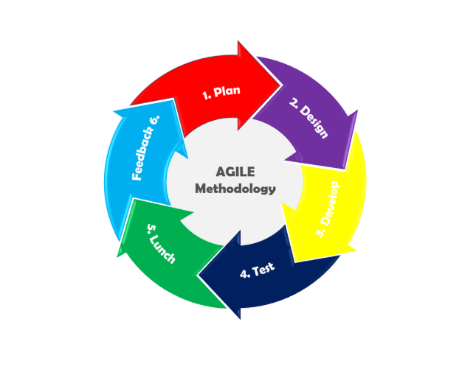
2.2 Software Development Life Cycle
Figure 1. Agile Methodology
Figure 1 shows the Agile Software Development Life Cycle, which is made possible by the Research Support Services and Monitoring System (RSSMS) development method. Because it allows for flexible development, ongoing stakeholder involvement, and small steps forward, the agile development method is perfect for bringing students, administrators, and research staff together in real time.
The RSSMS development process used several sprints to make modules that worked, beginning with student submission and continuing with administrative routing, personnel review, feedback notification, and certification issuance. During planning sessions at the start of each sprint for research operations at the school, the Research Office worked with librarians, statisticians, and student representatives to ensure system features were correct. After each sprint, the researchers kept trying the system to improve how the platform and interface worked while keeping user and institutional needs in mind.
2.3 System Architecture
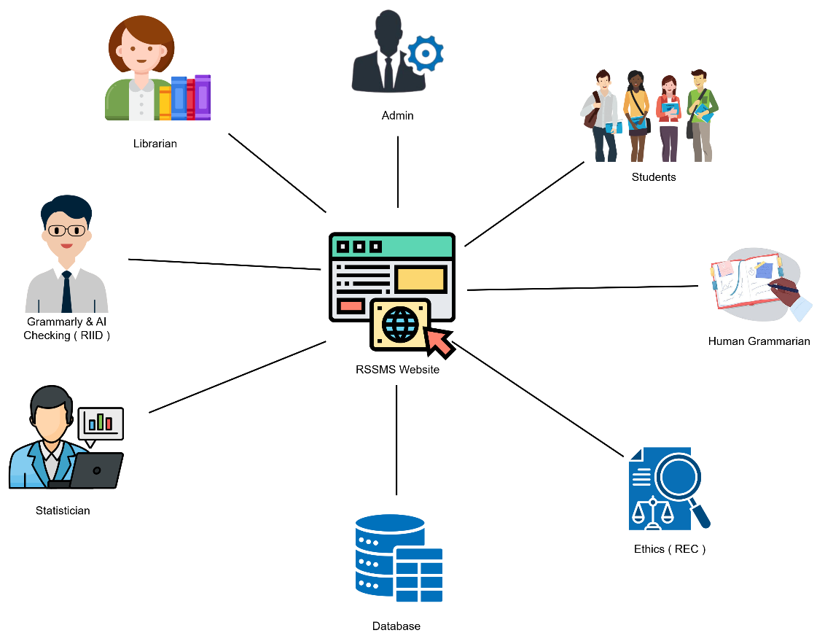

Figure 2. System Architecture
As illustrated in Figure 2, the Research Support Services and Monitoring System (RSSMS) utilizes a centralized, web-based client-server architecture. This model connects all system stakeholders—Students, Administrators, Librarians, Human Grammarians, Statisticians, Grammar & AI Checkers, and Ethics (REC) Reviewers—through a unified web portal accessible via the Internet.
The architecture is divided into distinct operational tiers. The Application Tier (represented by the central web interface) serves as the primary hub for all user interactions. It handles user authentication, executes automated task routing, and manages the communication interface. Administrators utilize this tier to manage user accounts and monitor institutional transactions, while designated academic personnel use it to retrieve assigned student submissions, input evaluation results, and issue clearances.
Underlying the application is the Data Tier, consisting of a centralized relational database. This component is responsible for the secure storage, retrieval, and management of all system data. It systematically archives user profiles, uploaded research manuscripts, assessment feedback, system logs, payment receipts, and generated certificates. The direct, secure connection between the web portal and the database ensures data integrity, enables real-time status tracking, and maintains a transparent audit trail of all operations.
Furthermore, the system architecture dictates specific conditional workflows for financial transactions. For the Grammarly & AI Checking service, the system enforces a pre-payment protocol; students must successfully upload payment receipts (e.g., via GCash) before the web application routes their documents for evaluation. Conversely, services involving the Statistician, Librarian, Human Grammarian, and Ethics Reviewer follow a post-approval payment model. In these workflows, the architecture permits initial document submission without payment, prompting financial settlement only after the respective personnel have verified and approved the submission. This logic ensures that students are only billed for completed and validated services.

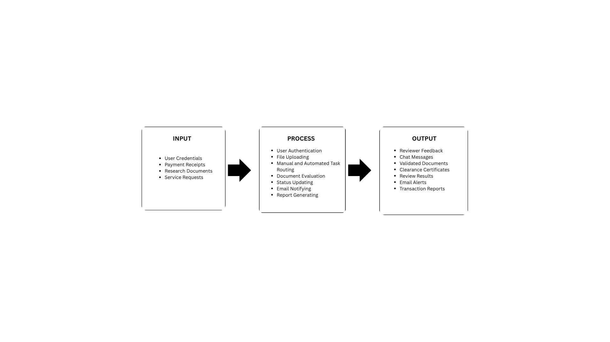
2.4 Conceptual Framework
Figure 3. Conceptual Framework
It illustrates the Research Support Services and Monitoring System (RSSMS), in the Input phase, the system receives the foundational data required to initiate research services. This includes user credentials for access control, payment receipts for transaction verification, and the core research documents and service requests submitted by students. Additionally, it captures reviewer feedback and chat messages, which facilitate structured communication between students and the assigned research personnel.
The Process phase encompasses the core technical and operational mechanisms of the RSSMS. It begins with user authentication and file uploading, followed by manual and automated task routing, which systematically assigns submitted documents to the appropriate academic personnel (Administrators, Grammarians, Statisticians, Librarians, and Ethics Reviewers). Throughout this phase, the system executes document evaluation, real-time status updating, automated email notifying, and report generating to ensure a highly organized and traceable workflow.
Finally, represents the tangible deliverables generated by the system upon the completion of the review process. These include validated documents, officially issued clearance certificates, detailed review results, and automated email alerts to keep users informed. Furthermore, the system produces comprehensive transaction reports for administrative monitoring. Ultimately, this framework demonstrates how the RSSMS centralizes academic research support, streamlines administrative duties, and ensures accountability across all user roles.

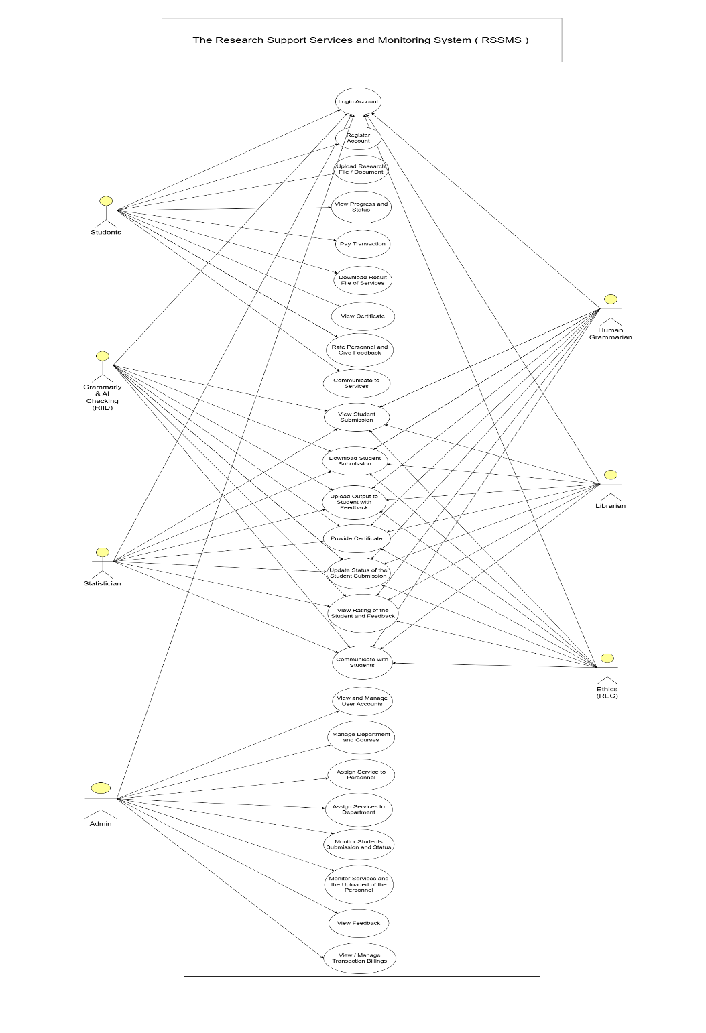
2.5 Use Case Diagram
Figure 4. Use Case Diagram
The operational flow for managing user accounts and services in RSSMS features a visual representation in Figure 5. After logging into RSSMS, the administrator accesses a centralized dashboard to manage various system components. The system allows administrators to create and update user accounts, assign service personnel, designate department personnel, and manage services to ensure appropriate distribution
Explains how the RSSMS interacts with its many users by emphasizing its features and goals. The primary users who choose services, upload research files, monitor progress, communicate with staff, and get results are students. Additionally, students can use the Internet to pay fees, review staff, and download certificates. This collection of use cases guarantees that students can complete their research requirements on a single platform, resulting in an open and effective process from start to finish.
The RSSMS includes several support positions: administrator, statistician, librarian, human grammarian, ethics, and Grammarly & AI. Verifying the staff, each of whom has specific duties. The administrator manages user accounts, service distributions, departments, and transactions for smooth operation. Other staff members examine students' submissions based on their areas of expertise.
Statisticians handle data analysis, librarians check references, human grammarians check language, ethics examines ethical adherence, and automated checking is done by grammar and AI staff using external software. Viewing and downloading submissions, providing feedback, updating status, and awarding certificates constitute the work. This structured interaction ensures accountability, proper workflow division, and consistent support for students' research projects.

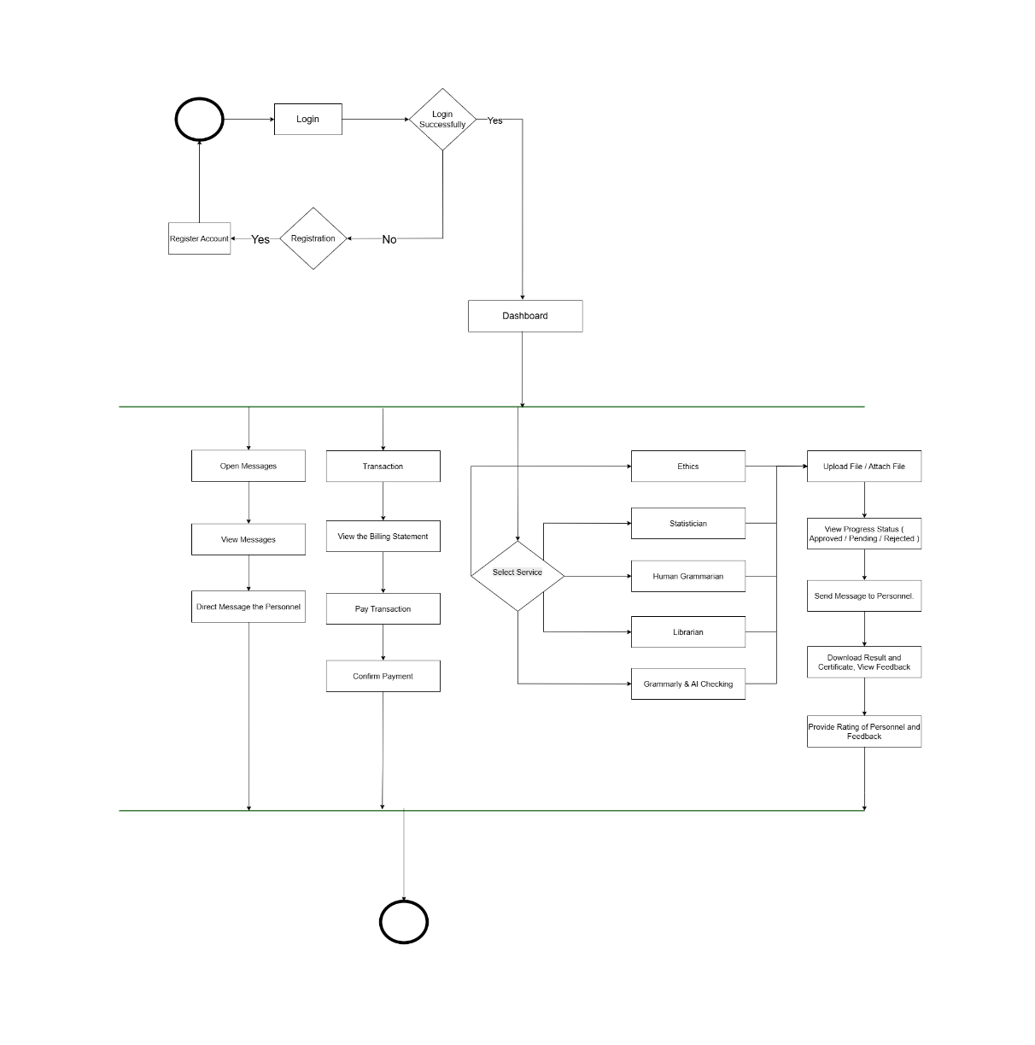
2.4 Activity Diagram

Figure 5. Activity Diagram - Students
Demonstrates the RSSMS system, which begins with student login and then allows service selection between grammar and AI checking, librarian reference, statistical, and ethics reviews, and a human grammar checker for manual grammar reviews. The student chooses the service they need before submitting their research paper to RSSMS for format validation and submission approval.
The RSSMS verifies the document before sending it to the appropriate reviewer for assignment, while students can monitor their submission status in real time through the system. The system maintains an efficient workflow for academic research document processing from submission to review through its structured process.
The student receives access to review feedback, and a reviewed document is downloaded with a completion certificate after the review process finishes. The student can use the system to contact personnel for additional edits or clarification needs. The student reviews the payment details before making an online payment to ensure a smooth transaction. The student can rate personnel and provide feedback before completing the activity flow. The activity diagram enables students to deliver an efficient interactive research assistance system.

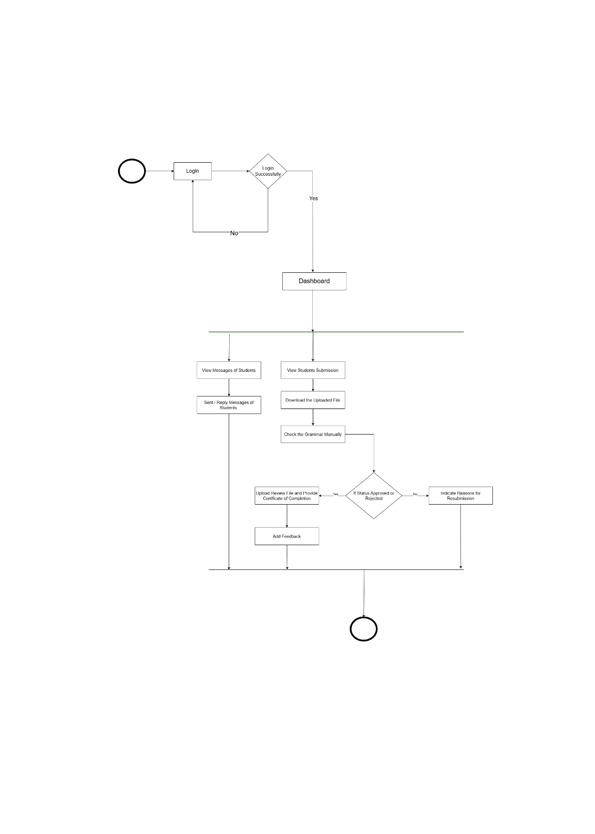
Figure 6 Activity Diagram – Human Grammarian
This figure illustrates the step-by-step manual research paper assessment process, which follows a structured format for designated personnel. The Human Grammarian service process starts when students select their service and then upload their research document before submitting it for review.
The RSSMS sends an instant email notification to designated grammar personnel after students submit their files for review. The grammarian accesses the system through login credentials to download the file for manual evaluation of grammar, language clarity, tone, and overall document coherence. The grammarian reviews the file before issuing a completion certificate or returning it with revision comments to the student.
The system sends the results to students through email notifications. Students can access their approved documents through download, but must resubmit their work after revisions. The messaging system enables students to maintain direct contact with the grammarian throughout their work process. Students assess the service quality through feedback, which personnel review to enhance service delivery and maintain high standards.
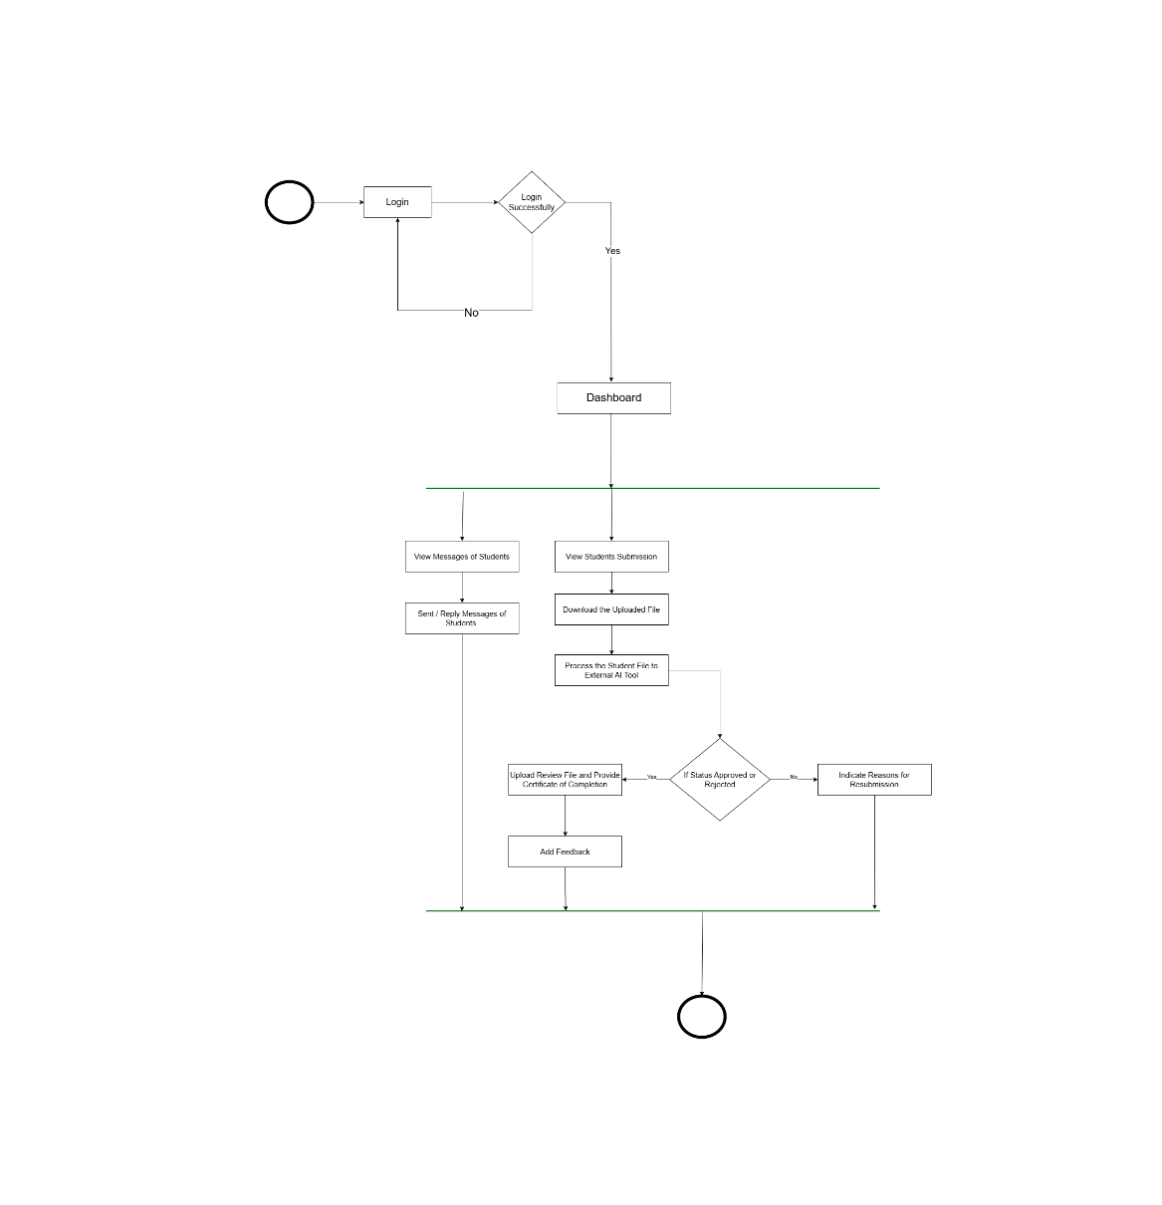
Figure 7. Activity Diagram – Grammarian & Ai Checking
The Diagram shows how email notifications are built into the system, ensuring that students and service personnel receive real-time alerts about submission events. When a file is submitted, the system automatically emails the personnel who can view the submission from their dashboard.
The system routes the file to an AI tool for processing and feedback. After the AI finishes the personnel, approve the submission by attaching or rejecting the certificate, prompting a resubmission. As soon as a status flips, the system sends an email to the student; the message either confirms that the service is complete and the file and certificate are ready for download, or it includes a rejection note outlining the required changes and asking for a resubmission. Staff members can also correspond with students. Reply to their messages. In short, this arrangement delivers an efficient real-time notification pipeline that enhances the user experience and keeps all parties informed and actively engaged throughout the transaction.
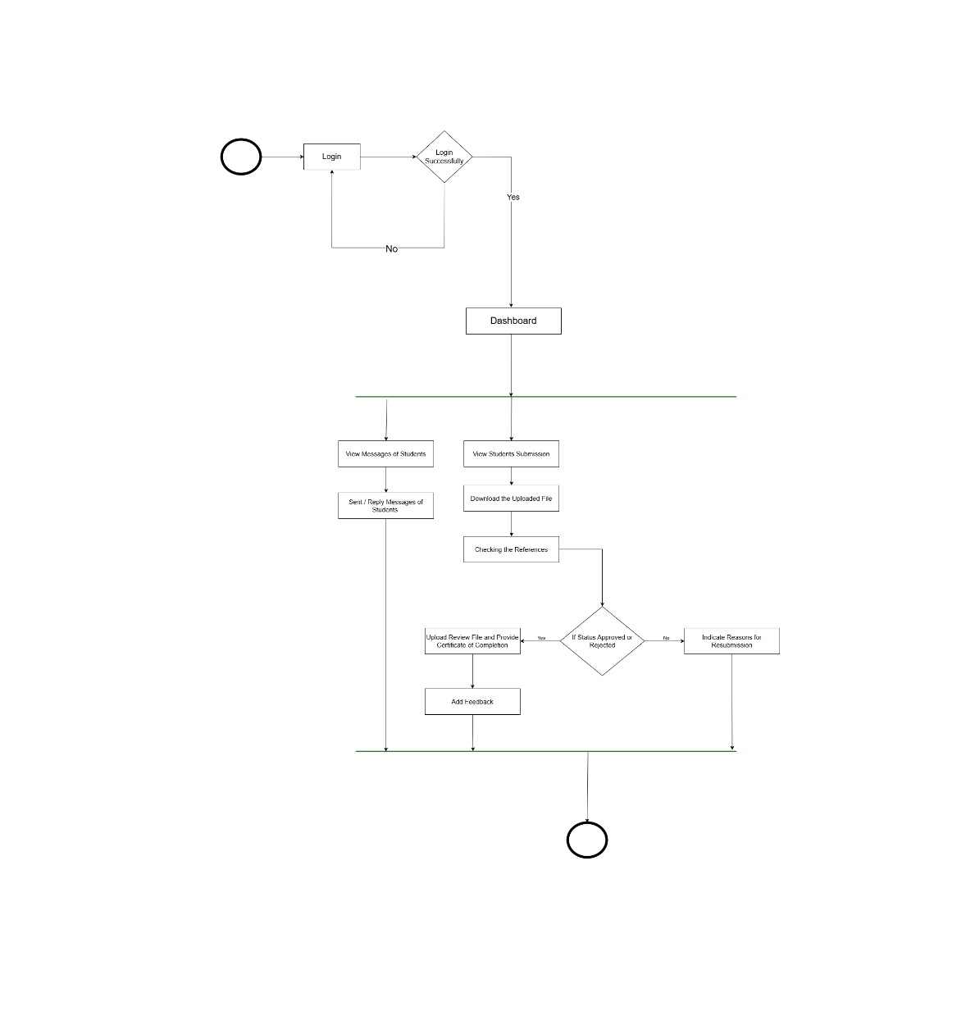

Figure 8. Activity Diagram – Librarian
The RSSMS includes a diagram in Figure 8 that shows the structured process for handling student research papers during reference verification and checking. The RSSMS accepts research papers from students who select a librarian service, store the documents, and send an email notification to their chosen librarian.
The librarian accesses RSSMS to check pending submissions and download the documents after logging in. The checking process involves verifying that citations match the correct sources and references follow the required formatting and citation style guidelines. The system verifies that the research paper meets the institution's academic referencing standards. The librarian completes the evaluation process by uploading a completed version of the submission, including a certificate of completion, or by rejecting it with feedback for another attempt.
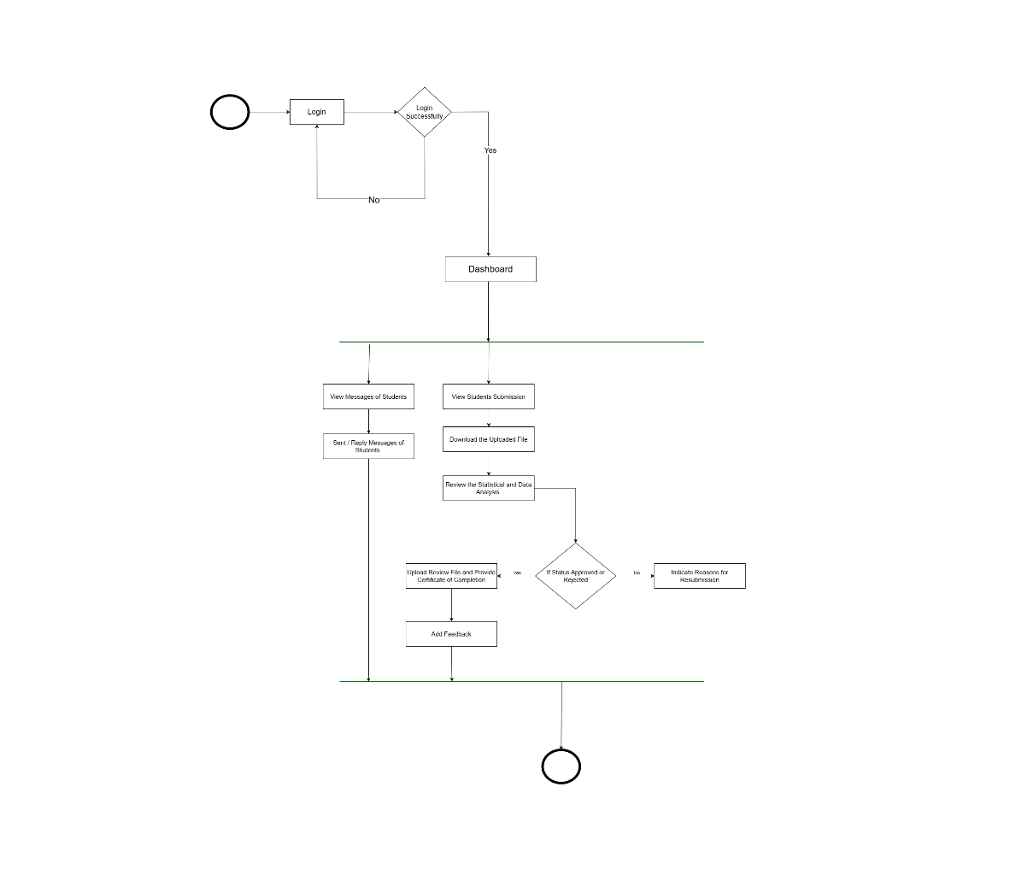
The RSSMS sends email notifications about submission results to students who can take the necessary steps. Students can contact librarians directly for clarification to maintain smooth coordination during the review process. Students provide their assessment of the service through ratings and feedback, which librarians can access to improve service quality. The system maintains complete transparency and accuracy and ensures accountability through its structured academic reference and citation management workflow.
Figure 9. Activity Diagram – Statistician
The RSSMS diagram outlines the steps in processing student research submissions for statistical analysis and verification. After students choose their statistician service and upload their research, the system notifies the assigned statistician via email, ensuring document security. Before downloading the available documents, the statistician logs into the system using their credentials to process any pending submissions.
Three steps make up the review process: evaluating the completeness of the data, validating statistical techniques, verifying statistical conclusions, and providing readability explanations. The review process ensures both methodological soundness and reasonable research outcomes. After reviewing the file, the statistician either rejects it with comments and revision instructions or approves it for final review and upload of statistical results and completion certificate.

Students receive automated email notifications from the system about the results of their reviews. In addition to having the option to resubmit their work after revisions, students can use the system to access their approved files. Students can interact with statisticians via the RSSMS messaging system to get clarification and feedback on their work. After reviewing the service, students provide feedback that statisticians can use to improve its quality. The systematic review process ensures accurate results, complete transparency, and accountability in statistical validation and review operations.

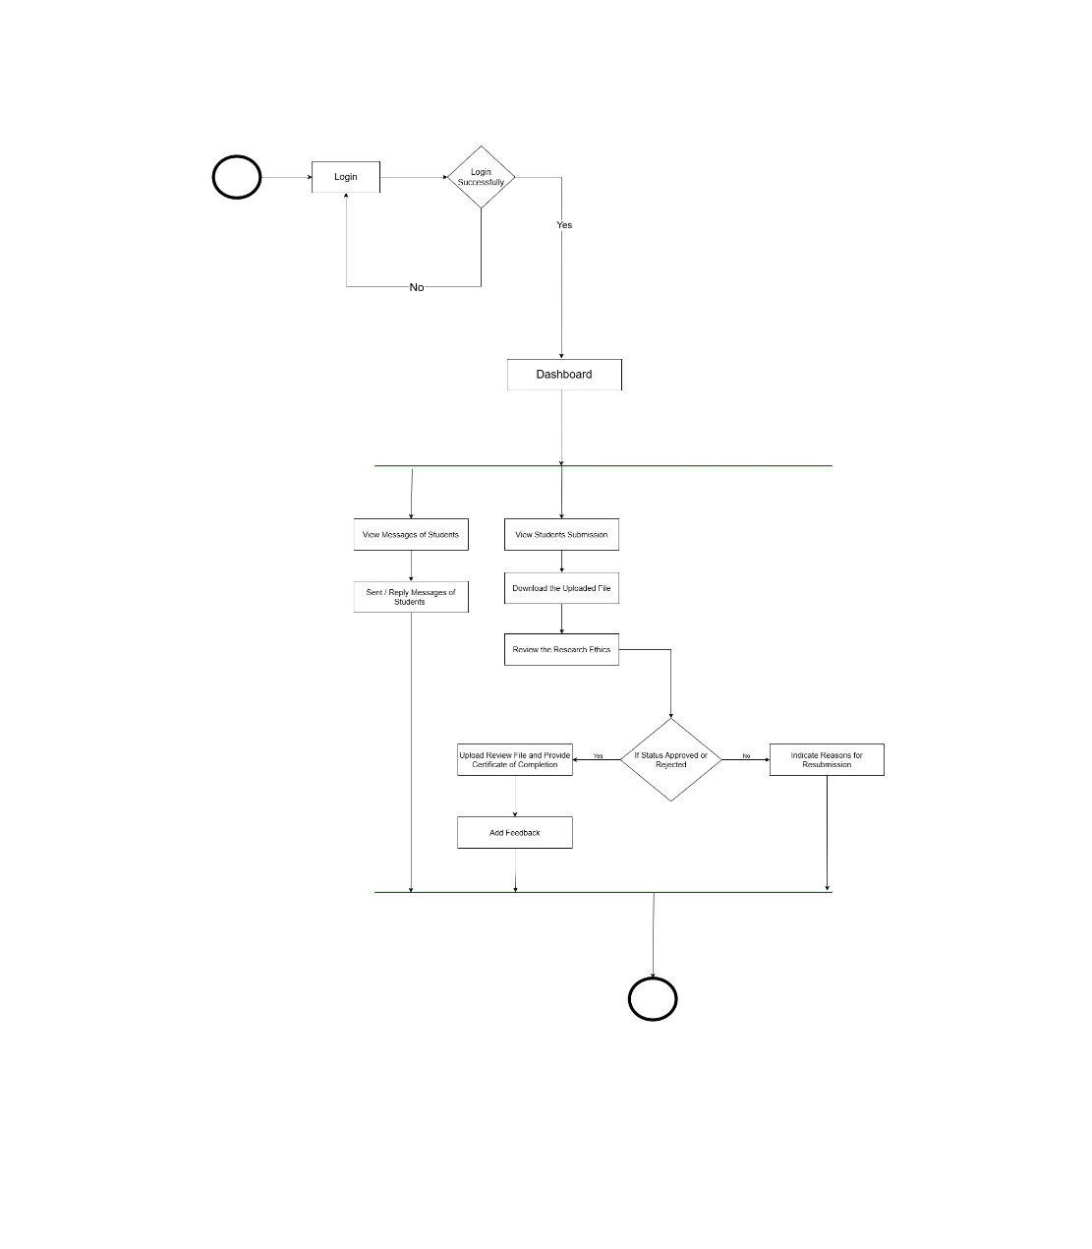
Figure 10. Activity Diagram – Ethics (REC)
The RSSMS uses Figure 7 to show its systematic approach for ethical research paper review within the system. The RSSMS receives research papers from students who select ethics as their service, while the system automatically sends notification emails to Ethics personnel. The personnel access the RSSMS system to review submitted documents for ethical compliance with institutional rules, research integrity standards, consent procedures, and confidentiality requirements.
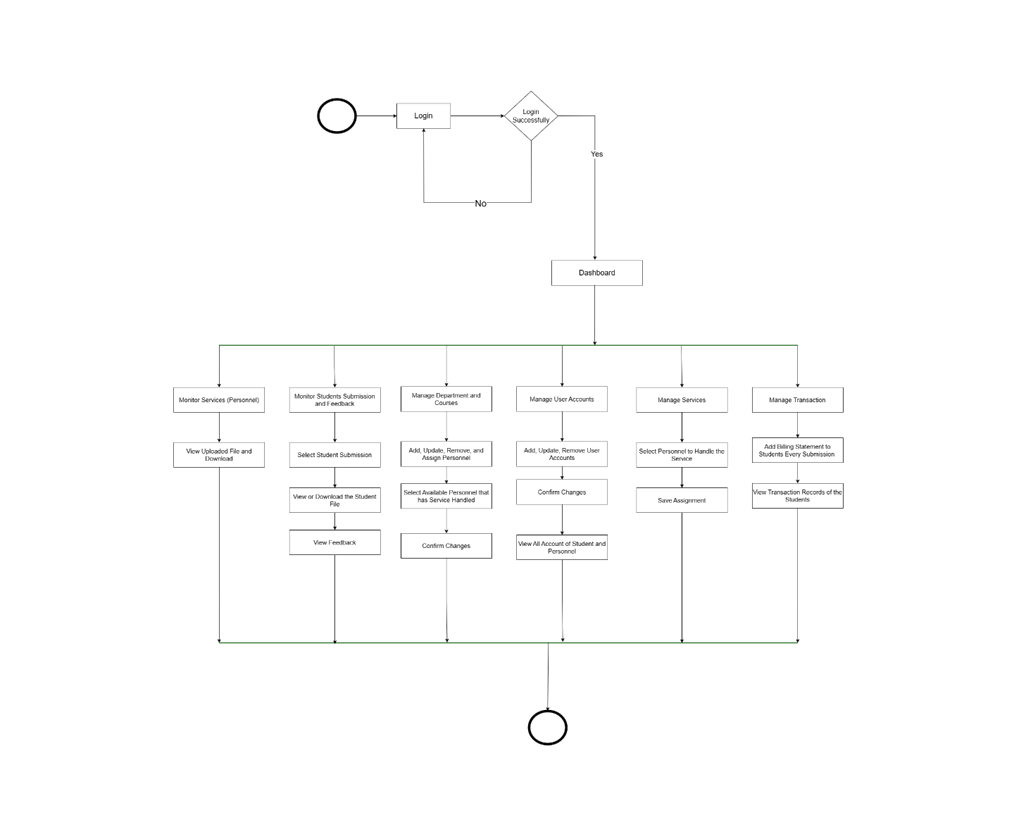
The review process verifies that research meets all ethical standards before advancing to publication or defense stages. The Ethics personnel complete their review of the document by issuing an approval certificate or providing detailed editing feedback for denial. The RSSMS delivers the review decision to students via email. The student can retrieve the document and certificate after downloading or resubmitting the document for editing. The messaging feature enables both parties to exchange messages to understand better and maintain transparency. The student provides service feedback and ratings to maintain high standards for ethics review services.
Figure 11. Activity Diagram – Admin
The operational flow for managing user accounts and services in RSSMS is displayed. After logging into RSSMS, the admin accesses a centralized dashboard to manage various system components. The system enables administrators to create and update user accounts, assign personnel to services and departments, and oversee services to ensure proper distribution.
The system enables administrators to track student submission status across all services while maintaining workflow efficiency and providing access to personnel and student file upload. The feedback module provides admins with performance data on service providers, helping them solve problems and enhance service quality. The system administrator maintains control over all system operations through their ability to review billing statements and transaction records.
The platform enables instant issue resolution through its built-in communication system, which connects personnel with students. The system maintains organized operations that enable administrative control, transparency, and coordination among all system components to support efficient interactions between student service personnel.
.

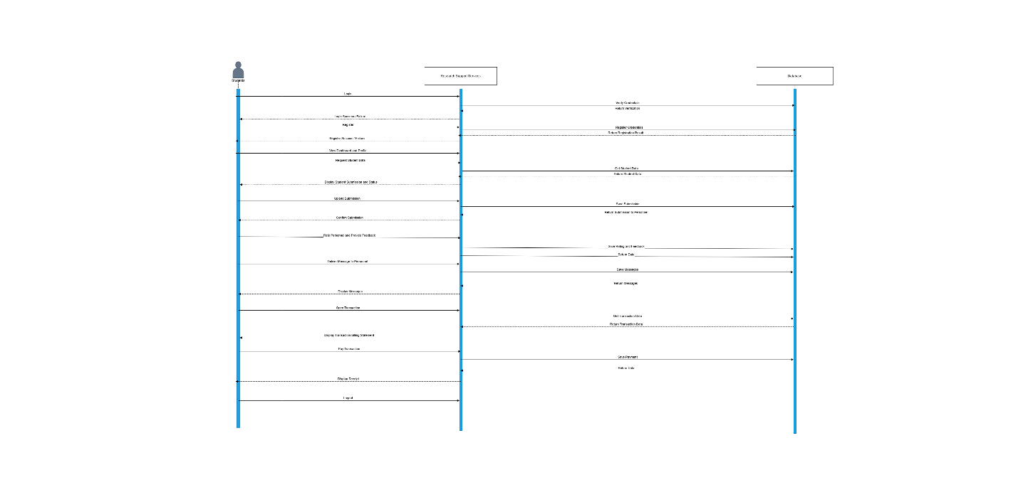
2.7 Sequence Diagram
Figure 12 Sequence Diagram – Students
The process of student-service personnel interaction at RSSMS appears to demonstrate the steps of communication for document submission and review. Students access the RSSMS dashboard to select their preferred service before uploading their research document. The RSSMS system sends automatic email notifications to personnel after file storage, while students receive confirmation of their successful document submission.
The system enables students to monitor request status and directly communicate with personnel for clarification, creating transparency and immediate user interaction. After finishing their review work, the personnel update the review status in RSSMS and send an email notification to the student.
Students access the system to check their reviewed files and completion certificates or make revisions before resubmitting their work if needed. The GCASH payment gateway enables students to make payments, resulting in a smooth and seamless process for accessing their results and certificates. Students need to finish their payment before they can access their result file and certificate. Students provide service ratings and feedback after completing their work, which helps the service improve continuously. The RSSMS uses a structured process to maintain clear communication paths, track progress, and deliver services efficiently.

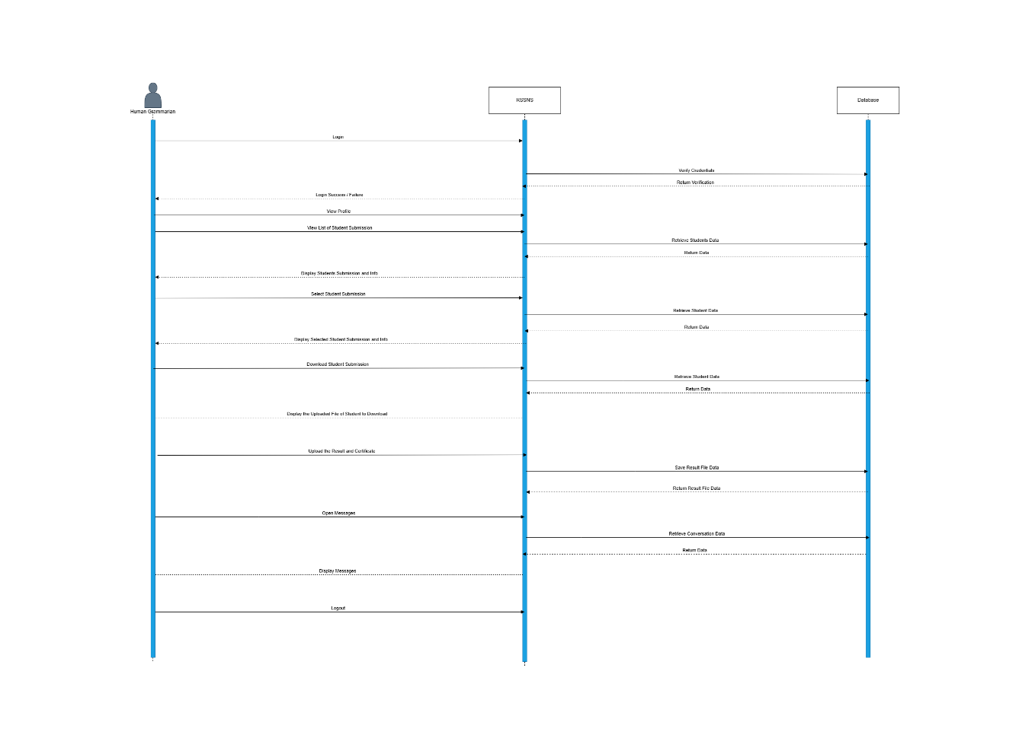
Figure 13. Sequence Diagram – Human Grammarian
The student starts by accessing RSSMS and reaching the human grammarian services, where they upload their document to assess its grammatical and writing quality. The RSSMS generates an email alert to the designated human grammarian personnel who can begin evaluating the submission.
The grammarian begins their work by downloading the student submission file for manual evaluation of grammatical mistakes, sentence organization, pragmatic elements, and clear writing. The human grammarian finishes their review by uploading the corrected file and marking the submission status as Approved, rejected with revision needs, or resubmitted.
The RSSMS sends email alerts to students about review results and output, while students must complete payment for approved submissions to access their reviewed files and certificates. The system grants students access to their reviewed file and certificate after verifying their payment transaction through RSSMS. The system provides students and grammar personnel with a communication tool to request clarification.
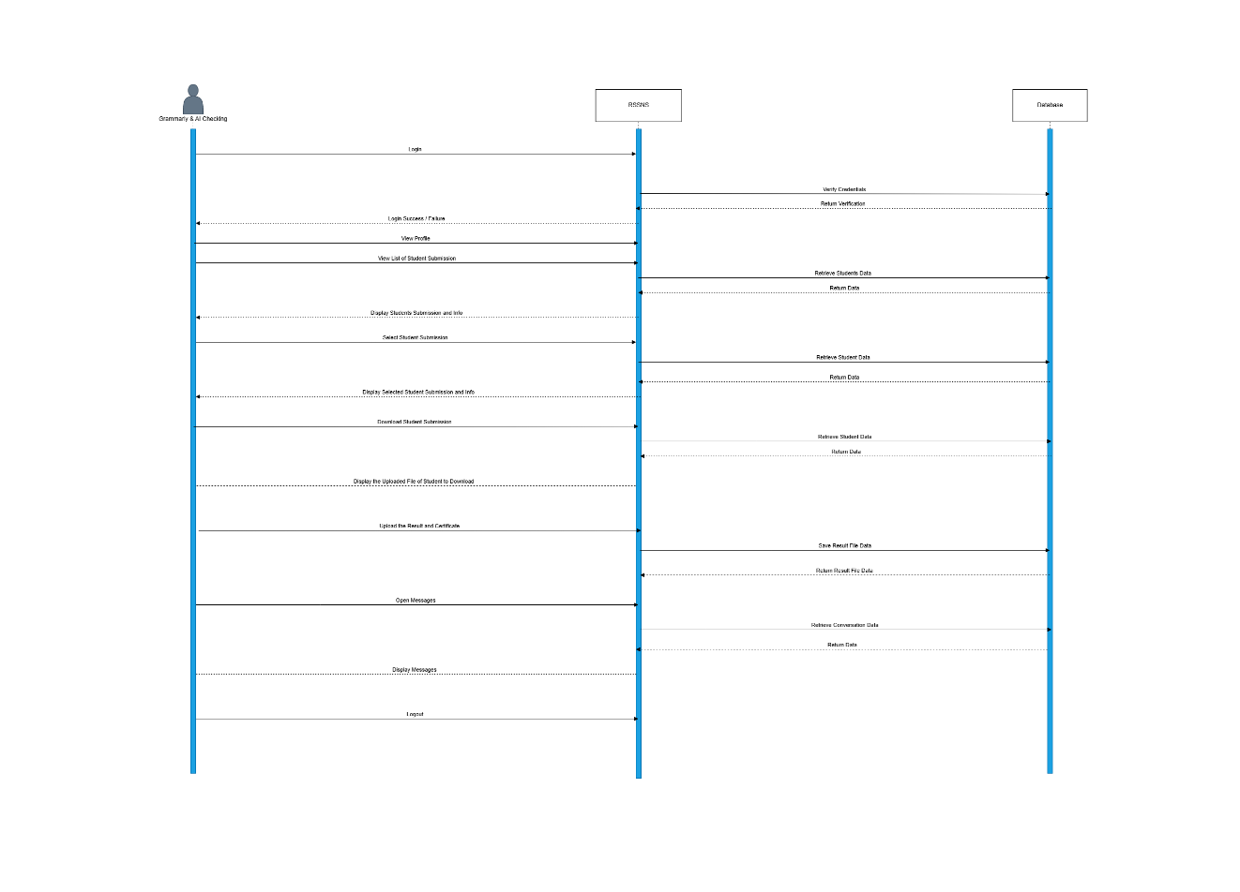
Figure 14. Sequence Diagram – Grammarian & Ai Checking
The RSSMS diagram shows how students' research submissions undergo automated and semi-manual checks for grammar and AI detection. The system allows personnel to access their dashboard, where they can upload files that trigger automatic email alerts to Grammarly and AI checking personnel.
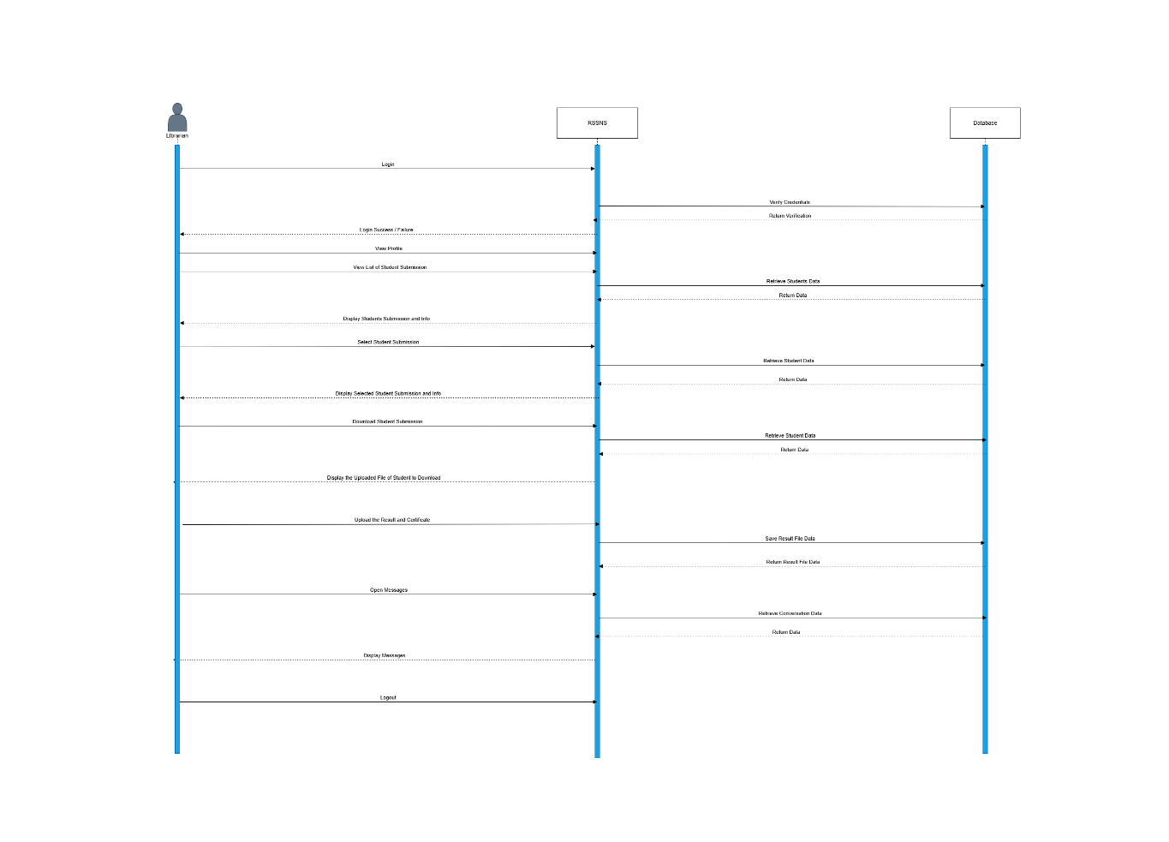
This process makes it easy for students to study, boosts communication, and clarifies things. The RSSMS gives different types of people different administrative jobs. These include admins, students, statisticians, librarians, human grammarians, ethics, grammar, and AI checking staff. Each job has specific responsibilities that ensure the work gets done quickly and well.

Figure 15. Sequence Diagram - Librarian
When students log in to the library system to share their research, the RSSMS starts its librarian sequence. After uploading their file to the RSSMS, the student sends it for reference review, which sends an email alert to the assigned librarian staff.
The librarian looks at the submission and ensures it meets the school's requirements. These include rules for formatting and citing sources. The librarian finishes the review process by adding the result file and certificate to RSSMS. The message indicates whether the student's work received approval or requires resubmission.
The RSSMS lets students know through emails about the results of their entries, so they can make any changes or resubmit them as needed. After being approved, the system takes students to a page where they can pay before letting them see their study results and certificates.
After completing the work, the RSSMS verifies that the university pays the students correctly and grants them access to their study results and certificates. The communication tool lets students and library staff share information easily and discuss other issues.
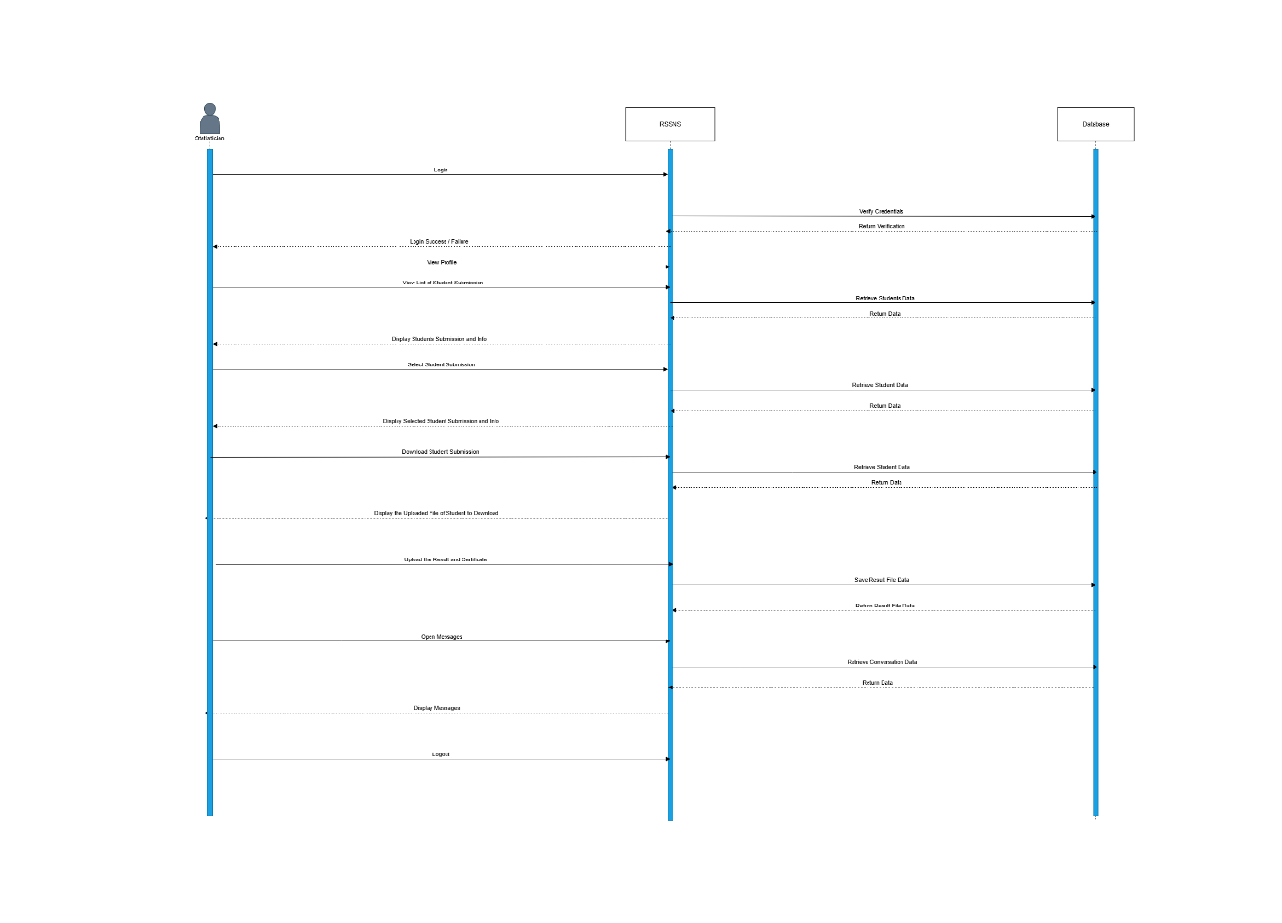
Figure 16. Sequence Diagram – Statistician
The analysts' sequence diagram shows how the organized process of statistical analysis for student data works after students upload their files and assignments to RSSMS. With secure data handling, the RSSMS system lets the statistician know about new
entries by email.
Before uploading the results and a completion certificate, the statistician does the necessary statistical analysis and data processing. When a student finishes paying, the RSSMS system changes the state to (Approved, Pending, or Rejected) instead of letting them see their results and certificates.
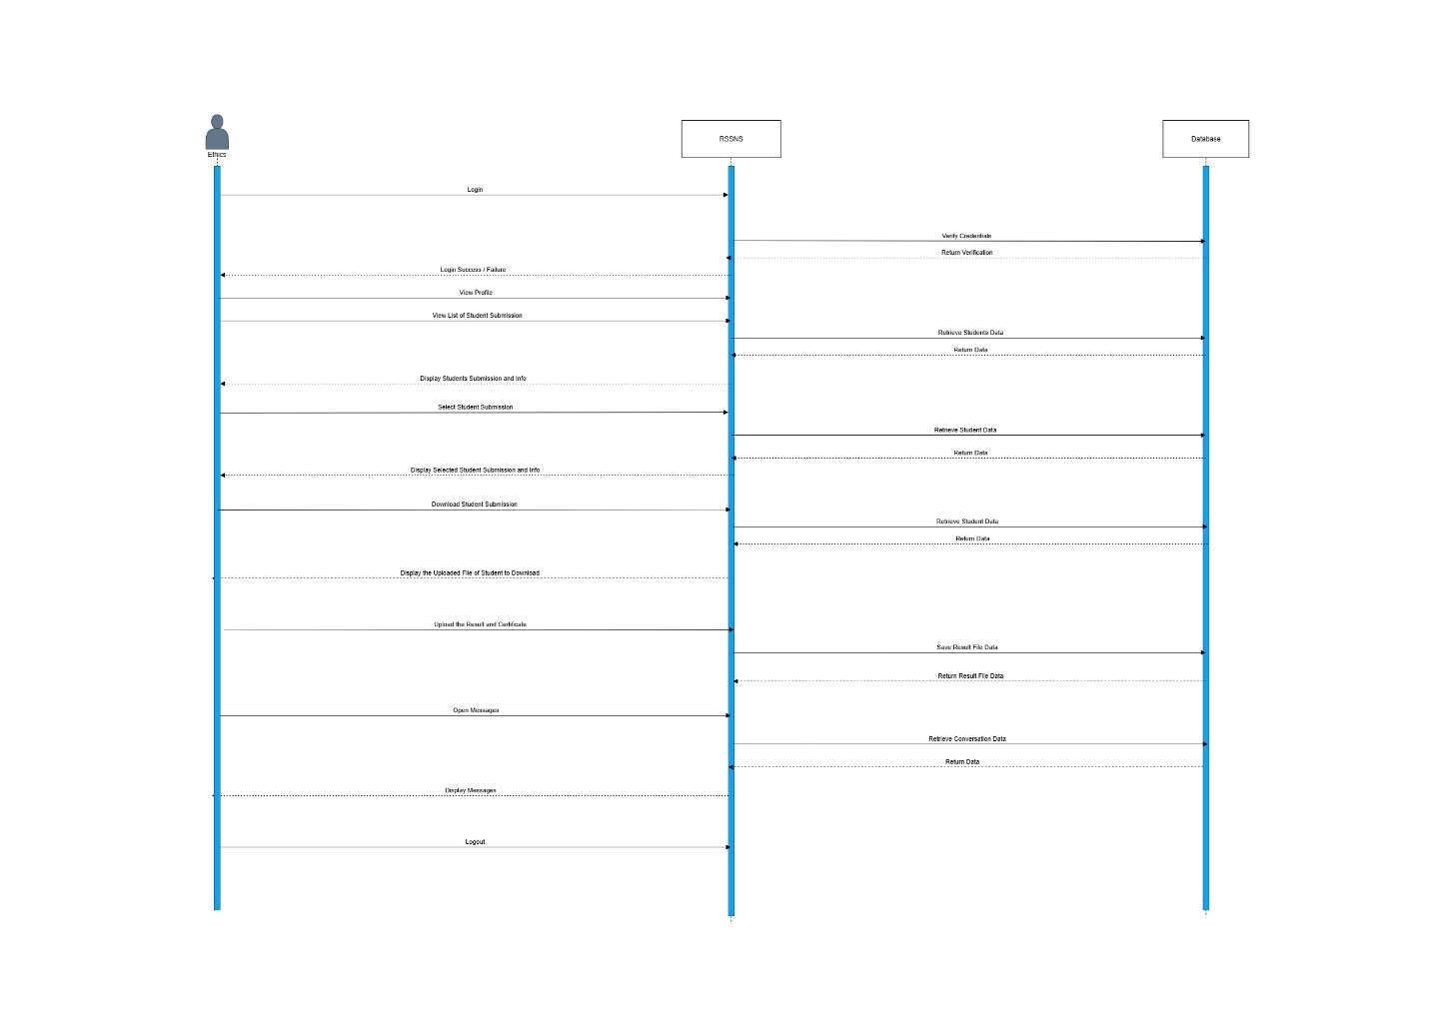
The system sends email alerts for submissions and readiness results after payment completion. The RSSMS system provides access to the reviewed file and certificate and allows students to resubmit their work in case of rejection. The system enables immediate communication between students and statisticians through real-time clarification, and the rating and feedback system helps maintain service quality and evaluation.

Figure 17. Sequence Diagram – Ethics (REC)
After logging in, the RSSMS starts when students access the Ethics services through the platform. Students must upload their required Ethics documents before submitting their application for review through the RSSMS, which then transfers the submission to the ethics service for review.
The ethics team reviews student submissions to verify ethical compliance before making approval or rejection decisions for the submission. The RSSMS delivers email notifications to students after ethics personnel complete their review, providing submission outcome information and requiring resubmission when necessary. Students who receive approval must complete transaction billing to access their result file and ethics certificate.
After payment verification, the RSSMS system provides students immediate access to their approved submission file and ethics certificate. The ethics service obtains confirmation of process completion for monitoring and reporting purposes through the structured flow, which maintains accountability and ethics compliance, enables real-time communication between student-ethics personnel, and restricts access to sensitive ethics documents in RSSMS.

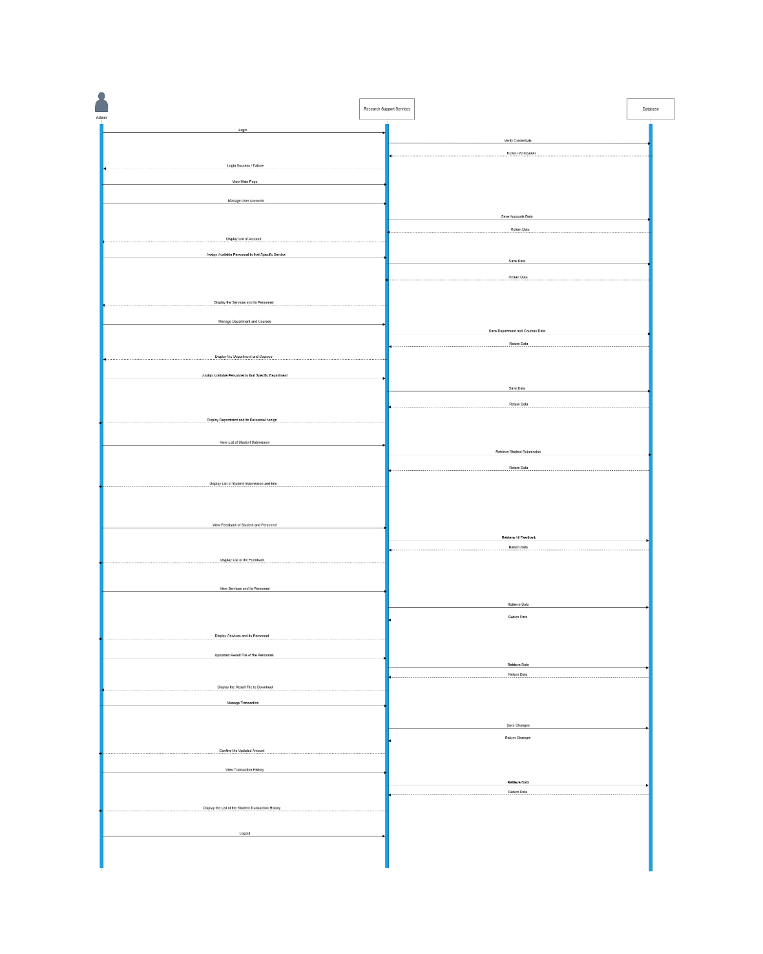
Figure 18. Sequence Diagram – Admin
The flowchart demonstrates the complete sequence of administrative tasks, including Dashboard management, Authentication and Research Support Services, Students and Personnel, and Database operations. The admin starts their process by logging in, which triggers authentication to verify their credentials. The system verifies the admin after authentication so that they can proceed with user account management and department and course administration.
The database processes all administrative changes through add, update, or remove operations, which result in immediate system updates to RSSMS. After completing account, department, and course management tasks, the admin can assign personnel members to research support services, including ethics review, human grammar check, statistical review, and additional research services.
The admin sequence includes student submission tracking, which displays research result files and certificates alongside personnel feedback. The system enables administrators to select feedback from students and personnel, helping them track communication and maintain the review process’s efficiency. The Diagram demonstrates how the admin controls research services and personnel oversight through transaction management, submission amount updates, student billing statements, and transaction history access. The administrative structure provides complete management control for RSSMS operations while maintaining system efficiency.

2.7 ERD (Database Design)
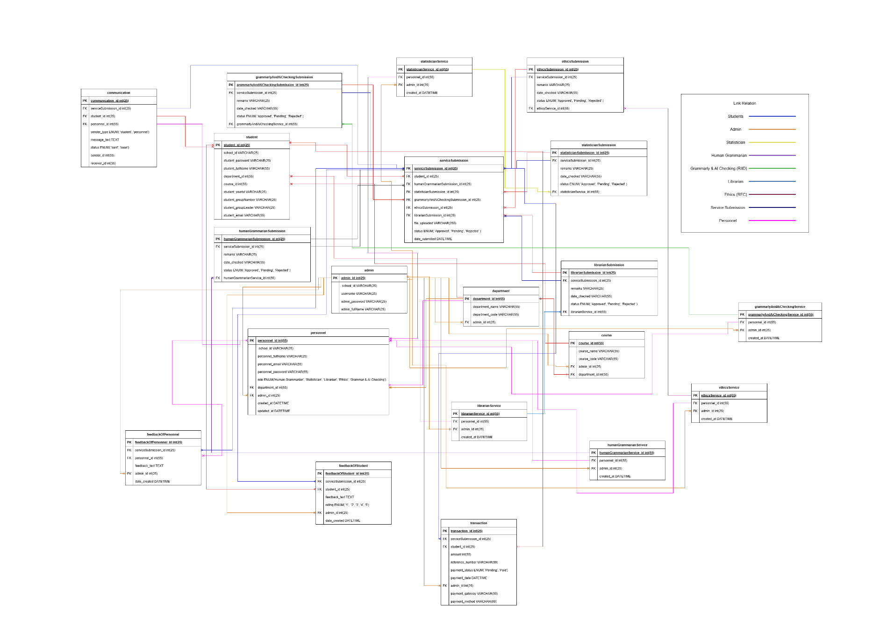
Figure 19. Entity-Relationship Diagram (Database Design)

The database schema demonstrates the complete data structure of RSSMS, which shows how all entities within RSSMS relate to each other. The student entity is the core element of RSSMS because it contains vital student information, including personal details, course and department enrollment, and uploaded submission files. The students maintain a connection to the service submission table, which functions as the central hub for all research submissions.
The submission bridge table connects students to different services via foreign keys that identify service destinations and contains file paths, status information, and submission dates for tracking service personnel handling. The admin controls personnel management through the personnel table while assigning staff members to particular services for handling. The system includes separate tables for each service type (librarian, statistician, human grammarian, grammar & AI checking, and ethics), enabling flexible role management and service submission linking. The admin controls department and course tables to establish organized student and personnel categories, facilitating communication between them.
The system includes a communication table to store all messages that students and personnel exchange with each other. The system enables transaction and billing operations through the transaction feature, which supports GCASH as its payment method. Students must finish payment transactions for service submissions before accessing their result files and certificates. At the same time, the feedback system enables students and personnel to rate services after completion for better accountability and service quality. The system provides secure and scalable data exchange between students and services in RSSMS while maintaining transparency for complex academic support operations.

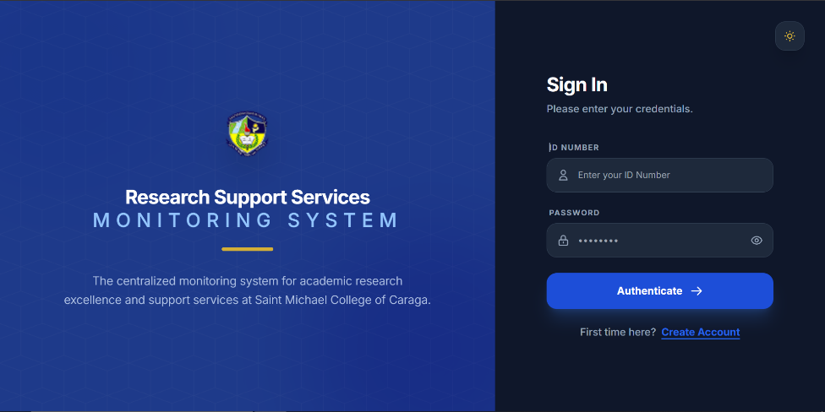
2.8 User Interface Design (Prototype)
STUDENT
Figure 20. Unified Log in form - Student
This page provides a single login page for all users like admin, personnel, and students to log in using their school ID and password, and the system automatically grants access based on the user’s role.
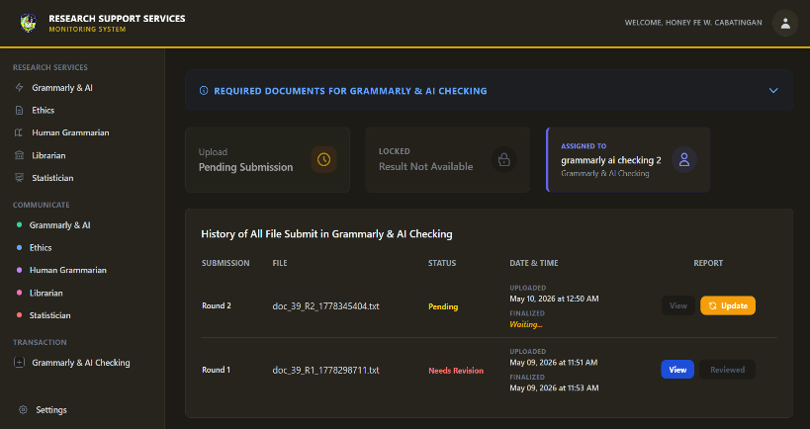
Figure 21. Grammarly & AI Checking Service Dashboard
Students initiate the process by uploading their research manuscript alongside a required payment receipt for validation. Once submitted, the assigned personnel review the document for grammar and AI plagiarism, marking the submission as either "Approved" or "Needs Revision." If revisions are necessary, students receive a detailed feedback report to guide their corrections. They must then address these issues and re-upload the refined document for subsequent evaluation rounds until final approval is achieved.

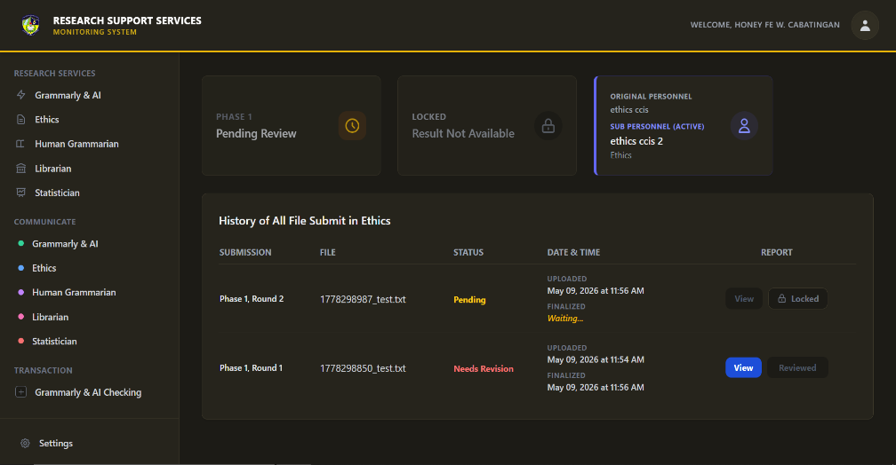

Figure 22. Ethics Review Service Dashboard
The student begins by uploading their required ethical clearance forms and manuscript for the designated research phase. Upon submission, the assigned Ethics Reviewer begins the evaluation, at which point the document is locked to prevent unauthorized modifications by the student. If the submission meets all ethical standards, it is marked as "Approved," automatically unlocking the next phase of the clearance process if dictated by the course curriculum. Throughout this cycle, students can seamlessly monitor exactly which personnel is actively handling their paperwork..

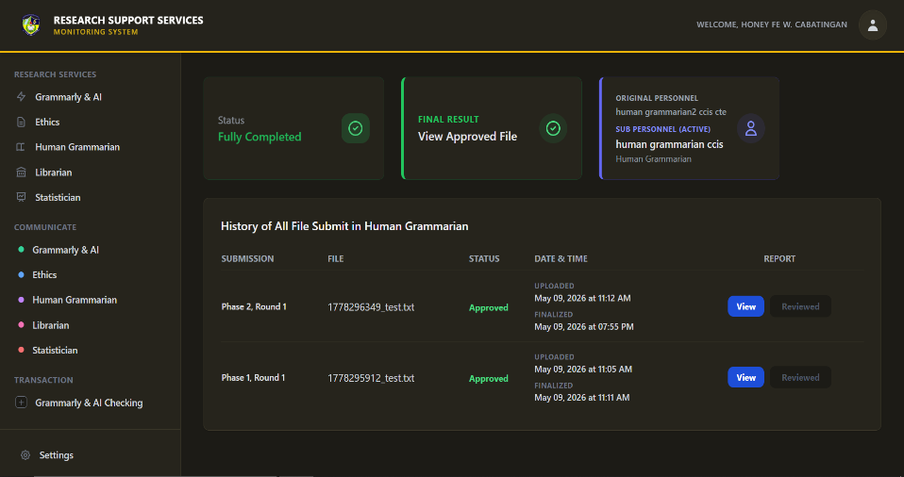
Figure 23. Human Grammarian Service Dashboard
The workflow commences when a student uploads their manuscript for manual, in-depth structural and grammatical editing. The assigned grammarian evaluates the text and returns the document with specific, page-by-page annotations detailing the necessary corrections. Students utilize this historical feedback loop to iteratively refine and re-submit their work across multiple rounds. Once the manuscript satisfies all grammatical standards, the dashboard transitions to a completed state, allowing the student to directly download their finalized, watermarked document. 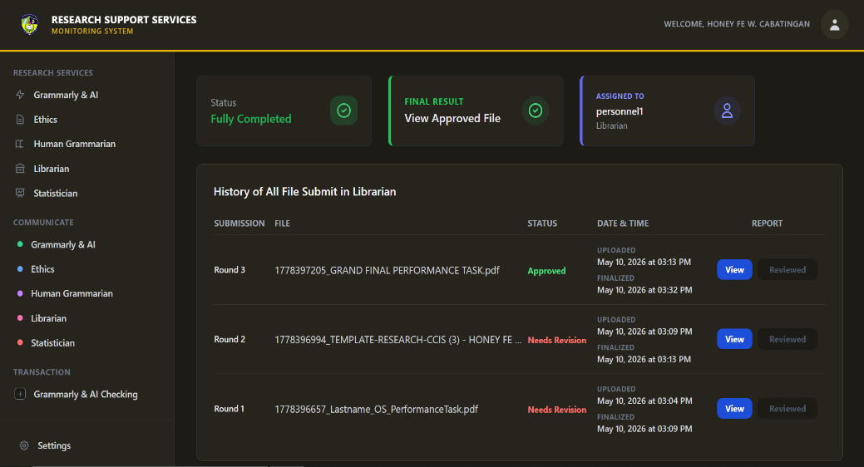
Figure 24. Librarian Service Dashboard
Students submit their manuscripts to the Librarian for strict formatting compliance and plagiarism similarity checks. If the document exceeds allowable similarity thresholds or contains formatting errors, the Librarian provides an annotated report and marks the file for revision. The student then updates the document and uploads it as a new round, with the system chronologically logging each attempt to maintain strict version control. This iterative revision loop continues until the manuscript passes all institutional checks and is officially approved for archiving. 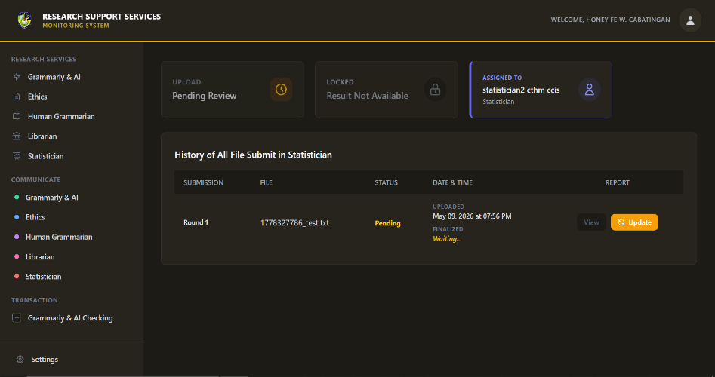
Figure 25. Statistician Service Dashboard
To begin, the student uploads their raw data, statistical requirements, and signed contract to their assigned institutional statistician. The submission enters a pending queue where it waits until the statistician locks the file to perform the necessary data treatments and computations. If there are flaws in the data gathering or variables, the statistician will flag the submission for revision. Otherwise, the computed statistical results are uploaded back to the dashboard, changing the student's status to approved and concluding the service workflow. 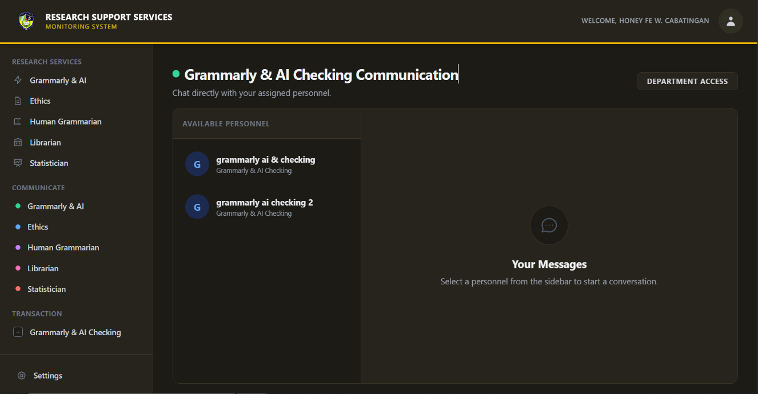
Figure 26. Student Communication Interface
Students access this module to directly interact with their assigned research personnel by selecting a specific service tab. Clicking on an assigned personnel's profile opens a secure, dedicated chat window for real-time communication. This centralized channel facilitates seamless inquiries, feedback clarification, and direct coordination regarding manuscript submissions without leaving the monitoring system.
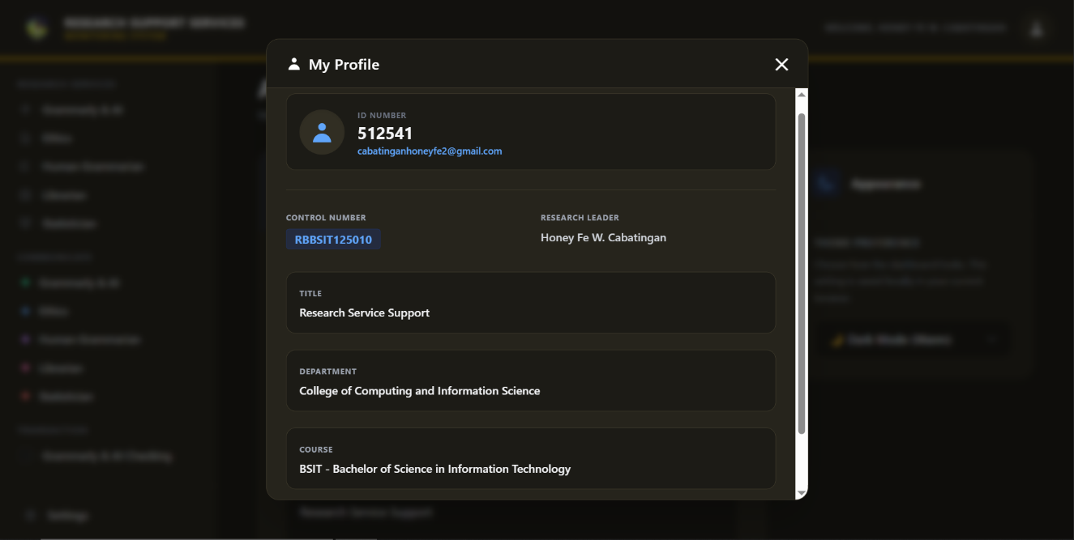
Figure 27. Student Profile Overview
This quick-reference modal is globally accessible from any dashboard page by clicking the user profile icon in the navigation bar. It instantly retrieves and displays immutable institutional data, including the student's Control Number, Department, Course, and Thesis Title. This allows students to efficiently verify their official system credentials and group details before submitting documents or messaging personnel.

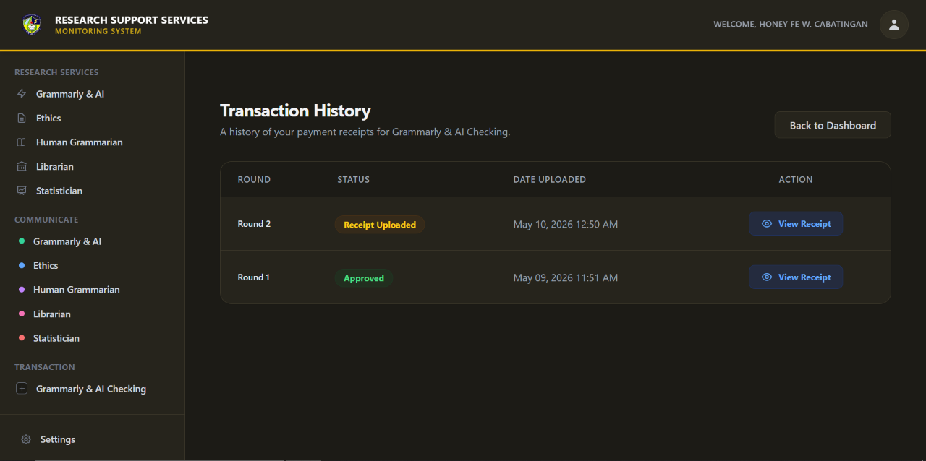
Figure 28. Transaction & Receipt History Dashboard
This dedicated transaction module allows students to monitor their financial compliance through a chronological ledger of uploaded payment receipts. Students can easily track the real-time verification status (e.g., "Pending" or "Approved") of each submission as it is processed by the administration. Additionally, built-in action buttons enable users to view their historical receipt files at any time for accurate record-keeping. 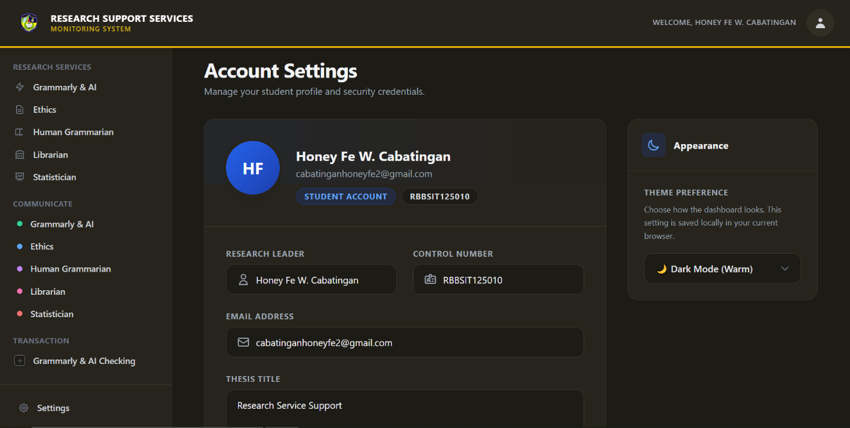
Figure 29 Student Account Settings Interface
The account settings interface serves as the central hub for reviewing foundational account parameters and managing the system's visual workspace. It securely displays official research credentials as locked, read-only fields to preserve institutional data integrity and prevent accidental alterations. Furthermore, students can utilize the appearance toggle to instantly apply and save custom theme preferences, such as dark mode, for enhanced visual comfort.
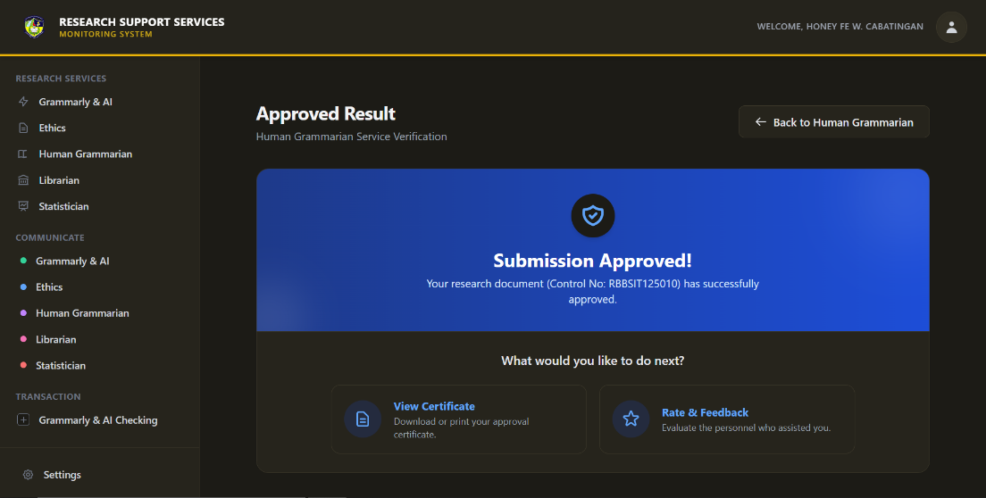

Figure 30. Approved Result Verification Interface
Upon the successful completion of all required phases and rounds for a specific research service, students are directed to this final verification interface. The dashboard displays a prominent success banner confirming the official approval of their manuscript tied to their specific control number. From this terminal hub, students are presented with actionable next steps, allowing them to instantly generate their official clearance certificate or proceed to evaluate the personnel who assisted them.
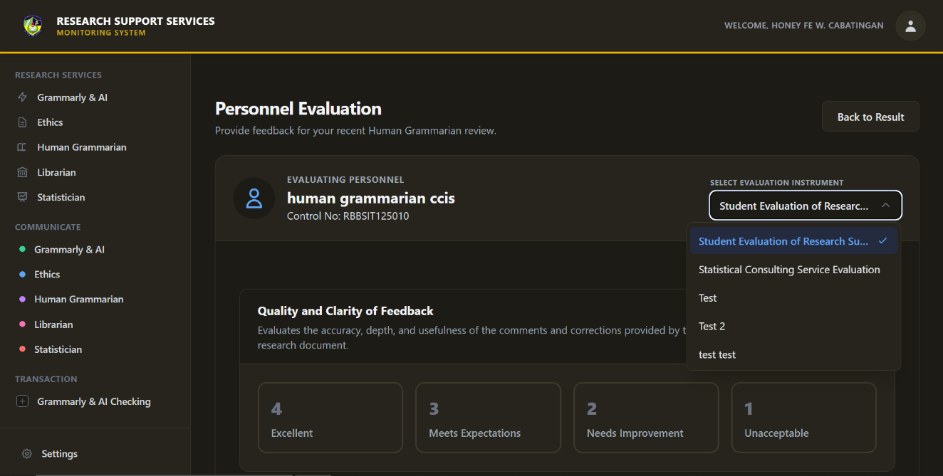
Figure 31. Personnel Evaluation and Feedback Interface
Students access the personnel evaluation interface after securing their approved research results to provide structured, quantifiable feedback on the service rendered. Users begin by selecting a specific evaluation instrument from a dropdown menu, which dynamically populates the screen with targeted assessment criteria such as the quality and clarity of feedback. The student then utilizes a standardized numerical rubric to rate each criterion before submitting the form, contributing to the institution's continuous quality monitoring.

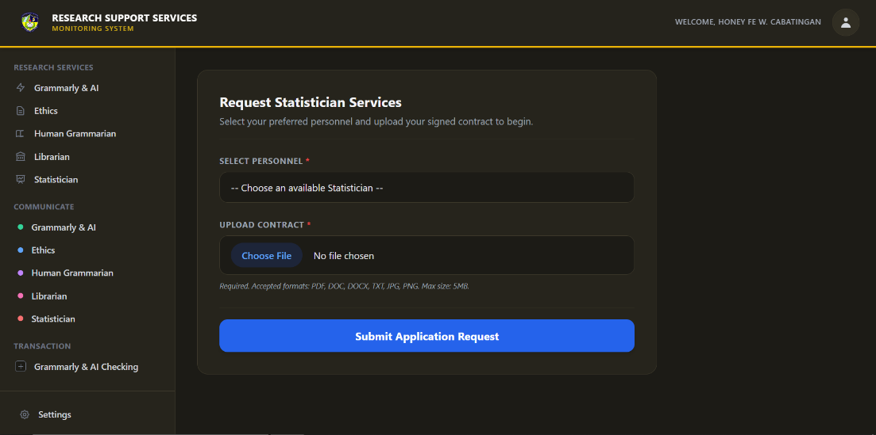
Figure 32. Statistician Service Request Interface
Students initiate the statistical review process by manually selecting their preferred statistician from a list of available personnel. Alongside this selection, students must upload a signed service contract to formally request the consultation. Upon submission, the application enters a pending state until the Administrator verifies the uploaded contract and finalizes the official personnel assignment. 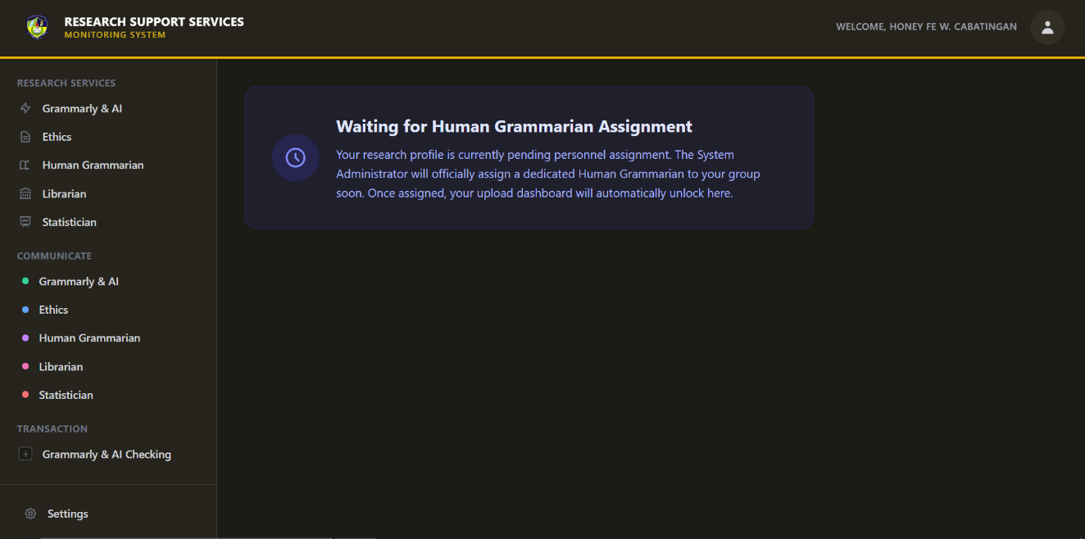
Figure 33. Pending Personnel Assignment Interface
When a research profile requires a specific service but currently lacks a designated evaluator, the system restricts document submission by displaying a pending assignment screen. During this period, the administrator evaluates the available staff workload to officially delegate a dedicated reviewer to the student's research group. Once this administrative assignment is finalized, the dashboard automatically unlocks, granting the student immediate access to the standard document upload interface.

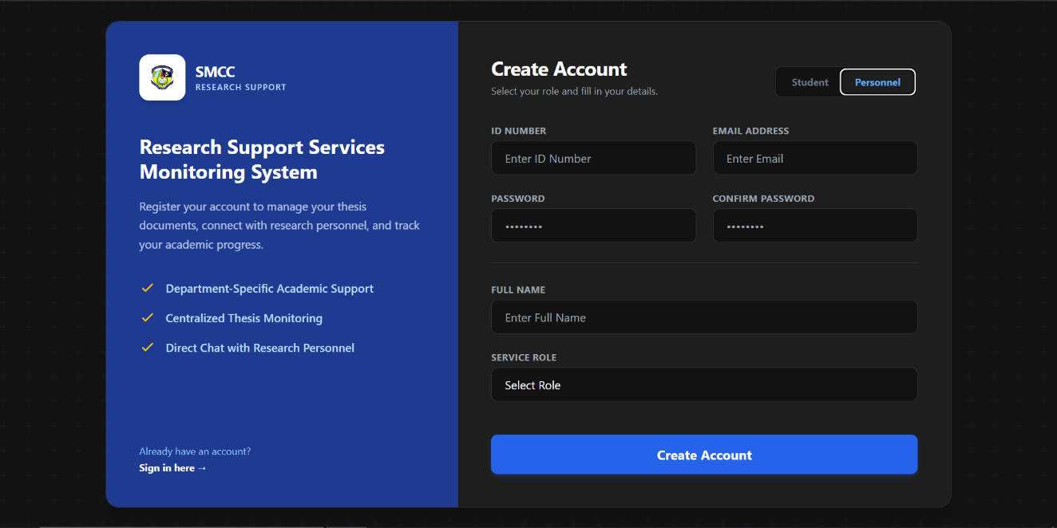
Figure 34. User Registration Interface
Users initiate the registration process by selecting their designated system role—either Student or Personnel using the interactive toggle at the top of the form. Depending on the selected role, the interface dynamically adjusts its input fields to capture the appropriate institutional credentials, such as specific research roles for staff or thesis details for students. Upon submitting the completed form, the system securely records the credentials and creates a pending account that awaits official administrative approval before granting dashboard access.
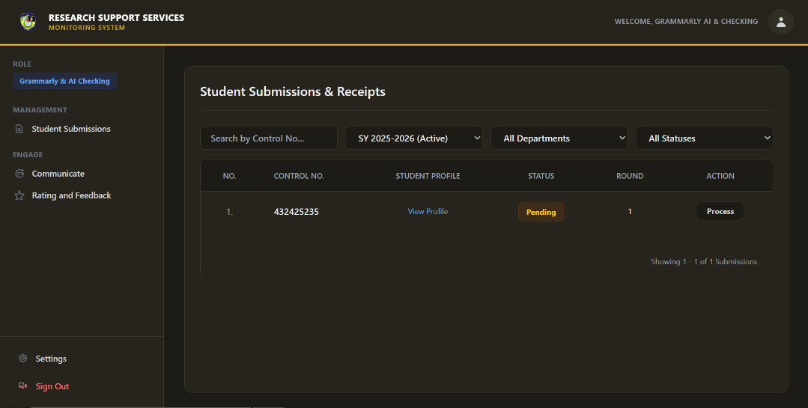
Figure 35. Personnel Submissions Dashboard
Upon logging in, the research personnel presented with a centralized data table displaying all student submissions actively assigned to their queue. Evaluators can utilize dynamic dropdown filters—such as school year, department, and status—to efficiently sort the ledger and locate specific manuscripts. Clicking the "Process" action button on a pending record initiates the formal evaluation sequence for that specific research group. 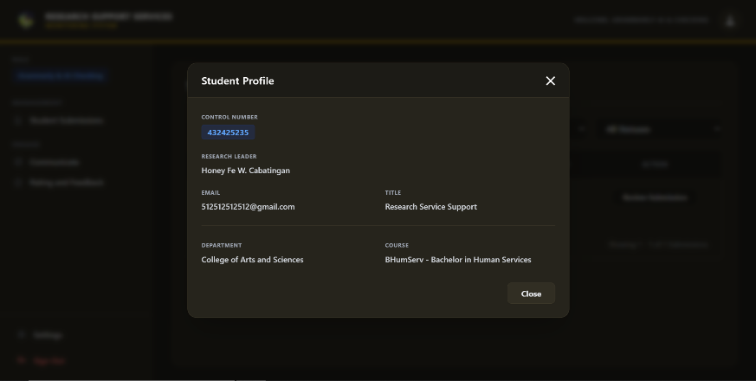
Figure 36. Personnel View of Student Profile
While evaluating a submission, personnel can trigger a profile modal to securely access the background information of the submitting research group. This overlay retrieves read-only institutional data, including the control number, research leader's contact details, and the official thesis title. This ensures the evaluator has immediate contextual verification of the manuscript's authors without disrupting their current review workspace.

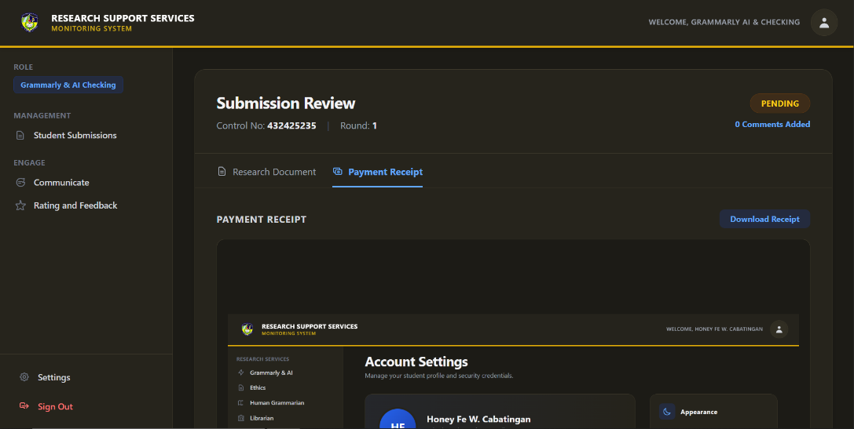
Figure 37. Payment Receipt Verification Interface
Unique to the Grammarly & AI Checking service, personnel must successfully process the financial compliance aspect of the submission before evaluating the actual research document. The interface securely displays the student's uploaded proof of payment, allowing the reviewer to visually inspect and verify the transaction details. The personnel must formally approve this receipt to unlock the subsequent manuscript evaluation phase within the system. 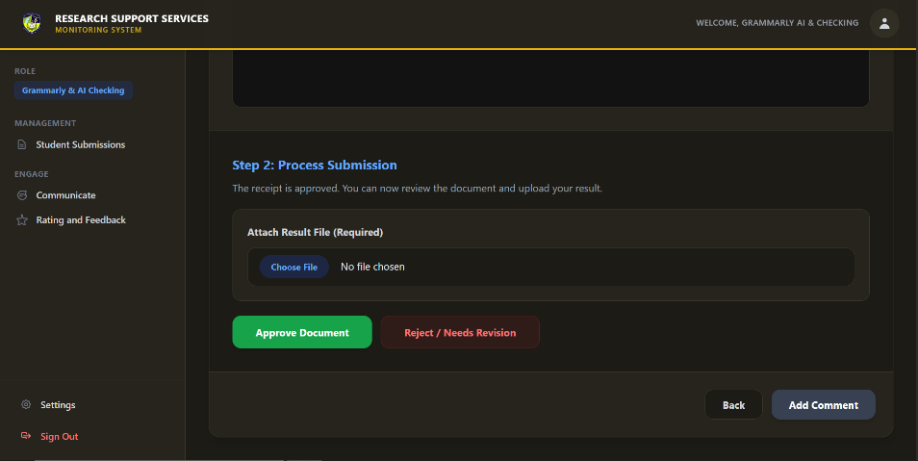
Figure 38. Document Evaluation and Result Finalization Interface
After clearing the receipt, the personnel thoroughly evaluate the research document and utilizes this finalization interface to conclude the review round. They attach their processed result file (such as an annotated manuscript or plagiarism report), append specific qualitative comments, and select a decisive status of either "Approve Document" or "Reject / Needs Revision." Upon submission, the system automatically logs the decision, permanently locks the round, and instantly dispatches an email notification to the student regarding the outcome. 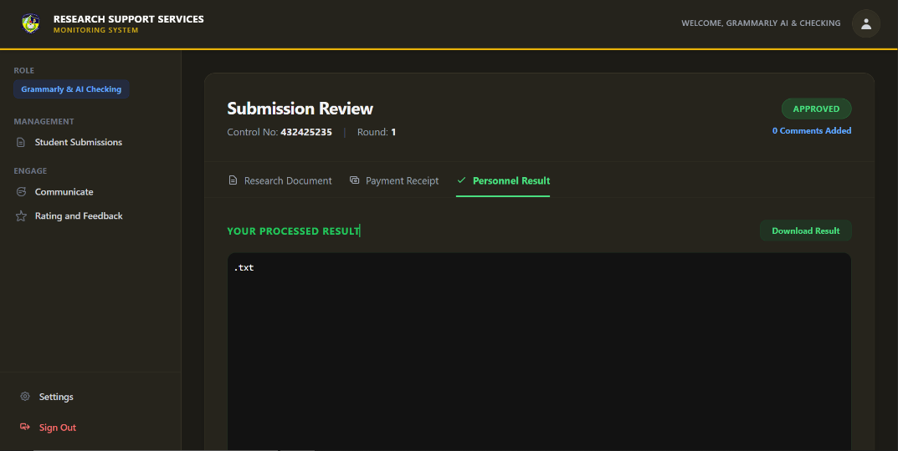
Figure 39. Personnel Processed Result Interface
After finalizing the document evaluation, the research personnel utilize this interface to review their officially submitted results and final decision. The dashboard securely hosts the processed file, displaying a prominent approval badge alongside a direct download link for immediate retrieval. This dedicated result tab serves as an immutable historical record, ensuring that the evaluated manuscript and any associated comments remain accessible for future institutional audits.
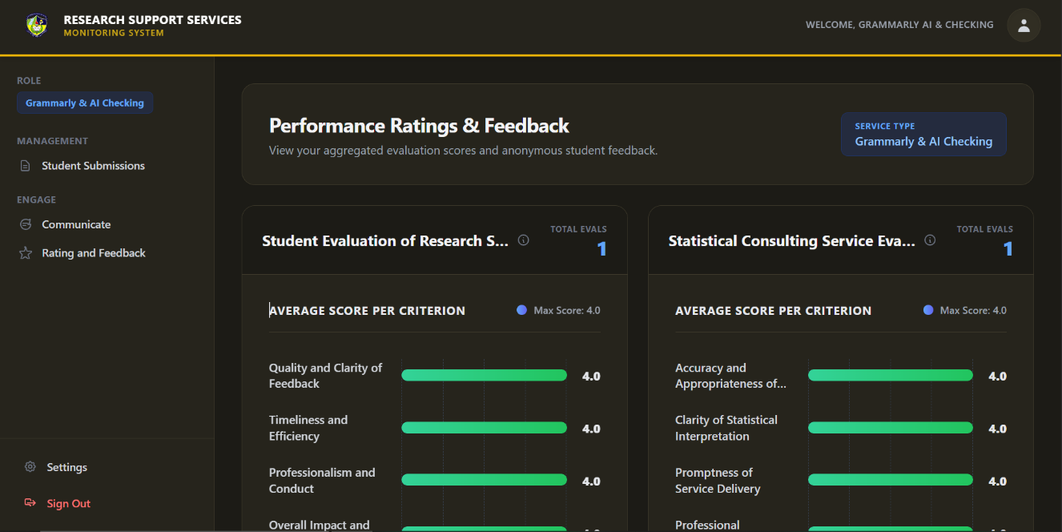
Figure 40. Personnel Performance Ratings & Feedback Dashboard
Personnel access this analytics dashboard to review their aggregated performance scores derived from anonymous student evaluations. The interface automatically calculates and visualizes average ratings across specific service criteria, such as feedback clarity and timeliness, using progressive bar charts. By monitoring these metrics, evaluators can identify areas for professional improvement and ensure they consistently meet institutional service standards.

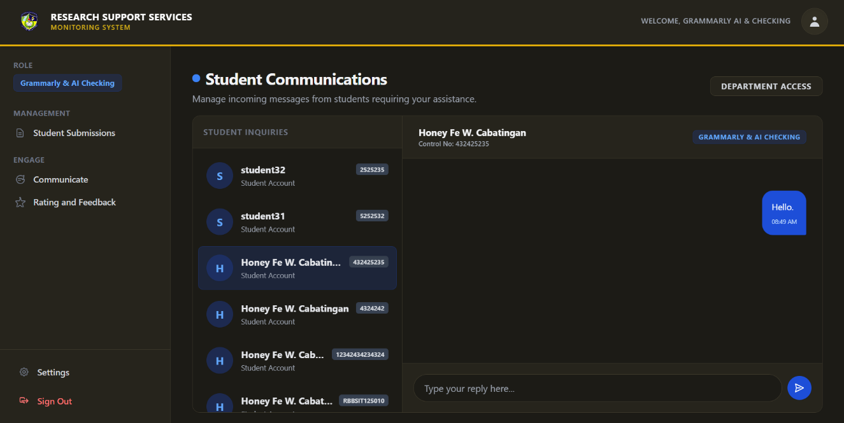
Figure 41. Personnel Student Communications Interface
Research personnel utilize this dedicated communication module to efficiently manage and respond to incoming inquiries from their assigned student groups. Evaluators select a specific student from the organized sidebar queue to open a secure, real-time chat thread linked directly to that group's control number. This centralized messaging system allows personnel to easily provide clarifications, address document concerns, and guide students through the revision process without leaving the platform.
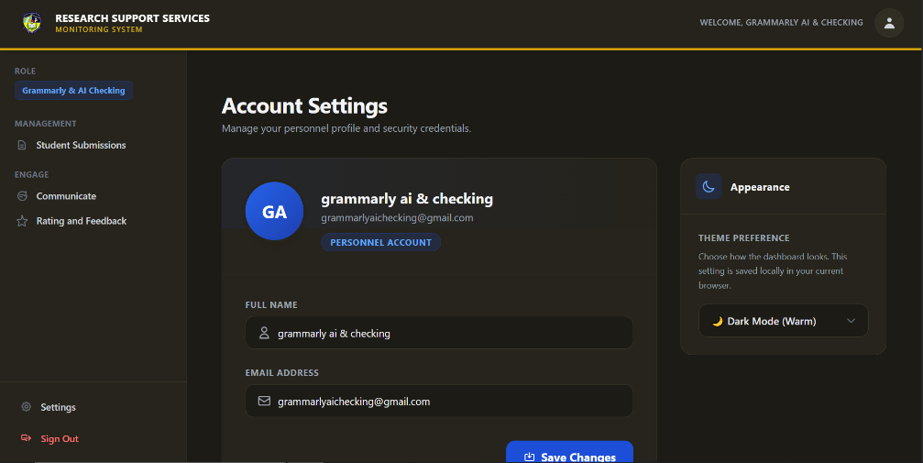
Figure 42. Personnel Account Settings Interface
Research personnel access this dedicated settings interface to securely manage their foundational profile credentials and personalize their system environment. Users can efficiently update their official contact information or utilize the appearance toggle to switch between light and dark themes for optimal visual comfort. Upon finalizing any personal adjustments, clicking the save button instantly commits the updates to the system.
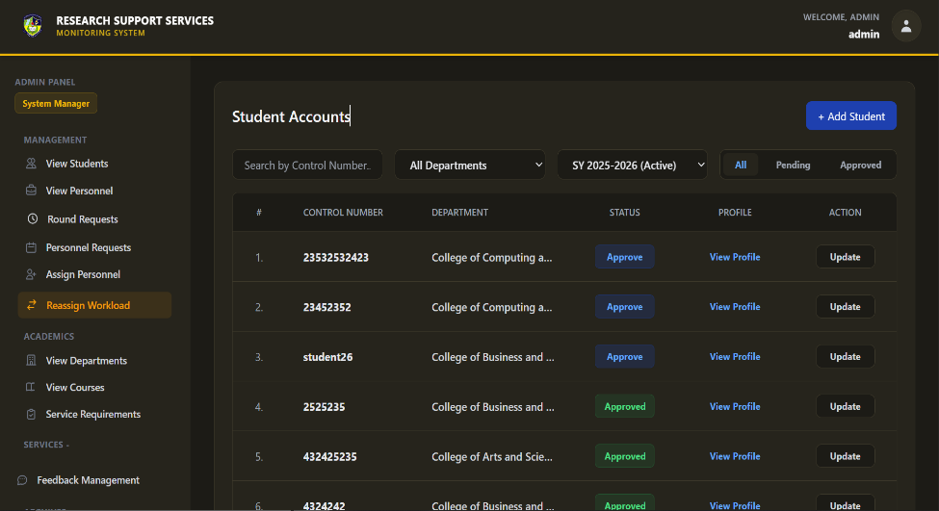
Figure 43. Administrator Student Accounts Dashboard
The System Administrator accesses this centralized dashboard to monitor and manage all registered student research groups within the platform. Using dynamic dropdown filters for departments, active school years, and account statuses, administrators can efficiently sift through the ledger to locate specific student profiles. From this main interface, the admin can execute critical actions such as formally approving pending registrations, viewing detailed profiles, or routing to the account update form. 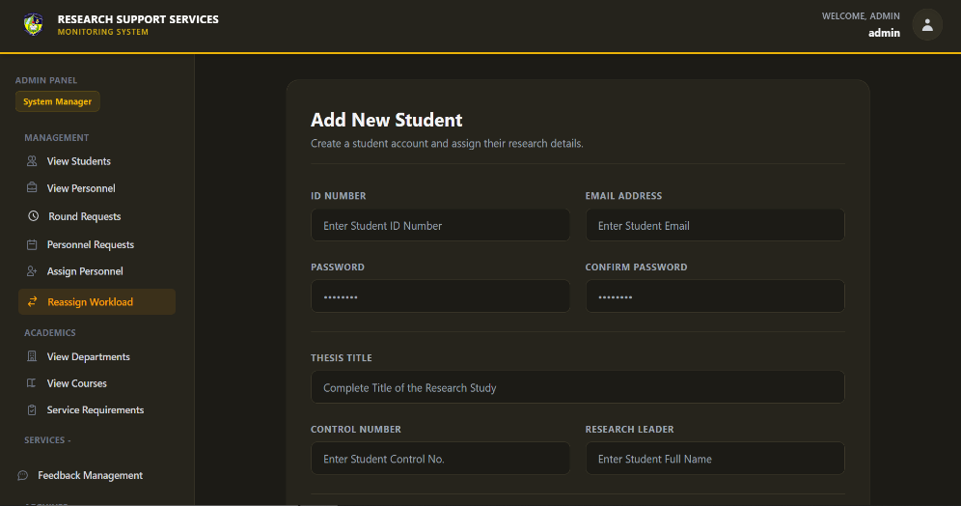
Figure 44. Administrator Add New Student Interface
Administrators utilize this interface to manually create new student accounts and securely register their foundational research details into the system database. The form requires the input of official institutional credentials, including the unique ID number, designated control number, and the complete thesis title. Upon submission, the system instantly provisions an active student account ready for dashboard access and service applications.
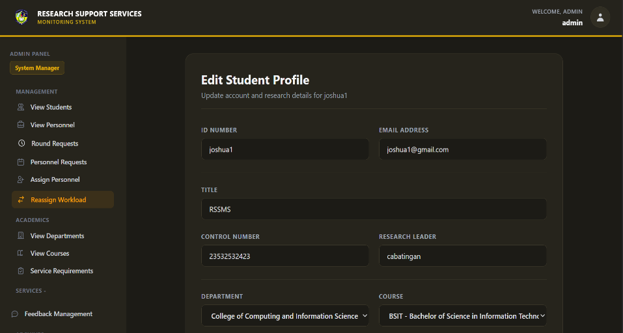
Figure 45. Administrator Edit Student Profile Interface
If a student's research group undergoes organizational changes, the administrator accesses this interface to instantly modify their existing account parameters. The form pre-populates with the student's current data, allowing the admin to easily update specific fields such as the research leader, thesis title, or departmental alignment. Submitting the updated form instantly overrides the outdated database records, ensuring all personnel evaluate the most current group information.
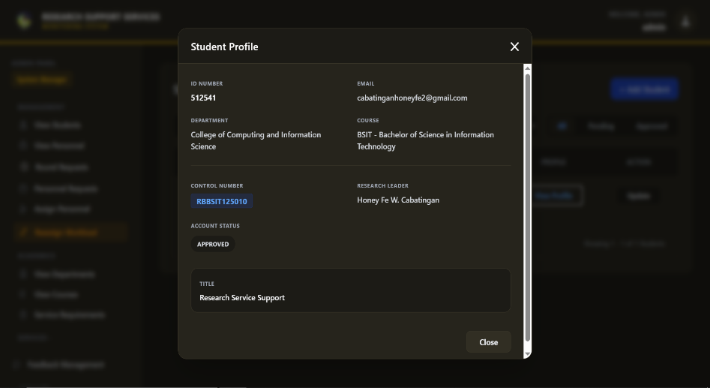
Figure 46. Administrator Student Profile Overview
To quickly verify a research group's background without leaving the main ledger, the administrator can trigger this read-only profile modal. The overlay dynamically fetches and displays the student's complete institutional metadata, including their course, department, and current account approval status. This localized view empowers the admin to make informed decisions regarding workload reassignments or account approvals without disrupting their current workflow. 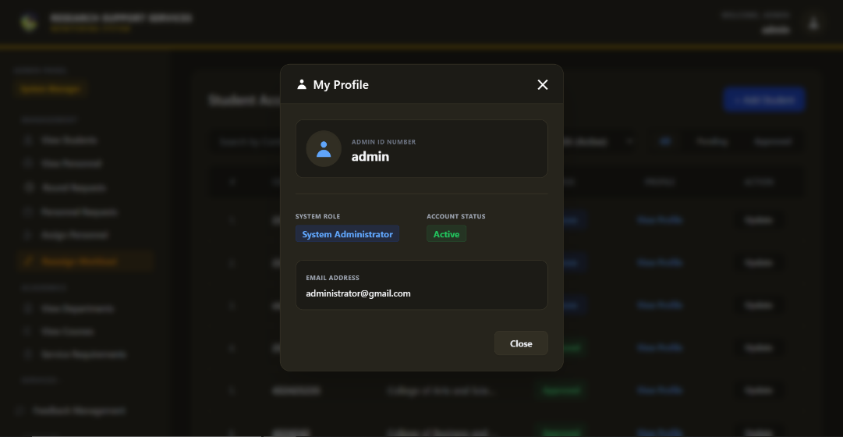
Figure 47. Administrator Profile
The Administrator can view their own core system credentials by accessing this secure profile overlay from the top navigation bar. It displays fundamental, immutable administrative identifiers, including the designated Admin ID number, official email address, and active account status.
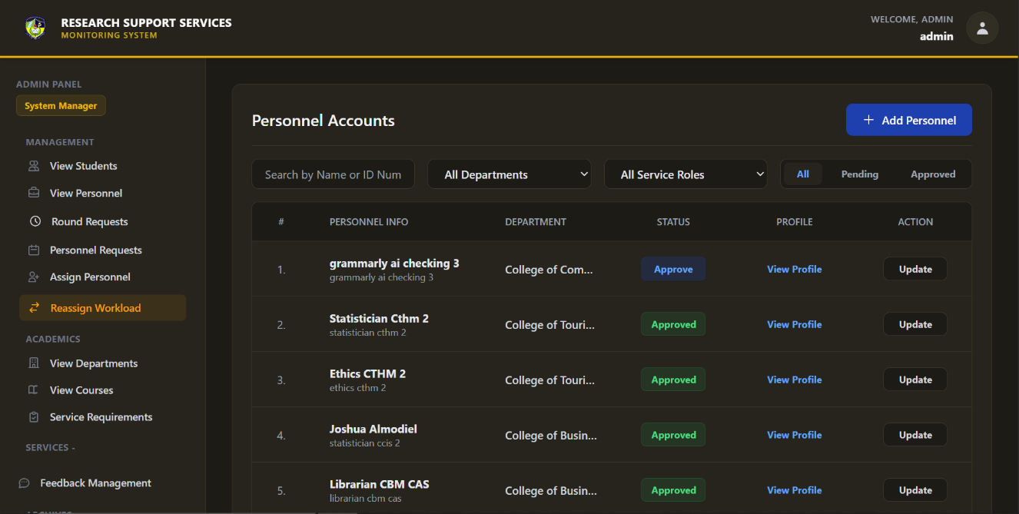
Figure 48. Administrator Personnel Accounts
The Administrator utilizes this centralized ledger to seamlessly monitor, filter, and manage all research personnel accounts across various departments and service roles. From this interface, the administrator can efficiently approve pending staff registrations, access detailed profiles, and route to specific account modification forms to maintain an accurate personnel directory.
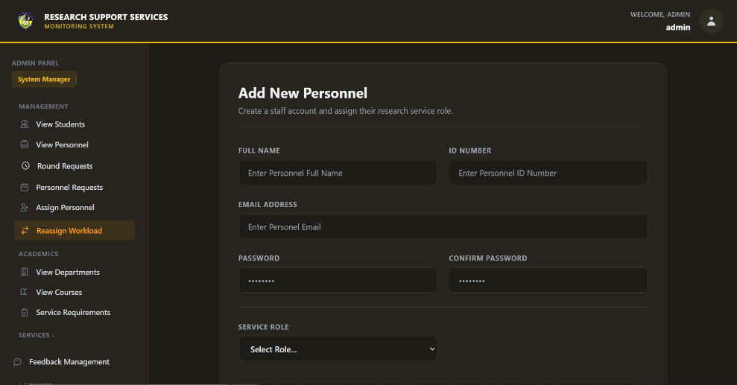
Figure 49. Administrator Add New Personnel Interface
Administrators use this dedicated form to manually provision new personnel accounts by entering essential credentials such as their identification number, secure password, and specific research service role. Upon submission, the system securely creates the personnel profile and assigns the necessary access privileges for immediate platform engagement.
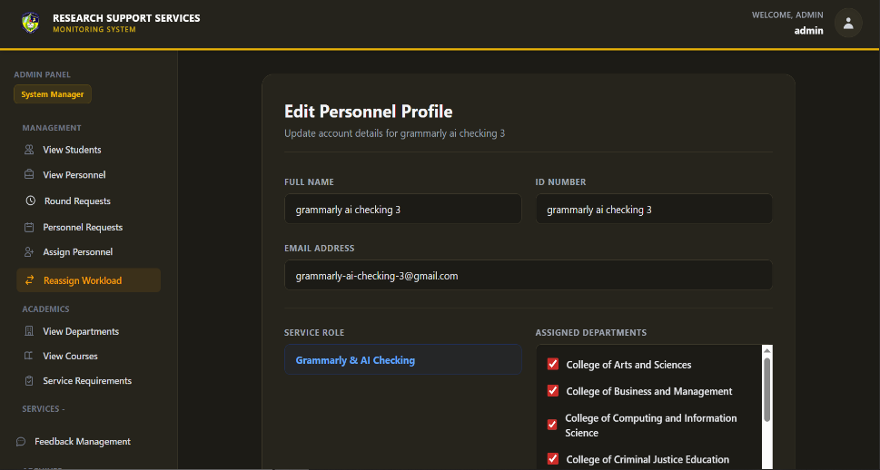
Figure 50 Administrator Edit Personnel Profile Interface
This modification interface allows administrators to dynamically update an existing personnel member's core details and reconfigure their specific departmental assignments via a multi-select checklist. Submitting these changes instantly overrides the database records, ensuring that student routing and system workloads reflect the personnel's most current institutional responsibilities. 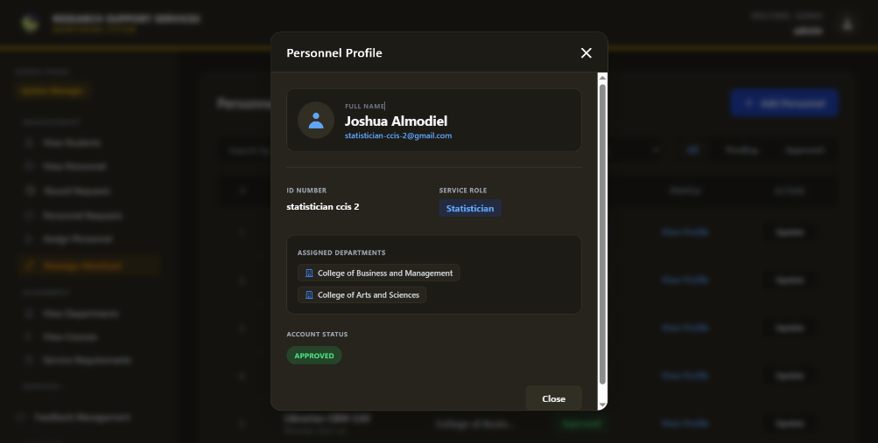
Figure 51. Administrator Personnel Profile Overview
To quickly verify a personnel member's system credentials, the administrator can trigger this secure, read-only overlay directly from the main personnel ledger. The view personnel profile provides immediate, contextual insight into the personnel's designated service role, assigned departments, and active account status without disrupting the administrator's primary workflow.
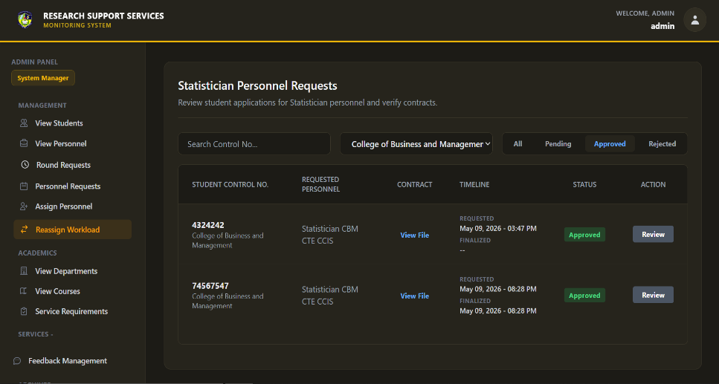
Figure 52. Administrator Statistician Personnel Requests Interface
The Administrator utilizes this dedicated interface to evaluate manual student requests for statistical consulting services and verify their uploaded service contracts. Administrators can filter the ledger by department or status to locate specific applications, subsequently clicking the review action to securely inspect the attached agreements. Based on the contract's validity, the administrator formally approves or rejects the requested personnel assignment, which instantly updates the student's dashboard allowing them to proceed with data submission. 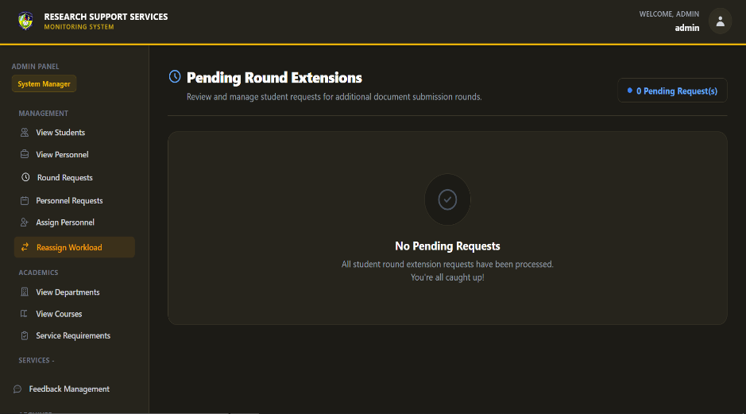
Figure 53. Administrator Pending Round Extensions Interface
When students exhaust their maximum allocated submission rounds for a specific research service, their formal extension appeals are routed to this centralized administrative dashboard. The System Administrator reviews these pending requests and utilizes integrated tools to either grant a specified number of additional upload rounds or reject the appeal. Processing these extensions immediately synchronizes with the student's portal, instantly unlocking their upload capabilities if approved and automatically dispatching an email notification. 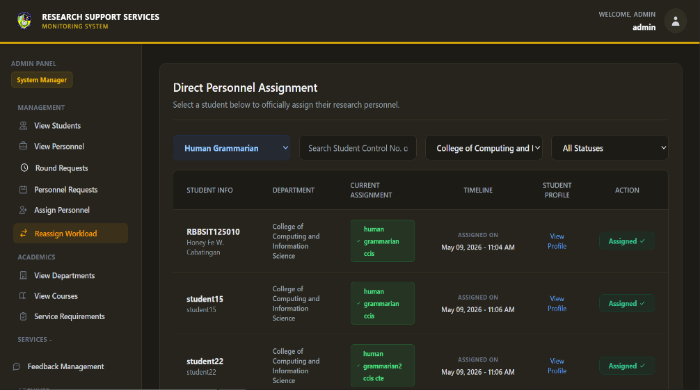
Figure 54. Administrator Direct Personnel Assignment Dashboard
Administrators utilize this dashboard to actively monitor and execute the manual distribution of research personnel to specific student groups across the institution. By utilizing dynamic dropdown filters for specific service roles, departments, and assignment statuses, the admin can quickly isolate unassigned student profiles that require immediate attention. From this filtered list, the administrator clicks the action button to trigger the assignment overlay, ensuring all students are promptly matched with the appropriate staff for their required service.

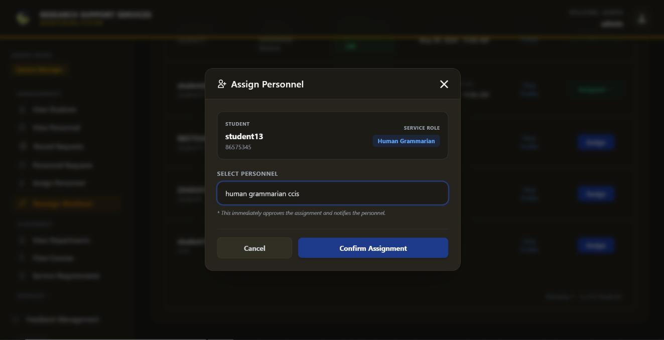

Figure 55. Administrator Assign Personnel Modal
Triggered directly from the assignment dashboard, this focused modal allows the administrator to quickly link a specific student group with an available research staff member. The overlay presents the student’s core details alongside a dropdown menu containing only the personnel who are actively assigned to that student's specific department and required service role. Upon clicking "Confirm Assignment," the system immediately approves the pairing, unlocks the student's upload dashboard, and dispatches automated notifications to both parties.

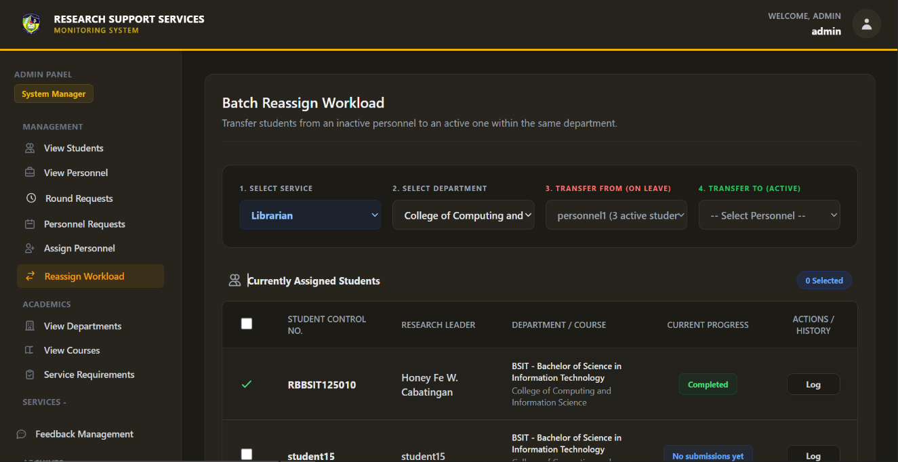
Figure 56. Administrator Batch Reassign Workload Interface
To address personnel absences or balance institutional workloads, administrators utilize this batch reassignment dashboard to seamlessly transfer student groups between active staff members. The admin sequentially filters the dashboard by selecting the required service role, specific academic department, and the original "inactive" personnel, which instantly populates the ledger with all currently assigned students. After selecting the desired student profiles via checkboxes and choosing a new active recipient from the dropdown, the administrator executes the batch transfer, automatically migrating document access and notifying all involved parties.
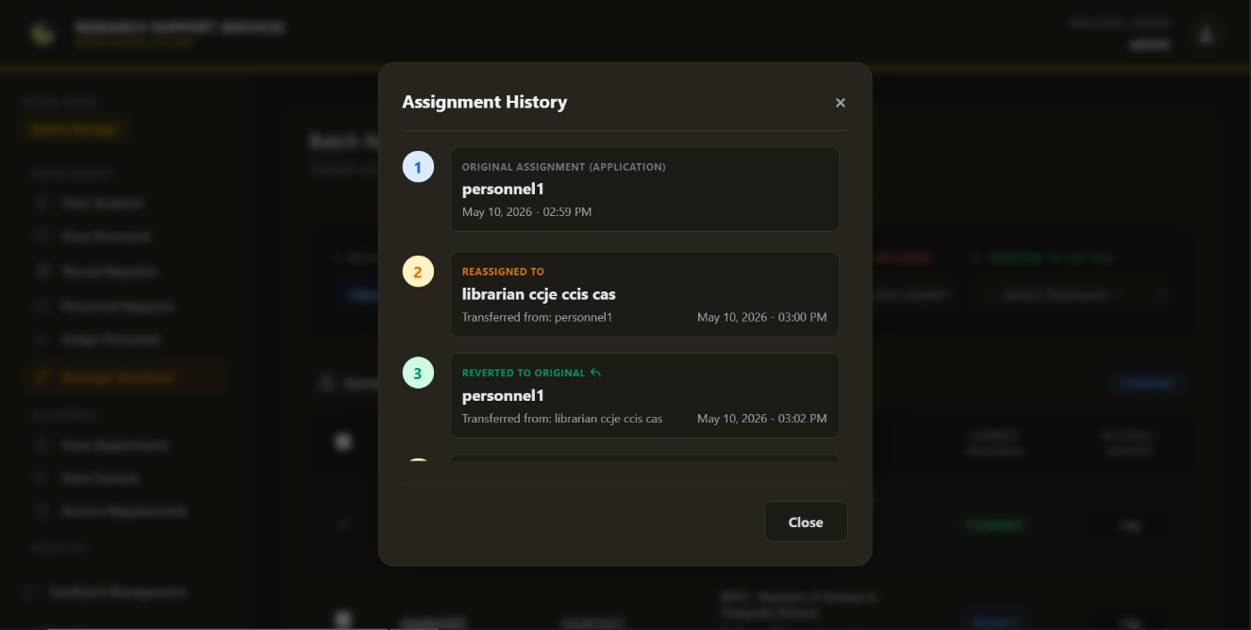
Figure 57. Administrator Assignment History Log
Administrators can actively audit the administrative chain of custody for any specific student group by accessing this detailed assignment history modal directly from the reassignment ledger. The overlay provides a chronological, numbered timeline that explicitly details the original application assignment and every subsequent personnel transfer, including reversions back to original staff. This granular historical record ensures complete institutional transparency, allowing the system administrator to track exactly when and to whom a research document was delegated at any given time.

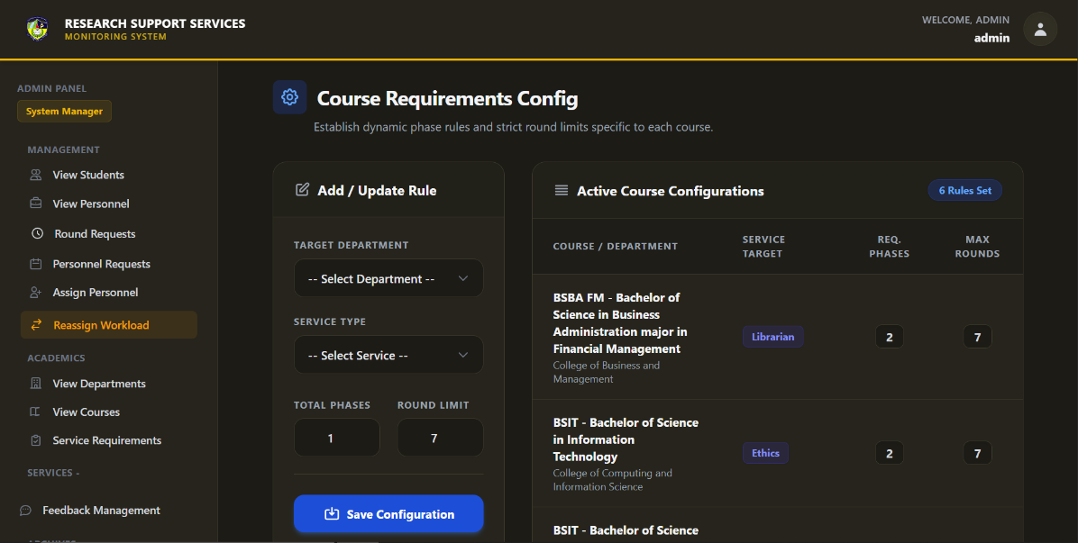
Figure 58. Administrator Course Requirements Configuration Interface
The Administrator utilizes this configuration module to establish strict, dynamic compliance rules for document submissions across various academic departments and specific service roles. By using the dedicated rule-creation form, the administrator defines the exact number of required evaluation phases and maximum permissible revision rounds for each specific research service. Once saved, these structural parameters are instantly applied to the active configuration ledger, automatically enforcing these operational limits on all student dashboards within the targeted academic program.
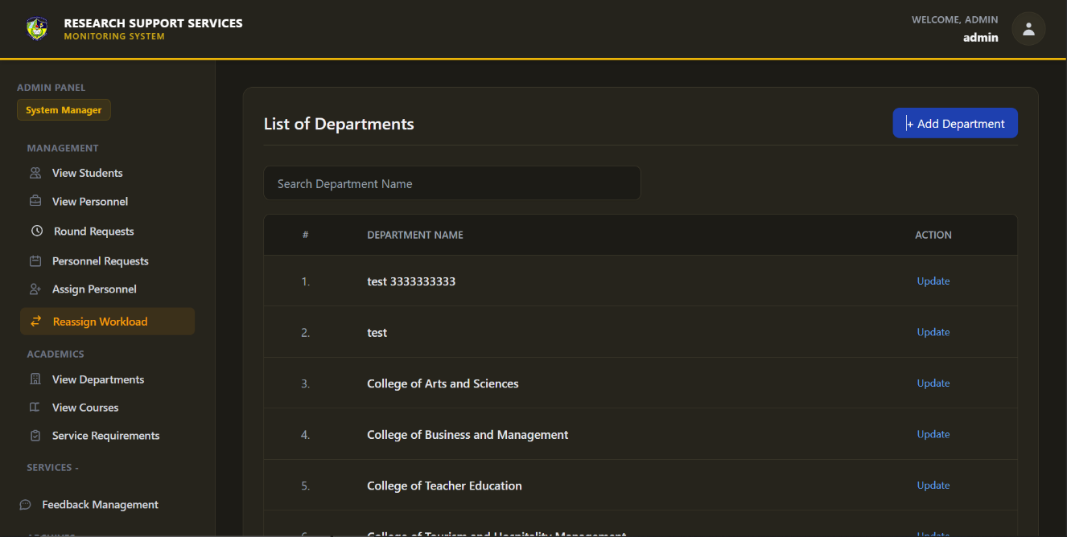
Figure 59. Administrator Departments Management Interface
The Administrator relies on this foundational interface to build and manage the overarching organizational structure of the institution's academic departments. Through this centralized hub, the administrator can efficiently search existing departmental records, update organizational nomenclature, or formally register newly established colleges into the platform. This macro-level organization is essential for the system's routing logic, ensuring that students, courses, and research personnel are accurately categorized and systematically mapped together. 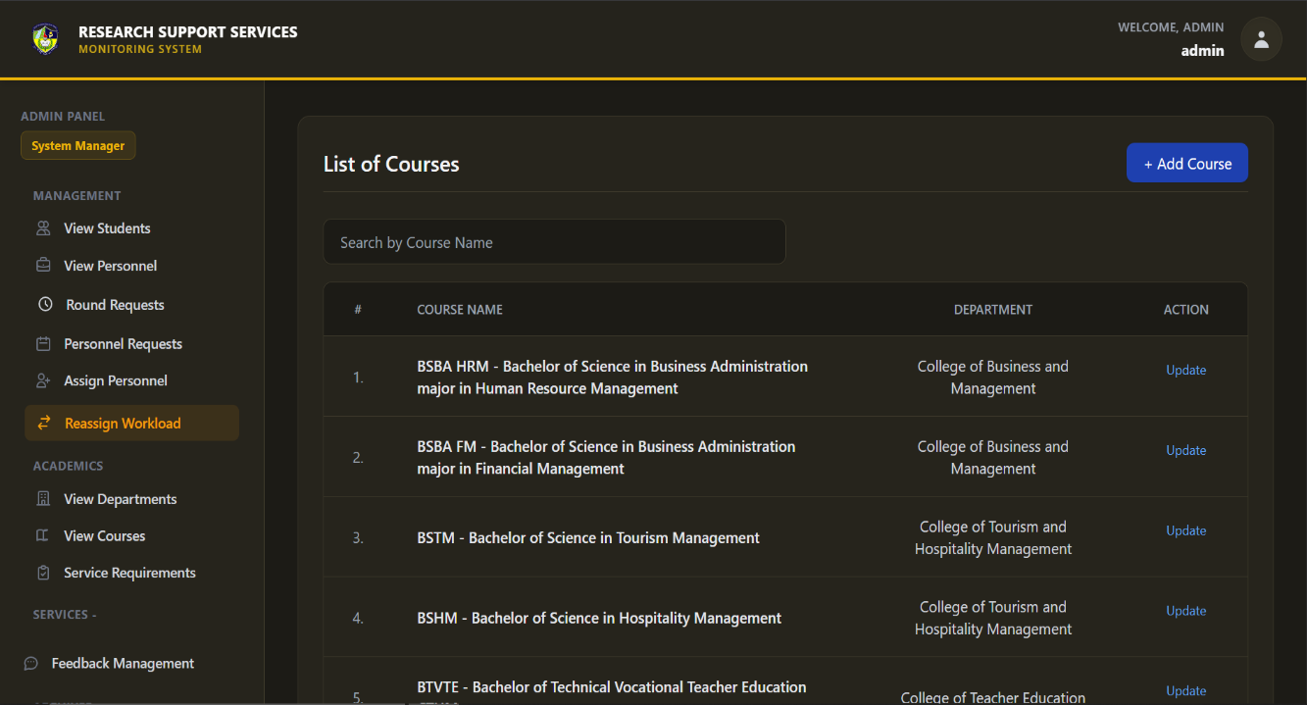
Figure 60. Administrator Courses Management Interface
This dedicated academic management interface allows the System Administrator to centrally organize and maintain the institution's official list of active academic courses. Administrators can actively search the existing ledger, update specific course nomenclature, or introduce entirely new programs into the system using the designated action buttons. Maintaining this accurate course database is critical, as it structurally links student registrations to their parent departments and dictates their specific research requirements.

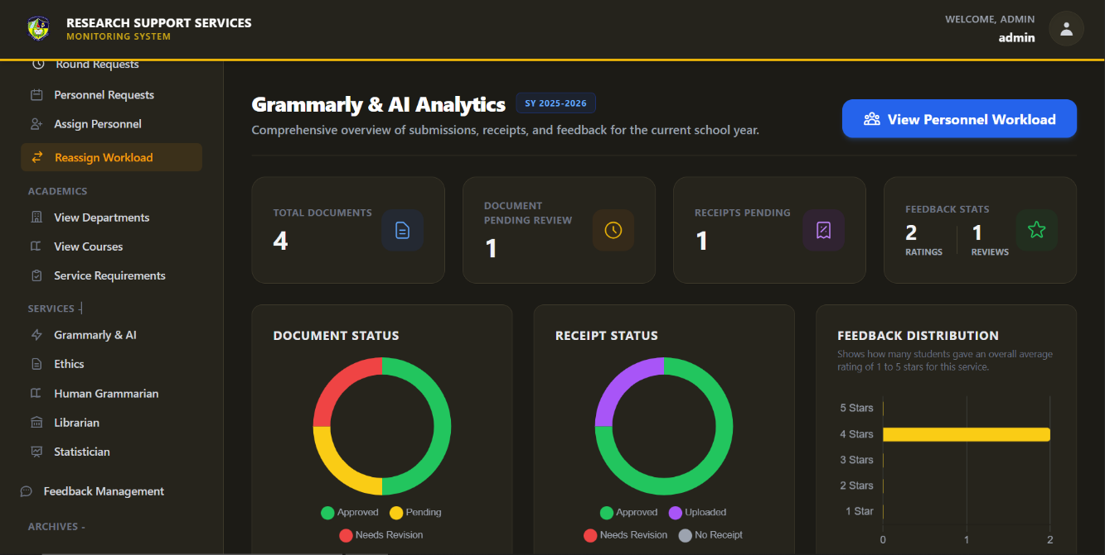
Figure 61. Administrator Grammarly & AI Analytics Dashboard
The Administrator relies on this comprehensive analytics dashboard to monitor the macro-level operational health of the Grammarly & AI Checking service for the active school year. The interface automatically aggregates system-wide data, utilizing interactive donut charts and bar graphs to visualize overall document statuses, receipt processing metrics, and the distribution of student feedback ratings. Analyzing this centralized data allows the administration to assess the overall efficiency of the service, identify systemic delays, and evaluate overall student satisfaction.

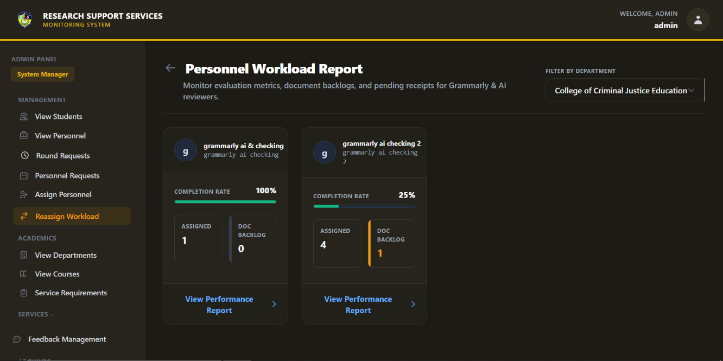
Figure 62. Administrator Personnel Workload Report Interface
This dedicated reporting interface provides the System Administrator with a macro-level overview of personnel efficiency across specific academic departments. By selecting a department from the dropdown filter, the dashboard generates individualized performance cards for each active staff member within that unit, highlighting their completion rates and current document backlogs. This comparative layout allows administrators to quickly identify underperforming personnel or overloaded staff members who may require workload redistribution.
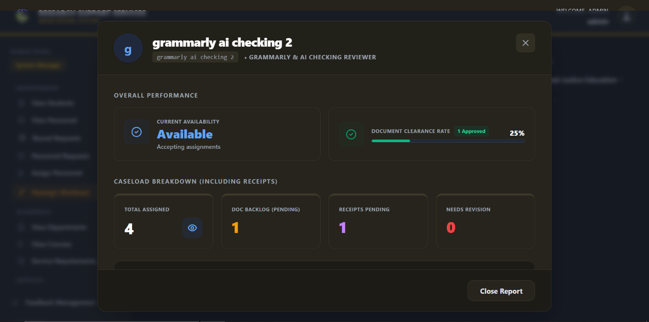
Figure 63. Administrator Personnel Overall Performance
Administrators utilize this analytical to evaluate the operational efficiency and current availability of individual research personnel. The overlay calculates and visualizes key performance indicators, such as the evaluator's document clearance rate, total assigned workload, and specific backlogs regarding pending documents and receipts. By reviewing these centralized metrics, the System Administrator can make informed, data-driven decisions regarding future student assignments and necessary workload rebalancing.
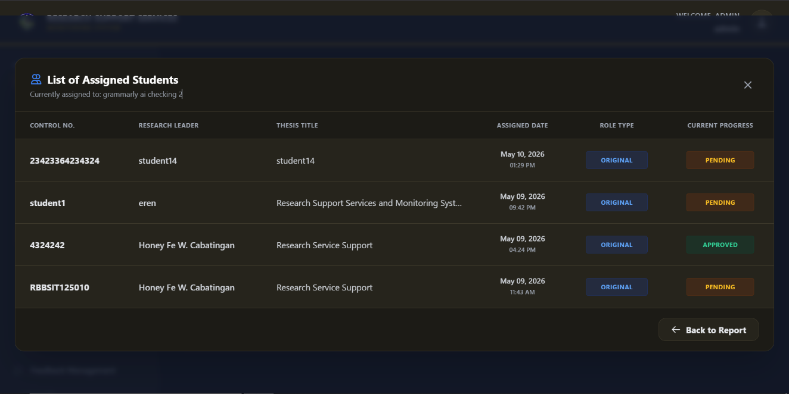
Figure 64. Administrator List of Assigned Students
To review the active caseload of specific research personnel, the administrator triggers this detailed overlay directly from the personnel ledger. It dynamically populates a comprehensive list of all student groups currently assigned to that specific evaluator, detailing each group's control number, thesis title, and current document progress. This localized view enables the administrator to rapidly assess individual staff workloads and identify potential bottlenecks without navigating away from the primary management dashboard.

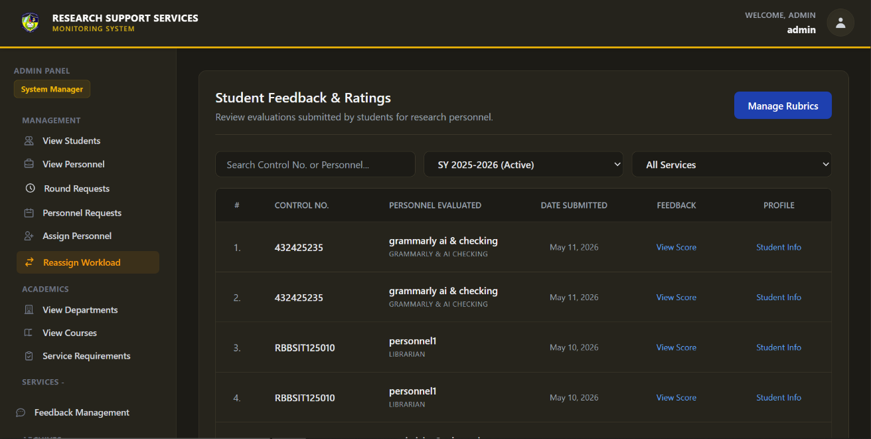
Figure 65. Administrator Student Feedback & Ratings Dashboard
The Administrator utilizes this comprehensive tracking dashboard to monitor all evaluations submitted by students across the institution. By applying dynamic dropdown filters for specific active school years and distinct service types, the admin can efficiently isolate and review feedback targeted at particular departments or personnel. From this central ledger, administrators can click to view the granular evaluation score of a specific submission or securely check the underlying student profile for context.

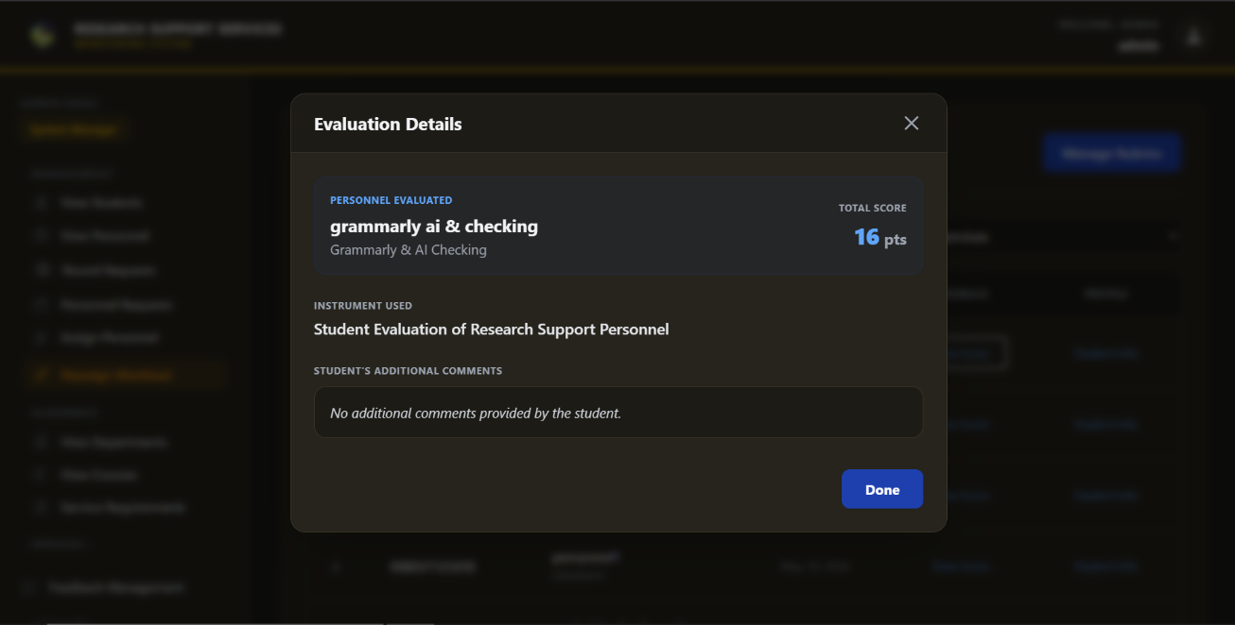
Figure 66. Administrator Evaluation Details
To investigate a specific student review, the administrator triggers this detailed evaluation modal directly from the main feedback ledger. The overlay provides a concise summary of the assessment, displaying the total aggregated score, the exact evaluation instrument utilized, and the specific personnel being rated. Additionally, it highlights any qualitative, open-ended comments provided by the student, granting the administrator deeper context behind the quantitative rating without disrupting their current workflow.
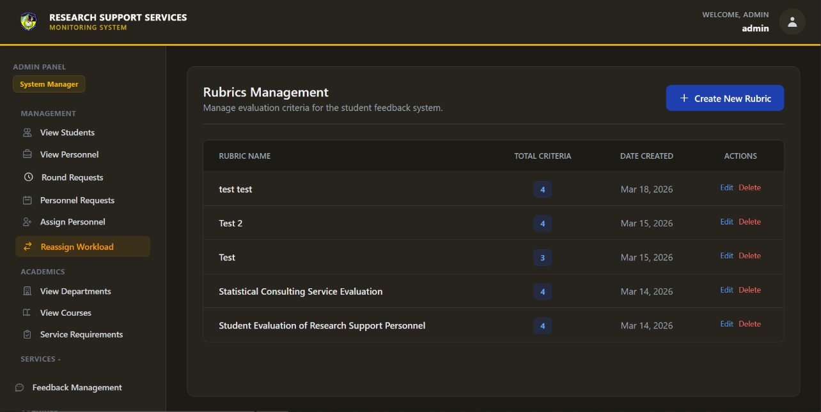
Figure 67. Administrator Rubrics Management Dashboard
This centralized management dashboard serves as the administrative repository for all active student feedback evaluation instruments within the platform. Administrators can review the overarching ledger to quickly identify the total number of specific criteria per rubric and the exact date each instrument was created. Furthermore, direct action buttons allow the admin to seamlessly edit existing rubrics to adapt to changing institutional standards or permanently delete outdated evaluation forms.

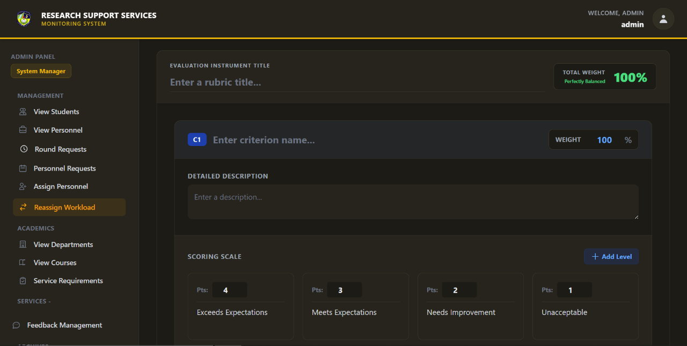
Figure 68. Administrator Evaluation Rubric Creation Interface
To standardize personnel performance assessments, the System Administrator utilizes this configuration module to build custom evaluation instruments. The admin defines the rubric's overarching title, adds specific evaluation criteria with designated percentage weights, and establishes a tiered scoring scale ranging from unacceptable to excellent. Once perfectly balanced and saved, this custom rubric becomes immediately available for students to utilize when formally rating their assigned research personnel.

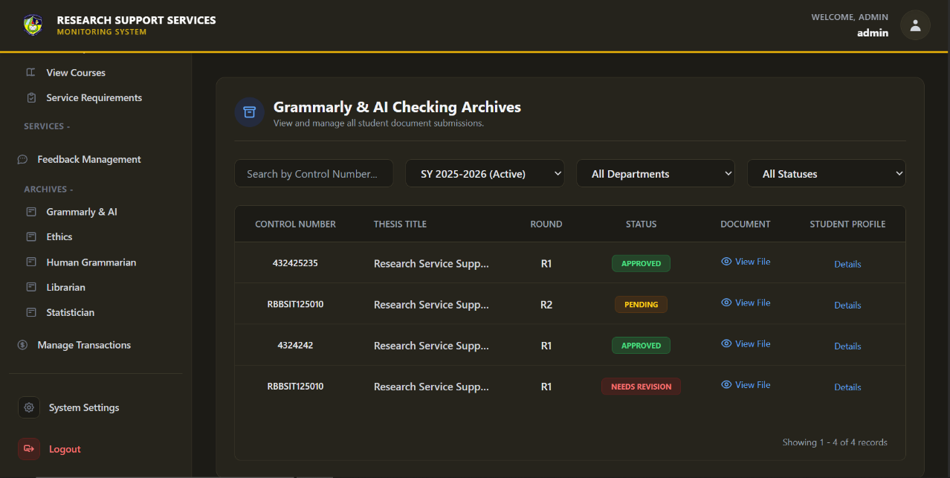
Figure 69. Administrator Service Archives
The Administrator utilizes this dedicated archive dashboard to securely access and review the complete historical ledger of all student document submissions for a specific research service. By employing dynamic dropdown filters for the academic year, department, and evaluation status, administrators can efficiently isolate and retrieve targeted institutional records. From this centralized repository, the admin can directly view the submitted manuscript files or click to access granular metadata regarding the student's research profile.

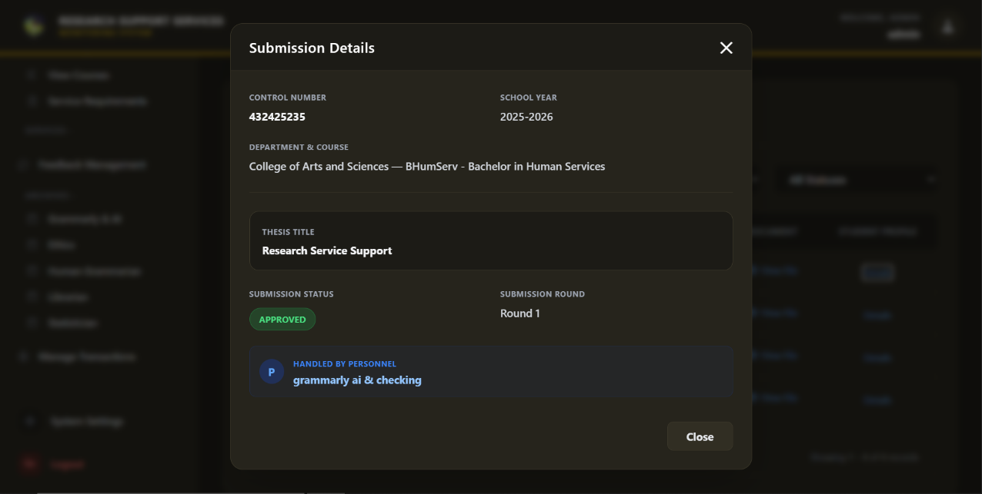
Figure 70. Administrator Submission Details
To investigate a specific archived record, the administrator triggers this detailed submission modal directly from the primary archival ledger. This read-only overlay instantly aggregates and displays critical metadata tied to the document, including the research group's academic alignment, the active thesis title, and the specific round of submission. Furthermore, it clearly identifies the exact research personnel responsible for handling the evaluation, ensuring strict administrative traceability and institutional accountability.

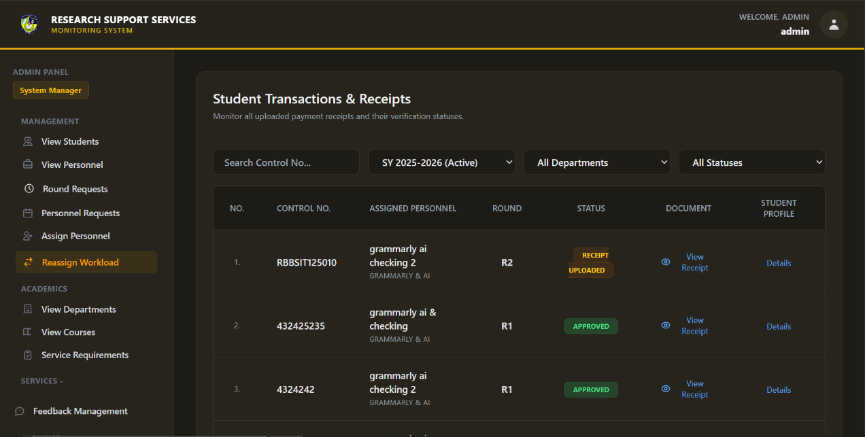
Figure 71. Administrator Student Transactions & Receipts
This financial tracking dashboard empowers the Administrator to monitor and audit all student payment receipts uploaded specifically for the Grammarly & AI Checking service. The administrator can utilize multi-layered filters to sort transactions by academic year, department, or validation status to efficiently manage the institution's financial compliance queue. From this ledger, the admin can securely view the attached receipt documents, verify the assigned personnel handling the round, and access the student's underlying profile for complete transactional transparency.

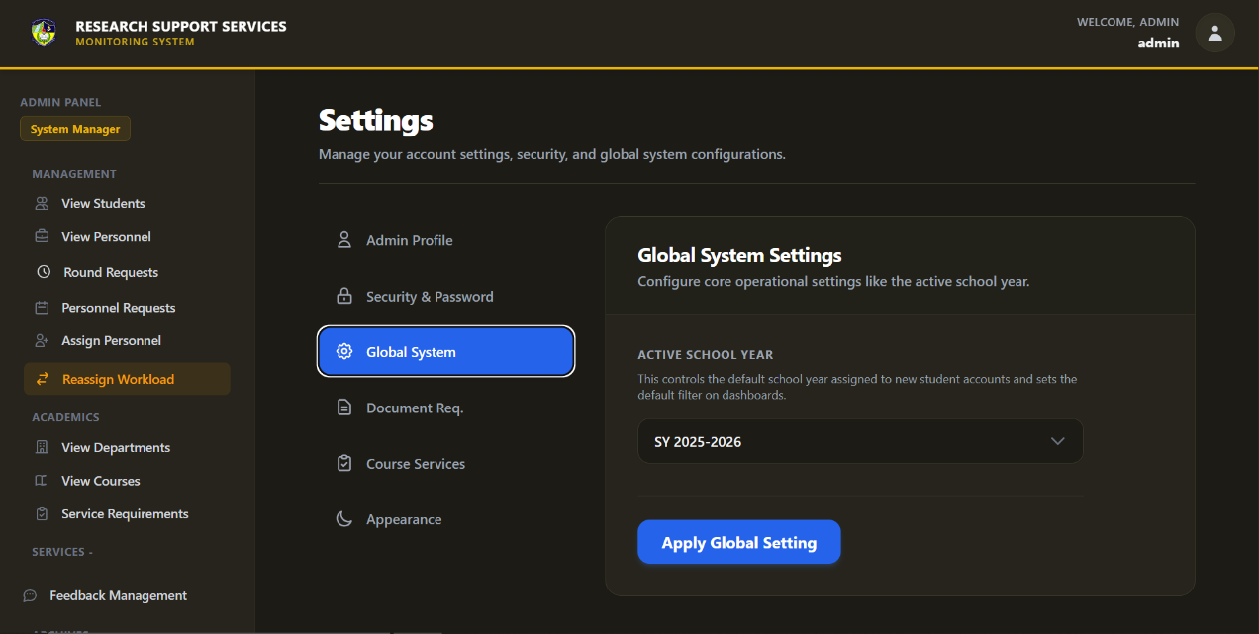
Figure 72. Administrator Global System Settings Interface
The System Administrator relies on this high-level configuration panel to establish and manage the core operational parameters of the entire monitoring system. By utilizing the global settings toggle, the admin securely dictates the currently active academic school year, which serves as the foundational data filter for all institutional records. Applying this global setting automatically synchronizes all administrative dashboards, archive ledgers, and newly created student accounts to operate within the designated timeframe.

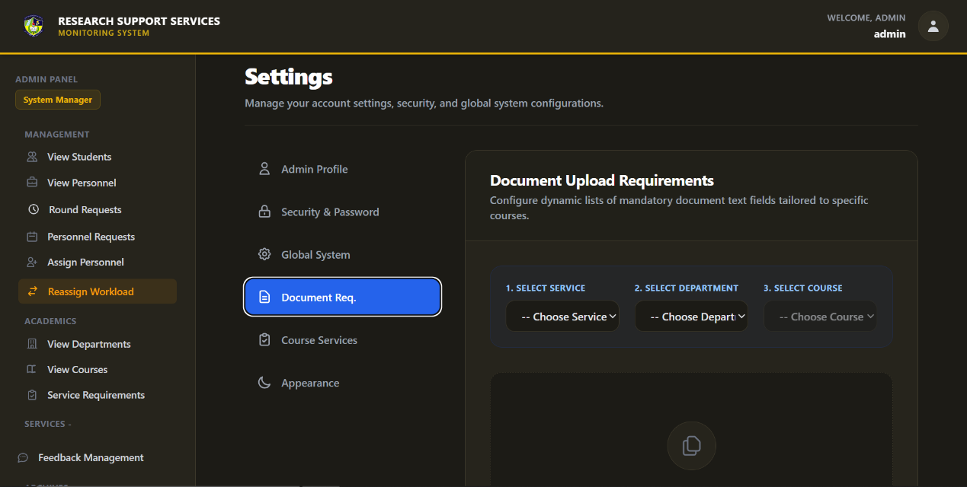
Figure 73. Administrator Document Requirements Configuration Interface
To enforce standardized submission protocols, the Administrator accesses this interface to configure dynamic lists of mandatory document requirements tailored to specific courses and service roles. The admin sequentially selects the target service, department, and course to input detailed, textual instructions outlining exactly what files the students must prepare. These established guidelines are then prominently displayed via collapsible menus on the respective student upload dashboards to ensure compliance before file submission.

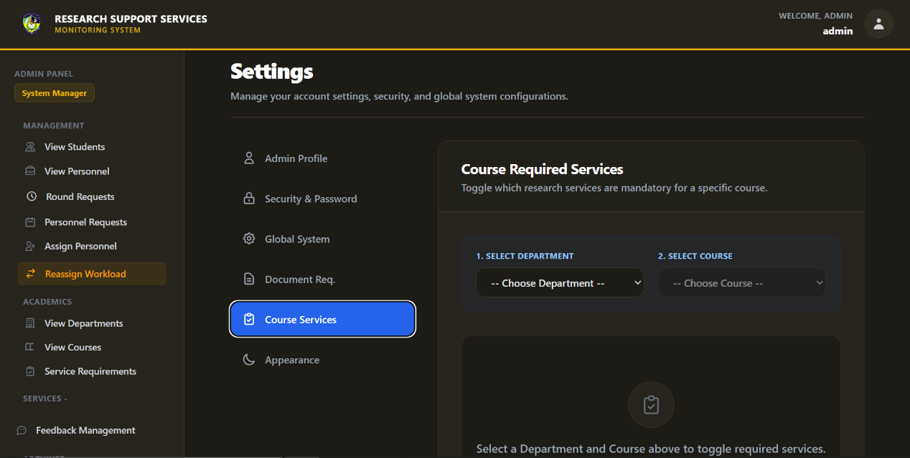
Figure 74. Administrator Course Services Configuration Interface
The Administrator utilizes this configuration module to explicitly define which research support services are mandatory for specific academic courses. By sequentially selecting a target department and course from the dropdown menus, the administrator can toggle the activation of individual services, such as Ethics or Statistician reviews. Once applied, these configurations dynamically customize the student dashboard, ensuring research groups only interact with the clearance protocols required for their specific curriculum.

Table 1

Software Platforms, Development Environments, and Tools

Components | Specification | Usage
Internet Browser | Any (Chrome, Edge, Firefox, etc.) | Internet Browser serves as the primary client interface for all users of your RSSMS including Students, Admin, and Personnel. Through the browser, users access the React.js frontend, which is rendered as a dynamic, responsive web interface styled with Tailwind CSS. This browser-based design allows users to log in, upload research files, communicate with assigned personnel, view service feedback, and process GCash payments — all without installing any software.
Front-end | HTML  Tailwind CSS  JavaScript | HTML (HyperText Markup Language) is used to design and structure the user interface of the RSSMS. It provides the layout for web pages such as login and registration forms, service selection pages, file submission forms, dashboards, and result viewing pages for students, personnel, and administrators. HTML ensures that system content is properly organized and accessible through standard web browsers.  Tailwind CSS is a utility-first CSS framework that simplifies the design process by providing pre-defined classes for styling. It is integrated into the RSSMS frontend to ensure a clean, modern, and responsive layout. Tailwind’s flexibility allows developers to quickly style components (e.g., buttons, tables, cards, modals) while maintaining design consistency across devices. Its customization features make it easy to align the system’s interface with institutional color schemes and accessibility standards, improving overall user experience.  JavaScript is used in the system to enhance interactivity and improve the overall user experience of the web application. It handles client-side functions such as form validation, dynamic content updates, user interface feedback, and asynchronous requests without requiring the page to reload. Through JavaScript, features like real-time input checking, dynamic rubric selection, file upload previews, and responsive user interactions are implemented to make the system more efficient, user-friendly, and reliable.
Server | XAMPP / APACHE | XAMPP, with its Apache web server and MySQL database, serves as the local development and deployment environment for the system. Apache is used to host and run the PHP-based backend of the application, while MySQL manages the storage of user accounts, submissions, feedback, ratings, and system records. XAMPP provides an integrated and stable environment that simplifies server configuration, database management, and testing during development.
Backend | PHP  SQL | PHP is utilized as the server-side scripting language of the RSSMS. It handles system logic such as user authentication and access control, processing of service submissions, file uploads and validation, review workflows, status updates, feedback handling, and communication between students and personnel. PHP also manages the integration with the PayMongo GCash payment gateway, verifies transactions, and controls access to result files and certificates based on payment status.  SQL (Structured Query Language) is used to manage and manipulate data stored in the MySQL database of the RSSMS. It supports the creation, retrieval, updating, and deletion of records related to students, personnel, services, submissions, payments, feedback, and transaction history. SQL ensures data integrity through relational constraints and enables efficient querying for system monitoring, reporting, and administrative decision-making.

Table 2

Hardware Requirements

Components | Specification | Usage
Device | RAM  Processor  HDD  SDD | RAM is used to temporarily store data and instructions that are actively being processed by the system. It allows the operating system, web server, and application programs to run smoothly by providing fast access to frequently used data, which improves system responsiveness and multitasking performance during development and deployment of the web-based system.  The processor is responsible for executing program instructions and performing all computational tasks of the system. It handles the processing of user requests, server-side scripts, database queries, and application logic, ensuring that the web application operates efficiently and responds quickly to user interactions.  The HDD is used as a primary storage device for storing the operating system, application files, databases, backups, and other system resources. It provides large-capacity, non-volatile storage to keep all system data persistent and accessible even when the computer is powered off.  The SSD is used for faster data storage and retrieval, particularly for the operating system, web server files, and frequently accessed application data. Compared to an HDD, it offers significantly faster boot times, quicker application loading, and improved overall system performance, which is beneficial for development, testing, and system operation.
Printer | Any Ink Jet  Printer Units | An inkjet printer is used to produce hard copies of documents such as reports, receipts, certificates, evaluation forms, and system-generated records. It supports the printing needs of the system by allowing users and administrators to generate physical copies of important files for documentation, submission, and archival purposes. This device is essential for preparing official outputs that require printed formats for review, approval, or record-keeping.

System Evaluation

The Research Support Services and Monitoring System (RSSMS) was evaluated using two approaches: the ISO 25010 quality model. This ensures the system is functionally reliable, user-friendly, and that its intelligent modules deliver accurate and meaningful assistance to researchers. Data was analyzed and interpreted using the following parameters:
Table 3

Adjectival Rating | Scale Range (Mean) | Verbal Interpretation
4 | 3.50 – 4.0 | Very Functional
3 | 2.50 – 3.49 | Functional
2 | 1.50 – 2.49 | Moderately Functional
1 | 1.0 – 1.49 | Poor Functional

Functional Suitability

Table 3 presents the criteria used to evaluate a product or System's functional suitability according to the ISO survey.
Table 4

Performance Efficiency

Adjectival Rating | Scale Range (Mean) | Verbal Interpretation
4 | 3.50 – 4.0 | Very Efficient
3 | 2.50 – 3.49 | Efficient
2 | 1.50 – 2.49 | Moderately Efficient
1 | 1.0 – 1.49 | Poor Efficient

Table 4 outlines the scoring parameters used to assess the System's overall performance efficiency in executing its functions and tasks.

Table 5

Usability
Adjectival Rating | Scale Range (Mean) | Verbal Interpretation
4 | 3.50 – 4.0 | Very Usable
3 | 2.50 – 3.49 | Usable
2 | 1.50 – 2.49 | Moderately Usable
1 | 1.0 – 1.49 | Poor Usable

Table 5 presents the scoring parameters used to assess the System's usability.

Table 6
Respondent’s Distribution
SMCC Learning Resource Center
Position | N (Population) | Percentage (%)
Research Head | 1 | 3%
Grammarly & AI Checking (RIID) | 7 | 20%
Statistician | 5 | 14%
Human Grammarian | 7 | 20%
Librarian | 3 | 9%
Ethics (REC) | 6 | 17%
Student | 6 | 40%
Total | 35 | 100

Table 6 outlines the distribution of respondents who participated in evaluating the system within the SMCC Learning Resource Center. The respondents are categorized based on their positions, with 24% holding personnel roles (Research Head and Research Support Staff) and 76% being students. This indicates that most feedback comes from students directly interacting with the system. Since they are the primary users, their insights provide a more accurate assessment of the system's functionality, efficiency, and usability in real-world scenarios.

2.11 Research Ethical Standards

A. Protection of Intellectual Property Rights (IPR)

The researchers recognize the importance of safeguarding intellectual property in the development of the Integrated Research Innovation System (IRIS). In accordance with the Philippine Intellectual Property Code (RA 8293), copyright protection applies to all outputs, including interface designs, source code, documentation, and system architecture, as these are original works of authorship. Patent protection does not apply since the system is not a novel invention under the law, while trademark protection is not currently sought unless the institution registers a logo or system name for branding purposes. Ownership of the system rests primarily with the student developers as creators, with Saint Michael College of Caraga holding shared rights in line with institutional research policies. This clarification ensures transparency, legal compliance, and proper recognition of intellectual property rights.

B. Informed Consent
Before the implementation, system testing, or data gathering, the researchers will clearly explain the study’s purpose, scope, and procedures to participants both verbally and in writing. A written consent form will be obtained prior to participation, ensuring that involvement will be voluntary and based on informed decision-making. The form will outline the minimal risks and potential benefits, as well as the participants’ right to withdraw at any time without penalty. This process will guarantee transparency, respect, and ethical responsibility in engaging with human participants.

C. Data Privacy and Confidentiality
The project will adhere to the Data Privacy Act of 2012 (RA 10173) to ensure the protection of sensitive information. Data to be collected will include uploaded research files, participant feedback, transaction logs, and personal information necessary for system testing and evaluation. During these processes, participant data will be anonymized or coded to prevent direct identification and to maintain confidentiality.
Access to all records will be strictly limited to authorized personnel such as the Research Director, System Administrator, and designated validators (grammarians, statisticians, librarians, and ethics reviewers). No data will be shared with third parties unless explicit participant consent or formal institutional authorization is obtained. All files and logs will be stored securely in the institutional database, protected through encryption, authentication, and role-based access controls. A retention policy will guide the storage and disposal of records, ensuring that data is deleted or anonymized after the specified period to prevent misuse.

D. Voluntary Participation and Freedom to Withdraw
Recruitment of participants will be conducted through formal invitations and announcements, ensuring that only those who are willing and eligible will be approached. Participation will be entirely voluntary, and authority figures such as advisers or administrators will not influence the decision to join. Refusal or withdrawal will not affect academic standing or institutional relationships. This assurance highlights that involvement in the study will be based solely on the participant’s choice, free from coercion, and guided by respect for autonomy.

E. Minimization of Harm and Risk Management
Participants may encounter certain risks during the testing and use of the Research Support Services and Monitoring System (RSSMS). These include privacy concerns, possible data misuse, technical errors, inconvenience during system testing, and discomfort in providing feedback. To minimize these risks, all uploaded research files, feedback, transaction logs, and personal information will be securely stored in the institutional database with encryption and role-based access controls. Participant data will be anonymized or coded during testing and evaluation to protect confidentiality. Technical support will be provided to address system errors or user difficulties, and participants will always have the option to withdraw from the study without penalty. These safeguards ensure that risks remain minimal and manageable while maintaining ethical responsibility.

F. Beneficence and Contribution to Knowledge
The project is expected to provide direct benefits to students, advisers, and research staff by offering faster feedback, reduced workload, and easier access to research support services such as grammar review, plagiarism detection, and statistical analysis. Indirect benefits may include improved workflow, greater transparency, and stronger collaboration between advisers and students. Results of the system will be shared with the Research Office and made available to participants, ensuring fairness and openness in research processes. Overall, the study is anticipated to contribute to knowledge by demonstrating how centralized digital platforms can enhance academic integrity, efficiency, and institutional development.

G. Justice and Fair Participant Selection
Participants will include enrolled students, faculty advisers, and research staff who are directly involved in research activities at Saint Michael College of Caraga. The inclusion criteria specify that only currently enrolled students, active faculty advisers, and designated research personnel such as grammarians, statisticians, and ethics reviewers may participate. Exclusion criteria apply to individuals outside the institution, non-enrolled persons, or those not directly connected to research activities. No participant will be excluded based on personal characteristics such as age, gender, socioeconomic status, or other social factors. This approach guarantees equal opportunity for all eligible stakeholders to contribute, aligning with the principles of justice and inclusivity.

H. Data Integrity and Accuracy
The system will enforce data validation, monitoring, and version control to maintain accuracy and reliability. Validation methods will include error-checking protocols, duplicate detection, and consistency reviews to ensure that records remain correct and tamper-free. Bias control will be applied by assigning reviewers based on expertise and role, preventing undue influence on results. Regular audits and feedback sessions will help maintain reliable and updated data, while any identified errors will be promptly corrected. This commitment ensures transparency, accountability, and the integrity of institutional research records.

I. Transparency and Honesty in Reporting
`The researchers will document and present all findings with honesty and accuracy. Any problems, limitations, or bugs encountered during system development and evaluation will be reported truthfully. Both favorable and unfavorable results from the system testing and evaluation will be included to ensure transparency and integrity. This commitment reinforces trust and credibility in the research process and guarantees accountability throughout the study.

J. Use of Patented or Copyrighted Materials
The system will integrate third-party tools and libraries strictly under their respective open-source or proprietary licenses. Documentation of these licenses, including software libraries, templates, and other copyrighted materials, will be attached or referenced in the project records to ensure compliance. No proprietary or patented technologies are being used in the system unless explicitly documented and approved. All third-party resources will be properly cited in the manuscript and system documentation to avoid copyright infringement and to acknowledge original creators. This approach ensures transparency, ethical compliance, and respect for intellectual property rights.

K. Considerations for Human Subjects
This study involves only human participants, specifically faculty advisers, students, and research personnel who will test the system, provide feedback, or participate in evaluation activities. No animal subjects are included in this research. Participation will involve minimal risk, such as possible inconvenience or academic pressure during testing, and safeguards will be in place to protect participants’ rights and privacy. Informed consent will be obtained prior to participation, and confidentiality of all records will be maintained through secure data handling and anonymization. Participants will also retain the right to withdraw at any time without penalty. These measures ensure that ethical standards are upheld throughout the conduct of the study.
L. Responsible Use of AI and Other Related Technologies
AI tools such as ChatGPT and Grammarly will be used only to support writing, grammar checking, organization, and idea refinement. These tools will not generate, alter, or manipulate research data, as all data collection, analysis, and validation will be conducted solely by the researchers. To ensure transparency, participants will be informed whenever AI-assisted writing or editing tools are used in the documentation process. All AI outputs will be reviewed and validated by the research team before inclusion, ensuring accuracy, reliability, and ethical compliance. Importantly, AI assistance will never replace human judgment, as final decisions and interpretations remain the responsibility of the researchers.

M. Responsible Use of AI and Other Technologies
Ethical clearance will be sought from the Research Ethics Committee of Saint Michael College of Caraga prior to any data gathering, system testing, or participant involvement. Approval will be obtained before implementation to ensure compliance with institutional, national, and international ethical standards. At this proposal stage, clearance is still pending, and this section will be updated to reflect the actual approval date and approving body once granted. This process guarantees that the study will be conducted responsibly, with respect for participants’ rights and adherence to established ethical guidelines.

CHAPTER III
RESULTS AND DISCUSSION
3.1 Requirement Analysis Result
The Research Support Services Monitoring System culminated in the development of comprehensive, service-specific analytics dashboards, directly addressing the institutional need for centralized, data-driven oversight. During the elicitation process, stakeholders identified that traditional, manual tracking of research manuscripts resulted in fragmented data, making it difficult to gauge overall operational efficiency. Consequently, a primary system requirement was established to translate complex, multi-departmental workflows into accessible, real-time visual metrics. The resulting analytics interfaces serve as the empirical realization of these administrative requirements, providing a unified vantage point to monitor the complete lifecycle of student submissions across various specialized services.
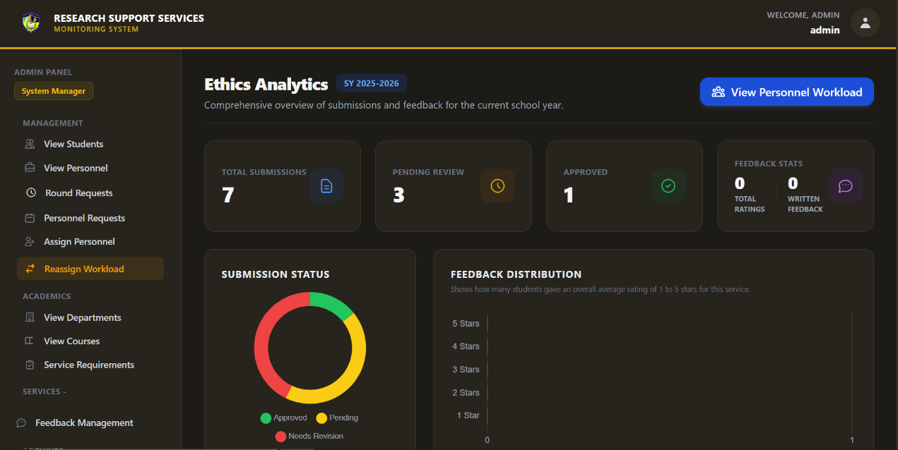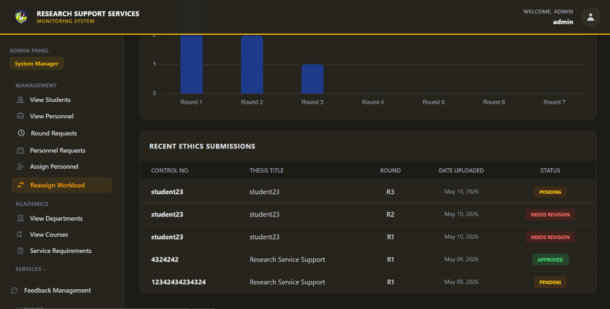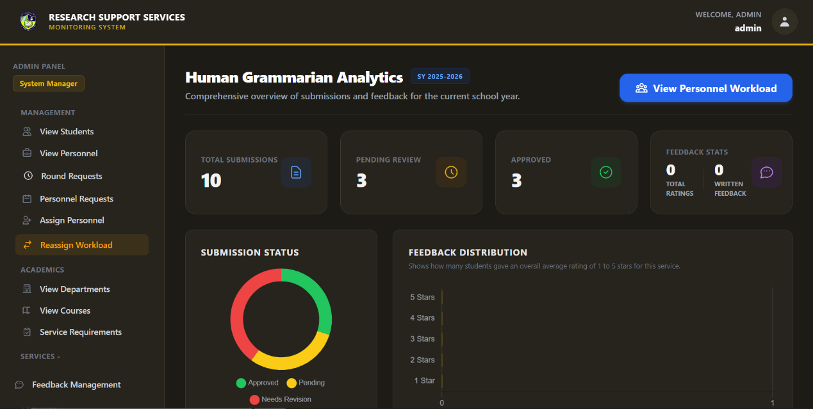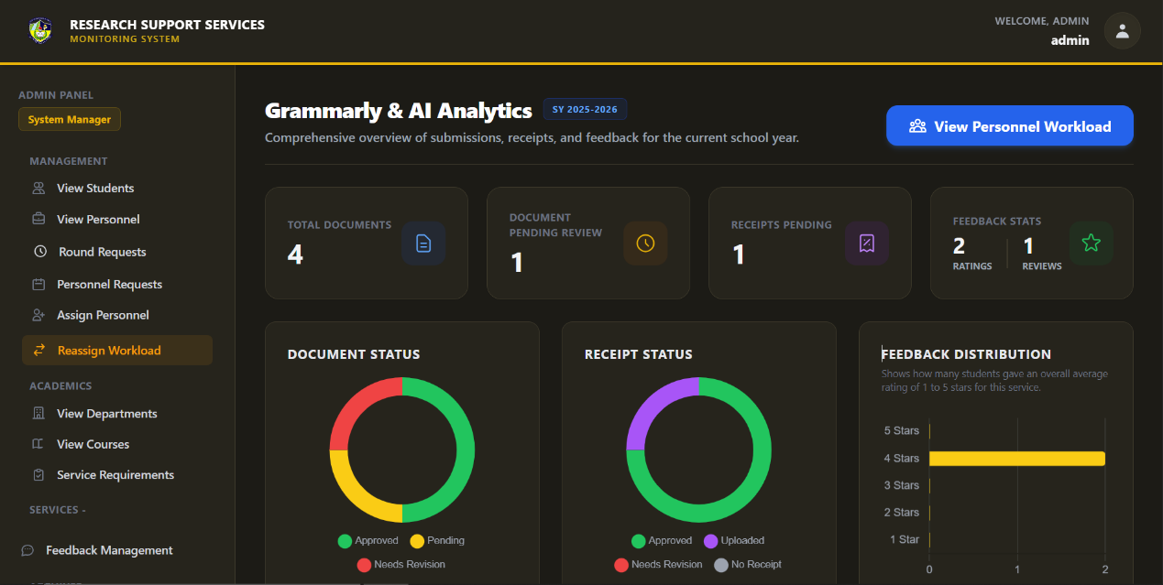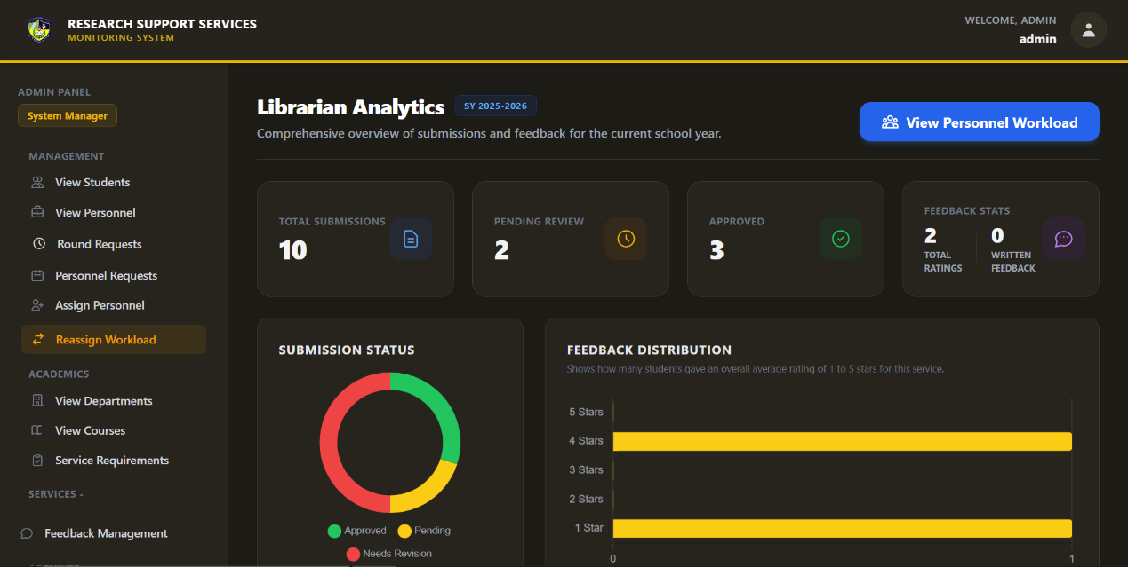
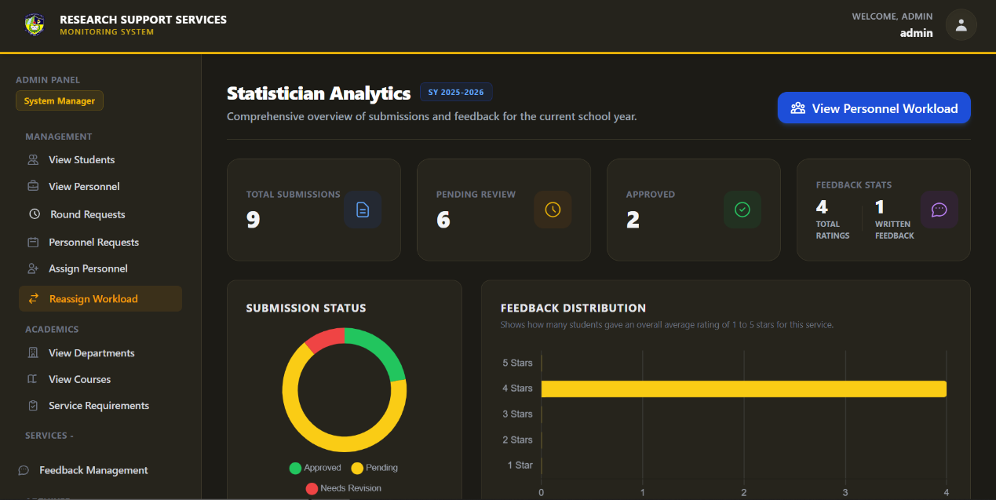
A critical requirement identified by the administration was the necessity for macro-level operational visibility to swiftly identify processing bottlenecks. To fulfill this need, the system’s architecture was designed to automatically aggregate raw database entries into top-level quantitative summaries, such as total submissions, pending reviews, and approved documents. These numerical indicators are paired with dynamic visualizations, specifically color-coded donut charts, which map the proportional status of all active documents. This design directly satisfies the requirement for an intuitive, at-a-glance monitoring tool, empowering administrators to assess system throughput and proactively manage document queues without undertaking tedious manual audits.

Furthermore, the requirement analysis revealed that a rigid, uniform monitoring approach would be insufficient, as different research support services possess highly specialized operational workflows. The system successfully addresses this need for structural adaptability by tailoring the analytics dashboards to reflect service-specific parameters. For instance, the Grammarly & AI Checking analytics module incorporates dedicated metrics for financial compliance, effectively tracking pending payment receipts alongside document statuses. Conversely, the Ethics Review module adapts to the highly iterative nature of ethical clearances by integrating multi-round tracking visualizations, proving the system's capacity to handle both linear and cyclical research approval protocols.

Institutional quality assurance and continuous service improvement were also established as non-negotiable administrative requirements. To transition subjective student experiences into actionable administrative data, the system integrates a robust feedback analytics engine. The dashboards explicitly display aggregated feedback statistics and map the distribution of student ratings across a standardized scoring scale. By fulfilling the requirement to quantify service quality, the administration is equipped with the necessary empirical evidence to monitor personnel professionalism, identify areas requiring intervention, and ensure that the institution's academic support standards are consistently maintained.

In conjunction with quality assurance, the administration required a functional mechanism to ensure equitable workload distribution and monitor the efficiency of individual research personnel. The overarching analytics dashboards directly address this by bridging macro-level service data with micro-level staff performance through integrated workload routing. By seamlessly connecting the general service analytics to specific personnel workload reports, the system fulfills the requirement for deep drill-down capabilities. This ensures that administrators can effortlessly trace systemic delays back to specific caseloads, allowing for the data-driven reassignment of staff and the optimization of institutional resources.

Ultimately, the developed analytics modules validate the integrity of the entire Requirement Analysis phase. By successfully mapping the identified administrative pain points to functional, automated tracking mechanisms, the system bridges the gap between institutional needs and technical execution. The resulting architecture not only streamlines the immediate oversight of research support services but also establishes a scalable, transparent framework that empowers the administration to continuously refine and optimize the academic research lifecycle.

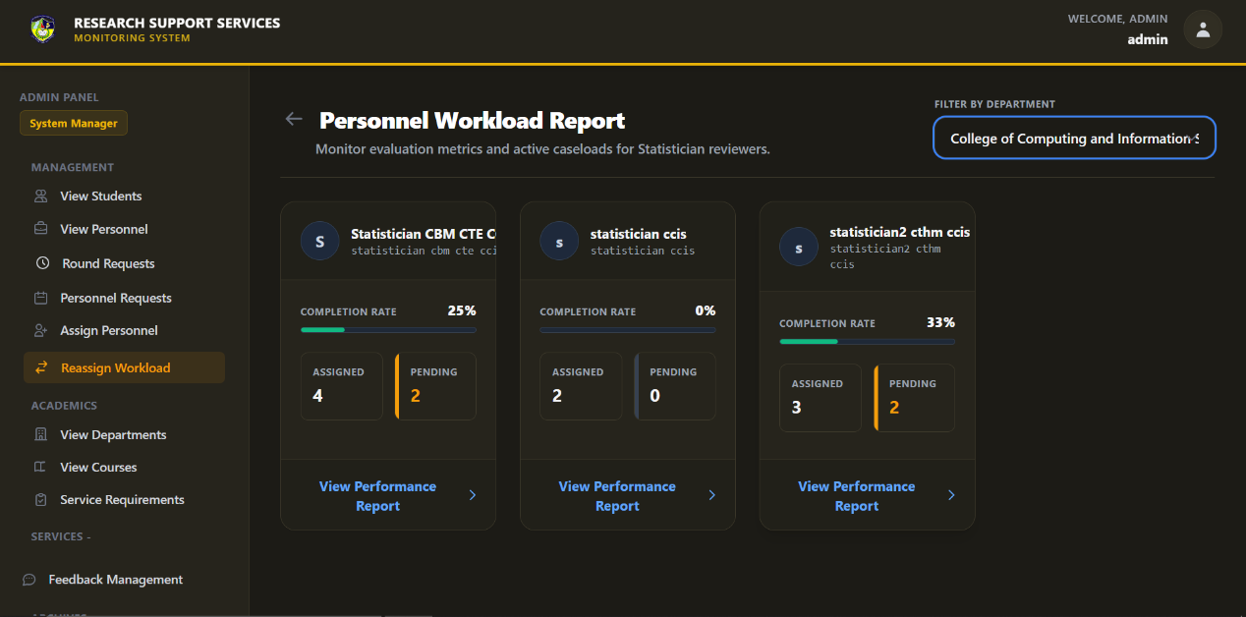
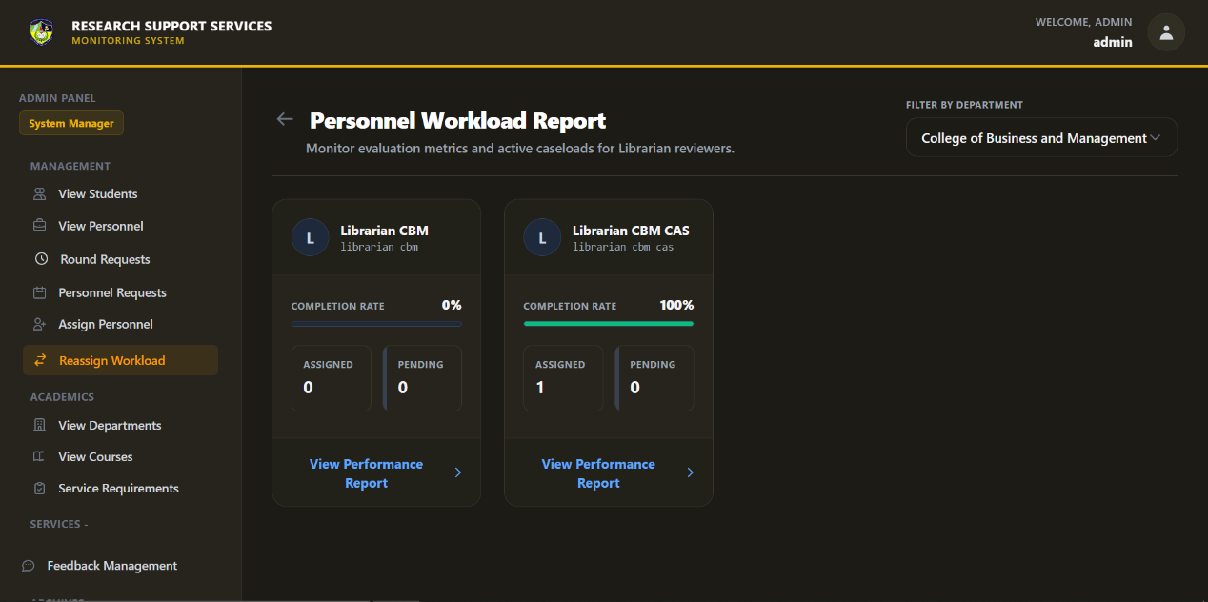
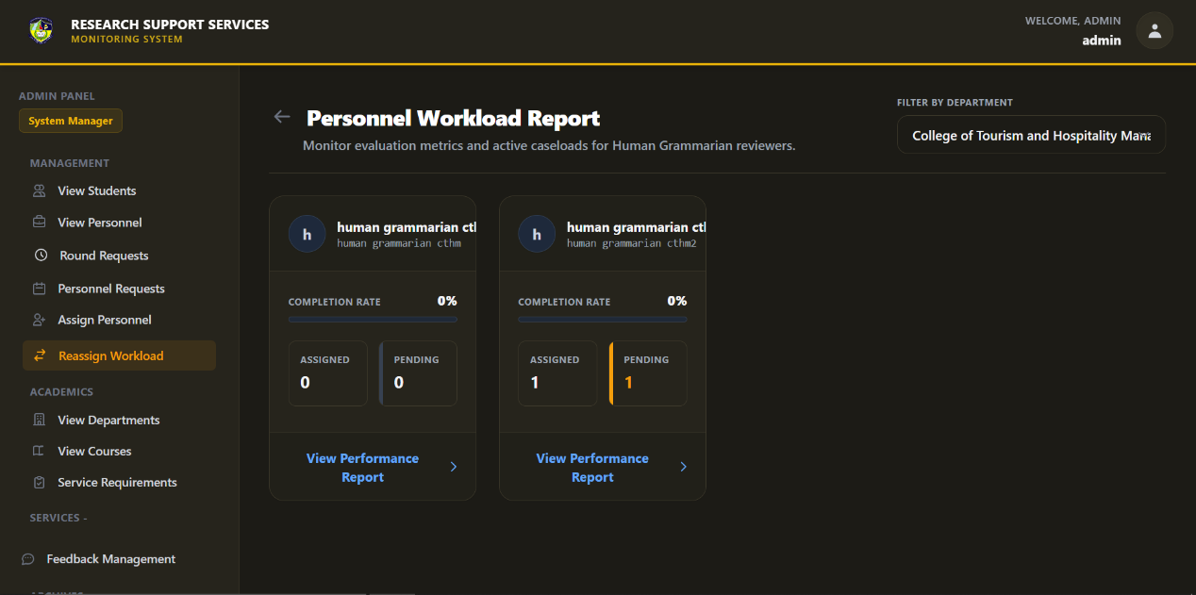

In the context, a critical operational challenge identified by institutional stakeholders was the inability to effectively monitor, evaluate, and balance the workload of research support staff across various departments. To prevent administrative bottlenecks and ensure timely clearance for students, the administration required a centralized mechanism to track human resource efficiency. The empirical realization of this requirement is evident in the deployment of dedicated Personnel Workload Reports spanning all core research services—including Grammarly & AI Checking, Ethics, Human Grammarian, Librarian, and Statistician workflows. This analytical module successfully shifts the system's tracking focus from the static document lifecycle to the active management of the personnel responsible for processing them.

To fulfill the requirement for scalable, cross-service monitoring, the system integrates a standardized reporting architecture that evaluates staff performance using consistent, quantifiable metrics. Through the workload dashboard, administrators are presented with comparative performance cards that detail real-time completion rates, total assigned submissions, and active document backlogs. This visual aggregation of performance data directly addresses the administration's need to quickly identify overloaded staff members or underutilized reviewers. By translating complex assignment queues into accessible percentage bars and numerical counters, the system provides the empirical evidence necessary for administrators to make informed, data-driven decisions regarding workload reassignment.

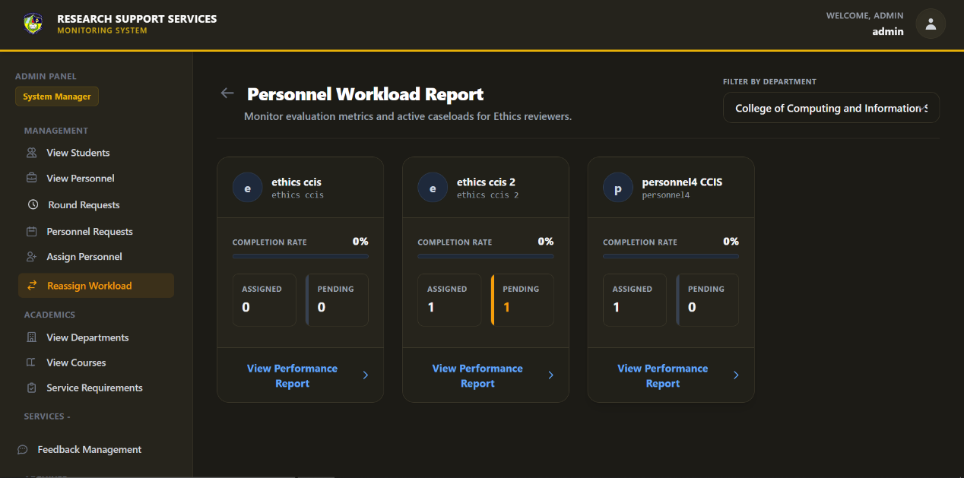

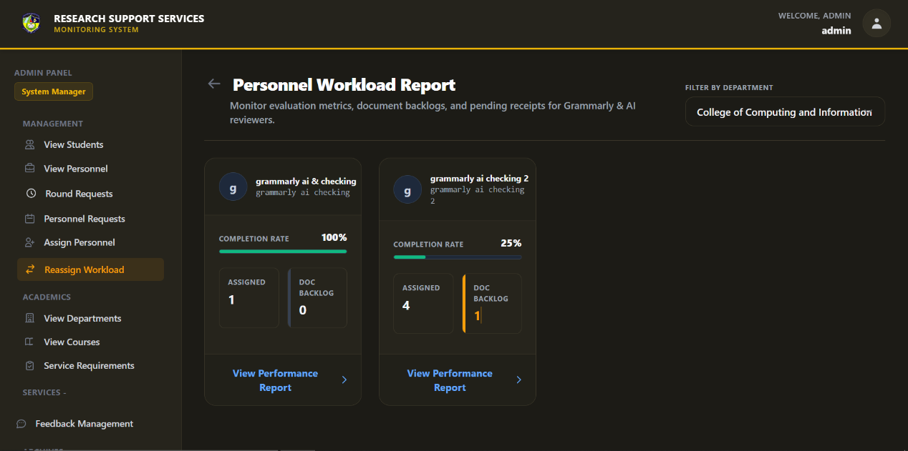

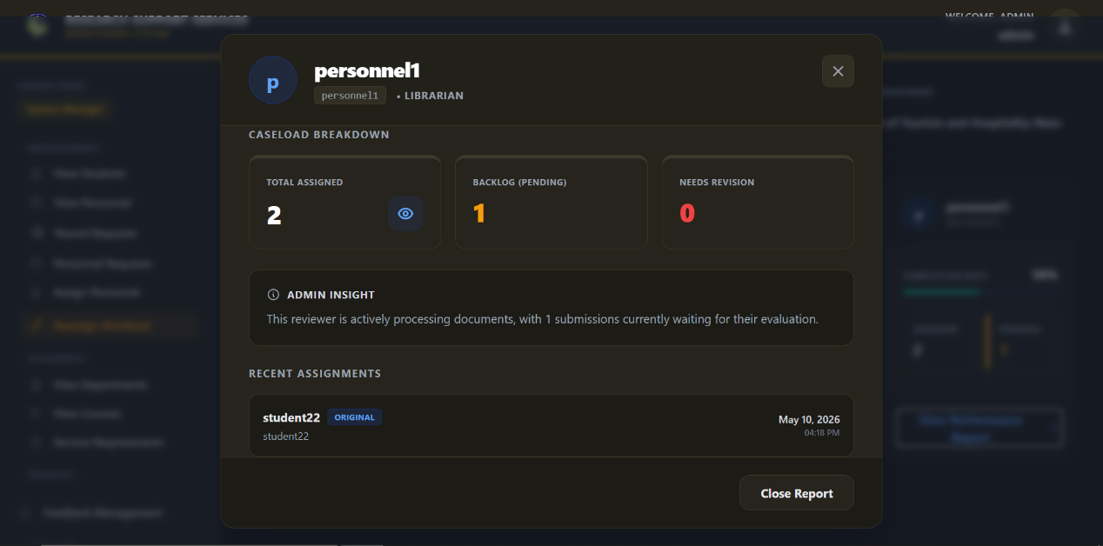

The workload reporting interfaces satisfy this requirement by incorporating dynamic departmental filtering. This functionality allows the System Administrator to seamlessly isolate performance metrics within specific colleges, such as the College of Computing and Information Science or the College of Business and Management. By enabling localized monitoring, the system ensures that administrators can maintain strict quality control, pinpoint localized bottlenecks, and optimize the operational flow within distinct academic units.

The administrative requirement for actionable, deep-dive intelligence is fulfilled through the detailed Caseload Breakdown modals. When an administrator investigates a specific personnel profile, the system generates a granular view of their active queue, explicitly categorizing tasks by total assignments, pending backlogs, and documents currently flagged for revision. Crucially, this interface introduces an automated "Admin Insight" feature that synthesizes these metrics into a plain-text operational status, instantly contextualizing the reviewer's current processing capacity. Paired with a chronological log of recent assignments, this granular tracking capability ensures total institutional transparency, empowering the administration to preemptively resolve workflow delays before they severely impact the students' research timelines.

3.2 System Development Output
The Research Support Services Monitoring System (RSSMS) is a centralized, comprehensive digital platform designed to streamline and manage the entire academic research evaluation lifecycle. By transitioning traditional, fragmented manuscript review processes into an automated web-based environment, the system effectively bridges the communication and workflow gaps between students, specialized research personnel, and institutional administrators. The platform structurally accommodates a multi-tiered clearance process—encompassing Grammarly & AI Checking, Ethics Review, Human Grammarian evaluation, Librarian compliance, and Statistical consulting—ensuring that research groups are systematically guided through their mandatory institutional requirements. Through real-time dashboard tracking, secure file management, and integrated direct communication channels, RSSMS eliminates manual workflow bottlenecks and fosters a transparent, highly organized academic support ecosystem.

Beyond facilitating document submissions and evaluations, the core strength of the RSSMS lies in its robust administrative oversight and quality assurance capabilities. The system empowers institutional administrators with dynamic analytics dashboards that aggregate complex operational data into actionable visualizations, allowing for real-time tracking of institutional throughput, document backlogs, and financial receipt verifications. Furthermore, the platform integrates sophisticated workload management modules and standardized, rubric-based feedback engines. This enables the administration to equitably distribute caseloads among active personnel, audit detailed assignment histories, and continuously monitor staff performance based on quantitative student evaluations. Ultimately, RSSMS acts as an indispensable institutional tool that not only expedites student research clearances but also provides the empirical data necessary to optimize operational workflows and uphold rigorous educational standards.

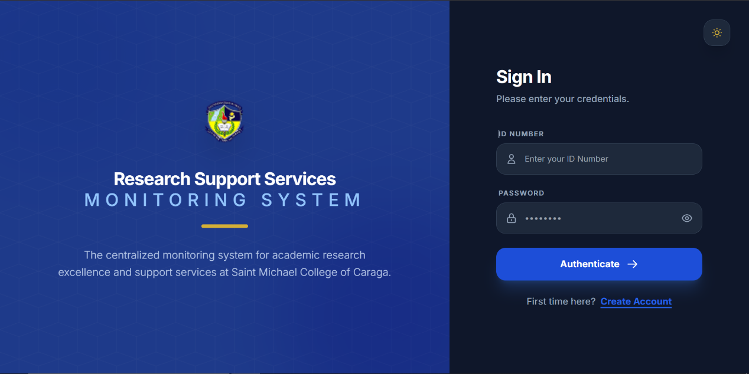
Figure 75. User Authentication Interface
Users access the platform through this centralized login portal by inputting their registered institutional ID number and secure password. Upon clicking "Authenticate," the system verifies the credentials against the database and automatically routes the user to their designated dashboard based on their specific system role.
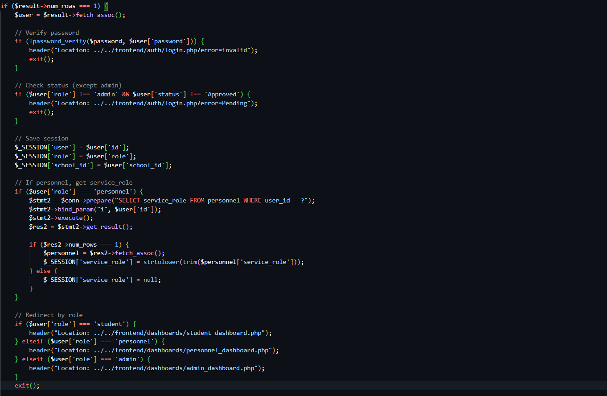
Figure 76. Code Snippet for RSSMS - User Authentication Interface
This securely authenticates the user by verifying their hashed password, checks if their account status is approved, initializes vital session variables, and executes conditional redirects to route students, personnel, and administrators to their respective dashboards.
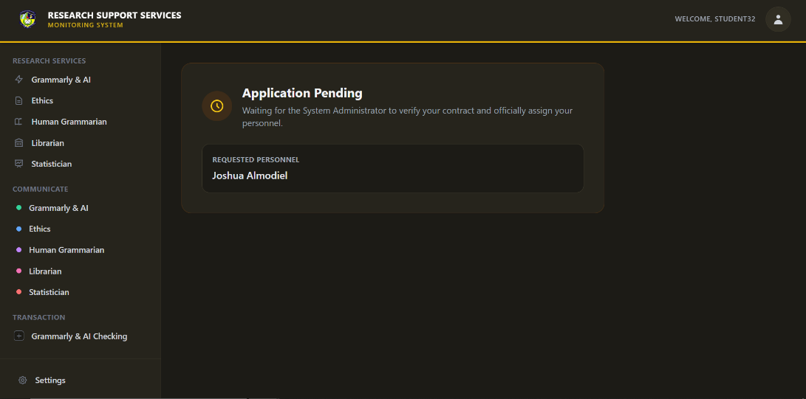
Figure 77. Student Pending Statistician Application Interface
After successfully submitting their signed contract and selecting a preferred statistician, the student is routed to this pending interface where document uploads are temporarily restricted. The dashboard remains locked in this state until the System Administrator formally verifies the attached agreement and officially approves the requested personnel assignment.

Figure 78. Code Snippet for RSSMS - Student Pending Statistician Application Interface
This script securely processes the student's manual statistician request by enforcing strict service-type validation and safely handling the upload, extension verification, and directory storage of the required contract file.
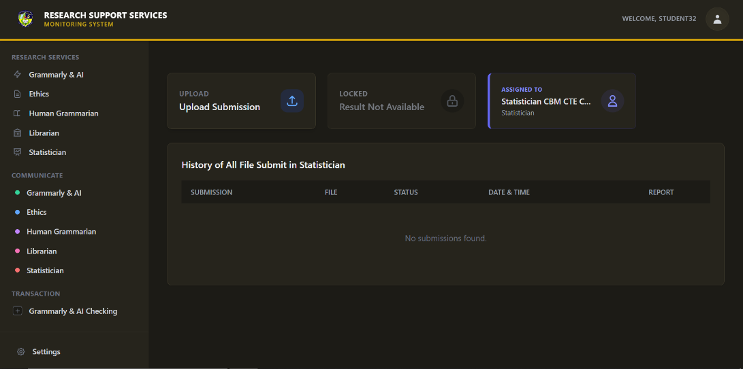
Figure 79. Student Statistician Service
Once the System Administrator approves the personnel application, this dashboard unlocks, empowering the student to initiate their document submissions. It serves as the central hub for the student to track their historical submission rounds, monitor real-time evaluation statuses, and verify their officially assigned statistical personnel.

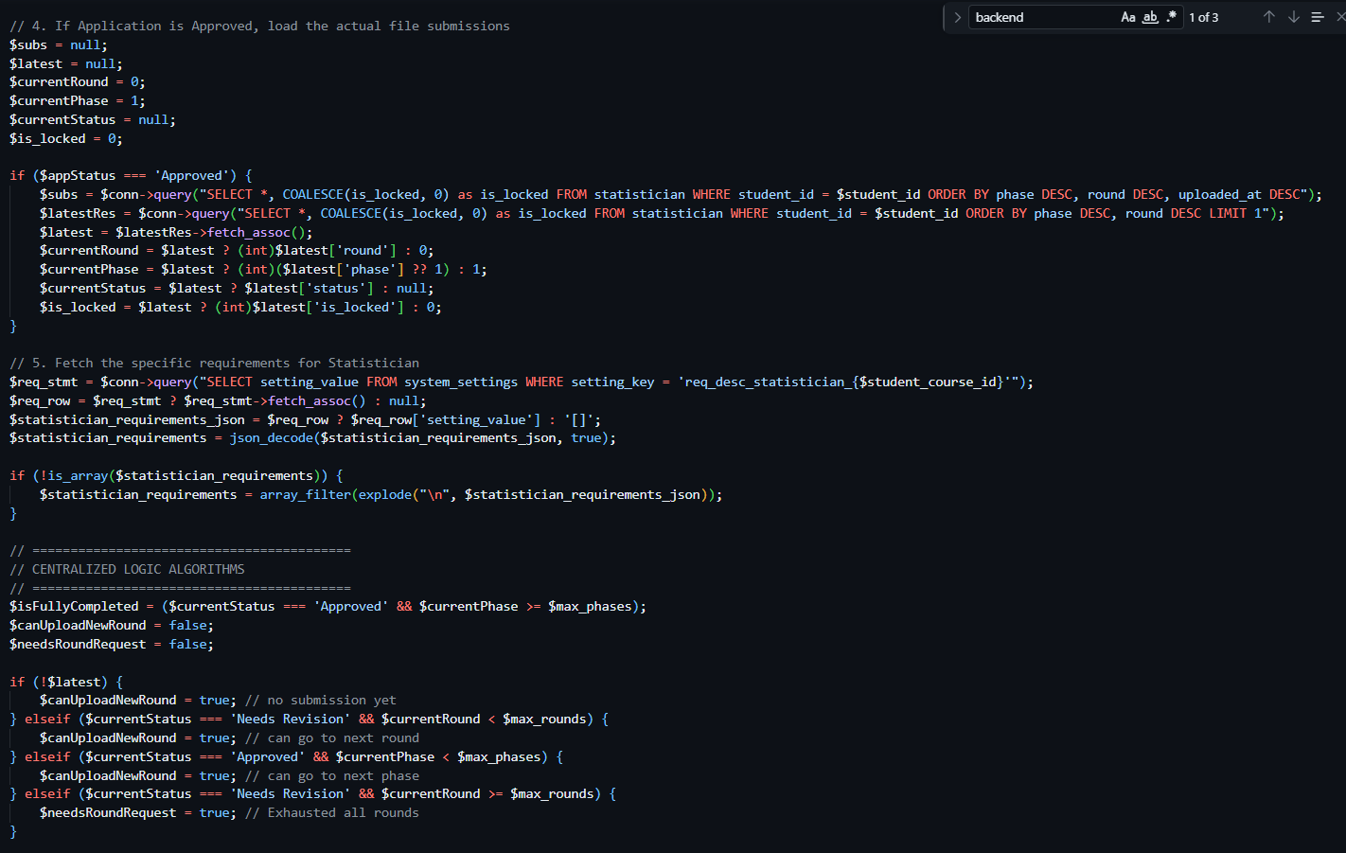
Figure 80. Code Snippet for RSSMS - Student Statistician Service
This utilizes centralized logic algorithms to fetch the student's latest submission record, dynamically comparing their current progress against administrator-defined maximum phase and round limits to determine if the user is authorized to trigger new file uploads on the front-end.
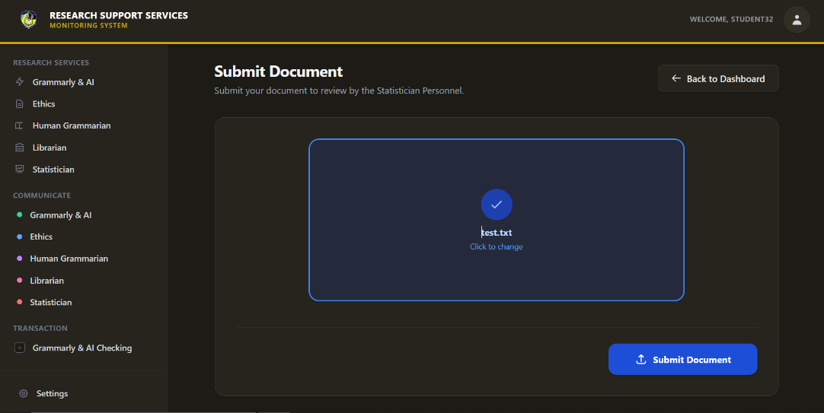
Figure 81. Student Statistician Document Upload Interface
Students utilize this dedicated interface to securely select and upload their raw data or research manuscripts for statistical computation. Clicking the submit button officially logs the file into the system database as a new evaluation round and queues it for the assigned statistician to review. 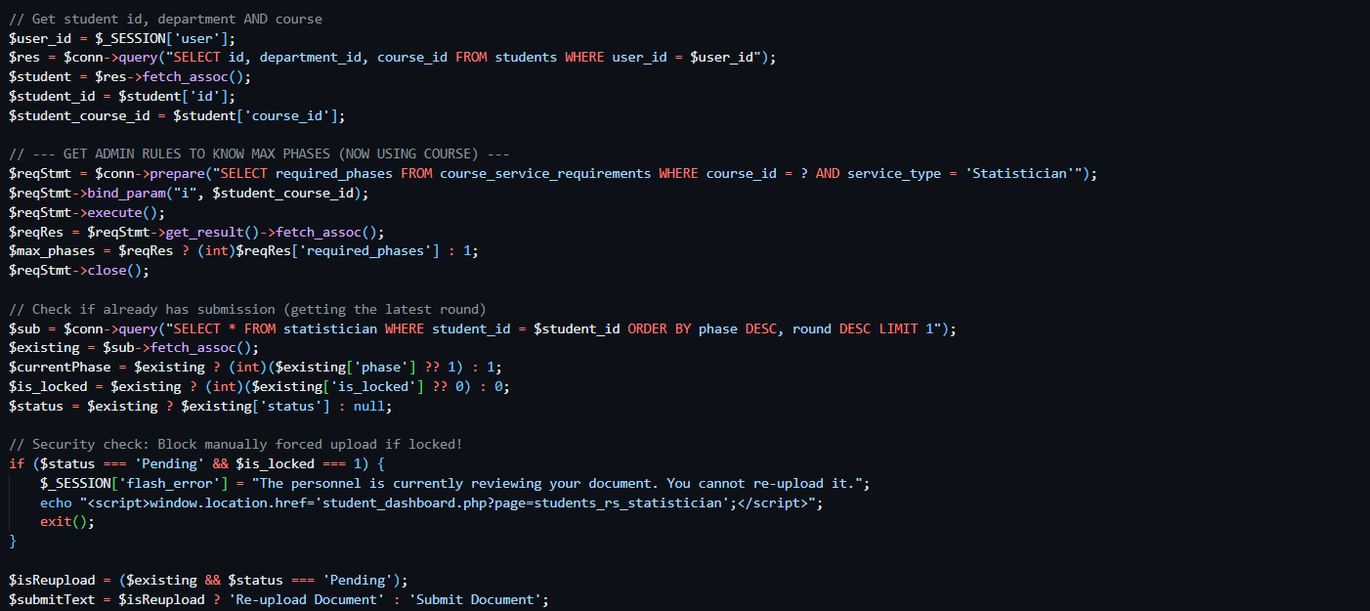
Figure 82. Code Snippet for RSSMS - Student Statistician Document Upload Interface
This acts as a critical security checkpoint prior to executing the file upload by querying the database to ensure the assigned personnel has not "locked" the current submission, explicitly preventing students from forcefully overriding or re-uploading documents during an active review.
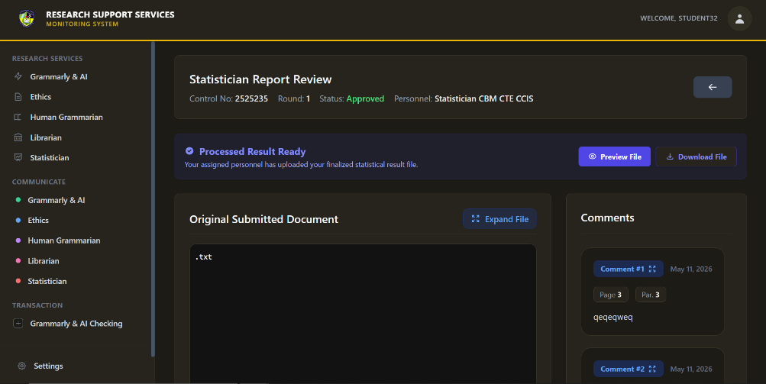
Figure 83. Student Statistician Service Report Review Interface
Students access this detailed report interface to review the statistician's comprehensive feedback, securely download their finalized statistical results, and read specific page-by-page annotations regarding their data treatments.
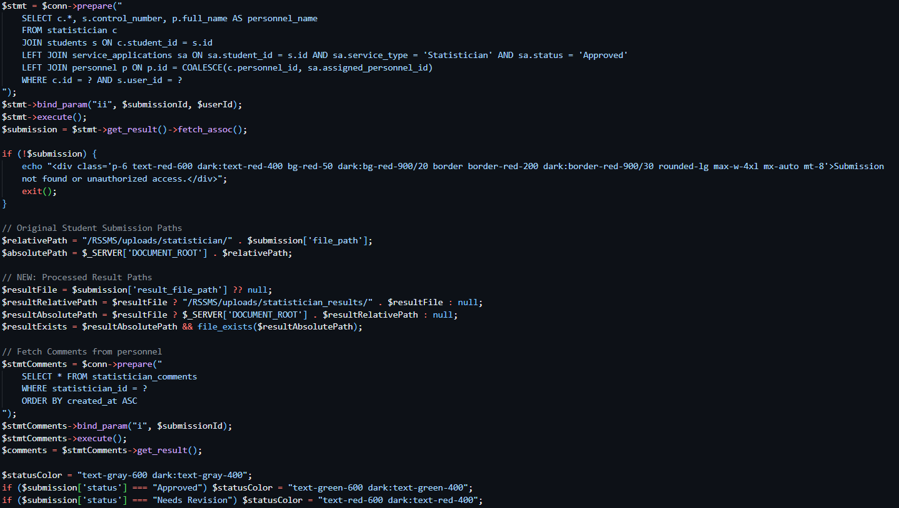
Figure 84. Code Snippet for RSSMS - Student Statistician Service Report Review Interface
This securely retrieves the specific evaluation round data from the database, dynamically resolves the server file paths for both the original and processed documents, and fetches all associated personnel feedback comments to populate the UI.
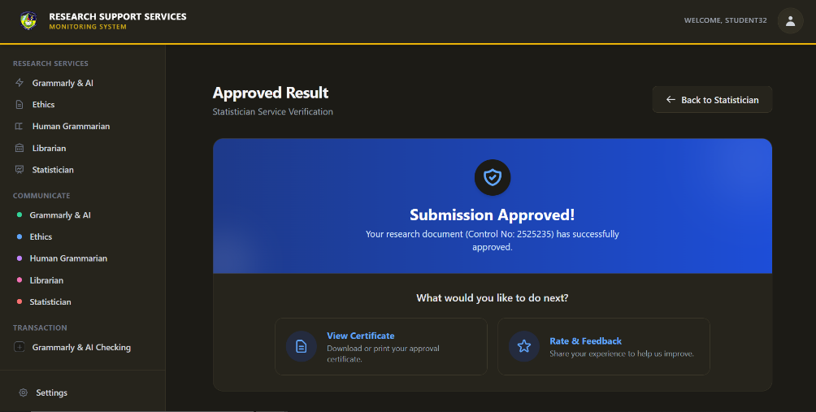
Figure 85. Student Statistician Approved Result Verification
Upon successfully passing the statistical evaluation phase, students are automatically routed to this terminal success screen where they can immediately generate their official clearance certificate or proceed to evaluate the assisting personnel.
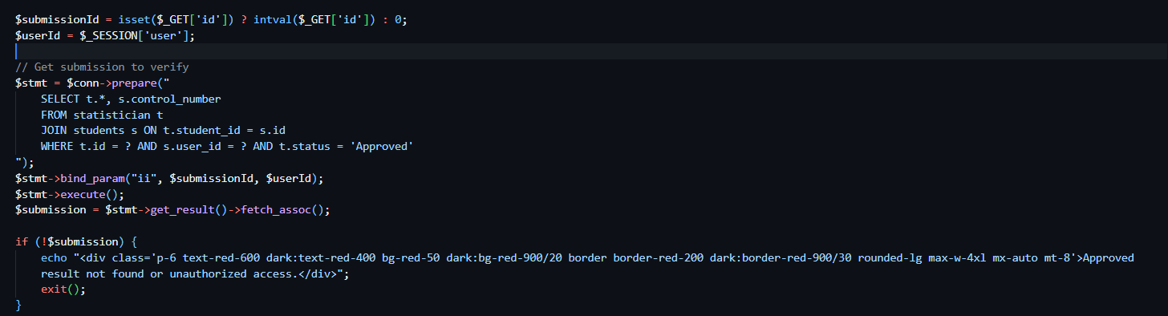
Figure 86. Code Snippet for RSSMS - Student Statistician Approved Result Verification
This script enforces strict access control by verifying that the requested submission ID matches the active user session and explicitly holds an "Approved" status before granting access to the certificate generation portal.
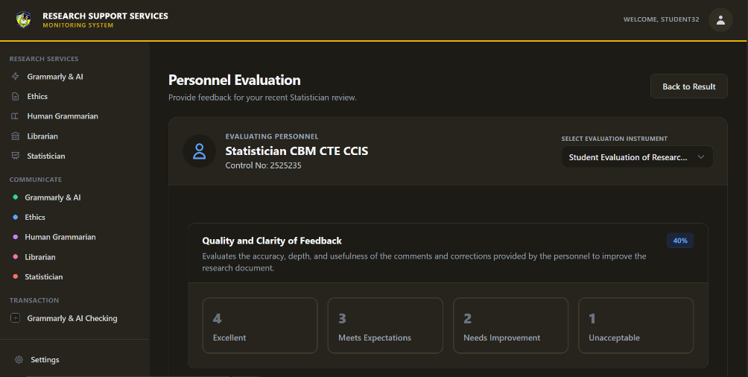
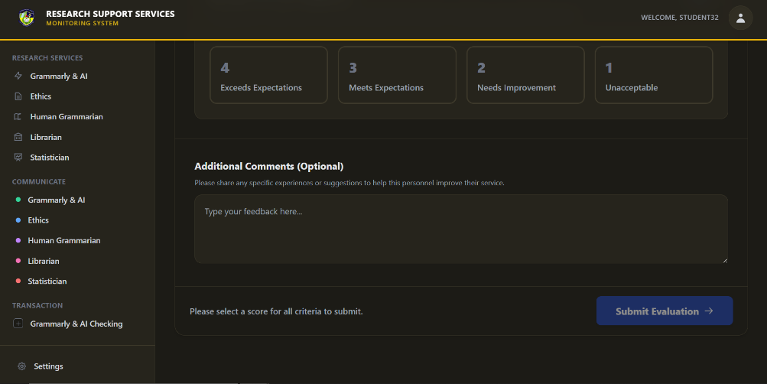
Figure 87. Student Statistician Service Feedback and Rating
Following the successful approval of their statistical results, students are directed to this evaluation interface to assess the personnel's performance. The student selects an evaluation instrument, rates the statistician across customized criteria using a point-based rubric, and submits the form to contribute to the institution's quality assurance metrics.
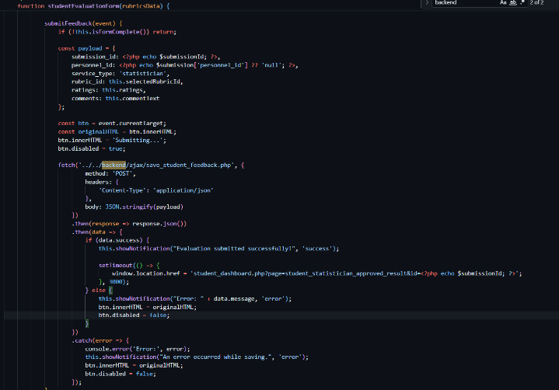
Figure 88. Code Snippet for RSSMS - Student Statistician Service Feedback and Rating
This JavaScript function handles the asynchronous submission of the student's evaluation form, compiling the selected rubric ratings and textual comments into a JSON payload, securely it to the backend, and executing a delayed redirect to the approved results page upon success.
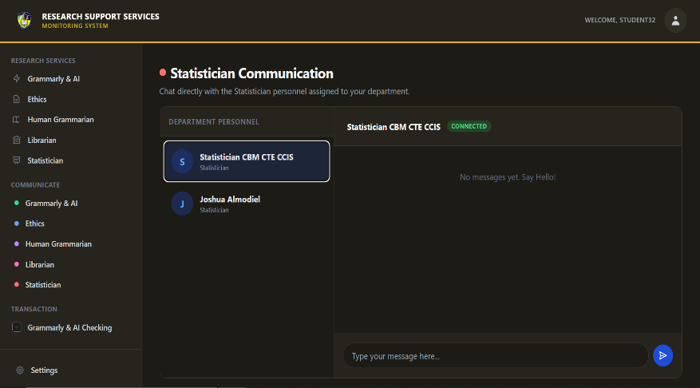
Figure 89. Student Statistician Communication Interface
Students access the communication module via the sidebar to directly interact with their assigned Statistician. Selecting the personnel from the active queue opens a secure chat window, allowing for real-time inquiries, feedback clarification, and direct coordination regarding complex data treatments without leaving the monitoring platform.
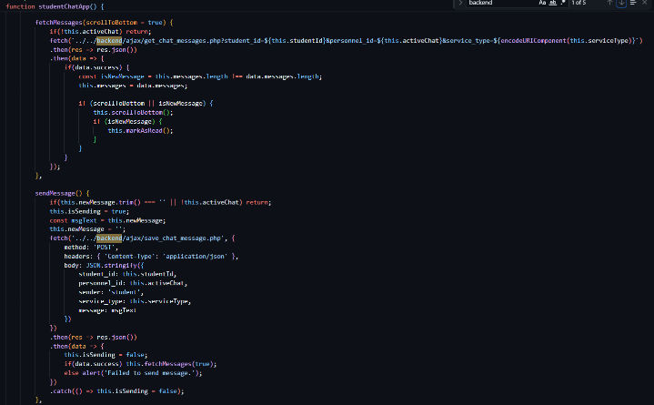
Figure 90. Code Snippet for RSSMS - Student Statistician Communication Interface
This JavaScript snippet controls the real-time chat functionality, utilizing fetch APIs to asynchronously retrieve the latest message history and securely send new text payloads to the backend database while automatically scrolling to the newest message.
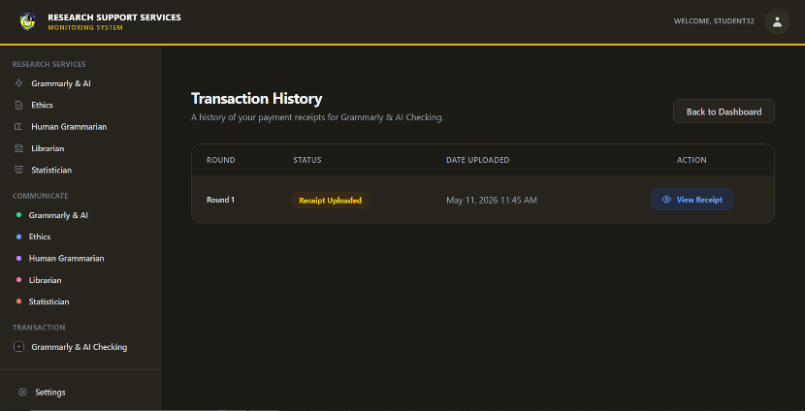
Figure 91. Student Grammarly & AI Transaction History
This interface provides students with a chronological summary of their payment submissions per checking round, displaying the current evaluation status and upload date. It also enables students to easily retrieve and verify the specific receipt file they submitted by clicking the "View Receipt" button.
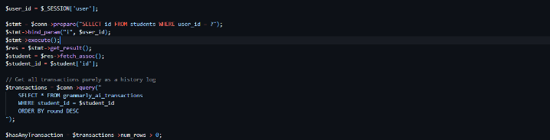
Figure 92. Code Snippet for RSSMS - Student Grammarly & AI Transaction History
The backend PHP script securely maps the active user's session to their unique student ID and queries the database to retrieve all their specific Grammarly transaction records, sorting them so the most recent round appears first.
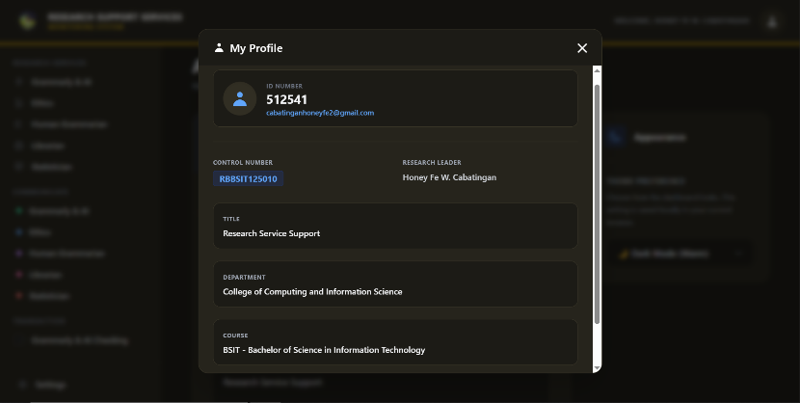
Figure 93. Student Profile View
Students can access this modal from their dashboard to verify their core academic identity details. It provides a read-only snapshot of their registered ID, control number, email, assigned research leader, thesis title, and their specific department and course affiliations.
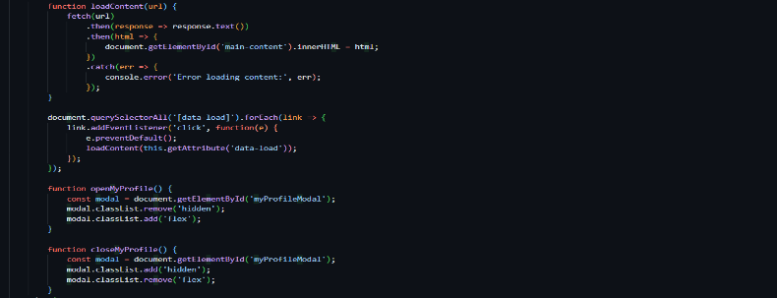
Figure 94. Code Snippet for RSSMS - Student Profile View
The simply toggle the visibility of the modal by adding or removing Tailwind CSS display classes (hidden vs flex), while the PHP backend populates the HTML structure with the user's data retrieved from the database upon page load.
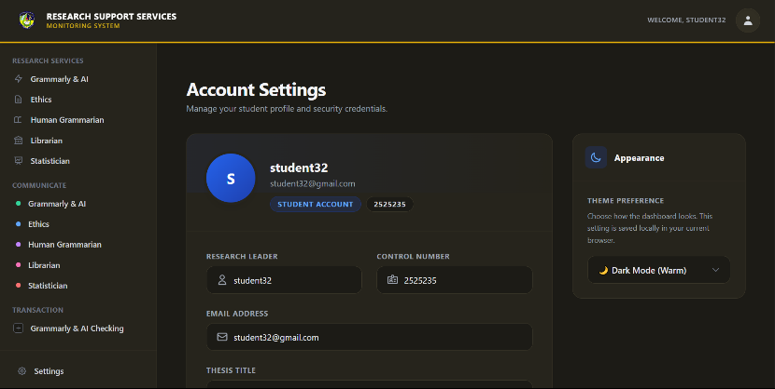
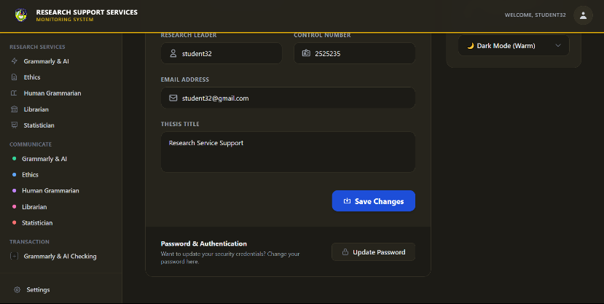
Figure 95. Student Account Settings
Students can directly edit their core academic information—such as their control number, research leader, email, and thesis title—while also customizing their dashboard to light or dark mode. Additionally, they can securely update their login credentials through a dedicated password change modal without leaving the page.
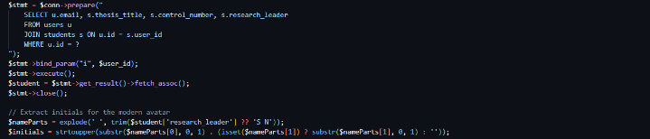
Figure 96. Code Snippet for RSSMS - Student Account Settings
The backend PHP script securely fetches the active user's combined account and student data using a joined SQL query, and utilizes string manipulation functions to dynamically generate a personalized two-letter avatar based on the research leader's name.

REFERENCES
[1] T. O. Adeyemi and N. F. AlOtaibi, “Designing a Feedback-Driven Decision Support System for Dynamic Student Intervention,” Aug. 2025, [Online]. Available: http://arxiv.org/abs/2508.07107
[2] I. Maryati, B. Purwandari, H. B. Santoso, I. Budi, I. Solichah, and F. Gani, “Research Support Services in Indonesian Academic Digital Libraries: A Proposed Business Model and Prototype Design,” DESIDOC Journal of Library and Information Technology, vol. 42, no. 1, pp. 18–29, 2022, doi: 10.14429/DJLIT.42.1.17108.
[3] J. Navarra and E. Antonio, “Efficient Student Monitoring and Data Tracking System,” Psychology and Education: A Multidisciplinary Journal, vol. 35, no. 8, pp. 848–867, Apr. 2025, doi: 10.70838/pemj.350801.
[4] E. Sawe, N. W. Mwai, and L. I. Oyieke, “Doctoral students’ satisfaction with research support services at public universities in Kenya,” South African journal of Libraries and information sciences, vol. 90, no. 1, May 2024, doi: 10.7553/90-1-2291.
[5] B. P. Singh and M. Madhusudhan, “ICT Based Research Support Services in Academic Libraries: A New Frontier to Enhancing Research Integrity and Productivity,” Journal of Knowledge & Communication Management, vol. 12, no. 2, pp. 128–149, 2022, doi: 10.5958/2277-7946.2022.00010.9.
[6] “Teachers Institute The Role of Student Support Services in Higher Education https://teachers.institute/institutional-management/student-support-services-higher-education,” 2023. [Online]. Available: https://teachers.institute/?print-my-blog=1&post-type=post&statuses%5B0%5D=publish&rendering_wait=0&columns=1&font_size=normal&image_size
[7] V. Sharma, “Digital Transformation in Libraries Challenges, Opportunities, and Evolving Needs of Users.” [Online]. Available: https://www.researchgate.net/publication/389498384
[8] B. P. Singh and M. Madhusudhan, “ICT Based Research Support Services in Academic Libraries: A New Frontier to Enhancing Research Integrity and Productivity,” Journal of Knowledge & Communication Management, vol. 12, no. 2, pp. 128–149, 2022, doi: 10.5958/2277-7946.2022.00010.9.
[9] S. L. Lampaza, M. J. P. Parrenas, A. D. Suarez, and K. T. Soberano, “Library Systems Development: Utilization, Usability and Impact for Private Schools in Negros Occidental, Philippines,” International Journal of Computer Science and Mobile Computing, vol. 14, no. 1, pp. 11–19, Jan. 2025, doi: 10.47760/ijcsmc.2025.v14i01.002.
[10] “Online Faculty Monitoring and Evaluation System.”
[11] E. N. O. Amora, K. V. Romero, R. C. Amoguis, J. E. Olandria, E. N. Olandria, and A. M. J. Bernales, “Web-Based Attendance Monitoring System,” Int Multidiscip Res J, vol. 2, no. 4, pp. 145–152, Dec. 2020, doi: 10.54476/iimrj324.
[12] H. ahmad Alawamleh, B. J. A Ali, H. Ahmad Alawamleh, A. Fadel Ali Tommalieh, and M. Qasem Hasan Al-Qaryouti, “THE CHALLENGES, BARRIERS AND ADVANTAGES OF MANAGEMENT INFORMATION SYSTEM DEVELOPMENT: COMPREHENSIVE REVIEW,” 2021. [Online]. Available: https://www.researchgate.net/publication/358357374
[13] J. Russell et al., “Exploring Financial Challenges and University Support Systems for Student Financial Well-Being: A Scoping Review,” Mar. 01, 2025, Multidisciplinary Digital Publishing Institute (MDPI). doi: 10.3390/ijerph22030356.
[14] N. Shaya, R. Abukhait, R. Madani, and M. N. Khattak, “Organizational Resilience of Higher Education Institutions: An Empirical Study during Covid-19 Pandemic,” Higher Education Policy, Sep. 2023, doi: 10.1057/s41307-022-00272-2.
[15] A. Jeilani and S. Abubakar, “Perceived institutional support and its effects on student perceptions of AI learning in higher education: the role of mediating perceived learning outcomes and moderating technology self-efficacy,” Front Educ (Lausanne), vol. 10, 2025, doi: 10.3389/feduc.2025.1548900.
[16] Fitria, M. Yahya, M. I. Ali, Purnamawati, and A. M. Mappalotteng, “The Impact of System Quality and User Satisfaction: The Mediating Role of Ease of Use and Usefulness in E-Learning Systems,” International Journal of Environment, Engineering and Education, vol. 6, no. 2, pp. 119–131, Aug. 2024, doi: 10.55151/ijeedu.v6i2.134.
[17] E. Steinbrink and C. Reuter, “The impact of transparency and trust on user acceptance of contact tracing apps: Implications for the adoption of crisis response apps,” International Journal of Disaster Risk Reduction, vol. 112, Oct. 2024, doi: 10.1016/j.ijdrr.2024.104661.
[18] L. Giraldi, M. Giovannetti, and E. Cedrola, “User Experience on E-learning Platforms in Higher Education,” May 15, 2023. doi: 10.21203/rs.3.rs-2753702/v1.
[19] O. A. Adedapo, J. Bello, M. A. Ogunrinde, M. O. Oyediran, M. O. Adio, and O. A. Oyekola, “Development of a Workflow Management System for Higher Education: A case study of the Department of Mathematical and Computer Sciences, Fountain University, Osogbo.,” FUOYE Journal of Engineering and Technology, vol. 8, no. 4, Dec. 2023, doi: 10.46792/fuoyejet.v8i4.1126.
[20] M. K. Kabier, A. A. Yassin, and Z. A. Abduljabbar, “Towards for Designing Educational System Using Role-Based Access Control,” International Journal of Intelligent Engineering and Systems, vol. 16, no. 2, pp. 50–63, 2023, doi: 10.22266/ijies2023.0430.05.
[21] R. P. F. Marques, H. M. Dinis dos Santos, and C. A. Lourenço dos Santos, “Automation of the approval and control process of documents,” in Organizational Integration of Enterprise Systems and Resources: Advancements and Applications, IGI Global, 2012, pp. 289–302. doi: 10.4018/978-1-4666-1764-3.ch016.
[22] B. G. Joanne Marshall and A. Professor, “The impact of the hospital library on clinical decision making: the Rochester study*.”
[23] N. K. W. Savitri, I. M. S. Sandhiyasa, Y. P. Fittryani, I. G. I. Sudipa, and D. M. D. U. Putra, “Design of Real-Time Project Monitoring Dashboard Using Kimball’s Data Warehouse Approach and Google Data Studio,” sinkron, vol. 9, no. 3, pp. 1050–1061, Jul. 2025, doi: 10.33395/sinkron.v9i3.14801.
[24] M. C. Bumalod and R. A. Mary Velasco, “Synergistic Information Security Design Implementation based on Role-Based Access Control, Information Classification, and AES Cryptographic Encryption,” INTERNATIONAL JOURNAL IN INFORMATION TECHNOLOGY IN GOVERNANCE, EDUCATION AND BUSINESS, vol. 6, no. 1, 2024.
[25] N. Tagge, L. Martin, and S. M. Mcguinness, “Reflecting on the Impact of Hybrid Work on an Academic Library Using the Socio-Ecological Model.”
[26] J. Setiyawan and H. B. Santoso, “FACTORS AFFECTING USER ACCEPTANCE OF E-LEARNING IMPLEMENTATION IN THE CONTEXT OF HIGHER EDUCATION: A CASE STUDY OF HEALTH SCIENCE,” 2022, Grand Canyon University. doi: 10.9743/jeo.2022.19.1.9.


CURRICULUM VITAE

NAME: HONEY FE W. CABATINGAN
ADDRESS: Manoligao Carmen, Agusan del Norte
EMAIL: cabatinganhoney11@gmail.com
Personal Information
Sex : Female
Date of birth : November 28, 2004
Height : 149cm
Weight : 39km
Civil Status : Single
Educational Attainment
Elementary : Manoligao Elementary School
Secondary : Manoligao National High School
Tertiary : Saint Michael College of Caraga
Membership/Affiliations
ORGANIZATION | POSITIONS HELD
NONE | NONE


CURRICULUM VITAE
Recent ID picture
(size 1 ½ x 2, preferably colored)

NAME: JOSHUA J. ALMODIEL
ADDRESS: District Gemelina Talisay Nasipit, Agusan Del Norte
EMAIL: joshuaalmodiel1133333@gmail.com
Personal Information
Sex : Male
Date of birth : February 4, 2003
Height : 160cm
Weight : 59km
Civil Status : Single
Educational Attainment
Elementary : Triangulo Elementary School
Secondary : Northwestern Agusan Colleges
Tertiary : Saint Michael College of Caraga
Membership/Affiliations
ORGANIZATION | POSITIONS HELD
NONE | NONE


CURRICULUM VITAE
Recent ID picture
(size 1 ½ x 2, preferably colored)

NAME: IAN V. MAISOG
ADDRESS: Km11 P6 Alubihid Buenavista Angun Del Norte
EMAIL: imaisog7@gmail.com
Personal Information
Sex : Male
Date of birth : February 15, 2004
Height : 164 cm
Weight : 81 kg
Civil Status : Single
Educational Attainment
Elementary : Matabao elementary school
Secondary : Saint James High school
Tertiary : Saint Michael College of Caraga
Membership/Affiliations
ORGANIZATION | POSITIONS HELD
NONE | NONE


CURRICULUM VITAE
Recent ID picture
(size 1 ½ x 2, preferably colored)

NAME: JOY CLISTER D. MENDOZA
ADDRESS: D-5 Triangulo, Nasipit Agusan del Norte
EMAIL: joy755570@gmail.com
Personal Information
Sex : Female
Date of birth : May 22, 2005
Height : 167 cm
Weight : 48 kg
Civil Status : Single
Educational Attainment
Elementary : Triangulo Elementary School
Secondary : Saint Michael College of Caraga
Tertiary : Saint Michael College of Caraga
Membership/Affiliations
ORGANIZATION | POSITIONS HELD
NONE | NONE


CURRICULUM VITAE
Recent ID picture
(size 1 ½ x 2, preferably colored)

NAME: ASHLEY R. PALISAN
ADDRESS: QUESABA ST., PUROK 5, POBLACION, CARMEN AGUSAN DEL NORTE
EMAIL: ashleypalisan16@gmail.com
Personal Information
Sex : Female
Date of birth : April 16, 2004
Height : 152cm
Weight : 37kg
Civil Status : Single
Educational Attainment
Elementary : Carmen Central Elementary School
Secondary : Carmen Central Elementary School
Tertiary : Saint Michael College of Caraga
Membership/Affiliations
ORGANIZATION | POSITIONS HELD
NONE | NONE

