CENRO NASIPIT FIELD OPERATIONS AND EQUIPMENT TRACKING SYSTEM
A Thesis Presented To The Faculty of
College of Computing and Information Sciences

In Partial Requirements for the Degree

BACHELOR OF SCIENCE IN INFORMATION TECHNOLOGY

By

ASHMEN S. CAMID JAY IVAN E. TADENA JOEL A. CALUYA III
JORYN M. CAGULANGAN RICH IAN JAMES I. BALAIDO

ADVISER: RONNEL A. FALO
MARCH 2026

ACKNOWLEDGEMENT

The researchers express their sincere gratitude for the opportunity to complete the "CENRO Nasipit Field Operations and Equipment Tracking System" study in partial fulfillment of the Bachelor of Science in Information Technology requirements at Saint Michael College of Caraga.
The researchers sincerely appreciate their adviser, Mr. Ronnel A. Falo, for his guidance, encouragement, and expertise throughout the study. His constant support and feedback significantly contributed to the success and improvement of this research. Gratitude is also given to the members of the thesis committee and the College of Computing and Information Sciences faculty for their insightful comments, advice, and assistance during the evaluation and completion of this work.
The researchers sincerely thank their families for their unwavering love, patience, and moral support, which served as their source of strength and motivation. Appreciate their friends and classmates' encouragement and cooperation throughout the research process.
Acknowledgment to the Community Environment and Natural Resources Office (CENRO) Nasipit for the opportunity to conduct the study and for the information and cooperation provided during data gathering and system testing.
Special recognition is given to ASHMEN S. CAMID, JAY IVAN E. TADENA, JOEL A. CALUYA III, JORYN M. CAGULANGAN, and RICH IAN JAMES I. BALAIDO for their collective effort, dedication, and teamwork in accomplishing this research project.

Finally, the researchers express profound gratitude to all individuals who, in one way or another, extended their support and assistance. Their contributions and encouragement made the completion of this study possible.

TABLE OF CONTENTS
Pages
TITLE PAGE i
CERTIFICATE OF RESEARCH APPROVAL ii
ABSTRACT ii
DEDICATION ii
ACKNOWLEDGEMENT ii
TABLE OF CONTENTS iv
LIST OF TABLES vi
LIST OF FIGURES vii

CHAPTER  1 | INTRODUCTION | 1
 | 1.1 Project Context | 1
 | 1.2 Literature Review | 3
 | 1.3 Project Objectives | 12
 | 1.4 Scope and Limitations | 12
 | 1.5 Definition of Terms | 13
2 | METHODOLOGY | 15
 | 2.1 Research Design | 15
 | 2.2 Software Development Life Cycle | 15
 | 2.3 System Architecture | 16
 | 2.4 Conceptual Diagram | 17
 | 2.5 Use Case Diagram | 19
 | 2.6 Activity Diagram | 20
 | 2.7 Sequence Diagram | 25
 | 2.8 ERD (Database Design) | 30
 | 2.9 User Interface Design (Prototype) | 32
 | 2.10 Software Platforms, Development Environments | 69
 | and Tools
 | 2.11 Hardware Requirements | 71
 | 2.12 System Evaluation/Evaluation Procedure | 72
 | 2.13. Research Ethical Standard | 74
3 | SOFTWARE DEVELOPMENT AND TESTING
 | 4.1 Development Process
 | 4.2 Testing Process
 | - Accuracy Test
 | - Functionality Test
 | - Performance Test
4 | SUMMARY, CONCLUSIONS AND RECOMMENDATIONS
 | 5.1 Summary of Findings
5.2 Conclusion
5.3 Recommendations

REFERENCES 80
CURRICULUM VITAE 84
ETHICAL STANDARD APPENDICES
CERTIFICATE OF TECHNOLOGY BASED ASSESSMENT PUBLISHABLE JOURNAL

 | LIST OF TABLES
Table |  | Pages
1 | Software Platforms, Development Environment and Tools | 69
2 | Hardware Requirements | 71
3 | System Evaluation | 72
4 | Performance Efficiency | 73
5 | Usability | 73
6 | Respondent’s Distribution | 74

 | LIST OF FIGURES
Figure |  | Pages
1 | Agile Methodology | 15
2 | System Architecture | 16
3 | Conceptual Diagram | 17
4 | Use Case Diagram | 19
5 | Activity – Administrator | 20
6 | Activity – Enforcement Officer | 21
7 | Activity – Enforcer | 22
8 | Activity – Property Custodian | 23
9 | Activity – Office Staff | 24
10 | Sequence – Administrator | 25
11 | Sequence - Enforcement Officer | 26
12 | Sequence – Enforcer | 27
13 | Sequence - Property Custodian | 28
14 | Sequence - Office Staff | 29
15 | ERD (Database Design) | 30
16 | Login Page (Common Access for All Roles) | 32
17 | Dashboard (Admin Interface Design) | 33
18 | User Management (Admin Interface Design) | 34
19 | Add New User (Admin Interface Design) | 35
20 | Spot Reports (Admin Interface Design) | 36
21 | Spot Report Details (Admin Interface Design) | 37
22 | Case Management (Admin Interface Design) | 38
23 | Case Management Details (Admin Interface Design) | 39
24 | Apprehended Items (Admin Interface Design) | 40
25 | Equipment Management (Admin Interface Design) | 41
26 | Assignments (Admin Interface Design) | 42
27 | Service Desk (Admin Interface Design) | 43
28 | Request details (Admin Interface Design) | 44
29 | Statistical Report (Admin Interface Design) | 45

- Dashboard (Enforcement Officer Interface Design) 46
- Spot Reports (Enforcement Officer Interface Design) 47
- Spot Report Details (Enforcement Officer Interface Design) 48
- Case Management (Enforcement Officer Interface Design) 49
- Case Details (Enforcement Officer Interface Design) 50
- Apprehended Items (Enforcement Officer Interface Design) 51
- Service Requests (Enforcement Officer Interface Design) 52
- Statistical Report (Enforcement Officer Interface Design) 53
- Dashboard (Enforcer Interface Design) 54
- Spot Reports (Enforcer Interface Design) 55
- New Spot Report (Enforcer Interface Design) 56
- Service Requests (Enforcer Interface Design) 57
- New Request (Enforcer Interface Design) 58
- Dashboard (Property Custodian Interface Design) 59
- Equipment Management (Property Custodian Interface Design) 60
- Add New Device (Property Custodian Interface Design) 61
- Assignments (Property Custodian Interface Design) 62
- Assigned Devices (Property Custodian Interface Design) 63
- New Requests (Property Custodian Interface Design) 64
- Request Details (Property Custodian Interface Design) 65
- Dashboard (Office Staff Interface Design) 66
- Service Request (Office Staff Interface Design) 67
- New Request (Office Staff Interface Design) 68

CHAPTER 1 INTRODUCTION

Project Context
The Department of Environment and Natural Resources (DENR) highlights the development of improved sustainable forest management, specifically utilizing logs turned over through Tree Cutting Permits (TCPs). Its primary purpose is to achieve the optimal utilization of products while reducing adverse environmental impacts. This study examines the present policy and practice of such logs and determines potential interventions to make them more efficient [1]. Presently, the Community Environment and Natural Resources Office (CENRO) depends on manual reports of spots for tracking logs, equipment, and vehicles. This process is burdensome for the staff, especially for the Commission on Audit (COA), conducting audits that need statistical reports. Without an automated system, data gathering is laborious, more often results in inaccuracy, and causes delays. Furthermore, the lack of a unified tracking system makes validating the confiscated items' exact status and condition hard. Again, even the units of devices in the office need auditing; the lack of a proper tracking system, in turn, forces staff members to manually label each unit and device with paper tags, again delaying the auditing process further. Studies indicate that the application of digital technologies such as Quick Response (QR) codes significantly improves tracking, transparency, and information management across operational processes. Van Groesen and Pauwels (2022) demonstrated that QR codes are an effective tool for asset tracking, allowing organizations to link physical items with digital records in a centralized system. Their study emphasized that QR code–based tracking improves data accuracy, reduces reliance on manual reporting, and enhances traceability throughout operational workflows. By enabling fast and reliable access to asset information through scanning, QR codes support real-time monitoring and decision-making while minimizing human error. These

advantages make QR code technology highly applicable to inventory control, asset auditing, and logistics-related operations, particularly in environments that require accurate reporting and accountability [2]. Using QR codes increases the clarity, traceability, and real-time availability of information, thus helping organizations improve functional effectiveness and reduce human mistakes.
Another study suggests that illegal deforestation is important in conducting activities specifically in designated protected areas, and only with the proper permits or licenses, which is still a significant problem. In breach of national and international laws, this type of activity causes significant harm to the environment, the economy, and communities, with illicit logging as a primary contributor to destroying the country's forested lands. Additionally, research suggests that improved enforcement of laws, better mechanisms of control, and the application of modern technological solutions could help curb this problem [3].
For years, CENRO Nasipit manually drafted spot reports to follow up on seized logs, vehicles, and equipment; however, completing statistical reports during COA audits was no easy task. Not only is it slow, but it is also inaccurate. Also, records are not centralized or updated in real time, making organizing and finding important files more challenging.
To address these issues, the researchers recommend developing a web-based system called the CENRO Nasipit Field Operations and Equipment Tracking System (CENRO NFO-ETS). The application is expected to digitize spot and inventory reports, thereby fast-tracking the report preparation process during Commission on Audit (COA) examinations and enabling accurate information about the number of turned-over logs, seized properties, and vehicles. Additionally, the system shall include a QR code-based equipment-tracking feature whereby each device shall receive a unique QR code augmented with its corresponding details. Upon scanning, the QR code shall display information about the equipment, user, and equipment status. The various users,

such as the enforcement officers, enforcers, property custodians, administrators, and office staff, shall be assigned varying access levels based on their respective mandates. The system shall also automatically print statistical reports, allow case-tracking, and store soft copies of the spot reports for easy access and verification.
The new system shall automate the encoding, tracking, and updating of seized items and field reports. It shall include a real-time monitor dashboard and a role-based user account maintenance for secure and orderly access to data. Moreover, the system includes a QR code-based tracking for office units, each with a unique QR code that bears specific details. Scanning the QR code allows easy access to associated information of the equipment, thereby improving inventory and audit procedure efficiency, accuracy, and manageability. Centralized data storage by CENRO staff allows easy retrieval and updating of records, thus streamlining audits and reporting while reducing manual mistakes. Since the data is stored centrally, it becomes easy for the staff of CENRO to access.

Literature Review

This chapter reviews literature and studies related to the development of a QR code– based asset and inventory management system for CENRO Nasipit. It provides background information and insights from previous research that support the design and implementation of the proposed system.

QR Codes for Data Management and Asset Management

Designed the raw material batch code and the traceability batch code through the analysis of the wheat ﬂour supply chain details. They y associated the traceability code with the production information and used QR codes and RFID to record and read information and developed a wheat traceability system to achieve the traceability of bulk wheat ﬂour [4]. Additionally, the QR code is the small square barcode individuals use to track documents. Any

smartphone or QR code scanner can scan them. It is easy for users to access information or records linked to the code quickly. The QR code is handy when tracking documents by making access to information quick, easy, and compatible with current records management systems [5]. The head nurse can easily monitor the status and operation of different equipment, while other nurses can view the equipment details anytime to manage them more efficiently [6]. QR codes are two-dimensional barcodes scanned using smartphones and tablets with built-in cameras and scanning apps. Their main advantage is their capacity to store large amounts of data, which makes them useful for inventory tracking [7]. The system automates many tasks, including order entry and inventory tracking. It also performs several other functions that help lessen mistakes, make work faster, enhance customer satisfaction, and increase overall operational efficiency [8]. The tracking feature allows users to scan QR codes attached to inventory items using smartphones or scanners. Once scanned, the system displays complete information about the item, such as its condition and storage location, helping users access inventory data quickly without manual searches. This process makes inventory management more accurate and efficient [9].
QR codes act as a link between physical items and digital records. Their exact scanning, compact size, and storage capacity for storing data make them helpful in adding detailed information to each item. When using the software, they help automate tasks like processing orders, updating inventory, and checking equipment. Implementing this system helps users access data faster and more accurately, leading to fewer mistakes, better real- time tracking, and improved efficiency, as long as the code remains clear and readable.

Inventory Management Systems

Inventory is essential in business operations, as maintaining accuracy helps prevent significant financial losses. Many companies fail to report profits due to low productivity

caused by poor inventory management. Effectively managing and monitoring inventory is key to successful business practices and can be the basis for achieving a competitive advantage. However, excessive purchases of raw materials or overstocking finished goods can result in financial strain and even bankruptcy [10]. Additionally, maintaining an inventory allows an organization to track the items acquired during a particular procurement period, determine the equipment status distributed to the personnel, and determine the equipment for another procurement. Inventory management is considered a good practice for every organization in managing properties to extend the estimated useful life of all acquired assets and control items for effective monitoring. Inventory management helps the organization achieve its vision, mission, goals, and mandates for quality and sustainable service to the public [11]. Conducting a physical inventory of properties, equipment, and supplies is one way to attest to the physical existence of these assets. Preparing accounting reports serves as a foundation and is crucial for planning additional acquisitions. [12].
Furthermore, effective inventory management helps reduce unnecessary capital investment that may result from holding excessive stock. It ensures uninterrupted production by ensuring a timely and sufficient supply of raw materials. It gives a proper record of all losses or consumption, so that the stock is maintained at all times, which helps, in turn, to replenish the stock as and when required [13].
Effective and accurate inventory management is the control system that connects a firm’s financial health, operational continuity, and strategic planning. Accurate inventory management prevents costly stock errors and the risk of overstocking or understocking, which can lead to bankruptcy. Progressive visibility over what was purchased, where it is, the organization’s mission, and service standards. By keeping the stock level optimal and tracking how inventory, some companies can free up working capital and keep the

company’s production running smoothly. In this approach, companies ensure that items are restocked only when necessary because of adequate and accurate inventory. As a result, accurate data leads to better decisions, lower costs, and more reliable services.

Illegal Logging and Enforcement

Illegal logging is a serious environmental problem that threatens sustainable forest management. According to Noor et al., illegal logging includes the unauthorized harvesting, transport, and sale of forest products and causes serious damage to the environment, loss of government revenue, and harm to communities that depend on forest resources. The study explains that illegal logging contributes to deforestation, biodiversity loss, soil erosion, flooding, and climate change, especially in developing countries [14]. Addressing this issue requires vigorous forest law enforcement, which involves surveillance, monitoring, investigation, apprehension, and prosecution of offenders. To be effective, enforcement strategies must consider local and national contexts, focusing on improving forest monitoring systems and data collection processes [15]. Several factors weaken the enforcement of laws against illegal logging. Rahmat explained that ineffective law enforcement is often caused by weaknesses in the legal system, particularly in legal structure, legal substance, and legal culture. The study pointed out that weak law enforcement institutions, unclear or poorly implemented laws, and low public awareness of legal rules make enforcement inconsistent and unfair. These problems allow illegal logging activities to continue because offenders are not properly monitored or punished. Strengthening legal institutions, improving the quality of laws, and increasing public legal awareness are necessary to make law enforcement more effective [16]. Illegal logging usually happens by clearing forests, mainly for commercial farming activities such as turning forest areas into pasture or crop fields. Although this has become a leading cause of illegal

deforestation, it differs from typical criminal logging because cutting or collecting timber is not the activity's primary purpose [17]. Forest certification programs support sustainable forest management by enhancing productivity, promoting biodiversity, encouraging conservation, and reducing air pollution. Despite these positive contributions, their overall impact remains limited and is not sufficient to effectively address the challenges of illegal logging and wood trafficking [18]. The high demand for wood, which exceeds its supply, drives the rise of illegal logging. Weak supervision from central and regional governments, poor law enforcement against offenders, lack of coordination among institutions, and the limited involvement of local organizations and communities contribute to the widespread problem of illegal logging. Therefore, it is necessary to strengthen law enforcement efforts and establish clear standards to address ongoing cases, ensuring stricter action against violators and preventing the recurrence of illegal logging [19]. The legal problems faced in Indonesia include the weakness of the legal apparatus in law enforcement, a lack of public legal awareness, and inappropriate legislation, both philosophically and sociologically, as it contradicts local culture and relies solely on juridical aspects [20].
Illegal logging is both a governance and a criminal problem. It affects the environment, economies, and communities, and is more common where institutions are weak and laws are unclear. Traditional enforcement, like surveillance, is important, but it works best when adapted to local situations and supported by good monitoring. Most illegal forest activity happens when land is for farming or raising livestock, with timber extraction as a secondary issue. Solving this problem requires changes in supply chains and land-use rules that go beyond timber regulations. Log certification can help the ecosystem sustainably, but it cannot entirely stop the trafficking and crime alone. Ongoing demand, weak supervision of law enforcement, legal gaps, low awareness, and cultural differences mean that lasting

solutions need better cooperation, stronger local communities, and market changes that reduce illegal forest clearing.

Applications of Specialized Systems' QR Code Technology

Inventory information management using a QR code-based prototype is the solution to widespread problems in inventory management. It makes processes faster and helps ensure the data is more accurate. It also yields improved management information to aid informed decisions. Every product from the system is given a special QR code conveniently scannable by smartphone [21]. In addition, the adoption of the QR code facilitates auditing stock management. The lab administrators can carry out rigorous checks by scanning the QR code for evidence of each stock's existence and condition in the lab. To ensure the integrity of the lab's inventory records, we can identify and address any discrepancies or issues. Additionally, the Computer Lab Inventory Management System offers features for automated notifications and alerts [22].
QR codes are also used extensively in retailing, advertising, and distribution. In daily activity, the barcode is equivalent to the QR code. However, the QR code can hold much information as it can show information up-and-down and sideways—only horizontal information is used in barcodes. While barcodes work well for situations such as scanning supermarket products, QR codes have a greater capacity to move data, possibly due to their simplicity, making them extremely prevalent [23]. The team uses a QR-based technique to create a system that guides visitors in the shop without needing a guide. Therefore, the proposed system can decrease the number of workers as much as possible, where smartphones and their applications were exploited for this purpose [24].
The method adds a QR Code to a label pasted on each asset. Scanning the QR code through an Android smartphone lets users get information directly. The research tried

optimizing the inventory system by adding a web address to the QR code labels [25]. The application of QR Code Labeling Techniques in the Management Information System can facilitate the identification of Inventory items in the field, where time efficiency, effectiveness in terms of accuracy in fixed asset management in the company increases, and asset security can help prevent loss of sets or theft of assets in every asset transfer that can be monitored and recorded [26]. QR codes are widely used in asset management because they can store large amounts of information in a small format and are easy to scan using mobile devices. Benrahman proposed a QR code–based asset management and tracking system that links physical assets to digital records through unique QR codes. The study showed that scanning QR codes allows users to quickly access asset details, improve identification accuracy, and simplify asset monitoring and record-keeping. The system also helps reduce manual work and supports more efficient inventory control and auditing processes [27]. The construction team implemented a portable QR code application to allow staff to receive and access physical asset information. The construction team implemented a portable QR code application to allow staff to receive and access physical asset information. The choice between an RFID application and a QR code application relies on RFID, which requires less development time [28]. The author's research yields multiple discernible conclusions. The suggested information system, capable of generating QR codes for goods, can streamline administrative activities performed by the staff responsible for managing facilities and infrastructure. By organizing materials and giving the search ability by article name and records of transactions, the system ensures that no information is lost, even where there is discontinuity in the device for records and transactions for loaning [29]. Through this system, the users can access unit conditions, specifications, and maintenance histories by scanning the code printed on the irrigation unit's body. The field managers will also be able to access

unit availability and operating status from the system under real-time conditions. Reducing the chance of operational problems caused by incorrect or poorly organized data is essential [30].
QR codes are a simple and affordable way to connect physical items to digital records. Since QR codes are easy to scan with all smartphones and hold much information, organizations can tag QR codes in each item with helpful information. Improving inventory management can enhance the accuracy of audits and assist in identifying issues that impact data quality. QR labels also require fewer staff members to guide customers and effectively manage assets. Staff can quickly access product details, maintenance records, and real- time updates, which lead to better decisions and fewer interruptions. Compared to RFID, QR systems are an effective inventory backbone, offering fast identification and being quicker and less expensive to set up. They still allow for reliable data collection and updates in the field. When QR codes are part of a larger information system that includes item categories, search, and transaction tracking, they help prevent data loss and reduce theft by making every transfer traceable. Implementing these changes creates a stronger, more effective operation that saves labor, boosts security, and improves service.
This paper fills the gap in the existing literature by combining field operations monitoring and equipment tracking into one digital system designed for government environmental offices like CENRO Nasipit. The reviewed studies show that automated systems improve accuracy, accountability, and efficiency in managing assets and inventories. They also make accessing information in real time easier and simplify reporting. Research on illegal logging and enforcement highlights that proper documentation, organized data, and timely reports are important for effective environmental governance. However, many government offices still rely on manual reports and scattered records, which

often cause delays and errors. The CENRO Nasipit Field Operations and Equipment Tracking System (CENRO NFO-ETS) introduces a web-based solution that digitalizes spot reports, case management, apprehended items, and service requests to address these issues. The system also includes a QR code feature for tracking office devices and equipment, making audits and inventory work faster and more accurately. This system promotes transparency, accuracy, and accountability of administrative and field operations.
Based on the studies reviewed, many researchers agree that technology helps make work faster, more accurate, and more organized. Using QR codes and automated systems helps lessen errors, improve record-keeping, and make information easier to find. In environmental work, several studies also point out that proper documentation and timely reports are crucial for good management and decision-making. However, most existing systems serve schools, businesses, and private organizations. Several systems cater to government offices, simultaneously handling field operations and office equipment. Because of this, the team developed the CENRO Nasipit Field Operations and Equipment Tracking System (CENRO NFO-ETS) to address that need. The system provides an easier and more reliable way to manage reports and track office equipment, supporting transparency, accountability, and better service in the agency.

Project Objectives

This study uses Agile Software Development methods to create a Field Operations and Equipment Tracking System for CENRO Nasipit. The researchers aim to develop a system to automate fieldwork monitoring, improve device tracking using QR codes, and generate reports more efficiently and accurately.
Specifically, the study aims:
- To highlight the distinct roles and access privileges of each user account within the system, ensuring secure and efficient task management based on user responsibilities.
- To use QR codes for tagging each office device and linking each staff profile to show the devices assigned to them, making inventory, audits, and accountability easier.
- To develop an automatic report generator for confiscated and inventory data with filtering, chart visualization, and printing or exporting features for CENRO Nasipit records.
- To evaluate the system's functionality, efficiency, and usability using ISO 25010 standards to ensure its effectiveness in addressing the identified problems.

Scope and Limitations
This capstone project aims to design and develop a web-based Field Operations and Equipment Tracking System for the Community Environment and Natural Resources Office (CENRO) in Nasipit, replacing the manual process of handling field reports, case records, and office equipment. The system allows authorized users, including the Administrator can view all the statistical report and can manage Service Desk and Assignment panel. The Administrator can also print out all the statistical report, Enforcement Officers only can manage Spot Reports, Case Managements, and Apprehended Items they can also send request for the Service Request panel , Enforcers these are staff that working in the field they can only submit Spot Report and make a request for Service Request , Property Custodian can manage Assignment, Equipment Management and Service Desk
panel, and Office Staff can only make request for the Service Desk panel. The system helps improve

efficiency, accuracy, and transparency in daily operations while providing easy access to information through any device with an internet connection.

The system operates online and can be accessed through computers or mobile devices using a web browser. However, the QR code feature is used only for office equipment and assigned devices, not for confiscated items or logs. The system’s performance depends on a stable internet connection and the accuracy of data entered by users.

1.5. Definition of Terms
The terms defined below explain the basic concepts and factors discussed during the conceptualization and development of the CENRO Nasipit Field Operations and Equipment Tracking System and contextual information on how the researchers apply these concepts in their study.
Administrator (Admin) – also referred to as the Superuser- is the account with the highest level of access in the CENRO NFO-ETS, assigned to the ICT Focal. The Administrator controls user accounts, equipment records, service desk requests, and statistical report generation. In modules such as Spot Reports, Case Management, and Apprehended Items, the Administrator is limited to viewing and optional printing. At the same time, the Enforcement Officer holds the primary authority to update and manage these records.
Backend – the part of a computer program or website that works behind the scenes to store, process, and send information to the user's screen. The backend system is the hidden component that stores and processes environmental data, enabling staff to manage records and services.
Database-Oriented Management System – used to store and manipulate databases. This software can help develop CENRO NFO-ETS by providing a user-friendly data-keeping process for specific purposes in different contexts. End-users – the ICT FOCAL can easily access the Database without worrying about the underlying schema.

End-user – the individual who will use and interact with the CENRO NFO-ETS. Roles included in this category are Enforcement Officers, Enforcers, Property Custodians, and office staff. They are ordinary users with limited access and can only use the features that match their assigned role. Frontend – the part of a website or app that users see and interact with, like buttons, text, and images. The part of the system's interface that staff members see and interact with on their computer or phone screen includes menus for logging equipment, forms for recording field activities, and tables displaying tracking data.
QR Code – a Quick Response Code, a two-dimensional (2D) barcode of black and white squares arranged in a grid that stores data. In the CENRO NFO-ETS, staff use QR codes to tag each office device and link each staff profile to show the devices assigned to them, making inventory, audits, and accountability easier.
QR Code Scanner – A tool or application reads Quick Response (QR) Codes and quickly displays the stored information when you scan a QR code. In the CENRO NFO-ETS, staff use the scanner to access details of tagged office devices and profiles, facilitating faster inventory, audits, and accountability.
Statistical Report – a system-generated CENRO NFO-ETS report that presents monthly, quarterly, and yearly data from Spot Reports, Case Management, Apprehended Individuals, Vehicles, Items. The system displays the Report through bar and pie graphs, with options to filter the period, print, or export for audit and documentation.

CHAPTER 2 METHODOLOGY

Research Design
The study shall use a Design and Development Research (DDR) design, emphasizing designing and developing the CENRO Nasipit Field Operations and Equipment Tracking System (CENRO NFO-ETS). The DDR design is fitting, as the study involves designing, developing, and validating a technology-based solution that tackles the problems in manual monitoring and equipment tracking in CENRO.

Software Development Life Cycle

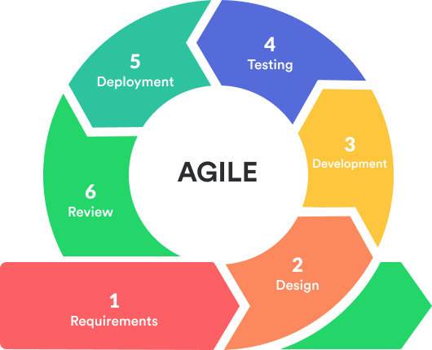

Figure 1. Agile Methodology

The development team chose Agile for the CENRO Nasipit Field Operations and Equipment Tracking System (CENRO NFO-ETS) because it helps create the system step by step, allows for changes, and involves the users. Instead of following a single linear process, the team divides the work into sprints, or short cycles, where they develop and test parts of the system.

The process will start with planning and gathering of requirements. The ICT Focal and office staff will identify the needed features, such as the Dashboard for monitoring, user management, spot reports, case management, apprehended items, equipment management, assignments, service desk requests, and statistical reports. Each sprint will focus on one module at a time, including its design, development, and testing. The researchers will gather feedback after every sprint to ensure immediate improvements.
Regular meetings will also be held with the stakeholders to check the progress and ensure the system fits the office's needs. After several sprints, the whole system will be completed and deployed. It will also be updated and improved based on feedback and maintenance. This Agile approach will make the system simple, practical, and adaptable for CENRO operations.

System Architecture
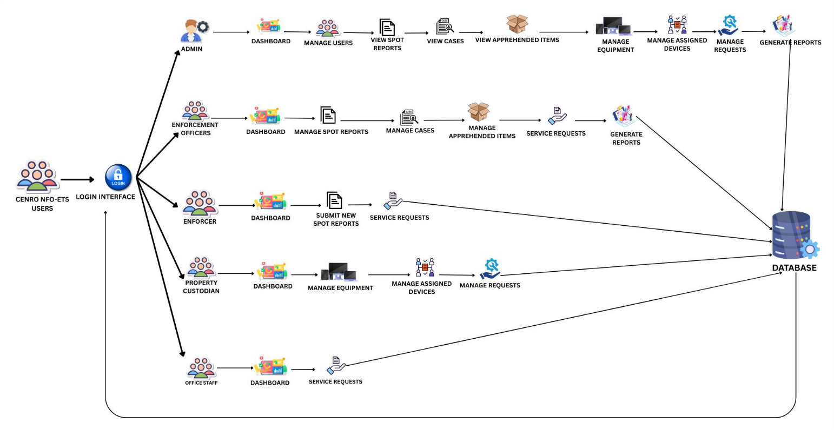

Figure 2. System Architecture

Figure 2. System Architecture shows how the CENRO NFO-ETS system works. All users, including Admin, Enforcement Officers, Enforcers, Property Custodians, and Office Staff, first log in through a single login page. This login checks their role and then brings them to their own Dashboard.
From the Dashboard, each user can perform different tasks. For example, the Admin can manage user accounts, view reports, and check cases. Enforcement Officers can review and approve spot reports. Enforcers can submit new reports. The Property Custodian can handle equipment and assigned devices, while the Office Staff can manage service requests.
All of these activities connect to one central Database. The Database keeps all the information, such as user details, reports, cases, items, equipment, requests, and assignments, safe and organized. It also ensures the system can generate reports and provide accurate information for everyone using it.

Conceptual Diagram
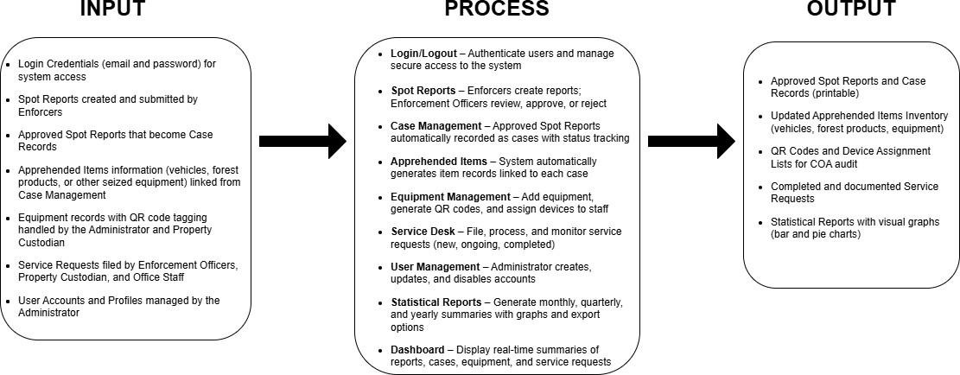

Figure 3. Conceptual Diagram

Figure 3 shows the Conceptual Diagram of the system. The Input includes Spot Reports from Enforcers, Service Requests from different staff, User Accounts and Profiles, and Equipment Records of devices with QR codes. Each device used in the office has a unique QR code that shows details like its brand, serial number, and assigned user. Staff profiles are also linked to these devices to make accountability easier. Apprehended items from field operations, such as logs, vehicles, and illegal equipment, are still recorded in the system but are not given QR codes.

The process covers the main functions of the system. Spot Reports are created by Enforcers and then reviewed by Enforcement Officers. Once approved, they automatically move into Case Management, where related apprehended items are listed. Equipment Management allows the Administrator or Property Custodian to add devices, generate QR codes, and assign them to staff. The Service Desk is used to file and handle requests. User Management lets the Administrator manage accounts, while the Statistical Report feature generates charts and summaries by month, quarter, or year. The Dashboard provides an overview of all activities.
The output gives reliable records such as printable spot reports and case records, updated lists of apprehended items, QR codes, device assignment lists for auditing, completed service requests, and statistical reports that can be printed or exported.

Use Case Diagram
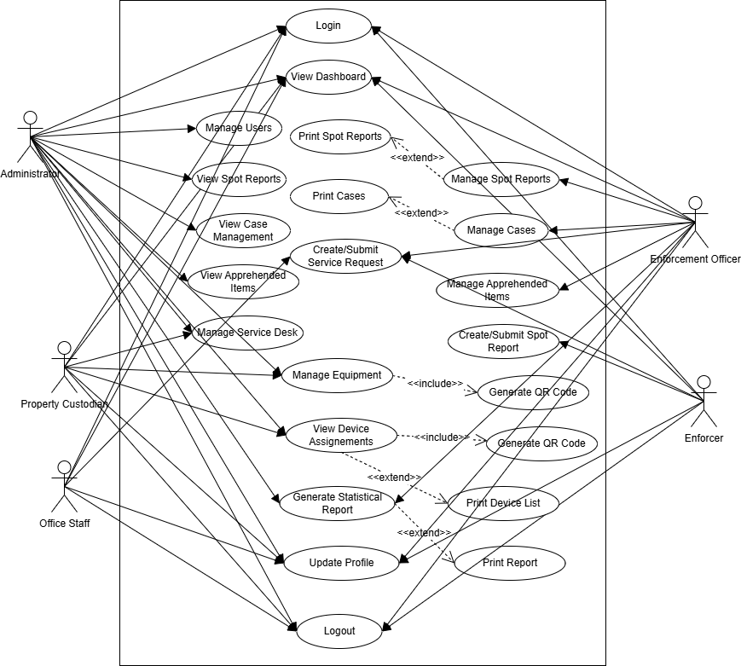

Figure 4. Use Case Diagram

Figure 4 shows the system's use case diagram. It describes the different users and what they can do inside the system. There are five main users: the Administrator, Enforcement Officer, Enforcer, Property Custodian, and Office Staff. Each of them has different levels of access depending on their role.
The Administrator has the widest access. They can log in, view the Dashboard, manage users, handle equipment, assign devices, manage the service desk, and generate statistical reports. However, regarding Spot Reports, Case Management, and Apprehended Items, the

Administrator can only view and print the reports, but cannot edit them. The Enforcement Officer can also log in and see the Dashboard, but they have more control because they can manage Spot Reports, Cases, and Apprehended Items. They are also allowed to submit service requests and generate reports.
The Enforcer has a minor role in the system. They can only log in, create new Spot Reports, submit service requests, update their profile, and log out. The Property Custodian, on the other hand, can log in, view the Dashboard, manage equipment, assign devices to staff, and also handle the service desk. The Office Staff has the simplest role because they can only log in, view the Dashboard, and submit service requests.
The Diagram also shows the relationship between the tasks. For example, viewing is part of managing, while creating Spot Reports and submitting service requests are extended functions that give extra work to the role. This way, the Diagram clearly explains how the system separates user responsibilities.

Activity Diagram
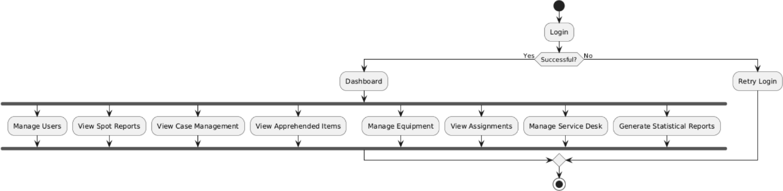
Figure 5. Activity – Administrator

Figure 5 shows the Administrator's activity diagram. After successfully logging in, the Administrator accesses the Dashboard, where they can manage users, view spot reports, handle case management, check apprehended items, manage equipment, view assignments, oversee the

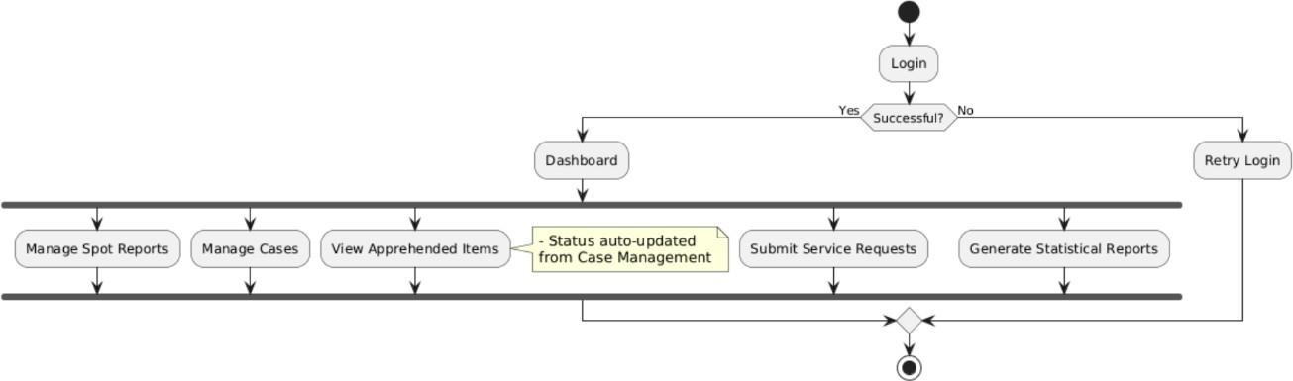
service desk, and generate statistical reports. If the login fails, the system prompts the Administrator to retry.

Figure 6. Activity – Enforcement Officer

Figure 6 shows the activity diagram of the Enforcement Officer. After a successful login, the officer accesses the Dashboard, which provides various modules. The officer manages spot reports submitted by enforcers, updates case statuses, and views apprehended items that the case management system automatically updates. The officer can also submit service requests to the administrator or property custodian and generate statistical reports, such as monthly, quarterly, or yearly outputs. If the officer fails to log in, the system prompts them to retry.

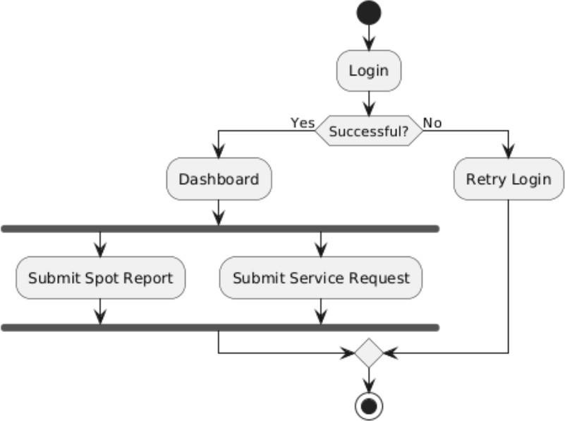

Figure 7. Activity – Enforcer

Figure 7 shows the activity diagram of the Enforcer. After successfully logging in, the Enforcer accesses the Dashboard, where they can submit spot reports for enforcement officers to review and request services for issues needing administrative or custodian support. If the login attempt fails, the system prompts the Enforcer to try again.

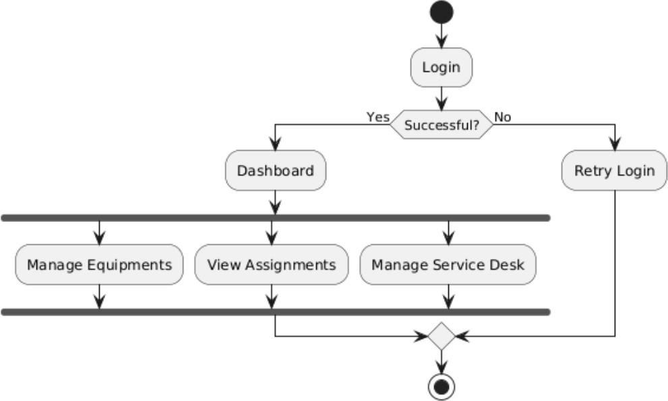

Figure 8. Activity – Property Custodian

Figure 8 shows the activity diagram of the Property Custodian. After a successful login, the property custodian redirected to the Dashboard to manage equipment by adding, deleting, or assigning devices, generating QR codes, and printing equipment lists. The custodian can also view assignments to monitor devices assigned to staff, and manage the service desk by handling user service requests. If the login attempt fails, the system prompts the property custodian to retry.

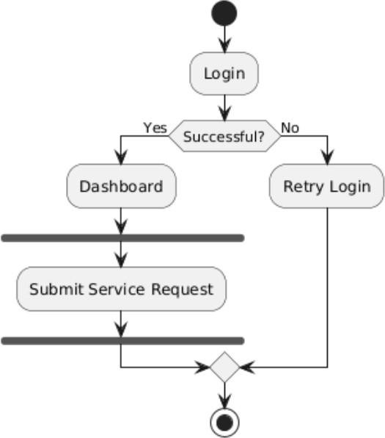

Figure 9. Activity – Office Staff

Figure 9 shows the activity diagram of the Office Staff. After logging in successfully, the staff redirected themselves to the Dashboard to submit service requests for assistance, such as repair or maintenance needs. If their login attempt fails, the system prompts them to retry.

Sequence Diagram
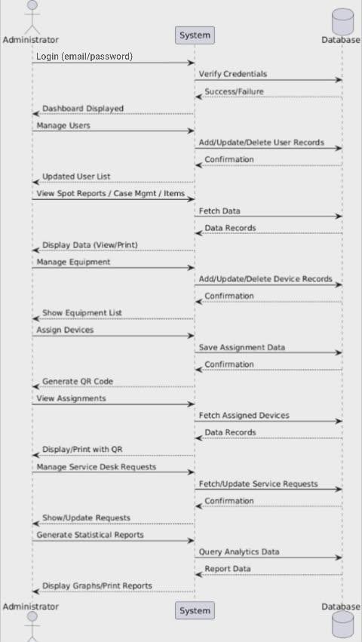

Figure 10. Sequence – Administrator

In the sequence diagram for the Administrator shown in Figure 10, the Administrator first logs in, and the system checks the login details in the Database. The system directs the Administrator to the Dashboard if the login is correct. From the Dashboard, the Administrator

manages users, views spot reports, manages cases, and apprehends items. In equipment management, the Administrator can add or delete devices, assign them to staff, and generate QR codes. The Administrator can print these codes and use them to track equipment. Additionally, the Administrator manages service desk requests and creates statistical reports, such as monthly, quarterly, or yearly summaries. The system processes all actions, and the database stores or retrieves the needed information.
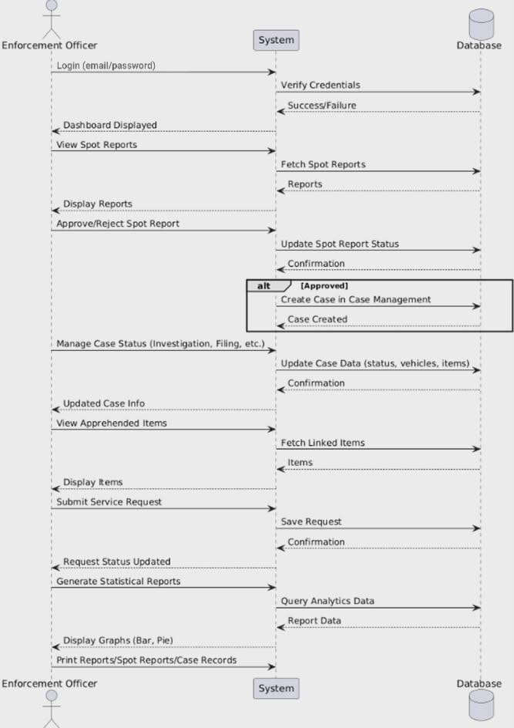

Figure 11. Sequence - Enforcement Officer
In Figure 11, the sequence diagram illustrates the actions of the Enforcement Officer role. After logging in and being redirected to the Dashboard, the Enforcement Officer manages Spot Reports submitted by Enforcers. The Diagram highlights how the Enforcement Officer approves

or rejects reports, showing that approved reports automatically forward to Case Management. The Enforcement Officer updates case statuses, including Under Investigation, For Filing, Ongoing, Dismissed, or Resolved, and these changes reflect in the Apprehended Items module. The Diagram also demonstrates how the Enforcement Officer submits service requests to the Administrator or Property Custodian and generates statistical reports. Each action flows through the system, ensuring data consistency with the Database.
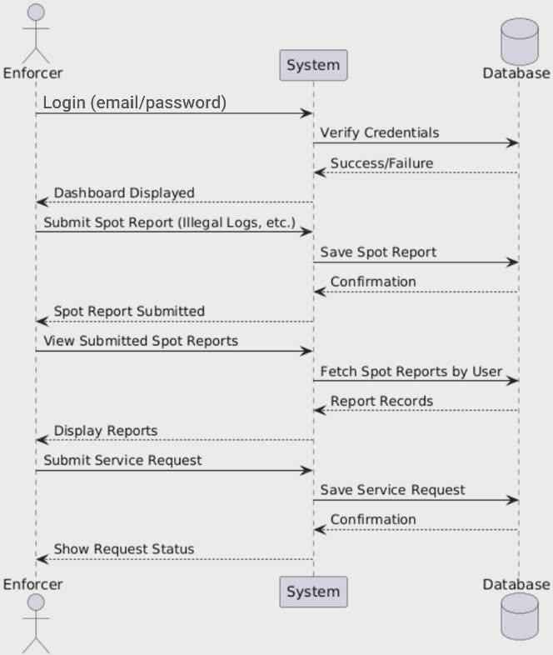

Figure 12. Sequence – Enforcer
Figure 12 shows the sequence diagram of the Enforcer role. The Enforcer logs in, and the system redirects them to the role-specific Dashboard. From there, the Enforcer creates and submits Spot Reports about apprehensions, such as illegal logs. The system stores these Spot

Reports in the Database, allowing the Enforcer to view them later. The Diagram also illustrates how the Enforcer submits service requests to report issues, such as equipment needing repair. The system manages all interactions, storing and retrieving the submitted data from the Database appropriately.
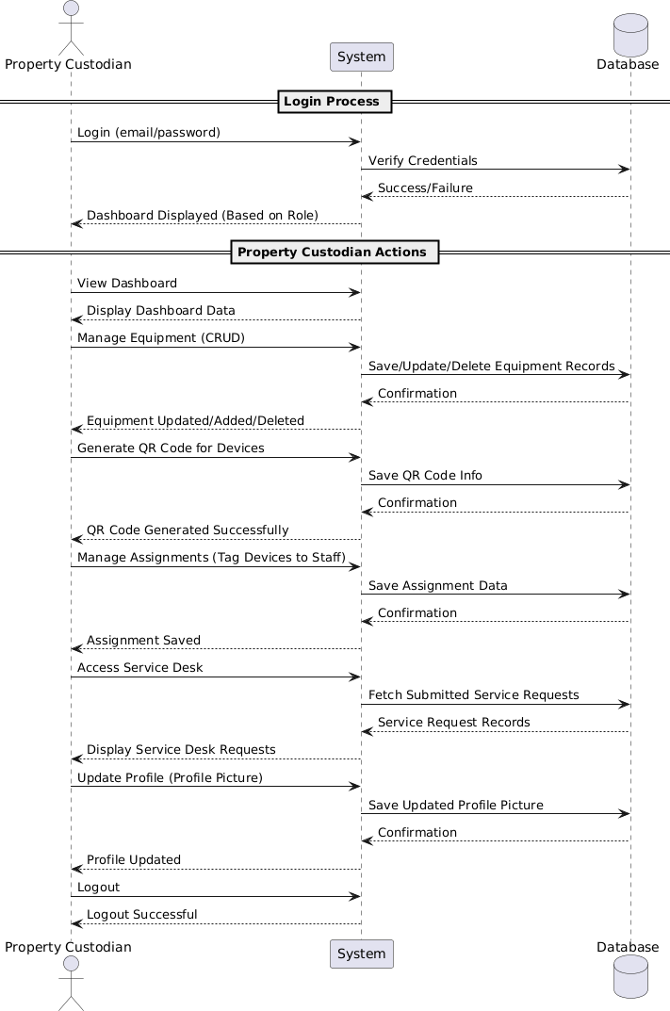

Figure 13. Sequence - Property Custodian
Figure 13 illustrates the sequence diagram for the Property Custodian role. After logging in, the system redirects the Property Custodian to the dashboard. The diagram highlights the Property Custodian’s main responsibility in Equipment Management, where they can add, update, delete, and assign devices to staff. Each assignment is stored in the database, and QR codes are generated for efficient tracking of equipment. The diagram also shows how the Property

Custodian can view staff assignments, print reports, and manage Service Desk requests submitted
by other users. All operations are processed through the system, which interacts with the database to store, update, and retrieve equipment-related data.
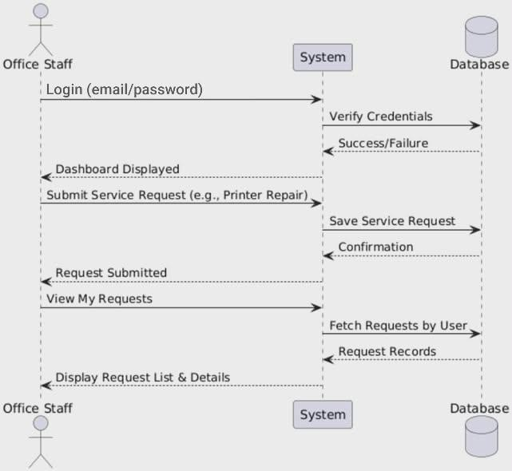

Figure 14. Sequence - Office Staff

The sequence diagram of the Office Staff role in Figure 14 illustrates the process clearly. The Office Staff logs in and gets redirected to the staff dashboard. Their primary responsibility focuses on managing Service Requests. The Diagram shows that the Office Staff submits service requests, such as reporting a broken printer, and stores these requests in the Database. Additionally, the Office Staff can view the status of their submitted requests (Pending, Ongoing, Completed) through the system. This system queries the Database and returns the results, ensuring transparency and tracking of all handled requests.

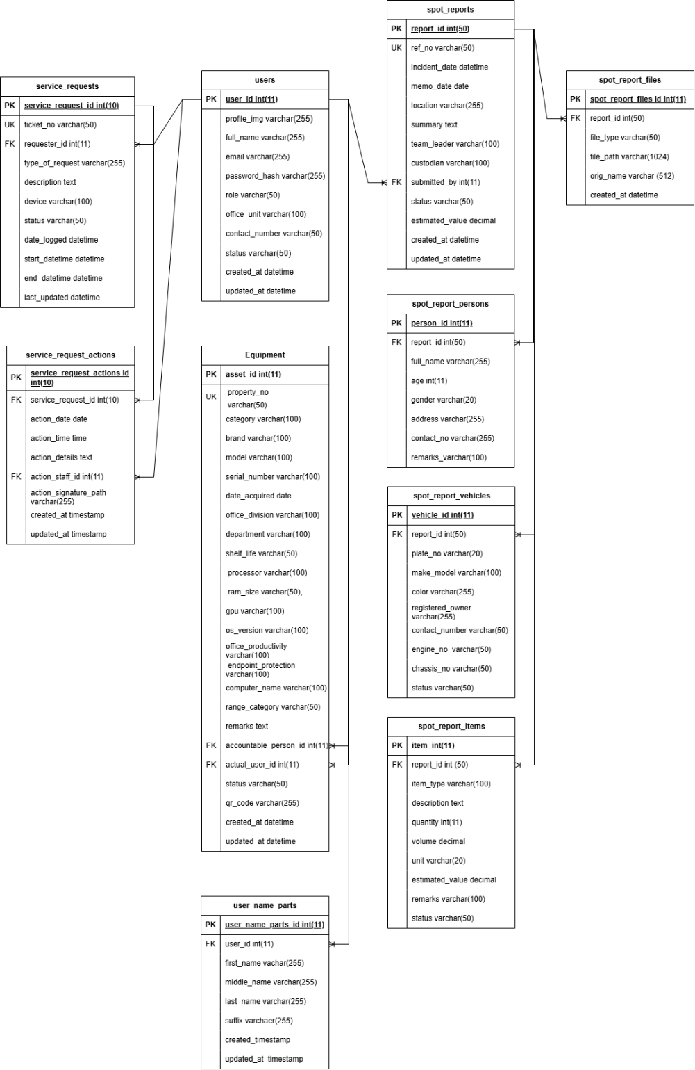
ERD (Database Design)

Figure 15. ERD (Database Design)

Figure 15 illustrates the Entity–Relationship Diagram (ERD), which outlines the design of the Database. It displays the entities, their details, and the connections among them. The main

entities include Users, Spot Reports, Cases, Apprehended Persons, Vehicles, Seized Items, Evidence, Equipment, Assignments, Service Requests, and their related authorizations and actions.
The modules connect using foreign keys to maintain data integrity. For example, Spot Reports link to Users and act as the parent for Cases, Apprehended Persons, Vehicles, Seized Items, and Evidence. Equipment links to users through assignments, and service requests tie to users, their authorizations, and actions.
In short, the ERD ensures the Database is well-structured, consistent, and can grow. It supports the system's purpose of combining operations, case management, equipment tracking, and service requests into one organized platform.

User Interface Design (Prototype)
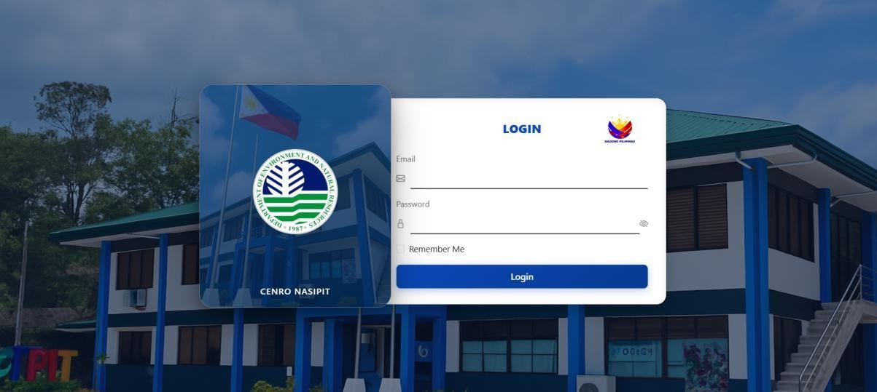

Figure 16. Login Page (Common Access for All Roles)
Figure 16 shows the login page, which serves as the main entry point for all users, including Admin, Enforcement Officer, Enforcer, Property Custodian, and Office staff. Each user enters their email and password to sign in, and the system grants access based on their specific role and responsibilities.

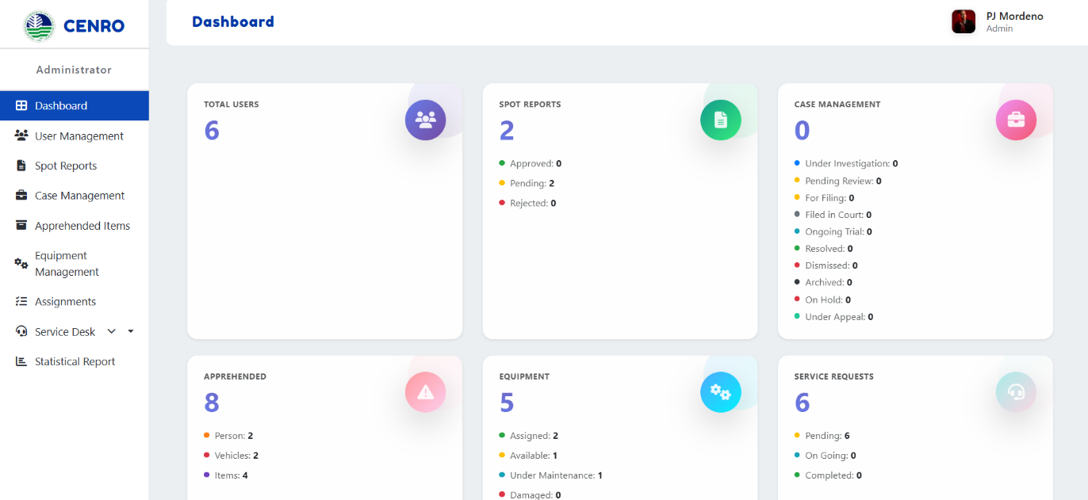

Figure 17. Dashboard (Admin Interface Design)
Figure 17 shows the system dashboard. It provides the Administrator with a quick overview of what is happening in the system, including the number of users, spot reports, cases, apprehended items, equipment, and service requests. It also includes charts that make the information easier to understand, such as the status of spot reports, the progress of cases, the availability of equipment, and a breakdown of user roles.

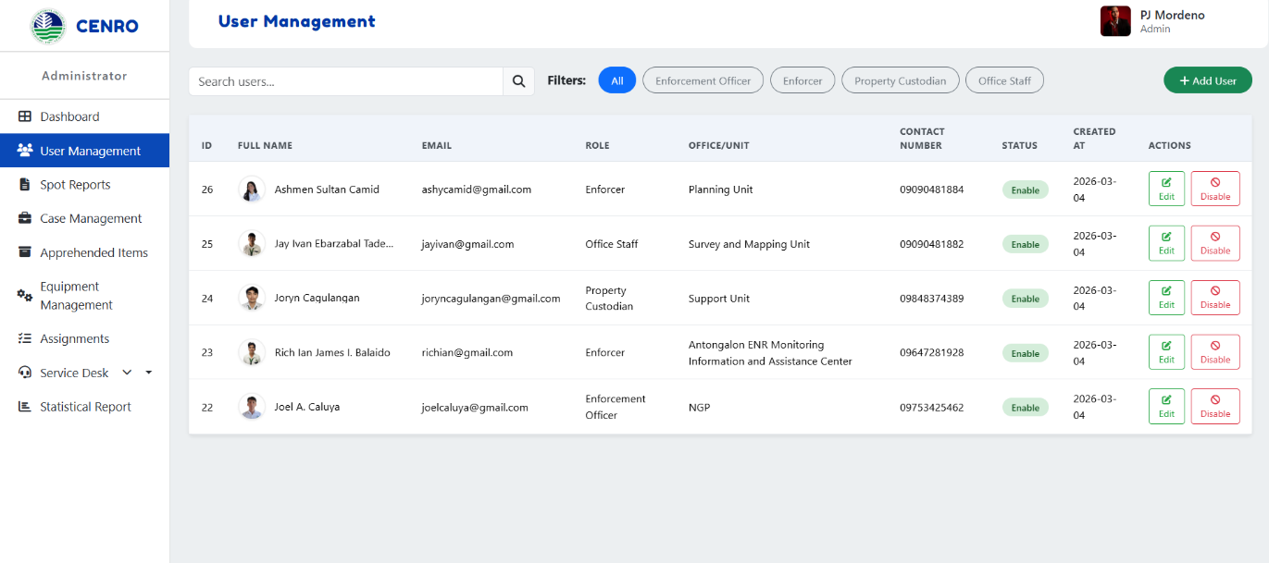

Figure 18. User Management (Admin Interface Design)
Figure 18 shows the User Management page. The Administrator can view a comprehensive list of all users in the system, which includes details such as their name, email, role, office/unit, contact number, status, and the date each user created their account. From this page, the Administrator can add new users or edit and disable existing ones. There are filters at the top to quickly sort users by their roles, such as Enforcement Officer, Enforcer, Property Custodian, or Office Staff.

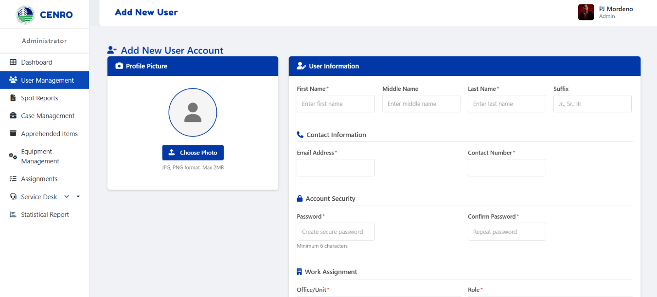

Figure 19. Add New User (Admin Interface Design)
Figure 19 shows the Add New User Account Module, where administrators can create a new user by filling in required details such as personal information, contact information, account security credentials, and work assignment. It also allows uploading a profile picture, ensuring proper identification and organization of user accounts within the system.

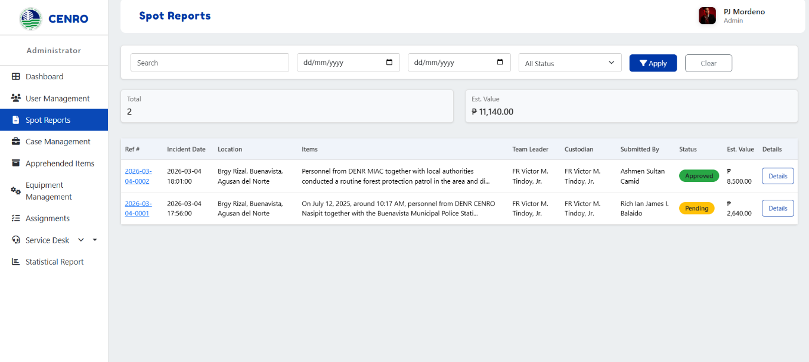

Figure 20. Spot Reports
(Admin Interface Design)

Figure 20 shows the Spot Reports page. It lists incident reports with details such as the reference number, date, location, items involved, team leader, custodian, who submitted it, status, estimated value, and a link to view more details. Both the Administrator and the Enforcement Officer have access to this page.

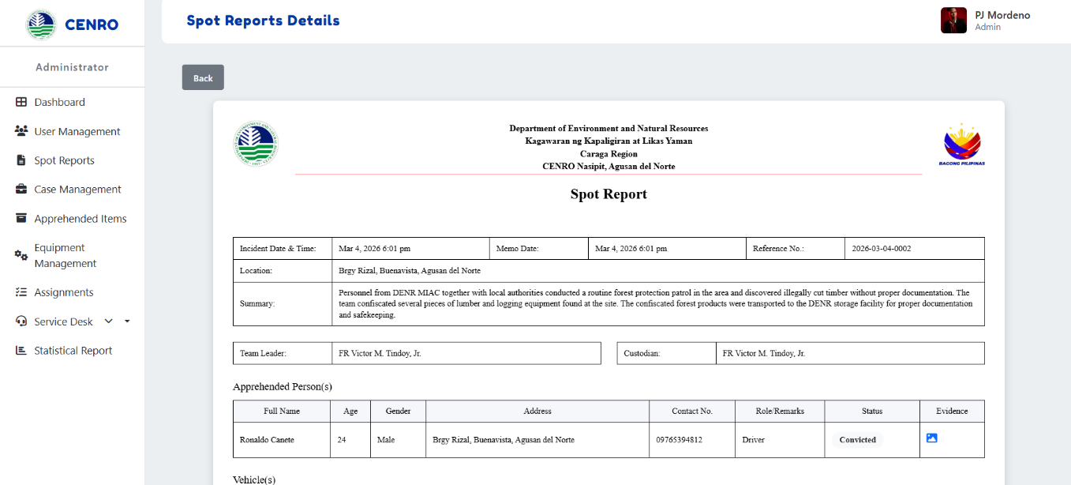

Figure 21. Spot Report Details (Admin Interface Design)
Figure 21 shows the detailed view of a Spot Report. Unlike the summary in Figure 10, this page displays the complete information, including the incident details, location, summary, team leader, custodian, apprehended persons, vehicles, seized items, evidence, and the Report's status. The Administrator can only view the details, while the Enforcement Officer can update the Report's status, such as approving or rejecting it.

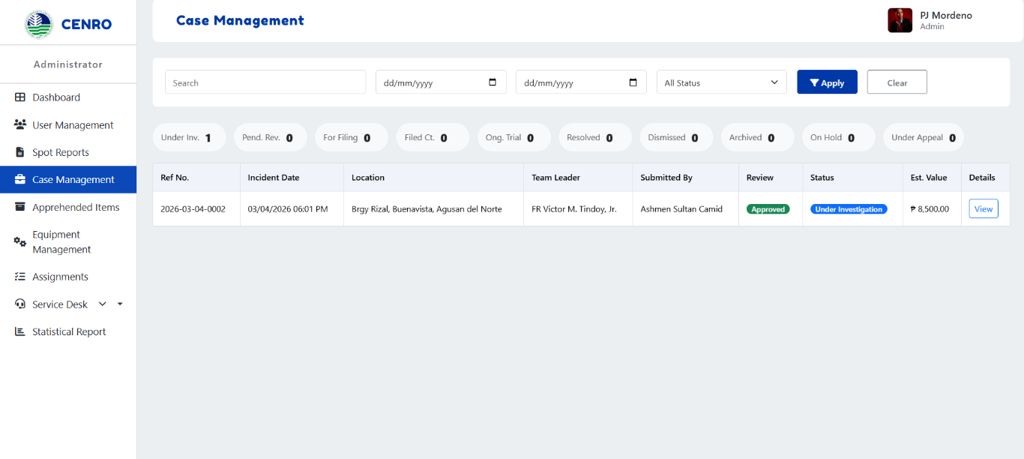

Figure 22. Case Management (Admin Interface Design)
Figure 22 shows the Case Management page. Once a Spot Report is approved, it automatically moves into Case Management. This page displays details such as the reference number, incident date, location, team leader, person who submitted it, review status, case status, estimated value, and an option to view full details.

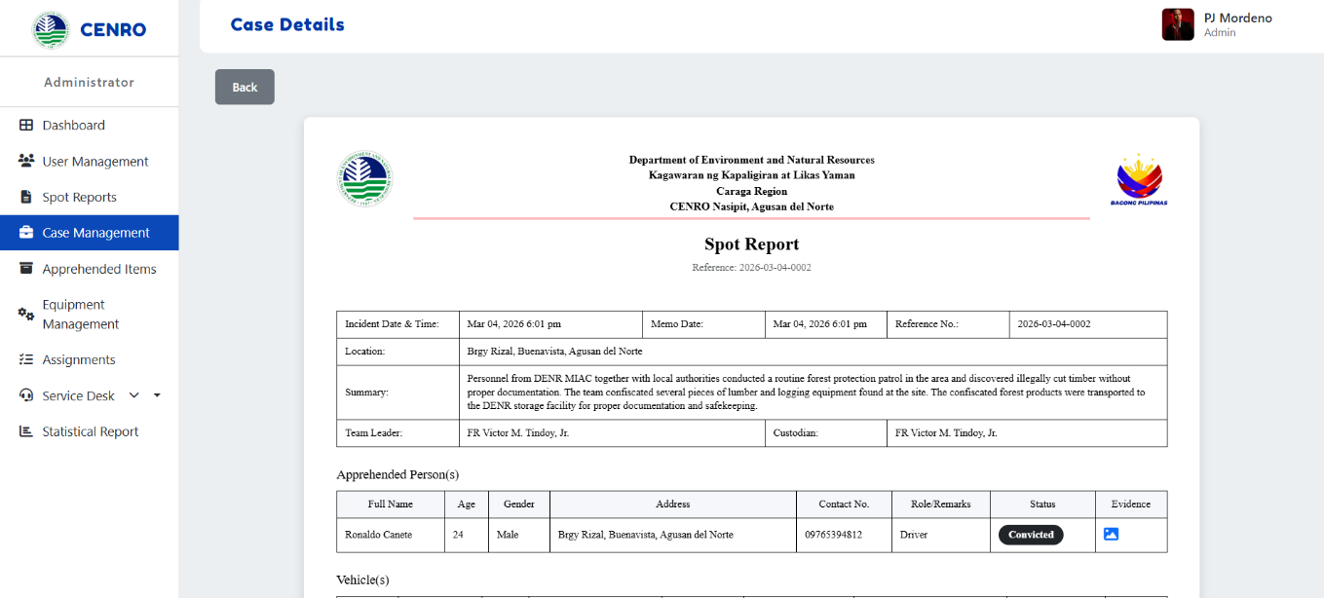

Figure 23. Case Management Details (Admin Interface Design)
Figure 23 shows the Case Details page. This page provides comprehensive information about a case originating from an approved Spot Report. It includes the incident details, location, summary, team leader, custodian, apprehended persons, vehicles, seized items, attached evidence, and the current status of the case.

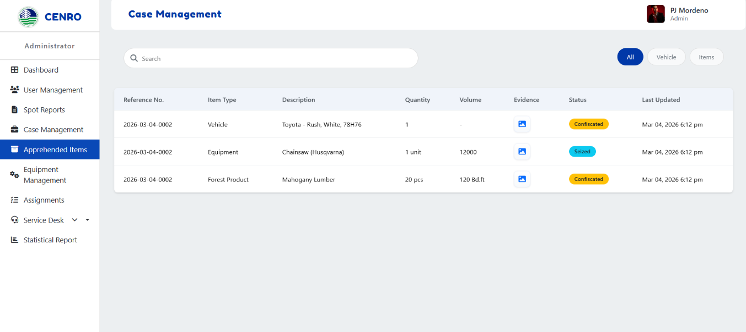

Figure 24. Apprehended Items (Admin Interface Design)
Figure 24 shows the Apprehended Items page. This page lists all items associated with a case, including vehicles, forest products, and equipment. The table provides the reference number, type, description, quantity, volume, status, and the date someone last updated it. Filters at the top make it easy to sort items by category.

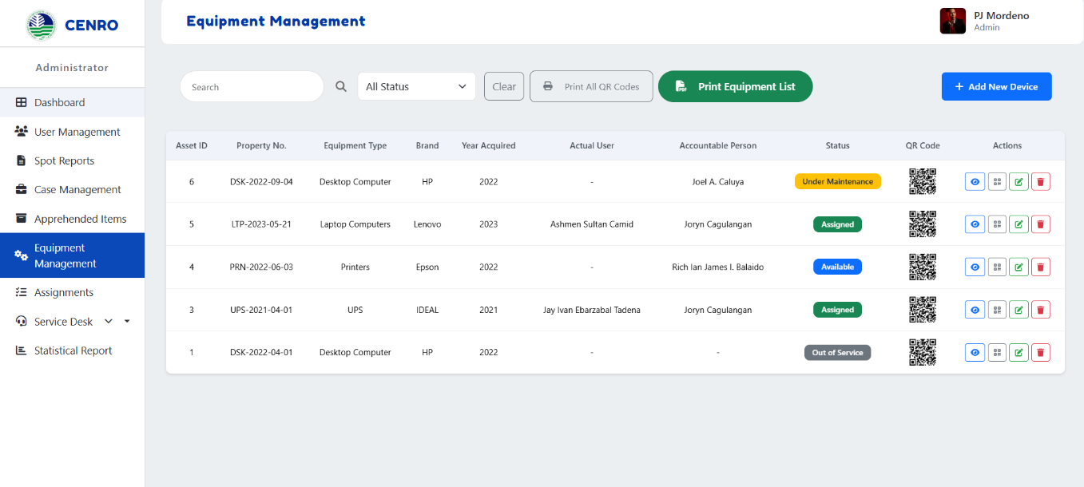

Figure 25. Equipment Management (Admin Interface Design)
Figure 25 shows the Equipment Management page, where all office equipment is recorded, monitored, and managed. This section is accessible to the Administrator and Property Custodian for handling equipment details. The table displays essential information such as Asset ID, Property Number, Equipment Type, Brand, Year Acquired, Actual User, Accountable Person, and Status, along with QR codes and action buttons for editing or deleting records. The page also provides options to add new devices, print individual or all QR codes, and generate a complete equipment list, making inventory tracking more organized and efficient.

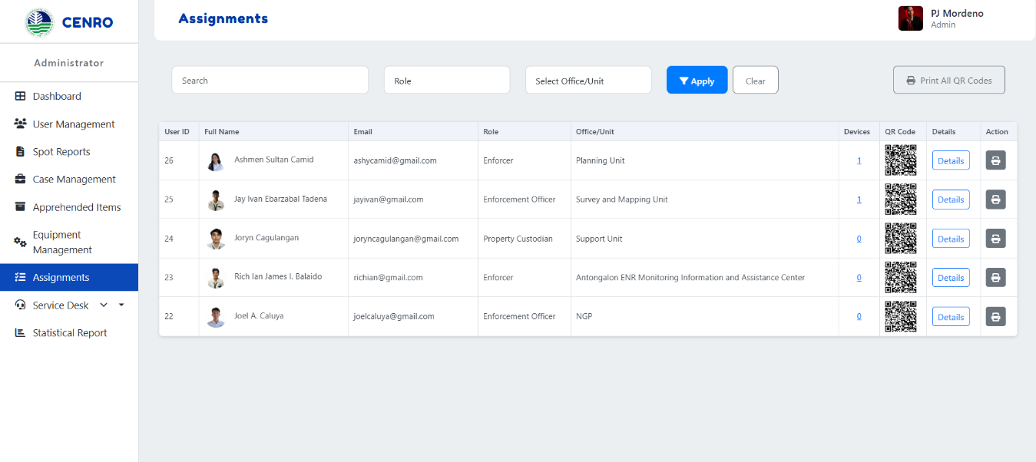

Figure 26. Assignments (Admin Interface Design)
Figure 26 The figure shows the Assignments module, where the Administrator can view and manage staff assignments and equipment accountability. The table displays details such as User ID, Full Name, Email, Role, Office/Unit, Number of Assigned Devices, and QR Codes, with action buttons for viewing and deleting records. It also includes search and filter options by role and office/unit, as well as a feature to print all QR codes. This module helps ensure accurate monitoring of personnel assignments and equipment distribution within the organization.

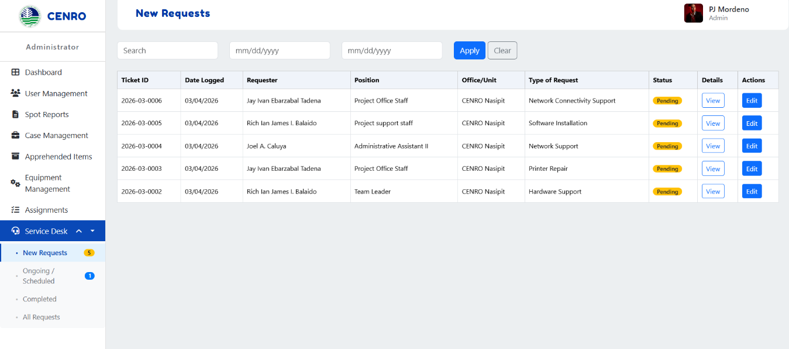

Figure 27. Service Desk (Admin Interface Design)
Figure 27 shows the figure shows the Service Desk – New Requests page, where all newly submitted service requests are displayed for review. The table includes key details such as Ticket ID, Date Logged, Requester, Position, Office/Unit, Devices, and Status, along with action buttons to view or edit each request. Search and date filter options allow the Administrator to easily locate specific tickets. This page helps efficiently manage and monitor pending service requests within the organization.

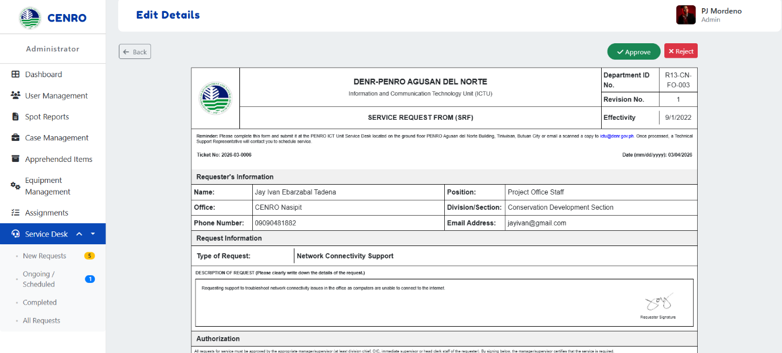

Figure 28. Request details (Admin Interface Design)
Figure 28 shows the Request Details page. A detailed form appears when users click the View button on the Service Desk – New Requests page (Figure 27). This form provides complete information about the service request, including the requester's details, the type of request, a description, an authorization section, infrastructure service authorization, and a feedback portion

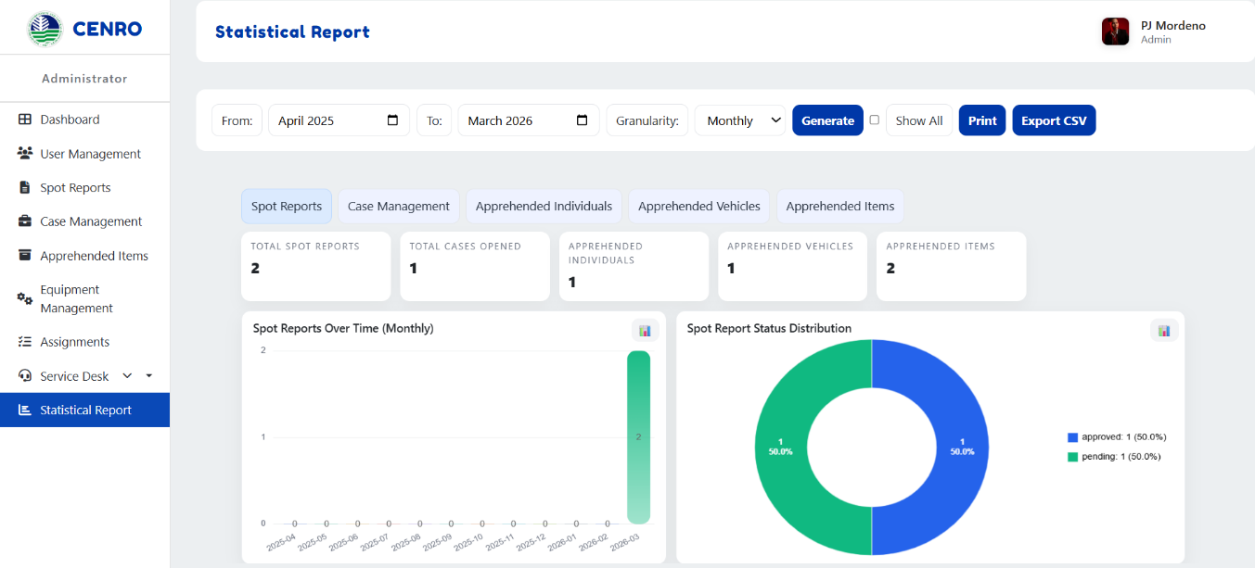

Figure 29. Statistical Report (Admin Interface Design)
Figure 29 shows the Statistical Report page, the system's automatic report generator. It can create reports by month, quarter, or year and display the data using bar graphs and pie charts. The reports cover areas such as Spot Reports, Case Management, Apprehended Individuals, Vehicles, Items. Users can set the period they want to view, display all graphs for printing, and easily print or export the reports.

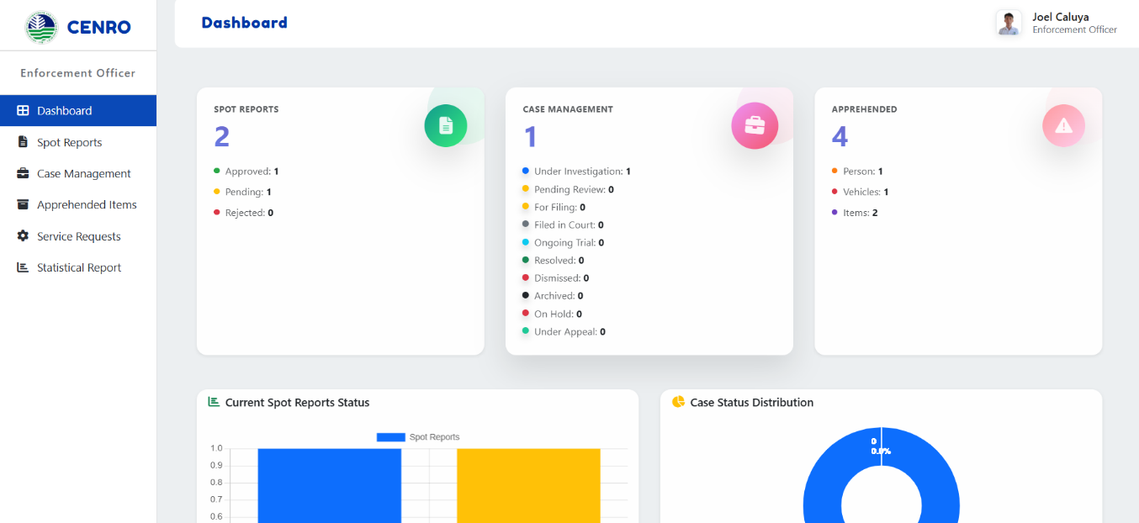

Figure 30. Dashboard (Enforcement Officer Interface Design)
Figure 30 shows the Enforcement Officer's Dashboard. It gives a quick overview of spot reports, case management, and apprehended items. The page also includes charts, such as the status of spot reports and the distribution of cases, to help the Enforcement Officer keep track of ongoing activities.

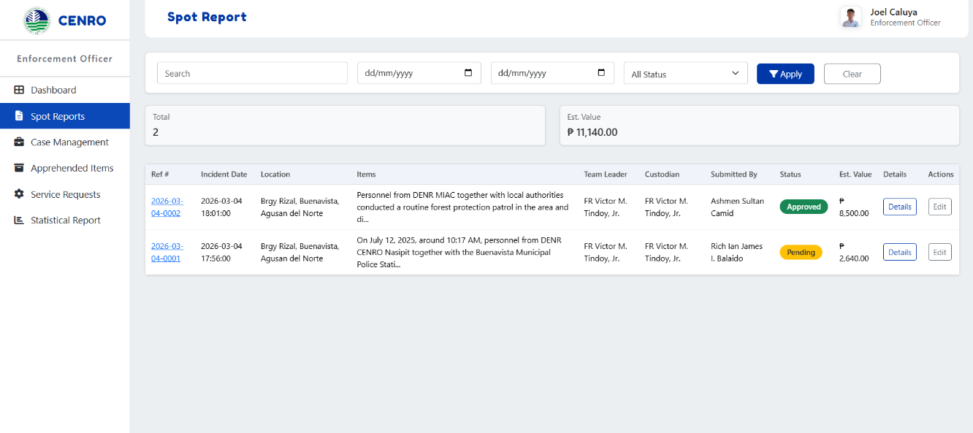

Figure 31. Spot Reports (Enforcement Officer Interface Design)
Figure 31 shows the Spot Reports page for the Enforcement Officer. It lists the reports with details such as the reference number, date, location, items, team leader, custodian, who submitted it, status, estimated value, and a link to view more details. Unlike the Administrator, the Enforcement Officer can manage these reports by updating their status, such as approving or rejecting them.

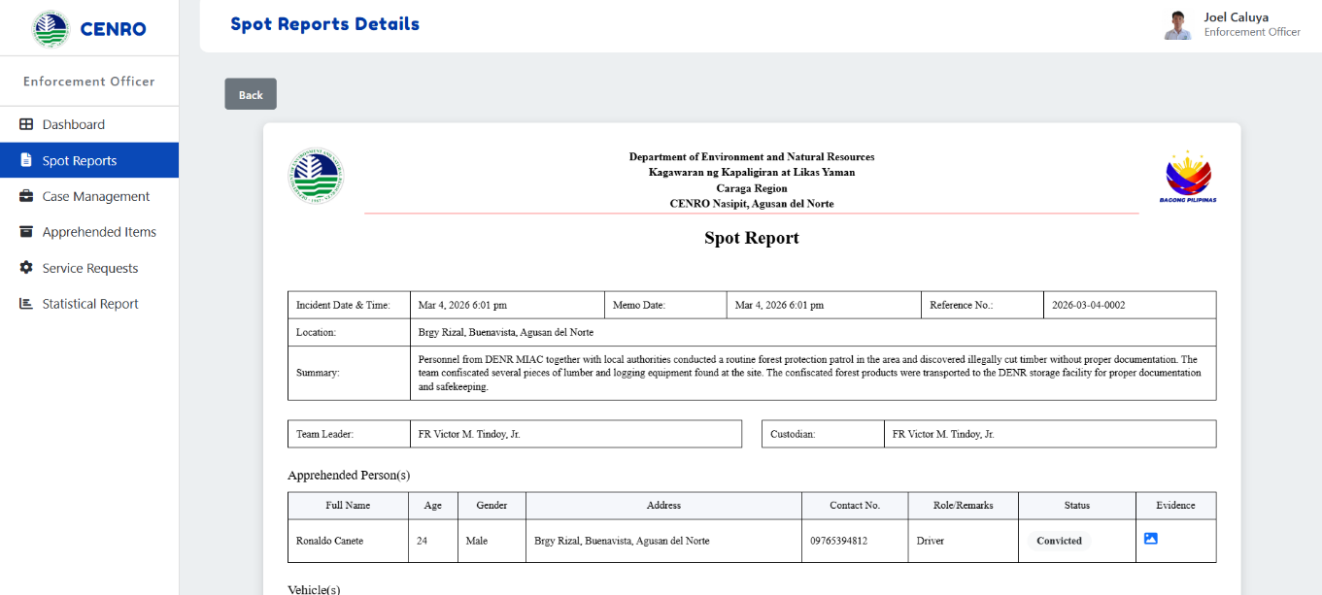

Figure 32. Spot Report Details (Enforcement Officer Interface Design)
Figure 32 shows the detailed view of a Spot Report for the Enforcement Officer. It includes complete information about the incident, such as the date, location, summary, team leader, custodian, apprehended persons, vehicles, seized items, evidence, and status. Unlike the Administrator, the Enforcement Officer can update the Report's status here, for example, approving or rejecting it.

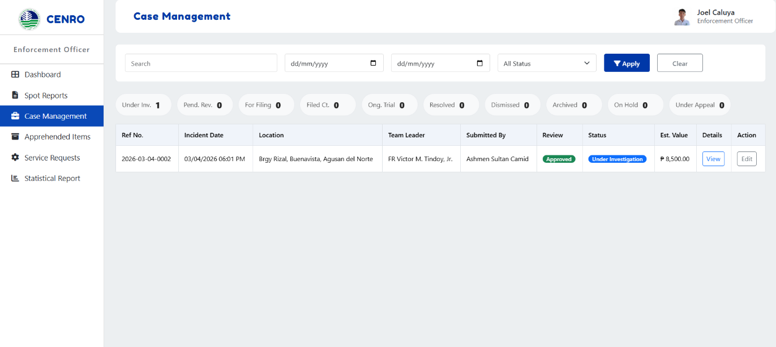

Figure 33. Case Management (Enforcement Officer Interface Design)
Figure 33 shows the Case Management page for the Enforcement Officer. This page lists the cases from approved Spot Reports, including the reference number, date, location, team leader, who submitted it, review status, case status, estimated value, and actions. Unlike the Administrator, the Enforcement Officer can manage these cases by updating their status, such as moving them under investigation, for filing, ongoing, dismissed, or resolved.

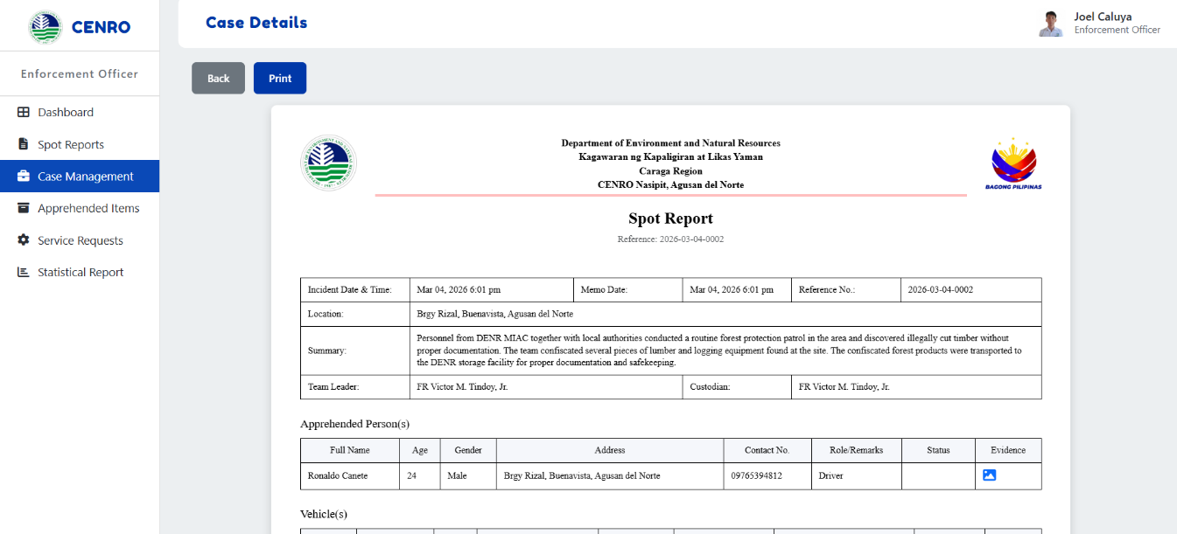

Figure 34. Case Details (Enforcement Officer Interface Design)
Figure 34 shows the Case Details page for the Enforcement Officer. It provides the complete information about a case, including the incident details, location, summary, team leader, custodian, apprehended persons, vehicles, seized items, attached evidence, and the current status. Unlike the Administrator, the Enforcement Officer can update the case status here, marking it under investigation, for filing, ongoing, dismissed, or resolved.

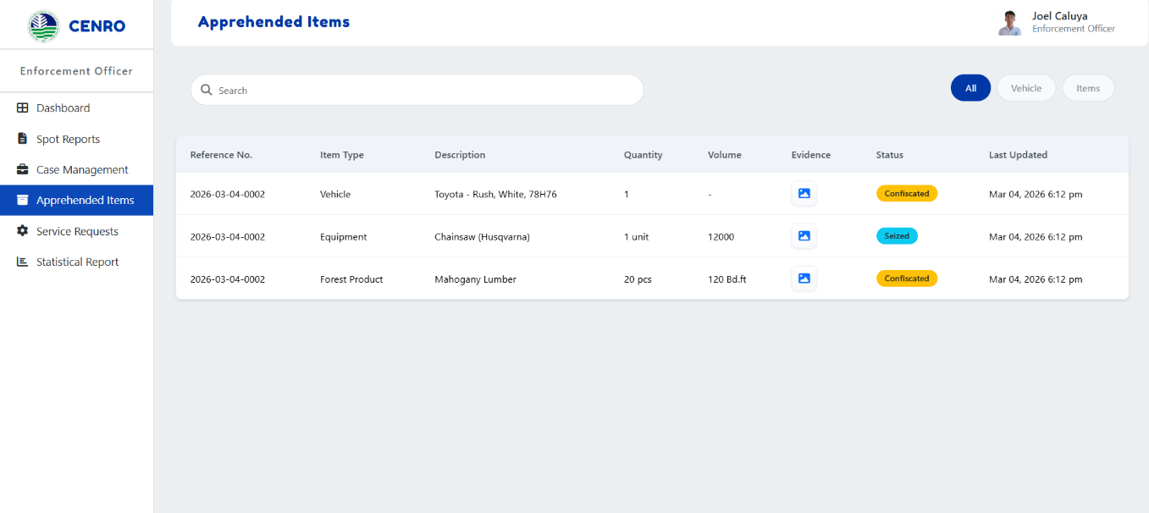

Figure 35. Apprehended Items (Enforcement Officer Interface Design)
Figure 35 shows the Apprehended Items page for the Enforcement Officer. It lists all the items linked to a case, including vehicles, forest products, and equipment. The table displays the reference number, item type, description, quantity, volume, status, and the date when someone last updated the information. The Enforcement Officer can manage this page by updating the status of the items, such as marking them for custody, disposed of, forfeited, etc.

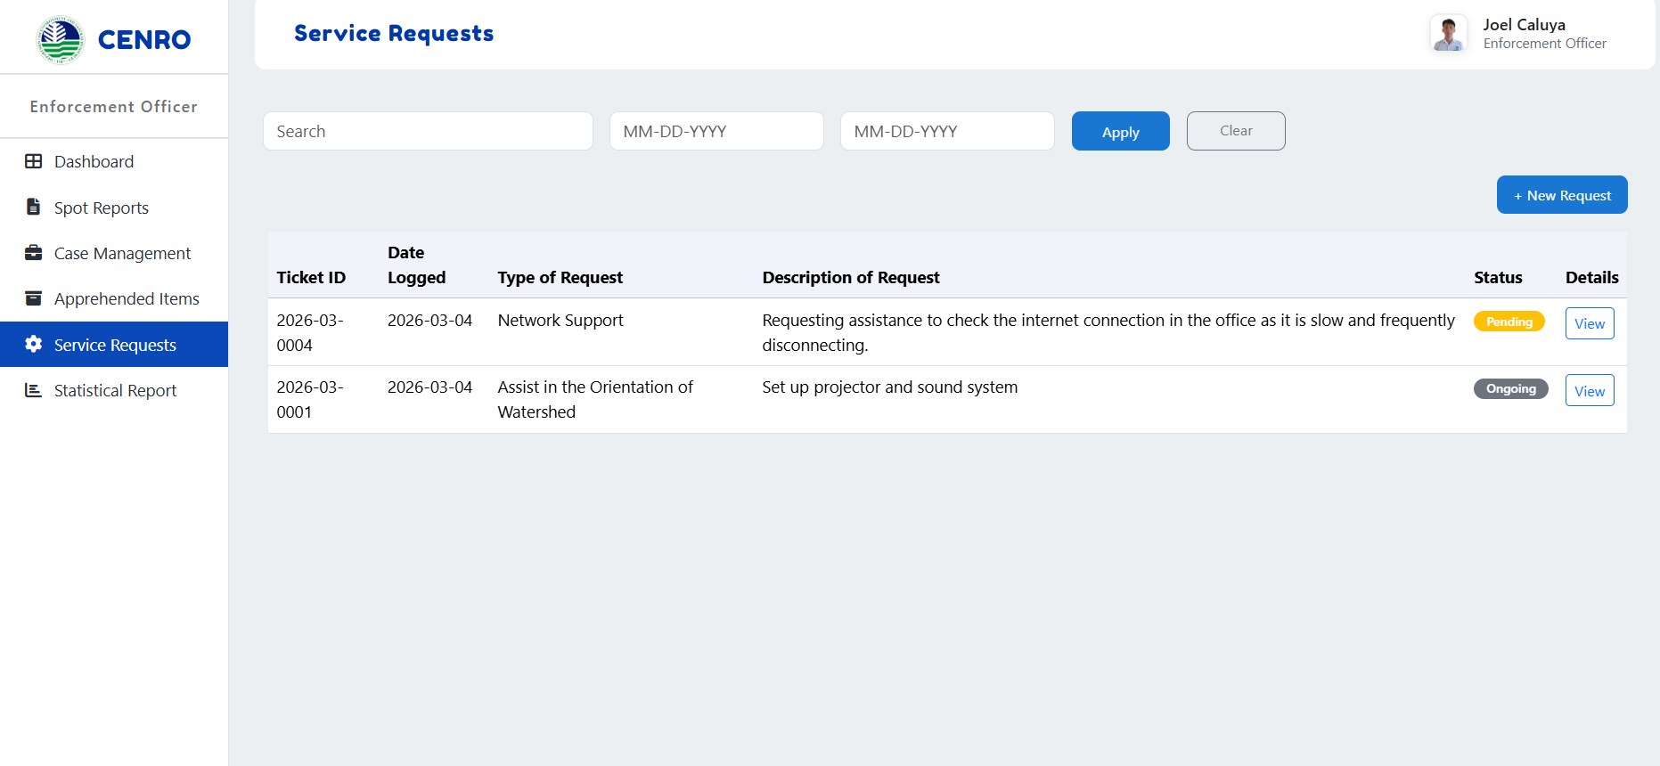

Figure 36. Service Requests (Enforcement Officer Interface Design)
Figure 36 shows the Service Request page for the Enforcement Officer. This page lists the requests made by the officer, with details such as the ticket ID, date logged, type of request, description, status, and a link to view more information. The Enforcement Officer can also create a new request from this page.

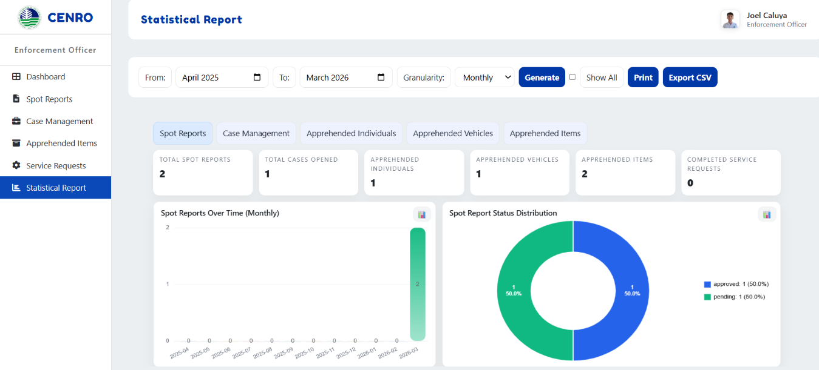

Figure 37. Statistical Report (Enforcement Officer Interface Design)
Figure 37 shows the Statistical Report page, the system's automatic report generator. It can create reports by month, quarter, or year and display the data using bar graphs and pie charts. The reports cover areas such as Spot Reports, Case Management, Apprehended Individuals, Vehicles, Items. Users can set the period they want to view, display all graphs for printing, and easily print or export the reports.

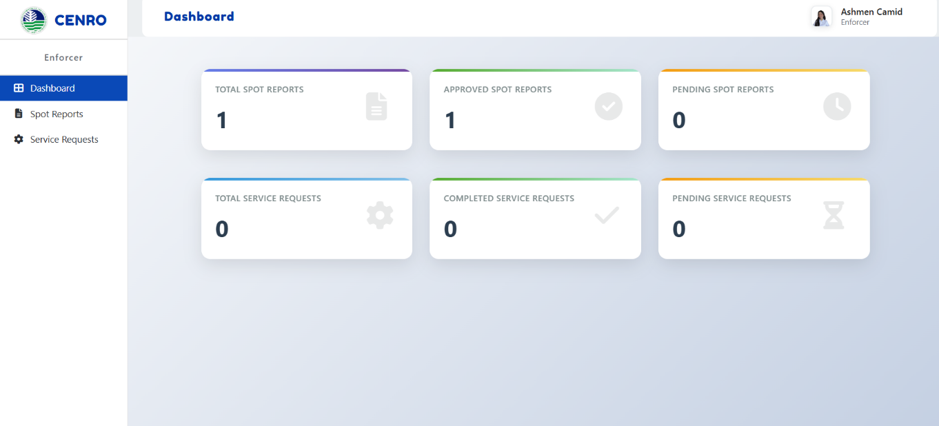

Figure 38. Dashboard (Enforcer Interface Design)
Figure 38 shows the Enforcer Dashboard interface design. The Dashboard gives a simple overview of the spot reports by showing the total number and how many are approved, pending, or rejected. The Dashboard helps the Enforcer quickly understand the status of reports. It also lists recent service requests, including the date, device, and current status. This way, the Dashboard provides the Enforcer with important information for monitoring reports and service activities in one centralized location.

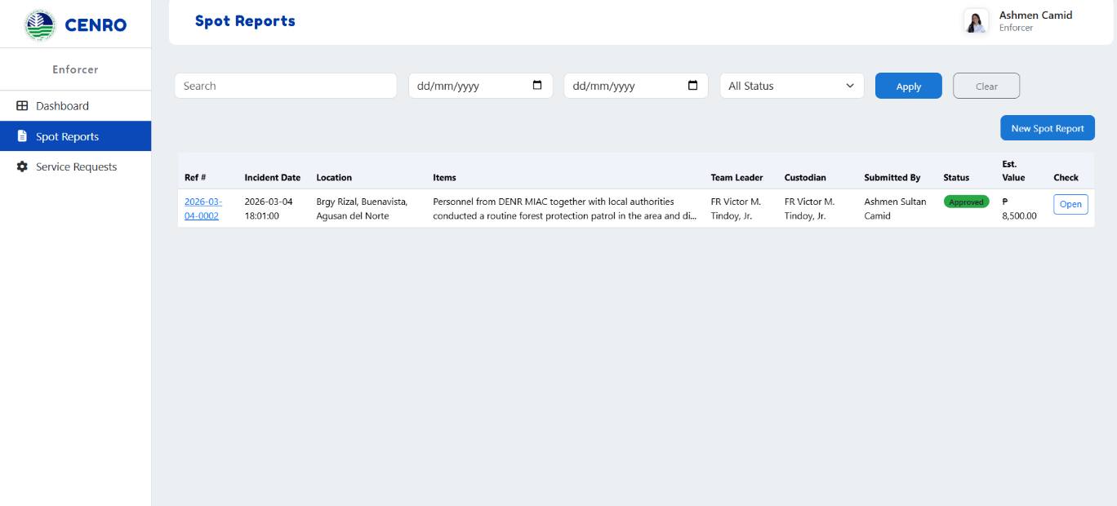

Figure 39. Spot Reports (Enforcer Interface Design)
Figure 39 shows the Spot Reports interface. The table presents a summarized view of the reports, displaying only the important details such as reference number, incident date, location, items, team leader, custodian, status, and estimated value. The Enforcer can quickly review and track reports using this system. The complete information about the selected spot report will be displayed when the user clicks the View button under the details column. The Enforcer can create or submit a new spot report on this page by clicking the New Spot Report button.

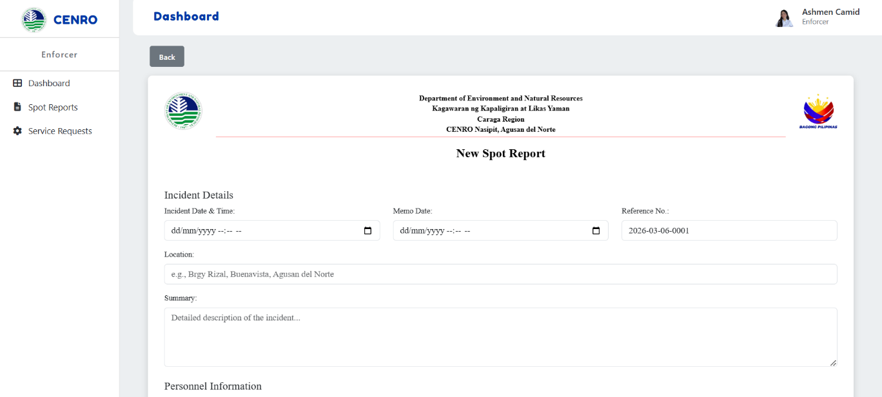

Figure 40. New Spot Report (Enforcer Interface Design)
Figure 40 shows the New Spot Report interface. This page allows the Enforcer to create and submit a detailed spot report. The form includes incident date and time fields, memo date, location, summary, team leader, and custodian. It also records details of apprehended persons, vehicles involved, and seizure items such as type, description, quantity, and estimated value. In addition, the Enforcer can upload supporting evidence and attach the spot report memorandum in PDF format. Finally, the page provides options to either submit the Report or clear all inputs for correction.

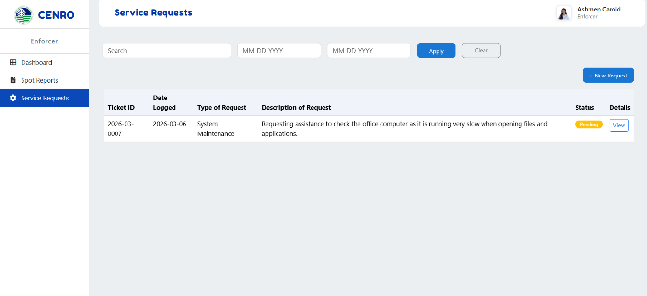

Figure 41. Service Requests (Enforcer Interface Design)
Figure 41 shows the Service Requests interface. This page allows the Enforcer to manage and track service-related concerns. The table summarizes each request, including the ticket ID, date logged, type of request, description, and current status. Users can also view the full details of a request by clicking the View button. In addition, the page includes a New Request button, which enables the Enforcer to create and submit a new service request when needed.

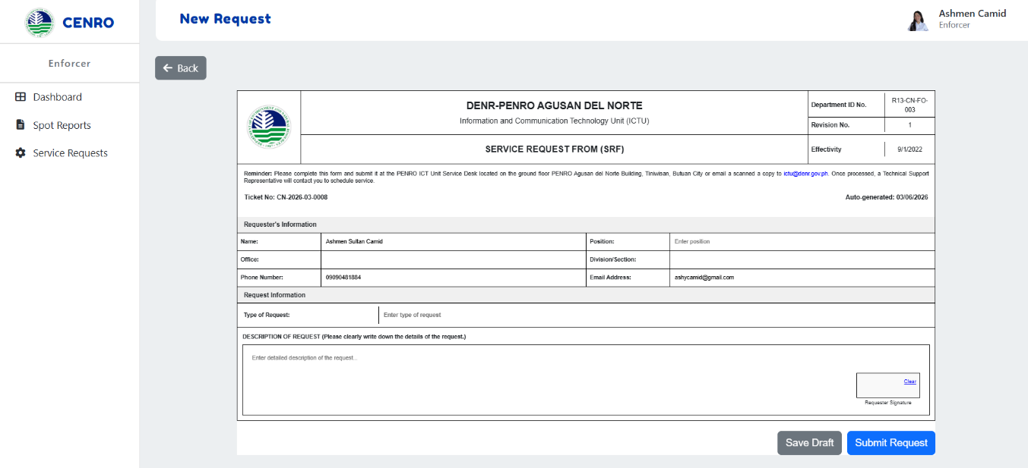

Figure 42. New Request (Enforcer Interface Design)
Figure 42 shows the Service Request Form (SRF). This form allows the Enforcer to submit service requests by filling in essential details, including personal information, office location, contact number, and a request description.

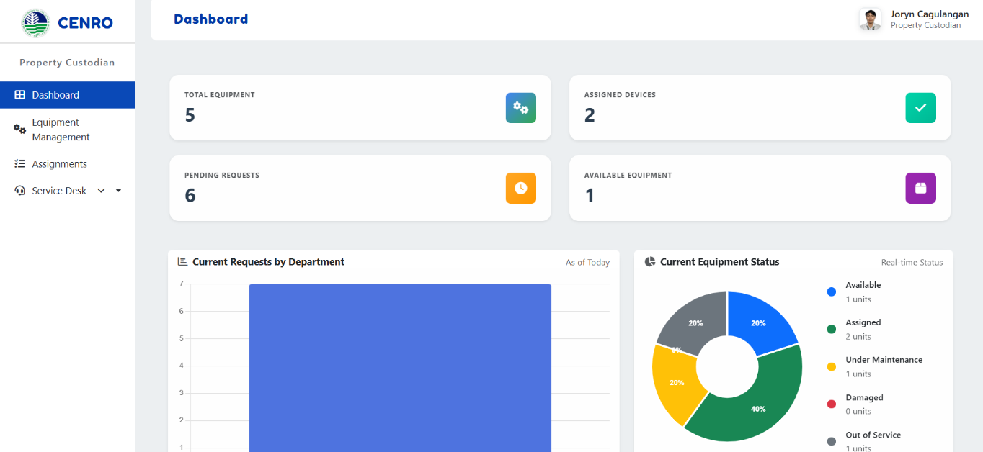

Figure 43. Dashboard (Property Custodian Interface Design)
Figure 43 shows the Dashboard of the Property Custodian interface. This Dashboard provides an overview of equipment records and requests. It displays the total number of equipment, assigned devices, pending requests, and available equipment. It also presents visual reports such as the department's current requests and real-time equipment status. The Property Custodian can easily monitor equipment distribution, availability, and condition through this interface, ensuring better accountability and management.

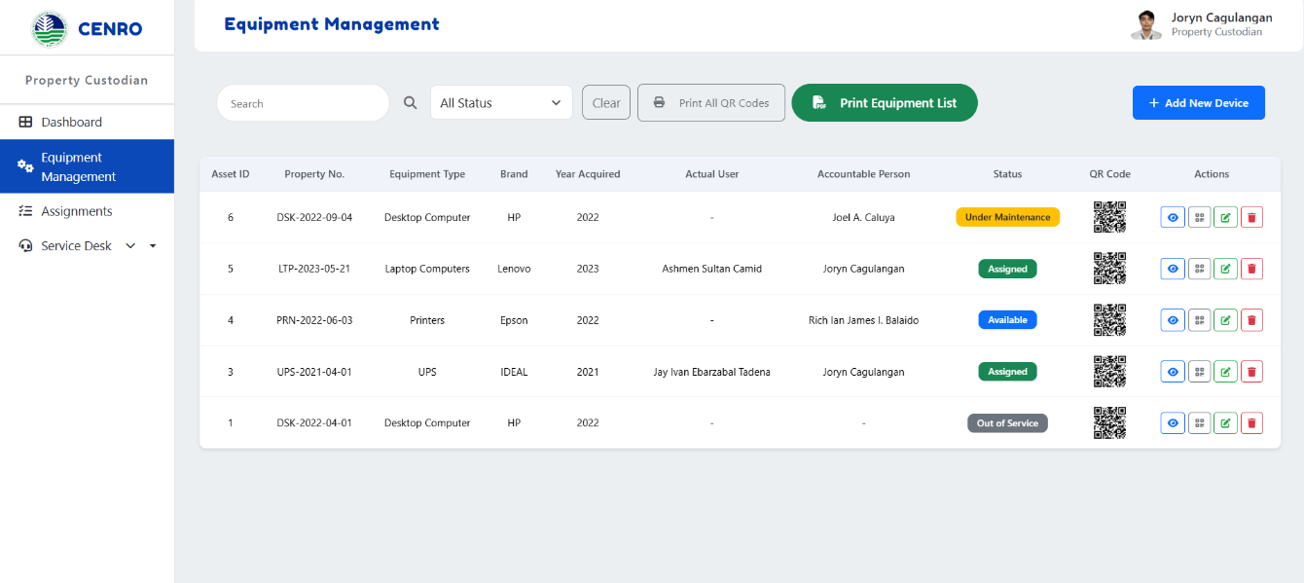

Figure 44. Equipment Management (Property Custodian Interface Design)
Figure 44 shows the figure shows the Equipment Management interface for the Property Custodian, which is used to record, organize, and monitor all office equipment. The table displays important details such as Asset ID, Property Number, Equipment Type, Brand, Year Acquired, Actual User, Accountable Person, and Status, along with QR codes for easy tracking and quick access to equipment information. The interface also provides options to add new devices, edit or delete records, print QR codes, and generate an equipment list, helping ensure accurate inventory control and accountability within the office.

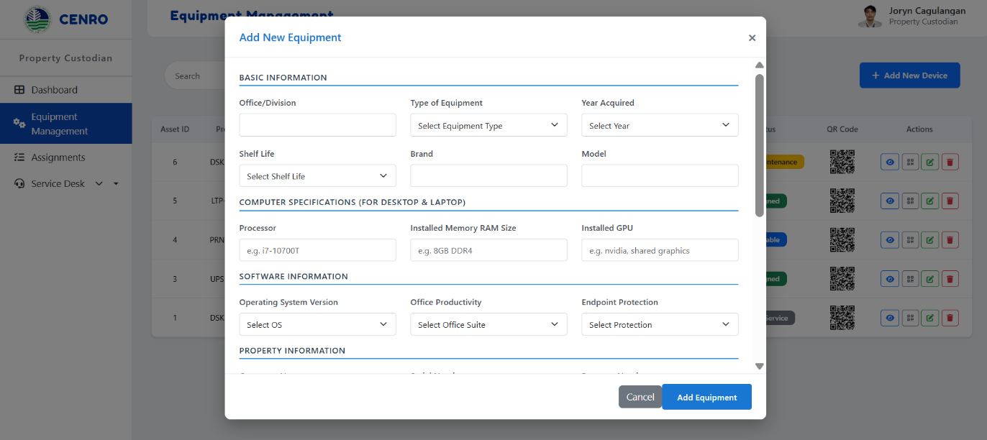

Figure 45. Add New Device (Property Custodian Interface Design)
Figure 45 shows the Add New Equipment form in the Equipment Management module. This interface allows the Property Custodian to register new equipment by filling in details such as office/division, type of equipment, year acquired, shelf life, brand, model, processor, RAM size, GPU, operating system version, office productivity suite, endpoint protection, property number, and serial number. Once completed, the information is saved in the system and linked to the equipment record, ensuring accurate documentation and proper tracking of office assets.

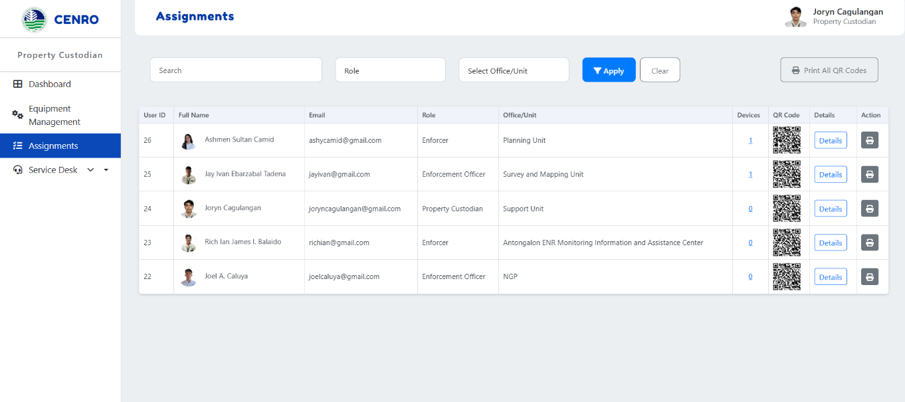

Figure 46. Assignments (Property Custodian Interface Design)
Figure 46 shows the Assignments interface of the Property Custodian module. It lists users with their roles, offices, emails, and assigned devices, each linked to a QR code for easy tracking. The interface includes tools to search, filter, view details, delete entries, and print all QR codes, helping the custodian manage equipment efficiently and maintain accountability.

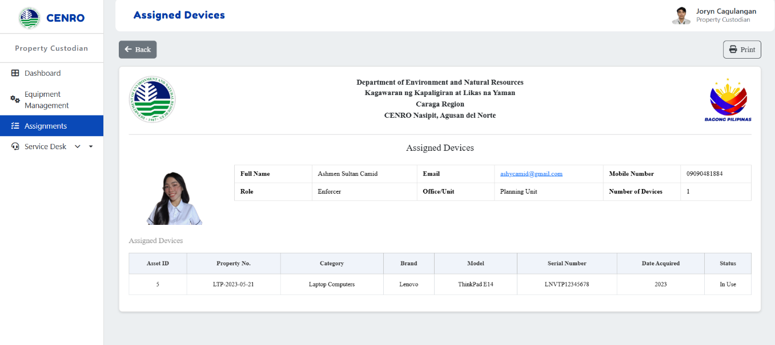

Figure 47. Assigned Devices (Property Custodian Interface Design)
Figure 47 displays the Assigned Devices view accessed through the Details option in the Assignments module. This interface presents a complete profile of the selected user, including their name, role, office/unit, email, mobile number, and number of assigned devices. Below this information, a detailed table lists each device’s asset ID, property number, category, brand, model, serial number, acquisition date, original owner, department, and current status. The interface also provides options to search, filter, and print records, supporting accurate monitoring and accountability of assigned equipment.

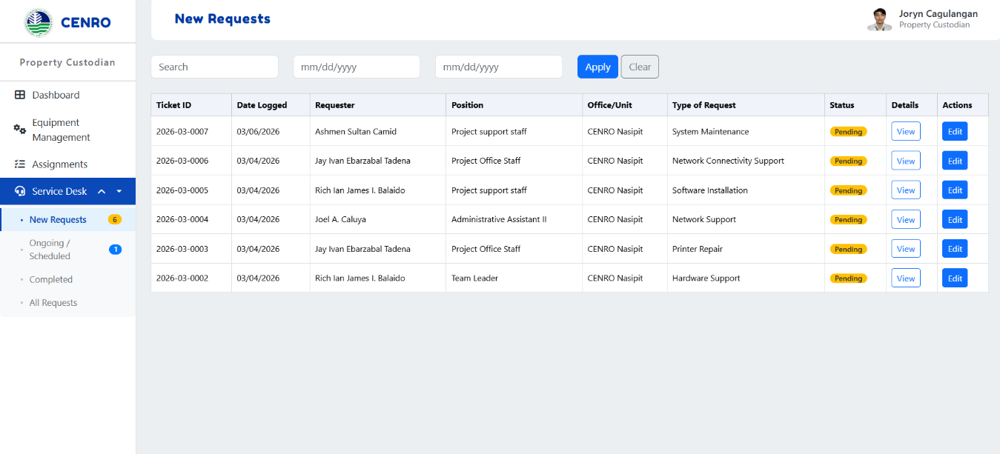

Figure 48. New Requests (Property Custodian Interface Design)
Figure 48 shows the New Requests interface in the Service Desk module. It lists submitted service requests with details such as ticket ID, date logged, requester, position, office/unit, device, and status. Each entry includes options to view or edit, while search and date filters help the Property Custodian efficiently track and manage new equipment or service requests.

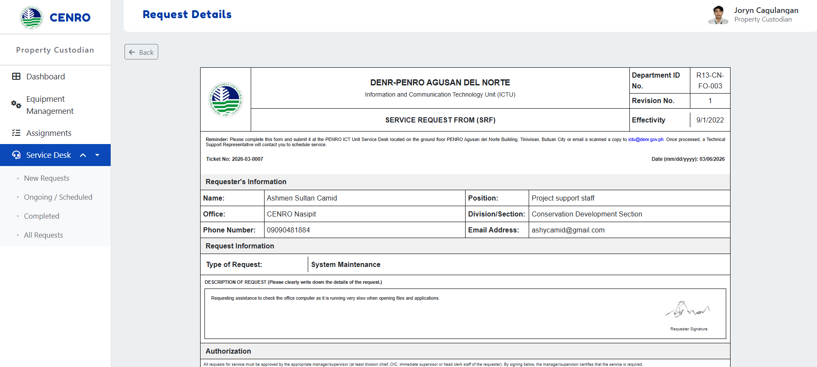

Figure 49. Request Details (Property Custodian Interface Design)
Figure 49 shows the Request Details form in the Service Desk module. This interface presents the complete information of a service request, including the requester's details, type, description of the request, and the required authorizations from supervisors or managers. It also contains sections for infrastructure service authorization, ICT staff actions, and feedback rating. This form ensures that each request is properly documented, approved, and monitored until completion.

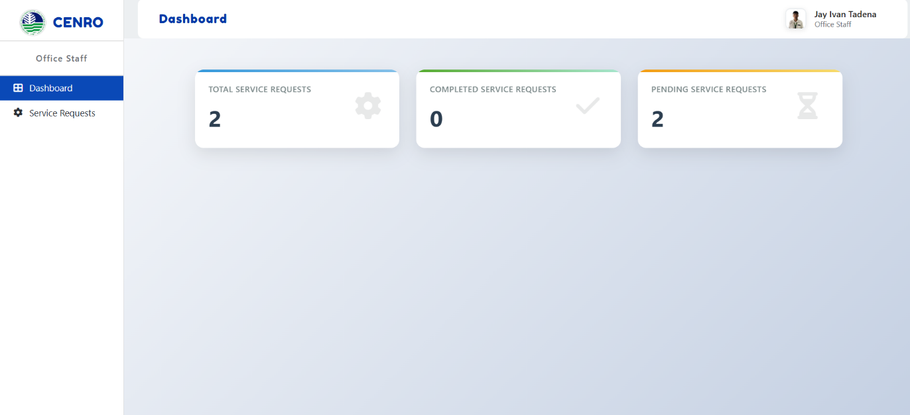

Figure 50. Dashboard (Office Staff Interface Design)
Figure 50 shows the Dashboard interface for Office Staff. The Dashboard summarizes service requests, including the total number of requests, those still pending, ongoing, and completed. This simple overview helps office staff monitor the status of their submitted requests and track their progress in real time.

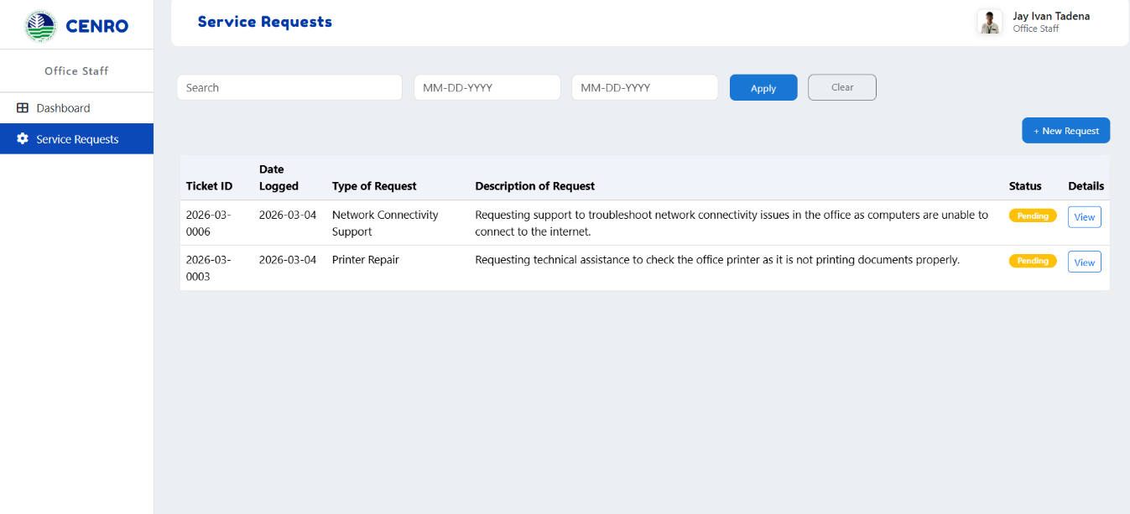

Figure 51. Service Request (Office Staff Interface Design)
Figure 51 displays the Requests interface specifically designed for Office Staff. This section includes a comprehensive list of all requests submitted by the staff, featuring details such as ticket ID, date logged, request type, a brief description, and the current status of each request. Additionally, each entry has a "View" option that allows staff to access more detailed information. This functionality enables office staff to effectively monitor the progress of their requests and stay updated on any pending actions.

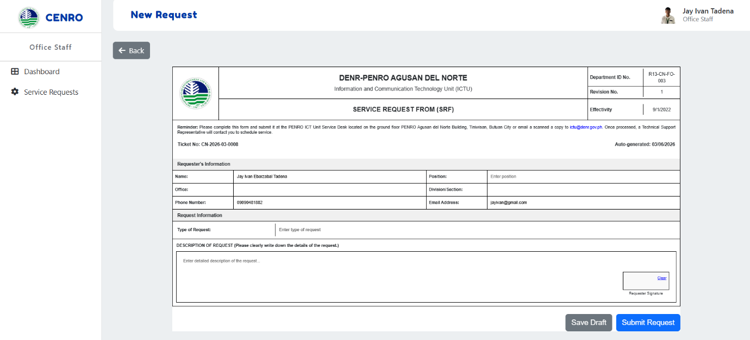

Figure 52. New Request (Office Staff Interface Design)
Figure 52 shows the New Request form for Office Staff. Staff use this form to create a service request by filling in personal and office information, the type of request, and a clear description of the concern. Office staff may also upload a scanned signature to validate the submission. A structured process ensures that service requests are formally documented and accurately recorded.

  - Software Platforms, Development Environment and Tools

Table 1
Software Platforms, Development Environments and Tools

Components | Specification | Usage
Internet Browser | Any | A web browser enables users to access and display content from the internet easily. It is responsible for loading the ISO IQA Management System's interface, allowing users access to the system's  features after a successful login.
Front-end | HTML  CSS  JavaScript  Bootstrap  JavaScript | HTML defines the structural layout of the ISO IQA Management System's interface, arranging elements like forms, texts, and other important elements.  CSS is used to improve the aesthetics and designs of HTML structures, providing a more engaging and responsive website.  To make the website interactive and provide more functionality for the users, JavaScript is used to handle all client-side functionalities.  Bootstrap allows developers to easily design responsive and mobile-first web pages by providing a collection of pre-designed components, grids, and styles to provide a more responsive website regardless of the screen size and device.  To make the website interactive and provide more functionality for the users, JavaScript is used to handle all client-side functionalities.  Bootstrap allows developers to easily design  responsive and mobile-first web pages by

providing a collection of pre-designed components, grids, and styles to provide a more responsive website regardless of the screen size
and device.
Back-end  QR Code Generation  Image Processing | MySQL (Database)  PHP  PHP QR Code Library v1.1.4  PHP GD Extension | developers to store and manage information efficiently. By utilizing the phpMyAdmin interface, developers can manage their databases and tables and perform queries.  PHP is used on the server side, which manages the interactions between user inputs and the database, ensuring smooth data flow.  The PHP QR Code library generates QR codes for device assignments and equipment tracking. It creates scannable QR codes that contain URLs or data for quick access to device information, assignment details, and equipment status. This enhances the system's functionality by providing mobile-friendly access to equipment data through QR code scanning.  The GD extension provides image processing capabilities required for QR code generation. It handles creating, manipulating, and rendering QR code images in PNG format. This extension is essential for the visual output of QR codes and ensures proper image quality and format  compatibility.
Server | Apache | Utilizing the XAMPP control panel, developers can manage the behavioral state of its components ensuring smooth and easy access to local host  servers like Apache and MySQL.

  - Hardware Requirements

Table 2 Hardware Requirements
Components | Specification | Usage
Device | RAM (16 GB)  Processor (Intel Core i5)  SSD (128 GB)  Flash Storage (8 GB) | RAM facilitates fast and temporary data storage. It is used to enhance the speed and performance of devices in accessing information.  The processor or the CPU, acts as the central component of the computer, handling the execution of instructions sent from the website. It also facilitates the processing of data.  Devices employ SSD to store large amounts of audit files, system software, and reports, while flash storage commonly used in mobile devices for lightweight data storage. These storage solutions ensure quick retrieval and secure long-term data handling.
Printer | Any Ink Jet Printer Units | Inkjet printers are tilized for printing audit reports, data summaries, and compliance documents, producing clear and high-quality output. These printers are versatile and affordable, making them suitable for regular printing tasks related to audit management, such as generating official documents for internal use or distribution to  stakeholders.
Mobile Device | Smartphone with camera and internet connectivity (Android/iOS compatible) | Mobile device for QR code scanning of equipment labels attached to device surfaces including hard- to-reach areas, enabling flexible inventory tracking and assignment verification through mobile  camera functionality.

  - System Evaluation

This section describes the different evaluation procedures done on the system to assess its functional suitability, performance efficiency, and usability. The survey instrument is adapted from ISO 25010 Software Product Quality Standards; the test scale gives four options to the respondents and will rate the system based on the question, with 4 as the highest and one as the lowest.

Table 3
Functional Suitability

Adjectival Rating | Scale Range (Mean) | Verbal Interpretation
4 | 3.50 – 4.0 | Very Functional
3 | 2.50 – 3.49 | Functional
2 | 1.50 – 2.49 | Moderately Functional
1 | 1.0 – 1.49 | Poor Functional

Table 3 presents the criteria for evaluating a product or system's functional suitability according to the ISO survey.

Table 4

Performance Efficiency
 | Adjectival Rating | Scale Range (Mean) | Verbal Interpretation
 | 4 | 3.50 – 4.0 | Very Efficient
 | 3 | 2.50 – 3.49 | Efficient
 | 2 | 1.50 – 2.49 | Moderately Efficient
 | 1 | 1.0 – 1.49 | Poor Efficient

Table 4 outlines the scoring parameters to assess the system's overall performance efficiency in executing its functions and tasks.

Table 5
Usability
Adjectival Rating | Scale Range (Mean) | Verbal Interpretation
4 | 3.50 – 4.0 | Very Usable
3 | 2.50 – 3.49 | Usable
2 | 1.50 – 2.49 | Moderately Usable
1 | 1.0 – 1.49 | Poor Usable

Table 5 presents the scoring parameters used for the usability of the system.

Table 6

Respondent’s Distribution SMCC Learning Resource Center
Position | N (Population) | Percentage (%)
ICT Focal Person | 1 | 10%
Enforcement Officers | 1 | 10%
Enforcers | 1 | 10%
Property Custodian | 1 | 10%
Office Staffs | 6 | 60%
Total | 10 | 100

Table 6 presents the distribution of respondents from the SMCC Learning Resource Center who participated in the system evaluation. The respondents are classified according to their positions, including the ICT Focal Person, Enforcement Officers, Enforcers, Property Custodian, and Office Staff. Each position represents one respondent, constituting 20% of the total population. This equal distribution ensures that feedback is gathered from all key personnel involved in operating, managing, and monitoring resources. Their collective insights provide a balanced assessment of the system's functionality, efficiency, and usability within the Learning Resource Center's operations.

2.13. Research Ethical Standard
- Protection of Intellectual Property Rights (IPR)
The capstone project ensures intellectual property protection related to the CENRO Nasipit Field Operations and Equipment Tracking System (CENRO NFO-ETS). The system was originally developed by the researchers and includes unique source codes, database design, and documentation, with ownership documented through version logs and authorship records. The Intellectual Property Code of the Philippines (Republic Act No. 8293) provides copyright protection to all original components of the system and does not require patent or trademark registration unless the system is later commercialized. The researchers utilized licensed third-party open-source tools and libraries in compliance with their respective licenses, including PHP QR Code Library version 1.1.4 (LGPL), Bootstrap (MIT License), and MySQL (GNU GPL v2), all of which are properly referenced and credited. Since the study did not involve the creation of a brand or logo, trademark registration is not applicable.

Informed Consent
Prior to data gathering, the researchers informed all participants and staff from CENRO Nasipit about the study’s purpose, procedures, scope of data collection, potential risks and benefits, and the importance of their participation. Informed consent was administered through printed written consent forms, which were explained and signed by the participants before their involvement in the study. The consent form clearly stated that participation was voluntary, that participants had the right to withdraw at any time without penalty, and that collected data would be used solely for academic purposes and securely stored for the duration of the study. Participants were informed of the specific type of data to be collected, including system feedback and user experience, and how their responses would contribute to system improvement. All signed consent forms are securely kept on file by the research team for ethical validation. The study involved only adult human participants and no animal subjects; therefore, while formal ethical approval was obtained from the Ethics Review Board Committee of Saint Michael College of Caraga as stated in Section M, no additional external or animal-specific ethical clearance was required.

Data Privacy and Confidentiality
The capstone project complies with the Data Privacy Act of 2012 (Republic Act No. 10173) to protect the personal and work-related information of participants from CENRO Nasipit. All collected data are treated as confidential and are accessed only by the researchers, the project adviser, and designated CENRO Nasipit supervisors for academic validation purposes. Informed consent forms explicitly state the purpose of data collection, scope of data use, data retention period, and conditions for possible data sharing strictly for academic and institutional review. Personal identifiers such as names, user accounts, and assigned device records are coded and anonymized to prevent direct identification of participants in the system and research outputs. Digital data are stored in password-protected devices and secured storage systems, while printed documents are kept in locked cabinets accessible only to authorized personnel. A basic internal data privacy compliance check aligned with the NPC Data Privacy Template was conducted prior to data collection to assess privacy risks. Anonymized data may be shared outside CENRO solely for academic evaluation, subject to explicit participant consent. All research data will be retained for one (1) year after project completion and will be securely disposed of through permanent deletion of digital files and shredding of physical documents.

Voluntary Participation and Freedom to Withdraw
Participation in this study will be voluntary and non-coercive. The researchers will inform the participants that they may withdraw from the study at any stage without penalty or adverse effect. In the event of withdrawal, all data directly associated with the participant, including responses and system feedback, will be excluded from analysis and permanently deleted from the research records. No financial incentives or special benefits will be offered for participation. The researchers will ensure that no positional authority, supervisory role, or workplace influence from CENRO Nasipit is used to pressure employees into participating, and that participation or non-participation will have no effect on their employment status or work evaluation. Participants’ responses and feedback will be collected voluntarily and honestly, and all ethical measures will be upheld throughout the research process to ensure the safety, privacy, and comfort of the participants.

Minimization of Harm and Risk Management
The research team conducted a formal risk assessment prior to the implementation of the study to ensure that the project posed no physical, emotional, or psychological harm to the participants. The study involved only interviews, surveys, and system testing; however, potential non-obvious risks—such as mild stress arising from audit-related system testing and possible concerns regarding errors in device data that could affect job-related perceptions—were identified and addressed through appropriate safeguards. Participants were informed that the system was for research and process improvement purposes only and would not be used for performance evaluation or disciplinary action. The researchers treated all participants with respect and ensured the protection of their privacy throughout the research process. Participants were also informed of available support mechanisms and their right to discontinue participation should any discomfort arise. The research was conducted in accordance with accepted ethical practices, maintaining professional, respectful, and safe interactions with participants. No animal testing or biological experiments were involved at any stage of the project.

Beneficence and Contribution to Knowledge

The CENRO Nasipit staff will be provided with a summary of the research findings, and participants may request a personal copy of the results for their reference. The findings will be formally disseminated through an institutional presentation to CENRO Nasipit officials and staff, as well as through the capstone defense and research forum at Saint Michael College of Caraga, and will be archived in the institutional research repository in accordance with academic requirements. The results may also be shared for academic review or scholarly purposes, subject to confidentiality safeguards. The findings aim to optimize audit effectiveness through improved and timely control of equipment and field activities, enhance data management by facilitating organized record retrieval, streamline operational workflows, and support more effective and responsible decision-making. While the primary institutional benefits include improved organizational efficiency and accountability within CENRO Nasipit, the broader societal and academic contributions of the study lie in promoting transparency, responsible management of public resources, and providing a reference model for other institutions and researchers interested in implementing similar systems.

Justice and Fair Participant Selection
Participants were selected based on explicit inclusion criteria, which included holding roles directly related to field operations, active involvement in equipment tracking and audit processes, and willingness to participate voluntarily. Exclusion criteria included employees not engaged in field operations, those on leave during the study period, or individuals who declined participation. This selection ensured that participants’ contributions were relevant to the professional functions under study while avoiding overrepresentation of any particular group. All roles within the field operations team were proportionately represented to provide fair and balanced input, minimizing bias and ensuring that the study accurately reflected the diverse responsibilities and perspectives of the office.

Data Integrity and Accuracy
The research team carefully checked all information collected to ensure accuracy, reliability, and consistency. Standardized data-gathering methods, including structured interviews, validated survey instruments, and system testing protocols, were employed to minimize errors and bias. Any identified errors or inconsistencies during data collection, coding, or analysis were logged in a dedicated error and correction register, systematically corrected, and revalidated through cross- checking with source records. The system was tested following ISO 25010 software quality standards using an evaluation checklist and test matrix to assess functionality, reliability, usability, performance efficiency, and maintainability, ensuring accurate and dependable results. All findings, including limitations, were transparently documented, and any potential sources of bias were addressed topromote research integrity.

Transparency and Honesty in Reporting
All existing sources, tools, software, references, and third-party materials used in the study, such as libraries, frameworks, and academic literature, were properly referenced to respect intellectual property rights, credit original authors, and maintain transparency and the highest standards of academic integrity. The researchers reported all results of the study truthfully and without alteration, explicitly noting any limitations in data collection, system testing, or analysis. To ensure transparency, an audit trail and documentation logs were maintained for all research activities, including data entries, code versions, and system testing results, allowing verification of procedures and outcomes. Potential conflicts of interest were evaluated through formal disclosure among all research team members and review by the project adviser, confirming that no personal, financial, or professional interests influenced the conduct or reporting of the study.

Use of Patented or Copyrighted Materials
No proprietary or patented systems were accessed without proper authorization. All third- party materials, including source codes, frameworks, open-source software, icons, templates, UI assets, and literature, were appropriately licensed, referenced, and credited. The researchers verified compliance with each license—for example, Bootstrap (MIT License), MySQL (GNU GPL v2), and PHP QR Code Library version 1.1.4 (LGPL)—and obtained permissions or clearance for any embedded materials when required. The study did not include AI-generated content that violated copyright or intellectual property rights, in accordance with SMCC RIID standards. These measures ensured full compliance with copyright requirements, honored intellectual property rights, promoted transparency in research practices, and maintained ethical and responsible behavior throughout the study.

Ethical Considerations for Human Subjects
The researchers informed the adult participants, all employees of CENRO Nasipit, about the study’s purpose, procedures, and scope prior to participation. The personal information collected included work-related identifiers (e.g., assigned devices, user accounts, office role) and feedback on system usage, classified under the Data Privacy Act of 2012 (RA 10173) as personal and sensitive personal information related to professional duties. Participants were informed of potential risks, including minimal stress or concerns arising from system testing or data accuracy, and were assured that participation was voluntary, with the right to withdraw at any time without penalty. To operationalize confidentiality, all digital data were stored in password-protected files, and hard copies were kept in locked cabinets accessible only to researchers and designated supervisors. Anonymization and coding of identifiers ensured participants could not be directly recognized in research outputs. Since participants were co-workers, the research team took measures to minimize coercion or power imbalances by ensuring that supervisors did not influence participation, no employment consequences were associated with participation, and responses were collected privately. The study received ethical approval from the institution, confirming adherence to proper ethical standards, and no animal subjects were involved.

Responsible Use of AI and Other Related Technologies
The researchers utilized AI tools, specifically Grammarly and ChatGPT, only for limited writing tasks such as grammar checking, sentence structuring, and organizing ideas. No research data, personal information, or participant feedback was uploaded into any AI tool, ensuring compliance with privacy safeguards. All AI-assisted outputs were carefully reviewed and validated by the research team and the project adviser, verifying that the content was accurate, original, and aligned with the study objectives. No AI tool was used for analysis, interpretation, or any research decision-making, ensuring that all research judgments were made solely by the human investigators in accordance with ethical AI usage standards.

Ethical Clearance and Institutional Approval
This capstone project has been granted ethical clearance from Saint Michael College of Caraga (SMCC). The school reviewed the study to ensure that it adheres to all institutional policies, safeguards participants’ privacy and rights, and protects the intellectual property of the researchers. The approval covers all aspects of the study, including system testing, data collection, and implementation, ensuring that the study is conducted ethically and that participants are respected and properly cared for throughout the research process.

CHAPTER III
RESULTS AND DISCUSSION



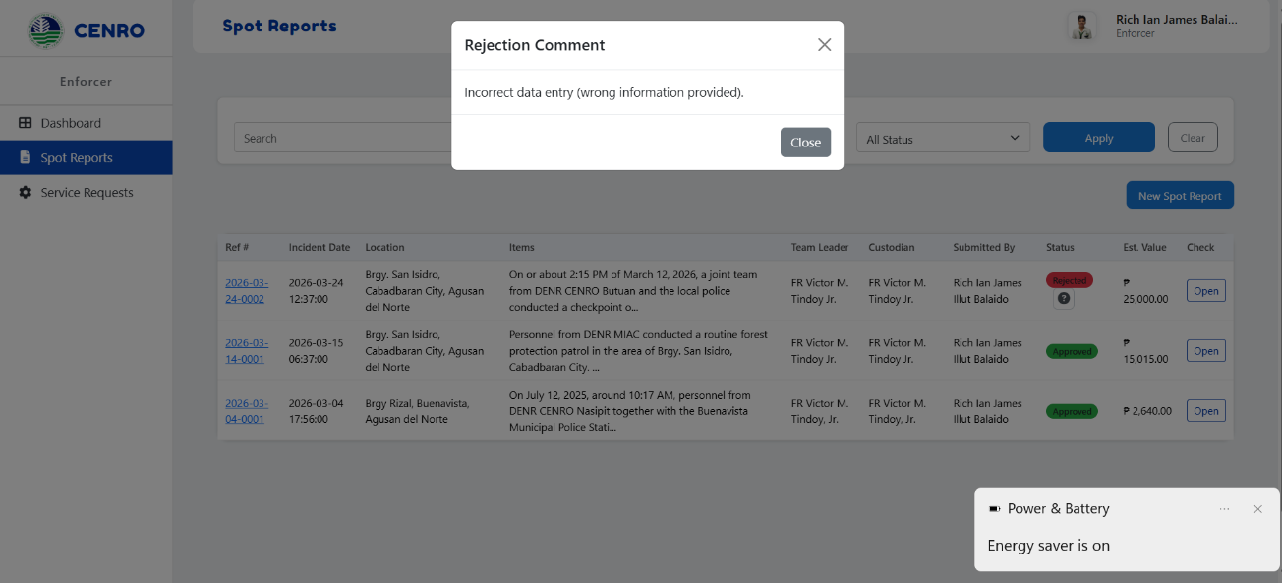
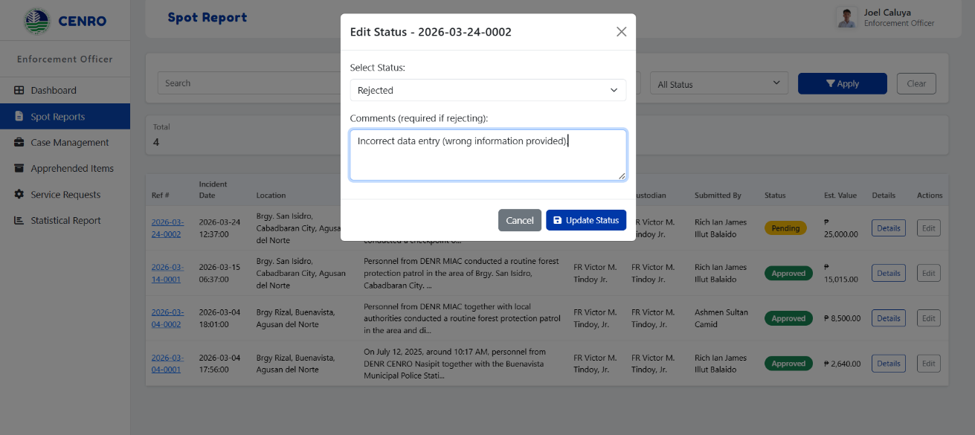
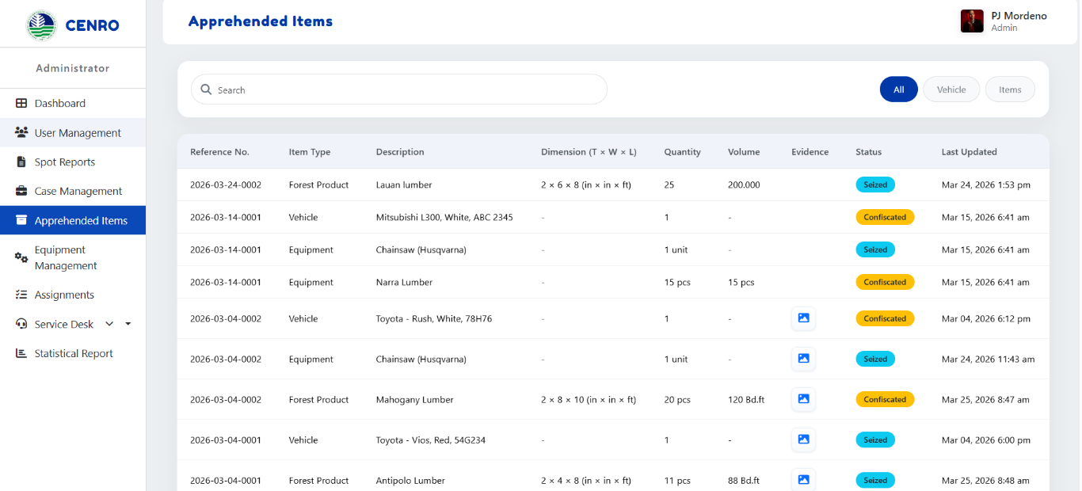
3.1 Requirement Analysis Result
The first goal of this study is to identify the requirements needed for the development of the CENRO Nasipit Field Operations and Equipment Tracking System. Requirement analysis was conducted through gathering feedback from users of the office to determine the necessary features that will improve their workflow, data management, and monitoring processes. The collected feedback highlights the needs of users and provides direction for the development of system functions that supports field operations and equipment tracking.
Based on the responses gathered, users required automated classification and dashboard visualization to help organize records and present data in a clear and understandable format. Automated classification allows the system to categorize operational records such as apprehended items, field activities, and equipment records without manual sorting. Dashboard visualization provides users with graphical summaries such as charts and reports, making it easier to monitor operations and analyze information quickly.
The dashboard visualization interface displays summarized information such as the number of field operations, equipment status, apprehended items, and other operational records. This allows users to easily monitor the current status of activities and quickly identify important information. The dashboard is designed to be simple and understandable to support efficient monitoring and decision-making.
Users also emphasized the importance of having a user-friendly and efficient system. Feedback indicated that the system is generally easy to use and functional, allowing accurate data entry and quick submission of required information. This usability helps staff manage office data and knowledge effectively. However, some users suggested improvements in navigation and recommended reducing delays when loading information to make the system smoother and faster.
The navigation interface shows the available system modules and features accessible to users. It is designed to provide smooth navigation between system functions. Improving the loading speed and responsiveness of this interface will enhance the overall user experience.
Another important requirement identified was the ability to edit or update submitted entries. Users expressed concern about possible data entry errors and requested clarification on whether incorrect data can be corrected after submission. This requirement highlights the need for an editing feature that allows authorized users to modify records while maintaining data accuracy.
The edit entry interface allows users to correct incorrect information submitted into the system. This feature ensures that records remain accurate and updated, reducing the risk of incorrect reports and improving data reliability.
Users also recommended adding additional dimensions or columns for apprehended items (scaling) to improve the completeness of recorded data. This requirement ensures that more detailed information can be stored in the system, making reports more accurate and reliable.
The apprehended items form includes additional fields for scaling and detailed recording of confiscated items. These added columns help provide more accurate data collection and improve reporting capabilities.
Another significant requirement identified is the need for notification alerts for overdue or missing equipment. This feature will help improve monitoring and accountability of equipment used in field operations, ensuring that missing items are immediately reported and addressed.
[Screenshot of Notification Alert System]
The notification alert system provides reminders and alerts when equipment is overdue or missing. This helps ensure timely action and improves equipment management within the office.
Overall, the requirement analysis results indicate that the proposed system is functional and highly usable for office data and knowledge management. However, enhancements such as improved navigation, editing capabilities, geographic data integration, additional data fields, and notification alerts are necessary to further improve the system’s performance and efficiency. These identified requirements served as the basis for designing and developing the features of the CENRO Nasipit Field Operations and Equipment Tracking System.

3.2 System Development Output
The CENRO Nasipit Field Operations and Equipment Tracking System was successfully developed and deployed in a test environment. The system includes major modules such as the login page, dashboard, spot reports, case management, equipment management, service desk, and statistical reports. These modules were developed to improve monitoring, tracking, and reporting processes in CENRO Nasipit.
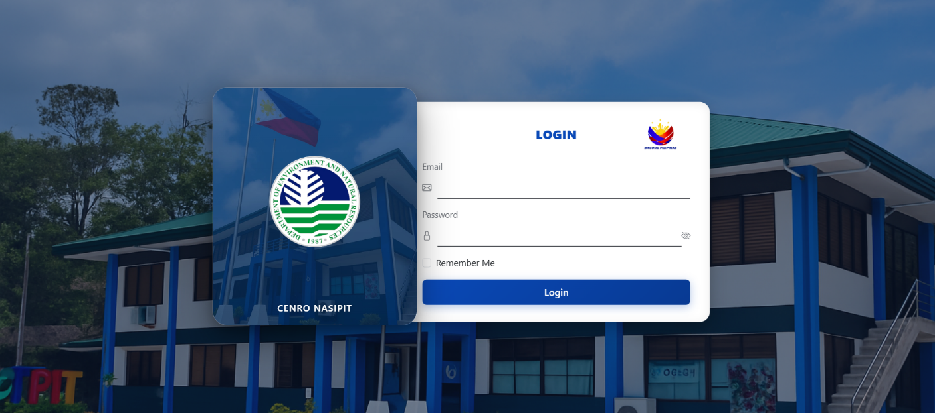

Figure 53. Login Page

The login page serves as the main entry point of the system. It allows users to enter their email and password to access the system based on their assigned roles. This ensures secure and controlled access.
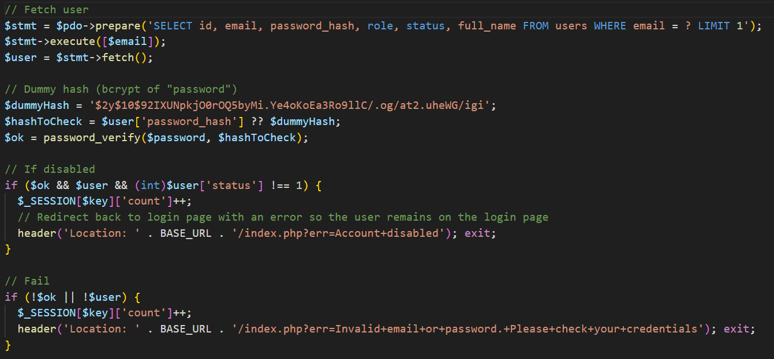
Figure 54. Code Snippet for CENRO NFO-ETS – Login Page
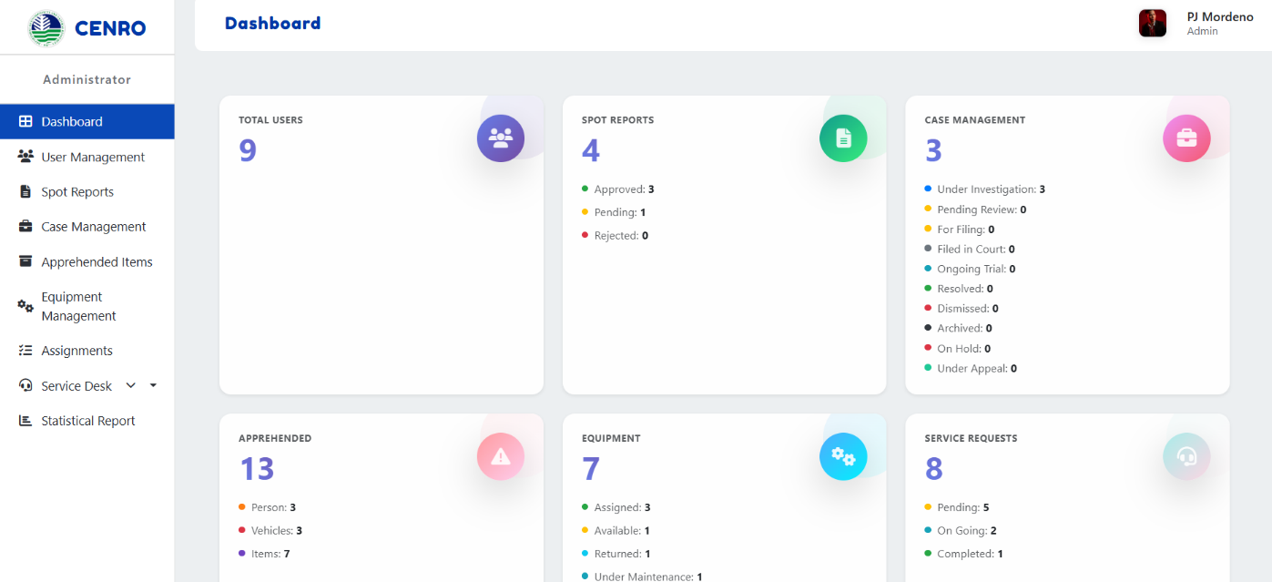
Figure 54 shows the backend process of the login function. It retrieves the user’s account from the database, verifies the entered password, and checks whether the account is active. If the login credentials are valid, the system allows access; otherwise, it returns an error message.

Figure 55. Dashboard (Admin Interface)
The dashboard shows a summary of key system data such as users, reports, cases, equipment, and service requests. It helps users quickly monitor activities and system status.
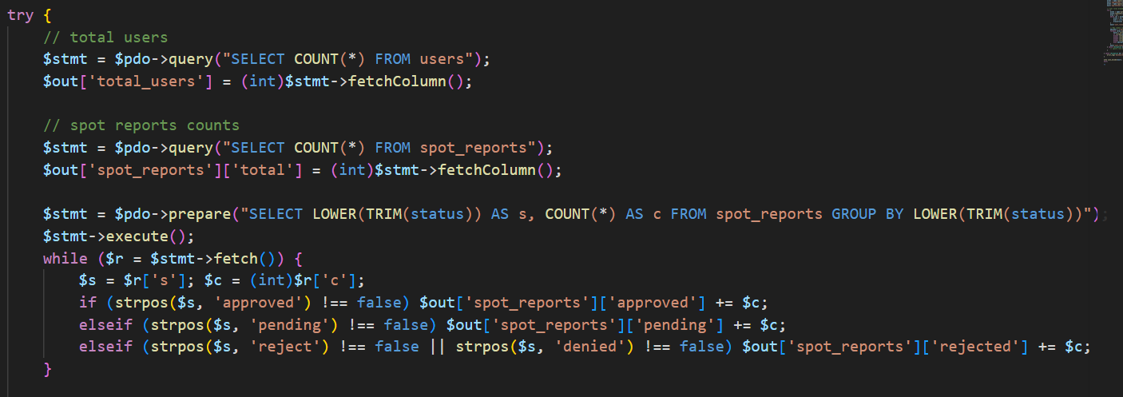
Figure 56. Code Snippet for CENRO NFO-ETS (Admin) – Dashboard
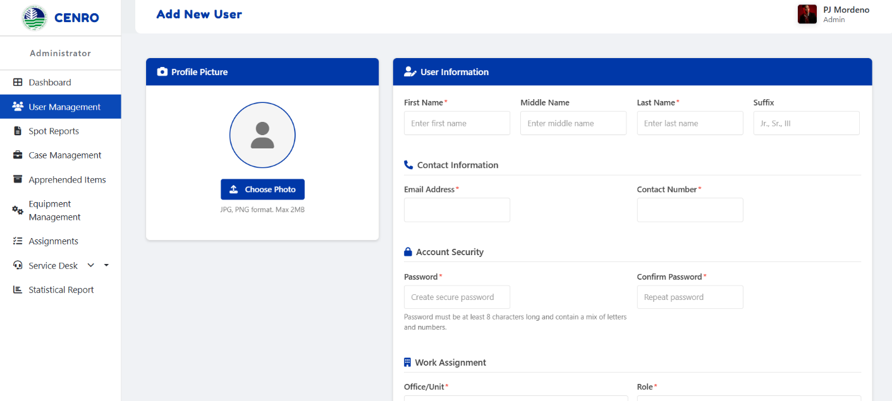
Figurer 54 shows the backend process of the admin dashboard. It retrieves and counts records from the database, such as the total number of users and spot reports by status. The gathered data is used to display summary information on the dashboard.

Figure 57. Add New User (Admin Interface)
Figure 57 shows the Add New User interface, which allows the administrator to create a new user account by entering personal, contact, and account information. It ensures proper user registration and role assignment in the system.
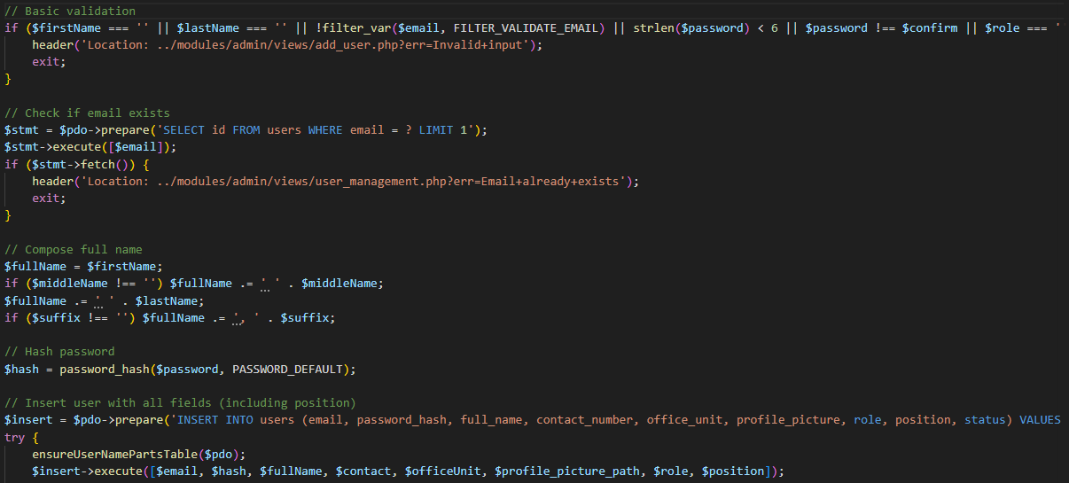
Figure 58. Code Snippet for CENRO NFO-ETS (Admin) – Add New User
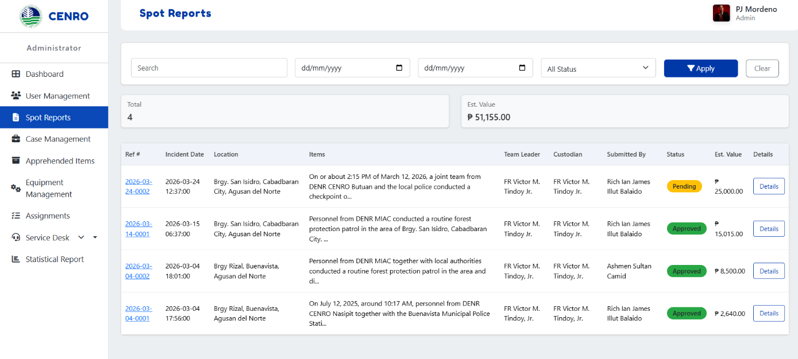
Figure 58 shows the process of adding a new user. It validates the submitted information, checks if the email already exists, encrypts the password, and stores the user’s details in the database.
Figure 59. Spot Reports (Admin Interface)
Figure 59 shows the Spot Reports interface for the administrator, which displays a list of submitted reports with details such as reference number, date, location, and status. The administrator can only view and monitor the reports for tracking purposes.

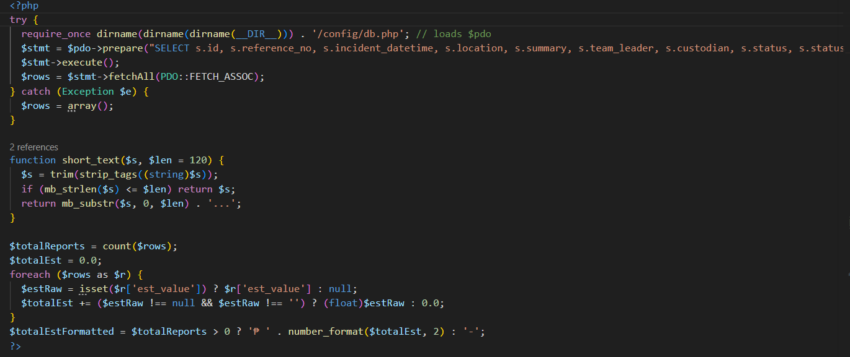
Figure 60. Code Snippet for CENRO NFO-ETS (Admin) – Spot Report
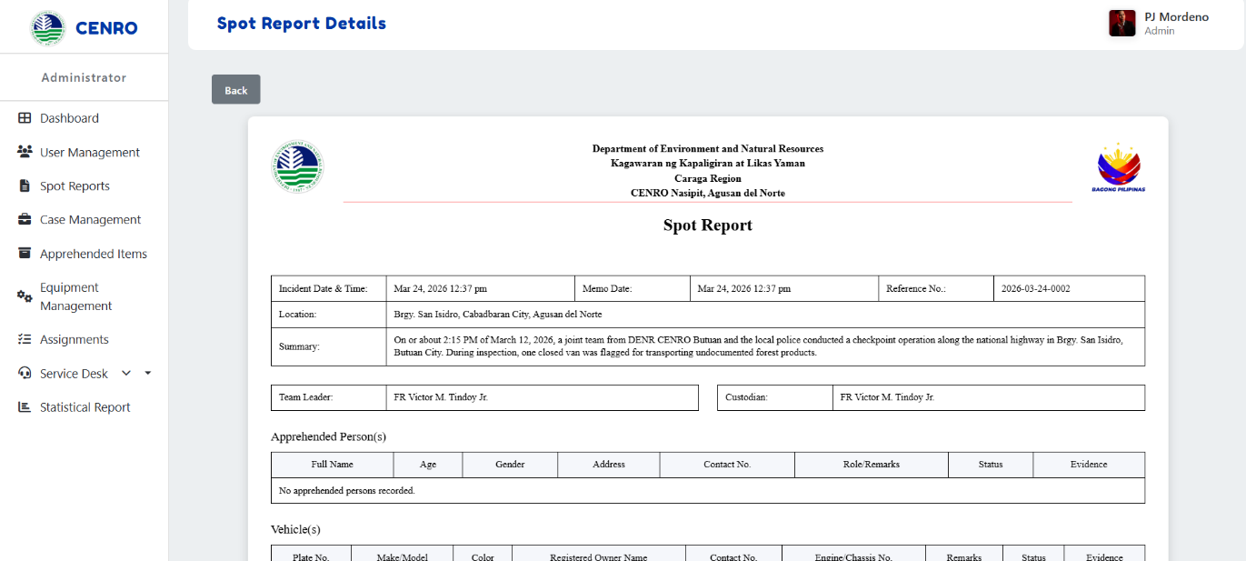
Figure 60 shows the process of retrieving spot report records from the database. It also counts the total number of reports and computes the estimated value of the recorded items. The gathered data is then used to display summary information in the Spot Reports module.
Figure 61. Spot Report Details (Admin Interface)
Figure 60 shows the Spot Report Details interface, which displays the complete information of a selected report, including incident details, location, summary, and related records. The administrator can only view the details for monitoring and reference purposes.

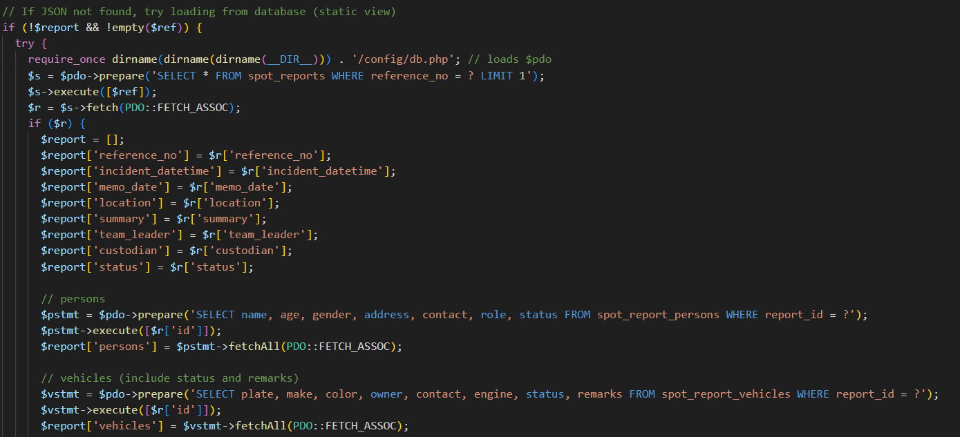
Figure 62. Code Snippet for CENRO NFO-ETS (Admin) – Spot Report Details
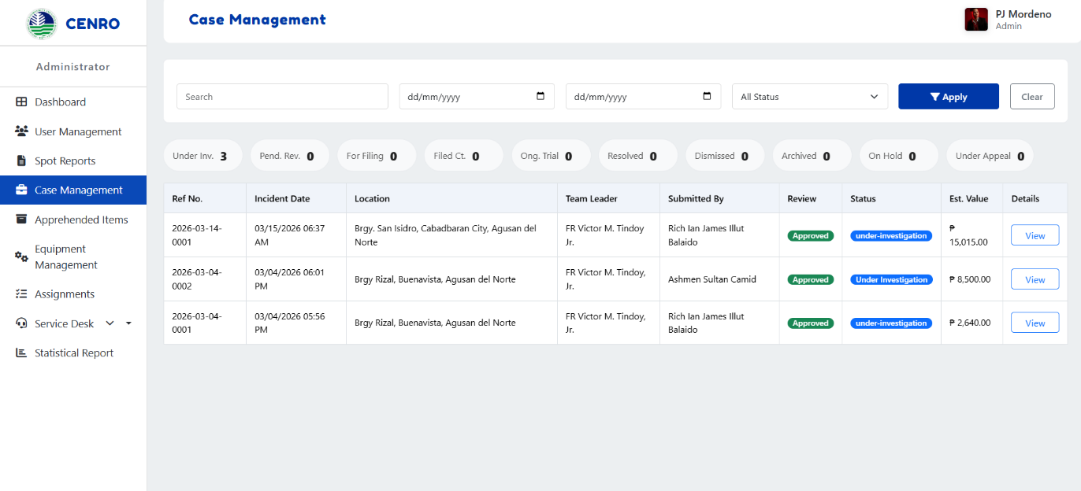
Figure 62 shows the process of retrieving the selected spot report from the database using its reference number. It also loads the related details, such as apprehended persons, vehicles, and seized items. The retrieved data is then used to display the complete information of the report.
Figure 63. Case Management (Admin Interface)
Figure 63 shows the Case Management interface, which displays a list of cases with details such as reference number, date, location, and status. The administrator can only view and monitor case records within the system.
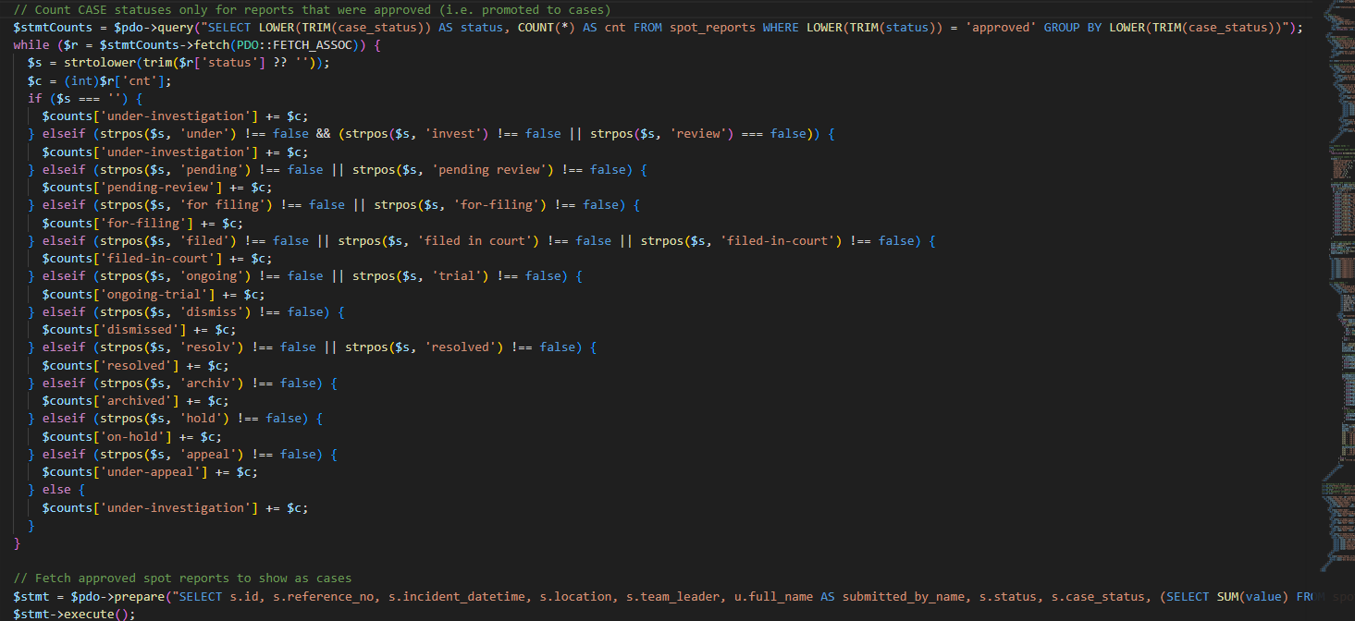
Figure 64. Code Snippet for CENRO NFO-ETS (Admin) – Case Management
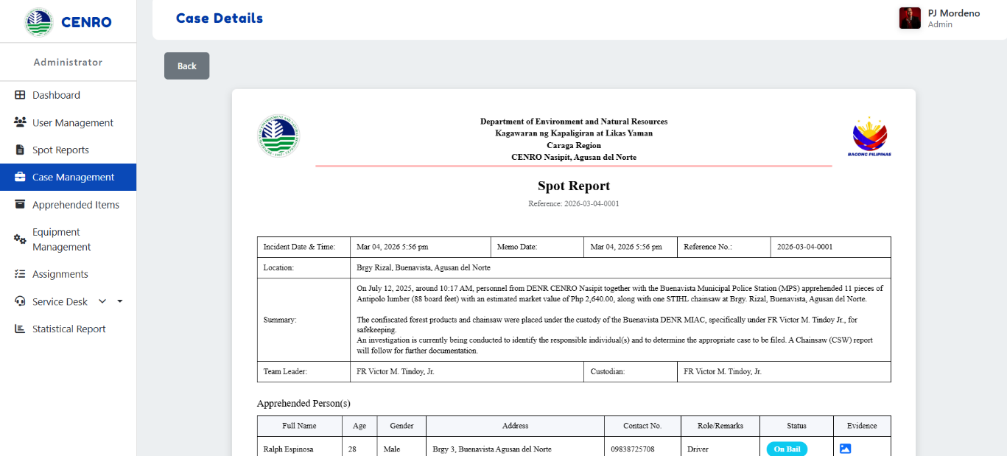
Figure 64 shows the process of retrieving case records for the Case Management module. It counts the case statuses and loads approved spot reports from the database to be treated as cases. The retrieved data is then used to display case information in the admin panel.
Figure 65. Case Details (Admin Interface)
Figure 60 shows the Case Details interface, which presents the complete information of a selected case, including incident details, summary, and related records. The administrator can only view the details for monitoring and reference purposes.

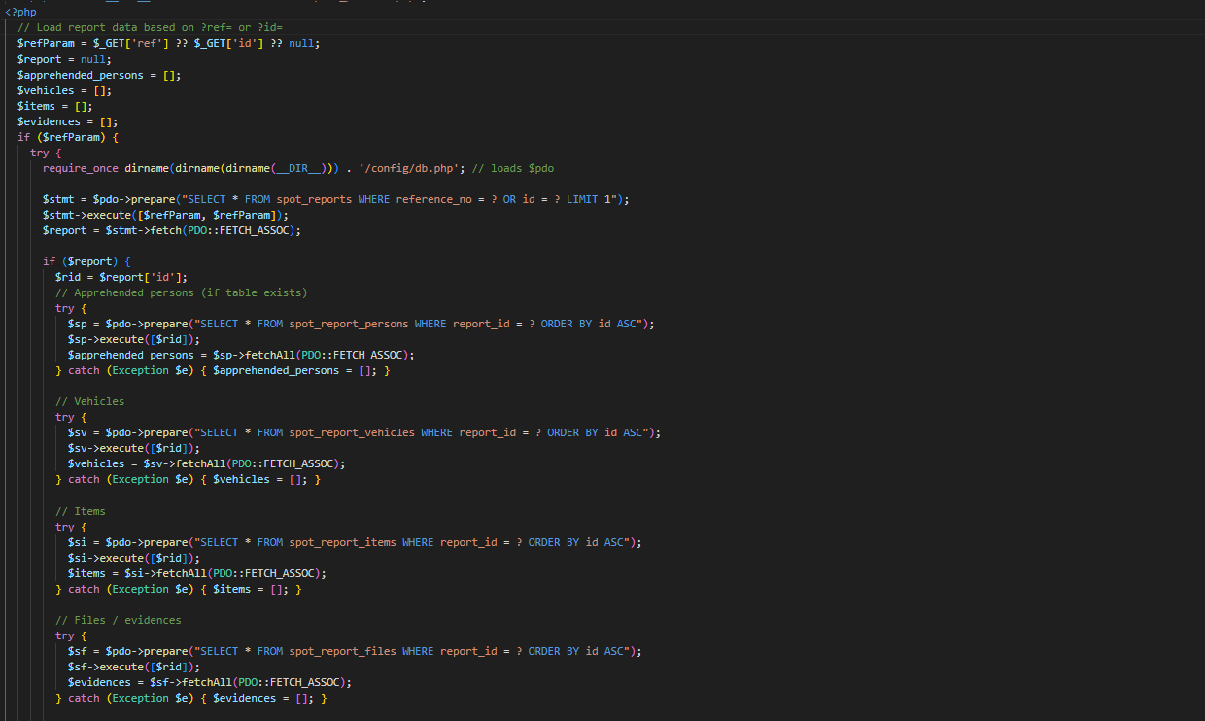
Figure 66. Code Snippet for CENRO NFO-ETS (Admin) – Case Details
Figure 66 shows the process of retrieving the selected case details from the database. It loads the main report together with the related persons, vehicles, items, and evidence records. The retrieved information is then used to display the complete details of the case in the system.


Figure 67. Apprehended Items (Admin Interface)
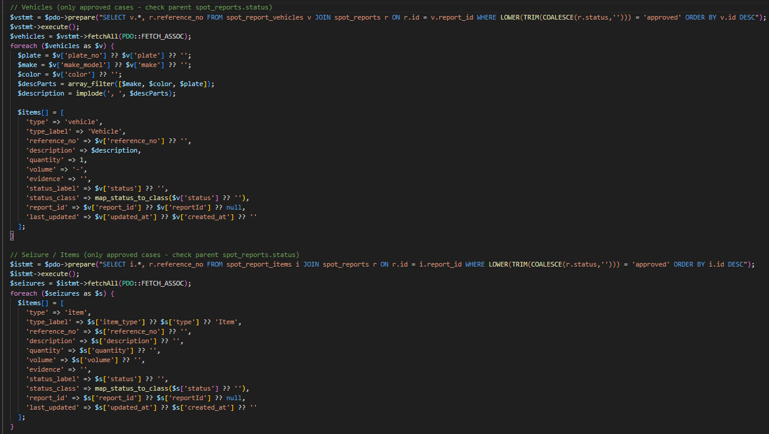
Figure 67 shows the Apprehended Items interface, which displays a list of confiscated or seized items with details such as reference number, type, description, quantity, and status. The administrator can only view and monitor these records for tracking purposes.
Figure 68. Code Snippet for CENRO NFO-ETS (Admin) – Apprehended Items
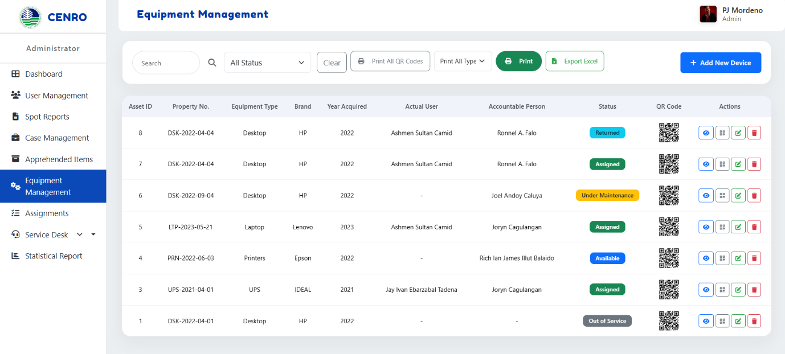
This code shows the process of retrieving apprehended vehicles and seized items from the database. It collects records from approved reports and organizes them for display in the Apprehended Items module. The retrieved data is then used to present the list of apprehended properties in the system.

Figure 67. Equipment Management (Admin Interface)
Figure 69 shows the Equipment Management interface, which displays a list of equipment with details such as asset ID, type, user, status, and QR code. It allows the administrator to monitor and manage equipment records efficiently.

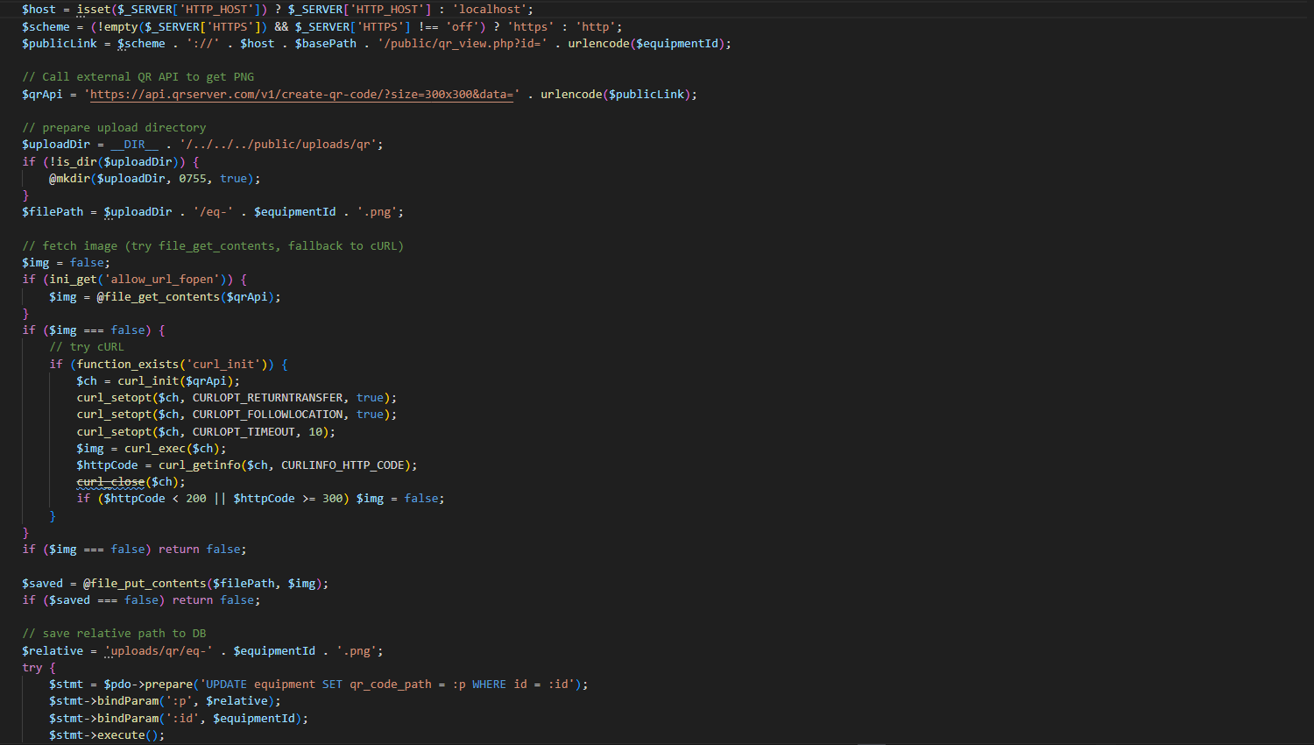
Figure 68. Code Snippet for CENRO NFO-ETS (Admin) – Equipment Management
Figure 68 shows the process of generating a QR code for an equipment record. It creates a link for the equipment details, generates the QR image, saves it to the system, and updates the database with the QR code file path. This feature supports quick identification and tracking of equipment records.

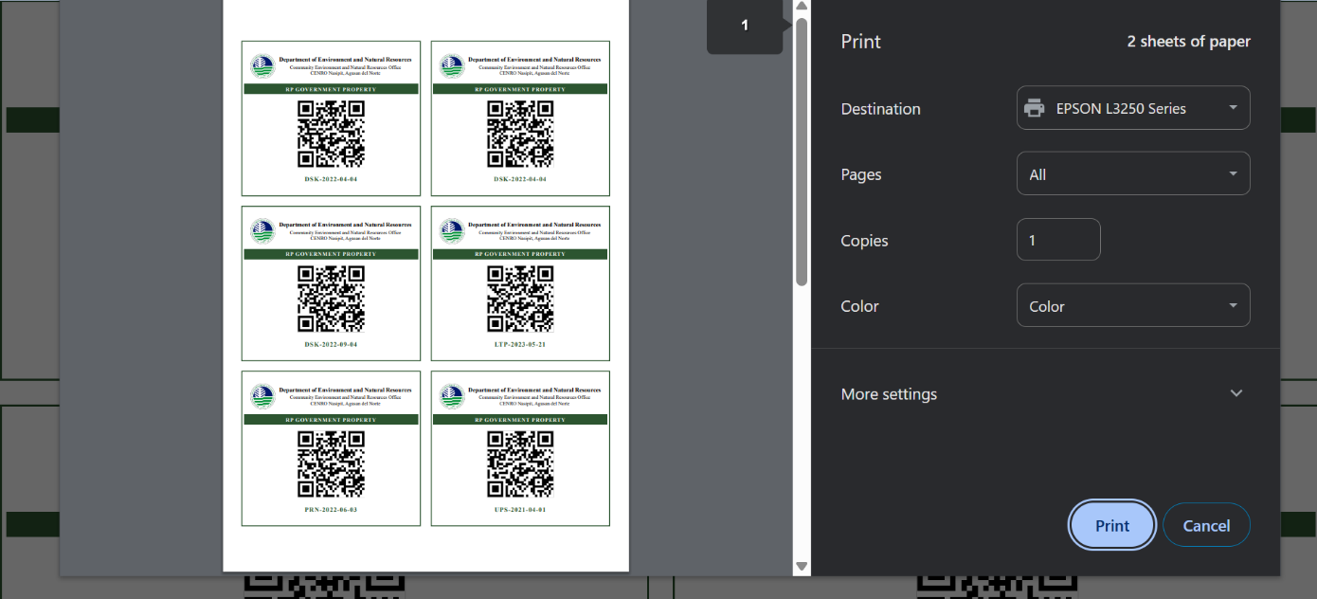
Figure 69. QR Code Printing Interface (Admin Interface)
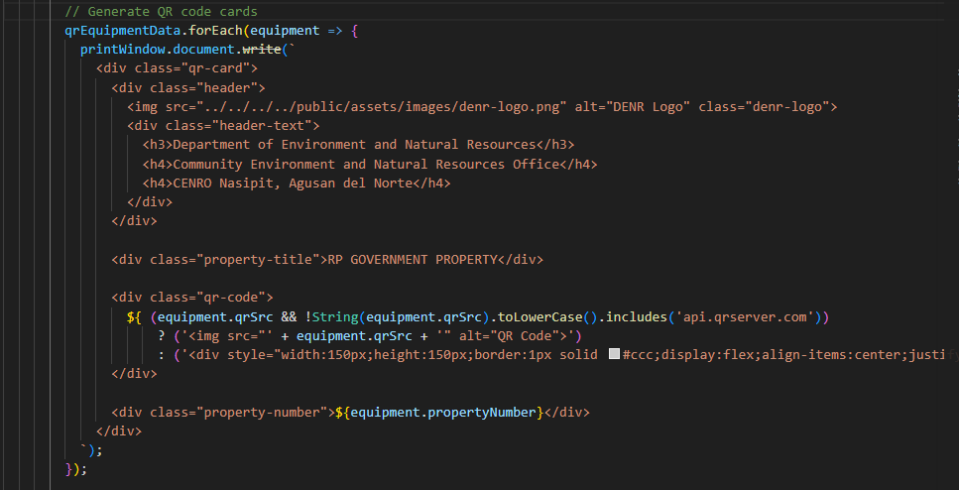
Figure 69 shows the print preview of generated QR codes for equipment. It allows the administrator or property custodian to print multiple QR code labels, which are used for tagging and tracking office devices efficiently.
Figure 70. Code Snippet for CENRO NFO-ETS (Admin) – QR Code Printing
Figure 70 shows the generation of QR code cards for printing. It displays the QR image together with the property number and prepares the content for the printed QR code sheet.
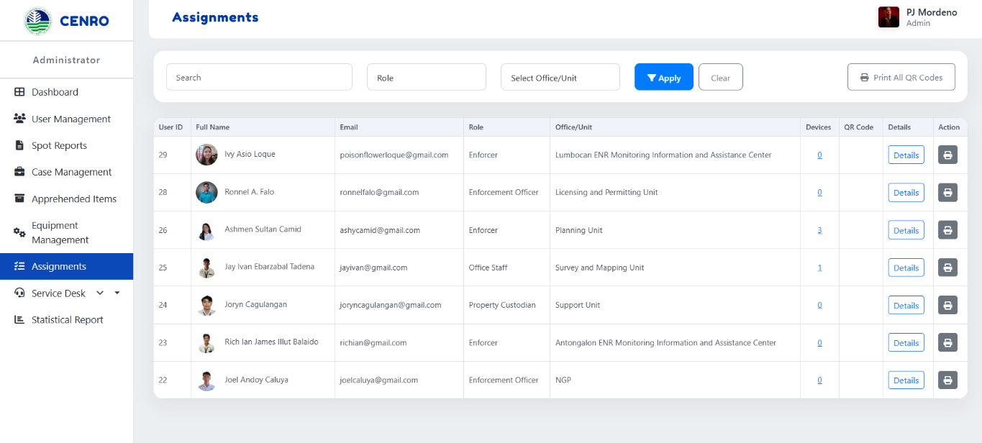
Figure 71. Assignments (Admin Interface)
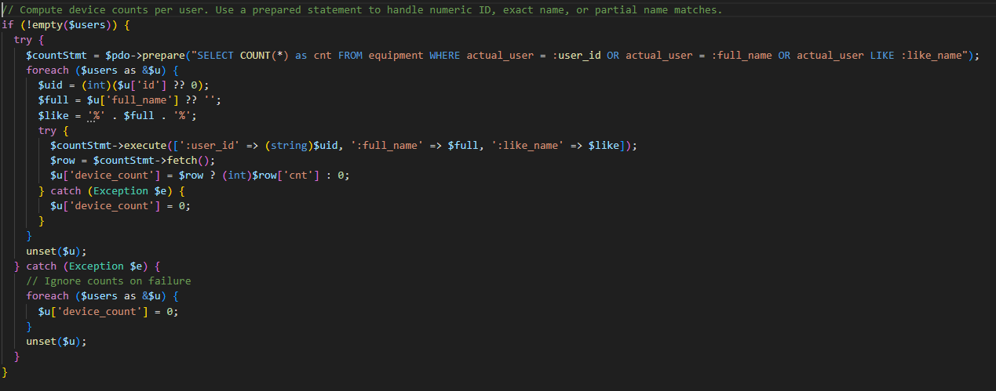
Figure 71 shows the list of users along with their assigned devices, roles, and office/unit. It allows the administrator to monitor equipment distribution, view assigned devices, and print QR codes for tracking and accountability.
Figure 72. Code Snippet for CENRO NFO-ETS (Admin) – Assignments
Figure 72 shows the process of counting the number of devices assigned to each user. It checks the equipment records and matches them with the corresponding user information. The computed device count is then displayed in the Assignments module.

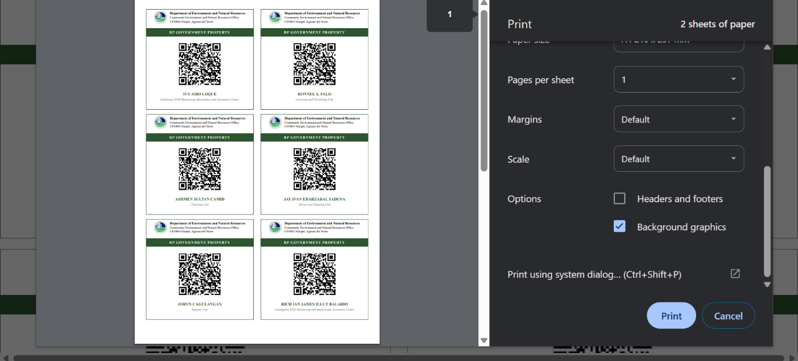
Figure 73. QR Code Printing for Assignments (Admin Interface)
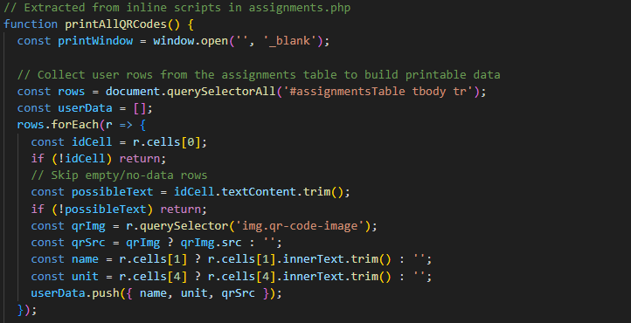
Figure 73 shows the print preview of QR codes assigned to users. It allows the administrator to print QR code labels for user assignments, enabling efficient tracking and identification of assigned equipment.
Figure 74. Code Snippet for CENRO NFO-ETS (Admin) – QR Code Printing for Assignments
Figure 74 shows the process of preparing user QR code data for printing in the Assignments module. It collects the QR image, user name, and office/unit from the table records and organizes them for the printable QR code layout.
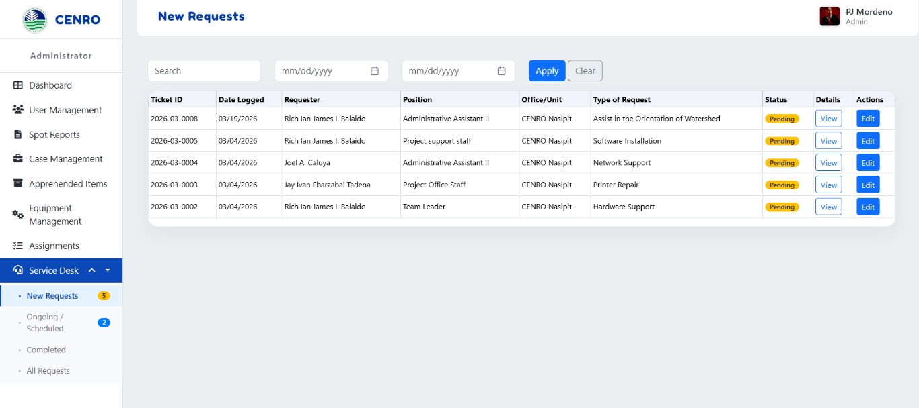
Figure 75. New Requests (Admin Interface)
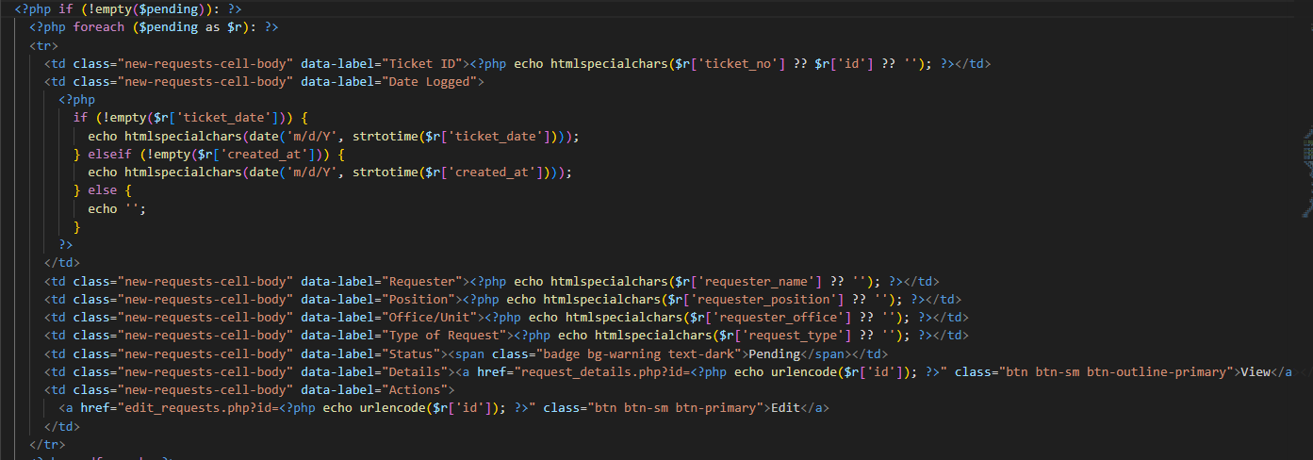
Figure 75 shows the New Requests interface, which displays a list of submitted service requests with details such as requester, type of request, and status. It allows the administrator to monitor, view, and manage incoming requests efficiently.
Figure 76. Code Snippet for CENRO NFO-ETS (Admin) – New Requests
Figure 76 shows the display of pending service requests in the New Requests module. It presents the request information such as ticket number, requester, type of request, and status. It also provides action buttons for viewing and editing the selected request.

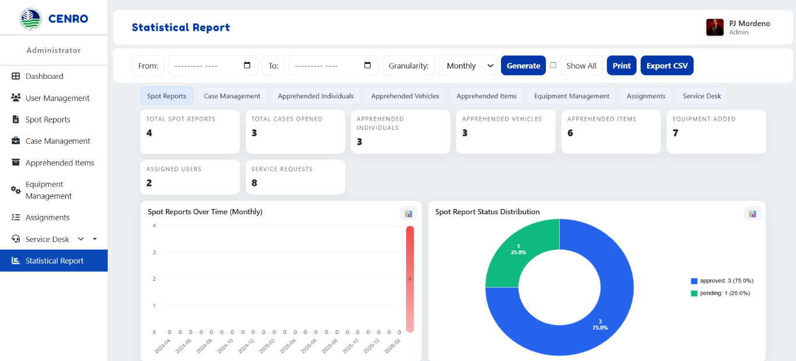
Figure 77. Statistical Report (Admin Interface)
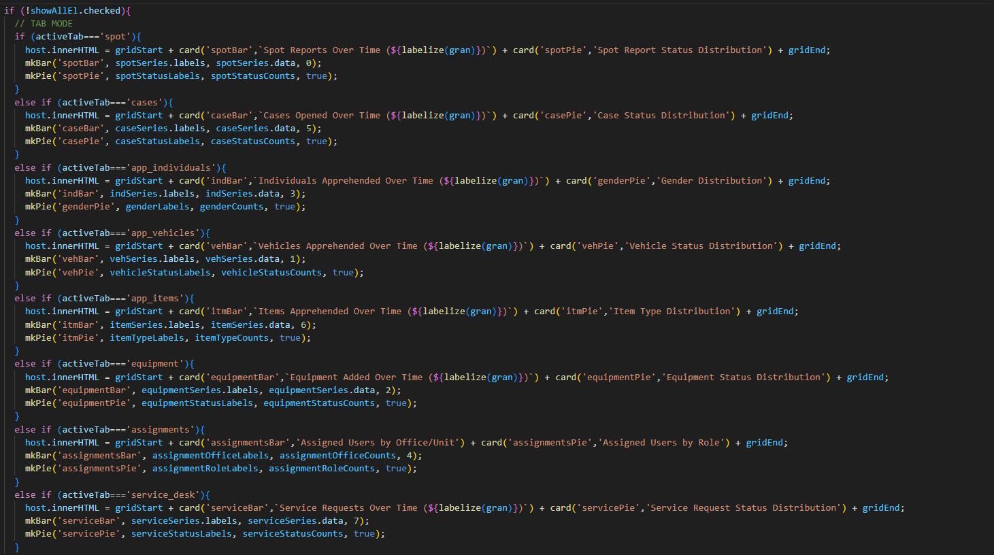
Figure 77 shows the Statistical Report interface, which presents summarized data and visual charts of system records such as spot reports, cases, and service requests. It allows the administrator to analyze trends and generate reports for monitoring and decision-making.
Figure 76. Code Snippet for CENRO NFO-ETS (Admin) – Statistical Report

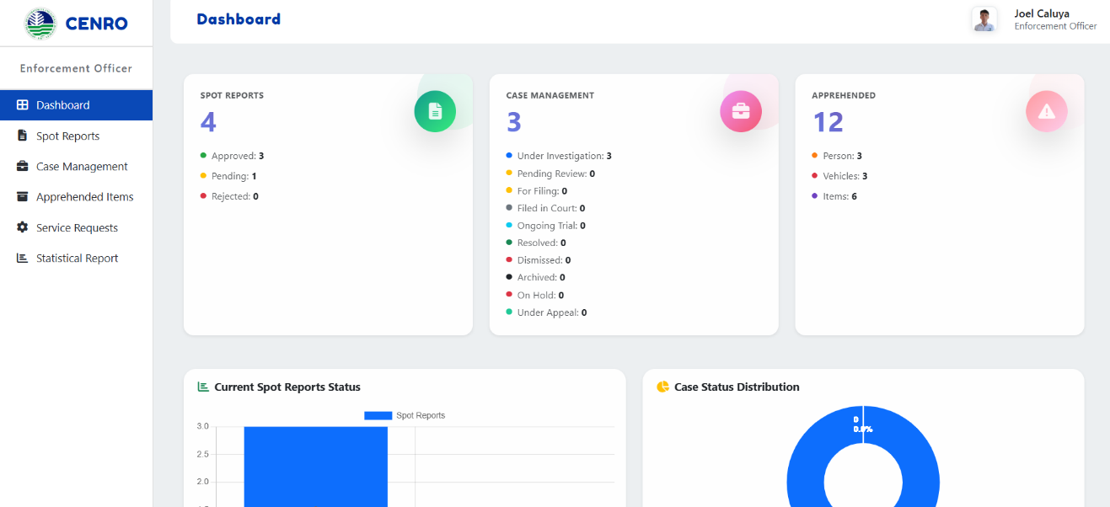
Figure 78 shows the process of generating the Statistical Report in the system. It selects the appropriate report category and displays the corresponding charts based on the available data. The generated charts are used to present summarized statistical information for each module.
Figure 79 Dashboard (Enforcement Officer Interface)
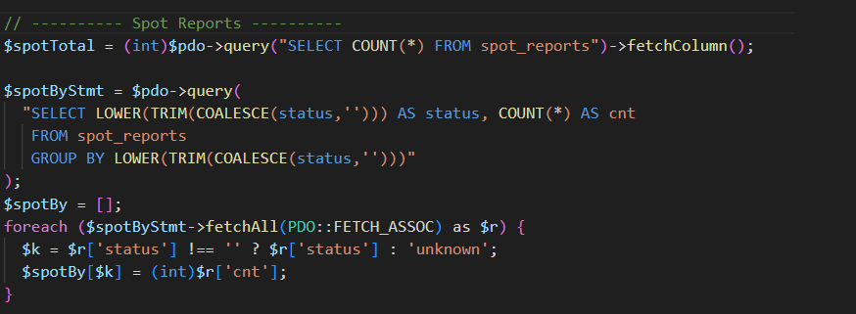
Figure 79 shows the dashboard interface for the enforcement officer, which displays a summary of spot reports, case status, and apprehended items. It helps users quickly monitor activities and track ongoing operations.
Figure 80. Code Snippet for CENRO NFO-ETS (Enforcement Officer) – Dashboard
Figure 80 shows the process of retrieving dashboard statistics for the Enforcement Officer module. It counts the total spot reports and groups them according to status. The retrieved data is then used to display summary information on the dashboard.
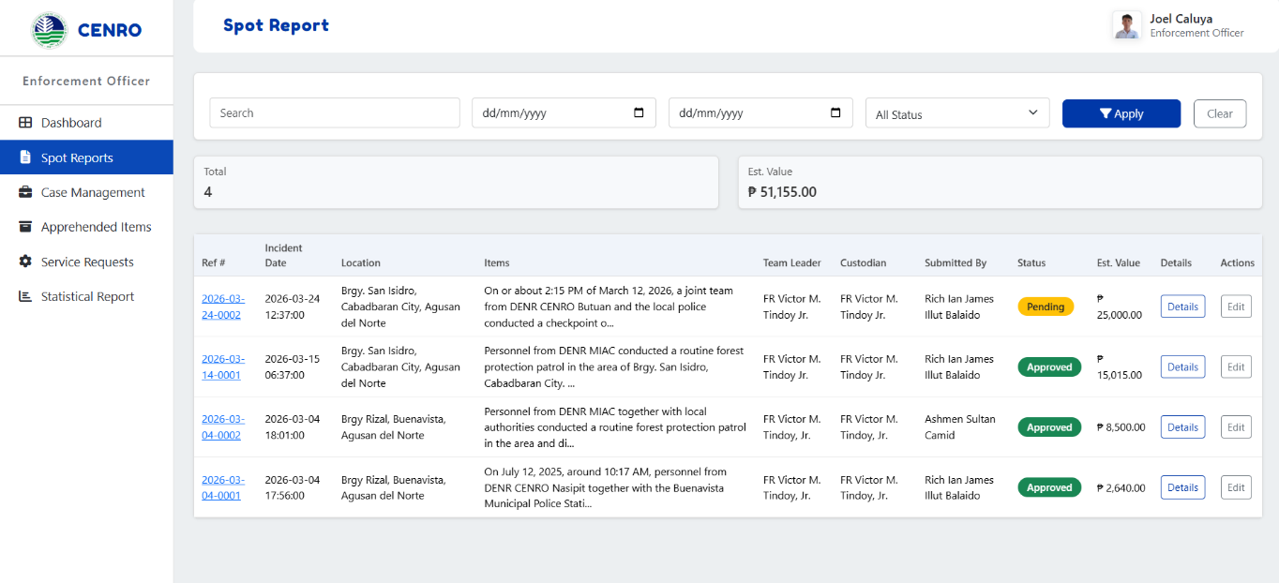
Figure 81 Spot Report (Enforcement Officer Interface)
Figure 81 shows the Spot Reports interface, which displays a list of submitted reports with details such as date, location, and status. It allows the enforcement officer to view and manage reports within the system.
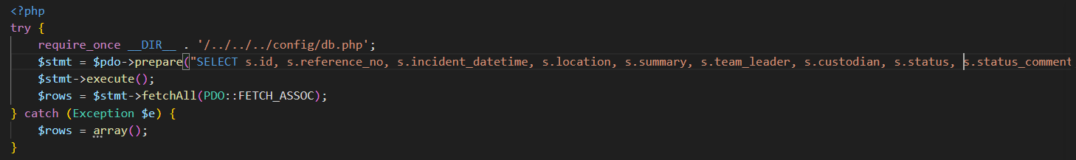

Figure 82. Code Snippet for CENRO NFO-ETS (Enforcement Officer) – Spot Report
Figure 82 shows the process of retrieving spot report records from the database. It loads the report details together with related information needed for display in the Spot Reports module.

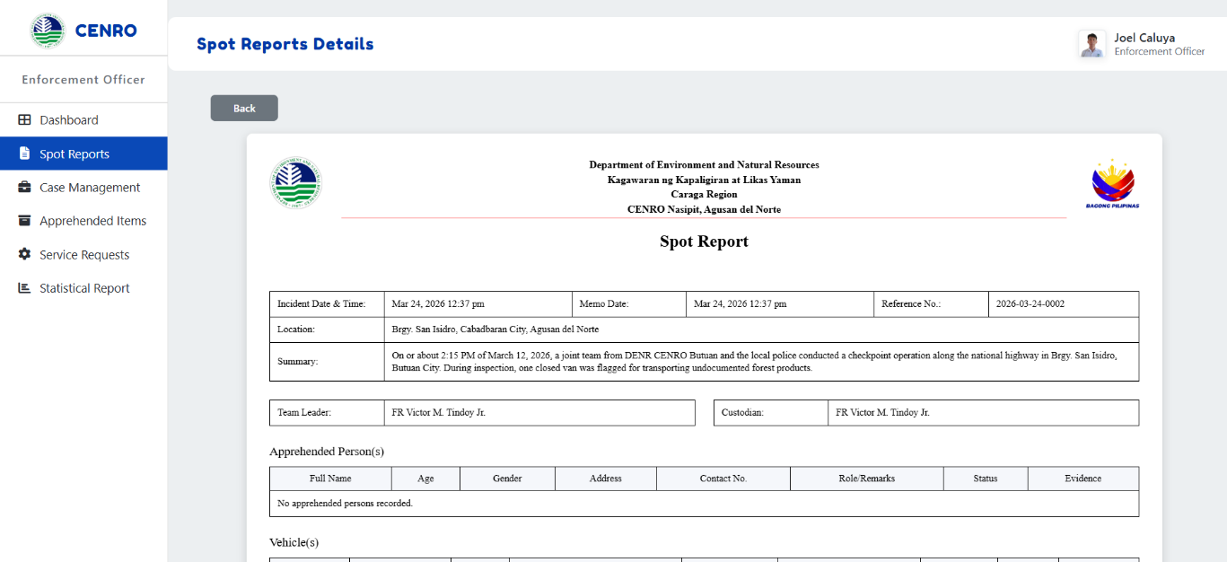
Figure 83 Spot Report Details (Enforcement Officer Interface)
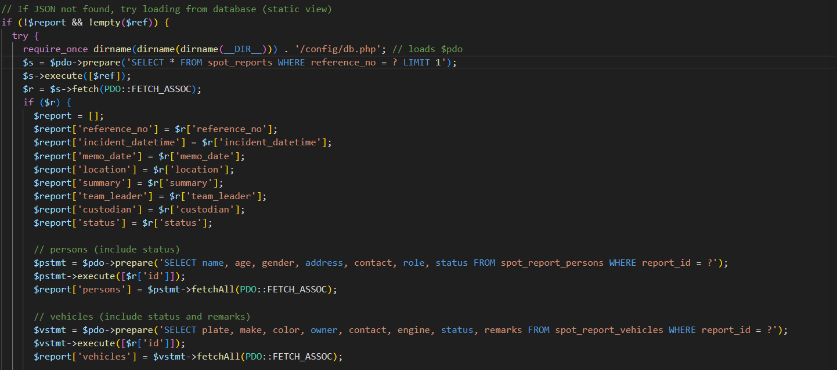
Figure 83 shows the Spot Report Details interface, which presents the complete information of a selected report, including incident details, summary, and related records. It allows the enforcement officer to view report details for monitoring and documentation purposes.
Figure 84. Code Snippet for CENRO NFO-ETS (Enforcement Officer) – Spot Report Details
Figure 84 shows the process of retrieving the selected spot report from the database. It also loads the related information such as persons, vehicles, and items associated with the report. The retrieved data is then displayed in the View Spot Report module.

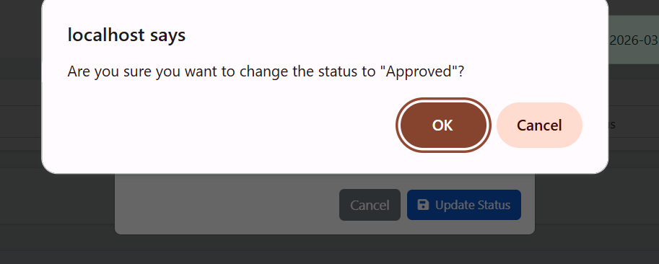
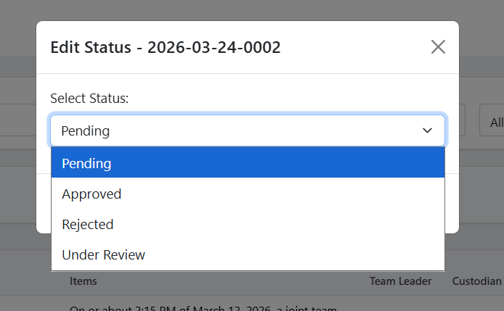

Figure 85. Edit Status Spot Report (Enforcement Officer Interface)
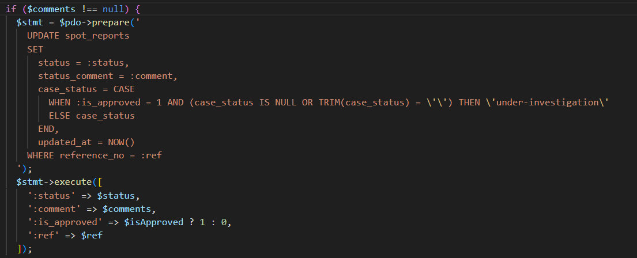
Figure 85 shows the Edit Status interface, which allows the enforcement officer to update the status of a spot report. It includes a confirmation prompt to ensure accurate and secure status changes.

Figure 86. Code Snippet for CENRO NFO-ETS (Enforcement Officer) – Edit Status Spot Report
Figure 86 shows the process of updating the status of a spot report in the system. It saves the selected status, records the corresponding comment, and automatically assigns a case status when the report is approved. This ensures that the status of the report is properly updated and tracked in the database.
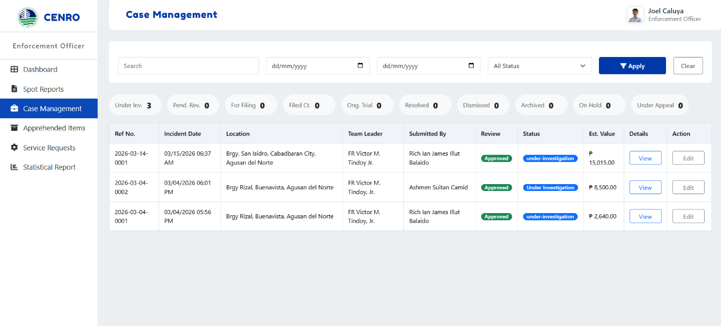
Figure 87. Case Management (Enforcement Officer Interface)
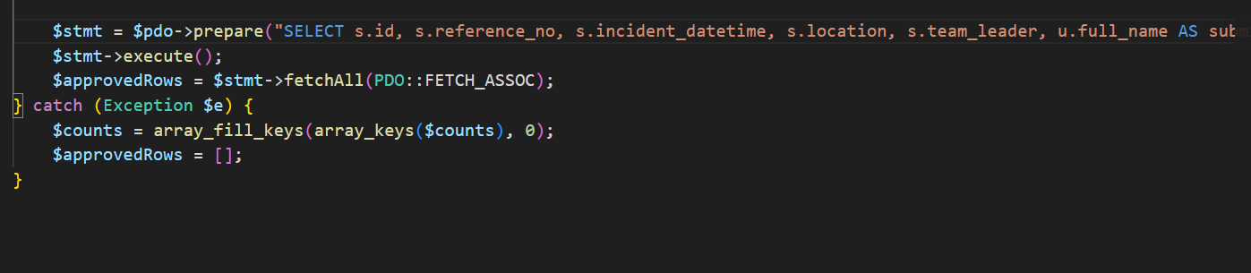
Figure 87 shows the Case Management interface, which displays a list of cases with details such as reference number, date, location, and status. It allows the enforcement officer to view and manage case records within the system.
Figure 88. Code Snippet for CENRO NFO-ETS (Enforcement Officer) – Case Management
Figure 88 shows the retrieval of approved spot reports used in the Case Management module. These records are treated as case entries and displayed in the system for monitoring and case handling.

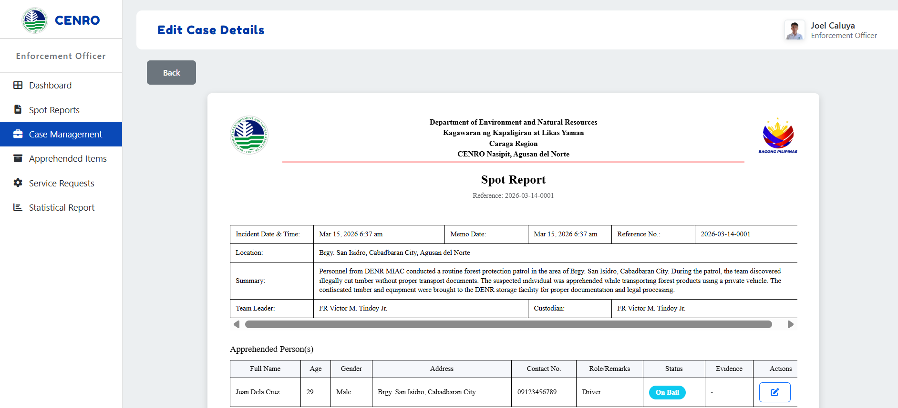
Figure 89. Edit Case Details (Enforcement Officer Interface)
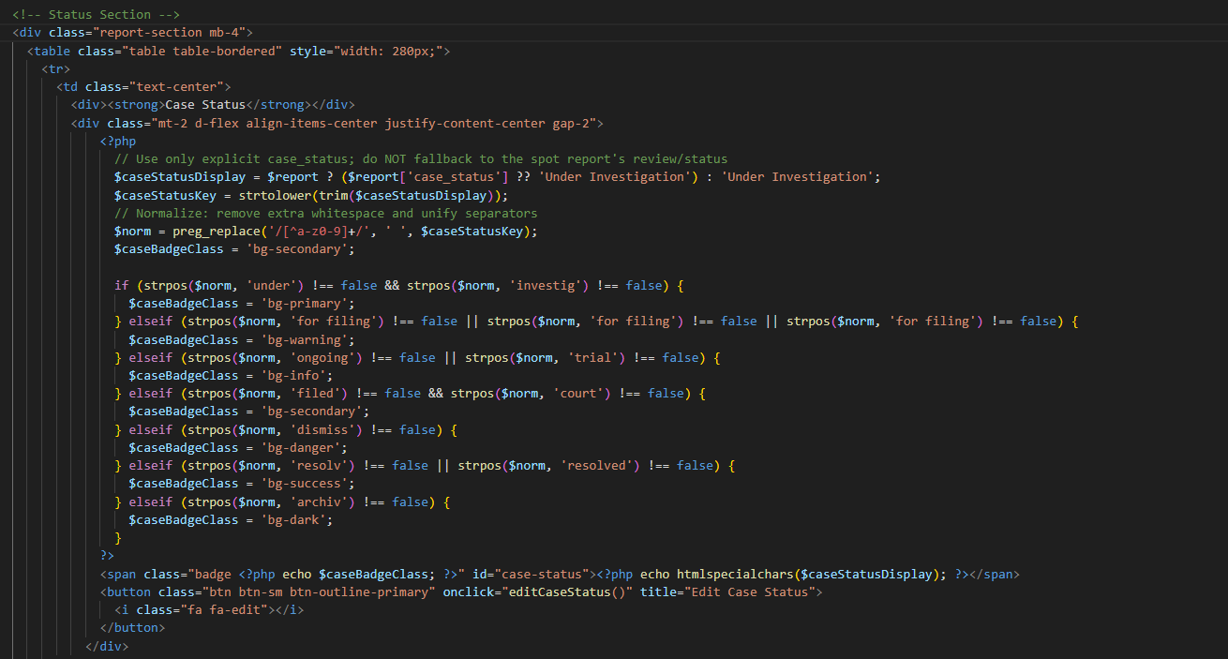
Figure 89 shows the Edit Case Details interface, which allows the enforcement officer to view and update the information of a selected case. It ensures accurate documentation and proper case management within the system.
Figure 90. Code Snippet for CENRO NFO-ETS (Enforcement Officer) – Edit Case Details
Figure 90 shows the case status section in the Edit Case Details module. It displays the current status of the case and provides an edit option for updating the case status in the system.
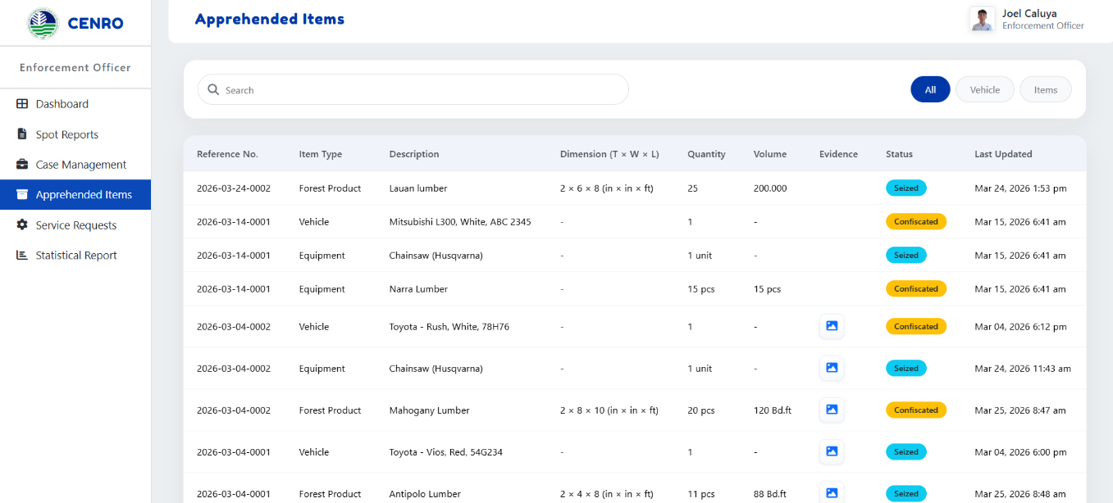
Figure 91. Apprehended Items (Enforcement Officer Interface)
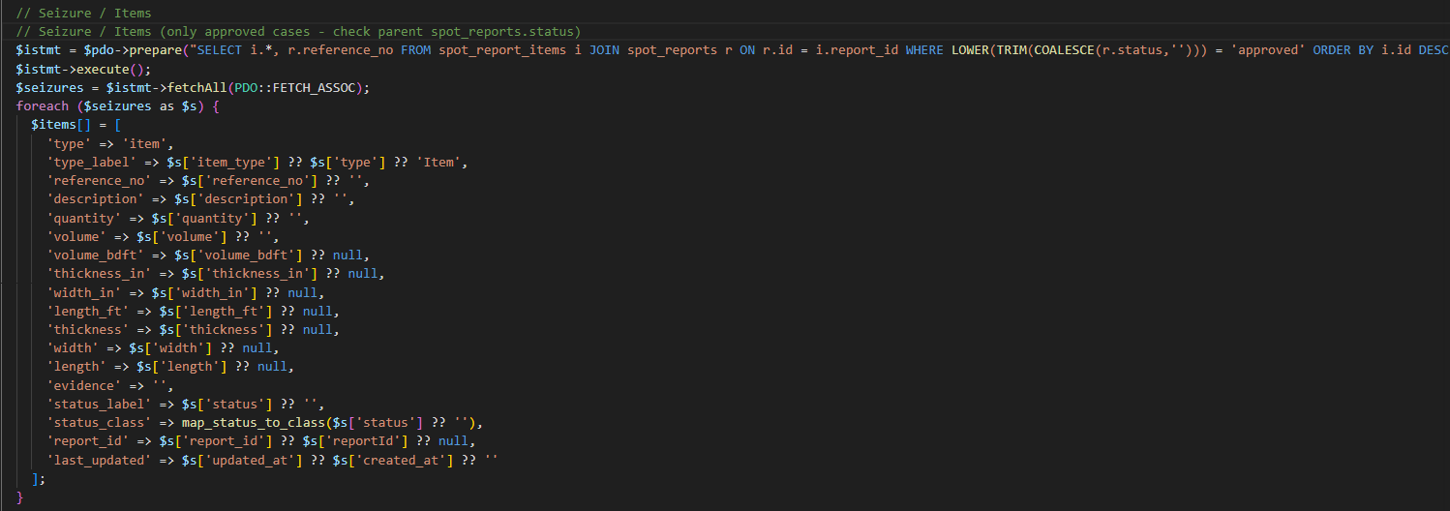
Figure 91 shows the Apprehended Items interface, which displays a list of seized or confiscated items with details such as type, quantity, and status. It allows the enforcement officer to view and monitor these records for tracking purposes.
Figure 92. Code Snippet for CENRO NFO-ETS (Enforcement Officer) – Apprehended Items
Figure 92 shows the retrieval of seized item records from approved reports. It gathers the item details from the database and prepares them for display in the Apprehended Items module.

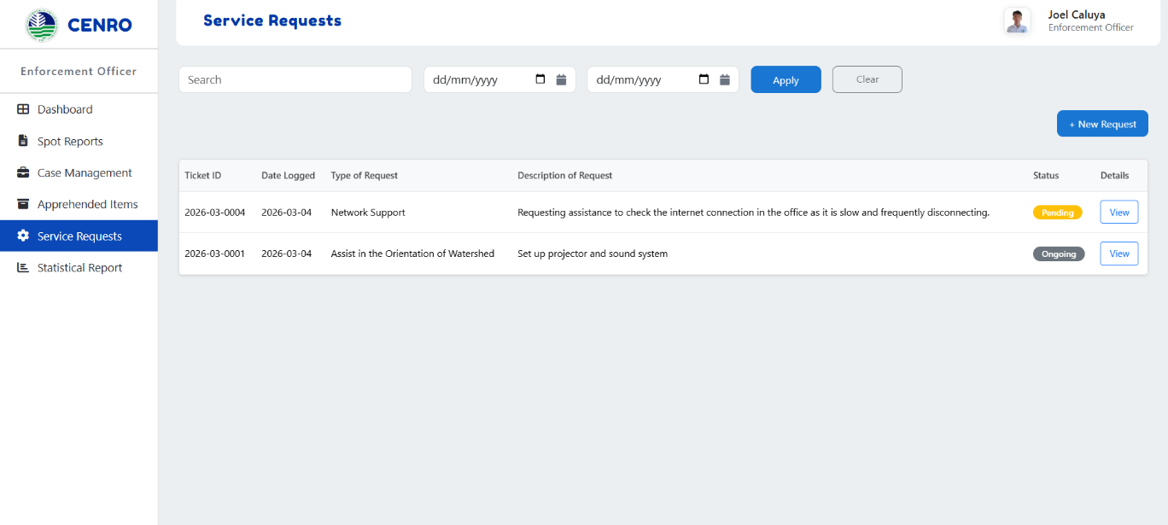
Figure 93. Service Requests (Enforcement Officer Interface)
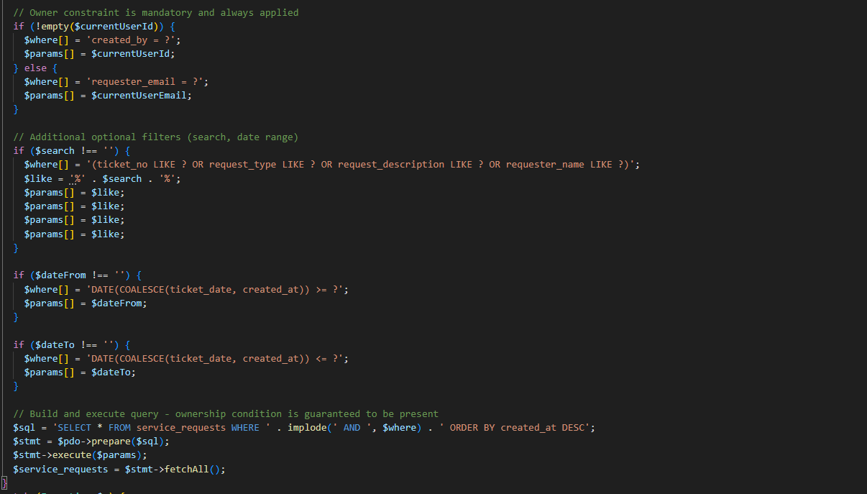
Figure 93 shows the Service Requests interface, which displays a list of submitted requests with details such as type, description, and status. It allows the enforcement officer to view and track service requests within the system.
Figure 94. Code Snippet for CENRO NFO-ETS (Enforcement Officer) – Service Requests
Figure 94 shows the process of retrieving service request records for the logged-in user. It applies the necessary filters, such as search and date range, before executing the database query. The retrieved records are then displayed in the Service Requests module.
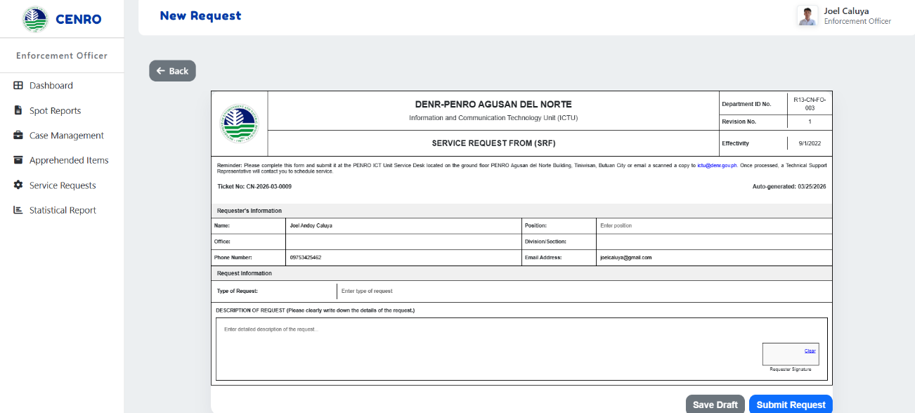
Figure 95. New Requests (Enforcement Officer Interface)
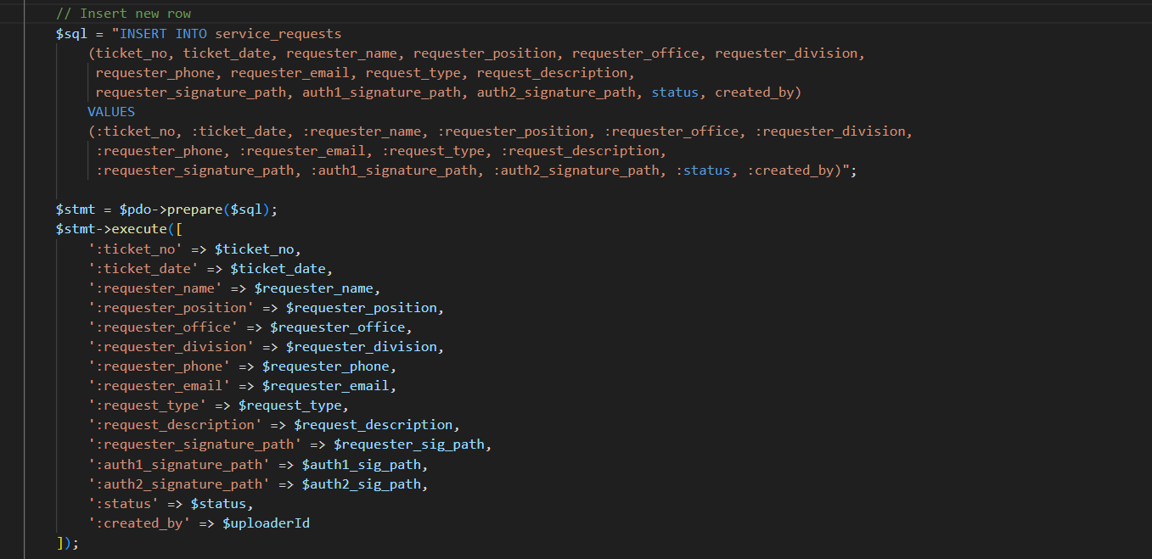
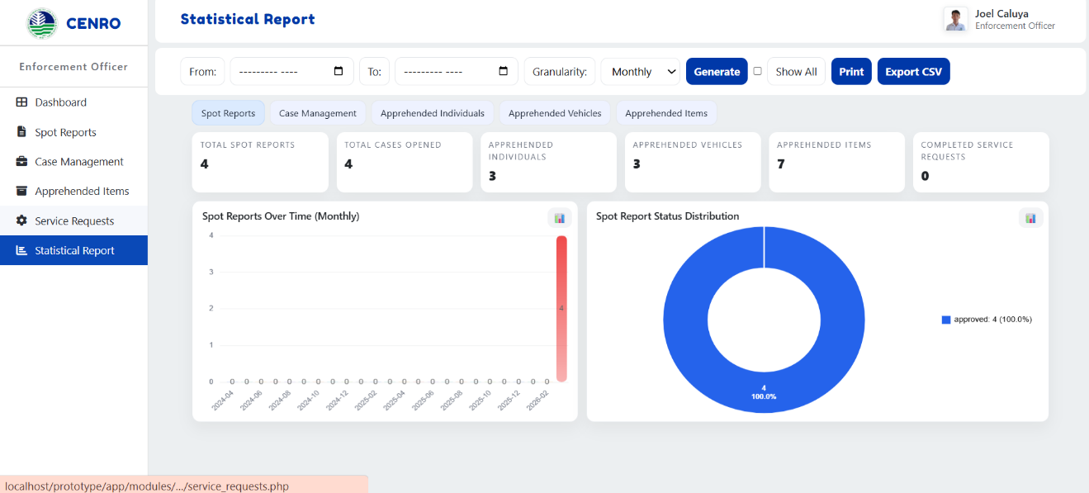
Figure 95 shows the New Request interface, which allows the enforcement officer to submit a service request by entering the required information. It ensures proper documentation and submission of requests within the system.
Figure 96. Code Snippet for CENRO NFO-ETS (Enforcement Officer) – New Requests
Figure 96 shows the process of saving a new service request in the system. It inserts the request details into the database, including the ticket number, requester information, request type, description, and status. The saved record is then used for tracking and processing of service requests.
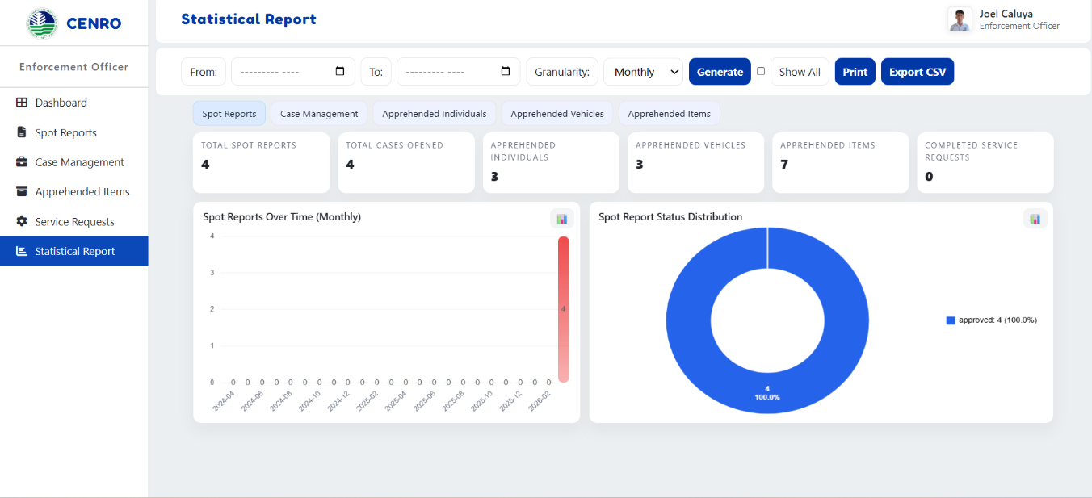
Figure 97. Statistical Report (Enforcement Officer Interface)
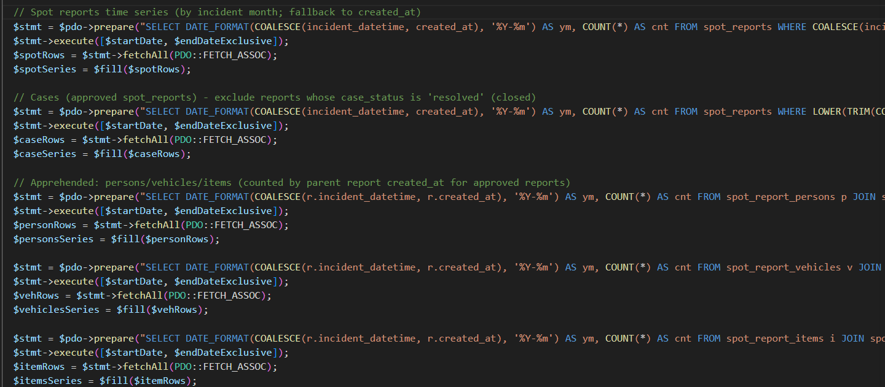
Figure 97 shows the Statistical Report interface, which presents summarized data and visual charts of system records. It allows the enforcement officer to analyze information and monitor system activities effectively.
Figure 98. Code Snippet for CENRO NFO-ETS (Enforcement Officer) – Statistical Report
Figure 98 shows the process of retrieving statistical data from the database for the Statistical Report module. It gathers the counts of spot reports, cases, apprehended persons, vehicles, and items within the selected period. The retrieved data is then used to generate the statistical report in the system.
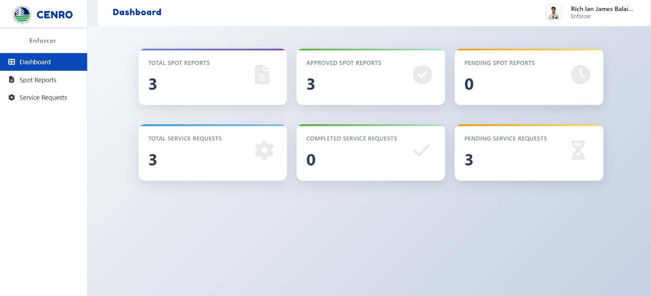
Figure 99. Dashboard (Enforcer Interface)
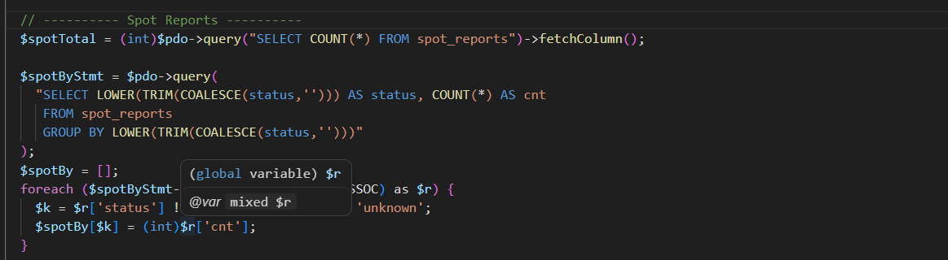
Figure 99 shows the dashboard interface for the enforcer, which displays a summary of spot reports and service requests. It helps users quickly monitor activities and track their assigned tasks.
Figure 100. Code Snippet for CENRO NFO-ETS (Enforcer) – Dashboard
Figure 100 shows the process of retrieving dashboard statistics for the Enforcement Officer module. It counts the total spot reports and groups them according to status. The retrieved data is then used to display summary information on the dashboard.

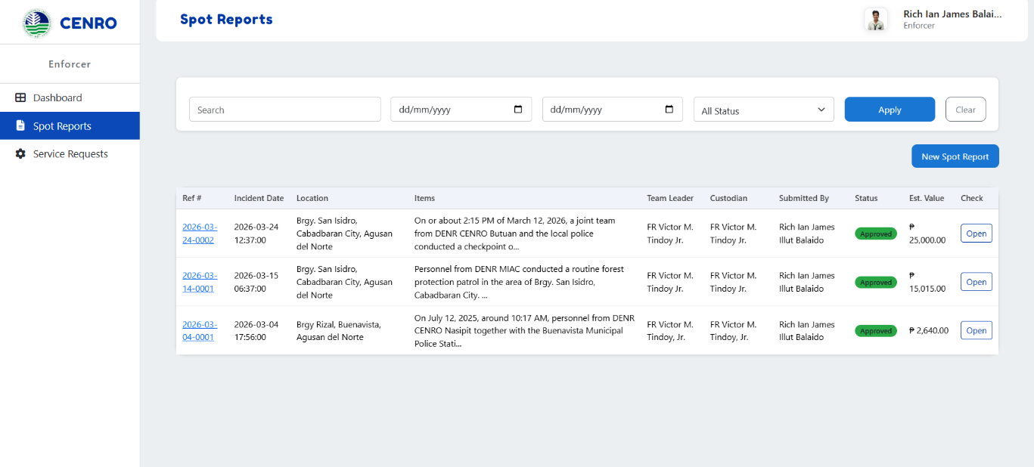
Figure 101. Spot Report (Enforcer Interface)
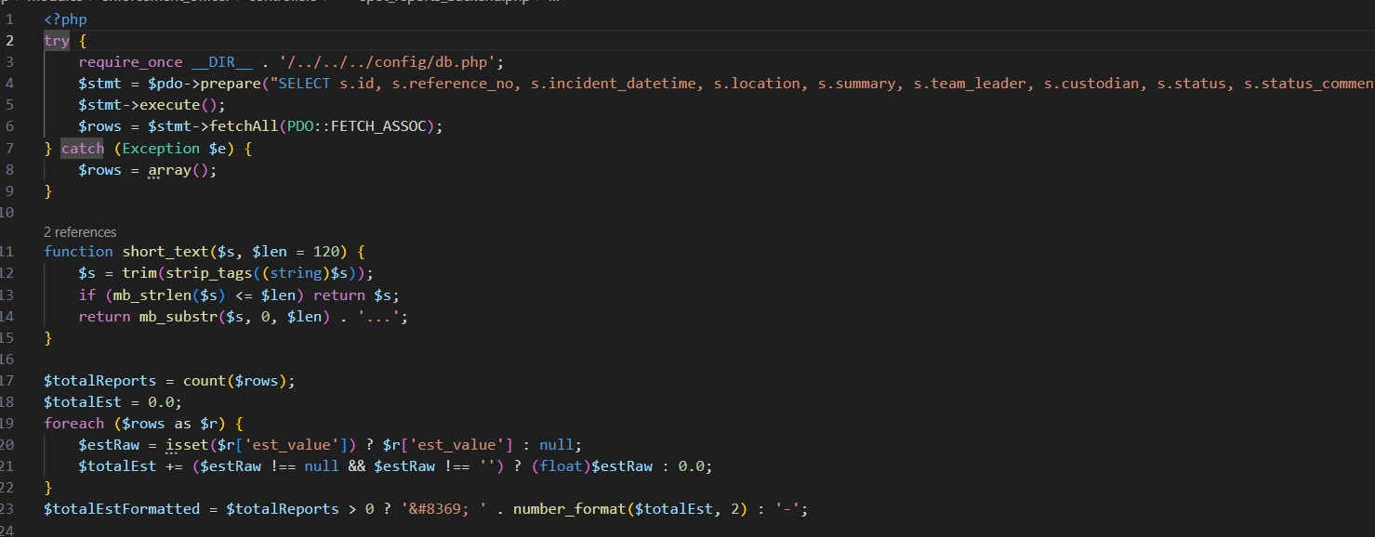
Figure 101 shows the Spot Reports interface, which displays a list of submitted reports with details such as date, location, and status. It allows the enforcer to view and check report records within the system.
Figure 102. Code Snippet for CENRO NFO-ETS (Enforcer) – Spot Report
Figure 102 shows the process of retrieving spot report records from the database. It loads the report information needed for display in the Spot Reports module.

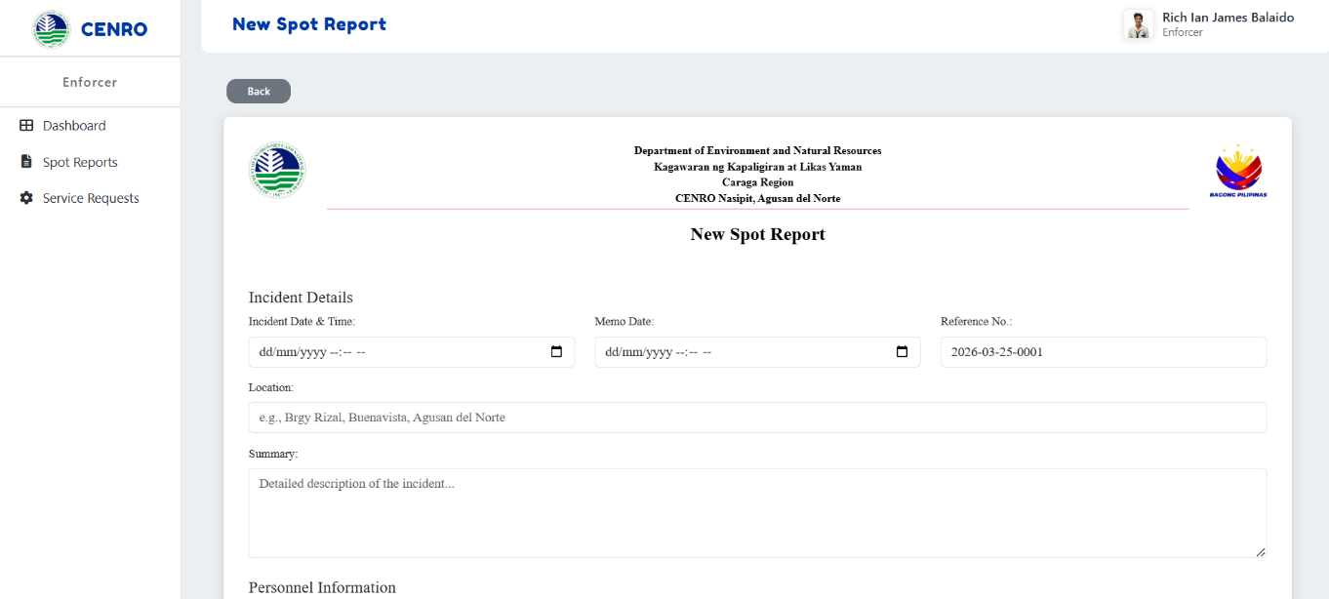
Figure 103. New Spot Report (Enforcer Interface)
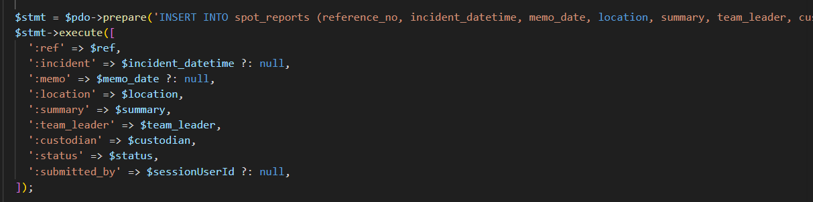
Figure 103 shows the New Spot Report interface, which allows the enforcer to create and submit a new report by entering incident details and relevant information. It ensures proper documentation of field activities within the system.
Figure 104. Code Snippet for CENRO NFO-ETS (Enforcer) – New Spot Report
Figure 104 shows the process of saving a new spot report in the system. It inserts the reference number, incident details, location, summary, personnel information, and status into the database. It also records the user who submitted the report.

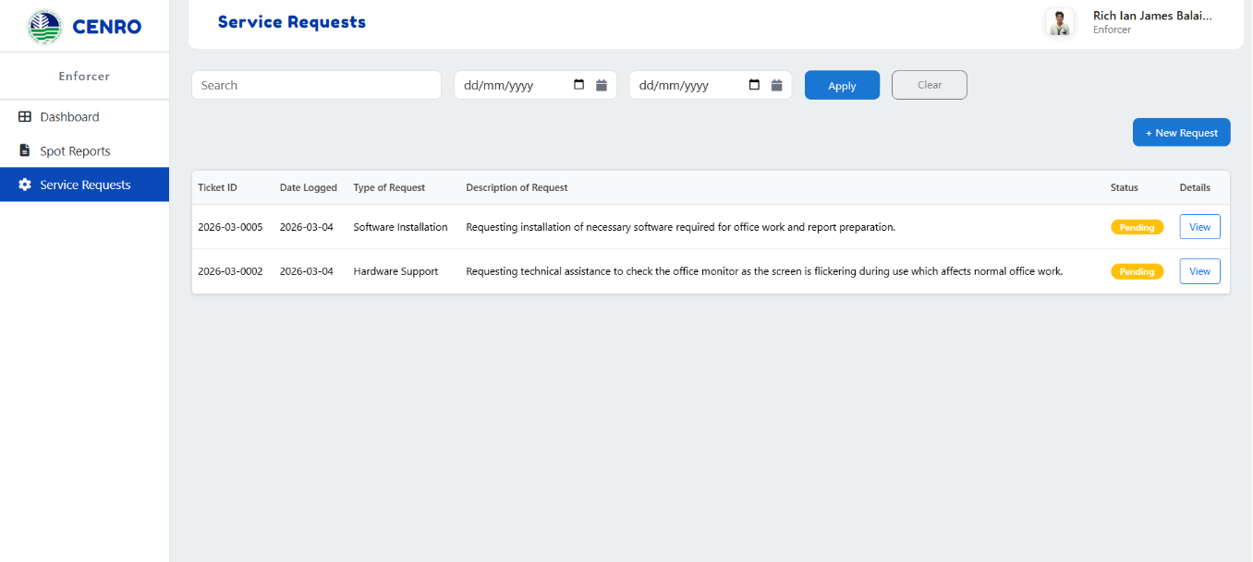
Figure 105. Service Requests (Enforcer Interface)
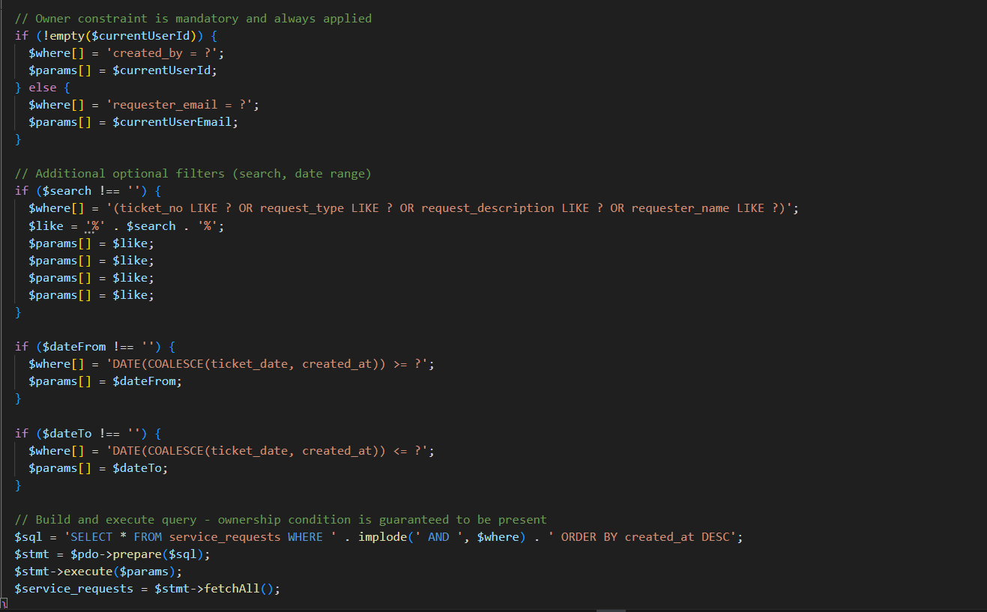
Figure 105 shows the Service Requests interface, which displays a list of submitted requests with details such as type, description, and status. It allows the enforcer to view and track service requests within the system.
Figure 106. Code Snippet for CENRO NFO-ETS (Enforcer) – Service Requests
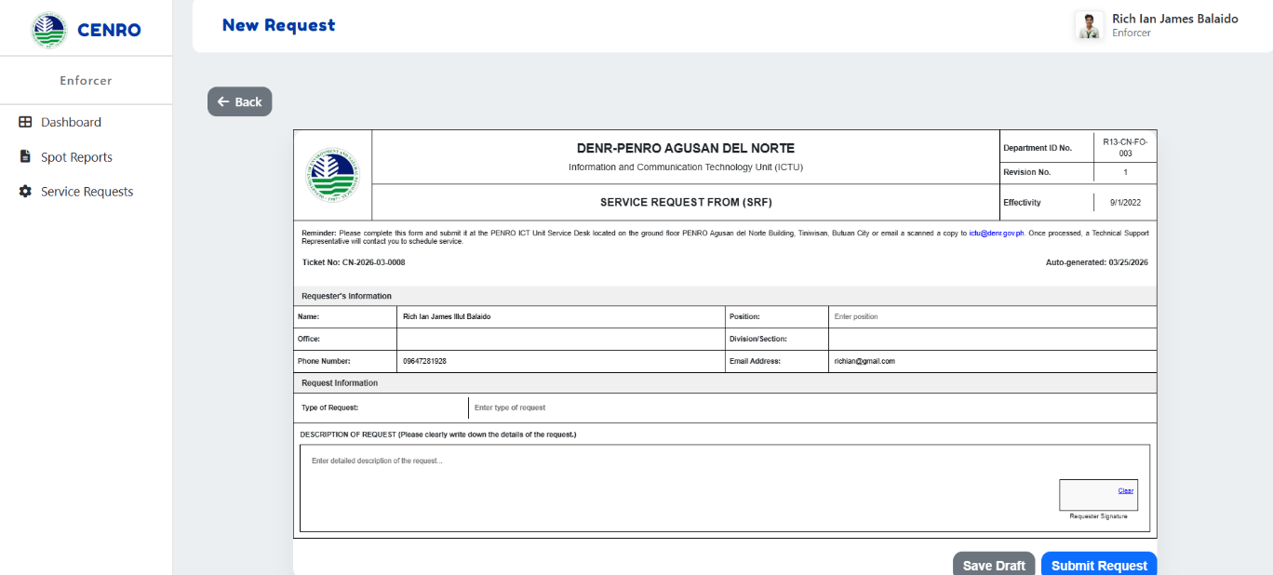
Figure 106 shows the process of retrieving service request records for the logged-in user. It applies the search and date filters before executing the database query. The retrieved records are then displayed in the Service Requests module.
Figure 105. New Requests (Enforcer Interface)
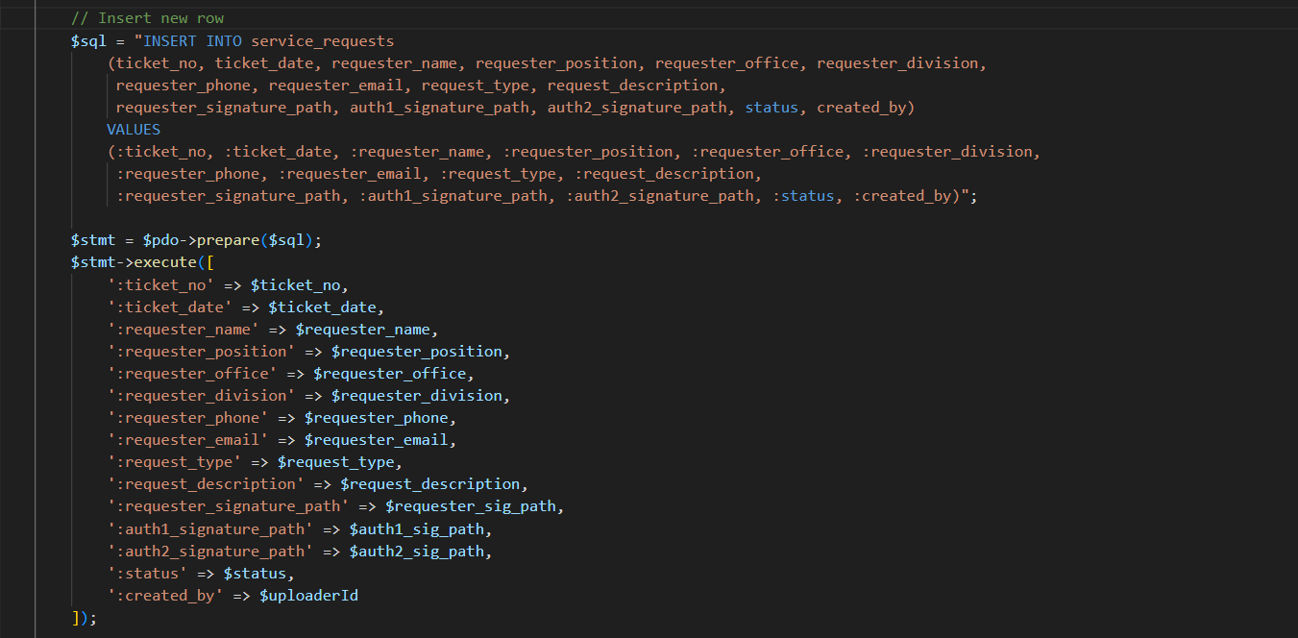
Figure 105 shows the New Request interface, which allows the enforcer to create and submit a service request by providing the required information. It ensures proper documentation and processing of requests within the system.
Figure 106. Code Snippet for CENRO NFO-ETS (Enforcer) – New Requests
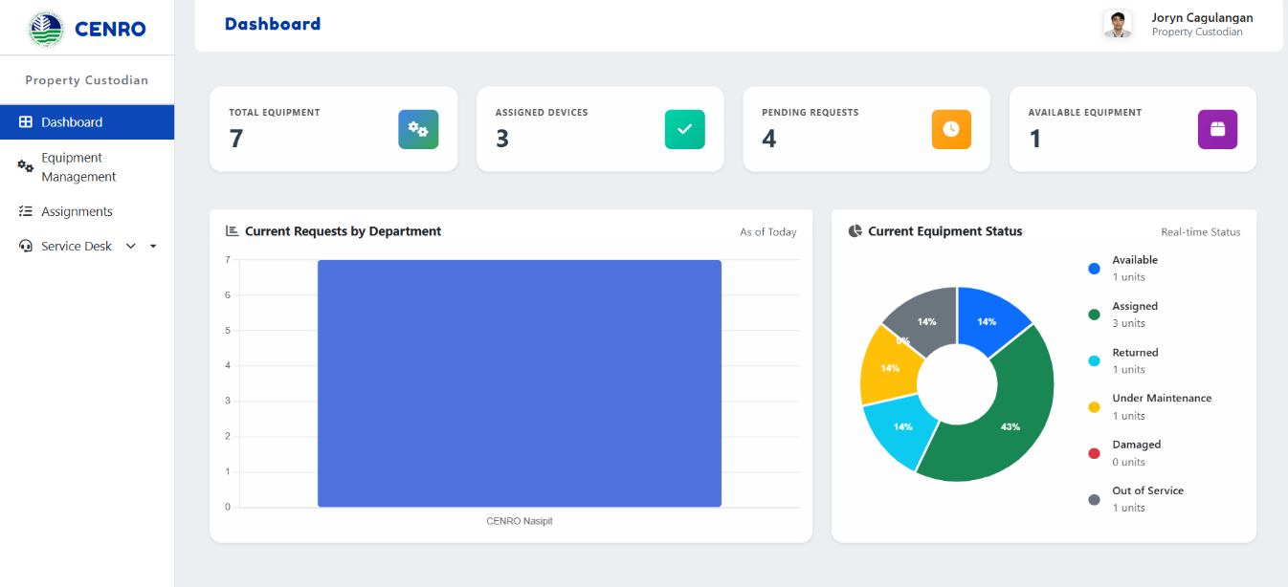
Figure 106 shows the process of saving a new service request in the system. It inserts the request details into the database, including the ticket number, requester information, request type, description, and status. The saved record is then used for tracking and processing of service requests.
Figure 107. Dashboard (Property Custodian Interface)
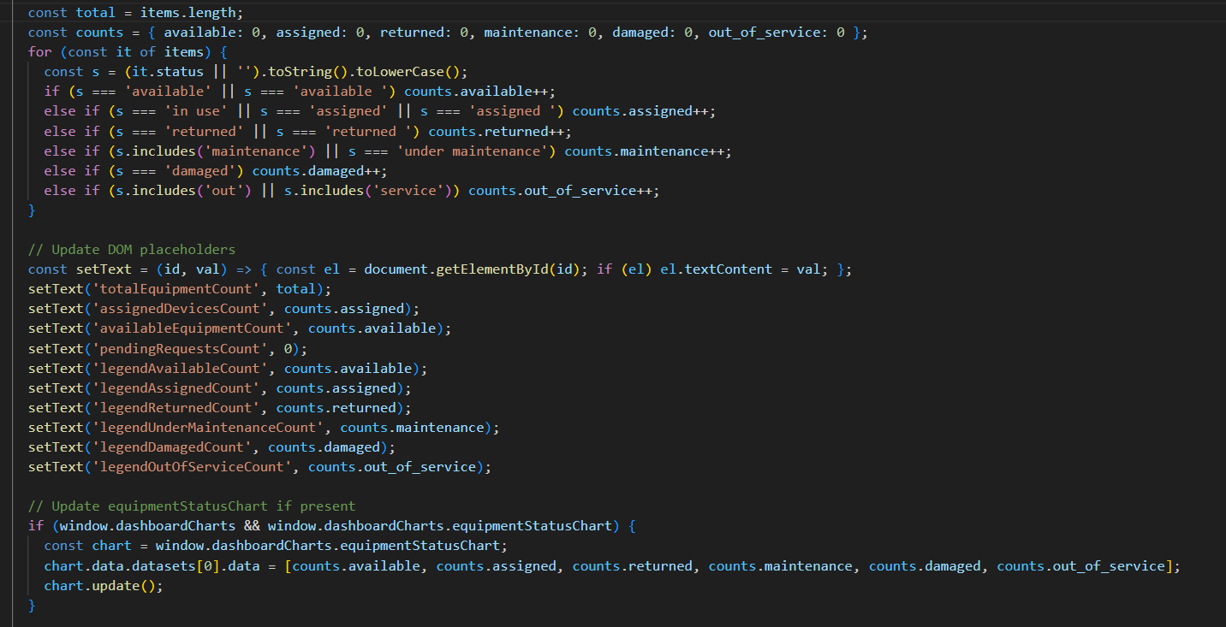
Figure 107 shows the dashboard interface for the property custodian, which displays a summary of equipment, assigned devices, and service requests. It helps users monitor equipment status and track system activities efficiently.
Figure 108. Code Snippet for CENRO NFO-ETS (Property Custodian) – Dashboard
Figure 108 shows the counting of equipment records based on their status. The computed totals are then used to update the summary information displayed on the dashboard.
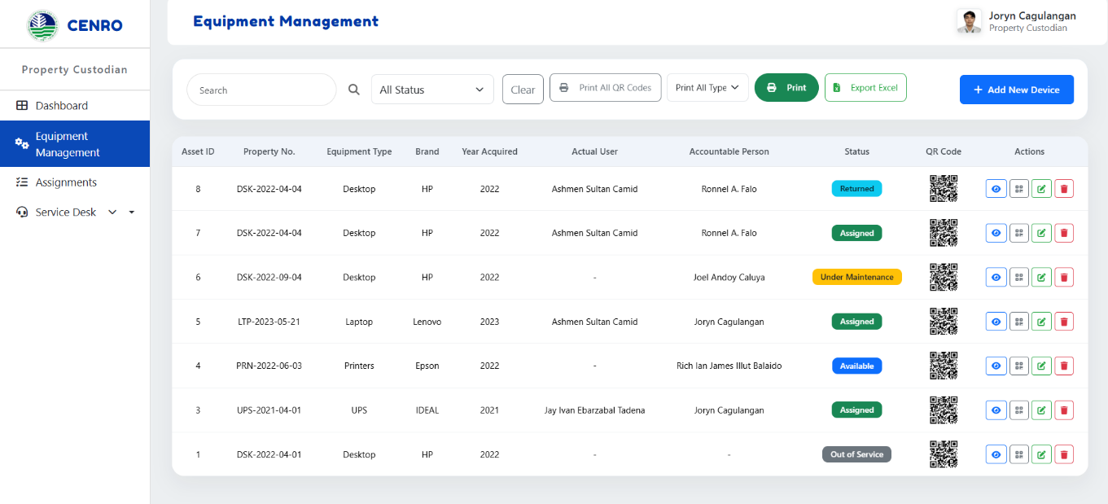
Figure 109. Equipment Management (Property Custodian Interface)
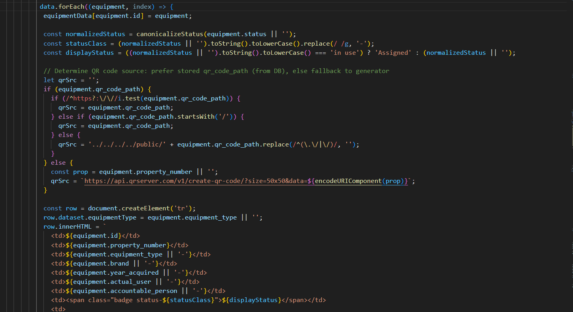
Figure 109 shows the Equipment Management interface, which displays a list of equipment with details such as asset ID, type, user, status, and QR code. It allows the property custodian to monitor and manage equipment records efficiently.
Figure 110. Code Snippet for CENRO NFO-ETS (Property Custodian) – Equipment Management
Figure 110 shows the process of retrieving and displaying equipment records in the Equipment Management module. It loads the equipment data, processes the status of each record, and presents the details together with the corresponding QR code in the table.
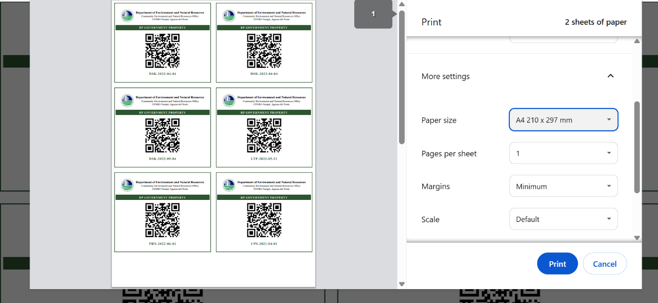
Figure 111. QR Code Printing (Property Custodian Interface)
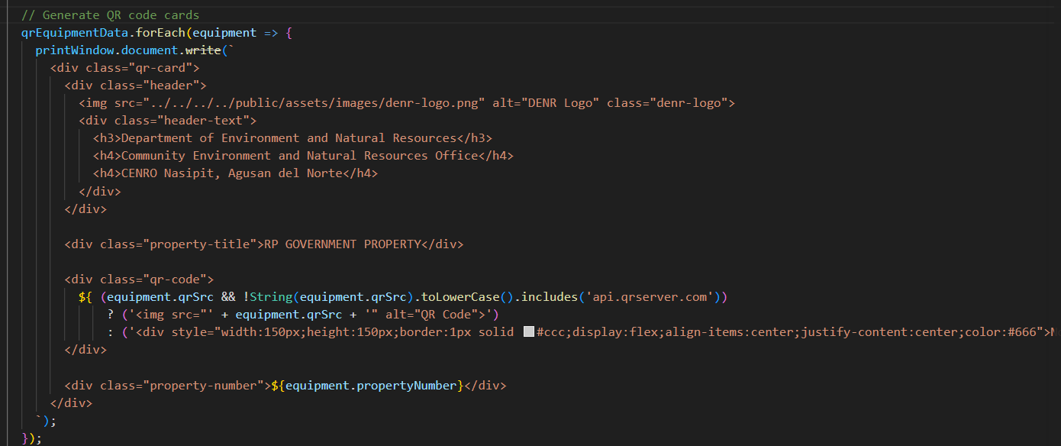
Figure 111 shows the print preview of generated QR codes for equipment. It allows the property custodian to print QR code labels used for tagging and tracking equipment efficiently.
Figure 112. Code Snippet for CENRO NFO-ETS (Property Custodian) – QR Code Printing
Figure 112 shows the process of preparing all equipment QR codes for printing. It retrieves the property number and QR image of each displayed equipment record and organizes them for the printable QR code layout.

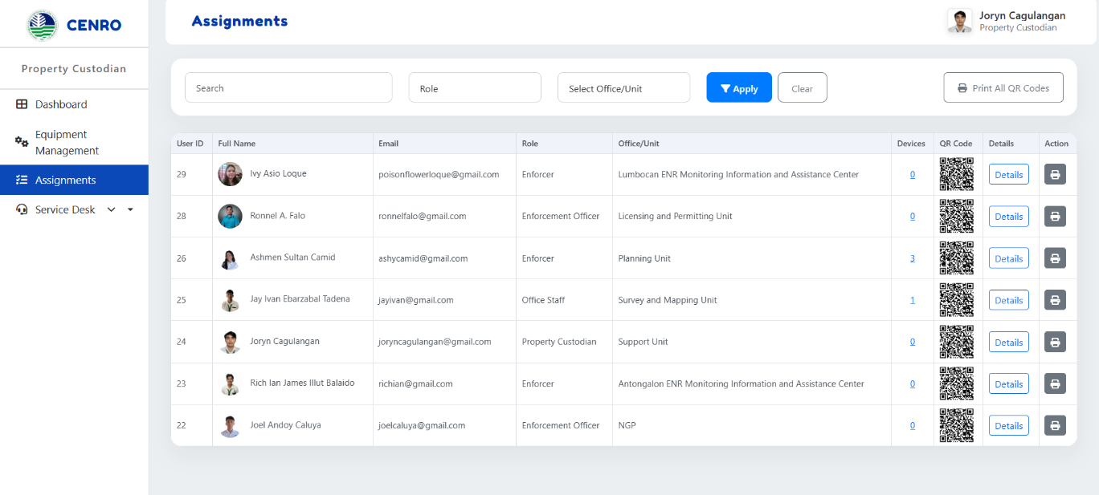

Figure 113. Assignments (Property Custodian Interface)
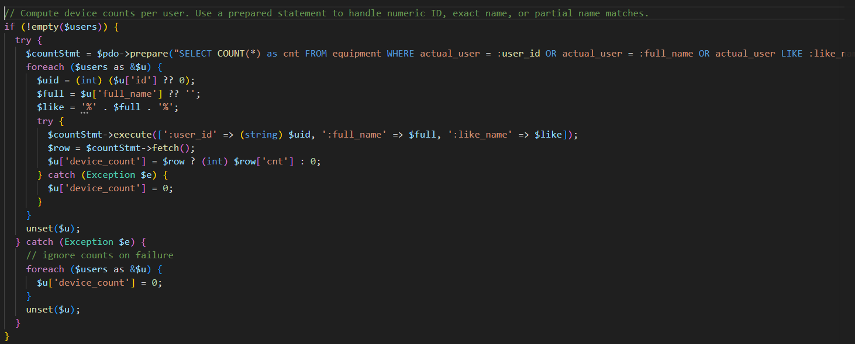
Figure 113 displays the Assignments module for the Property Custodian, where users are listed along with their roles, assigned office/unit, and number of devices issued. It also provides QR codes for each user, enabling efficient tracking and management of equipment assignments.
Figure 114. Code Snippet for CENRO NFO-ETS (Property Custodian) – QR Code Printing
Figure 114 shows the process of counting the number of devices assigned to each user. It checks the equipment records and matches them with the corresponding user information. The computed device count is then displayed in the Assignments module.
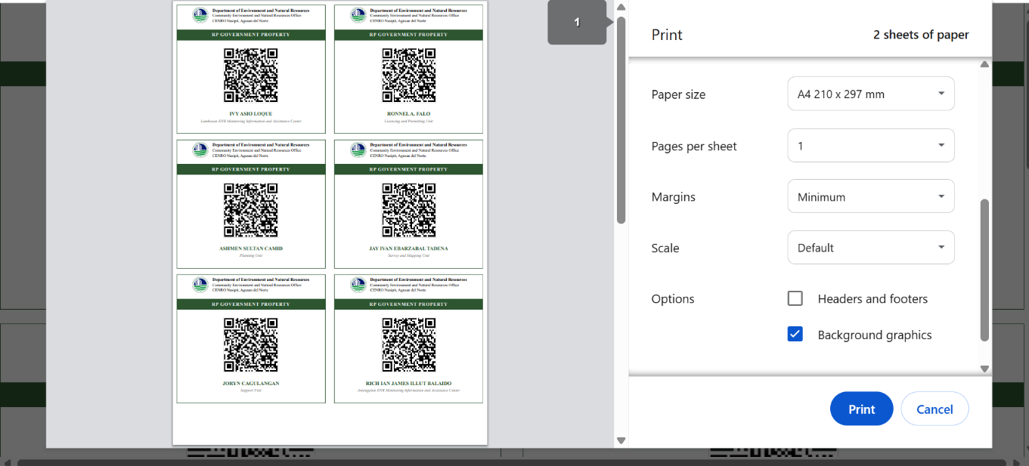
Figure 115. QR Code Printing Assignments (Property Custodian Interface)
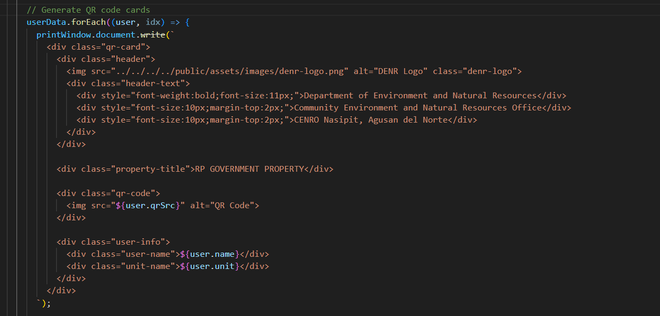
Figure 115 shows the print preview of generated QR codes for assigned personnel. Each QR code corresponds to a specific user and is formatted for bulk printing on A4 paper, allowing efficient labeling and tracking of equipment assigned to personnel.
Figure 116. Code Snippet for CENRO NFO-ETS (Property Custodian) - QR Code Assignments
Figure 116 shows the process of preparing user QR code data for printing in the Assignments module. It collects the QR image, user name, and office/unit from the table records and organizes them for the printable QR code layout.
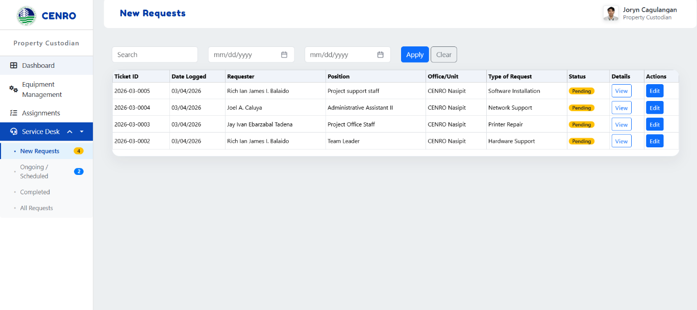
Figure 117. New Requests (Property Custodian Interface)
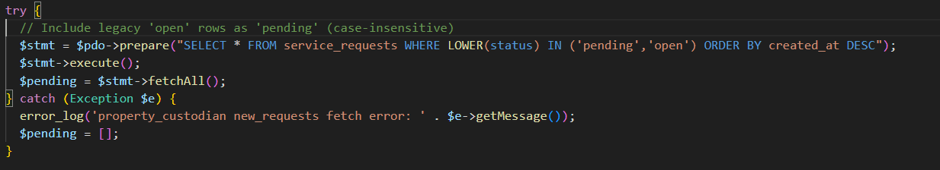
Figure 117 presents the New Requests module where the Property Custodian can view and manage incoming service requests. It displays essential details such as ticket ID, requester information, type of request, and current status. The interface also provides filtering options and action buttons to review and process each request efficiently.

Figure 118. Code Snippet for CENRO NFO-ETS (Property Custodian) – New Requests
Figure 118 shows the process of retrieving pending service requests from the database. It selects records with pending or open status and arranges them in descending order based on creation date. The retrieved records are then displayed in the New Requests module.
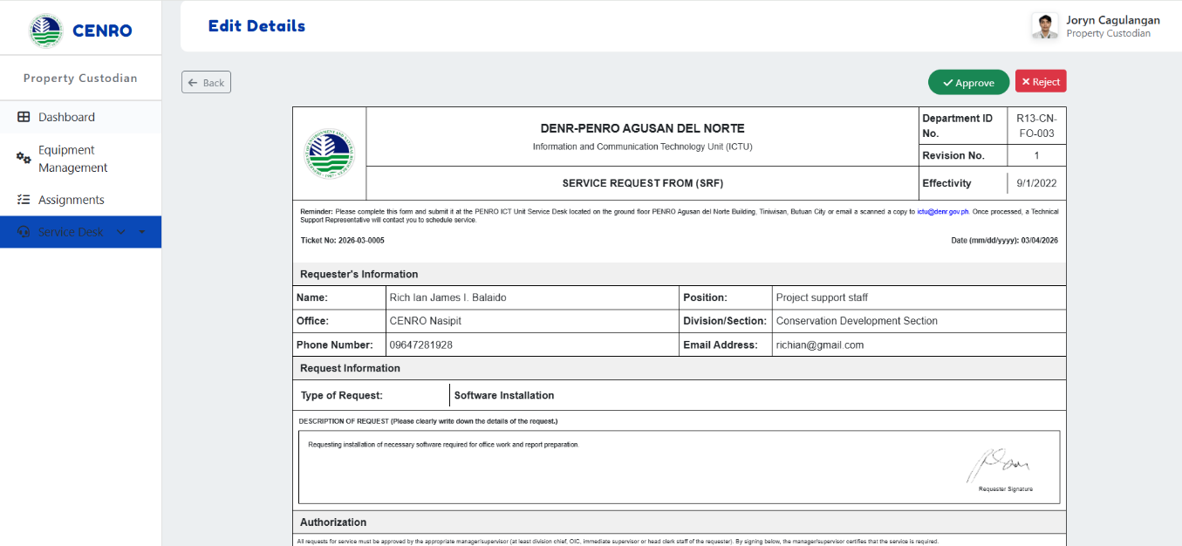
Figure 119. Edit Details Requests (Property Custodian Interface)
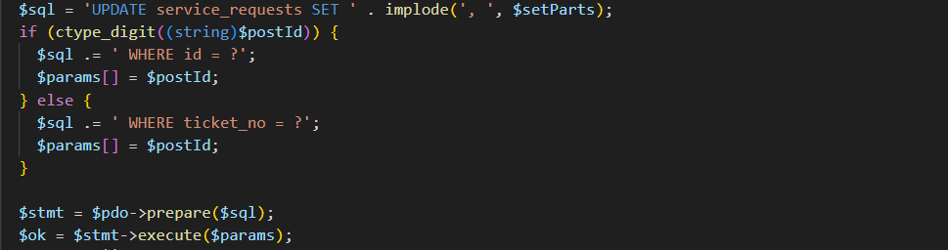
Figure 119 shows the detailed view of a service request, where the Property Custodian can review complete request information, including requester details, type of request, and description. The interface also provides action buttons to approve or reject the request, enabling efficient decision-making and request processing.

Figure 120. Code Snippet for CENRO NFO-ETS (Property Custodian) – Edit Details Requests
Figure 120 shows the process of updating an existing service request in the system. It prepares the edited request fields and applies the changes to the database through an update query. This ensures that the request record is kept accurate and up to date.

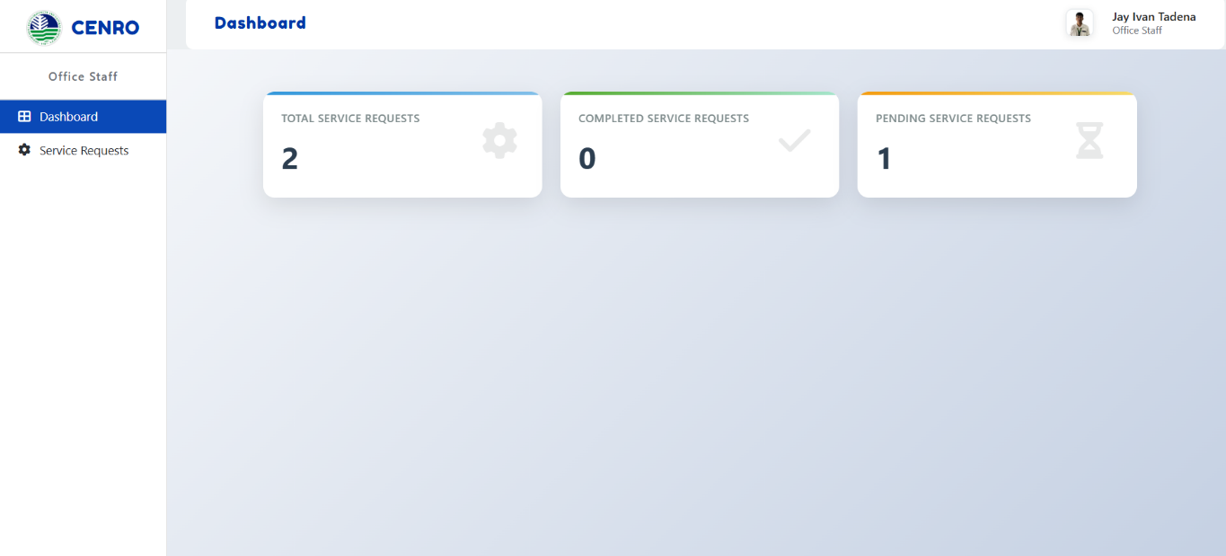
Figure 121. Dashboard (Office Staff Interface)
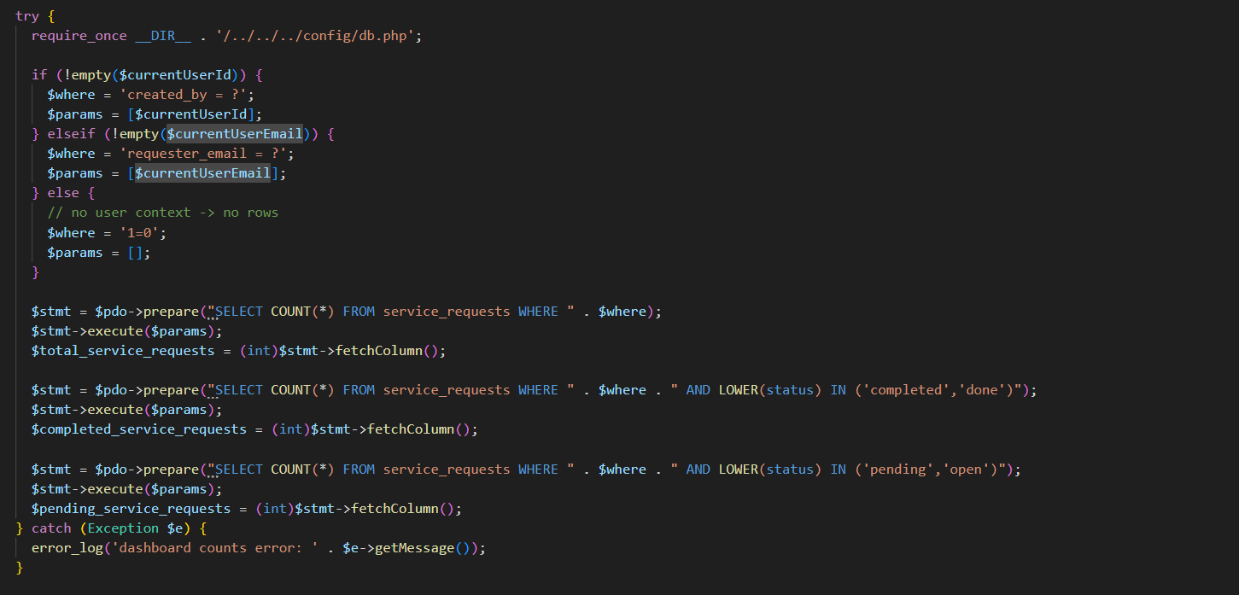
Figure 121 presents the dashboard interface for Office Staff, displaying a summary of service requests. It highlights key metrics such as total service requests, completed requests, and pending requests, providing users with a quick overview of request status and workload.
Figure 122. Code Snippet for CENRO NFO-ETS (Office Staff) - Dashboard
Figure 122 shows the process of retrieving service request counts for the Office Staff dashboard. It counts the total, completed, and pending requests of the logged-in user. The retrieved data is then displayed as summary information on the dashboard.
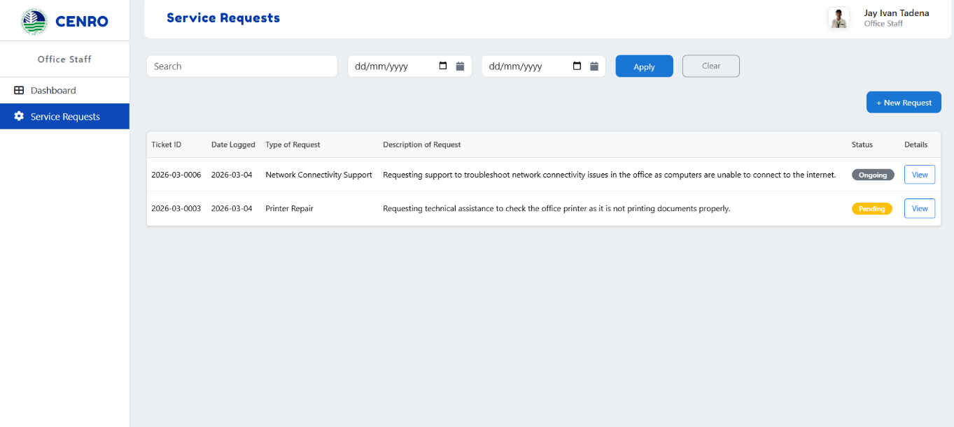
Figure 123. Service Requests (Office Staff Interface)
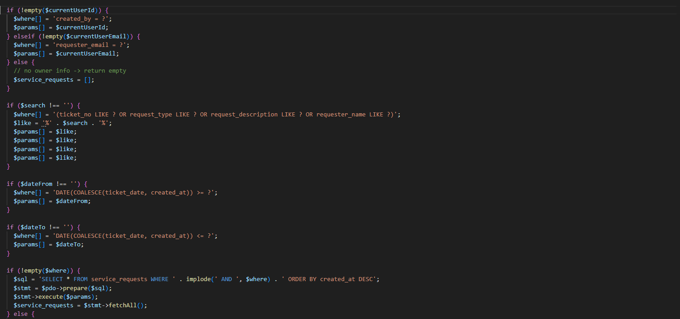
figure shows the Service Requests module for Office Staff, where users can view submitted requests along with their details such as ticket ID, type of request, description, and current status. The interface also includes search and filtering options, as well as a button for creating new service requests.
Figure 124. Code Snippet for CENRO NFO-ETS (Office Staff) – Service Requests
Figure 124 shows the process of retrieving service request records for the logged-in user. It applies the search and date filters before executing the database query. The retrieved records are then displayed in the Service Requests module.
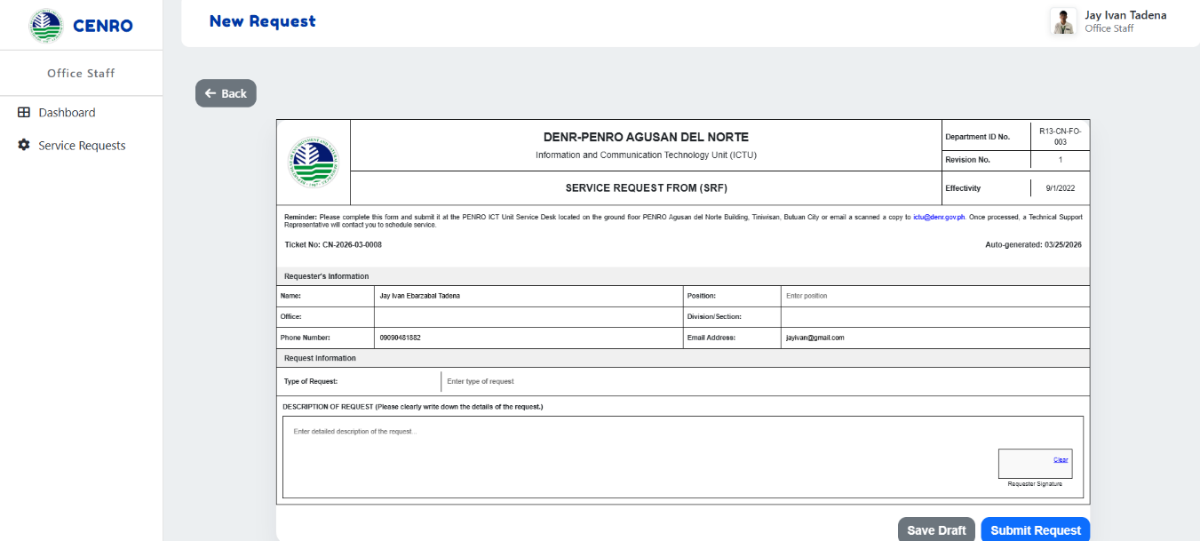
Figure 125. New Requests (Office Staff Interface)

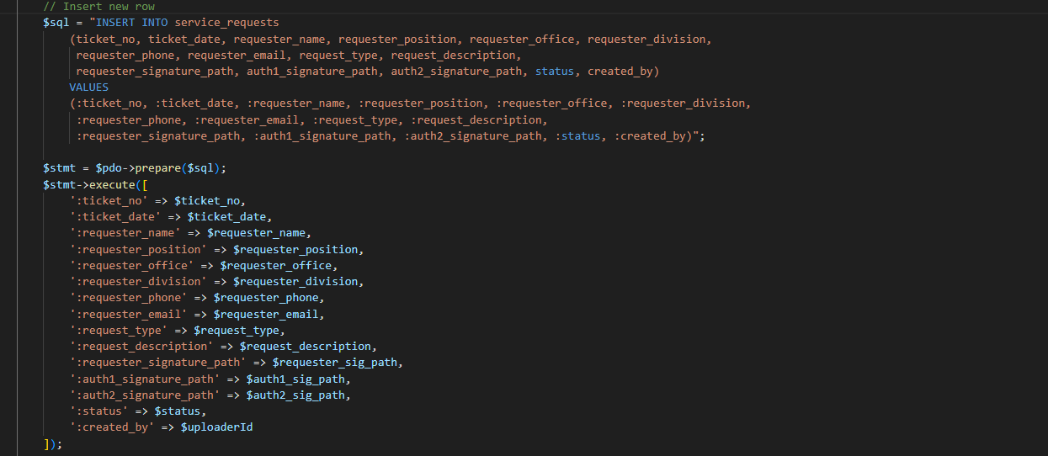
Figure 125 shows the New Request form used by Office Staff to submit service requests. It allows users to input necessary details such as requester information, type of request, and description. The interface also provides options to save the request as a draft or submit it for processing.
Figure 126. Code Snippet for CENRO NFO-ETS (Office Staff) – New Requests
Figure 126 shows the process of saving a new service request in the system. It inserts the request details into the database, including the ticket number, requester information, request type, description, and status. The saved record is then used for tracking and processing of service requests.

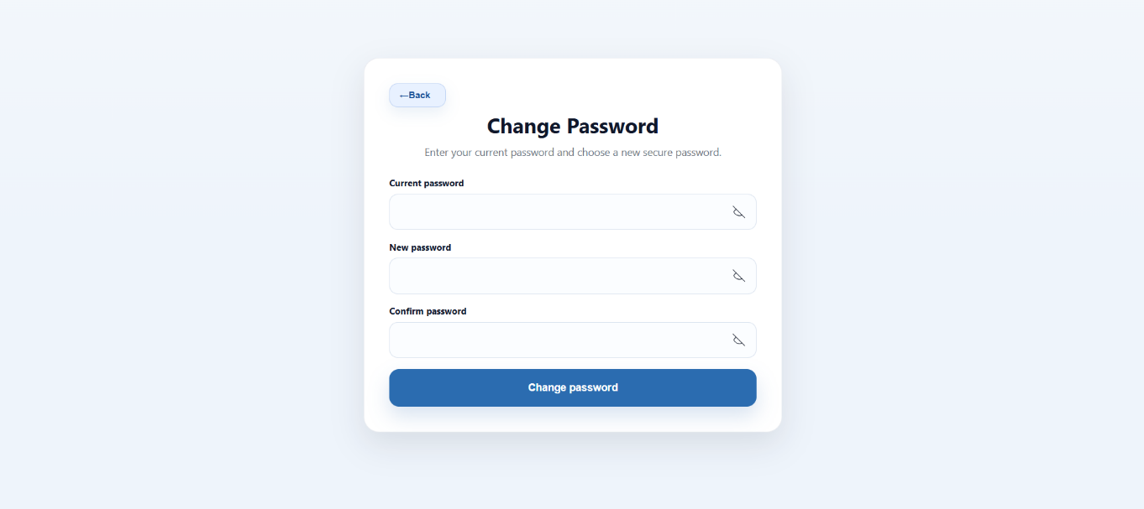
Figure 127. Change Password (Office Staff Interface)
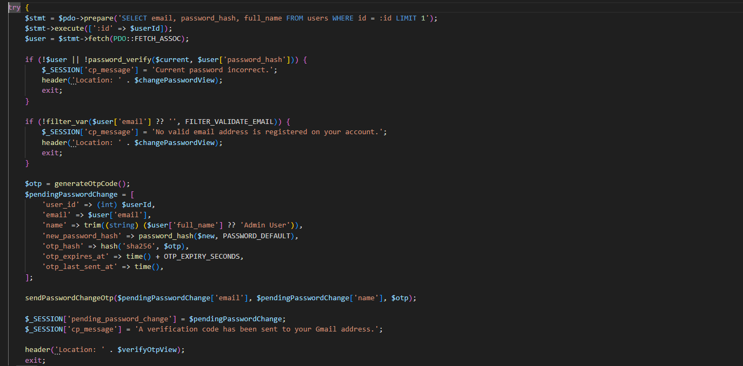
Figure 127 shows the Change Password interface, which allows users to update their account credentials securely. Users are required to enter their current password, create a new password, and confirm it before submitting the change, ensuring account security and proper authentication.
Figure 128. Code Snippet for CENRO NFO-ETS (Office Staff) – Change Password
Figure 128 shows the process of changing the user password in the system. It verifies the current password, validates the user account, hashes the new password, and generates an OTP for additional verification. This helps ensure that the password change process is secure and authorized.
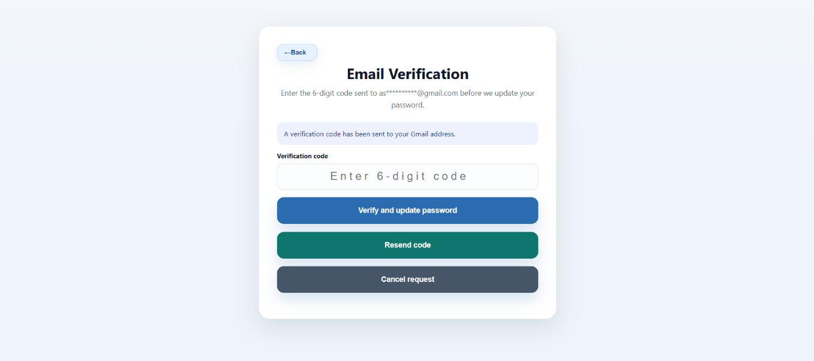
Figure 129. Email Verification (Office Staff Interface)
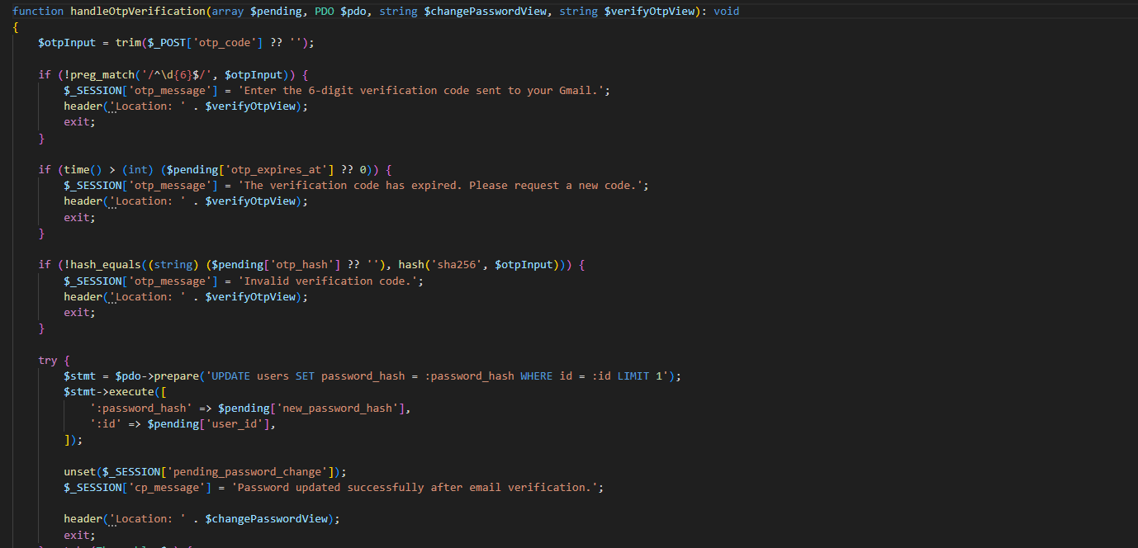
Figure 129 presents the Email Verification interface used during the password reset process. A 6-digit verification code is sent to the user’s registered email address, which must be entered to confirm identity before updating the password. The interface also provides options to resend the code or cancel the request, ensuring both security and user control during authentication.
Figure 128. Code Snippet for CENRO NFO-ETS (Office Staff) – Email Verification
shows the process of verifying the email verification code in the system. It checks whether the entered OTP is valid and not expired before updating the user password in the database. This adds an extra layer of security to the password change process.
3.3 System Evaluation Using ISO/IEC 25010 Standards
Overall Mean Rating: 3.90– Very Satisfactory
The ISO/IEC 25010 Software Quality Standards were used to evaluate the CENRO Nasipit Field Operations and Equipment Tracking System (CENRO NFO-ETS) to ensure that the developed system meets the required standards for functionality, performance efficiency, and usability. The evaluation determined whether the system effectively improves the field operations, equipment tracking, and reporting processes of CENRO Nasipit.
The system was assessed by selected personnel, including the ICT Focal Person, Enforcement Officers, Enforcers, Property Custodian, and Office Staff. Their responses were collected using a structured evaluation questionnaire adapted from the ISO 25010 quality model. The results show that the system obtained an overall mean rating of 4.52, interpreted as Very Satisfactory, indicating that the developed system meets the expected quality standards and successfully supports operational requirements.
Functional Suitability
In terms of Functional Suitability, the system successfully performed its intended functions based on the designed modules. The role-based access feature allowed each user to access only the functions assigned to their respective roles. Administrators were able to manage user accounts, view statistical reports, and monitor system records. Enforcement Officers managed spot reports, case management, and apprehended items, while Enforcers submitted spot reports and service requests. Property Custodians handled equipment management, QR code generation, and device assignments, and Office Staff managed service desk requests.


Figure 129. Login Interface of the System


Figure 130. Administrator Dashboard


Figure 131. Enforcement Officer Dashboard
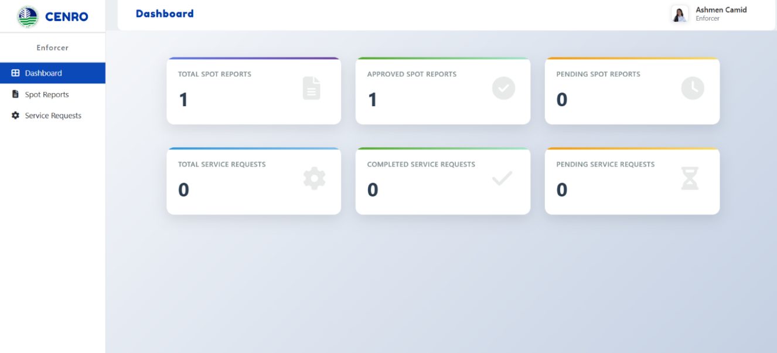

Figure 132. Enforcer Dashboard

Figure 133. Property Custodian Dashboard


Figure 134. Office Staff Dashboard
The login interface ensures secure access to the system by validating usernames and passwords before allowing entry. Once logged in, the system automatically directs users to their respective dashboards according to their assigned roles. This role-based functionality improves security and ensures proper task distribution among users.

Figure 135. Spot Report Creation Interface (Enforcer Side)

The Spot Report Management Module enables enforcers to generate and submit reports regarding field operations. These reports are then reviewed and processed by enforcement officers for documentation and monitoring.
Figure 136. Submitted Spot Reports List


Figure 137. Spot Report Review (Enforcement Officer Side)

Additionally, the Equipment Management Module allows property custodians to register devices, generate QR codes, and assign equipment to specific personnel. This feature improves inventory tracking and simplifies auditing procedures.

Figure 138. Equipment Registration Interface




Figure 139. QR Code Generation Output

Figure 140. Device Assignment Interface

The functional suitability of the system confirms that all required modules operate as intended and effectively support the daily operations of CENRO Nasipit.
Performance Efficiency
For Performance Efficiency, the system demonstrated fast processing and reliable data handling. When reports were submitted by enforcers, the data were immediately stored in the database and reflected in the system dashboards. This real-time update feature enables enforcement officers and administrators to monitor activities without delay.

Figure 141. Real-Time Spot Report Submission Reflected on Dashboard


Figure 142. Statistical Report Generation Interface

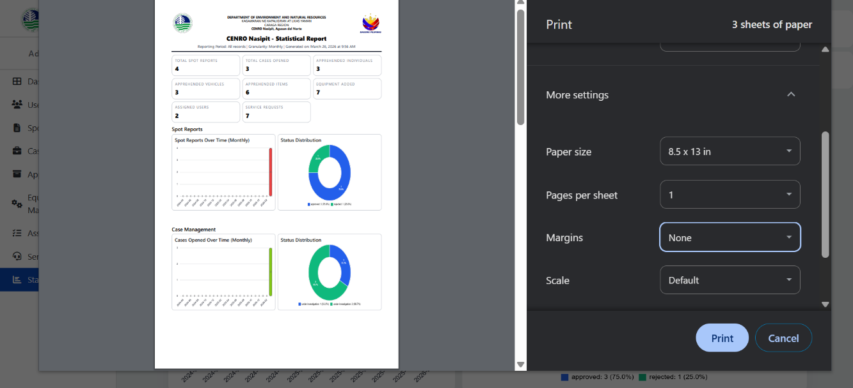
The system also supports exporting reports into printable formats. Statistical reports generated by the system can be viewed, downloaded, and printed, which significantly reduces manual documentation tasks and improves workflow efficiency.
Figure 143. Printable Report Preview


Figure 144. QR Code Scanning Output
Furthermore, the QR code scanning process allows quick identification of equipment and assigned personnel. This feature improves tracking speed and reduces the time required for inventory verification.

Overall, the performance efficiency results indicate that the system processes data quickly, updates information accurately, and supports efficient completion of operational tasks.
Usability
In terms of Usability, the system was designed to be user-friendly and easy to understand for all types of users. Each dashboard contains organized menus and clearly labeled functions that guide users through their assigned tasks.

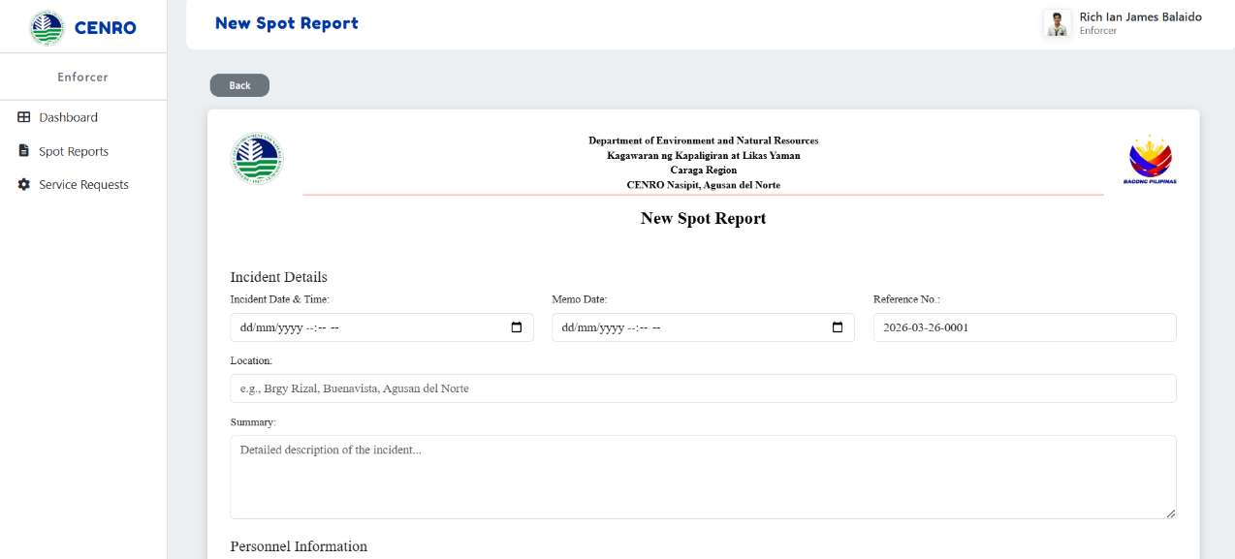

Figure 147. Spot Report Submission Form

Figure 148. Service Request Form Interface
Users were able to navigate the system with minimal assistance, demonstrating that the interface design supports ease of use and reduces the learning curve for new users.

The usability evaluation confirms that the system interface is understandable, accessible, and convenient for daily use, making it suitable for continuous implementation in the CENRO Nasipit environment.
Based on the results of the ISO/IEC 25010 evaluation, the CENRO Nasipit Field Operations and Equipment Tracking System (CENRO NFO-ETS) achieved an overall mean rating of 3.90, which is interpreted as Very Satisfactory. This result indicates that the system effectively meets the functional requirements, operates efficiently, and provides a user-friendly interface for its users.

The evaluation confirms that the developed system significantly improves the management of field operations, report processing, equipment tracking, and service request handling within CENRO Nasipit. The implementation of the system supports faster processing of reports, accurate equipment monitoring, and improved data accessibility, thereby enhancing overall organizational efficiency.

CHAPTER IV
SUMMARY, CONCLUSION, AND RECOMMENDATION
Summary of Findings
This study focused on the design and development of the CENRO Nasipit Field Operations and Equipment Tracking System (CENRO NFO-ETS) to improve the management of field operations, equipment tracking, and report generation in CENRO Nasipit. The system automated previously manual processes such as Spot Report submission, case monitoring, equipment assignment, and service request handling.
The developed system successfully implemented QR code-based equipment tracking, which enhanced the identification, monitoring, and accountability of assigned equipment. The centralized database enabled secure storage and efficient retrieval of records, allowing authorized users to access real-time information through role-based dashboards.
Additionally, the statistical reporting module provided automated generation of graphical reports, reducing the time required to prepare operational summaries. The system was evaluated using the ISO/IEC 25010 software quality standards, and the results indicated a Very Satisfactory level of performance, confirming that the system demonstrated strong usability, functionality, and performance efficiency.
Overall, the findings showed that the developed system significantly improved operational efficiency, reduced manual workload, and enhanced the accuracy of equipment and field operation records.
Conclusion
Based on the findings of the study, the researchers conclude that the CENRO Nasipit Field Operations and Equipment Tracking System (CENRO NFO-ETS) successfully achieved the specific objectives of the project. The system effectively addressed the limitations of manual processes by providing automated tools for managing field reports, tracking equipment, and generating statistical summaries.
The integration of QR code technology improved equipment tracking accuracy and accountability, while the centralized database ensured secure and organized storage of operational data. The role-based access control contributed to improved workflow management and enhanced data security.
Furthermore, the ISO/IEC 25010 evaluation results confirmed that the system met the required standards in terms of usability, functionality, and performance efficiency. Therefore, the researchers conclude that the developed system is a reliable and effective solution for improving operational management and equipment tracking processes within CENRO Nasipit.
Recommendation
Based on the results of the study, several recommendations are proposed to enhance the system and support future development.
Future researchers may improve the system by developing a mobile-based version that allows field personnel to submit reports and scan QR codes using mobile devices. This enhancement would increase accessibility and improve real-time data recording during field operations.
It is also recommended to implement additional security measures such as multi-factor authentication and automated backup systems to ensure data protection and system reliability. Integration with other related government systems is also suggested to improve inter-agency coordination and information sharing.
Moreover, future studies may expand the system by incorporating advanced data analytics and reporting tools to support better decision-making. Regular system updates, maintenance, and user training are likewise recommended to sustain system efficiency and usability over time.

REFERENCES

- B. Tauli-Calugan, “Improving Forest Management: A Case Study of DENR-CAR’s Turned-over Logs,” Journal of Interdisciplinary Perspectives, vol. 3, no. 3, 2025, doi: 10.69569/jip.2024.0645.
- W. van Groesen and P. Pauwels, “Tracking prefabricated assets and compliance using quick response (QR) codes, blockchain and smart contract technology,” Automation in Construction, vol. 141, Art. no. 104420, 2022, doi: 10.1016/j.autcon.2022.104420.
- A. Labutap-Noble and J. B. Vicente, “The Implementation of Anti-Illegal Logging Law in Eastern Visayas: An Assessment,” International Multidisciplinary Research Journal, Jun. 2023, doi: 10.54476/ioer-imrj/798897.
- S. Zhang, J. Liao, S. Wu, J. Zhong, and X. Xue, “A Traceability Public Service Cloud Platform Incorporating IDcode System and Colorful QR Code Technology for Important Product,” Mathematical Problems in Engineering, vol. 2021, pp. 1–15, Jun. 2021, doi: https://doi.org/10.1155/2021/5535535
- L. Piloton, G. Z. Gamboa, M. A. dela Cerna, and R. A. Reyna, “Development of Records Tracking

Management System with QR Code,” 2023. doi: DOI:10.36948/ijfmr.2023.v05i04.5508.
- L. Ma, Y. Mu, L. Wei, and X. Wang, “Practical Application of QR Code Electronic Manuals in Equipment Management and Training,” Frontiers in Public Health, vol. 9, Nov. 2021, doi: 10.3389/fpubh.2021.726063.
- C. P. Noguerra Jr, “Design and Evaluation of an Innovative Mobile Solution: QR Code-based Inventory Monitoring System,” International Journal of Advanced Engineering and Management Research, vol. 08, no. 03, pp. 231–242, 2023, doi: 10.51505/ijaemr.2023.8317.
- Alsadah, Z. A., Alhashem, R. A., Alansari, D. T., Alshehri, R. A., Alqahtani, H. F., & Mohammed

  - (2025). Trends and Challenges in Smart Inventory Management. https://doi.org/DOI:10.17577/IJERTV14IS040010

- M. A. Yaqin, S. A. Ariyanto, L. S. Amtini, and F. N. Zhalianti, “Development of a QR Code-Based Inventory System and Consumable Material Management using Django Python,” Journal of Intelligent Computing & Health Informatics, vol. 5, no. 2, p. 64, Sep. 2024, doi: 10.26714/jichi.v5i2.15578.
- A. Ahmad, “e-AIMSS (Electronic Asset Inventory and Management System in School) for Resource Optimization and Organizational Productivity,” 2023, doi: 10.5281/zenodo.8326056.
- J. Gumilao, “AUTOMATED INVENTORY MANAGEMENT SYSTEM FOR DEPARTMENT OF EDUCATION REGIONAL OFFICE IX,” 2024, doi: 10.13140/RG.2.2.20268.48006.
- A. Hugo and G. N. Ngo, “Private Blockchain-based Procurement and Asset Management System with QR Code,” International Journal of Computing Sciences Research, vol. 8, pp. 2971– 2983, Jan. 2024, doi: 10.25147/ijcsr.2017.001.1.197.
- M. B. Tungcul and M. G. C.- Kummer, “Supplies and Equipment Inventory, Monitoring and Tracking Management System using Data Mining Techniques,” International Journal of Recent Technology and Engineering (IJRTE), vol. 10, no. 2, pp. 81–85, Jul. 2021, doi: 10.35940/ijrte.B6174.0710221.
- M. N. H. M. Noor, R. Kadir, and S. Muhamad, “Issues of forest enforcement against illegal logging and forest offences in Peninsular Malaysia,” Journal of Sustainability Science and Management, vol. 16, no. 7, pp. 260–272, Oct. 2021, doi: 10.46754/jssm.2021.10.019.
- M. N. H. M. Noor, R. Kadir, and S. Muhamad, “Issues Of Forest Enforcement Against Illegal Logging And Forest Offences In Peninsular Malaysia,” Journal of Sustainability Science and Management, vol. 16, no. 7, pp. 260–272, Oct. 2021, doi: 10.46754/jssm.2021.10.019.
- D. Rahmat, “The effectiveness of law enforcement on illegal logging based on the value of justice,” UNIFIKASI: Jurnal Ilmu Hukum, vol. 7, no. 1, pp. 28–34, 2020, doi: 10.25134/unifikasi.v7i1.2715.

- I. Carry and G. Maihold, “Illegal logging, timber laundering and the global illegal timber trade,” in Geopolitics of the Illicit, Nomos Verlagsgesellschaft mbH & Co. KG, 2022, pp. 275–308. doi: 10.5771/9783748935940-275.
- E. T. Kaya et al., “The Impact of Trade Measures to Address Illegal Wood Trafficking on the Global Forest Products Market,” 2024. doi: 10.1080/20426445.2017.1419541.
- Ardiyanto, S. Y., & Rahmadan, D. (2020). Law Enforcement Pattern on Illegal Logging in Order to Maintain the Sustainability of Forest in Riau, Indonesia. https://doi.org/10.2991/assehr.k.200529.268
- D. Rahmat, “The Effectiveness of Law Enforcement on Illegal Logging Based on the Value of Justice,” UNIFIKASI : Jurnal Ilmu Hukum, vol. 7, no. 1, p. 28, Apr. 2020, doi: 10.25134/unifikasi.v7i1.2715.
- M. Fajar, R. Azhar, Y. Anshori, and R. Laila, “Optimization of Inventory Management with QR Code Integration and Sequential Search Algorithm: A Case Study in a Regional Revenue Office,” 2025. doi: 10.30871/jaic.v9i2.8919.
- Mr. J. M. N., “Lab Inventory Management using QR Code,” INTERNATIONAL JOURNAL OF SCIENTIFIC RESEARCH IN ENGINEERING AND MANAGEMENT, vol. 08, no. 03, pp. 1–5, Mar. 2024, doi: 10.55041/IJSREM29806.
- S. Kamble, “A QR CODE TECHNOLOGY FOR CENTRALIZED INVENTORY MANAGEMENT
SYSTEM,” International Research Journal of Engineering and Technology, 2021, doi: 10.33564/IJEAST.2021.v06i06.018.
- S. Nasir, S. M. Al-Qaraawi, and M. S. Croock, “QR based management system for plants shopping center,” Indonesian Journal of Electrical Engineering and Computer Science, vol. 19, no. 2, pp. 931–939, Aug. 2020, doi: 10.11591/ijeecs.v19.i2.pp931-939.

- Benrahman, “Asset Management Information and Tracking System with QR Code Based on the Human Centred Design Method,” in Journal of Physics: Conference Series, IOP Publishing Ltd, Apr. 2021. doi: 10.1088/1742-6596/1830/1/012006.
- M. S. Lawalata, M. Lengkey Kiet Tumiwa, H. Pesik, E. S. A Lumunon, and P. Negeri Manado, “QR Code Labeling Design for Fixed Asset Management in Accounting Information System PT. Cipta Jaya Perkasa,” 2024, doi: 10.59188/covalue.v15i6.4836.
i[27] Benrahman, “Asset management information and tracking system with QR code based on the human centred design method,” Journal of Physics: Conference Series, vol. 1830, Art. no. 012006, 2021, doi: 10.1088/1742-6596/1830/1/012006.
- W. van Groesen and P. Pauwels, “Tracking prefabricated assets and compliance using quick response (QR) codes, blockchain and smart contract technology,” Automation in Construction, vol. 141, Sep. 2022, doi: 10.1016/j.autcon.2022.104420.
- N. Muhammad, F. Fadhila, M. Fahmi, R. Risanti, A. Sudrajat, and S. Mardira Indonesia, “Goods Asset Information System with Application (QR) Code (Study At One of The Schools in Bandung),” Infotmatics Management, Engineering, and Information System Journal, vol. 2, no. 1, pp. 8–15, 2024, doi: 10.56447/imeisj.
- E. Y. Anggraeni, S. Hartati, and D. Murwanto, “QR Code-Based Information System Designed to Display Irrigation Unit Data,” bit-Tech, vol. 7, no. 3, pp. 750–757, Apr. 2025, doi: 10.32877/bt.v7i3.2165.

CURRICULUM VITAE


NAME: ASHMEN S. CAMID
ADDRESS: BARANGAY 3, BUENAVISTA AGUSAN DEL NORTE EMAIL: ASHMEN_CAMID@SMCCNASIPIT.EDU.PH

Personal Information
Sex : Female
Date of birth : September 04, 2005 Height : 5’5
Weight : 42 kg Civil Status : Single

Educational Attainment
Elementary : Buenavista Central Elementary School Secondary : Saint James High School
Tertiary : Saint Michael College of Caraga

Membership/Affiliations

ORGANIZATION | POSITIONS HELD
N/A | N/A


CURRICULUM VITAE

NAME: JAY IVAN E. TADENA
ADDRESS: PUROK 5, ROJALES, CARMEN, AGUSAN DEL NORTE EMAIL: JAYIVAN_TADENA@SMCCNASIPIT.EDU.PH

Personal Information
Sex : Male
Date of birth : September 06, 2005 Height : 5’7
Weight : 64 kg Civil Status : Single

Educational Attainment
Elementary : Rojales Elementary School Secondary : Carmen Senior High School Tertiary : Saint Michael College of Caraga

Membership/Affiliations

ORGANIZATION | POSITIONS HELD
N/A | N/A


CURRICULUM VITAE

NAME: JOEL A. CALUYA III
ADDRESS: D-7, BRGY SACOL, BUENAVISTA, AGUSAN DEL NORTE EMAIL: JOEL_CALUYAIII@SMCCNASIPIT.EDU.PH

Personal Information
Sex : Male
Date of birth : April 09, 2005 Height : 5’6
Weight : 52 kg Civil Status : Single

Educational Attainment
Elementary : Buenavista Central Elementary School Secondary : Saint James High School
Tertiary : Saint Michael College of Caraga

Membership/Affiliations

ORGANIZATION | POSITIONS HELD
N/A | N/A


CURRICULUM VITAE

NAME: JORYN M. CAGULANGAN
ADDRESS: BARANGAY BUGABUS P-4, BUTUAN CITY, ADN EMAIL: JORYN_CAGULANGAN@SMCCNASIPIT.EDU.PH

Personal Information
Sex : Male
Date of birth : October 01, 2004 Height : 5’3
Weight : 58 kg Civil Status : Single

Educational Attainment
Elementary : Imelda Mar Elementary School Secondary : La Soledad National High School Tertiary : Saint Michael College of Caraga

Membership/Affiliations

ORGANIZATION | POSITIONS HELD
N/A | N/A

CURRICULUM VITAE


NAME: RICH IAN JAMES I. BALAIDO
ADDRESS: BRGY 7, NASIPIT, AGUSAN DEL NORTE
EMAIL: RICHIANJAMES_BALAIDO@SMCCNASIPIT.EDU.PH

Personal Information
Sex : Male
Date of birth : February 27, 2004 Height : 5’7
Weight : 62 kg Civil Status : Single

Educational Attainment
Elementary : Nasipit Central Elementary School Secondary : Nasipit National Vocational School Tertiary : Saint Michael College of Caraga
Membership/Affiliations

ORGANIZATION | POSITIONS HELD
N/A | N/A

