Paysync- Smart Expense Tracker
SRM University – AP, Andhra Pradesh
for the partial fulfillment of the requirements to award the degree of
Bachelor of Technology
In
Computer Science and Engineering

School of Engineering and Sciences
Submitted by
Padyala Chakravarthi AP22110011269
Pydi Ramachandra AP22110011288
Seeram Ram Yegneswar AP22110011302
Ospari Jagadeesh AP22110011304



Under the guidance of
Dr. Amit Kumar Singh
Assistant professor, Dept.of CSE
SRM University-AP Neerukonda, Mangalagiri, Guntur
Andhra Pradesh-522240
April, 2025

CERTIFICATE
Date: 28-04-2025
This is to certify that the work present in this Project entitled
“PaySync” has been carried out by
P. Chakravarthi, P. Rama Chandra, S. Ram Yageneshwar, O. Jagadeesh under my supervision. The work is genuine, original, and suitable for submission to the SRM University – AP for Software Engineering and Project Management Course.

Supervisor
(Signature)
Dr. Kavitha Rani
Assistant Professor,
Department of CSE

ACKNOWLEDGEMENTS

We would like to express our sincere gratitude to our mentor and advisor, Dr. Kavitha Rani, for his invaluable guidance, continuous support, and encouragement throughout the development of this project. His deep knowledge and experience were instrumental in shaping our ideas, refining our methodologies, and steering us toward a successful outcome.
We are also deeply thankful to our team members for their unwavering commitment, teamwork, and collaborative spirit. Each member contributed their unique strengths and skills, making this project a true team effort. The dedication and enthusiasm shown by everyone played a significant role in the smooth execution of our goals.
In addition, we extend our heartfelt thanks to SRM University – AP for providing us with the necessary infrastructure, resources, and academic environment that enabled us to complete this project effectively.
This project, “PaySync,” stands as a reflection of our collective effort, and we are truly grateful for the support that made it possible.

Abstract
- In today's fast-paced financial world, managing personal expenses efficiently is a growing necessity. PaySync is a mobile application developed to assist users in managing both online and offline financial transactions in a structured, secure, and easy-to-use manner. It allows users to manually enter transactions, add images (such as receipts), capture transaction locations via GPS, include descriptive notes, categorize expenses (like food, travel, shopping), and group transactions under events (e.g., "Trip to Goa", "Wedding Expenses").
- PaySync addresses the challenges faced by individuals in tracking daily expenses, ensuring budget control, and analyzing spending patterns. The system integrates core functionalities like monthly expense summaries, budget planning with alerts, support for multi-currency transactions, and seamless cloud backup using Firebase. It also offers real-time notifications for bill payments, daily reminders, and security features like biometric lock and encrypted data storage.
- The backend, developed using Java Spring Boot, ensures robust API management for transactions, event grouping, recurring payments, analytics generation, and cloud synchronization. Data is securely stored in Firebase Firestore and optionally MySQL databases. PaySync's future roadmap includes features like collaborative expense sharing and advanced AI-driven financial insights.
- This document captures the full Software Development Life Cycle (SDLC) of PaySync, including requirement elicitation, system design using UML diagrams, testing strategies, deployment considerations, and future improvements. Built using Agile methodologies and cutting-edge mobile technologies like Flutter, PaySync aspires to offer a next-generation personal finance management solution for users worldwide.

Table of Contents
- Introduction
- Overall Description
- External Interface Requirements
- System Features
- Non-Functional Requirements
- UML Diagrams
- Frontend Description
- Backend Description
- Testing
- Results
- Conclusion
- References

1. Introduction

1.1Background

Managing personal finances has become increasingly complex with the rise in diverse payment methods and digital transactions. PaySync simplifies financial tracking and provides real-time insights into spending habits, promoting better money management practices.

1.2 Problem statement
Current manual and semi-automated methods for personal finance tracking are inefficient, error-prone, and lack comprehensive analytics.

1.3 Objectives

Develop a user-friendly app for manual and automated transaction recording.

Enable categorization, event-based grouping, and location tagging.

Provide budgeting tools and financial analytics.

Implement strong data security and cloud backup features.

1.4 Scope
The PaySync application includes mobile app development using Flutter, backend services using Spring Boot, and cloud services integration with Firebase for authentication, database management, and storage.

2. Overall Description

2.1 Product Perspective
PaySync functions as a centralized personal finance management system. It offers real-time synchronization across devices, supporting Android, iOS, and web platforms.

2.2 Product Functions
Module | Functionality
Transaction Management | Allows users to manually enter transactions, categorize them, attach receipts, add notes, and save transaction locations.
Budget Planning and Monitoring | Enables users to set monthly budgets, track spending, and receive alerts when approaching or exceeding budget limits.
Event-Based Expense Grouping | Allows users to group related transactions under events (e.g., "Trip to Goa") for better expense tracking and reporting.
Cloud Sync and Offline Mod | Synchronizes transaction data across devices in real-time and enables offline data entry, syncing automatically once connected.
Notifications and Reminders | Sends real-time alerts to clients, volunteers, and admins

2.3 User Characteristics

Users must possess basic to moderate familiarity with smartphone operations and mobile applications.

Users should have an active interest in tracking, analyzing, and managing their financial transactions and personal expenses efficiently.

2.4 Constraints

Continuous internet connectivity is essential for ensuring real-time synchronization of transaction data with the cloud services.

The system must comply with data privacy regulations, such as GDPR, ensuring user data is securely managed, encrypted, and handled appropriately.

2.5 Assumptions and Dependencies
- irebase Authentication, Firestore, and other Firebase services are assumed to be operational without major downtime, ensuring cloud functionalities are continuously available.
- Users are expected to own smartphones equipped with basic features like internet access, GPS functionality for location tracking, and camera access for receipt/image uploading related to transactions.

3. External Interface Requirements

3.1 User Interfaces

The mobile application will be developed using Flutter.

The UI will adhere to Google's Material Design and Apple's Cupertino standards to provide a native look and feel across Android and iOS platforms.

The app will have intuitive navigation, responsive layouts, and user-friendly data entry forms for transactions.

Dashboards will present budget summaries, spending analytics, and event-related expenses in graphical formats.

3.2 Hardware Interfaces

Android smartphones (minimum Android 5.0 Lollipop or later).

iOS devices (minimum iOS 11.0 or later).

Optional desktop or web access can be provided via Flutter Web.

Devices should have GPS functionality for location tagging and cameras for receipt/image uploads.

3.3 Software Interfaces

Firebase Authentication: For user login, registration, and secure authentication.

Firestore Database: For real-time transaction data storage and retrieval.

Firebase Storage: For storing uploaded receipt images securely.

Google Maps API: To capture and display the transaction location on the map.

Spring Boot Backend APIs: RESTful APIs for transaction management, event linking, budgeting, and notifications.

3.4 Communication Interfaces

REST API communication between mobile app and backend services.

Secure communication using HTTPS protocol.

Push Notifications via Firebase Cloud Messaging (FCM).

Real-time database synchronization via Firestore listeners.

System Features for PaySync
- Transaction Management
  - Manual Entry: Users can input details like transaction amount, date, and payment method.
  - Categorization: Users can assign categories (e.g., food, travel, shopping) and add notes for transactions.
  - Media Attachments: Users can attach images (receipts, invoices) to each transaction.
  - Location Tracking: The system allows users to store the transaction location via GPS.
  - Event-Based Transactions: Users can group transactions under custom events (e.g., "Trip to Goa," "Wedding Expenses").
- Expense Tracking & Analytics
  - Monthly Expense Summary: Users can view a visual breakdown (pie charts, bar charts) of their spending.
  - Category-wise Breakdown: The system categorizes spending (e.g., food, travel) to help users track where their money is going.
  - Budget Planning: Users can set monthly budgets for each category, and the system will notify them when spending exceeds the limit.
  - Spending Trends: The system tracks weekly/monthly spending patterns and provides insights.
- User Authentication & Security
  - Firebase Authentication: The system uses Firebase Auth for user registration and login (Google, email/password, OTP).
  - Biometric Security: Users can set up biometric login (FaceID, fingerprint) for enhanced security.
  - Data Encryption: Sensitive data is encrypted both on the device and in the cloud.
- Multi-Currency & Localization
  - Currency Support: Users can input transactions in different currencies, and the app will handle conversions.
  - Language Options: Users can choose their preferred language for the app interface.
- Cloud Sync & Backup
  - Firebase Firestore/MySQL Database: User data, including transactions and budgets, is securely stored in the cloud.
  - Offline Mode: Users can log transactions offline, and the data will sync when the app is online.
  - Data Backup & Recovery: The system automatically backs up data and allows for easy recovery when needed.
  - Export Reports: Users can generate downloadable transaction reports in PDF or Excel format.
- Notifications & Reminders
  - Daily Expense Reminders: Users receive daily prompts to log their expenses.
  - Bill Due Alerts: The app notifies users when their bill payments are due.
  - Savings Goal Tracker: Notifications remind users to save money based on their spending habits.
- Recurring Transactions
  - Auto-Addition of Recurring Expenses: The system automatically adds fixed transactions (e.g., rent, subscriptions) at specified intervals.
  - Transaction Schedules: Users can set the frequency of recurring transactions (daily, weekly, monthly).
- Collaborative Features
  - Expense Sharing: Users can split transactions with others (e.g., group dinners, travel costs).
  - Event-Based Collaboration: Multiple users can track expenses within shared events, e.g., a trip or a party.
- Reporting and Analytics
  - Transaction Reports: Admins and users can generate detailed reports based on transaction data (monthly/yearly, category-wise).
  - Spending Insights: The system provides insights into spending patterns and offers suggestions for optimization.
  - Budget Reports: Users and admins can analyze how closely budgets are being followed.
- System Audit and Logs
- Activity Logging: The system logs user activities such as transaction submissions, budget updates, and authentication events.
- Security and Transparency: The logs ensure system transparency, secure handling of user data, and troubleshooting support.

5. Non-Functional Requirements
- Performance: The system should be able to handle at least 1,000 simultaneous users without significant latency.
- Scalability: The system must be able to scale horizontally to accommodate growing users and transaction data.
- Security: User data should be encrypted both in transit and at rest. Multi-factor authentication is mandatory for user accounts.
- Usability: The system should have an intuitive and user-friendly interface, with easy navigation for clients and admins.
- Availability: The system should have 99.9% uptime, with redundancy and disaster recovery measures in place.

6: UML Diagramas

DFD level-0:
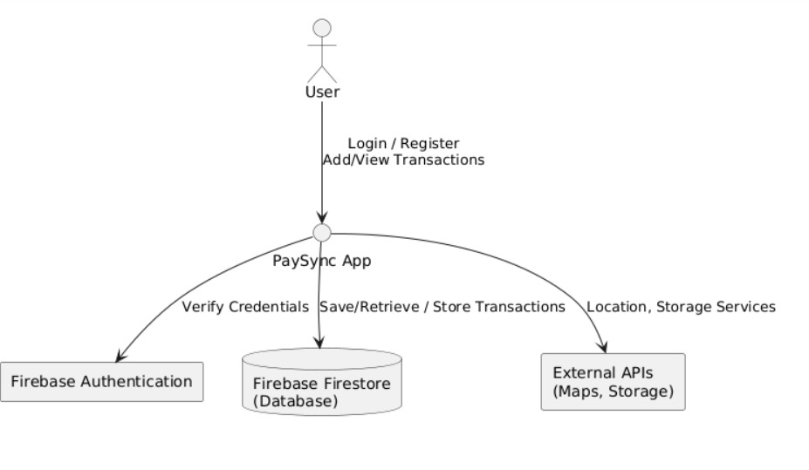

DFD Level-1:

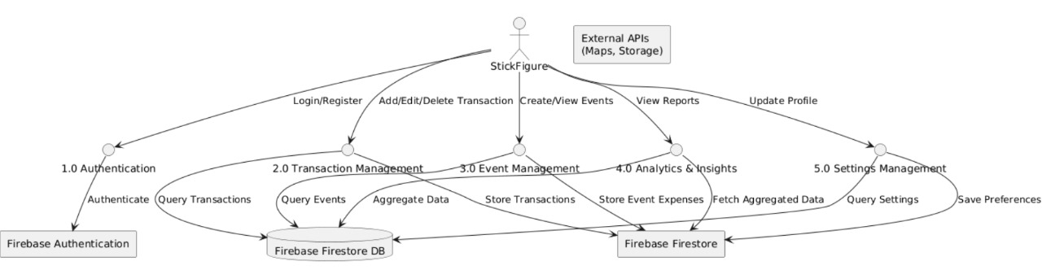

DFD level-2:
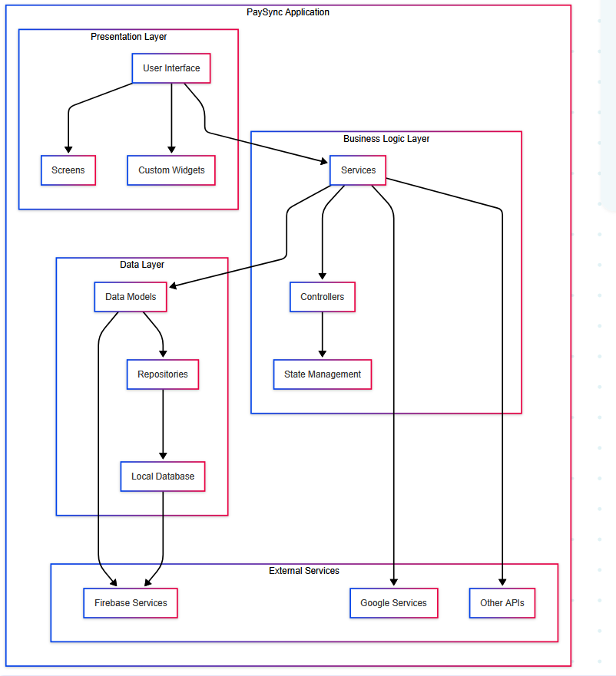

Activity diagram:
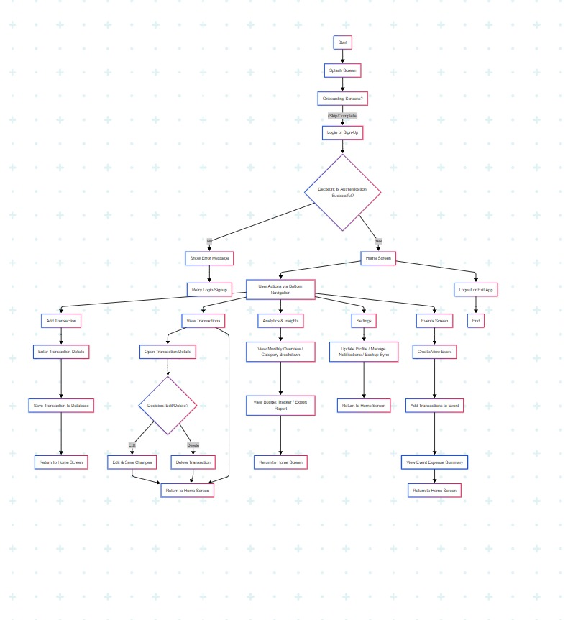

7. Frontend description
- Technology Stack
- Built using Flutter framework (Dart language)
- Firebase integration for backend services
- Cross-platform support (Android, iOS, Windows, Linux, macOS)
- Material Design implementation
- State management using GetX package
- Architecture
- Clean architecture pattern with separate layers for:
- UI (screens and widgets)
- Business logic (services)
- Data layer (models and repositories)
- Firebase integration for real-time data sync
- Local database using SQLite (sqflite)
- Offline-first approach with sync service
- UI Components
- Custom futuristic app bar with gradient and shadow effects
- Material Design components
- Responsive layouts
- Custom widgets for consistent UI
- Support for both light and dark themes
- Animated transitions and loading states
- Features
- Authentication system (Google Sign-In)
- Real-time data synchronization
- Offline data storage
- Location services integration
- File handling capabilities
- Chart and visualization components (fl_chart, syncfusion_flutter_charts)
- Push notifications support
- Performance Optimizations
- Lazy loading of resources
- Efficient state management
- Background sync service
- Optimized asset loading
- Memory management

- Security Features
- Firebase Authentication
- Secure data storage
- Permission handling
- API key management
- Data encryption
- Development Tools
- Flutter SDK version 3.7.2
- Android Studio/Gradle for Android builds
- Xcode for iOS builds
- CMake for Windows/Linux builds
- Flutter linting and code analysis
- Cross-Platform Support
- Android (minSdk 23)
- iOS
- Windows
- Linux
- macOS
- Web (potential support)

8. Backend description
- Backend Architecture
- Hybrid architecture combining Firebase and Spring Boot
- Firebase for real-time data and authentication
- Spring Boot server for business logic and data processing
- Microservices approach with separate services for different functionalities
- Core Technologies
- Firebase Services:
- Firestore for NoSQL database
- Firebase Authentication
- Firebase Cloud Messaging
- Firebase Admin SDK
- Spring Boot:
- Spring Boot 2.x
- Spring Web for REST APIs
- Spring Actuator for monitoring
- Spring Boot DevTools for development
- Data Management
- Firestore Database:
- Collections: users, transactions, events, collaborations
- Real-time data synchronization
- Offline data persistence
- Security rules implementation
- Local SQLite Database:
- Offline data storage
- Sync status tracking
- Transaction management
- Services Layer
- User Management Service:
- User CRUD operations
- Authentication handling
- Profile management
- Transaction Service:
- Transaction processing
- Transaction history
- Data validation
- Sync Service:
- Bi-directional sync
- Conflict resolution
- Offline support
- Collaboration Service:
- Event invitations
- Member management
- Status tracking
- Security Implementation
- Firebase Authentication:
- Google Sign-In
- Email/Password authentication
- Token-based authentication
- Firestore Security Rules:
- Role-based access control
- Data validation rules
- Time-based access restrictions
- API Security:
- HTTPS encryption
- API key management
- Request validation
- Integration Features
- Real-time Data Sync:
- Automatic synchronization
- Conflict resolution
- Offline-first approach
- Push Notifications:
- Firebase Cloud Messaging
- Local notifications
- Background message handling
- Location Services:
- Geolocation tracking
- Geocoding support
- Permission handling
- Performance Optimizations
- Caching mechanisms
- Batch operations
- Efficient data queries
- Background processing
- Connection state management

- Monitoring and Maintenance
- Error logging
- Performance monitoring
- Health checks
- Automated backups
- Version control
The backend is designed to be:
- Scalable: Can handle growing user base and data volume
- Reliable: With offline support and data synchronization
- Secure: Multiple layers of security implementation
- Maintainable: Well-structured code and services
- Performant: Optimized for speed and efficiency
The architecture supports:
- Real-time data updates
- Offline functionality
- Secure data handling
- Efficient resource usage
- Easy maintenance and updates
- Cross-platform compatibility

9. Testing
- Testing Framework and Tools
- Flutter Test Framework for UI and widget testing
- XCTest for iOS platform testing
- JUnit for Spring Boot backend testing
- Mockito for mocking dependencies
- Flutter Lints for code quality checks
- Unit Testing
- Model Testing:
- Testing data models (User, Transaction, Event, etc.)
- Validation logic testing
- Data conversion testing
- Service Testing:
- Authentication service tests
- Transaction service tests
- Sync service tests
- Database operations tests
- Utility Testing:
- Helper functions
- Data formatting
- Validation utilities
- Widget Testing
- UI Component Testing:
- Custom widget testing (FuturisticAppBar, FuturisticBudgetInput, etc.)
- Form validation testing
- State management testing
- Animation testing
- Screen Testing:
- Navigation testing
- Screen state testing
- User interaction testing
- Integration Testing
- Firebase Integration:
- Authentication flow testing
- Firestore operations testing
- Real-time updates testing
- Backend Integration:
- API endpoint testing
- Data synchronization testing
- Error handling testing
- Cross-Platform Testing:
- iOS-specific features
- Android-specific features
- Web-specific features
- Performance Testing
- Load Testing:
- Concurrent user testing
- Data synchronization performance
- API response time testing
- Memory Testing:
- Memory leak detection
- Resource usage monitoring
- Cache management testing
- Network Testing:
- Offline mode testing
- Sync performance testing
- Bandwidth usage testing
- Security Testing
- Authentication Testing:
- Login flow testing
- Token validation
- Session management
- Data Security:
- Encryption testing
- Data validation
- Access control testing
- API Security:
- Endpoint security testing
- Input validation testing
- Rate limiting testing
- Automated Testing Pipeline
- CI/CD Integration:
- Automated test execution
- Test coverage reporting
- Build verification
- Test Environment:
- Development environment testing
- Staging environment testing
- Production environment testing
- Test Reporting:
- Test result analysis
- Coverage reports
- Performance metrics
- Testing Best Practices
- Test Coverage:
- Minimum 80% code coverage
- Critical path testing
- Edge case testing
- Test Documentation:
- Test case documentation
- Test plan maintenance
- Test result documentation
- Test Maintenance:
- Regular test updates
- Test optimization
- Test refactoring
The testing strategy ensures:
- Code quality and reliability
- Consistent user experience
- Secure data handling
- Optimal performance
- Cross-platform compatibility
- Easy maintenance and updates

The testing framework is designed to be:
- Comprehensive: Covering all aspects of the application
- Automated: Minimizing manual testing efforts
- Scalable: Supporting future feature additions
- Maintainable: Easy to update and modify
- Efficient: Providing quick feedback on code changes

10.Results

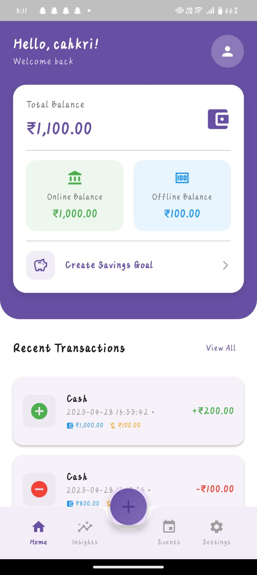 Home Page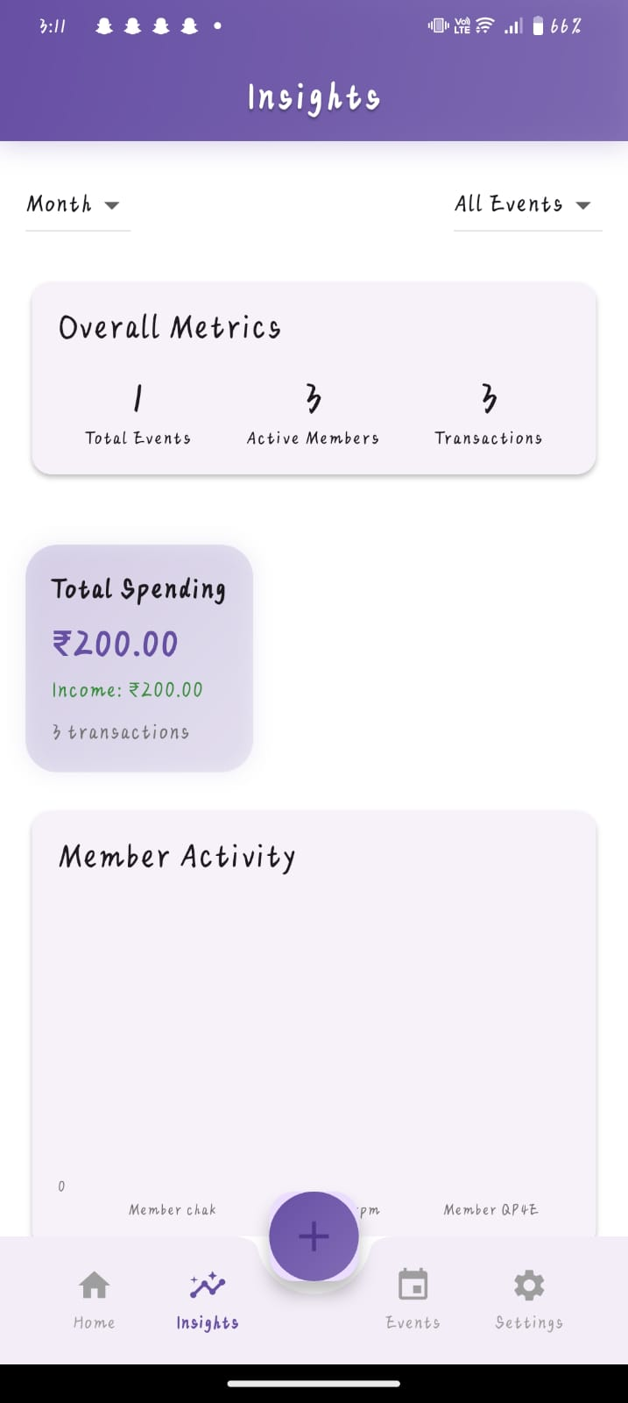 Insights Page

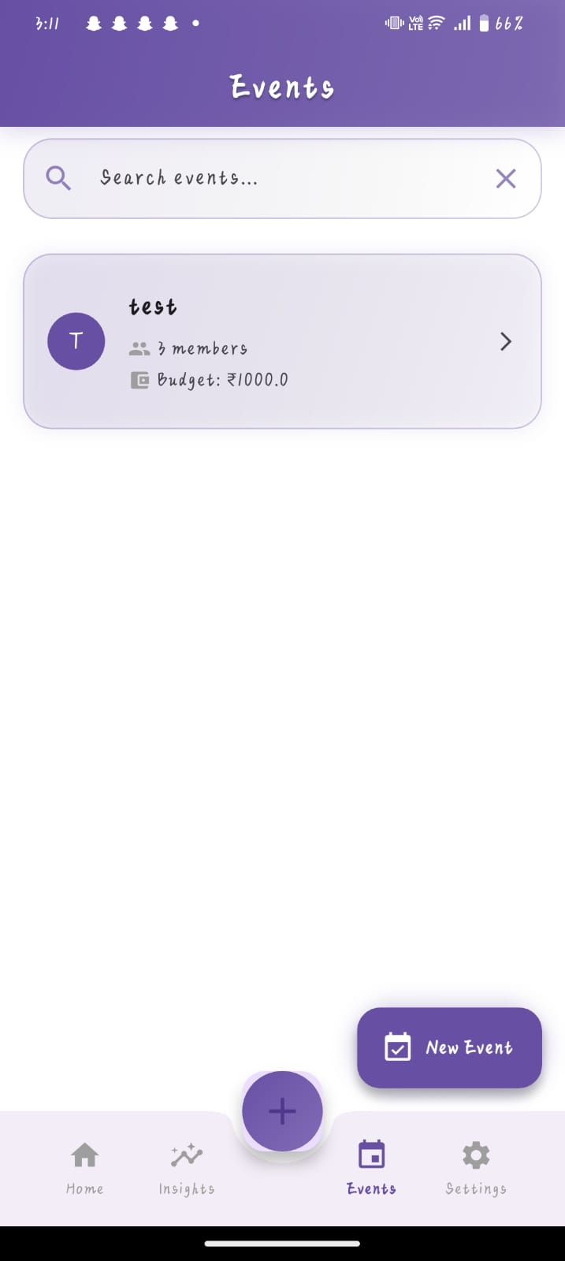 Events Page

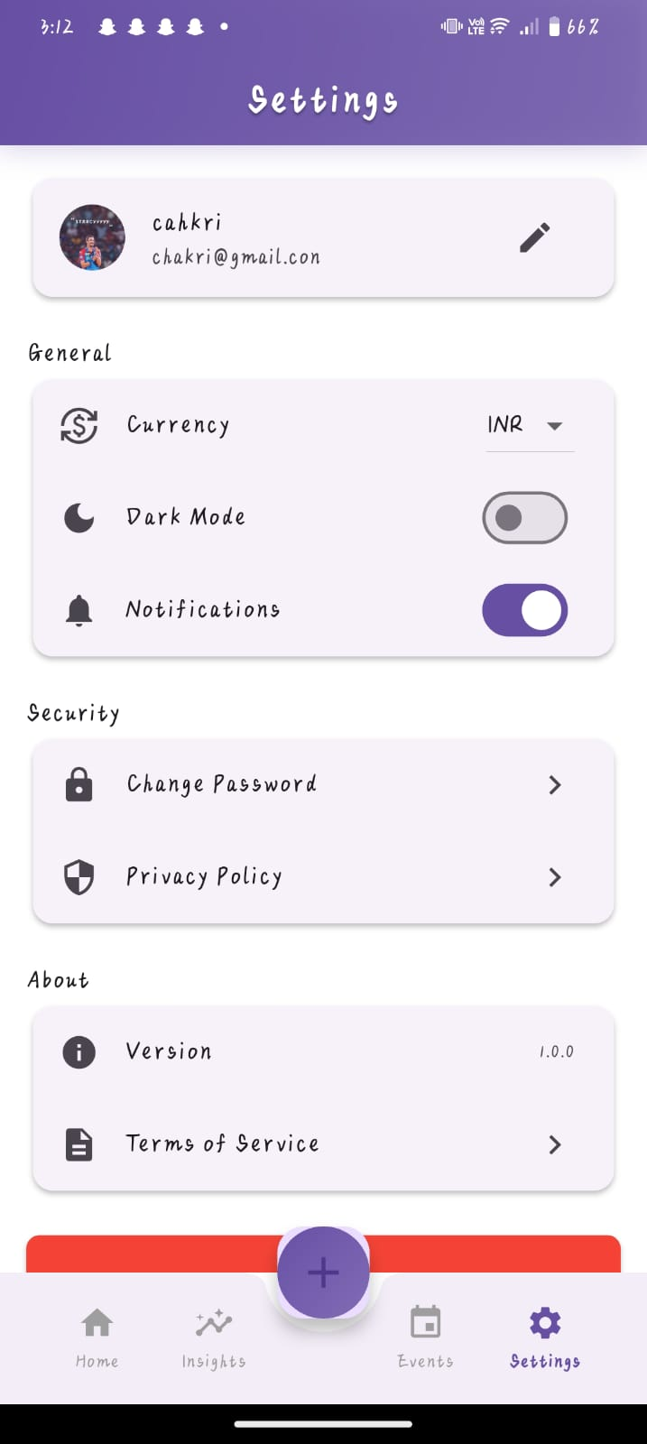 Profile Page

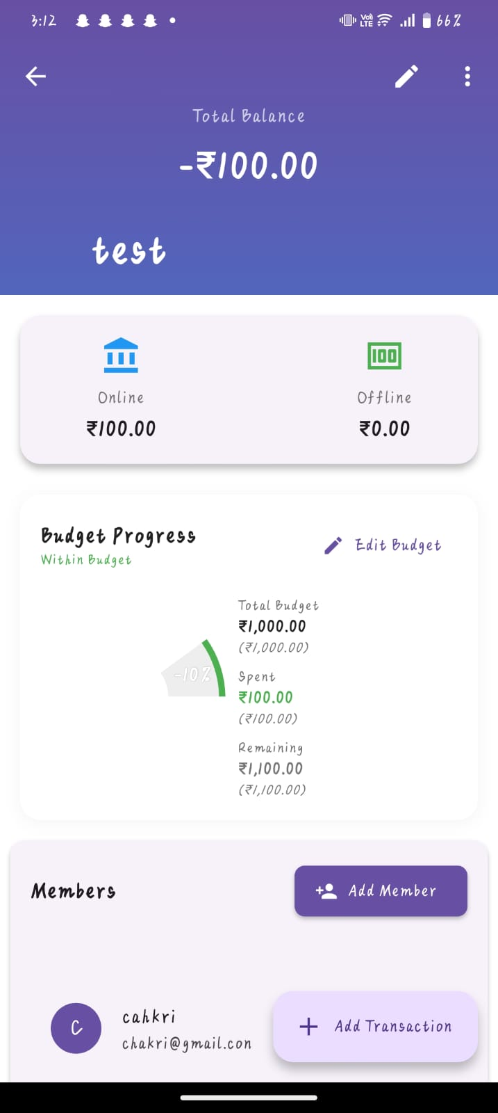 Event details page

11. Conclusion
PaySync is a comprehensive financial management application that successfully combines modern technology with user-centric design. Built using Flutter and Firebase, it offers a robust, cross-platform solution for managing personal finances, tracking expenses, and achieving savings goals. The application's architecture demonstrates strong technical implementation with clean code practices, efficient state management, and reliable data synchronization. Its user interface features a modern, futuristic design with smooth animations and intuitive navigation, ensuring a pleasant user experience. The project incorporates comprehensive testing strategies, security measures, and offline functionality, making it both reliable and accessible. With its scalable architecture and well-structured codebase, PaySync is well-positioned for future enhancements and growth, serving as a solid foundation for a feature-rich financial management platform that meets the needs of modern users while maintaining high standards of performance, security, and usability.

