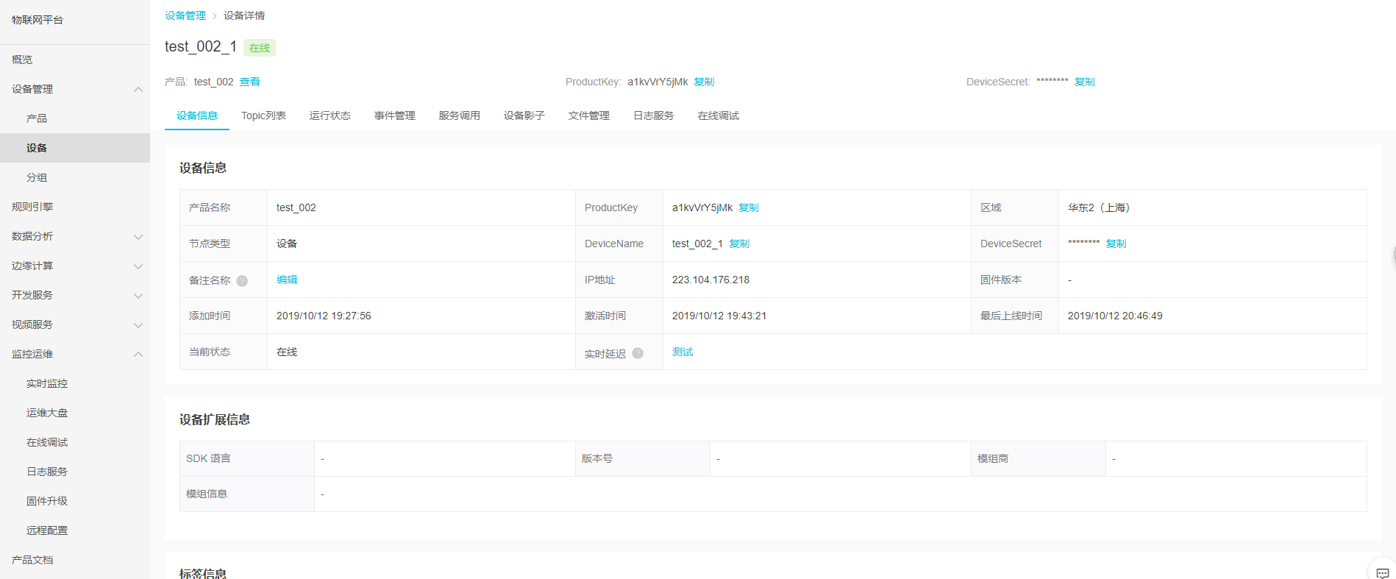

**1、设备连接格式定义：**

0x10+剩余长度+长度+MQTT（协议名称）+版本（固定值）+连接标识符(有用户，密码，客服端掉线后服务清空客服端信息)+心跳包+长度+ Client ID +长度${YourDeviceName}&${YourPrductKey}+长度+Password

**2、设备连接实际发送格式：**

0x10+剩余长度+长度+MQTT+0x04+0xC2+0x00+0x3C+长度+ 123456|securemode=3,signmethod=hmacsha1|+长度+test_002_1&a1kvVrY5jMk+长度+48D5335668BD2369F310C0CD3CA405F9E2E5D5B4

**3、数据发布格式定义：**

0x30+剩余字节（变化）+ Topic主题+报文标识符+发布的应用消息

**4、设备连接实际发送格式：**

0x30+剩余字节+ 长度+/sys/a1kvVrY5jMk/test_002_1/thing/event/property/post+{"method":"thing.event.property.post","id":"0000000001","params":{"CurrentTemperature":23,"CurrentHumidity":56,"HVOC":4,"CO2":20,"PM2_5":140,"PM10":170,"HCHO":5},"version":"1.0.0"}

绿色的字需要替换成实际的数据

|  |  |  |
| --- | --- | --- |
| 标识符 | 含义 | 数据类型 |
| CurrentTemperature | 温度 | float |
| CurrentHumidity | 湿度 | int32 |
| HVOC | 挥发性有机物 | double |
| CO2 | CO2 | int32 |
| PM2_5 | PM2.5 | int32 |
| PM10 | PM10 | int32 |
| HCHO | 甲醛 | double |