CODE:

package com.selenium.cse;

import org.testng.annotations.Test;

import io.github.bonigarcia.wdm.WebDriverManager;

import junit.framework.~~Assert~~;

import org.testng.annotations.BeforeTest;

import org.openqa.selenium.By;

import org.openqa.selenium.WebDriver;

import org.openqa.selenium.WebElement;

import org.openqa.selenium.edge.EdgeDriver;

import org.openqa.selenium.support.ui.Select;

import org.testng.annotations.AfterTest;

public class CA1Q01 {

WebDriver driver;

*@Test*

public void f() throws Exception {

String title = driver.getTitle();

System.***out***.println(title);

~~Assert~~.~~assertEquals~~(title, "");

WebElement f1 = driver.findElement(By.*className*("p13n-sc-truncate-desktop-type2 p13n-sc-truncated"));

f1.click();

WebElement f2 = driver.findElement(By.*id*("add-to-cart-button"));

f2.click();

WebElement f6 = driver.findElement(By.*className*("a-button-input"));

f6.click();

// WebElement f7 = driver.findElement(By.name(""));

WebElement f3 = driver.findElement(By.*xpath*("//*[@id=\"a-autoid-0-announce\"]"));

f3.click();

Select s1=new Select(f3);

s1.selectByIndex(1);

WebElement f4 = driver.findElement(By.*name*("proceedToRetailCheckout"));

f4.click();

WebElement f5 = driver.findElement(By.*xpath*("//*[@id=\"sc-active-b22fc32f-226d-4d97-b87d-79d799d04b31\"]/div[4]/div/div[3]/div[1]/span[2]/span/input"));

f5.click();

}

*@BeforeTest*

public void beforeTest() throws Exception {

WebDriverManager.*edgedriver*().setup();

driver = new EdgeDriver();

driver.manage().window().maximize();

String url = "https://www.amazon.in/ap/signin?openid.pape.max_auth_age=900&openid.return_to=https%3A%2F%2Fwww.amazon.in%2Fgp%2Fyourstore%2Fhome%3Fpath%3D%252Fgp%252Fyourstore%252Fhome%26useRedirectOnSuccess%3D1%26signIn%3D1%26action%3Dsign-out%26ref_%3Dnav_AccountFlyout_signout&openid.assoc_handle=inflex&openid.mode=checkid_setup&openid.ns=http%3A%2F%2Fspecs.openid.net%2Fauth%2F2.0";

driver.get(url);

WebElement username = driver.findElement(By.*name*("email"));

username.sendKeys("nithyasivan@gmail.com");

WebElement conti = driver.findElement(By.*xpath*("//*[@id=\"continue\"]"));

conti.click();

WebElement password = driver.findElement(By.*name*("password"));

password.sendKeys("******");

WebElement sign = driver.findElement(By.*xpath*("//*[@id=\"signInSubmit\"]"));

sign.click();

Thread.*sleep*(3000);

}

*@AfterTest*

public void afterTest() {

driver.quit();

}{

}

}

}

CONSOLE OUTPUT:

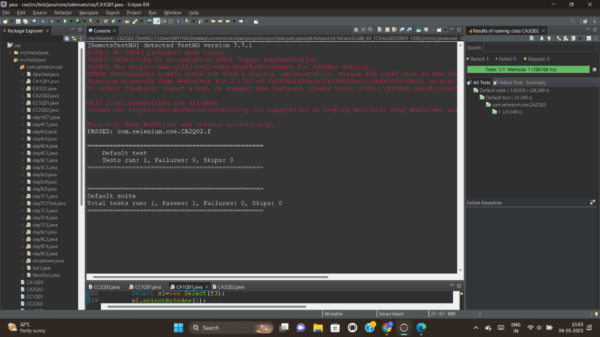



CODE:

package com.selenium.cse;

import java.util.List;

import org.openqa.selenium.By;

import org.openqa.selenium.Keys;

import org.openqa.selenium.WebDriver;

import org.openqa.selenium.WebElement;

import org.openqa.selenium.edge.EdgeDriver;

import org.testng.annotations.AfterTest;

import org.testng.annotations.BeforeTest;

import org.testng.annotations.Test;

import io.github.bonigarcia.wdm.WebDriverManager;

public class CA2Q02 {

WebDriver driver;

*@Test*

public void f() {

WebElement search = driver.findElement(By.*name*("field-keywords"));

search.sendKeys("Toys");

search.sendKeys(*Keys*.***ENTER***);

WebElement t1 = driver.findElement(By.*xpath*("//*[@id=\"search\"]/div[1]/div[1]/div/span[1]/div[1]/div[3]/div/div/div/div/div/div/div[3]/div[1]/h2/a/span"));

System.***out***.println(t1.getText());

WebElement t2 = driver.findElement(By.*xpath*("//*[@id=\"search\"]/div[1]/div[1]/div/span[1]/div[1]/div[4]/div/div/div/div/div/div/div[2]/div[1]/h2"));

System.***out***.println(t2.getText());

WebElement t3 = driver.findElement(By.*xpath*("//*[@id=\"search\"]/div[1]/div[1]/div/span[1]/div[1]/div[5]/div/div/div/div/div/div/div[2]/div[1]/h2/a/span"));

System.***out***.println(t3.getText());

WebElement t4 = driver.findElement(By.*xpath*("//*[@id=\"search\"]/div[1]/div[1]/div/span[1]/div[1]/div[6]/div/div/div/div/div/div/div[2]/div[1]/h2/a/span"));

System.***out***.println(t4.getText());

WebElement t5 = driver.findElement(By.*xpath*("//*[@id=\"search\"]/div[1]/div[1]/div/span[1]/div[1]/div[7]/div/div/div/div/div[3]/div[1]/h2/a/span"));

System.***out***.println(t5.getText());

WebElement price = driver.findElement(By.*xpath*("//*[@id=\"p_36/2485525031\"]/span/a/span"));

price.click();

WebElement category = driver.findElement(By.*xpath*("//*[@id=\"n/1378311031\"]/span/a/span"));

category.click();

}

*@BeforeTest*

public void beforeTest() throws Exception {

WebDriverManager.*edgedriver*().setup();

driver = new EdgeDriver();

driver.manage().window().maximize();

String url = "https://www.amazon.in/ap/signin?openid.pape.max_auth_age=900&openid.return_to=https%3A%2F%2Fwww.amazon.in%2Fgp%2Fyourstore%2Fhome%3Fpath%3D%252Fgp%252Fyourstore%252Fhome%26useRedirectOnSuccess%3D1%26signIn%3D1%26action%3Dsign-out%26ref_%3Dnav_AccountFlyout_signout&openid.assoc_handle=inflex&openid.mode=checkid_setup&openid.ns=http%3A%2F%2Fspecs.openid.net%2Fauth%2F2.0";

driver.get(url);

WebElement username = driver.findElement(By.*name*("email"));

username.sendKeys("nithyasivan@gmail.com");

WebElement conti = driver.findElement(By.*xpath*("//*[@id=\"continue\"]"));

conti.click();

WebElement password = driver.findElement(By.*name*("password"));

password.sendKeys("******");

WebElement sign = driver.findElement(By.*xpath*("//*[@id=\"signInSubmit\"]"));

sign.click();

Thread.*sleep*(3000);

}

*@AfterTest*

public void afterTest() {

driver.quit();

}

}

CONSOLE OUTPUT:

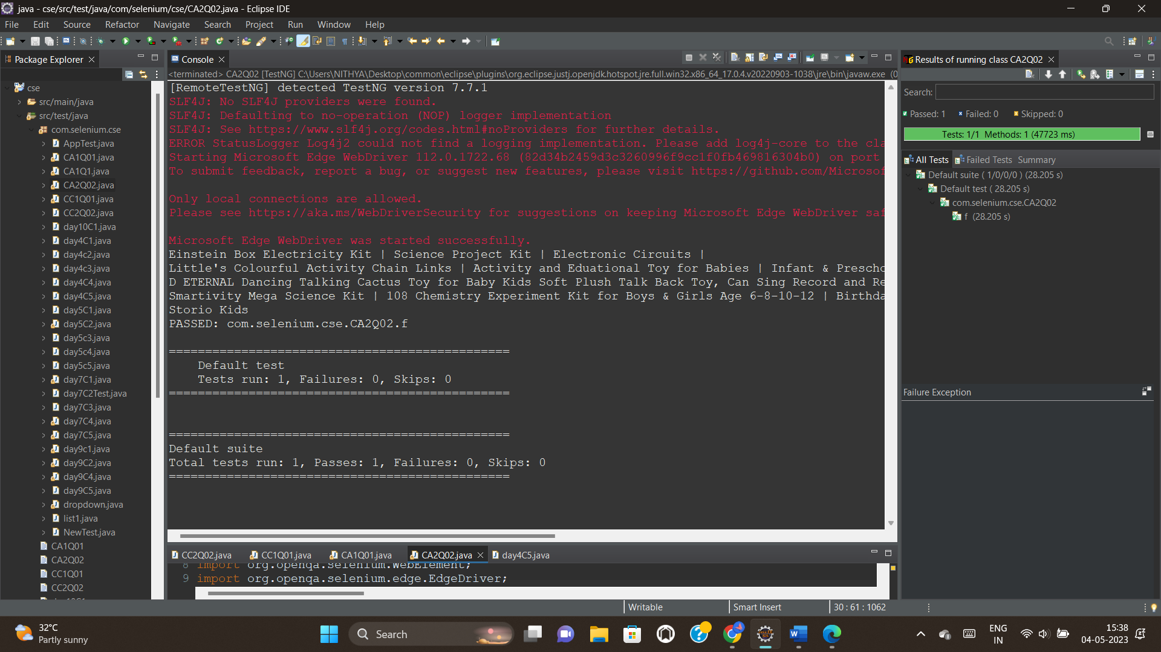



CODE:

package com.selenium.cse;

import org.openqa.selenium.By;

import org.openqa.selenium.WebDriver;

import org.openqa.selenium.WebElement;

import org.openqa.selenium.edge.EdgeDriver;

import org.openqa.selenium.support.ui.Select;

import org.testng.annotations.AfterTest;

import org.testng.annotations.BeforeTest;

import org.testng.annotations.Test;

import io.github.bonigarcia.wdm.WebDriverManager;

public class CA1Q03 {

WebDriver driver;

*@Test*

public void f() {

WebElement account = driver.findElement(By.*xpath*("//*[@id=\"nav-link-accountList\"]/span"));

account.click();

// Select s1=new Select(account);

// s1.selectByIndex(1);

WebElement other = driver.findElement(By.*xpath*("//*[@id=\"a-page\"]/div[2]/div/div[2]/div[1]/a/div/div"));

other.click();

WebElement pack = driver.findElement(By.*xpath*("//*[@id=\"a-pack\"]/div[2]/div/div[2]/div[1]/a/div/div"));

pack.click();

WebElement view = driver.findElement(By.*xpath*("//*[@id=\"a-vieworderdetails\"]/div[2]/div/div[2]/div[1]/a/div/div"));

view.click();

WebElement cancel = driver.findElement(By.*xpath*("//*[@id=\"a-vieworderdetails\"]/div[2]/div/div[2]/div[1]/a/div/div"));

cancel.click();

}

*@BeforeTest*

public void beforeTest() throws Exception {

WebDriverManager.*edgedriver*().setup();

driver = new EdgeDriver();

driver.manage().window().maximize();

String url = "https://www.amazon.in/ap/signin?openid.pape.max_auth_age=900&openid.return_to=https%3A%2F%2Fwww.amazon.in%2Fgp%2Fyourstore%2Fhome%3Fpath%3D%252Fgp%252Fyourstore%252Fhome%26useRedirectOnSuccess%3D1%26signIn%3D1%26action%3Dsign-out%26ref_%3Dnav_AccountFlyout_signout&openid.assoc_handle=inflex&openid.mode=checkid_setup&openid.ns=http%3A%2F%2Fspecs.openid.net%2Fauth%2F2.0";

driver.get(url);

WebElement username = driver.findElement(By.*name*("email"));

username.sendKeys("nithyasivan@gmail.com");

WebElement conti = driver.findElement(By.*xpath*("//*[@id=\"continue\"]"));

conti.click();

WebElement password = driver.findElement(By.*name*("password"));

password.sendKeys("******");

WebElement sign = driver.findElement(By.*xpath*("//*[@id=\"signInSubmit\"]"));

sign.click();

Thread.*sleep*(3000);

}

*@AfterTest*

public void afterTest() {

driver.quit();

}

}

CONSOLE OUTPUT:

